Growth and Yield Variability in Cowpea (*Vigna unguiculata* L. Walp.) Cultivars Infected with Cowpea Aphid-Borne Mosaic Virus and Southern Bean Mosaic Virus

# ABSTRACT

Eight cowpea (*Vigna unguiculata* L. Walp.) cultivars were evaluated for *Cowpea Aphid-Borne Mosaic Virus* (CABMV), *Southern Bean Mosaic Virus* (SBMV), CABMV+SBMV, and SBMV+CABMV resistance under greenhouse conditions at the School of Agriculture and Agricultural Technology Minna, Nigeria in 2016 (lat.9o40ʹN; long 6o30ʹE at an altitude of 220m.a.s.l). Virus infected plants were evaluated independently using a Completely Randomized Design with three replications. In single infections, cowpea seedlings were inoculated at 10 days after sowing (DAS), while in mixed infections the second virus inoculation was performed at 21 DAS. Disease incidence, symptom severity, plant’s growth and yield characters were recorded. The data were subjected to analysis of

variance and Duncan’s Multiple Range Test was used for mean separation. Results showed that one hundred percent infection was obtained regardless of the cultivar. High disease severity with the symptom score of 4.0 was recorded for all the cowpea cultivars infected with CABMV alone and CABMV+SBMV, while moderate resistance with a symptom score of 3.0 was recorded only in cultivars IT09K-231-1 and IT10K-973-1 to SBMV, and in IT07K-299-6 and IT10K-973-1 to SBMV+CABMV. Through the four virus treatments, seed weight per plant was significantly (*p*<0.05) highest in IT10K-843 infected with CABMV which, produced 3.5 g; cultivar, IT07K-299-6 inoculated with SBMV produced 4.9 g, while IT10K-973-1 under CABMV+SBMV infections produced 4.9 g; and IT07K-298-9 infected with SBMV+CABMV produced 4.4 g. The cowpea cultivar IT07K-299-6 which gave the highest seed weight under single and double virus infections can be exploited in hybridization studies to develop resistant cowpea varieties for use by farmers.

*Keywords: Cowpea; virus; severity; growth and yield characters.*

# INTRODUCTION

Cowpea (*Vigna unguiculata* L. Walp) is one of the most important pulse crop globally and the most widely used legume crop in the tropics [1] and [2]. It originated and was domesticated in Southern Africa. It was then cultivated in East and West Africa as well as Asia and today, it is grown mostly in semi-arid tropical zones across Africa, Asia, Europe and the Americas [3]. It is a major food for millions of people and also ensures the availability of high quality hay for livestock feed in dry and wet seasons [4]. Cowpea is commonly intercropped with cereal crops such as maize and sorghum because it fixes atmospheric nitrogen into the soil. In the developing world where soil infertility is high; it gives to the soil a huge supply of nitrogen and permits its cultivation without the use of nitrogenous fertilizer [5]. It also suppresses weeds and prevents soil erosion [6].

Cowpeas are grown extensively throughout savanna regions of the tropics and sub-tropics, between 35ºN and 30ºS, especially in Western and Central African countries, across Asia and Oceania, the Middle East, southern Europe, southern USA, and Central and South America. In 2015, the African continent produced almost 95% of the global cowpea production on a land area of more than 11 million hectares, followed by Asia (3.2%), the Americas (1.3%) and Europe (0.5%) [7].

Cowpea is susceptible to a complex of insect pests and diseases and they attack the crop from vegetative stage to storage [5], which forms part of the most important impediments to its profitable production [8]. Virus diseases are the most damaging diseases of cowpea and represent a significant proportion of losses

regarding the potential value of the crop in sub- Saharan Africa [9].

*Cowpea Aphid Borne Mosaic Virus* (CABMV), a member of the genus *Potyvirus* is an important virus disease of cowpea and can cause a yield loss of 13 – 87% depending on crop susceptibility, virus strain and the environmental conditions. It is readily transmitted by mechanical inoculation, several aphid species and through cowpea seeds [10].

Similarly, *Southern Bean Mosaic Virus* (SBMV) a member of the genus *Sobemoviruses* is highly prevalent in cowpea fields causing severe yield losses [11].

Mixed virus infections are not uncommon in nature; as such cowpea plants may be infected by more than one virus disease, resulting in serious economic losses in agricultural production [11,12]. Mixed virus infections usually result in a more severe disease symptom resulting in significant reductions in quantitative parameters such as plant height, weight and subsequently yield and at times causing plant death [13].

Mixed infections in crops involving two or more unrelated or closely related viruses can induce a series of within-host interactions and the outcome may be synergistic or antagonistic [14]. A recent study in eastern Africa revealed that Maize lethal necrosis disease is caused by a synergistic interaction of *Maize Chlorotic Mottle Virus* (MCMV, genus *Machlomovirus*) and *Sugarcane Mosaic Virus* (SCMV, genus *Potyvirus*) or other *Potyviruses* e.g. *Maize Dwarf Mosaic Virus* and *Wheat Streak Mosaic Virus*. This has resulted in huge losses to farmers and seed companies [15].

Differences in virus strains and types alongside varying host plant system and other factors influence the accumulation dynamics of the interacting viruses in mixed infections and disease severity in host plants [16]. Breeding efforts for developing resistant cultivars against diseases and evaluation of the locally adapted cowpea cultivars against single and mixed infections of cowpea viruses will provide useful information for breeding cowpea cultivars with double resistance to these viruses. Thus, cultivation of these resistant cultivars can prevent severe yield losses in case of disease outbreak and also ensure food security. This study was, therefore, conducted to determine the resistance of selected cowpea cultivars to single and mixed infections of CABMV and SBMV and to ascertain the effects that these two viruses have on the selected cowpea cultivars in single and mixed infections.

# MATERIALS AND METHODS

## Study Location

The experiment was conducted at the greenhouse of the Department of Crop Production, Federal University of Technology, Minna, Niger State (9o 40’ N and 6o30’ E) in the Southern Guinea Savanna region of Nigeria.

## Source of Cowpea Seeds

The eight cowpea cultivars used for the experiment were obtained from the Genetic Resource Unit, International Institute for Tropical Agriculture, (IITA), Ibadan, Nigeria. These were IT07K-210-1-1, a susceptible check, IT07K-298- 9, IT07K-299-6, IT09K-231-1, IT10K-817-7, IT10K-843, IT10K-973-1 and IT11K-61-82.

These cultivars exempting the susceptible check were selected because there is scarcity of information of single and mixed infections with CABMV and SBMV on them.

## Source of Virus Isolates

The *Cowpea Aphid-borne Mosaic Virus* (CABMV) and *Southern Bean Mosaic Virus* (SBMV) isolates used were obtained from the stock in the Department of Crop Production Federal University of Technology (FUT), Minna. The isolates are severe strains of CABMV and SBMV that have been previously maintained on silica gels in vial bottles at room temperature.

## Soil Sterilization, Treatments and Experimental Design

Sandy loam soil used for the study was sterilized before it was used to fill the polyethylene bags. Steam sterilization was done using the trough method as described by [17]. The trough consisted of the upper and the lower pieces. The upper piece, perforated at the bottom served as the soil container, while the lower or bottom piece held the water. To set up the trough, the bottom piece was positioned on a metal stand. The piece was then filled half-way with water. The upper piece designed to fit tightly was then positioned on the bottom piece after which it was filled with soil and covered with thick sacking, followed by a moderately tight-fitting lid through which a hole was made that permitted the thermometer to be pushed into the top soil as described by [17]. The covering was necessary to ensure sterilization up to the soil surface. Firewood was set in between the metal stand and then set on fire. The steam produced by the water in the bottom piece passed through the perforations on the bottom of the top piece to sterilize the soil to the temperature of 100oC.

Four independent trials were conducted simultaneously, for single and mixed infections of CABMV and SBMV. The treatments evaluated were CABMV-infected (T1), SBMV-infected (T2), CABMV + SBMV infected (T3) and SBMV + CABMV infected plants (T4). The treatments were laid out in a Completely Randomized Design with three replications. In each trial, the chosen eight cowpea cultivars were evaluated.

## Sowing, Inoculation and Management

Three cowpea seeds were sown after dressing with Apron-plus at the rate of 3 g per 10 kg seeds in polyethylene bags of good drainage containing sterilized soil of 8 kg and were later thinned to one plant per bag at 8 days after sowing (DAS). Each bag represented a cultivar and three bags were used per treatment. These bags were placed on iron benches with adequate spacing. Extract for inoculation was prepared by triturating (grinding) leaf isolate in extraction buffer at the ratio of 1:10 w/v, that is, one gram of leaf in 10 ml of the inoculation buffer, using pre-cooled sterilized ceramic mortar and pestle as described by [18]. Two micro-litres of beta-mercaptoethanol were mixed with the extract just before use. Cowpea seedlings were inoculated at 10 days after sowing (DAS) by rubbing the virus infected sap on the upper surface of the leaves dusted

with carborundum powder with 600-mesh. The inoculated plants were rinsed with sterile distilled water and thereafter left for symptom expression.

Seedlings of the first treatment were inoculated at ten DAS with CABMV isolate, representing the single infection trial for virus A, seedlings of the second treatment were inoculated at 10 DAS with SBMV isolate, representing the single infection trial for virus B, seedlings of the third treatment were inoculated at ten DAS with the isolates of Virus A (CABMV) and Virus B (SBMV) at 21 DAS, representing type 1 double infections and finally, seedlings of the fourth treatment were inoculated at ten DAS with the isolates of Virus B (SBMV) and Virus A (CABMV) at 21 DAS, representing type 2 double infections. The inoculated plants were sprayed at 2 weeks interval until maturity with Cypermethrin 10% E.C insecticide in order to prevent cross contamination.

## Data Collection and Statistical Analysis

Disease incidence was assessed as percentage of the total plants showing typical disease symptoms after inoculation, which was observed for the first and second weeks after inoculation (WAI). Disease severity, plant height, and number of leaves per plant were recorded at 8 WAI.

Disease severity was evaluated based on a visual scale of 1-5 as described by [19], where 1

= no symptoms or apparently healthy plants; 2 = slight mosaic; 3 = moderate mosaic; 4 = severe mosaic, leaf distortion and stunting; 5 = severe mosaic, stunting and plant death. Plant height was measured with a metre rule from ground level to the highest leaf, and the mean values per plot of the tagged plant were computed. The number of leaves per plant was determined by counting the leaves of the plant manually. Seed weight per plant was determined at harvest. The data were subjected to analysis of variance using Statistical Analysis System [20] and means were separated using Duncan’s Multiple Range Test at 5% level of probability.

# RESULTS

## Disease Incidence and Severity

Symptoms became visible on the leaves of inoculated plants irrespective of the virus treatments at 8 days after inoculation (DAI). At 2

WAI, 100% infection was obtained regardless of the cultivar. Disease severity increased progressively after inoculation and the symptoms observed on the plants varied based on the virus type they were inoculated with. The plants inoculated with CABMV showed mottling, mosaic and leaf distortion while those inoculated with SBMV showed vein clearing, mosaic and leaf distortion which were more pronounced on the younger leaves (Plate 1). On the other hand, uninoculated (control) plants were symptomless (score = 1) (Fig. 1).

The symptoms observed on plants inoculated with CABMV + SBMV were not much different from those of CABMV alone, and the symptoms observed on SBMV + CABMV plants were also just like those of SBMV alone. It was observed that in the four virus treatments, the disease severity differed significantly (*p<*0.05) among the eight cultivars investigated.

At 8 WAI, the cowpea cultivars infected with CABMV alone had the same severity score of 4 (Fig. 1). In the SBMV infected plants, cultivars IT07K-210-1-1, IT07K-298-9, IT07K-299-6, IT10K-817-1, IT10K-843 and IT11K-61-82 were

the most affected with severity score of 4 while IT09K-231-1 and IT10K-973-1 had a severity score of 3. In the CABMV + SBMV infected plants, all the cultivars had the same severity score of 4.

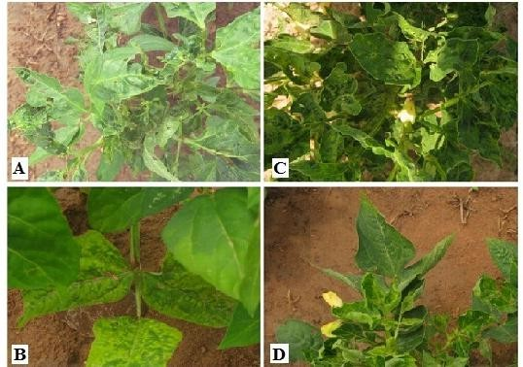

**Plate 1. Symptoms of *Cowpea Aphid-Borne Mosaic Virus* (CABMV) (A), *Southern Bean Mosaic Virus* (SBMV) (B), CABMV+SBMV (C) and SBMV+CABMV (D) on IT10K-843 at 8**

### weeks after inoculation of cowpea [*Vigna unguiculata* (L.) Walp.] plants at Department of Crop Production, Federal University of Technology, Minna, Niger State in the Southern Guinea Savanna region of

**Nigeria in 2016**

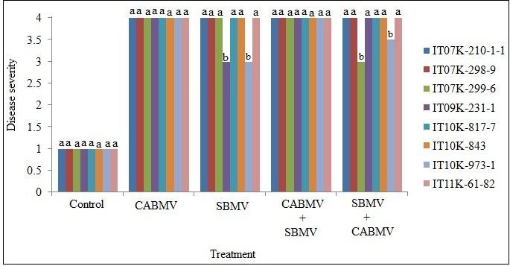

**Fig. 1. Disease severity on cowpea [*Vigna unguiculata* (L.) Walp.] cultivars infected with CABMV, SBMV, CABMV+SBMV and SBMV+CABMV at 8 weeks after inoculation at Department of Crop Production, Federal University of Technology, Minna, Niger State in the Southern Guinea Savanna region of Nigeria in 2016**

*Note: Bars with dissimilar letter are differ significantly by Duncan’s Multiple Range Test at p≤0.05*

In the SBMV + CABMV infected plants, IT07K- 210-1-1, IT07K-298-9, IT09K-231-1, IT10K-817-

1, IT10K-843 and IT11K-61-82 were the most affected with a severity score of 4 while IT07K- 299-6 and IT10K-973-1 had a severity score of 3 (Fig. 1). Through the four virus treatments, IT07K-210-1-1, IT07K-298-9, IT10K-817-7,

IT10K-843 and IT11K-61-82 were of the same severity score of 4. Also, CABMV and CABMV + SBMV induced high and the same symptom severity score of 4 in all the cultivars.

## Effect of Virus Infections on Growth Components

### Plant height

Un-inoculated plants exhibited heights that varied between 37.1 (IT09K-231-1) and 75.2 (IT11K-61-82) cm (Fig. 2). At 8 WAI, the heights of the inoculated plants varied significantly (*p<*0.05) from 27.3 to 36.8 cm for the CABMV infected plants, 25.5 to 68.3 cm for SBMV infected plants, 20.0 to 65.2 cm for CABMV + SBMV infected plants and 25.2 to 54.2 cm for SBMV + CABMV. In the plants inoculated with CABMV, cultivar IT11K-61-82 produced the tallest plants with 36.8 cm height, while height differences of the remaining cultivars were not significant (*p>*0.05) (Fig. 2).

In the plants inoculated with SBMV, IT11K-61-82 produced the tallest plants with 68.3 cm height, followed by cultivar IT07K-299-6 with 35.8 cm tall plants. Cultivar IT10K-817-7 produced the shortest plants measuring 25.5 cm, while the height difference between cultivars IT09K-231-1 and IT10K-973-1 was not significant (*p>*0.05).

In the plants inoculated with CABMV + SBMV, cultivar IT11K-61-82 produced the tallest plants measuring 65.2 cm, followed by cultivar IT07K- 298-9 with 39.2 cm tall plants, followed by cultivar IT10K-843 with 33.2 cm tall plants. The difference in height between cultivars IT07K-299-

6 of 28.5 cm and IT10K-973-1 with 27.5 cm tall plants was not significant (*p*>0.05). Cultivars IT07K-210-1-1 and IT09K-231-1 were the

shortest and of the same height of 23.3 cm (Fig. 2).

In the plants inoculated with SBMV + CABMV, cultivar IT11K-61-82 produced the tallest plants measuring 54.2 cm, followed by cultivar IT07K- 298-9 with 39.2 cm tall plants. The height differences among cultivars IT07K-210-1-1 of

28.3 cm, IT07K-299-6 with 30.0 cm, IT09K-231-1

with 28.8 cm, IT10K-843 with 28.3 cm and IT10K-973-1 with 29.3 cm tall plants were not significant (*p*>0.05). However, cultivar IT10K- 817-7 produced the shortest plants of 25.2 cm height (Fig. 2). Through the four virus treatments,

cultivar IT11K-61-82 plants were observed to be the tallest.

### Number of Leaves Per Plant

The healthy (control) plants of each cultivar produced higher number of leaves than virus- infected plants. Leaf number varied significantly (*p*<0.05) between 39 (IT07K-299-6) and 60 (IT10K-817-7 and IT11K-61-82) per plant (Fig. 3). The number of leaves per plant ranged from 31 to 38 for the CABMV infected plants, 30 to 53 for SBMV infected plants, 32 to 53 for CABMV + SBMV infected plants and 30 to 50 for SBMV + CABMV infected plants (Fig. 3). In CABMV infected plants, cultivar IT10K-843 produced the highest number of leaves per plant of 38 which was not significantly (*p>*0.05) different from cultivar IT07K-298-9 that produced 37 leaves per plant. The next ones were cultivars IT07K-210-1- 1 and IT07K-299-6 which had the same number of leaves per plant of 36, followed by varieties IT09K-231-1 and IT10K-817-7 that also produced the same number of leaves per plant of 32. Cultivars IT10K-973-1 and IT11K-61-82 produced the lowest number of leaves of 31 (Fig. 3).

In SBMV infected plants, cultivar IT11K-61-82 produced significantly (*p<*0.05) the highest number of leaves per plant of 53, followed by

cultivar IT07K-298-9 with 42 then cultivar IT10K- 843 with 35 leaves. The differences in the number of leaves per plant among cultivars IT07K-210-1-1 with 35, IT07K-299-6 with 33, IT09K-231-1 with 32 and IT10K-973-1 with 35

leaves were not significant (*p>*0.05). On the other hand, cultivar IT10K-817-7 produced the lowest number of leaves per plant of 31 (Fig. 3).

In CABMV + SBMV infected plants, IT11K-61-82 produced the highest number of leaves per plants of 53, followed by cultivars IT07K-298-9 with 45 and IT10K-817-7 with 43 leaves which were not significantly (*p>*0.05) different. The differences in the number of leaves per plant of cultivars IT10K-843 with 39, IT10K-973-1 with 39, IT07K-210-1-1 with 37 and IT07K-299-6 with

37 leaves were not significant (*p>*0.05), while cultivar IT09K-231-1 produced the lowest number of leaves per plant of 32.

In SBMV + CABMV infected plants, cultivar IT11K-61-82 also produced the highest number of leaves per plant of 50, followed by cultivar IT10K-843 with 35 and cultivars IT07K-298-9 and IT09K-231-1 produced 33 leaves per plants. However, cultivar IT10K-817-7 produced 32 leaves per pant and it was not significantly (*p>*0.05) different from those of cultivars IT07K- 210-1-1 and IT10K-973-1 which had the lowest number of leaves of 30.

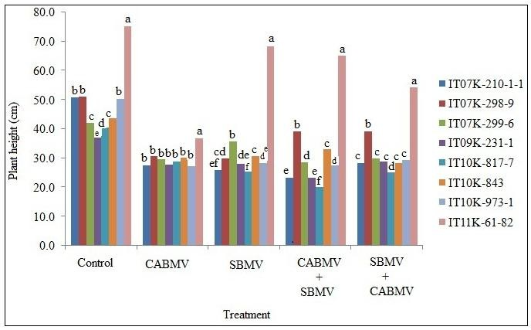

**Fig. 2. Plant height of cowpea [*Vigna unguiculata* (L.) Walp.] cultivars inoculated with CABMV,SBMV, CABMV+SBMV and SBMV+CABMV at 8 weeks after inoculation at Department of Crop Production, Federal University of Technology, Minna, Niger State in the Southern Guinea Savanna region of Nigeria in 2016**

*Note: Bars with dissimilar letter (s) are differ significantly by Duncan’s Multiple Range Test at p=0.05*

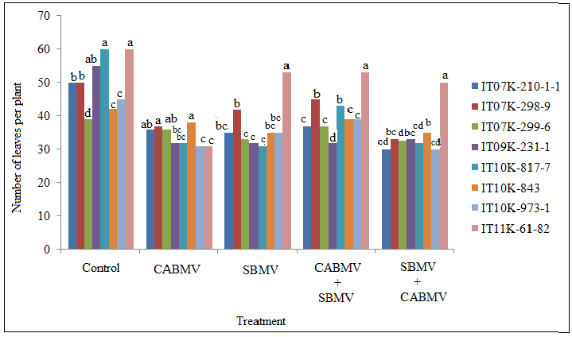

**Fig. 3. Number of leaves per plant of cowpea [*Vigna unguiculata* (L.) Walp.] cultivars inoculated with CABMV,SBMV, CABMV+SBMV and SBMV+CABMV at 8 weeks after inoculation at Department of Crop Production, Federal University of Technology, Minna, Niger State in the Southern Guinea Savanna region of Nigeria in 2016**

*Note: Bars with dissimilar letter (s) are differ significantly by Duncan’s Multiple Range Test at p=0.05*

## Effect of Virus Infections on Yield Character

### Seed weight

A range of 3.9 (IT09K-231-1) to 7.2 (IT10K-843)

grams of seed weight was observed among the

healthy (control) plants (Fig. 4). The seed weight observed ranged significantly (*p<*0.05) from 0.2 to 3.5 g for CABMV infected plants, 1.3 to 4.9 g for SBMV infected plants, 0.9 to 4.9 g for CABMV

+ SBMV infected plants and 0.7 to 4.4 g for SBMV + CABMV infected plants (Fig. 4).

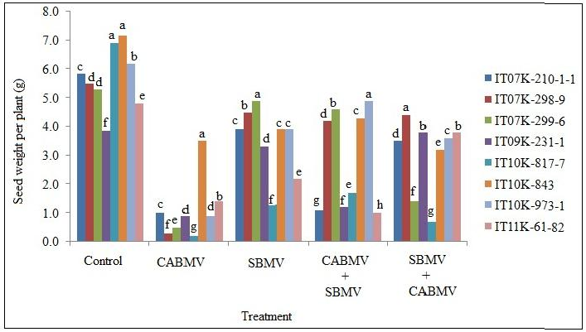

**Fig. 4. Seed weight per plant of cowpea [*Vigna unguiculata* (L.) Walp.] cultivars inoculated with CABMV, SBMV, CABMV+SBMV and SBMV+CABMV at Department of Crop Production, Federal University of Technology, Minna, Niger State in the Southern Guinea Savanna region of Nigeria in 2016.**

*Note: Bars with dissimilar letter are differ significantly by Duncan’s Multiple Range Test at p=0.05*

In CABMV infected plants, cultivar IT10K-843 had the highest seed weight per plant of 3.5g, followed by cultivars IT11K-61-82 with 1.4 g and IT07K-210-1-1 with 1.0 g. However, cultivars IT09K-231-1 and IT10K-973-1 exhibited the same seed weight of 0.9 g. The next ones were the seed weights of cultivars IT07K-299-6 with

0.5 g, IT07K-298-9 with 0.3 g, while cultivars IT10K-817-7 had the lowest seed weight per plant of 0.2 g (Fig. 4). In SBMV infected plants, cultivar IT07K-299-6 had the highest seed weight of 4.9 g followed by cultivar IT07K-298-9 with 4.5

g. The next ones were seed weights of cultivars IT07K-210-1-1, IT10K-843 and IT10K-

973-1 with 3.9 g which were the same, while cultivar IT10K-817-7 exhibited the lowest seed weight of 1.3 g.

In CABMV + SBMV infected plants, cultivar IT10K-973-1 produced the highest seed weight of 4.9 g, followed by cultivars IT07K-299-6 (4.6 g), IT10K-843 (4.3 g), IT07K-298-9 (4.2 g), IT10K-817-7 (1.7 g), IT09K-231-1 with 1.2 g,

IT07K-210-1-1 with 1.1 g while cultivar IT11K-61- 82 had the lowest seed weight of 1.0 g. In SBMV

+ CABMV infected plants, cultivar IT07K-298-9 exhibited the highest seed weight of 4.4 g, followed by cultivars IT09K-231-1 and IT11K-61-

82 with 3.8 g, IT10K-973-1 with 3.6 g, IT07K-

210-1-1 with 3.5 g, IT10K-843 with 3.2 g, IT07K-

299-6 with 1.4 g, while cultivar IT10K-817-7 had the lowest seed weight of 0.7 g.

# DISCUSSION

The single and double virus infections reported in this study had significant and different effects on the eight cowpea cultivars evaluated which can be attributed to the different susceptibility levels of the cultivars to the respective viruses. All the inoculated plants exhibited disease symptoms indicating their susceptibility to single and double infections of *Cowpea aphid-borne mosaic virus* (CABMV) and *Southern bean mosaic virus* (SBMV). This is in agreement with the work of [21], who reported the susceptibility of cowpea to single and double infections of CABMV and SBMV.

Disease severity observed in this study was based on the cowpea cultivar, age at the onset of the virus infection and the type of virus treatment. High symptom severity exhibited by all CABMV infected and CABMV + SBMV infected plants implied that CABMV was more aggressive than SBMV. This observation is supported by the

report of [22] who affirmed that high severity can occur when one of the infecting viruses is a member of the genus *Potyvirus*. Another reason that could be responsible for the high symptom severity can be that these plants were infected at an early stage of ten days after sowing by CABMV which agrees with the findings of [21] who recorded higher symptom severity on cowpea infected with CABMV ten days after sowing than at 30 days after sowing.

The cultivars which exhibited moderate symptom severity probably possess resistant genes to the respective viruses. More so, it was observed that some cultivars infected with CABMV + SBMV exhibited high symptom severity and vice versa when infected with SBMV + CABMV. This suggests that the contrary response of these cultivars to the two types of double infections might be due to the order and time of entry of the viruses involved in the double infections. It can also be due to the synergistic reaction occurring from the other virus within the cultivars as reported by [14].

Most of the cultivars produced leaves and pods of the appreciable number but hardly gave appreciable seed weights which are in contrast to their initial satisfactory growth. This is similar to the findings of [21] who reported a cowpea cultivar that produced more leaves than the control plants but eventually hardly produced any yield. The plants infected with CABMV alone were the most affected as they gave the lowest seed weight per plant. This is in agreement with the findings of [21] who reported that there are cases where single virus infections had more devastating effects on the crop than in double infections.

# CONCLUSION AND RECOMMENDA- TIONS

The present study has established that the evaluated cowpea cultivars were susceptible to single and double infections of CABMV + SBMV. Cultivar IT07K-299-6 can be recommended to cowpea farmers as a guarantee against crop failure in case of CABMV and SBMV attack. It can also be used as sources of CABMV and SBMV tolerant genes for breeding purposes. Intensive biotechnological research that will result in the development of cowpea cultivars with multiple resistance to economically important viruses should be explored.

# COMPETING INTERESTS

Authors have declared that no competing interests exist.

# REFERENCES

**Please write references according to the journal’s system, then check them with those on the manuscript.**

1. Francisco TCD, Ana PMS, H.C.D.B. Genetic divergence in cowpea genotypes with upright growth and early cycle. Crop Breeding App. Biotech. 2014;9:253- 259.
2. Carvalho M, Lino‐Neto T, Rosa E, Carnide

V. Cowpea: A legume crop for a challenging environment. J. Sci. Food Agric. 2017;97:4273–4284.

1. International Institute of Tropical Agriculture (IITA). Cowpea; 2015.

Available:<http://www.iita.org/cowpea> (Accessed in April 2015)

1. Agbogidi OM. Response of six cultivars of cowpea (*Vigna unguiculata* (L.) Walp.) to spent engine oil. Afr. J. Food Sci. Tech. 2010;1(6):139-142.
2. Timko MP, Ehlers JD, Roberts PA. Cowpea. In: Pulses, sugar and tuber crops, genome mapping and molecular breeding in plants (Kole C, ed.). (3). Berlin, Heidelberg Springer-Verlag. 2007; 49-67.
3. Phophi MM, Mafongoya PL, Odindo AO, Magwaza LS. Screening cover crops for weed suppression in conservation agriculture. Sust. Agric. Res. 2017;6:124– 131.
4. Food and Agriculture Organization (FAO). Cowpea Production; 2015.

Available:<http://faostat.fao.org/site/567/Des> ktopDefault.aspx?PageID=567#ancor

1. Yakubu BL, Mbonu OA, N’da AJ. Cowpea (*Vigna unguiculata*) pest control methods in storage and recommended practices for efficiency: A review. J, Biol. Agric. Healthcare. 2012;2:27-33.
2. Tarawali SA, Smith JW, Hiernaux P, Singh BB, Gupta SC, Tabo R, Harris F, Nokoe S, Fernandez-Rivera S, Bationo A. Integrated natural resource management putting livestock in the picture. Integrated Natural Resource Management Meeting held at Penang, Malaysia; 20-25 August 2000.
3. Alegbejo MD. Virus and virus-like diseases of crops in Nigeria. Ahmadu Bello University Press, Zaria, Nigeria. 2015; 272.
4. Taiwo MA, Kareem KT, Nsa IY, Hughes J. D’A. Cowpea viruses: effect of single and mixed infections on symptomatology and virus concentration. Virol. J. 2007;4:95. DOI: 10.1186/1743-422X-4-95
5. Byoung-Cheorl K, Inhwa Y, Molly MJ. Genetics of plant virus resistance. Annu. Rev. Phytopathol. 2005;43:581-621.
6. Aliyu TH, Balogun OS, Kumar L. Survey of the symptoms and viruses associated with cowpea (*Vigna unguiculata* (L).) in the agroecological zones of Kwara State, Nigeria. Ethiopian J. Environ. Studies Manage. 2012;5(4):613-619.
7. González Jara P, Tenllado F, Martínez García B, Atencio FA, Barajas D, Vargas M, Díaz Ruiz J, Díaz-Ruiz JR. Host-dependent differences during synergistic infection by Potyviruses with Potato virus X. Mol Plant Pathol. 2004;5: 29–35.
8. Wangai AW, Redinbaugh MG, Kinyua ZM, Miano DW, Leley PK, Kasina M, Mahuku G, Scheets K, Jeffers D. First Report of maize chlorotic mottle virus and maize lethal necrosis in Kenya. Plant Dis. 2012; 79:1-6.
9. Vanitharani R, Chellappan P, Pita JS, Fauquet CM. Differential roles of AC2 and AC4 of cassava geminiviruses in mediating synergism and suppression of post- transcriptional gene silencing. J. Virol. 2004;78:9487-9498.
10. Lawrence WJC. Ed. Soil Sterilization. John Innes Horticultural Institution, Hertford. George Allen and Unwin Ltd. Ruskin House, Museum Street. London. 1995;47- 49.
11. Owolabi AT. A textbook of plant virology. University of Calabar Press, Calabar, Nigeria. 2012;33-34.
12. Arif M, Hassan S. Evaluation of resistance in soybean germplasm to *Soybean mosaic Potyvirus* under field conditions. J. Biol. Sci. 2002;2:601–604.
13. Statistical Analysis System (SAS). Statistical analysis system SAS/STAT User’s guide. Ver. 9.2. Cary: N.C SAS Institute Inc.; 2008.
14. Nsa IY, Kareem KT. Additive interactions of unrelated viruses in mixed infections of cowpea (*Vigna unguiculata* L. Walp). Frontiers Plant Sci. 2015;6: 8-12.
15. Anjos JR, Jarlfors U, Ghabrial SA. *Soybean mosaic virus Potyvirus* enhances the titer of two *Comoviruses* in dually infected soyabean plants. Phytopathol. 1992;82:1022-1027.