# AN INVESTIGATION OF THE EFFECTIVENESS OF GOVERNMENT SUPPORT STRUCTURES ESTABLISHED TO SUPPORT SMMES DURING COVID-19 PANDEMIC IN ETHEKWINI MUNICIPALITY

musawenkosi Ngibe

1 Correspondence Author

**Abstract**

This research paper investigates the effectiveness of government support structures on Small Medium and Micro Enterprises (SMMEs) during COVID-19 pandemic in eThekwini Municipality. Conforming to a positivist philosophy, a quantitative research approach was used for this study. Data was collected from 201 SMME owners, and managers using a questionnaire as a data collection instrument, while SPSS version 28.0 was used to analyze data. Elucidating the challenges faced by SMMEs, this research reveals from data collected, that the significant challenges faced by SMMEs include supply chain disruptions, inventory shortages, cash flow issues, and reduced income during the pandemic. Other challenges included difficulties in accessing government support, exclusion of informal traders, insufficient innovative training, absence of established economic policies, and the limited awareness/ advertising of government initiatives. To mitigate the challenges and tackle these concerns, this study recommends that government support structures intensify efforts to promote accessible funding opportunities, design innovative business training programs customized to meet individual business needs and offer feedback to SMMEs on their funding applications. It is further recommended that SMMEs actively seek out available funding opportunities. These recommendations will help the government identify gaps and provide targeted support, while also keeping SMMEs informed about opportunities that can benefit them. The paper concludes that insufficient understanding and communication, regarding initiatives to assist SMMEs resulted in most SMMEs not receiving benefits from allocated funds.

**Keywords:** SMMEs, sustainability, COVID-19, government support, innovative, eThekwini MunicipalityTop of Form

## Introduction and background

SMMEs are crucial to the South African economy due to their significant contributions to GDP and employment (Mkhize, 2021; Chimucheka & Rungani, 2013) and are pivotal for job creation and innovation as highlighted in the National Development Plan (NDP) (Hlebela, 2020). The government aims for SMMEs to create 90 percent of new jobs by 2030 (Wiid & Cant, 2021). However, the COVID-19 pandemic has severely impacted SMMEs, causing closures, layoffs, and ongoing recovery struggles (Mihajlovna, 2021). There exists a significant research gap regarding the effectiveness of governmental relief packages in supporting small, medium, and micro enterprises (SMMEs) during the COVID-19 pandemic, despite extensive investigations into the broader impacts of the virus and these relief measures. Few studies have critically examined how effectively these support mechanisms have mitigated the persistent challenges encountered by SMMEs, such as difficulties in accessing funding, business closures, workforce reductions, and the overall adequacy of the programs implemented (Chukwuneme et al., 2023). This paper aims to address the research gap by evaluating the effectiveness of governmental support mechanisms for SMMEs during the COVID-19 pandemic.

## Objectives of the study:

This study aims to ascertain the perceptions of SMME owners on the impact of the COVID-19 pandemic on their businesses. The following objectives will be addressed:

* To determine the effectiveness of the government structures established to support SMMEs during the pandemic.
* To determine the kind of support SMMEs required to sustain their businesses during the COVID-19 pandemic.

## Research questions:

* What perceptions do SMME owners have on the impact COVID-19 on their businesses?
* How effective are government structures established to support SMMEs during the COVID-19 pandemic?

The paper is organized into six sections: an introduction and background, an overview of SMME characteristics and their economic significance, a detailed methodological approach, an examination of research findings on SMME challenges, and concludes with recommendations based on these findings.

## Review of Literature

## Definition of SMMEs: As per Lekhanya and Dlamini (2017), the definition of SMMEs exhibits variability across regions, locations, and national economies, with the number of employees serving as the primary determinant. This perspective finds support in the assertion of Abor and Quartey (2020), who highlight the differing definitions of SMMEs across countries, which often hinge on factors such as the number of employees or annual sales turnover. According to the National Small Business Amendment Act 29 of 2006, SMMEs encompass businesses operating in both formal and informal contexts, typically characterized by a lack of formal registration, such as spaza stores, minibus taxis, and domestic industries. These enterprises commonly employ a workforce ranging from 1 to 200 workers and generate annual revenues of up to R2 million. According to Mabotja and Maloka (2018), the absence of a consistent and standardized definition for SMMEs presents a challenge in identifying these enterprises across various sectors. This inconsistency also complicates the formulation of effective SMME policies and the implementation of development programs, as well as the provision of financial and technical assistance.

## 

## Figure 1: SMMEs according to the National Small Business Act (Source: Lekhanya, 2015)

## Overview of SMMEs in South Africa: According to Bhorat et al. (2018) the utilization of SMMEs, to drive employment growth and diminish inequality in South Africa has been underwhelming. In comparison, in low-income nations, both formal and informal SMMEs account for over 70 percent of employment and 60 percent of GDP (Etim and Daramola, 2020). Meanwhile, in middle-income countries, these figures are notably higher, with SMMEs contributing 95 percent to employment and 70 percent to GDP (Bhorat, 2018). In contrast, South African SMMEs employ approximately 56 percent of the workforce and contribute an estimated 45 to 50 percent to GDP (Adesile, 2020).

## Various sources in the literature acknowledge the significant role that SMMEs play in the economy. Research conducted in the United States of America by Lee (2017) indicates that despite the presence of large businesses, SMMEs are key drivers of economic activity. Lee et al. (2016) argues that globally, 90% of firms are classified as SMMEs, collectively employing over 50% of the private sector workforce, with Swedish SMMEs contributing 56% to economic wealth generation. Nagaya (2017) conducted a study in India, revealing that SMMEs positively impact economic growth by generating employment opportunities and reducing poverty. Similarly, Bello et al. (2018) found that SMMEs in Nigeria play a crucial role in enhancing economic growth and facilitating overall economic development.

## In the South African context, statistical data suggests that approximately 91% of formal business entities are categorized as SMMEs, contributing between 51% and 57% to the Gross Domestic Product (GDP) and accounting for 60% of total employment (Reginald and Millicent, 2014). These figures highlight the substantial economic contributions of SMMEs in South Africa.

## According to the Department of Small Business Development (2017), SMMEs serve as vital engines for job creation, especially in a country like South Africa which is grappling with high unemployment rates. While the percentage of the workforce employed by SMMEs may not be as high as in some other nations, their role in absorbing a significant portion of the labor force cannot be overlooked. They provide opportunities for employment, particularly for individuals in marginalized communities and those with limited access to formal employment (Bvuma and Marnewick, 2020).

## Gumede (2022) stated that SMMEs contribute to economic diversification and resilience. In a nation historically reliant on a few key industries, the presence of a vibrant SMME sector helps spread economic activity across various sectors. This diversification reduces the economy's vulnerability to shocks in specific industries and enhances its overall resilience (Conz et al. 2017).

## Additionally, SMMEs foster innovation and entrepreneurial spirit. SMMEs at the forefront of adopting new technologies, developing innovative products and services, and exploring emerging markets (Nazir and Roomie, 2020). This culture of innovation is essential for driving economic growth and competitiveness in the global arena. However, a study conducted by Leboea (2017) presents a contrasting perspective. It states that the primary reason for the failure of SMMEs, particularly in developing countries, is attributed to their lack of innovation and further suggests that SMMEs from developed countries are the ones that exhibit technological advancement.

## Moreover, SMMEs contribute to social upliftment and empowerment. Many of these enterprises are owned and operated by individuals from previously disadvantaged backgrounds, including women, youth, and minorities (Chikweche and Mujeyi, 2015). By providing opportunities for entrepreneurship and economic participation, SMMEs contribute to broader social development objectives and help address inequalities within society.

## Impact of COVID-19 to SMMEs: Literature indicates that SMMEs face significant challenges in terms of longevity, with only a 37 percent likelihood of survival over a four-year period and a mere 9 percent chance of continuing operations beyond a decade (Bushe, 2019). Additionally, a substantial proportion, ranging between 70 and 80 percent, experience failure within their initial year, and approximately half of the surviving businesses cease operations within the subsequent five years (Friedrich, 2016). The advent of the COVID-19 pandemic exacerbated these already concerning statistics. This presents a troubling prospect, particularly given the potential economic contributions that small and medium-sized enterprises (SMMEs) offer.

## The COVID-19 pandemic has had far-reaching consequences for small businesses globally (Anyeaka et al. (2021). Lockdown measures and reduced consumer spending led to significant financial strain, with many businesses experiencing revenue declines or closures (Wang et al. 2021). This, in turn, resulted in widespread job losses and operational challenges, including disruptions to supply chains and the need for costly safety measures (Nordhagen et al. 2021) Small businesses faced difficulties accessing funding (Dheer et al. 2022) and were forced to adapt rapidly to digital platforms (Mishrif and Khan, 2023). Nevertheless, some businesses encountered challenges in transitioning to online work due to a lack of expertise, resources, and compatibility issues with the nature of their businesses (Caballero-Morales, 2021). The pandemic also took a toll on the mental health of business owners (Afulani et al. 2021).

## This is supported by Knio et al. (2022) who stated that the impact of COVID-19 on SMMEs has been severe and multifaceted. Many businesses experienced retrenchments and salary reductions because of economic downturns. Some companies were forced to relocate or shut down entirely due to financial strain or changes in consumer behaviour (Donthu and Gustafsson, 2020). The closure of suppliers further disrupted supply chains, while projects were put on hold and bookings cancelled (Nai and Ran, 2022).

## Government support: According to Ijere (2014), the government is perceived as a political entity tasked with overseeing the administration of a nation's economic and social assets to facilitate its development. Like many governments worldwide, the South African government implemented COVID-19 relief packages in response to the pandemic. However, it's worth noting that various government support systems existed even before the COVID-19 crisis emerged.

## The success of small businesses in South Africa is influenced not only by individual decisions but also by government policies and support structures. Since 1994, the South African Government has implemented various policies aimed at promoting Small, Medium, and Micro Enterprises (SMMEs) for economic growth and job creation. These include the White Paper on National Strategy for the Development and Promotion of Small Business, the National Small Business Act of 1996, and subsequent amendments aimed at enhancing support for SMMEs (Bryce, 2017; Dhanah, 2016; Maluleke, 2011). Additionally, the Preferential Procurement Policy Framework Act of 2000 and the Companies Act of 2008 provided further legislative support for small businesses (Dhanah, 2016). These policies have established institutions such as the Small Enterprise Development Agency (SEDA) and the Companies and Intellectual Property Commission (CIPC) to facilitate the development and management of small businesses in South Africa (Moos, 2014).

## Other initiatives include the National Youth Development Agency (NYDA), formed in 2009, focuses on assisting South African youth aged 14 to 35 in starting and operating businesses, shifting its focus from venture capital to education and skills development. Additionally, the Small Enterprise Finance Agency (SEFA), established in 2012 through the merger of SAMAF, Khula Enterprise Fund, and IDC's small business operations, provides financing up to R3 million to small businesses, operating under the Department of Small Business Development. These initiatives reflect concerted efforts by the South African government to support entrepreneurship, address socio-economic challenges, and foster economic growth and development.

## The National Empowerment Fund (NEF), created by the National Empowerment Fund Act of 1998, aims to provide financial and non-financial assistance to black-owned businesses and foster an investment culture among black individuals. Operating under the Public Finance Management Act, it adheres to national treasury controls and governance standards. The Industrial Development Corporation (IDC), established in 1940, serves as a national development finance institution, initially focused on boosting the domestic industrial sector and later expanding its mandate to include investment in Africa. Similarly, the Development Bank of South Africa (DBSA), founded in 1983, functions as a developmental finance institution, championing infrastructure development in South Africa and across the continent. Moving to market access, the Department of Trade and Industry (DTI) strives to promote industrialization, competitiveness, inclusiveness, and employment through strategic initiatives such as financial system transformation and trade relations development. Lastly, various Sector Education and Training Authorities (SETAs), established in 2005, aim to develop skills across industries and occupations, benefiting stakeholders like school leavers, unemployed graduates, and SMME owners, thus contributing to the country's economic growth.

## Business initiatives tailored for COVID-19 relief include the Business Growth Fund, offering diverse forms of aid to businesses involved in local manufacturing or supplying hygiene or medical products to combat the pandemic. The SMME Relief Scheme provides soft-loan funding to businesses adversely affected by the COVID-19 outbreak. Additionally, the Sefa Debt Restructuring program allows businesses currently funded by Sefa to apply for a repayment moratorium if they've suffered from the pandemic's impact. The UIF Covid Relief offers emergency assistance to employers to cover salaries of temporarily laid-off employees due to COVID-19 lockdown measures. Moreover, the Tourism Relief Fund allocates R200 million to support SMMEs in the tourism and hospitality sector facing challenges due to new travel restrictions.

## Methodology

This study utilized a quantitative research approach to investigate the effectiveness of government support structures. Quantitative research is often characterized by its ability to produce generalizable findings (Tsang, 2014), allowing the researchers to draw conclusions that can be applied to a broader population. A quantitative approach was appropriate for this study due to the large target population. The study is informed by a positivism research philosophy to allow generalization and to minimize bias in this study. Using a non-probability (purposive) sampling technique, the target population of the study consisted of 201 SMME leaders, owners, and managers located in Durban, under eThekwini metropolitan municipality. The researcher did not apply strict criteria or preferences regarding the selection of business sectors. The SMMEs interviewed needed to have been operational in 2020. The study used a closed-ended questionnaire with Likert scale from strongly disagree to strongly agree, and one open-ended question. The questionnaire was physically distributed to participants with the assistance of a Research assistant. Data collected from the participants was analyzed using SPSS version 28.0.

The study's limitations included its focus solely on SMMEs in the eThekwini municipality, some of which had already closed. The study ensured reliability and validity by employing Cronbach's alpha coefficient to assess internal consistency. Data collected was treated with ethical consideration and at no point compromised the integrity of the participants. A Letter of Information explaining the scope of the study to the participants during the recruitment process was used.

## Results and Discussion

## The sections below explain the findings of the study:

## Research Design: The initial step in investigating the effectiveness of government support structures from the perspective of owners and managers is to ascertain their basic profile. Given that owner-managers operate within diverse sectors, variations exist in the challenges faced by SMMEs and the type of assistance they receive. These variances may stem from factors such as the specific activity or sub-sector of the business, years in operation, number of employees, and the impact of COVID-19-related challenges on the business. Understanding the profile of the respondents provides context for the challenges encountered, and these distinguishing factors can serve as indicators for policymakers and government agencies to identify areas requiring intervention and where to direct enterprise development support.

* 1. **The business retrenched staff members.**

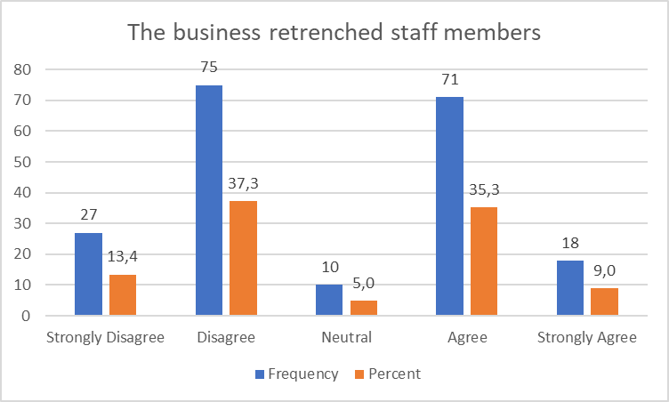

**Figure 1:** **The business retrenched staff members.**

The results depicted in Figure 1, reveal nuanced insights into the impact of the COVID-19 pandemic on employment within small and medium enterprises (SMMEs). A moderate portion of respondents (37.7%) disagreed with the notion that they retrenched staff, while an additional 13.4% strongly disagreed. This indicates that a significant majority of businesses did not resort to layoffs during the pandemic. In contrast, 35.3% agreed that they had to lay off employees, with only 9.0% strongly agreeing.

The Chi-square test results (P > 0.001) confirm that some businesses indeed experienced staff reductions, highlighting the broader economic challenges faced during this period. Specifically, 44.3% of SMMEs reported laying off employees primarily due to insufficient income to cover operating costs and salaries. This aligns with findings from Bartik et al. (2020), which noted that 43% of small businesses faced closures, resulting in an average workforce reduction of 40%. Additionally, Dua et al. (2020) highlighted that two-thirds of jobs in SMMEs were at risk due to the pandemic.

Interestingly, despite the significant challenges, the majority of respondents did not report layoffs, suggesting that many SMMEs managed to navigate the crisis without resorting to such drastic measures. This could indicate that these businesses were in a relatively stable financial position or successfully employed alternative strategies to mitigate the impact of the pandemic. Wenzel et al. (2020) identified four strategic responses to the crisis—retrenchment, persevering, innovating, and exit—implying that many businesses may have opted for perseverance or innovation rather than layoffs.

Overall, while the pandemic undeniably strained many SMMEs, the varied responses highlight resilience among some business owners and suggest that a segment of the market was able to adapt without sacrificing their workforce. This resilience could be critical for recovery as the economy stabilizes post-pandemic.

* 1. **Lockdown rules caused a loss in sales and profits.**

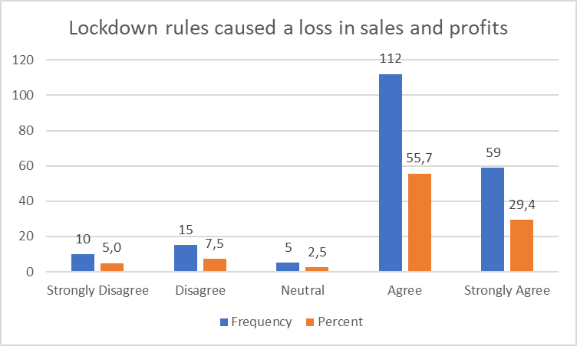

**Figure 2: Lockdown rules caused a loss in sales and profits.**

As shown in figure 2, a significant number of the responses (55.7%) agreed and (29.4%) further strongly agreed that lockdown rules caused a loss in sales and profits. A considerable number of the respondents (2.5%) were neutral, while (7.5%) disagreed and (5.0%) strongly disagreed with the statement. A Chi-square test was further conducted to determine whether lockdown rules caused a loss in sales and profits. The results show that (P > 0.001) for this variable, indicating that lockdown rules caused a loss in sales and profits and can be considered as a critical hindrance in sustainability of SMMEs post COVID-19 pandemic. This outcome was anticipated as lockdown measures required individuals to isolate and abstain from close contact with others, venturing out only for essential purposes. Consequently, businesses were inevitably compelled to close, leading to decreased sales.Top of Form This is further supported in a study conducted by Alfers, Harvey, and Moussié (2020), which highlighted that there was a significant drop in customer demand due to the closure of major marketplaces and towns, alongside a substantial portion of the population transitioning to remote work arrangements. Contrary to these results, Fairlie and Fossen (2021:1) found that not all businesses experienced significant losses during the pandemic. Essential businesses were allowed to remain operational without closure. While food and beverage stores saw a slight uptick of (1.7%), this growth rate fell below the usual year-over-year sales increase. In contrast, building material and garden equipment stores saw a notable surge of (12.1%), likely due to increased home and garden renovation projects undertaken by homeowners with more time at home during the pandemic. The results indicate that (P > 0.001) for this variable, signaling that lockdown rules caused a loss in sales and profits.

* 1. **Government initiated reboot start-up policies to enhance the potential of innovative new ventures for SMMEs recovery.**

**Figure 3:** Government initiated reboot start-up policies to enhance the potential of innovative new ventures for SMMEs recovery.

As depicted in figure 3, a considerable number of the respondents (63.2%) and (10.4%) disagreed and strongly disagreed respectively as to whether government-initiated reboot start-up policies to enhance the potential of innovative new ventures for SMMEs recovery. A smaller percentage of respondents (8.0%) were neutral. On the other hand, a substantial number of respondents (17.9%) and (0.5%) agreed and strongly agreed that government-initiated reboot start-up policies to enhance the potential of innovative new ventures for SMMEs recovery. The results indicate that (p > 0.001) for this variable, indicating that the government-initiated reboot start-up policies are significant to enhance the potential of innovative new ventures for SMMEs recovery. These findings may stem from the fact that most respondents did not access any assistance, and they have not observed any changes in their respective fields. Nonetheless, there was a notable reaction with the unveiling of a R500 economic relief fund on April 21st, 2020. This fund, equivalent to roughly 10% of South Africa's GDP, signifies a considerable endeavor aimed at tackling the obstacles presented by the pandemic (De Villiers, Cerbone, D. and Van Zijl, 2020). Common types of policies implemented for support include financial assistance programs such as grants, loans, and tax incentives, often outlined in government budget allocations and economic recovery plans. Governments also establish incubation and acceleration programs, regulatory reforms, research and development initiatives, skills development and training programs, and internationalization support to foster innovation, growth, and resilience within the SMME sector.

* 1. **The business had to reduce operating costs to survive.**

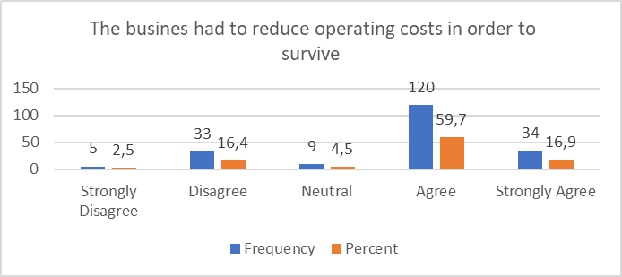

**Figure 4: The business had to reduce operating costs to survive.**

As illustrated in figure 4, a significant majority of respondents (76.6%) expressed agreement with the necessity for businesses to reduce operating costs to ensure their survival, with 59.7% agreeing and 16.9% strongly agreeing. This assertion is corroborated by a Chi-square test aimed at assessing whether businesses indeed implemented cost reductions as a survival strategy. The findings reveal a statistically significant result (P < 0.001) for this variable, underscoring the critical role of cost reduction in business sustainability. Conversely, a minority of respondents (18.9%) disagreed with the statement, comprising 16.6% who disagreed and 2.5% who strongly disagreed. The data clearly demonstrate that small, medium, and micro enterprises (SMMEs) strategically minimized operational expenditures to navigate adverse conditions, a proactive approach that was essential for their continued viability. In light of the extensive service closures during the COVID-19 pandemic, there was a marked decline in demand for the services offered by these businesses. As a result, they were compelled to make strategic decisions, focusing their resources on providing only essential services.

* 1. **Staff salaries or wages had to be reduced.**

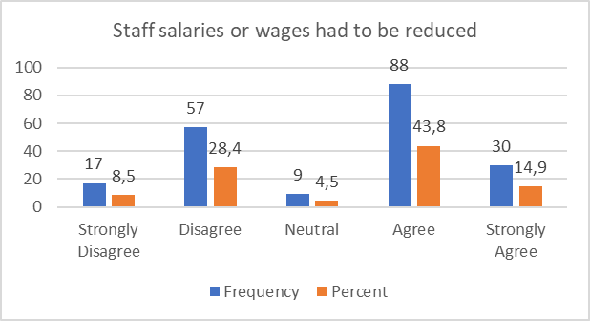

**Figure 5: Staff salaries or wages had to be reduced.**

A considerable proportion of respondents, specifically 43.8%, indicated agreement, while 14.9% expressed strong agreement regarding the necessity of reducing staff salaries or wages, as illustrated in figure 4.10. Conversely, a smaller segment of the respondents, amounting to 4.5%, remained neutral, whereas 28.4% disagreed and 8.5% strongly disagreed with the proposition. Although Section 34 of the Basic Conditions of Employment Act prohibits employers from deducting from an employee's salary without consent or adherence to a fair procedure, the extraordinary circumstances brought about by the COVID-19 pandemic necessitated a reevaluation of such policies. The global impact of the pandemic caught many unprepared, leading to a general understanding among employees regarding the need for salary reductions during this crisis. For numerous businesses, implementing salary cuts was perceived as a strategic approach to maintain operations while safeguarding employee job security. This perspective is corroborated by Benhura and Magejo (2020), who noted that some employees who retained their positions experienced a loss of at least 50% of their income. To assess the necessity of salary reductions, a Chi-square test was performed, yielding results that indicated a significant relationship (P > 0.001) for this variable, thereby affirming the need for salary reductions during the COVID-19 pandemic.

* 1. **Lockdown rules caused a loss in sales and profits.**

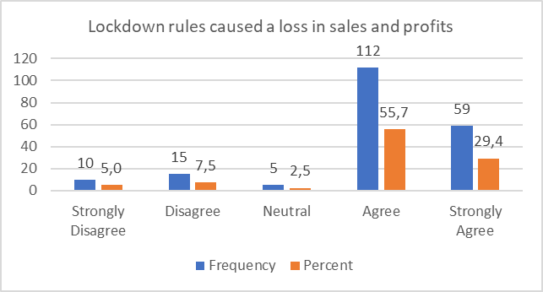

**Figure 6: Lockdown rules caused a loss in sales and profits.**

As illustrated in figure 6, a notable proportion of respondents (55.7%) expressed agreement, while an additional 29.4% indicated strong agreement regarding the assertion that lockdown regulations resulted in diminished sales and profits. A smaller segment of the participants (2.5%) remained neutral, whereas 7.5% disagreed and 5.0% strongly disagreed with the claim. To further investigate the impact of lockdown regulations on sales and profits, a Chi-square test was performed. The findings revealed a significance level of (P > 0.001) for this variable, suggesting that lockdown measures indeed led to a decline in sales and profits, thereby representing a significant obstacle to the sustainability of small, medium, and micro enterprises (SMMEs) in the aftermath of COVID-19.

* 1. **Suppliers hiked the price of their products making it difficult to order products.**

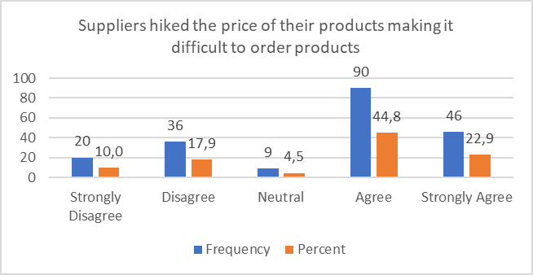

**Figure 7: Suppliers hiked the price of their products making it difficult to order products.**

Figure 7 illustrates that a significant proportion of respondents (44.8%) expressed agreement, while an additional (22.9%) strongly concurred that suppliers increased their product prices, thereby complicating the ordering process. A smaller segment of the respondents (4.5%) remained neutral, with (17.9%) agreeing and (10.0%) disagreeing with the statement. These observations are corroborated by a Chi-square test aimed at determining the relationship between supplier price increases and the challenges faced in product ordering. The results yielded a significance level of (P > 0.001) for this variable, indicating that price increases from suppliers posed difficulties for business owners in procuring or stocking products. The findings underscore the extensive disruptions in global supply chains caused by the COVID-19 pandemic, which resulted in shortages of essential goods due to halted production, diminished workforce availability, and logistical hurdles. This scarcity subsequently led to price escalations, consistent with the principles of supply and demand economics. Mogues (2020) similarly reported that the COVID-19 pandemic triggered notable price hikes for essential food items across various regions. For example, bread prices soared by 80 percent in Côte d’Ivoire, rice prices doubled in the Maldives, and potato prices increased by 133 percent in Guyana. These instances exemplify the repercussions of supply chain disruptions on consumer pricing during the global crisis.

* 1. **The Government is doing enough to support SMMEs that were affected by COVID-19 pandemic.**

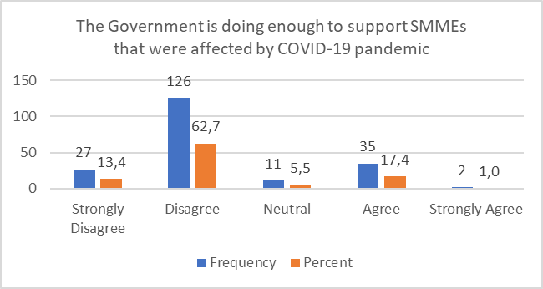

**Figure 8 The Government is doing enough to support SMMEs that were affected by COVID-19 pandemic.**

As illustrated in figure 8, a significant proportion of respondents (62.7%) expressed disagreement, with an additional 13.4% strongly disagreeing, regarding the adequacy of government support for SMMEs impacted by the COVID-19 pandemic. A notable segment of respondents (5.5%) remained neutral on this issue. These findings suggest that a majority perceive the government's efforts as insufficient in aiding SMMEs. Conversely, only 17.4% and 1.0% of respondents agreed and strongly agreed with the statement, respectively. The statistical analysis reveals a significance level of (P > 0.001) for this variable, indicating widespread dissatisfaction among respondents concerning the support received. This suggests that, despite the existence of government initiatives aimed at assisting SMMEs, their effectiveness remains questionable (Mothoa and Rankhumise 2021:9).

* 1. **The services provided by the Government support structures have contributed to the resuscitation of the business.**

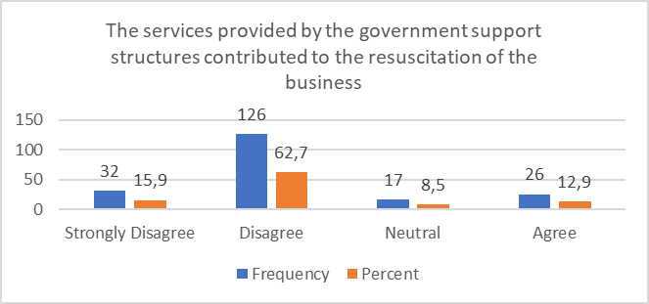

**Figure 9: The services provided by the Government support structures have contributed to the resuscitation of the business.**

As illustrated in figure 9, a significant portion of the respondents, specifically 62.7%, expressed disagreement, with an additional 15.9% indicating strong disagreement regarding the effectiveness of government support services in revitalizing their businesses. A smaller segment, comprising 8.5%, remained neutral, while only 12.9% acknowledged agreement with the statement. These observations are corroborated by a Chi-square test aimed at evaluating the impact of government support services on business recovery. The results yielded a significance level of (P > 0.001) for this variable, suggesting that the government services have indeed played a role in business revitalization. This may be due to the lack of customization in the services offered, leading to some assistance being perceived as irrelevant or unhelpful for certain enterprises. Kelly et al. (2021:10) further support this notion, noting that while respondents were aware of various initiatives, they struggled to engage with or benefit from them, primarily because the available initiatives did not align with the specific growth objectives of their businesses.

* 1. **There are clear guidelines on how to acquire government support.**

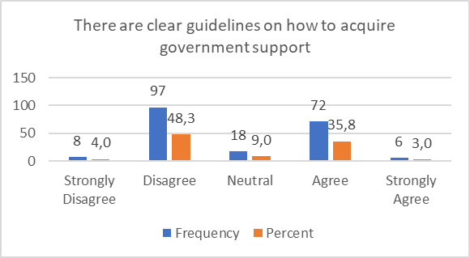

**Figure 9: There are clear guidelines on how to acquire government support**

As illustrated in figure 9, nearly half of the participants (48.3%) expressed disagreement, while a smaller portion (4.0%) strongly disagreed with the assertion that clear guidelines exist for obtaining government support. A notable segment of respondents (9.0%) remained neutral, and (35.8%) indicated agreement, with only (3.0%) strongly opposing the statement. This suggests that about half of the respondents perceived the guidelines as straightforward, whereas the other half experienced challenges in comprehending them. This discrepancy may stem from the potential difficulties some respondents face in understanding specific terminology due to limited formal education or the receipt of inconsistent information from various government entities or officials, complicating their ability to identify the correct processes for securing support. Soga (2022) noted that there might be an absence of specialized support channels or helplines that SMME owners can utilize to seek assistance or clarification regarding government support initiatives.Top of Form

1. **Recommendations**

**Government support structures**: The government should support businesses facing retrenchments they should expand their financial assistance programs, ensuring that they are easily accessible and tailored to the unique challenges posed by the pandemic. This could include providing targeted subsidies or grants for businesses that have had to downsize or reduce wages to maintain operations. Additionally, the government should work on stabilizing supply chain disruptions by collaborating with suppliers to manage pricing and ensure that essential goods remain affordable for SMMEs. Regular updates and clearer communication on available support structures will also empower businesses to take full advantage of existing resources.

The government should continue to refine and reboot start-up policies aimed at fostering innovative ventures, ensuring that these initiatives are well-publicized and accessible to a diverse range of entrepreneurs. Workshops and informational sessions could help SMMEs understand how to effectively navigate the guidelines for acquiring government support. Furthermore, establishing a task force to monitor the impact of lockdowns and economic challenges on small businesses will allow for timely interventions, promoting resilience and recovery in the sector. There should also be clear guidelines stipulating the types of services that the government is offering to the SMMEs and how these services are provided to small businesses. This can be achieved through termly workshops facilitated by the government. Or roadshows can be effective in providing awareness to small businesses on how to seek and utilize the services provided by the government. A complaints procedure should also be established where service providers, in this case the government fails to live up to expectations.

Top of Form

**SMME owners and Managers:** SMMEs should prioritize staying informed about industry trends and regulations while continuously seeking opportunities for innovation and improvement. Researching funding opportunities through social media, government websites, and television can unveil resources to support recovery efforts. Cultivating a customer-centric approach is vital; providing exceptional service and actively soliciting feedback will help refine offerings and enhance customer loyalty. Investing in strategic marketing initiatives will expand reach, attract new customers, and nurture existing relationships, all of which are crucial for long-term success.

Building a reliable team of skilled professionals who share similar visions and values is essential. Empowering employees to contribute to the business's growth can foster a motivated workforce. SMMEs should develop clear goals and flexible strategies that allow for adaptation to changing market dynamics. Actively engaging with government support structures and networking with other businesses can provide valuable insights and best practices for recovery. Additionally, investing in employee training and development will enhance productivity and innovation, positioning the business for future growth as the economy stabilizes.

.

1. **Conclusion**

The challenges faced by businesses during lockdowns, including staff retrenchments, reduced sales, and increased operational costs, have significantly impacted the viability of many SMMEs. While the government-initiated reboot start-up policies and provided support, these structures often proved ineffective in addressing the immediate needs of struggling businesses. Although the intention was to foster recovery and innovation within the sector, many SMMEs found the support insufficient to navigate the severe hurdles posed by reduced staff salaries and rising supplier prices. Moving forward, it is essential for SMMEs to leverage the available resources more effectively, adopt customer-centric approaches, and continuously seek opportunities for improvement and innovation. By doing so, they can build resilience and contribute to a more robust economic recovery, while advocating for more responsive government support structures in the future.

## References

Adesile, O.O. 2020. Economic determinants of small business growth: the case of selected areas in the Johannesburg Metropolitan region. PhD., North-West University.

Afulani, P. A., Gyamerah, A. O., Nutor, J. J., Laar, A., Aborigo, R. A., Malechi, H. and Awoonor, J. K. 2021. Inadequate preparedness for response to COVID-19 is associated with stress and burnout among healthcare workers in Ghana. PloS one, 16(4): 250-294.

Alfers, L., Moussié, R. and Harvey, J. 2020. The COVID-19 crisis: income support to informal workers is necessary and possible. Development Matters, 22: 11-12.

Bai, H. and Ran, W. 2022. Analysis of the vulnerability and resilience of the tourism supply chain under the uncertain environment of COVID-19: Case study based on Lijiang. Sustainability, 14(5): 25-71.

Bartik, A.W., Bertrand, M., Cullen, Z., Glaeser, E.L., Luca, M. and Stanton, C. 2020. The impact of COVID-19 on small business outcomes and expectations. Proceedings of the national academy of sciences, 117(30): 17656-17666.

Bello, A., Jibir, A. and Ahmed, I. 2018. Impact of Small and Medium Scale Enterprises on Economic Growth: Evidence from Nigeria. Global Journal of Economics and Business, 4(2): 236- 244.

Bhorat, H., Asmal, Z., Lilenstein, K. and Van der Zee, K. 2018. SMMEs in South Africa: Understanding the constraints on growth and performance. Available: https://africaportal.org/wp-content/uploads/2023/05/DPRU_WP201802.pdf (Accessed 17 April 2024).

Bryce, R. J. 2017. The [Flourishing] Entrepreneur: A case for legislative intervention to support healthy SMME financial. PhD., University of Cape Town.

Bushe, B. 2019. The causes and impact of business failure among small to micro and medium enterprises in South Africa. Africa’s public service delivery and performance review, 7(1): 1-26.

Bvuma, S. and Marnewick, C. 2020. Sustainable livelihoods of township small, medium and micro enterprises towards growth and development. Sustainability, 12(8): 31-49.

Caballero-Morales, S.O. 2021. Innovation as recovery strategy for SMEs in emerging economies during the COVID-19 pandemic. Research in international business and finance, 57: 101-396.

Chikweche, T. and Mujeyi, K. 2015. Emerging models of inclusive growth: revisiting entrepreneurship and SMMEs in Zimbabwe. Beyond the Crises: Zimbabwe’s Prospects for Transformation, 12: 283.

Chimucheka, T. and Rungani, E.C. 2013. Obstacles to accessing finance by small business operators in the Buffalo City Metropolitan Municipality. The Journal of Business, Economics and Environmental Studies, 3(1): 17-22.

Chukwuneme, E. P., Olaniyi, A. T. and Innocent, B. 2023. South African government palliative funds for SMMEs during COVID-19: challenges of implementation and suggestions for improvement. Journal of Accounting, Finance and Auditing Studies, 9(2): 18-45.

Conz, E., Denicolai, S. and Zucchella, A. 2017. The resilience strategies of SMEs in mature clusters. Journal of Enterprising Communities: People and Places in the Global Economy, 11(1): 186-210.

De Villiers, C., Cerbone, D. and Van Zijl, W. 2020. The South African government's response to COVID-19. Journal of Public Budgeting, Accounting and Financial Management, 32(5): 797-811.

Dhanah, D. 2016. Small businesses and job creation South Africa. PhD., University of Cape Town.

Dheer, R.J. and Salamzadeh, A. 2022. Pandemic threats: how SMEs can respond to the challenges from global crises. International Journal of Globalisation and Small Business, 13(1): 1-17.

Donthu, N. and Gustafsson, A. 2020. Effects of COVID-19 on business and research. Journal of business research, 117: 284-289.

Dua, A., Ellingrud, K., Mahajan, D. and Silberg, J. 2020. Which small businesses are most vulnerable to COVID-19. Available: https://www.rab.com/research/27526.pdf (Accessed 17 April 2024).

Etim, E. and Daramola, O. 2020. The informal sector and economic growth of South Africa and Nigeria: A comparative systematic review. Journal of Open Innovation: Technology, Market, and Complexity, 6(4): 134.

Fairlie, R. and Fossen, F.M. 2021. The early impacts of the COVID-19 pandemic on business sales. Small Business Economics, 11(3):1-12.

Friedrich, C. 2016. Why do 70% to 80% of small businesses fail within five years. Available: https://www. moneyweb. co. za/mybusiness/why-do-70 (Accessed 10 May 2024).

Gumede, T.K. 2022. Building Resilient Tourism SMMEs amidst and post COVID-19 Pandemic: A Case of South Coast, KwaZulu-Natal, South Africa. International Journal of Business and Management, 17(4): 29-41.

Hlebela, N. 2020. Government and manufacturing SMME partnerships to create jobs in South Africa. PhD., North-West University.

Ijere, T.C. 2014. The state, governance and socioeconomic development realities in nigeria. Public Policy and Administration Research, 4(1): 46-49.

Ikadeh, M. S., and Cloete, C. E. 2020. The impact of shopping centre development on informal and small businesses in Lagos, Nigeria. Journal of Business and Retail Management Research, 14(3): 1-10.

Kelly, T.D., Shumba, K., Zindiye, S. and Donga, G. 2021. An Evaluation of Government Support Services for SMMEs in Thohoyandou, South Africa. Journal of Entrepreneurial Innovations, 2(1): 54-140.

Knio, M., Balikel, A.E. and Bellos, G. 2022. Examining the Impact of COVID-19 on Today's Businesses. In COVID-19: Tackling global pandemics through scientific and social tools, 12(1): 151-165.

Leboea, S.T. 2017. The factors influencing SME failure in South Africa. PhD., University of Cape Town.

Lee, K., Herold, D. and Yu, A. 2016. Small and medium enterprises and corporate social responsibility practice: A Swedish perspective. Corporate Social Responsibility and Environmental Management, 23(2): 88-99.

Lee, Y.S. 2017. Entrepreneurship, small businesses and economic growth in cities. Journal of Economic Geography, 17(2): 311-343.

Mabotja, L.L. and Maloka, C.M. 2018. Analysis of Owner-Manager Perception of the Challenges of SMMEs in The Manufacturing Sector in South Africa. and Management Dynamics, 13(1): 101-102.

Mihajlovna, T.A. 2021. Crisis Management Strategies of Small and Medium-Sized Enterprises during the COVID-19 Pandemic: Saint-Petersburg Region Case. Masters in MP., St. Petersburg University.

Mishrif, A. and Khan, A. 2023. Technology adoption as survival strategy for small and medium enterprises during COVID-19. Journal of Innovation and Entrepreneurship, 12(1): 53.

Mkhize, N.L.A. 2021. The impact of financial audits on the sustainable growth of SMME’s: a case study of the eThekwini Municipality. MBA., Durban University of Technology.

Moos, M. N. 2014. Evaluating the South African Small Business Policy to determine the need for and nature of an entrepreneurship policy. PhD., University of Pretoria.

Nagaya, N. 2017. SME impact on output growth, a case study of India. Palma Journal, 16(13): 11-170.

Nazir, M.A. and Roomi, M.A. 2020. Barriers to adopting electronic commerce for small and medium-sized enterprises in emerging economies. EMAJ: Emerging Markets Journal, 10(2): 43-55.

Nordhagen, S., Igbeka, U., Rowlands, H., Shine, R.S., Heneghan, E. and Tench, J. 2021. COVID-19 and small enterprises in the food supply chain: Early impacts and implications for longer-term food system resilience in low-and middle-income countries. World Development, 141: 105-405.

Onyeaka, H., Anumudu, C.K., Al-Sharify, Z.T., Egele-Godswill, E. and Mbaegbu, P. 2021. COVID-19 pandemic: A review of the global lockdown and its far-reaching effects. Science progress, 104(2): 18-54.

Reginald, M. and Millicent, C. 2014. Challenges and key success factors of African descent foreign-owned SMEs in the Eastern Cape Province of South Africa: a case of selected towns. Mediterranean Journal of Social Sciences, 5(4): 5-9.

Rogerson, C.M. 2008. Tracking SMME development in South Africa: Issues of finance, training and the regulatory environment. Urban forum 19 (1): 61-81.

The Department of Small Business Development. 2017. Small Business Development Department Budget Vote 2017/18. Available: https://www.gov.za/speeches/minister-lindiwe-zulusmall-business-develoment-dept-budget-vote-201718-18-may-2017-0000 (Accessed 10 May 2024).

Tsang, E.W. 2014. Generalizing from research findings: The merits of case studies. International Journal of Management Reviews, 16(4): 369-383.

Wang, C., Wang, D., Abbas, J., Duan, K. and Mubeen, R. 2021. Global financial crisis, smart lockdown strategies, and the COVID-19 spillover impacts: A global perspective implications from Southeast Asia. Frontiers in psychiatry, 12: 643-783.

Wenzel, M., Stanske, S. and Lieberman, M.B. 2020. Strategic responses to crisis. Strategic Management Journal, 41(7): 31-61.

Wiid, J.A. and Cant, M.C. 2021. The future growth potential of township SMMEs: An African perspective. Journal of Contemporary Management, 18(1): 508-530.