**EXPLORING THE ANTIMICROBIAL POTENTIAL AND PHYTOCHEMICAL COMPOSITION OF OCIMUM TENUIFLORUM LEAF EXTRACTS: AN ANALYTICAL APPORACH**

# ABSTRACT

**Aim:** To explore the antimicrobial potential and phytochemical composition of *Ocimum tenuiflorum* leaf extratcs against *Staphylococcus aureus*, *Escherichia coli* and *Aspergillus niger*.

**Study Design:** The dried *Ocimum tenuiflorum* leaves were extracted using decoction and digestion methods and conducted preliminary qualitative phytochemical analysis of the extracts. Antibacterial activity of the extracts were analyzed by agar diffusion method followed by determination of Minimum Inhibitory Concentration (MIC) and Minimum Bactericidal Concentration (MBC) of the extracts against *Staphylococcus aureus, a*nd *Escherichia coli*. Poisoned food technique was employed to determine the fungicidal activity of the extracts against *Aspergillus niger*. The experiments were conducted in triplicate, and the average values were depicted graphically.

**Place and Duration of Study:** Sahrdaya College of Engineering and Technology, Kodakara and Centre for Research on Molecular and Applied Sciences, Thiruvananthapuram, between May to August 2023.

**Methodology:** Dried *Ocimum tenuiflorum* leaves underwent extraction by decoction and digestion methods. Preliminary qualitative analysis was conducted to identify the presence of various phytochemicals. Extracts were evaluated for MIC and MBC/ MFC against *Staphylococcus aureus*, *Escherichia coli*, and *Aspergillus niger*.

**Results:** The preliminary phytochemical screening reveals that, both types of extracts exhibited the presence of alkaloids and steroids. However, exclusive to the decoction extract were flavonoids and terpenoids. Notably, saponins were identified in the digestion extract only. Both the extracts displayed an increased zone of inhibition (ZOI) against *Aspergillus niger*, followed by *Staphylococcus aureus* and *Escherichia coli*. The MIC value for decoction extract against both *Esherichia coli* and *Staphylococcus aureus*, the MIC were 250 µg/ml and those of digestion extract was 500 µg/ml. The decoction extract demonstrated an inhibition rate of 52.692% at a concentration of 125µg/ml against *Aspergillus niger*.

**Conclusion:** The findings of this study provide valuable insights into the pharmacological properties of *Ocimum tenuiflorum*, paving the way for further research on potential therapeutic applications and the plant’s potential as natural preservative. The presence of diverse phytochemicals and the observed antimicrobial effects hints at its potential multifaceted therapeutic benefits.

**Keywords:** Antimicrobial activity, Minimum inhibitory concentration, Phytochemical analysis, Traditional medicine

# INTRODUCTION

The escalating challenges associated with synthetic drugs, including their high cost, inadequacy in treating diseases, and propensity for adulteration and side effects, have led to an increased focus on alternative infection-fighting strategies [1]. Medicinal plants, with their historical use and advantages such as fewer side effects, better patient tolerance, cost-effectiveness, and renewable nature, are gaining prominence as potential sources for novel antimicrobial agents. Researchers are turning their attention to herbal products to discover leads for developing drugs against multidrug-resistant microbial strains. Phytoconstituents, the natural bioactive compounds found in plants, play a crucial role in the therapeutic benefits of medicinal plants [2]. Phytochemicals exhibit antioxidant or hormone-like effects, contributing to the fight against various diseases, including cancer, heart disease, diabetes, and high blood pressure. These compounds, divided into primary and secondary constituents based on their functions in plant metabolism, include common sugars, amino acids, proteins, chlorophyll, alkaloids, terpenoids, steroids, and flavonoids [3]. *Ocimum tenuiflorum*, also known as Tulsi in India, is native and widely spread in Asia and its medicinal properties have been described in the Ayurveda for thousands of years [4]. Tulsi have been used for the treatment of several pathologies, such as, headaches, coughs, diarrhoea, constipation, warts, worms and kidney malfunctions [4, 5]. The antimicrobial activity of *Ocimum tenuiflorum* has been extensively studied, demonstrating efficacy against various pathogenic microorganisms [6]. The plant's active components, including glycosides, alkaloids, steroids, terpenoids, flavonoids, and saponins, play a role in interfering with microbial growth or metabolism, ultimately leading to cell death [6]. This antimicrobial potential is particularly significant in the context of global concerns about microbial drug resistance. The present study aims to explore phytochemical composition and the antimicrobial activity of two distinct types of aqueous leaf extracts derived from *Ocimum tenuiflorum* against diverse pathogenic microorganisms, including *Staphylococcus aureus, Escherichia coli*, and *Aspergillus niger*. These microorganisms were selected due to their ubiquity in the environment and their roles as primary causative agents of common infections. This study contributes to the ongoing quest for alternative antimicrobial agents by investigating the phytochemical analysis and antimicrobial activity of *Ocimum tenuiflorum*. The potential therapeutic benefits of this traditional medicinal plant are explored, offering insights into its effectiveness against a range of pathogenic microorganisms, thereby addressing the global challenge of antimicrobial drug resistance.

# MATERIALS AND METHODS

### Collection and preparation of Ocimum tenuiflorum leaf extracts

Healthy leaves were collected from the Mapranam region, located in Irinjalakuda, Thrissur District, and Kerala. The leaves were thoroughly cleaned, shade-dried, finely powdered and stored in a cool and dry atmosphere.

*Digestion Method*: 160 ml of distilled water was added to the 10 g of powdered leaves and kept in a water bath at 50°C for 2 hours with intermittent stirring to facilitate digestion [7].

*Decoction Method*: 10 g of powdered leaves were mixed with 160 ml of distilled water and boiled for 15 minutes [7].

After extraction both the extracts were separately filtered using Whatman No.1 filter paper and clarified filtrates were stored in sterile bottles at 4°C.

* 1. **Preliminary phytochemical screening**

The phytochemical composition of the aqueous leaf extracts was assessed using established protocols [8]. Tests were conducted to identify the presence of alkaloids, flavonoids, phenols, glycosides, saponins, steroids, tannins and terpenoids.

### Antibacterial activity by agar diffusion study

Antibacterial activity of *Ocimum tenuiflorum* leaf extracts against common pathogenic microorganisms including *Escherichia coli* (ATCC25922), *Staphylococcus aureus* (ATCC25923) and *Aspergillus niger* (ATCC 16404) was evaluated using the agar diffusion method on Muller Hinton agar medium. A 24-hour bacterial culture inoculum was uniformly spread on the solid agar plates according to Kirby Bauer method. 100μl of the sample was introduced into 6mm diameter wells and incubated the plates for 24 hours at 37°C. Streptomycin (100µg) and Clotrimazole (100µg) were served as the positive control for bacteria and fungi respectively. The zones of inhibition s were measured in millimeters [9].

### Minimum Inhibitory Concentration (MIC), Minimum Bactericidal Concentration (MBC) determination

The determination of the minimal inhibitory concentration (MIC) involved employing a two-fold serial dilution method, with the growth of the stock inoculum adjusted to 1% McFarland Standard. This assay was conducted in a 96-well microtiter plate, where each well was added with increasing concentrations of the extracts ranging from 62.5 µg/mL to 1000 µg/mL. The plates were then incubated overnight for 24 hours at 37ºC, with the positive control being Muller Hinton broth medium inoculated with microorganisms. After incubation, 30 µl resazurin (0.015 %) was added to all wells, and further incubated for 2–4 hours for the observation of colour change. On completion of the incubation, columns with no colour change were scored as above the MIC value. The minimum bactericidal concentration (MBC) was determined by plating directly the content of wells with concentrations higher than the MIC value. These plates were incubated at 37˚C for 48 hours, and observed for bacterial growth. The Minimum Bactericidal Concentration (MBC) endpoint was determined as the minimum concentration of the antimicrobial agent necessary to eliminate 99.9% of the initial bacterial population [10].

.

* 1. **Poisoned food technique for fungi**

The antifungal activity of the leaf extracts of *Ocimum tenuiflorum* was evaluated against *Aspergillus niger* by using poisoned food technique. *Aspergillus niger* was inoculated on potato dextrose agar (PDA) plates in triplicates and incubated for 250C for 3 to 7 days, to obtain young, actively growing colonies of molds. 100µl of plant extract was mixed with 15ml of cooled (450C) molten PDA medium, poured on to the plates and allowed to solidify at room temperature for 30 minutes. A mycelial disc 6mm diameter, cut out from periphery of 3 to 7 day old cultures, was aseptically inoculated onto the agar plates containing the plant extract. PDA plates with 100µl sterile distilled water and Clotrimazole (100µg) were used as negative and positive control respectively. The inoculated plates were incubated at 250C and colony diameter was measured and recorded after 7 days. Percent mycelial growth inhibition was calculated [11].

# RESULTS AND DISCUSSIONS

In this study, *Ocimum tenuiflorum* leaf extracts were prepared by decoction and digestion methods. The final extracts were stored at cool and dry conditions in airtight glass bottles.

* 1. **Preliminary phytochemical screening**

As summarized in Table1, the preliminary phytochemical screening reveals that, both types of extracts exhibited the presence of alkaloids and steroids. However, exclusive to the decoction extract were flavonoids and terpenoids. Notably, saponins were identified in the digestion extract but were absent in the decoction extract. The presence of both alkaloids and terpenoids in decoction extract supports its enhanced antibacterial and antifungal activities compared to that of digestion extract, in which terpenoids are absent [3]. The observed presence of flavonoids further supports the antioxidant and anticancer potential of the decoction extract [3]. Additionally, the identification of alkaloids in the digestion extracts contributes to their antimicrobial activity [3].

Table 1: Qualitative phytochemical analysis of the *Ocimum tenuiflorum* leaf extracts

|  |  |  |
| --- | --- | --- |
| Tests | Decoction | Digestion |
| Alkaloids | + | + |
| Flavonoids | + | - |
| Phenol | - | - |
| Glycosides | - | - |
| Saponins | - | + |
| Steroids | + | + |
| Tannins | - | - |
| Terpenoids | + | - |

### Antibacterial activity by agar diffusion study

Antimicrobial activity of *Ocimum tenuiflorum* leaf extracts were evaluated against common pathogenic Gram-negative *Escherichia coli*, Gram positive *Staphylococcus aureus* and the fungi *Aspergillus niger*. Both the decoction and digestion extracts displayed an increased zone of inhibition (ZOI) against *Aspergillus niger*, followed by *Staphylococcus aureus* and least zone of inhibition (ZOI) against *Escherichia coli*. Streptomycin (100µg) and Clotrimazole (100µg) were served as the positive control for bacteria and fungi respectively, whereas distilled water, showing no observable zone of inhibition, was considered as the negative control. The mean diameter of the inhibition zones, measured in millimeters, is summarized in Figure 1 and Figure 2 with 250 µg/ml, 500 µg/ml and 1000 µg/ml concentrations of the extracts. The results indicated that both the extracts showed effective antibacterial activity both in Gram negative and Gram positive bacteria.

The antimicrobial effect of the plant extract was examined using the well diffusion assay which is mainly used to test the sensitivity of bacterial strains towards antibiotics with a clear zone around the well reflects the bacterial sensitivity towards antibiotics. This observed antimicrobial activity could be explained by the fact that plant extract may attach to the surface of the cell membrane disturbing permeability and respiration functions of the cell. The interaction of plant extract with microbial cytoplasmic components and nucleic acids can inhibit the respiratory chain enzymes, and interferes with the membrane permeability, limiting the development of bacteria and yeasts. It is also possible that extract not only interact with the surface of membrane, but can also penetrate inside the bacteria. The susceptibility of Gram positive and Gram negative bacteria to extract was found to vary from one study to another [12].

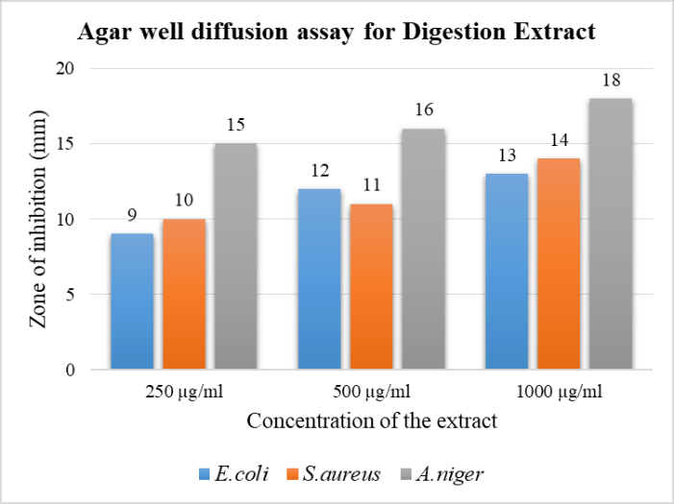

Figure 1: Agar well diffusion assay (zone of inhibition) for digestion extract

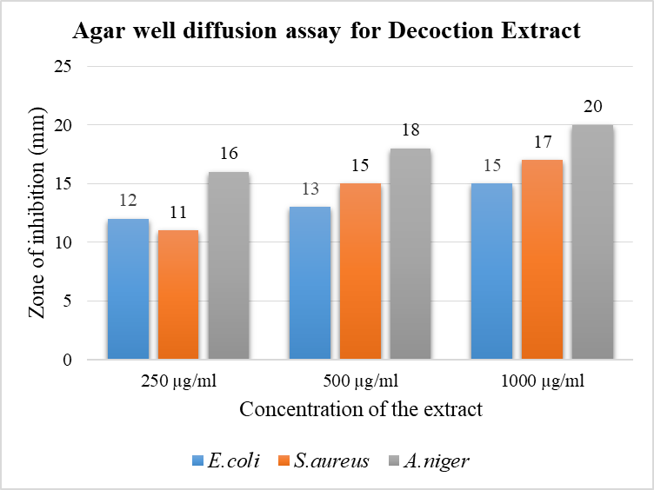

Figure 2: Agar well diffusion assay (zone of inhibition) for decoction extract

**3.3 Minimum Inhibitory Concentration (MIC), Minimum Bactericidal Concentration (MBC) determination**

The minimum inhibitory concentration of the decoction and digestion extracts of *Ocimum tenuiflorum* leaves needed to inhibit the growth of both *Esherichia coli* and *Staphylococcus aureus* was determined using microtitre plate broth dilution method using resazurin dye as the indicator. The MIC value for decoction extract against *Esherichia coli* was 250 µg/ml and that of digestion extract was 500 µg/ml respectively. In the case of *Staphylococcus aureus* the same trend could be seen. Table 2 depicts the MIC, and MBC values of both the extracts against *Esherichia coli* and *Staphylococcus aureus*. In evaluating antibacterial activity, we relied on the MBC/MIC ratio. A ratio of MBC/MIC ≤4 was indicative of a bactericidal effect, while a ratio exceeding 4 was characterized as bacteriostatic. [13, 14]. In this study both the extracts exhibited bactericidal effect against both *Esherichia coli* *and Staphylococcus aureus*.

Table 2: Antimicrobial activity expressed as minimum inhibitory concentration (MIC (µg/ml)) and MBC (µg/ml)) of the aqueous crude extracts of *Ocimum tenuiflorum*

|  |  |  |  |  |  |  |
| --- | --- | --- | --- | --- | --- | --- |
| Sample | MIC (µg/ml) | | MBC (µg/ml) | | MBC /MIC | |
| *E.coli* | *S.aureus* | *E.coli* | *S.aureus* | *E.coli* | *S.aureus* |
| *Decoction* | 250 | 250 | 500 | 500 | 2 | 2 |
| *Digestion* | 500 | 500 | 1000 | 1000 | 2 | 2 |

**3.4 Poisoned food technique**

Poisoned Food Technique was employed to assess the inhibitory effect of plant extracts on the mycelial growth of *Aspergillus niger*. The findings clearly indicate that both extracts exhibit significant inhibitory potential against *Aspergillus niger*. Specifically, the decoction extract demonstrated a noteworthy capacity to hinder mycelial growth, achieving an inhibition rate of 52.692% at a concentration of 125µg/ml. Moreover, at a higher concentration of 250µg/ml, the decoction extract exhibited an even more substantial inhibition, reaching 53.254%. These results underscore the promising antifungal properties of the extracts and suggest their potential utility in combating *Aspergillus niger* growth. The results are depicted in Figure 3.

Plant extracts possess antifungal properties due to the presence of bioactive compounds with inherent fungicidal or fungistatic attributes [15]. These bioactive compounds, such as alkaloids, flavonoids, terpenoids, and phenolic compounds, exhibit diverse mechanisms of action against fungal organisms. The capacity to impede fungal growth can differ amongvarious extracts, and the impact on growth inhibition is contingent upon the specific type of fungi involved.

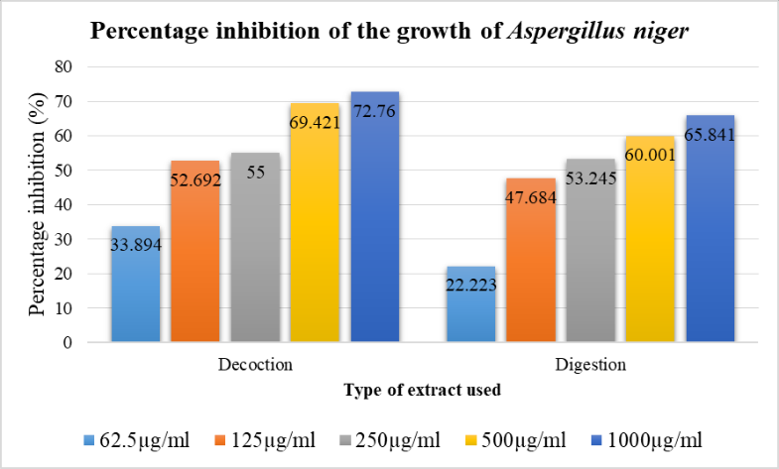

Figure 3: Percentage mycelial growth inhibition of *Aspergillus niger* by decoction and digestion extracts

# CONCLUSION

This study sheds light on the pharmacological attributes of *Ocimum tenuiflorum*, opening avenues for extensive research into its therapeutic potential and its possible role as a natural preservative. The array of phytochemicals identified, coupled with its demonstrated antimicrobial properties, and suggests a wide range of potential health benefits.

# REFERENCES

1. Saravanakumar P, Thangapandiyan S, Dharanipriya R, Gowri SS. Phytochemical analysis and antimicrobial activity of Ocimum tenuiflorum (Tulsi), a known Indian folk medicinal plant. Int J Pharm Sci Rev Res. 2018;53:24-8.
2. Velu G, Palanichamy V, Rajan AP. Phytochemical and pharmacological importance of plant secondary metabolites in modern medicine. Bioorganic phase in natural food: an overview. 2018:135-56.
3. Saxena M, Saxena J, Nema R, Singh D, Gupta A. Phytochemistry of medicinal plants. Journal of pharmacognosy and phytochemistry. 2013; 1(6):168-82.
4. Piras A, Gonçalves MJ, Alves J, Falconieri D, Porcedda S, Maxia A, Salgueiro L. Ocimum tenuiflorum L. and Ocimum basilicum L., two spices of Lamiaceae family with bioactive essential oils. Industrial Crops and Products. 2018 Mar 1; 113:89-97.
5. Araújo Silva V, Pereira da Sousa J, de Luna Freire Pessôa H, Fernanda Ramos de Freitas A, Douglas Melo Coutinho H, Beuttenmuller Nogueira Alves L, Oliveira Lima E. Ocimum basilicum: Antibacterial activity and association study with antibiotics against bacteria of clinical importance. Pharmaceutical biology. 2016 May 3;54(5):863-867.
6. Pingale SS, Firke NP, Markandetya AG. Therapeutic activities of Ocimum tenuiflorum accounted in last decade: a review. J Pharm Res. 2012 Apr;5(4):2215-20.
7. Abubakar AR, Haque M. Preparation of medicinal plants: Basic extraction and fractionation procedures for experimental purposes. Journal of pharmacy & bioallied sciences. 2020 Jan;12(1):1.
8. Shaikh JR, Patil M. Qualitative tests for preliminary phytochemical screening: An overview. International Journal of Chemical Studies. 2020 Mar;8(2):603-8.
9. Sumi, M.B., Ittiachen, L. (2023). Evaluation of Antibacterial activity of Biosynthesized Silver nanoparticles coated Low Density Polyethylene films. Materials Today: Proceedings, 80, 2133-2137.
10. Elshikh M, Ahmed S, Funston S, Dunlop P, McGaw M, Marchant R, Banat IM. Resazurin-based 96-well plate microdilution method for the determination of minimum inhibitory concentration of biosurfactants. Biotechnology letters. 2016 Jun;38:1015-9.
11. Pundir RK, Jain P. Antifungal activity of twenty two ethanolic plant extracts against food-associated fungi. J Pharm Res. 2010 Jan;3(1):506-10.
12. Naik LS, Shyam P, Marx KP, Baskari S, Devi VR. Antimicrobial activity and phytochemical analysis of Ocimum tenuiflorum leaf extract. Int. J. PharmTech Res. 2015;8(1):88-95.
13. Levison ME. Pharmacodynamics of antimicrobial drugs. Infectious Disease Clinics. 2004 Sep 1;18(3):451-65.
14. Benjamin TT, Adebare JA, Remi Ramota R, Rachael K. Efficiency of some disinfectants on bacterial wound pathogens. Life Sci J. 2012;9:2012.
15. El-Shahir AA, El-Wakil DA, Abdel Latef AA, Youssef NH. Bioactive Compounds and Antifungal Activity of Leaves and Fruits Methanolic Extracts of Ziziphus spina-christi L. Plants. 2022 Mar 11;11(6):746.