Book Name: | Current Progress in Arts and Social Studies Research
Manuscript Number: | Ms_BPR_3844
Title of the Manuscript: | Mind-Language, the Expanding Heart of Cognition
Type of the Article | Book Chapter

PART 1: Review Comments
Compulsory REVISION comments | Reviewer’s comment | Author’s Feedback (Please correct the manuscript and highlight that part in the manuscript. It is mandatory that authors should write his/her feedback  here)
Please write a few sentences regarding the importance of this manuscript for the scientific community. Why do you like (or dislike) this manuscript? A minimum of 3-4 sentences may be required for this part. | In general this manuscript talks about the relation between thoughts (cognition), language and how it is affected each other. Therefore, the topic undeniably interesting and relevant to the scientific community as it studies about how language and cognition develop together specially to babies or children as the part of human development can really come in handy in designing educational system in a country.
Is the title of the article suitable?  (If not please suggest an alternative title) | “Mind-Language, the Expanding Heart of Cognition”, is an enganging title, yet it is too general and not specific to reflect the content of the manuscript, what I read is particularly about acquiring language (language acquisition) and it totally discusses about Vygotsky’s theory. Also, this article has been already published, so I highly recommend to have the title be paraphrased or changed. My suggestions:  - Language Shaping the Young Mind, or Vice Versa?  - Early Language: A Cognitive Catalyst  - Vygotsky;s Theory: Mind-Language, What Comes first?
Is the abstract of the article comprehensive? Do you suggest the addition (or deletion) of some points in this section? Please write your suggestions here. | Yes, it is. It is understandable at some points. But, I reckon the author did not take into account the correct abstract structures. It should start from the background (the reason of the author choosing the topic); and then the objectives of topic (what the author wants to achieve by studying about the topic); the method (what the author’s strategy to achieve the objectives, if it is a literature review, it must be shown in the abstract); result and conclusion (what the author finds out and how he/she elaborates that by adding his/her own statement to conclude his/her article.  Here some suggestions for the author:  - Because the first sentence goes straight into the details of the phylogeny and psychogenetic research of the language, which may confuse readers who do not have the same background. It needs a more general introduction and grabs the reader's attention.  - Abstract covers many things, from phylogeny to psychologenetics, the six stages of development, and the role of Vygotsky. The main focus is less clear. What does the author want to emphasize? This why set the goals (objectives) is crucial.  - The author states that thoughts and language develop simultaneously and reciprocatingly, and change the brain's potential. This statement needs to be supported by evidence, if the author does not do the research  him/herself, he/she can add more up-to-date published research to strengthen the statement
Are subsections and structure of the manuscript appropriate? | In my humble opinion, the subsection of the manuscript is in accordance with the theme raised. However, I feel that the structure of the manuscript is poorly organized. As a reader, I feel confused about the continuity between the subsections of one another.  I read that language acquisition by an infant consists of three steps, but those steps are not clearly explained in the existing subsections. Here are the subsections related to those steps:  - Language before Language  - Learning the First Language  - From Cerebral Code Language to Articulated Language  - Vygotsky and Conceptualization  - Visual Summary  - The Zone of Proximal Development  Instead, the author should consider creating a new subsection titled "Steps of Acquiring Languages." In this subsection, the author can explain the steps in question in a more structured and clear way. Additionally, I suggest adding a subsection titled "Speech Delay." This subsection is important as an antithesis of what has been discussed earlier, as well as to explain how speech delays can affect a child's cognitive and language abilities.  Does speech delay mean that their thinking skills are also impaired, or not?
Please write a few sentences regarding the scientific correctness of this manuscript. Why do you think that this manuscript is scientifically robust and technically  sound? A minimum of 3-4 sentences may be required for this part. | This manuscript demonstrates scientific truth by relying on well-established cognitive theories, especially those put forward by Vygotsky and Piaget, that are relevant in the context of language development for children in particular. However, I note that the structure of the manuscript is poorly organized, which can confuse the reader in following the author's line of thought.

Are the references sufficient and recent? If you have suggestions of additional references, please mention them in the review form. | The references used are limited, with the last reference coming from 2016. This can reduce the strength of the argument, given the many recent studies that can provide additional insights and support the correctness of these theories. Authors should consider improving the structure of the manuscript to make it more logical and systematic, as well as incorporating current literature to strengthen the argument and show the relevance of Vygotsky and Piaget's theory in the context of current research. Here are some references I can suggest:  - An article written by Felix & Sascha W: 2019 (Cognition and language growth)  - A book written by Bjorklund & David F.: 2022 (Children′ s thinking: Cognitive development and individual differences)  - An article written by Sunderajan, T., & Kanhere, S. V: 2019 (Speech and language delay in children: Prevalence and risk factors)

Minor REVISION comments  Is the language/English quality of the article suitable for scholarly communications? | Broadly speaking, the quality of English is good, but of course there are some things that I can highlight and can be considered by the author for improvement:  - Clarity and Accuracy  In the sentence: "The development of language in children is a complex process that involves many factors that are interrelated and can affect each other in various ways." This sentence is too long so it can result in multiple interpretations. Breaking down sentences will make it easier to understand.  Suggestions: "The development of language in children is a complex process influenced by many interrelated factors. These factors can affect each other in various ways."  In addition, in the sentence: "There is little mind without language and vice versa little language without the mind." This sentence can confuse the reader because the use of the phrases "little mind" and "little language" is not clear in the context.  Perhaps the author's intention is "There is no mind without language and vice versa, no language without the mind." With this improvement, the meaning to be conveyed will be clearer, namely that thoughts and language are interdependent.  - Grammar and Spelling  In the sentence: “Children who has speech delay may not be able to express their thoughts clearly”. The verb form for the plural subject should be "have" and the use of the plural form "delays."  - Consistency  In the sentence: I also found some inconsistencies in the manuscript. In some passages, the author uses the third-person pronoun "he/she," but in others it only uses "he." This can confuse the reader and it is best for the author to choose one consistent form to use throughout the text.  In addition, there is inconsistency in the mention of terms. Authors sometimes use "baby," "fetus," and "child," although the terms refer to the same meaning.
 |  | 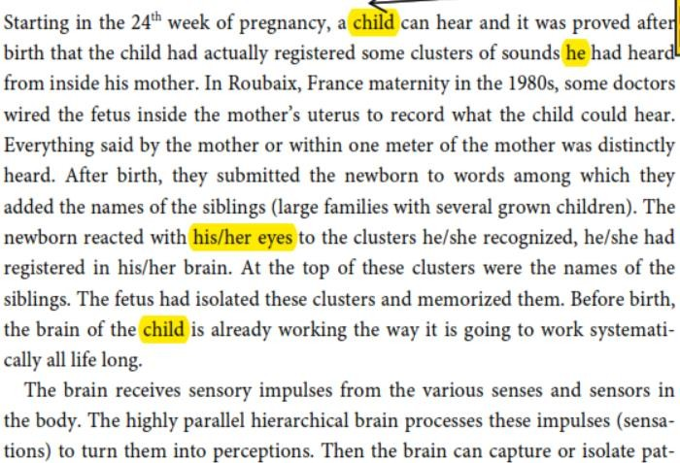

 |  | 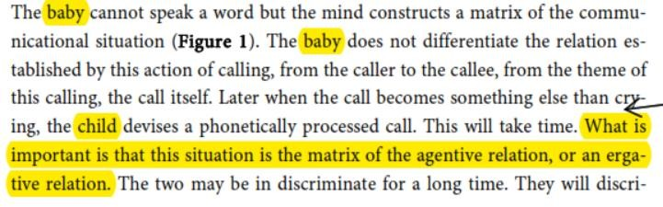
Optional/General comments | It needs improvement in several important aspects. In terms of language, there are inconsistencies in the use of terms and pronouns, as well as some unclear sentences. The structure and organization of the writing also need to be improved, including the addition of relevant subsections to clarify the flow of thought. In addition, revisions to grammar and spelling are urgently needed, and authors should consider updating the references with the latest research.

PART 2:

 | Reviewer’s comment | Author’s comment (if agreed with reviewer, correct the manuscript and highlight that part in the manuscript. It is mandatory that authors should write his/her feedback here)
Are there ethical issues in this manuscript? | (If yes, Kindly please write down the ethical issues here in details)

Reviewer Details:

Name: | Suhria
Department, University & Country | STKIP Abdul Mujib Laewang Dampal Selatan, Indonesia

