Design and Modeling of Brushless Doubly-Fed Reluctance Generator for Wind Mills

***Abstract*: *For the wind energy systems the wind generators the most significant device for achieving better energy efficiencies. So in the case of wind generators, different generators are used for different conditions. In this paper we proposed to analyze the performance analysis of the Brushless Doubly-Fed Reluctance Generator (BDFRG). The BDFRG methods simulated in MATLAB/Simulink software. The proposed model is analyzed with different parameters like THD, ISE, IE, and ITE. The results of the parameters are combined with the other conventional generators like DFIG and BDFIG for result validation. The BDFRG achieved better results in all the parameters than the other conventional generators.***

**1. The Abstract is weak and should contain some values ​​for the results obtained.**

**2. Review the rules and grading because it contains many errors.**

***Keywords:* BDFRG, BDFIG, DFIG, THD, ISE, IE and ITE**

## INTRODUCTION

Power electronics, being the technology of effectively changing over electric power, assumes a significant part in the wind power system. It is an vital section of directing the variable-speed wind power generation levels to achieve maximum performance and efficiency in the power system. Certainly, even in fixed-speed wind turbine systems where wind power generators are linearly associated with the grid, thyristors are utilized as the soft starters. The PEC is utilized to coordinate the attributes of wind turbines with the necessities of grid connections comprising frequency, voltage, harmonics, control of reactive and active power, etc. [1].

The main parts of a wind turbine system are a turbine rotor,

a gearbox, a generator, a power electronic structure, and a transformer for grid association. A wind turbine monitors the power from wind by techniques for turbine blades and changes it to mechanical power. It is fundamental to have the choice to control and compel the transformed mechanical power during high wind velocities. The power limitation may be done whether by dynamic stall, pitch control, or stall control. It might be seen that the power may be effectively compelled by rotating the blades whether by pitch or dynamic

stall control while the power from a stall controlled turbine demonstrates a little overshoot and a less power yield for high wind velocity. The regular method to change over the minimum-speed, high-torque mechanical power to electrical power is utilizing a gearbox and a generator with the regular velocity. The gearbox adjusts the minimum velocity of the turbine rotor to the fast of the generator. In any case, the gearbox might not be required for multi-pole generator model.

The generator changes over the mechanical energy into electrical energy, which is fed into a grid possibly through PEC, and a transformer with circuit breakers and power meters. The two most ordinary sorts of electrical generators utilized in wind turbines are synchronous generators and induction generators [1].

## BDFG

The BDFG has been treated as a feasible substitution to the conventional DFIG for wind turbines [2]. A normal DFIG was a generally suitable decision for geared wind turbines where variable velocity extents of 2:1 or so enable the converter to be cut back to around 25-30% of the generator rating with clear cost decrease recommendations. In any case, dependability and support issues of brush gear yet one of the fundamental DFIG contemplations. BDFGs might be a practical solution for these known DFIG impediments. Beside more economical advantages of brush-less structure, another significant advantage of the functional BDFG over DFIG is the prevalent FRT limit without the requirement for protective crowbar circuit to by-pass the in the partially assessed converter. This prominent BDFG feature is overseen by the generally higher leakage inductances and hence low fault current levels correlated with the DFIG. Not at all like the conventional DFIG, the BDFG has two standards, distributed sinusoidal, stator windings of various numbers of the pole and implement frequencies and a rotor with a half portion of the complete number of stator pole [3].

Classifications of WTGs are as indicated by its velocity of operating and the size of the related proselytes as underneath:

* + F S W T (Fixed Speed Wind Turbine
  + V S W T (Variable Speed Wind Turbine)
  + F S F C (full-scale frequency converter)
  + P S F C (partial scale frequency converter)

The BDFG has two common stator windings of many applied frequencies and pole numbers, in contrast to the DFIG. The principle (power) winding is grid associated, and the auxiliary (control) winding is ordinarily provided from a bi-directional power converter.

A BDFG reluctance type, the BDFRG, gives off an impression of being more appropriate than its 'nested' cage rotor structure, the BDFIG. This inclination has been predominantly attributed to the perspective for high efficiency and simpler control related to the cage less reluctance rotor. In any case, the BDFG rotor should have a half portion of the whole number of stator poles to give the rotor placement based magnetic coupling among the stator windings needed for the machine torque generation [2].

## BDFG

BDFIG, the name implies it has double feds through the two stator windings with uncommon pole pair numbers. The pole pair numbers were selected in order to ignore direct coupling with that the differentiation among the quantities of pole sets of the two windings must be an integer more one. The two windings were subsided into one pair of slots as twofold structures. Once this generator is utilized as a section of WECS, the stator windings are called as power winding (PW) linked with grid linearly and Control winding (CW) that is linked with the grid over PEC. It is a variable velocity wind electric generator with the advantage of the nonappearance of slip-rings and brushes, and less converter size. The BDFM could be utilized as a generator or engine. The relative power streams in the generator winding rely upon whether the generator is generating or motoring, and either it is operating at, underneath or better than average velocity [16].

BDFIG is the very familiar VSWT with PSFC types in the present research field as a result of its procured properties of DFIG that is the very common WTG type at the present market, close by its brush-less angle which DFIG does not have. As presented in the fig.1, BDFIG comprises of two cascaded induction generators; one for the generation and the other for control so as to avoid the utilization of slip-rings and brushes that are the principle disadvantages of DFIG. This brushless perspective expands its dependability that is especially necessary for an offshore application [6].

The Figure indicates two-cascade connections are related. One is for the control perspective and another is for the generation.

### Advantages of BDFIG

* + Higher energy output
  + Higher active /reactive power control
  + Less cost on PEC
  + Fewer losses by PEC
  + Low Mechanical stress
  + Compact size
  + Brush/slip-ring absence

## BDFRG

The BDFRGs has been considered as a feasible option in contrast to regular slip-ring DFIGs for grid associated wind turbines where just the constrained variable velocity ability is needed (for example commonly, a 2:1 extent or so around the synchronous velocity). The BDFG would enable to hold the equivalent DFIG money-saving advantages of utilizing the small inverter (for example over 25% of the generator rating), however with high efficiency and service free activity by the inexistence of brush gear.

In contrast to the DFIG, the BDFRG has two common stator windings of various used frequencies and pole numbers, and the cage less reluctance rotor with a half portion of the whole outnumber of stator poles to give the rotor location-based magnetic coupling among the windings, a pre-essential for generation of the torque. The BDFRG provides the aspect for high efficiency with less complex modeling and control than it is ‘nested’ cage rotor structure, the BDFIG. Control of the essential electromagnetic torque and reactive power is naturally decoupled in the BDFRG and DFIG, not in the BDFIG. Another significant BDFRG quality is the apparently predominant low-voltage-FRT capacity to the DFIG that might be achieved securely with no crowbar circuit attributable to the large leakage inductance and accordingly the less fault current level [5].

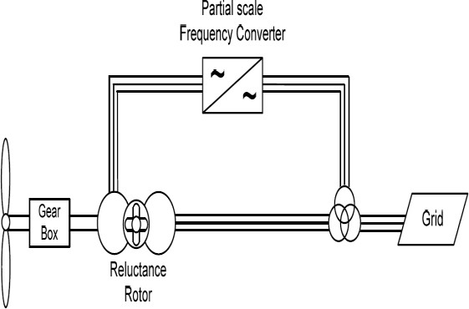The figure represents one diverse design contrasted with BDFIG is its reluctance rotor that is generally an iron rotor with no copper winding which is the minimum cost than the wound rotor or Permanent Magnet rotor.

### Figure.2. Schematic Representation of BDFRG Advantages of BDFRG [4]

* + Active /reactive power is highly controllable
  + Less Cost
  + Minimum loss
  + Mechanical stress is minimum
  + Absence of Brush and slipring
  + In rotor side No copper loss
  + Higher Energy Output.

## OPERATION ANALYSIS

The speed of shaft angular ωr is controlled by the angular

frequencies of stator as:

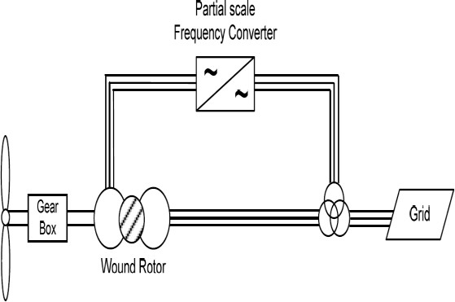(1)

p1, p2 and ω1, and ω2 are the pole pair number and two stator windings angular frequency independently. The BDFIG is depicted by the so-called regular velocity when the CW is given with DC:

(2)

A vector modeling organized with the PW stationary frame is utilized in this paper for the generator performance analysis. The model could be conveyed as:

power factor. Wide sensible results of simulation considering the standard sensible impacts are presented.

The essential angular velocity relationship for the electromechanical power change in the machine with pr rotor pole and ωp,s = 2πfp,sapplied frequencies (rad/s) to the particular 2p-pole and 2q-pole windings are:



### Table.1. Parameters for the above conditions

|  |  |  |  |
| --- | --- | --- | --- |
| **Parameters** | **Power winding** | **Control winding** | **Rotor** |
| Resistance | *Rs*1 | *Rs*2 | *Rr* |
| Self-inductance | *Ls*1 | *Ls*2 | *Lr* |
| Mutual  inductance | *Ls*1*r* | *Ls*2*r* | *-* |
| Voltage vector | *v*1 | *v*2 | *Vr* |
| Current vector | *i*1 | *i*2 | *Ir* |
| Flux linkage  vector | *φ*1 | *φ*2 | *Φr* |

(3)

(4)

(5)

(6)

(7)

(8)

(9)

where the main and auxiliary windings are signified by the subscripts 'p' and 's' individually, the 'generalized' slip and is the synchronous velocity (for ωs= 0) similarly as with a 2pr – pole wound rotor synchronous turbo generator. Note that ωs>

0 for 'super-synchronous' activity, and ωs< 0 at 'sub-synchronous' velocities (for example a contrary stage series of the auxiliary to the main winding) the two speed methods of the BDFRG are proportional to a 2pr - pole induction machine (for example s < 0) in spite of the very particular working standards.

The generator instantaneous torque and the rotor activity (for example the acceleration torque) considering the friction terms could be communicated as pursues,



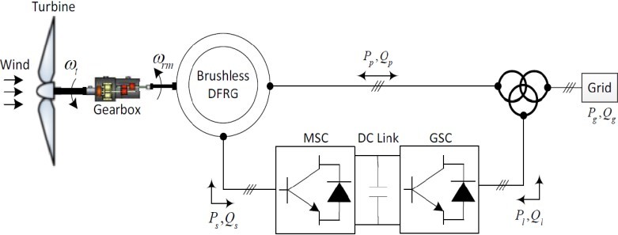

### Figure.3. BDFRG Variable Speed WECS

Various control algorithms have been made for the BDFRG with direct torque control, vector control (VC), scalar control, torque and reactive power control, field-based control, sliding mode power control, direct power control, and non-linear Lyapunov control theory. Moreover, a similarity review of a portion of these control techniques have been not completely made in various works, it is fascinating that there is some detailed explicitly noted on PFC of the BDFRG being of most significance for applications of the generator. In the BDFRG, the 'VC' is normally intended to as the main winding voltage control, by similarity to the DFIG’s stator voltage control. With an appropriate determination of the reference structures and cautious tuning of the dedicated PI controllers, incredible potential and active response of the VC model has been shown without information of any generator parameters. The execution of VC is analyzed utilizing the MPFC method. This control target has been treated as a result of the reachable efficient gain at unity line

(10)

(11)

Where λps is the main flux linking the auxiliary winding (for instance the mutual flux linkage). The depiction of the 3-phase self (Lps) and mutual(Lps) inductances could be referred to in [5]. While the main flux and current space vectors in (10) are in ωp turning outline, the relating auxiliary counterpart, including the λpsdq segments, are in the frame as indicated by (9) and the theory of BDFRM. This selection maps the factors into their normal reference outlines where they show up DC numbers that are simple to control. Presented that λp and λps in (10) are generally consistent by the main winding grid connection, torque control could be accomplished through the auxiliary dq current in the ωs frame.

Utilizing (9), one could infer the mechanical power condition indicating singular commitments of each winding:



(12)

The machine working method is fixed by the power stream in the main winding, for example to the grid for BDFRG while Te< 0 in (12). The auxiliary winding could whether take or convey actual power (Ps) liable to its phase arrangement, for example, the ωs sign: the BDFRG will produce Ps > 0 at sub (super) synchronous velocities. Note that (9) and (12) are similar type conditions utilized for conventional induction generators with Pp and ωs assuming the role of rotor power and slip frequency, separately.

### B. Vector Control

Vector control is used to achieve decoupled control of reactive and active powers. To supply and furthermore get the slip power, the rotor of the generator is able along with it tends to be driven at sub-synchronous, synchronous or progressively synchronous rates.

Utilizing the BDFRG space-vector model, the accompanying steady-state connections for the primary mechanical power and reactive power could be fixed:



(13)



(14)

VC of Pp and Qp is linked as both the isd and isq auxiliary current presented in (13) and (14). The level of linking could be decreased by adjusting the qp-axis of the reference frame to the main voltage vector. For this circumstance, the main flux vector (λp) will be phase moved before the relating dp-axis dependent upon the values of resistance winding. This angular displacement is less with large generators having less resistance.

(23)

In this way, the essential voltage that must be connected to the auxiliary winding is presented above

## RESULT AND DISCUSSION

Both the generators BDFIG and BDFRG have been performed for similar ratings based on the simulation of WECS.The performance evaluations of both these generators are analyzed and compared in terms of total harmonic distortion, integral square error, integral error, and integral time-weighted error with DFIG.



**A. PDPC**

(15)

### Figure.4.Rotor Output Voltage before Controller and Filter

The proposed PDPC standards have the accompanying features:

* Computation of the important auxiliary winding voltage subject to the generated anticipated power model inside a fixed sample period, Ts, directly.
* Generation of appropriate voltage vectors inside the fixed sample period to estimate the determined auxiliary winding voltage by SVPWM technique.

Assume that the reactive and active power failures are gotten from the accompanying conditions toward the beginning of the kth sample period:

(16)



(17)

The control target inside the accompanying fixed sample time is the removal of the reactive and active power failures toward the part of the samplingtime (the k + 1st sample point), for example

(18)



(19)

Whether ''zero-order sample and hold" is utilized for reference estimations of the main winding reactive and active powers, at that point  and

 and the required modifications in reactive and active controls over the kth sampling period are as per the following:

Fig.1 represents the BDFRGs output voltage of the rotor which is analyzed before the controller and filter, in that the output voltage fluctuates more.

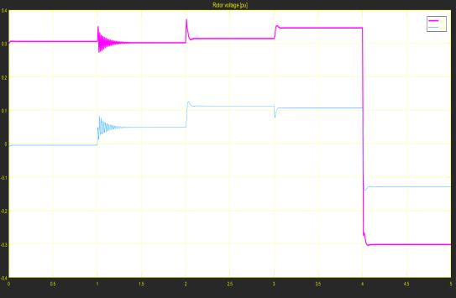

### Figure.5. Rotor Output Voltage after Controller and Filter

This fig.2 represents the BDFRGs output voltage of the rotor which is analyzed after the controller and filter process.

(20)



(21)

The secondary winding’s flux change inside Ts could be acquired with coordinating from the two sides,

 (22)

In this way, the essential voltage that must be connected to the auxiliary winding is presented by the accompanying:

### Figure.6. Terminal Voltage of the Generator

The terminal voltage of the BDFRG generator is analyzed by naming the terminals like A, B, and C, in which the voltages are termed as VAr, VBr, and VCr.

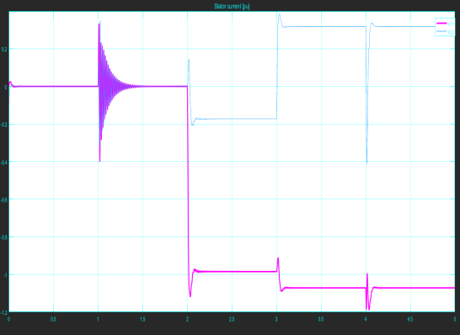

### Figure.7. THD of Stator Current

The total harmonic distortion of the BDFRGs Stator current is represented in fig.4 as is1 and is2.

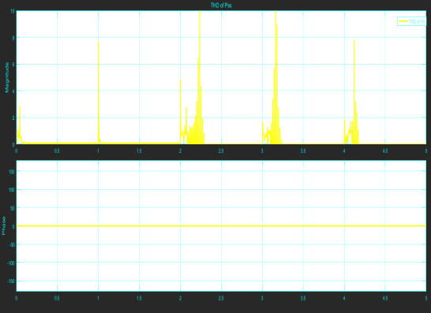

### Figure.8. THD of Stator Power

The total harmonic distortion of the stator power of the BDFRG is represented in fig.5and the rotor power in phase in fig.6 respectively.

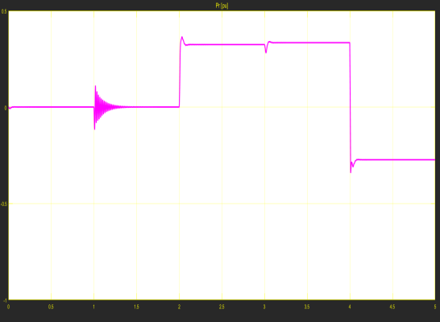

### Figure.9. Rotor Power in Phase

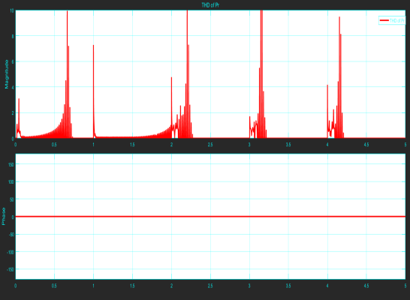

### Figure.10. THD of Rotor Power Table.2. Results of the Parameters

|  |  |  |  |  |
| --- | --- | --- | --- | --- |
| **Generator** | **THD** | **ISE** | **IE** | **ITE** |
| DFIG | 14.5 | 2.46 | 5.15 | 3.77 |
| BDFIG | 10.9 | 1.85 | 3.86 | 2.83 |
| BDFRG | 7.28 | 1.23 | 2.57 | 1.88 |



**Figure.11. Comparative Analysis of THD**

The above figure represents the THD performance of the BDFRG and BDFIG and compared with DFIG.



### Figure.12. Comparative Analysis of ISE

Fig.10 represents the comparative analysis of integral square error analysis of the proposed generators.

### Figure.13. Comparative Analysis of IE



The integral error analysis of the proposed generators are computed and represented in fig.11.



### Figure.14. Comparative Analysis of ITE

Fig.12 represents the integral time-weighted error analysis evaluated for the generators and compared with DFIG.

## CONCLUSION

This performance analysis is made for analyzing the proposed BDFRG generator’s performance based on WECS and to validate that the proposed BDFRG is the best electrical generator for WECS over other electrical generators. The MATLAB/Simulink power system toolbox is used to measure the simulation results. The simulation results presented in this work represents the performance made on different parameters like THD, ISE, IE, and ITE. From all those parameter analyses the BDFRG has achieved better results in all the parameters and the results are compared with other conventional generators like BDFIG and DFIG.

## REFERENCES

1. Zhe Chen, Josep M. Guerrero, and Frede Blaabjerg, 2009, A Review of the State of the Art of Power Electronics for Wind Turbines, IEEE Tran. on Power Electronics, Vol.24, No.8, pp-1859-1875.
2. Jude K.Obichere, Milutin Jovanovic, and Sul Ademi, 2015, Power Factor Control of Large Doubly-Fed Reluctance Wind Generators, W C E C S, Vol.1, pp-1-6.
3. K. Balachander, “Design and Hardware Implementation of Portable Generator using TEG”, International Journal of Innovative Technology and Exploring Engineering, Vol. 08(10), pp. 843-846.
4. Sul Ademi and MilutinJovanovic, 2016, Control of doubly-fed reluctance generators for wind power applications, Rene. Energy, Elsevier, Vol.85, pp-171-180.
5. Devang B Parmar and Chirag. K. Vibhakar, 2014, Overview of Different Wind power tech. Connected to Grid & Modelling of wind Turbine, Int. Jou. of Engg. Development and Research, pp-53-61.
6. K. Balachander, Dr. A. Amudha, ‘Cost Effective Analysis of Variation of Altitude of Wind Turbine System’, World Applied Sci. Jou. , Volume

- 33 No. 09 (2015), pp. 1539-1544.

1. S. Ademi, M. Jovanović, and J. K. Obichere, 2013, Control of Brushless Doubly-Fed Reluctance Wind Generators, CIGRE US Nat. Committee 2013 Grid of the Future Symp. pp-1-9.
2. HyongSik Kim and Dylan Dah-Chuan Lu, 2010, Wind Energy Conversion System from Electrical Perspective-A Survey, Smart Grid and Rene. Energy, Sci. Research, Vol.1, pp-119-131.
3. Andrew M Knight, Robert E Betz, and David Dorrell, 2013, Design & analysis of brushless doubly-fed reluctance machines, IEEE Tran. on Ind. Applications, pp-1-9.
4. Milutin Jovanovic, Sul Ademi, Ayman Attya, and Liancheng Zhu, 2016, Encoder-less Flux Vector Oriented Control of Brush less Doubly-Fed Reluctance Generators, IEEE Ind. Electronics Conf., pp. 1918-1923.
5. Milutin Jovanovic and Hamza Chaal, 2016, Wind power applications of doubly - fed reluctance - generators with parameter-free hyst. control, Energy Conversion & Management, Elsevier, pp-1-11.
6. Jude K. Obichere and Milutin Jovanovic, 2016, Optimum Power Factor Control of Large Doubly-Fed Reluctance Wind Generator Applications, Pro. of the World Congress on Engg., Vol.1, pp-1-6.
7. Maryam Moazen, Rasool Kazemzadeh, and Mohammad-Reza Azizian, 2016, Model-based predictive direct power control of brushless doubly-fed reluctance generator for wind power applications, Alexandria Engg. Jou., Elsevier, Vol.55, pp-2497-2507.
8. Sul Ademi, Milutin G. Jovanovic´, HamzaChaal, and Wenping Cao, 2016, A New Sensorless Speed Control Scheme for Doubly-Fed Reluctance- Generators, IEEE Tran. on Energy Conversion, pp-1-9.
9. K. Balachander, S. Kuppusamy, Dr. Vijayakumar Ponnusamy, Comparative Study of Hybrid Photovoltaic-Fuel Cell System / Hybrid Wind-Fuel Cell System for Smart Grid Distributed Generation System, Proc. of IEEE International Conference on Emerging Trends in Science, Engineering and Technology at JJ Collage of Engineering, Trichy on 13th and 14th December 2012. DOI: 10.1109/ INCOSET. 2012.6513950, pp.462-466.
10. Su lAdemi, MilutinJovanovic, and Jude K. Obichere, 2014, Comparative Analysis of Control Strategies for Large Doubly-Fed Reluctance Wind Generators, Proceedings of the World Congress on Engineering and Computer Science, Vol.1, pp-1-6.
11. R. Saravanan, A. Hanumaiah, M. Venkatesan, K Balachander, (Sept 2019) “Simulation of Switched Capacitor Inverter Topology with Boost Facility”, International Journal of Recent Technology and Engineering, Vol. 08 (03), pp. 616-619.
12. M. Venkatesan, K Balachander, S. G. Ramesh Kumar, “PWM Controlled3-Phase Inverter for Renewable Energy Applications and Environmental Impacts”, Journal of Green Engineering, Vol. 9 (5), Sept 2019, pp. 189-200.
13. K. Balachander, Design and Hardware Implementation of Portable Generator using TEG, International Journal of Innovative Technology and Exploring Engineering, Vol. 08(10), pp. 843-846.
14. Shiyi Shao, Ehsan Abdi, and Richard McMahon, 2009, Dynamic Analysis of the Brushless Doubly-Fed Induction Generator during Symmetrical Three-Phase Voltage Dips, Int. Conf. on Power Electronics and Drive Systems (PEDS), IEEE, pp. 464-469.
15. K. Balachander, A. Amudha, “Energy Saving Measures in Textile Mill”, International Journal of Innovative Technology and Exploring Engineering, Volume-8 Issue-8, June 2019, pp.2026-2032.
16. Resmi. R, C. ArunAgoram, P. Adithya, and V Vanitha, 2015, Design and Analysis of Brushless Doubly Fed Induction Generator, SMART GRID Technologies, Elsevier, Vol.21, pp-604-610.