## 

## ECG Predictors of Myocardial infarction - Localization and culprit artery

# ECG

## Definition

An electrocardiogram (ECG) is a graphical representation of electrical activity generated by the heart. The signals, detected by means of metal electrodes attached to the extremities and chest wall, are amplified and recorded by the electrocardiograph device. ECG leads (derivations) are configured to display the instantaneous differences in potential between specific pairs of

Electrodes

## Synopsis

### ECG :

* + **Definition**
  + **14 Features to analyze ECG**
* **Myocardial infarction**
  + **Definition**
  + **ECG changes and EVOLUTION OF ECG during MI**

### STEMI

* **Coronary arteries and relation to MI**
* **De Winter ST/T waves**
* **Wellens’ Syndrome**

### NSTEMI

* **Sgarbossa’s Criteria**
* **Brugada syndrome**
* **Reperfusion related ECG changes**

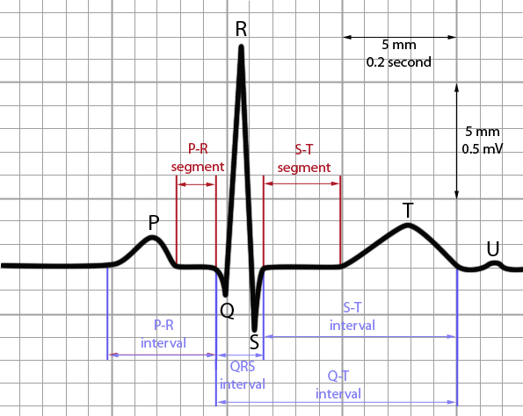

FIG 11,2 NORMAL ECG

## 14 Features to analyze on ECG

1. Standardization
2. Heart rate : atrial and ventricular if not the same
3. Rhythm/ AV conduction
4. PR (AV) interval
5. QRS Complex (Width)
6. QT/QTc intervals
7. QRS axis
8. P waves (width, amplitude , shape)
9. QRS voltages: normal , high or low
10. R wave progression in chest leads
11. Q waves ( normal vs. abnormal )
12. ST segments
13. T waves
14. U waves

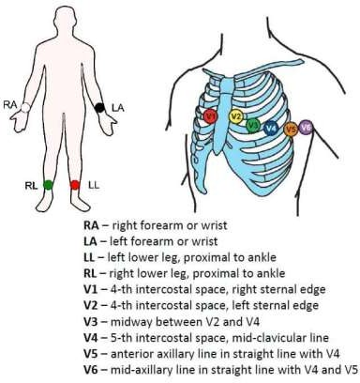

FIG 23 LEADS RESTING ECG ELECTRODE PLACEMENT

# MYOCARDIAL INJURY

Elevated cardiac troponin values with at least one value above the 99th percentile of upper reference limit and acute - Rise and/or fall of cardiac troponin values.

# MYOCARDIAL INFARCTION

The term acute MI should be used when there is acute Myocardial injury with clinical evidence of acute Myocardial ischemia and with detection of a rise and/or fall of cTn values with at least one value above the 99th percentile URL and at least one of the following

* 1. symptoms of Myocardial ischemia.
  2. New ischemic ECG changes.
  3. Development of pathologic Q waves.
  4. Imaging evidence of new loss of viable myocardium or new regional wall motion. abnormality in a pattern consistent with an ischemic etiology.
  5. Identification of a coronary thrombus by angiography or autopsy.

## Characteristic changes in AMI

It is characterized by ST segment elevation over area of damage, ST depression in leads opposite infarction, Inverted T waves and the appearance of pathological Q waves.

## ST Elevation MI

Know what to look for - ST elevation > 1mm in 2 contiguous leads.

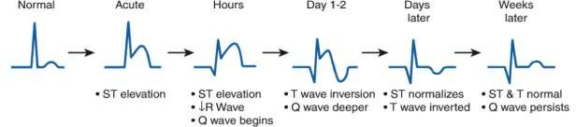

FIGURE 34 CHANGES ON ECG IN ST ELEVATION MI WITH TIME

Know where to look for -I , AVL, V5, V6 – Lateral.

V1, V2, V3 V4 – Anterior. II , III, AVF – Inferior.

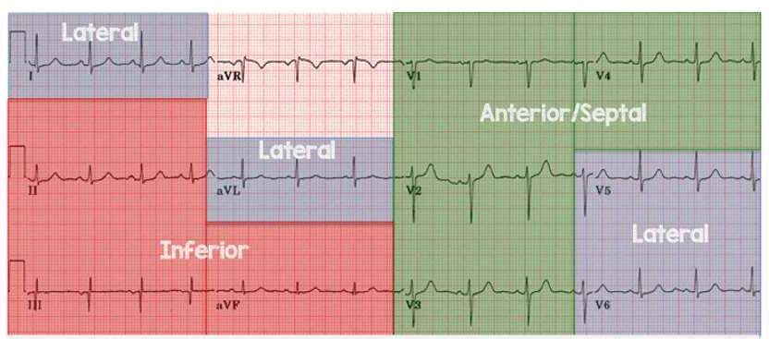

FIGURE 44 RELATIONSHIP BETWEEN ECG LEADS WITH WALLS OF HEART

**Criteria for STEMI :** According to the ACC/AHA guidelines

There must be "New ST elevation at the J point in at least 2 contiguous leads of ≥ 2 mm (0.2 mV) in men or 1.5 mm (0.15 mV) in women in leads V2-V3 and/or of ≥1 mm (0.1 mV) in other contiguous chest leads or the limb leads."

Thus, 1 mm in any 2 contiguous leads EXCEPT leads V2 or V3 where the elevation must be 2 mm in men or 1.5 mm in women.

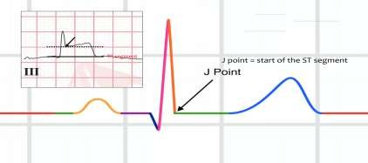

FIG 5 IDENTIFICATION OF J POINT

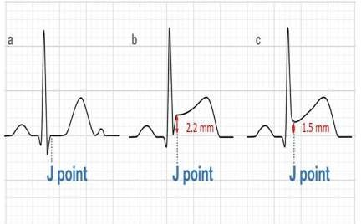

FIG 6 RELATIONSHIP OF STEMI WITH J POINT

ST segment elevation in V1(>2.5 mm) or

ST segment elevation in V1, V2, V3

Right bundle branch block with Q wave or both

ST segment depression (<_1mm)or ST seghment elevation in II, III< and aVf

Proximal Left Anterior Descending Artery

Sensitivity 12%

Specificity 100%

Distal Left Anterior Descending Artery

Sensitivity 66%

Specificity 73%

## Reciprocal ST Depression in STEMI

ST segment depression

(>1mm ) in II , III, and aVf

Proximal Left Anterior

Descending Artery Sensitivity 34%

Specificity 98%

**Defined as:**

ST segment depression distant opposite wall from STEMI. Seen in 75% of inferior STEMI and 30% anterior STEMI. Increase diagnostic accuracy of STEMI when present (PPV of >90%).

Most useful with subtle ST elevation. It is associated with larger STEMI, lower resultant EF and increased mortality.

## ECG changes and evolution of ECG during STEMI

Hyperacute phase

Evolved phase

Chronic stable

**Hyperacute Phase- Critical and Vulnerable phase**

It is characterised by tall symmetrical, peaked, and widened T waves along with slop

elevation of ST segment, increased amplitude of R wave and increased ventricular activation time.

**T Waves** - T waves >/= 5 mm in limb leads, >/=10mm in precordial leads.

**ST segment -** Slop elevation of ST segment is seen.

**In the absence of LBBB**

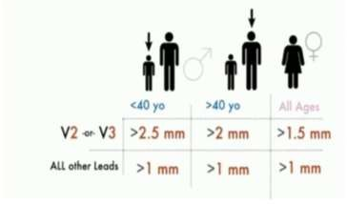

FIG 75,6 CHANGES IN V2 AND V3 IN STEMI

**R wave/Changes in the terminal QRS complex-** Increased amplitude of R wave

**Increased ventricular activation time** -From the beginning of the QRS complex to the apex of the R wave. Normal <40 ms in left-oriented leads, <20 ms in right-oriented leads.

## Hyper acute Antero-Lateral Wall MI:

**Evolved Phase**

FIG 8 ECG WITH ANTEROLATERAL MI

It is characterised by appearance of new q waves- QS, Qr or qR along with T wave Inversion.

Others: Decrease R wave height and decrease J point and ST elevation. (Persistent ST elevation suggests ongoing injury, evolving aneurysm or associated pericarditis)

## Evolved Inferior Wall MI

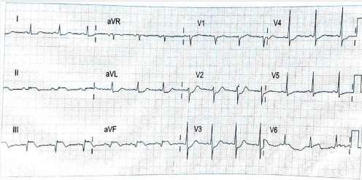

FIG 9 ECG WITH INFERIOR WALL MI

## Pathological Q Waves

A sign of previous myocardial infarction result from the absence of electrical activity from myocardial scar tissue. Generally take several hours to days to develop (mostly with acute infarct) Q-waves are often seen in the first hour after chest pain onset. In V1, V2, and V3: Any Q wave Any Q wave >= 20 ms/QS complex or Q wave >30 ms and >/1 mm (2 contiguous leads) in other leads (Except lead III and aVR).

In Lead III- Q waves of at least 40 ms or amplitude of > 5 mm or amplitude >/= 25% of height of the R wave plus Q wave in aVF that is 30 ms seconds in duration and 1 mm deep.

## Evolved AWMI

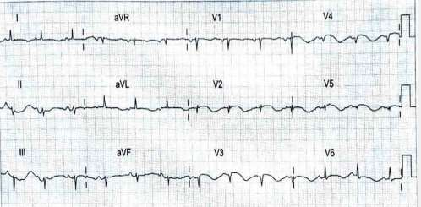

**Chronic Stable phase**

FIG 10 ECG WITH AWMI

Q waves evolves maximally, R wave remains small. J point and ST segment return to baseline. T wave regains its positivity.

# IDENTIFYING “ISCHAEMIA AT A DISTANCE”

Patients with ST elevation in one territory often have ST depression in other territories.

The additional ST deviation may represent ischaemia in a myocardial region other than the area of infarction or may represent pure reciprocal changes.

There is abundant literature concerning the significance of different types of ST depression during acute myocardial infarction. Most of the common patterns of remote ST depression probably represent reciprocal changes and not “ischaemia at a distance”.

In anterior myocardial infarction, ST depression in the inferior leads is reciprocal to involvement of the basal anterolateral region, supplied by the first diagonal branch and represented by ST elevation in leads I and aVL.

In patients with inferior myocardial infarction, ST depression in lead aVL is a pure reciprocal change and is found in almost all patients, and ST depression in leads V1–V3 probably do not represent “ischaemia at a distance”, but rather reciprocal changes due to more

posterior, inferoseptal, apical, or lateral left ventricular involvement.

In contrast, among patients with inferior myocardial infarction, ST depression in leads V4–V6 is associated with concomitant left anterior descending coronary artery stenosis or three

vessel disease.

Thus, presence of an atypical pattern of ST depression, and especially ST depression in leads V4–V6 in inferior myocardial infarction may signify “ischaemia at a distance”

Patients with maximal ST depression in leads V4–V6 during acute inferior myocardial

infarction have higher morbidity and mortality compared with patients without precordial ST depression or with maximal depression in leads V1–V3.

Likewise, patients with maximal ST depression in leads V4–V6 undergo multivessel revascularization (multivessel percutaneous coronary interventions or coronary artery bypass surgery) more often than do patients without such an ECG pattern.

## Coronary Arteries

FIG 117 CORONARY CIRCULATION

**Left coronary artery -**it supplies Left ventricle , Interventricular septum , part of right ventricle

and heart's conduction system

It has 3 branches- Anterior descending artery (LAD), circumflex artery and obtuse marginal artery

**Right coronary artery –** it supplies Right atrium , right ventricle and part of conduction system It has 2 branches - Posterior descending artery and Marginal artery

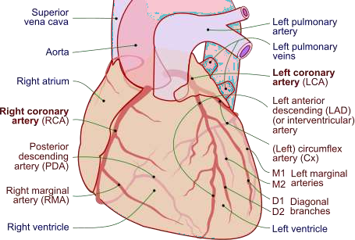

FIG 128 CORONARY ARTERIES WITH THEIR BRANCHES

**Left Anterior Descending (LAD) Artery**  
**Anatomy:** The left main coronary artery bifurcates into two major branches: the Left Anterior Descending (LAD) and the Left Circumflex (LCx) arteries. The LAD travels toward the apex of the heart along the anterior interventricular groove, supplying blood to the anterior wall of the left ventricle (LV). In some cases, the LAD may extend toward the inferoapical wall by encircling the apex of the LV.

**Key Branches of the LAD:**

* **First Branch (First Diagonal Artery):** The first diagonal artery branches off the LAD and runs parallel to the LCx coronary artery, supplying the basal anterolateral wall of the LV. In electrocardiogram (ECG) terms, ST elevation in leads I and aVL is commonly associated with this branch, with reciprocal ST depression seen in leads III and aVF.
* **Second Branch (First Septal Branch):** The first septal branch of the LAD penetrates perpendicularly into the ventricular septum, supplying the basal septum, including the proximal conduction system (which can lead to a new onset right bundle branch block [RBBB]). ST elevation is typically observed in lead V1 in this case.

# LAD OCCLUSION

|  |  |  |
| --- | --- | --- |
| **Part involved** | **ECG changes** | **Type of MI** |
| Before first branch | V1-V6, I, aVL | Ext. Anterior wall MI |
| After first branch  (Between first and second) | V1-V4 | Anteroseptal MI |
| After second branch | V2-V4 | Apical MI |
| Wrap around LAD | V2-V6, II,III, aVF | Anteroinferior MI |
| First diagonal | I & aVL | High lateral MI |

**ECG criteria to identify site of occlusion in LAD**

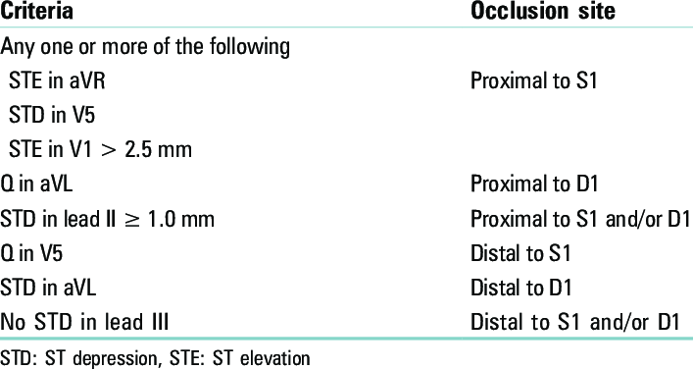

FIG 13 ECG criteria to identify site of occlusion in LAD

## Which Artery is the culprit ?

The vast majority (80%) of inferior STEMIs are due to occlusion of the the dominant right coronary artery(RCA). Less commonly ( around 18% 0f the time) the culprit vessel is a dominant Left circumflex artery (LCx).

The injury current in RCA occlusion is directed inferiorly and rightward producing ST elevation in lead III >lead II (as lead III is more rightward facing).

The injury current in LCx occlusion is directed inferiorly and leftward , producing STelevation in the lateral leads I and V5-6.

**Left Circumflex (LCx) Artery**  
**Anatomy:** The LCx artery runs along the left atrioventricular (AV) groove, laterally between the left atrium and left ventricle (LV). It gives off branches that supply the anterolateral and posterolateral walls of the LV. In 10% to 15% of individuals, the LCx continues posteriorly toward the heart’s crux and travels down the posterior interventricular groove, becoming the posterior descending artery (PDA). In these cases, the LCx serves as the dominant coronary artery, supplying not only the inferior wall of the LV but also providing blood to the AV node.

**Right Coronary Artery (RCA)**  
The RCA follows the medial AV groove, running between the right atrium and right ventricle. It gives rise to acute marginal branches that supply the right ventricle. In 85% to 90% of people, the RCA is the dominant artery, supplying the AV node before it continues posteriorly toward the apex of the LV as the posterior descending artery (PDA), which provides blood to the inferior wall of the LV. The RCA may also extend posterolaterally beyond the crux to the opposite (left or lateral) AV groove, where it sends branches to supply the LV.

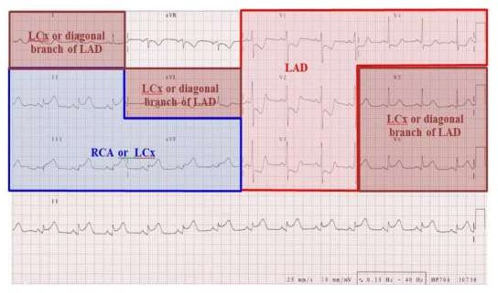

FIG 14 ECG RELATIONSHIP WITH CORONARY ARTERIES

**Anterior Myocardial Infarction (MI) Due to LAD**  
If the infarction occurs proximal to the first branch of the LAD, ST elevation is typically seen in leads V1 to V4 (or sometimes up to V6), along with elevation in leads I and aVL, indicating a large anterior MI. This is often accompanied by reciprocal ST depression in leads III and aVF.

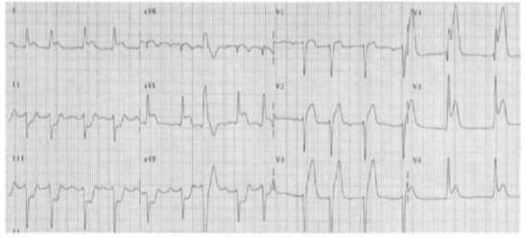

FIG 15

Anterior Myocardial Infarction

**Between the First and Second Branches of the LAD**  
If the blockage occurs distal to the first diagonal branch but proximal to the first septal branch, ST elevation will typically be seen in leads V1 to V4, but not in leads I and aVL. This pattern is consistent with an acute anteroseptal myocardial infarction (MI).

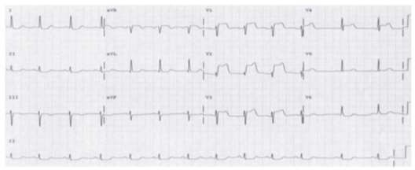

FIG 16 First and Second Branches of the LAD

**After the second branch**: If the lesion is distal to the first diagonal and first septal branches, ST elevation will involve V2-V4 but not V1 or I and aVL consistent with anterior often called apical MI.

**Occlusion of the first diagonal branch:** If a large first diagonal branch is the only artery

occluded, and the LAD is spared, ST elevation is confined to leads I and aVL consistent with high lateral MI, which involves the base of the LV.

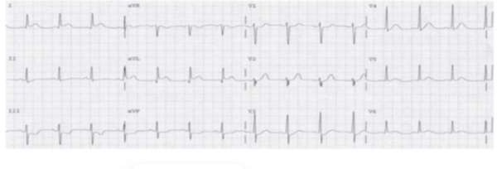

FIG 17

Occlusion of the first diagonal branch

If the LAD is particularly long, it may curve around the apex and extend to the inferoapical wall of the left ventricle (LV). Blockage of a "wrap-around" LAD can lead to ST elevation and eventually Q waves, affecting not only the anterior wall but also the inferior wall, as seen in leads II, III, and aVF.

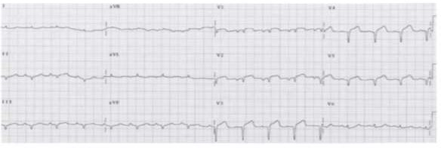

FIG18 Blockage of a "wrap-around" LAD

**Lateral STEMI**

The lateral wall of the LV is supplied by branches of the left anterior descending (LAD) and left circumflex (LCx) arteries. Infarction of the lateral wall usually occurs as part of a ○ larger

territory infarction, e.g. anterolateral STEMI.

Isolated lateral STEMI is less common. Lateral extension of an anterior, inferior or posterior MI indicates a larger territory of myocardium at risk with consequent worse prognosis.

ST elevation in the lateral leads (I, aVL, V5-6). Reciprocal ST depression in the inferior leads (III and aVF).

ST elevation primarily localised to leads I and aVL is referred to as a high lateral STEMI.

**Types of lateral STEMI**

1. Anterolateral
2. Posterolateral

# ANTEROLATERAL MI

When there is a proximal occlusion of the LCx coronary artery, ST elevation will be observed in leads I, aVL, V5, and V6.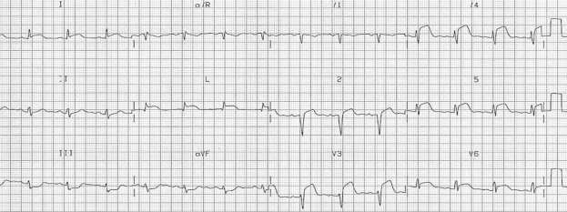

# POSTEROLATERLMI

FIG 19 ECG WITH ANTEROLATERAL MI

In the case of a posterolateral myocardial infarction (MI), reciprocal ST depression is typically seen in leads V1 to V3. These leads, being directly opposite the posterolateral wall, show this reciprocal depression when a posterior MI is present. To confirm a posterior MI, additional electrodes can be placed in leads V7, V8, and V9. V7 is positioned at the left posterior axillary line, V8 at the tip of the left scapula, and V9 at the left side of the spinal column at the same horizontal level as leads V4-V6.

ST elevation limited to leads I and aVL generally suggests a lateral MI, often caused by involvement of the LCx coronary artery. In cases of lateral MI, ST elevation in leads I, aVL, V5, and V6 is frequently seen along with ST elevation in leads V7 to V9 and reciprocal ST depression in leads V1 to V3, indicating a concomitant posterolateral MI.

## Inferior Wall MI

|  |  |
| --- | --- |
| **Anterolateral MI** | **I, aVL , V5, V6** |
| Posterolateral MI | Elevation in I, aVL,V5,V6,V7-V9 Depression in V1- V3 |

Occlusion in either RCA ( 80%) or the LCx Artery

**LCX Occlusion**

* ST elevation lead II > aVF > III
* ST elevation in lead V5 and V6
* No ST depression in lead I and aVL (Sometimes Elevation)

**RCA Occlusion**

* ST elevation lead III > aVF > II
* ST depression in lead I and Avl

**LCX Occlusion**

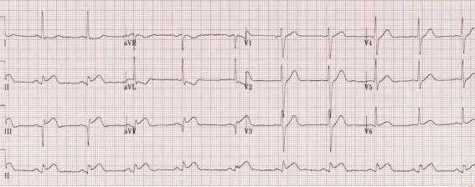

FIG 20 ECG WITH LCX OCCLUSION

**RCA Occlusion**

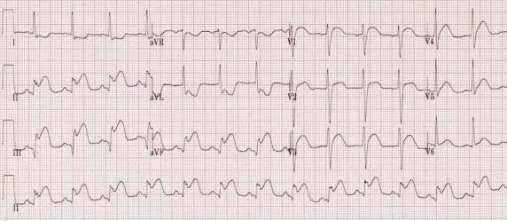

FIG 21 ECG WITH RCA OCCLUSION

**Inferior wall MI**

|  |  |
| --- | --- |
| **ST Elevation lead III>aVF>II ST depression in lead I & aVL** | **RCA Occlusion**  **ST depression in V3/ST Elevation in lead III**  **< 0.5 = proximal RCA 0.5-1.2 = Distal RCA** |
| ST Elevation lead II> aVF> III  No ST depression in lead I & aVL | LCX occlusion |

# INFERIOR MI

Acute inferior myocardial infarction (MI) is caused by occlusion of the right coronary artery (RCA) in 85% to 90% of cases, but in 10% to 15% of patients, it results from a dominant left circumflex (LCx) artery.

In acute inferior MI, ST elevation is typically observed in leads II, III, and aVF. When the LCx is the affected vessel, the ST elevation in lead II is either equal to or greater than in lead III. Additionally, there is often reciprocal ST depression in leads I and aVL.

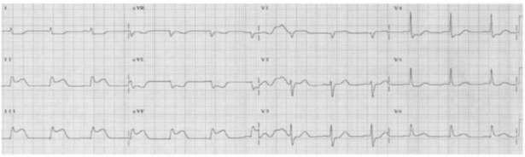

FIG 22 ECG WITH INFERIOR MI

## Isolated Posterior STEMI:

Posterior heart is involved in 20% cases, but Isolated Posterior STEMI is seen in 5% patients only.

When to suspect Posterior STEMI?

When there is presence of Inferior & Lateral. STEMI, always do a Posterior ECG to rule out. Posterior STEMI. ECG shows: Isolated ST Depressions in V1-V3.

**ECG Signs of Isolated Posterior STEMI:**

* 1. ST Depressions in leads V1-V3.
* 2. Prominent T waves in leads V1-V3.
* 3. R:S ratio in lead V2 is >1.

**Lead Placement for Posterior STEMI:**

First put the Electrode for lead V8 at Tip of Scapula and then put V7 & V9 on either sides of V8. On acquiring Posterior ECG, you can Diagnose Posterior. STEMI if there is >0.5mm ST

elevations in Posterior.

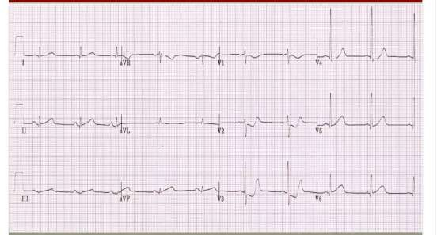

FIG 23 ECG WITH POSTERIOR MI

## DD for ST depressions plus T inversions in V1-V3:

1. Isolated Posterior STEMI.
2. Anterior wall Subendocardial Ischemia.
3. RVH with Strain Pattern.

# LEFT MAIN STEM OCCLUSION OR TRIPLE VESSEL DISEASE

Marked downsloping ST depression in I, II, and V4 - V6 and STE in aVR. When total ST change is

≥ 12mm, PPV 86%. aVR STE occurred more in LMCA than in LAD and in more voltage. V1 STE was less in LMCA than LAD. High mortality rate in those with higher STE in aVR.

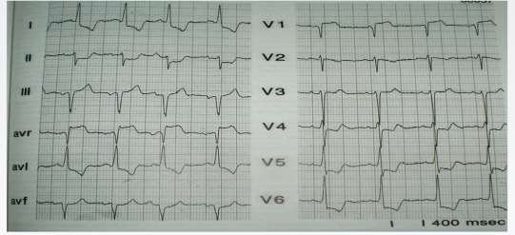

FIG 24 ECG WITH TRIPLE VESSEL DISEASE

## De Winter ST/T waves

ECG abnormality described by de Winter et al. in 1998.

The De Winter ECG pattern is an anterior STEMI equivalent that presents without obvious ST segment elevation. These patients are suffering occlusion myocardial infarction (OMI) and require immediate reperfusion therapy. Suspicious for Acute LAD occlusion.

Characterized by 1-3 mm of ST-depression with upright, symmetrical T-waves.

## ECG Diagnostic Criteria

Tall, prominent, symmetrical T waves in the precordial leads.

Upsloping ST segment depression > 1mm at the J point in the precordial leads. Absence of ST elevation in the precordial leads.

Reciprocal ST segment elevation (0.5mm-1mm) in aVR.

Typical STEMI morphology may precede or follow the De Winter pattern.

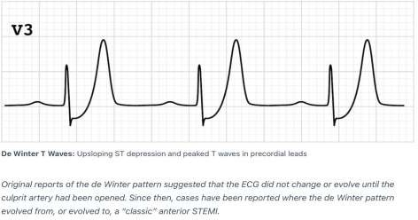

FIG 25 UPSLOPING ST DEPRESSION AND PEAKED T WAVES

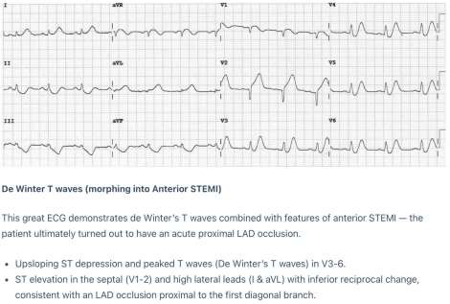

FIG 26 ECG WITH DE WINTER T WAVES

## Wellens' Syndrome

Wellens syndrome (sign) is pattern of deeply inverted in biphasic T waves in V2-3, which is highly specific for a critical stenosis of the left anterior descending artery (LAD).

Patients may be pain free by the time the ECG is taken and have normally or minimally elevated cardiac enzymes; however, they are at extremely high risk for extensive

anterior wall MI within the next 2-3 weeks.

**Type 1 (75 % cases)**

Type 1 Wellens' T-waves are deeply and symmetrically inverted.

The biphasic T waves in V2 -3 are characteristic of wellens’ syndrome.

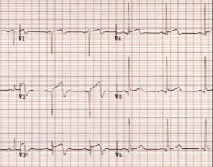

FIG 27 ECG WITH TYPE 1 WELLEN’S

**Type 2 ( 25% of cases)**

Type 2 Wellens' T-waves are biphasic, with the initial deflection positive and the terminal deflection negative.

There are deep , symmetrical T waves inversion throughout the anterolateral leads( V1-6, I, aVL).

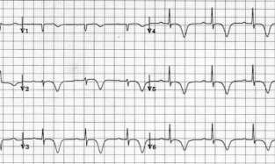

FIG 28 ECG WITH TYPE 2 WELLEN’S

### NSTEMI

ST depression (Down sloping/Horizontal) >/= 0.5mm in two contiguous leads.

T wave inversion >/= 1mm in two contiguous leads with P rominent R wave or R/S ratio >1.

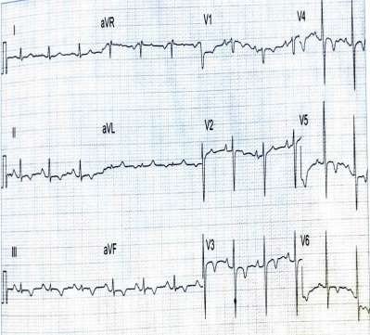

FIG 29 ECG SHOWING NSTEMI

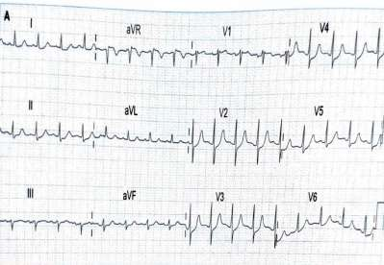

## Sgarbossa's Criteria

FIG 30 ECG SHOWING NSTEMI

|  |  |
| --- | --- |
| ST elevation ≥1 mm in a lead with a positive QRS complex (ie: concordance) | **5 points** |
| ST depression ≥1 mm in lead V1, V2, or V3 | **3 points** |
| ST elevation ≥5 mm in a lead with a negative (discordant) QRS complex | **2 points** |

* **>3points =** 90% specificity and 20% sensitivity

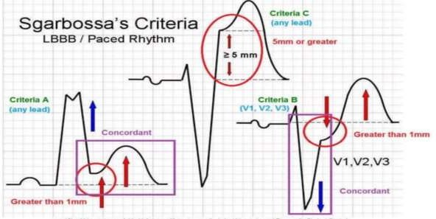

FIG 31 SGARBOSSA’S CRITERIA

## Brugada syndrome

In 1992, Brugada et al described a syndrome which was characterized by RBBB, ST

segment elevation in leads V1 to V3 and sudden cardiac death in subjects < 65 years

The imbalance between inwards and outwards ionic currents at phase I defines the pathological substrate for Brugada. This channelopathy is a rare conidition.

Originally, 3 patterns of Brugada syndrome were described. But only the type I that is charecterized by a RBBB pattern, ST segment elevation with coving, can be confused with MI.

1. **In Type I** Brugada syndrome,- maximum ST elevation-In v1 or V2, coved ST segment with J point elevation followed by negative T wave.
2. **In Type II** - saddle back configuration with high takeoff of ST segment, ending in positive or biphasic T wave without touching baseline.
3. **In Type III** - ST segment elevation of <0.1mv with either of the morphologies

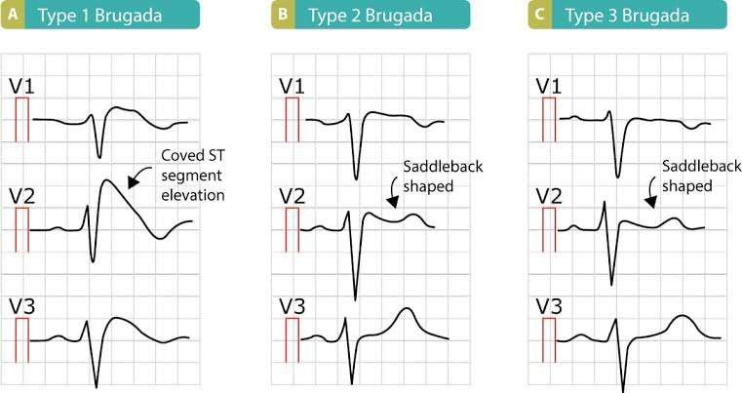

FIG 32 TYPES OF BRUGADA

## Reperfusion related ECG changes

Decrease ST elevation by at least 50% after 90 min of reperfusion. When decrease by -70% or more- Good result, 30%-70%- Average response,<30%- No response to reperfusion strategy.

## Differential diagnosis of ST Segment elevation

ST Segment elevation MI. Pericarditis.

Myocarditis. Hyperkalemia. LBBB.

Brugada Syndrome. Hypothermia.

Class Ic Anti-arrhythmic Drugs.

DC Cardioversion (Immediately after procedure). Hypercalcemia.

Intracranial Haemorrhage.

## References

1. LeoSchamroth- An Introduction to Electrocardiography
2. Braunwald’s Heart Disease A Textbook of Cardiovascular Medicine
3. Basic and Bedside Electrocardiography by Baltazar
4. Kumbar M, Rayar V. Identification of R-peaks to Detect Ventricular Fibrillation, Ventricular Tachycardia and Atrial Fibrillation.
5. https://aimcardio.com/blog/12-lead-placement-guide-with-diagram
6. <https://medictests.com/units/cardiology-and-ecg-quick-and-dirty-reference>
7. Tannenbaum, L., Bridwell, R.E., Inman, B.L. (2022). Acute Coronary Syndrome. In: EKG Teaching Rounds. Springer, Cham. https://doi.org/10.1007/978-3-031- 06028-1_7
8. https://[www.teachingmedicine.com/lesson.aspx?l_id=139](http://www.teachingmedicine.com/lesson.aspx?l_id=139)
9. [**https://clinicalgate.com/heart-and-great-vessels/**](https://clinicalgate.com/heart-and-great-vessels/)
10. Epomedicine. Coronary Arteries : Mnemonic [Internet]. Epomedicine; 2023 Jun 12
11. Zimetbaum PJ, Josephson ME. Use of the electrocardiogram in acute myocardial infarction. New England Journal of Medicine. 2003 Mar 6;348(10):933-40.
12. https://[www.grepmed.com/images/258/concordance-discordance-cardiology-diagnosis-](http://www.grepmed.com/images/258/concordance-discordance-cardiology-diagnosis-) sgarbossa
13. Gao X. On the improved correlative prediction scheme for aliased electrocardiogram (ECG)  
    data compression. In: 2012 Annual International Conference of the IEEE Engineering in  
    Medicine and Biology Society (EMBC); August 28-September 01; San Diego, CA, USA.  
    2012. pp. 6180–6183
14. Rosén KG, Amer-Wåhlin I, Luzietti R, Norén H. Fetal ECG waveform analysis. Best  
    Practice & Research Clinical Obstetrics & Gynaecology. 2004;18(3):485–514  
    Interpreting Cardiac Electrograms - From Skin to Endocardium72
15. AIMCARDIO.COM. 12 Lead Placement Guide with Diagram. Available online: <https://aimcardio.com/blog/12-lead-placement-guide-with-diagram/>
16. [Rebellion in EM 2018: STEMI Equivalents by Tarlan Hedayati, MD - REBEL EM Emergency Medicine Blog](https://rebelem.com/rebellion-in-em-2018-stemi-equivalents-by-tarlan-hedayati-md/)
17. O'gara PT, Kushner FG, Ascheim DD, et al. 2013 ACCF/AHA guideline for the management of ST-elevation myocardial infarction: executive summary: a report of the American College of Cardiology Foundation/American Heart Association Task Force on Practice Guidelines. Circulation. 2013;127(4):529-55
18. O'gara PT, Kushner FG, Ascheim DD, et al. 2013 ACCF/AHA guideline for the management of ST-elevation myocardial infarction: a report of the American College of Cardiology Foundation/American Heart Association Task Force on Practice Guidelines. Circulation. 2013;127(4):e362-425