**Metabolic Syndrome**

Introduction:

Metabolic syndrome, also known as syndrome X or insulin resistance syndrome, encompasses a cluster of metabolic abnormalities that collectively elevate the risk of cardiovascular disease (CVD) and diabetes mellitus (DM). Central obesity, characterized by excess fat accumulation around the abdomen, serves as a hallmark feature of metabolic syndrome. Hypertriglyceridemia, or elevated levels of triglycerides in the blood, along with low levels of high-density lipoprotein (HDL) cholesterol, further contribute to the dyslipidemia observed in individuals with metabolic syndrome. Additionally, hyperglycemia, reflecting impaired glucose metabolism, and hypertension, indicative of elevated blood pressure, are integral components of this multifaceted syndrome. Together, these major features of metabolic syndrome create a complex metabolic milieu that significantly heightens the risk of developing both CVD and DM, necessitating comprehensive management strategies to mitigate adverse health outcome

**Criteria:**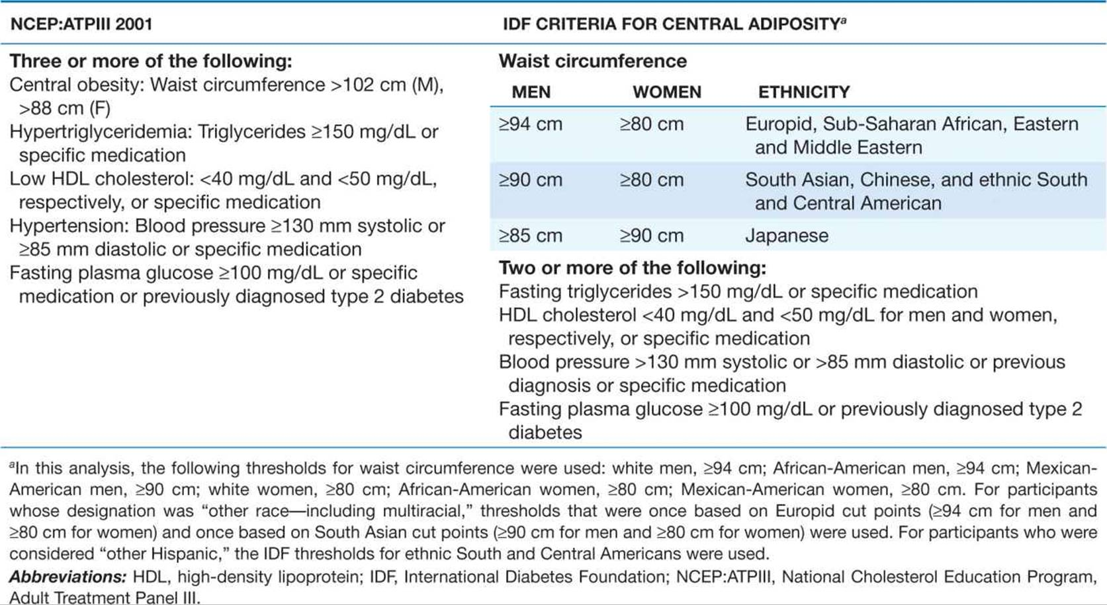

**Epidemiology:**

n the realm of metabolic health, intra-abdominal circumference, often indicative of visceral adipose tissue accumulation, emerges as a critical determinant. This deep-seated fat deposition within the abdominal cavity correlates most strongly with insulin resistance and poses a significant risk factor for cardiovascular disease (CVD) and diabetes. Remarkably, even among individuals with similar waist circumferences, the distribution of adipose tissue between subcutaneous and visceral depots can vary substantially, underscoring the importance of considering not just overall adiposity but also its regional distribution in assessing metabolic risk. Moreover, the prevalence of metabolic syndrome exhibits notable disparities across populations, with Native Americans experiencing particularly high rates. Age-adjusted prevalence rates reveal a striking burden, with women and men among Native American communities displaying prevalence rates of 53% and 45%, respectively. Furthermore, the concerning trend of obesity in children introduces metabolic syndrome features to a younger demographic, signaling the urgency of early intervention and preventive measures to curb the progression of metabolic disorders in vulnerable populations.

**Distribution of component and trend :**

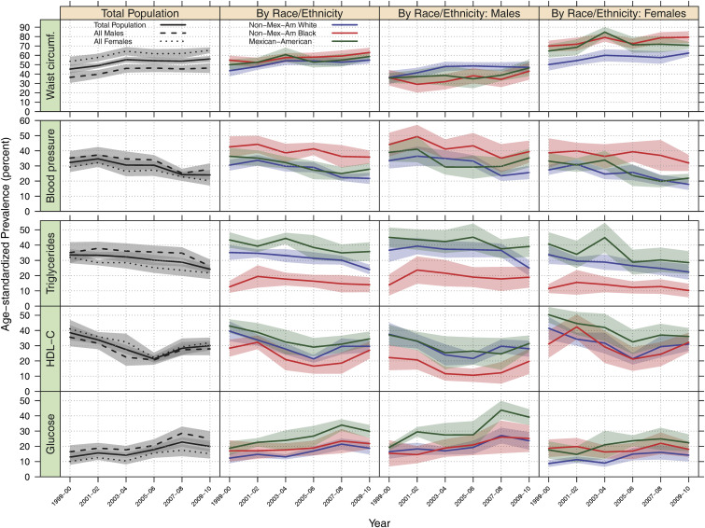

**Risk factor:**

Metabolic syndrome, a multifaceted health condition, intertwines with various factors, including genetics, lifestyle, and age-related changes, to significantly impact individual health outcomes. Genetic predispositions play a pivotal role in the development of metabolic syndrome, with a myriad of genetic variants identified as contributors. These variants often influence body weight regulation, composition, insulin sensitivity, and lipid metabolism, collectively shaping an individual's susceptibility to metabolic abnormalities. Moreover, lifestyle factors, such as sedentary behavior and poor dietary habits, interact with genetic predispositions to exacerbate metabolic syndrome risk. Sedentary lifestyles, characterized by physical inactivity and reduced cardiorespiratory fitness, are closely associated with the development of metabolic syndrome, as each component of the syndrome is exacerbated by a lack of regular exercise. Additionally, advancing age amplifies the prevalence of metabolic syndrome, particularly among older adults, with women showing a higher susceptibility. Furthermore, metabolic syndrome intertwines intricately with other prevalent health conditions like diabetes mellitus and cardiovascular disease (CVD), amplifying the risks associated with each. Understanding the interplay between genetics, lifestyle, and age-related factors is crucial for implementing effective preventive strategies and personalized interventions to mitigate the burden of metabolic syndrome and its associated complications on public health.

**Etiology :**There are many contributory factor for etiology which are responsible for metabolic syndrome-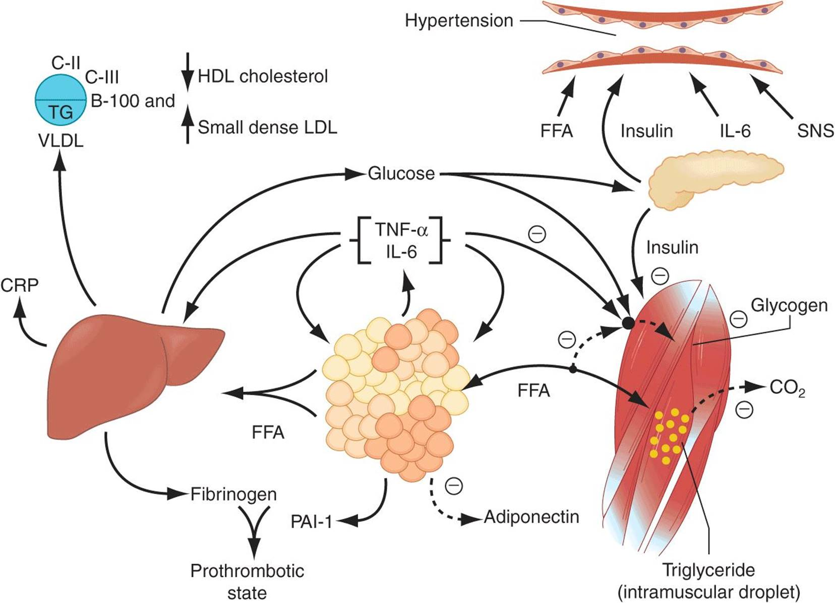

Insulin resistance lies at the core of metabolic syndrome, driven by a complex interplay of factors. A significant contributor to its development is the surplus of circulating fatty acids, which overwhelms metabolic pathways and disrupts insulin signaling. This excess of fatty acids not only increases substrate availability but also induces insulin resistance by altering downstream signaling mechanisms. Additionally, leptin resistance, characterized by diminished responsiveness to the hormone leptin, further exacerbates insulin resistance, contributing to the pathophysiology of metabolic syndrome. The oxidative stress hypothesis proposes that oxidative damage resulting from an imbalance between reactive oxygen species and antioxidants plays a crucial role in the development of insulin resistance. Furthermore, emerging research suggests that the gut microbiome, comprising trillions of microorganisms residing in the gastrointestinal tract, may influence insulin sensitivity and metabolic health through intricate interactions with host physiology and metabolism.

Waist circumference, particularly visceral adipose tissue accumulation, plays a pivotal role in the pathogenesis of metabolic syndrome. Visceral adipose tissue-derived free fatty acids have direct access to the liver, where they can disrupt insulin signaling pathways, whereas those from subcutaneous adipose tissue enter systemic circulation. The relative increase in visceral compared to subcutaneous adiposity may explain the higher prevalence of metabolic syndrome observed among Asians and Asian Indians, who tend to exhibit a central pattern of obesity.

Dyslipidemia, characterized by abnormal lipid levels, is a common feature of metabolic syndrome. Hypertriglyceridemia serves as a robust marker of insulin resistance, reflecting dysregulated lipid metabolism. Additionally, reductions in high-density lipoprotein (HDL) cholesterol levels, resulting from alterations in HDL composition and metabolism, contribute to the dyslipidemic profile associated with metabolic syndrome. Moreover, changes in low-density lipoprotein (LDL) composition, such as increased small, dense LDL particles and decreased large, buoyant LDL particles, further exacerbate the atherogenic potential and cardiovascular risk associated with metabolic syndrome. Understanding the intricate mechanisms underlying insulin resistance, visceral adiposity, and dyslipidemia is essential for developing targeted interventions to mitigate the risks associated with metabolic syndrome and improve overall metabolic health.

Glucose intolerance, a hallmark of metabolic dysfunction, manifests through impaired regulation of glucose metabolism in the body. This condition involves the inadequate suppression of glucose production by the liver and kidneys, along with diminished glucose uptake and metabolism in insulin-sensitive tissues. Insulin resistance plays a central role in this process, as cells become less responsive to the effects of insulin, leading to reduced glucose uptake and utilization. Initially, individuals may exhibit impaired fasting glucose (IFG) or impaired glucose tolerance (IGT), indicating a prediabetic state where glucose regulation is compromised but does not meet the criteria for type 2 diabetes mellitus (T2DM). However, without effective compensatory mechanisms, such as increased insulin secretion by the pancreas, there is a progressive deterioration in glucose homeostasis, culminating in the development of T2DM. This progression underscores the importance of early detection and intervention strategies aimed at preserving insulin sensitivity and preventing the onset of overt diabetes.

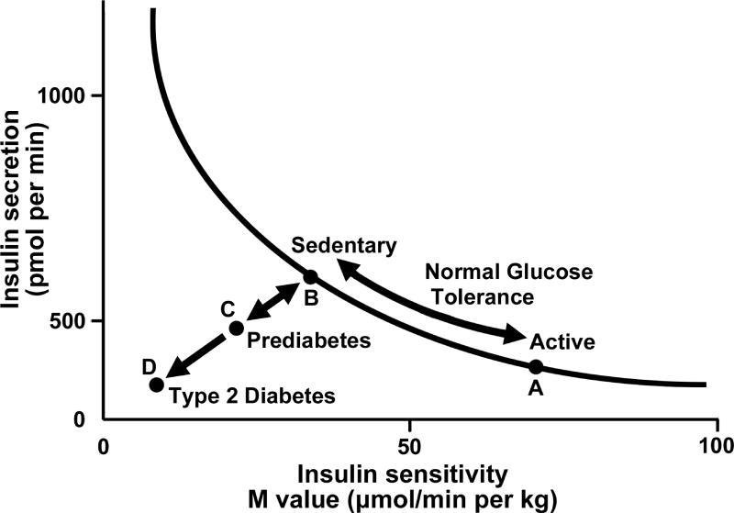

Hypertension, often intertwined with metabolic disturbances, arises from a complex interplay of physiological factors. Insulin resistance, a hallmark of metabolic syndrome, contributes significantly to the development of hypertension through various mechanisms. Firstly, insulin resistance leads to the loss of the vasodilatory effect of insulin, exacerbating vasoconstriction and elevating blood pressure. Despite this, renal sodium absorption remains preserved, further fueling hypertension. Additionally, sympathetic nervous system (SNS) activity is heightened in the presence of insulin resistance, perpetuating a state of increased vascular tone and blood pressure. Furthermore, impairment in phosphatidylinositol-3-kinase signaling disrupts the delicate balance between nitric oxide (NO) and endothelin-1, favoring vasoconstriction and hypertension.

Moreover, increased expression of the angiotensinogen gene promotes the production of angiotensin II (AT2), a potent vasoconstrictor, exacerbating hypertension. Perivascular adipose tissue, previously regarded as inert, emerges as an active contributor to vascular function, exerting vasoactive effects that may further exacerbate hypertension. Hyperuricemia, characterized by elevated levels of uric acid in the blood, exerts deleterious effects on nitric oxide synthase in the macula densa of the kidney, impairing renal function and contributing to the activation of the renin-angiotensin system (RAS), thereby exacerbating hypertension. Collectively, these intricate mechanisms underscore the multifaceted nature of hypertension in the context of metabolic dysfunction, highlighting the importance of comprehensive management strategies aimed at addressing both metabolic and cardiovascular health parameters to effectively mitigate the risks associated with hypertension.

Pro-inflammatory cytokines such as IL-1, IL-6, IL-18, resistin, TNF-alpha, and systemic CRP play pivotal roles in the intricate network of signaling molecules within the body, exerting both paracrine and endocrine effects. These cytokines are closely associated with the development of insulin resistance, a hallmark of metabolic syndrome (MetS). Their dysregulation contributes to chronic low-grade inflammation, impairing insulin signaling pathways and promoting metabolic dysfunction. In contrast, adiponectin, an anti-inflammatory cytokine predominantly secreted by adipose tissue, operates in opposition to these pro-inflammatory signals. Reduced levels of adiponectin are commonly observed in MetS. Adiponectin not only mitigates inflammation but also enhances insulin sensitivity by inhibiting the expression of gluconeogenic enzymes, increasing glucose transport, and promoting fatty acid oxidation in muscle cells. Its multifaceted actions underscore its importance in regulating metabolic homeostasis and combating the detrimental effects of insulin resistance

**Clinical feature:**

**Sign and symptoms-**(a) Metabolic syndrome (MetS) usually does not present with noticeable symptoms.(b) Elevated waist circumference and blood pressure are common indicators that may lead to further laboratory tests.(c) Lipoatrophy and acanthosis nigricans are less commonly observed.

**Associated disease:** Cardiovascular disease (CVD) risk for individuals without diabetes is generally 1.5 to 3 times higher. Among the components of metabolic syndrome (MetS), diabetes mellitus (odds ratio: 2.72) and hypertension (odds ratio: 2.60) pose a greater risk than other factors. MetS is linked to an increased risk of stroke, peripheral vascular disease, and Alzheimer's disease. Elevated levels of high-sensitivity C-reactive protein (hsCRP) in MetS are associated with a 1.34-fold increased risk of all-cause mortality. The risk of developing type 2 diabetes mellitus (T2DM) in individuals with MetS is 3 to 5 times higher. The population attributable risk (PAR) for developing T2DM is 62% for men and 47% for women, based on an 8-year follow-up study from the Framingham Offspring Study (FOS).

**NAFLD/NASH:** The mechanism involves an increase in free fatty acid flux, reduced fatty acid oxidation within the liver, leading to heightened triglyceride synthesis, hepatocellular fat accumulation, and oxidative stress. In patients with metabolic syndrome (MetS), approximately 25-60% have non-alcoholic fatty liver disease (NAFLD), with up to 35% progressing to non-alcoholic steatohepatitis (NASH). NASH affects about 3-5% of the U.S. population and may become a more prevalent cause of end-stage liver disease

**Pcos**:PCOS is associated with insulin resistance(50-80%) and MetS with MetS prevalence: 40-50%. Women with PCOS are 2-4 times more likely to have MetS and hepatocellular carcinoma (HCC).

**Diagnostic and lab test :** Diagnosis relies on specific criteria. Medical history should assess symptoms of obstructive sleep apnea (OSA) in all patients and polycystic ovary syndrome (PCOS) in premenopausal women. Family history is also important for evaluating the risk of cardiovascular disease (CVD) and diabetes mellitus (DM). Lab tests include fasting lipid levels, glucose, and additional biomarkers such as ApoB, hsCRP, fibrinogen, uric acid, and urine albumin-to-creatinine ratio (UACR). Liver function tests (LFT) should be performed, and a sleep study is recommended if symptoms of obstructive sleep apnea (OSA) are present. For suspected polycystic ovary syndrome (PCOS), tests should include serum testosterone, LH, FSH, and an abdominal ultrasound.

* **Treatment:**

**Lifestyle:**

Weight reduction is the primary approach, Weight loss includes a combination of caloric restriction,increased physical activity and behaviour modification . Caloric restriction is the most important component, with increase in physical activity important for maintenance of weight loss .

* **Diet:**

Diet restricted in carbohydrate provide more rapid initial weight loss . A high quality dietary pattern i.e. diet rich in fruits, vegetables, whole grains, lean poultry and fish is recommended.

* **Physical Activity:**

High risk patients should undergo formal CVS evaluation before exercise initiation, daily 60-90 minute activity can lead to modest weight reduction ,At least 30 minute of moderate intensity activity has significant health benefit

* **Behavior Modification:**

Includes recommendations for dietary restriction and more physical activity .Variety of methods implied such as personal/group counselor, internet,social media and follow up to maintain bidirectional contact .

* **Obesity:** Weight loss drugs: appetite suppressants and absorption inhibitors -Appetite suppressants: Phe,ntermine/topiramate , Lorcaserin Naltrexone/bupropion, High dose liraglutide , Absorption inhibitors: Orlistat .Metabolic/bariatric surgery: IF BMI>40/>35 with comorbidities then Gastric bypass/Sleeve gastrectomy .
* **LDL Cholesterol:**

Statin should be prescribed in all patients with diabetes age 40-79 with LDL b/w 60-189mg/dl .High intensity statins(ex: Atorvas 40-80 mg/rosuvas 20-40 mg daily) should be prescribed to those with diabetes and known ASCVD. Fibrates are best to employ to lower LDL when TG are not elevated.

* **Triglycerides:**

Fibrate is DOC to lower fasting TG levels. Omega 3 fatty acid preparations lower fasting TG levels by ~25-40%

* **HDL Cholesterol:**
* Nicotinic acid can increase HDL cholesterol by upto 30% but no evidence affecting AsCVD events on raising HDL levels
* **Blood Pressure:**

ACE inhibitor/ARB are effective and well tolerated

* A sodium restricted dietary pattern enriched in fruits and vegetables, whole grains should be advocated
* **Insulin resistance:**

Several drug classes( biguanides,TZDs) increase insulin sensitivity

TZD benefits has been seen in patients with NAFLD and metformin in women with PCOS

* **Subclinical hypothyroidism and Metabolic Syndrome:**

SCH is associated with an increased risk of MetS, as well as four out of five of its components: central obesity, hyper‐ tension, high TG levels and low HDL-C levels (Meta analysis finding*)

Lack of thyroid hormones in SCH ---- decrease the transcription of the low-density lipoprotein (LDL) receptor gene --- suppressed essential enzyme activity involved in the metabolism of lipoproteins---- dyslipidemia

SCH SCH may be a predictive biomarker for the risk of CVD and its metabolic risk factors .

**References :**

1.Khan C R et al. Joslin’s Diabetes Mellitus 14th Edition. Lippincott Williams & Wilkins

2.Harvey R A. Lippincott’s Illustrated Reviews: Biochemistry Fifth Edition. Lippincott Williams & Wilkins

3.Melmed S et al. Williams Textbook of Endocrinology 14thEdition.Elsevier

4.Fauci et al. Harrison Principles of Internal Medicine 17thEdition.Mc Graw Hill

5.Ding et al. The association between subclinical hypothyroidism and metabolic syndrome: an update meta-analysis of observational studies.Endocrine Journal. 2021, 68 (9), 1043-1056.