**TACHYARRHYTHMIAS AND BRADYARRHYTHMIAS**

**SYNOPSIS:**

1.Basics of ECG

2. Arrhythmias

3.Tachyarrhythmia

4.Bradyarrhythmia

5.References

**History of ECG:** In1895 William Einthoven was credited with the invention of EKG and in 1906 using a string electrometer EKG he diagnosed heart problems and in 1924 he was alloted the noble prize for physiology and medicine for his work on EKG.The ECG is a cumulative recording of cardiac electrical activity on the body surface, generated by the action potentials of millions of cardiomyocytes.[1]The multiple, complex, homeostatic mechanisms involved in the generation of the ECG enable it to serve as a unique identifying fingerprint for each individual, to function as an early detector of disease, and potentially to upend medical screening and remote monitoring.

To capture this data, electrodes are placed on specific locations of the body, and the resulting signals are either displayed on a monitor or recorded on graph paper. The human heart consists of four chambers: the right atrium, left atrium, right ventricle, and left ventricle. The atria are the two upper chambers, while the ventricles are the two lower chambers. In a healthy heart, the heartbeat is initiated at the sinoatrial (SA) node in the right atrium, where specialized cells generate electrical signals. These signals are then transmitted from the atria to the atrioventricular (AV) node, which connects to a network of fibers in the ventricles. This network ensures that the electrical impulses are conducted throughout the ventricles, triggering their contraction.The ECG became central to the diagnosis of critical conditions such as acute myocardial infarction, atrial fibrillation (AF), and ventricular tachycardia. In this chapter we would be discussing about the basics of ECG and associated tachyarrhythmias and bradyarrhythmias.

**Basics of an ECG:**

P waves correspond to atrial depolarization. In individuals with normal heart function, each QRS complex should be preceded by a P wave. The PR interval spans from the beginning of the P wave to the start of the Q wave, reflecting the time it takes for electrical impulses to travel from the atria to the ventricles. The QRS complex represents ventricular depolarization and is seen on the ECG as three closely spaced waves: the Q wave, R wave, and S wave. The PR segment is the flat, typically isoelectric portion of the ECG, occurring between the end of the P wave and the onset of the QRS complex

The ST segment begins at the end of the S wave and ends at the start of the T wave. It is an isoelectric line that reflects the period between the depolarization and repolarization of the ventricles, corresponding to ventricular contraction. The T wave represents ventricular repolarization and appears as a small wave following the QRS complex.

The RR interval is measured from the peak of one R wave to the peak of the next R wave, indicating the time between two successive QRS complexes.

The QT interval starts at the beginning of the QRS complex and ends at the conclusion of the T wave. It reflects the total duration of ventricular depolarization and repolarization. The QT interval is typically measured in lead II or V5-6, but the lead showing the longest interval should be used for accuracy.

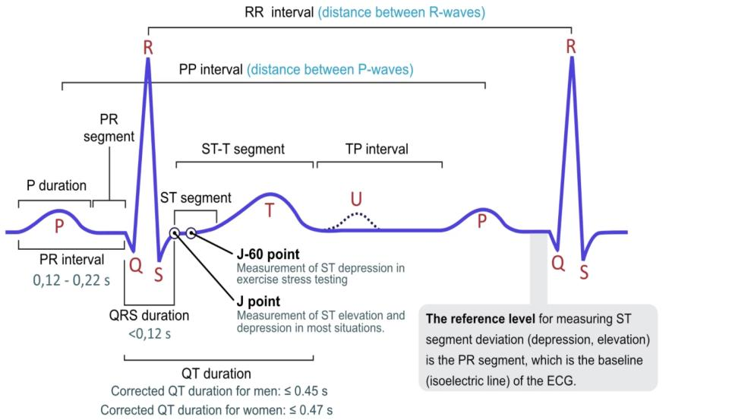

Fig 1: ECG of a heart in normal sinus rhythm

SOURCE<https://ecgwaves.com/topic/ecg-normal-p-wave-qrs-complex-st-segment-t-wave-j-point/>

While connecting an ECG machine there are 6 precordial,3 bipolar and 3 augmented unipolar leads that need to be connected in an orderly fashion.

The relationships of the bipolar limb leads are such that the sum of the electrical currents recorded in leads I and III equal the sum of the electric current recorded in lead II. This relationship is called **Einthoven’s law**, and is expressed mathematically as: Lead I + Lead III = Lead II

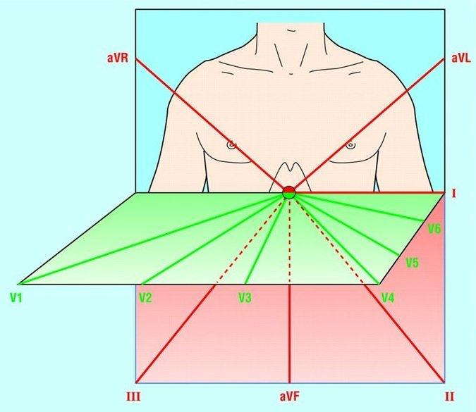

Fig 2: (a) Sagittal plane (x − z plane), frontal plane (y − z plane) and transverse plane (x − y plane) (public domain image). (b) Typical ECG signals: continuous line represents a normal ECG. Dotted and dashed lines represent pathological ECGs

*SOURCE:*[*https://www.researchgate.net/figure/a-Sagittal-plane-x-z-plane-frontal-plane-y-z-plane-and-transverse-plane-x-y_fig1_345360593*](https://www.researchgate.net/figure/a-Sagittal-plane-x-z-plane-frontal-plane-y-z-plane-and-transverse-plane-x-y_fig1_345360593).

It follows that if the values for any two of the leads are known, the value for the third lead can be calculated. Ideally, electrodes are placed on the ankle and wrists for convenience to the subject undergoing the ECG evaluation. In order for the ECG recorder to work properly, a ground reference point on the body is required. This ground is obtained from an electrode placed on the right leg above the ankle. To represent the body in three dimensions, three planes are defined for electrocardiography.

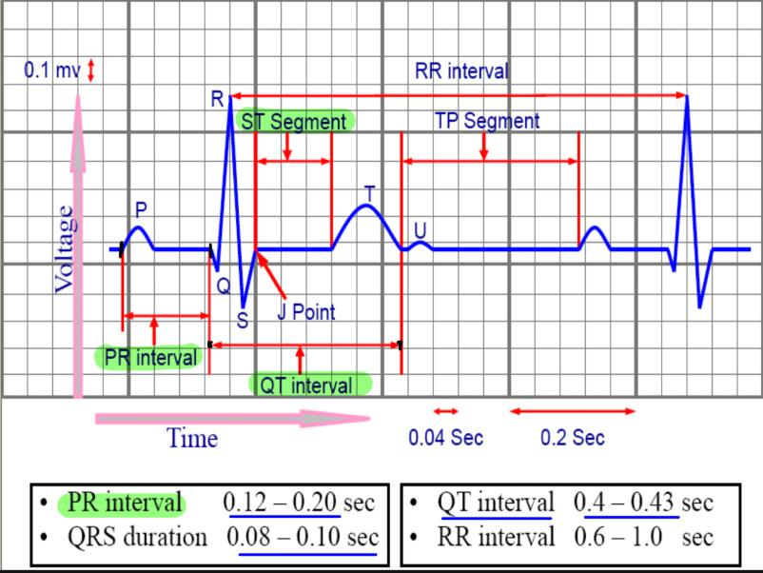Fig 3:A sample ECG signal and its different components[4] Source:<https://www.researchgate.net/publication/356035639_Automatic_Heart_Disease_Detection_by_Classification_of_Ventricular_Arrhythmias_on_ECG_Using_Machine_Learning#pf10>

The Normal duration of a P wave is < 0.12 s (< 120ms or 3 small squares) and the normal PR interval is between 120 – 200 ms (0.12-0.20s) in duration (three to five small squares)

Normal QRS width is 70-100 ms in duration or less than 2.5 small squares (a duration of 110 ms is sometimes observed in healthy subjects). The QRS width is useful in determining the origin of each QRS complex (e.g. sinus, atrial, junctional or ventricular).

**QTc is prolonged if > 440ms in men or > 460ms in women.**

**Corrected QT interval (QTc)**

The corrected QT interval (QTc) *estimates* the QT interval at a standard heart rate of 60 bpm.This allows comparison of QT values over time at different heart rates and improves detection of patients at increased risk of arrhythmias

**Bazette formula for calculating QTC interval = QT / √ RR**

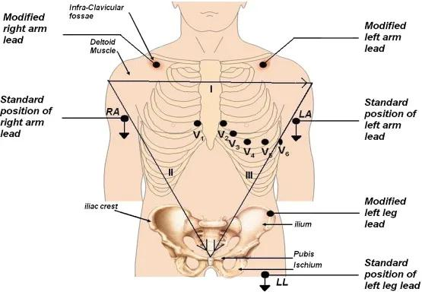

Fig 4:ECG Lead placement. The diagram above shows a heart and the direction of the resultant electrical vector. Below it, the 12 leads are shown as typically appear on an ECG tracing. The three limb leads, the three augmented limb leads, and the six precordial chest leads. The plus or negative sign with a circle around it shows you which direction the QRS wave will be deflected. Positive is up and negative is down [5]

[Source:<https://www.careerguide.com/career/full-form/ecg-full-form>]

**TACHYARRHYTHMIAS:**

Definition:

Tachyarrhythmia is defined as **a heart rhythm with a ventricular rate of equal or greater than 100 beats/min.**

Tachyarrhythmias are frequently symptomatic and present with [palpitations](https://www.sciencedirect.com/topics/medicine-and-dentistry/palpitations), [diaphoresis](https://www.sciencedirect.com/topics/medicine-and-dentistry/diaphoresis), dyspnea, [chest pain](https://www.sciencedirect.com/topics/medicine-and-dentistry/thorax-pain), [dizziness](https://www.sciencedirect.com/topics/medicine-and-dentistry/dizziness), syncope, and heart failure.

Tachyarrhythmias, including both supraventricular and ventricular types, typically begin with premature beats that trigger arrhythmias through either focal or reentrant mechanisms

​​Classification of Tachyarrhythmias:

1. Based on anatomical location:

Table 1:Classification of Tachyarrhythmia with the location responsible for the generation of the arrhythmia

|  |  |  |
| --- | --- | --- |
| SERIAL NO | TACHYARRHYTHMIAS | LOCATION |
| 1 | Sinus tachycardia | SA Node |
| 2 | Atrial ectopic beats  Atrial flutter    Atrial fibrillation  Paroxysmal supraventricular tachycardia | Atria |
| 3 | Atrio ventricular nodal tachycardia | AV Node |
| 4 | Ventricular tachycardia  Ventricular fibrillation  Ventricular ectopic beats  Torsades De Pointes | Ventricle |

B**.** Based on the width of the QRS complex:

Tachyarrhythmia is broadly classified into either narrow complex tachycardia (NCT) or wide complex tachycardia (WCT) based on the width of the QRS

complexes.

**SINUS TACHYCARDIA:**

A dysrhythmia known as sinus tachycardia (ST) starts in the sinus node and travels via the heart's regular conduction pathways, resulting in normal depolarization and an ECG pattern. It is linked to an elevated heart rate, typically between 100 and 180 beats per minute.

Cause: The sympathetic and vagal nerve terminals innervate the sinus node, and both sympathetic stimulation and vagal withdrawal raise the sinus rate, which can result in syncope, dizziness, chest pain, shortness of breath, palpitations, and dizziness.

The sinus rate is also influenced by the catecholamines in the blood.

Cause:

The sinus node is innervated by the sympathetic and vagal nerve endings and the

**Sympathetic stimulation, as well as vagal withdrawal,is responsible for increasing the sinus rate** that may lead to syncope,dizziness,chest pain,shortness of breath,dizziness and palpitations

The circulating catecholamines also affect the sinus rate.

The following is a list of some common causes of ST:

Physiological aspects: The heart rate is accelerated and ST is caused by fever >101F, low oxygen levels leading to hypoxia, hemorrhage, hypotension, anemia, pain, anxiety and injury to any area of the body.

Drugs responsible: The body's overall metabolism and heart rate can be raised by atropine, adrenaline, dopamine, thyroxine, and glucagon.

Heart tissue damage: The heart rate may rise as a result of acute injuries such as coronary artery disease, trauma, viral myocarditis, congestive heart failure or cor pulmonale.

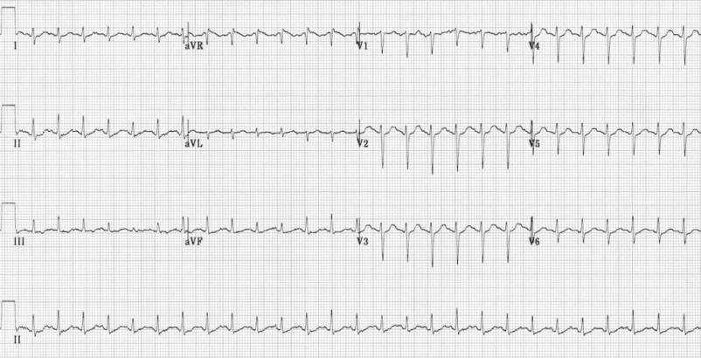

Fig 5: Sinus tachycardia.Source[[ECG-Sinus-Tachycardia.jpg](https://litfl.com/wp-content/uploads/2018/08/ECG-Sinus-Tachycardia.jpg)]

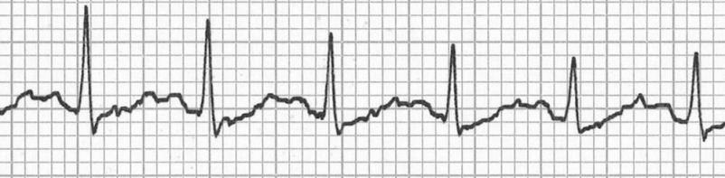

Fig 6:With very fast heart rates the P waves may be hidden in the preceding T wave, producing a **‘camel hump’ appearance**.

(Source:[ECG-Camel-hump-hidden-p-waves.jpg](https://litfl.com/wp-content/uploads/2018/08/ECG-Camel-hump-hidden-p-waves.jpg))

The ECG would show regular sinus rhythm with a heart rate of more than 100bpm with regular rhythm with uniform shaped qRS complex and each complex followed by a P wave with PR interval ranging from 0.12-0.20 seconds.

**ATRIAL TACHYCARDIA:**

ATRIAL TACHYCARDIA: Three or more atrial ectopics occurring quickly after one another cause atrial tachycardia (AT). It has characteristics with the solitary atrial ectopic beat. Moreover it is characterized by an elevated atrial rate (145 to 260 beats per minute). Generally speaking, it is quicker than sinus tachycardia. The diastole is shortened by the fast atrial heart rate, which causes ischemic myocardial alterations, decreased cardiac output, demand supply mismatch to the myocardium and the heart tissue , and a loss of atrial contraction leading to the loss of presystolic accentuation. Vagal maneuvers and AV nodal blockers are ineffective in stopping tachycardias because they do not involve the atrioventrciular node in participation of the generation of tachycardia

Reasons: The pacemaker function is taken over from the SA node by an extremely hyperexcitable region in the focus of atria that is rapidly initiating impulses one after another. The atrioventricular node conducts all impulses. The common causes may include MI, Wolf Parkinson white syndrome,Valvular heart diseases, Congenital anomalies.

The ECG may be s/o

|  |  |
| --- | --- |
|  | * Atrial rate exceeding 100 bpm * P waves with abnormal morphology and axis due to an ectopic origin * Unifocal, consistent P waves * Isoelectric baseline * qRS of width <120ms   ECG Ectopic atrial tachycardia inverted p waves  Fig 7:Narrow QRS complex tachycardia with HR of 120 bpm.  Source:[ECG-Ectopic-atrial-tachycardia-inverted-p-waves.jpg](https://litfl.com/wp-content/uploads/2018/08/ECG-Ectopic-atrial-tachycardia-inverted-p-waves.jpg) |

**NOTE: Multifocal Atrial Tachycardia :**A rapid, irregular atrial rhythm originating from multiple ectopic foci within the biatrial region.It is most frequently observed in patients with lung pathology likely to be COPD and is hence found in smokers. This rhythm often serves as an intermediate pattern between frequent premature atrial complexes (PACs) and atrial flutter or fibrillation. therefore treatment for multifocal atrial tachycardia depends on the underlying pulmonary illness.

ECG is s/o

|  |  |
| --- | --- |
|  | * Heart rate typically exceeds 100 bpm, usually ranging from 100 to 150 bpm, but it can reach up to 250 bpm. * The rhythm is irregularly irregular, with varying PP, PR, and RR intervals. * There are at least three distinct P-wave morphologies observed consecutively in the same lead. * No flutter waves are appreciated   Multifocal Atrial Tachycardia (MAT)  Fig 8:ECG showing a rapid irregular rhythm > 100 bpm with at least 3 distinct P wave morphologies  SOURCE:[Multifocal-Atrial-Tachycardia-MAT.jpg](https://litfl.com/wp-content/uploads/2018/08/Multifocal-Atrial-Tachycardia-MAT.jpg) |

**Atrial Fibrillation**:

Atrial fibrillation (AF) is the most prevalent sustained arrhythmia, characterized by irregular atrial electrical activity and contraction, thus causing an "irregularly irregular" ventricular response and the presence of "fibrillation waves."AF can present in various forms, including acute AF, transient AF, paroxysmal AF, or chronic AF.

It can have a controlled rate or may have a fast ventricular rate.

Patients with AF can be either hemodynamically stable or unstable.

The incidence and prevalence of AF are rising, with an estimated lifetime risk of around 25% for individuals over the age of 40.Also to keep in mind is the fact that likelihood of developing AF increases with age.  
AF is also commonly seen after cardiac surgery, affecting 10-40% of patients, typically occurring between the second and third post-operative days.

It is the most common sustained tachyarrhythmia, and is characterised by the absence of P waves on the EKG along with an irregularly irregular ventricular rhythm with R-R intervals not coinciding with the previous one. The rate of atrial fibrillation often exceeds 300 to 600 beats/minute.

When ectopic foci in the atria initiate impulses, depolarization cannot occur in an organized fashion. Instead, small areas of the atria depolarize individually, causing the atrial muscle to quiver without a coordinated contraction. One common complication of long-standing atrial fibrillation is the formation of mural thrombi.

In atrial fibrillation, the AV node is overwhelmed by numerous ectopic atrial impulses, which vary in rate and amplitude. The AV node then conducts these impulses in a random and inconsistent manner, leading to an irregular ventricular response. During the initial onset of atrial fibrillation, the atrial rate is often immeasurable, and the ventricular rhythm becomes both irregular and very rapid. The cardiac ventricles only respond to impulses that are transmitted through the AtrioVentricular node, thus resulting in the wide variation in R-R intervals on an EKG seen in AF patients. A rapid ventricular response can be life-threatening in some cases

Table 2: Types of atrial fibrillation

|  |  |  |  |
| --- | --- | --- | --- |
|  | PAROXYSMAL AF | PERSISTENT AF | LONG STANDING PERSISTENT AF |
| DEFINITION | Episodes self terminate or via CV in< 7days | Episodes do not self terminate in < 7days | Persistent AF > 1year |
| LA size | Normal to mildly enlarged | Mild to severely enlarged | Typically,severely enlarged |
| LA scar burden | Low | Moderate | High |
| Efficacy of AAD | Often effective | Not as effective | Usually refractory |
| When to offer ablation? | First line therapy reasonable | First line appropriate but usually offered after AAD failure | After AAD failure,not always a good option |
| Ablation technique | PV isolation alone usually effective | PV isolation and any identified non-PV AF source | PV isolation;additional ablation for substrate modification modification likely needed |

A normal ventricular response is between 60 and 100 beats per minute.

When the ventricular rate falls below 110 beats per minute with the help of rate controlling drugs, atrial fibrillation is considered to be well-controlled.

A ventricular rate above 110 beats per minute indicates fast/uncontrolled atrial fibrillation.

**Characteristics of 'f Waves':**

* In recent atrial fibrillation, f waves are typically coarse (greater than 2 mm).
* For longer-duration atrial fibrillation, f waves are generally finer (less than 1 mm).
* The amplitude of f waves increases in the presence of left atrial hypertrophy or myocardial enlargement.

**COMPLICATIONS OF ATRIAL FIBRILLATION:**

Adverse effects on haemodynamics: Chronic AF may lead to loss of atrial systole with decreased diastolic filling time due to irregular heart rate along with a rate related cardiomyopathy which can occur over weeks to months

Chronic AF may also lead to Atrial thrombus formation which can further lead to systemic embolism [likely ischemic stroke] and pulmonary embolism.

The annual risk of ischemic stroke likely due to an embolus from AF is dependant on the CHA2DS2-VASc scoring system

* There are 3 categories:
  + score 0: negligible risk of stroke (~ 0%/y) (low risk)
  + score 1: 1.3%/y risk of stroke (intermediate risk)
  + score >=2: >2.2% risk of stroke (high risk)
* The maximum score of 9 predicts a 15.2%/y i.e. very high risk of stroke
* Antiplatelet agents are alone not sufficient
* In a study done it was found that Direct acting anticoagulants were **NOT INFERIOR** to warfarin in non valvular a fib, **no efficacy demonstrated in RHD mitral stenosis** and.Also it was found that DOACs **did not prevent thromboembolism in patients with mechanical heart valves**

Table 3- CHAD2VASc score

|  |  |
| --- | --- |
| RISK FACTOR SCORE | |
| Congestive heart failure | 1 |
| Hypertension | 1 |
| Age >75 years | 2 |
| Diabetes Mellitus | 1 |
| Stroke/TIA/Thromboembolism | 2 |
| Vascular disease | 1 |
| Age 65-74 | 1 |
| Sex category (i.e. female sex) | 1 |
| Maximum Score 9 | |

**Atrial Flutter :**

**Atrial Flutter :**is characterised by an atrial macroreentrant circuit (typically in the right atrium) leading to a type of cardiac arrhythmia marked by atrial rates ranging from 240 to 400 beats per minute, often accompanied by varying degrees of atrioventricular (AV) node conduction block.. There is typical 2:1 conduction through the atrioventricular node, resulting in heart rates close to 160 beats/min.

ECG features of Atrial flutter:

* Narrow complex tachycardia
* A regular atrial activity with rhythm generation of about 200-400 bpm
* Loss of the isoelectric baseline from the PR interval
* A “Saw-tooth” pattern of inverted flutter waves in all leads and all have identical morphology

There are two primary types of atrial flutter:

**Typical Atrial Flutter:** This is the most common form. It occurs when abnormal electrical signals circulate in a counterclockwise direction within the right atrium, often involving the tricuspid valve, which regulates blood flow between the right atrium and right ventricle. In less common cases, the electrical signals may move in a clockwise direction, known as reverse typical atrial flutter. In rare instances, the signals can circulate in both directions.

**Atypical Atrial Flutter:** This less common type does not involve the tricuspid valve and can occur in either the right or left atrium. It may develop following heart surgery or other cardiac procedures.

* 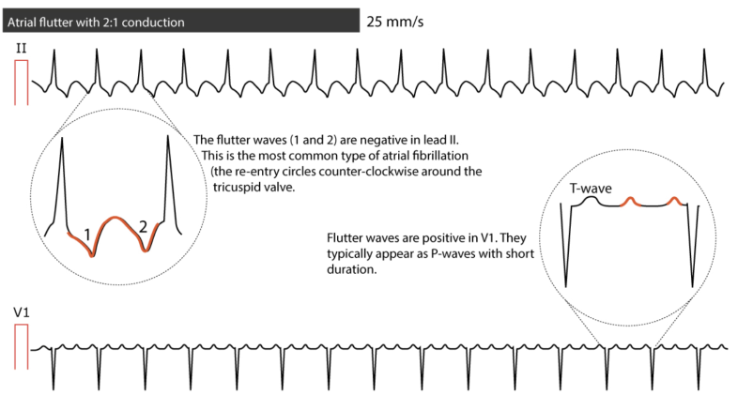

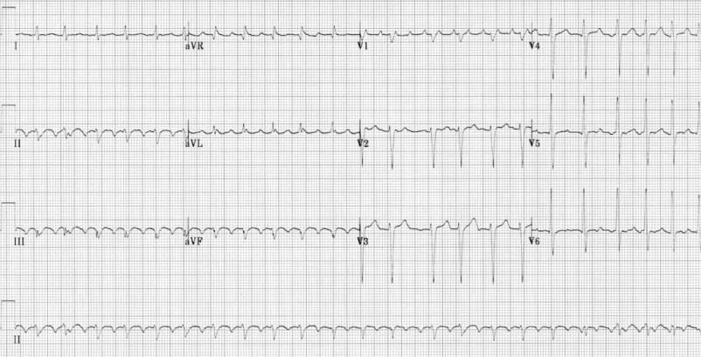

Fig 9: Atrial flutter with 2:1 block

*(SOURCE*:[ECG-Atrial-Flutter-with-2-1-Block-1-.jpg](https://litfl.com/wp-content/uploads/2018/08/ECG-Atrial-Flutter-with-2-1-Block-1-.jpg))

|  |  |  |
| --- | --- | --- |
|  | ATRIAL FLUTTER | ATRIAL FIBRILLATION |
| ATRIAL RATE | 220-350 bpm | >350 bpm |
| ATRIAL ACTIVITY | It has saw tooth Flutter(F) waves | It has fibrillatory(f) waves which have a ragged appearance. |
| VENTRICULAR ACTIVITY | Constant R-R interval | Variable R-R interval |
| VENTRICULAR RATE | Regular to 1/4rth of atrial rate | Variable, with no relation to atrial rate |

**BRADYARRHYTHMIAS:**

**Definition: ﻿**Bradyarrhythmias are most commonly caused by a failure in impulse generation via the pacemaker i.e. SA node(such as sinus node dysfunction) or by impaired impulse conduction through the conducting pathway which involves the atrioventricular (AV) node or bundle of his or Purkinje fibres.These bradyarrhythmias usually result from diseases that directly affect the structural and functional integrity of the sinus node, atria, AV node, or His-Purkinje system. Alternatively, they can be triggered by external factors (such as autonomic disturbances or medications) that do not cause structural damage.

Causes of bradyarrhythmias:

|  |  |  |
| --- | --- | --- |
| 1 | SA Nodal dysfunction | Sinus Bradycardia  Sinus arrest  Sinus pause  SA nodal exit block  Tachy-bradycardia syndrome  Chronotropic Incompetence |
| 2. | AV Nodal dysfunction | 1st Degree Heart block  2nd Degree Heart Block  Mobitz Type 1 [Wenkenbach]    Mobitz Type 2  2:1 Atrioventricular block  3rd Degree/Complete Heart Block |

SA Nodal Dysfunction: ﻿Sinus node dysfunction is a clinical syndrome, characterised by a wide range of electrophysiologic abnormalities which may result from failure of impulse generation via the pacemaker, failure of impulse transmission to the atria due to the conduction , inadequate subsidiary pacemaker activity. Sinoatrial exit block occurs when pacemaker impulses fail to propagate beyond the sinoatrial (SA) node. Although the SA node continues to depolarize normally, some of the sinus impulses are "blocked" before they can be transmitted, resulting in intermittent atrial depolarization failure (dropped P waves). This disorderencompasses a variety of terminologies such as the sick sinus syndrome, tachycardia-bradycardia syndrome, SA disease, and SA dysfunction.

Sinus bradycardia: When the heart rate is <60 bpm with a normal P wave,qRS complex and T wave.It is a normal phenomenon which might be seen in athletes,sleep,uremia,raised ICT,structural nodal disease,use of Beta blockers,Carotid sinus hypersensitivity.

Further workup is warranted where the resting heart rate goes below 40 in awake state in absence of physical conditioning OR The symptoms of patient can’t be attributed to anything else, but just to sinus bradycardia

Sinus pause and Sinus Arrest: ﻿Sinus pause or arrest refers to the failure of the pacemaker of heart (sinoatrial node) to discharge, leading to a lack of atrial activation originating from the sinus node. This eventually results in the absence of P waves and may cause periods of ventricular asystole if lower pacemakers (such as junctional ectopics or ventricular ectopics) do not generate escape beats. The pause in sinus activity should not be a multiple of the preceding sinus cycle length (P-P interval). **The length of pause will the P-P interval,** from the onset to p wave in cycle just before the pause to the onset of p wave in cycle just after the pause.As sinus pauses upto 3s length can be normally present,

*Symptomatic pause OR asymptomatic pause more then 6s should be considered for permanent pacemaker.*

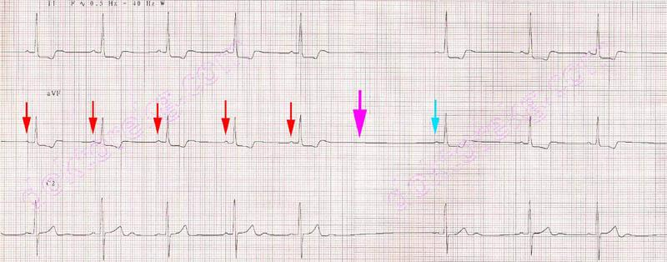

Fig 10: lead telemetry study of a young person showing, normal heart rate with prolonged PR interval(suggestive of high vagal tone) before the pause. P waves are consistent with normal morphology.

*SOURCE:*[*http://metealpaslan.com/ecg/sinus-arrest.htm*](http://metealpaslan.com/ecg/sinus-arrest.htm)

***FIRST DEGREE AV BL***

TACHY-BRADY SYNDROME: ﻿Sinus bradycardia interspersed with periods of atrial tachyarrhythmias is a common manifestation of sinus node dysfunction

﻿﻿The atrial tachyarrhythmias usually range from paroxysmal atrial tachycardia to atrial flutter and atrial fibrillation. Apart from underlying sinus bradycardia of varying severity, these patients often experience prolonged sinus arrest and asystole upon termination of the atrial tachyarrhythmias, resulting from suppression of sinus node and secondary pacemaker

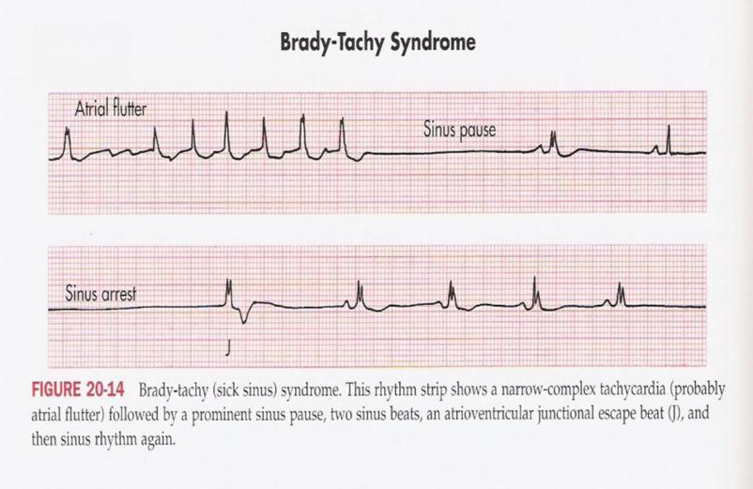

Fig 11: Brady-tachy syndrome.This rhythm strip shows a narrow complex tachycardia (probably atrial flutter) followed by a prominent sinus pause,two sinus beats,an atrioventricular junctional escape beat(J),and then sinus rhythm again.

*(SOURCE*<https://litfl.com/sinus-node-dysfunction-sick-sinus-syndrome/>)

Risk of thromboembolism is much increased in tachy brady syndrome, as most common tachy associated is A.fibrillations, which *should be treated with anticoagulants*

Treating episodes of tachyarrhythmia with continuous rate suppression therapy can be fatal in such patients coz it may lead to sinus arrest.Therefore the presence of tachy brady syndrome warrants insertion of permanent pacemaker

CHRONOTROPIC INCOMPETENCE: It is defined as failure to increase the heart rate with exercise where the resting heart rate may be normal but most of the patients complaint of exercise intolerance.It is present in approximately 20 to 50 percent of patients with sick sinus syndrome

***This is alternatively defined as failure to reach 85% of predicted maximal heart rate at peak exercise OR failure to achieve a heart rate >100 beats/min with exercise***

* ﻿They present with normoglycemic syncope , bradycardia, exercise intolerance ,fatigue,venous stasis with thromboembolic events

**AV NODAL DYSFUNCTION:**

Delay or interruption in conduction of atrial impulse through Av node & bundle of HIS

Etiologies of AV node dysfunction:

1.Autonomic causes: includes Carotid sinus hypersensitivity,Vasovagal

2.Metabolic/endocrine causes: include Hyperkalemia Hypothyroidism, Hypermagnesemia ,Adrenal insufficiency

3.Drug-related causes: include Beta blockers ,Adenosine ,Calcium channel blockers Antiarrhythmics (class 1 & III),Digitalis,Lithium

4.Infectious causes: include Endocarditis,Tuberculosis ,Lyme disease,Diphtheria,Chagas disease,Toxoplasmosis,Syphilis

5.Inflammatory causes include:SLE,MCTD,Rheumatoid arthritis,Scleroderma

6. Infiltrative causes : include Amyloidosis,Hemochromatosis,Sarcoidosis

7. Neoplastic/traumatic: include Lymphoma,Radiation,Mesothelioma, Catheter

ablation, Melanoma

8. Degenerative causes:include Lev disease Lenègre disease

9.Coronary artery disease such as Acute MI

10.Heritable/congenital Congenital heart disease: include Facioscapulohumeral MD (4935), Maternal SLE,Kearns-Sayre syndrome Emery-Dreifuss MD,) Myotonic dystrophy ,Progressive familial heart block

Types of AV Nodal dysfunction:

**1ºheart block** :The conduction time is prolonged, but all conducting impulses are normal with a prolonged PR interval(>0.20 sec) & but all P waves an EKG are followed by a qRS complex

It can occur due to defect in AV node i.e. supranodal [generating a narrow QRS complex]

Or due to defect in the bundle of his or any one of the branches of bundle of his i.e. infranodal [producing a wide QRS complex]

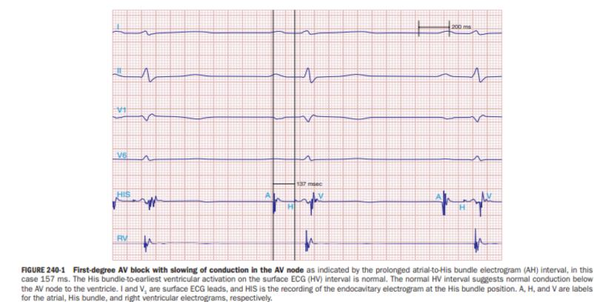

Fig 12:First-degree AV block is characterized by delayed conduction through the AV node, as reflected by a prolonged atrial-to-His bundle (AH) interval, which in this case is 157 ms. However, there is no abnormality in the His bundle to the earliest ventricular activation (HV) interval. Conduction to the ventricles below the AV node is unaltered, as indicated by the usual HV interval. "HIS" stands for the endocavitary electrogram obtained at the His bundle site, whereas "I" and "V" stand for surface ECG leads. The labels "A," "H," and "V" stand for the right ventricular, His bundle, and atrial electrograms, respectively.

*SOURCE:*[*https://emedicine.medscape.com/article/161829-workup?form=fpf*](https://emedicine.medscape.com/article/161829-workup?form=fpf)

**Second Degree Heart Block:** is defined asIntermittent failure of AV conduction with some of sinus impulses which may not be transmitted through Av Node ( where p wave is not followed by a QRS (dropped beat).

It can be of two types: Mobitz type 1 and Mobitz Type 2

Second Degree heart block(Mobitz type -1):

Also known as the **Wenkenbach Block** where there is a progressive prolongation of the PR interval before a pause (due to decremental properties of AV node) and is usually considered as a low grade benign block

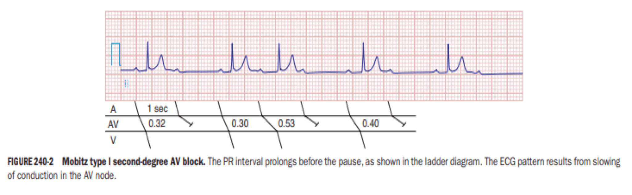

Fig 13: Mobitz type 1 second degree AV block.The PR interval prolongs before the pause as shown in the ladder diagram.The ECG pattern results from slowing of conduction in the AV node.

*SOURCE:*[*second-degree-type-i-av-heart-block-mobitz-i-wenckebach-ecg-review*](https://www.registerednursern.com/second-degree-type-i-av-heart-block-mobitz-i-wenckebach-ecg-review/)

Second Degree Heart Block- Mobitz Type 2: is the one where the block is usually at the lower level either in the bundle of his or the purkinje system and is considered to be a malignant block.There is usually a fixed number of non-conducted P waves for every successfully conducted QRS complex.

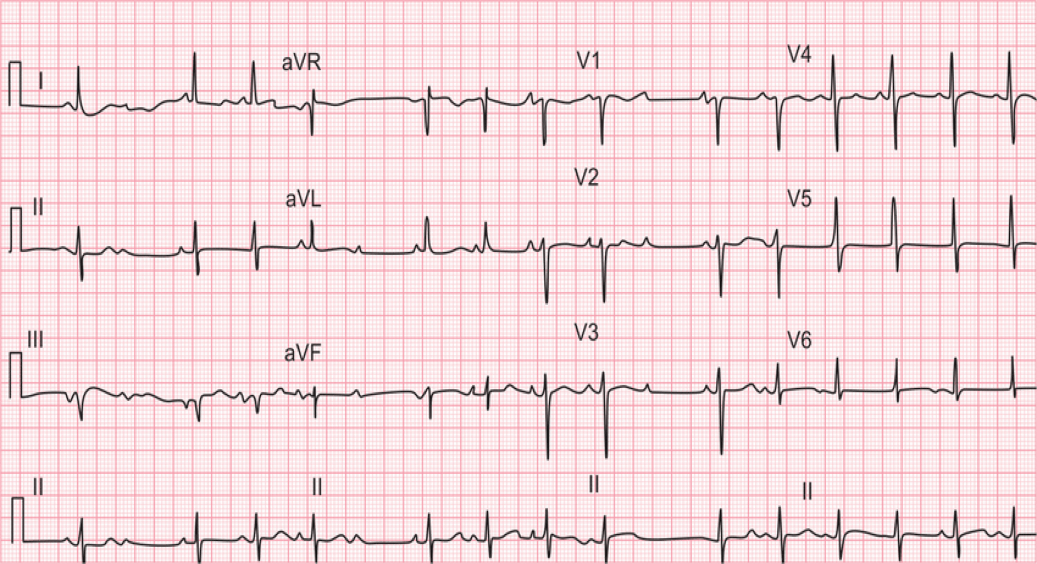

Fig 14:Mobitz type II second-degree AV block. Intermittently P wave fails to conduct, but not preceded by prolongation of PR interval

*SOURCE:*[*https://www.researchgate.net/figure/Mobitz-type-II-second-degree-AV-block-Intermittently-P-wave-fails-to-conduct-but-not_fig1_308310323*](https://www.researchgate.net/figure/Mobitz-type-II-second-degree-AV-block-Intermittently-P-wave-fails-to-conduct-but-not_fig1_308310323)

|  |  |
| --- | --- |
| *Mobitz type 1* | *Mobitz type 2* |
| *blocks AV node/ Bundle of HIS* | *Blocks distal conduction system* |
| *QRS complex narrow usually* | *QRS usually wide(a/w bundle block)* |
| *Atropine increases HR* | *Atropine worsens the block* |

**Third Degree heart block:**

It is defined as complete interruption of atrioventricular conduction i.e. infranodal block where all the supraventricular impulses are blocked to reach the ventricles and the ventricles are activated by ectopic pacemaker located in the AV node or below in the ventricular myocardium itself.

Thus both atria and ventricles are activated by 2 different pacemakers and they both contract on their own without any relation to each other and leads to a complete AV dissociation.

Here the two rhythms are asynchronous and independent of each other where the P wave do not bear any relation with the QRS complex i.e. every P wave is not followed by a QRS complex and leads to generation of a cannon a wave on JVP axis

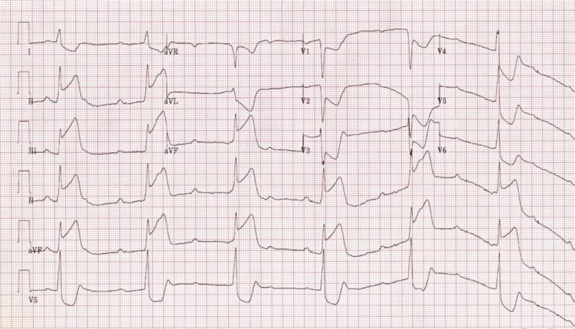

SOURCE:[ECG-Inferior-STEMI-with-3rd-degree-AV-Block-CHB.jpg](https://litfl.com/wp-content/uploads/2018/08/ECG-Inferior-STEMI-with-3rd-degree-AV-Block-CHB.jpg)

**REFERENCES:**

1. AlGhatrif M, Lindsay J. A brief review: history to understand fundamentals of electrocardiography. Journal of community hospital internal medicine perspectives. 2012 Jan 1;2(1):14383

2.Lakshminarayan K, Anderson DC, Herzog CA, Qureshi AI. Clinical epidemiology of atrial fibrillation and related cerebrovascular events in the United States. The neurologist. 2008 May 1;14(3):143-50.

3. Barham, J.N., Mechanical Kinesiology, Saint Louis, 1978.

4. M. Naz, J. H. Shah, M. Sharif, M. Raza and R. Damaševiˇcius, “From ECG signals to images: A transformation based approach for deep learning,” PeerJ Computer Science, vol. 7, no. 1, pp. e386, 2021

5.Heeringa J, van der Kuip DA, Hofman A, Kors JA, van Herpen G, Stricker BH, Stijnen T, Lip GY, Witteman JC. Prevalence, incidence and lifetime risk of atrial fibrillation: the Rotterdam study. European heart journal. 2006 Apr 1;27(8):949-53.

6.Leonelli FM, De Ponti R, Bagliani G. Challenges in Bradicardias Interpretation. Cardiac Electrophysiology Clinics. 2019 Apr 12;11(2):261-81.

7.Kerola T, Eranti A, Aro AL, Haukilahti MA, Holkeri A, Junttila MJ, Kenttä TV, Rissanen H, Vittinghoff E, Knekt P, Heliövaara M. Risk factors associated with atrioventricular block. JAMA Network Open. 2019 May 3;2(5):e194176.

8.Trardi Y, Ananou B, Haddi Z, Ouladsine M. A novel method to identify relevant features for automatic detection of atrial fibrillation. In2018 26th Mediterranean Conference on Control and Automation (MED) 2018 Jun 19 (pp. 613-618). IEEE.

9.Aljohani MS. Competency in ECG interpretation and arrhythmias management among critical care nurses in Saudi arabia: A cross sectional study. InHealthcare 2022 Dec 19 (Vol. 10, No. 12, p. 2576). MDPI.

10.Bond R, Finlay D, Al-Zaiti SS, Macfarlane P. Machine learning with electrocardiograms: a call for guidelines and best practices for ‘stress testing’algorithms. Journal of Electrocardiology. 2021 Nov 1;69:1-6.

11.Duncker D, Ding WY, Etheridge S, Noseworthy PA, Veltmann C, Yao X, Bunch TJ, Gupta D. Smart wearables for cardiac monitoring—real-world use beyond atrial fibrillation. Sensors. 2021 Apr 5;21(7):2539.

12.Tang DH, Gilligan AM, Romero K. Economic burden and disparities in healthcare resource use among adult patients with cardiac arrhythmia. Applied health economics and health policy. 2014 Feb;12:59-71.

13.Parvaneh S, Rubin J. Electrocardiogram monitoring and interpretation: from traditional machine learning to deep learning, and their combination. In2018 Computing in Cardiology Conference (CinC) 2018 Sep 23 (Vol. 45, pp. 1-4). IEEE.

|  |
| --- |
|  |