### APPROACH TO ALTERED SENSORIUM IN PATIENTS LIVING WITH HIV AND AIDS

**ABSTRACT**

The approach to altered sensorium in patients living with HIV and AIDS is a critical component of clinical care, given the complex interplay of factors contributing to cognitive impairment in this population. Altered sensorium, characterized by changes in consciousness, cognition, and perception, can stem from a variety of etiologies including opportunistic infections, malignancies, metabolic disturbances, and direct effects of HIV on the central nervous system. Early identification and comprehensive assessment are paramount in managing these patients effectively. The initial evaluation should include a thorough history, physical examination, and targeted diagnostic investigations such as neuroimaging, lumbar puncture, and relevant laboratory tests. Common infectious causes like cryptococcal meningitis, toxoplasmosis, and cytomegalovirus encephalitis must be considered, alongside non-infectious conditions such as HIV- associated neurocognitive disorders (HAND), primary CNS lymphoma, and progressive multifocal leukoencephalopathy (PML). Management strategies should be tailored to the identified cause, incorporating antiretroviral therapy (ART) optimization, antimicrobial treatments, and supportive care measures.

Multidisciplinary collaboration involving neurologists, infectious disease specialists, and other healthcare professionals is essential for holistic patient care. Additionally, addressing psychosocial factors, adherence to ART, and regular monitoring for neurocognitive changes are vital components of long-term management.

Given the evolving landscape of HIV treatment and the aging HIV-positive population, ongoing research into the pathophysiology, prevention, and management of altered sensorium in this group remains crucial. This approach aims to improve patient outcomes, enhance quality of life, and reduce the burden of neurocognitive complications in those living with HIV and AIDS.

### Introduction

Early in the course of HIV-1 disease, at or around the acute seroconversion reaction, HIV-1 invades the central nervous system (CNS). Virus may be carried into the brain through infected T- lymphocytes and/or monocytes. However, terminally differentiated brain mononuclear phagocytes (MP) (brain macrophages and microglia) harbor the majority of integrated virus in brain tissue. Commonly, in late stage HIV-1 disease, when peripheral CD4+ T cell counts decline, HIV-infected MP become immunologically active and initiate an inflammatory cascade within the brain parenchyma culminating in neuronal destruction. Laboratory investigations suggest cytokines, chemokines and their receptors expressed in the CNS may predispose a subset of HIV patients to virus- and/or MP-mediated neuronal damage. In this subset of individuals, viral and/or host immune factors secreted by MP may disrupt neuronal homeostasis resulting in HIV-associated dementia (HAD). Recent advances in anti-retroviral regimens have retarded the progression of HIV disease in affected individuals and decreased the incidence of HAD. Moreover, because infection and activation of MP are necessary for macrophage-mediated neuronal damage, adjunctive anti- inflammatory and/or neuroprotective therapeutic strategies have received intense attention recently.

Treatments aimed at disabling macrophage activation and/or its neurotoxic secretions may positively affect the progression of HIV-neuropathogenesis.(1)

### Neuropathogenesis

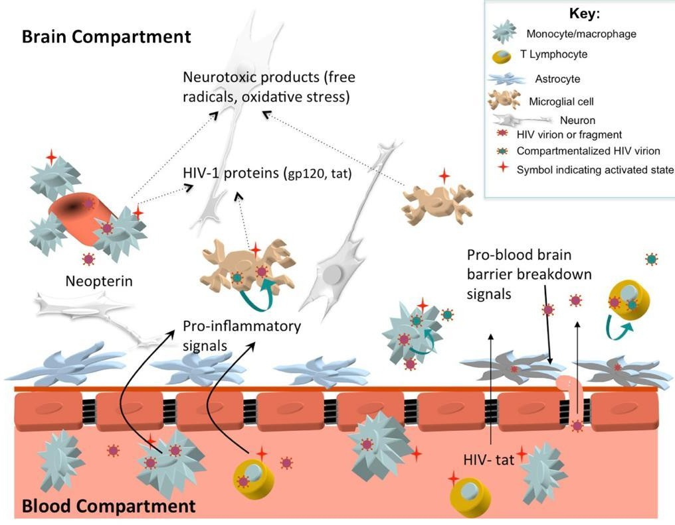

*Figure 1*

The above image depicts the neuropathogenesis of HIV infection(2)

Potential mechanisms of HIV related CNS injury prior to combination antiretroviral therapy. Systemic activation of immune cells stimulates increased transmigration of lymphocytes and monocytes across the blood brain barrier (BBB). Once in the central nervous system (CNS) compartment, immune cells release pro-inflammatory signals that stimulate further immune cell influx (cytokines such as monocyte

chemoattractant protein-1 and interferon-inducible protein-10) and matrix metalloproteinases that disrupt the BBB. Some of the imported cells are infected with HIV, allowing for local production of virions that enter resident CNS cells including perivascular macrophages, brain microglial cells, and astrocytes. Macrophage, microglial, and T lymphocyte infection may support local CNS HIV replication, facilitating emergence of unique ‘compartmentalized’ CNS HIV that reflects production of HIV independent from the periphery.

Activated microglia and perivascular macrophages release neurotoxic immune products that lead to neuronal dysfunction; this activation stimulates production of neopterin, a pteridine biomarker of immune activation readily measured in the cerebrospinal fluid. Potentially neurotoxic HIV proteins such as HIV-tat may freely cross the BBB or be released by resident HIV infected cells. Astrocytes harboring HIV virions or fragments may not facilitate viral replication, but may contribute to neuropathogenesis through multiple mechanisms including injury to the blood brain barrier and release of neurotoxic products.

### Neurologiocal manifestations of HIV infection

Neurological Manifestations of HIV infection

* + - **ACUTE ASEPTIC MENINGITIS**
    - **CHRONIC MENINGITIS**
    - **HIV ASSOCIATED NEUROCOGNITIVE DISORDER**

**HIV RELATED (DIRECT TOXICITY)**

**(HAND)**

* **HIV ENCEPHALOPATHY**
* **VACUOLAR MYELOPATHY**
* **PERIPHERAL NEUROPATHY (SENSORY)**
* **MYOPATHY**

**OI (OPPORTUNISTIC INFECTION) RELATED**

* **CRYPTOCOCCAL MENINGITIS**
* **CEREBRAL TOXOPLASMOSIS**
* **CMV RETINITIS AND ENCEPHALITIS**
* **PMLE (PROGRESSIVE MULTIFOCAL LEUKOENCEPHALOPATHY)**
* **TUBERCULOSIS**
* **SYPHILLIS**

**NEOPLASMS:**

* **PRIMARY CNS LYMPHOMA**
* **KAPOSI’S SARCOMA**

**DRUG RELATED (HAART)**

* + **IRIS**
  + **NEUROPSYCHIATRIC SYMPTOMS**
  + **NEUROMUSCULAR WEAKNESS**
  + **DISTAL SYMMETRIC POLYNEUROPATHY**
  + **MYOPATHY**

1. **PLHIV patient presenting to Emergency room is approached systematically keeping in mind the opportunistic infections common in PLHIV.**

# Approach in EMERGENCY

Yes

Headache(persistent/severe)/

altered mental status?

Evaluation of immunodeficiency (previous OI, oral thrush, weight loss, CD4 count<200)?



Yes

Ring enhancing lesions?

Normal

Contrast enhance

CT/MRI

**Initial assessment:**

Vital signs

Airway, breathing, circulation→ Gag reflex absent, GCS <8 →intubate

IV, oxygen, monitor

glucose Naloxone Thiamine

Yes

No

No

Lumbar puncture− CSF cell counts, protein, glucose,

Gram stain, culture, India ink, AFB/CBNAAT/VDRL

Fever +/− meningismus?

Focal signs/seizures?

Known case of PLHA

Empirical treatment for TE

Consider antibiotics, send cultures, admit and evaluate further

Other workup suggestive of Toxo

− IgG +ve?

Treat appropriately

**History:**

Onset, duration, temporal progression of symptoms Symptoms suggesting raised ICP, seizures Medication/substance use

Toxic/metabolic etiology?

**Secondary Survey:**

Evidence of trauma,

brainstem reflexes, seizures related injuries, toxidromes

Yes

### TUBERCULAR MENINGITIS

It may present with tuberculomas, tubercular brain abscess, myeloradiculopathy. It also has a varying presentation – acute, subacute or chronic. The symptoms include, headache, lethargy, vomiting, altered sensorium, seizures. The signs include Focal neurological deficits secondary to vasculitic infarcts, hydrocephalus, Cranial nerve palsies among which most commonly the 6th cranial nerve, but the 2nd, 3rd, 4th and 8th may also be affected. Some atypical manifestations include slowly progressive dementia over months, personality change, social withdrawal, memory deficits.

Diagnosis : The radiological imaging in tubercular meningitis shows Basal exudates, Hydrocephalus, Vascular infarct and Tuberculomas. Lumbar puncture and CSF analysis can be done which reveal high opening pressure, increased proteins (40-100) and low sugars (<0.5), with lymphocytic predominance. AFB and CBNAAT may reveal the organism and culture of CSF takes several weeks.

ADA sensitivity and specificity respectively are 82.14% and 90.91% respectively (3) Positive and negative predictive value and positive and negative likelihood ratios and accuracy of the test in TBM cases were 92% (95% CI 75.03-97.77), 80% (95% CI 60.86-91.13), 9.03 (95% CI 2.38-34.25), 0.19

(95% CI 0.09-0.44) and 86%, respectively. (3)

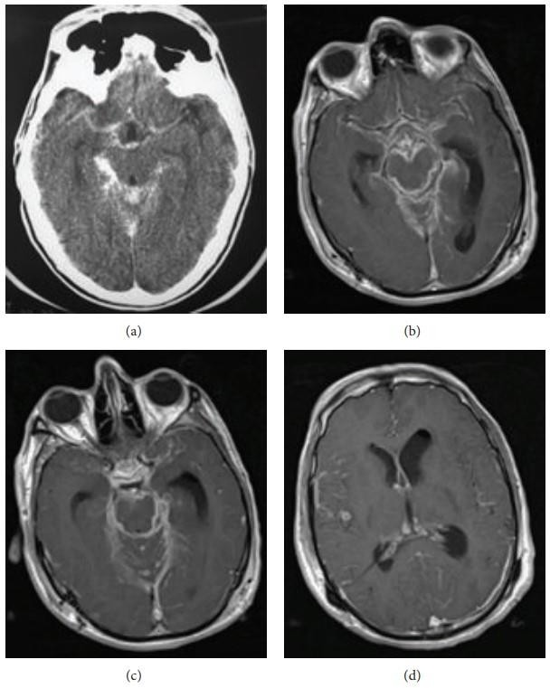TUBERCULAR MENINGITIS

*Figure 2*

(a) Axial postcontrast brain CT shows typical thick enhancement of basilar cisterns. (b) Axial postcontrast T1-weighted MR images in a different patient ((b), (c), and (d)) demonstrate enhancing basilar exudates and leptomeningeal enhancement. A small tuberculoma in right temporal region (d) and hydrocephaly (more severe in left ventricle) and the evidence of prior craniotomy (Burr hole, left pneumoventricle) are also evident(4)

TUBERCULOMAS TUBERCULAR BRAIN ABSCESS

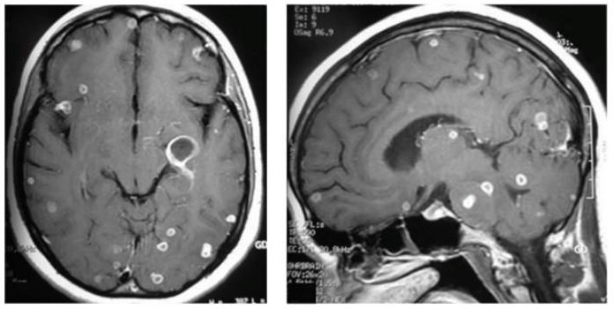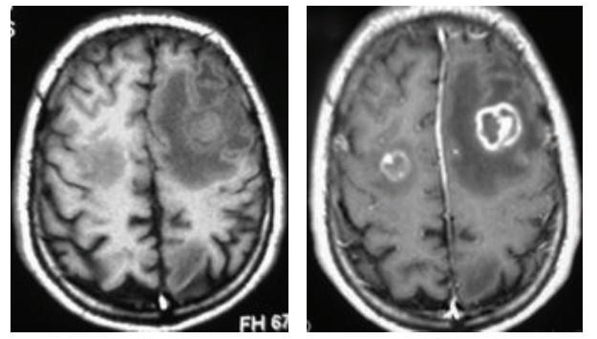

*Figure 3*

Multiple supra- and infratentorial tuberculomas. Seen as multiple small ring enhancing lesions without peripheral edema or mass effect in axial and sagittal postcontrast T1-weighted MR images. Tubercular abscesses seen as hypointense in T1 and hyperintense in T2 with contrast enhancement of rim and central liquefaction. Associated with peripheral edema and mass effect.

Treatment: Standard Antitubercular therapy consisting of Isoniazid, Rifampicin, Pyrazinamide can be given. Also, steroids can be added as they show clear evidence in HIV suggesting reduced mortality. The usual regimen (8 weeks) is: 0.4mg/kg x 2 weeks followed by 0.3mg/kg x1 week f/b 0.2mg x 1 week f/b 4mg/day x 1 week, 3mg/day x 1week, 2mg/day x1 week, 1mg/day x 1 week.

### Management of HIV and TB co-infection

*Table 1*

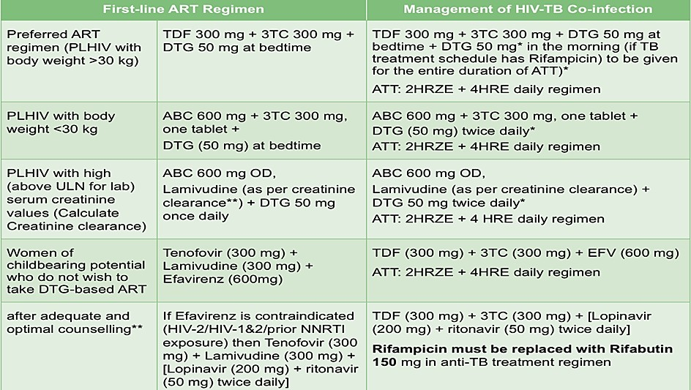

ART should be started as soon as possible within two weeks of initiating TB treatment, regardless of CD4 cell count, among people living with HIV (PLHIV) (except when signs and symptoms of meningitis are present)

**Appropriate ART regimen**

Among PLHIV with TB meningitis, ART should be delayed for at least 4 weeks (and initiated within 8 weeks) after treatment for TB meningitis is initiated. Corticosteroids should be considered as adjuvant treatment for TB meningitis.

### CRYPTOCOCCAL MENINGITIS

It is caused by an encapsulated yeast called Cryptococcus neoformans (more common in immunocompromised patients), Cryptococcus gatti. Clinically significant invasive disease can occur due to reactivation of latent infection among immunocompromised such as PLHIV, months to years after exposure.

Clinical manifestations: It usually presents with Subacute meningitis/meningoencephalitis with symptoms of fever, headache, malaise, lethargy. 65-75% do not have classic signs of meningeal irritation early in the course but as disease progresses, altered mental status, neck stiffness, cranial nerve abnormalities can occur. Visual symptoms include diplopia and photophobia at the onset, and reduced acuity later in the disease (due to high cerebrospinal fluid (CSF) pressure or compression of the optic nerve and tracts).(5) Also, seizures and focal neuro deficits can occur rarely. Some indolent cases can present as subacute dementia also.

Diagnosis: On CSF analysis, high opening pressure, high protein, low sugar, mononuclear cells are seen. Cryptococcal antigen (CrAg) detection in CSF or in the serum will reveal positive result in 95 % of the cases. Visualization of the capsule of fungal cells in CSF with India ink will show positive in 75% of cases. Culture of CSF and blood will be diagnostic for cryptococcosis. Serum Cryptococcal Antigen is indicated in all PLHIV presenting with CD4 counts <200 with or without symptoms of cryptococcal meningitis. If positive, lumbar puncture is needed to rule out cryptococcal meningitis.

**Treatment :**(6) Induction therapy –

Amphotericin B deoxycholate (0.7 to 1.0 mg/kg/day) + flucytosine (100 mg/kg/day orally) for 2 weeks (A1 Evidence)

* Liposomal amphotericin B (3 to 4 mg/kg/day) or amphotericin B lipid complex (5 mg/kg/day; kidney function surveillance) + flucytosine (100 mg/kg/day) for 2 weeks (B2 Evidence)
* Amphotericin B deoxycholate (0.7 to 1.0 mg/kg/day) or liposomal amphotericin B (3 to 4 mg/kg/day) or amphotericin B lipid complex (5 mg/kg/day, for patients who do not tolerate flucytosine) for 4 to 6 weeks (B2 Evidence)

Induction therapy alternatives –

* Amphotericin B deoxycholate + fluconazole (B1 Evidence)
* Fluconazole + flucytosine (B2 Evidence)
* Fluconazole (B2 Evidence)
* Itraconazole (C2 Evidence) Consolidation therapy -
* Fluconazole (400 mg/day) for 8 weeks (A1 Evidence) Maintenance therapy -
* Fluconazole (200 mg/day) for 1 or more years (A1 Evidence) Maintenance therapy alternatives -
* Itraconazole (400 mg/day) for 1 or more years (C1 Evidence)
* Amphotericin B deoxycholate (1 mg/kg/week) for 1 or more years (C1 Evidence)

Management of raised ICP in cryptococcal meningitis: If the opening pressure is elevated, then remove ample CSF (20 to 30 ml) to reduce the opening pressure to a normal pressure (less than 20 cm

H2O), or at least by 50 percent. Sometimes, serial lumbar punctures may be required daily to maintain opening pressure <20cm. If the patient initially has focal neurologic deficits, or serial LP with removal of CSF fails to control increased ICPs, then lumbar drains or ventriculostomy can be done.

Medical therapy with mannitol, acetazolamide or corticosteroids, is not effective and is not recommended.

## SYNDROMIC APPROACH

Cognitive impairment, altered

consciousness, psychiatric features,

seizures

**ENCEPHALITIS**

CEREBRAL

TOXOPLASMOSIS

HSV

CYTOMEGALOVIRUS

*Schematic diagram 1 – Approach to Encephalitis.*

### TOXOPLASMA ENCEPHALITIS:

It is the most common CNS infection in patient with AIDS not receiving appropriate prophylaxis. It is caused by a Protozoan parasite named Toxoplasma gondii. Reactivation/disseminated infection usually occurs when CD4 count falls below 100 cells/µL. Most common extracerebral manifestations involve pulmonary and ocular systems.

Clinical features: They include Headache, confusion, motor weakness, fever. Some patients may present with non-focal manifestations like non-specific headache and psychiatric symptoms.

Disease progression in absence of treatment can result in seizures, stupor, coma and death. Diagnosis:

**Definitive diagnosis** - compatible clinical syndrome + identification of one or more mass lesion by brain imaging + detection of organism in a biopsy specimen.

**Presumptive diagnosis**: CD4 count <100, not receiving prophylaxis and has all of the following:

1. A compatible clinical syndrome
2. A positive T. gondii IgG antibody
3. Brain imaging (preferably MRI) that demonstrates typical radiographic appearance. (e.g multiple ring enhancing lesions)

Neuroimaging: MRI shows Multiple ring enhancing brain lesions often associated with edema and mass effect in basal ganglia and grey white matter interface of cerebral hemispheres. Neither CT nor MRI can adequately distinguish toxoplasmosis from other CNS lesions (e.g CNS lymphoma, Cryptococcoma).

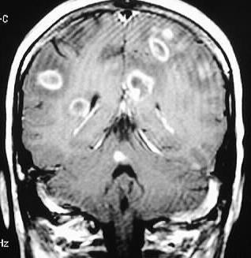

*Figure 4: CNS Toxoplasmosis-Ring enhancing lesions source: Gavin Udstuen,Neuroradiologyteachingfilles.com*

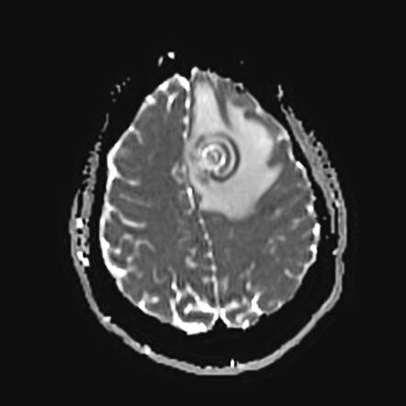

*Figure 5: Cerebral toxoplasmosis – concentric target sign. Source: Radiopaedia.org*

Lumbar puncture - Detection of Toxoplasma gondii by PCR in CSF has high specificity (96-100%) but variable sensitivity (50 to 98%). Thus, positive PCR establishes a diagnosis, but a negative one does not rule it out. Tachyzoites can also be seen in fluid specimens including centrifuged CSF. Stereotactic brain biopsy provides a definitive diagnosis by aiding in visualisation of the organism.

TREATMENT

|  |
| --- |
| **ACUTE INFECTION: Total duration is 6 weeks** |
| **Preferred regimen** : |
| Pyrimethamine 200mg PO once followed by dose based on body weight |
| ≤60kg − pyrimethamine 50mg OD + sulfadiazine 1000mg QID + leucovorin 10−25mg OD |
| >60kg − pyrimethamine 75mg OD + sulfadiazine 1500mg QID + leucovorin 10 −25mg OD |
| **Alternatives:** |
| Pyrimethamine plus clindamycin 600mg iv OD or PO QDS who are intolerant to sulfadiazine or do not  respond to preferred regimen |
| **Chronic maintenance therapy** |
| Preferred: pyrimethamine 25 − 50mg OD + sulfadiazine 2000 −4000 PO daily + leucovorin 10 −25mg OD |
| Alternatives: Clindamycin 600mg TDS +pyrimethamine 25 − 50mg OD + leucovorin 10 −25mg OD or TMP−  SMX DS 1 tablet BD. |
| Discontinuing maintenance therapy: Patient completed initial therapy, asymptomatic and CD4 counts  >200 for >6months in response to ART |

* PRIMARY PROPHYLAXIS: To prevent the first occurrence of toxoplasmosis infection, with Toxoplasma IgG antibody positive and CD4 count <100, a single strength tablet of TMP/SMX is given.
* SECONDARY PROPYLAXIS: To prevent recurrence of toxoplasma infection if CD4 count <200, Sulfadiazine/pyrimethamine and leucovorin is given and it shall be discontinued if CD4 count

>200 for 6 months.

### CYTOMEGALOVIRUS ENCEPHALITIS:

The Neurologic manifestations of CMV infection include ventriculo encephalitis, dementia, retinitis, polyradiculomyelopathies, peripheral neuropathies, ventriculo encephalitis which manifests with abrupt onset and rapidly progressive confusion and lethargy. Cranial nerve palsies most often involving oculomotor and facial nerve, focal neurologic deficits and cognitive decline can occur.

Neuroimaging: It shows non-specific increased T2/FLAIR signal in the white matter most prominent in periventricular distribution. If ventriculitis is also present, then enhancement of the ependymal surface and hydrocephalus may also be seen. No mass effect is produced. CSF analysis

for isolating CMV DNA by PCR or CMV antigen in the CSF is highly sensitive and specific for CMV neurologic disease in the brain.

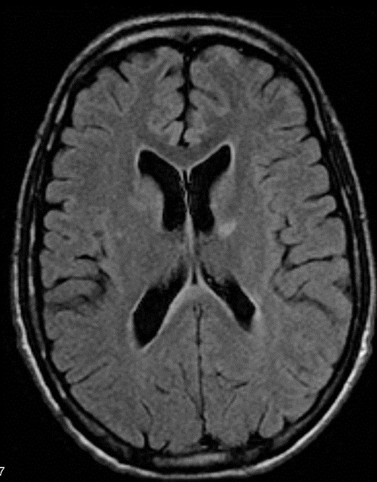

*Figure 6. Non-specific increased FLAIR signal in the white matter most prominent in periventricular distribution.*

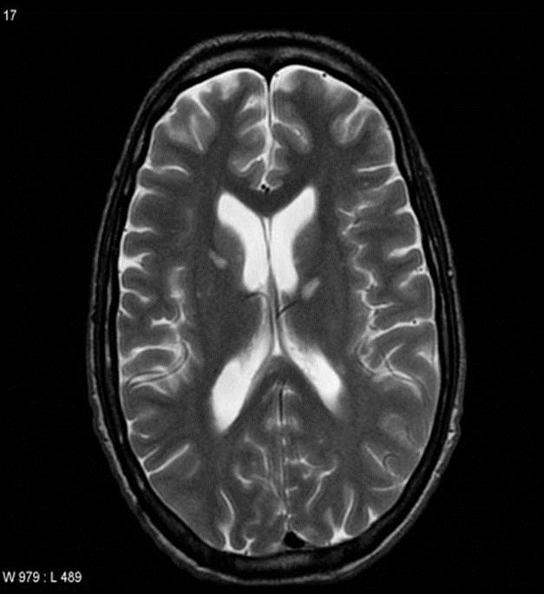

*Figure 7 Non-specific increased T2 signal in the white matter most prominent in periventricular distribution.*

# Treatment

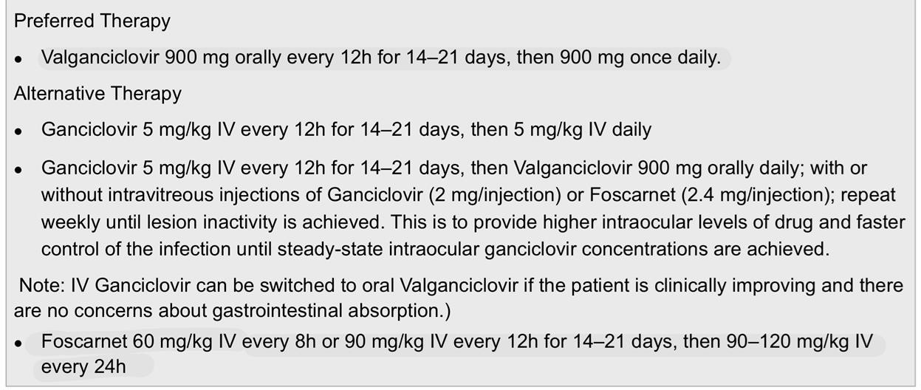

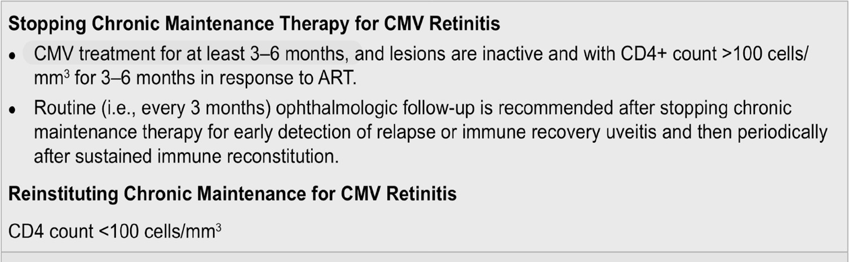

## SYNDROMIC APPROACH

Altered sensorium, convulsions, focal

neurological deficits?

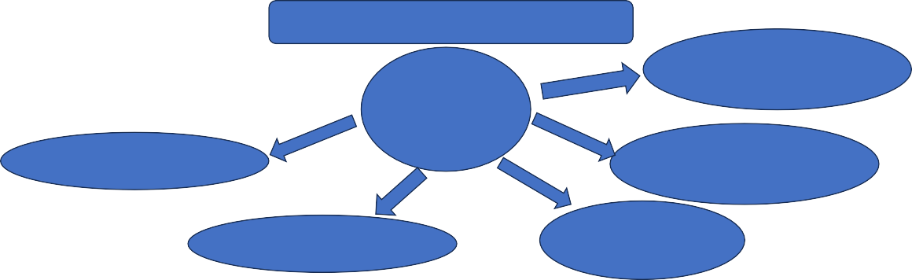

Focal neurological signs +

NEUROSYPHILLIS

**FOCAL**

**CEREBRAL LESIONS**

TUBECULOMAS

PMLE

CEREBRAL

TOXOPLASMOSIS

PRIMARY CNS

LYMPHOMA

*Schematic diagram 2 – Approach to focal cerebral lesions.*

### PROGRESSIVE MULTIFOCAL LEUKOENCEPHALOPATHY:

It is caused by a neurotropic human polyomavirus, John Cunningham virus (JC virus). It is a Debilitating demyelinating disease of CNS which has a subacute onset and progressive neuro deficit. The manifestations – headache, nausea, vomiting are not characteristic of the disease and if present should suggest alternative diagnosis. The disease is a late manifestation of AIDS seen in 1 to 4 % of patients with AIDS.

Clinical manifestations:

It manifests as focal neurological deficits, usually with insidious onset and steady progression. The time course of evolving demyelination, with clinical progression over several weeks, often provides a clue to diagnosis. It particularly affects specific lobes of brain causing specific symptoms like, involvement of occipital lobes leads to hemianopsia, involvement of Frontal and parietal lobes produces aphasia, hemiparesis and hemisensory deficits. Involvement of cerebellar peduncles leads to ataxia. Seizures can be seen in 20% of PML patients and is associated with lesions immediately adjacent to cortex.

Diagnosis:

T2/FLAIR hyperintense imaging shows multiple non enhancing white matter asymmetrical lesions with predilection for occipital and parietal lobes with no mass effect. JCV DNA by PCR can be done which has sensitivity of 76% with specificity close to 100%. In some instances, brain biopsy is required.

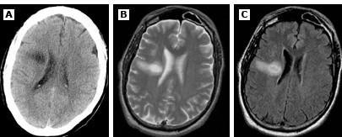

*Figure 8. T2/FLAIR hyperintense imaging shows multiple* ***non enhancing*** *white matter* ***asymmetrical*** *lesions with predilection for occipital and parietal lobes with no mass effect.*

Treatment: There is no effective antiviral therapy to prevent or treat JC virus infections or PMLE. The main approach is treatment to preserve immune function and reverse HIV associated immunosuppression with effective ART. In ART naive patients who are diagnosed with PML, ART should be started immediately. HIV associated PML sometimes complicated by clinically significant IRIS that may require administration of corticosteroid therapy. (7)

### NEUROSYPHILIS:

HIV co-infection makes syphilis more severe and increases the likelihood of syphilitic CNS involvement.

**EARLY NEUROSYPHILIS** has three forms.

**Asymptomatic neurosyphilis** – CSF abnormalities + serological evidence of syphilis - no neurological signs and symptoms. It occurs within weeks to months after infection.

**Symptomatic meningitis** – within first 2 years of infection but can occur years later. Headache, meningeal irritation and cranial nerve abnormalities (especially 2, 6, 7 and 8) can occur.

**Meningovascular syphilis**: few months to 10 years (average 7 years) after primary infection. Tthrombosis, ischemia, stroke involving brain and spinal cord can occur.

**Parenchymal neurosyphilis**: late stage.

**Syphilitic paresis (general paralysis of the insane, paralytic dementia, general paresis) :** Syphilitic paresis is now a rare presentation of neurosyphilis. It typically presents initially as a slowly progressive dementia with memory issues, unexplained personality changes, or a similar psychiatric disorder. (8) It is actually a progressive, chronic meningoencephalitis affecting the frontotemporal lobes. The

chronic inflammation results in meningeal fibrosis, small cerebral parenchymal plaques in the frontal and parietal cortices, and cortical atrophy with loss of cerebral function. The cumulative effect of strokes can also contribute to dementia. Associated findings may include hypotonia of the face and extremities, abnormal reflexes, and tremors. Late manifestations include tremors, dysarthria, hyperreflexia, myoclonic jerking, significant muscular deterioration, and seizures. In the terminal stage, the patient is typically bedridden, severely disoriented, cachectic, and status epilepticus may be present. Argyll Robertson pupils are characteristic of tertiary or late-stage syphilis and describe small bilateral pupils that constrict when focusing on a close object but sluggishly or not at all when exposed to bright light.

**Tabes dorsalis:** Tabes dorsalis or syphilitic myelitis results from the functional destruction of the posterior dorsal columns and dorsal nerve roots. The pathology develops from the localized cellular response to the inflammatory infiltrate produced due to the *T pallidum* infection, resulting from cytokine release, reactive oxidative agents, and neuronal damage from direct bacterial nerve invasion. Symptoms include an uncoordinated, unbalanced (ataxic) or stomping gait, sharp (lancinating or stabbing) pain, paresthesia, reduced reflexes, visceral crises (intermittent attacks of severe epigastric pain accompanied by nausea and vomiting), and loss of vibration and proprioception.

### CSF ANALYSIS

* Reactive VDRL
* Pleocytosis (usually 10-400 cells), lymphocytic
* Elevated protein (46-200) Treatment :

### Preferred:

Aqueous penicillin G 3 to 4 million units IV every 4 hours (or 18 to 24 million units continuous iv infusion) for 10-14 days. If possible, patient allergic to penicillin should be desensitized with penicillin.

### Alternative:

Penicillin G procaine 2.4 million units IM daily plus probenecid 500 mg orally four times daily, both for 10 to 14 days. Ceftriaxone 2 g IV daily for 10 to 14 days also to be given.

### PRIMARY CNS LYMPHOMA :

It accounts for approximately 10-15% of non-Hodgkin lymphomas (NHLs) in people living with HIV. The incidence has declined with widespread adoption of ART. Pathogensis is strongly linked to EBV infection, virtually detected in all patients with HIV related PCNSL. The Risk factors include low CD4 count, high HIV viral load, chronic co-infection with Hepatitis B, Hepatitis C infection. CD4 counts <50 cells per microLitre

Clinical manifestations: It manifests in acute to subacute presentation progressing over days to weeks. Mental status changes such as confusion, memory loss, impaired level of consciousness,

cognitive and behavioural disturbances and focal neurological deficits such as hemiparesis, aphasia and/or seizures, gait abnormality. Gait abnormality. Constitutional symptoms (systemic B symptoms) like fever, night sweats, weight loss occur in over 80 % patients.

Neuroimaging: The lesion can be solitary or multifocal. Around 40-80% are located in cerebral hemispheres, most commonly in frontal lobes, often periventricular in the white matter. On NCCT, lesions are isodense or hyperdense and often have surrounding hypodensity indicative of cerebral edema. On MRI, T1 weighted images - isointense or hypointense, and in T2 weighted images - hypo, iso or hyperintense. Post contrast enhancement is often irregular and inhomogeneous, whereas in non HIV PCNSL it is homogenously enhancing. This is due to more rapid growth with high degree of central necrosis. When lesions exhibit necrosis and/or haemorrhage, there may be a tumor associated ring like enhancement similar to that of toxoplasmosis. On MRI DWI sequences elevated signal on DWI and low signal in apparent diffusion coefficient maps (ADC) indicative of restricted diffusion within tumour mass.

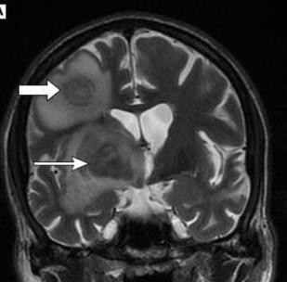

*Figure 9. T2 weighted images - hypo, iso or hyperintense.*

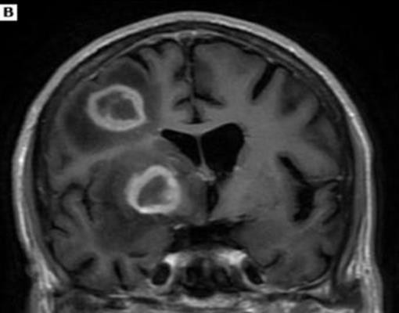

*Figure 10. T1 weighted images - isointense or hypointense.*

Other tests: Thallium SPECT and PET can distinguish CNS lymphoma from TE and other infections. Lymphoma has greater thallium uptake on SPECT and greater glucose and methionine metabolism on PET compared to others. Lumbar puncture should be performed in all patients with suspected HIV related PCNSL unless contraindicated by mass effect or Flow cytometry. Cytology shows the appropriate clinical context, positive CSF cytology and/or flow cytometry for lymphoma is considered diagnostic of HIV related PCNSL. EBV PCR can be done in selected case, when biopsy is contraindicated and cytology/flowcytometry uninformative, presence of EBV in CSF by PCR with radiographic features may be used to establish the diagnosis. Glucocorticoids should be avoided if possible before biopsy in suspected cases to maximize diagnostic yield.

Treatment: High-dose Methotrexate (HD-MTX; ≥ 3 g/m² body surface, given as a 4-hour IV infusion) is the most effective single active agent and a key component of all combination regimens. Outside of clinical trials and without subsequent consolidation, HD-MTX–based polychemotherapy should be administered over at least 6 cycles together with adequate supportive care (hydration, urine alkalinization, Leucovorin rescue, and monitoring of MTX levels). HD-MTX monotherapy achieves complete remissions in only 30% to 40% of patients and is comparatively well tolerated (moderate toxicity in <10% of cases) (29, 30). Adverse events include renal failure, blood count abnormalities, liver function abnormalities, pneumonitis, mucositis, and, in the long term, clinically relevant leukoencephalopathy, especially in older patients. Combination chemotherapies with other cytostatic agents capable of crossing the blood–brain barrier, for example high-dose Cytarabine (HD- arac), Thiotepa or Ifosfamide, increase the overall response rate along with increased toxicity, while treatment-associated mortality remains unchanged (9)

# SYNDROMIC APPROACH

Memory loss, behavioural disturbances, motor function deterioration

Gradual/slow onset

**HIV ASSOCIATED NEUROCOGNITIVE DISORDER**

*Schematic diagram 3 – HIV associated neurocognitive disorder.*

HIV associated neurocognitive disorders : It can develop in any stage of HIV. But in the era of HAART, 10-20% of HIV patients are affected by it.

Spectrum:

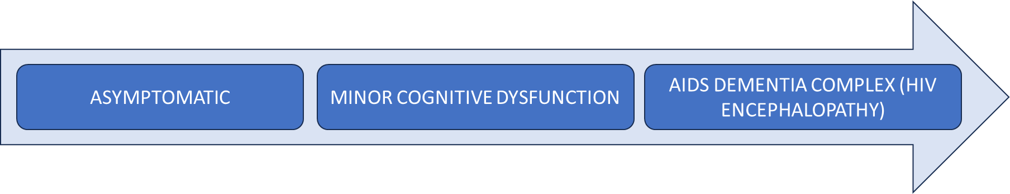

### HIV ENCEPHALOPATHY :

It occurs in advanced, untreated HIV infection with CD4 counts <200 and high plasma viral load.

* Cognitive impairment – Forgetfulness

Decreased attention and concentration. Inability to perform complex tasks.

Decreased sexual drive and disrupted sleep.

* Motor Dysfunction - Unsteady gait

Poor balance Tremor

* Vegetative state- Bowel/bladder incontinence

Unable to ambulate.

Lying in bed with vacant stare Clinical staging of HAND [Frascati criteria]

*Table 2*

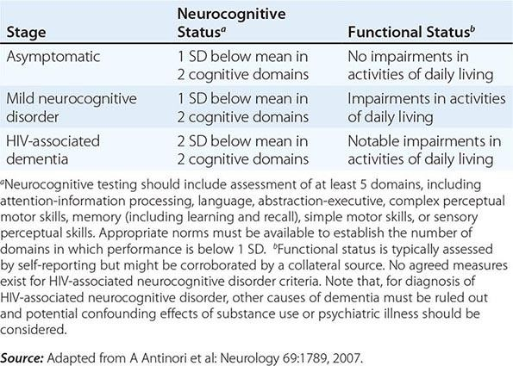

Neuroimaging: Cerebral atrophy is seen. It affects mainly basal ganglia (particularly caudate) and cortical regions. On MRI T2 weighted images, diffuse or patchy white matter hyperintensity, which may corelate with high levels of HIV in those regions of the brain.

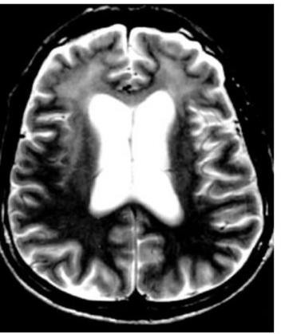

*Figure 11 On MRI T2 Weighted images, diffuse or patchy white matter hyperintensity, which may corelate with high levels of HIV in those regions of the brain.*

It is a Diagnosis of exclusion after ruling out confounding conditions (CNS OIs, neurosyphilis, substance abuse, toxic metabolic disorders, psychiatric diseases, age related dementias). ART is of benefit, improvement in neuropsychiatric test scores has been noted for both adults and paediatric patients. The drugs under trials area are Maraviroc (CCR5 antagonist), paroxetine, intranasal insulin.

### IRIS [IMMUNE RECONSTITUTION INFLAMMATORY SYNDROME]

It refers to the worsening of an existing clinical condition (paradoxical) or abrupt appearance of a new clinical finding (unmasking) following the initiation of ART. It occurs weeks to months following initiation. It is most common in patients with CD4 count <50 who experience rapid drop in viral load. It can be fatal. The types of IRIS include ‘Paradoxical’ in which worsening of symptoms, after an overwhelming response to a previously diagnosed opportunistic infection (OI) occur and the other type is ’Unmasking’ which reveals a previously occult OI.

Table 3. Difference between PML and PML - IRIS

|  |  |
| --- | --- |
| PML | PML - IRIS |
| Non enhancing lesion. | Contrast enhancement. |
| No edema / mass effect. | Perlesional edema / mass effect commonly  seen. |
| Usually CD4 count low / viral high. | CD4 count improving / viral load decreased. |

### References:

1. Zink WE, Zheng J, Persidsky Y, Poluektova L, Gendelman HE. The neuropathogenesis of HIV-1 infection. FEMS Immunol Med Microbiol. 1999 Dec;26(3–4):233–41.
2. Zayyad Z, Spudich S. Neuropathogenesis of HIV: From Initial Neuroinvasion to HIV-Associated Neurocognitive Disorder (HAND). Curr HIV/AIDS Rep. 2015 Mar;12(1):16–24.
3. Chander A, Shrestha CD. Cerebrospinal fluid adenosine deaminase levels as a diagnostic marker in tuberculous meningitis in adult Nepalese patients. Asian Pac J Trop Dis. 2013 Feb;3(1):16–9.
4. Taheri MS, Karimi MA, Haghighatkhah H, Pourghorban R, Samadian M, Kasmaei HD. Central nervous system tuberculosis: an imaging-focused review of a reemerging disease. Radiol Res Pract [Internet]. 2015 [cited 2024 May 23]; Available from: https://link.gale.com/apps/doc/A462298705/HRCA?u=anon~b1c1a98&sid=googleScholar&xid=89 656811
5. Williamson PR, Jarvis JN, Panackal AA, Fisher MC, Molloy SF, Loyse A, et al. Cryptococcal meningitis: epidemiology, immunology, diagnosis and therapy. Nat Rev Neurol. 2017 Jan;13(1):13– 24.
6. Perfect JR, Dismukes WE, Dromer F, Goldman DL, Graybill JR, Hamill RJ, et al. Clinical Practice Guidelines for the Management of Cryptococcal Disease: 2010 Update by the Infectious Diseases Society of America. Clin Infect Dis. 2010 Feb 1;50(3):291–322.
7. Tan K, Roda R, Ostrow L, McArthur J, Nath A. PML-IRIS in patients with HIV infection: Clinical manifestations and treatment with steroids. Neurology. 2009 Apr 28;72(17):1458–64.
8. Mukku S, Safal S, Pritam R, Nashi S, Nagarathna C, Pt S, et al. Neurosyphilis presenting as rapidly progressive psychosis & dementia – A forgotten entity. Asian J Psychiatry. 2019 Feb;40:103–6.
9. Von Baumgarten L, Illerhaus G, Korfel A, Schlegel U, Deckert M, Dreyling M. The Diagnosis and Treatment of Primary CNS Lymphoma. Dtsch Ärztebl Int [Internet]. 2018 Jun 22 [cited 2024 Jun 4]; Available from: https://[www.aerzteblatt.de/10.3238/arztebl.2018.0419](http://www.aerzteblatt.de/10.3238/arztebl.2018.0419)