**The** **Population** **of** **~~Leaf~~****~~Beetles~~****~~(~~*Leptualaca*** ***fassicollis*** **thoms;** **Coleoptera~~:~~** ; **Chrysomelidae~~)~~** **and** **~~Flower~~****~~Thrips~~****~~(~~*Megalurothrips*** ***usitatus*** **Bagnall;** **Thysanoptera~~:~~** ;**thripide~~)~~** **on** **Pigeonpea** **under** **the** **Influence** **of** **Plant** **Density** **and** **Planting** **Date** **in** **a** **Rain** **Forest** **Zone,** **Nigeria**

# Abstract

~~Pigeonpea field trial was conducted at the Postgraduate Teaching and Research Farm, Department of Crop Science and Technology, Federal University of Technology, Owerri Imo State in April, July and October 2009 and repeated in 2010, t~~ To determine the best plant density and date of planting early maturing pigeonpea in relation to thrips infestation (ICPL 84023) for optimum performance in the field. Experiment was laid out in a 3 x 4 factorial and treatments consisted of four plant populations with density of 190,474 plants ha-1 (15 cm x 35 cm), 125,000 plants ha-1 (20 cm x 40 cm), 80,000 plants ha-1 (25 cm x 50 cm), 55,556 plants ha-1 (30 cm x 60 cm), with three planting dates, April (early season), July (Mid-season), and October (late season), 2009 and 2010. The result of the effects of plant densities and planting dates on population of ~~pigeonpea leaf beetles (~~*Leptualaca* *fassicollis* thoms and ~~flower thrips (~~*Megalurothrips* *usitatus* Bagnall~~)~~ showed that pigeonpea planted at higher plant density of 190,474 plants ha-1 had higher population of *L.* *fassicollis* and flower thrips compared with pigeonpea plants at lower densities

**Keywords:** Leptualaca fassicollis, *Megalurothrips* *usitatus,* population, planting dates, plant density.

# Introduction.

Pigeonpea (*Cajanus* *cajan* (L.) Millsp) belongs to the genus *Cajanus*, subtribe *cajanae*, tribe phaseoleae and family fabaceae (Baldev 1988). Many species of closely related genus Atylosia successfully cross with pigeonpea (Van der Maesen 1980). All the evidence gathered to date points to Peninsular India as the place where pigeonpea originated (Van der Maesen 1989). It is believed that pigeonpea moved from India, its primary center of origin and diversity to Eastern Africa over 1,000 years ago (Van der maesen 1980) with Kenya as the world’s second largest producer of pigeonpea from an estimated area of 100,000 hectares annually (Onim 1981). Pigeonpea production in Africa contributes 9.3 % of the world production, which is very little compared to the 74 % contribution from India alone (Damaris 2007).

Also in Nigeria pigeonpea seed has been recommended as an alternative to maize, soybean meal or groundnut cake in the diet of broilers (Amaefule & Obioha 2001, Onu & Okongwu 2006), pullet chicks (Amaefule & Obioha 2005, Amaefule *et* *al*. 2006) and layers (Agwunobi 2000). Cultivation of pigeonpea has been reported in Nigeria (Aiyeloja & Bello 2006). Insect pests (leaf beetles, thrips and among other major pests, the podsucking bugs, and podborers are the major factor limiting the production of pigeonpea in Nigeria with 100% thrips relative abundance throughout the sowing dates in 2009 and 2010 and black leaf beetles (Leptualaca fassicollis) relative abundance of 25-40% during April and July planting in 2009 and 2010 (Dialoke *et* *al*. 2013)

Careful selection of sowing dates makes it possible to ensure that the vulnerable stage in a crop does not coincide with the period of pest abundance. Also for many pest and crop systems, planting date will dictate whether or not a pest will be present in high numbers to attain pest status. For some insect pests, planting a crop early can be a practical solution to their management.

In Nigeria, with regards to planting of early maturing pigeonpea cultivar, information on the appropriate time to plant the cultivar in the rainforest zone of South Eastern Nigeria is lacking, Moreover, information on the production and insect pest problems of the improved pigeonpea is also lacking in Nigeria. Hence the objective of this research is to determine the effect of plant density and planting dates on population of ~~pigeonpea leaf beetles (~~*L.* *fassicollis* and ~~flower thrips (~~*M.* *usitatus*~~)~~ in a rainforest tropical Zone of Imo State, Nigeria

# Materials a~~A~~nd Methods.

Field research was carried out in the Postgraduate Teaching and Research Farms, Department of Crop Science and Technology, Federal University of Technology, Owerri, Imo State Nigeria. Experiment was carried out in the months of April, July, and October, 2009 and repeated in 2010. The research field is located in the rain forest

belt, longitude 7° 12′ E and latitude 5° 27′ N of equator. The annual monthly temperature, rainfall, and relative humidity prevalent in the study area in year 2009 and 2010 were obtained from Federal Ministry of Aviation Owerri Meteorological Station, Imo State (Table 1).

An area of land measuring 11.0 m × 10.0 m (110 m2) was mapped out at the Postgraduate and Research Farms, Department of Crop Science and Technology, Federal University of Technology, Owerri during each sowing time (7/4/2009 for April, 7/7/2009 for July, and 7/10/2009 for October planting and repeated same time in 2010. The area was cleared of grasses, tilled manually, measured with tape.

The area was divided into 3 replications with 1m pathways between replications. Each replication comprised 4 plots of uniform size. 3.0 m × 3.6 m (10.8 m2), with different plant spacings of 15 cm x 35 cm, 20 cm x 40 cm, 25 cm x 50 cm, 30 cm x 60 cm and separated by 1 m pathway between plots. Each plot contained 5 ridges with 12 rows of pigeonpea per plot to give a total of 60 plants per plot. The improved pigeonpea cultivar (ICPL 84023) used was seed-dressed with Apron-star before sowing at the rate of 2 kg of seeds per a sachet, to control fungal diseases. Planting was done using 3 seeds per hole at each sowing time and later thinned down two weeks after planting (WAP) to one stand per hole to give the plant population per hectare for different crop arrangements as shown below:

1. 55,556 plants ha-1 at spacing of 30 cm x 60 cm
2. 80,000 plants ha-1 at spacing of 25cm x 50 cm
3. 125,000 plants ha-1 at spacing of 20 cm x 40 cm
4. 190,474 plants ha-1 at spacing of 15 cm x 35 cm

The experimental Design was a 4 x 3 factorial laid down in a Randomized Complete Block Design (RCBD) with

(3) replications. All the treatments were randomly allocated in the plots.

Coleoptera: From early morning between 6.30 -7.70 am, the population of small black leaf beetles (*Leptualaca* *fassicollis*) were assessed from four plants per row selected randomly from the three middles ridges giving a total of 12 sampled plants per plot. During vegetative phase plants were carefully examined for the presence of *Leptualaca* *fassicollis*. The *Leptualaca* *fassicollis* counts were expressed as the number of pest per one metre row per plot. The collected leaf beetles were preserved with 75% ethyl alcohol, and identified using insect samples from the Insect museum of the Institute of Agricultural Research, (IAR) ABU, Zaria

Thysanopteran pests**:** Pigeonpea thrips were sampled by randomly removing 20 flowers from plants located within the two outer rows per plot. The flowers were placed in vials containing 30-70% alcohol and taken to the laboratory where they were dissected and number of thrips counted with hand lens and identified using specimen samples from the Laboratory of Department of Crop Science and Technology, Federal University of Technology, Owerri.

# Statistical Analysis.

The *L.* *fassicollis* and Thrips (*M.* *usitatus*) population data collected were subjected to analysis of variance using Genstat Discovery Edition 3 (2009). Data on insect counts were subjected to square root transformation before analysis of variance was carried out, while treatment means was separated by the use of Least Significant Difference at 5 % level of significance.

# Cultural Practices:

Weeding was done manually with the use of hoe at two weeks and six weeks after planting. There was no application of either organic or inorganic fertilizers to the pigeonpea plots in all the experiments as the area was left fallow for over 5 year.

# Results~~.~~

Table 1, revealed the average weather conditions prevalent in the study area during 2009 and 2010 planting seasons. The highest amount of rainfall, relative humidity and number of rain days occurred in July while April and October received low rainfall, relative humidity and number of raindays with fluctuations in temperature.

The result of the effect of plant population and planting date on the population of ~~pigeonpea leaf beetles (~~*Leptualaca* *fassicollis*~~)~~ during 2009 and 2010 is presented in figures 1 and 2. At 21 DAP and 35 DAP in 2009, there was significantly high population of ~~leaf beetles~~ *L.* *fassicollis* at higher plant densities of 125,000 plats/ha and 190,474 plants/ha, while at lower plant densities of 80,000 plants /ha and 55,556 plants/ha there were reduced population of leaf beetles.

The population of the ~~leaf beetles (~~*L.* *fassicollis*~~)~~ was high on the leaves at 35 DAP and 42 DAP during April and July planting, but were absent on the leaves during October period.

In figure 2a, during 2010, plants at high plant densities recorded higher population of beetles at 28 DAP compared with plants at lower plant densities. The beetles during April planting reached peak population at 21 DAP and decreased at 28 DAP and 35 DAP (figure 2b). There was absence of the beetles on the leaves during

July and October planting.

The effect of plant density and planting dates on the population of ~~flower thrips (~~*Megalurothrips* *usitatus*~~)~~ during 2009 planting is presented in figure 3 (a and b). The plant densities from 49 DAP to 63 DAP had no significant effect (p<0.05) on the population of pigeonpea flower thrips (figure 3 (a). However at 70 DAP there was significant reduction (p<0.05) of the flower thrips which later increased slightly. Planting date significantly (p<0.05) affected the population of flower thrips (figure 3 (b). More thrips were observed in April and October at 63 DAP and July at 77 DAP while October planting had low population of thrips.

The results of plant density and planting date and their effects on the population of *M.* *usitatus* in 2010 is presented in figure 4 (a and b). Again, plant densities showed no significant influence (at p>0.05) on populations of flower thrips at 49 DAP, 56 DAP, and 63 DAP, though low plant density of 55,556 plants-1 recorded lower population of flower thrips compared with other plant densities.

April planting also recorded the highest population of thrips followed by July at 56 DAP and 63 DAP while October planting had the least thrips population.

# Discussions

The amount of rainfall in April favoured the population build up of the ~~small black leaf beetle (~~*L*. *fassicollis*~~)~~ and ~~flower thrips (~~*Megalurothrips* *usitatus*~~)~~, while, high rainfall in July discouraged the survival and development of the pests. This finding agreed with Dialoke *et* *al*. (2013) who worked on improved pigeonpea (ICPL 84023) in rainforest zone of Imo State and recorded high number of variegated grasshopper nymphs in April with absence of the pests in July and October.

The result of the occurrence of leaf beetles (L. *fassicollis*) on vegetative parts shows high population of leaf beetles at high density plants and reduced population of the beetles at low density plants. Plants at high density due to competition for food, light, and space produce very tender leaves which attracted much population of the leaf beetles. Plants at low density, due to less competition and longer time to forage for nutrients produced lignified/thick leaves probably may not be palatable to the leaf beetles as food. Sorenson (2003), Wolda & Denlinger (1994) earlier high population of leaf beetles on tender leaves of tropical plants at higher density.

From the result of pests on vegetative parts, short duration pigeonpea could be grown in this locality, at low plant density of 55,556 plants/ha to minimize the population of grasshopper nymphs and leaf beetles.

The leaf beetles in 2009, April and July planting were high and were absent during October planting. During 2010, the leaf beetles population was high in April but were absent during July and October plantings. This absence in July and October could be due to seasonal variation and distribution of temperature and rainfall which must have imposed restriction to their feeding and reproduction. This result was supported by Janzen (1973) who recorded high population of foliage insects on tropical vegetations.

The results on the flower thrips in 2009, *Megalurothrips* *usitatus* on pieonpea at different plant densities was not-significant at 63 DAP being the peak period of flowering and variations in thrips population existed as days after planting increased. In 2010, there was slight reduction of thrips at peak flower period of 63 DAP, with plants at low density having low thrips population. At peak flowering, thrips population was at the increased proportion probably due to existence of abundant food supply. This observation supported the earlier work of Malik & Hafeez (2003), Panicker & Patel (2001) who recorded low population of onion thrips at increased row plant spacing. Also Dialoke (2013) working on early maturing pigeonpea cultivar ICPL 84023 in Owerri, Nigeria reported high population of *Zonocerus* *variegatus* on pigeonpea plants at higher densities compared with plant at lower densities.

In 2009 and 2010, the population of *M.* *usitatus* increased significantly in April, followed by July and at low population in October. In April 2009, average rainfall of 232.27 mm must have encouraged the build up of *M.* *usitatus* population on pigeonpea. This finding was in agreement with Morsello *et* *al.* (2008) who reported that during April, and May, movememt of *Frankliniella* *fusca* Pergande on tobacco and *Thrips* *tabaci* on onions increased tremendously. Also Dialoke & Ezueh (2003) observed significant population of *Z.* *variegatus* on short duration pigeonpea cultivars at Nsukka during April planting.

At average rainfall of 394.07 mm (2009) and 511.13 mm (2010) during July, the population of *M.* *usitatus* dropped and this information was supported by earlier findings of Ibrahim & Adesiyun (2009) that infestation of thrips on onion plants was significantly lower during rainy and cool seasons than during dry and hot seasons. This was attributed to high larval mortality and slower population growth rates (Kirk 1997). In 2010 planting season, high rainfall and high relative humidity caused significant reduction in the population of *M.* *usitatus* than the population experienced in 2009 planting. The population of *M.* *usitatus* during October representing late season planting, was very low and this could be due to poor flower production brought about by water stress/harsh weather.

Earlier, Nakamura and Numata (2006) reported that changes in temperature affect the seasonal abundance of

*Dolycoris* *baccanum* (L.) Heteroptera: Pentatomidae). Akhilesh & Parasnath (2003) have also reported high

population of *M.* *pustulatus* on pigeonpea flowers at the onset of rainy season.

# Conclusion and Recommendation

The small black leaf beetles (*Leptualaca* *fassicollis*) occurred more on pigeonpea at higher plant densities than on plants at lower plant densities during April and July planting seasons and could not be observed on pigeonpea during October planting. Thrips populations were observed on the plants throughout the planting seasons (April, July and October). Greater population of the thrips was observed in April planting followed by October planting and least with July planting season. To avert pest problems on pigeonpea in this zone, the planting of the early maturing cultivar in July by farmers is highly recommended. July periods seemed to exhibit adverse environmental effects on the survival of these pests, hence their population were at the reduced level compared with April October planting seasons.

Table 1. Summary of average monthly rainfall, temperature, relative Humidity, Number of rain days, from a maximum of three months (from planting to harvest)

|  |  |  |  |  |  |
| --- | --- | --- | --- | --- | --- |
|  | Cropping season Rainfall | Maximum | Minimum | Relative | No. of Rain |
| **2009** (mm) | Temp.(0c) | Temp.(0c) | Humidity (%) | days(day) |
|  | Early cropping  April 232.30  Mid-cropping  July 394.10 | 34.67  34.33 | 15.33  19.00 | 79.67  86.33 | 11.33  18.33 |
|  | Late-cropping  October 218.83 | 31.64 | 18.67 | 78.00 | 7.67 |
|  | Mean 281.74 | 33.55 | 17.67 | 81.33 | 12.44 |
|  | **2010**  Early cropping  April 237.90  Mid-cropping | 33.17 | 22.47 | 87.09 | 10.67 |
|  | July 511.13  Late-cropping  October 155.33 | 33.60  35.33 | 21.03  19.33 | 89.67  81.00 | 14.00  7.33 |
|  | Mean 301.45 | 34.03 | 20.94 | 85.92 | 10.67 |

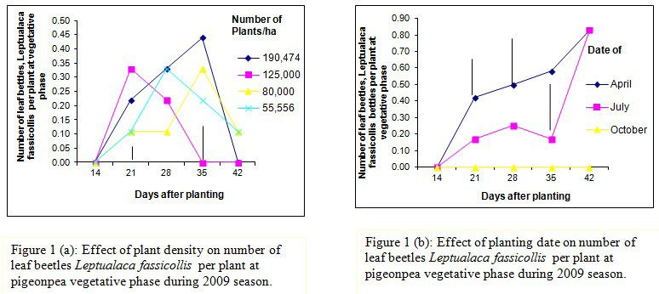

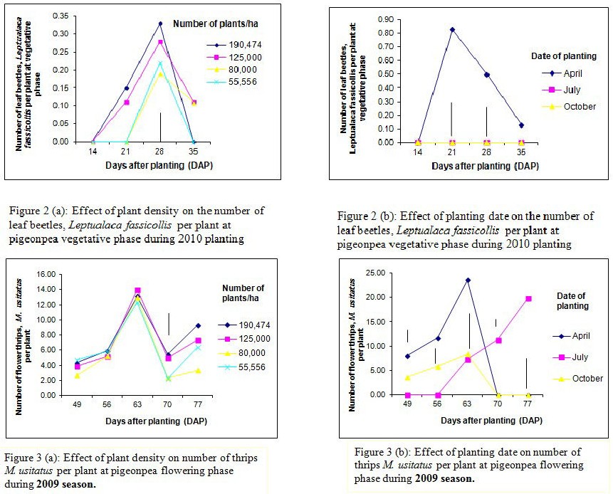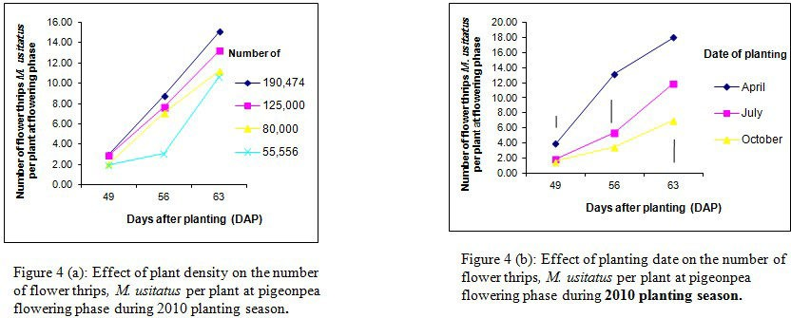

# References

Agwunobi, L.N. (2000). Effect of feeding heat treated soybean (Glycine max) and pigeonpea (Cajanus cajan) as major sources of proteins on layer performance. *Global* *Journal* *of* *Pure* *and* *Applied* *Science,* *6:* *1-3.*

Akhilesh, K., & parasnath, D. (2003). Pest complex and their population dynamics on an early variety of pigeonpea UPAS-120 at varanesi. *Ind.* *J.* *Ent.* *65* *(4):* *453-460.*

Aiyeloja, A.A. & Bello, O.A. (2006). Ethnobotanical of common herbs in Nigeria.A case study of Enugu State, Educational Research and Review, 1: 16-22.

Amaefule, K. U., Ironkwe, M. C. & Ojewola, G. S. (2006). Pieonpea (*Cajanus* *cajan*) seed meal as protein source for pullets. 1. Performance of grower pullets fed raw or processed pigeonpea seed meal diets.

*International* *Journal* *of* *Poultry* *Science,* *5(1)* *60-64.*

Amaefule, K. U. & Obioha, F. C. (2005). Performance of pullet chicks fed raw or processed pigeonpea (*Cajanus* *cajan*) seed meal diets. Livestock Research for Rural Development,17:33.http:

//[www.cipav.org.co/Irrd/Irrd17/03/amae](http://www.cipav.org.co/Irrd/Irrd17/03/amae) 17033.htm.

Amaefule, K.U. & Obioha, F. C. (2001). Performance and nutrient utilization of broiler starters feed diets containing raw, boiled or dehulled pigeonpea seeds (*Cajanus* *cajan*). *Nigerian* *Journal* *of* *Animal* *production,* *28:* *31-39.*

Damaries, A.O. (2007). The potential pigeonpea (Cajanus cajan (L.) Millsp) in Africa. *Natural* *Resources* *forum,* *U.K,* *31:* *297-305.*

Dialoke, S.A. & Ezueh, M.I. (2003). Population dynamics of insect pests on short duration pigeon pea cultivar at three planting dates Under Nsukka agro-ecological zone of Nigeria. *Journal* *of* *Agriculture,* *Forestry* *and* *the* *social* *sciences* *(JOAFSS)* *Vol.1* *No.1,* *ISSN* *1597-0906,* *pp.* *6-16.*

Dialoke, S.A. (2013). The population trend of *Zonocerus* *variegatus* Fab. (Orthoptera: Pyrgomorphidae) on pigeonpea vegetative phase at different plant spacing and time of sowing in Imo State, representing the South Eastern Zone of Nigeria. International Journal of Agric. and Rural Dev. Vol.16(1): 1451-1455

Dialoke, S.A., Peter-Onoh, C.A., Ibeawuchi, I.I., Ngwuta, A.A., Kabuo, N.O., Cookey, C.O., Kayagha, R. E., Bosah, B.O., Egho, E.O. & Akalazu, J.N. (2013). The insect orders and relative abundance (R.A) of major pest species on early maturing pigeonpea cultivar (*Cajanua* *cajan* (L.) Millsp in Imo State, Nigeria. International Journal of Agric. and Rural Dev. Vol.16 (1): 1436-1444

Genstat Release Edition 3, (2009). Free version of Statistical package. htt://discovery.genstat.co.uk

Gopalan, C., Rama sastris, B.V. & Balasubramanian, C.S. (1984). Nutritional value of Indian Foods, Hyderabad, India: *India* *institute* *of* *nutrition,* *pp.204.*

Ibrahim, N.D. & Adesiyun, A. A. (2009). Effects of staggered planting dates on the control of *thrips* *tabaci*

Lindeman and yield of onion in Nigeria. *Africa* *Journal* *of* *Agricultural* *Research* *vol.,4(1)* *pp.* *033* *–* *039.*

Janzen, D.H. (1973). Samples of tropical foliage insects: effects of seasons, vegetation types, elevation, time of the day and insularity. *Ecology* *54(3):* *687-708.*

Kirk, W.D.J. (1997). Distribution abundance and population dynamics. In: T.Lewis (ed.), thrips as crop pests. CAB, Oxon., United Kingdom, pp.217-257.

Malik, M.F., Nwaz, M. & HafeeZ, Z. (2003). Inter and intra row spacing effects on things (thrips spp) pop – onion (*Allium* *cepa*). *Asian* *J.* *plant* *Sci.* 2(9), 713-715.

Nakamura, K. & Numata, H. (2006). Effects of photoperiods and temperature on the induction of adult diapause in *Dolycoris* *baccanum* (L.) Heteroptera: Pentatomidae) from Osaka and Hokkaido, Japan. *The* *Japanese* *journal* *of* *Applied* *Entomolgy* *and* *Zoology* 41 (1): 105-109.

Onim J.F.M. (1981). Pigeon pea improvement in Kenya, Pages 427-436 in proceedings of international workshop on pigeon pea, 15-19 Dec., 1980, ICRISAT Center, India. Vol.1 Patancheru, A.P.502 324, India: ICRISAT.

Onu, P. N. & Okongwu, S.N. (2006). Performance characteristics and nutrient utilization of starter broilers fed raw and processed pigeonpea (*Cajanus* *cajan*) seed meal. International Journal of poultry science, 5(7): 693-697. Panicker, B.K. & Patel, J.B. (2001). Population dynamics of different species of thrips on chilli, cotton, and pigeonpea. *Ind.* *J.* *Entomol*., 63: 170-175.

Sorenson, M., (2003). New records of feather wing beetles (coleopteran: Pullidac) in North America. Coleopterists Bulletin 57: 369-381.

Van der Maesen, L.J.G. (1989). *Cajanus* *cajan* (L.) Millsp. In: Van der Maesen, L.J.G. and Somaatmadga, S (Editors). Plant Resources of South East Asia No 1. Pulses, Pudoc., Wageningen, The Netherlands, pp.39-42.

Van der Maesen, L.J.G. (1980). Pigeonpea: origin, history and evolution, taxonomy. In: Y.L. Nene, S.H. Hill, and V.K.Sheila. The pigeonpea, Cab international, Wallingford, U.K. p.15-46.

Wolda, H. & Denlinger, D.L. (1984). Diapause: a large aggregation of a tropical beetle. Ecological Entomology 9: 217-230.