# Planning the Manufacturing Process Using Feature Recognition

## ABSTRACT

In the context of fierce market competition, companies are forced to continuously optimize their product portfolios, both in terms of design and functional performance, and by adopting advanced manufacturing technologies. This requirement is aimed at achieving high-performance standards while reducing production costs and time. The close integration of CAD and CAM applications has driven research in the field of geometric entity recognition (Feature Based Modeling - FBM), with the aim of automating various stages of the product life cycle, from design and manufacturing, to production planning, assembly and quality management. To make the production process more efficient, an important research direction is the automatic generation of machining programs for numerical control (CNC) machine tools, directly from the characteristics of the constituent geometric entities of the part. Through a case study, this paper explores the methodology for generating CNC machining programs using the Entity Recognition (FBM) functionalities offered by the Siemens NX platform.

*Keywords: [feature recognition manufacturing, machining, cnc program].*

**1. INTRODUCTION**

Ever-changing competitive pressure, forces companies to constantly review their requirements for product design, product complexity, quality standards, durability, environmental impact, delivery times and more. This dynamic has imposed the need to identify advanced technologies that facilitate both accelerated product development and more efficient manufacturing at higher-quality standards.

The exponential progress in information technology has facilitated the emergence and development of integrated software suites dedicated to the complete management of product lifecycle management (PLM). These systems cover all stages, from the initial conception and detailed design, manufacturing process planning, and resource management to decommissioning and component recycling or reuse strategies.

In the design phase, using CAD (Computer-Aided Design) platforms provide the designer with an advanced set of tools for 3D parametric modeling, finite element analysis (FEA), and automatic generation of technical documentation. Design parameter changes are automatically propagated throughout the model, allowing the rapid exploration of a broad spectrum of constructive variants and their optimization according to criteria such as mechanical performance, production costs, manufacturability (DFM - Design for Manufacturing), and assembly (DFA - Design for Assembly). Integration with CAM (Computer-Aided Manufacturing) systems allow automatic generation of CNC machining paths, optimizing manufacturing times and minimizing human errors. This integrated approach contributes to reducing Time-to-Market and increasing product competitiveness.

The concept of computer-aided manufacturing (CAM - Computer-Aided Manufacturing) has multiple interpretations. CAM includes both program generation for numerically controlled machine tools (CNC), flexible manufacturing cells (FMS - Flexible Manufacturing Systems), and industrial robots, as well as the computer-aided design of production processes (CAPP - Computer -Aided Process Planning), where all aspects of the process are controlled and optimized, from the selection of materials and the definition of technological operations to resource planning and quality control.

In contemporary industrial practice, the term CAM primarily refers to the utilization of specialized software applications for the generation, simulation, and verification of CNC machining paths, as well as for the real-time control and monitoring of manufacturing equipment, including CNC machine tools, industrial robots, and flexible manufacturing systems. These applications facilitate the optimization of cutting parameters, the reduction of processing times, the minimization of errors, and the enhancement of precision and quality in finished products.

Implementing CAM solutions contributes significantly to reducing product development time, increasing the manufacturing process's efficiency and improving the processing quality. This is possible thanks to the tool path simulation capability, which allows the CNC program to be checked and optimized before actual execution on the machine tool. The simulation allows the detection of potential collisions, the optimization of cutting parameters, and the validation of program correctness, minimizing the risk of errors and scraps and increasing productivity and the quality of the finished product.

The tight integration of CAD and CAM applications has become a necessity in today's industry context, as it eliminates errors associated with the use of neutral data transfer formats (e.g., STEP, IGES), maximizes productivity, improves product quality, reduces development time, and provides increased flexibility in the manufacturing process. This integration enables a two-way and continuous flow of data between the design and manufacturing environment, ensuring information consistency and optimization of the entire process [1] (Gideon H, 2001).

The evolution of computer-aided engineering software has stimulated intense research in the field of automatic recognition of geometric and technological entities (feature recognition). This key concept aims to automate the various activities involved in making a product, from design and manufacturing, to production planning, assembly and quality management. Entity recognition enables the automatic generation of machining sequences, the optimization of cutting parameters and the increase of the efficiency of the entire manufacturing process.

In order to optimize the production process, the automatic generation of CNC programs was approached based on the recognition of geometric and technological entities (features) that define the part. This approach, based on feature recognition, enables the efficient creation of CNC programs directly from the 3D CAD model, eliminating the need for manual programming, and thus reducing the manufacturing setup time.

The paper [2] (Razak M, 2012) presents a methodology and a case study for automatically generating CNC programs for various geometric entities, such as slots, holes, pockets, etc. The proposed method is based on identifying and classifying these geometric entities, followed by generating CNC macros containing the processing sequences specific to each type of entity. The use of macros allows the automation of repetitive operations and increases the flexibility of the CNC programming process. This approach leads to a significant reduction in programming time and an improvement in the quality and consistency of the generated CNC programs.

Article [3] (Razak M, 2013) addresses the generation of parametric CNC programs based on the automatic recognition of geometric and technological entities (feature recognition) from the CAD model. The authors propose a specific model for FBM (Feature-Based Manufacturing), which allows the creation of CNC programs that are flexible and adaptable to changes in the part's design. The parameterization of CNC programs allows a quick adaptation to dimensional or geometric variations of the part without the need for manual reprogramming.

Researchers in [4] (Mäntylä M, 1996) analyze the role of modeling and the influence of product characteristics on the manufacturing process. The study highlights the importance of a complete and unambiguous representation of product features in the CAD model to facilitate the automation of manufacturing planning processes (CAPP) and CNC program generation. Proper product modeling enables effective communication between the design and manufacturing stages, helping to reduce errors, optimize processes, and increase the quality of the finished product.

The authors of the paper [5] (Shukla A, 2016) propose a manufacturing model based on the recognition of geometric and technological entities, focusing on aspects related to productivity and cost. The study includes comparative experiments between the proposed model and a commercial CAM system, evaluating the performance of CNC program generation time, machining time, and associated costs. This approach allows an objective evaluation of the benefits of the proposed model in the context of an existing industrial system.

Article [6] (Zhenkai L, 2007) presents a method of sequencing machining operations (machining process planning) based on rules (knowledge-based rules) and geometric reasoning (geometric reasoning rules). The authors develop a set of rules for the automatic generation of processing sequences, rules validated through a concrete case study. This approach combines human experience with computer processing capabilities to generate optimal machining sequences, considering geometric, technological, and economic factors.

Feature Recognition (FR) is a crucial technology in modern digital manufacturing that facilitates the integration of CAD, CAPP, and CAM systems. Although deep learning methods have made significant progress in recognizing complex and geometrically intersecting features, the use of synthetic data to train neural networks, due to the high cost of labeling accurate CAD models, leads to decreased performance on real data. To address these challenges, the BrepMFR network was developed in [7] (Zhang, S, 2024) which transforms B-rep models into graphs by integrating the local geometric shape information and global topological relationships. It uses a graph neural network based on the transformer architecture and attention mechanisms to extract advanced semantic representations necessary for processing feature recognition. With a two-stage training strategy based on transfer learning and a diverse synthetic dataset including 24 typical features, BrepMFR offers top performance and superior generalization on real CAD models, proving effective in practical engineering scenarios mechanics.

Integrating CAD, CAPP, and CAM systems is significantly improved by deep learning-based Automatic Feature Recognition (AFR) methods that outperform traditional approaches in handling complex features. However, these methods face two significant challenges: the loss of geometric and topological information from the original B-Rep models caused by voxelized or point-based representations and the limitation of supervised methods in recognizing novel features absent from predefined datasets. To solve these problems, the study [8] (Ma, L, 2024) proposes the Multidimensional Attributed Face-Edge Graph (maFEG) graphics language, which preserves the geometric and topological details of CAD models, and the Sheet-metalNet graphics neural network, capable of efficiently interpreting these graphs. A three-step incremental learning strategy (pre-training, replay, and knowledge distillation) enables adaptation to dynamic datasets. Experimental results show that Sheet-metalNet outperforms existing AFR methods, successfully recognizing new features and maintaining high performance.

Recent advances in artificial intelligence have opened new perspectives for the automation of machining feature recognition (Machining Feature Recognition - MFR). Among the proposed methods, those based on deep learning using neural networks have achieved remarkable results. In this context, the Edge Adjacency Graph Instance Segmentor (EAGIS) method is proposed in [9] (Li, Y., 2024), which combines a graph neural network with a graph data structure that represents the topological and geometric relations of the edges. Evaluations on the open-source synthetic dataset MFInstSeg show that EAGIS provides comparable performance to existing deep learning-based methods while having a significantly reduced number of trainable parameters in its architecture.

Machining Feature Recognition (MFR) is essential for integrating CAD, CAPP, and CAM systems. Traditional rule-based method Trained on a large labeled dataset, ASIN demonstrated high performance in accurate feature recognition and segmentations are difficult to apply to the intersecting features. In recent years, methods based on machine learning have been proposed, but many of them are complex and time-consuming, or they only roughly locate features without accurately segmenting them, which affects the planning of subsequent processes. In order to solve these problems in [10] (Zhang, H, 2022), the Associatively Segmenting and Identifying Network (ASIN) is proposed, based on point cloud data, which performs three tasks: groups parts face with high similarities in processing characteristics, predicts the semantic class (ex . hole, pocket) for each face and identify the basic faces of the features. Combining these results, ASIN segments and identifies processing characteristics, including intersecting ones.

Machining feature recognition (MFR), which extracts manufacturing information from the geometry of CAD models, is crucial in computer-aided process planning (CAPP). Classical rule-based methods face difficulties with their complex and intersecting features. Deep learning provides solutions, but sometimes loses geometric and topological details through representations such as voxels or point clouds. In article [11] (Wu, H , 2024) the proposed solution, the AAGNet graph neural network, uses assigned adjacent graphs (gAAG) to maintain topological, geometric, and extension information from the B-Rep models. AAGNet performs semantic, instance, and basic face segmentation by identifying processing features and their associated faces. Tested on the MFCAD, MFCAD++, and MFInstSeg datasets, AAGNet demonstrates superior accuracy to existing methods and is a promising solution for MFR in CAPP.

Deep learning methods have demonstrated the ability to recognize shape features (e.g., machining features) in CAD models but have difficulty handling intersecting features and leveraging geometric and topological information from the boundary representation (B-Rep) of the CAD models. Study [12] (Colligan, A. R., 2022) proposes a new hierarchical graph representation of B-Rep shapes, which encodes information about the surface geometry and topology of faces in the B-Rep. To learn from this representation, a hierarchical graph convolutional network, named Hierarchical CADNet, was created that outperforms other state-of-the-art neural architectures in identifying features, including intersecting ones. Hierarchical CADNet provides significant improvements in accuracy, especially for complex CAD models, demonstrating its effectiveness in machining feature recognition.

With these aspects in mind, tight integration of computer-aided design (CAD) with CAM applications is an essential requirement in today's industrial context. FBM (Feature-Based Manufacturing) plays a crucial role in this integration process, as it allows the association of design and manufacturing data with geometric and technological entities (features) that contain relevant information for the sequencing of the technological process. Grouping entities with common characteristics helps reduce machining time by optimizing toolpaths and minimizing the number of tool changes.

Specialized studies highlight an increased interest in the development of advanced algorithms for the automatic recognition of geometric and technological entities from CAD models. The main goal of this research is to automate the process of generating CNC programs, which will directly reduce the time required for manufacturing preparation and increase the efficiency of the production process.

The present paper presents a methodology for generating machining programs for numerically controlled (CNC) machine tools using the entity recognition (FBM) functionalities provided by the Siemens NX software platform. This study demonstrates the practical applicability of the FBM concept within an industrial CAD/CAM system, providing an efficient solution for automating CNC programming.

**2. methods**

Currently, most CAM systems allow the import of 3D part models in neutral formats such as STEP, Parasolid, or IGES. The traditional approach to generating G-code for CNC machine tool machining using a CAM application generally follows the steps illustrated in figure 1.

Recognition of geometric and technological entities (feature recognition) is an advanced technique implemented in modern CAD/CAM systems. It allows the automatic identification of a part's geometric features (holes, channels, pockets, flat surfaces, etc.) directly from its 3D CAD model. This information is then used to automatically generate the machining paths and NC code needed to control CNC machine tools in manufacturing.

Siemens NX is a leading integrated CAD/CAM software platform, offering powerful 3D modeling tools and advanced solutions for programming CNC machine tools with up to 5 axes. Its capabilities include support for High-Speed Cutting (HSC), hybrid manufacturing, and programming of industrial robots for machining operations. It also offers CNC programming automation functionality through predefined templates [7]. These templates contain optimized machining strategies for different types of geometric entities, such as holes, pockets, steps, slots, and user-defined irregular entities, simplifying and speeding up the creation of CNC programs. The process involves going through the following stages:

* Automatic identification of geometric entities relevant for processing (holes, channels, pockets, etc.) by analyzing the 3D CAD model.
* Association of entities with specific processing operations (drilling, milling, turning, etc.) for each identified entity;
* Generating optimal toolpaths, thereby optimizing manufacturing time and costs based on previously associated entities and operations.
* The virtual simulation of the machining process offers the possibility to check potential collisions, programming errors, and the efficiency of the generated trajectories.



**Fig. 1. Main steps for getting G code using CAM application**

Recognition of geometric entities (FBM) in Siemens NX is possible (available) both for native CAD files created in the NX platform and for files imported from other CAD systems using neutral formats such as STEP or IGES. The user can select the appropriate template for the entity type and specific machining parameters, thus quickly generating an optimized CNC program.

After the automatic recognition of geometric and technological entities, the extracted information is processed according to the rules and filters defined in the processing knowledge base (Machine Knowledge). This process allows the automatic identification of the necessary technological operations, the selection of suitable tools, the determination of the optimal cutting parameters and the generation of machining trajectories for each tool. Figure 2 schematically illustrates the workflow for automating the generation of CNC programs.



**Fig.2. Block diagram for automatic generation of CNC programs**

The central components of the automation process of mechanical processing within the FBM (Feature-Based Machining) module are the Manufacturing Knowledge Editor (MKE) and the Manufacturing Knowledge Library (MKL). The Manufacturing Knowledge Editor is the software tool that defines and implements machining strategies based on the information and rules stored in the Manufacturing Knowledge Library. The MKL library contains rules regarding the types of geometric entities recognized, the available machining strategies, the tools used, and their dimensions for each technological operation.

The recognized geometric entities are validated according to the rules defined in MKE (Manufacturing Knowledge Editor). These rules allow the automation of the machining process by selecting the necessary operations and tools. Knowing the material of the part and the tool, the system determines the optimal cutting parameters. Finally, an optimal tool path is generated for each recognized geometric entity.

Preliminary part model analysis is important for developing an effective production plan. This analysis must include the following aspects:

* Machine tool: its selection is made considering its capabilities and specifications.
* Cutting tools and fixtures: number and types of tools required, fixtures).
* Processing operations: type of operation (roughing and finishing), Number and sequence of processing operations, cutting parameters for each operation, processing additions, etc.
* The specifications of the geometric parameters of the cutting tools: the length of the tool, the length of the cutting edge, the number of teeth, the tolerances of the tool, the connection radii, the orientation of the axis of the tool, etc.
* Specifications of the semi-finished product: (quality of the material of the semi-finished product, type of semi-finished product (cast, laminated, etc.), dimensions, tolerances, etc.

Siemens NX offers several options for feature recognition, including feature identification, parametric recognition, legacy hole recognition, legacy face and pocket recognition, and manual recognition (manual recognition). Of these, generic identification and parametric recognition (figure 3) are most commonly used, with NX recommending the use of the parametric recognition method.

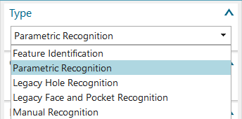

**Fig. 3. Types of feature recognition.**

The NX Feature Based Machining (FBM) module enables the recognition of geometric entities and the automatic generation of CNC programs for various manufacturing processes, including turning, milling and wire EDM (EDM). Regarding milling operations, FBM supports multiple strategies, such as Hole Making, Floor/Wall Milling, Cavity Milling, Thread Milling, Hole Milling Milling), Planar Milling, Plunge Milling, Z-Level Milling, Fixed Axis Surface Contouring), Variable Axis Z-Level Milling and Variable Axis Surface Contouring. An important advantage of FBM in NX is the ability to automatically recognize geometric entities without user intervention [13] (Tom van ‘t Erve, 2015).

**3. EXPERIMENTAL**

The workpiece (figure 4) is a rectangular plate used in a pneumatic clamping system. It has several rectangular recesses of various sizes and is characterized by a concentric border recessed around a central deeper cavity. Each rectangular socket was tapered or rounded at its corners and contained a small central pierced hole. Several circular recesses are also present on the plate, some with concentric, recessed borders for twisting the seals. The holes, present in large numbers on the plate, serve to fix the plate in the assembly of which it is a part but also to facilitate the flow of air. The processing is carried out in a milling center with HAAS numerical control. The processing operations consists of flat milling, pocket milling, centering, drilling, and reaming operations. The piece is made of 7075 aluminum alloy.

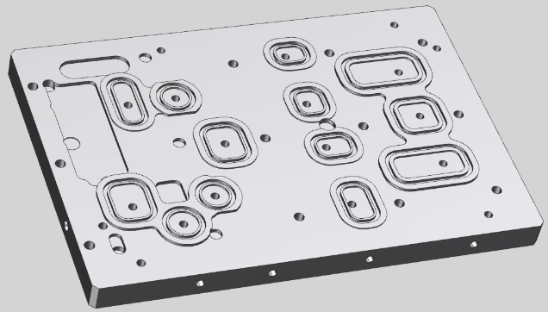

**Fig. 4. The workpiece to be processed**

After establishing the coordinate system of the part and defining the blank, the feature identification process is as follows: Their recognition can be fully automatic or assisted by the user, allowing the explicit selection of the types of targeted features (figure 5).

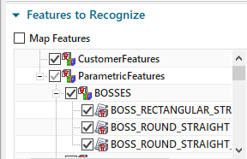

**Fig. 5. Features to be recognized.**

To increase efficiency, additional restrictions can be imposed, such as limiting the search area to specific surfaces or defining the processing direction. The features identified in the model are shown in figure. 6.

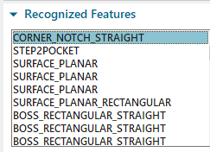

**Fig. 6. Recognized features.**

The next step involved creating a machining process for each feature. Knowing the material of the part and the dimensions of the recognized features (figure 7).

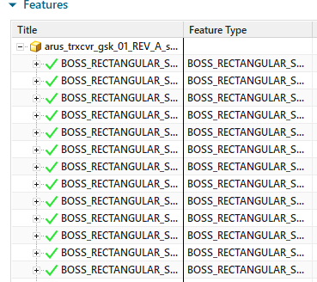

**Fig. 7. Feature navigator**

The system consults technological databases (knowledge libraries) to identify the necessary machining operations (figure 8).

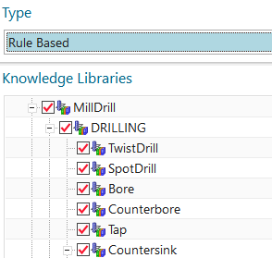

**Fig. 8. The machining operations.**

Tool types and sizes were automatically selected, cutting parameters were determined, and a sequence of operations was established (Figure 9).

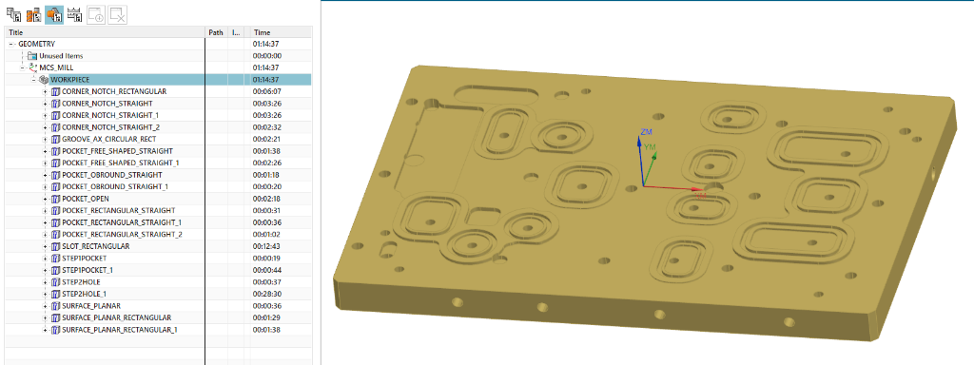

**Fig. 9. Sequencing of operations using FBM.**

Toolpaths were generated automatically (figure 10), and a 3D simulation of the machining is shown in figure 11.

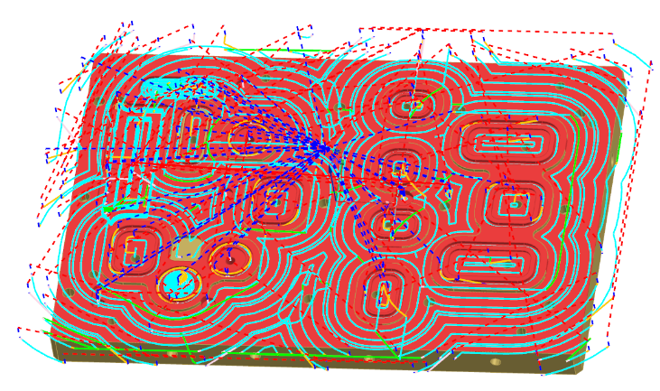

**Fig. 10. The cutting paths for each tool.**

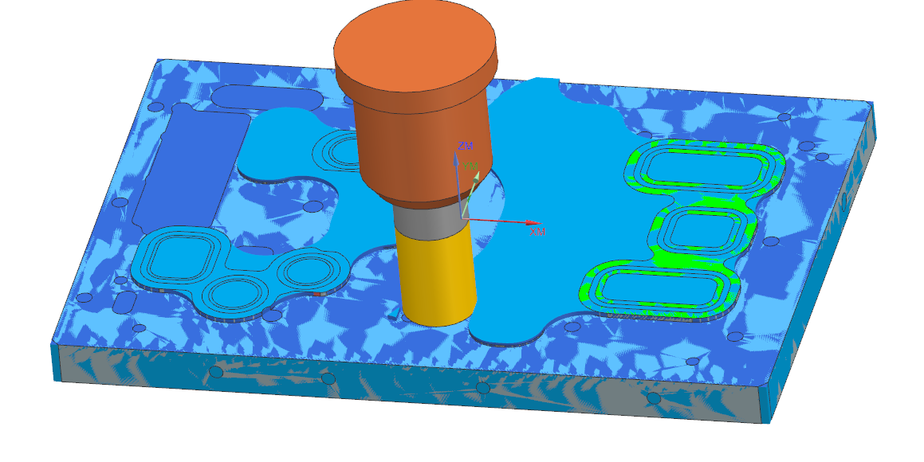

**Fig. 11. The 3D simulation of the cutting paths.**

The CNC program was generated by post-processing for a HAAS machining center. Before execution on the CNC machine, the program was checked using a back plotter (figure 12).

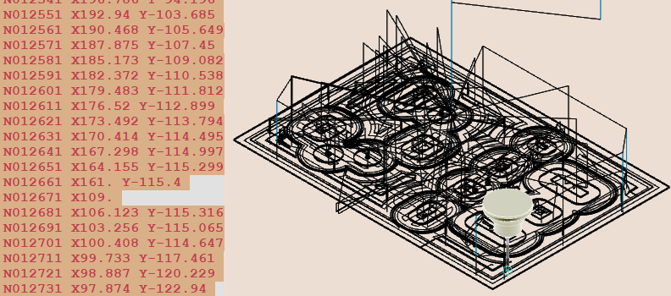

**Fig. 12. The simulation of the CNC program.**

The structure of a manually made CNC program for machining the same part is presented for comparison. The timed time to create the CNC program using FBM lasted 18 min, and the time to create the program in classic mode, using the functions and operations of NX, lasted 47 min.

Also, the estimated time for processing the part using the FBM functions is 1h: 15 min, while the estimated time using the classic production system is 2h and 12. The final piece is shown in figure 13

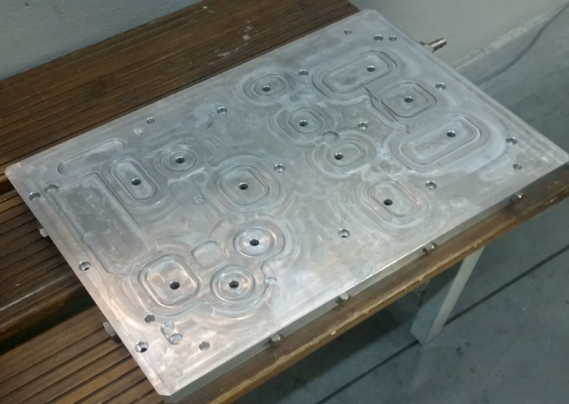

**Fig. 13. The machined part.**

**4. DISCUTIONS**

In the first part, a short discussion is presented regarding the difference between the time (29 min) of creating CNC programs using FBM (18 min) and the programming time using the traditional work mode in Siemens NX CAM (47 min).

Feature Based Machining is a modern approach that fundamentally transforms how CNC machine tool programs are created and managed. This technological leap in CAM programming reduces programming time and optimizes the entire manufacturing process. Some of the features that make CNC programming using FBM more advantageous than the traditional method are:

• Automation of the recognition process

• Implementation of processing strategies

• Parameterization and reuse of processing operations

• Optimization of toolpaths and tool changes

• Standardization and consistency in manufacturing

• Manage changes and updates

• Integrated tool management

• Manufacturing validation

• Integration with production systems

*Automation of the recognition process* through the FBM's ability to automatically identify the part's geometric elements (features). The system recognizes holes, pockets, channels, and other characteristic geometric elements. This automation eliminates the sometimes-considerable time required for manual geometry selection and, more importantly, significantly reduces the risk of human error in the feature identification process.

*Automatic implementation of processing strategies* for each type of identified feature. These strategies are the results of validated tests and represent the most effective processing methods for the respective features. Eliminating the need to manually select operations dramatically reduces programming time and ensures process consistency.

*Parameterization and reuse* of the machining process by using machining rules. Once defined, these rules can be applied quickly and efficiently to all families of similar parts. Geometric changes are automatically propagated into the machining program, eliminating the need for manual reprogramming and significantly reducing overall programming time.

*Optimizing toolpath* by using algorithms to calculate optimal routes between features. This optimization substantially reduces dead times and idle tool travel. Furthermore, the system organizes the order of operations to minimize tool changes, contributing to overall process efficiency.

*Standardization and consistency* mean that the FBM implements the best processing practices, reducing variations that can occur in manual programming. This leads to consistent quality of the generated programs and the resulting parts.

*Manage 3D model changes and updates*, which eliminates the need for manual reprogramming and dramatically reduces the time required to implement changes, providing outstanding flexibility in the production process.

The system's *integrated tool management* automatically selects the optimal tools for each feature and optimizes the use of available resources. This automation reduces setup time and streamlines the tool change process.

*FBM manufacturing validation* uses verification and validation algorithms, which identify potential collisions and problems before actual execution. The system ensures process traceability and reduces document preparation time.

*Integration with production systems* with standardized databases for tools and cutting parameters. This integration eliminates time searching and manual data entry, ensuring consistency with company standards.

Discuss the difference between the machining times for the same part using a program made with the traditional working method in Siemens NX CM and a program made with Feature Based Machining (FBM), highlighting the essential technical aspects.

The difference of 53 minutes between the machining time using the traditional program (by manually selecting the machining operations and setting the parameters of the operations) and the one made using Feature Based Machining can be attributed to several factors:

* Optimization of Tool Paths
* Organization of processing operations
* Advanced machining strategies
* Efficient management of cutting depths
* Global coordination and optimization

*Toolpath Optimization* refers to how FBM manages toolpaths by implementing sophisticated optimization algorithms that analyze and calculate the most efficient paths between different features of the part. This leads to a substantial reduction in idle tool travel, an aspect that is difficult to optimize in manual programming, even for experienced programmers.

Intelligent *organization of FBM processing operations* by implementing optimization algorithms that can group operations in a logical and efficient manner. For example, the system can automatically identify all operations that use the same tool and group them accordingly, thus minimizing time wasted with tool changes. In contrast, in manual programming, this optimization is more difficult to achieve, often resulting in redundant tool changes that consume valuable time.

*Advanced machining strategies* are another prion modality at which FBM excels. The system uses predefined and optimized processing strategies for each specific type of feature. They also automatically calculate and adjust the cutting parameters (feed speeds, revolutions, cutting depths) for each particular situation. In manual programming, these parameters are often chosen based on personal experience and may be sub-optimal.

*Managing cutting depths* means the FBM system automatically calculates the optimal number of passes and their depth, ensuring a balance between efficiency and safety. Manual programming tends to use more conservative values, which, while safe, can result in longer processing times.

The FBM system *coordinates and optimizes the machining process globally* because its algorithms can identify and implement overlaps between operations where possible. The system automatically eliminates redundant operations and optimizes the overall processing technology. This macro-level optimization capability is difficult to achieve in manual programming.

**5. CONCLUSIONS**

One of the major advantages of FBM is its ability to be applied to a wide range of parts from various industries, such as molds, machinery, and automobiles. Predominant features machined through FBM include pockets, holes, and slots, which are frequently encountered in parts of these fields.

In addition, standard features such as holes and pockets appear in many parts, regardless of their complexity. This versatility makes the FBM an efficient and adaptable solution capable of meeting the varied demands of modern manufacturing. By automating the programming process and using machining rules based on best practices, FBM not only saves time and resources but also improves the quality and accuracy of the manufacturing process.

Feature Based Machining represents a superior solution to manual programming, offering substantial benefits in terms of efficiency, consistency and quality. Extensive automation, process optimization and system integration make FBM an ideal choice for modern manufacturing, especially in the context of series manufacturing and parts with complex geometries. The cumulative benefits of this technology translate into significant reductions in total manufacturing time and improved quality of finished products.

Feature-Based Machining (FBM) technology contributes significantly to reducing the time required to create CNC programs, automate machining processes, and eliminate repetitive programmer tasks. By using "standardized" machining processes, FBM not only speeds up the programming process but also minimizes human error, ensuring high consistency in CNC program generation.

The observed 53-minute time difference in the machining process is not accidental but a direct result of the FBM system's superior optimization capabilities. This demonstrates that while human experience remains valuable, modern automated systems can achieve levels of efficiency that exceed the capabilities of conventional manual programming.

**Disclaimer (Artificial intelligence)**

Author(s) hereby declares that NO generative AI technologies such as Large Language Models (ChatGPT, COPILOT, etc.) and text-to-image generators have been used during the writing or editing of this manuscript.

**References**

1. Gideon H 2001 Handbook of Production Management Methods Butterworth-Heinemann
2. Razak M., Jusoh A., Zakaria A., 2012 Feature-Based Machining using Macro, International Journal of Mathematical, Computational, Physical, Electrical and Computer Engineering Vol:6, No:8 World Academy of Science, Engineering and Technology
3. Razak M.A., Ibrahim M.R., Sulaiman S., Jusoh A., Zakaria A. 2013 Parametric Programming in Feature-Based Machining International Journal of Engineering & Technology Sciences (IJETS) 1(4): 218-225 ISSN 2289-4152 Academic Research Online Publisher.
4. Mäntylä M., Nau D., Shah J. 1996 Challenges în feature-based manufacturing research, Communications of the Association for Computing Machinery, Volume 39 Issue 2, Feb. 1996, pp 77-85
5. Shukla A, Jani S.S, Acharya G.D. 2016 Developing a Cam Estimator for feature based machining time estimation în VB environment International Journal of Advance Research and Innovative Ideas în Education, Vol-2 Issue-3 2016, pp 527-535.
6. Zhenkai L, Lihui W 2007 Sequencing of interacting prismatic machining features for process planning Computers in Industry Volume 58, Issue 4 (2007) pp 295–303, Science Direct Elsevier
7. Zhang, S., Guan, Z., Jiang, H., Wang, X., & Tan, P. (2024). BrepMFR: Enhancing machining feature recognition in B-rep models through deep learning and domain adaptation. Computer Aided Geometric Design, 111, 102318. https://doi.org/10.1016/j.cagd.2024.102318
8. Ma, L., & Yang, J. (2024). Adaptive recognition of machining features in sheet metal parts based on a graph class-incremental learning strategy. Scientific Reports, 14(1), 1-23. https://doi.org/10.1038/s41598-024-61443-2
9. Li, Y., Li, E., Lenover, M. et al. Edge adjacency graph and neural network architecture for machining feature recognition. Int J Adv Manuf Technol (2024). https://doi.org/10.1007/s00170-024-14903-y
10. Zhang, H., Zhang, S., Zhang, Y., Liang, J., & Wang, Z. (2022). Machining feature recognition based on a novel multi-task deep learning network. Robotics and Computer-Integrated Manufacturing, 77, 102369. https://doi.org/10.1016/j.rcim.2022.102369
11. Wu, H., Lei, R., Peng, Y., & Gao, L. (2024). AAGNet: A graph neural network towards multi-task machining feature recognition. Robotics and Computer-Integrated Manufacturing, 86, 102661. https://doi.org/10.1016/j.rcim.2023.102661
12. Colligan, A. R., Robinson, T. T., Nolan, D. C., Hua, Y., & Cao, W. (2022). Hierarchical CADNet: Learning from B-Reps for Machining Feature Recognition. Computer-Aided Design, 147, 103226. https://doi.org/10.1016/j.cad.2022.103226
13. Tom van ‘t Erve 2015 NX CAM Feature-Based Machining Introduction Siemens PLM Software