Original Research Article

**Inhibitory effect of *Asparagus officinalis* extract on allergic asthma in Swiss albino mice**

|  |
| --- |
| ***Abstract***  ***Purpose:*** *To determine the inhibitory effect of Asparagus officinalis extract (AOE) on allergic asthma induced by carrageenan (CGN).*  ***Methods:*** *Forty male mice were divided into 4 groups: the 1st group was untreated control; 2nd group was treated orally and daily with 500 mg/kg AOE for one week; the 3rd group was treated with single dose of CGN 2 %w/v (200 µL/mice) intraperitoneally and left for one week; while the 4th group was treated first with CGN as in 3rd group and treated with AOE as 2nd group after CGN injection for one week. After treatment, the animals were sacrificed and blood samples were subjected to white blood cell count. IL6 and TNF-α were measured in the lung homogenate while histopathological analysis was performed for lung samples.*  ***Results:*** *A single dose of CGN resulted in significant increase in white blood cell (WBC) count and pro- inflammatory cytokines (IL6 and TNF-α; p < 0.05). Histopathological analysis showed severe lung alterations such as accumulation of infiltration cells that blocked alveolar sacs, over-secretion of collagenous fibers, extracellular matrix and hyaline membranes. Moreover, treatment with AOE after CGN injection significantly reduced WBC count (p = 0) and pro-inflammatory cytokines (IL-6 and TNF-α) that were raised by CGN (p = 0). Furthermore, AOE reduced the pathological signs that were induced by CGN leading to improvement of lung function and reduction of collagenous fibers and hyaline membranes.*  ***Conclusion:*** *Asparagus officinalis extract reduces the allergic effect and lung pathological signs induced by CGN. Since AOE inhibits the production of inflammatory cytokines, it has the potential to be developed as a source of active pharmaceutical ingredients for the management of lung and airway injury.*  ***Keywords:*** *Carrageenan, Asparagus officinalis extract, Lung, Allergy, Cytokines* |
|  |

# INTRODUCTION

Allergic asthma is a chronic inflammatory alteration of lung airways stimulated by immune- mediated reactions [1]. The most represented symptoms of asthma are cough, chest tightness,

*Trop J Pharm Res, May 2024; 23(5):* 825

shortness of breath and wheezing [2]. Many common triggers for allergic asthma are environmental and some others look chemical in nature. Natural triggers include pollen, dust mites, mold and insects while chemical triggers may be fumes, cigarettes and smog [3]. Chronic

inflammatory allergic asthma is accompanied by histopathological signs such as metaplasia and hyperplasia of bronchioles epithelia and goblet cells, and mucus hypersecretion. Additionally, allergic asthma activates T helper cells (Th2) as a result of allergens which in turn produces extreme secretions of many cytokines such as interleukins-4, 5, 6, 9, 13 (IL-4, IL-5, IL-6, IL-9, IL-

13) [4].

Nevertheless, many experimental allergens have been used in various animal models of allergic asthma in laboratory settings such as ovalbumin, mite allergens, cockroach extracts and cotton dust, the choice depending on the condition [5]. The present study used carrageenan (CGN) as an asthmatic allergen. Many studies have used CGN in animal models to induce inflammation, edema, hyperalgesia and erythema following subcutaneous paw injection. CGN is red seaweed extract, it has been used in many industries as a gelling and thickening factor. CGN consists mainly of polysaccharides macromolecules that are composed of d- galactose and 3,6-anhydro-d-galactose units with binding sulfate group [6].

*Asparagus officinalis* belongs to the Asparagaceae family and is a medicinal vegetable cultivated in Europe and Asia. It is used in everyday life as a component of soups, salads and vegetable dishes [7]. *Asparagus officinalis* or sparrow grass as is known in folk medicine is a herbaceous and perennial climber plant, its height may reach 100-150 cm, and it is used as a spring vegetable [8]. Different parts of the plant contain bioactive components such as oligosaccharides, steroidal saponins, flavonoids and amino acid derivatives. Findings have reported that *Asparagus officinalis* rhizome has an impact on inflammatory activities via reduction of arthritic activity induced in rat paws by CGN [9]. *Asparagus officinalis* also reduce liver inflammation induced by CGN and pro- inflammatory cytokines [10]. The present work aimed to investigate the effect of *Asparagus officinalis* extract on asthma induced by CGN in male albino mice.

# EXPERIMENTAL

## Materials

Powder of Carrageenan was obtained from Fit Lane Nutrition (USA). Extract of *Asparagus officinalis* rhizome was purchased from Solaray Company (USA).

## Animals

Male albino mice (40) aged 14 weeks with an average weight of 30 ± 5 g were used in the study. The Animal House of Zoology, Department of Science College, King Saud University, Riyadh provided the animals for this research. The animals were housed under controlled temperature (23 ± 5 ℃) and 12 / 12 h light-dark cycle, and had free access to clean water and commercial diet. The study was approved by the Institutional Review Board (IRB), Committee of Ethics, King Saud University, Riyadh, Saudi Arabia (approval no. KSU-SE-22-02), and followed international guidelines for animal studies.

## Study protocol

Male Swiss albino mice were divided randomly into four groups, 10 in each group. First group was untreated control, 2nd group was treated orally and daily with 500 mg/kg AO extract for one week, 3rd group was treated with single dose of carrageenan 2 %w/v (200 µL/mice) intraperitoneally and left for one week, 4th group was treated firstly with CGN as in 3rd group and treated with AOE as 2nd group after CGN injection with one week [10].

## Sample collection

At the end of the experiment, animals were anesthetized using carbon dioxide (CO₂) flow [10]. Blood samples were collected via cardiac puncture, then drained into EDTA tubes and subjected to leucocytic count. Lung samples were removed and cut into small pieces, fixed in

10 % neutral buffered formalin (NBF) for histopathological investigation.

## Biochemical analysis

Lungs were homogenized in cold PBS with a ratio of 1:3 for 3 min then centrifuged for 15 min at 4 oC twice then filtered, the supernatant was separated and stored at -80 oC till assay.

## Determination of inflammatory cytokines

Tumor necrosis factor-alpha (TNF-α) and Interleukin 6 (IL6) were determined in the lung homogenate using commercial kits of enzyme- linked Immunosorbent assay (ELISA) [11].

## Histopathological analysis

Lung samples were fixed in 10 % formalin and then dehydrated with ethanol; they were embedded in paraffin wax, then sectioned into 6-

µm size samples, and stained using hematoxylin and eosin, Masson’s trichrome, and PAS stain. Photomicrographs of the sections were taken using Nikon-Japan. Stained lung sections were subjected to pulmonary histopathological scoring system [12].

## Statistical analysis

Data was represented as mean ± standard error of the mean (SEM), the differences between the treated and control mice were evaluated using one-way ANOVA, and the differences were statistically significant when *p* ≤ 0.05.

# RESULTS

## AOE lowered WBCs count raised by CGN

Mice group treated with AOE showed insignificant change in WBC count compared to control group. Whereas, group treated with CGN revealed significant (*p* < 0.05) WBCs increase compared to control group. However, pre- treatment with AOE before CGN treatment resulted in significant WBC decrease (*p* < 0.05) compared to the group treated with CGN only (Figure 1).

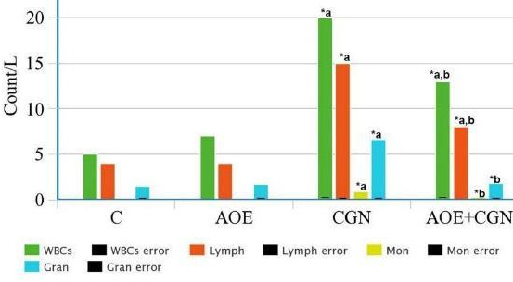

**Figure 1:** WBC count in all the groups. ***Key:*** The Bar graph showed a significant decrease (*p* < 0.05) in WBC count following treatment with AOE previously increased by CGN

AOE treatment revealed no significant change in cytokines (TNF-α and IL6) levels compared to

control levels. Meanwhile, treatment with single- dose CGN resulted in significant (*p* < 0.05) increase in TNF-α and IL6 levels compared to control levels. Furthermore, treatment with AOE before CGN caused significant decrease (*p* < 0.05) in TNF-α and IL6 cytokines levels compared to group treated with CGN alone.

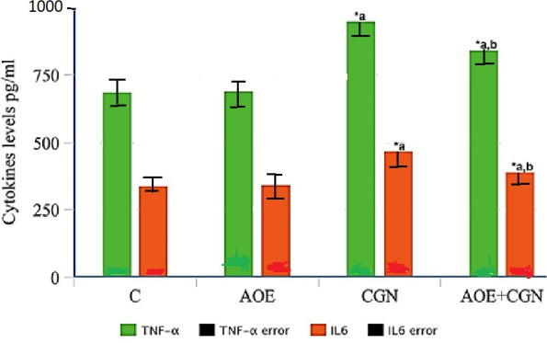

**Figure 2:** Estimation of pro-inflammatory cytokines. ***Key:*** Bar graph shows significant decrease of pro- inflammatory cytokines by pre-treatment with AOE that was increased by CGN

Untreated control mice lungs showed normal structure of well-opened bronchioles and alveolar sacs besides thin interalveolar septa, with no depositions of collagenous fibers (Figures 3A, 4A) with less percentage and optical density of Masson’s trichrome stain distribution (Figure 5), also it revealed normal content of extracellular matrix in the interalveolar septa and around alveoli but no hyaline membranes (Figure 6 A) with less percentage and optical density of PAS stain distribution (Figure 7), in addition to having the lowest pathological score (Table 1). Additionally, the lungs of mice group treated with AOE resembled same results of untreated control (Figure 3 B, Figure 4 B and Figure 6 B). Whereas, the lungs of mice treated with single dose of CGN exhibited severe pathological alterations manifested by accumulation of inflammatory great aggregations leading to wide thickness of interalveolar septa and blockade of alveolar sacs (Figure 3 C).

## Pulmonary histopathological scoring system criteria

|  |  |  |  |
| --- | --- | --- | --- |
| **Score** | **Vascular alterations** | **Vascular and alveolar changes** | **Bronchiole alterations** |
| 0 | Few | Few | None |
| 1 | Hemorrhage and mild RBC obstruction | Patchy edema, mild inflammation | Mild infiltration |
| 2 | Moderate hemorrhage and obstruction | Moderate alveolar septa thickening, moderate infiltration | Moderate infiltration, dysplasia of lining epithelia, hyaline membranes |
| 3 | Diffuse hemorrhage  and intense obstruction | Severe alveolar septa thickening,  severe infiltration exudate, amorphous materials | Severe infiltration exudate, dysplasia  a and hyperplasia, destruction of bronchiole, hyaline membranes |

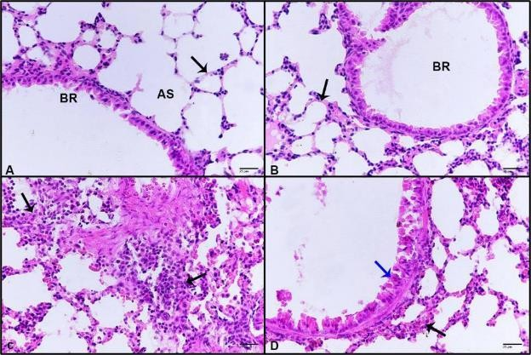

**Figure 3:** Photomicrographs of mice lung stained by H&E ***Key:*** (A) Untreated control lung showing normal pulmonary view, bronchiole (BR), alveolar sac (AS), interalveolar septum (black arrow), (B) lung treated with AOE revealing healthy structure, (C) lung treated with CGN displayed thickened interalveolar septa due to accumulation of infiltrative cells (black arrows), (D) lung treated with AOE + CGN showing less pathological signs, less thickened interalveolar septum (black arrow), less distorted columnar bronchiolar epithelia (blue arrow). (H & E-400x)

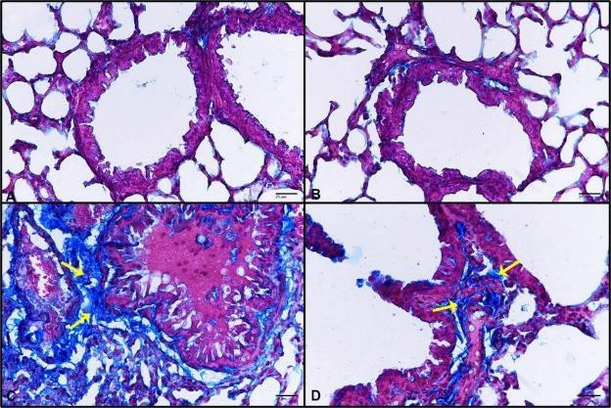

**Figure 4**: Photomicrographs of mice lung stained by Masson’s trichrome. ***Key:*** (A) Untreated control lung showing no collagenous depositions, (B) lung treated with AOE revealing no collagenous depositions, (C) lung treated with CGN displayed depositions of collagenous fibers and extracellular matrix (yellow arrows), distorted epithelia of bronchioles that is congested with edema (D) lung treated with AOE+CGN showing less depositions (yellow arrow). (Masson’s trichrome-400x)

Moreover, CGN-induced dysplasia and destruction of bronchioles columnar epithelia, heavy depositions of collagenous fibers and extracellular matrix stained blue by Masson’s trichrome (Figure 4 C) that sections registered high score of Masson’s trichrome percentage and optical density (Figure 5), PAS staining for lungs of mice treated with CGN revealed intense existence of hyaline membranes (Figure 6 C) with highest levels of PAS stain percentage and optical density (Figure 7), also pathological score reached the highest value (Table 1). However, mice lungs treated with AOE prior to CGN

administration showed great improvement represented by recovery of lung tissue except for some alterations of bronchioles epithelia (Figure 3 D), lung sections stained by Masson’s trichrome showed less content of fibers (Figure 4 D) and less percentage and optical density (Figure 5). Staining by PAS also revealed less hyaline membrane content (Figure 6 D) besides there was less percentage and optical density (Figure 7), in addition to lowering the pathological score (Table 1).

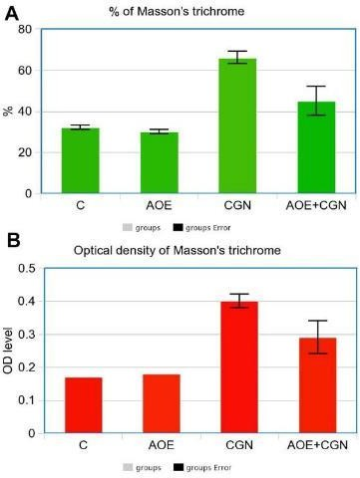

**Figure 5:** Masson’s trichrome stain percentage and optical density. ***Key:*** Treatment with AOE before CGN single dose lowered Masson’s trichrome stain percentage and optical density, (A) Masson’s trichrome stain percentage (%) (B) Masson’s trichrome stain optical density (OD).

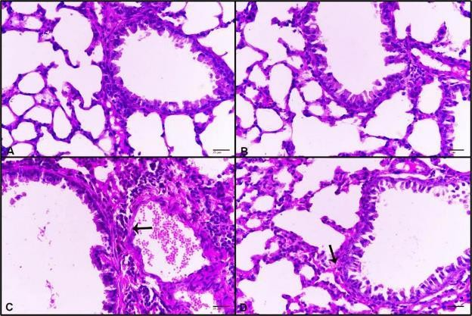

**Figure 6:** Photomicrographs of mice lung stained by Periodic acid Schiff. ***Key:*** (A) untreated control lung showing no hyaline membranes, (B) lung treated with AOE revealing no hyaline membranes, (C) lung treated with CGN displayed hyaline membranes (black membrane), (D) lung treated with AOE+CGN showing less hyaline membranes (black arrow). (PAS-400x)

**Table 1:** Effect of AOE on the pathological scoring of lung raised by CGN

|  |  |  |  |  |
| --- | --- | --- | --- | --- |
| **Group** | **Vascular alterations** | **vascular and alveolar changes** | **Bronchiole alterations** | **Total score** |
| C | 0 | 0 | 0 | 0 |
| AOE | 0 | 0 | 0 | 0 |
| CGN | 2 | 3 | 3 | 8 |
| AOE+CGN | 1 | 1 | 1 | 3 |

C: Control, AOE: Asparagus officinalis extract, CGN: Carrageenan

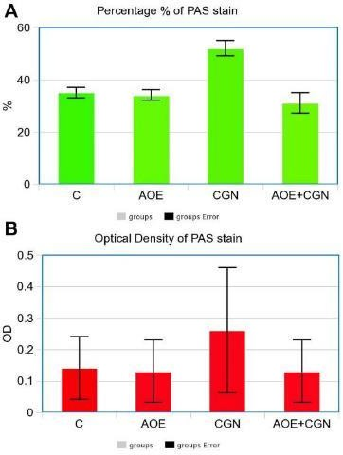that showed CGN administration increased WBC count, lymphocytes and monocytes. However, the present work revealed that AOE administration significantly decreased the total count of WBCs, lymphocytes, monocytes and neutrophils that were raised due to CGN treatment and this is in tandem with the study by Elnagar [10].

**Figure 7**: PASs stain percentage and optical density. ***Key:*** Treatment with AOE before CGN single dose lowered pas stain percentage and optical density, (A) PAS stain percentage % (B) PAS stain optical density (OD)

# DISCUSSION

In the present study the effect of *Asparagus officinalis* on allergic asthma was investigated by using carrageenan (CGN) as the allergen trigger. Many studies have used CGN as a trigger of inflammation, inducer of edema and hypersensitivity in rats [11], another study used CGN experimentally for screening anti- inflammatory drugs [13], therefore the present study used CGN as a trigger for asthma to study the effect of AOE on asthma induced experimentally by CGN.

Previous studies reported that exposure to CGN increased WBCs count especially neutrophils and eosinophils [14]. In addition, another study revealed that injection with a single dose of CGN significantly raised WBC count [10] these findings were compatible with the present results

It has been reported that induction of inflammation by kappa carrageenan (k-CGN) or lambda carrageenan (ƛ-CGN) resulted in hyper- secretion of inflammatory cytokines such as interleukins ( IL4 and 5) [15]. Other studies postulated that not only Th2 cytokines but also pro-inflammatory cytokines such as IL 6 and TNF-α are increased [16]. The present findings collaborate with previous studies as the results show that the administration of a single dose of CGN resulted in increased proinflammatory cytokines; IL6 and TNF-α due to stimulation and increased levels of monocytes and macrophages. AOE administration suppressed the overproduction of IL6 and IL-1β induced by macrophages in the case of SARS-CoV-2 Spike Protein-Induced production of inflammatory cytokines [17]. The present work also reported that pre-treatment with AOE after CGN lowered levels of pro-inflammatory cytokines.

The current study showed the severe lung pathological alterations induced by CGN, that its single dose caused heavy inflammation in the lung tissue besides the intense accumulation of fibrosis, extracellular matrix and hyaline membranes. It has been reported that CGN activates neutrophils in the lung resulting in accumulation of infiltrative cells leading to lung injury [18]. Since AOE inhibits the production of inflammatory cytokines, it therefore reduces inflammation, and lung and airway injury [18].

# CONCLUSION

Carrageenan is an allergen-induced inflammatory agent and causes marked pathological alterations thereby increasing pulmonary pathological scarring in addition to increasing the WBC count and pro-inflammatory cytokines. *Asparagus officinalis* extract reduces the allergic effect and lung pathological signs

induced by CGN. Since AOE inhibits the production of inflammatory cytokines, it has the potential to be developed as a source of active pharmaceutical ingredients for the management of lung and airway injury.

# DECLARATIONS

***Ethical approval*** None provided.

### Availability of data and materials

The datasets used and/or analyzed during the current study are available from the corresponding author on reasonable request.

# REFERENCES

* 1. *Périz M, Pérez-Cano F, Rodríguez-Lagunas M, Cambras T, Pastor-Soplin S, Best I, Castell M., Cladera M. Development and characterization of an allergic asthma rat model for interventional studies. Int J Mol Sci 2020; 21(11): 1-15.*
  2. *Papi A, Brightling C, Pedersen S, Reddel H. Asthma. Lancet 2018; 391(10122):783–800.*
  3. *Bates J, Rincon M, Irvin C. Animal models of asthma. Am J Physiol Lung Cell Mol Physiol 2009; 297(3): 1-10.*
  4. *Shinagawa K, Kojima M. Mouse model of airway remodeling: strain differences. Am J Respir Crit Care Med 2003; 168(8):959–67.*
  5. *Zosky G, Sly P. Animal models of asthma. Clin Exp Allergy 2007; 37(7): 973–988.*
  6. *Hagimori M, Kamiya S, Yamaguchi Y, Arakawa M. Improving frequency of thrombosis by altering blood flow in the carrageenan-induced rat tail thrombosis model. Pharmacol Res 2009; 60(4): 320–323.*
  7. *Huang X, Lin Y, Kong L. Steroids from the roots of Asparagus officinalis and their cytotoxic activity. J Integr Plant Biol 2008; 50(6): 717–722.*
  8. *Mfengwana P, Mashele S. Medicinal properties of selected asparagus species: A review. IntechOpen 2019; Ch. 10.*
  9. *Kumar S, Srivastava P, Gupta S, Dhanawat M, Rani S, Ajiboye B, Gautam R. Pharmacological evaluation of different extracts of Asparagus officinalis (Asparagaceae) as an analgesic, anti-inflammatory and anti-arthritic agent in rats. Pharmacog Res 2023; 15: 184–205.*
  10. *Elnagar DM. Anti-inflammatory activity of Asparagus officinalis extract on liver inflammation carrageenan- induced in swiss albino mice. Uttar Pradesh J Zool 2023; 44(10): 48–56.*
  11. *Lukacs N, Strieter R, Chensue S, Widmer M, Kunkel*

*S. TNF-alpha mediates recruitment of neutrophils and eosinophils during airway inflammation. J Immunol 1995; 154(10): 5411–5417.*

* 1. *Passmore M, Byrne L, Obonyo N, See Hoe L, Boon A, Diab S, Dunster K, Bisht K, Tung J, Fauzi M, et al. Inflammation and lung injury in an ovine model of fluid resuscitated endotoxemic shock. Respir Res 2018; 19(1): 1-10.*
  2. *Fehrenbacher J, Vasko M, Duarte D. Models of inflammation: Carrageenan- or complete Freund’s adjuvant (CFA)-induced edema and hypersensitivity in the rat. Curr Protoc Pharmacol 2012; Chapter 5.*
  3. *Patil KR, Mahajan UB, Unger BS, Goyal SN, Belemkar S, Surana SJ, Ojha S, Patil C. Animal models of inflammation for screening of anti- inflammatory drugs: Implications for the discovery and*

*development of phytopharmaceuticals. Int J Mol Sci 2019; 20(18): 1-38.*

* 1. *Duarte D, Vasko M, Fehrenbacher J. Models of inflammation: carrageenan air pouch. Curr Protoc Pharmacol 2012; Chapter 5.*
  2. *Wu W, Wang F, Gao X, Niu T, Zhu X, Yan X, Chen H. Synergistic effect of κ-carrageenan on oxazolone- induced inflammation in BALB/c mice. BMC Gastroenterol 2016; 16(1): 1-13.*
  3. *Ou Z, Zhao J, Zhu L, Huang L, Ma Y, Ma C, Luo C, Zhu Z, Yuan Z, Wu J, Li R, Yi J. Anti-inflammatory*

*effect and potential mechanism of betulinic acid on λ- carrageenan-induced paw edema in mice. Biomed Pharmacother 2019; 118: 1-9.*

* 1. *Shirato K, Takanari J, Kizaki T. Standardized extract of Asparagus officinalis stem attenuates SARS-CoV-2 spike protein-induced IL-6 and IL-1β production by suppressing p44/42 MAPK and Akt phosphorylation in murine primary macrophages. Molecules 2021; 26(20): 1-15.*