**Title:** **Natural Compounds as Promising Modulators of Breast Cancer Signalling: The Role of Tea Polyphenols**

**ABSTRACT**

Breast cancer, as a disease, is highly prevalent among women in India and worldwide.Aberrant expression and signalling through various pathways like the focal adhesion kinase (FAK) pathway, the mitogen activated protein kinase (MAPK) pathway and the extracellular signal regulated kinase (ERK) pathway have been reported to cause breast cancer progression and metastasis. Treatment of breast cancer patients via chemotherapy can often pose severe toxic side effects with peripheral tissue and organ damage. Determining anti-tumorigenic potential of various natural compounds is an interesting arena of work in order to address this issue. As FAK. MAPK and ERK signalling pathways are important factors in progression and spread of breast cancers, we analysed the potential of two tea polyphenols, epigallocatechin-3-gallate (EGCG) and theaflavin, for targeting these signalling pathways. Molecular docking and analysis indicated both theaflavin and EGCG showed good binding affinity and interactions via hydrogen bonding with various amino acids on the FAK, p38MAPK and ERK2 molecules. Theaflavin and EGCG however, appear to interact with different sites on p38MAPK and ERK2 but both bind around the same site on FAK. Our studies indicate the potential of the tea polyphenols, theaflavin and EGCG, as signalling pathway inhibitors for treatment of breast cancers. Further *in vitro* and *in vivo* studies to understand the pattern of interactions of theaflavin and EGCG with these target molecules could result in positive outcomes for breast cancer treatment.

**KEYWORDS:** Breast cancer, Epigallocatechin-3-gallate (EGCG), Theaflavin, Focal adhesion kinase (FAK), Mitogen activated protein kinase (MAPK), Extracellular signal regulated kinase (ERK)

**1. INTRODUCTION**

The GLOBOCAN data of World Health Organization showed around 1,78,361 breast cancer cases in Indian women were reported in 2020 [1]. A report analyzing breast cancer statistics from 2012-2016 along with prediction for 2025 showed southern states along with Delhi had a higher burden of the disease compared to eastern and northeastern states. Estimation showed around 515.4 disability-adjusted life years (DALYs) per 100,000 Indian women with breast cancer burden [2]. The cause behind increasing incidence of breast cancer cases every year lies in predominantly lifestyle issues and reason for late diagnosis lies in lack of awareness and screening facilities. According to reports, most Indian women when diagnosed with breast cancer showed stage III and IV, mostly with invasive lobular carcinoma or infiltrating duct carcinoma pathology [3]. Research has highlighted the importance of various cellular signaling pathways which play key roles in breast cancer development and progression. Aberrant expression and signaling through cellular signalling pathways like the focal adhesion kinase (FAK), mitogen activated protein kinase (MAPK) and extracellular signal regulated kinase (ERK) pathways has been reported extensively to cause breast cancer development and metastasis.

Focal adhesion kinase (FAK), a cytoplasmic tyrosine kinase, mediates downstream signalling from integrin receptors in breast cancer. FAK after auto-phosphorylation binds to Src which activates downstream targets of signalling cascades to promote breast cancer progression and metastasis [4]. Overexpression of FAK in breast tumours has been reported to promote cell survival, proliferation, angiogenesis, metastasis and cancer initiation [5]. According to research, G-protein coupled oestrogen receptors promote FAK expression and signalling in breast cancer as studied in MDA-MB 231 and SUM159 triple negative breast cancer cell lines [6]. Correlation of FAK and VEGF expression in breast cancer has shown that FAK regulates VEGF expression in triple negative breast cancer cells to mediate angiogenesis [7]. Analysis of breast tumour samples showed that tumours with aberrant FAK overexpression had p53 mutations 2.5 times more than FAK negative tumour samples [8]. FAK expression and activation has been shown to mediate IGF1R (insulin like growth factor-1 receptor) mediated cellular invasion in triple negative breast cancer [9]. Integrin α5β1 or αvβ3 mediated activation of FAK expression and activity was reported to aid in MMP-9 expression in MDA-MB 231 breast cancer cells [10].

The complex mitogen activated protein kinase (MAPK) pathway includes a series of kinases playing important roles in cancer development, metastasis and drug resistance. Association of growth factors from the tumor microenvironment with epidermal growth factor EGFR/ receptor tyrosine kinases (RTKs) on cell membranes cause activation and phosphorylation of RAS. Phosphorylated RAS further activates downstream cascade of MAPKKK (mitogen activated protein kinase kinase kinase or RAF) followed by MAPKK(MEK) and MAPK (which includes ERK1/2). MAPK family include p38 MAP Kinases, ERK1/2 isoforms and JNKs [11]. Downstream activation of ERK1/2 in the RAS/RAF pathway further activate various transcription factors like c-Myc, NF-κB (nuclear factor kappa B) and CREB (cAMP response element-binding protein) to modulate gene expression in cancer. According to reports, around 30% of human solid tumours have RAS mutations. Experimental research showed over expression of CD147 activates MAPK-MEK-ERK pathway in BT549 breast cancer cells [12]. Breast cancer cell lines like MDA-MB231 and SUM159PT when co-cultured with palmitic acid and adipogenic conditioned medium showed over expression of periostin and MMPs via activation of MAPK/ERK pathway [13]. Overexpression of filament A (FLNA) in breast cancer cells caused docetaxel resistance via MAPK-ERK signalling as studied in MDA-MB231, HCC38, Htb126 and HCC1937 cells [14]. Expression of splice isoform of CD99 (i.e CD199 type II) caused MMP-9 expression via ERK1/2 signalling in MDA-MB-231 and MCF-7 breast cancer cells [15]. Upregulation of microfibrillar-associated protein 5 (MFAP5) expression caused MMP-2 and MMP-9 expression and bone metastasis via activation of ERK signalling pathway in breast cancer [16]. Thus, the FAK and MAPK-ERK pathways are important factors in progression and spread of breast cancers.

The prevalent modes of treatment in breast cancer includes extensive chemotherapy and radiotherapy that can pose harmful side effects to breast cancer patients. Research with various natural compounds is an interesting arena of work in order to address this issue in cancer treatment. With this objective, we analysed the potential of the tea polyphenols, epigallocatechin-3-gallate (EGCG) and theaflavin, for targeting signalling pathways in breast cancer.

**2. ANTI-TUMORIGENIC POTENTIAL OF TEA POLYPHENOLS**

**Epigallocatechin-3-gallate** **(EGCG)** obtained from green tea (*Camellia sinensis*) has been shown to have anti-fungal, anti-bacterial, anti-viral and anti-infective properties along with effects on neurodegeneration and carcinomas [17,18]. In previous experimental research conducted, treatment of breast cancer cells with EGCG downregulated fatty acid metabolism and fatty acid synthase (FASN) along with reduction in HER2, ERK1/2 and Akt expression [19]. Treatment of MCF10A and MDA-MB 231 cells with EGCG downregulated the hepatocyte growth factor (HGF)-Met (important marker in breast cancer) along with downstream Akt and ERK to reduce cellular migration and invasion [20]. Previous research has highlighted the effect of EGCG in downregulation of β-catenin and p-Akt to reduce cellular viability in MDA-MB 231 cells. The use of synthetic PI3K inhibitors like LY294002 or wortmannin along with EGCG actually enhanced the effect of EGCG in reducing the expression levels of β-catenin [21]. Treatment of breast carcinoma cells with EGCG considerably reduced expression of HER2 along with downstream expression of STAT3, Bcl-xl and cyclin D1 [22]. Treatment of MDA-MB 231 cells with EGCG and other green tea polyphenols (GTPs) downregulated phosphorylation and expression of Akt and β-catenin along with reduction in MMP-9 expression and activity [23]. EGCG treatment has shown to reduce STAT3 expression and interaction with NF-κB via translocation of STAT3 to nucleus to prevent regulation of CD44 expression [24]. EGCG treatment reduced formation and aggregation of myeloid-derived suppressor cells MDSCs in 4T1-breast tumour mice model with downregulation of downstream NF-κB /STAT3 signalling cascade [25]. Microarray analysis showed the presence of DEGs (differential expressed genes) in focal adhesions of breast cancer cells. EGCG treatment was shown to downregulate focal adhesion kinase and promote apoptosis via regulation of CCND1 expression [26]. EGCG treatment on MCF-7, MCF-7TAM and MDA-MB-231 cells reduced EGFR phosphorylation and expression of p473-Akt expression to inhibit MMP-2, MMP-9, CD44 and EMMPRIN expression and upregulate TIMP expression [27]. EGCG treatment was reported to mediate the expression of transcriptional repressor HBP1 and downregulate Wnt signalling to inhibit cellular invasion in breast cancer [28]. EGCG treatment inhibited tyrosine phosphorylation of EGFR and downregulated EGFR mediated downstream PI3K-Akt pathway and NF-κB pathway in MMTV-HER2/neu NF639 cells obtained and cultured from breast tumour samples [29].

**Theaflavin** is obtained from black tea and has potent anti-microbial, anti-inflammatory, anti-oxidant and anti-cancer properties along with effects on obesity and osteoporosis [30,31]. Treatment with theaflavin**s** have been reported to cause p53 phosphorylation, ROS generation and nuclear translocation of NF-κB via regulation of p38-MAPK signalling. This also downregulates MMP-2 and MMP-9 expression [32]. Treatment of mouse mammary C-127 tumour cells with theaflavins caused downregulation in mRNA levels of Akt, PI3K and Bcl-2 with increased levels of caspase 3 and Bax to promote apoptosis and inhibit cell survival [31]. Treatment of MCF-7 breast cancer cells with theaflavin-1 (TF-1), TF-2, and TF-3 was reported to downregulate EGF induced signalling and downstream signalling through PI3K-Akt, inhibiting fatty acid synthase (FAS) to inhibit lipogenesis [33].

**3. METHODOLOGY**

In order to study and analyse the interactions between tea polyphenols and macromolecules, molecular docking technique with AutoDock Tools (ADT) 1.5.6 (Scripps Research Institute, USA, https://ccsb.scripps.edu/mgltools/1-5-6/) [34] was used. The crystal structures of the macromolecules (MAPK, ERK2 and FAK) were obtained from Research Collaboratory for Structural Bioinformatics (RCSB) Protein Data Bank (www.rcsb.org/) [35]. Crystal structures of human p38 MAPK (PDB ID: 3HVC), human ERK2 (PDB ID: 5NHJ) and human FAK catalytic domain (PDB ID: 4I4F) were obtained from the Protein Data Bank site. Structure of ligands (tea polyphenols) were obtained from PubChem, NIH, National Centre for Biotechnology Information (https://pubchem.ncbi.nlm.nih.gov/) [36]. Post molecular docking, analysis of docked macromolecule-ligand complexes was conducted using PYMOL (version 2.5.4, Schrodinger, LLC). Surface images of docked complexes were obtained using Chimera 1.18 and PYMOL. Some macromolecule structures obtained from PDB had bound ligands. Prior to docking with above natural compounds, these inherent ligands were removed using PYMOL. In the docking process, water molecules were removed, polar hydrogens and Kollman charges were added to assign AD4 subtype to prepare macromolecules. Ligand preparation with choosing and detection of roots was done, followed by setting up grid parameters, grid box and docking parameters involving both the protein and ligand. After docking, generation of protein ligand complex of the best conformation was done where pattern of interactions was analysed via PYMOL (https://www.pymol.org) [37-40]. Binding pattern and affinity was studied by considering the lowest ΔG value of conformations of the docked protein-ligand complexes.

**4. RESULTS**

**4.1. Interactions of Theaflavin and EGCG with p38 MAPK**

Molecular docking (Table 1) showed high binding affinity of both theaflavin and EGCG with p38 MAPK with theaflavin (ΔG = - 7.10) showing a higher binding affinity compared to EGCG (ΔG = - 6.17). The domains and amino acids of MAPK with which theaflavin and EGCG interact are as shown in Fig. 1. Theaflavin formed hydrogen bonds with Lys-15, Lys-54, Phe-59, Asn-100 and Asp-101 (Fig. 1D) while EGCG formed hydrogen bonds with Arg-23, Asp-88, Ala-93, Arg-94 and Phe-348 (Fig. 1F).

**A 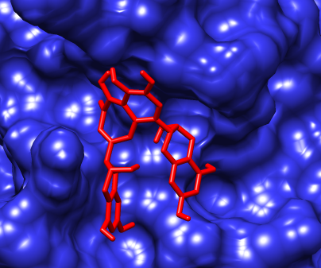 B** 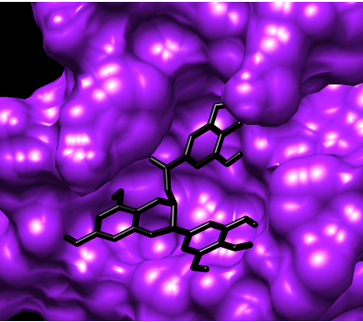

**C 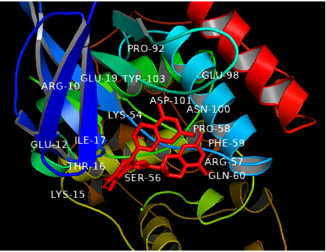 D**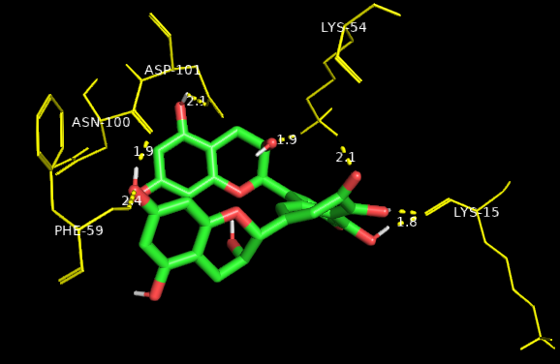

**E 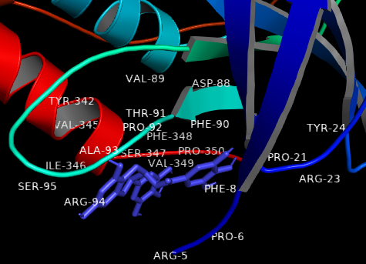 F** 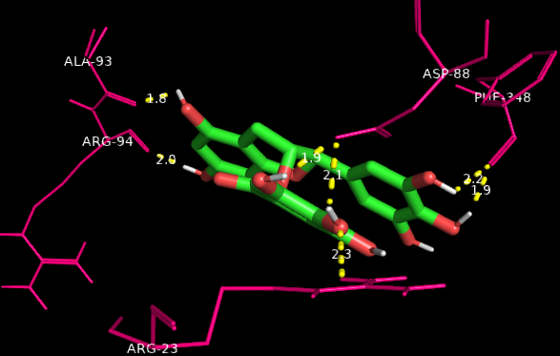

**Fig. 1: Analysis of interactions of human MAPK with theaflavin and EGCG.** Interactions of human MAPK (PDB ID: 3HVC) with theaflavin and EGCG represented using surface zoomed view (Fig. 1A & 1B respectively) and ribbon representations (Fig. 1C & 1E respectively) and hydrogen bonding of amino acids of human MAPK with theaflavin (Fig. 1D) and EGCG (Fig. 1F) with estimated bond distances.

**4.2. Interactions of Theaflavin and EGCG with ERK 2**

Molecular docking (Table 2) showed high binding affinity of both theaflavin and EGCG with ERK2 with both theaflavin (ΔG = -7.66) and EGCG (ΔG = -7.77) having comparable binding affinity. The domains and amino acids of ERK2 with which theaflavin and EGCG interact are as shown in Fig. 2. Theaflavin formed hydrogen bonds with Pro-176, His-180, Asn-201 and Asp-251 (Fig. 2D) while EGCG formed hydrogen bonds with Asp-106, Met-108, Glu-109, Asp-111, Ser-153 and Asn-154 (Fig. 2F).

**A 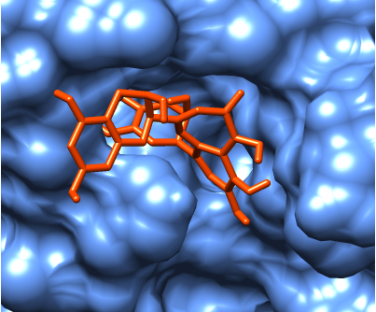 B** 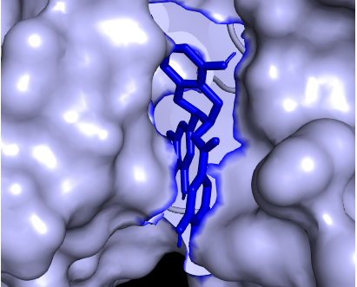

**C 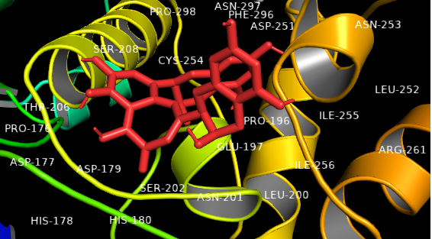 D** 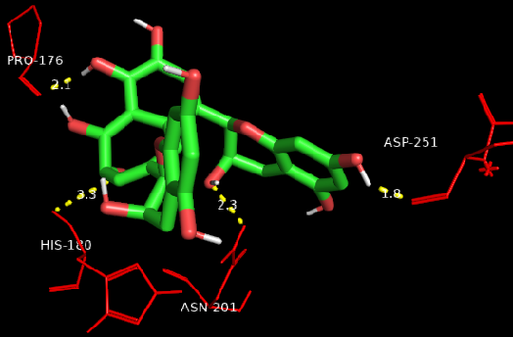

**E 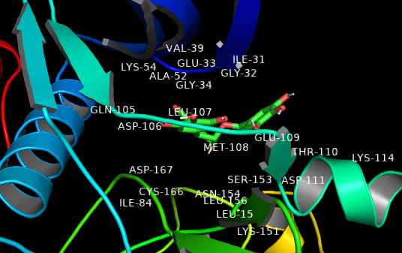 F** 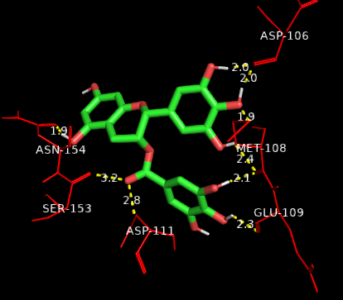

**Fig. 2: Analysis of interactions of human ERK2 with theaflavin and EGCG.** Interactions of human ERK2 (PDB ID: 5NHJ) with theaflavin and EGCG represented using surface zoomed view (Fig. 2A & 2B respectively) and ribbon representations (Fig. 2C & 2E respectively) and hydrogen bonding of amino acids of human ERK2 with theaflavin (Fig. 2D) and EGCG (Fig. 2F) with estimated bond distances.

**4.3. Interactions of Theaflavin and EGCG with FAK**

Molecular docking (Table 3) showed high binding affinity of both theaflavin and EGCG with p38 MAPK with theaflavin (ΔG = -8.12) having a higher binding affinity than EGCG (ΔG = -7.48). The domains and amino acids of FAK with which theaflavin and EGCG interact are as shown in Fig. 3A-D. Theaflavin formed hydrogen bonds with Glu-430, Gln-432, Arg-508, Arg-550 and Lys-583 (Fig. 3D) while EGCG formed hydrogen bonds with Arg-508, Ile-547, Lys-583, Leu-584, Ile-586, Lys-621 and Asn-628 (Fig. 3F).

**A 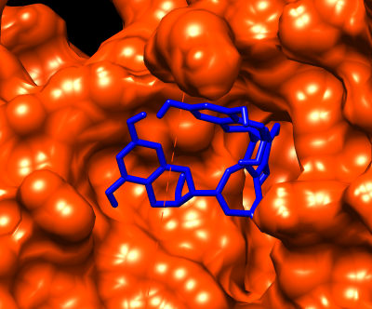 B** 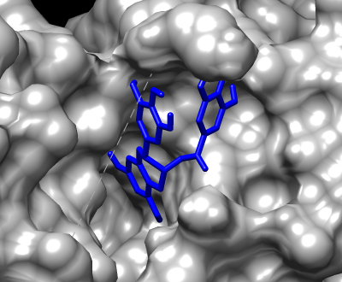

**C 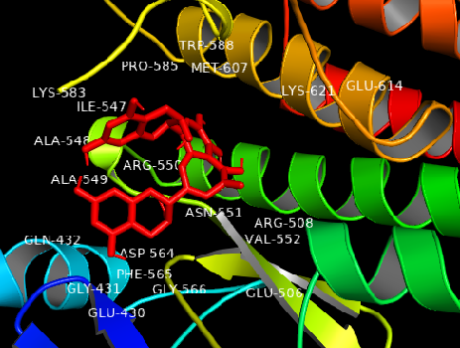 D** 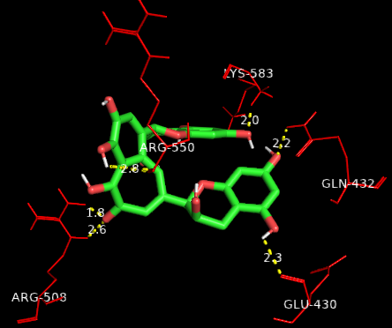

**E 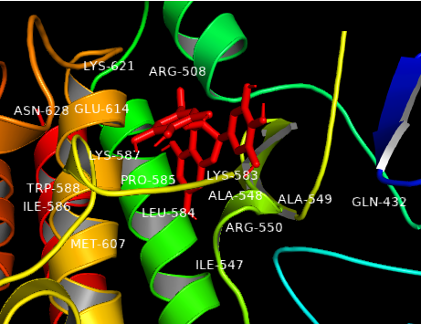 F** 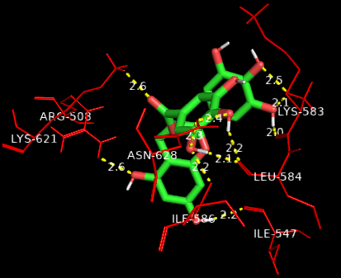

**Fig. 3: Analysis of interactions of human FAK with theaflavin and EGCG.** Interactions of catalytic domain of human FAK (PDB ID: 414F) with theaflavin and EGCG represented using surface zoomed view (Fig. 3A & 3B respectively) and ribbon representations (Fig. 3C & 3E respectively) and hydrogen bonding of amino acids of human FAK with theaflavin (Fig. 3D) and EGCG (Fig. 3F) with estimated bond distances.

**Table 1: Binding affinities of theaflavin and EGCG with human MAPK (PDB ID: 3HVC)**

|  |  |  |  |  |
| --- | --- | --- | --- | --- |
| **Sl. No.** | **Compound** | **PubChem CID** | **ΔG**  **(Kcal/mol)** | **Hydrogen Bonding to Amino Acids with Bond Lengths** |
| 1. | Theaflavin | 4263901 | -7.10 | Lys-15 (1.8Ǻ and 2.1Ǻ), Lys-54 (2.1Ǻ and 1.9Ǻ), Phe-59 (2.4Ǻ), Asn-100 (1.9Ǻ), Asp-101 (2.1Ǻ) |
| 2. | EGCG | 65064 | -6.17 | Arg-23 (2.3Ǻ), Asp-88 (1.9Ǻ and 2.1Ǻ), Ala-93 (1.8Ǻ), Arg-94 (2.0 Ǻ), Phe-348 (2.2Ǻ and 1.9Ǻ) |

**Table 2: Binding affinities of theaflavin and EGCG with human ERK2 (PDB ID: 5NHJ)**

|  |  |  |  |  |
| --- | --- | --- | --- | --- |
| **Sl. No.** | **Compound** | **PubChem CID** | **ΔG**  **(Kcal/mol)** | **Hydrogen Bonding to Amino Acids with Bond Lengths** |
| 1. | Theaflavin | 4263901 | -7.66 | Pro-176 (2.1Ǻ), His-180 (3.3Ǻ), Asn-201 (2.3 Ǻ), Asp-251 (1.8Ǻ) |
| 2. | EGCG | 65064 | -7.77 | Asp-106 (2.0Ǻ and 2.0Ǻ), Met-108 (1.9Ǻ, 2.1Ǻ and 2.4Ǻ), Glu-109 (2.3Ǻ), Asp-111 (2.8Ǻ), Ser-153 (3.2Ǻ), Asn-154 (1.9Ǻ) |

**Table 3: Binding affinities of theaflavin and EGCG with human FAK (PDB ID: 414F)**

|  |  |  |  |  |
| --- | --- | --- | --- | --- |
| **Sl. No.** | **Compound** | **PubChem CID** | **ΔG**  **(Kcal/mol)** | **Hydrogen Bonding to Amino Acids with Bond Lengths** |
| 1. | Theaflavin | 4263901 | -8.12 | Glu-430 (2.3Ǻ), Gln-432 (2.2Ǻ), Arg-508 (1.8Ǻ and 2.6Ǻ), Arg-550 (2.8Ǻ), Lys-583 (2.0Ǻ) |
| 2. | EGCG | 65064 | -7.48 | Arg-508 (2.6 Ǻ), Ile-547 (2.2Ǻ), Lys-583 (2.5Ǻ and 2.1Ǻ), Leu- 584 (2.0Ǻ, 2.2 Ǻ and 2.4 Ǻ), Ile-586 (2.2Ǻ), Lys-621 (2.6Ǻ), Asn-628 (2.3Ǻ and 2.4Ǻ) |

**5. DISCUSSION AND CONCLUSION**

Breast cancer, as a disease being highly prevalent among women in India and worldwide, often lead to fatal outcomes due to poor prognosis and late diagnosis. Dysregulation of various cellular signaling pathways which play key roles in breast cancer development, like MAPK, ERK and FAK, can result in breast cancer progression and metastatic spread to distant organs which requires extensive treatment. Extensive treatment via chemotherapy of breast cancer patients can often pose severe toxic side effects with peripheral tissue and organ damage. Use of chemotherapeutic drugs like taxanes, trastuzumab and anthracyclines in breast cancer patients was reported to cause severe allergies, leukoneutropenia along with cardiac, gastro-intestinal and haematologic toxicity in breast cancer patients. The effect of these treatments can cause damage to patients who have other comorbidities and reduction or discontinuation of chemotherapy dose often results in poor prognosis and treatment outcomes [41,42]. To address these issues of medical and treatment catastrophe, research for analyzing and studying the anti-tumorigenic possibilities of treatment with natural compounds like the tea polyphenols, theaflavin and EGCG, needs to be conducted. The anti-tumorigenic properties of these phytochemicals have been indicated by varied areas of research.

Our studies indicated that both theaflavin and EGCG showed high binding affinity for p38 MAPK, with binding affinity of theaflavin being higher than EGCG (ΔG = -7.10 and -6.17 respectively). Analysis of amino acid interactions and protein-ligand complexes showed theaflavin and EGCG bind at different sites on the protein. For ERK2, both theaflavin and EGCG showed high binding affinity, with binding affinity of the two being comparable but slightly higher for EGCG (ΔG = -7.66 and -7.77 respectively). Again, analysis of amino acid interactions and protein-ligand complexes showed theaflavin and EGCG bind at different sites on the protein. For FAK, both theaflavin and EGCG showed high binding affinity, with binding affinity of theaflavin being higher than EGCG (ΔG = -8.12 and -7.48 respectively). Analysis of amino acid interactions and protein-ligand complexes showed theaflavin and EGCG bind around the same site on the protein. However, interactions with amino acids during binding interestingly indicate amino acids can engage in different kinds of bonding when interacting with different ligands. For instance, Arg-508 and Lys-583 showed hydrogen bonding with both theaflavin and EGCG (although the number of H bonds were different) while Gln-432 and Arg-550 showed hydrogen bonding with theaflavin but nonpolar interactions with EGCG.

In our study, both theaflavin and EGCG showed good and appreciable binding affinity for targets like FAK, MAPK and ERK which play key roles in breast cancer cell signalling and progression, indicating the potential of theaflavin and EGCG as signalling pathway inhibitors for treatment of breast cancers. Further research to understand the pattern of interactions of these compounds with target molecules, beside *in vitro* and *in vivo* studies about the effective anti-cancer potential of these phytochemicals, could result in positive outcomes for developing therapies for breast cancer treatment.

**ETHICAL ISSUES**

This article does not contain any studies with human participants or animals performed by the authors.

**COMPETING INTERESTS**

Authors have declared that no competing interests exist.

**REFERENCES**

1. World Health Organization, International Agency for Research on Cancer. Accessed December 2024. https://gco.iarc.fr/today/data/factsheets/populations/900-world-fact-sheets.pdf
2. Kulothungan, V., Ramamoorthy, T., Sathishkumar, K., Mohan, R., Tomy, N., Miller, G.J., *et al.* (2024). Burden of female breast cancer in India: estimates of YLDs, YLLs, and DALYs at national and subnational levels based on the national cancer registry programme. *Breast Cancer Research and Treatment*, 205(2), 323-332.
3. Kumar, N., Gera, K., Patel, P., Lakhera, K.K., Singh, S., Gurjar, B., *et al.* (2024). From Statistics to Stories: Unveiling the Epidemiology of Breast Carcinoma in Northwestern India. *Indian Journal of Surgical Oncology*, 1-7.
4. Guan, J.L. (2010). Integrin signaling through FAK in the regulation of mammary stem cells and breast cancer. *IUBMB Life*, 62(4), 268-276.
5. Luo, M., & Guan, J.L. (2010). Focal adhesion kinase: a prominent determinant in breast cancer initiation, progression and metastasis. *Cancer Letters*, 289(2), 127-139.
6. Shiau, J.P., Wu, C.C., Chang, S.J., Pan, M.R., Liu, W., Ou-Yang, F., *et al.* (2021). FAK regulates VEGFR2 expression and promotes angiogenesis in triple-negative breast cancer. *Biomedicines*, 9(12), 1789
7. Tancioni, I., Miller, N.L., Uryu, S., Lawson, C., Jean, C., Chen, X.L., *et al.* (2015). FAK activity protects nucleostemin in facilitating breast cancer spheroid and tumor growth. *Breast Cancer Research*, 17, 1-17.
8. Wu, H. J., Hao, M., Yeo, S.K., & Guan, J.L. (2020). FAK signaling in cancer-associated fibroblasts promotes breast cancer cell migration and metastasis by exosomal miRNAs-mediated intercellular communication. *Oncogene*, 39(12), 2539-2549.
9. Lu, H., Hu, L., Yu, L., Wang, X., Urvalek, A.M., Li, T., *et al.* (2014). KLF8 and FAK cooperatively enrich the active MMP14 on the cell surface required for the metastatic progression of breast cancer. *Oncogene*, 33(22), 2909-2917.
10. Ganguly, K. K., Pal, S., Moulik, S., & Chatterjee, A. (2013). Integrins and metastasis. *Cell Adhesion & Migration*, 7(3), 251–261.
11. Braicu, C., Buse, M., Busuioc, C., Drula, R., Gulei, D., Raduly, L., *et al.* (2019). A comprehensive review on MAPK: a promising therapeutic target in cancer. *Cancers*, 11(10), 1618.
12. Li, F., Wang, J., Yan, Y.Q., Bai, C.Z., & Guo, J.Q. (2023). CD147 promotes breast cancer migration and invasion by inducing epithelial-mesenchymal transition via the MAPK/ERK signaling pathway. *BMC Cancer*, 23(1), 1214.
13. Wu, J., Li, J., Xu, H., Qiu, N., Huang, X., & Li, H., (2023). Periostin drives extracellular matrix degradation, stemness, and chemoresistance by activating the MAPK/ERK signaling pathway in triple–negative breast cancer cells. *Lipids in Health and Disease*, 22(1), 153.
14. Zhao, P., Ma, W., Hu, Z., Zang, L., Tian, Z., & Zhang, K. (2016). Filamin A (FLNA) modulates chemosensitivity to docetaxel in triple-negative breast cancer through the MAPK/ERK pathway. *Tumor Biology*, 37, 5107-5115.
15. Byun, H.J., Hong, I.K., Kim, E., Jin, Y.J., Jeoung, D.I., Hahn, J.H., *et al.* (2006). A splice variant of CD99 increases motility and MMP-9 expression of human breast cancer cells through the AKT-, ERK-, and JNK-dependent AP-1 activation signaling pathways. *Journal of Biological Chemistry*, 281(46), 34833-34847.
16. Wu, Z., Wang, T., Fang, M., Huang, W., Sun, Z., Xiao, J., *et al.* (2018). MFAP5 promotes tumor progression and bone metastasis by regulating ERK/MMP signaling pathways in breast cancer. *Biochemical and Biophysical Research Communications*, 498(3), 495-501.
17. Steinmann, J., Buer, J., Pietschmann, T., & Steinmann, E., 2013. Anti‐infective properties of epigallocatechin‐3‐gallate (EGCG), a component of green tea. *British Journal of Pharmacology*, 168(5), 1059-1073.
18. Chakrawarti, L., Agrawal, R., Dang, S., Gupta, S., & Gabrani, R. (2016). Therapeutic effects of EGCG: a patent review. *Expert Opinion on Therapeutic Patents*, 26(8), 907-916.
19. Puig, T., Vázquez-Martín, A., Relat, J., Pétriz, J., Menéndez, J.A., Porta, R., *et al.* (2008). Fatty acid metabolism in breast cancer cells: differential inhibitory effects of epigallocatechin gallate (EGCG) and C75. Breast Cancer Research and Treatment, 109, 471-479.
20. Bigelow, R.L.H., & Cardelli, J.A. (2006). The green tea catechins,(−)-Epigallocatechin-3-gallate (EGCG) and (−)-Epicatechin-3-gallate (ECG), inhibit HGF/Met signaling in immortalized and tumorigenic breast epithelial cells. *Oncogene*, 25(13), 1922-1930.
21. Bimonte, S., Cascella, M., Barbieri, A., Arra, C., & Cuomo, A. (2020). Current shreds of evidence on the anticancer role of EGCG in triple negative breast cancer: an update of the current state of knowledge. *Infectious Agents and Cancer*, 15, 1-6.
22. Masuda, M., Suzui, M., Lim, J.T., & Weinstein, I.B. (2003). Epigallocatechin-3-gallate inhibits activation of HER-2/neu and downstream signaling pathways in human head and neck and breast carcinoma cells. *Clinical Cancer Research*, 9(9), 3486-3491.
23. Thangapazham, R.L., Passi, N., & Maheshwari, R.K. (2007). Green tea polyphenol and epigallocatechin gallate induce apoptosis and inhibit invasion in human breast cancer cells. *Cancer Biology & Therapy*, 6(12), 1938-1943.
24. Marín, V., Burgos, V., Pérez, R., Maria, D.A., Pardi, P., & Paz, C. (2023). The potential role of Epigallocatechin-3-Gallate (EGCG) in breast cancer treatment. *International Journal of Molecular Sciences*, 24(13), 10737.
25. Xu, P., Yan, F., Zhao, Y., Chen, X., Sun, S., Wang, Y., *et al.* (2020). Green tea polyphenol EGCG attenuates MDSCs-mediated immunosuppression through canonical and non-canonical pathways in a 4T1 murine breast cancer model. *Nutrients*, 12(4), 1042.
26. Luo, X., Guo, L., Zhang, L., Hu, Y., Shang, D., & Ji, D. (2018). Bioinformatics analysis of microarray profiling identifies the mechanism of focal adhesion kinase signalling pathway in proliferation and apoptosis of breast cancer cells modulated by green tea polyphenol epigallocatechin 3-gallate. *The Journal of Pharmacy and Pharmacology*, 70(12), 1606-1618.
27. Farabegoli, F., Govoni, M., Spisni, E., Papi, A. (2017). EGFR inhibition by (-)-epigallocatechin-3-gallate and IIF treatments reduces breast cancer cell invasion. *Bioscience Reports*, 37(3), BSR20170168.
28. Kim, J., Zhang, X., Rieger-Christ, K.M., Summerhayes, I.C., Wazer, D.E., Paulson, K.E., *et al.* (2006). Suppression of Wnt signaling by the green tea compound (–)-epigallocatechin 3-gallate (EGCG) in invasive breast cancer cells: requirement of the transcriptional repressor HBP1. *Journal of Biological Chemistry*, 281(16), 10865-10875.
29. Pianetti, S., Guo, S., Kavanagh, K.T., & Sonenshein, G.E. (2002). Green tea polyphenol epigallocatechin-3 gallate inhibits Her-2/neu signaling, proliferation, and transformed phenotype of breast cancer cells. *Cancer Research*, 62(3), 652-655.
30. O’Neill, E.J., Termini, D., Albano, A., & Tsiani, E. (2021). Anti-cancer properties of theaflavins. *Molecules*, 26(4), 987.
31. Zhang, L., Meng, S., Yan, B., Chen, J., Zhou, L., Shan, L., *et al.* (2021). Anti-Proliferative, Pro-Apoptotic, Anti-Migrative and Tumor-Inhibitory Effects and Pleiotropic Mechanism of Theaflavin on B16F10 Melanoma Cells. *OncoTargets and Therapy*, 14, 1291–1304.
32. Adhikary, A., Mohanty, S., Lahiry, L., Hossain, D.M.S., Chakraborty, S., & Das, T. (2010). Theaflavins retard human breast cancer cell migration by inhibiting NF-κB via p53-ROS cross-talk. *FEBS Letters*, 584(1), 7-14.
33. Yeh, C.W., Chen, W.J., Chiang, C.T., Lin-Shiau, S.Y., & Lin, J.K. (2003). Suppression of fatty acid synthase in MCF-7 breast cancer cells by tea and tea polyphenols: a possible mechanism for their hypolipidemic effects. *The Pharmacogenomics Journal*, 3(5), 267-276.
34. Scripps Research Institute, USA. https://ccsb.scripps.edu/mgltools/1-5-6/
35. Research Collaboratory for Structural Bioinformatics (RCSB) Protein Data Bank. https://www.rcsb.org/
36. National Center for Biotechnology Information, PubChem. https://pubchem.ncbi.nlm.nih.gov/

PubChem CID 4263901: https://pubchem.ncbi.nlm.nih.gov/compound/4263901.

PubChem CID 65064: https://pubchem.ncbi.nlm.nih.gov/compound/65064.

1. PYMOL. https://www.pymol.org
2. Tomita, N., Hayashi, Y., Suzuki, S., Oomori, Y., Aramaki, Y., Matsushita, Y., et al. (2013). Structure-based discovery of cellular-active allosteric inhibitors of FAK. Bioorganic & Medicinal Chemistry Letters, 23(6), 1779-1785.
3. Ward, R.A., Bethel, P., Cook, C., Davies, E., Debreczeni, J.E., Fairley, G., *et al.* (2017). Structure-guided discovery of potent and selective inhibitors of ERK1/2 from a modestly active and promiscuous chemical start point. Journal of Medicinal Chemistry, 60(8), 3438-3450.
4. Perry, J.J.P., Harris, R.M., Moiani, D., Olson, A.J., & Tainer, J.A. (2009). p38α MAP kinase C-terminal domain binding pocket characterized by crystallographic and computational analyses. *Journal of Molecular Biology*, 391(1), 1-11.
5. Zanuso, V., Fregoni, V., & Gervaso, L. (2020). Side effects of adjuvant chemotherapy and their impact on outcome in elderly breast cancer patients: a cohort study. Future Science OA, 6(9), FSO617.
6. van den Boogaard, W.M., Komninos, D.S., & Vermeij, W.P. (2022). Chemotherapy side-effects: not all DNA damage is equal. *Cancers*, 14(3), 627.