**Synthesis and characterization of a novel metal complex Cobalt (III) with a tetradentate N,N,O,O-donor ligand and 2,2'-{propane-1,2-diyl- bis[nitrilo(E)methylidene]}bis(6-methoxyphenol)**

## Abstract

Schiff bases have often been used as chelating ligands in the field of coordination chemistry, and their metal complexes have been extensively investigated due to their potential applications. It is known that reactions of N,N,O,O-donor Schiff bases ligands with transition metal ions have produced series of complexes with interesting structures and magnetic properties. A new complex prepared by the reaction of 2,2'-{propane-1,2-

diyl-bis[nitrilo(E)methylidene]}bis(6-methoxyphenol) (**H2L**) with Co(III) ion is reported in this paper. The bicompartmental ligand acts in a tetradentate fashion. The **H2L** ligand is structurally characterized by elemental analysis, NMR and infrared spectroscopies, conductance and single X-ray diffraction.

The compound with Co(III) crystallizes in the monoclinic system in the space group P21/c with the unit cell parameters a = 13.168(2) Å, b = 15.795(2) Å, c = 15.882(2) Å, α

= 90°, β = 110.703(16)°, γ = 90°. The cobalt (III) ion has slightly distorted octahedral coordination geometry.

In the structure of the mononuclear complex, the Co(III) cation is coordinated by two imine nitrogen atoms, two phenoxo oxygen atoms, from deprotonated Schiff base ligand and two oxygen atoms of water. There is also neighboring two molecule of DMF and one perchlorate anion non coordinating.

## Introduction

Since a long time, chelating agents derived from organic compounds containing N,S,O-donor as a functional group have a strong ability to form metal complexes and exhibit a variety of biological activities [1-8]. A number of studies have been done in the various Schiff bases complexes formed by the condensation of secondary amines with different aldehydes and ketones [9-12]. From the survey of existing literature, it appears that metal complexes of Schiff bases played a vital role in the development of coordination chemistry and their analytical utility in the determination of transition metal ions. Literature studies revealed that during the past decades, there has been a great deal of interest in the synthesis and structural elucidation of transition metal complexes containing N,N,O,O-donor.

In the present work, we described synthesis and characterization of new Schiff base 2,2'-{propane-1,2-diyl-bis[nitrilo(E)methylidene]}bis(6-methoxy phenol), derived from the condensation of ortho vanillin and 1,2 diaminopropane and its metal mononuclear complex obtained with Co(III).

## Synthesis of 2,2'-{propane-1,2-diyl-bis[nitrilo(E)methylidene]}bis(6-methoxy phenol)(H2L)

3.04g (20 mmol) of ortho vanillin was dissolved in methanol and then 0.9 mL (10 mmol) of 1,2-diaminopropane was added. The orange-yellow mixture obtained is heated

under reflux with magnetic stirring for 4 hours, then filtered and air-dried. A yellow- orange precipitate is obtained, which is washed with diethyl ether. The compound was thoroughly washed with ether and dried over P4O10. The yield is 65.5 %.

2 +

O

HO

O

H2N

NH2

MeOH

N N

OH HO

O O

+ 2 H2O

**RMN 1H :** (δ, ppm) : 13.65 (s, 2H, Ar-O**H**), 8.30 (s, 2H, **H**C=N), 6.92-6.75 (m, 6H, Ar-

**H**), 3.79-3.86 (m, H1, H1’), 3.71(s, 6H, -C**H3**), 1.40 (3H-C**H3**-CH).

**RMN 13C :** (δ, ppm) : 65.20(C1), 55,9 (C1’), 166.5(C2 ; C2’), 148.08(C3 ; C3’), 123.14(C4 ;

C4’), 118,28(C5 ; C5’), 118.00(C6 ; C6’), 151.40(C7 ; C7’), 154.6(C8 ; C8’), 64.49(C9 ; C9’),

20.25 (C10’).

**IR H2L: ν(cm-1) :** 1625 (s) (C=N); 3196 (m) (HC=N); 3190(m)(OH), (1466 - 1358) (m) (C=C); 1249 (m) (C-O),2931 (m) (C-H).

N N

OH HO

O O

C19H22N2O4 342.39

342.157957

C 66.65% H 6.48% N 8.18% O 18.69%

10'

2

1

1'

2'

3' 4'

8'

7'

6'

N N

4 3

8

6

7

5 OH HO 5'

O O

9 9'

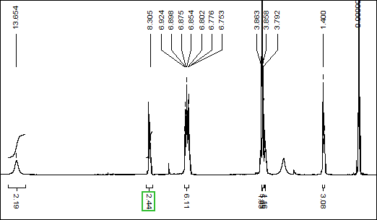

**Figure 1.** RMN of 1H.

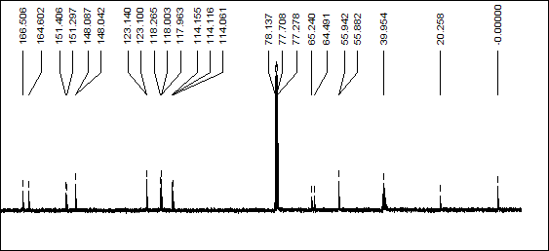

**Figure 2.** RMN of 13C.

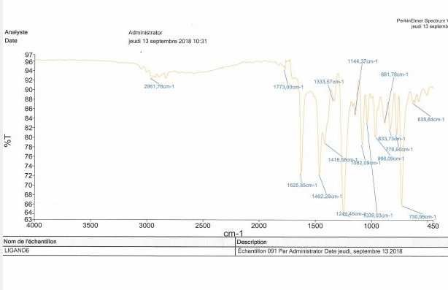

**Figure 3.** Spectre IR of ligand.

## Synthesis of complex of Co(III) with cobalt perchorate and L2-

In a 50 mL flask, the H2L ligand (3 mmol, 0.1g) was dissolved in DMF. The solution of Co(ClO4)2.6H2O (0.3 mmol, 0.11g) in methanol is added. The mixture is heated with magnetic stirring for 2 hours, a dark brown solution is obtained and then filtered. One month of evaporation after, crystals of brown color are obtained which can be analyzed by X-ray.

CH3



DMF

H2O

CH3

N

N

N N

Co(ClO4)2 6 H2O Co

O O

OH HO

O O

DMF 2 H H2O

O O

4

ClO -

DMF

IR: ν(C=N) =1617cm-1; ν(Ar-C-O) =1239cm-1; ν(H2O) =2934 cm-1

Ʌ (S.cm2.mol-1) : 106 and 23[13].

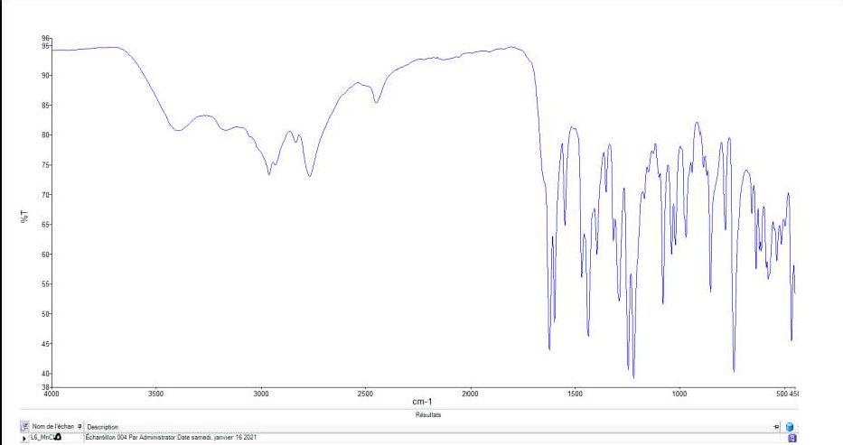

**Figure 4.** Spectre IR of complex with Co(III).

The complex crystallizes with two molecules of DMF and a perchlorate ion.

**Table 1.** Crystal data

|  |  |
| --- | --- |
| Chemical formula | C11H10Cl0.92CoNO |
| Mr | 263.85 |
| Density | 1.843 Mg m−3 |
| Crystal system | Monoclinic |
| Space group | P21/c |
| Radiation | Mo Kα |
| λ | 0.71073 Å |
| a | 13.168 (2) Å |
| b | 15.795 (2) Å |

|  |  |
| --- | --- |
| c | 15.882 (2) Å |
| µ | 2.03 mm−1 |
| T | 293 K |
| β | 110.703 (16)° |
| V | 3090.0 (8) Å3 |
| Z | 13 |
| *F*(000) | 1738 |

**Table 2.** Data collection.

|  |  |
| --- | --- |
| *R*int | 0.120 |
| θmax | 29.5° |
| θmin | 2.6° |
| *h* | −18 17 |
| *k* | −21 20 |
| *l* | −20 21 |
| independent reflections | 7399 |
| measured reflections | 18921 |
| reflections with *I*> 2σ(*I*) | 2272 |

**Table 3.** Refinement.

|  |  |
| --- | --- |
| Refinement | on F2 |
| Least-squares matrix | full |
| Hydrogen site location | mixed |
| *R*[*F*2> 2σ(*F*2)] | 0.094 |
| *wR*(*F*2) | 0.330 |
| *w* | 1/[σ2(*F* 2) + (0.1465*P*)2]  o  where *P* = (*F* 2 + 2*F* 2)/3  o c |
| S | 0.91 |
| (Δ/σ)max | 1.048 |
| Reflections | 7399 |
| Δρmax | 0.88 e Å−3 |
| Δρmin | −0.60 e Å−3 |
| Parameters | 405 |
| Extinction coefficient | 0.0000 (8) |

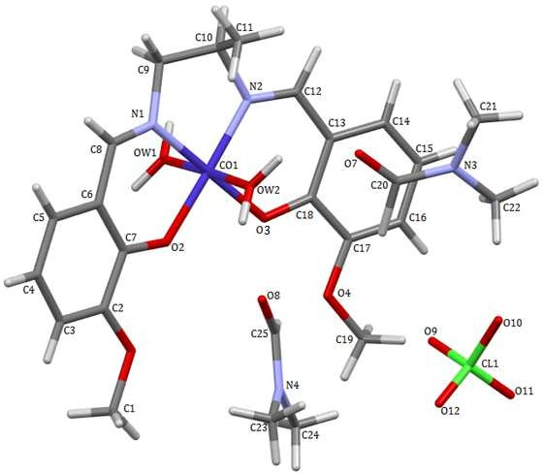

**Figure 5.** Crystal structure of the Co(III) complex.

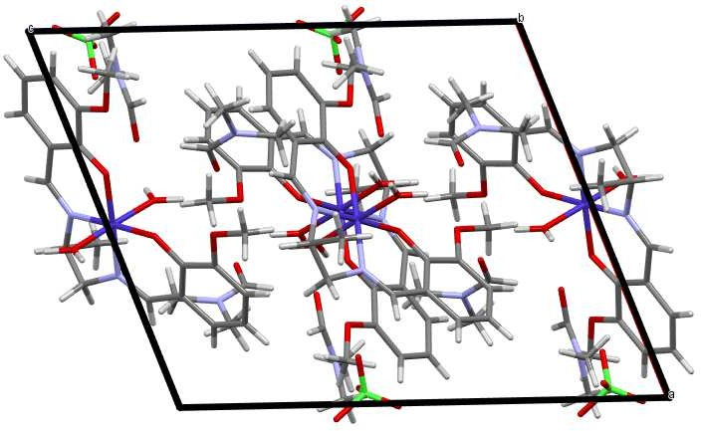

**Figure 6.** The packing of the compound in the crystal structure.

## Results and Discussion

The 1H NMR spectrum of **H2L** (Figure 1) shows three singlets, one doublet and multiplets. The singlets at δ = 3.71 and δ = 13.65 ppm represent (C**H3**-O) and Ar-O**H** respectively. The multiplet in the region 3.79-3.85 ppm represents H1, H1’. The aromatic protons appear as multiplets in the region 6.92-6.75 ppm.

The 13C NMR spectrum of **H2L** (Figure 2) show a signal at δ = 166.5 ppm which represent the carbon atom of the imine **C**=N. The peaks at δ = 151.40 and δ = 64.49 ppm represent respectively the aromatic Cipso of the OH of the phenol and the O-**C**H3.

The IR spectrum of **H2L** (Figure 3) show a strong band at 1625 cm−1 assigned to the ν(C=N) vibration [14]. Upon coordination the band due to C=N shift to low frequencies for both complexes. For compound the band of the C=N is pointed at 1560 cm–1. The broad band of medium intensity that appear in the range 3190 cm−1 is due to the O−H stretching vibration of the phenolic and alcohol OH groups. The phenolic C−O stretching shift to low frequencies for complex at 1316 cm−1.

The cobalt (III) ion has a slightly distorted octahedral coordination geometry. Co (III) is coordinated by two imine nitrogen atoms, N1 and N2, two phenoxo oxygen atoms, O2 and O3 from deprotonated Schiff base ligand and two oxygen atoms Ow1 and Ow2 of water. There is also neighboring two molecule of DMF and one perchlorate anion non coordinating. A deviation from 90° of the bond angles involving the chelation is observed N2—Co1—N1=84.4°; N2—Co1—O3=95.1° O2—Co1—N1=93.9°; O2—Co1—

O3=86.6°). Relevant bonds distances are: *d*(Co1- N1)=1.883Å, *d*(Co1- N2)=1.870Å, *d*(Co1- O2)=1.876Å, *d*(Co1- O3)=1.909 Å, *d*(Co1- Ow1)=1.925Å, *d*(Co1- Ow2)=1.905 Å. Otherwise (N2-Co1-O2=178.3°; N1-Co1-O3=178.8°; Ow1-Co1-Ow2=177.4°) are different to 180° and (N2-Co1-Ow2=92.0°; O2-Co1-Ow2=88.2°; O2-Co1-Ow1=89.2°; N1-Co1-Ow2=90.8°; N1-Co1-Ow1=89.1°; O3-Co1-Ow2=90.3°; O3-Co1-Ow1=89.9°)

are different to 90°.

The molar conductivity values of the freshly DMF (10-3 M) complex solution and fifteen days later are, respectively, 106 (S.cm2.mol-1) and 23 (S.cm2.mol-1) for complex.

## Conclusion

This work allowed us to synthesize and characterize a new isolated bicompartmental ligand as well as its cobalt (III) complex. From spectroscopies methods we were able to

demonstrate the formation of ligand. We also determined structure of complex of Co(III) by X-ray diffraction. The structure reveals tetradentate coordination of the ligand via two nitrogen atoms and two deprotonated phenolicoxygen atoms. In this complex the central metal center is hexacoordinated. This complex is characterized by spectroscopic studies (IR, NMR), molar conductivity and X-ray diffraction.

## References

1. Ibers, J. A., & Holm, R. H. (1980). Modeling coordination sites in mettallobiomolecules.

*Science, 209*(4453). https://doi.org/10.1126/science.7384796

1. Caki, N., Gündüz, S., Rengarasu, R., & Angelovski, G. (2015). Synthetic strategies for preparation of cyclen-based MRI contrast agents. *Tetrahedron Letters, 56*, 759-765. https://doi.org/10.1016/j.tetlet.2014.12.087
2. Fenton, D. E., Casellato, U., Vigato, P. A., & Vidali, M. (1984). *Inorganic Chimica Acta, 95*, 187. https://doi.org/10.1016/S0020-1693(00)87465-4
3. Yang, X.-B., Huang, Y., Zhang, J.-S., Yuan, S.-K., & Zeng, R.-Q. (2010). Synthesis, characterization and DNA interaction of copper (II) complexes with Schiff base ligands derived from 2-pyridinecarboxaldehyde and polyamines. *Inorganic Chemistry Communications, 13*, 1421-1424. https://doi.org/10.1016/j.inoche.2010.08.006
4. Ishak, N. N. M., Jamsari, J., Ismail, A. Z., Tahir, M. I. M., Tiekink, E. R. T., & Veerakumarasivam, A. (2019). Synthesis, characterisation and biological studies of mixed-ligand nickel (II) complexes containing imidazole derivatives and thiosemicarbazide Schiff bases. *Journal of Molecular Structure, 1198*, 126888. https://doi.org/10.1016/j.molstruc.2019.126888
5. Refat, M. S., & El-Metwaly, N. M. (2012). Spectral, thermal and biological studies of Mn(II) and Cu(II) complexes with two thiosemicarbazide derivatives. *Spectrochimica Acta Part A: Molecular and Biomolecular Spectroscopy, 92*, 336-346. https://doi.org/10.1016/j.saa.2012.02.041
6. Spira, D. J., Winkler, M. E., & Solomon, E. I. (1982). *Biochemical and Biophysical Research Communications, 107*, 721. https://doi.org/10.1016/0006-291x(82)91550-9
7. Lubien, C. D., Winkler, M. E., Thamann, T. J., Scott, R. A., Co, M. S., Hodgson, K. O., & Solomon, E. I. (1981). *Journal of the American Chemical Society, 103*, 7014. https://doi.org/10.1021/ja00413a063
8. Berends, H. P., & Stephan, D. W. (1984). *Inorganic Chimica Acta, 93*, 173. https://doi.org/10.1016/S0020-1693(00)87956-6
9. El-Gammal, O. A., Abd, I. M., Al-Gader, A. A., & El-Asmy. (2014). Synthesis, characterization, and biological activity of binuclear Co(II), Cu(II), and mononuclear Ni(II) complexes of bulky multi-dentate thiosemicarbazide. *Spectrochimica Acta Part A: Molecular and Biomolecular Spectroscopy, 128*, 759-772. https://doi.org/10.1016/j.saa.2014.01.119
10. Campbell, V. D., Parsons, E. J., & Pennington, W. T. (1993). *Inorganic Chemistry, 32*, 1773. https://doi.org/10.1107/S0108270195014739
11. Kayatani, T., Hayashi, Y., Suzuki, M., Inomata, K., & Uehara, A. (1996). *Bulletin of the Chemical Society of Japan, 69*, 389. https://doi.org/10.1246/bcsj.69.389
12. Geary, W. J. (1971). The use of conductivity measurements in organic solvents for the characterisation of coordination compounds. *Coordination Chemistry Reviews, 7*, 81-122. https://doi.org/10.1016/S0010-8545(00)80009-0
13. Nakamoto, K. (1970). *Infrared Spectra of Inorganic and Coordination Compounds*

(second edition). https://doi.org/10.1002/bbpc.19710750622

**SUPPLEMENTARY MATERIALS**

|  |  |  |  |  |
| --- | --- | --- | --- | --- |
|  | x | y | z | Uiso*/Ueq |
| Co1 | 0.48651 (8) | 0.14663 (7) | 0.01226 (6) | 0.0559 (4) |
| Cl1 | 1.0282 (2) | 0.1458 (2) | 0.3860 (2) | 0.1029 (9) |
| N1 | 0.3524 (5) | 0.2031 (4) | −0.0178 (4) | 0.0686 (18) |
| N2 | 0.5151 (5) | 0.2264 (4) | −0.0635 (4) | 0.0661 (17) |
| N3 | 0.8879 (6) | 0.3180 (6) | 0.1465 (5) | 0.089 (2) |
| N4 | 0.7212 (6) | 0.0207 (5) | 0.3339 (5) | 0.085 (2) |
| OW1 | 0.4223 (4) | 0.0717 (3) | −0.0881 (3) | 0.0558 (13) |
| HW1A | 0.418887 | 0.087639 | −0.145467 | 0.067* |
| HW1B | 0.394810 | 0.019583 | −0.079332 | 0.067* |
| OW2 | 0.5477 (4) | 0.2175 (3) | 0.1149 (3) | 0.0691 (14) |
| HW2A | 0.575799 | 0.270199 | 0.108738 | 0.083* |
| HW2B | 0.549388 | 0.199411 | 0.171075 | 0.083* |
| O1 | 0.4550 (5) | −0.0427 (4) | 0.2075 (3) | 0.0771 (16) |
| O2 | 0.4536 (4) | 0.0680 (3) | 0.0873 (3) | 0.0590 (13) |
| O3 | 0.6217 (4) | 0.0887 (3) | 0.0401 (3) | 0.0557 (12) |
| O4 | 0.7907 (4) | −0.0070 (4) | 0.0919 (4) | 0.0723 (16) |
| O7 | 0.7102 (6) | 0.3147 (5) | 0.1302 (5) | 0.117 (3) |

|  |  |  |  |  |
| --- | --- | --- | --- | --- |
| O8 | 0.6278 (6) | 0.1363 (4) | 0.2690 (4) | 0.093 (2) |
| O9 | 0.9613 (15) | 0.1168 (10) | 0.3072 (10) | 0.331 (11) |
| O10 | 1.0421 (8) | 0.2344 (6) | 0.3785 (8) | 0.178 (4) |
| O11 | 1.1240 (11) | 0.1100 (8) | 0.4021 (13) | 0.270 (8) |
| O12 | 0.9918 (18) | 0.1201 (15) | 0.4441 (12) | 0.363 (12) |
| C1 | 0.4573 (8) | −0.1056 (7) | 0.2732 (6) | 0.096 (3) |
| H1A | 0.517894 | −0.142828 | 0.282035 | 0.145* |
| H1B | 0.464492 | −0.078486 | 0.329096 | 0.145* |
| H1C | 0.391174 | −0.137731 | 0.252488 | 0.145* |
| C2 | 0.3733 (7) | 0.0167 (6) | 0.1858 (5) | 0.065 (2) |
| C3 | 0.2961 (8) | 0.0208 (7) | 0.2255 (6) | 0.093 (3) |
| H3 | 0.295246 | −0.018669 | 0.268672 | 0.112* |
| C4 | 0.2188 (8) | 0.0855 (9) | 0.1995 (8) | 0.111 (4) |
| H4 | 0.167368 | 0.089281 | 0.227135 | 0.133* |
| C5 | 0.2163 (7) | 0.1425 (7) | 0.1361 (6) | 0.090 (3) |
| H5 | 0.162662 | 0.183906 | 0.119444 | 0.108* |
| C6 | 0.2950 (6) | 0.1397 (6) | 0.0946 (5) | 0.069 (2) |
| C7 | 0.3754 (6) | 0.0765 (5) | 0.1217 (5) | 0.063 (2) |

|  |  |  |  |  |
| --- | --- | --- | --- | --- |
| C8 | 0.2861 (7) | 0.1980 (6) | 0.0237 (6) | 0.070 (2) |
| C9 | 0.3306 (9) | 0.2580 (8) | −0.0968 (8) | 0.122 (4) |
| H9A | 0.293030 | 0.225747 | −0.150870 | 0.147* |
| H9B | 0.283761 | 0.304166 | −0.093337 | 0.147* |
| C10 | 0.4266 (9) | 0.2908 (8) | −0.1021 (10) | 0.127 (5) |
| H10 | 0.419219 | 0.309136 | −0.162986 | 0.153* |
| C11 | 0.4373 (14) | 0.3692 (8) | −0.0334 (8) | 0.163 (6) |
| H11A | 0.501326 | 0.401294 | −0.027501 | 0.245* |
| H11B | 0.374582 | 0.404926 | −0.056477 | 0.245* |
| H11C | 0.442322 | 0.347566 | 0.024441 | 0.245* |
| C12 | 0.6010 (7) | 0.2299 (5) | −0.0850 (5) | 0.067 (2) |
| C13 | 0.6947 (6) | 0.1755 (6) | −0.0496 (5) | 0.066 (2) |
| C14 | 0.7845 (8) | 0.1920 (7) | −0.0752 (6) | 0.088 (3) |
| H14 | 0.781232 | 0.237938 | −0.112632 | 0.106* |
| C15 | 0.8748 (8) | 0.1443 (7) | −0.0480 (8) | 0.103 (3) |
| H15 | 0.932644 | 0.155844 | −0.066957 | 0.124* |
| C16 | 0.8784 (7) | 0.0764 (7) | 0.0101 (7) | 0.089 (3) |
| H16 | 0.940218 | 0.042693 | 0.030618 | 0.107* |

|  |  |  |  |  |
| --- | --- | --- | --- | --- |
| C17 | 0.7934 (6) | 0.0590 (6) | 0.0369 (5) | 0.066 (2) |
| C18 | 0.6961 (6) | 0.1092 (5) | 0.0087 (5) | 0.0577 (18) |
| C19 | 0.8854 (7) | −0.0578 (6) | 0.1238 (7) | 0.099 (3) |
| H19A | 0.875130 | −0.101928 | 0.161528 | 0.148* |
| H19B | 0.899116 | −0.082418 | 0.073582 | 0.148* |
| H19C | 0.946124 | −0.023336 | 0.157798 | 0.148* |
| C20 | 0.7987 (10) | 0.2801 (8) | 0.1451 (7) | 0.098 (3) |
| C21 | 0.8907 (9) | 0.4070 (10) | 0.1341 (9) | 0.146 (5) |
| H21A | 0.962164 | 0.423441 | 0.137196 | 0.220* |
| H21B | 0.839011 | 0.422092 | 0.076240 | 0.220* |
| H21C | 0.872926 | 0.435664 | 0.180357 | 0.220* |
| C22 | 0.9891 (8) | 0.2728 (9) | 0.1600 (8) | 0.135 (5) |
| H22A | 1.043858 | 0.312342 | 0.158702 | 0.203* |
| H22B | 1.012191 | 0.244583 | 0.217235 | 0.203* |
| H22C | 0.977745 | 0.231779 | 0.112972 | 0.203* |
| C23 | 0.7116 (12) | 0.0375 (10) | 0.4185 (8) | 0.163 (6) |
| H23A | 0.745628 | −0.007268 | 0.459731 | 0.244* |
| H23B | 0.746559 | 0.090227 | 0.441532 | 0.244* |

|  |  |  |  |  |
| --- | --- | --- | --- | --- |
| H23C | 0.636259 | 0.040764 | 0.411370 | 0.244* |
| C24 | 0.7848 (9) | −0.0537 (8) | 0.3291 (8) | 0.131 (4) |
| H24A | 0.806496 | −0.083453 | 0.385454 | 0.197* |
| H24B | 0.741533 | −0.090365 | 0.281811 | 0.197* |
| H24C | 0.848069 | −0.036220 | 0.317037 | 0.197* |
| C25 | 0.6809 (8) | 0.0728 (7) | 0.2681 (7) | 0.085 (3) |
| H12 | 0.612 (5) | 0.280 (4) | −0.124 (4) | 0.06 (2)* |
| H8 | 0.225 (11) | 0.228 (9) | 0.014 (9) | 0.20 (6)* |
| H25 | 0.690 (5) | 0.045 (5) | 0.218 (5) | 0.06 (2)* |
| H20 | 0.809 (7) | 0.204 (6) | 0.175 (5) | 0.10 (3)* |

**Atomic displacement parameters (Å2)**

|  |  |  |  |  |  |  |
| --- | --- | --- | --- | --- | --- | --- |
|  | U11 | U22 | U33 | U12 | U13 | U23 |
| Co1 | 0.0499 (6) | 0.0525 (7) | 0.0694 (7) | 0.0041 (5) | 0.0261 (5) | 0.0036 (5) |
| Cl1 | 0.0775 (16) | 0.107 (2) | 0.130 (2) | −0.0048 (16) | 0.0426 (15) | −0.0179 (18) |
| N1 | 0.071 (4) | 0.058 (5) | 0.080 (4) | 0.013 (4) | 0.031 (4) | 0.013 (4) |
| N2 | 0.051 (3) | 0.063 (5) | 0.086 (4) | 0.005 (3) | 0.026 (3) | 0.013 (3) |
| N3 | 0.067 (5) | 0.091 (6) | 0.097 (5) | 0.007 (5) | 0.016 (4) | −0.008 (5) |
| N4 | 0.075 (5) | 0.087 (6) | 0.085 (5) | 0.003 (4) | 0.020 (4) | 0.001 (5) |
| OW1 | 0.061 (3) | 0.053 (3) | 0.053 (2) | −0.003 (2) | 0.020 (2) | 0.005 (2) |

|  |  |  |  |  |  |  |
| --- | --- | --- | --- | --- | --- | --- |
| OW2 | 0.082 (4) | 0.051 (3) | 0.075 (3) | 0.000 (3) | 0.027 (3) | −0.003 (3) |
| O1 | 0.084 (4) | 0.078 (4) | 0.076 (3) | −0.003 (3) | 0.037 (3) | 0.015 (3) |
| O2 | 0.053 (3) | 0.063 (4) | 0.067 (3) | 0.007 (2) | 0.029 (2) | 0.000 (2) |
| O3 | 0.049 (3) | 0.047 (3) | 0.078 (3) | 0.005 (2) | 0.031 (2) | 0.005 (2) |
| O4 | 0.048 (3) | 0.070 (4) | 0.097 (4) | 0.015 (3) | 0.023 (3) | 0.012 (3) |
| O7 | 0.074 (4) | 0.122 (6) | 0.161 (7) | −0.015 (5) | 0.048 (4) | −0.028 (5) |
| O8 | 0.110 (5) | 0.077 (5) | 0.085 (4) | 0.018 (4) | 0.024 (4) | −0.012 (3) |
| O9 | 0.36 (2) | 0.269 (17) | 0.216 (12) | −0.179 (16) | −0.082 (13) | 0.056 (12) |
| O10 | 0.151 (8) | 0.085 (7) | 0.271 (12) | −0.012 (6) | 0.042 (8) | −0.025 (7) |
| O11 | 0.174 (11) | 0.140 (10) | 0.55 (3) | 0.015 (9) | 0.201 (15) | 0.039 (14) |
| O12 | 0.49 (3) | 0.44 (3) | 0.323 (19) | 0.04 (2) | 0.34 (2) | 0.053 (18) |
| C1 | 0.099 (7) | 0.111 (8) | 0.089 (6) | 0.001 (6) | 0.044 (5) | 0.040 (6) |
| C2 | 0.080 (5) | 0.066 (6) | 0.064 (4) | −0.017 (5) | 0.043 (4) | 0.000 (4) |
| C3 | 0.108 (8) | 0.106 (8) | 0.088 (6) | 0.007 (7) | 0.064 (6) | 0.012 (6) |
| C4 | 0.085 (7) | 0.148 (11) | 0.124 (8) | −0.010 (8) | 0.068 (6) | −0.025 (8) |
| C5 | 0.080 (6) | 0.108 (9) | 0.106 (7) | 0.025 (6) | 0.061 (5) | 0.014 (6) |
| C6 | 0.050 (4) | 0.082 (7) | 0.083 (5) | 0.011 (4) | 0.035 (4) | −0.011 (5) |
| C7 | 0.061 (5) | 0.068 (6) | 0.067 (4) | 0.000 (4) | 0.033 (4) | −0.009 (4) |
| C8 | 0.056 (5) | 0.075 (7) | 0.080 (5) | 0.017 (5) | 0.026 (4) | 0.005 (5) |

|  |  |  |  |  |  |  |
| --- | --- | --- | --- | --- | --- | --- |
| C9 | 0.094 (8) | 0.138 (11) | 0.153 (9) | 0.060 (8) | 0.066 (7) | 0.066 (8) |
| C10 | 0.079 (7) | 0.107 (10) | 0.207 (12) | 0.032 (7) | 0.063 (8) | 0.081 (9) |
| C11 | 0.26 (2) | 0.070 (8) | 0.141 (10) | 0.022 (10) | 0.054 (11) | −0.018 (8) |
| C12 | 0.089 (6) | 0.048 (5) | 0.080 (5) | −0.002 (5) | 0.048 (5) | 0.008 (4) |
| C13 | 0.062 (5) | 0.064 (6) | 0.086 (5) | 0.001 (4) | 0.042 (4) | 0.006 (4) |
| C14 | 0.098 (7) | 0.083 (7) | 0.110 (7) | −0.007 (6) | 0.069 (6) | 0.011 (6) |
| C15 | 0.085 (7) | 0.095 (8) | 0.160 (10) | 0.016 (6) | 0.081 (7) | 0.004 (7) |
| C16 | 0.062 (5) | 0.085 (7) | 0.132 (8) | 0.008 (5) | 0.048 (5) | 0.019 (6) |
| C17 | 0.055 (4) | 0.072 (6) | 0.079 (5) | −0.003 (4) | 0.034 (4) | −0.006 (5) |
| C18 | 0.056 (4) | 0.053 (5) | 0.074 (5) | −0.002 (4) | 0.036 (4) | −0.008 (4) |
| C19 | 0.073 (6) | 0.088 (8) | 0.129 (8) | 0.022 (5) | 0.026 (5) | 0.036 (6) |
| C20 | 0.098 (8) | 0.084 (8) | 0.120 (8) | −0.029 (7) | 0.050 (7) | −0.027 (7) |
| C21 | 0.091 (8) | 0.143 (13) | 0.176 (12) | 0.000 (9) | 0.012 (8) | 0.012 (11) |
| C22 | 0.076 (7) | 0.172 (13) | 0.149 (9) | 0.010 (8) | 0.029 (7) | −0.025 (9) |
| C23 | 0.216 (16) | 0.186 (15) | 0.101 (8) | 0.072 (13) | 0.075 (9) | 0.018 (9) |
| C24 | 0.108 (9) | 0.142 (12) | 0.137 (9) | 0.044 (8) | 0.035 (7) | 0.000 (8) |
| C25 | 0.094 (7) | 0.083 (8) | 0.078 (6) | 0.011 (6) | 0.030 (5) | −0.013 (6) |

|  |  |  |  |  |
| --- | --- | --- | --- | --- |
| **Selected bond lengths (Å) and angles (°)** | | | | |
| Co1—N2 | 1.870 (6) |  | C5—C6 | 1.411 (11) |
| Co1—O2 | 1.876 (5) |  | C5—H5 | 0.9300 |
| Co1—N1 | 1.883 (6) |  | C6—C7 | 1.407 (11) |
| Co1—OW2 | 1.905 (5) |  | C6—C8 | 1.427 (12) |
| Co1—O3 | 1.909 (4) |  | C8—H8 | 0.90 (14) |
| Co1—OW1 | 1.925 (4) |  | C9—C10 | 1.396 (14) |
| Cl1—O12 | 1.247 (12) |  | C9—H9A | 0.9700 |
| Cl1—O11 | 1.323 (12) |  | C9—H9B | 0.9700 |
| Cl1—O9 | 1.332 (12) |  | C10—C11 | 1.623 (17) |
| Cl1—O10 | 1.421 (9) |  | C10—H10 | 0.9800 |
| N1—C8 | 1.268 (10) |  | C11—H11A | 0.9600 |
| N1—C9 | 1.468 (11) |  | C11—H11B | 0.9600 |
| N2—C12 | 1.294 (10) |  | C11—H11C | 0.9600 |
| N2—C10 | 1.505 (11) |  | C12—C13 | 1.445 (11) |
| N3—C20 | 1.310 (12) |  | C12—H12 | 1.05 (7) |
| N3—C21 | 1.423 (15) |  | C13—C18 | 1.393 (11) |
| N3—C22 | 1.459 (12) |  | C13—C14 | 1.404 (11) |

|  |  |  |  |  |
| --- | --- | --- | --- | --- |
| N4—C25 | 1.288 (11) |  | C14—C15 | 1.344 (13) |
| N4—C23 | 1.418 (12) |  | C14—H14 | 0.9300 |
| N4—C24 | 1.460 (12) |  | C15—C16 | 1.405 (13) |
| OW1—HW1A | 0.9300 |  | C15—H15 | 0.9300 |
| OW1—HW1B | 0.9300 |  | C16—C17 | 1.359 (11) |
| OW2—HW2A | 0.9300 |  | C16—H16 | 0.9300 |
| OW2—HW2B | 0.9300 |  | C17—C18 | 1.436 (10) |
| O1—C2 | 1.377 (10) |  | C19—H19A | 0.9600 |
| O1—C1 | 1.434 (9) |  | C19—H19B | 0.9600 |
| O2—C7 | 1.333 (8) |  | C19—H19C | 0.9600 |
| O3—C18 | 1.288 (8) |  | C20—H20 | 1.28 (9) |
| O4—C17 | 1.370 (9) |  | C21—H21A | 0.9600 |
| O4—C19 | 1.417 (9) |  | C21—H21B | 0.9600 |
| O7—C20 | 1.232 (13) |  | C21—H21C | 0.9600 |
| O8—C25 | 1.225 (11) |  | C22—H22A | 0.9600 |
| C1—H1A | 0.9600 |  | C22—H22B | 0.9600 |
| C1—H1B | 0.9600 |  | C22—H22C | 0.9600 |
| C1—H1C | 0.9600 |  | C23—H23A | 0.9600 |
| C2—C3 | 1.373 (11) |  | C23—H23B | 0.9600 |

|  |  |  |  |  |
| --- | --- | --- | --- | --- |
| C2—C7 | 1.396 (10) |  | C23—H23C | 0.9600 |
| C3—C4 | 1.398 (14) |  | C24—H24A | 0.9600 |
| C3—H3 | 0.9300 |  | C24—H24B | 0.9600 |
| C4—C5 | 1.342 (14) |  | C24—H24C | 0.9600 |
| C4—H4 | 0.9300 |  | C25—H25 | 0.96 (7) |

|  |  |  |  |
| --- | --- | --- | --- |
| N2—Co1—O2 | 178.3 (2) | C10—C9—H9B | 109.3 |
| N2—Co1—N1 | 84.4 (3) | N1—C9—H9B | 109.3 |
| O2—Co1—N1 | 93.9 (3) | H9A—C9—H9B | 108.0 |
| N2—Co1—OW2 | 92.0 (3) | C9—C10—N2 | 108.1 (9) |
| O2—Co1—OW2 | 88.2 (2) | C9—C10—C11 | 96.2 (11) |
| N1—Co1—OW2 | 90.8 (3) | N2—C10—C11 | 111.8 (10) |
| N2—Co1—O3 | 95.1 (2) | C9—C10—H10 | 113.2 |
| O2—Co1—O3 | 86.6 (2) | N2—C10—H10 | 113.2 |
| N1—Co1—O3 | 178.8 (2) | C11—C10—H10 | 113.2 |
| OW2—Co1—O3 | 90.3 (2) | C10—C11—H11A | 109.5 |
| N2—Co1—OW1 | 90.6 (2) | C10—C11—H11B | 109.5 |
| O2—Co1—OW1 | 89.2 (2) | H11A—C11—H11B | 109.5 |
| N1—Co1—OW1 | 89.1 (2) | C10—C11—H11C | 109.5 |

|  |  |  |  |
| --- | --- | --- | --- |
| OW2—Co1—OW1 | 177.4 (2) | H11A—C11—H11C | 109.5 |
| O3—Co1—OW1 | 89.9 (2) | H11B—C11—H11C | 109.5 |
| O12—Cl1—O11 | 107.9 (13) | N2—C12—C13 | 125.2 (8) |
| O12—Cl1—O9 | 106.4 (13) | N2—C12—H12 | 121 (4) |
| O11—Cl1—O9 | 107.7 (13) | C13—C12—H12 | 114 (4) |
| O12—Cl1—O10 | 118.5 (12) | C18—C13—C14 | 121.2 (8) |
| O11—Cl1—O10 | 107.2 (7) | C18—C13—C12 | 121.0 (7) |
| O9—Cl1—O10 | 108.8 (8) | C14—C13—C12 | 117.8 (8) |
| C8—N1—C9 | 121.3 (7) | C15—C14—C13 | 122.9 (9) |
| C8—N1—Co1 | 126.5 (6) | C15—C14—H14 | 118.5 |
| C9—N1—Co1 | 112.2 (5) | C13—C14—H14 | 118.5 |
| C12—N2—C10 | 119.1 (8) | C14—C15—C16 | 117.3 (9) |
| C12—N2—Co1 | 126.4 (6) | C14—C15—H15 | 121.3 |
| C10—N2—Co1 | 114.5 (6) | C16—C15—H15 | 121.3 |
| C20—N3—C21 | 121.1 (10) | C17—C16—C15 | 121.3 (9) |
| C20—N3—C22 | 123.1 (11) | C17—C16—H16 | 119.3 |
| C21—N3—C22 | 115.8 (10) | C15—C16—H16 | 119.3 |
| C25—N4—C23 | 120.0 (10) | C16—C17—O4 | 124.3 (8) |
| C25—N4—C24 | 123.5 (9) | C16—C17—C18 | 122.3 (8) |

|  |  |  |  |
| --- | --- | --- | --- |
| C23—N4—C24 | 116.3 (9) | O4—C17—C18 | 113.4 (6) |
| Co1—OW1—HW1A | 120.0 | O3—C18—C13 | 127.8 (7) |
| Co1—OW1—HW1B | 120.0 | O3—C18—C17 | 117.2 (7) |
| HW1A—OW1—HW1B | 120.0 | C13—C18—C17 | 115.0 (7) |
| Co1—OW2—HW2A | 120.0 | O4—C19—H19A | 109.5 |
| Co1—OW2—HW2B | 120.0 | O4—C19—H19B | 109.5 |
| HW2A—OW2—HW2B | 120.0 | H19A—C19—H19B | 109.5 |
| C2—O1—C1 | 117.9 (6) | O4—C19—H19C | 109.5 |
| C7—O2—Co1 | 125.4 (5) | H19A—C19—H19C | 109.5 |
| C18—O3—Co1 | 124.3 (5) | H19B—C19—H19C | 109.5 |
| C17—O4—C19 | 116.2 (6) | O7—C20—N3 | 125.6 (12) |
| O1—C1—H1A | 109.5 | O7—C20—H20 | 117 (4) |
| O1—C1—H1B | 109.5 | N3—C20—H20 | 116 (4) |
| H1A—C1—H1B | 109.5 | N3—C21—H21A | 109.5 |
| O1—C1—H1C | 109.5 | N3—C21—H21B | 109.5 |
| H1A—C1—H1C | 109.5 | H21A—C21—H21B | 109.5 |
| H1B—C1—H1C | 109.5 | N3—C21—H21C | 109.5 |
| C3—C2—O1 | 123.9 (8) | H21A—C21—H21C | 109.5 |
| C3—C2—C7 | 120.7 (9) | H21B—C21—H21C | 109.5 |

|  |  |  |  |
| --- | --- | --- | --- |
| O1—C2—C7 | 115.4 (6) | N3—C22—H22A | 109.5 |
| C2—C3—C4 | 118.6 (9) | N3—C22—H22B | 109.5 |
| C2—C3—H3 | 120.7 | H22A—C22—H22B | 109.5 |
| C4—C3—H3 | 120.7 | N3—C22—H22C | 109.5 |
| C5—C4—C3 | 122.2 (9) | H22A—C22—H22C | 109.5 |
| C5—C4—H4 | 118.9 | H22B—C22—H22C | 109.5 |
| C3—C4—H4 | 118.9 | N4—C23—H23A | 109.5 |
| C4—C5—C6 | 120.1 (9) | N4—C23—H23B | 109.5 |
| C4—C5—H5 | 119.9 | H23A—C23—H23B | 109.5 |
| C6—C5—H5 | 119.9 | N4—C23—H23C | 109.5 |
| C7—C6—C5 | 118.4 (8) | H23A—C23—H23C | 109.5 |
| C7—C6—C8 | 122.9 (7) | H23B—C23—H23C | 109.5 |
| C5—C6—C8 | 118.6 (8) | N4—C24—H24A | 109.5 |
| O2—C7—C2 | 116.6 (7) | N4—C24—H24B | 109.5 |
| O2—C7—C6 | 123.5 (7) | H24A—C24—H24B | 109.5 |
| C2—C7—C6 | 119.8 (7) | N4—C24—H24C | 109.5 |
| N1—C8—C6 | 124.8 (8) | H24A—C24—H24C | 109.5 |
| N1—C8—H8 | 128 (9) | H24B—C24—H24C | 109.5 |
| C6—C8—H8 | 107 (9) | O8—C25—N4 | 125.9 (10) |

|  |  |  |  |
| --- | --- | --- | --- |
| C10—C9—N1 | 111.4 (9) | O8—C25—H25 | 129 (4) |
| C10—C9—H9A | 109.3 | N4—C25—H25 | 104 (4) |
| N1—C9—H9A | 109.3 |  |  |

|  |  |  |  |  |  |  |
| --- | --- | --- | --- | --- | --- | --- |
| Donor --- | H Acceptor | [ARU] | D - H | H...A | D...A | D - H...A |
| Ow1 | --Hw1A O1 | [3655.01] | 0.93 | 2.32 | 2.929(8) | 123 |
| Ow1 | --Hw1B O3 | [3655.01] | 0.93 | 1.86 | 2.766(7) | 164 |
| Ow1 | --Hw1B O4 | [3655.01] | 0.93 | 2.39 | 2.966(8) | 120 |
| Ow2 | --Hw2A O7 | [1555.03] | 0.93 | 1.82 | 2.574(10) | 136 |
| Ow2 | --Hw2B O8 | [2645.04] | 0.93 | 1.83 | 2.631(8) | 143 |
| C9 | --H9B O11 | [4554.02] | 0.97 | 2.48 | 3.42(2) | 164 |
| C12 | --H12 O8 | [3665.04] | 1.05(6) | 2.22(6) | 3.248(10) | 167(5) |
| C15 | --H15 O10 | [4654.02] | 0.93 | 2.59 | 3.421(16) | 149 |
| C22 | -H22B O10 | [1655.02] | 0.96 | 2.46 | 3.344(17) | 154 |

Translation of ARU-Code to CIF and Equivalent Position Code

====================================================

[3655.] = 1-x,-y,-z [2645.] =1-x,-1/2+y,1/2-z [4554.] = x,1/2-y,-1/2+z [3665.] = 1-x,1-y,-z

[4654.] = 1+x,1/2-y,-1/2+z [1655.] =1+x,y,z