PREDICTION OF RUNOFF BY SYNTHETIC UNIT HYDROGRAPH METHODS FOR THE DESIGN STORMS IN WARANA RIVER BASIN, MAHARASHTRA, INDIA

# Abstract

**The authors' goal was to calculate average representative unit hydrographs (UHs) from a few isolated storms for the upper Warana River basin in Maharashtra, India. Based on the approaches used by Snyder, the Soil Conservation Service (SCS), the Central Water Commission (CWC), and Common, synthetic unit hydrographs were created. This study was utilised to choose appropriate correlation coefficients for Synthetic Unit Hydrograph (SUH) evaluation for the ungauged basins with identical hydrological conditions. The outcomes were then analyzed with those attained using other techniques and with the actual UH. In order to calibrate and validate the effectiveness of Snyder's model, the authors employed it on the sub-basins of the Warana river basin. The hydrograph's shape resembled the observed UH produced by the other methods, according to the results, and the peak discharge calculated using Snyder's technique had the lowest percentage error (0.26%)**

**Keywords: Ungauged basins, Isolated storm, Unit hydrograph, Peak discharge, Time to peak, Synthetic unit hydrograph**

# Introduction

There does not seem to be a single agreed-upon definition of the unit hydrograph (UH) hypothesis, despite the fact that it has been utilised in runoff calculation for about 40 years. Sherman (1932) first defined the UH idea as the hydrograph of runoff water on a specific basin as a result of an effective rainfall for a unit of time. The UH is a common method for representing the linear system reaction to rainfall over the watershed at the outlet (Maidment *et al*., 1996). The UH theory (Dooge 1959; Bruen and Dooge, 1992) states that

a catchment functions on an inflow of functional rainfall in a continuous and time-invariant way to generate a result of direct storm runoff. The hydrologic system is described as linear and time- invariant (Dooge, 1973). Rainfall and runoff figures are frequently insufficient in many parts of the world to establish the unit hydrograph of a basin or watershed. This situation occurs regularly since the most of the rivers and streams in the upper Krishna basin lack gauging stations.

The current study focused on the Warana River basin, selected due to its abundance of sites lacking hydrologic data (Thorvat and Mujumdar, 2011). Within various techniques available to determine runoff from limited data, the SUH holds significance in calculating runoff volume over time (Bhunya *et al*., 2009). Additionally, the SUH serves as a valuable tool to establish UHs for additional gauging stations within the same catchment or for similar catchments without runoff data (Singh, 2000). Historically, different approaches have been employed to convert rainfall into runoff and calculate essential hydrograph metrics. Bernard (1935) successfully utilized a distribution graph based on catchment features for this purpose. Snyder (1938) employed empirical equations to calculate key hydrograph metrics such as peak discharge, time to peak, base period, and UH widths at 50% and 75% of peak discharge. Commons, 1942, developed a dimensionless hydrograph using flood hydrographs from Texas. Mitchell (1948) analyzed 58 SUHs in Illinois, creating summation curves with a probable error of 39.0% in crest magnitude and 37.5% in time.

The Soil Conservation Service (SCS), under the US Department of Agriculture, developed a method to generate the shape of the Synthetic Unit Hydrograph (SUH) from an average dimensionless hydrograph automatically, eliminating the need for manual fitting (USDA 1957). However, it’s important to recognize that assuming the SCS dimensionless UH is invariant regardless of catchment location, size, or form may not always be acceptable (Singh, 2000). When applying the UH to design rainfall excess to obtain the design storm hydrograph, the results can be significantly influenced by both the base period and the shape of the UH (Hoffmeister and Weisman, 1977). To study the effects of urbanization on watersheds, Huang and colleagues (2012) investigated correlations between model parameters and urbanization characteristics.

In other studies, researchers explored various hydrograph modeling techniques for specific regions and watersheds. For instance, Galavi *et al*. (2013) addressed the need for a structured river stage forecasting model for the Klang River in Malaysia, considering an adaptive neuro-fuzzy inference system and autoregressive integrated moving average models. Mirzaei *et al*. (2015) examined the uncertainty of rainfall depths using the bootstrap sampling approach and a normal probability density function for depth duration frequency curves.

In India, Patel and Thorvat (2016) found that Mitchell’s technique provided an acceptable percentage error for the Higher Kumbhi Watershed and the Dhamani Watershed in Maharashtra. Similarly, Idfi *et al*. (2020) determined that the SCS method exhibited a high degree of precision for the Indonesian Ngotok River watershed. These studies demonstrate that not all methods are universally suitable for all river basins. For the Rel River basin in Rajasthan, India, Shaikh *et al*. (2022) discovered that the CWC SUH method proved to be the most appropriate SUH technique. Their simulation model closely matched the measured hydrograph shape, with minimal disparity in peak time between the observed and simulated hydrographs.

In conclusion, selecting the most appropriate method for hydrograph analysis relies on understanding the unique characteristics of the study area. Researchers must make thoughtful choices to ensure accurate results and meaningful insights for their specific field of research. In cases of undeveloped watersheds, obtaining basic stream flow and precipitation data can be challenging, hindering the planning and implementation of water management systems and hydraulic structures. However, solutions have emerged in the form of techniques that allow for the generation of synthetic unit hydrographs (SUH). Among these methods are the Common’s Method, the Soil Conservation Service (SCS) Method, Snyder’s Method, and the CWC Method (Salami *et al*., 2017). By employing design storm hydrographs constructed from unit hydrographs generated through tested methods, researchers can determine peak discharges of stream flow caused by rainfall.

In the context of the current paper, the focus was on evaluating methods to derive SUH parameters specifically for the Warana River basin in Maharashtra, India. This was accomplished by employing empirical equations that relate UH parameters to catchment characteristics and slope. The ultimate goal was to establish a conceptual understanding of these various methods and select the most suitable empirical approach for ungauged basins with hydrological conditions similar to the study area. In summary, the search for effective hydrograph analysis techniques becomes crucial in areas where basic data is scarce. By exploring and comparing various methods, researchers aim to find the best-suited approach for generating synthetic unit hydrographs that can enhance water management planning in ungauged basins.

## Study Area

The River Warana (16° 47' 00"N to 17°15'15'' N and 73°30'45" E to 74°30'00'' E), a tributary of the River Krishna, begins in the Sahyadri range in Patan Taluka of Satara District, Maharashtra, India, and flows southwest for 160 km. before joining the River Krishna at Haripur near Sangli (Figure 1). In the western part of the Deccan Plateau, the river drains a total area of 2095 sq km. The eastern part of the basin is less mountainous and has a flat rolling landscape than the western part. The basin is located in the Western Ghats’ rain-shadow zone and has a moderate climate (source: IMD, Pune) with three distinct seasons: monsoon season (June upto September), winter season (October upto January), and summer season (February upto May).

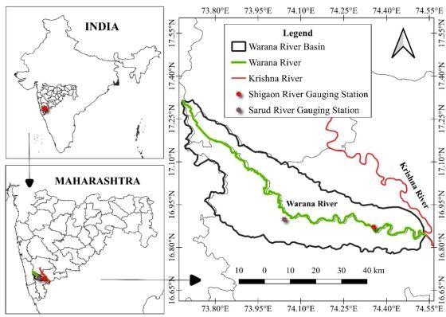

**Figure 1. Location of the Warana River basin in Western Ghat region, Maharashtra, India**

The current study aims to develop various physiographic characteristics quantitatively for the derivation of UHs by a single-event method for the selected basins. Quantum Geographical Information Systems (QGIS) 3.16 open-source software is used to analyze the morphometry of the Warana River basin. From the Survey of India topographic sheets 47G/12, 47G/6, 47H/13, 47K/4, 47L/1, 47L/5, and

47L/9, the catchment borders and all streams were plotted at a scale of 1:50,000. The Shuttle Radar Topographic Mission (SRTM) provided a 30 m digital elevation model, which was imported using USGS Earth Explorer (Figure 2). The parameters for the aerial and relief elements were determined. For an additional morphometric study, a digital database for drainage networks was constructed. The classical method (Horton, 1945; Strahler, 1957) was used to analyze drainage characteristics. According to this ordering system, the Warana River basin is a Seventh-order basin. Catchment characteristics

and stream lengths of the Warana River basin were evaluated and are presented in Table 1. The Warana River is a 7th-order stream (Figure 3) (Table 1). Sub- basin 1, Sub-basin 2, and Sub-basin 3 are sixth-order basins. Stream order is a function of the proportion size of streams. This suggests a well-drained basin with a dendritic structure (Figure 3). The average stream length for the first-order basin is found to be more whereas, for the fourth and fifth-order streams, it is lesser (Figure 3). This indicates that the basin has a steep slope upstream and a gentle downstream. From two automatic rain gauge stations located at Shigaon and Sarud (Figure 2), records of hourly precipitation for the Warana basin were obtained through Hydrology Project Circle, Nashik, India. The hourly discharges from Shigaon and Sarud gauging stations were used for the storms that were selected.

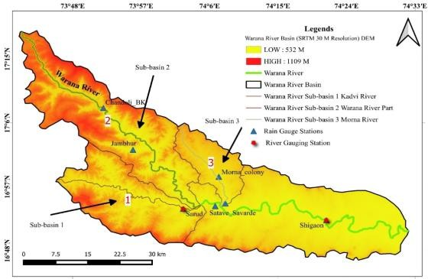

**Figure 2. Shuttle Radar Topographic Mission (SRTM) (30 m Resolution) Digital Elevation Model Warana River Sub-basins 1,2,3**

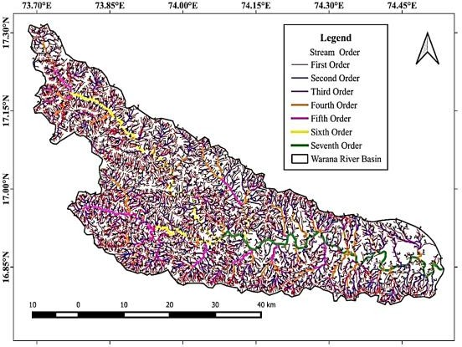

**Figure 2. Stream Order map by (Strahler method) Warana River basin**

**Table 1. Basin characteristics and stream lengths of the Wrana River basin and Sub-basins**

|  |  |  |  |  |
| --- | --- | --- | --- | --- |
| **Basin Characteristics** | **Warana River basin** | **Sub-basin 1** | **Sub-basin 2** | **Sub-basin 3** |
| Stream Order | 7 | 6 | 6 | 6 |
| Stream Number | 6268 | 1745 | 2066 | 479 |
| Stream Length (Km) | 5057.18 | 1219.363 | 1688.072 | 396.357 |
| Basin Area (Km2) | 2095.00 | 439.10 | 684.22 | 175.17 |
| Basin Perimeter (Km) | 343.46 | 108.289 | 168.33 | 68.87 |
| Relative Perimeter (Km) | 6.10 | 4.05 | 4.06 | 2.54 |
| Maximum Elevation (m) | 1109 | 1027 | 1109 | 884 |
| Elevation at Outlet (m) | 532 | 550 | 550 | 552 |
| Length of the Main channel (Km) | 160.4 | 46.01 | 82.14 | 28.84 |
| Length between outlet and centroid of the basin (LC) | 56.0 | 17.10 | 37.50 | 14.20 |
| Length of Basin (Lb) (Km) | 86.83 | 36.86 | 61.59 | 22.64 |
| Watershed Relief (H) | 569.00 | 477.00 | 559.00 | 334.00 |
| Relief Ratio | 6.55 | 12.94 | 9.08 | 14.75 |
| Absolute Relief | 685.00 | 685.00 | 685.00 | 585.00 |
| Watershed slope (m/km) | 3.55 | 10.37 | 6.81 | 11.58 |
| No. of 1st order streams | 4828 | 1343 | 1633 | 365 |
| Length of 1st order streams | 3033.00 | 742.83 | 1108.19 | 224.90 |
| No. of 2nd order streams | 1101 | 308 | 346 | 83 |
| Length of 2nd order streams | 1029.15 | 238.35 | 318.16 | 92.25 |
| No. of 3rd order streams | 262 | 76 | 68 | 22 |
| Length of 3rd order streams | 494.52 | 131.43 | 119.07 | 33.96 |
| No. of 4th order streams | 60 | 13 | 15 | 6 |
| Length of 4th order streams | 240.09 | 37.21 | 70.78 | 24.65 |
| No. of 5th order streams | 13 | 4 | 3 | 2 |
| Length of 5th order streams | 91.82 | 50.25 | 9.74 | 8.10 |
| No. of 6th order streams | 3 | 1 | 1 | 1 |
| Length of 6th order streams | 90.93 | 19.28 | 62.11 | 9.54 |
| No. of 7th order streams | 1 | - | - | - |
| Length of 7th order streams | 77.67 | - | - | - |
| Mean Bifurcation Ratio (Rbm) | 4.15 | 4.30 | 4.47 | 3.37 |
| Stream Frequency (SF) | 2.99 | 3.97 | 3.02 | 2.73 |
| Drainage Density (D) (km/km2) | 2.41 | 2.78 | 2.47 | 2.26 |
| Time of Concentration (hr) | 28.61 | 7.24 | 13.30 | 4.84 |

# Material and Methods

The current study aimed to develop various physiographic characteristics quantitatively for the derivation of UHs by a single-event method for the considered basins. For the storms selected, records of hourly rainfall and discharge data from two autographic rain gauge and river gauging stations at Shigaon and Sarud for the Warana River basin were collected from Hydrology Project Circle, Nashik, India. The criterion used for the UH derivation was that the flow at gauging stations should be at low stages (Singh, 1994). Therefore, the river flows were chosen from the low-flow months-i.e., June, September, and October. Basin Morphology i.e Linear, Aerial, and Relief aspects are determined by using Shuttle Radar Topographic Mission (SRTM) (30 m Resolution) Digital Elevation Model (DEM) (Figure 2) to check the interrelationship between morphometric parameters to assess the qualitative basin potential of the Warana River basin. Further, the morphometry of Sub-basins and the interrelationship between morphometric parameters of Sub-basins is used to categorize the sub-basins with similar hydro-climatic regions.

In the present study, the UHs derived for 23 isolated storm events for the Warana river basin

practically satisfy the assumptions made in the derivation of UH. As hourly rainfall and hourly discharge data are available, it is possible to choose the UH duration as one hour which is suitable for the basins under study and is analyzed to derive UH by single event method. From the results, it is observed that there is a considerable variation in the Peak Discharge (QP) and Time to peak (TP) of UH computed for each storm event. Hence an attempt is made to develop an average representative UH with minimum root mean square error and maximum efficiency, which is useful to provide a tool for the prediction of the design flood. For the Warana River basin, it is observed that the UHs derived for 23 isolated storm events are not identical. Therefore, the average UH is evaluated to determine the representative average UH for this basin. To facilitate the validation by the LOOCV method (Zhao *et al*., 1995; Patel and Thorvat 2016), 23 average UHs are determined by leaving out one UH every time and averaging the remaining 22 UHs. LOOCV method is described as follows.

1. Let’s say, there have been ‘R’ storms observed. The LOOCV approach involves eliminating one storm from a group of R storms at a time, then determining a UH based on the‘R - 1’ storms that remain.
2. Use the calculated UH to additionally forecast the excluded storm.
3. The Root Mean Square Error (ERMS) value for forecasting the DRH of the excluded storm is then determined.
4. The ‘R’ values of the ERMS are averaged after the leave-one-out is carried out for every ‘R’ storm.
5. Then, the UHs from various methods are compared for their prediction performance using the mean ERMS.
6. The algorithm of the LOOCV method can be outlined as follows:

Consider R storm events, S = (S1, S2, ..., Sn) Let t = 1.

Leave out storm event Sr, from the original data set S, Use the selected method to determine a UH calIed Uhr based on the remaining R-1 storms, that is, (S1, S2, S3, Sr-1. Sr+1…. Sr)

Predict the DRH of the excluded storm event Sr using the calculated UH and effective rainfall data from that storm event. The associated ERMS value is then determined.

The average UH is determined by averaging QP, TP, TB, W50, and W75 of peak discharge of individual UH. All the UHs are validated by applying effective rainfall (ER) of the left-out storm to the corresponding average UH ordinates. Thus, in the validation stage, 23 calculated DRHs are produced and compared to the respective observed DRHs.

For the Warana River basin, four SUH methods were tested: Snyder’s method, SCS dimensionless SUH, Common’s SUH, and CWC SUH method. The authors have attempted to select the proper empirical method useful for ungauged basins with similar hydrological conditions to develop widespread equations to determine peak discharge, time to peak, base period, and widths (in time units) at 50 and 75% of peak discharge of a SUH. They next compared the peak discharges expressed as percentage error and the shape of the hydrograph using this approach and other synthetic methods with the corresponding observed UH finalized from the LOOCV method using actual storm data. The authors then calibrated and validated the performance of the best suitable method by applying it to the Sub-basins to determine various SUH parameters. Finally, SUH results using the best suitable method and other synthetic methods were compared with the corresponding average UH obtained by the LOOCV method.

**Morphometric parameters and their interactions** The link between stream frequency and bifurcation ratio, as well as drainage density and bifurcation ratio, is used by (Al-Saud, 2009;

Bhagwat *et al*., 2013) to assess the basin’s qualitative potential to categorize the sub-basins with similar hydro-climatic regions. (Figure 4(a) and Figure 4(b))

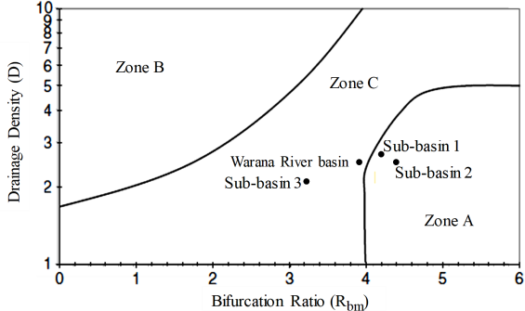

(a)

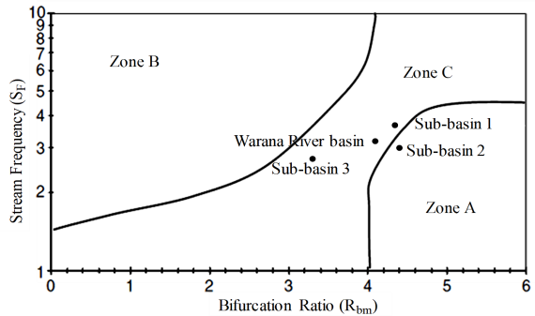

(b)

**Figure 4. (a) Graph of Drainage Density vs Bifurcation Ratio for the Warana River basin situated in various agroclimatic zones (Field boundaries after Al-Saud, 2009; Bhagwat *et al*., 2013). ( b) Stream frequency vs Bifurcation ratio and for the Warana River basin situated in various agroclimatic zones (Field boundaries after Al-Saud, 2009; Bhagwat *et al*., 2013).**

Zone A: Low flood probability and high recharge property,

Zone B: High flood probability and low recharge property,

Zone C: Moderate to high flood property and moderate recharge property.

Based on the bifurcation ratio, Drainage density, and Stream frequency Warana River Basin is found beneath "Zone C." This suggests that the Warana Watershed has a moderate to high potential for flooding as well as a moderate potential for recharging. Under "Zone C," Sub-basins 1 and 3 are located. This suggests that sub-basins 1 and 3 have medium recharge and moderate to high flood potential. Sub-basin 2 is located in "Zone A," which suggests a low probability of flooding and a high

probability of recharge A basin's various morphometric characteristics are the most accurate indicators of its subsurface geology, landforms, terrain, slope, climate, and hydrological activities. Surface water harvesting and watershed management plans benefit greatly from morphometric studies of the basin area (Jahan *et al*., 2018; Rai *et al*., 2019; Giday *et al*., 2021). Additionally, the geomorphic progression of any place is shown by this characteristic. When managing a watershed, particularly in ungauged basin structures, drainage network parameters can provide an indication of the hydrological behaviour of a basin (Bhagwat *et al*., 2018). The morphometric investigation of the drainage network of the basin displays dendritic patterns with modest drainage texture. The highest stream order of Sub-basins under study is the 6th order (Table 1). Sub-basin 1 and Sub-basin 2 overland flow is not dominating then concentrated flow dominates and it leads to flooding downstream. Sub-basin 3 has less than a 06-hour time of concentration (Table 1) due to these flash floods there. Sub-basin 2 is elongated and has delayed (Concentrated flow), whereas Sub- basin 1 time of concentration is less as compared to Sub-basin 2 and has structural control in third and fourth-order streams hence leading to moderate recharge also. Alteration in slope and terrain could be the cause of the difference in stream length ratio. The basin's bifurcation ratio shows that it falls within the category of a typical basin, and the existence of modest drainage density suggests that the subsoil is moderately permeable and has finer drainage texture. According to the stream frequency value (Table 1), there is a positive link between growing stream number and increasing drainage density in the basin. According to morphological characteristics, sub-basins 1 and 3 suggest that the Warana basin has modest recharge and moderate to high flood potential. The subbasins 1 and 3's hydro geomorphological and hydrograph features offer a moderate storage potential, permitting for the construction of several check dams for groundwater replenishment. Also planning for different water conservation structures can be considered for constructing a comprehensive watershed development plan. Further, the morphometry of Sub-basins and the interrelationship between morphometric parameters of Sub-basins is used to categorize the sub-basins with similar hydro- climatic regions to calibrate and validate the performance of the best suitable method SUH by applying it to the Sub-basins.

## Synthetic Unit Hydrograph Methods Snyder’s method.

Snyder (1938) was the first to develop empirical formulas to derive SUH for a catchment area with inadequate data by using the catchment characteristics of the basin (Subramanya, 2008). Snyder’s method is given by equation s 1-5:

tp = Ct (L.LC)0 (1)

QP = 640 CP A/tp (2)

TB = 5 [(tp/11) + tp] (3)

W50 = 2.14 (qp)–1.08 (4)

W75 = 1.22 (qp)–1.08 (5)

where tp (hours) is the time of lag to peak, Ct is a regional constant representing watershed slope and storage effects, L (kilometres) is the length of the main channel, Lc (kilometres) is the length between the outlet and centroid of the watershed, QP (cubic meters per second) is the peak discharge of a UH, CP is an indication of the retention and storage capacity of the watershed, A (square kilometres) is the drainage area, TB (hours) is the base period, W50 and W75 (hours) are the widths at 50 and 75%, respectively, of peak discharge of a SUH, and qp (cubic meters per second per square kilometre) is the peak discharge per unit catchment area (Subramanya, 2008). Physical parameters used for deriving Ct and CP regional constant for the catchment of Shigaon and Sarud gauging station are Drainage area of the basin (A), Length of the main channel (L), Length between outlet and centroid of the basin (Lca), Effective rainfall duration (tR), and Time to Peak (TP), Time to Peak (ARUH)

## SCS Dimensionless Synthetic Unit Hydrograph (1957)

Several researchers propose dimensionless unit hydrographs to make it easier to develop synthetic unit hydrographs. These are based on an analysis among several unit hydrographs. A simplified version of a triangle unit hydrograph can be used to determine the typical value of peak flow (QP), time to peak (TP), and base time (Tb) (Subramnaya, 2008). The majority of the hydrograph is defined by the Soil Conservation Service using an average dimensionless hydrograph that was produced from the study of several natural unit graphs that varied significantly in size and location. The abscissa values of the peak discharge QP are

written as the dimensionless ratio t/tR, while the ordinate variables are represented as the non - dimensional ratio Q/Qv. It is possible to construct the unit hydrograph once the parameters of QR and tR have been established using the given formula.

SCS suggests that,

Base time (Tb) = 2.67 * Tp (6)

SCS also discovered the following, based on a significant number of minor watersheds:

TC=0.0662*L (0.77) * S(-0.305)

The longest watercourse in the watershed (L), its average slope (S) calculated by using QGIS 3.16 software.

tP = 0.6*tc (7)

where, tc = Time of concentration

Thus

TP = tr + 0.6tc (8)

2

Since the area under the unit hydrograph must be equal to 1 cm,

If A= Area of the catchment in km2,

QP = 0.139 A/Tu in m3/sec (11)

Tb = 100Tu (12)

The parameters derived in this method are time unit (Tu) in hours, volume, and peak discharge (Qu) in cubic meters per second as shown in Eqs. 10-12. where Tu stands for the dimensionless graph's

time unit. The synthetic unit hydrograph has a 100 Tu base time and a 14 Tu peak time. To calculate the peak flow in metric units, take into account 10 mm of extra precipitation on a watershed measured in square kilometres.

## Central Water Commission (CWC) (1993) Synthetic Unit Hydrograph

For the various sub-zones of India, the Central Water Commission (CWC) established the geographical unit hydrograph correlations linking to the several unit hydrograph variables with certain important physiographic properties. For Krishna and Pennar subzone-3 (h), unit hydrograph can be produced applying the spatial correlations suggested by CWC. For various sub-zones of India, CWC determined regional unit hydrograph equations related to different unit hydrograph elements with certain significant physiographic features. The parameters necessary for the development of the CWC Unit hydrograph are area (A), length (L),

Peak Discharge (Q ) =2.08 𝐴

(9)

stream slope (S), and length between outflow and

Where,

P 𝑇𝑝

centroid of basin (LC). To calculate flood hydrographs along every stream reach, this information is helpful.

QP= Peak Discharge in m3/sec, tr = Duration of effective rainfall, TP= Time to peak, tp = Lag time, Tb= Base time.

## Commons’ Dimensionless Synthetic Unit Hydrograph

A required unit hydrograph's desirable parameter must be known in order to use Commons' dimensionless hydrograph. The time to peak and base length for every storm are characteristics that may be obtained on the site without having to set up complex recording apparatus. The dimensionless graph and these estimates, which were acquired from a small number of storm events, could be combined to generate a synthetic unit hydrograph for the basin. Snyder’s equations can be used to estimate the time to the peak from the representative basin if the required time or facilities are not available. In order to arrive at his specified model for peak flow, Commons took into consideration one inch of extra precipitation occurring over the watershed in square miles.

Tu = Tp/14 (10)

Interpolation approaches assist in obtaining more accurate flood discharge and peak time estimates with minimal calculation. A few significant tributary points that join the main stream are chosen in order to calculate the equivalent slope

(S) of the catchment, catchment area (A), main stream length (L), Length of the main stream from the centre of gravity of the catchment (LC). In order to determine the unit hydrograph for Krishna and Pennar subzone-3 (h), the CWC recommended following regional relationships.

tp = 0.325(LLC/√s) 0.447 (13)

TB = 7.392(tp)0.525 (14)

qp = 0.996/(tp)0.497 (15)

QP = qp x A (16)

W50 = 2.389/(qp)1.065 (17)

W75 = 1.415/(qp)1.067 (18)

# Results and Discussion

The UHs calculated for 23 lone storm events in the Warana basin in the current study essentially meet the criteria stated up in the UH derivation. Given the availability of records on hourly rainfall and hourly discharge, it is possible to choose the UH duration as one hour, which is appropriate for the basins under study and is examined to estimate UH through single event approach.

Average rainfall for the respective events is calculated based on Thiessen weights derived from the Thiessen network map of the Catchment. The current work is done by using commercial geographic information system software QGIS 3.16. Hourly rainfall data of each station is multiplied by respective Thiessen Weight and added to obtain the average rainfall entire catchment for considered isolated storm events. Infiltration loss by constant loss rate is determined for each event with known value of 01-hour rainfall and depth of direct runoff by using the trial-and-error method. To get 1- hour rainfall excess, 1-hour infiltration loss is subtracted from 1-hour rainfall.

It is necessary to separate the observed hydrograph into its component parts namely, the direct runoff and baseflow. For identifying starting point of rising limb of direct runoff hydrograph (DRH) to same as that of start of effective rainfall trial and error method is utilized. To mark the endpoint of direct runoff hydrograph, an empirical equation is used.

N = 0.827A02 (19)

Where, N (days) is the time measured from the time of peak discharge and A (km2) is the drainage area (Subramanya, 2008). Thus, e.g., for the Warana River sub-basin 1 with a drainage area of 439.10 km2,

N=0.827 (439.10)0.2

N= 2.79 Days

i.e., approximately 67.0 hr. This seems to be too long for the small basins. Thus, the endpoint is fixed by observing the recession limb of the hydrograph where it flattens almost toa straight line and, the separation line joints it asymptotically. For the selected isolated storms, the corresponding runoff hydrograph is plotted and the base flow is separated to determine the DRH ordinates. To obtain the UH ordinates, the ordinates of DRH are divided by the depth of effective rainfall (ER). The selected flood events are plotted with MS Excel. The base flow is separated through the normal procedure

to obtain direct runoff hydrographs and the direct runoff depth over the catchment is computed for each storm event.

A Duration of 01-hour is selected for the derivation of unit hydrographs. By using an iterative process, the 1-hour unit hydrographs are generated from the rainfall excess hyetographs and their related direct runoff hydrographs. The iterations continue until there is a favourable comparison between the estimated and observed direct runoff hydrograph.

Given that the Peak discharge (QP) and Time to peak (TP) of the UH calculated for every storm shown significant variation, an effort was made to build an average representative UH with least root mean square error (ERMS), which would serve as a vital tool for peak runoff predictions.

## Unit hydrographs (UH) developed for the Warana River basin

Because the QP and TP of UH computed for each 28 storm events are not identical, hence an attempt is made to develop an average representative UH with minimum percentage error, which is useful to provide a tool for the prediction of the design flood. Therefore, the average UH is evaluated to determine the representative average UH for this basin. To facilitate the validation by Leave One Out Cross Validation (LOOCV) method (Zhao *et al*., 1995; Patel and Thorvat 2016), 23 average UHs are determined by leaving out one UH every time and averaging the remaining 22 UHs. The average UH is determined by averaging QP, TP, TB, W50, and W75 of peak discharge of individual UH. All the UHs are validated by applying effective rainfall (ER) of the left-out storm to the corresponding average UH ordinates. Thus 23 computed DRHs are obtained and compared with the corresponding observed DRHs in the validation part. It is observed that average UH derived from storm events (18) predicts DRH in better agreement with percentage error. It is observed that the average UH derived from storm event 18 predicts DRH with minimum root mean square error (ERMS) as 3.800 m3/s and maximum efficiency (E) as 98.989%. The percentage error in the prediction of direct runoff peak discharge (EP) is observed to be 0.391% and the percentage error in the prediction of direct runoff time to peak (ET) is observed to be 12.500 %. Therefore, the average UH from storm event (18) is considered an Average Representative UH for the Warana River basin and named ARUH-18 which provides the most suitable method for an ungauged catchment in the same region having similar hydrological characteristics. Figure 5 shows the Computed DRH 18 by the LOOCV method and

observed DRH of Storm Event 18 Warana River basin.

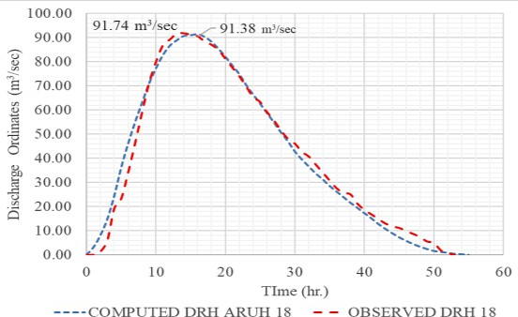

**Figure 5. Computed DRH of ARUH18 by the LOOCV method and observed DRH of Storm Event 18 of the Shigaon gauging station**

that the average UH derived from storm event 12 predicts DRH with minimum root mean square error (ERMS) as 2.450 m3/s and maximum efficiency (E) as 98.969%. The percentage error in the prediction of direct runoff peak discharge (EP) is observed to be -0.660 % and the percentage error in the prediction of direct runoff time to peak (ET) is observed to be -25.00 %. The negative sign here indicates that the computed value was greater than the observed value. Therefore, the average UH from storm event (12) is considered an Average Representative UH for the Warana River Sub-basin 1 and named ARUHS1 which provides the most suitable method for an ungauged catchment in the same region having similar hydrological characteristics. The computed DRH parameters using ARUH18 and ARUHS1 and the corresponding observed DRH parameters and error functions in predicting DRHs are summarized in Table 2.

## Unit hydrographs (UH) developed for Sub-basin 1

As hourly rainfall and hourly discharge data are available, it is possible to choose the UH duration as one hour which is suitable to derive UH by single event method. In the present study, the UHs derived for 23 isolated storm events for the Warana River basin practically satisfy the assumptions made in the derivation of UH. Also, Warana River sub-basin 1, Sub-basin 3, and the entire Warana river basin have the same qualitative basin potential i.e. lying in Zone C: Moderate to high flood property and moderate recharge property (Figure 4(a) and Figure 4(b)). Event of the same time interval concerning the Warana river basin is considered for developing UH for Warana river Sub-basin 1. Again, the river gauging station present in sub-basin 1 adds better flexibility to validate the developed synthetic unit hydrograph. From the results, it is observed that there is a considerable variation in QP and TP of UH computed for each storm event. To facilitate the validation by (LOOCV) method, 23 average UHs of Sub-basin 1 is determined by leaving out one UH every time and averaging the remaining 22 UHs. The average UH is determined by averaging QP, TP, TB, W50, and W75 of peak discharge of individual UH. All the UHs are validated by applying effective rainfall (ER) of the left-out storm to the corresponding average UH ordinates. Thus 23 computed DRHs are obtained and compared with the corresponding observed DRHs in the validation part. Figure 6 shows the Computed DRH 12 by the LOOCV method and observed DRH of Storm Event 12 of Sub-basin 1.

It is observed that the average UH derived

from storm event 12 predicts DRH in better agreement with the percentage error. It is observed

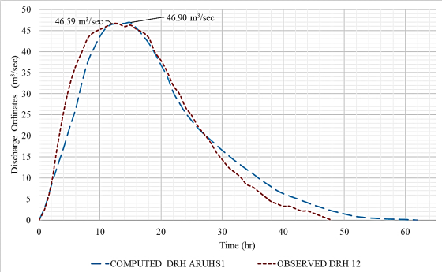

**Figure 6. Computed DRH of ARUH18 by the LOOCV method and observed DRH of Storm Event 18 of the Shigaon gauging station**

## Synthetic Unit Hydrographs (SUHs) of Warana River Basin

For the Warana River basin, four SUH methods were tested: Snyder’s method, SCS dimensionless SUH, Commons SUH, and CWC SUH method. From this study, it is observed that in Snyder’s method, the UH peak discharge gives fairly correct values and the percentage error (QP) is

0.26 %. The percentage error in the prediction of direct runoff base time (Tb) is observed to be -24.29

%. The percentage error in the prediction of direct runoff time to peak (TP) is 0 %. The value of W50 and W75 of the concerned DRH is -0.89% and -0.66

% error (Table 3). The positive sign here indicates that the observed peak discharge is slightly greater than the computed peak discharge. Also, the shape of the hydrograph shows poor estimates, particularly in the tail part of the recession curve

(Figure 7). The Snyder coefficients Cp and Ct derived from the UH parameters based on the observed are

0.55 and 1.06 respectively. These values are fairly small and hence are undeniably considered regional coefficients for some of the sub-basins of the upper Krishna basin under study. For the Warana River Sub-basin 1, it is observed that in Snyder’s method, the UH peak discharge gives fairly correct values and the percentage error in discharge (QP) is 0.32 %. The percentage error in the prediction of direct runoff time to peak (TP) is 0 %. The value of W50 and W75 of the concerned DRH is a -0.34 % error.

From this study, it is observed that in SCS dimensionless method the UH peak discharge is giving fairly correct values and the percentage error in peak discharge (QP) is 0.54%. The percentage error in the prediction of direct runoff base time (Tb) is observed to be 8.16 %. The percentage error in the prediction of direct runoff time to peak (TP) is - 22.22% (Table 3). Also, the shape of the hydrograph shows a fair estimate, particularly in the start and tail parts of the recession curve (Figure 7). For sub-basin 1, SCS dimensionless SUH method the UH peak discharge gives large overpredicted values and the percentage error in peak discharge is -253.97%. The percentage error in the prediction of direct runoff time to peak (TP) is 140.00% (Table 3). Also, the shape of the hydrograph shows a very poor estimate (Figure 8).

CWC’s method overpredicted the UH peak discharge with a percentage error in discharge (QP) of -118.14 %. The percentage error in the prediction of direct runoff base time (Tb) is observed to be

66.46 %. The percentage error in the prediction of direct runoff time to peak (TP) is -13.26 %. Additionally, the shape of the hydrograph showed a very poor estimate (Figure 7), particularly in the tail part of the recession curve. For Sub-basin 1 CWC’s method overpredicted the UH peak discharge with a percentage error (QP) of -223.58 %. The percentage error in the prediction of direct runoff time to peak (Tp) is 71.43 % (Table 3). The negative sign here indicates that the computed values of CWC synthetic UH are larger than observed ARUHS1. Additionally, the shape of the hydrograph showed a very poor estimate (Figure 8) at the start and particularly in the tail part of the recession curve.

Results demonstrate that Snyder’s method provided reasonably accurate results for simulating SUHs, given the differences in QP, TP, and Tb. As these results show, the approach gives an accurate estimate of the predicted volume of the UH, as these data suggest, well below the error margin that could be considered in a study similar to this (Eslamian and Eslamian 2022). Study findings demonstrate that use of the Snyder’s method to simulate SUHs offers the advantages of being simpler and faster than the other synthetic methods of UH analysis.

**Table 2. Computed and observed DRH parameters and error functions in predicting DRHs**

|  |  |  |  |
| --- | --- | --- | --- |
| **Error Functions** | **Symbol (SI Unit)** | **Shigaon Gauging Station** | **Sarud Gauging Station** |
| Computed direct runoff peak discharge | Qdrp (m3/s) | 91.38 | 46.90 |
| Computed direct runoff time to peak | Tdrp (h) | 16 | 15 |
| Observed direct runoff peak discharge | Qdrp (m3/s) | 91.74 | 46.59 |
| Observed direct runoff time to peak | Tdrp (h) | 14 | 12 |
| Efficiency | E (%) | 99.98 | 99.96 |
| Root mean square error | ERMS (m3/s) | 3.80 | 2.45 |
| The percentage error in direct runoff peak discharge | EP (%) | 0.39 | -0.66 |
| The percentage error in direct runoff time to peak | ET (%) | 12.50 | -25.00 |

**Table 3. Comparison of Synthetic Unit Hydrograph methods with error functions in predictions for observed Unit Hydrograph of Warana River basin and Sub-basin 1**

|  |  |  |  |  |  |  |  |  |  |  |
| --- | --- | --- | --- | --- | --- | --- | --- | --- | --- | --- |
|  | **ARUH** |  | **Snyder's Method** | | **SCS Method** | | **CWC Method** | | **Commons’ Method** | |
| **UH**  **Parameters** | Warana River basin | Sub- basin 1 | Warana River basin | Sub-basin 1 | Warana River basin | Sub-basin 1 | Warana River basin | Sub-basin 1 | Warana River basin | Sub-basin 1 |
| QP  (m3/sec) | 173.10 | 53.31 | 172.65 | 53.14 | 172.17 | 188.70 | 377.60 | 172.50 | 210.74 | 71.22 |
| Tb (hr) | 53 | 48 | 70 | 60 | 49 | 13 | 31.84 | 20 | 100 | 86 |
| TP (hr) | 14 | 12 | 14 | 12 | 18 | 5 | 16.14 | 7 | 14 | 12 |
| W50 | 22.30 | 20.86 | 22.50 | 20.93 | 22.43 | 5.32 | 10.50 | 5.87 | 19.50 | 15.02 |
| W75 | 12.71 | 11.89 | 12.80 | 11.93 | 12.78 | 3.03 | 6.23 | 3.34 | 10.86 | 8.71 |
| QP Error (%) | |  | 0.26 | 0.32 | 0.54 | -253.97 | -118.14 | -223.58 | -21.74 | -33.59 |
| Tb Error (%) | |  | -24.29 | -20 | 8.16 | 271.52 | 66.46 | 140.00 | -47.00 | -43.99 |
| TP Error (%) | |  | 0.00 | 0 | -22.22 | 140.00 | -13.26 | 71.73 | 0.00 | 0 |
| W50 Error (%) | |  | -0.89 | -0.34 | -0.58 | 291.00 | 52.90 | 255.45 | 14.36 | -48.47 |
| W75 Error (%) | |  | -0.66 | -0.34 | -0.58 | 291.00 | 51.00 | 255.45 | 17.08 | -45.98 |

method produces reasonably accurate results for generating SUHs when taking into account variations in peak discharge, time to peak, and base period. Additionally, the findings show that the percentage error in peak discharge, time to peak, and base period appears to be well within the range of error that could be incorporated in such predictions. The hydrograph's shape also offers a satisfactory fit to the unit hydrograph that was observed, as in the case of the Warana river basin, Sub-basin 1, and Sub-basin 3 (Figure 10).

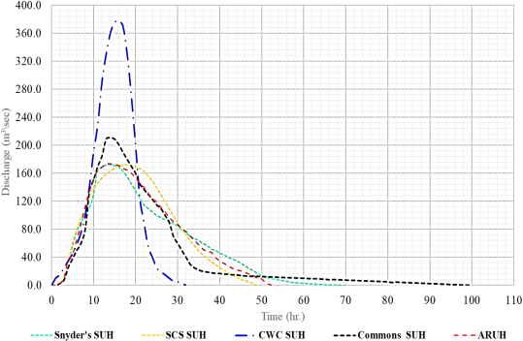

**Figure 7. Synthetic Unit hydrographs developed by Various methods and ARUH for the Warana River basin**

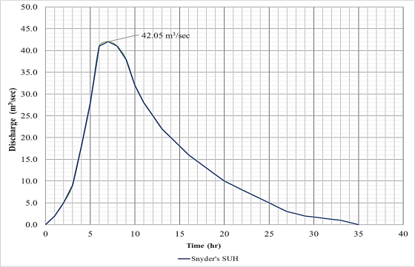

**Figure 9. Snyder’s Synthetic Unit hydrograph developed for Sub-basin 3**

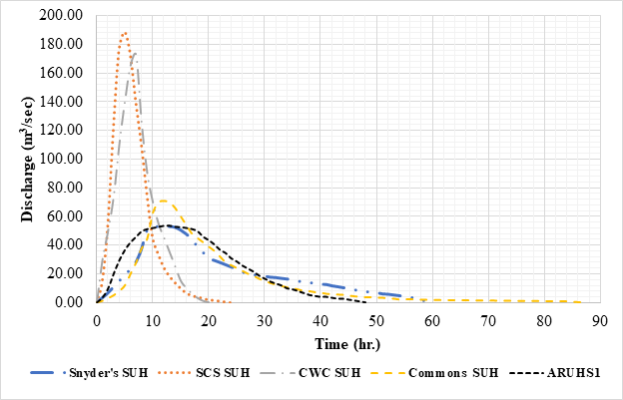

**Figure 8. Synthetic Unit hydrographs developed by Various methods and ARUHS1 for Sub- basin 1**

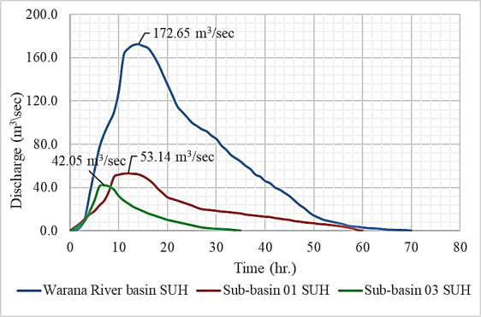

## Synthetic Unit hydrograph for Sub-basin 3

For the Warana River Sub-basin 1, four SUH methods were tested: Snyder’s method, SCS dimensionless SUH, Commons SUH, and CWC SUH method compares SUH results basin with error functions in prediction by using the above four methods. From this study, it is observed that in Snyder’s method, the UH peak discharge gives fairly correct values and the percentage error in discharge (QP) is 0.32 %. Developed Snyder coefficient values are fairly small and hence are undeniably considered regional coefficients for the sub-basins of the Warana river basin having similar hydroclimatic regions. As Sub-basin 3 is not having a river gauging station based on morphometry Snyder’s synthetic hydrograph is developed for Sub-basin 03 (Figure 9). As sub-basin 3 is having a similar hydroclimatic condition using the same derived Snyder’s coefficient (Ct and Cp) of the Warana river basin is used for deriving Snyder’s synthetic unit hydrograph. After comparing Snyder's SUH results, it is found that Snyder’s

**Figure 10. Snyder’s Synthetic Unit hydrograph developed for Warana river basin and Sub-basins**

# Conclusion

In order to construct a synthetic unit hydrograph for an ungauged basin within its hydrological zone, a representative watershed was used in this investigation to evaluate several approaches. Basin and sub-basin levels in each of the two hydrological zones were used to test four synthetic hydrograph methods. The methods of synthetic unit hydrograph

were tested based on the qualitative basin potential of Warana river sub-basins. The following approaches were put to the test: (1) a modified Snyder method, (2) Commons’ dimensionless hydrograph, (3) Soil Conservation Service's dimensionless hydrograph, and (4) the Central Water Commission method. Studies on morphometric properties Warana River basin indicated that the Warana River basin has Moderate to high flood property and moderate recharge property. Sub-basin 1 and Sub-basin 3 has Moderate to high flood property and moderate recharge property. Sub-basin 2 has Low flood probability and high recharge property. Snyder’s method, the UH peak discharge gives fairly correct values and the percentage error (QP) is 0.26 % for the Warana River basin and 0.32 % for the Sub-basin 1. After comparing derived Snyder’s SUH for Sub-basin 1 and Sub-basin 3 it is concluded that Snyder’s approach is judged to provide a reasonable solution for the direct determination of the SUH Warana River basin. When the outcomes of this strategy were compared to those of other approaches, the findings similarly showed good proximity. The Snyder coefficients Cp and Ct derived Warana River basin are 0.55 and 1.06 respectively. These values are fairly small and hence are undeniably considered regional coefficients for some of the sub-basins having similar hydroclimatic conditions (Patel and Thorvat 2016; Shaikh *et al*, 2022). These results of sub-basin show that Snyder’s synthetic unit hydrographs may be applicable for runoff prediction for watershed management activities within the Warana river basin or basins with basin having similar hydroclimatic conditions. The type of assumptions used in their formulation and how effectively they might apply to each individual problem both have an impact on said approach in this study. The successful validation of the UH at the sub-basin level offers several advantages for water resources management. It enables stakeholders to make informed decisions regarding water allocation, flood control, and reservoir operation within the specific sub-basin boundaries.

# References

Al-Saud, M., (2009). Morphometric analysis of Wadi Aunah Drainage system, Western Arabian Peninsula. The Open Hydrology Journal, 3:1-10.

Bernard, M. (1935). An approach to determinate stream flow. Transactions of the American Society of Civil Engineers, 100:347-362.

Bhagwat, T.N., Hegde, V.S. and Shetty, A. (2018). Application of remote sensing and GIS for identification of potential groundwater recharge sites in Semi-arid regions of Hard- rock terrain, in north Karnataka, South India. Sustain. Water Resour. Manag., 4:1,063-1,076.

Bhagwat, T.N., Shetty, A. and Hegde, V.S. (2013). Spatial variation in drainage characteristics and geomorphic instantaneous unit hydrograph (GIUH); implications for watershed management-A case study of the Varada River basin, Northern Karnataka. Catena an Interdisciplinary Journal of Soil Science and Geomorphology, 87:52-59.

Bhunya, P.K., Berndtsson, R., Ojha, C. and Mishra, S.K. (2009). Suitability of gamma, chi-square, Weibull and beta distributions as synthetic unit hydrographs. Journal of Hydrology, 334:28-38.

Bruen, M. and Dooge, J.C.I. (1992). Unit hydrograph estimation with multiple events and prior information: I. Theory and a computer program. Hydrological Sciences Journal, 37(5):429-443.

Central Water Commission. (1993). Flood Estimation Report for Luni Sub Zone-1(a). Central Water Commission, New Delhi.

Commons, C.G. (1942). Flood Hydrographs. Civil Engineering, 12.

Dooge, J.C. (1959). A General Theory of the Unit Hydrograph.

Journal of Geophysical Research, 4(2):58.

Dooge, J.C.I. (1959). A General Theory of the Unit Hydrograph.

Journal of Geophysical Research, 64:2-241.

Eslamian, S., and Eslamian, F. (Eds.). (2022). Flood Handbook: Analysis and Modeling (1st ed.). CRC Press.

Galavi, H., Mirzaei, M., Lee, T.S. and Valizadeh, N. (2013). Klang River Level Forecasting Using ARIMA and ANFIS Models. Journal AWWA, 105(9):E496.

Giday, G., Ketema, T., Gashu, G. and Deressa, S. (2021). GIS Based Morphometric Analysis of Gudina Wacho Watershed, Western Ethiopia: Suggestion for Surface Irrigation Development. Journal of Water Resources and Ocean Science, 10:92-99.

Hoffmeister, G. and Weisman, R.N. (1977). Accuracy of synthetic hydrographs derived from representative basins. Hydrological Sciences Bulletin, 22(2):297-310.

Horton, R.E. (1945). Erosional development of streams and their drainage basins, a hydro- physical approach to quantitative morphology. Geological Society of America

Huang, T. and Merwade, V. (2012). Developing Customized NRCS Unit Hydrographs for Ungauged Watersheds in Indiana, USA. Authored Preprints, H35N, 1196.

Idfi, G., Yulistyorini, A. and Suryoputro, N. (2020). The comparative study of peak discharge atNgotokwatershed by using themethod of SCS, Snyder, and Nakayasu for flood control needs. IOP Conference Series: Materials Science and Engineering, 930(1):012075.

Jahan, C., Rahaman, M.d., Arefin, R., Ali, S., and Mazumder, Q. (2018). Morphometric Analysis and Hydrological Inference for Water Resource Management in Atrai-Sib River Basin, NW Bangladesh Using Remote Sensing and GIS Technique. Journal of the Geological Society of India, 91:613-620.

Maidment, D.R., Olivera, F., Calver, A., Eatherall, A. and Fraczek, W. (1996). Unit hydrograph derived from a spatially distributed velocity field. Hydrological Processes, 10(6):831-844.

Mirzaei, M., Huang, Y.F., El-Shafie, A., Chimeh, T., Lee, J. and Vaizadeh, N., (2015). Uncertainty Analysis for Extreme Flood Events in a Semi-arid Region. Natural Hazards, 78(3):1,947. Doi: <http://dx.doi.org/10.1007/s11069-015->

1812-9.

Mitchell, W.D. (1948). Unit Hydrographs in Illinois. Illinois Department of Public Works and Buildings. Division of Waterways.

Patel, J.N. and Thorvat, A.R. (2016). Synthetic unit hydrograph development for ungauged basins using dimensional analysis. American Water Works Association, 108(3): 145-153.

Rai, P., Singh, P., Mishra, V., Singh, A., Sajan, B. and Shahi, A. (2019). Geospatial Approach for Quantitative Drainage Morphometric Analysis of Varuna River Basin, India. Amity Journal of Landscape Ecology, 12:21-26

Salami, A.W., Bilewu, S.O., Ibitoye, B.A. and Ayanshola, M.A. (2017). Runoff hydrographs using Snyder and SCS synthetic unit hydrograph methods: a case study of selected rivers in south west Nigeria. Journal of Ecological Engineering, 18(1):25-34.

Shaikh, M., Yadav, S. and Manekar, V. (2022). Assessment of the empirical methods for the development of the synthetic unit hydrograph: a case study of a semi-arid river basin, Journal of Geovisualization and Spatial Analysis, 5(2):1- 21.

Sherman, L.K. (1932). Stream flow from rainfall by the unit hydrograph method. Engineering News Record, 108:501- 505.

Singh, S.K. (2000). Transmuting synthetic unit hydrographs into gamma distribution. Journal of Hydrologic Engineering, 5(4):380-385.

Singh, V.P. (1994). Elementary Hydrology, pp.439-566, PHI Learning Pvt. Ltd., New Delhi.

Snyder, F.F. (1938). Synthetic unit hydrographs. Eos, Transactions American Geophysical Union, 19(1):447- 454.

Soil Conservation Service (SCS) (1957). Hydrology, National Engineering Handbook. Department of Agriculture, Washington, DC.

Strahler, A.N., (1957). Quantitative analysis of watershed geomorphology. Eos, Transactions American Geophysical Union ,38(6):913-920.

Subramanya, K. (2008). (3rd ed.). Engineering Hydrology. Tata McGraw Hill Publishing, New Delhi.

Thorvat, A.R. and Mujumdar, M.M. (2011). Design Flood Estimation for Upper Krishna Basin Through RFFA. International Journal of Engineering Science and Technology, 3(6):5252.

USDA (US Department of Agriculture), (1957). Use of Storm and Watershed Characteristics in Synthetic Hydrograph Analysis and Application. US Department of Agriculture, Soil Conservation Service, Washington.

Zhao, B., Tung, Y.K., Yeh, K.C., and Yang, J.C. (1995). Statistical Validation Methods: Application to Unit Hydrographs. Journal of Hydrologic Engineering, 121:618.