THEPRESENTSTATEOFBOTANICALKNOWLEDGE IN CÔTE D’IVOIRE

*Abstract*.—The aim of this present study is to summarize the current state of research on the flora of the Côte d’Ivoire from the SIG IVOIRE database to better direct future collection efforts. Herbarium specimen data used for this study covered the period from 1894 to 2000, and were assembled by 226 collectors. This database comprises 15,228 samples, grouped in 3621 species, 1371 genera, and 198 families. A grid system was used to cover the Ivorian territory at spatial resolution of 0.75° x 0.75°. Indices of evenness and completeness were calculated to characterize sampling and identify floristically well-known regions. The exploration of the Ivorian territory is far from uniform, such that some areas were more densely surveyed, but others partially or not at all. The regions of Grands Ponts, Agnéby- Tiassa, Loh-Djiboua, part of Gbèkè, Boukani, San Pedro and Cavally were floristically well known; environmentally, the largest gaps in coverge were in the mountains in western Côte d'Ivoire.

*Keywords*.—Côted’Ivoire,flora,biodiversity,SIGIVOIRE,GIS,completeness.

Introduction

The forests of the tropical world are characterized by particular community structures and specific floristic compositions. Floristicrichnessoftropicalforesthavebeenhighlighted bynumerousstudies(Gentry1988;Wright2002). For Leigh et al. (2004), tropical forests are clearlymuseumsofspeciesdiversity.Theflora oftropicalAfricahasattractedtheinterestof many botanists, such as Auguste Chevalierie,AndréAubréville,GeorgeMangenot,andAke Assi Laurent. These botanists, via several sum- maries (De Gouvenain and Silander 2003; Kelat- wang and Garzuglia 2005; Lehmann and Kioko 2005; Jørgensen 2006; Nair 2006; Kowero et al. 2006;Glenday2008)havehighlightedmanyof the details of the distribution and diversity of the African flora (Aké-Assi 2001, 2002).

InCôted'Ivoire,manystudies(Kouakou 1989; Corthay 1996; Kouamé 1998; Nusbaumer 2003; Adou Yao and N'Guessan 2005) havefocused on the flora in general (Aké-Assi 2001, 2002). Work on botany in Côte d’Ivoire beganearly in the twentieth century, and is active continuingtoday,withmanydetailedstudies.The flora of Côte d’Ivoire is rich; according to recent estimates, it includes 3677 species ofvascular plants, divided between forests and savannas(Ake-Assi1961,1962,1976,1984,

1998,2001,2002).Severalyoungresearchers havelaunchedbotanicalinventorystudiesinkey

areas of Côte d'Ivoire as part of their theses orotherresearch.Still,despitealltheseefforts, many areas are yet to be inventoried in detail and remain poorly known. These gaps underline the importanceofincreasinggeographicknowledgeof the flora of country to provide a solid base for development of future strategies for document- tation,understanding,conservation,anduseofthe biodiversity of the country.

It is in this perspective that, for many years,theConservatoryandBotanicalGardenof Geneva (CJBG) and the National Floristic Centerof the University of Abidjan, with the help of the Swiss Center for Scientific Research in Côte d’Ivoire (CSRS), have conducted research on the flora and vegetation of the country (Bänninger1995;Corthay1996;Kouamé1993,1998;Dotty

1999; Bakayoko 1999; Menzies 2000). CJBG implemented a geographic information system(GIS) for Côte d'Ivoire, which includes rich botanicaldata,withdiversemapinformationon the physical environments of the country. It combines a relational botanical database and a mapping environment (Gauthier et al. 1999); this system provides the base data for this study.

Biogeographic studies aim to understand how living organisms are distributed spatially, which factorsinfluencethosedistributions,andhow these patterns change over time (Brown and Lomolino1998).Biodiversitydatabasesarethe

main source of information for such studies, specifically data that place particular species at georeferenced locations at specific points in time. Based on this information, spatial patterns can be investigated at scales ranging from local to global (Brown and Maurer 1989). Hence, biogeographic understanding depends heavily on the quality and completeness of information in biodiversity databases.

The present study aims to summarize the currentstateofknowledgeofthefloraofthe Côte d’Ivoire as summarized in the SIG IVOIRE database. Specifically, study goals are (1)determine the frequency and distribution of botanical investigations across Côte d’Ivoire, (2) assess the intensity and completeness of these explorations, and (3) identify areas that remain poorly known in the country.

METHODS

*Studydata*

The Republic of Côte d'Ivoire covers an areaof 322,462 km2, limited to the north by Mali and Burkina Faso, to the west by Liberia and Guinea,to the east by Ghana, and to the south by the Atlantic Ocean. The country has 22 million inhabitants, according to General Census of Population and Housing of 2014. Côte d'Ivoire covers parts of two climatic zones: equatorial and tropical (Eldin 1971), and as such has two rainy seasons and two dry seasons, althoughnorthern Côte d'Ivoire has only one rainy and one dryseason.

Thenaturalvegetationtypesacrossthe country include dense humid evergreen forest,semi-deciduousrainforest,montanerainforest, andsavannah(GuillaumetandAdjanohoun1971).Theterrainconsistsofplains,plateaus, and mountains, with Mount Nimba (1750 m) representing the high point in southwestern Côte d'Ivoire. Côte d'Ivoire is characterized by desaturated lateritic soils, ferruginous soils, eutrophic brown soils, hydromorphic soils, and pseudo-podzols. (Aubert and Segalen 1996).

*Plantoccurrencedatabase*

Thedatabaseofherbariumspecimensfor Côte d'Ivoire has been developed at the Conser- vatory and Botanical Gardens of Geneva, and summarizes the Ivoirian specimen holdings of herbaria in Abidjan (CNF), Geneva (CJGB),Natural History Museum of Paris, and Universityof Wageningen (WUR). As each record in the database contains geographic coordinates, it is related to maps througha GIS called SIG

IVOIRE (Gautier et al. 1999). The data are managed in an Access database, and related to ecological and spatial data in raster formats using IDRISI (version 2.0) and ArcView (version 3.2). SIG IVORE thus integrates botanical information with environmental data through a geographic information system(Gautieretal.1999),and aims marshal the best information to address conservation needs of overlooked species in the face of environmental degradation (Chatelain 2002).

*Databasecompleteness*

Data were cleaned via an iterative series of inspectionsandexplorationsdesignedtodetect anddocumentinconsistencies.(1)Wecreated listsof unique names in each data set in Excel, and inspected them for repeated versions of the same taxonomic concepts: misspellings, name variants, different versions of authority infor- mation, etc. Such repeated name variants were flagged, checked via independent sources, and corrected to produce single scientific names that correctly referred to single taxa. (2) We checkedfor geographic coordinates that fell outside of the country,butthatwerereferredtoCôted’Ivoire.

(3) Within the country, we checked for consis-tency between textual descriptions of region and geographic coordinates. In each case, where possible, we corrected the data record; where no correctionwasclear,wediscardeddata,recording data losses at each step in the cleaning process. (4) We discarded data records for which information on year, month, or day of collectionwas lacking; we created a unique ‘stamp’ of timeas year_month_day.

We then aggregated point-based occurrence data to 0.75° spatial resolution across Côted’Ivoire.Thisspatialresolutionwastheproduct of a detailed analysis of balancing the benefits of aggregating data (i.e., larger sample sizes), versus the negative of loss of spatial resolution that can make important geographic features impercep-tible. Details of this procedure are provided inAriño et al. (in prep.).

Weproducedshapefilesrepresentingthe 0.75° grid system in the vector grid module of QGIS, version 2.4. We added grid system identification codes to each individual occurrence datum, and aggregated each datum to the coarse- resolution aggregation squares. In Excel, we explored relationships between data on species identity, time, and aggregation square. We calculatedtotalnumbersofrecordsavailable fromeachgridsquare(termed*N*);wereprojected

the aggregation grid to an Africa Albers Equal-area Conic Projection, measured the area of each grid square (taking into account the area of grid squares that overlapped the edge of the country), and calculated numbers of data records per unit area.BecausedataforplantsofCôted’Ivoire werenotmassivelyabundant,fulldevelopmentofcompletenessindices(Sousa-Baenaetal.2013) proved rather fruitless: very few aggrega-tionaquares could be termed well-known; as a consequence, we used a more crude criterion of a densityof15.2occurrencedatapoints/1000km2

Then, a series of analyses was developed to explore patterns further. First, the whole country was considered; then it was partitioned into four cells, and then 16 cells (Table 1). At eachresolution, samples were counted within the cells. All of this information was submitted to the EstimateSsoftwareversion9.1.0.(Colwell,2013) to calculate a series of indices.

Table1.SizesandnumberofcellscoveringCôte d’Ivoire at different spatial resolutions.

ScalesCell area(km2)Number ofcells with≤1 record

|  |  |  |  |
| --- | --- | --- | --- |
| toestablishwhichsquaresshouldbeconsidered | C1 | 322,462 | 1 |
| well-known. | C4 | 80,615.5 | 4 |

Once we had established these criteria inQGIS, we linked the table of grid square statisticsto the aggregation grid, and saved this file as a shapefile. We created a shapefile of well-sampled aggregationsquares,whichweinturnconverted toraster(geotiff)formatusingcustomscriptsin R version 3.1.2 (Venables and Smith 2014). This raster coverage was the basis for our identifi-cation of coverage gaps, as follows.

We used the proximity (Raster Distance) function in QGIS to summarize geographic distances across the country to any well-sampled aggregation square. To create a parallel view of environmental difference from environments representedinwell-sampledareas,weplotted 5000randompointsacrossCôted’Ivoire,and used the Point Sampling Tool in QGIS to extract values of each point to the geographic distance raster, and to raster coverages (2.5’ spatial resolution) summarizing annual mean tempera-tureandannualprecipitationdrawnfromthe

C1620,153.875 16

Ivorian territory was divided into 64 finer resolution (0.75°) cells. We counted numbers ofdata points in each cell using the “count points in polygon” function in QGIS. We used the index of evenness or regularity to describe the distributionof numbers of individuals between different cells (Walaetal.2005).Thisindexofevenness (Pielou 1975) is:



𝑛

𝑖!1

𝑝𝑖Log(𝑝𝑖)

𝐸=− Log(𝑛)

where *pi*is the proportional frequency of cell of each number and *n* is the number of subdivisions. The index ranges from 0 to 1, tending to 0 whenone value dominates, and to 1 when values are, evenly distributed.

Aquadratmethodwasusedtocharacterize

thespatialpatternwiththeindexofdispersion

WorldClimclimatedataarchive(Hijmansetal.

𝑥2=

𝑚

𝑖!1

𝑛𝑖

−𝜇2/𝜇, with 𝜇=𝑛𝑖

/𝑚,

2005).

We exported the attributes table associatedwith the random points, and analyzed further in Excel,asfollows.Wefirststandardizedthe values of each environmental variable to theoverallrangeofthevariableas:(*xi*–*xmin*)/(*xmax*

- *xmin*), where *xi*is the particular observed value in question. We then created a matrix of Euclidean distances in the two-dimensional climate space, calculating distances for each of the points with a geographic distance >0 to all of the points with geographic distance of zero; the latter represent pointsfallinginwell-sampledregions,whereas the former are scattered across the entire country; points in well-sampled regions were assigned (by definition) environmental distances of zero.Finally,theenvironmentaldistanceswere importedbackintoQGIS,andlinkedtothe random points shapefile.

where *ni*is the proportional frequency of cells of each number and *n* is the number of subdivisions,*m* is the number of cells contained entirely within theterritoryand𝜇themean.Thetestistwo tailed: large values of 𝑥2indicate aggregation or heterogeneity,whereassmallvaluesof𝑥2indicate regularity.

RESULTS

This study is based on herbarium data thatcovertheperiod1894-2000,includingworkby 226collectors.Oldestspecimenswerecollected by Pobégui and Jolly, and the most recent werefrom2000(Jongkind,Hawthorne,AssiJean, Aman Kadjo and others). In general, we observed threemajorperiods(Figure1).During1894- 1905, data accumulation was slow; it took offduring 1906-1994, when it reached a plateau that lastedtotheendofthedatabaseperiodin2000.

Figure1.FrequencyofbotanicalinvestigationsinCôted’Ivoireovermorethanacentury shown as the cumulative number of specimens in the SIG IVOIRE database.

22000

20000

18000

16000

14000

12000

10000

8000

6000

4000

2000

0

**Year**

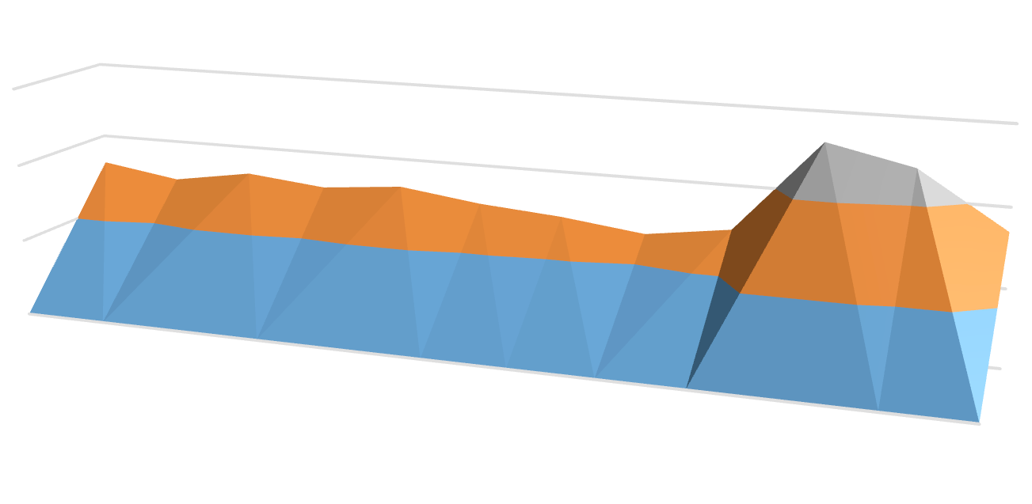

2000-3000

1000-2000

0-1000

**Monthoftheyear**

12

11

10

9

8

7

6

5

4

3

2

1

3000

2000

1000

0

**Cumulativenumberofsamples**

**Numberofsamples**

1894

1896

1898

1900

1902

1904

1906

1909

1917

1925

1930

1932

1934

1936

1938

1942

1945

1947

1949

1951

1953

1955

1957

1959

1961

1963

1965

1967

1969

1971

1973

1975

1977

1979

1981

1983

1985

1987

1989

1991

1993

1995

1997

2000

Figure2.FrequencyofcollectionoftheplantsofCôted’Ivoirebymonthofcollectionas represented in the SIG IVOIRE database.

Months when collection was most intense were October and November (Figure 2).

The database for this study comprised 15.2 records of 3621 species in 1371 genera and 198 families. Ten species were represented by 20-35 records,31speciesby16-20records,197species

by 11-15 records, 718 species 6-10 records, and 2665 species by 1-5 records. The best represented species were *Andropogon gayanus*Kunth(Poaceae),*Culcasiascandens*P.Beauv.(Araceae), *Rauvolfia vomitoria* Afzel (Apocynaceae) and *Voacangaafricana*Stapf ex Scott-Elliot (Apocynaceae). The best represented genera were *Cyperus* L. (Cyperaceae), *Ficus* L. (Moraceae) and *Indigofera* L. (Leguminosae); the best represented families were Leguminosae with 1610records(10.6%),Poaceaewith1531records

(10.1%),Rubiaceaewith1166records(7.7%),

Cyperaceaewith771records(5.1%)and

Apocynaceaewith710records(4.7%).

The sampling distribution map (Figure 3)shows botanical exploration across Côte d’Ivoire. ExplorationoftheIvorianterritoryisnot uniform.Someareasweremoredensely surveyed, while others have seen partial surveys onlyornoneatall.Theequitabilityindex(*E*)had avalueof0.73,calculatedacrosscells, confirming the irregularity of botanical explora-tion across Côte d’Ivoire. Also, the value of the index of dispersion (*X*2 = 41419; *X*2m-1 = 44.99) shows considerable aggregation.

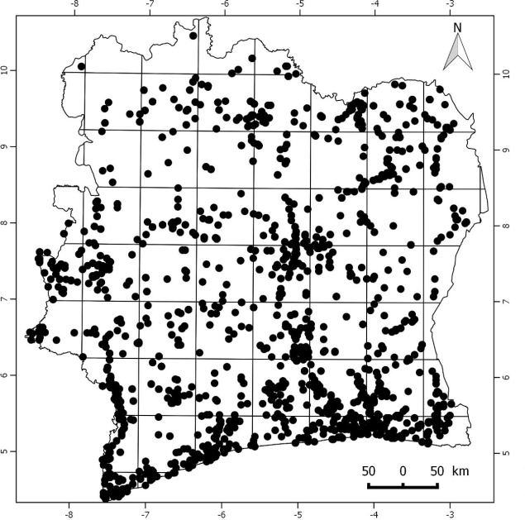

Figure 3. Intensity of botanical exploration acrossCôted’Ivoire,showingpointsfromwhichdatarecords exist in the SIG IVOIRE database and the aggregation squares that cover the country.

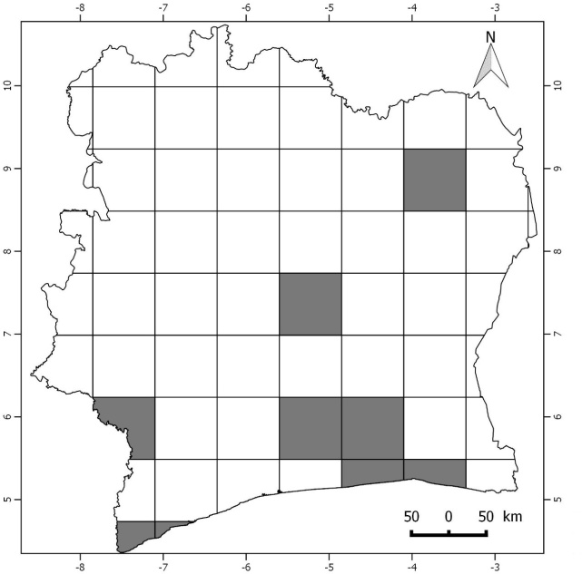

Figure4.Summaryoffloristicallywell-knownareas across Côte d'Ivoire (in gray).

Because C values showed that few or no cells were completely inventoried, we used density of records instead. Here, the general pattern of only 10% of the cells could be called floristically well- known (Figure 4). These cells correspond to the regionsoftheGrandsPonts,Agnéby-Tiassa,Loh-Djiboua, Gbèkè and parts of Boukani, San Pedro, and Cavally. The best-known regions floristically were Grands Ponts and Agnéby-Tiassa. On the other hand, 90% of cells were not densely sampled. Figure 5 shows the relationship between sample size and number of species, showing that most grid squares hold only single records of a species. Figure 6 shows that ICEvaries with spatial resolution, whereas the Chao index is constant regardless of spatial resolutionand proves relatively invariant.

Geographically,thewell-sampledregions were concentrated in the south-east. Geographic distance from these regions accumulated overspace, and was highest in the Tomkpi region. Environmentally,differencefromenvironmentsof well-sampled areas (Figure 7), was relativelylow in the south-east and north-east, but the montaneregioninwesternCôted'Ivoire,was quite different from well-sampled environments.

DISCUSSION

The flora of Côte d’Ivoire ranks among the best-knownflorasofWestAfrica(Aké-Assi 2001).Severalstudiesinthecountryallowan idea of the degree of exploration achieved. Botanical investigations in Côte d'Ivoire began in 1882(Aké-Assi2001),andaccumulatedslowly

in the early years. Twentieth century botanical explorationsreflectthebeginningofpenetration ofEuropeansintoAfricanforests(Schenel1950).

2000



y=1.2274x−19.377 R² = 0.99657

1800

1600

1400

1200

1000

**N**

800

600

400

200

0

0 500 1000 1500 2000

**Sobs**

Figure5.Relationshipbetweenbetweensamplesize

(*N*)andobservednumberofspeciesinagridsquare (*Sobs*).

The work of one of the explorers, Auguste Chevalier, provided the foundations of botanical knowledge of the country (Schenel 1950; Aké-Assi 2001). He worked in the country in 1906-1907 (Chevalier 1908). In 1932, Aubréville made important collections and new discoveries by visiting Tai at Tabou. In 1950, the team of Mangenot began important investigations in the south-west parts of the country, surveys that continued over succeding decades. Adjanohounand Guillaumet realized important work on theflora and vegetation of the area (Adjanohoun and Guillaumet1961;Guillaumet1967;Guillaumet

and Adjanohoun 1968, 1971), and in 1975, Ake AssidreawupalistofplantsinTaïNational Park(Aké-AssiandPfeffer1975).Exceptfor

work by Van Rompaey (1993), botanical work in thecountrybecamelessfrequentafterthatpoint; a few inventories focused on forest fragmentation problems in the Taï area (Bakayoko 2005;Chatelain et al. 2010; Martin 2010).

Botanical exploration is not uniform across Ivorian territory, as some regions have been explored more than others. Regions where investigations were intense were concentratedalong the coast, near activity centers, research institutions and universities, classified forests, natural parks, and reserves. Outside these areas, however, large and diverse areas of natural vegetationremainunexploredorareonlypartially documented. These findings are consis- tentwiththoseofHepper(1979)andKoffi (2008), who indicated that well-known areas arefewacrossAfrica,andthatmoderatelyand poorly known areas cover broad area. The most unique and unsampled environmental were concentrated in western Côte d'Ivoire. This area comprises one of the few true montane areas of WestAfrica,withMountNimba,whichrisesto an elevation of 1752 m above a panorama of undulating forested plains.

In sum, after more than a century of botanical research in Côte d'Ivoire, much effort is stillneeded. Certainly, the work of several prominent researchers has produced a view of the basic dimensions and characteristics of the flora and vegetation of Côte d’Ivoire. However, manyregionsofCôted'Ivoirearenotknown floristically or remain only partially documented. Thisstudyprovidesdetailedanalysesand mapping efforts that should guide new botanical investigations in Côte d'Ivoire. This study also underlines the importance of continued systema-tic study of plant diversity as a priority in the botanicalgardens,universities,andotherresearch organizations.

Figure 6. Summary of diverse inventory statistics and their relationship to spatial resolution of the aggregationgridusedacross Côte d’Ivoire.

Simpsonmean Bootstrapmean Jack 2 mean

Jack 1 mean

Chao2 mean

Chao1mean ICE mean ACEmean

Smean(runs) S(est) analytical

Individuals

C16 C4 C1

0 5000 10000 15000 20000

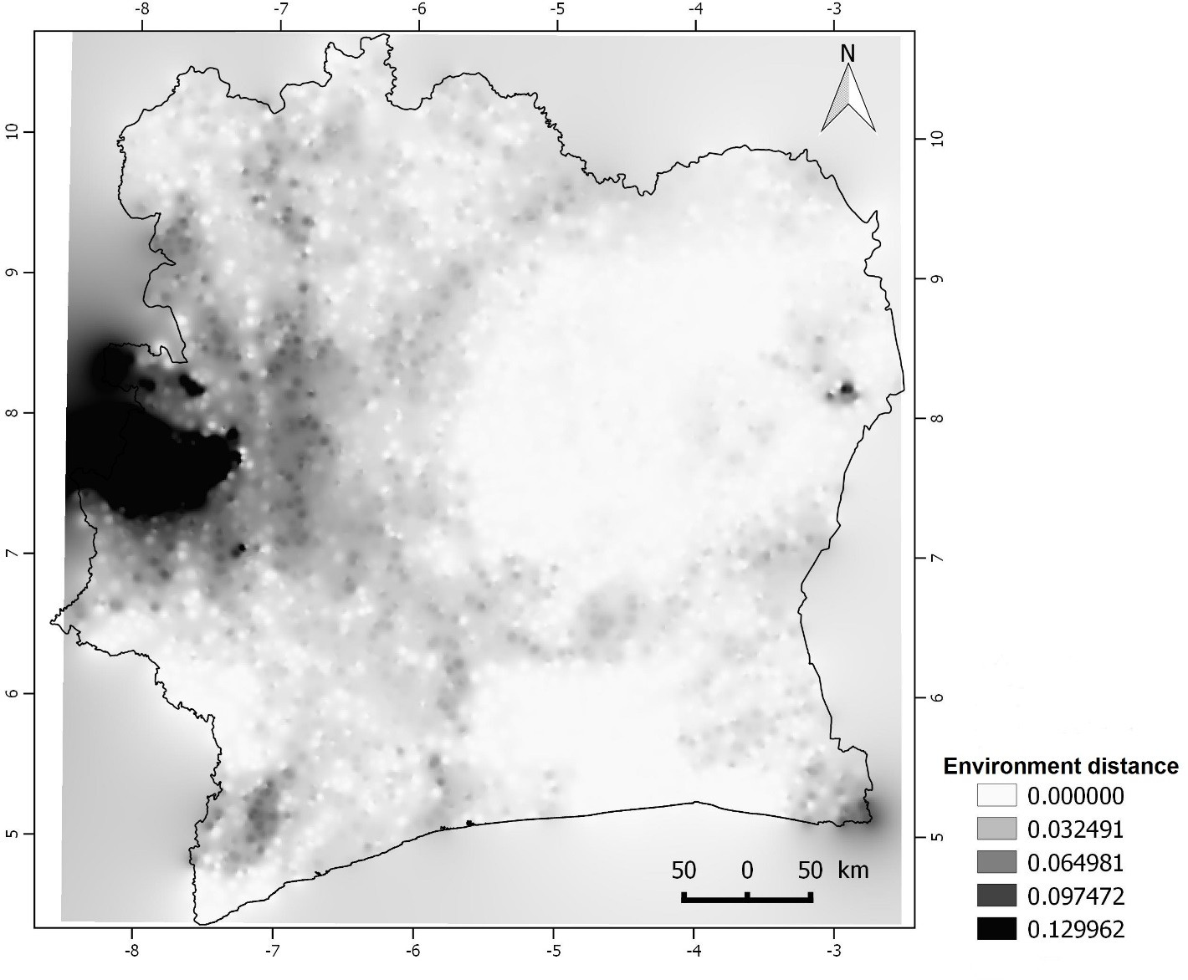

Figure7.Mapofdistancesinenvironmentalspacetowell-inventoriedgridcellsacrossCôted'Ivoire.

Conclusion and recommendation

REFERENCES

Adjanohoun, E. and J. L. Guillaumet. 1961. Etude botanique entre Bas-Sassandra et Bas-Cavally. ORSTOM, Adiopodoumé. Côte d’Ivoire.

Adou Yao, C.Y. and E. K. N'Guessan. 2005. DiversitébotaniquedanslesudduparcnationaldeTaï,Côte d'Ivoire. Afrique Science, 1: 295 - 313.

Aké-Assi L. 1961. Contribution à l’étudefloristique de la Côte d’Ivoire et des territoireslimitrophes.Thèse unique. Paris. 205 pp.

Aké-Assi L. 1962. Contribution à l’étudefloristique de laCôted’ivoireetdesterritoireslimitrophes.Vol

II: Les Monocotylédones et Ptéridophytes. Thèse unique. Paris. 147 pp.

Aké-AssiL.1976.Esquissedelafloregénéralede Côte d’Ivoire. Boissiera 24: 543-549.

Aké-Assi L. 1984. Flore de la Côte d’Ivoire: Étude descriptive et biogéographique avec quelquesnotes ethnobotaniques. Thèse de Doctoratd’État, Faculté de Sciences et Techniques, Université de Cocody, Abidjan (Côte d’Ivoire), 1206 p.

Aké-Assi L. 1998. Impact de l'exploitationforestière et du développementagricole sur la conservation dela biodiversitébiologiqueen Côte d'Ivoire. Le flamboyant, 46: 20-21.

Aké-Assi L. 2001. Flore de la Côte d’Ivoire 1, catalogue, systématique, biogéographie etécologie. Genève, Suisse: Conservatoire et Jardin Botanique de Genève (Suisse); Boisseria 57, 396p.

Aké-Assi L. 2002. Flore de la Côte d’Ivoire 2, catalogue, systématique, biogéographie etécologie.Genève,Suisse:ConservatoireetJardin

Botanique de Genève (Suisse); Boisseria 58, 441p.

Aké Assi, L. and P. Pfeffer. 1975. Etude d'aménagementtouristique du Parc National deTaï. Tome 2: Inventaire de la flore et de la faune. BDPA, Paris. France.

Aubert, G. and P. Segalen. 1966. Projet declassification des sols ferrallitiques. Cahiers ORSTOM-Pédologie, 4: 97-112.

Bakayoko, A. 1999. Comparaison de la composition floristique et de la structure forestière de parcelles de la forêtclassée de Bossématié, dans l’est de la Côte d’Ivoire. Mémoire DEA., UFR Biosciences, Université de Cocody-Abidjan, 72 p.

Bakayoko, A. 2005. Influence de la fragmentation forestière sur la composition floristique et la structure végétale dans le Sud-Ouest de la Côte d'Ivoire. Thèse de Doctorat, Université d’Abidjan.

Bänninger, V. 1995. Inventairefloristique des Dicotylédones de la Réserve de Lamto (V Baoulé) en Côte d’Ivoire central. Diplôme, Université de Genève, 110 p.

Brown, J. H. and B. A. Maurer. 1989. Mac-roecology: The division of food and space among species on continents. Science 243: 1145–1150.

Brown, J. H. and M. V. Lomolino. 1998.Biogeography. 2nd ed. Sunderland: Sinauer. Massachusetts (Sinauer Associates, Inc. Publishers)**.**

Chatelain, C., Kadjo, B., Koné, I. and J. Refisch. 2000. Relations faune - flore dans le Parc National de Taï: une étude bibliographique. Tropenbos Côte d’Ivoire.

Chatelain, C., Bakayoko, A., Martin, P. and L. Gautier. 2010. Monitoring tropical forest fragmentation in the Zagne-Tai area (west of Tai National Park, Cote d'Ivoire). Biodiversity and Conservation. 19: 2405–2420.

Chevalier, A.1908. LaForêtvierge delaCôte d'Ivoire.

LaGéographie17:201-210.

Colwell, R. K. 2013. EstimateS: Statistical estimationof species richness and shared species from samples.Version9.PersistentURL

<purl.oclc.org/estimates>.

Corthay, R. 1996. Analysefloristique de la forêtsempervirente de Yapo (Côte d'Ivoire). Université de Genève.

De Gouvenain, R. C. and J. A. J. R. Silander. 2003. Do tropical storm regimes influence the structure of tropical lowland rain forests? Biotropica, 35:166 - 180.

Dotia, Y. P. 1999. Arbres, arbustes et lianesligneuses delacommunedeKouto,norddelaCôted’Ivoire. DEA, Université de Cocody-Abidjan.

Eldin,M.1971.LeclimatdelaCôted’Ivoire.Pp.73-

108 in Avenard J.M., Eldin E., Girard G.,Sircoulon J., Touchebeuf P., Guillaumet J.L., Adjanohoun E. and A. Perraud. ed. 1971. Lemilieu naturel de Côte d’Ivoire. Mémoires ORSTOM n° 50, Paris (France).

Gautier, L., Aké Assi, L., Chatelain, C. and R. Spichiger. 1999. Ivoire: a geographic information system for biodiversity managment in Ivory Coast. Pp. 183-194 in Timberlake, J. and S. Kativus. ed. African Plants: Biodiversity Taxonomy and uses. Royal Botanic Gardens, Kew.

Gentry, A. H. 1988. Tree species richness of upper Amazonian forests. Proceeding of the National Academy of Sciences, USA, 85: 156-159.

Glenday, J. 2008. Carbon storage and carbon emission offset potential in an African riverine forest, the lower Tana River forests, Kenya. Journal of East African Natural History, 97: 207 - 223.

Guillaumet, J. L. 1967. Recherches sur la flore et la végétation du Bas-Cavally (Côte d'Ivoire). Mémoires ORSTOM n°20.

Guillaumet, J. L. and E. Adjanohoun. 1968. Carte de la végétation de la Côte d'Ivoire au 1/500.000. ORSTOM.

Guillaumet, J. L. and E. Adjanohoun. 1971. La végétation de la Cote d’Ivoire. Pp. 161-263 in Avenard J.M., Eldin E., Girard G., Sircoulon J., Touchebeuf P., Guillaumet J.L., Adjanohoun E. and A. Perraud. ed. Le milieu naturel de Côte d’Ivoire. Mémoires ORSTOM n° 50, Paris (France).

Hepper, N. F. 1979. Deuxième édition de la carte du degréd’explorationfloristique de l’Afrique au sud du Sahara. Pp. 157-162 in G. Kunkel ed. Proceedings of the IXth plenary meeting of the Association pour l'EtudeTaxonomique de la Flore d'AfriqueTropicale (AETFAT). Las Palmas de Gran Canaria.

Hijmans,R.J.,Cameron,S.E.,Parra,J.L.,Jones,P.

G. and A. Jarvis. 2005. Very high resolution interpolated climate surfaces for global land areas. InternationalJournalofClimatology25:1965-

1978.

Jørgensen, I. 2006. Forestry in Africa: a role fordonors? International Forestry Review, 8: 178 - 182.

Kelatwang, S. and M. Garzuglia. 2006. Changes in Forest Area in Africa 1990 - 2005. International Forestry Review, 8: 21 - 30.

Koffi, K. J., D. Champluvier, E. Robbrecht, M. ElBana, R. Rousseau and J. Bogaert. 2008. Acanthaceae species as potential indicators of phytogeographicterritoriesincentralAfrica.In:A. Dupont & H. Jacobs (eds.) *Landscape Ecology Research Trends*: 165-182. Nova Science Publishers, ISBN 978-1-60456-672-7.

Kouakou, N. 1989. Contribution à l'étude de la régénération naturelle dans les trouées de l'exploitationenforêt de Taï (Côte d'Ivoire): approchesécologiques et phytosociologiques. Faculté des Sciences et Technique. Université d’Abidjan.

Kouamé, N. F. 1993. Contribution au recensement des Monocotylédones de la Réserve de Lamto (Côte d’IvoireCentrale)etàlaconnaissancedeleur

place dans les différentsfacièssavaniens.Mémoire de DEA. Université de Cocody-Abidjan, 128 p.

Kouamé, N. F. 1998, Influence de l'exploitationforestière sur la végétation et la flore de la forêtclassée du Haut Sassandra (Centre-Ouest de laCôte d'Ivoire). UFR Biosc., Univ. CocodyAbidjan.

Kowero, G., Kufakwandi, F. & Chipeta, M. 2006. Africa's capacity to manage its forests: an overview.InternationalForestryReview,8:110-

117.

Lehmann,I.andE.Kioko.2005.Lepidopteradiversity, floristic composition and structure of three Kaya forests on the south coast of Kenya. Journal ofEast African Natural History, 94: 121 - 163.

Mangenot, G. 1956. Etude sur la forêt des plaines et plateaux de Côte d'Ivoire. Etudes éburnéennes. IFAN, Dakar, 4: 55 - 67.

Martin, P. J. A. 2010. Influence de la fragmentation forestière sur la régénération des espècesarborées dans le Sud-Ouest de la Côte d'Ivoire. Thèse de Doctorat, Université de Genève. 306 p.

Menzies, A. 2000. Structure et composition floristique de la forêt de la zone ouest du parc national de Taï (Côte d’Ivoire). Diplôme, Université de Génèse, 124 p.

Nair, C. T. S. 2006. What is the Future for African Forests and Forestry? International Forestry Review, 8: 4 - 13.

Nusbaumer, L. 2003. Structure et composition floristiquedelaForêtClasséeduScio(Côte

d'Ivoire): étude descriptive et comparative. Université de Genève, Suisse. 150 p.

Pielou, E. C. 1975. Ecological diversity. New York, John Wiley & Sons. 165 p.

Mariane, S. S. B., Letıcia, C. G. and T. P. Andrew. 2013. Completeness of digital accessible knowledge of the plants of Brazil and priorities for survey and inventory. Diversity and Distributions, 20: 1-13.

Schnell, R. 1950. Etat actuel des recherches sur la végétation de l'Afriqueintertropicale française. Vegetation, 1.2: 331-340.

Singh, K. D. 1993. L’évaluation des ressourcesforestièresen 1990. Unsaylva 174 (44): 10-20.

Van Rompaey, R. S. A. R. 1993. Forest gradients in West Africa: A spatial gradient analysis. Thesis Wageningen. 142 p.

Venables, W. N. and D. M. Smith. 2014. An Introduction to R: A Programming Environmentfor Data Analysis and Graphics Version 3.2.2. The R Development Core Team. R Foundation for Statistical Computing, Vienna, AU. U.R.L.: [http://www.r-project.org/.](http://www.r-project.org/)

Wala, K., Sinsin, B., Guelly, K. A., Kokou, K. and K. Akpagana. 2005. Typologie et structure des parcs agroforestiers dans la préfecture de Doufelegou (Togo). Sécheresse, 16 (3): 209-216.

Whittaker, R. J., Araùjo, M. B., Paul, J., Ladle, R. J., Watson, J. E. M. and K. J. Willis. 2005. Conservation biogeography: assessment and prospect. Diversity and Distributions 11: 3–23.