**Isolation and Cultivation of Hair Melanocytes**

**Abstract**

Hair melanocytes have garnered significant attention for their utility in research and therapeutic applications. Studies have highlighted their applications in pigmentation research and disease modeling, making them an indispensable tool for understanding melanin biosynthesis and disorders associated with pigmentation. A reliable protocol for isolating and culturing hair melanocytes ensures consistency in cell yield, viability, and functionality. Daily imaging of cultured melanocytes highlights their morphology, proliferation, and pigmentation potential. The inclusion of selective trypsinization with G418 further ensures the removal of contaminating cell types, enhancing culture purity. This methodology can further support advancements in stem cell-based regenerative therapies and the development of precision medicine approaches.

**Keywords:** Hair melanocytes, biosynthesis, Dysfunctions, pigmentary disorders

**Introductions**

Hair melanocytes are specialized pigment-producing cells located in the hair follicle, primarily in the bulb region. These cells have been widely studied for their role in pigmentation and as a model system for cellular and molecular studies [1, 2]. Recent advances have further emphasized their relevance in understanding genetic regulation and environmental interactions influencing pigmentation. These cells are responsible for the synthesis and distribution of melanin, the pigment that determines hair color. Melanin production in hair melanocytes is tightly regulated by genetic, environmental, and hormonal factors. The functional integrity of melanocytes is critical not only for pigmentation but also for their roles in oxidative stress regulation and cellular homeostasis. Dysfunctions in melanocyte biology have been linked to conditions such as vitiligo, melanoma, and hair graying [2, 3]. Additionally, emerging studies point to their role in systemic metabolic disorders and oxidative stress-related diseases. Dysfunctions in melanocyte biology are associated with various conditions, such as premature hair graying, alopecia, and pigmentary disorders.

Hair melanocytes have garnered significant attention for their utility in research and therapeutic applications. Studies have highlighted their applications in pigmentation research and disease modeling, making them an indispensable tool for understanding melanin biosynthesis and disorders associated with pigmentation [1, 3]. Their use extends to elucidating mechanisms underlying hair follicle biology and developing interventions for pigmentary conditions. They serve as a model system for studying pigmentation pathways, drug screening for pigmentary diseases, and regenerative medicine applications. A robust and reproducible protocol for isolating and culturing hair melanocytes is essential to ensure their utility across these domains.

**Applications of hair melanocytes**

1. Hair melanocytes provide a primary cell system to explore melanin biosynthesis and its regulation under physiological and pathological conditions.
2. These cells are instrumental in developing in vitro models for pigmentary disorders like vitiligo and albinism.
3. Hair melanocytes are used to evaluate the efficacy and safety of compounds aimed at modulating pigmentation.
4. The potential of melanocytes in tissue engineering and regenerative therapies is being explored, particularly for skin grafts in patients with depigmentation disorders.

**Importance of a robust protocol**

A reliable protocol for isolating and culturing hair melanocytes ensures consistency in cell yield, viability, and functionality. Challenges such as contamination, low cell yield, and loss of phenotypic characteristics necessitate meticulous optimization of each step—from sample collection to cell expansion. The following sections detail the optimized protocol for isolating hair melanocytes from human hair follicles.

**Materials and methods**

**Materials**

* **Carrier media:** DMEM with high glucose (Gibco - 11965092), 10% fetal bovine serum (FBS), and 10X antibiotic-antimycotic (Ab-Am).
* **Washing buffer:** 1X Dulbecco’s phosphate-buffered saline (DPBS) with 1X Ab-Am.
* **Enzymes:** Collagenase Type V (Stemcell Technology - 07431) (working stock:0.5%) and Trypsin (0.05%).
* **Culture media:** MGM Gold media (Lonza - CC-3249)
* **Consumables:** Petri dishes, 6-well plates, cell strainers (40–70 μm), and T75 flasks.
* **Selective agent:** G418 (Sigma - 4727878001) (working stock: 100 μg/mL).
* **Selective marker:** S100𝝱 **(**ThermoFisher - 6285-MSM2-P1ABX)
* **Instruments:** Centrifuge, CO2 incubator, hemocytometer, brightfield microscope, flow cytometer, and confocal microscope.

**Protocol**

**Sample Preparation**

1. Store hair follicles in carrier media under chilled conditions.
2. Wash follicles with a washing buffer (5 mL) in a 15 mL Falcon tube. Shake for 1 minute and allow the follicles to settle. Discard the supernatant.
3. Repeat the washing process 7–8 times to ensure thorough cleaning.

**Enzymatic Digestion**

1. Prepare a 0.5% Collagenase Type 5 solution.
2. Incubate hair follicles in 10 mL of collagenase solution in a petri dish for 1 hour at 37°C in a CO2 incubator. (NOTE - Working stock in 10mL DMEM high glucose)
3. Wash the digested tissue 4 times with 1X DPBS, allowing a 1-minute incubation during each wash.

**Trypsinization**

1. Add 3 mL of 0.05% trypsin to hair follicles and incubate at 37°C for 5 minutes.
2. Collect the spent trypsin, neutralize with MGM Gold media supplemented with 10% FBS, and pool in a single tube.
3. Repeat the trypsinization process two additional times.
4. Pass the pooled suspension through a 40–70 μm cell strainer.
5. Centrifuge at 300 × g for 5 minutes at 22°C. Resuspend the pellet in 1 mL of MGM Gold media. Seed at a density of 10,000–20,000 cells/cm² in MGM Gold media.

**Selective Trypsinization and G418 treatment.**

1. Keratinocyte cells can remove with selective trypsinization 0.05% for 2-3 min incubation at 37°C.
2. Once primary cultures are established, treat cells with G418 at a working concentration of 100 μg/mL for 48 hours to selectively eliminate fibroblast cells.
3. Monitor the culture daily under a brightfield microscope to ensure selective survival of melanocytes.
4. Wash cells thoroughly after G418 treatment to remove residual antibiotic.

**Cell Culture**

1. Count the cells using Trypan Blue and a hemocytometer. Seed at a density of 10,000–20,000 cells/cm² in MGM Gold media.
2. Maintain the culture at 37°C in a CO2 incubator. Do not change the media until Day 7.
3. Post Day 7, change the media every 3 days.
4. Subculture cells when they reach 80–90% confluence using the trypsinization 0.05% protocol (37°C/3-5 min).
5. Freeze cells in cryopreservation media (90% FBS + 10% DMSO) at a density of 1.5 × 10⁶ cells/vial.

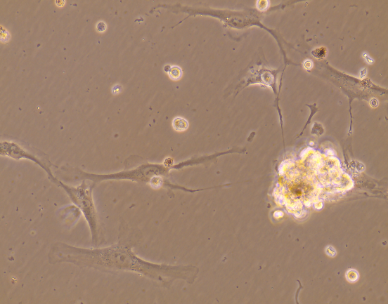 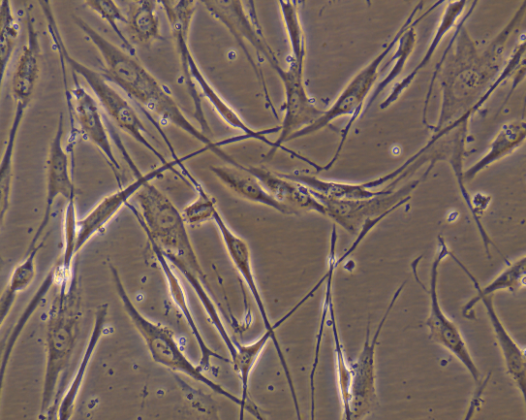

Fig.1: 40X Phase Contrast microscopy images of hair melanocytes at passage 0 and passage 5.

**Flow Cytometry**

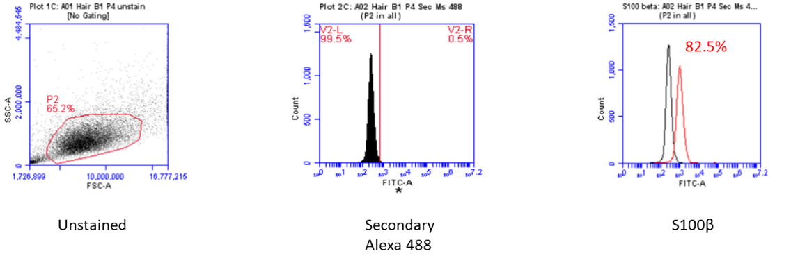Fig.2: Flow cytometric analysis using the BD Accuri C6 Plus shows 82.5% expression of the hair melanocyte marker S100β.

**Confocal Microscopy**

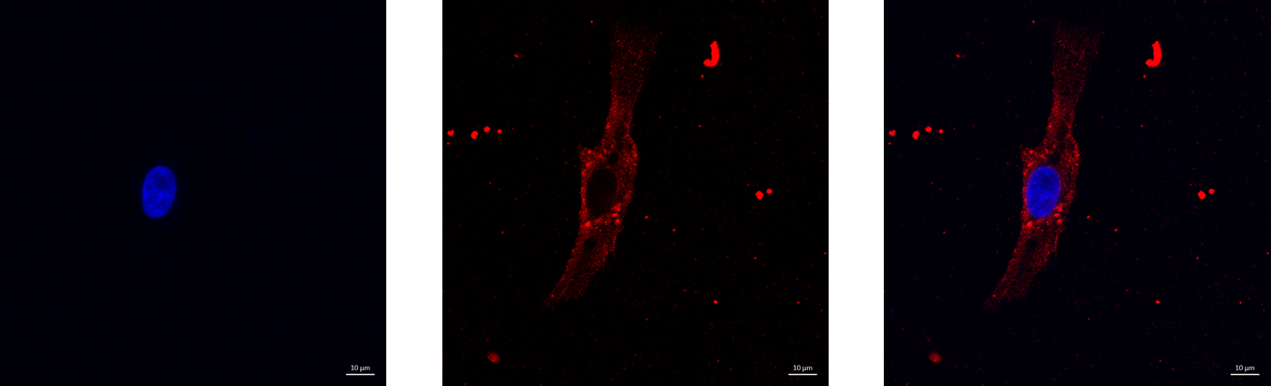

DAPI Alexa Fluor 647 -S100β Overlay

Fig.3: Confocal microscopy images (63X) of passage 5 hair melanocytes show S100β expression labeled with Alexa Fluor 647 and Nucleus with DAPI.

**Results and Discussion**

The protocol described has been validated for its efficiency in isolating viable and functional hair melanocytes. Results show a post-thaw viability of 89.4% and consistent seeding efficiency. Flow cytometry analysis using S100β, a melanocyte-specific marker, confirmed the purity of the isolated cells, with studies indicating their consistent expression in hair follicle melanocytes [2]. Confocal imaging has also revealed expression of S100β pigmentation capacity, providing a reliable readout for their functional integrity.

Daily imaging of cultured melanocytes highlights their morphology, proliferation, and pigmentation potential. The inclusion of selective trypsinization with G418 further ensures the removal of contaminating cell types, enhancing culture purity.

**Conclusion**

This chapter provides a comprehensive guide to the isolation and culture of hair melanocytes, emphasizing their utility in research and clinical applications. The described protocol offers a robust framework for obtaining high-quality melanocytes with consistent yield and viability. Future studies can leverage these protocols to explore advanced applications in pigment biology, drug discovery, and regenerative medicine. These protocols provide a foundation for advanced investigations into melanocyte biology, supporting the development of therapeutic interventions and novel drug targets [1, 3]. This methodology can further support advancements in stem cell-based regenerative therapies and the development of precision medicine approaches.

**References**

1. Yamaguchi, Y., Brenner, M., & Hearing, V. J. (2007). The regulation of skin pigmentation. *Journal of Biological Chemistry*, 282(38), 27557–27561.
2. Abdel-Malek, Z. A., et al. (2000). Melanocortins and their receptors: Their functions in regulating melanocyte biology. *Annals of the New York Academy of Sciences*, 917(1), 290–297.
3. Nakamura, M., et al. (2002). Proliferation, differentiation, and apoptosis of murine hair follicle melanocytes during the hair cycle. *Journal of Investigative Dermatology*, 119(5), 1241–1247.
4. Hörmann, K., et al. (2018). Functional hair follicle melanocytes can be generated from induced pluripotent stem cells. *PLOS ONE*, 13(4), e0195693.
5. Passeron, T., & Ortonne, J. P. (2005). Physiological and pathological aspects of skin pigmentation and its modulation by UV radiation. *Clinics in Dermatology*, 23(3), 247–252.
6. Costin, G. E., & Hearing, V. J. (2007). Human melanocyte culture system as a model to study melanocyte biology and melanogenesis. *Pigment Cell Research*, 20(1), 63–73.
7. Kang, H. Y., et al. (2001). Enhanced pigmentation and melanocyte dendricity induced by forskolin: A cAMP activator. *Pigment Cell Research*, 14(2), 142–146.
8. Boissy, R. E., et al. (2012). Modern approaches to the biology of skin pigmentation. *Pigment Cell Research*, 25(4), 259–271.
9. Lee, D. J., et al. (2020). Advances in understanding melanocyte stem cell biology. *Journal of Dermatological Science*, 98(2), 65–72.
10. Tobin, D. J. (2009). The role of melanocytes in skin and hair pigmentation. *Journal of Investigative Dermatology*, 129(5), 1030–1038.
11. Slominski, A., & Paus, R. (1993). Melanogenesis in the hair follicle. *Experimental Dermatology*, 2(1), 30–46.
12. Kauser, S., et al. (2002). Human hair follicle melanocytes as a novel tool for studies of pigmentation and aging. *FASEB Journal*, 16(9), 979–981.