Research Article

**COMPARATIVE STUDY ON THE SYNERGISTIC ACTION OF DIFFERENTIALLY SYNTHESIZED COPPER NANOPARTICLES WITH *ESCHERICHIA COLI AND STAPHYLOCOCCUS AUREUS***

**ABSTRACT**

The synthesis of metal nanoparticles has received much attention due to their wide range of applications. Copper nanoparticles, due to their interesting properties, low cost preparation and many potential applications in catalysis, microbial activity, cooling fluid or conductive inks, have attracted a lot of interest in recent years. This research is carried out to compare the stability and antibacterial activity of the biologically and chemically synthesized copper nanoparticles of two different nanometer ranges. In the chemical synthesis of copper nanoparticles copper sulphate is used as the precursor, ascorbic acid (natural vitamin C) was employed as a reducing agent and Polyethylene glycol (PEG) is used as a capping agent whereas in biological synthesis the high medicinally valued Aqueous Root bark extract *of Sansevieria trifasciata* acts both as a reducing as well as the capping agent. The synthesized Cu-NPs were analyzed by UV-Vis spectroscopy, X-ray diffraction, scanning electron microscopy and energy-dispersive X-ray spectroscopy measurements were taken to investigate the size, structure and composition of synthesized Cu Nano crystals, respectively. Antibacterial effect against different strains of microbial species and the zone of inhibition of growth of microbes are also investigated.

**Key words:** Copper nanoparticle, bio and chemical reduction, UV, SEM, EDAX, XRD and antibacterial activity.

## C:\Users\Jesus\Desktop\cu plant image.jpgINTRODUCTION

Research in nanomaterials has achieved considerable attention because of their unique properties and numerous applications in different areas [1-2]. Applications of such materials in different fields depend on the type and nature of nanoparticles (NPs). Now days, metallic nanoparticles are of great interest due to their excellent physical, chemical and catalytic properties [3]. Cu NPs were assumed cost-effective as compared to noble metals like Ag, Au, and Pt. Copper nanoparticle are very reactive due to their surface-to-volume ratio and easily interact with other particles [4]. Copper nanoparticles have wide applications like Anti fouling, biocidal, heat transfer systems, antimicrobial materials, Super-strong materials, sensors, and catalysts, wound dressing and solar cells [5-12]. Copper nanoparticles have been synthesized by different methods such as thermal reduction, thermal decomposition, electrochemical reduction, mechano–chemical process, chemical reduction [13- 16] have all been developed to prepare copper nanoparticles. Chemical reduction method is one of the most convenient methods for the synthesis of metallic nanoparticles but however, the use of a chemical reducing agent resulted in generation of larger Particles, energy consumption is more and also the stability of the particles formed is very less [17]. Thus, a more economically and ecologically sustainable plant reduction technique is preferred for the synthesis of copper nanoparticles. This biological method is not only environment friendly but also rapid, easily scalable to large scale and more efficient than conventional methods [18,19]. It is also highly advantageous by being compatible for various biomedical and pharmaceutical applications as they do not use toxic chemicals for the synthesis. Moreover, green synthesis generates nanoparticles with high dispersity, high stability and narrow size distribution [20].

**Figure 1. *Sansevieria trifasciata* plant images*.***

*Sansevieria trifasciata* (Snake Plant) is a flowering plant in the family asparagaceae, native to tropical West Africa from Nigeria east to Congo. Different parts of *Sansevieria trifasciata* tradionally used as fodder, edible and ceremonial. All parts of this plant (leaves, sap of the root) are medicinally important in the tradional system of medicine in India.

## MATERIALS AND METHODS

### Materials

All of the chemicals were analytical grade and used as such without any further purification. Copper sulfate pentahydrate salt, CuSO4.5H2O, of 98% purity was dissolved in Deionised water. Polyethylene glycol was used as a capping agent. L- ascorbic acid was used as a reducing agent.

### Preparation of root bark extract

Fresh *Sansevieria trifasciata* root were collected from the place of Lalgudi village in Trichirapalli. The collected roots were washed several times under running water and then washed with distilled water 3 to 4 times to remove dust particles. The roots were dried in shade to remove the moisture content and powdered in a blender. The extraction process was carried out using water as a solvent. The sample was soaked in 100ml of water and boiled for 20 min. Then the un-dissolved portion was filter off using watt man No 1 filter paper. The extract was then cooled and kept at 4°C for further studies.

### Synthesis of copper nanoparticles Chemical synthesis

Ascorbic acid dissolved in DD water is added to the copper sulphate solution in a glass vile, the combined solution turned blue to green color. PEG in DD water is added as the stabilizing agent along with sodium hydroxide. The green colored solution obtained is Microwave irradiated for 5minutes. The immediate color change from green to black indicates the formation of copper nanoparticles.

### Biological synthesis

50µl of root bark extract of *Sansevieria trifasciata* is added to 1000µl of copper sulphate solution in an effendrof. The reaction mixture was kept aside in a room temperature for 2 min. The immediate color change from pale yellow to dark brown indicates the formation of copper nanoparticles.

### Characterization of copper nanoparticles

The synthesized copper nanoparticles were characterized using UV-Vis, SEM, and EDAX and XRD analysis. The reaction of copper sulfate pentahydrate solution with PEG and L-ascorbic acid as the capping and reducing agent was optically measured using shimadzu UV-Visible spectrophotometer. Shape and size of the synthesized copper nanoparticles were studied by using scanning electron microscope. The main element in the synthesized materials was determined using energy dispersive X-ray spectroscopy. The crystalline nature of the synthesized copper nanoparticle was characterized using XRD analysis.

### Phytochemical analysis

The preliminary qualitative tests have been attempted in root bark extract of *Sansevieria trifasciata* to find out the presence of certain bio-active compounds. The extract was screened for the presence of phytochemicals using the standard Harbone method.

### Antibacterial activity

By disc diffusion method, the antibacterial activities of the synthesized copper nanoparticles were studied. Nutrient agar for bacteria were used, sterilized and solidified. Then the bacterial strains *Escherichia coli and Staphylococcus aureus* were swabbed on the plates. The dried copper nanoparticle sample were weighed (10mg/10ml) and dissolved in sterile distilled water to prepare appropriate dilution to get required

concentrations of about 50μl (50μg), 100μl (100μg) and 150μl (150μg). Control used as de ionized water. They were kept for incubation at 370c for 24 hours. Zone of inhibition for control and copper nanoparticles were measured and the mean values of zone of inhibition were presented.

## RESULTS AND DISCUSSION

### Visual observation

It is well known that Copper Nano particles exhibit a black color in aqueous solution due excitation of surface plasma vibrations. Reduction of Copper ions to Copper Nano particles could be followed by a color change and UV-Vis Spectroscopy. The technique outlined above has proven to be very useful for analysis of Nano particles. Therefore, the process in conversion reaction of Copper ions to Copper Nanoparticles was followed by a color change and spectroscopic techniques. The below Figure (2) shows the visual observation photographs of sample solution containing Copper Sulfate pentahydrate and L-ascorbic acid, Poly ethylene Glycol ,Sodium Hydroxide solutions after completion of the reaction. The appearance of black color confirms the existence of copper Nano particles in the solution and the Figure (3) shows the photographs of sample solutions containing copper sulphate and copper sulphate in the presence of optimized aqueous bark extract of *Sansevieria trifasciata* solutions after completion of CuNPs formation. The appearance of a dark brown color precipitate confirms the existence of copper nanoparticles in the solution.

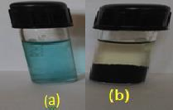 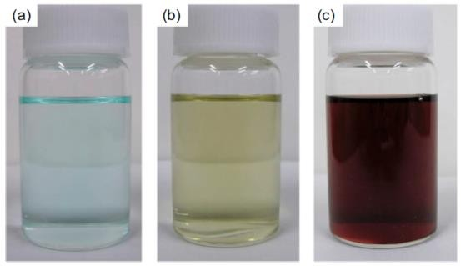

**Figure 2. a) copper sulphate solution**

**b) chemically synthesized CuNPs**

**Figure3. a) CuSO4.5H2O solution (b)Aqueous root bark extract of*Sansevieria trifasciata***

### Phytochemical screening

**Table 1. Phytochemical compounds of *sansevieria trifasciata* bark extract**

|  |  |
| --- | --- |
| **Phytochemical compounds** | **Water solvent** |
| Terpenoids | + |
| Flavonoids | + |
| Alkaloids | _ |
| Steroids | _ |
| Glycosides | _ |
| Carbohydrates | + |
| Saponins | + |
| Tannins | + |
| Proteins | _ |
| Phenols | + |
| Anthraquinones | _ |
| Anthocyanins | _ |
| Sterols | _ |
| Emalions | _ |

The qualitative phytochemical screening of *sansevieria trifasciata* bark extract was done and the result are shown in the Table.1. The present study revealed that *Sansevieria trifasciata* bark extract contains Terpenoids, flavonoids, carbohydrates, phenols, saponins and tannins.

### UV –visible spectroscopy

To study the stability of colloidal Copper Nano particles was measured by UV-visible spectroscopy. The absorption band of copper Nano particles has been reported in the range of 500- 600nm23. UV- visible absorption spectra of CuNPs by chemical reduction method and bio-reduction method is shown in the following figures 4 and 5 respectively.

This spectrum is recorded immediately after the synthesis of copper nanoparticles. The figure show the broad absorption peaks at 585nm for biologically synthesized copper nanoparticles and 480nm for chemically synthesized copper nanoparticles which proves the greater stability biologically synthesized Copper nanoparticles in the solution. The initial pale yellow color of the solution turned brown precipitate; the shifting in color is due to the surface Plasmon resonance (SPR). Metals possess SPR band the invisible range due to free electrons, which gives such intense colors. This property observed in the Copper due to the presence of free electrons.

### Scanning electron microscope (SEM)

The morphology of the synthesized copper nanoparticle was determined using Scanning Electron Microscope. Figure 6 depicts the SEM images of the chemically synthesized copper nanoparticles and figure 7 shows the SEM images of biologically synthesized copper nanoparticles. Comparison of experimental results showed that the copper nanoparticles synthesized by both the methods are more or less spherical in shape but however, the size of the chemically synthesized copper nanoparticles could not be exactly determined because of the instable colloidal formation of copper nanoparticles whereas

the diameter of the biologically prepared copper nanoparticles in the solution was found to be 29-68 nm which is attributed to their greater stability for a long period of time24.

### Energy dispersive X-ray analysis

Energy dispersive X-ray analysis is used to find out the purity of the synthesized metal nanoparticles. Figure 8 shows the copper metal purity in the synthesized copper nanoparticle solution. Table 2 shows the purity of metal copper in chemically synthesized copper nanoparticle. The composition of copper present in synthesized copper nanoparticle is 82.40%

### X-ray diffraction analysis

XRD analysis is used to determine the phase distribution, crystallinity and purity of the synthesised nanoparticles particles25. Figure 9 shows the XRD patterns of *Sansevieria trifasciata*. With reference to the JCPDS data file No. 04-0783 it was concluded that the nanoparticles were crystalline in nature having approximate spherical shape with size equivalent to

21.7nm with no such impurities.

### Antibacterial activity

The copper Nanoparticles pretend to have good bactericidal activity26. Based on the zone of inhibition produced, the biologically synthesized copper Nano particles exhibited a very good antibacterial activity against gram negative *“Escherichia coli”* whereas when the chemically synthesized copper nanoparticles were tested against the gram positive bacteria “Staphylococcus aureus” the zone of inhibition produced is less.

### Measurement of zone of inhibition

The antimicrobial potential of test compounds was determined on the basis of millimeters. The zones of inhibition of the tested microorganisms by the samples were measured using a millimeter scale.

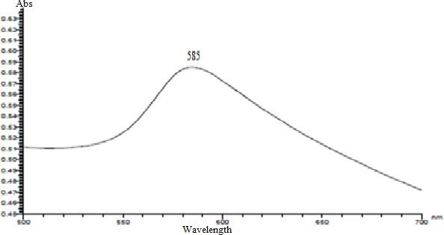 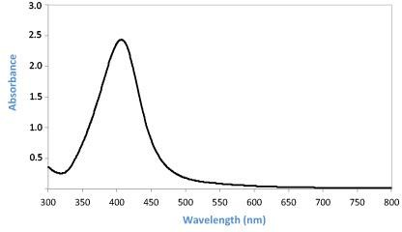

**Figure 4. UV-Visible spectrum of biosynthesized copper**

**nanoparticle Figure 5. Sharp peak at 439nm of the Chemically synthesized Cu Nps.**

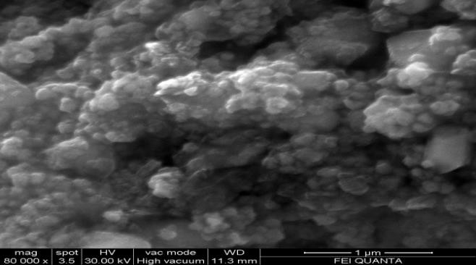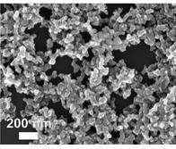

**Figure 6. SEM images of chemically synthesized Copper Nano particles**

**Figure 7. SEM images of biologically Synthesized Cu Nps.**

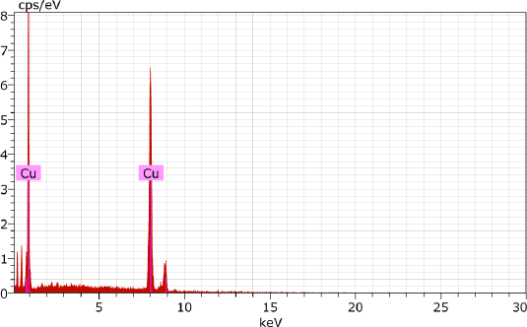 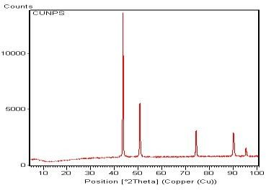

**Figure 8. EDAX images of copper Nanoparticles Figure 9. XRD analysis of biologically synthesized Copper**

**Nanoparticles**

**Table.2 Elemental analysis of Copper Nano particles**

|  |  |  |  |  |  |  |  |
| --- | --- | --- | --- | --- | --- | --- | --- |
| EI | AN | Series | Unn. [wt.% ] | c.norm [wt. %] | C.Atom [at. % ] | C.Error | (1 sigma) [wt.] |
| Cu | 29 | K-series | 82.40 | 100.00 | 100.00 |  | 2.22 |
|  |  | Total | 82.40 | 100.00 | 100.00 |  |  |

**Table 3. Antibacterial activity of copper nanoparticles**

|  |  |  |  |  |  |  |  |  |
| --- | --- | --- | --- | --- | --- | --- | --- | --- |
| Microorganisms | CuNPs | | | | | | Standard (30µl) | |
| (50µl) | | (100µl) | | (150µl) | |
| **Bacteria** | | | | | | | | |
| *Escherichia coli* (mm) | 1.90±0.13 | | 3.40±0.23 | | 6.60±0.46 | | 9.80±0.68 | |
| *Staphylococcus aureus* (mm) | | 0.60±0.04 | | 2.70±0.18 | | 6.40±0.44 | | 10.10±0.70 |

Values were expressed as Mean ± SD for triplicates

|  |  |
| --- | --- |
| Antibiotic Bacterial standard | Chloramphenicol |
| Antibiotic Fungal standard | Fluconazole |
| Control | Deionized water |

### Anti -bacterial activity

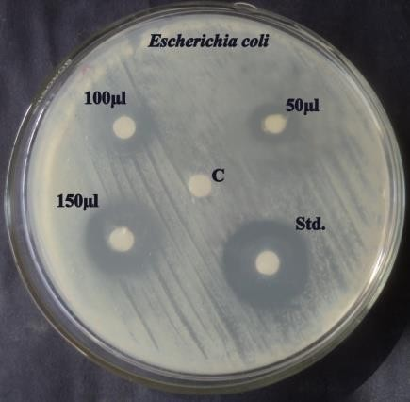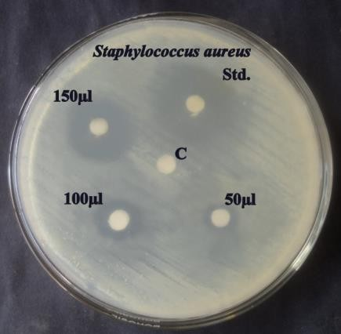

**Figure 10. Antibacterial activity of the chemically and biologically synthesized Copper nanoparticles**

## CONCLUSION

On the basis of the results obtained, we conclude that the copper nanoparticles synthesized by bio-reduction technique is well- dispersed, within the nanometer range and it is of greater stability compared to that of the chemically synthesized copper nanoparticles. Thus, the plant under investigation *Sansevieria trifasciata* could be further employed for the synthesis of other nanoparticles. The phytochemical analysis of the plant *Sansevieria trifasciata* revealed the presence of many phytoconstituents and Moreover, the aqueous root-bark extract- stabilized copper nanoparticles exhibited considerable antibacterial activity against pathogenic bacteria, which is comparable with that of standard antibiotic. Based on these results we conclude that the aqueous root bark extract of *Sansevieria trifasciata* stabilized copper nanoparticles may have potential biomedical applications when compared to chemically synthesized copper nanoparticles.

## REFERENCES

1. Mansur HS, Grieser F, Marychurch MS, Biggs S, Urquhart RS, Furlong D,Photoelectrochemical properties of 'qstate' cds particles in arachidic acid langmuirblodgett films. Journal of the Chemical Society, 91: 665-672, (1995).
2. Colvin VL, Schlamp MC, Alivisatos A, Light emitting diodes made from cadmium selenide nanocrystals and a semiconducting polymer. Nature, 370:354-357, (1994).
3. Saranyaadevi, K., Subha, V., Ernest, R.S. and Renganathan, S., Green synthesis and characterization of silver nanoparticle using leaf extract of Capparis zeylanica, Asian journal of pharmaceutical and clinical research 7: 44-48 (2014).
4. Y. Wang, M. Chen, F. Zhou and E. Ma, Nature, 419, 912 (2002).
5. R. K. Guduru, K. L. Murty, K. M. Youssef, R. O. Scattergood and C. C. Koch, Materials Science and Engineering A 463, 14 (2007).
6. S. K. Das, S. U. S. Choi, W. Yu and T. Pradeep, Ganoids: Science and Technology (John Wiley & Sons, Inc, New York, 2008).
7. R. K. Guduru, K. L. Murty, K. M. Youssef, R. O. Scattergood and C. C. Koch, Materials Science and Engineering. A 463, 14 (2007).
8. Rotello, VM. 2003. Nanoparticles: Building Blocks for Nanotechnology.1st Ed. New York: Springer.
9. Sangiliyandi, G., K. Kalishwaralala, R.Vaidyanathana,V Deepak , S. R. K. Pandiana, J.Muniyandia, N. Hariharan and

S. H. Eom, 2009. Biosynthesis, purification and characterization of silver nanoparticles using Escherichia coli*.* Colloids and Surfaces B: Bio interfaces. 74: 328–335.

1. Devi, H.S. and Singh, T.D., Synthesis of copper oxide nanoparticles by a novel method and its application in the degradation of Methyl Orange, Advance Electronic Electrical*.* Engineering 4(1): 83-88 (2014).
2. Shikha Jain, Anita Jain and Vijay Devra., “Experimental investigation on the synthesis of copper nanoparticles by chemical reduction method” International Journal of Scientific and Engineering Research, volume 5, issue 11, November-2014.
3. Liu Qing-ming, Táchira Yasunami, Kensuke Kuruda, Masazumi Okido., “ Preparation of cu nanoparticles with ascorbic acid by aqueous solution reduction method” Transactions of Nonferrous Metals Society of China 22(2012) 2198-2203.
4. Ponce AA and Klabunde KJ, Chemical and catalytic activity of copper nanoparticles prepared via metal vapor synthesis. Journal of Molecular Catalysis A, 225: 1-6, (2005).
5. Bicer M, Sisman I, Controlled synthesis of copper nano/microstructures using ascorbic acid in aqueous CTAB solution. Powder Technology, 198: 279-284, (2010).
6. Xie, S.Y., Z.J. Ma, C.F. Wang, S.C. Lin, Z.Y. Jiang, R.B.

Huang and L.S. Zheng, 2004. Preparation and Self- Assembly of Copper Nanoparticles Via Discharge of Copper Rod Electrodes in a Surfactant Solution: A Combination of Physical and Chemical Processes. Journal of Solid State Chemistry. 177(10): 3743-3747.

1. Zhu, H., C. Zhang, and Y. Yin, 2005. Novel synthesis of copper nanoparticles: influence of the synthesis conditions on the particle size. Nanotechnology. 16: 3070-3083.
2. Vitulli G, Bernini M, Bertozzi S, Pitzalis E, Salvadori P, Coluccia S, Martra G, Nanoscale copper particles derived from solvated Cu atoms. Chemistry of Materials, 14: 1183, (2002).
3. Liu, C.M., L. Guo, H.B. Xu, Z.Y. Wu , and J. Weber, 2003. Seed mediated growth and properties of copper nanoparticles, nanoparticle 1D arrays and Nano rods. Microelectronic Engineering. 66: 107-114.
4. Susrutha, V. and Karthikeyan, K.V., Microwave mediated green synthesis of copper oxide (CuO) nanoparticles and application in environmental pollution controlling studies, International Journal of VLSI Design, Microelectronics and Embedded System. 5: 819-824 (2014).
5. BC Wolverton; WL Douglas; K Bounds.*,* [A study of interior](https://ntrs.nasa.gov/archive/nasa/casi.ntrs.nasa.gov/19930073077.pdf) [landscape plants for indoor air pollution abatement*.*](https://ntrs.nasa.gov/archive/nasa/casi.ntrs.nasa.gov/19930073077.pdf) *NASA- TM-108061, (*July 1989).

Note : once just see the highlighted references , you have to add year at the last of references

1. **For eg :** S. K. Das, S. U. S. Choi, W. Yu and T. Pradeep, Ganoids: Science and Technology (John Wiley & Sons, Inc, New York, 2008).