# Research Article

COMPARISON OF FIVE ANTIOXIDANT ASSAYS FOR ESTIMATING ANTIOXIDANT CAPACITY FROM THREE *SOLANUM* SP. EXTRACTS

**ABSTRACT**

**Objectives:** The aims of this research were to determine the antioxidant capacity of various extracts from black nightshade, turkey berry, and round green eggplant using five antioxidant assays which were ferric reducing antioxidant power (FRAP), cupric reducing antioxidant capacity (CUPRAC), H2O2 scavenging, phosphomolybdenum assay, and beta-carotene bleaching (BCB), correlation of total phenolic, flavonoid, and carotenoid content with their inhibitory concentration 50% (IC50) and exhibitory concentration 50% (EC50) of five antioxidant assay and correlation between five antioxidant assays.

**Methods:** Extraction was conducted by reflux using gradient polarity solvents. The extracts were evaporated using a rotary evaporator. The antioxidant capacity study, determination of phenolic, flavonoid, and carotenoid content were performed by ultraviolet-visible spectophotometry, while its correlation with IC50 and EC50 of five methods were analyzed by Pearson’s method.

**Results:** Ethanolic and ethyl acetate fruit extracts of turkey berry denoted the highest antioxidant capacity using FRAP (EC50: 41.32 µg/ml), H2O2 scavenging assay (IC50: 1.01 µg/ml), and CUPRAC (EC50: 117.56 µg/ml). While ethyl acetate fruit extract of round green eggplant gave the highest phosphomolybdenum capacity (EC50: 375.47 µg/ml), and ethyl acetate fruit extract of black nightshade showed the highest BCB capacity (EC50: 158.66 µg/ml). Phenolic content of all fruit extracts had a tendency to correlate with FRAP and H2O2 scavenging antioxidant capacity, meanwhile flavonoid and carotenoid content had a tendency to correlate with CUPRAC, phosphomolybdenum, and BCB antioxidant capacity.

**Conclusions:** Phenolic compounds were a major contributor in antioxidant capacity of black nightshade, turkey berry, and round green eggplant extracts using FRAP and H2O2 scavenging, meanwhile flavonoid and carotenoid compounds were a major contributor in antioxidant capacity using CUPRAC, phosphomolybdenum and BCB assays. FRAP assay had linear correlation with H2O2 scavenging, meanwhile CUPRAC had linear correlation with phosphomolybdenum and BCB.

**Keywords:** Antioxidant, Antioxidant assays, *Solanum* fruits.

## INTRODUCTION

Reactive oxygen species (ROS) are produced as a normal product of metabolism [1]. Excess ROS induces oxidative stress that contributing to degenerative diseases and aging [1,2]. Reactivity of ROS can be scavenged by antioxidant. There is evidence that consumption of fruits and vegetables effective to prevent negative effects of oxidative stress because they have phenolic, flavonoid, and carotenoid compound which have the antioxidant capacity [2]. Black nightshade (*Solanum americanum* Miller), turkey berry (*Solanum torvum* Swartz), and round green eggplant (*Solanum coagulans* Forsskal) are three local fruits from West Java that often used as traditional medicine and potentially have the antioxidant capacity [3-6].

There are some methods to determine the antioxidant capacity in plant extracts; they are classified as the single electron transfer (SET), and hydrogen atom transferred (HAT)- based assays [7,8]. SET-based assay measures the capacity of antioxidants in the reduction of an oxidant, which color was changed when reduced. The degree of color change (either an increase or decrease of absorbance of the probe at a given wavelength) is correlated to the concentration of antioxidant in the sample [7]. Meanwhile, HAT-based assay measures the ability antioxidant to quench free radicals by hydrogen atom donation [7,8].

The objectives of this research were to determine the antioxidant capacity of nine plant extracts from black nightshade, turkey berry, and round

green eggplant using five methods assay which were ferric reducing antioxidant power (FRAP), cupric reducing antioxidant capacity (CUPRAC), H2O2 scavenging, phosphomolybdenum assay, and beta- carotene bleaching (BCB), correlation of total phenolic content (TPC), total flavonoid content (TFC), and total carotenoid content (TCC) with antioxidant capacity of five assays, and correlation between five antioxidant assays.

## METHODS

### Materials

Neocuproine (2,9-dimethyl-1,10-phenanthroline), 2,4,6-tripyridyl- s-triazine (TPTZ), linoleic acid, hydrogen peroxide, ammonium molybdate, sodium phosphate, sulfuric acid, ammonium acetate, sodium acetate, ferric chloride, copper (II) chloride, ascorbic acid, gallic acid, quercetin, beta-carotene, alpha-tocopherol were purchased from Sigma-Aldrich (MO, USA), black nightshade, turkey berry, and round green eggplant fruits. All other reagents were analytical grades.

### Preparation of sample

Fruit from three *Solanum* sp. that were black nightshade (*S. americanum* Miller), namely, SA was collected from Pangalengan - West Java*,* turkey berry (*S. torvum* Swartz) as sample ST from Lembang - West Java, round green eggplant (*S. coagulans* Forsskal) as sample SC from Sumedang - West Java, were thoroughly washed with tap water, sorted while wet, cut, dried, and grinded into powder.

### Extraction

About 300 g of powdered samples were extracted by reflux using different polarity solvents. Extraction using n-hexane was repeated 3 times. The remaining residue was then extracted three times using ethyl acetate. Finally, the remaining residue was extracted three times using ethanol. Hence, total there were nine extracts: three n-hexane extracts (SA1, ST1 AND SC1), three ethyl acetate extracts (SA2, ST2, and SC2), and three ethanolic extracts (SA3, ST3, and SC3).

### Exhibitory concentration 50% (EC50) of FRAP capacity

Preparation of FRAP reagent was modified from Benzie’s method [9]. The FRAP reagent was prepared in acetate buffer pH 3.6. Various concentrations of each extract was pipetted into FRAP 50 µg/ml (1:1) to initiate the reaction for obtaining a calibration curve. After 30 minutes incubation, the absorbance was observed at wavelength 593 nm using ultraviolet -visible (UV-Vis) spectrophotometer Beckman Coulter DU 720. Acetate buffer was used as a blank, FRAP 50 µg/ml as control and ascorbic acid as standard. The analysis was performed in triplicate for standard and each extract. Antioxidant capacity of each extract was determined based on increasing with Fe (II)-TPTZ absorbance by calculating the percentage of antioxidant capacity [9]. EC50 of FRAP capacity of each extract can be calculated using its calibration curve.

### EC50 of CUPRAC

Preparation of CUPRAC reagent was conducted using the method from Apak *et al*. [10] with minor modification. The CUPRAC reagent was prepared in ammonium acetate buffer pH 7. The various concentrations of each extract was pipetted into CUPRAC 50 µg/ml (1:1) to initiate the reaction for obtaining a calibration curve. After 30 minutes incubation, the absorbance was read at wavelength 450 nm using UV- Vis spectrophotometer Beckman Coulter DU 720. Ammonium acetate buffer was used as a blank, CUPRAC 50 µg/ml as control and ascorbic acid as standard. The analysis was done in triplicate for standard and each extract. Antioxidant capacity of each extract was determined based on increasing in Cu (I)-neocuproine absorbance by calculating the percentage of antioxidant capacity [10]. EC50 of CUPRAC capacity of each extract can be calculated using its calibration curve.

**Inhibitory concentration 50% (IC50) of H2O2 scavenging assay** Preparation of H2O2 solution was adopted from Ruch *et al*. [11]. H2O2 solution was prepared in phosphate buffer pH 7.4. The various concentrations of each extract was pipetted into H2O2 68 µg/ml (1:1) to initiate the reaction for obtaining a calibration curve. After 10 minutes incubation, the absorbance was read at wavelength 230 nm using UV- Vis spectrophotometer Beckman Coulter DU 720. Phosphate buffer was used as a blank, H O 68 µg/ml as control and ascorbic acid as standard.

Various concentrations of each extract were pipetted into beta-carotene- linoleic acid emulsion 100 µg/ml (1:1) to initiate the reaction for obtaining a calibration curve. The tubes were capped and incubated in a water bath at 50°C for 120 minutes. After the samples cooled, the absorbance was observed at wavelength of 470 nm against a blank using UV-Vis spectrophotometer Beckman Coulter DU 720. Emulsion without beta-carotene was used as a blank, beta-carotene-linoleic acid emulsion 100 µg/ml as control and ascorbic acid as standard. Analysis was done in triplicate for standard and each extract. Antioxidant capacity of each extract was determined based on ability antioxidant in minimizing beta carotene oxidation [14]. EC50 BCB of each extract can be calculated using its calibration curve.

### TFC, TPC, and TCC

TFC was measured using modified method from Chang *et al*. [15]. The absorbance was read at wavelength of 415 nm. Analysis was done in triplicate for each extract. The TFC was exposed as a percentage of total quercetin equivalent per 100 g extract (g QE/100 g). Determination of TPC was adapted from Pourmorad *et al*. [16] using Folin–Ciocalteu reagent. The absorbance was measured at the wavelength of 765 nm. TPC was reported as a percentage of total gallic acid equivalent per 100 g extract (g GAE/100 g). Evaluation of TCC was performed using the method from Thaipong *et al*. [17] with minor modification. Each extract was diluted in acetone. The absorbance was read at wavelength 470 nm. The TCC was demonstrated as a percentage of total beta-carotene equivalent per 100 g extract (g BE/100 g).

### Statistical analysis

Each sample analysis was performed in triplicate. All of the presented results are means (±standard deviation) of at least three independent experiments. Statistical analysis using analysis of variance with a statistical significance level set at p<0.05 and *post-hoc* Tukey procedure was carried out with SPSS 16 for windows. Correlation between the TPC, TFC, TCC, and antioxidant capacity, and the correlation between five antioxidant capacity methods were carried out using the Pearson’s method.

## RESULTS

### Antioxidant capacity of fruit extracts of *Solanum* sp. using five methods

Antioxidant capacity in various fruit extracts of *Solanum* sp. using five methods were shown in Figs. 1-5. IC50 and EC50 of each extract were compared to ascorbic acid, quercetin, and alpha-tocopherol as standard.

The lowest value of IC50 and EC50 means had the highest antioxidant activity.

2 2

Analysis was carried out in triplicate for standard and each extract. Antioxidant capacity of each extract was determined based on ability to decrease absorbance of H2O2 [11]. IC50 of H2O2 scavenging of each

extract can be calculated using its calibration curve.

### EC50 of phosphomolybdenum assay

Preparation of phosphomolybdenum reagent was performed using

modified Prieto’s method [12]. The various concentrations of each extract were pipetted into phosphomolybdenum reagent 50 µg/ml (1:1) to initiate the reaction for obtaining a calibration curve. The tubes were capped and incubated in a water bath at 95°C for 90 minutes. Left the samples cooled, then absorbance was measured at the wavelength of 695 nm using UV-Vis spectrophotometer Beckman Coulter DU 720. Distilled water was used as a blank, phosphomolybdenum 50 µg/ml as control and alpha-tocopherol as standard. Analysis was conducted in triplicate for standard and each extract. Antioxidant capacity of each extract was determined based on increasing absorbance of Mo (V)-phosphate [12]. EC50 phosphomolybdenum capacity of each extract can be calculated using its calibration curve.

### EC50 of BCB assay

Preparation of BCB reagent was performed using the method from Othman *et al*. [13] and Marco [14], with minor modification. The

### TFC, TPC, and TCC in various fruit extracts of *Solanum* sp.

The TFC in various fruit extracts from black nightshade, turkey berry, and round green eggplant had a different results varied from 0.44 to

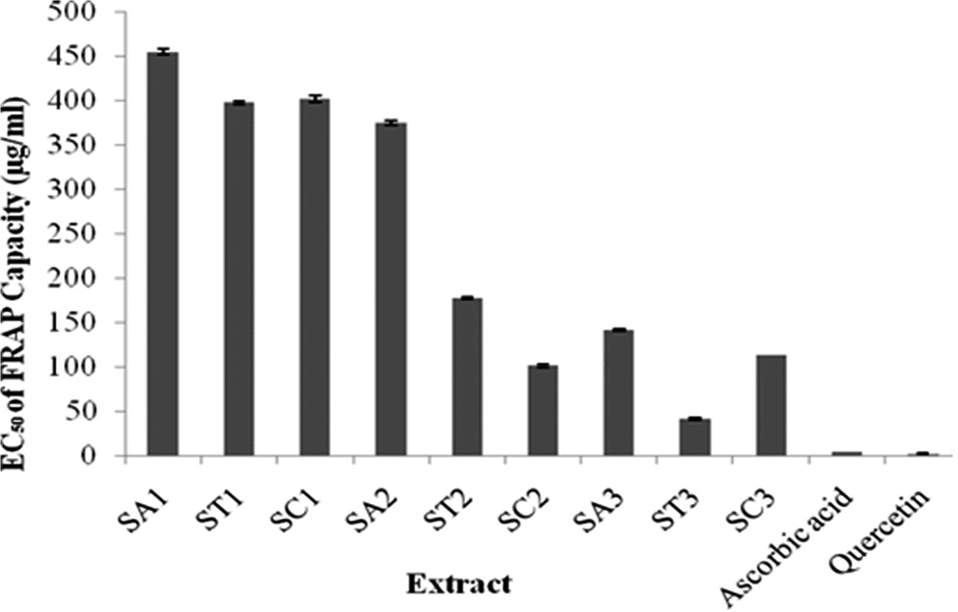

**Fig. 1: Exhibitory concentration 50% of ferric reducing antioxidant power of *Solanum* fruit extracts, n=3**

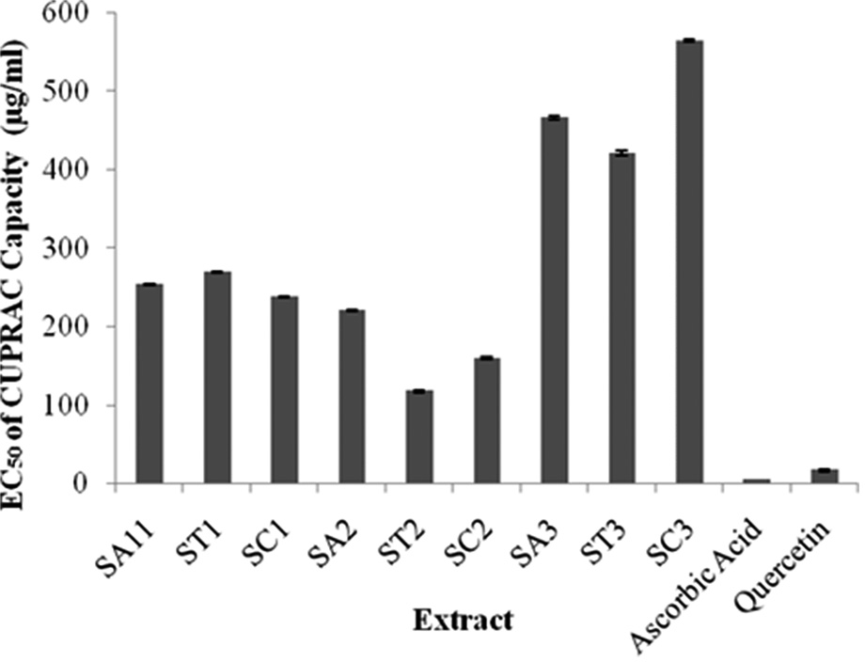

**Fig. 2: Exhibitory concentration 50% of cupric reducing antioxidant capacity of *Solanum* fruit extracts, n=3**

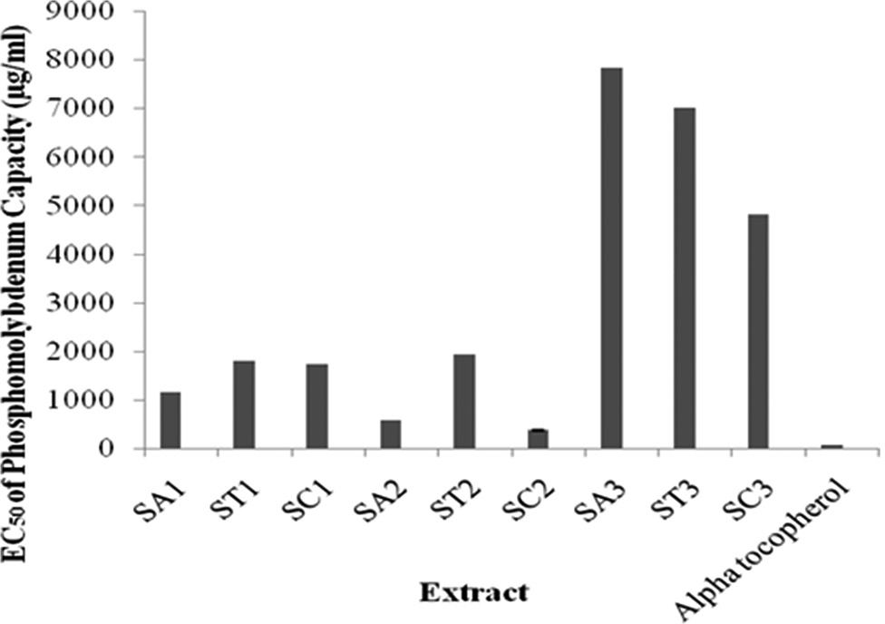

**Fig. 4: Exhibitory concentration 50% of phosphomolybdenum capacity of *Solanum* fruit extracts, n=3**

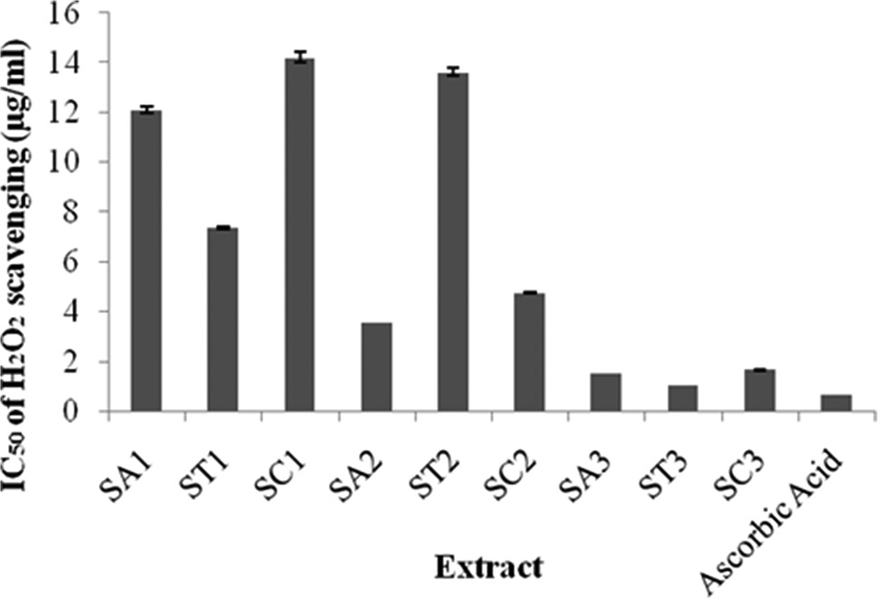

**Fig. 3: Inhibitory concentration 50% of H2O2 scavenging of**

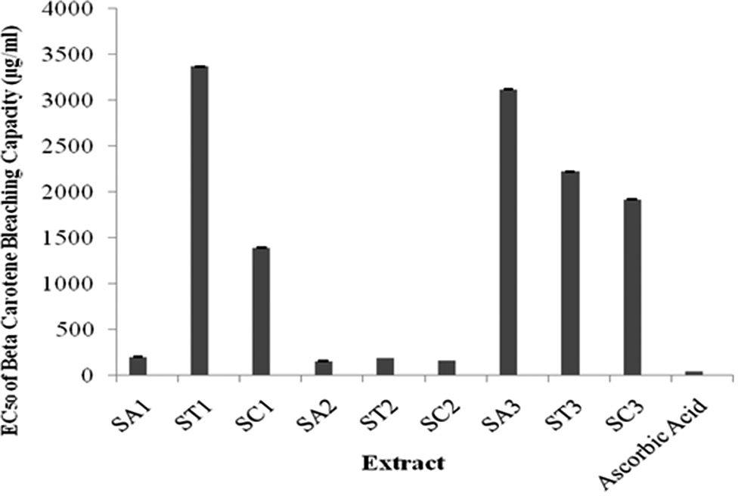

***Solanum* fruit extracts, n=3**

### Fig. 5: Exhibitory concentration 50% of beta-carotene bleaching

**capacity of *Solanum* fruit extracts, n=3**

9.37 g QE/100 g, TPC in the range of 0.30-5.15 g GAE/100 g and TCC ranged from 0.0088 to 0.87 g BE/100 g (Table 1). Ethyl acetate extract of black nightshade (SA2) showed the highest TFC (9.37 g QE/100 g) and the highest TCC (0.87 g BE/100 g). The highest phenolic content (5.15 g GAE/100 g) was given by ethanolic extract of turkey berry (ST3).

## DISCUSSION

Black nightshade (SA Miller), turkey berry (ST Swartz), and round green eggplant (SC Forsskal) are three local fruits from West Java, Indonesia that often used as traditional medicine [3-6]. Several studies revealed that fruit of black nightshade, turkey berry, and round green eggplant had antioxidant capacity. Antioxidant capacity of *Solanum nigrum* and ST using 2,2-diphenyl-1-picrylhydrazyl, 2,2’-azino-bis(3- ethylbenzothiazoline-6-sulfonic acid), and FRAP assays had been studied [18-21], meanwhile Somawathi *et al*. [22] compared the antioxidant activity from different skin colored eggplant (*Solanum melongena*). There was no research that compars antioxidant capacity of various fruit extracts of SA Miller, ST Swartz, and SC Forsskal using five methods which were FRAP, CUPRAC, H2O2 scavenging, phosphomolybdenum assay, and BCB.

Basic classification of *in vitro* antioxidant capacity is based on type of reaction, which are SET-based assay and HAT-based assay [7]. SET assay is based on the ability of antioxidant to transfer one electron to reduce oxidant [8]. The degree of color change (either increase or decrease of absorbance of the probe at a given wavelength) is

|  |  |  |  |
| --- | --- | --- | --- |
| **Table 1: TFC, TPC, and TCC of *Solanum* fruit extracts** | | | |
| **Sample** | **TFC**  **(g QE/100 g)** | **TPC**  **(g GAE/100 g)** | **TCC**  **(g BE/100 g)** |
| SA1 | 2.25±0.29a | 0.30±0.008a | 0.45±0.009a |
| ST1 | 1.21±0.12a | 0.84±0.15b | 0.46±0.05a |
| SC1 | 2.57±0.42b | 0.60±0.02b | 0.087±0.017b |
| SA2 | 9.37±0.47a | 2.85±0.11a | 0.87±0.03a |
| ST2 | 6.34±0.29b | 3.23±0.34a | 0.16±0.001b |
| SC2 | 5.45±0.39c | 2.62±0.06a | 0.12±0.0009b |
| SA3 | 1.13±0.08a | 3.08±0.43a | 0.02±0.002a |
| ST3 | 0.58±0.02b | 5.15±0.96b | 0.0098±0.0002b |
| SC3 | 0.44±0.03c | 4.34±0.11b | 0.0088±0.0004b |
| SA: black nightshade, ST: turkey berry, SC: round green eggplant, 1: n-hexane extract, 2: ethyl acetate extract, 3: Ethanolic extract, n=3. Different letter in one cell showed a significant difference at p<0.05. TPC: Total phenolic content, TFC: Total flavonoid content, TCC: total carotenoid content, QE: Quercetin equivalent, GAE: gallic acid equivalent, BE: beta-carotene equivalent | | | |

correlated to the concentration of antioxidant in the sample [7]. Meanwhile, HAT-based assay measure ability of antioxidants to quench radical by hydrogen donation [8]. SET and HAT mechanism almost always occur together, and mechanism that appear predominantly is influenced by ionization potential (DIP), bond dissociation energy (BDE), redox potential, pH, and solvent [7,8]. Antioxidant mechanism is predominantly SET for compound with ΔIP > −45 kcal/mol, and predominantly HAT for compound with DBDE of ~10 kcal/mol and ΔIP < −36 kcal/mole [8].

FRAP measure reduction of Fe3+-TPTZ to Fe2+-TPTZ by antioxidant at low pH, form an intense blue color with maximum absorbance at 593 nm [9]. This method is fast, reproducible, and non-specific [9]. Any compound which has the lower reduction potential than 0.77 V (redox potential of Fe3+/Fe2+) can be detected by FRAP assay [9,23]. EC50 of FRAP capacity is a concentration of sample or standard that can exhibit 50% of FRAP capacity. The lowest EC50 means had the highest antioxidant capacity. EC50 were used to determine the antioxidant capacity of a sample compared to standard [24].

CUPRAC assay is based on reduction Cu2+ to Cu+ by antioxidant at pH 7, and Cu+ react with neocuproine form Cu+-neocuproine, yielding a chromophore with maximum absorbance at 490 nm [8,10]. CUPRAC assay is fast, stable, and selective. It has lower reduction potential (0.159 V) than FRAP reagent, so that simple sugar and citric acid are not detected [10].

Hydrogen peroxide can be formed *in vivo* by metabolism process. It can cross cell membrane and attack many cellular compounds. Hydrogen peroxide reacts with Fe to produce free radicals [25]. H2O2 scavenging assay measure ability of antioxidant to scavenge hydrogen peroxide in pH 7.4 [11]. H2O2 solutions have a high redox potential (1.776 V), hence any compound with lower reduction potential than H2O2 can be detected [26].

Molybdenum is active site of xanthine oxidase, an enzyme that produces free radicals [27]. Phosphomolybdenum assay measure reduction of Mo (VI) to Mo (V) and subsequent formation of a green phosphate-Mo

(V) complex at acidic pH [12]. The reaction of Mo (VI) to Mo (V) has reduction potential 0.43 V.

BCB is one of the HAT-based assays. This method measures ability of antioxidants to minimize beta-carotene oxidation in linoleic acid emulsion system [28]. Linoleic acid produces hydroperoxide radicals during incubation at 50°C. These radicals oxidize beta-carotene and generate decolorization of it. The presence of antioxidants will minimize the oxidation of beta-carotene by donating a hydrogen atom to radical [28].

The EC50 of various fruit extracts of black nightshade, turkey berry, and round green eggplant were shown in Figs. 1-5. In this study, exposed that EC50 FRAP of various extracts varied from 41.32 to 454.36 µg/ ml, EC50 CUPRAC 117.56 to 564.34 µg/ml, IC50 H2O2 scavenging 1.01-14.2 µg/ml. Meanwhile, EC50 phosphomolybdenum assay in the range of 375.47- 7833.19 µg/ml, and EC50 of BCB 158.66-3370 µg/ ml.

The present study revealed that ethanolic extract of turkey berry had the highest antioxidant capacity using FRAP and H2O2 scavenging assay, meanwhile ethyl acetate extract of turkey berry had the highest antioxidant capacity using CUPRAC assay. Ethyl acetate of round green eggplant had the highest phosphomolybdenum antioxidant capacity, and ethyl acetate extract of black nightshade had the highest antioxidant capacity using BCB assay.

Quercetin has first redox potential −0.11 V, lower than reduction potential of CUPRAC reagent and FRAP reagent [29]. Therefore, quercetin showed agood antioxidant capacity using CUPRAC and FRAP assay.

Copper, free, and in phenanthroline complex has low reduction potential. This low reduction potential enhances redox cycling, a repeat redox reaction [8]. Therefore, a high concentration of extract is required to reduce Cu2 to Cu+ and make higher EC50 value.

Hydrogen peroxide has redox potential 1.776 V [26]. Any compound with lower reduction potential than 1.776 V can be detected using H2O2 scavenging assay. Several studies revealed that flavonoid, phenolic, and carotenoid compound has the lower reduction potential than hydrogen peroxide [30-32]. Therefore, in the present study, all extract showed high antioxidant capacity (low IC50) because there were many compounds could scavenge hydrogen peroxide.

There are two steps in phosphomolybdenum complex formation. The first step is formation of 12-molybdophosphoric acid (12-MPA) (Mo VI), and the next step is a reduction of 12-MPA to phosphomolybdenum complex (Mo V) by antioxidant. The stoichiometry of Mo (VI) and 12- MPA is 6:1 [33]. In the present study which was adopted from Prieto *et al*. [12], the amount of ammonium molybdate which was used too low, so that only a little 12-MPA formed and then react with antioxidant and gave phosphomolybdenum complex. It might be still many excessive antioxidants in sample will oxidize again Mo (V) to Mo

(VI). These reactions will be repeated in many times between Mo (VI) to Mo (V) and Mo (V) to Mo (VI); therefore, it denoted that the extract had higher EC50 phosphomolydenum capacity.

Antioxidant capacity using BCB assay is correlated to solubility, antioxidant structure, and chemical bond. The presence of hydrogen bonding between phenolic and emulgator Tween 20 will decrease antioxidant capacity of phenolic acid [34]. This study corresponding to the result of the present study, where phenolic was not correlated with antioxidant capacity using BCB assay.

|  |  |  |  |  |  |  |  |
| --- | --- | --- | --- | --- | --- | --- | --- |
| **Table 2: Pearson’s correlation coefficient of TPC, TFC, TCC in various fruit extracts of *Solanum* sp. with their IC50 and EC50 of five antioxidant assays** | | | | | | | |
| **Antioxidant parameter** | **Coefficient correlation Pearson (r)** | | |  |  |  |  |
|  | **Total phenolic** | **Total flavonoid** | **Total carotenoid** | **EC50 FRAP** | **EC50 CUPRAC** | **IC50 H2O2** | **EC50 BCB** |
| EC50 FRAP (SA) | −0.850** | 0.203ns | 0.574ns |  |  |  |  |
| EC50 FRAP (ST) | −0.959** | −0.050ns | 0.992** |  |  |  |  |
| EC50 FRAP (SC) | −0.870** | −0.122ns | 0.211ns |  |  |  |  |
| EC50 CUPRAC (SA) | 0.452ns | −0.696* | −0.924** | −0.843** |  |  |  |
| EC50 CUPRAC (ST) | 0.428ns | −0.910** | −0.323ns | −0.365ns |  |  |  |
| EC50 CUPRAC (SC) | 0.730* | −0.903** | −0.981** | −0.300ns |  |  |  |
| IC50 H2O2 scavenging (SA) | −0.980** | −0.214ns | 0.189ns | 0.912** | −0.549ns |  |  |
| IC50 H2O2 scavenging (ST) | −0.446ns | 0.902** | 0.343ns | 0.384ns | −1.00** |  |  |
| IC50 H2O2 scavenging (SC) | −0.970** | 0.151ns | 0.466ns | 0.962** | −0.546ns |  |  |
| EC50 BCB (SA) | 0.544ns | −0.613* | −0.876** | −0.898** | 0.994** | −0.638* |  |
| EC50 BCB (ST) | −0.397ns | −0.893** | 0.522ns | 0.490ns | 0.633* | −0.616* |  |
| EC50 BCB (SC) | 0.248ns | −0.981** | −0.872** | 0.262ns | 0.842** | −0.008ns |  |
| EC50 phosphomolibdenum (SA) | 0.496ns | −0.658* | −0.902** | −0.870** | 0.999** | 0.592ns | 0.998** |
| EC50 phosphomolibdenum (ST) | 0.815** | −0.565ns | −0.764* | −0.796* | 0.854** | −0.865** | 0.138ns |
| EC50 phosphomolibdenum (SC) | 0.643* | −0.945** | −0.984** | −0.183ns | 0.993** | −0.441ns | 0.901** |
| SA: Black nightshade, ST: Turkey berry, SC: Round green eggplant, ns: Not significant, *Significant at p<0.05, **Significant at p<0.01. CUPRAC: Cupric reducing  antioxidant capacity, FRAP: Ferric reducing antioxidant power, BCB: Beta-carotene bleaching | | | | | | | |

Phenolic, flavonoid, and carotenoid might have antioxidant capacity [24]. Based on Pearson correlation on Table 2, phenolic content of all sample fruit extracts had a tendency to correlate with FRAP and H2O2 scavenging assay. Antioxidant capacity using FRAP appears to be related to the degree of hydroxylation and the extent of conjugation in polyphenols [8]. Meanwhile, antioxidant capacity using H2O2 scavenging assay is related to the number and position of hydroxyl group bonded to the aromatic ring. Ortho and para hydroxyl substitution have stronger antioxidant capacity [35]. Therefore, it can be predicted that major phenolic compounds in all sample fruit extracts have a higher degree of hydroxylation and extent of conjugation, but only black nightshade and round green eggplant extracts have phenolic with ortho and/or para hydroxyl substitution.

Flavonoid and carotenoid content of all sample fruit extracts had a tendency to correlate with CUPRAC, phosphomolybdenum, and BCB assay. Flavonoid may have antioxidant effects as hydrogen-donating compound, metal chelating ion, single oxygen transfer, and singlet oxygen quencher [36]. Basically, structural requirement for hydrogen donating and metal chelating is related to o-dihydroxy structure in the ring B, C-2-C-3 double bond and oxo group at C-4 [36]. The presence of OH at C-3 and C-5 will increase the metal chelating activity of flavonoid. Therefore, it can be predicted that major flavonoid compounds in all samples have o-dihydroxy, C-2-C-3 double bond and oxo group at C-4.

Carotenoid a compound that contributes to yellow color of fruits and vegetables have antioxidant capacity. The structural requirement for antioxidant capacity of carotenoid is the presence of conjugated double bonds. Carotenoids that contain more than seven conjugated double bonds were reported to have stronger antioxidant capacity [37].

This study showed that a single *in vitro* antioxidant method was not possible to determine the antioxidant capacity of extract. Each method had different mechanism, and the result might be different. Therefore, it was important that variety of assays with different mechanism were used in the plant extract to investigate its antioxidant potential.

## CONCLUSION

Antioxidant activity of the sample should be measured using different assay in parallel because different method gave a different result. Turkey berry extract showed good antioxidant capacity using FRAP, H O scavenging

IUPAC technical report. Pure Appl Chem 2013;85(5):957-98.

1. Prior RL, Wu X, Schaich K. Standardized methods for the determination of antioxidant capacity and phenolics in foods and dietary supplements. J Agric Food Chem 2005;53(10):4290-302.
2. Benzie IF, Strain JJ. The ferric reducing ability of plasma (FRAP) as a measure of “antioxidant power”: The FRAP assay. Anal Biochem 1996;239(1):70-6.
3. Apak R, Güçlü K, Ozyürek M, Karademir SE. Novel total antioxidant capacity index for dietary polyphenols and vitamins C and E, using their cupric ion reducing capability in the presence of neocuproine: CUPRAC method. J Agric Food Chem 2004;52(26):7970-81.
4. Ruch RJ, Cheng SJ, Klaunig JE. Prevention of cytotoxicity and inhibition of intercellular communication by antioxidant catechins isolated from Chinese green tea. Carcinogenesis 1989;10(6):1003-8.
5. Prieto P, Pineda M, Aguilar M. Spectrophotometric quantitation of antioxidant capacity through the formation of a phosphomolybdenum complex: Specific application to the determination of vitamin E. Anal Biochem 1999;269(2):337-41.
6. Othman A, Ismail A, Ghani NA, Adenan I. Antioxidant capacity and phenolic content of cocoa beans. Food Chem 2007;100(4):1523-30.
7. Marco GJ. A rapid method for evaluation of antioxidants. J Am Chem Oil Soc 1968;45:594-8.
8. Chang CC, Yang MH, Wen HM, Chern JC. Estimation of total flavonoid content in propolis by two complementary colorimetric methods. J Food Drug Anal 2002;10(3):178-82.
9. Pourmorad F, Hosseinimehr SJ, Shahabimajd N. Antioxidant activity, phenol and flavonoid content of some selected Iranian medicinal plants. Afr J Biotechnol 2006;5(11):1142-5.
10. Thaipong K, Unaroj B, Kevin C, Luis CZ, David HB. Comparison of ABTS, DPPH, FRAP and ORAC assays for estimating antioxidant activity from guajava fruit extracts. J Food Compost Anal 2006;19:670-1.
11. Loganayaki N, Siddhuraju P, Manian S. Antioxidant activity of two traditional Indian vegetables: *Solanum nigrum* L. And *Solanum torvum*

L. Food Sci Biotechnol 2010;19(1):121-7.

1. Al-Fatimi M, Wurster M, Schröder G, Lindequist U. Antioxidant, antimicrobial and cytotoxic activities of selected medicinal plants from Yemen. J Ethnopharmacol 2007;111(3):657-66.
2. Ramamurthy CH, Kumar MS, Suyavaran VS, Mareeswaran R, Thirunavukkarasu C. Evaluation of antioxidant, radical scavenging activity and polyphenolics profile in *Solanum torvum* L. Fruits. J Food Sci 2012;77(8):C907-13.
3. Adebooye OC, Vijayalakshmi R, Singh V. Peroxidase activity, chlorophylls and antioxidant profile of two leaf vegetables (*Solanum nigrum* L. and *Amaranthus cruentus* L.) under six pretreatment methods before cooking. Int J Food Sci Technol 2008;43(1):173-8.

2 2 22. Somawathi KM, Rizliya V, Wijesinghe DG, Madhujith WM. Antioxidant

assay, and CUPRAC method and potential to be developed as a source of natural antioxidants. Phenolic compounds were major contributors in antioxidant capacity of black nightshade, turkey berry, and round green eggplant extracts using FRAP and H2O2 scavenging assays, meanwhile flavonoid and carotenoid compounds were major contributors in antioxidant capacity using CUPRAC, phosphomolybdenum, and BCB assays.

## REFERENCES

1. Sharma P, Jha AB, Dubey RS, Pessarakli M. Reactive oxygen species, oxidative damage, and antioxidative defense mechanism in plants under stressful conditions. J Bot 2012;2012:1-26.
2. Gramza-Michalowska A, Czlapka-Matyasik M. Evaluation of the antiradical potential of fruit and vegetable snacks. Acta Sci Pol Technol Aliment 2011;10(1):63-72.
3. Rajani C, Ruby KM, Aastha S, Jaya D. *Solanum nigrum* with dinamic therapeutic rule: A review. Int J Pharm Sci Rev Res 2012;15(1):65-71.
4. Chah KF, Muko KN, Oboegbulem SI. Antimicrobial activity of methanolic extract of *Solanum torvum* fruit. Fitoterapia 2000;71(2):187-9.
5. Mohan M, Jaiswal BS, Kasture S. Effect of *Solanum torvum* on blood pressure and metabolic alterations in fructose hypertensive rats. J Ethnopharmacol 2009;126(1):86-9.
6. Mutalik S, Paridhavi K, Rao CM, Udupa N. Antipyretic and analgesic effect of leaves of *Solanum melongena* Linn. in rodents. Indian J Pharmacol 2003;35:312-5.
7. Apak R, Gorinstein S, Böhm VK, Schaich MK. Methods of measurement and evaluation of natural antioxidant capacity activity:

activity and total phenolic content of different skin coloured brinjal (*Solanum melongena*). Trop Agric Res 2014;26(1):152-61.

1. MacDonald-Wicks LK, Wood LG, Garg ML. Methodology for the determination of biological antioxidant capacity *in vitro*: A review. J Sci Food Agric 2006;86:2046-56.
2. Fidrianny I, Johan Y, Sukrasno. Antioxidant activities of different polarity extracts from three organs of makrut lime (*Citrus hystrix* DC) and correlation with total flavonoid, phenolic, and carotenoid content. Asian J Pharm Clin Res 2015;8(4):239-43.
3. Ak T, Gülçin I. Antioxidant and radical scavenging properties of curcumin. Chem Biol Interact 2008;174(1):27-37.
4. Pataki L, Zapp E. Basic Analytical Chemistry. 1st ed. Oxford: Pergamon Press; 1980.
5. Aitken RJ, Buckingham D, Harkiss D. Use of a xanthine oxidase free radical generating system to investigate the cytotoxic effects of reactive oxygen species on human spermatozoa. J Reprod Fertil 1993;97(2):441-50.
6. Velioglu YS, Mazza G, Gao L, Oomah BD. Antioxidant activity and total phenolics in selected fruits, vegetables and grain products. J Agric Food Chem 1998;46(10):4113-7.
7. Simic A, Manojlovic D, Segan D, Todorovic M. Electrochemical behavior and antioxidant and prooxidant activity of natural phenolics. Molecules 2007;12(10):2327-40.
8. Happiot P, Pinson J, Yousfi N. Substituent effects on the redox properties of phenolates in acetonitrile: One electron redox potential. New J Chem 1992;16:877-81.
9. Kleinová M, Hewitt M, Brezová V, Madden JC, Cronin MT, Valko M. Antioxidant properties of carotenoids: QSAR prediction of their redox potentials. Gen Physiol Biophys 2007;26(2):97-103.
10. Hodnick WF, Milosavljevic EB, Nelson JH, Pardini RS. Electrochemistry of flavonoids. Relationships between redox potentials, inhibition of mitochondrial respiration, and production of oxygen radicals by flavonoids. Biochem Pharmacol 1988;37(13):2607-11.
11. Crouch SR, Malmstadt HV. Mechanistic investigation of molybdenum blue method for determination of phosphate. Anal Chem 1967;39(10):1084-9.
12. Terpinc P, Abramovic H. A kinetic approach for evaluation of the antioxidant activity of selected phenolic acids. Food Chem

Comments for the author:

1. The manuscript shows the potential, the writing is clear and concise, but some section could be improved. Many grammatical mistakes found in the manuscript, so I corrected some of them by the use of track change tool of MS word. So author can check and corrected them.

2. The absence of literature review found in this research article.

3. Arrange all the references as mentioned in the author’s instruction.

4. Author can also elaborate the discussion portion of the article to improve the quality of the research article.

2010;121:366-71.

1. Sroka Z, Cisowski W. Hydrogen peroxide scavenging, antioxidant and anti-radical activity of some phenolic acids. Food Chem Toxicol 2003;41(6):753-8.
2. Amic D, Davidovic-Amic D, Beslo D, Rastija V, Lucic B, Trinajstic N. SAR and QSAR of the antioxidant activity of flavonoids. Curr Med Chem 2007;14(7):827-45.
3. Beutner S, Bloedorn B, Hoffmann T, Martin HD. Synthetic singlet oxygen quenchers. Methods Enzymol 2000;319:226-41.