Antioxidant potential and high performance thin layer chromatography profiling of Siddha formulation Veppampoo mathirai

**Abstract**

The present study was aimed to study the antioxidant potential and basic TLC, HPTLC

fingerprinting profile of poly herbal Siddha formulation Veppampoo Mathirai used for hypertension to regulate blood pressure in siddha system of medicine. The antioxidant action was measured by ABTS free radical scavenging assay, lipid peroxidation and nitric oxide scavenging measure. The common modern techniques that help to evaluate the quality control of complex herbal medicine are Thin layer chromatography (TLC) and High performance thin layer chromatography (HPTLC). World health organization also indicated the above as a valuable tool to ensure the quality of medicinal plant products. Analysis of TLC was done by silica gel 60F254, 7X6 cm (Merck) and HPTLC by CAMAG Twin trough chambers. CAMAG software was used. The study revealed presence of prominent peak at 366 nm in TLC analysis and twelve prominent peaks in HPTLC analysis with Retention factor (Rf) value ranges from 0.02 to 0.86. ABTS scavenging assay, lipid peroxidation and nitric oxide scavenging showed EC50 values of aqueous extract of Veppampoo mathirai at 55.32 μg/mL, 51.3 μg/mL and 51.31 μg/mL, separately. The above results revealed that aqueous extract of Veppampoo mathirai have solid antioxidant possibilities and also a good source of natural antioxidants.

**Key words**:TLC, HPTLC, Siddha, Veppampoo Mathirai, antioxidants.

**Introduction**

In today’s world, herbals play a significant role in boosting immunity and preventing diseases. In some parts of the world, they are the primarily required materials for health care system. However, more recently, herbs and spices have been identified as sources of various phytochemicals, many of which possess powerful antioxidant activity1. An antioxidant has power to scavenge and remove reactive

oxygen species or reduce oxidative substances in order to protect tissues and organs from oxidative damage2. Further, some plants or specific combinations of herbs in formulations may act as antioxidants by exerting superoxide scavenging activity or by increasing superoxide dismutase activity in various tissue site3.Plant antioxidants plays a vital role in the battle against cellular damage and disease. As folklore has long instructed, certain plants play specific

roles in disease prevention and treatment. A well-known hepatic antioxidant, silymarin, from the milk thistle (*Silybum marianum*), for example, inhibits liver damage by scavenging free radicals among other mechanisms4. Hence, plants with antioxidant properties are becoming popular all over the world in the past few decades and there is a growing research interest in plants as a therapeutic agent.

Herbal medicines due to its innate complexity nature it is always become a challenge to prove its quality with standard modern techniques. Thin layer chromatography (TLC), High performance thin layer chromatography (HPTLC) is routine analytical technique for fingerprint identification and characterization of herbal products nowadays. This technique has gained popularity among various analytical fingerprinting techniques for the quality control of traditional medicines5The World Health Organization has emphasized the need to ensure the quality of medicinal plant products using modern controlled techniques and applying suitable standards6High performance thin layer chromatography (HPTLC) is a valuable quality assessment tool for the evaluation of botanical materials efficiently and cost effectively. The use of herbal medicine as a treatment modality has significantly increased over the last decade7. Siddha medicine has served to south Indian people since ancient times and played a vital role in today’s medical care8. The siddha poly herbal formulation Veppampoo mathirai consisting of

15 herbal ingredients to regulate blood pressure had been in use for decades9. In this regard its quality assessment like fingerprint identification is needed to know about the phytocomponents present in it as well as its antioxidant potential. The present study was aimed to evaluate the antioxidant potential of veppampoo mathirai by ABTS assay, Nitric oxide scavenging assay and inhibition of lipid peroxidation activity and analysis of basic TLC, HPTLC finger printing profile.

# Materials and methods

**Procurement of herbal ingredients and authentication**

The herbal ingredients for the study were purchased from indigenous raw drug store at Chennai, in the Month of February 2021. They were identified and authenticated by the Botanist, Government Siddha medical college, Chennai (voucher number GSMC/MB-89/2021). The 15 herbal ingredients authenticated were *Azadirachta indica, Phyllanthus amarus, Solanum trilobatum, Eclipta prostate, Zingiber officinalis, Piper nigrum, Piper longum, Terminalia chebula, Terminalia bellerica, Emblica officinalis, Eugenia caryophyllata, Cinnamom zeylanicum, Elatteria cardamomum* and *Coeus vettiveroides* and *Citrus lemon.*

# Sample preparation

As per sikitcha rathna deepam saraku suthi muraigal Siddha classical text, the herbal ingredients were purified and made in to fine powder separately10. They were mixed in a stone mortar and grounded with required quantity of lime juice for about 72 h and made in to 500 g tablets8. The tablets were dried completely in shade and stored in a clean dry porcelain jar. The antioxidant activity and TLC, HPTLC of the sample was studied at Noble research solutions, kolathur, Chennai, accredited with ISO 9001: 2015.

# ABTS (2,2'-azino-bis-3-ethyl benzthiazoline-6- sulphonic acid) radical scavenging assay

ABTS radical scavenging movement of aqueous extract of Veppampoo mathirai was adopted by method of Re et al. (1999). ABTS radical was set up by addition 5 mL of 4.9 mM potassium persulfate solution to 5 mL of 14 mM ABTS solution and kept for 16 h in dark room. The solution was diluted with distilled water to produce an absorbance of 0.70 at 734 nm and the same was utilized for the antioxidant movement. The final solution of

standard gather was made up to 1 mL with 950 μL of ABTS arrangement and 50 μL of Ascorbic acid, subsequently within the experiment group, 1 mL reaction mixture included 950 μL of ABTS arrangement and 50 μL of diverse concentration of each extract. The reaction mixture was vortexed for 10 s and after 6 min, absorbance was recorded at 734 nm against distilled water by using a Profound Vision (1371) UV–Vis Spectrophotometer and compared with the control ABTS arrangement. Ascorbic acid was utilized as reference antioxidant compound. $ABTS Scavenging Effect (\%) = [(A0- A1/A0) ×100]$ Where A0 is the absorbance of the control reaction and A1 is the absorbance of extract11.

# Nitric oxide radical scavenging assay

The nitric oxide radical scavenging assay was carried out as per Panda et al. (2009). The extracts were prepared from 10 mg/mL of ethanol crude extract. At that point, they were serially diluted with distilled water to create concentrations from 25-100 μg/mL of aqueous extract of Veppampoo mathirai and standard. They were kept away at 4°C for afterward utilization. Griess reagent was arranged by mixing 1% sulphanilamide in 2.5% phosphoric acid and 0.1% naphthyl ethylene diamine dihydrochloride in 2.5% phosphoric acid for instant use. A volume of 0.5 mL of 10 mM sodium nitroprusside in phosphate buffered saline was mixed with 1 mL of the distinctive concentrations of the ethanol extracts (10−100 μg/mL) and incubated at 25°C for 180 min. The extract was mixed with same volume of freshly arranged Griess reagent. Control samples without the extracts but with similar volume of buffer were arranged in a comparative way as done for the test samples.

The colour tubes had ethanol extracts without sodium nitroprusside at the same concentrations. To a 96-well plate, transferred a volume of 150 μL of the reaction mixture. The absorbance was measured at 546 nm in Profound Vision (1371) UV–Vis Spectrophotometer with Ascorbic acid as standard12-13. The percentage nitrite radical scavenging activity of the ethanol extracts and ascorbic acid were calculated using the following formula: $nitric oxide scavenged (\%) = Acontrol – Atest / Acontrol ×100$ percentage nitrite radical scavenging activity where Acontrol = absorbance of control sample and Atest = absorbance in the presence of the samples of extracts or standards.

# Inhibition of lipid peroxidation activity

Lipid peroxidation initiated by Fe2

+ascarbate frame work in egg yolk was surveyed as thio barbituric acid responding substances (TBARS) by the method of Ohkawa et al. (1979). The experimental mixture contained 0.1 mL of egg yolk (25% w/v) in Tris- HCl buffer (20 mM, pH 7.0); KCl (30 mM); FeSO4 (NH4)2SO4.7H2O (0.06 mM); and different concentrations of aqueous extract of Veppampoo mathirai in a last volume of 0.5 mL. The test blend was brooded at 37°C for 1 h. After the incubation period, 0.4 mL was collected and treated with 0.2 mL sodium dodecyl sulphate (SDS) (1.1%); 1.5 mL thio barbituric corrosive (TBA) (0.8%); and 1.5 mL acidic acid (20%, pH 3.5). The ultimate volume was made up to 4.0 mL with distilled water and after that kept in a water shower at 95 to 100 °C for 1 h. After cooling, 1.0 mL of refined water and 5.0 mL of *n*-butanol and pyridine mixture (15:1 v/v) were added to the response mixture, shaken vigorously and centrifuged at 4000 rpm for 10 min. The absorbance of butanol-pyridine layer was recorded at 532 nm in Profound Vision (1371) UV–Vis Spectrophotometer to measure TBARS. Hindrance of lipid peroxidation was decided by comparing the

optical density (OD) of test sample with control. Ascorbic acid was utilized as standard. Inhibition of lipid peroxidation (%) by each extract was calculated concurring to 1-(E/C) × 100, where C is the absorbance esteem of the completely oxidized control and E is absorbance of the test sample14.

# Thin layer chromatography Analysis

Test sample was subjected to thin layer chromatography (TLC) as per conventional dimensional ascending method using silica gel 60F254, 7X6 cm (Merck) and were cut with ordinary household scissors. Plate markings were made with soft pencil. Micro pipettes were used to spot the sample for TLC applied sample volume 10-micro liter by using pipette at distance of 1 cm at 5 tracks in the twin trough chamber with the specified solvent system. After the run plates were dried, it was observed in UV chamber using visible light Short-wave UV light 254 nm and light long-wave UV light 365 nm for physical identification of maximum spots and the scanning was done only for 366 nm as it renders maximum peaks15.

**High Performance Thin Layer Chromatography Analysis**

HPTLC method is a modern sophisticated and automated separation technique derived from TLC. Pre-coated HPTLC graded plates and auto sampler was used to achieve precision, sensitive, significant

separation both qualitatively and quantitatively. HPTLC method offers high degree of selectivity, sensitivity and rapidity combined with single- step sample preparation. Thus, this method can be conveniently adopted for routine quality control analysis. It provides chromatographic fingerprint of phytochemicals which is suitable for confirming the identity and purity of phytotherapeutics.

Chromatogram development was carried out in CAMAG Twin Trough chambers. Sample elution was carried out according to the adsorption capability of the component to be analyzed. After elution, plates were taken out of the chamber and dried. Plates were scanned under UV at 366 nm. The data obtained from scanning were brought into integration through CAMAG software. Chromatographic finger print was developed for the detection of phytoconstituents present in each sample and their respective Rf values were tabulated16-17. **Statistical analysis**

All outcomes of the sample were communicated as mean ± standard deviation compared with control.

# Result and discussion

**ABTS Radical scavenging activity assay**

The antioxidant activity of aqueous extract of Veppampoo mathirai evaluated by ABTS, showed noteworthy free radical scavenging potential (EC50 55.32±2.34 µl/mL) (Table-1).

4908

# Table-1. ABTS Radical scavenging activity by aqueous extract of Veppampoo mathirai

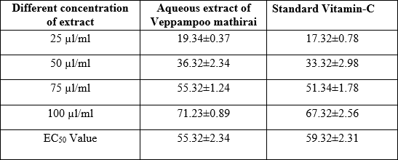

Results were expressed as percentage radical scavenging activity ABTS formation with respect to control. Each value represents the mean+SD of three experiments.

# Nitric oxide radical scavenging

Aqueous extract of Veppampoo mathirai appeared a solid nitric oxide scavenging activity which was comparable to the standard ascorbic acid. The EC50 esteem 45.32 µL/mL of aqueous extract of Veppampoo mathirai was less than ascorbic acid 49.35 µL/mL. Rate of Nitric oxide

radical scavenging movement of aqueous extract Veppampoo mathirai and benchmarks were displayed in Table-3. Within the current consider, nitrite was created by brooding of sodium nitroprusside in standard phosphate saline buffer at 25°C diminished by aqueous extract of Veppampoo mathirai. Noteworthy scavenging action may be due to the antioxidant property of flavonoid and compounds displayed in aqueous extract of Veppampoo mathirai, which compete with oxygen to respond with nitric oxide.

# Table-2. Nitric oxide radical scavenging assay of aqueous extract of Veppampoo mathirai

|  |  |  |
| --- | --- | --- |
| **Different concentration of extract** | **Percentage of Nitric oxide radical scavenging activity** | |
| **Aqueous extract of Veppampoo mathirai** | **Standard Vitamin-C** |
| 25 µl/ml | 21.34±0.78 | 17.34±0.89 |
| 50 µl/ml | 43.35±2.37 | 41.34±2.37 |
| 75 µl/ml | 61.34±0.78 | 58.34±1.87 |
| 100 µl/ml | 83.65±2.89 | 78.32±2.46 |
| EC50 value | 45.32 | 49.35 |

Results were expressed as percentage of Nitric oxide radical activity with respect to control. Each value represents the mean+SD of three experiments.

# Inhibition of lipid peroxidation

Within the display considered, egg yolk was used as substrate for gratis radical interceded lipid peroxidation, which may be a non- enzymatic method. Aqueous extract of Veppampoo mathirai was repressed with lipid peroxidation initiated by ferrous sulfate in egg

yolk homogenates. Greatest inhibition was recorded in aqueous extract of Veppampoo mathirai 74.32% with EC50 value 51.31 at 100 µl/ml and least inhibition rate of ascorbic acid 70.32% with EC50 value 73.32 at 100 µl/ml (Table-2). It is recognized that lipid peroxidation is the net result of any free radical attack on layer and other lipid components show within the framework, the lipid peroxidation may be enzymatic (Fe/NADPH) or non-enzymatic (Fe/ascorbic acid). (Mill operator, 1996).

# Table-3. Inhibition of lipid peroxidation activity of aqueous extract of Veppampoo mathirai

|  |  |  |
| --- | --- | --- |
| **Different concentration of extract** | **Inhibition percentage of Lipid peroxidation** | |
| **Aqueous extract of Veppampoo mathirai** | **Standard Vitamin-C** |
| 25 µl/ml | 15.32±2.37 | 13.64±2.37 |
| 50 µl/ml | 31.24±0.34 | 28.34±1.89 |
| 75 µl/ml | 52.34±1.78 | 46.34±2.37 |
| 100 µl/ml | 74.32±2.34 | 70.32±1.45 |
| EC50 value | 51.31 | 73.32 |

Results were expressed as percentage inhibit of lipid peroxidation with respect to control. Each value represents the mean+SD of three experiments**.**

# TLC and HPTLC finger profile of Veppampoo mathirai

TLC analysis of the sample showed maximum peak at 366 nm at UV chamber. HPTLC finger printing analysis of the sample reveals the presence of twelve prominent peaks. RF (Retention factor) of the Peak ranges from 0.02 to 0.86. First prominent peak with Rf value of

0.02 with peak area of 3287.6. Second and third largest peak with Rf value of 0.08 and 0.15 with

corresponding peak area of 4506.9 and 4283.4. The fourth less prominent peak with Rf value of

0.24 with peak area of 237.2, The fifth very largest prominent peak with Rf value of 0.33 with the peak area of 9463.4. Six was very least prominent peak with Rf value of 0.46 with the peak area of 90.3. Peak seven appears with Rf value 0.51 with peak area of 2262.0. Eight and nine had less prominent peak with Rf value 0.59 and 0.66, and their corresponding peak area were 504.6 and 588.9. The tenth, eleventh and twelfth prominent peak appears with the Rf value 0.71, 0.78, 0.86 with corresponding peak

area of 1158.0, 1418.5, 4124.9 respectively.

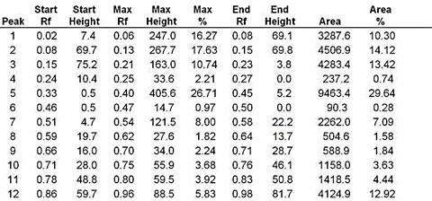

# Fig-1. TLC Visualization of sample – TLC visualization at 366 nm

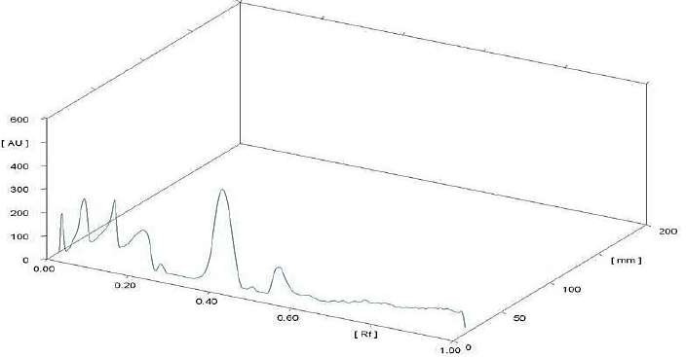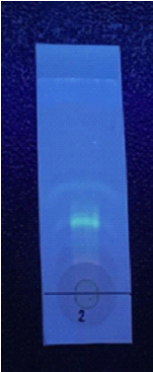**Fig-2. 3D Chromatogram**

4911

# Fig-3. HPTLC Fingerprinting of the sample Veppampoo mathirai

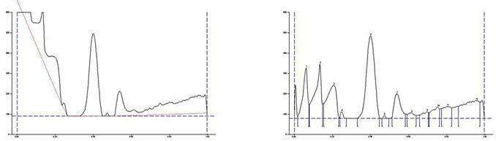

**Conclusion**

The present study showed aqueous extract of Veppampoo mathirai had most notable phenolic and flavonoid compound and exhibited solid antioxidant activities, which were comparable to the commercial, medicate antioxidant ascorbic acid. Further, TLC analysis showed the presence of prominent peak at 366 nm at UV chamber whereas HPTLC analysis showed the presence of twelve prominent peaks with Rf value ranges from 0.02 to 0.86 with a maximum peak area of 9463.4 as fifth prominent peak in the finger profile. Hence siddha formulation Veppampoo mathirai has a good source of natural antioxidants that can be utilized for age related diseases like blood pressure as therapeutic.

# References

1. Dragland S, Senoo H, Wake K, Holte K,

Blomhoff RSeveral culinary and medicinal herbs are important sources of dietary antioxidants.J Nutr. 2003 May; 133(5):1286-90*.*

1. Shun Chan, Sha Li, Ching Kwok, Iris Benzie, Yim Szeto, De Jian Guo, Xiao He & Peter Yu (2008) Antioxidant Activity of Chinese Medicinal Herbs, Pharmaceutical

Biology, 46:9, 587-

595, DOI: [10.1080/13880200802179667](https://doi.org/10.1080/13880200802179667)

1. Sawant O, Kadam VJ, Ghosh R. *In vitro* free radical scavenging and antioxidant activity of *Adiantum lunulatum*. *J Herbal Med Toxicol.* 2009;3(2):39–44.
2. Saito K, Kohno M, Yoshizaki F, Niwano

Y. Extensive screening for edible herbal extracts with potent scavenging activity against superoxide anions. *Plant Foods Hum Nutr.* 2008;63(2):65

1. Ankli A, E.Reich, M.Steiner. Rapid High performance thin layer chromatographic method for detection of 5% adulteration of black cohosh with *Cimicifuga foetida, C.heracleifolia, or C.dahurica, or C. Americana* Journal ofAOAC International, (2008) 91, pp

1257-1264.

1. Choi HY, Jhun EJ, Lim BO. Application of flow injectionchemilumineacence to the study of radical scavenging activity in plants. Phytother Res. 2000;14:250–3.
2. Frishman W. H., Beravol P., Carosella C.,2009 Alternative and complementary medicine for preventing and treating

cardiovascular disease. Dis.Mon, 55, 121-192. 10.1016/j.disamonth

2008.12.002.

1. Chitra SM, Mallika P, Anbu N, Narayanababu R, Sugunabai A, David Paul Raj RS, Premnath D. An open clinical evaluation of selected siddha regimen in expediting the management of COVID-19 -a randomized controlled study. J Ayurveda Integr Med. 2022 Jan- Mar;13(1):100397.
2. Shanmugavelu M, HPIM, Noigaluku Siddha parigaaram, Part I, venkateshwara pub, 2012; pg. 146-147.
3. Kannusamy pillai C, sikitcha rathna deepam saraku suthi muraigal, Rathinanaicker publications, pg.no. 28,29,30,34.
4. Re R, Pellegrini N, Proteggente A, Pannala A, Yang M, Rice-Evans C. Antioxidant activity applying an

improved ABTS radical cation decolorization assay. Free Radic Biol Med (1999), 26: 1231-1237.

1. 12.Olabinri BM, Odedire OO, Olaleye MT, Adekunle AS, Ehigie LO. Olabinri PF.. In vitro evaluation of hydroxyl and nitric oxide radical scavenging activities of artemether. Research Journal of

4912

Biological Science; (2010)5 Issue 1: 102-

105.

1. 13.Panda BN, Raj AB, Shrivastava NR and Prathani AR.. The evaluation of nitric oxide scavenging activity of *Acalypha indica* Linn Root,” *Asian Journal Research Chemistry*, (2009) vol. 2, no. 2, pp. 148–150.
2. Ohkowa H, Ohisi N, Yagi K.. Assay for lipid peroxides in animals tissue by thiobarbituric acid reaction. Analytical Biochemistry; (1979) 95: 351-35.
3. Lukasz Komsta, Monika Waksmundzka- Hajnos, Joseph Sherma. Thin Layer

Chromatography in Drug Analysis. CRC Press, Taylor and Francis.

1. 16. Wagner H. Plant Drug Analysis. A thin Layer chromatography Atlas.2nd ed. Heidelberg: Springer-Verlag Belgium; 2002:305, 227.
2. 17.Sunil K, Sayeed A, Paras S. Pharmacognostic evaluation and HPTLC fingerprinting of Nicotiana tabacum stem collected from different geographical regions of India. Der Pharmacia Sinica. 2011;2:1e11

4913