# Utilization of Flooding Control Strategies in Recharging Water Reservoirs

# ABSTRACT

Globally climate change, rapid urbanization, and population expansion are causing a water demand rise which increases the stress on groundwater. Groundwater recharge is one of the promising water resources sustainability approaches which helps in securing water for drought seasons. Artificial groundwater recharge is a planned human’s activity to store surface floodwater in aquifers resulting in enhancing groundwater quantity available for abstraction. Significant amount of research works have been carried out to reduce water crises using various groundwater recharge techniques.

The purpose of this research is to provide a review on groundwater recharge techniques. The common techniques include numerous methods for surface (spreading) and sub-surface methods of groundwater recharge. In addition, indirect methods are illustrated which include induced and aquifer modification methods. A total of eleven artificial groundwater methods have been reviewed in this research.

The research discusses the artificial groundwater recharge techniques alongside their applications in several fields, as well as their environmental impacts either beneficial or harmful ones. The review also identifies the technical problems and challenges in applying these techniques. Finally, the review recommends further studies and applications on the groundwater recharge approach.

# INTRODUCTION

Water is in continuous motion on planet Earth and its state is continually varying between solid, liquid, and vapor. Water evaporation from oceans, lakes and from any source of surface water, after rises by convection and condenses into clouds it starts precipitate on ground. The fallen precipitation on the Earth’s surface can be intercepted partially by vegetation, stored in surface depressions, infiltrated into the ground, or can partially flow into rivers which discharge into oceans. All these processes are part of a broad system known as water/hydrologic cycle (Figure 1). The overall amount of water cycling on Earth is finite, as it is continuously recycled by the Earth system: there is an overall of around 1,400 ×106 km3 of water on Earth.

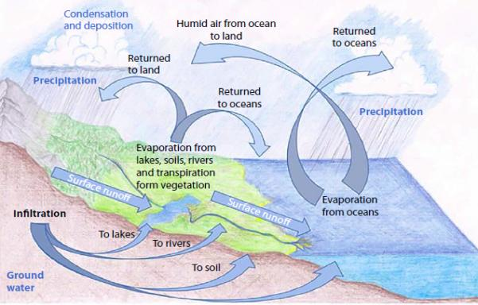

Figure 1 The global water cycle on Earth (Tharu *et al.*, 2015)

Among the above-mentioned amount of water only 2.5% is fresh water, two thirds of the fresh water can be found in form of icecaps and glaciers (Shiklomanov, 1993). Accordingly, the available fresh water is limited with water demand already exceeds supply in many parts of the world; leaving many countries suffer from water scarcity.

Water scarcity can be defined as the shortage of adequate available water supplies to meet the demands of water use within a certain area. The water scarcity already affects the whole world and around 4 billion people around the world suffers a severe water scarcity status at least one month per year. More than half billion people are subjected to extreme water scarcity during the whole year (Mekonnen and Hoekstra, 2016). Water scarcity involves water stress, water shortage or deficits, and water crisis. Although the notion of water stress is fairly recent, it is difficult to access fresh water supplies for use over a period of time and may contribute to even further depletion and deterioration of the available water resources.

Water shortages may be caused by climate change, such as altered weather patterns including droughts or floods, increased pollution, and increased human demands including water overuse. A water crisis happens when the available uncontaminated potable water in an area is less than the requirements of this country. Figure 2 presents the world’s water projected scarcity in 2025.

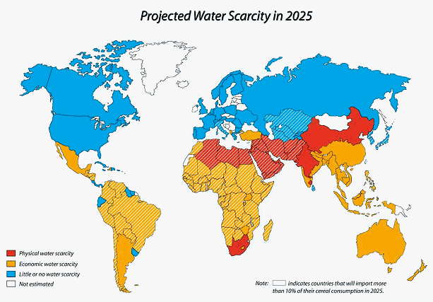

Figure 2 Projected water scarcity in 2025 (Powers, 2018)

On a global and annual basis adequate freshwater is available to satisfy humans requirements, but there are great spatial and temporal variations in water demand and water availability which in many parts of the world lead to water scarcity during particular times of the year. Due to the imbalance between rising demand and the constant availability of water in many regions of the world has reached critical levels, a sustainable approach to manage water resources is crucial (Mancosu *et al.*, 2015).

Sustainability is both an ambiguous and politicized word, but it is precisely because the world community has been rallying around sustainability and sustainable growth as ecological-economic success normative targets that the stakes are high to define the definition in a way that is true to its spirit. Water, by itself is never an end. It is always a means to more fundamental ends. Asking the question, what we want to sustain? If we are trying to manage our water resources sustainably. Fortunately, the answer is so easy. We want to sustain human welfare, widespread prosperity, peace, and ecosystem health, recognizing that sustaining each of these depends upon sustaining the others. We want to avoid, as competition for freshwater resources intensifies, sacrificing any of these for the sake of the others or for special interests.

Water sustainability means the opportunity to satisfy today's water needs without sacrificing future generations' opportunity to do the same. There is no single winning strategy to improve water sustainability. This sustainable water management refers to all practices that utilize the available conventional and non-conventional water resources to meet the socio-economic and environmental needs. Some sustainable water management strategies are suitable for regions and are not suitable for another regions.

Rain/floodwater harvesting is one of most sustainable and traditional methods to achieve water resources sustainability in order to maintain a balance between water demand and supply. The harvested water can be used either for direct use for either domestic or irrigation purposes, or for recharging groundwater aquifers for later usage (Rahman *et al.*, 2014). The sustainable objectives of groundwater recharge can be summarized as:

* Conservation and storage of excess surface runoff for future requirements,
* Enhance the yield of existing wells in depleted aquifers due to excess usage,
* Leading to dilution of toxic chemicals/salts, which improves water quality,
* Gathering new communities around the groundwater harvesting and recharging areas,
* Reduction in energy costs for lifting water, especially where there is a significant rise in groundwater levels.

The main objective of this research is to review the water harvesting techniques focusing on utilizing the harvested rain/floodwater in recharging the groundwater aquifers. This will be done by illustrating various groundwater recharging methods as a step towards a sustainable water resources management. In addition, the review will cover the applications of these methods and their impact on the environment.

The research started by reviewing the water harvesting techniques, then focusing on the groundwater recharging methods. In addition, the research will illustrate the application of these methods, environmental impact, and their operation problems accompanied with their ways to maintain. Moreover, the review will illustrate the groundwater recharge application in Egypt. Finally, the review will provide some future research direction concerning groundwater recharge approach.

# WATER HARVESTING

Water harvesting can be defined as a method of harnessing water for use in any form of system or technique that collects, stores, and increases the availability of intermittent surface runoff and groundwater in arid/semi-arid regions (Bruins, Evenari and Nessler, 1986; Prinz, 1996; Oweis, Prinz and Hachum, 2012). Water harvesting not only provides water for irrigation purposes but also it may provide potable water for animal and human consumption. Water harvesting is a water conservation method that is intended to contribute significantly to ensuring water sustainability in different nations (Gebreyess and Amare, 2019). Water harvesting could be defined as all measures to accumulate available water resources, temporarily storing excess water for consumption when necessary, especially in seasons of drought or when there are no available continuous water resources (Kalkidan and Tewodros, 2017; Hafizi Md Lani, Yusop and Syafiuddin, 2018).

There are several different methods of water harvesting that have been established and developed over time. In different regions, water harvesting technology with the same techniques could be called differently and some others could be called similarly, but in fact they are totally dissimilar. There are, however, different definitions and categorizations of water harvesting techniques, and there is no simple standardization of the name of a technique performed at local and global levels (Gebreyess and Amare, 2019).

In this review, the water harvesting can be classified into main groups, groundwater harvesting and surface water harvesting as illustrated in Figure 3. The ground water harvesting is classified into water wells and Qanats. While the surface water harvesting is then classified into four sub-groups (Mekdaschi and Liniger, 2013). The four sub-groups are rooftop (courtyard) harvesting, micro-catchment harvesting, macro-catchment harvesting, and floodwater harvesting. The surface water harvesting group is classified based on the catchment scale and also considers storage strategies and water harvesting purpose (Oweis, Prinz and Hachum, 2012; Tuinhof, Van Steenbergen and Tolk, 2012; Yemenu, Hordofa and Abera, 2014).

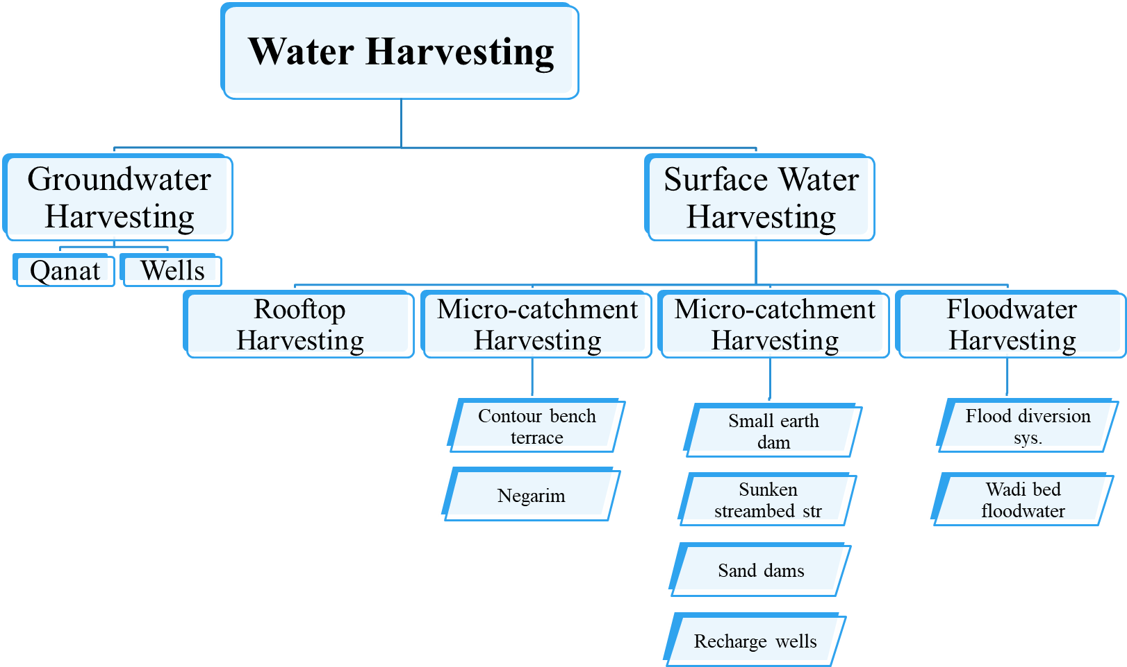

Figure 3 Water harvesting methods

## Groundwater Harvesting

The groundwater harvesting is extracting water from the groundwater table. This type of water harvesting is divided into two groups; water wells and Qanats. The water wells are an artificial holes that reach the groundwater table and they were the first structures built by human being to extract water in arid/semi-arid regions (Issar, 2001). Issar stated that the early built wells were hand dug shallow wells which are excavated in wadis beds. Nowadays, more sophisticated water wells which are lined and equipped with some kind of powered lifting pumps are used all over the world.

The other type of groundwater harvesting is Qanat. A Qanat system consists of a network of underground pipes or tunnels which convey water from aquifers in highlands to a lower levels field by gravity (Figure 4). A dense series of vertical shafts or wells connecting the tunnel to the surface serve as shafts for construction, maintenance access, and allow air to flow in and out the system. The mother well is the uppermost part of these shafts. If the system fails to provide sufficient water due to groundwater depletion, additional tunnels may be constructed that branch from the main tunnel until the groundwater is re-tapped (Lightfoot, 1996b). The tunnel beds are often sealed with mortar to avoid water seepage from the system. Qanats are usually constructed at the mountainous catchments outlet. This system has different names all over the world (e.g. Khettara in Syria, Galleria in Spain, and Felaj in Oman) (Costa, 1983; Lightfoot, 1996a, 2000; Boustani, 2008). The Qanat system is used in irrigation in more than 34 arid/semi-arid countries.

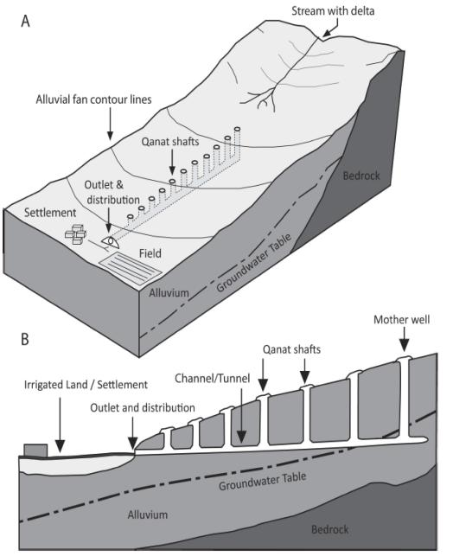

Figure 4 Qanat system sketches. A: adapted from (Cech, 2009) , B: adapted from (Lightfoot, 1996b)

## Surface Water Harvesting

The surface water harvesting systems is mainly depending on rain water, and that is why in most of the literature it is named rain water harvesting. This type of water harvesting has many benefits (Julius, Prabhavathy and Ravikumar, 2013):

1. The rain water is a free water source with no contamination
2. It is socially and environmentally accepted and preferred.
3. It always uses simple and inexpensive technologies to be harvested.
4. Helps in reducing flood hazards and soil erosion.
5. It is used in arid/semi-arid areas which face insufficient water resources.
6. It can be used to recharge groundwater naturally or artificially.
7. It can be used locally and no need for conveying.

The rainwater harvesting is an ancient water harvesting technique which has gained a growing attention nowadays due to droughts, water contamination, and population growth (Nolde, 2007). It is defined as the use of rainwater in small scale productive purposes through collection and storage (Mwenge Kahinda *et al.*, 2008). Mati et al., (2006) also defined rainwater harvesting as a rainwater collection from a certain watershed and its storage within the soil profile using physical structures. As mentioned before, the surface/rainwater harvesting method is classified into four sub-groups as follows:

### Rooftop (courtyard) harvesting

These types of water harvesting method are used for household hygiene or irrigation purposes to preserve water access. These are primarily used by countries such as the South Pacific, India, China, the Caribbean, and Australia, which are established and economically developing. Rainwater may be harvested from the rooftops of different facilities in houses or services building (e.g. hospitals, schools, and administrative buildings). The size of the rooftops of the buildings and the amount of seasonal rainfall reflects the amount of rainwater can be collected. Only 80-85% of the rainfall can be collected since the rainwater is trapped on the rooftops. The collected rainwater is usually conveyed by a gutter system to tanks or underground reservoirs and used for animal and domestic consumption and the small-scale irrigation of gardens. In addition, the collected rainwater can be used for household drinking purposes if tap water is unavailable. In most arid/semi-arid regions, these mechanisms are applied. In the case of courtyard water harvesting, rainwater is collected from condensed soil, concrete surface, or a ground coated with plastic (Oweis, Prinz and Hachum, 2012; Mekdaschi and Liniger, 2013).

### Micro-catchment harvesting

The micro-catchment harvesting is a type of rainwater harvesting which collects rainwater from a small (1 – 1000 m2) catchment and channel the harvested water to an adjacent cropping areas or individual plants as planting pits (Prinz, 2002). Some type of special tillage method or earthen embankments are used to modify the catchments. The modifications might include the interception of catchments on steeper slopes by creating counter-parallel individual or continuous bunds, contour ridges, or agricultural terraces as demonstrated in Figure 5. However, in mildly slope to flat catchments the system could be modified by building small drainage basins by excavating ditches or by constructing bunds.

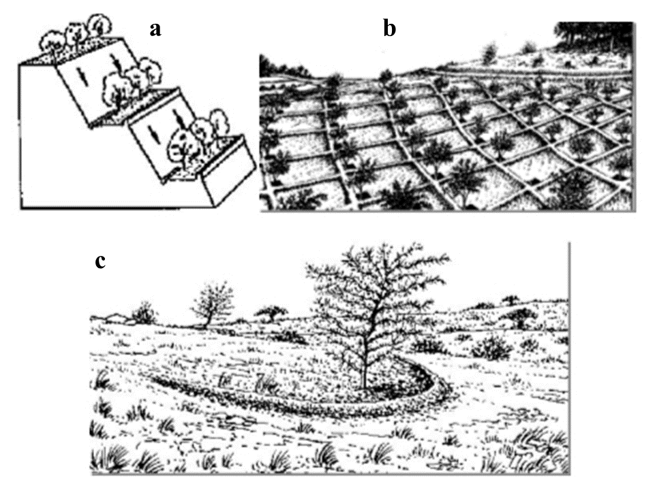

Figure 5 Samples of micro-catchment water harvesting technique (a: contour bench terrace, b: bunds, c: Negarim)

A broadly used type of construction is called Negarims. These type of construction is a semi-circular (half-moon) micro-catchments and eyebrow terraces (Prinz, 2002). The Negarims are earthen bunds and diamond in shape with a few square meters in area. They are used to collect the runoff and channel it to its lowest corner where the water is stored in the plant root zone. This technique is commonly used in combination with some agricultural activities, such as plant production, soil fertility management and pest management (Critchley and Gowing, 2012).

### Macro-catchment harvesting

Systems which collect rainwater from a larger catchment (more than 1000 m2) such as hillsides are called Macro-catchment harvesting methods. This method can be defined as the collection of overflow water from highland or hill surfaces, diverting it using obstructions and storage structures to the appropriate position of implementation. The water is stored in surface storage such as tanks, jars, and ponds or in underground storage such as soil reservoirs and cisterns. Based on the quantity and quality of stored water, it could be used for irrigation, animal production and household use (Critchley and Gowing, 2012; Oweis, Prinz and Hachum, 2012). These systems need complex structures to be constructed and maintenance is labour intensive (Prinz, 2002).

Mekdaschi and Liniger, (2013) classified the macro-catchment harvesting sub-group into small earth dams, sunken streambed structure, sand dams, and recharge wells. They are briefly described below:

#### Small earth dams

They are small earth barriers or dams which are commonly constructed around foots of hill slopes to store rainwater runoff from upriver catchment areas (Biazin *et al.*, 2012). These small dams store water mainly for household use, animal production, and irrigation of small farms. They are widely used in many countries in Africa (Makurira *et al.*, 2007).

#### Sunken streambed structure

They are rectangular excavations in seasonal stream beds built to collect and retain runoff to increase groundwater recharge, thereby raising groundwater table level in the nearby shallow wells used for irrigation. A sketch of sunken streambed holes are illustrated in Figure 6Depending on the stream bed section, the dimension of a typical one is 1.0-1.5 m deep with variable lengths (up to 40 m) and widths (up to 10 m), with an average capacity of 400 m3 (Gebreyess and Amare, 2019).

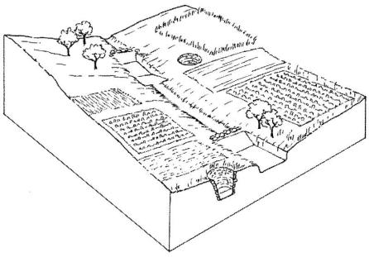

Figure 6 Sunken streambed structure sketch

#### Sand dams

They are stepping brick/rock dams constructed on steep sloped sandy seasonal rivers as shown in Figure 7. It is a simple, inexpensive, easy to maintain, and reproducible method of rainwater harvesting. With time, sediment is trapped behind the rock walls and agricultural soil is gradually produced (Missaoui, 1996). The collected water is used for both household, irrigation purposes, and enhancing groundwater recharge (Hut *et al.*, 2008). This type of water harvesting is used in North Africa, Kenya and Ethiopia.

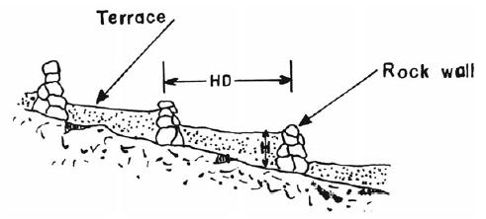

Figure 7 Sand dam sketch (Missaoui, 1996)

#### Recharge wells

To properly flow water to deep aquifers, injection or recharge shafts are necessary (Figure 8). Basically, injection wells are ideal in areas where there is a dense, impermeable or slowly penetrable layer between the topsoil surface and the aquifer (Gebreyess and Amare, 2019). This system can be used individually or accompanied with other system to enhance groundwater infiltration. This system is used in arid/semi-arid regions and specially in North Africa countries.

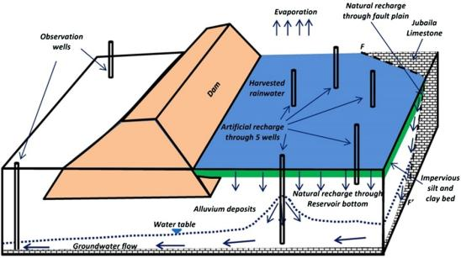

Figure 8 Recharge wells used with dam water harvesting system (Alataway and El Alfy, 2019)

### Floodwater harvesting

Floodwater harvesting method is used in large catchments with several square kilometers in size, from which heavy floods in short duration flows into a large wadi which requires more complex structure and distribution network. In particular, floodwater harvesting can be further classified into:

#### Floodwater diversion system

It is also called Spate irrigation. The system forces the wadi runoff to leave its natural course and convey the water to irrigate adjacent crop fields downstream usually before planting as shown in Figure 9. This diversion system is already used thousand years ago, but nowadays with improved engineering skills some modifications have recently been introduced to the system (Tesfai and Stroosnijder, 2001).

#### Wadi bed floodwater harvesting

In this method, structures are built across the wadi to dam floodwater and store it in a surface reservoir. These structures are usually built of masonry or earthen embankments (Oweis, Prinz and Hachum, 2012). This water is mainly used for irrigation purposes and groundwater recharge. The system always consists of a multiple of check dams aligned in series along the wadi course as shown in Figure 9. The transported sediments accumulate behind the dams and gradually buildup a sediment reservoir upstream which is suitable for cultivation.

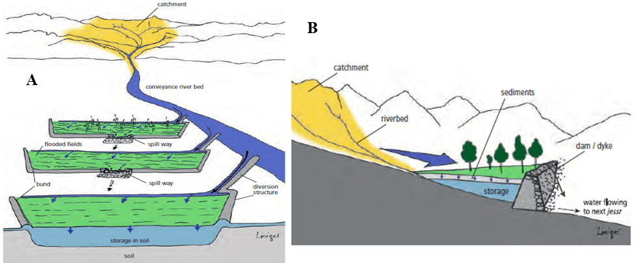

Figure 9 Floodwater harvesting; A: floodwater diversion system; B: Wadi bed floodwater harvesting (Matthews, 2014)

Although ground water recharge technique is mentioned explicitly in macro-catchment water harvesting methods, but it is used also in floodwater harvesting method. The artificial groundwater recharge is always used whenever there is an in-stream storge to enhance the groundwater replenishment. However, a limited use of groundwater recharge is used in micro-catchment water harvesting (Mekdaschi and Liniger, 2013). Moreover, the groundwater recharge has been used on the smallest catchments in water harvesting, rooftop water harvesting (Gale, 2005). Due to the importance of groundwater recharge and its influence on rain/floodwater harvesting, the next sections will discuss the commonly used groundwater recharge techniques, problems and challenges in applying these techniques, various applications, environmental impacts, and finally the application of these techniques in Egypt.

# GROUNDWATER RECHARGE

Groundwater recharge can be classified into natural and artificial groundwater recharge. In natural phenomenon, water infiltrates through the permeable ground surface and fills the vadose (unsaturated) zone before reaching the groundwater table (Gheith and Sultan, 2002; Sen, 2008). After filling up the vadose zone, the infiltration rate decreases and the water tends to runoff on the surface more than infiltrating. The natural recharge depends on ground geology, and soil moisture characteristics (Hashemi *et al.*, 2013).

On the other hand, artificial groundwater recharge occurs by man’s activities, under pumping or non-pumping condition, and by which the recharge of groundwater to an aquifer is increased at a rate much higher than those under natural percolation status (Kimrey, 1989; Hussain *et al.*, 2019). Certain artificial groundwater recharging techniques have been used for decades; others have been developed only in recent years. The most efficient use of artificial groundwater recharge includes a detailed understanding of the physical and chemical characteristics of the aquifer systems, as well as comprehensive on-site experimentation and adjustment of the technique of artificial recharge to suit local or regional conditions.

This review focuses on using the artificial groundwater recharge for rain/floodwater and the following context will discuss the commonly used techniques used in this purpose.

## Artificial Groundwater Recharge Techniques

There are various of methods or techniques to enhance groundwater recharge, and they are as diverse as the ingenuity of those involved in their construction and operation (Gale, 2005). Artificial groundwater recharge methods may be grouped under two broad categories (i) direct methods, and (ii) indirect methods as illustrated in Figure 10 (Bhattacharya, 2010).

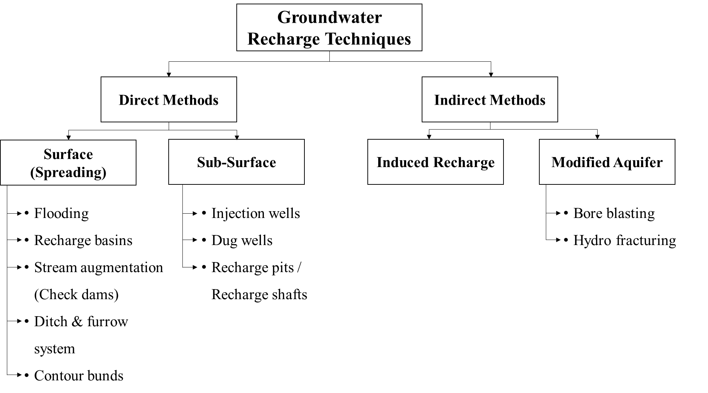

Figure 10 Artificial groundwater recharge techniques

### Direct methods

#### Surface (spreading) techniques

The most commonly utilized methods of artificial groundwater recharge which use various techniques to increase the contact area and surface-water residence time with the soil so that the maximum amount of water can infiltrate and increase the storage of groundwater (Zhang, Xu and Kanyerere, 2020). For surface-water spreading techniques, areas with gently sloping land without gullies or ridges are best suited. Water spreading method is suitable for applying where an shallow unconfined aquifer to be recharged exists. The rate of infiltration depends on the characteristics of the top soil, if soil is sandy the infiltration rate is higher than those of silty soil. The infiltration rate might be reduced if the top soil pores are clogged with fine sediment suspended in the water. The various spreading methods are as below:

1. *Flooding*

The flooding method is used in selected areas where an acceptable hydro-geological situation exists for the groundwater recharge of the shallow unconfined aquifer by spreading the surplus surface water from canals / streams over large areas for sufficiently long duration. This method is optimum for mild to flat topography with land slopes of about 1 – 3 % without gullies and ridges (Figure 11). A higher infiltration rate can be achieved on areas without vegetation and with sandy soil.

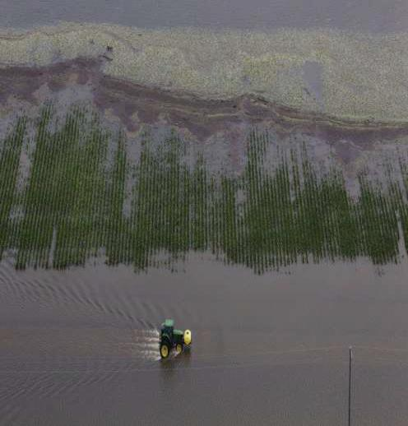

Figure 11 Flood spreading method

1. *Recharge basins or percolation tanks*

This is the most common and used surface (spreading) groundwater recharge method. In this method, the water is impounded in series of basins or percolation tanks which are either excavated or enclosed by dikes or levees as shown in Figure 12. The basin sizes depend on the topography of the area, the flatter slope the larger basins (Daji, 2011). This method is applicable in alluvial areas as well as hard rock formations, and the basins are usually built parallel to stream channels. Compared to any other method , this method tolerates more turbid water. (O’Hare *et al.*, 1986).

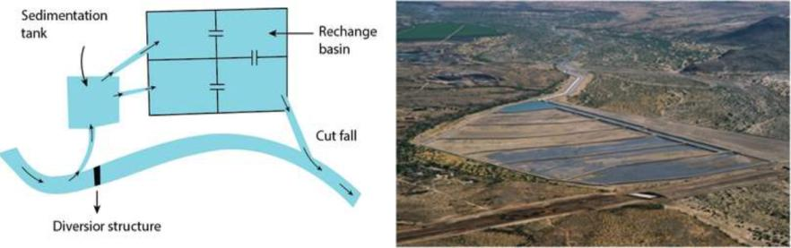

Figure 12 Recharge basins/percolation tanks samples

1. *Stream augmentation (Check dams)*

Seepage from natural stream or channels is one of the most important source of groundwater recharge. Yet, when the total water discharging through a stream exceeds the infiltration rate, the excess water is lost as surface runoff. This runoff can be collected by a series of check dams constructed across stream creating a small reservoir in the upstream direction (Figure 13). Check dams are constructed in both hard rock and alluvial formations having mild slopes. A sufficient thickness of permeable bed should present to select a suitable site to construct check dams, to facilitate groundwater recharge in a short period. The stored water upstream the check dam is always confined by the stream banks which is typically 2 m in height.

A similar technique called “gully plug” is built for small gullies and streams with tiny catchments on hill slopes. These plugs are normally constructed using local materials such as stones, earth and weathered rock, and brushwood (Malesu, Oduor and Odhiambo, 2007; Bhattacharya, 2010).

“Gabion structure” is a check dam constructed across small streams. It is constructed using locally available boulders rapped with steel wires. The silt carried by the runoff deposit inside the structure and make it more impermeable by time. The maximum height of the gabion is 0.5 m.

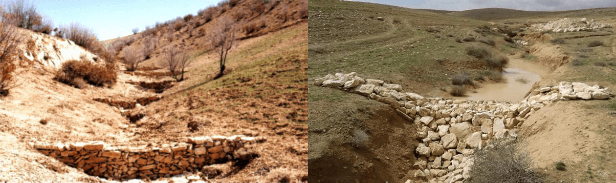

Figure 13 Left-side: A series of check dams (Hassanli and Beecham, 2013), Right-side: A gully plug (Mirzabaev *et al.*, 2019)

1. *Ditch and furrow system*

In irregular terrain, shallow, and flat-bottomed areas closely spaced ditches and furrows provide optimum water contact area for groundwater recharge from the source stream or canal (Figure 14). The spacing of the ditches depends on the soil permeability. For low permeability soil, densely spaced should be applied. In this technique, less land preparation is needed compared to recharge basins, and it is also less susceptible to silting process.

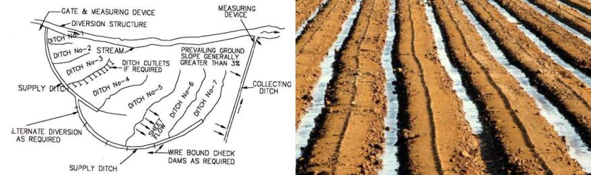

Figure 14 Left-side: A ditch system sketch, Right-side: A furrow system

1. *Contour bund*

Contour bund is a small embankment constructed along the contour (land with same elevations) in hilly regions to collect runoff and retain it for longer time to recharge in ground reservoirs (Figure 15). This system is usually used in hilly with low rain areas.

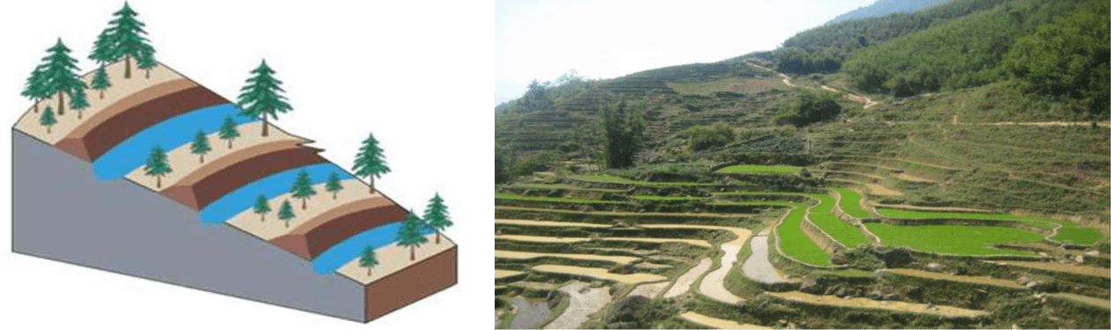

Figure 15 Left-side: Contour bund sketch, Right-side: contour bunds system in China (WILDCHINA, 2012)

#### Sub-surface techniques

As impermeable layers overlay deeper aquifers, the sub-surface aquifer can not be recharged under natural conditions by infiltration from the surface. The sub-surface techniques adopted the idea of recharging the deep confined aquifers directly from surface-water source (Bhattacharya, 2010). Important structures commonly used are Injection Wells, Dug Wells, Recharge Pits, and Recharge Shafts.

1. *Injected wells*

Injected wells are used to recharge water directly to deep confined aquifer by making use of the spreading channels and percolation tanks, and recharge from the losses of the canals (Kavuri, Boddu and Annamdas, 2011). They are similar to pumping wells but with purpose of augmenting groundwater storage (Figure 16). The water is injected by pumps to recharge the groundwater aquifer under pressure. This type of wells can be used as a pumping wells in non-rainy seasons. This technique can use single or multiple wells. This technique is expensive and requires special treatment to maintain.

In contrast to a pumping well of similar nature in the same scenario, the injection wells show lower efficiency (40 to 60 %) due to high losses caused by clogging. Injection-cum-pumping wells are more successful because during the operation, the well can be washed.

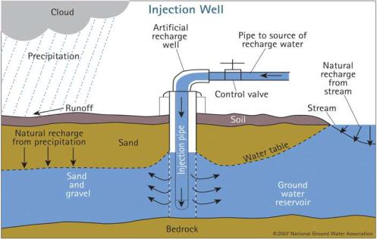

Figure 16 A sketch for an injection well

1. *Dug wells*

Thousands of dug wells have gone dry in alluvial as well as hard rock arid/semi-arid areas due to a significant drop in groundwater table levels. These wells can be used to recharge the groundwater aquifer. Water from different sources (stormwater, tank water, and canal water) can be obtained through a distribution system and can be discharged using dug wells. A pipe to the bottom of the well, can be used to guide water for recharge to avoid scoring and entrapment of bubbles in the aquifer. A schematic diagram of dug well recharge is illustrated in Figure 17.

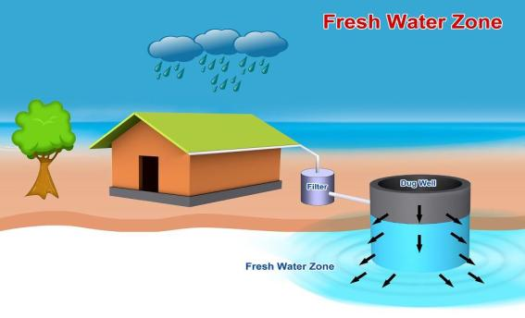

Figure 17 Groundwater recharge dug well (Raphael, 2014)

1. *Recharge pits and recharge shafts*

Recharge pits are very similar to recharge basins/percolation tanks with deeper dimensions. They look like a canal trench as shown in Figure 18. They are applied wherever less permeable soil exist, and surface flooding recharge methods are not showing a satisfactory performance. At this time a recharge pit can be excavated deep enough to penetrate the less permeable soil.

Recharge shafts are similar to recharge pits, but the cross section of the recharge shafts is narrower compared to the pits (Figure 18). They are also similar to recharge pits as they are used to recharge groundwater to unconfined aquifers. These are the most effective and cost-efficient techniques for direct recharging of the aquifer and needs very simple technology and design to be built. The shaft is normally be more than 2 m in diameter to recharge more water with creating less eddies. In case that the water has suspended silt, the shafts must be filled with boulders, gravel, and sand to be a filter. The sandy layer must be removed and cleaned periodically. As recharge and dug wells, recharge shafts can be used for groundwater recharging as well as discharging (Pyne, 1995).

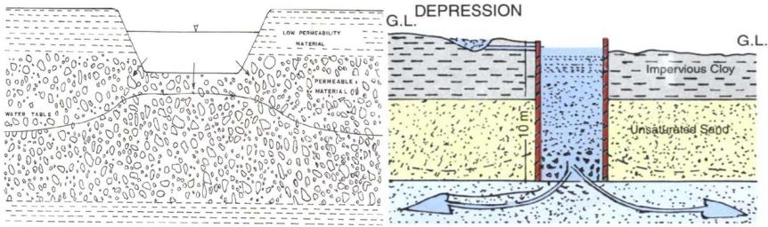

Figure 18 Recharge pits on the left-side and recharge shaft on the right-side

### Indirect methods

#### Induced recharge

An indirect method of recharge is induced recharge. In some literature it is named by induced bank infiltration (Zhang, Xu and Kanyerere, 2020). When the cone of depression reaches as far as the stream, the induced recharge happens, reducing the water table below it. If there are no impermeable obstacles, such as clay or dense organic muck deposits in the stream bank, the pump will draw water from the stream down through the aquifer and into the well. Under these conditions, contaminated surface water can reach the well and enhance the quality of the collected water and make it more reliable (Figure 19). A travel time greater than one month is required to ensure that the surface water in the soil is properly filtered by natural processes. (Maliva and Missimer, 2012). In fact, in such method, there is no artificial recharge of groundwater storage, but only the movement of surface water to the pump through the aquifer.

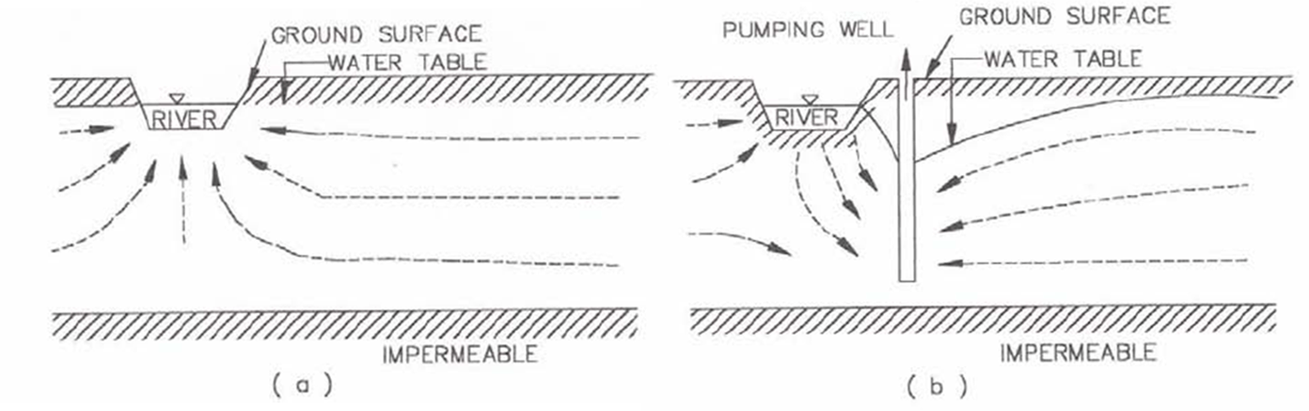

Figure 19 Induced recharge method sketch. (a) Normal flow pattern, (b) Flow pattern in induced recharge method

#### Aquifer modification techniques

These techniques change the properties of the aquifer in order to improve its capacity to store and transfer more water. While they are yield increase strategies rather than artificial recharging systems, they are often considered to be artificial recharging systems due to the resulting increase in the storage of groundwater in aquifers (Mukherjee, 2016). After application of it further recharge takes place in both natural and artificial conditions. The most commonly used methods of aquifer modification techniques are bore blasting and hydro-fracturing.

1. *Bore blasting*

This method is used to increase the fracture porosity of either confined or unconfined aquifers. This method is commonly used in hard crystalline and consolidated aquifers which displays limited seasonal dryness (Mukherjee, 2016).

The system of bore blasting method consists of shallow wells which are drilled where fracture porosity of an aquifer is expected to increase. These bore wells are blasted using explosive materials that cause fracture porosity in the aquifer.

1. *Hydro-fracturing*

The hydro-fracturing method is similar to blast fracturing one in enhancing the groundwater storage by increasing the fracture porosity. Yet, the difference is that the blast method uses explosive materials and the hydro one uses the hydraulic pressure to widen the existing fracture of the strata. The high-pressure water injection also helps to eliminate clogging, interconnects fractures, and extends the current length of the old fracture.. In addition, the high-pressure water creates new fracture in the hard rock strata, which increases the groundwater storage and transmitting capacity (Mukherjee, 2016). There are some other techniques used to increase well discharge yield and on the same time can be used to increase the pore spaces in the aquifer such as “jack well techniques” and “stream blasting”.

## Artificial Groundwater Recharge Applications

Domestic use is the most popular application for groundwater recharge (Zhang, Xu and Kanyerere, 2020). The domestic use is followed the agriculture use, and then on the third place comes the ecological and environmental protection. The last application is the industrial use.

The literature showed that the mentioned applications are using groundwater recharge in purpose of achieving four main fields, which are water resources adjustment, ecological and environmental protection, water quality improvement, and thermal exchange.

### Water resources adjustment

It is clear that the water resources adjustment is the most important application in groundwater recharge since its main purpose is to overcome the imbalance between water supply and demand in groundwater aquifers. The groundwater recharge adjusts the water resource by adjusting the flow of water in time, size and volume, and is commonly used for domestic water supply and agricultural irrigation (Scanlon *et al.*, 2016; Sprenger *et al.*, 2017).

### Ecological and environmental protection

Increased attention has been paid to the application of groundwater recharge in the area of ecological and environmental protection by growing people's awareness on the environment. These applications include conservation of groundwater-dependent ecosystems, prevention of land collapse, and prevention of seawater intrusion.

For the conservation of groundwater-dependent ecosystems: in some areas the subsurface-dependent ecosystems have been destroyed due to a decrease in groundwater levels caused by severe weather condition or by over-extraction over the last few decades. Shi et al. (2016) have reported many successful cases in preventing land collapse by groundwater recharging. Salt intrusion is one of the most issues affecting coastal lands, since it ruins water and cultivated land due salt excess. Groundwater recharge is one of the most effective processes which prevent salt water intrusion (Bugan *et al.*, 2016; Sprenger *et al.*, 2017).

### Water quality improvement

A significant benefit of groundwater recharge is the ability to increase the quality of water during storage. It relies on natural processes such as mechanical filtering, sorption, and biodegradation to purify water, that have been used to improve water quality and to treat recycled wastewater (Betancourt *et al.*, 2014; Sharma and Kennedy, 2017).

### Thermal exchange

The groundwater source heat pump system, which operates by pumping groundwater through wells and then recharging it back into the original groundwater aquifer after heat transfer for heating or cooling purposes, is considered to be a standard groundwater recharge activity in this area (Ni *et al.*, 2015). On the contrary, warm water from deep aquifers are used to be pumped in pipes under footpaths and roads to melt snow and then recharge the warm water back to the aquifer (Yokoyama *et al.*, 2020).

## Artificial Groundwater Recharge Issues

The sediment load carried out by the collected water always causes problems to the artificial groundwater recharge methods, either surface or sub-surface techniques. In this section, the most common problems occur during groundwater recharge will be discussed.

### Clogging

Clogging is one of the main issues for the sustainable activity of groundwater recharge schemes. The of infiltration surface can be occurred in both surface (spreading) as well as the sub-surface techniques. Four major forms of clogging are included: physical, biological, chemical, mechanical clogging.

#### Physical clogging

This is considered to be the primary type of clogging mechanisms and it is mainly occured due to the accumulation of aquifer sediments as well as organic and inorganic suspended solids in collected water (Bouwer, 2002; Youngs *et al.*, 2009). The physical clogging mechanism can be explained as when the suspended sediment size in water source is larger than the permeating medium pore diameter. The smaller the pore size of the permeating medium, the higher the concentration of suspended solids, the easier the incidence of clogging (Beibei, Xilai and Zhenji, 2013). Many techniques are used to prevent and reduce the effect of physical clogging including water pre-treatment using filters, in addition to periodic backwashing (Pavelic *et al.*, 2007).

#### Biological clogging

Biological clogging is considered as the second most significant clogging process caused to groundwater recharge methods. The clog is caused by algae and bacterial flocs accumulation in water source on the infiltration media. The growth of these micro-organisms is very rapid in the soil. They form a biofilms and biomass which block the pores leading to a decrease in the hydraulic conductivity (Bouwer, 2002). The disinfection process is used to remove organic matter and prevent the biological clogging to happen. Through sterilization, backwashing, and well washing the accumulated biological clogging can be rehabilitated.

#### Chemical clogging

Chemical processes and reactions may change water quality as well as aquifer permeability. There are many factors affecting chemical clogging including chemical composition of source water and in groundwater, mineral composition of the aquifer, and some other physical conditions such as pressure and temperature. Bouwer (2002) stated that the precipitation of calcium carbonate, gypsum, phosphate, iron, and manganese oxide hydrates is usually causes the chemical clogging. The pre-treatment processes, acidizing, and backwashing are considered to be effective to rehabilitation of chemical clogging.

#### Mechanical clogging

The mechanical clogging is caused by the air entering the recharge well under negative pressure. The produced air bubbles block the aquifer pore spaces, causing a reduction in the hydraulic conductivity. Another reason for air entraining the recharge well is caused by bacteria activities which produce nitrogen and methane gases. It is reported that entrapped air and gases from bacterial activities can occupy 7 – 20% of the pore spaces (Heilweil *et al.*, 2004). The mechanical clogging occurs in both surface and sub-surface groundwater recharging methods. Backwashing is used to prevent and rehabilitate this type of clogging (Liu, Liu and Dai, 2013).

### Erosion and deposition of sediment

Check dams built on streams intercept large quantities of sediment. Nyssen et al. (2004) discuss the effect of horizontal distance between check dams on drainage area and bed slope. They reported that the steeper channel slopes the closer the horizontal distance between check dams. They came up with a rule states that the distance between two check dams is equal to distance between the toe of the upstream check dam and head of the downstream dam. If this distance is too small, the upstream dam might be buried with sediment as shown in Figure 20. On the other hand, the downstream direction to obstruction structure are suffering erosion if the check dam is individually built and not built in series as in gully plug or gabion structure (Figure 20)

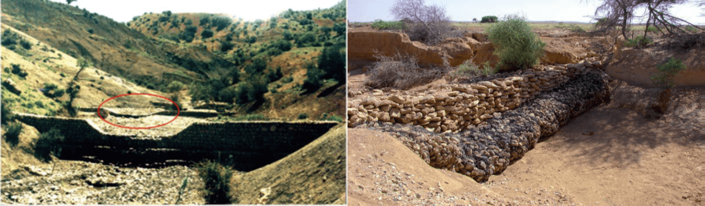

Figure 20 Left-side: Buried check dam due to incorrect spacing (Esmaeili, Hasanli and Soufi, 2008), Right-side: Soil erosion after a gully plug (Gale, 2005)

### Aquifer contamination

The aquifer strata act as a natural filter which removes many contaminants suspended in source water resulting in enhancing water quality. The contamination load may include atmospheric deposition on catchment area surface, inert solids, road surface accumulation, construction or industrial activities, human or animal organic wastes, decaying animals or vegetation, and agricultural activities including fertilizers and pesticides (Gale, 2005). Once this contaminated runoff is recharged into an aquifer, the beneficial effects of natural filtration are lost and the aquifer’s water must be treated using slow sand filtration process which is expensive and time consuming. In California state, they demand pretreatment process before infiltration into a potable aquifer (e.g. reverse osmosis treatment) (Health, 2014). Such pre-treatment standards have dramatically increased costs while reducing the risk of aquifer destruction. Therefore, comprehensive studies, of subsurface geology and water contaminants that might exist on the watershed, are recommended before groundwater recharge (Alataway and El Alfy, 2019).

## Artificial Groundwater Recharge Environmental Impact

Both beneficial and harmful environmental impacts may be occurred from using artificial groundwater recharge process (National Research Council, 1994). From the beneficial impacts:

* The rise of groundwater table near the surface, which confidently leads to a capillary rise which maintain a higher rate of vegetation production even in drought seasons in arid area. This would help in livestock grazing for inhabitants of arid regions.
* Groundwater table may be restored or retained to at levels by artificial recharge that can help to prevent or decrease land subsidence.
* After groundwater table raises due to recharge, less energy is used in discharging well pumps during drought seasons which can be considered as an indirect environmental impact.

On the other hand, there are some harmful environmental impacts due to artificial groundwater recharge and can be summarized as follows:

* Soils may become waterlogged (saturated with water) and salinized if a groundwater table is permitted to rise to the vadose zone and agricultural crops or natural native vegetation may be negatively affected.
* The water cycle on Earth starts with evaporation from surface water bodies either on land or from oceans. By artificially recharging some of the surface water bodies, results from flooding events, to groundwater might modify the water cycle.
* Risk of pollution to the groundwater aquifers if the recharged water is not quality controlled.

## Artificial Groundwater Recharge Advantages and Disadvantages

Artificial groundwater recharge has many applications rather than storing harvested rainwater such as control of seawater intrusions on coastal regions and injecting treated wastewater. Since the artificial recharge has many applications, it has also many advantages and disadvantages which can be summarized as follows (Spandre, 2009; Mukherjee, 2016).

### Advantages of groundwater recharge:

1. There is no need for massive storage systems to store water.
2. Enhance the yield of existing wells in depleted aquifers due to excess usage
3. Conservation and storage of excess surface runoff for future requirements
4. Negligible losses as compared to surface storage losses
5. Leading to dilution of toxic chemicals/salts, which improves water quality
6. Environment friendly, such as controlling soil erosion and no agriculture land failure
7. No adverse social impact, such as no relocation of local residents
8. Reduction in energy costs for lifting water, especially where there is a significant rise in groundwater levels
9. To improve bacteriological and other impurities from sewage and wastewater by filtration with sand, so that water is suitable for re-use
10. Control the salt intrusion in coastal regions which raised the salinity of both soil and fresh groundwater.

### Disadvantages of groundwater recharge:

The use of artificial recharging techniques is associated with a variety of problems. These include:

1. Water recovery efficiency (for example, not all recharged water may be recoverable)
2. Cost efficiency
3. Risks of pollution due to low quality of recharged water and aquifer clogging
4. Soils may become water-logged due to rise of groundwater table
5. Lack of awareness of the long-term effects of the groundwater recharge method. Therefore, the selection of a suitable artificial recharge site in a particular area should be carefully considered.

## Operation and Maintenance of Groundwater Recharge Structures

Detailed hydrological and geological studies for the collecting watershed are required to ensure an effective and efficient operation of a selected artificial groundwater recharge system. In addition, periodic maintenance of the artificial groundwater recharge structures is important since the infiltration rate might obviously drop rapidly due to silting, chemical and biological precipitation, and organic and inorganic accumulation (Mukherjee, 2016). The reverse action process which is switching between recharge and discharge for sub-surface techniques helps to rehabilitate the wells and extends its lifetime. Moreover, for the surface artificial groundwater recharge an annual de-silting process is essential, otherwise the water storage volume will decrease and therefore the recharge will decrease accordingly.

## Artificial Groundwater Recharge in Egypt

Flash floods in Egypt are occurring in the Eastern desert and Sinai causing an environmental damage threatening human lives and causing infrastructure damage. Many studies have been conducted to predict, mitigate, and manage flash floods. Also, some studies developed systems for harvesting floodwater in both urban and rural regions (Gado and El-Agha, 2020; Negm, 2020).

It is reported that the most used method in floodwater harvesting is constructing low-cost gabions dams, masonry check dams and the surface groundwater recharge technique is adopted. Most of the floodwater harvesting structures are constructed in Sinai (Omran, 2020). Shata (1992) reported that there are seven ancient dams in Sinai made of masonry. From the seven dams, three of them is silted up, one is washed away, and one is badly damaged. The most interesting dam is called Rawafaa located on Wadi El-Arish, was built in 1946 with original capacity of 3 Mm3. The reservoir is silting up and losing a capacity of approximate 10,000 m3/year. Also, the dam is experiencing an evaporation loss.

Many studies suggested potential sites for constructing check dams as shown in Figure 21 (Ramli, 1982; Abd-El Monsef, 2010; Masoud, 2011; Sumi, Saber and Kantoush, 2013; Omran, 2020). Also, it is planned to increase Rawafaa dam height (Omran, 2020). In addition to the check dams, it is expected to construct many diversion dams and water spreading dykes in central and north Sinai.

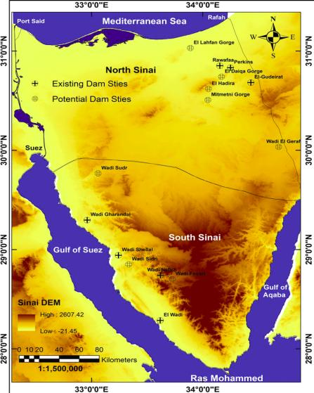

Figure 21 Existing dams and potential sites for dams in Sinai (Omran, 2020)

Both proposed check dams and diversion dams will lead to the presence of communities around these dams to utilize the harvested surface water in domestic use, agriculture, and grazing. While in the drought seasons, they use the recharged groundwater using mainly dug wells.

# Future Research Directions

With respect to water supply crises, the artificial groundwater recharge is expected to be increased and applied on a wider range including water resources management, water quality improvement, and also for ecological and environmental protection. In this section, some future research directions will be proposed:

* The literature on artificial groundwater recharge states all techniques which are used all over the world. However, some studies may put an attention on the combination between more than one technique to raise the recharge efficiency. A suggestion of these proposed researches is to study the combination between surface and sub-surface recharge techniques, since there is a huge evaporation loss due to surface techniques.
* Solar energy is proposed to be studies instead of using fossil energy in sub-surface and indirect recharge methods. In these methods, fossil energy is used in pumps due to lack of government electricity line in deserts. Also, the solar energy is generated locally and no need to transmit it, besides it is a clean sustainable energy.
* The negative impact on the global water/hydrologic cycle is proposed to be studies especially when broadly applying the artificial groundwater recharge.
* The effect of silting on the soil infiltration rate in the surface (spreading) groundwater recharge is proposed to be studies. Also, what is the optimum di-silting intervals can be studied on case studies, since sediment particle sizes differs from watershed to another.
* The literature states four types of clogging might during artificial groundwater recharge process. It is proposed to study the interaction and mechanism of multi-type clogging. It is proposed to research on methods to asses, predict, manage, and treatment of multi-type clogging happen at the same time.
* In Egypt, after scanning all previous studies, it is found that the only groundwater recharge technique used is the surface method and in Sinai only. It is proposed to study the effect of groundwater recharge efficiency using sub-surface methods since the evaporation plays a great role in losing the surface harvested water. In addition, more research is proposed on potential sites of recharging in Eastern desert.
* A research on utilizing Toshka, Egypt depressions in groundwater recharge is proposed. The water reaches Toshka depressions through an emergency spillway at the High Aswan Dam if water level exceeds the permissible levels at the dam. A small amount of this water is subjected to a seepage loss into the vadose zone, while the major quantity of water is evaporated at a rate of about 8 mm/d (Fassieh and Zaki, 2014). A study on utilizing this large quantity of water is proposed to recharge the non-renewable Nubian Sandstone deep aquifer instead of being lost through evaporation.

# CONCLUSIONS

Water resources are at the forefront of global concerns today. Many countries have taken a great interest in improving and preserving these resources, increasing their productivity and optimizing their revenues, and using modern methods to meet the increasing demands of all sectors. The dilemma is how to rationalize the use of water in the current situation of growing demands for water and the exploitation of water supplies.

Artificial groundwater recharge is one of the techniques which achieves water resources sustainability and prevents water crises. The artificial groundwater recharge occurs by man’s activities, under pumping or non-pumping condition, in which the surface water is recharged to an aquifer at a rate much higher than those under natural percolation status. The concept of groundwater recharge has arisen from the early history of human civilization, and it has persisted to the present generation. However, it is going to gain more attention in the present and future to secure water availability as population grows and external events affect water quality. According to the great importance of the groundwater recharge, this research reviews all rain/floodwater harvesting techniques and focuses on groundwater recharge methods.

The review has shown all artificial groundwater techniques and common problems and challenges. The techniques include various methods for surface (spreading) and sub-surface groundwater recharge. In addition, indirect methods are illustrated which include induced and aquifer modification methods. A total of eleven artificial groundwater methods have been reviewed in this research.

The review also shows the wide applications of the artificial groundwater recharge including water resources adjustment, ecological and environmental protection, water quality improvement, and thermal exchange applications. In addition, both beneficial and harmful environmental impacts of applying artificial groundwater recharge techniques are illustrated in the review.

Moreover, the existing problems and challenges for applying artificial groundwater recharge are discussed in the review including different clogging mechanisms, sedimentation, and aquifer contamination. The review also covers the application of groundwater recharge in Egypt.

Finally, the review proposed some future research directions which can be summaries as follows:

* Study the combination between surface and sub-surface groundwater recharge methods to raise the efficiency of recharging.
* Study the use of solar energy instead of tradition energy in artificial groundwater recharge.
* Study the negative impact of changing the water cycle as a result of artificial groundwater recharge.
* Study the interaction between different types of aquifer clogging.
* Study the application of sub-surface groundwater recharge methods in Egypt, and propose their potential sites in Eastern desert.
* Study the groundwater recharge of water collected at Toshka depressions into Nubian Sandstone deep aquifer.

# REFERENCES

Abd-El Monsef, H. (2010) ‘Selecting the best locations for new dams in Wadi El-Arish basin using remote sensing and geographic information system’, in *Sinai International Conference for Geology & Development Saint Katherine, South Sinai–Egypt*.

Alataway, A. and El Alfy, M. (2019) ‘Rainwater harvesting and artificial groundwater recharge in arid areas: Case study in Wadi Al-Alb, Saudi Arabia’, *Journal of Water Resources Planning and Management*, 145(1), p. 5018017.

Beibei, S., Xilai, Z. and Zhenji, Q. (2013) ‘Experimental study of aquifer physical clogging during artificial recharge process’, *Periodicalof OceanUniversityofChina (EarthScienceEdition)*, 43(10), pp. 97–101.

Betancourt, W.Q. *et al.* (2014) ‘Assessment of virus removal by managed aquifer recharge at three full-scale operations’, *Journal of Environmental Science and Health, Part A*, 49(14), pp. 1685–1692.

Bhattacharya, A.K. (2010) ‘Artificial Ground Water Recharge With a Special Reference To India’, *International Journal of Research and Reviews in Applied Sciences - IJRRAS*, 4(August), pp. 214–221.

Biazin, B. *et al.* (2012) ‘Rainwater harvesting and management in rainfed agricultural systems in sub-Saharan Africa - A review’, *Physics and Chemistry of the Earth* [Preprint]. Available at: https://doi.org/10.1016/j.pce.2011.08.015.

Boustani, F. (2008) ‘Sustainable water utilization in arid region of Iran by Qanats’, in *Proceeding of world academy of science, engineering and technology*, pp. 213–216.

Bouwer, H. (2002) ‘Artificial recharge of groundwater: Hydrogeology and engineering’, *Hydrogeology Journal*, 10(1), pp. 121–142. Available at: https://doi.org/10.1007/s10040-001-0182-4.

Bruins, H.J., Evenari, M. and Nessler, U. (1986) ‘Rainwater-harvesting agriculture for food production in arid zones: the challenge of the African famine’, *Applied Geography*, 6(1), pp. 13–32.

Bugan, R.D.H. *et al.* (2016) ‘Four decades of water recycling in Atlantis (Western Cape, South Africa): Past, present and future’, *Water SA*, 42(4), pp. 577–594.

Cech, T. V (2009) *Principles of water resources: history, development, management, and policy*. John Wiley & Sons.

Costa, P.M. (1983) ‘Notes on traditional hydraulics and agriculture in Oman’, *World Archaeology*, 14(3), pp. 273–295.

Critchley, W. and Gowing, J.W. (2012) *Water Harvesting in Sub-Saharan Africa*. Routledge.

Daji, S. (2011) ‘Importance of Percolation Tanks for Water Conservation for Sustainable Development of Ground Water in Hard-Rock Aquifers in India’, *Water Conservation* [Preprint], (October). Available at: https://doi.org/10.5772/30568.

Esmaeili, N.A., Hasanli, A.M. and Soufi, M. (2008) ‘A Study of The Influential Factors Affecting The Slopes Of Deposited Sediments behind The Porous Check Dams And Model Development For Prediction’, *Journal of Desert*, 12, pp. 113–119.

Fassieh, K.M. and Zaki, M.A. (2014) ‘A water management model for toshka depression’, *Journal of Applied Mathematics*, 2014(February 2014). Available at: https://doi.org/10.1155/2014/731846.

Gado, T.A. and El-Agha, D.E. (2020) ‘Feasibility of rainwater harvesting for sustainable water management in urban areas of Egypt’, *Environmental Science and Pollution Research*, 27(26), pp. 32304–32317. Available at: https://doi.org/10.1007/s11356-019-06529-5.

Gale, I. (2005) *Strategies for Managed Aquifer Recharge (MAR) in semi-arid areas*. UNESCO.

Gebreyess, B.F. and Amare, A. (2019) ‘Water harvesting technologies in semi-arid and arid areas’, *Journal of Degraded and Mining Lands Management*, 7(1), p. 1921.

Gheith, H. and Sultan, M. (2002) ‘Construction of a hydrologic model for estimating Wadi runoff and groundwater recharge in the Eastern Desert, Egypt’, *Journal of Hydrology*, 263(1–4), pp. 36–55.

Hafizi Md Lani, N., Yusop, Z. and Syafiuddin, A. (2018) ‘A review of rainwater harvesting in Malaysia: prospects and challenges’, *Water*, 10(4), p. 506.

Hashemi, H. *et al.* (2013) ‘Natural vs. artificial groundwater recharge, quantification through inverse modeling’, *Hydrology and Earth System Sciences*, 17(2), pp. 637–650. Available at: https://doi.org/10.5194/hess-17-637-2013.

Hassanli, A.M. and Beecham, S. (2013) ‘Criteria for optimizing check dam location and maintenance requirements’, *Check Dams, Morphological Adjustments and Erosion Control in Torrential Streams*, (January 2013), pp. 11–31.

Health, C.D. of P. (2014) ‘Regulations Related to Recycled Water’. California Department of Public Health.

Heilweil, V.M. *et al.* (2004) ‘Gas‐partitioning tracer test to quantify trapped gas during recharge’, *Groundwater*, 42(4), pp. 589–600.

Hussain, F. *et al.* (2019) ‘Rainwater harvesting potential and utilization for artificial recharge of groundwater using recharge wells’, *Processes*, 7(9), p. 623.

Hut, R. *et al.* (2008) ‘Effects of sand storage dams on groundwater levels with examples from Kenya’, *Physics and Chemistry of the Earth, Parts A/B/C*, 33(1–2), pp. 56–66.

Issar, A. (2001) ‘The knowledge of the principles of groundwater flow in the ancient Levant’, in *International Symposium OH2 Origins and History of Hydrology. Dijon*.

Julius, J.R., Prabhavathy, R.A. and Ravikumar, G. (2013) ‘Rainwater Harvesting (Rwh) - a Review’, *International Journal of Scientific & Engineering Research*, 4(8), pp. 276–282. Available at: http://www.ijser.org.

Kalkidan, F. and Tewodros, M. (2017) ‘Review on the role of small scale irrigation agriculture on poverty alleviation in Ethiopia’, *North Asian International Research Journal of Multidisciplinary*, 3(6), pp. 2326–2454.

Kavuri, M., Boddu, M. and Annamdas, V.G.M. (2011) ‘New methods of artificial recharge of aquifers: A review’, *poster presented at the 4th International Perspective on Water Resources & the Environment (IPWE), National University of Singapore (NUS), Singapore*, pp. 4–6.

Kimrey, J.O. (1989) ‘Artificial recharge of groundwater and its role in water management’, *Desalination*, 72(1–2), pp. 135–147.

Lightfoot, D.R. (1996a) ‘Moroccan khettara: traditional irrigation and progressive desiccation’, *Geoforum*, 27(2), pp. 261–273.

Lightfoot, D.R. (1996b) ‘Syrian qanat Romani: history, ecology, abandonment’, *Journal of arid environments*, 33(3), pp. 321–336.

Lightfoot, D.R. (2000) ‘The origin and diffusion of qanats in Arabia: new evidence from the northern and southern peninsula’, *Geographical Journal*, 166(3), pp. 215–226.

Liu, L.J., Liu, J.L. and Dai, W. (2013) ‘Study on gas-clogging effect of pressure recharge in groundwater source heat pump system’, *Water Saving Irrigation*, 12, pp. 46–47.

Makurira, H. *et al.* (2007) ‘Evaluation of community-driven smallholder irrigation in dryland South Pare Mountains, Tanzania: A case study of Manoo micro dam’, *Physics and Chemistry of the Earth, Parts A/B/C*, 32(15–18), pp. 1090–1097.

Malesu, M., Oduor, A. and Odhiambo, O. (2007) *Green Water Management Handbook*, *World*.

Maliva, R. and Missimer, T. (2012) *Arid lands water evaluation and management*. Springer Science & Business Media.

Mancosu, N. *et al.* (2015) ‘Water scarcity and future challenges for food production’, *Water (Switzerland)*, 7(3), pp. 975–992. Available at: https://doi.org/10.3390/w7030975.

Masoud, A.A. (2011) ‘Runoff modeling of the wadi systems for estimating flash flood and groundwater recharge potential in Southern Sinai, Egypt’, *Arabian journal of Geosciences*, 4(5–6), pp. 785–801.

Mati, B. *et al.* (2006) ‘Mapping the potential of rainwater harvesting technologies in Africa’, *A GIS overview on development domains for the continent and ten selected countries. Technical Manual*, 6, p. 126.

Matthews, J.A. (2014) *Water Harvesting*, *Encyclopedia of Environmental Change*. Available at: https://doi.org/10.4135/9781446247501.n4126.

Mekdaschi, R. and Liniger, H. (2013) *Water harvesting: guidelines to good practice*. Centre for Development and Environment.

Mekonnen, M.M. and Hoekstra, A.Y. (2016) ‘Four billion people facing severe water scarcity’, *Science advances*, 2(2), p. e1500323.

Mirzabaev, A. *et al.* (2019) ‘Desertification’, in, pp. 1–174.

Missaoui, H. (1996) ‘Soil and water conservation in Tunisia’, in *Sustainability of irrigated agriculture*. Springer, pp. 121–135.

Mukherjee, D. (2016) ‘A Review on Artificial Groundwater Recharge in India’, *International Journal of Civil Engineering*, 3(1), pp. 60–65. Available at: https://doi.org/10.14445/23488352/ijce-v3i1p108.

Mwenge Kahinda, J. *et al.* (2008) ‘Water resources management in rainwater harvesting: An integrated systems approach’, *Water Research Commission Report*, (1563/1), p. 8.

National Research Council (1994) *Ground water recharge using waters of impaired quality*. National Academies Press. Available at: https://doi.org/https://doi.org/10.17226/4780.

Negm, A.M. (2020) *Flash Floods in Egypt*.

Ni, L. *et al.* (2015) ‘A review of heat pump systems for heating and cooling of buildings in China in the last decade’, *Renewable Energy*, 84, pp. 30–45.

Nolde, E. (2007) ‘Possibilities of rainwater utilisation in densely populated areas including precipitation runoffs from traffic surfaces’, *Desalination*, 215(1–3), pp. 1–11.

Nyssen, J. *et al.* (2004) ‘The effectiveness of loose rock check dams for gully control in Tigray, northern Ethiopia’, *Soil Use and Management*, 20(1), pp. 55–64.

O’Hare, M.P. *et al.* (1986) ‘Recharge of Groundwater’, *Michigan: Lewis Publishers* [Preprint].

Omran, E.-S.E. (2020) ‘Egypt’s Sinai desert cries: Utilization of flash flood for a sustainable water management’, in *Flash Floods in Egypt*. Springer, pp. 237–251.

Oweis, T.Y., Prinz, D. and Hachum, A.Y. (2012) *Rainwater harvesting for agriculture in the dry areas*. CRC press.

Pavelic, P. *et al.* (2007) ‘Water quality effects on clogging rates during reclaimed water ASR in a carbonate aquifer’, *Journal of Hydrology*, 334(1–2), pp. 1–16.

Powers, M. (2018) *Water Scarcity Issues: We’re running out of water - FEW Resources.org*. Available at: https://www.fewresources.org/water-scarcity-issues-were-running-out-of-water.html (Accessed: 29 September 2020).

Prinz, D. (1996) ‘Water harvesting—past and future’, in *Sustainability of irrigated agriculture*. Springer, pp. 137–168.

Prinz, D. (2002) ‘The role of water harvesting in alleviating water scarcity in arid areas’, in *Keynote Lecture, Proceedings, International Conference on Water Resources Management in Arid Regions*, pp. 23–27.

Pyne, R.D.G. (1995) ‘Groundwater recharge and wells: Lewis’, *Boca Raton, FL* [Preprint].

Rahman, S. *et al.* (2014) ‘Sustainability of rainwater harvesting system in terms of water quality’, *The Scientific World Journal* [Preprint]. Available at: https://doi.org/10.1155/2014/721357.

Ramli, I. (1982) ‘Water Resources in the Sinai Peninsula and its basic and regional development plans in the next 50 years (1982–2032)’, *Research Institute, Ministry of Agriculture, Al-Matareya, Cairo.* [Preprint].

Raphael, J.C. (2014) ‘Ground Water cum “Dug Well” Recharge of Coastal Eco Systems: Recharging with Roof Rainwater supports desalination of Coastal Water Bodies: The Case of Kerala’. India.

Scanlon, B.R. *et al.* (2016) ‘Enhancing drought resilience with conjunctive use and managed aquifer recharge in California and Arizona’, *Environmental Research Letters*, 11(3), p. 35013.

Sen, Z. (2008) *Wadi hydrology*. Crc Press.

Sharma, S.K. and Kennedy, M.D. (2017) ‘Soil aquifer treatment for wastewater treatment and reuse’, *International Biodeterioration & Biodegradation*, 119, pp. 671–677.

Shata, A. (1992) ‘Watershed management, development of potential water resources and desertification control in Sinai’, in *Proceeding of the 3rd Conference on the Geology and Development of Sinai. Ismailia, Egypt*, p. 280.

Shi, X. *et al.* (2016) ‘The effects of artificial recharge of groundwater on controlling land subsidence and its influence on groundwater quality and aquifer energy storage in Shanghai, China’, *Environmental Earth Sciences*, 75(3), p. 195.

Shiklomanov, I. (1993) ‘World fresh water resources, water in crisis: A guide to the world’s fresh water resources’. Oxford University Press, New York.

Spandre, R. (2009) ‘Artificial groundwater recharge’, *Groundwater-Volume III*, p. 53.

Sprenger, C. *et al.* (2017) ‘Inventory of managed aquifer recharge sites in Europe: historical development, current situation and perspectives’, *Hydrogeology Journal*, 25(6), pp. 1909–1922.

Sumi, T., Saber, M. and Kantoush, S.A. (2013) ‘Japan-Egypt hydro network: science and technology collaborative research for flash flood management’, *Journal of Disaster Research*, 8(1), pp. 28–36.

Tesfai, M. and Stroosnijder, L. (2001) ‘The Eritrean spate irrigation system’, *Agricultural water management*, 48(1), pp. 51–60.

Tharu, B.R. *et al.* (2015) ‘Water Use Master Plan’, (December), p. 276.

Tuinhof, A., Van Steenbergen, F. and Tolk, L. (2012) ‘Profit from storage: The costs and benefits of water buffering’, *Wageningen, The Netherlands, 3R Water Secretariat*, p. 115.

Wildchina (2012) *Cross Border Journey: Trip Notes from Vietnam and China*. Available at: https://www.wildchina.com/blog/2012/05/cross-border-journey-trip-notes-from-vietnam-and-china/ (Accessed: 28 September 2020).

Yemenu, F., Hordofa, T. and Abera, Y. (2014) ‘Review of water harvesting technologies for food security in Ethiopia: challenges and opportunities for the research system’, *Journal of Natural Sciences Research*, 4(18), pp. 40–49.

Yokoyama, T. *et al.* (2020) ‘Seasonal aquifer storage and recovery of heat with groundwater’, in *Management of Aquifer Recharge for Sustainability*. CRC Press, pp. 379–384.

Youngs, J. *et al.* (2009) ‘Cloudbreak: The critical role of MAR in a major Pilbara mine water management scheme’, in *Achieving Groundwater Supply Sustainability & Reliability through Managed Aquifer Recharge, Proceedings of the 7th International Symposium on Managed Aquifer Recharge, ISMAR7, Abu Dhabi, UAE*, pp. 9–13.

Zhang, H., Xu, Y. and Kanyerere, T. (2020) ‘A review of the managed aquifer recharge: Historical development, current situation and perspectives’, *Physics and Chemistry of the Earth*, (November 2019), p. 102887. Available at: https://doi.org/10.1016/j.pce.2020.102887.