KNOWLEDGE TRANSFER FROM PRACTICE TO THEORY AS THE MOST EFFECTIVE MODE FOR SKILLS’ TRANSFERENCE.

Abstract
This chapter discusses learning argues that learning from practice to theory as is the most effective mode of knowledge transfer. This is in tandem with the axiom: There is an expression saying, ‘You keep on listening, you are likely to forget, but you keep on doing, you will never forget’. This simply implies that practical knowledge is more important than theoretical knowledge. The fact is I am aware that theory assists researchers and teachers with a clearer understanding of a research problem; and to critically reflects on education policy and classroom practice, but that does not necessarily mean that theoretical knowledge should be more important than practical knowledge. This study remains chiefly a product of research literature review and complemented by interviews. The idea was to find out what other scholars have discovered about practice as the most effective mode for skills’ transference, as well as the integration of theory and practice with the Creative Arts disciplines. Literature review was used as the primary source for collecting data. Information about horizontal discourse was obtained by critical, close reading of published Journal articles, books, and theses; complemented by face-to-face and telephonic interviews and personal experience.The interviews were aimed at eliciting first-hand information on the knowledge of the subject matter.The questions raised for this study are: 1) are we really transforming the teaching and learning practice?2) why are we travelling a long way, as far as Europe, Asia, USA, etc. to seek for solutions to our academic challenges, while the pot of gold is buried in our own backyard? and 3) as educators, do we want our students to appreciate the importance of both classroom and field educational experiences and learn that there is nothing more practical than a good theory? Closer investigation has revealed that the gap between theory and practice is undeniable, and art educators have long committed to achieving a more effective synthesis of both art theory and studio practice.The results of this study suggest that we need a fast and lasting solution to our academic challenge; and practical work should create a strong base for theory, but not the opposite.It was concluded that the most effective mode of learning Creative Art subjects is from practice to theory, but not the opposite. The underlined words should be part of the introduction. The author should summarize the entire work in the abstract. This is to say, that the abstract, is not a true summary of the work.
Keywords:Knowledge transfer, theoretical knowledge, Creative Arts disciplines, practice, theory, academic challenge.
Introduction
This paper is theory driven (Theory of Knowledge; Bernstein 2000 & 2005), because I Bernstein (2000 & 2005), believe that theory & practice ought to be inextricably interconnected, but that does not necessarily mean that theoretical knowledge should be more important than practical knowledge. I am aware that The obvious is that theory and practice are the obverse sides of the same coin, but my the contention is that the most effective mode of learning Creative Art subjects is from practice to theory, but not the opposite. I The assertion strongly believe that practical work should create a strong base for theory, but not the opposite. I am aware that integration of theory and practice is a challenge. I am aware that The belief is that the integration of theory and practice has created an anxiety for students and practice teachers as they work to meet the requirements for social work education in university and in practice. I am also aware that theoretical knowledge of skill-based subjects needs to be supported by practice. For example, Creative Art subjects and Engineering are skill based. In these subjects, practical knowledge is more important than theoretical knowledge. Practical work includes learning by doing, experiments in laboratories, study tours, projects, assignments, etc.My dear friends from different cardinal points across the globe, can you imagine someone teaching you how to swim or drive a vehicle, within four walls of a classroom? It is impossible!!! You have to get into the water to learn swimming; and you have to be out on the road to learn driving. Creative Art subjects, Engineering and others, are skill-based and practice oriented. For your information, (1) when you do something with your own hands you remember better; (2) Practical work promotes experiential learning; (3) Practical work encourages self-learning; (4) Practical work familiarizes students with tools and equipment that they will be required to use; (5) Practice leads to perfection; (6) One cannot become an expert overnight, greater the practice, greater the expertise; (7) Practical work is a good change from the monotonous lecture method; (8) students are required to participate actively in practical activities; (9) Practical assignments are often carried out in groups & group work helps to inculcate social values and values like sharing, cooperation, team spirit, compassion, etc., and practical work makes students independent and increases their confidence. These viewpoints are endorsed by (Olalere 2018:3), see fig. 1. Olalere identifies five areas for structuring an integrated theory-practice strategy in art teaching, learning, and assessment. These are art theories, art criticism, aesthetics exploration, studio production, and assessment.
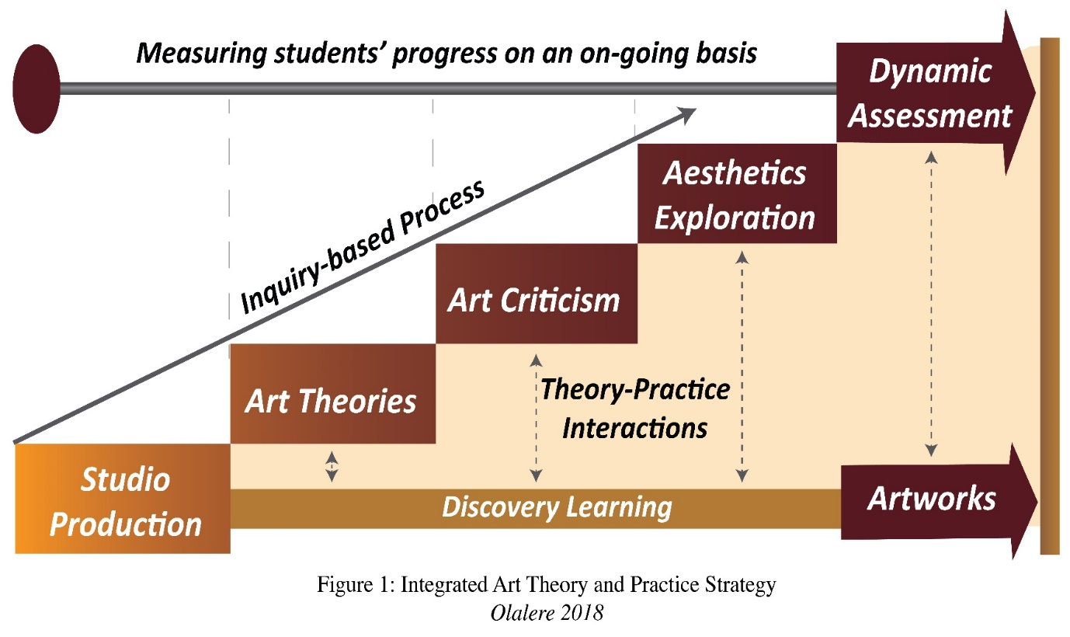
According to Olalere (2018:4) studio production (practical knowledge) is the first stage of the integrated strategy, and it runs throughout the discovery learning process. In his view, studio production takes students through an exploration and discovery learning process that develops their theoretical knowledge through experience in artmaking (2018:4). Olalere further observes that since the studio production runs through the whole learning process, the final outputs (artworks) at this stage are informed and enriched through the inspiration and knowledge gained from subsequent stages such as exposure to art theories, art criticism, aesthetics exploration and assessment (2018:4). Efforts are made in this paper to dig into evidence gathered to support and strengthen my argument. This is followed by looking at recommendations for further studies.
The author choice of words like ‘I am’, ‘I’ etc makes the work so boring to read. The author should look out some corrections effected and take a cue.

Theoretical Framework
The present study is based on the theory of knowledge as proposed by Bernstein Basil (2000), which views music as something profoundly experienced and embedded in social life (Carver 2017:130). Like in this study, indigenous music in the Bapedi culture is regarded as profoundly experiential and is embedded in the Bapedi people’s cultural context in their daily social and cultural activities and in social life. Bernstein theory advocates for horizontal knowledge structure, whereby new knowledge is introduced in the form of a new “language” that does not depend on the previous concepts but has its own logic (Carver 2017:128). He regards ‘horizontal discourse’ as everyday knowledge. For him, horizontal discourse concerns every day or common knowledge, that is, the knowledge needed to perform tasks of everyday life (2000:157). Bernstein postulates that learned through modelling, horizontal discourse is likely to be oral, local, context dependent and specific, tacit, multi-layered and contradictory across but within contexts; the crucial feature is that it is segmentally organized (2000:159). He asserts that this segmental organization means that horizontal discourse is concerned with the immediate context, and what is known in one context cannot be transferred or applied in a different context (Carver 2017:127); and this is precisely what is happening in the Bapedi people’s cultural context. Moreover, Bernstein observes that ‘horizontal discourse’ is directed towards acquiring a common competence rather than a graded performance (Carver 2017:127). Further, he elaborates that ‘horizontal discourse’ should lead to the type of music that all members of the community can perform and it becomes a context (Carver 2017:127). He points out that it is not simplicity or complexity that differentiates horizontal and vertical discourse, but the degree to which the discourse is systematically organized. Finally, Bernstein describes music as a member of the Humanities, and as having a horizontal knowledge structure. Building on Bernstein’s theory of knowledge structures, Maton Karl asserts that Bernstein’s conceptualisation, while suggestive, is dichotomous and does not allow for the subtleties and variations within knowledge fields (Maton 2014:47). Maton concurs with Bernstein but suggests that he extends his theory to allow for more fine-tuned analyses and interpretations. The Bapedi people’s cultural context is ideal for this model since, when the Bapedi children’s musical arts are analysed and examined through the theoretical framework of this study, the ‘horizontal discourse’ focuses on new knowledge which is related to Bapedi people’s daily activities and everyday life, as well as the transmission processes, context, structures and performance styles. This theory is applicable to this study because in the Bapedi culture, there are musical types for children, for men, and for women.
Previous Related Studies Empirical Studies
A review of the literature on the integration of theory and practice within the Creative Arts disciplines discovered several studies that found that graduates of Creative Arts degree programmes felt that their classwork had not adequately prepared them for real world practice Please re-caste the sentence underlined as it too poor. (Apriani 2016; Carver 2017; Kaya &Seleti 2013; Muya 2007; Nompula 2012; Nyerere 1967; Olalere 2018; Williamson 2000; Wilson & Peterson 2006 and Wrenn &Wrenn 2009). Relatively, few studies have focused upon knowledge transfer from practice to theory as the most effective mode for skills transference (Carver 2017; Collin &Tynjala 2003; Collingwood 2005; Kaya &Seleti 2013; Lebaka 2022; Nadaner 1983; Nyerere 1967; Olalere 2018; Randi & Corno 2007; Wrenn & Wrenn 2009). In particular, Randi & Corno (2007:335) opine that new ways of thinking about transfer of knowledge have important implications for the design of theory-based, instructional interventions. They assert that studying about how transfer occurs yields new ways of thinking about how to share research findings with practitioners in ways that will promote transfer (2007:335). Furthermore, these scholars have observed that transfer of research findings into practice has been as difficult as promoting transfer of learning from classrooms to real-life application (2007:336). They further point out that identifying teaching problems that might be solved by the application of theoretical principles is a much different way of working than applying theory into practice; and they suggest that teachers should be encouraged to draw upon their prior knowledge and past experiences to interpret their present teaching situations, and by so doing, the transfer of research into practice may be more easily accomplished (2007:341).

Endorsing the above observations, Wrenn and Wrenn (2009:258) believe that experience is a great teacher, and using an active learning environment can enhance the integration of practice and theory in the classroom (2009:259). These scholars also advice teachers to create an environment that allows students to take risks, and this type of environment includes 1) being strongly interested in students as individuals; 2) acknowledging students’ feelings about an assignment or other pertinent items; 3) encouraging students to ask questions; 4) communicating both openly and subtly that each person’s learning is important; and 5) encouraging students to be creative and independent and form their own views (2009:260).Corroborating the above observations, Schneider et al. (2022:1) postulate that content knowledge and repetition of facts are more common than problem-based and learner-centred teaching. According to these scholars, individuals expect an education that promises them good opportunities on the labour market, while companies are asking for qualified employees who can productively implement their business processes (2022:2). These scholars are not in favour of learning which is theory-driven but advocate for the creation of actual action situations in class, with authentic and practical tasks (2022:3). They believe that this approach plays an important role in the transfer of knowledge. According to them, what is important here, is the creation of complete practical actions, which means a combination of ‘acting, thinking and doing’ (2022:3). Existing literature have emphasized more on the theory and practice and have emphasized that the two are inextricably interrelated (Keiler 2018; Kalil & Grant 2021; Haijan 2019; Taguma et al. 2018).
Research Strategy This sub-heading is not ideal
This work remains chiefly a product of research literature review and complemented by interviews. Unnecessary please remove.The idea was to find out what other scholars have discovered about knowledge transfer from practice to theory as the most effective mode for skills’ transference. Literature review was used as the primary source for collecting data. Information about horizontal discourse was obtained by critical, close reading of published Journal articles, books and theses; complemented by face-to-face and telephonic interviews and personal experience. Of the participants interviewed, nine (9) were female and thirteen (13) were male. The ages of the participants ranged from 40-63 years. All of them are professionals in different sectors and have served in different councils and committees. Participants were also informed of the confidentiality and anonymity of their responses, as well as the option of withdrawing from participation if they felt uncomfortable. Once they had received this information and, if they wished to participate in the study, they were offered the option of providing their consent for the confidential treatment of their data for research purposes. After agreeing to participate, they were asked series of questions. Following next are some of the questions asked.

The questions raised for this study are: 1) are we really transforming the teaching and learning practice? 2) why are we travelling a long way, as far as Europe, Asia, USA, etc. to seek for solutions to our academic challenges, while the pot of gold is buried in our own backyard? and 3) as educators, do we want our students to appreciate the importance of both classroom and field educational experiences and learn that there is nothing more practical than a good theory?

The literature review was conducted to provide a fuller and more up-to-date synthesis of the evidence of the creation of complete practical actions, which means a combination of ‘acting, thinking and doing’, as well as the learning which is practice-driven. I looked particularly for evidence about knowledge transfer from practice to theory as the most effective mode for skills’ transference. In the next section, results will be discussed.
Results and discussion
Sharing more insight on the integration of theory and practice, Olalere (2018:3) pursued research on ‘Integrating theory and practice: A critical pedagogy in Art Education’ and has discovered that the gap between theory and practice is undeniable, and art educators have long committed to achieving a more effective synthesis of both art theory and studio practice. He opines that in spite of the seemingly mutual isolation of theory and practice, they must be related (2018:3). According to him, this relationship begins with the recognition that some theoretical assumptions always permeate practice, and that a more deliberate, reflective application of theory can only improve practice (2018:3; Nadaner 1983). There is an expression saying ‘Actions speak louder than words’. My interpretation of this expression in the context of this paper is that actions are ‘practice’ and ‘words’ are theory. This implies that practice is more important than theory.Olalere’s advocacy is in line with what is happening in my culture (Bapedi culture). By attending social and cultural ceremonies, children can unconsciously absorb the beauty of music and strive to reproduce that beauty, reflect beauty in their inner selves and make evidence in sensitivity, expression, and attitude (see photo 1). Children learn by observing and listening to activities of adults and other children. Learning through keen observation and listening in anticipation of participation seems to be valued and emphasized in Bapedi society, like in other societies in the continent where children have access to learning from informal community involvement (Lebaka 2017:110; Lebaka 2022:1040).

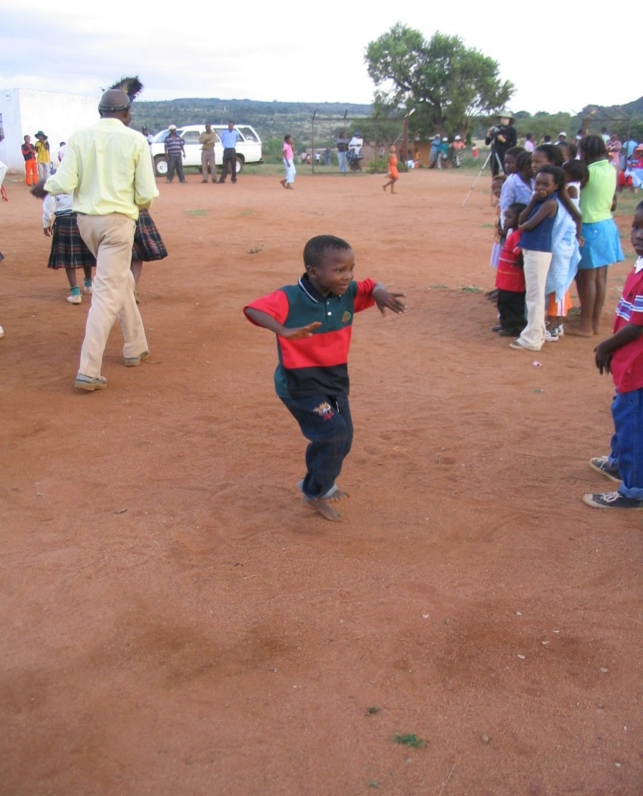
Photo 1
In the Bapedi culture, by attending music festivals, children can unconsciously absorb the beauty of music and strive to reproduce that beauty, reflects beauty in their inner self and make evidence in sensitivity, expression, and attitude (Ga-Marodi village, 20.10.2007), Photographer: Jukka Louhivuori.
This child does not know anything about theory. He is not even aware that theory exists, but he has an ear music and learns how to dance through imitation.It is worthwhile to mention here that learning through keen observation in anticipation of participation seems to be effective mode of music and dance transmission and enculturation process.

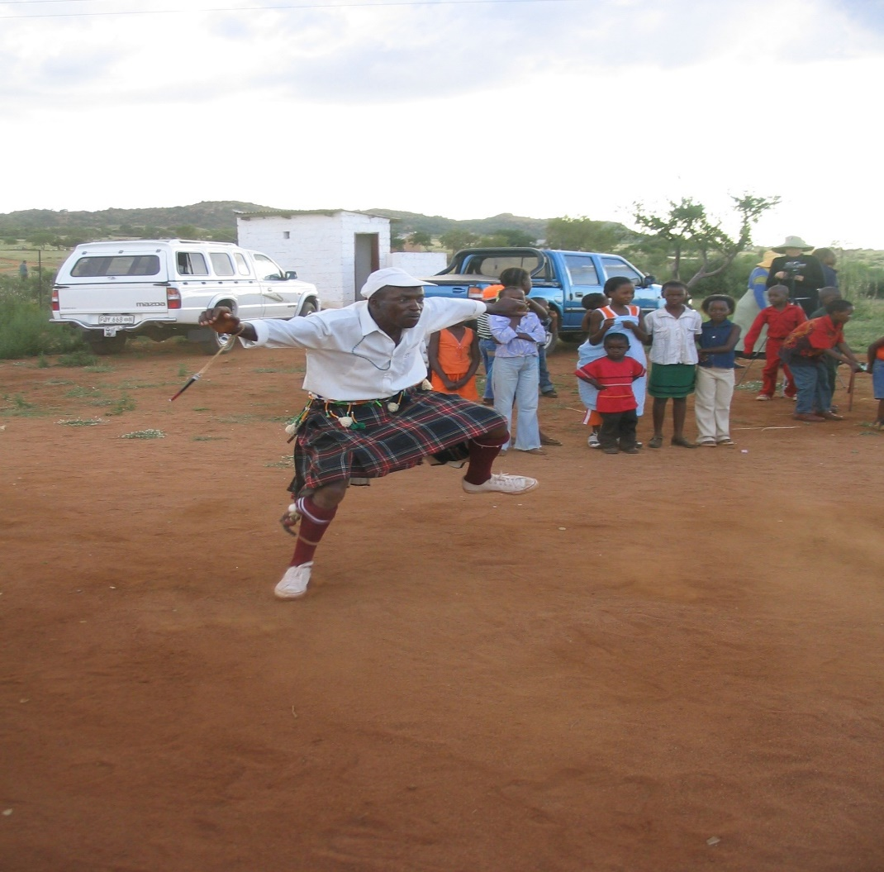
Photo 2
In the Bapedi culture, children are learning through keen observation and listening, in anticipation of participation (Ga-Marodi village, 20.10.2007), Photographer: Pekka Toivanen.

From the observations and interviews, it was established that learning should be self-directed, meaning students should have some choice in what and how to learn. It was also established that choice allows learners to have a stake in the class, while control helps them determine the level of risk they will take and thus increase their confidence. The impression created during interviews and observations was that people with more of growth mindset, on the other hand, tend to believe that ability is the outcome of hard work and effort. It is worthwhile to mention here that this way of imparting knowledge, skills, and competencies, with a focus on learning and action-oriented teaching, thus also has an influence on the role of the teacher (Schneider et al. 2022:3).

My statement of position is that South Africa is in need of a Creative Arts philosophy that is culturally embedded, cognizant of the societal context in which it is to function and informed by South African ideas and philosophy of life. My argument is supported by the late former President of Tanzania, Mwalimu Julius Nyerere (1967), when he was questioning the role of higher education in a developing country such as Tanzania, characterized by poverty and inequality (Kaya &Seleti 2013:31). May his soul rest in peace. He criticized the separation of theory from practice as emphasized in western education and scholarship. His concern was whether such a country can afford pure academics who put emphasis on theoretical knowledge at the expense of community engagement (Kaya &Seleti 2013:32). In his view, this is demonstrated by the fact that despite decades of self-rule, African scholars have not succeeded in empowering the continent to develop its own educational theoretical and methodological framework for knowledge production and sustainable development (Kaya &Seleti 2013:32). In the same vein, Kaya &Seleti assume that there could be several reasons for this, but one of the key factors is that education, especially higher education, in Africa has not been relevant to the needs and concerns of African societies. Endorsing these viewpoints, Muya (2007) postulates that this approach makes higher education in the continent too distant from community concerns and production of graduates who tend to be inadequately sensitive to the developmental challenges of their local communities and country.Based on the foregoing Kaya and Seleti (2013:33), suggest that African intellectuals should help Africa close the gap created by over four hundred years of domination and marginalisation of African people’s systems, by rejecting the utilization of dominant Western world view of knowing and knowledge production as the only way of knowing. The question is: Are we ready to close the gap? These scholars strongly believe that there is also the need to change the mindset, attitudes and practices of researchers and extension workers, working in African local communities (2013:33) They need to leave the assumption that the “modern” must replace the “traditional”.Based on the foregoing, it is evident that vocational courses are a necessity.What remains the factual ground for this study is that the gap between theory and practice is undeniable, and art educators have long committed to achieving a more effective synthesis of both art theory and studio practice.
Concluding Thoughts Conclusion and Recommendations
If one should conclude based on available data, it could be said, that Thus far, to the best of my knowledge, Kenya, Uganda and Zimbabwe are doing well in decolonizing, indigenizing and africanising the curriculum. Why can’t we have a delegation to visit these countries to observe their strategy in transforming the teaching and learning practice. Alternatively, we can establish a pool of knowledgeable, adequate, and experienced researchers (at least 3 representatives from all institutions of higher learning in South Africa) to conduct a research and come up with an appropriate curriculum for South Africa. We travel a long way, as far as Europe, Asia, USA, etc. to adopt what is not relevant to our teaching and learning environment. A good example is Outcomes Based Education (OBE). Oral accounts and literary evidence have revealed that it was adopted in Australia. It did not work for us and was replaced or phased out because South Africa is not Australia. If it works very well in Australia or USA, that does not necessarily mean that it will work for South Africa. South Africa is in need of a curriculum and/or Creative Arts philosophy that is culturally embedded, cognizant of the societal context in which it is to function and informed by South African ideas and philosophy of life. This approach is supported by Reck, Slobin and Titon (1992:444), who argue that although we may travel to far-away places to meet, see, and relate with unfamiliar things and people, or search for marvellous treasures, ‘the pot of gold is buried in one’s own backyard’. These scholars encourage researchers to seek out nearby musical cultures, which they can observe, understand, and document, in order to contribute to the body of knowledge on musical activities generally. The above viewpoints resonate well with the theory of aesthetic functionalism as advocated by Prof Emily Achieng Akuno (2005). The theory views the meaning of music as being rooted in the role music plays in the life of those who make it.

To buttress the point on a lighter note the best conclusion may be drawn from this story; Let me conclude with a funny anecdote. One Mr. R had a master’s degree in automobile engineering and worked on a high post in a reputed organization. One day, on his way to the office, his car stopped working and he got off to investigate the problem. With his high qualification and expertise in the area, he examined each part on the car carefully but could not find any fault. After a while, a peasant who was passing asked him, “what is the matter?”. He answered, “Well, something is wrong with the car”. The peasant replied, “Did you check the petrol tank? Perhaps there is no petrol”. The peasant was right. This is what might happen when theoretical knowledge is not supported by practical knowledge, especially when theoretical knowledge is regarded as more important than practical knowledge.Based on the findings of this study, we need a fast and lasting solution to our academic challenge.Further research will shed light on how learning is realized in practice.

References
Armaroli, B. 2003. Arts Integration and the Reggio Approach at Chicago Commons. Applied Research in Child Development, Number 5, pp. 11-19.
Apriani, E. 2016. A New Literacy: The role of technology to develop student’s character. Ta’dib:Journal of Islamic Education, Volume 21, Number 1, June 2016, pp. 59-71.
Bernstein, B. 2000. Pedagogy Symbolic Control and Identity: Theory, Research, Critique. New York and Oxford: Rowman & Littlefield.
Carver, M. 2017. Knowledge transfer: Indigenous African music in the South African music curriculum. Journal of International Library of African Music, 10 (3), pp. 119-141.
Collin, K. &Tynjala, P. 2003. Integrating theory and practice? Employees’ and students’ experiences of learning at work. Journal of Workplace Learning, Volume 15, Number 7/8-2003, pp. 338-344.
Collingwood, P. 2005. Integrating theory and practice: The Three-Stage Theory Framework. Journal of Practice Teaching 6(1) 2005, pp. 6-23.
Falkenberg, T., Goodnough, K. & MacDonald, R. J. 2014. Views on and practices of integrating theory and practice in teacher education programs in Atlantic Canada. Alberta Journal of Educational Research, Vol. 60, No.2, Summer 2014, pp. 339-360.
Hattie, J.A.C & Donoghue, G. M. 2016. Learning strategies: a synthesis and conceptual model. Science of Learning (2016), 1, 16013; pp. 1-13.
Haijan, S. 2019. Transfer of Learning and Teaching: A Review of Transfer Theories and Effective Instructional Practices. IAFOR Journal of Education, Volume 7, Issue 1, Summer 2019, pp. 93-111.
Jones, A. & Penney, D. 2019. Investigating the ‘interpretation of theory and practice’ in examination physical education. European Physical Education Review (2019), Volume 25, Number 4, pp. 1036-1055.
Kalil, C. A. & Grant, T. 2021. A Social Learning theory model for understanding team-based professional communication learning for computer science students. South African Journal of Higher Education, Volume 35, Number 3, July 2021, pp. 45-64.
Kaya, H. O. &Seleti, Y. N. 2013. African Indigenous Knowledge Systems and relevance of higher education in South Africa. The International Education Journal: Comparative Perspectives, 2013, 12(1), pp. 30-44.
Keiler, L. S. 2018. Teachers’ roles and identities in student-centered classrooms. International Journal of STEM Education (2018), 5:34, pp. 1-20.
Lebaka, M.E.K. 2022. Promoting Indigenous Bapedi Musical Heritage for posterity: The Case of Mantshegele Musical Arts. In Assoc. Prof. Dr. Manuchar SHISHINASHVILI & Asst. Prof. Dr. Giorgi CHUBINIDZE; pp. 1038-1044; Proceedings of International Conference on Global Practice of Multidisciplinary Scientific Studies Dedicated to the 100th Anniversary of “GEORGIAN TECHNICAL UNIVERSITY-GTU” Science Georgia; Tbilisi, Georgia; 24-26 June 2022; ISBN: 978-625-8323-63-4; Website: www.sciencegeorgia.com; or www.sciencegeorgia.com/tbilisi; Issued: 30 July 2022;
Muya, S. 2007. The efficacy of traditional knowledge in African education. Paper Presented at the Conference on Education and Indigenous Knowledge Systems in Africa. College of Business Education, Dar es Salaam, Tanzania, 2-3 August 2007.
Nadaner, D. 1983. ‘Building Theory-Practice Interactions in Art Teacher Education’. Visual Arts Research 9(1): 64-70.
Nompula, Y. 2012. An investigation of strategies for integrated learning experiences and instruction in the teaching of creative art subjects. South African Journal of Education, Volume 32, pp. 293-306.
Nyerere, J. K. 1967. Education for self-reliance. Nairobi: Oxford University Press.
Olalere, F. E. 2018. Integrated Theory and Practice: A Critical Pedagogy in Art Education. The International Journal of Humanities Education, Volume 16, Issue 3 (2018), pp. 1-8.
Ott, B. 2021. Integrating theory and practice: An Educational challenge. Acta Theologica Supplementum31, Published 14 June 2021; pp. 5-24.
Peng, M. C. et al. 2021. Use of Knowledge Transfer Theory to improve Learning Outcomes of Cognitive and Non-Cognitive skills of University students: Evidence from Taiwan. Frontiers in Psychology, Volume 12, Article 583722, March 2021, pp. 1-11.
Randi, J. and Corno, L. 2007. Theory into Practice: A matter of transfer. Theory into Practice, 46(4), pp. 334-342.
Reck, D. B., Slobin, R. B. &Titon, J. T. 1992. ‘Discovering and documenting a World of Music’, in Titon, J. T. (ed New York: Schirmer Books, Mcmillan Inc.). Worlds of Music: An introduction to the music of the worlds people.
Scheinfeld, D. R. 2004. Arts integration in the classroom: Reflections on theory and application. Applied Research in Development, Number 5, Spring 2004, pp. 1-10.
Schneider, S., Wessels, A. & Pilz, M. 2022. Theory and Practice of Teaching and Learning in the Classroom – Lessons from Indian Industrial Training Institutes. Vocations and Learning, pp. 1-21.
Taguma, M. et al. 2018. Future of Education and skills 2030: Conceptual Learning Framework; A Literature summary for Research on the Transfer of Learning. EDU/EDPC (2018) 45/ANN3, pp.1-21.
Van Vuuren, E. N. J. 2018. Arts Across the curriculum as a pedagogic ally for primary school teachers. South African Journal of Childhood Education, 8(1), pp. 1-10.
Williamson, M. C. 2000. A Comparative analysis of Outcomes Based Education in Australia and South Africa.Masters’ thesis submitted in accordance of the requirements for the degree Master of Education in the subject Comparative Education, University of South Africa, Pretoria, November 2000.
Wilson, S. M. & Peterson, P. L. 2006. Theories of Learning and Teaching. What do they mean for Educators? Working paper; Nea National Education Association, Washington (July 2006), pp. 1-23.
Wrenn, J. & Wrenn, B. 2009. Enhancing Learning by Integrating Theory and Practice. International Journal of Teaching and Learning in Higher Education, 2009, Volume 21, Number 2, pp. 258-265.

