# CASE REPORT

Invasive Sino-orbital Aspergillosis in an Immunocompetent Host selecting a Surgical Approach: Changing Trend

## ABSTRACT

Invasive aspergillosis in an immunocompetent host is a rare clinical entity. The purpose of this article is to create awareness of existence of invasive sino-orbital aspergillosis in an immunocompetent, young and otherwise healthy host and its management with emphasizing the importance of balancing open surgical approach with endoscopic approach in order to achieve the optimum clearance of disease. A 48 years old female patient presented with 6 months history of non-tender swelling over the left maxilla, 5 months history of left-sided nasal blockage and 2 months history of left orbital proptosis.

**Keywords:** Invasive aspergillosis, Granuloma, Immunocompetent host.

**Introduction**

Invasive sino-orbital fungal infections in immunocompetent patients are a rare clinical entity; the diagnosis and management of which is challenging. Orbital fungal disease is not often suspected, because of its relative rarity and the wide range of orbital pathologies that can present similarly. Currently, there are no standard guidelines for management and outcome is invariably poor without timely diagnosis and appropriate treatment [9]. We present a report of an invasive sino-orbital aspergillosis in an immunocompetent host and selecting a surgical approach for treatment.

## Case presentation

A 48 years old female patient presented with history of non-tender swelling over left maxillary region, spontaneous in onset rapidly growing in size since 6 months, followed by history of left-sided nasal blockage, rapidly worsened since 5 months which was followed by history of left orbital proptosis mimicking that of sinonasal malignancy. There was history of numbness over left cheek and upper lip. There was no history suggestive of allergic rhinitis. There was no history suggestive of diminution of vision, blurring of vision, recurrent headache, vomiting, altered sensorium and convulsion. Patient was not diabetic, immunocompetent and so far had not received topical or systemic steroids.

On examination, there was ill-defined approximately 4 × 5 cm diffuse fullness over the left maxillary region and left orbital proptosis. There was loss of sensation over distribution of left maxillary division of trigeminal nerve. However patient’s vision, extraocular movements were not affected and fundoscopy revealed no abnormality (Figs 1A and B).

Following specific investigations were done:

* Serological test for hepatitis B, HIV-1, 2
* Diagnostic nasal endoscopy
* Nasal swab for fungal culture sensitivity
* Biopsy from nasal mass
* Computed tomographic (CT) scan paranasal sinus (PNS)

with orbit

* Magnetic resonance imaging (MRI) orbit, PNS and brain.

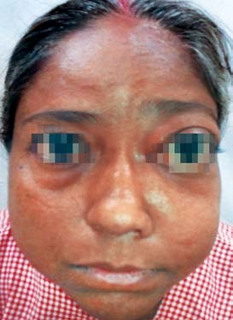

**Fig. 1A:** Clinical photograph of patient showing fullness over left maxilla with left orbital proptosis

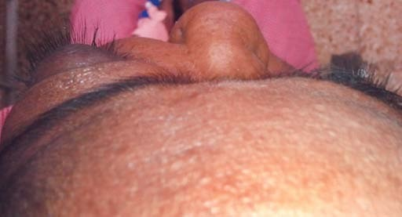

**Fig. 1B:** Clinical photograph of patient showing left orbital proptosis as viewed from top. Fullness over the left maxilla can also be appreciated

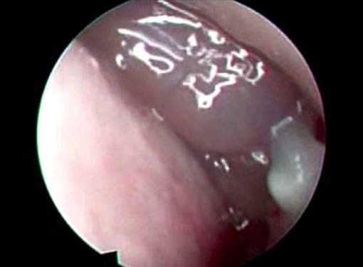

**Fig. 1C:** Clinical photograph of patient showing polyps and tenacious secretions in nasal cavity as seen endoscopically

Diagnostic nasal endoscopy revealed polyps and tenacious secretions in bilateral nasal cavity (Fig. 1C). Polyps were pale in color, insensitive to and did not bleed on touch. CT scan PNS revealed lobulated hyperdense partially enhancing soft tissue with areas of bone scalloping, thinning and erosion involving the medial wall of orbit, anterior, posterior and medial wall of left maxillary sinus and left ethmoid lamellae extending upto clivus with proptosis of left eye ball. However, dura matter was not breached by mass (Figs 2A and B). Findings were suggestive of chronic invasive fungal sinusitis (CIFS).

Nasal swab for fungal culture revealed septate, branching, spore forming fungal hyphae consistent with aspergillosis. Biopsy from nasal mass revealed respiratory mucosa with granulomatous inflammation with features consistent that with aspergillosis (Fig. 3).

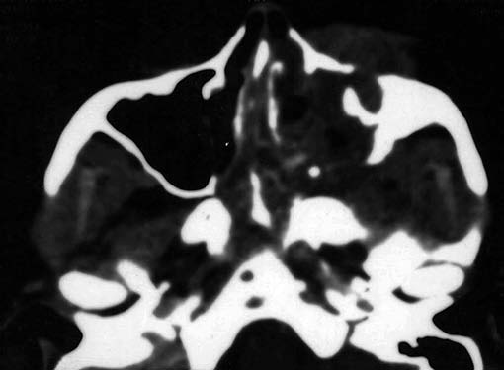

**Fig. 2A:** CT scan PNS revealed lobulated hyperdense partially enhancing soft tissue with areas of bone scalloping, thinning and erosion involving the medial wall of left orbit, anterior, posterior and medial wall of left maxillary sinus and left ethmoid lamellae, also depicts proptosis of left orbit (postcontrast, slice thickness: 5 mm)

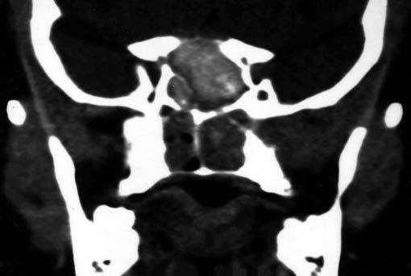

**Fig. 2B:** CT scan PNS revealed lobulated hyperdense partially enhancing soft tissue with areas of bone scalloping, thinning and erosion extending up to clivus (post nonionic contrast, slice thickness: 5 mm)

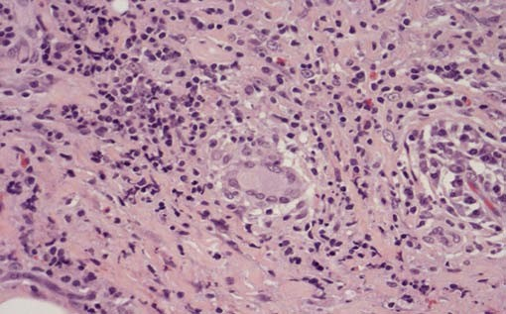

**Fig. 3:** Microphotograph of nasal mass biopsy depicting granulomatous inflammation with hyphal elements suggesting fungal granuloma (H&E staining, magnification 20×)

Subsequently the patient was worked up for endoscopic

debridement of fungal granuloma.

Considering the extensive lesion, the debridement was carried out in two stages. Under cover of antifungal such as injection voriconazole pre-, peri- and postoperatively, endoscopic debridement was done. Careful exploration of all sinuses bilaterally by endoscopic approach was done and thick tenacious material removed which was then sent for histopathological examination. All sinus ostia were opened widely and adequately for easy douching. However, the disease lateral to orbital periosteum was not cleared surgically and orbital periosteum was not breached. Subsequently patient was put on oral voriconazole for 2 weeks.

Histopathology confirmed the diagnosis of fungal

granuloma (Figs 4A to C).

MRI orbit, PNS and brain was done 2 weeks after the first stage of debridement revealed a large residual lesion approximately 5.3 × 3.4 cm in maximum transverse dimensions and 6.8 cm in supero-inferior extent on the left.

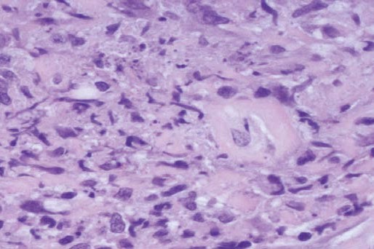

**Fig. 4A:** Microphotograph of nasal mass depicting granulomatous inflammation with hyphal elements suggesting fungal granuloma, also depicting vascular and basement membrane invasion (H&E staining, magnification 40×)

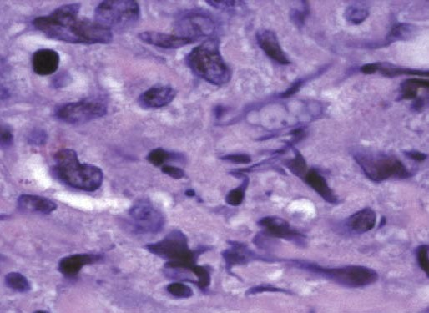 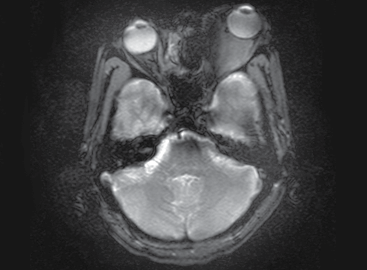

**Fig. 4B:** Microphotograph of derided material from sino-orbital mass showing granuloma with branching, septate fungal hyphae with vascular invasion (H&E staining, magnification 100× oil immersion)

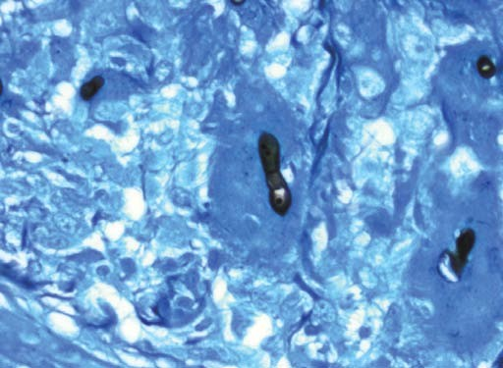

**Fig. 4C:** Microphotograph of derided material from sino-orbital mass showing granuloma with branching, septate fungal hyphae (GMS: Grocott’s methenamine silver stain, magnification 40×)

premaxillary soft tissues, extending contiguously into left maxillary sinus, nasal cavity and orbit. The lesion was extending superiorly to erode the floor and medial wall of left orbit infiltrating the extraconal compartment of left orbit resulting in orbital proptosis (Figs 5 and 6). Since this lesion could not be approached by endoscopic approach, we approached the lesion by Caldwell-Luc approach in order to clear disease from anterolateral and roof of maxillary sinus. Oral voriconazole continued post debridement. MRI orbits with PNS repeated after 3 weeks revealed substantial clearing of soft tissue lesion seen on previous scan. However, there was approximately 3.4 × 2.2 cm residual lesion within medial extraocular compartment of left orbit with retrobulbar extension (Figs 7 and 8).

Patient became symptomatically better with significant

decrease in orbital proptosis. Here, we decided to continue

**Fig. 5A:** MRI orbit, PNS and brain were done 2 weeks after the first stage of debridement showing residual lesion extending superiorly to erode the floor and medial wall of left orbit infiltrating the extraconal compartment of left orbit resulting in orbital proptosis (T2-weighted image, transverse section)

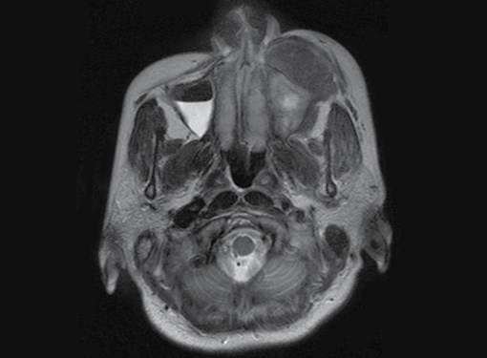

**Fig. 5B:** MRI orbit, PNS and brain were done 2 weeks after the first stage of debridement showing residual lesion extending superiorly to erode the floor and medial wall of left orbit infiltrating the extraconal compartment of left orbit resulting in orbital proptosis

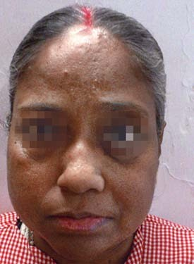

**Fig. 6:** Clinical photograph of patient 2 weeks after first stage of debridement showing reduced maxillary fullness and reduced proptosis

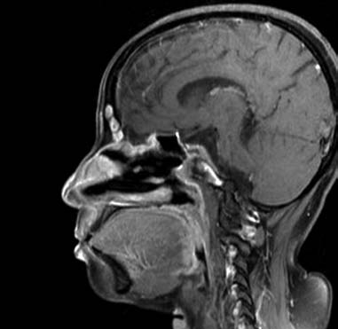 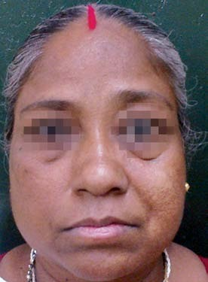

**Fig. 7A:** MRI orbits with PNS repeated 3 weeks after second stage of debridement showing substantial clearing of soft tissue lesion seen on previous scan (T1-weighted image, sagittal section)

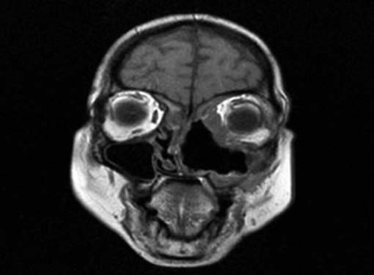

**Fig. 7B:** MRI orbits with PNS repeated after 3 weeks showing substantial clearing of soft tissue lesion seen on previous scan (T2-weighted image, coronal section)

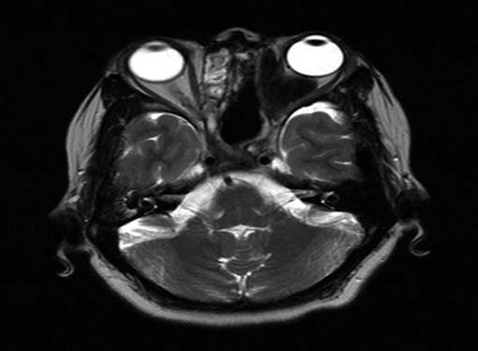

**Fig. 7C:** MRI orbits with PNS repeated after 3 weeks showing substantial clearing of soft tissue lesion seen on previous scan (T2-weighted image, transverse section)

**Fig. 8:** Clinical photograph of patient 3 weeks after second stage of debridement showing marked reduction in proptosis

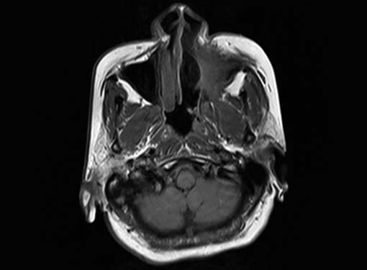

**Fig. 9A:** MRI scans repeated 3 months after debridement showed obliteration of maxillary sinus cavity with no significant change in extent of residual lesion. There was change in lesion morphology suggesting post-treatment changes (T1-weighted image, transverse section). However, there was significant clinical improvement (below is the clinical photograph)

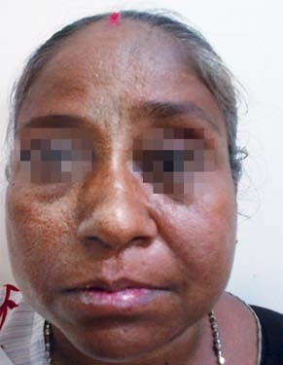

**Fig. 9B:** Clinical photograph of patient 3 months after second stage of debridement showing marked reduction in proptosis

with medical line of management. Oral voriconazole was continued for 3 months. Following which she had uneventful recovery (Figs 9A and B).

## DISCUSSION

Aspergillosis refers to several forms of disease caused by fungus in genus *Aspergillus*. *Aspergillus* fungal infections can occur in ear, eyes, nose, PNS and lungs.1 DeShazo (1998) noted three types of invasive disease:2,3 acute fulminant fungal sinusitis (AIFS), the CIFS and granulomatous invasive fungal sinusitis. For all practical purposes, the term CIFS is used to describe both granulomatous and nongranulomatous nonfulminant but invasive disease. In granulomatous invasive fungal rhinosinusitis *Aspergillus flavus* is the commonest pathogen isolated.3 The CIFS is diagnosed by the clinical presentation and histopathology report. A diagnosis of CIFS is made in patients with a prolonged clinical course (symptoms persisting for more than 4 weeks), radiologic evidence of sinusitis and presence of hyphal forms (septate hyphae) in the tissue.4 Orbital invasive aspergillosis is rare but often results in fatal *Aspergillus* sinus mycoses. Invasive aspergillosis can either be localized or fulminant. Localized disease often starts in the sinuses and spreads to adjacent structures through focal bony erosion or even through vessel walls. The fulminant form is characterized by multiple organ involvement. There is no uniformly accepted completely effective treatment for orbital aspergillosis.4 Management often begins with surgical debridement followed by systemic antifungal drug therapy. Some antifungal drugs described such as polyenes (amphotericin B), azoles (itraconazole, voriconazole) and other newer classes, such as lipid complex nystatin and echinocandins. Of the azole class, itraconazole, voriconazole are safer and easier to administer than amphotericin B.5 There is no consensus regarding the extent of surgery required for this condition and whether nongranulomatous form should be treated differently from the granulomatous form.1,6 It is rational to remove all diseased tissue without violating protective tissue planes, such as periorbita and dura that may act as barriers to further spread of disease and without sacrificing the important structures.7,8

In this case, even after initial stage of endoscopic debridement there was a large residue in left maxillary sinus over anterolateral wall and roof which could not be accessed by endoscope hence we had to use Caldwell-Luc approach to remove the disease. However, there was still a tiny residue in retrobulbar region but patient’s proptosis had drastically reduced. Here we had to balance between radical debridement *vs* functional outcome hence we decided to continue with medical line of management in the form of oral voriconazole 200 mg twice a day for

3 months. Patient had uneventful recovery on 3 months of follow-up. Here we decided to continue oral voriconazole thereafter. Although, MRI scan repeated thereafter showed obliteration of maxillary sinus cavity with no significant change in extent of residual lesion, there was change in lesion morphology suggesting post-treatment changes. Question still remains unanswered as to how long the treatment needs to be continued. Since, lesion seen on imaging does not seem to signify active pathological process as in this case, investigations such as C-reactive protein and ESR remain markers for clinical improvement.

## CONCLUSION

Although, invasive sinonasal aspergillosis is more commonly seen in immunocompromised patients, it can occur in young, healthy immunocompetent host. Since, there is no consensus regarding the extent of the surgery required for this condition, each case needs to be assessed individually for appropriate surgical intervention. Although, endoscopic approach is widely recommended the role of open surgical approach should not be underestimated to achieve optimum clearance. Appropriate surgical debridement should be followed by systemic antifungal agents.

## REFERENCES

1. de Souza, Chris.; Rodrigues, J Peter. Chapter 8: Fungal rhinosinusitis. In: de Souza, Chris.; Har-El Gady, editors. Head and neck surgery: rhinology. Vol 1.1st ed. India, New Delhi: Jaypee Brothers Medical Publishers; 2009. p. 117-125.
2. DeShazo RD. Fungal sinusitis. Am J Med Sci 1998 Jul;316(1):

39-45.

1. DeShazo RD, O’Brien N, Chapin K, Soto-Aguilar M, Gardner L, Swain R. A new classification and diagnostic criteria for invasive fungal sinusitis. Arch Otolaryngol Head Neck Surg 1997 Nov;123(11):1181-1188.
2. Choi HS, Choi JY, Yoon JS, Kim SJ, Lee SY. Clinical characteristics and prognosis of orbital invasive aspergillosis. Ophthal Plast Reconstr Surg 2008 Nov-Dec;24(6):454-459.
3. Herbrecht R, Denning DW, Patterson TF, Bennett JE, Greene RE, Oestmann JW, Kern WV, Marr KA, Ribaud P, Lortholary O, et al. Voriconazole versus amphotericin B for primary therapy of invasive aspergillosis. N Engl J Med 2002 Aug 8;347(6):408- 415.
4. Stringer SP, Ryan MW. Chronic invasive fungal rhinosinusitis. Otolaryngol Clin North Am 2000 Apr;33(2):375-387.
5. Washburn RG. Fungal sinusitis. Curr Clin Top Infect Dis 1998;18:60-74.
6. Sandison AT, Davidson CM, Gentle JG. Aspergillosis of paranasal sinus and orbit in Northern Sudanese. Sabouradia 1969;6:57-59.
7. Adulkar NG, Radhakrishnan S, Vidhya N, Kim U. Invasive sino-orbital fungal infections in immunocompetent patients: a clinico-pathological study. Eye. 2019 Jun;33(6):988-94.