Significant Effect of Liquid PhosBac and NitroBac Biofertilizers through Integrated Plant Nutrient System on Growth and Yield of Cotton Plant

**Abstract**

Plant Growth Promoting Rhizobacteria improves the plant growth through several mechanisms. Several agricultural countries have now adopted this technology of using PGPR(s) as biofertilizer formulations. Certain essential nutrients such as phosphate, potassium, nitrogen etc., are required by the plant through natural systems such as by solubilization or fixation methods for improved growth and yield of plant. In our experiment two formulations of Bio fertilizers namely PhosBac and NitroBac were used on Cotton plant along with 1/4th dose of DAP which is used as substrate for the phosphate solubilizing bacteria (*B. circulance*) along with *Azotobacter sp* as nitrogen fixing PGPR applied through integrated plant nutrient on 3 keys stages of plant growth (at time of sowing, on flowering stage and fruiting stage)

Significant improvements in growth and yield of cotton plant were observed, which were equivalent to the chemical fertilizer “Cotton Grow” These results are ray of hope for gradually replacing chemical inorganic fertilizers with biofertilizer formulations which will result in rescuing the deteriorating agricultural land of Pakistan.

**Keywords:** Bio fertilizer; Cotton grow; PGPR

# Introduction

Plant benefiting bacterial and fungal species are being used in soil as bio fertilizers since several decayed. These plant benefiting microorganisms when inoculated in plant rhizosphere improves the plant growth and crop yield through several mechanisms such as by improving the nutritional requirements of the plant, by production of plant benefiting hormones, also by inhibiting the plant pathogens through various mechanisms. These PGPRs also reported to improves the soil structure [1,2].

PGPRs can be classified according to their functional characteristics such as when PGPR are being used as bio fertilizers they improves the plant growth and crop yield by improving the nutritional requirements of the plan, they are also reported to regulate the plant growth by producing phytohormones such as Cytokinin, Auxins, Gibberellins, Ethylene and Ascorbic Acid [3]. These are also used as Phyto stimulators when PGPRs work as Bio remediators as they help in degrading soil organic pollutants. PGPR are also reported to be used as bio-pesticides since these plant benefiting microorganisms are also being used to control the plant pathogens by producing antibacterial and antifungal metabolites [4]. Chemical fertilizers alone could not fulfill all the nutritional requirements of the plant [5]. Due to this reason integrated plant nutrient system was introduced in which the inorganic chemical fertilizers are used along with PGPRs as bio fertilizer. These PGPRs helps in providing unavailable form of nutrients such as nitrogen, potassium, phosphorus etc., to the plants resulting in not only improving the plant yield but also helps in improving the fertility of the soil.

In viewing the deteriorating condition, due to extensive use of chemical fertilizers resulting in waterlogging and salinity problems of

agricultural lands of Pakistan in Sindh and Punjab provinces, this experiment was designed to check the effect of nitrogen fixing and phosphate solubilizing PGPRs on the growth and yield of the crop when applied according to integrated plant nutrient system technique. Where inorganic fertilizers DAP (Di-ammonium phosphate) was used as a substrate at 1/4th of its dose. For comparative study chemical fertilizer for cotton crop namely “cotton Grow” was used.

# Materials and Methods

## Collection of soil sample

Different soil samples were collected from active agricultural lands of PCSIR Karachi labs. Which were collected from rhizosphere of different crops? These were then stored in polyhene bags for future experimental use.

## Sample preparation

Soil sample was inoculated in distilled water initially. Shake well to get soil bacterial culture in to the liquid medium. 1 ml of the diluent (sterilized distilled water) mixed well and transferred to 9 ml of the dilution tube. Soil sample was diluted up to 10-7 dilutions.

## Isolation of phosphate solubilizing PGPR

1 ml of the last two dilutions was plated by using selective Picovaskaya agar medium containing Ca3PO4 as a substrate, specific for phosphate solubilizing microorganisms. The plates were incubated at 37°C for 72 hrs.

## Optimization studies

Best cultural conditions for growth and PO4 solubilization character: The optimization studies of phosphate solubilizing character of selected 11 strains has been carried out by incorporating different nitrogen and carbon sources along with high salt (KCl and NaCl) concentrations ( 0.2, 1, 2.5 and 5%) at 7, 8 and 9 pH values.

Effect of different carbon sources on growth and PO4 solubilization character: Glucose, Sucrose and Lactose sugars at 0.1, 0.5 and 1.0% concentrations were incorporated in selective Picovaskaya medium. Selective bacterial strains were spot inoculated on this agar plate medium and incubated at 37°C for 72 hrs.

Effect of different carbon sources on growth and PO4 solubilization character: Yeast extract and casein were incorporated at 0.1, 0.5% concentrations in selective Picovaskaya medium. Selective bacterial strains were spot inoculated on this agar plate medium and incubated at 37°C for 72 hrs.

## High salt tolerance

Effect of KCl at 0.2, 1, 2.5 and 5 (%) concentration on growth and PO4 solubilizing character of bacterial strains at 7, 8 and 9 pH values: KCl salt was incorporated in the Picovaskaya selective medium at the 0.2, 1, 2.1, 2.5 and 5(%) concentrations at different (7, 8 and 9) pH values. Plates were incubated at 37°C for 72 hrs.

Effect of NaCl at 0.2, 1, 2.5 and 5 (%) concentration on growth and PO4 solubilizing character of bacterial strains at 7, 8, 9 pH values: NaCl salt was incorporated in the Picovaskaya selective medium at the 0.2, 1, 2.1, 2.5 and 5(%) concentrations at different (7, 8 and 9) pH values. Plates were incubated at 37°C for 72 hrs.

## Isolation and identification of non-symbiotic nitrogen fixing

**PGPR**

Sample preparation: Soil sample was inoculated in distilled water initially. Shake well to get soil bacterial culture in to the liquid medium.

1 ml of the diluent (sterilized distilled water) mixed well and transferred to 9 ml of the dilution tube. Soil sample was diluted up to 10-7 dilutions.

Isolation of nitrogen fixing bacterial species: For the isolation of non-symbiotic nitrogen fixing bacterial strains from diluted soil sample were carried out by using Ashby medium. 1 ml of the last two dilutions was plated on Ashby agar medium and plates were incubated at 28°C for 48 hrs.

Identification of phosphate solubilizing and nitrogen fixing bacterial strains: Identification of the isolated strains of phosphate solubilizes and nitrogen fixing bacterial strains was carried out according to Bergey’s manual.

## Bio fertilizer formulations

NitroBac and PhosBac biofertilizer: NitroBac and PhosBac bio fertilizer formulations were prepared by using optimized strains of nitrogen fixing and phosphate solubilizing bacteria.

Liquid PhosBac biofertilizer: Broth Picovaskaya medium was prepared and inoculated with phosphate solubilizing bacterial strain and incubated at 37°C for 72 hrs.

Liquid NitroBac bio fertilizer: Broth Ashby medium was prepared and inoculated with nitrogen fixing bacterial strains and incubated at 28°C for 48 hrs.

## Application of bio fertilizers (PhosBac and NitroBac bio fertilizer)

PhosBac and NitroBac bio fertilizer were applied in agricultural field along with irrigation water at three different stages i.e., at sowing time at flowering stage and at fruiting stags through integrated plant nutrient system.

# Results and Discussion

**Phosphate solubilizing *B. circulance* strains**

Initially 300 bacterial colonies were isolated on selective Picovaskaya medium as PSM out of which, 11 best phosphate solubilizing strains were selected for further studies. Optimization studies were also conducted of these selected strains.

## Optimization studies

Effect of different nitrogen sources on growth and PO4 solubilizing character of *B. circulance* strains: Yeast extract and casein were incorporated in selective Picovaskaya medium to check their effect on growth and phosphate solubilizing character. It was observed that at 0.1% w/v of yeast extract concentration the 11 selected phosphate solubilizing strains gave best zones of clearance. While in case of casein, at both 0.1 and 0.5% concentrations the bacterial strains gave very poor growth with no zones of solubilization.

Effect of different carbon sources on growth and PO4 solubilizing character of *B. circulance* strains: Glucose, Sucrose and Lactose were incorporated at 0.1, 0.5 and 1% concentrations. Among these carbon sources glucose at 1% concentration gave best growth and zones of phosphate solubilization in all selected 11 *B. circulance* strains as compared to 0.5% concentration. While complex sugars like sucrose and lactose when incorporated in the Picovaskaya medium, inhibited the growth and phosphate solubilizing g activity of the inoculated strains.

## Salt and pH tolerance characterization

Effect of various concentrations of NaCl at 0.2, 1, 2.5, 5% (w/v) at pH 7 and 8 on growth and PO4 solubilization character of *B. circulance*: It can be observed from that when NaCl was incorporated at 0.2, 1, 2.5, 5% (w/v) at pH 7 concentrations it was observed that at pH 7, these inoculated strains gave best zones of solubilization of (Ca)3PO4 at 1% concentration. While the same was also observed at pH 8 as well but with the increase of salt concentration the solubilization character was gradually decreased.

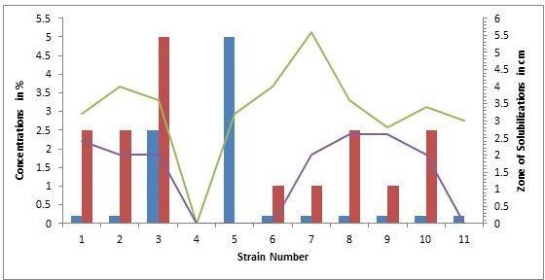

Figure 1: Effects of maximum and minimum concentrations of NaCl on phosphate solubilization by *Bacillus circulance* Strains at pH 7.

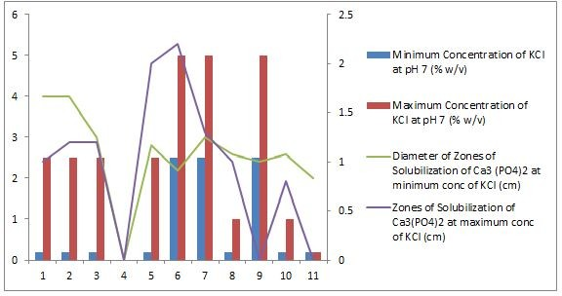

Figure 3: Effects of maximum and minimum concentration of KCl on phosphate solubilization by *Bacillus circulance* Strains at pH 7.

Effect of various concentrations of KCl (0.2, 1, 2.5 and 5%) at pH 7,

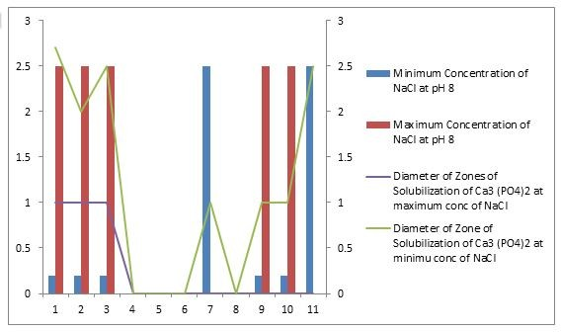

Figure 2: Effects of maximum and minimum concentration of NaCl on phosphate solubilization by *Bacillus circulance* Strains at pH 8.

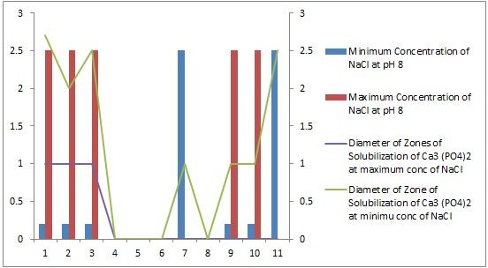

Figure 4: Effects of maximum and minimum concentration of KCl on phosphate solubilization by *Bacillus circulance* Strains at pH 8.

8 on growth and phosphate solubilizing character of selected *B. circulance*: It can be observed from that at neutral pH 7 the incorporation of the KCl in the medium results in improved growth and solubilization activity of *B. circulance* strains. Average concentration of KCl which supports the growth and phosphate solubilizing character were 0.2 and 1% (w/v) with increased concentration of KCl in the medium significant decrease in solubilization character of the substrate was observed. But when pH value was shifted from neutral pH 7 to alkaline pH 8 the solubilization character of substrate Ca3(PO4)2 of *B. circulance* strains were significantly decreased.

Effect of various concentrations of KCl and NaCl (0.2, 1, 2.5, 5%) at pH 9 on growth and phosphate solubilizing character of *B. circulance*: When the 0.2, 1, 2.5, 5% (w/v) concentrations of NaCl and KCl were incorporated in the medium at pH 9, P solubilizing activity of *B. circulance* strains were lost.

Therefore, collectively it can be concluded that at pH 7 the growth and phosphate solubilizing activity of all phosphate character were decreased. This optimization study is in agreement with the findings of solubilizing *B. circulance* strains were significant but with the increase pH values and salt concentrations the growth and phosphate solubilization Ahmed and Khan according to which under stressed conditions such as pH, high temperature conditions effects the growth and PO4 solubilizing characters of the strains.

## Field experiment

Liquid bio fertilizers (PhosBac and NitroBac) were applied on cotton plant through Integrated Plant Nutrient System (IPNS) using DAP being used as substrate for phosphate solubilizing *B. circulance* strains 1/4th of its recommended dose. Chemical fertilizer namely “Cotton Grow” was also applied as a part of comparative study along with control experiment in which no treatment was given.

Crop yield of bio fertilizer treatment was significantly equivalent to the chemical fertilizer results, for example in bio fertilizer experiment.

“Cotton Grow” were obtained which is a ray of hope of replacing or reducing the use of chemical fertilizers which have resulted in rendering our agricultural lands in to drought hatted and saline hatted.

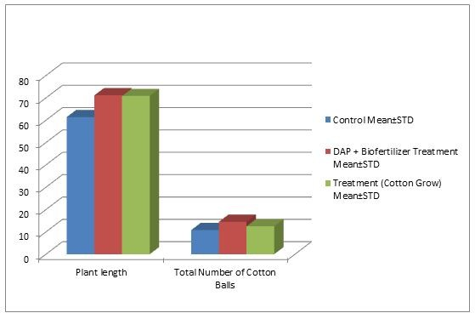

Figure 5: Effect of NitroBac and PhosBac bio fertilizers against chemical fertilizer on the growth of cotton Plant.

These PGPR based bio fertilizers are ecofriendly and improves the physical and chemical structure of the soil as well.

There were 14 number of cotton balls on average on each cotton plant which was 12 cotton balls in chemical fertilizer and average 10 cotton balls/plant in control experiment. Besides plant height was also significantly improves in bio fertilizer experiment as compared to chemical and control experiments. These results are 100% improved results of growth and yield of cotton plant by the application of (PhosBac and NitroBac) bio fertilizers.

75% improvement of crop yield when PSM was applied in combination with *Azospirillum sp* in terms of fresh and dry weights of cotton plant, cotton plant roots, and number and weight of cotton balls/plant [6]. The improvement of plant growth and yield of several experimental crop, when *Bacillus* and *Pseudomonas sp* was applied in combination as bio fertilizer [7].

*Bacillus sp* has more significance as compared to other PGPRs due to their spore forming characters. Bacillus species are prominently present along with other soil microorganisms they colonize the rhizosphere of plant and improve the plant growth and crop yield [8-11]. Bio fertilizer formulations based on *Bacillus sp* were found to be more effective in terms of improving plant growth and productivity due to their ability to form heat and desiccation resistant spores [12].

Nitrogen fixing non symbiotic *Azotobacter sp* is also reported to be good PGPR which improve the plant growth and yield significantly. *Azotobacter sp* as nitrogen fixing PGPR on wheat and cotton crops and reported the improved crop yield and significant nutrient uptake by its application [13,14]. The improvement of nutrient uptake and crop yield by the application of nitrogen fixing PGPR [15-18]. The improvement of nutritional uptake when PSM were inoculated as bio fertilizer [19].

Significant improvement of morphological characters such as plant length, plant height and root length was observed when PhosBac and NitroBac bio fertilizers were inoculated in cotton plant.

The beneficial effect of PGPR involves N2 fixation, IAA and sidophore production as direct or indirect mechanisms [11,20-22].

Therefore, it can be concluded from the experimental findings that when PhosBac and NitroBac bio fertilizers were inoculated in cotton plant through IPNS, improves the crop yield and growth of the plant more significantly and equivalent results with chemical fertilizer

# References

1. [Wilson M, Lindow SE (1995) Enhanced epiphytic coexistence of near-](https://aem.asm.org/content/61/3/1073) [isogenic salicylate-catabolizing and non-salicylate-catabolizing](https://aem.asm.org/content/61/3/1073) [Pseudomonas putidastrains after exogenous salicylate application. Appl](https://aem.asm.org/content/61/3/1073) [Enviro Microbiol 61: 1073-1076.](https://aem.asm.org/content/61/3/1073)
2. [Davison (1988) Plant beneficial bacteria. Biotechnol 6: 282-286.](https://www.nature.com/articles/nbt0388-282)
3. [Somers EJ, Vanderleyden J, Srinivasan M (2004) Rhizosphere bacterial](https://www.tandfonline.com/doi/abs/10.1080/10408410490468786) [signalling: a love parade beneath our feet. Crit Rev Microbiol 30: 205-240.](https://www.tandfonline.com/doi/abs/10.1080/10408410490468786)
4. [Antoun PD (2005) Ecology of plant growth promoting rhizobacteria In:](https://www.springer.com/in/book/9781402040023) [Sidiqui ZA (Eds), PGPR: Biocontrol and biofertilization. Springer,](https://www.springer.com/in/book/9781402040023) [Netherland, pp: 1-38.](https://www.springer.com/in/book/9781402040023)
5. Ahmad N, Rashid M, Vaes AG (1996) Fertilizer and their use in Pakistan NFDC: Publication No. 4/96 Planning commission NFDC. Islamabad, Pakistan, pp: 142-175.
6. [Dhale DA, Chatte SN, Jadhav VT (2010) Effect of Bio-inoculents on](https://www.cabdirect.org/cabdirect/abstract/20103318879) [Growth, Yield and Fibre Quality of Cotton under Irrgation. Res J Agri](https://www.cabdirect.org/cabdirect/abstract/20103318879) [Biol Sci 6: 542-547.](https://www.cabdirect.org/cabdirect/abstract/20103318879)
7. Haas D, Defago G (2005) Biological control of soil-borne pathogens by

fluorescent Pseudomonads. Nat Rev Microbiol 3: 307-319.

1. [Beneduzi A, Peres D, Costa BPZ, Anettini MHB, Passaglia LMP (2008)](https://www.sciencedirect.com/science/article/pii/S0923250808000363) [Genetic and phenotypic diversity of plant growth promoting Bacilli](https://www.sciencedirect.com/science/article/pii/S0923250808000363) [isolated from wheat fields in southern Brazil. Res Microbiol 159: 244-250.](https://www.sciencedirect.com/science/article/pii/S0923250808000363)
2. [Idris EES, Iglesias D, Talon M, Borriss R (2007) Tryptophan dependent](https://apsjournals.apsnet.org/doi/abs/10.1094/MPMI-20-6-0619) [production of indole-3-acetic acid (IAA) affects level of plant growth](https://apsjournals.apsnet.org/doi/abs/10.1094/MPMI-20-6-0619) [promotion by Bacillus amyloliquefaciens FZB42. Mol Plant Microb](https://apsjournals.apsnet.org/doi/abs/10.1094/MPMI-20-6-0619) [Interact 20: 619-626.](https://apsjournals.apsnet.org/doi/abs/10.1094/MPMI-20-6-0619)
3. [Kim SD, David MW, Cook RJ (1997) Population Dynamics of Bacillus sp.](https://apsjournals.apsnet.org/doi/abs/10.1094/PHYTO.1997.87.5.559) [L324-92R12 and Pseudomonas fluorescens 2-79RN10 in the Rhizosphere](https://apsjournals.apsnet.org/doi/abs/10.1094/PHYTO.1997.87.5.559) [of heat. 87: 559-564.](https://apsjournals.apsnet.org/doi/abs/10.1094/PHYTO.1997.87.5.559)
4. [Kloepper JW, Ryu CM, Zhang S (2004) Induced systemic resistance and](https://apsjournals.apsnet.org/doi/abs/10.1094/PHYTO.2004.94.11.1259) [promotion of plant growth by Bacillus sp. Phytopathol 94: 1259-1266.](https://apsjournals.apsnet.org/doi/abs/10.1094/PHYTO.2004.94.11.1259)
5. [Emmert EAB, Handelsman H (1999) Biocontrol of plant disease: a](https://academic.oup.com/femsle/article/171/1/1/580470) [(Gram-) positive perspective. FEMS Microbiol Let 171: 1-9.](https://academic.oup.com/femsle/article/171/1/1/580470)
6. [Narula N, Kumar V, Singh B, Bhatia R, Lakshminarayana K (2005)](https://www.tandfonline.com/doi/abs/10.1080/03650340400029382) [Impact of bio fertilizers on grain yield in spring wheat under varying](https://www.tandfonline.com/doi/abs/10.1080/03650340400029382) [fertility conditions and wheat-cotton rotation. Arch Agron Soil Sci 5:](https://www.tandfonline.com/doi/abs/10.1080/03650340400029382) [79-89.](https://www.tandfonline.com/doi/abs/10.1080/03650340400029382)
7. [Narula N, Saharan BS, Kumar V, Bhatia R, Bishnoi LK, et al. (2005)](https://www.tandfonline.com/doi/abs/10.1080/03650340400029275) [Impact of the use of biofertilizers on cotton (Gossypium hirsutum) crop](https://www.tandfonline.com/doi/abs/10.1080/03650340400029275) [under irrigated agro-ecosystem. Arch Agron Soil Sci 5: 69-77.](https://www.tandfonline.com/doi/abs/10.1080/03650340400029275)
8. [Zaidi A, Khan MS, Amil M (2003) Interactive effect of rhizotrophic](https://www.sciencedirect.com/science/article/pii/S1161030102000151) [microorganisms on yield and nutrient uptake of chickpea (Cicer](https://www.sciencedirect.com/science/article/pii/S1161030102000151) [arietinumL). Eur J Agron 19: 15-21.](https://www.sciencedirect.com/science/article/pii/S1161030102000151)
9. [Rudresh DL, Shivaprakash MK, Prasad RD (2005) Effect of combined](https://www.sciencedirect.com/science/article/pii/S092913930400099X) [application of Rhizobium, phosphate solubilizing bacterium and](https://www.sciencedirect.com/science/article/pii/S092913930400099X) [Trichoderma sp on growth, nutrient uptake and yield of chickpea (Cicer](https://www.sciencedirect.com/science/article/pii/S092913930400099X) [arietinum L). Appl Soil Ecol 28: 139-146.](https://www.sciencedirect.com/science/article/pii/S092913930400099X)
10. [Wu SC, Cao ZH, Li ZG, Cheung KC, Wong MH (2005) Effects of](https://www.sciencedirect.com/science/article/pii/S0016706104001922) [biofertilizer containing N-fixer, P and K solubilizers and AM fungi on](https://www.sciencedirect.com/science/article/pii/S0016706104001922) [maize growth: a greenhouse trial. Geoderma 125: 155-166.](https://www.sciencedirect.com/science/article/pii/S0016706104001922)
11. Wani PA, Khan MS, Zaidi Z (2007) A Synergistic effects of the inoculation with nitrogen-fixing and phosphate-solubilizing rhizo bacteria on the performance of field-grown chick pea. J Plant Nutr Soil Sci 170: 283-287.
12. [Hayat Q, Hayat S, Irfan M, Ahmad A (2010) Effect of exogenous salicylic](https://www.sciencedirect.com/science/article/abs/pii/S0098847209001579) [acid under changing environment: A review. Environ Experi Bot 68:](https://www.sciencedirect.com/science/article/abs/pii/S0098847209001579) [14-25.](https://www.sciencedirect.com/science/article/abs/pii/S0098847209001579)
13. Pikovskaya RI (1948) Mobilization of phosphorus in soil in connection with vital activity of some microbial species. Methods in Applied Soil Microbiology and Biochemistry. Elsevier, USA, pp: 362-370.
14. Dobereiner J (1995) Isolation and identification of aerobic N2-fixing bacteria from soil and plants. Methods in Applied Soil Microbiology and Biochemistry. Elsevier, USA.
15. Costacurta A, Vanderleyden J (1995) Synthesis of phytohormones by plant-associated bacteria. Crit Rev Microbiol 21: 1-18.