Remarkable events that have determined modifications in paleoclimate conditions

**Abstract**. Since the beginning of the human evolution, the climate and environment were influencing the social, economic, cultural and military activities. The human evolution was considerable affected by the climate changes from Pliocene and Pleistocene, as a result of the complex natural events. Paleoclimate represents the Earth geological past climate. It was indirectly studied on the basis of ice distribution and composition, plants and animals fossils or relief characteristics. The study of the paleoclimate is an assessment and analysis source for the actual climate situation and for possible prognosis of the future climate evolution. The climate modifications were more intensive on high latitudes. Consequently, it was chosen the subpolar ecologic system to realize a complex analysis of the climate changes. In this context, it was studied the special literature, wherefrom there were studied and adopted some theories and mathematical models, which were correlated with stochastic and experimental data obtained on the field, in order to find a modality to explain the global climate changes.

**Key Words**: paleoclimate, ecologic system, human evolution, models.

**Introduction regarding the investigation methods**. Paleoclimate data are the basis of past climate restructuring and testing hypothesis regarding the climate changes causes. If the past climatic fluctuations were understood, the prognosis of the future climate variations will be much stable.

Following our visit in the North Scandinavia (Norrbotten, Sweden), we have to remark that hundreds of million years ago, the mountains from the Abisko area rose from the sea. During the time, they have been moulted and altered by ice, water and wind. The most visible effects today, are from the last ice age (Constantinescu & Jonasson 2009). It is very probable that this climatic change forced people to make more intensive use of the nature. In Figure 1 is presented a landscape in Abisko Reservation as result of climate changes during the last 10 kyr (1kyr = 103 years).

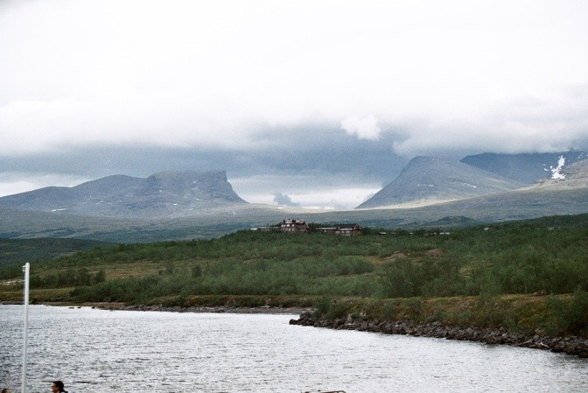

Figure 1. Lapporten (Cuonjávággi) and Torneträsk Lake in Abisko Reservation (photo: D. Constantinescu, July 2009).

A basic element in order to investigate the temperature changes in paleoclimatology is the isotope *δ*18O or delta-O-18. The definition is in ‰, parts per thousand, by the equation:

‰ (1)



where: O18 and O16: isotopes of oxygen.

The components of the climate system change and respond to external factors at different levels. In order to understand the role such many factors play in the evolution of climate, it is necessary to have a record considerably longer than the time it takes for them to undergo significant changes (Bradley 2015). In Figure 2, it is presented the evolution of the global temperature, over the past 65 million years.

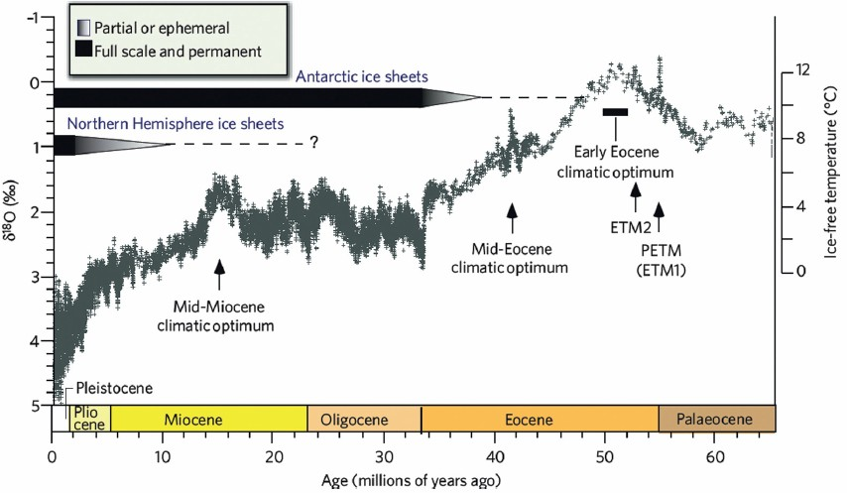

Figure 2. Evolution of the temperature levels and global climate over the past 65 million years (the δ18O temperature scale, on the right axis, assumes an ice-free ocean and so only applies to the time preceding the onset of large-scale glaciations on Antarctica (about 35 million years ago) (Source: Bradley 2015).

**Methods of paleoclimatic reconstruction**. The climate fluctuates along different time scales and each periodicity is an indication of the separate force mechanisms. Most of the terrestrial systems are climate dependent and can generate paleoclimatic information. As the climatic construction, the paleoclimatic reconstruction has some steps. The first one is the collection of main data, followed by initial analysis and measurements. The second step implies a data calibration, having in view recent climatic registration; the secondary data are furnishing a registration of the past climate variations. The third phase consists in the statistical analysis of the secondary data (Buchdahl 1999). The most used acquisition techniques of paleoclimatic data are:

* historical records: observations of meteorological phenomena; registering of phenomena dependent naturally on weather; phenology registering of biological phenomena, dependent on weather. Sources: ancient inscriptions, annals, governmental records, commercial and maritime registering, special literature, fine art and painting;
* ice centers: ice and snow are accumulating in the polar zones and mountain glacier; it can be established the environment conditions in their forming time;
* the analysis of stable isotopes;
* chemical and physical characteristics of the ice deposits: an important component of the ice deposits or blocs is the atmospheric gas;
* skeletons and vegetal fossils corresponding to the geological periods;
* dendroclimatology: the studying method of past climates, by the complex study of the annual changes of the tree ring thickness or using C14 (Figure 3);

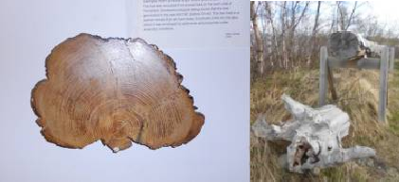

Figure 3. Pine sample (over 6,000 years old) ANS, Sweden (photo: A. B. Carlan, 2015).

* ocean sediments: because sediments are composed by organic and inorganic substances, it can be an indicator of climate conditions;
* terrestrial sediments (Figure 4);

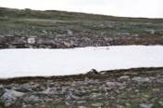

Figure 4. Geological changes on the Njoulla Mountain, Norrbotten, Sweden (Photo: D. Constantinescu, 2010).

* pollen analysis: when the pollen and spores are accumulating along time, there are registering of the past climate vegetation;
* sedimentary rocks: the rocks composition is generating information regarding the past climate in the period of sediments deposition.

**Milankovitch and Hays theory about the ice age**. Milankovich theory describes the effects of changes in the Earth’s movements upon its climate (Milankovich 1941). Milankovich mathematical model explains that variations in the eccentricity, axial tilt and precession of our planet orbit determine climate changes at global level through orbital forcing. The author considered the models of the solar radiation to the Earth surface depending on the precession and obliquity as critical factors in the increasing or decreasing of the continental ice layer. He thought that if the axial angle is low, the eccentricity is high and the perihelia occur during the Northern Hemispheres winters.

In Figure 5, the main parameters regarding the Milankovich theory are presented.

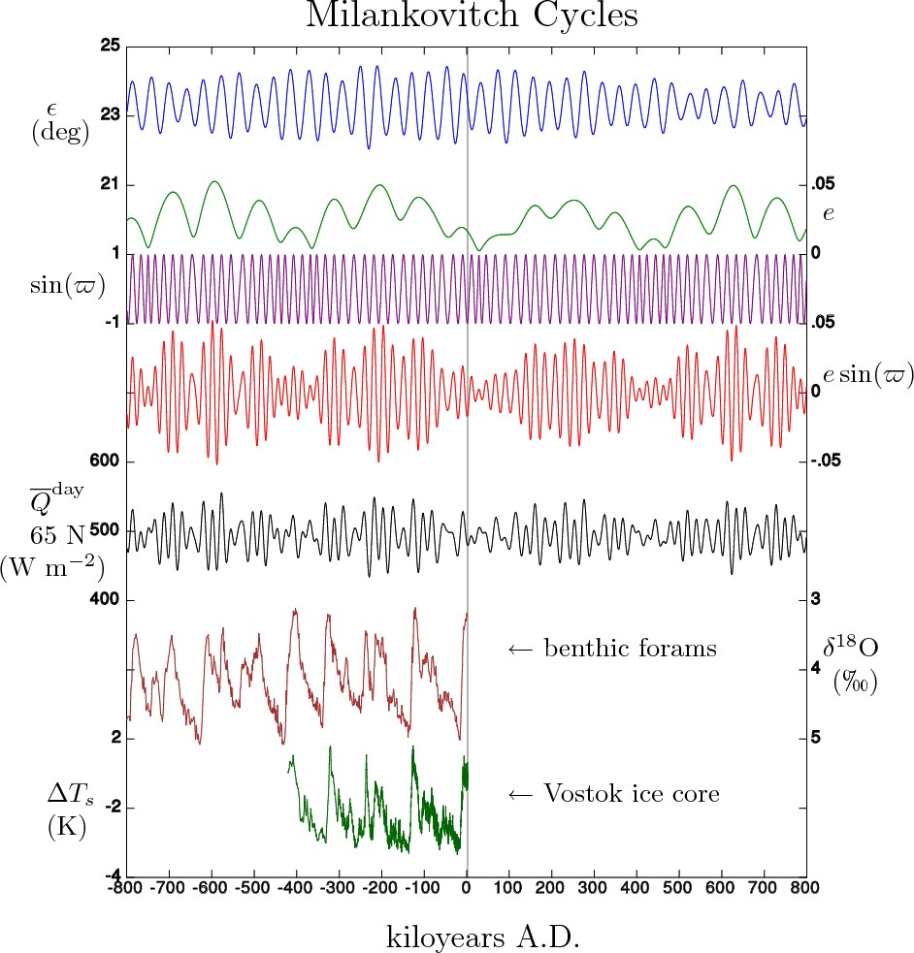

Figure 5 - Data from the Milankovich model, for ±800 kyr reported to A.D. 0 (after Milankovitch M.

Model). Notations: ε - obliquity (axial tilt); *e -* eccentricity (km); ϖ - longitude of perihelion (the sum of the longitude of ascending node Ω); *e.*sin(ϖ) - the precession index (which together with obliquity, controls the seasonal cycle of insolation);  - the calculated daily-averaged insolation at the top of the atmosphere, on the day of the summer solstice at 65° N latitude (W/m2); ΔTS - temperature variation, (K); δ18O – oxygen isotope, (‰). Graphic data obtained by (Petit et al 2001; Lisiecki & Raymo 2005).

The components of orbital variations are influencing the totally flux of the entrance of solar radiation and its temporal and spatial distribution. These variations have the potential of influencing the energy quantity of the climatic system; they may be considered possible causes of the climate changes, along a temporal scale from 104 to 105 years.

The eccentricity (e) is given by the equation:

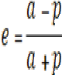 (2)

The eccentricity – the distance from the Sun do not determine seasons (Figure 6):

* aphelion (a) has NOW the value (km): 152.1x106;
* perihelion (p) has NOW the value (km): 147.1x106;
* eccentricity has NOW the value (km): min. 0.0005 – max. 0.0607.

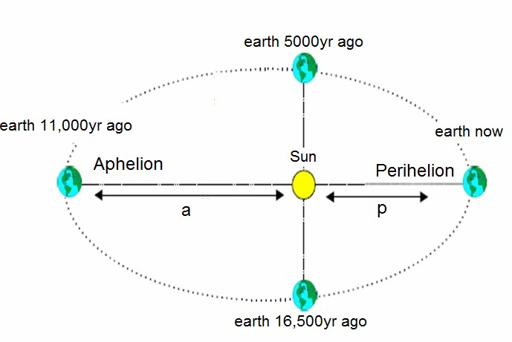

Figure 6. Earth position (Milankovich theory) (after Goodess et al 1992).

The obliquity – determines seasons:

* NOW has the value: 23.5 degrees (it can fluctuates between the minimum distance of 22.1 degrees and the maximum value of 24.5 degrees);
* the cycles: 40kyr (determines the radiation value at the Earth surface).

The precession (Figure 7):

* NOW is at 13kyr from the cycle;
* the minimum precession: -0.06;
* the maximum precession: +0.06.

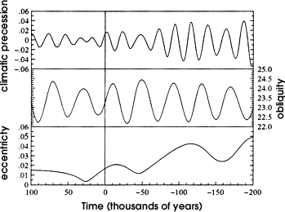

Figure 7. Periodicity during 300kyr (0: today) (Source: ***Milankovitch Theory).

Hays et al (1976) show that for more than a century the cause of fluctuations in the Pleistocene ice sheets has remained an intriguing and unsolved scientific mystery. Interest in this problem has generated a number of possible explanations. One group of theories invokes factors external to the climate system, including variations in the output of the sun, or the amount of solar energy reaching the earth caused by changing concentrations of interstellar dust (Dennison & Mansfield 1976); the seasonal and latitudinal distribution of incoming radiation caused by changes in the earth's orbital geometry; the volcanic dust content of the atmosphere (Henderson-Sellers 1986); and the earth's magnetic field. Other theories are based on internal elements of the system believed to have response times sufficiently long to yield fluctuations in the range 104 to

106 years. Such features include the growth and decay of ice sheets, the surging of the Antarctic ice sheet; the ice cover of the Arctic Ocean; the distribution of carbon dioxide between atmosphere and ocean; and the deep circulation of the ocean. Additionally, it has been argued that as an almost intransitive system, climate could alternate between different states on an appropriate (***Lorraine-Lisiecki).

**Today global radiation at the sub-polar level**. During the visits and researches at ANS (Abisko Reservation, Norrbotten, Sweden), accomplished in the period 2006-2015, for every year (for both summer and winter time), there were obtained values of the global radiation at the latitude of 68oN. The data refers to the period 1984-2015 and are obtained by measurements, not by calculation. The results and some comments are presented in the Figures 8, 9, 10 (graphics in OriginLab).



450

main statistics

400

global radiation (1)

350

300

250

200

150

100

50

0

-50

1985.08.031986.09.071987.10.121988.11.151989.12.201991.01.241992.02.28

Periode: 1984 - 2005

B [1:7718] average 92,61347 min: -2,5 max: 385,5 671910,7

2

Global radiation, W/m

Figure 8. Global radiation at 68oN, daily registration for the period 1984-2005 (A.N.S. data).

130

120

registred data(1) linear fit (2)

polinomial fit 3td dgr (3)

2005; highest = 124.132 W/m2

110

100

[1981;

2007; 100,6W/m2

2

90

83.8W/m ]

80

70

1981;

74W/m2

Increase of radiation at 68N:

56 64 W/m2 in 20yrs

1984; lowest=65.23

60

1980

1985

1990

1995 2000

2005

Period 1984- 2005

[1:22] Average: 92,23743 Min: 65,04803 Max:124,13263 22 Sum: 2029,2233

2006; 129W/m2

G lo b a l rad iatio n (W /m 2)

Figure 9. Average annual radiation at 68oN for 21 years (1984-2005) and evaluation for 1981-2007 (1984+1985: eruption of Mauna Loa volcano in Hawaii and Villarica in Chile).

Figure 10. Average annual radiation at 68oN for 31 years (1984-2015) and evaluation for 1981- 2015 (2005; hottest year, strong solar eruptions).

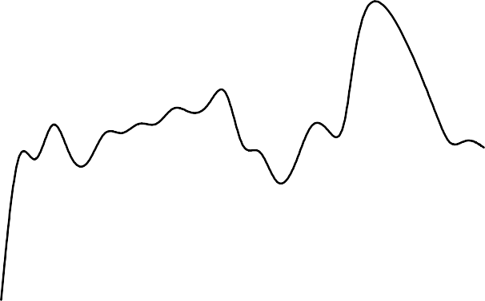

130

registred data(1) linear fit (2)

polinomial fit (3)

120

2005; highest = 124 W/m2

110

2014; 98 W/m2

100

[1981;

87 W/m2]

90

90W/m2

2014; 97W/m

2

80

1981;

72W/m2

Increase of radiation at 68N:

25 W/m in 35yrs

2

70

1984; lowest=65.23

60

1980

1985

1990

1995

2000

2005

2010

2015

Periode, years

Global rediation, W/m2

In Figures 11 and 12, there are presented the global thermal radiation for the same period for the summer and for the winter seasons (graphics in OriginLab).

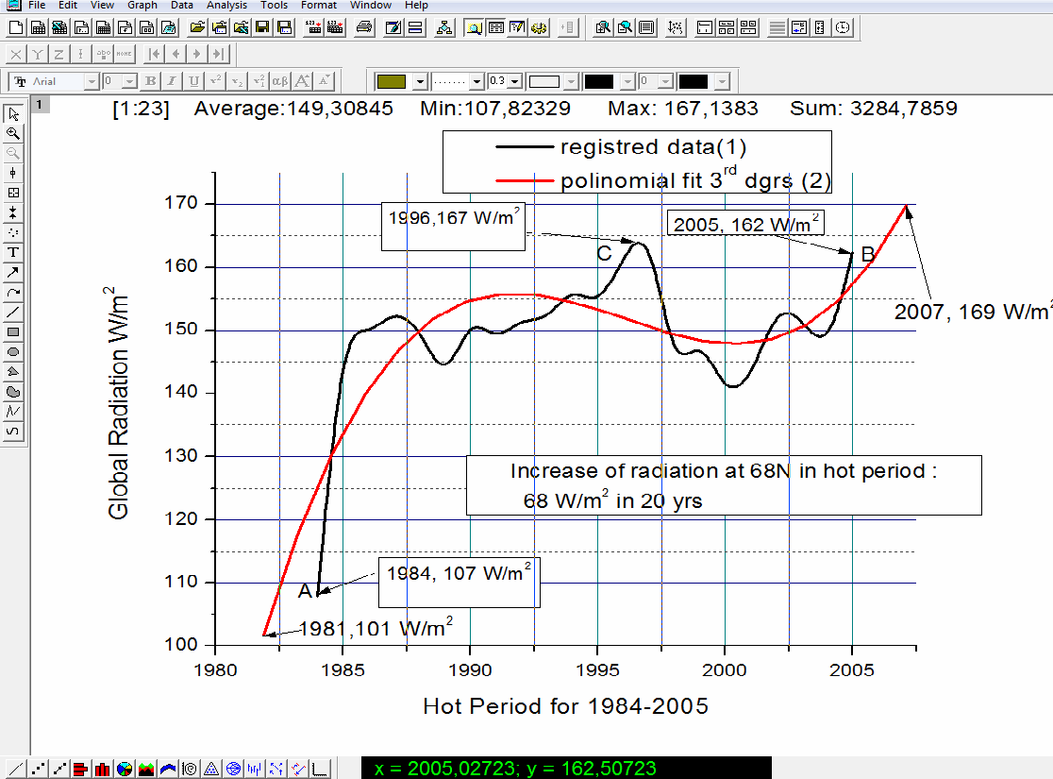

Figure 11 - Summer seasons at 68oN for the years (1984-2005) and evaluation for 1981-2007; A: eruption of Mauna Loa volcano in Hawaii and Villarica in Chile; C&B solar eruptions, hottest years.

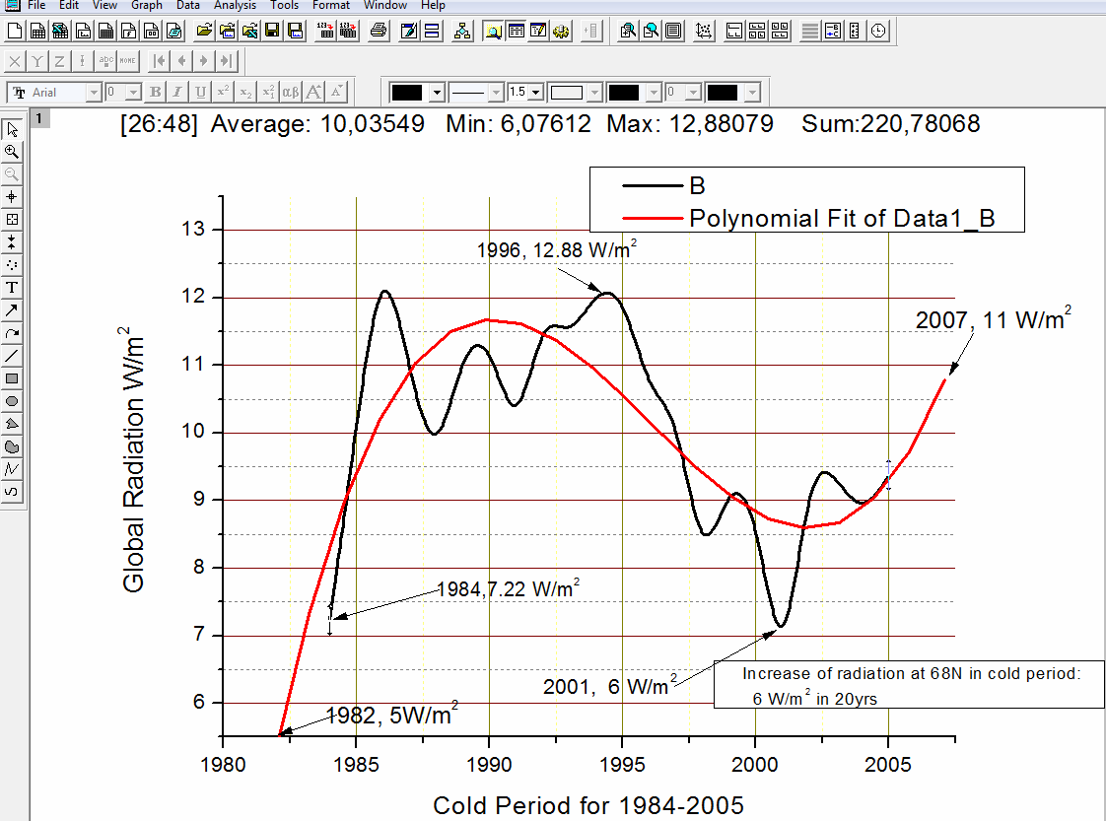

Figure 12. Winter seasons at 68oN for the years (1984-2005) and evaluation for 1981-2007; (1984, 1985 eruption of Mauna Loa volcano in Hawaii and Villarica in Chile).

**The influence of volcano emissions**. The affinity between volcano and the climate oscillations is very strong, because, when it erupts, there are expelled in the atmosphere volcano ash, dirt, SO2, HCl, CO2. The ash and dirt particles from the stratosphere are reducing the quantity of Earth solar energy and the carbon dioxide influence the “green house” effect.

Keys (1999) considers that the eruption of Krakatau volcano, in the year 535 B.C. caused calamitous changes in the Earth climate, as: the end of the big cities and the ancient world; the end of Persia; the decay of Tikal city and Nasca civilization; the transformation of the Roman Empire in Byzantine Empire. Also, this global disaster caused, directly, the death of many people. Indirectly, it affected the politics of each continent and contributed to the Roman Empire decay. It means that the situation of roman, civil and military sites, along the Danube River, was influenced not only by the strategic situation or the economic evolutions, but also by the environmental conditions and the global climate situation, from the 6th century (Constantinescu 2013).

During time, the climate changes topic was intensely treated in the Romanian special literature too (Pârvan 1926). After many analyses on the land, the archeologists remember that “the entire Europe had, in the last millennium B.C., a colder climate than today”. This affirmation was confirmed by the late maturation of the grapes.

To estimate the atmospheric dispersion of volcano pollutant emissions, it can be taken into consideration, as working instrument, the statistic model generated by a Gaussian distribution (Moussiopoulos et al 1996; Barnea & Ursu 1969; Sandu et al 2004; Sutton 1950):

q  y2   H 

2 

2

2σz 







2

(3)

Cx, z 

exp exp e  , where

where:

2πuσy σz

   

 2σ  

y 



   

C(x,z) – pollutant concentration at z level for a position (x,y), in [kg/m3]; x – distance from the crater, on wind direction, [m];

z – vertical direction, perpendicular to x axis, [m]; q – volcano pollutant debit, [kg s-1];

u – wind speed, [m s-1]

He- elevation of the emission source (volcano)

σ y, σz – diffusion coefficients for the direction perpendicular on the wind direction, respectively to the vertical.

The problem is, to establish the exact values for these coefficients, having in view that the literature do not offer too many data. The volcano pollutants dispersion, using a Gaussian model, is described in Figures 13 and 14.

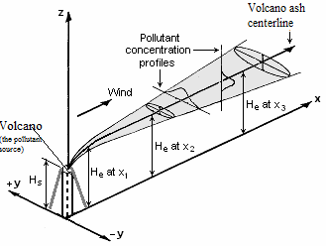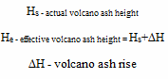

Figure 13. The volcano pollutant dispersion, using a Gaussian model.

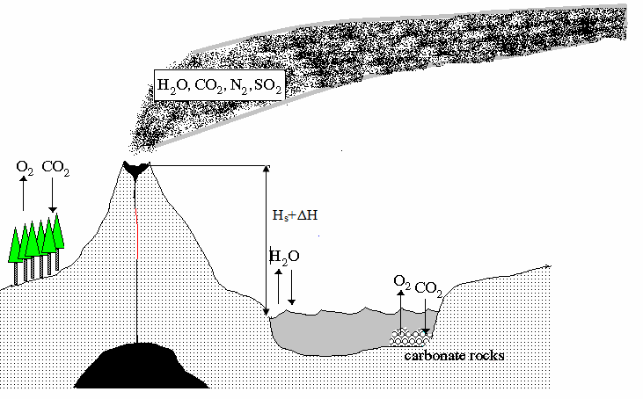

Figure 14. The volcano pollutant stream, corresponding to the Gaussian model.

The volcano pollution affects the atmospheric energetic balance, but dirt and aerosols remains in the stratosphere. The equation which describes the mass transfer phenomenon, applicable for dispersion, has the following form (Sutton 1950):

# C(x, z,y, t)

  *C**x*, *z*, *y*,*t*

(4)

 *div**ρ* *x*, *z*, *y*,*t**C**x*, *z*, *y*,*t* *div**D**x*, *z*, *y*,*t*  *ρ**x*, *z*, *y*,*t* *grd*     *S*

   *r*

*t*   *ρ* *x*, *z*, *y*,*t*

where :

  

TD TC

C(x, y, z, t) – the pollutant concentration; D(x, y, z, t) – the diffusion coefficient;

T.D. – the diffusivity transport factor; T.C. – the convective transport factor; Sr – initial substance source;

x, z, y – coordinate of the place; t – time.

The volcano activity can affect the climate, on a global scale, for a long period of time. During millions years periods, the increasing of volcano activity had generated enormous volumes of green house gases, with a huge potential of global heating.

**Conclusions**. The paleoclimate study is an assessment and analysis source of the actual climate situation and of possible prognosis for the climate future evolution.

The climate modifications are more intense on high latitudes; one of the main consequences was that the circulation system was changed.

During the last period of 30 years the intensity of global radiation at latitudes of 66-68oN have an evident increasing trend, very probable in concordance to the evolution of the geophysical parameters.

The affinity between volcano and climate modifications is very strong; the volcanic activity influences the radiation and convection process on large areas.

The decaying of the Roman Empire was caused also by the environmental situation – the situation of the roman sites along the Danube River was influenced by the global climate conditions of the 6th century.

There are some climate models which may simulate the behavior of a climatic system, in order to explain the physical or chemical processes which adjust the climate.

**References**

Barnea M., Ursu P., 1969 [Protection of the atmosphere from the pollution with solid particles and gazes]. Technical Publishing House, Bucharest, page 52 and next [in Romanian].

Bradley S. R., 2015 Paleoclimatology: reconstructing climates of the quaternary. Third Edition*,* Academic Press, pp. 1-11.

Buchdahl J., 1999 Global climate change student guide: a review of contemporary and prehistoric global climate change. Manchester Metropolitan University, 99 pp.

Constantinescu D., 2013 Roman defence sites on the Danube River and environmental changes. Structural studies, repairs and maintenance of heritage architecture XIII”, series volume 131, WIT Press 2013, ISBN 978-1-84564-730-8.

Constantinescu D., Jonasson C., 2011 Abisko Reservation – a special area for the researches about the global climate changes. Environment & Progress 15:87-95.

Dennison B., Mansfield V. N., 1976 Glaciations and dense interstellar clouds. Nature 261:32-34.

Goodess C. M., Palutikof J. P., Davies T. D., 1992 The nature and causes of climate change: assessing the long term future. Belhaven Press, London, pp. 157-173.

Hays J. D., Imbrie J., Shackleton N. J., 1976 Variations in the Earth's orbit: pacemaker of the ice ages. Science 194:1121-1132.

Henderson-Sellers A., 1986 Cloud changes in a warmer Europe. Climatic Change 8:25- 52.

Keys D., 1999 Catastrophe: an investigation into the origins of modern civilization.

Ballantine Books, Great Britain, ISBN 978-0345408761.

Lisiecki L. E., Raymo M. E., 2005 A Pliocene-Pleistocene stack of 57 globally distributed benthic δ18O records. Paleoceanography 20, PA1003, 17 pp.

Milankovitch M. M., 1941 Canon of insolation and the ice age problem. Königlich Serbische Academie, Belgrade; English translation by the Israel Program for Scientific Translations, United States Department of Commerce and the National Science Foundation, Washington D.C., Milankovich Theorry/Cicles.

Moussiopoulos N., Berge E., Bohler T., Leeuw F., Gronskei K., Mylona S., Tombrou M., 1996 Ambient air quality, pollutant dispersion and transport models. EEA Copenhagen, Denmark, 98 pp.

Pârvan V., 1926 [Getica – A protohistory of Dacia]. In: Historical section memories. Romanian Academy, 3rdOrder, 3rd Volume, National Culture, Bucharest [in Romanian].

Petit J. R., et al., 2001 Vostok Ice Core Data for 420,000 Years, IGBP PAGES/World Data Center for Paleoclimatology Data Contribution Series #2001-076. NOAA/NGDC Paleoclimatology Program, Boulder CO, USA.

Sandu I., Pescaru I. V., Sandu I. 2004 [Models for the evaluation of the pollutant dispersion in atmosphere]. Edit. Sitech, Craiova, ISBN 973-657-495-4, pp. 80 and next [in Romanian].

Sutton O. G., 1950 The dispersion of hot gases in the atmosphere. Journal of Meteorology 7:307-312.

*** Data source of Milankovich Model: https://commons.wikimedia.org/wiki/File:MilankovitchCyclesOrbitandCores.png.

*** ftp://ftp.ncdc.noaa.gov/pub/data/paleo/icecore/antarctica/vostok/deutnat.txt.

***<http://lorraine-lisiecki.com/thesis_appendix.html#2-Appendix-B-The-d18O-of-> Foraminifera.

***https://[www.google.ro/search?q=milankovitch+theory&biw=1280&bih=819&tbm=isc](http://www.google.ro/search?q=milankovitch%2Btheory&biw=1280&bih=819&tbm=isc) h&tbo=u&source=univ&sa=X&ved=0ahUKEwi9j6LUusfJAhVFdw8KHc8UAioQsAQIQw &dpr=1#imgrc=eyuznBWcUXeNXM%3A.