**The Design of a Smart Prototype Security System for Wildlife Conservation**

**Abstract**

The exploitation of natural resources through poaching and plundering has a significant impact on the environment, society, economy, and culture. Namibia has recently witnessed a surge in wildlife crime, as evidenced by the reported poaching incidents in the iconic Etosha Game Park in 2022, where 61 black and 26 white rhinos were killed. Elephants, rhinos, and pangolins are currently the three main high-value targets for poachers due to their ivory, horns, scales, and flesh. Despite the Namibian government's efforts to combat poaching, the illegal killing of wild animals persists, which negatively impacts natural diversity and the national tourism industry. This paper proposes an innovative, intelligent system to facilitate real-time detection and monitoring of wild animals and timely detection of poaching activities. The system is designed to assist national parks and private game parks in identifying and combating poaching in real-time by utilising off-the-shelf components.

**Keywords:** Raspberry Pi, Thermal Camera, detection, Visual Network Computing, Intruder; Wildlife poaching

**Introduction**

Namibia possesses abundant natural resources and a diverse wildlife population, making it an attractive tourist destination. The Namibian travel and tourism industry significantly contributes to the country's economy, providing employment opportunities to over 100,000 people and contributing to the Gross Domestic Product [1, 2] while generating foreign income.

However, the rampant poaching of wild animals poses a significant threat to wildlife conservation in game parks. Illegal poaching and wildlife trafficking endanger the survival of endangered species in Namibia. Namibia has recently witnessed a surge in wildlife crime, as evidenced by the reported poaching incidents in the iconic Etosha Game Park in 2022, where 61 black and 26 white rhinos were killed. Elephants, rhinos, and pangolins are currently the three main high-value targets for poachers due to their ivory, horns, scales, and flesh [3,4]

Poaching has profound social and cultural roots, so the Namibian government has implemented various legislative policies to support the travel and tourism industry and initiatives like Blue Rhino, 'community conservation,' and the Wildlife Protection Service Unit to combat poaching [5].

Although there has been a decrease in the poaching of wild animals, it is still rampant in wildlife game parks, private conservancies, and government-owned reserves. Poaching poses a severe threat to the iconic wildlife of Namibia, despite conservationists' and law enforcement agencies' efforts. Poachers continuously devise new and innovative ways to evade detection and carry out their activities, putting wildlife at risk.

With the advent of the Industrial Revolution, digitalisation, and technological innovations, there has been an increasing interest in the potential of artificial intelligence (AI) and the Internet of Things (IoT) to aid in the fight against poaching and wildlife protection. By coupling AI with IoT, the efficiency and effectiveness of anti-poaching efforts can be significantly improved [6,7].

This paper presents the design and testing of a prototype Smart System that uses AI for wildlife conservation. The system treats poaching as a multifaceted issue by identifying poachers, capturing their images, and communicating in real time. The artificially intelligent innovative system uses a thermal camera to capture and record images. A Raspberry Pi microcontroller integrates the thermal camera and the GSM communication system into a real-time monitoring system. The results are then analysed to evaluate the system's effectiveness in detecting and preventing poaching.

In summary, this paper aims to contribute to the expanding body of research on the use of AI in wildlife conservation while also providing insights into the potential advantages and obstacles of utilising AI as an anti-poaching system. By examining the technical and ethical considerations involved in developing and deploying such a system, our objective is to offer guidance for future efforts to safeguard endangered species and protect our natural heritage.

**Design of the Intelligent Anti-poaching system**

The fight against poaching increasingly integrates intelligent technologies, such as thermal and CCTV cameras, traditional patrols, and, more recently, satellite technology. This paper highlights the effectiveness of thermal imaging technology as a complement to anti-poaching initiatives.

Thermal cameras can remotely sense the temperature of moving objects through the reflected and refracted infrared wavelengths they emit [8]. This technology is instrumental in detecting humans, who often have a more robust thermal signature than their surroundings, even in complete darkness. While insulating clothing may mask this signature, thermal imaging remains an attractive anti-poaching technique, as much poaching activity occurs at night when detecting poachers is challenging and dangerous [9,10,11].

This paper aims to introduce a real-time, intelligent anti-poaching monitoring system that assists national parks and private game parks in identifying and combating poaching. Telegram is used as a communication platform between the system and administrators or users in the control room. The system generates real-time notifications to alert users of intrusions in the park.

**Block diagram of the Smart system:**

Figure 1 illustrates the fundamental concept of this system and the various components used in the system. The system has two main parts: the sensing and control units.

Raspberry pi 3 B+

Solar charger

SD card

Thermal camera-AMG8833

4G dongle

Figure 1: Block diagram of the Smart Security System

The anti-poaching monitoring system described in this paper comprises a Raspberry Pi microcontroller, AMG8833 thermal camera, SD card, 4G communication portal, and solar power supply. The system detects potential intruders or poachers through thermal imaging technology and sends real-time notifications to the control room to enable rapid response and intervention [8,9,10].

**Design Principle:**

The main component of the anti-poaching monitoring system described in this paper is the Raspberry Pi microcontroller, which serves as the control unit and interfaces with the other system components. These include the AMG8833 thermal camera, which has a microbolometer that senses heat and converts it into a thermal image [7]. The system is designed to detect temperature variations within a range of 7 meters and an aperture of 60°, which enables it to detect human presence even in complete darkness. When the system detects a temperature variation indicating the presence of a potential intruder or poacher, the Raspberry Pi sends commands to the camera to capture images of the area. These images are then transmitted in real-time to the control room computer via a 4G communication portal, and a warning notification is generated to alert users of the intrusion. To ensure a reliable and sustainable power supply, the system is designed with a solar power supply of 5V, which charges an in-built battery that powers the Raspberry Pi and thermal camera.

A Visual Network Computing server and viewer are also used to access a live stream of the camera on the control room computer or mobile devices.

**The function of components**

**Thermal Camera**

Thermal cameras can detect and measure heat emitted by objects and convert that information into an electronic image that displays the object's surface temperature. This technology can operate in the presence or absence of light and weather conditions, which makes it a valuable tool for security and surveillance applications. The camera has an optical system that focuses heat energy onto a detector chip containing thousands of detector pixels arranged in a grid. A temperature value is assigned a different colour, and the resulting matrix of colours is sent to memory, and the camera displays as a thermal image.

**AMG8833 thermal camera sensor**

The AMG8833 thermal camera can detect temperatures within a range of 0°C to 80°C (32°F to 176°F) with an accuracy of +- 2.5°C (4.5°F). It can detect temperature variations within a distance of 7 meters, which is 23 feet.

The camera has an 8x8 array of infrared thermal sensors that can detect and transmit 64 individual infrared temperature readings over I2C. The camera uses a synchronous I2C communication protocol to share the clock signal between the master and the slave device to synchronise the data transfer. The camera can record a video of objects and scenes and translate thermal energy into visible light for analysis through thermography. The resulting image the camera produces is called a thermogram [7].

## **VNC (Virtual Network Computing)**

The VNC viewer and VNC server were installed in the computer as a platform for remotely displaying the Raspberry Pi desktop on the computer. This enabled the control of the Smart Security System and watching live stream videos [12,13]. The VNC server captures the desktop of a Raspberry Pi in real time and sends it to the VNC viewer for display. VNC viewer gathers the input (mouse, keyboard, or touch) and sends it to VNC Server to inject and achieve remote control.

**Solar charger**

The solar charger provides power to the system to monitor the Game Park by detecting, capturing and sending notifications.

**Telegram application**

Telegram application was used for communication between the system and the administrators or users in the control room; it specifically transmits real-time notifications to alert users of intrusion into the park.

## **Operational Flow Chart**

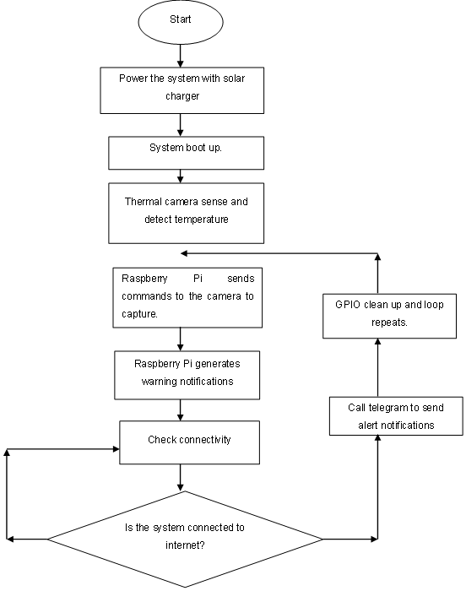

Figure 2 Operational Flow Chart of the System

## **Engineering Design and System Assembling**

To enable the connection of the AMG8833 Thermal camera to the Raspberry Pi pin, the camera is soldered to strips. The system was assembled as displayed in Figure 3 below.

**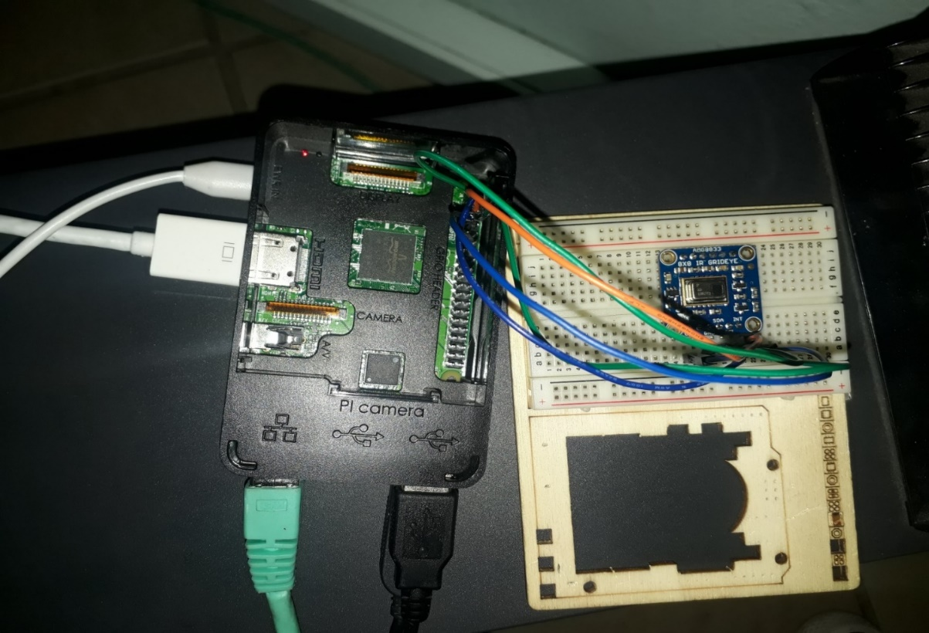**

Figure 3: System Assembling

* **Vin** was connected to the 3V or 5V power supply
* **GND** was connectedto the ground pin on the Raspberry Pi
* **SDA** was connected to **SDA** on the Raspberry Pi
* **SCL** was connected to **SCL** on the Raspberry Pi

### Enabling I2C for interfacing

After connecting the AMG8833 Thermal camera to the Raspberry Pi, the system was powered on to enable I2C to connect low-speed peripherals to computers and embedded systems.

**SYSTEM TESTING**

**Thermal Camera Testing**

The thermal camera was tested to verify that the sensor was assembled correctly. Figure 4 below illustrates the output when the camera is correctly assembled.

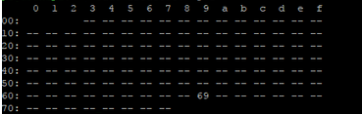

Figure 4: I2C Results

## 

## **AMG8833 Thermal camera testing sensor detection of the human temperature**

The thermal camera temperature is set from 26 °C to 35 °C, the environmental human body temperature. The AMG8833 thermal camera detects the human temperature within a distance of 7 meters and an aperture angle of 60°.

Upon sensing the temperature within the range of (26°C to 35°C) real-time notifications and the captured picture by the camera are sent to the computer. The camera also captures a livestream video displayed on the computer using Virtual Networking Computing to alert users of intrusion in the park as shown in Figure 5.

The results shown below in Figure 5 are a real-time recording of the thermal camera (sensor) as viewed on the Raspberry Pi desktop. The readings of 25.5°C, 24.5°C, 23.75°C shown in the figure are ambient environmental temperatures, such as without human or animal intrusion, whilst the readings of 26°C and higher, such as those shown in Figure 26.0°C, 27.5°C, 28.25°C are those detected when there was a human intrusion in the vicinity of the camera.

As soon as the camera senses a temperature of 26°C or higher, it sends a real-time notification to the mobile phone and computer located at the control room. Figure 5 illustrates the real-time messages received, intrusion detection, the highest temperature recorded and the picture received.

|  |  |  |
| --- | --- | --- |
| A Screenshot of a Real-time notifications | Screenshot of the temperature reading | Thermal image |
|  | C:\Users\Toshiba\AppData\Local\Temp\2019-05-24-104755_1024x768_scrot.png |  |

Figure 5: Illustration of real-time messages received, and the thermal image produced

The thermal camera returned an array of 64 individual infrared temperature readings over I2C. These temperature readings are then converted into a thermogram as shown in Figure 5.

**CONCLUSION**

This system is environmentally friendly as it does not emit any kind of radiation to the ecosystem, hence no harmful gasses are released since no combustion is involved. The system will reduce power consumption since the energy being used is renewable. The system is flexible and can be controlled and monitored worldwide. This system allows all individuals who may be willing to learn about Smart security systems to understand different engineering and programming knowledge. This system can protect the lives of wild animals, thus contributing to the Namibian economy.

REFERENCES

1. <https://www.trade.gov/country-commercial-guides/namibia-travel-and-tourism>
2. <https://www.giz.de/en/downloads/giz-2022-en-sector-brief-namibia-tourism.pdf>
3. (<https://www.esaamlg.org/reports/TYPOLOGIES-REPORT-ON-THE-WILDLIFE-CRIMES-AND-RELATED-ML..pdf>)
4. <https://www.bbc.com/news/world-africa-64461645>
5. <https://n-c-e.org/resource/operation-blue-rhino>
6. U. Jayalatsumi, A. Feza Naaz, Kodavaluru Sravani , Anusha, Alla Vasavi. (2018). A low-cost Thermal Imaging System for Medical Diagnostic Applications.
7. Wong, W., Hui, J., Loo, C., & Lim, W. (2012). Thermal imaging based on off-time swimming pool surveillance system. Kuala Lumpur University of Malaya
8. Thermal Imaging vs Night Vision. (n.d.). Retrieved from www.flir.com: <https://www.flir.com/discover/ots/thermal-vs-night-vision/>
9. Fitch, C. (2018). Deep learning technology to watch over wildlife parks. Chris Fitch Contributor. (n.d.). Deep learning technology to watch over wildlife parks. Retrieved from Africa Vision Global: <http://africavisionglobal.com/deep-learning-technology-to-watch-over-wildlife-parks/>
10. Adam G. Hart, Richard N. Rolfe, Shantelle Dandy, Hannah Stubbs, Shantelle Dandy, Hannah Stubbs, Dougal MacTavish, Lynne MacTavish, & Anne E. Goodenough. (2015). Can Handheld Thermal Imaging Technology Improve Detection of Poachers in African Bushveldt?
11. Boonstra R, Krebs C, Boutin S, Eadie J. (1994). Finding mammals using far-infrared thermal imaging. J mammal
12. Sheshai, S. S. (2016). RASPBERRY PI BASED SECURITY SYSTEM
13. Priya. (n.d.). Engineers Garege Retrieved from https://www.engineersgarage.com/Contribution/Controlling-IoT-Devices-through-Emails-over-IMAP-Protocol