Utilization and Payload Operations onboard the Starlab Commercial Space Station

Abstract

The design of efficient commercial space infrastructure plays a pivotal role in the pursuit of sustainable space exploration that benefits life on Earth. This paper describes utilization aspects and the payload operations advantages offered by the innovative commercial space station, Starlab. Focused on optimizing efficiency, operational fluidity, and customer experience, Starlab is designed to be a transformative platform for future space missions and users ranging across research, technology development and demonstration, product manufacturing, education and marketing objective. This concept fosters LEO access to private and government research agencies, commercial enterprises, as well as sovereign space agencies.

Developed in partnership with NASA’s Commercial LEO Destinations Program, Starlab prioritizes specific design principles and operational strategies to address challenges associated with extended space research missions. One of the primary payload operations advantages of Starlab lies in its modular and adaptable architecture. Utilizing state-of-the-art payload integration processes, the station facilitates seamless deployment of scientific instruments, experiments, and commercially owned facilities. The modular design accommodates diverse research objectives, fostering collaboration between international space agencies, research institutions, and private enterprises.

*Keywords: Starlab; commercial space station; payload operation*

1. Introduction

The International Space Station (ISS) has been an unpreceded milestone in international collaboration to explore and utilize the unique environment provided in low earth orbit (LEO) for scientific investigations (Ruttley et al., 2017). Since the initial launch in 1998 hundreds of experiments have been performed on-board the ISS advancing our understanding in various scientific fields. However, after being in service for more than 25 years, the retirement of the ISS is in sight (Comstock et al., 2020; Graham & Lucier, 2023).

In preparation for the post-ISS time, NASA initiated the Commercial Low-Earth Destination Program (CLDP) in 2021, encouraging space industry to develop space stations which are able to replace ISS. Such space stations will not only be developed and built under industry responsibility, but remain in ownership of the commercial providers. NASA and other space agencies will be customers using the commercial services provided by the space station (NASA, 2023).

Several concepts are being put forward in course of a space-act agreement, one of it being Starlab. The industrial setup forming Starlab is remarkable in different aspects. On the one hand, the international spirit of the ISS is resembled in a unique way with the main joint venture partners representing USA, Europe, Japan, and Canada. On the other hand, the joint venture combines the benefits of 30 years of heritage in space business (>2,000 flown missions) and future-oriented transformation drivers, e.g. leading in AI implementation. Strategic partners from academia, launch providers, interior design, and other relevant sectors complement the industrial setup aiming to revolutionize the future of low-earth orbit destinations.

1. Starlab

*Note: The provided Starlab data and figures represent a status before the conference took place and have evolved since.*

The initial idea for the Starlab Station was to build a habitat which is fully outfitted and can be brought into orbit with one single launch. This is being enabled by SpaceX’s Starship which is currently under development. Apart from the monetary advantage of a single launch, the main goal of this bold approach is to be first to market.

Apart from the space station a whole ecosystem will be established to support human life and science in low-earth orbits, see Fig. 1. Under the commercial services approach, the Starlab Program will offer end-to-end mission services such as purchase to all customers:

* Astronaut flights including pre-flight training and support, on-orbit support and post-flight reconditioning
* Payload services including pre- and post-flight payload processing
* Crew and cargo transport to and from the CLD
* In-flight accommodation and support for crew, payloads, activities, studies, and technology demonstrations such as power and data services, provision of consumables and common use of equipment and tools, mission activity planning services, activity execution services, non-Government crew time, and payload integration.

The commercialization concept for Starlab is to provide all capabilities the ISS is currently providing with respect to human presence and research in low-earth orbits, but to commercially run the station. This explicitly aims also at payload operations and integration such that the provided services are viable. The provision of sustainable revenues is prerequisite for future extension of the service palette, also in respect to attracting larger customer base.

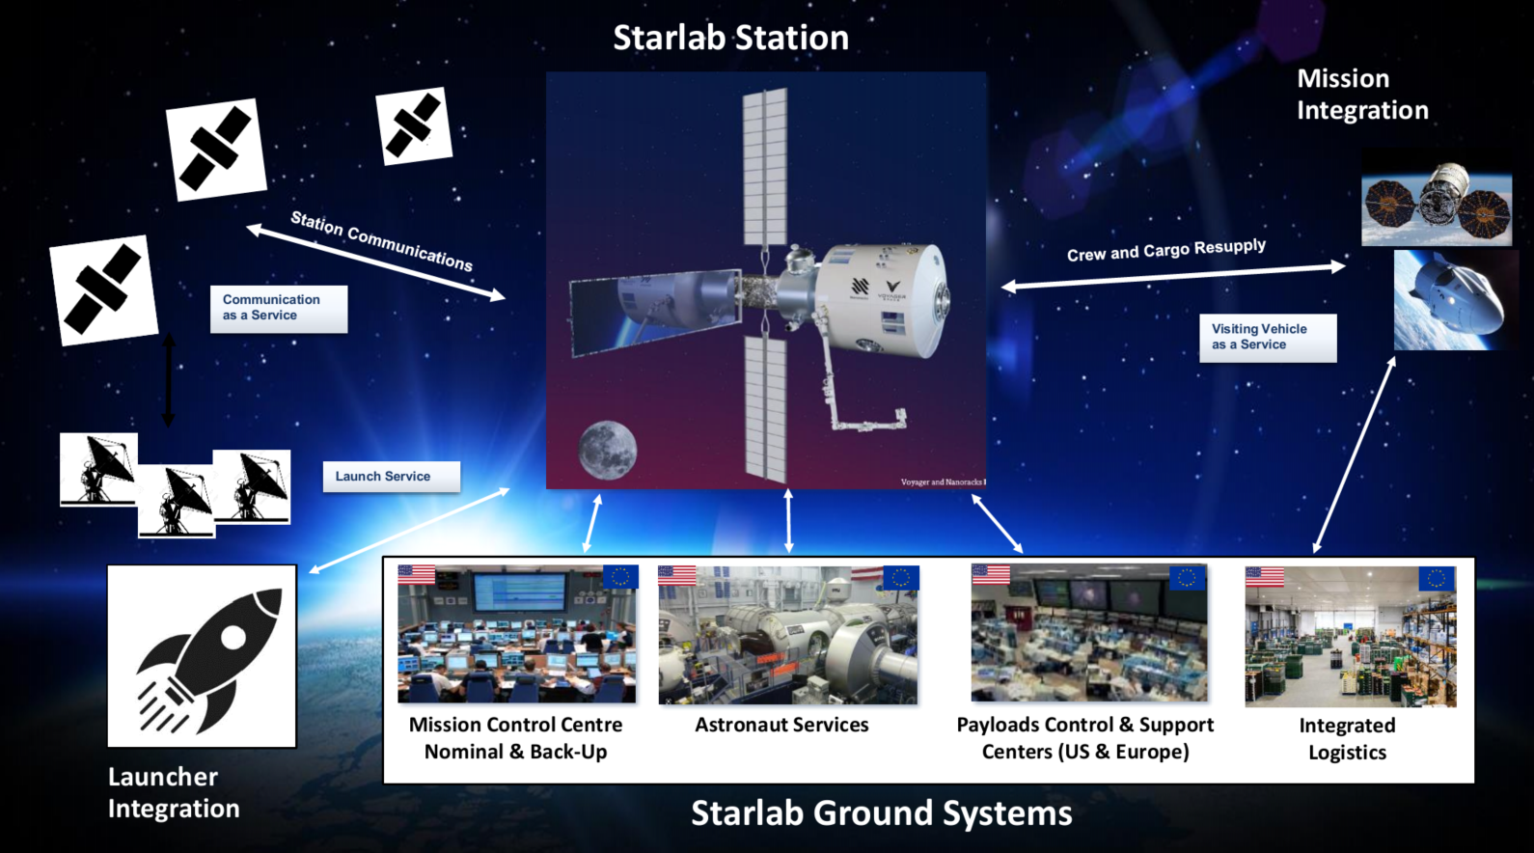

Fig. 1. Starlab ecosystem

* 1. Payload Integration and Operations

This chapter focuses on the view of the end-customer or the principal investigator (PI) towards payload integration and operation, without going into detail on specific details.

On ISS, Payload Integration and Operations are performed by the space agencies. Starlab will provide all related services on an on-demand basis. Following a payload lifecycle, see Fig. 2, all aspects are covered by Starlab, providing standard and extended services to the customer or direct to the PI. Optimizing the processes around Starlab, a single entity enables the development of lean and streamlined processes.

Depending on the exact set-up of a certain mission, however, parts of the processes can be also provided by the agencies. An example for this, could be the operation of a payload, which is used by a dedicated researcher community and part of an agency supporting the roadmap. Such a payload would be owned and operated by the agency which could be responsible for providing ground services to the principal investigators, depending on the specificities of the contract with Starlab. In other words, , the process for the PI would not differ from the current implementation on ISS.

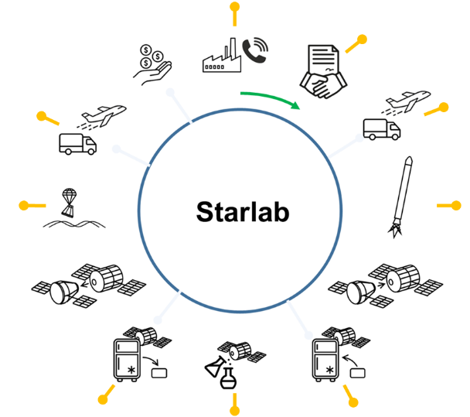

Fig. 2. Payload Mission lifecycle

The Payload Integration on Starlab is following a so-called customer centered approach. That means that the customer’s needs and requirements are in the center of Starlab’s ambition to provide the most suitable service for each customer. In order to do so, Starlab foresees that each customer has only one single interface, the Payload Integration Manager. This function will support the customer in the development of a mission and will guide the customer through all processes during the whole lifecycle. This end-to-end responsibility will foster Starlab’s understanding of the customers’ needs and goals, which ultimately leads to faster payload turn-over, more successful missions and improved customer experience.

For Payload Operations Manager, Starlab implements a similar denominated approach: Payload focused approach. Similar to the customer centered approach, the payload-focused approach aligns functions, tasks and procedures, to provide clear responsibilities for one dedicated payload. One main function representing this approach is the Payload Operations Manager. The responsibility of this function covers not only the standard operation of the corresponding payload or facility, but also all other operations related tasks, procedures, checks, and approvals. In case of anomalies, the Payoad Operations Manager is the main point of contact towards other disciplines and coordinates with Payload Integration Manager and customer for the best way forward in resolving anomalies or other issues related to Payload operations

Considering the current status of the project, the average lifecycle duration in the order of 15 months has been achieved, however, Starlab aims to reduce this time frame drastically, working on disruptive process and implementation for the future.

* 1. The HAB

The Starlab Station is composed of four main Elements: The Habitat Element, Extra-Vehicular Robotics, the Power & Thermal Element, and the Propulsion and Control Element. The overall dimension reflects the aim to maximize the utilization of mass-volume space capability provided by the launch vehicle within its payload fairings. The scope of this paper is to provide insights in payload operations mainly towards future capabilities with regards to material science, only the HAB, as shown in Fig. 3, will be discussed further.

The habitat is optimized to make the most efficient use of the laboratory equipment and subsystems to meet science, research and crew habitation requirements.

The HAB is separated into three levels, or decks. Deck 1 provides the crew quarters, which allows up to four crew members to live continuously on the Station, and supports up to 4 additional crew members during crew change operations. The other two other decks constitute the Internal Payload Laboratory.

The habitat also includes a compatible International Docking System Standard (IDSS) access port to allow the current Commercial Crew Program (CCP) systems to rendezvous and dock. The HAB is further outfitted with a science airlock to provide external payload services, utilizing the robotic arm for performing routine maintenance and payload manipulation.

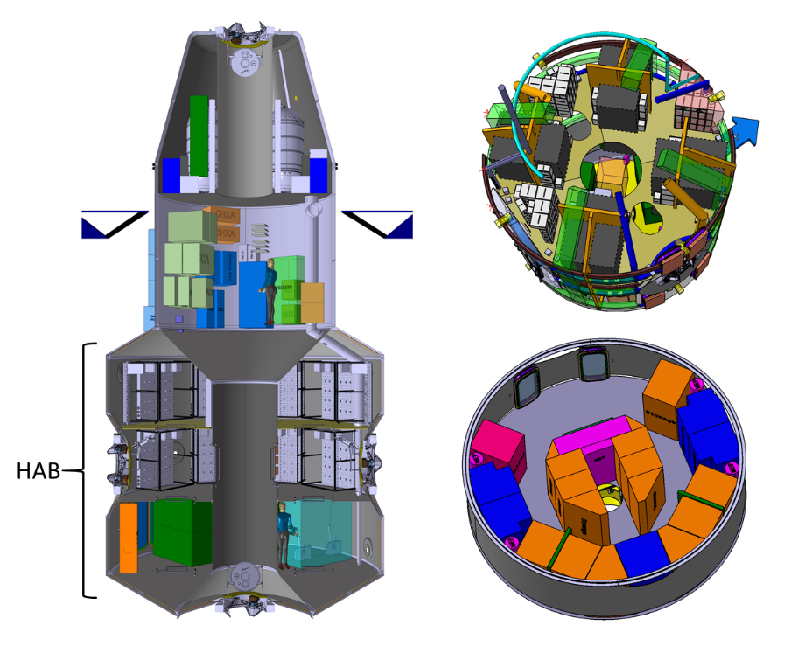

Fig. 3. Cross sectional view of the Starlab Space Station (right), and outfitting of Deck 3 (upper right) and Deck 1

* 1. Internal Payload Laboratory

The Internal Payload Laboratory (IPL) provides the required laboratory capabilities as services to customers. The concept is modular and configurable to support different Payloads from various scientific fields, commercial interests, and government entities. This flexibility allows Starlab to be commercially viable across different categories of Customers.

The IPL expands over two decks. On each deck, 8 dedicated locations are foreseen to host payloads, providing the main interface for customers payloads, which is called Payload Bench. In addition, the SIPL will provide additional infrastructure specially for dedicated sciences such as plant research, physical science, biological science, materials science, and human research. These capabilities are termed Payload Facilities, and will also include general-use laboratory services; cold stowage, a workbench, and several gloveboxes. The current design has ten payload benches reserved to host payload facilities.

* + 1. Payload Bench

The Payload Bench is a Payload hosting solution to support a varied range of scientific researches. These benches are envisioned as an open concept that provide the ability to mount and connect payloads to the module interfaces. Power, communications, and fluid interfaces for payloads are planned to be accessible from the bench surface, with air cooling provided by ports throughout the bench.

Three standard modules provide these basic payload interfaces: the Flow Module (FLM) provides cooling fluids (the flow module controls both air and water flow), the DC Power Module (DCPM) provides conditioned payload power, and the Comm Module provides payload communications (including command, telemetry, and science data return). All these modules supports payload interfaces routed outside the bench structure, which allows easier maintenance or replacement if there should be connection anomalies. More information on these modules is available in the following sections.

Additional services can be provided to the benches, including payload fluids such as nitrogen or vacuum, image handling, data input/output, AC power, interface EXPRESS Rack adapter plate, and payload containment.

The proposed design of the bench can be seen in Figure 4. A volume of 0.684 m3 is available to customer payloads per Bench, which is equivalent to 10 middeck locker sized units. The benches are designed such that a single bench can provide up to 4 kW to customer payloads. On average the power consumption of the whole internal payload laboratory is restricted to 9.5 kW, though.

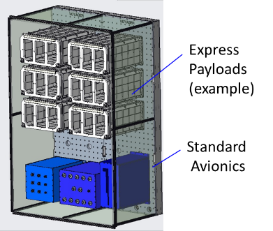

Fig. 4. Concept of a Payload Bench

* + 1. Payload Facilities

The aim of the payload facility ensemble is to provide the standard capabilities required for dedicated scientific areas and are commonly utilized by the majority of researchers working in the same area. Providing such services aims to reduce effort and cost for the customers as well as increase research turnover.

The facilities have been chosen based on the Starlab customer market survey and data trend utilization of such facilities currently onboard the ISS. The Starlab customer survey identifies top-level market driven Starlab research goals, objectives, and recommendations for Starlab research facilities and payload accommodations. The survey informs the functionalities of Starlab program including facilities to have in the payload laboratory.

The implementation of the payload facilities strongly depends on the scientific area to be addressed. For some research areas currently pursued on ISS, commonalities in hardware can be identified. Good examples for some of the scientific areas is the Biological Science, with incubators, centrifuges, microscopes, and glovebox commonly used. For other scientific areas, the implementation of commonly used equipment can be more challenging. For instance, the investigation of solidification of matter; a material science research topic has however an overall large community working on the research topic and thus the hardware capabilities required differs considerably, depending on the exact material or the exact scope of research. In such cases, Starlab strongly encourages the corresponding research communities to openly approach Starlab in order find the best-fit implementation strategy.

1. Summary

Aiming to succeed ISS as main LEO destination is Starlab, whichdevelops the capabilities and products to enrich customer experience and leverage future LEO utilization withmodularity and customer-focus approach being main drivers to realize set target and goal. Starlab strongly encourages current users, principal investigators, research communities and space agencies to explore their future ambitions with Starlab program as commercial space ststaion

References

Ruttley, T. M., Robinson, J. A., & Gerstenmaier, W. H. (2017). The international space station: collaboration, utilization, and commercialization. *Social science quarterly*, *98*(4), 1160-1174.

Comstock, D. A., Gatens, R., Cox, C., Keaton, J. L., Edeen, M., Read, M., & Korth, D. H. (2020, March). NASA's Plan for Commercial LEO Development. In *2020 IEEE Aerospace Conference* (pp. 1-12). IEEE.

Graham, L. D., & Lucier, L. M. (2023). *Commercial Low-Earth Orbit Destination (CLD) Concept of Operations* (No. CLDP-WP-1101). National Aeronautics and Space Administration.

NASA. (2023). Commercial Destinations in Low Earth Orbit - NASA. Available at: https://www.nasa.gov/humans-in-space/commercial-space/low-earth-orbit-economy/commercial-destinations-in-low-earth-orbit/ [Accessed 13 Jan. 2025]. ‌