# Chapter 22 - The Iron Nitriding in N2 and N2-H2 Afterglows

**ABSTRACT**

The iron nitriding has been studied in microwave plasma afterglows in Ar-N2 ,Ar- N2-H2 and Ar-N2-CH4 gas mixtures by optical spectroscopy . The quality of ϵ and γ’ layers have been analysed by micrography.

*Keywords: Iron nitriding , N-atom density,* ϵ and γ’ *iron layers*

## INTRODUCTION

It is presently reported and discussed the results obtained by optical spectroscopy in the LSGS-Nancy lab. to control the plasma processes.

The optical spectroscopy has been applied to detect the density of N-atoms playing an important role in the iron nitriding process. The quality of the iron layers (is) are analysed by micrography.

## – IRON NITRIDING IN N2 AND N2-H2 AFTERGLOWS

The nitriding process is employed to harden the surfaces of metal workpieces. This process has largely been developed with ion nitriding in industrial reactors in which the metal workpiece is the cathode of a N2–H2 glow (*only one space between the words is better*) discharge which is produced inside a heating device at temperatures up to 600◦C [1]. Such a temperature is necessary in order to stabilize the nitrided layers, as is shown by the Fe–N phase diagram in Fig. 22.1.

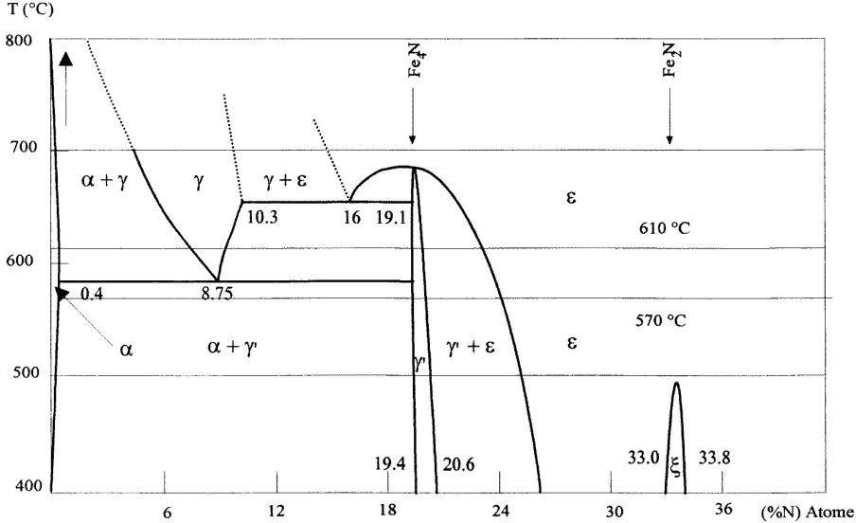

## Fig. 22.1. The Fe–N phase diagram

At T = 570◦C, the ε, γ’ and α layers are obtained. At 600◦C, the γ layer is a supplementary source of N atoms which are diffusing inside the workpiece (in the α phase) to harden it.

The ε, γ and γ’ layers increase the resistance to wear and the corrosion and decrease the coefficient of friction of the workpiece’s surface.

The α layer increases the resistance to deep wearing inside the workpiece. In the ion nitriding process, the plasma ions are accelerated in the cathode sheath (the workpiece to be treated) which is then heated by the ion impacts. The key factor in ion nitriding is to control both the production of active species and the temperatures of plasma ions and neutral species.

A review paper of new nitriding processes (is) are(?) in [2].

The advantage of nitriding treatments in afterglow processes is to avoid high energy electrons which was estimated to be detrimental to the quality of deposited films. The reported experiments as it follows were additional results to those of chap.12. The afterglow reactor of LSGS- Nancy is reported in Fig.22.2.

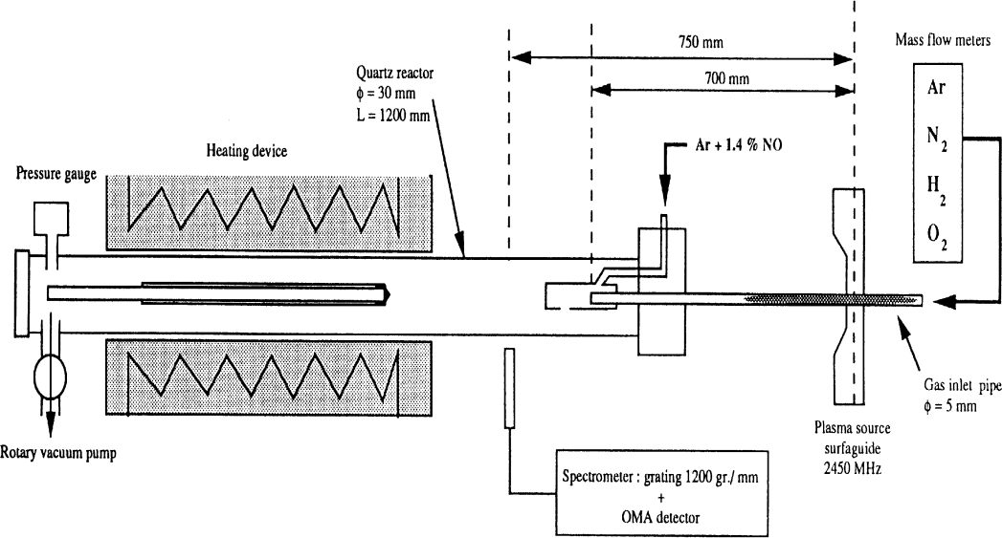

## Fig. 22.2. Experimental flowing afterglow set-up with N and O atoms titration by NO in LSGS(Nancy)

It is presented the results previously published in the review article [3]. For a N2 gas pressure of 2.3 Torr and a flow rate Q = 0.3 slpm, similar γ’-Fe4 N *(only one space between the characters is better)* layers of 5–8 µm thi**c**kness with α diffusion layers have been obtained in Fe–0.1% C steel substrates heated to 600°C.

It has been demonstrated that the microwave reactor can work at high gas pressures in Ar–N2 mixtures, up to the atmospheric gas pressure (760 Torr) with flow rates up to 10 slpm and at low power (80–200 W).

By performing numerous nitriding treatments with the post-discharge reactor of Fig. 21.2, the correlation between the γ’-layer thickness and the degree of dissociation of N2 , *(only one space between the characters is better)* where the N-atom density was measured by NO titration [3], was reported in Fig. 22.3. The ε layer appeared when the N/N2 ratio exceeded 0.01 at 30Torr.

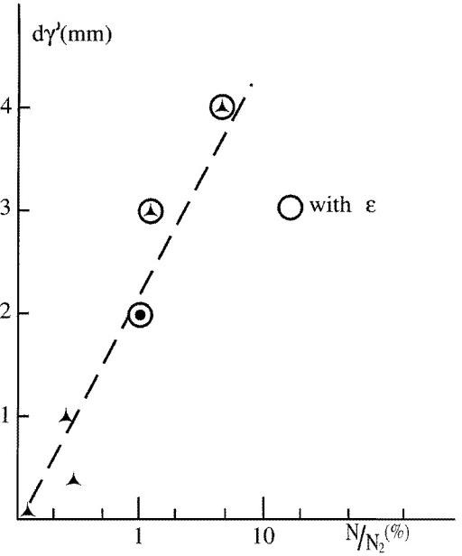

## Fig. 22.3. Variations in γ’ layer thickness ( dγ’) with N/N2 (%) in Ar–11%N2 microwave post- discharges (in the range 30- 300 Torr, 3-10 slpm , 70 W, afterglow time 10-1s) with a nitriding time of 1 h at 840K.

A pure iron substrate was also treated in the postdischarge reactor of Fig. 22.2 for 4 h at 840 K and at a distance z = 20 cm in the Ar–11% N2–x (H2) post-discharge plasma [3]. Cross sections of iron compounds and diffusion layers are reproduced in Fig. 22.4 (a)–(c) for x = 0, 0.5 × 10−3 and 5 × 10−2, respectively.

A γ ‘ layer of thickness 3–4 µm was obtained, as shown in Fig. 22.4a, for which a thin outer Fe4O3 layer was detected by x-ray analysis. For x = 5 × 10−3 (Fig. 21.4b) and 5 × 10−2 (Fig. 22.4c), a thick ε layer (about 10 µm thick) appeared without an oxide layer. Insofar as the ε layer appeared, it seems that oxides are eliminated by H atoms.

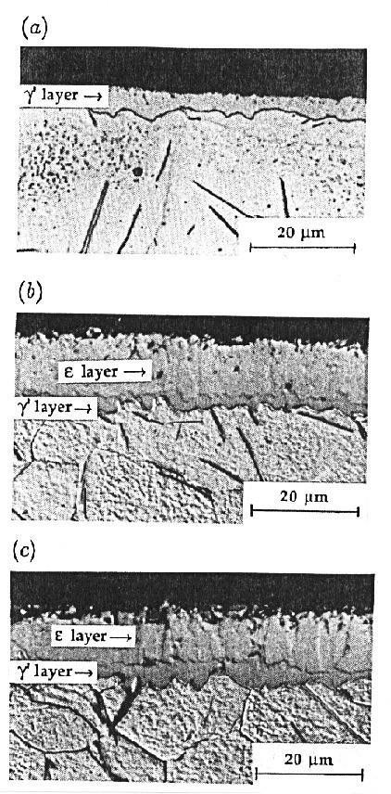

## Fig. 22.4. A micrograph of pure iron nitrided by a 4 h treatment in an Ar–N2–H2 post-discharge plasma, with discharge parameters: Ar-11%N2-x(H2) at 44 Torr , 3.2 slpm and 120 W: (a) x = [H2]/[N2] = 0, (b) x = 5 × 10−3 and (c) x = 5 × 10−2

A flowing post-discharge reactor at an industrial scale, 40 cm in diameter and 70 cm high (88 liters) is reproduced in Fig. 22.5a. Two Ar-N2-H2 plasmas are created in a quartz tube 0.6 cm in diameter with two surfatron cavities at a transmitted power of 500 W, a flow rate of 1-3 slpm and a pressure of 7-20 Torr. The post-discharges run into the reactor where the substrates are located. The reactor chamber can be heated by internal resistances up to 850 K to obtain the ε, γ’ and α nitrided layers on iron substrates (see [4]).

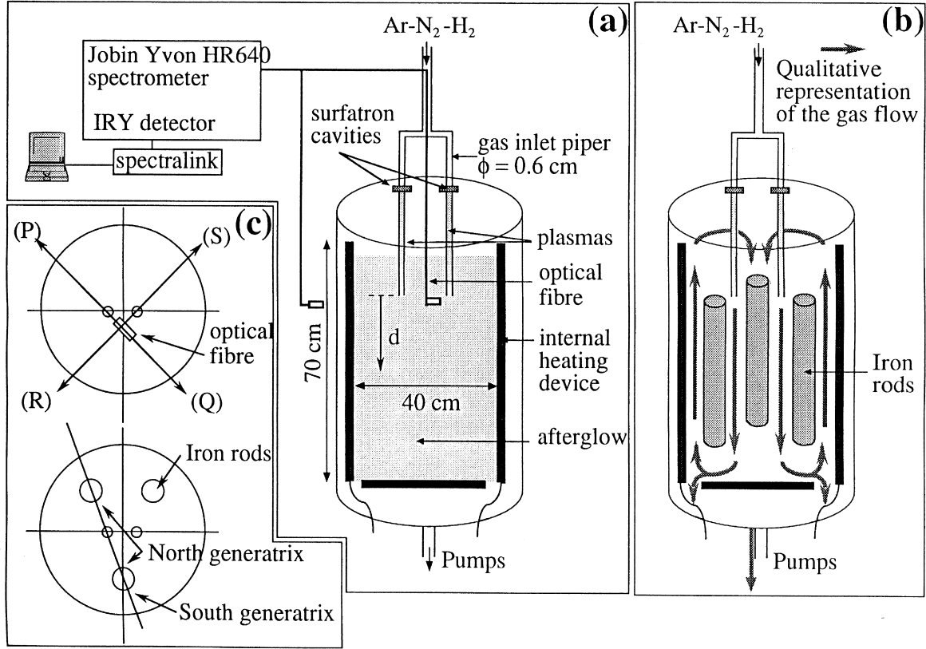

## Fig. 22.5. LSGS (Nancy) (a) Microwave post-discharge reactor at an industrial scale without substrates. (b) Description of the reactor with the three iron rods used for nitriding treatment.

**(c) Description of the (P), (Q), (R), (S) direction for OES measurements and location of the so called north and south generatrix**

The emission spectra of the discharge and of the afterglow are recorded with the same spectrometer as shown in Fig. 22.2, which is connected by a quartz optical fibre. This fibre can be located either outside the reactor and measurements are done through a porthole or inside the reactor (see Fig. 21.5a).The N-atom density has been determined by NO titration at the outlet of one of the gas pipes inside the reactor (see Fig. 22.2). The obtained results are reported in Table 22.1 for several experimental conditions.

These results show an increase of N atom densities as less than 1% H2 is introduced into N2 and a maximum value with about a 50:50 Ar-N2 gas mixture.

## Table 22.1. N atom density as determined by NO titration with four experimental conditions.

**Gas temperature: 400 K, outlet gas pipe 10-3s after the discharge**

|  |  |
| --- | --- |
| **Experimental conditions** | **N atom density (cm-3)** |
| 0.8 Ar-0.2 N2, 250 W, 15Torr and 1 slpm | 0.6 1015 |
| 0.4 Ar-0.6 (N2-0.25% H2), 250 W, 15 Torr and 1 slpm | 1.1 1015 |
| N2-0.25% H2, 150 W, 11 Torr and 1 slpm | 0.6 1015 |
| N2-1% H2, 150 W, 11Torr and 1 slpm | 0.45 1015 |

As the reactor chamber is heated, it was observed a sharp decrease of the I580 intensity which disappeared as the gas temperature reached 450 K. The rate coefficients for the N+N+M recombination (kb) and of the N2(B,11) state quenching (kQ11) are depending on gas temperature with kb(700 K)= 0.1kb(300 K) and kQ11 (700 K)=1.5 kQ11 (300 K) [4].

The k1 value in the following eq.1 is then decreasing by 6 10-2 at T = 700 K, explaining that for the same value of N- atom density, the density of N2 (B,v’ = 11) and then the I580 intensity decreased by more than one order of magnitude.

[N2(B,11)]= k1 [N]2 (1)

It has been observed that the increase of gas temperature up to 450 K in the reactor of Fig. 22.5a has produced a decrease of the I580 intensity by a factor of three, giving only a small decrease of N atom density by a factor of 1.2.

In the reactor of Fig. 22.5a, a new afterglow emission appeared above 400 K which was identified as coming from radiative states of the Na and K atoms. These atoms are probably outgassing from the internal heating device. Such optical emissions were used as Na probes of the N2 (X,v) vibrational temperature (details in [4]). The Na line emissions are coming from upper levels which are in resonance with the vibrational levels of N2 (X,v) as follows:

N2 (X,v > 16) + Na → N2 + Na (n > 4d) (a)

The Na lines clearly identified are reported in Table 22.2.

## Table 22.2. Na line transitions and upper level energies

|  |  |  |
| --- | --- | --- |
| **Na line (nm)** | **Optical transition** | **Upper level energy (eV)** |
| 589.2 | 3s1/2-3p3/2 | 2.11 |
| 569.0 | 3p3/2-4d5/2 | 4.29 |
| 498.4 | 3p3/2-5d5/2 | 4.59 |

The two Na( 569 nm) and (498:4 nm) line intensity ratio has been compared to a Boltzman distribution to determine the TNa* temperature. Then TNa* is considered as equal to the θX,16,17 vibrational temperature (characteristic vibrational temperature between N2(X , v=16 and 17)).

In the following conditions: 0.8 Ar-0.2 (N2-0.5% H2), 6 Torr, 3 slpm and 200 W, where the Na* lines are the most intense, it has been determined at the reactor temperature T0 = 823 K, TNa* = θX,16,17 = 5500 K. By using the Treanor - Gordiets distribution [4] as shown in Fig. 22.6, it has been determined the θX,0,1 characteristic vibrational temperature between N2 (X,v= 0 and 1) : θ X,0,1 = 2600 K.

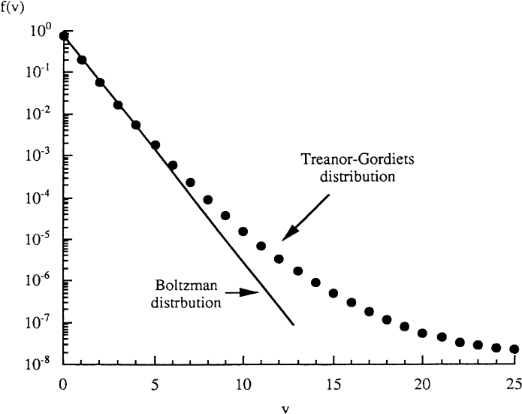

## Fig. 22.6. Treanor-Gordiets distribution of the vibrational states of N2 (X) for a characteristic temperature θX,0,1 = 2600 K and a gas temperature Tg = 823 K, [N2(X,v > 4)]= 3 1013 cm-3 for an

* 1. **Ar-0.2 N2 gas mixture at 7 Torr**

The obtained value [N2X,v<4]=3 1013 cm-3 is largely less than the N atom density ([N] = 6 1014 cm-3). Then, it can be argued that N atoms are the most populated active species to nitride the workpieces in the flowing post-discharge reactor.

Moreover, it has been observed that the introduction of few H2 (0.25-1%) into N2, which increased the N atom production, produced an extinction of the Na emission.

Then, the N atoms are clearly the dominant nitriding species in N2-(0.25-1%) H2 gas mixtures. Then the yellow diffuse emission of the afterglow was well characterized by the I580 nm intensity.

The spatial distribution of N-atoms in the post-discharge reactor is reproduced in Fig. 22.7 in configuration (a) of Fig. 22.5a for an Ar-50%(N2-0.5% H2 gas mixture at 7 Torr, 3 slpm, 500 W and a gas temperature of 380 K.

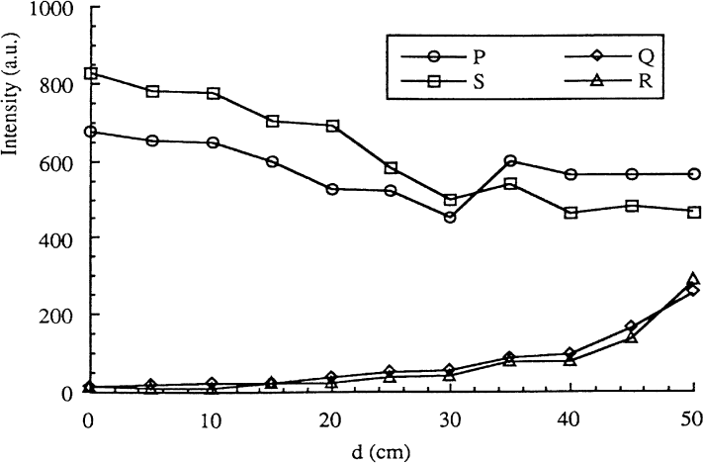

## Fig. 22.7. Intensity of N2 (B,v’= 11) state versus distance d from the discharge tube exits (see Fig. 21.5a) for an Ar-50% (N2-0.5% H2) gas mixture at 7 Torr, 3 splm, 500 W and a gas temperature of 380 K. The curves P and S along the afterglow jets and the curves Q and R in perpendicular directions (see Fig.22.5b)

The I580 intensity (proportional to [N]2, see eq.1) is reproduced versus the distance (d) from the discharge tube exits (see Fig. 22.5a). The curves (P) and (S) are obtained in the direction of post- discharge jets and the curves (Q) and (R) in the perpendicular direction as described in Fig. 22.5b. In the direction of post-discharge jets, the N atom spatial distribution is quasi-homogeneous.

In the perpendicular direction, the N atoms are hardly detected near the discharge tube exit (d = 0) and are present at the bottom of the reactor, as a result of the recirculation of N atoms.

Indeed, the gas flow in configuration (a) is practically the same as that represented in Fig. 22.5b where three iron rods are introduced in the reactor. The influence of the presence of the rods on the gas flow can be neglected in the first step because of the small diameter (3 cm) of these rods when it is compared to the reactor dimensions.

Three pure iron rods have thus been set up inside the reactor (Fig. 22.5b) and nitrided at T = 823 K. The treated parts of rods standing in front of the post-discharge jets (what is named the north generatrix in Fig. 22.5b) are shown in the micrographs of Fig. 22.8.

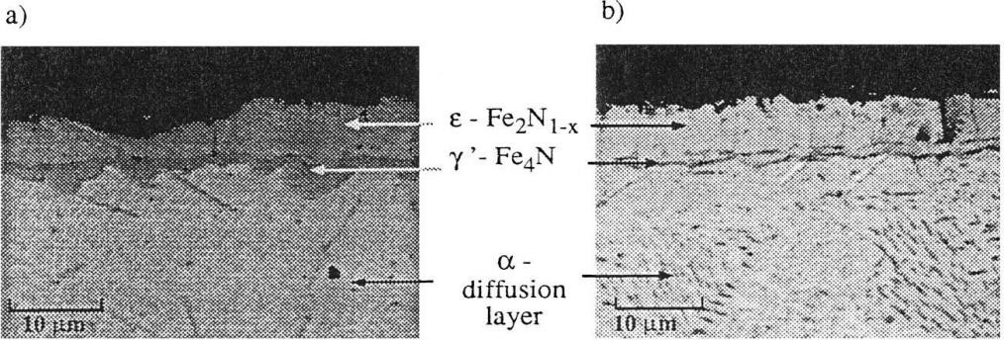

## Fig. 22.8. Cross-section micrograph of compound and diffusion layers in pure iron. The samples were nitrided for 2 h at 823 K in front of the post-discharge jets in a Ar-50% (N2- 0.25% H2) flowing post-discharges at 7 Torr, 1.5 slpm and 500 W (reactor of Fig. 22.5a).

* + 1. **d = 20 cm and (b) d = 13 cm**

A thick ε-layer is obtained after a 2 h treatment. Along the south generatrix (see Fig. 22.5b), the ε and the γ’ layers were absent on the surface rods and only the α diffusion layer was detected.

However, at the bottom of the rods (d = 45 cm), on south generatrix, nuclei of ε and γ’ have been detected in relation with the N atom recirculation as shown in Fig. 22.9.

The thickness of ε and γ’ layers versus the distance d from the discharge tube exit are reproduced in Fig. 22.9 for the surface rod in front of the post-discharge jets.

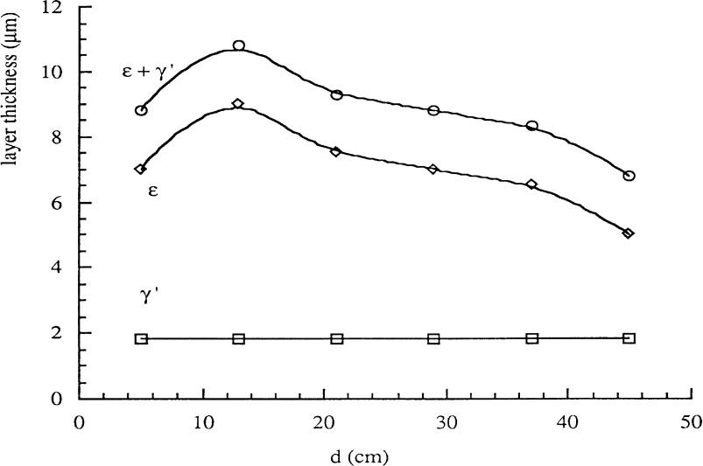

## Fig. 22.9. Thickness of ε , γ’ and ε+ γ’ layers versus distance d from the discharge tube exit (surface rods in front of the post-discharge and for experimental conditions of Fig. 22.8)

The total thickness was about 10 μm for a 2 h treatment and kept a nearly constant value from d = 4 to 45 cm. A good correlation is found here between the spatial distribution of the N atoms in the post- discharge jets as shown in Fig. 22.7 and the nearly constant values of the thickness of the nitrided layers as reproduced in Fig. 22.8. Note also that the N atom density in the post-discharge jets is high enough to synthesize an ε nitride layer of constant thickness over 50 cm on the iron rods. Also, a small decrease of N atom density along the jets will not be detrimental to the homogeneity of the nitrided layers.

## 22.3- THE IRON CARBONITRIDING IN N2-CH4 AFTERGLOWS

As it was discussed before, the microstructure of the nitrided zone consists of a surface compound layer and a diffusion zone underneath the compound layer. Depending on the nitrogen content in the gas mixture, the compound layer may be constituted by ε-Fe2–3N or γ’-Fe4N phases or a mixture of both. Carbonitriding is a variant of nitriding. It makes it possible to produce an ε-Fe2–3N combination layer directly in contact with the α diffusion layer by simultaneous diffusion of nitrogen and carbon in iron.

Such a configuration is reported to have better tribological properties than the ε-Fe2–3N + γ’-Fe4N or only γ’-Fe4N configurations [5]. It is possible to obtain this configuration of the compound layer whatever the carbonitriding process: salt bath, gas phase at atmospheric pressure or even assisted by a low-pressure plasma, considering temperature, nitrogen and carbon concentration constraints. Initially these constraints were only resolved by experimental implementations. From 1993 the precise plot of the isothermal sections of the Fe-C-N diagram carried out in [6] made it possible to show that this particular morphology had a thermodynamic origin.

There was a restricted two-phases domain α + ε between 510°C and 570°C for a minimum nitrogen content of 5.5 wt% of nitrogen corresponding to the γ' phase in the binary Fe-N system and a carbon content between 0.7 and 1.2 wt%. This two-phases domain made it possible to ensure the direct transition between ε and α during a carbonitriding experiment.

The metallographic cross section of an iron sample nitrided in an Ar - 11% N2 post-discharge shown in Fig. 22.3 corresponds precisely to the γ’/α configuration as confirmed by the associated X-ray diffraction diagram (XRD) analysis.

The presence of a thin surface layer of iron oxide (Fe3O4) revealed by this analysis shows that the steel substrate is very sensitive to oxidation, resulting in part from water and air impurities in the reactor. In order to avoid this problem, H2 gas can be introduced into the N2 used in the ion nitriding process.

Here, we intentionally did not introduce any hydrogen into the reactor because the objective was to test the influence of CH4 on the nitriding reaction.

The metallographic cross-section of an iron sample nitrided at the same temperature 570°C with the same nitrogen percentage but in the presence of methane (Ar-11% N2-5 10-5 % CH4) is presented in figure 22.10b. As previously, the combination layer obtained under these conditions also appears to be single-phase. However, its thickness is higher. The associated XRD shows that this layer is in reality mainly made up of an ε phase in accordance with the predicted thermodynamic calculations [6] and that the γ' nitride is only present there in the form of precipitates resulting from the natural cooling of sample in the oven. It should be noted that this type of ε-γ’ transformation, which appears during cooling of the samples, has been the subject of an in-depth study [7].

Incidentally, we can see that the introduction of CH4 even in very low concentration in the nitriding medium makes it possible to avoid the surface oxidation of the samples during treatment. Fortunately, the atomic carbon density necessary to ensure the stability of the ε phase is low enough not to decrease the atomic density of nitrogen, which makes it possible to reach the critical nitrogen content of the growing layer. Such a low atomic carbon density also avoid the formation of cementite or carbon films as could have been the case according to Fig. 22-10b for higher atomic carbon densities. It should also be noted that according to the isothermal sections of the Fe-C-N diagram between 510°C and 570°C, the ε carbonitrided layer can be obtained according to a wide range of N concentrations and thus lead to a wide range of physical and chemical properties of the carbonitrided surface.

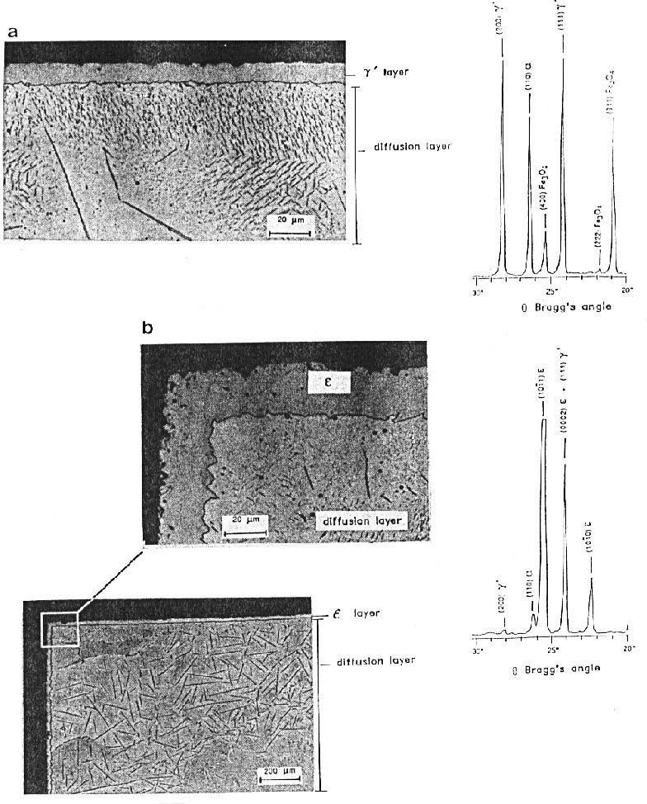

## Fig. 22.10. Micrographs of pure iron nitrided by a 3 h treatment in a microwave Ar–N2–CH4 post- discharge plasma (reactor of Fig. 22.2 at 130 W, 42 Torr, 3 slpm, δt = 10−1 s): (a) Ar–11% N2 with [N] = 5(±1) × 1015 cm−3 and (b) Ar–11% N2–5 × 10−5 CH4 with [N] = 4.9 × 1015 cm−3 and [C] = 1.6 ×

**1013 cm−3. X-ray diffraction diagrams are also shown**

With the reactor of Fig.22-2, carbonitrided layers have been obtained on iron surfaces by heating the samples with an external furnace up to 823 K. This temperature is chosen to obtain a satisfactory diffusion of N and C atoms inside the iron sample. It has been observed that at such a high temperature, the density of N atoms kept a nearly constant density in the gas phase, but that of C atoms decreased by one order of magnitude. By increasing the pressure up to 30 Torr, the C atom density increased to (3–4) 1012 cm-3 and the N atoms remained to a density of 2 1015 cm3. Thus, by choosing the following treatment conditions: p = 32 Torr, Q = 1 slpm, 150 W, treatment time 2 h., it was obtained the coating layers as reproduced on the micrograph of Fig. 21.10. To avoid the oxide layer formation, a pretreatment with an Ar–50%H2 post- discharge at 4 Torr, 0.3 slpm, 50 W was produced during the rise of furnace temperature. After the treatment, the sample was slowly cooled. It was covered by a fine layer of soot. As shown in Fig. 22.11, it was obtained an ε + γ’ layer 5–6 μm thick over an α layer. About 1 wt % of C atoms was measured in the ε + γ’ layer by atomic probe microanalysis in accordance with the predicted isothermal sections with an electron microprobe analysis, about 1 wt% of C was found in the compound layer in accordance with the predicted isothermal sections of the Fe-C-N diagram at 570°C.

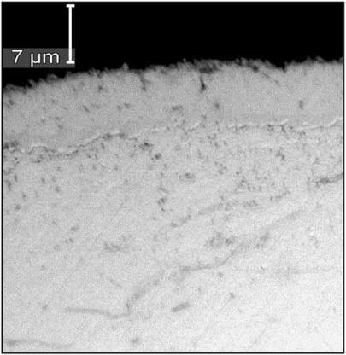

## Fig. 22.11. Micrography of iron surface after a treatment by a N2–0.05%CH4 gas mixture at 823 K during 2 h., at 150 W, 32 Torr and 1 slpm; ε + γ’ layer of 5–6 μm and α layer inside; 1% C in the ε

**+ γ’ layer**

## 22.4 - CONCLUSION

The introduction of H2 into N2 has the main interest to remove the oxide layers, allowing a better nitriding process with the hard ε-layers. Also, a few CH4 into N2 enhanced the thickness of the ε-iron nitride layers.

To avoid films damage by the plasma high energy electrons, remote plasmas have given satisfactory results for iron nitriding with hard coatings.

## REFERENCES

1. Lebrun JP, Michel H, Gantois M. Mem. Sci. Rev. Metal. 1972;69:727.
2. Czerwiec T, Michel H, Bergmann E. Low pressure, high density plasma nitriding: mechanisms, technology and results, Surf. and Coating Tech. 1998;108-109, 182.
3. Ricard A. The production of active plasma species for surface treatments. J. Phys D AP 1997;30:2261.
4. Ricard A, Czerwiec T, Belmonte T, Bockel S, Michel H. Detection by emission spectroscopy of active species in plasma-surface processes, Thin Solid Films. 1999;341:1.
5. Binder C, Bendo T, Hammes G, Klein AN, de Mello IDB. Effect of nature of nitride phases on sliding wear of plasma nitride sintered iron, Wear. 2015;332-333, 993.
6. Du H. A reevaluation of the Fe-N and Fe-C-N systems. J. of Phase equilibria. 1993;14:682.
7. Gerardin D, Michel H, Gantois M. [Microstructure de couches de carbonitrures de fer obtenus à](https://www.sciencedirect.com/science/article/pii/0036974877901089) [l'aide de traitements thermochimiques par bombardement ionique.](https://www.sciencedirect.com/science/article/pii/0036974877901089) Scripta Metallurgica. 1977; 11:557.