**Yttrium-Doped γ-Glycine Crystals for Enhanced Nonlinear Optical Applications**

### ABSTRACT

The γ-glycine nonlinear optical (NLO) crystal was grown using the slow evaporation technique at room temperature. Powder X-ray diffraction analysis confirmed the γ-phase structure of the crystal. The influence of additives on the optical transparency of the glycine crystal was evaluated through linear optical transmittance studies. Differential scanning calorimetry (DSC) was performed to examine the material's thermal stability and potential polymorphic phase transitions. The second harmonic generation (SHG) efficiency of the synthesized crystal was found to be 3.5 times higher than that of the standard KDP crystal.

**Key words:** Physicochemical properties; Dielectrics; NLO Applications;

1. **INTRODUCTION**

The demand for advanced nonlinear optical (NLO) materials has surged due to the critical role optical technologies play in modern society. Optical fibers, widely used in telecommunications, optoelectronics, optical communication, and data storage, are integral to the development of ultrafast systems [1-3]. This rapid advancement has amplified the need for materials that exhibit superior nonlinear optical properties. Organic materials, particularly amino acid-based crystals, offer significant advantages over their inorganic counterparts in terms of tunable nonlinear optical efficiency and faster response times. The incorporation of electron donor-acceptor groups in organic NLO complexes contributes to their unique asymmetric charge distribution, which is responsible for their nonlinear optical behavior [4-8]. However, organic crystals often suffer from weak mechanical, thermal, and damage threshold properties, making them susceptible to damage during processing. In contrast, inorganic materials, despite their robust mechanical and thermal properties, exhibit limited nonlinear optical properties due to the lack of electron delocalization [9-10]. To bridge these limitations, researchers have focused on combining organic and inorganic materials, such as amino acids with various metal ions, to create materials that can rival the performance of traditional inorganic nonlinear optical materials like Potassium dihydrogen phosphate (KDP) and niobates [11, 12].

In this context, yttrium-doped γ-glycine crystals represent a promising candidate for enhanced nonlinear optical applications. The combination of yttrium ions with γ-glycine not only enhances the material's nonlinear optical properties but also opens the door to potential biomedical applications [13-15]. These crystals are being investigated for their optical transparency, dielectric properties, and ability to withstand laser irradiation, along with their thermal stability and chemical resistance [16-17]. The incorporation of yttrium aims to further improve the performance of γ-glycine crystals, making them suitable for advanced nonlinear optical devices. This work explores the growth and characterization of yttrium-doped γ-glycine crystals, focusing on their nonlinear optical behavior.

**2. Experiment**

*2.1. Crystal growth*

The experiment utilized commercially available glycine and yttrium nitrate. To prepare the saturated glycine solution, double-distilled water was added to a beaker, followed by the addition of 0.05 M yttrium nitrate. The mixture was stirred for 5 hours using a magnetic stirrer to ensure uniform saturation. The resulting solution was filtered using a Whatman No.1 filter paper and transferred to a 30 mm crystallization dish that had been thoroughly rinsed. The dish was then covered with a holed lid to prevent vibrations and placed in a temperature-controlled room, allowing the solvent to evaporate gradually. After 38 days, high-quality single crystals with dimensions of 12x14x11 mm³ were obtained, as shown in Fig. 1.

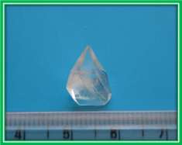

**Fig. 1. Image of the crystal.**

**3. Results and discussion**

***3.1. PXRD analysis***

The Powder XRD analysis was conducted using a Bruker AXS D8 Advance X-ray diffractometer with Cu Kα (λ=1.5406 Å) radiation, scanning the range from 10˚ to 50˚ at a rate of 1˚ per minute, as shown in Fig. 2. The grown crystal exhibits a γ-polymorphic structure with a hexagonal symmetry, belonging to the non-centrosymmetric space group P31. The Powder XRD pattern confirms the high crystallinity of the crystals. The lattice parameters were calculated from the data, yielding values of a = 7.131, b = 7.131, and c = 5.762 [18]. Although there are minor differences in the unit cell dimensions between the standard and grown γ-glycine crystals, these variations may be attributed to the influence of the growth process on the crystal. Despite this, the yttrium ion did not alter the structure or space group of the γ-glycine crystals.

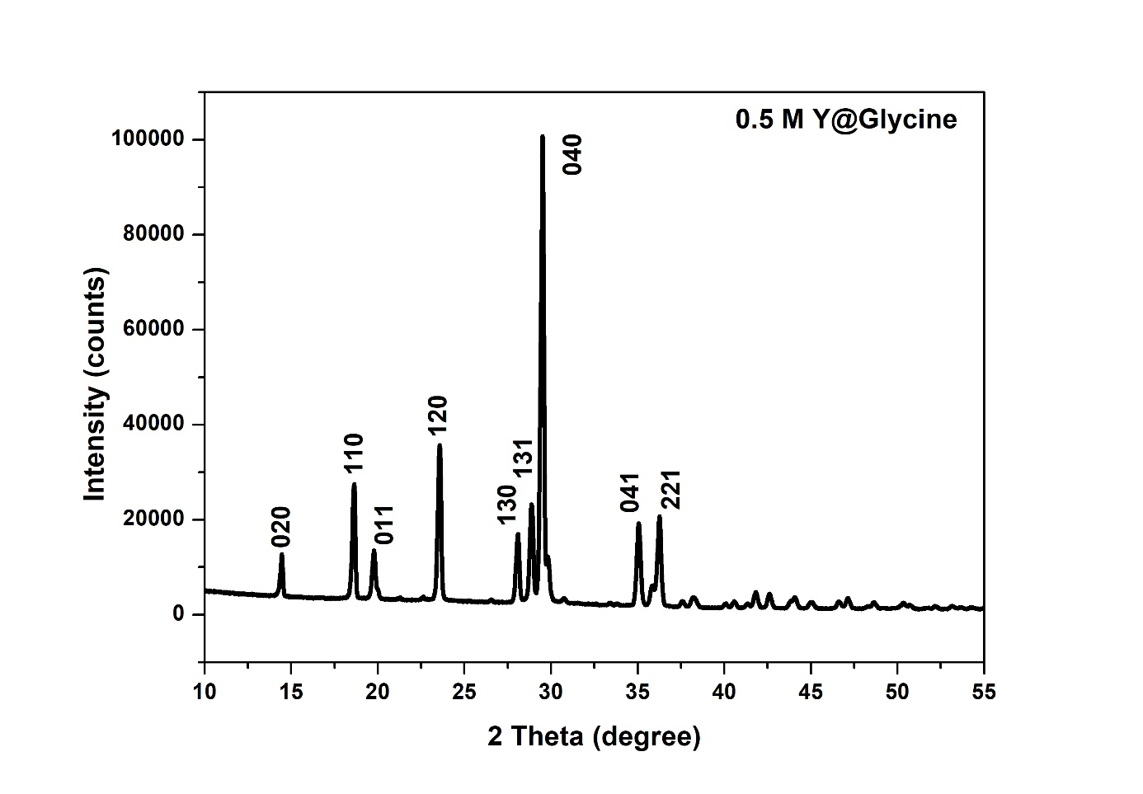

**Fig. 2. PXRD spectrum of obtained crystal**

***3.2. ICP- OES Studies***

An ICP-OES analysis was performed to confirm the presence of yttrium in the grown crystal. The yttrium content in the doped glycine crystal was quantified to determine its precise weight percentage. A solution was prepared by dissolving 10 mg of finely powdered doped glycine crystals in 30 ml of deuterium-depleted water, which was then analyzed using ICP. The results revealed that out of 0.05% of the added dopant, 0.025% was yttrium. This indicates that doped crystals incorporate a lower percentage of the dopant compared to the initial solution [19].

***3.3. UV-Vis Analysis***

The optical properties of the grown crystal were analyzed across the wavelength range of 190 nm to 800 nm, as illustrated in Fig. 3. The compound demonstrates high transparency throughout the scanned spectrum, with a wavelength cutoff at 225 nm. The maximum linear optical transmittance of 85% observed in the crystal can be attributed to various factors that influence optical transmittance, including material composition, allowed electron transitions, molecular anisotropy, structural defects, and crystalline imperfections. The enhanced transmittance may be due to yttrium's lower absorbance properties. The results indicate that the developed γ-glycine crystal exhibits fewer scattering centers and reduced defects such as voids, striations, impurities, and inclusions, which collectively contribute to improved optical transmittance [18-19].

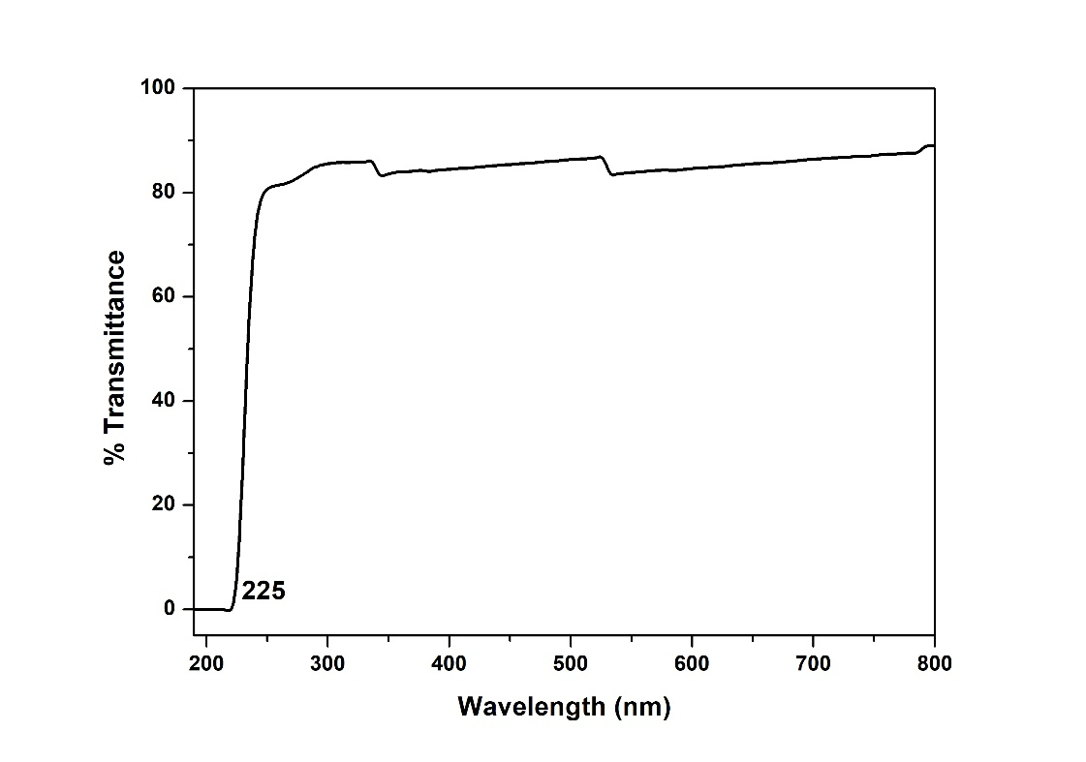

**Fig. 3. UV-Vis transmittance spectrum of grown crystal**

***3.4. Differential scanning calorimetry (DSC) analysis***

Differential Scanning Calorimetry (DSC) analysis was conducted to identify the presence of additional polymorphic forms in the grown crystal, as shown in Fig. 4. The γ-glycine sample was heated in an alumina crucible, revealing an endothermic peak at 202–204°C on the recorded spectrum prior to melting. This confirms that the nucleated samples are γ-glycine. The melting point of the grown crystal was observed at 256.8°C. Previous studies have reported the γ-to-α polymorphic transition to occur between 165°C and 205°C [20–21]. In the present study, the yttrium nitrate-doped glycine crystal demonstrated stability up to 203.6°C.

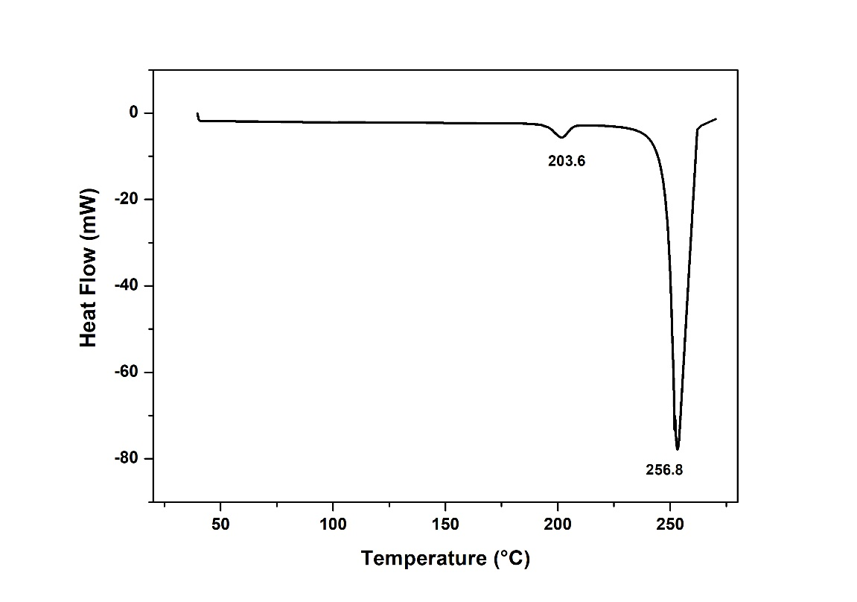

**Fig. 4. Differential Scanning Calorimetry thermogram of the grown *γ*-glycine crystal**

***3.5. Dielectric studies***

To safeguard the experimental data, a high-quality γ-glycine crystal with a thickness of 1 mm was coated with silver electrodes on both sides for dielectric analysis. The dielectric properties were measured using a HIOKI (Model 3532-50) LCR HITESTER over a frequency range of 50 Hz to 5 MHz. **Fig. 5(a)** illustrates the plot of dielectric loss (tan δ) versus logarithmic frequency, while **Fig. 5(b)** displays the plot of the dielectric constant (εr) versus logarithmic frequency.

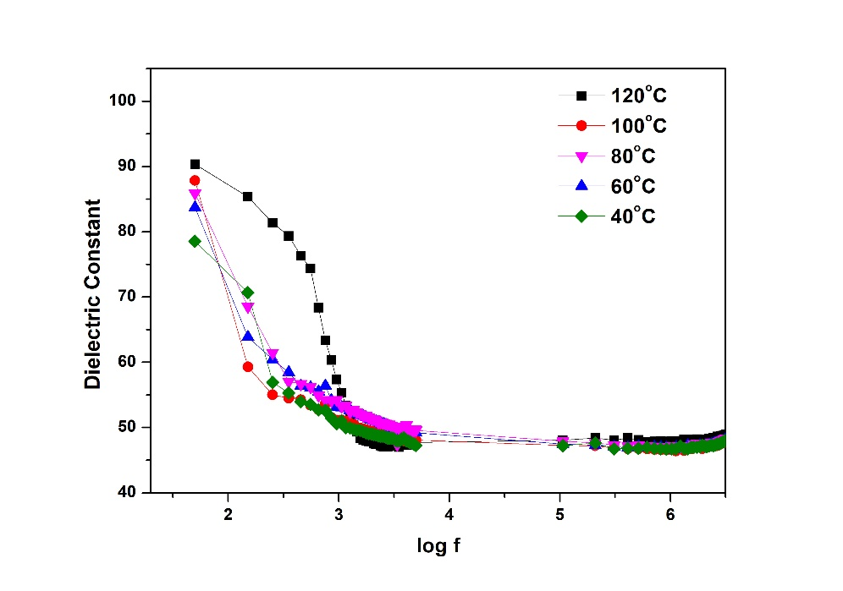

**Fig. 5 (a). Plot between log f and dielectric constant**

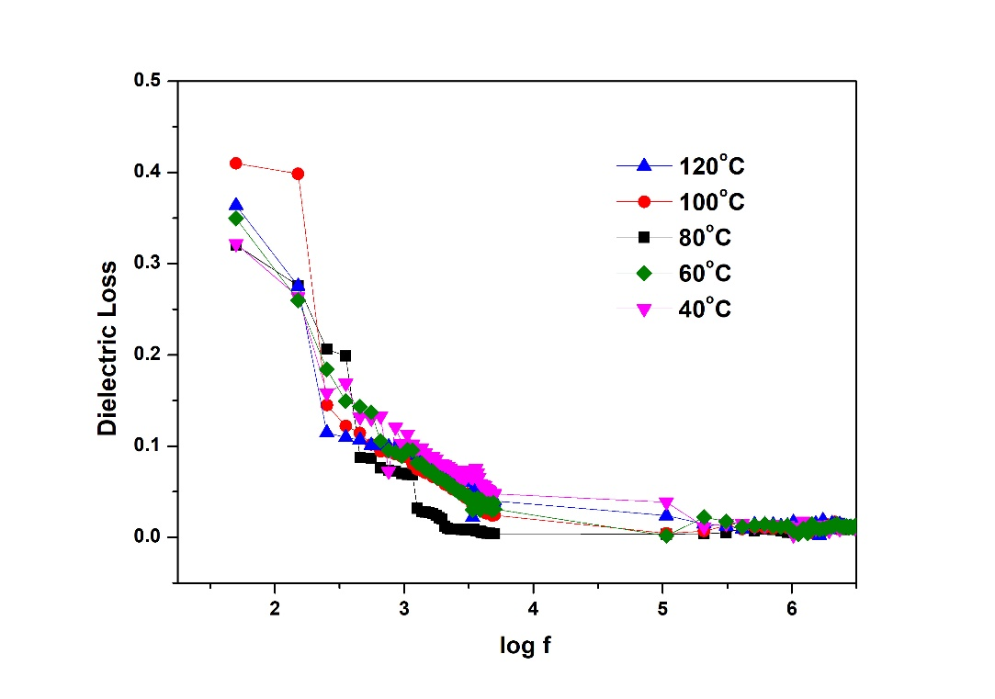

**Fig. 5 (b) Plot between log f and dielectric loss**

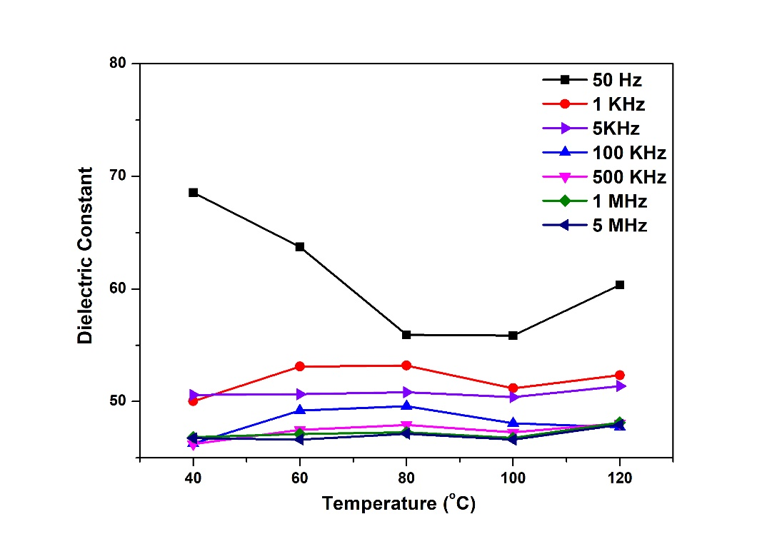

**Fig. 5 (c) Plot between temperature and dielectric constant**

The graph indicates that polarization mechanisms such as dipolar, electronic, ionic, and space charge polarizations influence the dielectric properties. Both the dielectric constant and dielectric loss exhibit a sharp decline at lower frequencies [10–11]. With increasing frequency, the dielectric constant gradually decreases and eventually stabilizes at higher frequencies. **Fig. 5(c)** illustrates the temperature dependence of the dielectric constant, while **Fig. 5(d)** depicts the dielectric loss across various temperatures ranging from 40°C to 120°C for different frequencies. These results confirm that both parameters increase with rising temperature, primarily due to the contribution of space charge polarization.

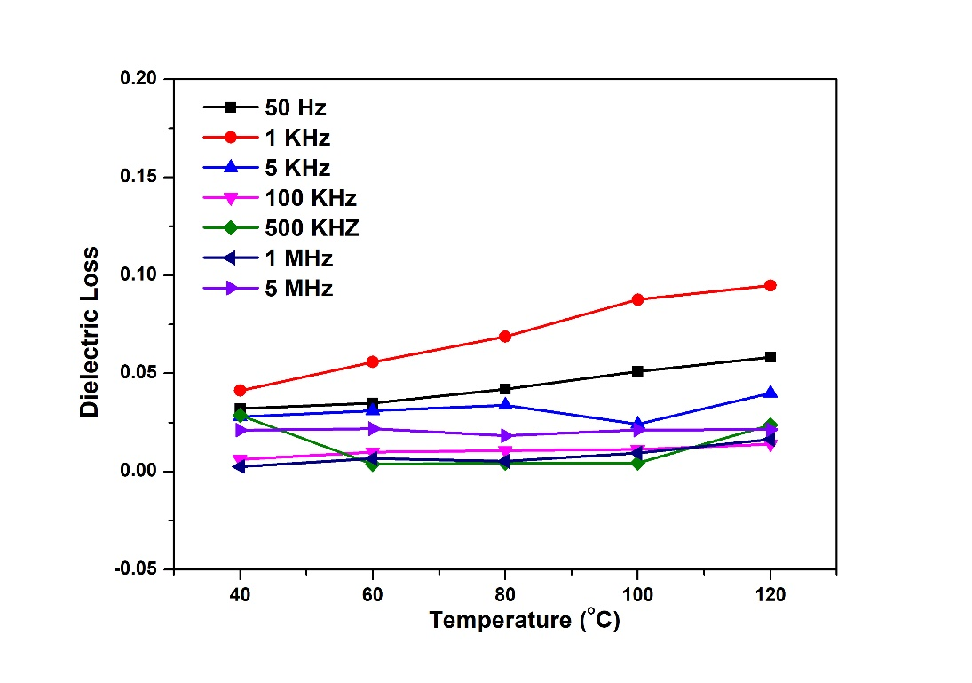

**Fig. 5 (d) Plot between temperature and dielectric loss**

Space charge polarization is typically active at low frequencies and elevated temperatures. Dielectric loss is influenced by several defects, including grain boundaries, vacancies, micro- and macro-fractures, porosity, inclusions, and irregular crystal growth [11,19–21]. The lower dielectric loss observed in the grown crystals indicates improved optical quality and reduced imperfections. This characteristic is essential for the suitability of these crystals in optoelectronic and photonic device applications.

## *3.6. Second harmonic generation analysis*

In this experiment, the grown crystal was finely powdered into uniform grains of approximately 150 µm and placed inside a seamless micro-tube for SHG analysis. The sample-filled capillary tube was mounted in a sample holder and subjected to multiple pulses of the Gaussian beam from an Nd:YAG laser in Q-switched mode. The output signal from the crystal was captured using a photomultiplier tube array and converted into an electrical signal, which was displayed on an oscilloscope. The measured SHG output for the reference KDP crystal was 24 mV, whereas the γ-glycine crystal produced an output of 84 mV. This indicates that the γ-glycine crystal exhibits significantly higher SHG efficiency than the KDP crystal. This enhancement is likely due to increased charge transfer across the donor-π-acceptor moieties and the incorporation of organic components, which introduce sub-energy bands below the band gap, resulting in a higher nonlinear optical response [11].

**4. Conclusions**

A γ-glycine crystal with enhanced optoelectronic properties was successfully grown using the solvent evaporation method with 0.05 M of yttrium nitrate as an additive. Powder XRD analysis confirmed the γ-phase with a hexagonal structure and a non-centrosymmetric P31 space group, highlighting its suitability for optoelectronic applications. UV-Visible spectroscopy demonstrated significant optical transparency across the UV-Visible range, supporting its potential in nonlinear optical devices. Thermal analysis revealed stability up to 203.6°C, and SHG studies showed the crystal’s second-order nonlinear optical efficiency to be 3.5 times greater than that of the KDP crystal. These results emphasize that yttrium nitrate effectively improves the physicochemical properties of γ-glycine crystals. The crystal's notable optical and dielectric characteristics suggest its application in advanced piezoelectric, optoelectronic, and nonlinear optical technologies.

**References**

1. C. Ji, T. Chen, Z. Sun, Y. Ge, W. Lin, J. Luo, Q. Shi, M. Hong Cryst. Engg. Comm. 15 (2013) 2157-2162.
2. B Thilagarajeswari, P Sathya, P Dhanasekaran, S Meyvel, Optik (2020) 215, 164746.
3. Mohd Anis, S.P. Ramteke, M.D. Shirsat, G.G. Muley, M.I. Baig Opt. Mater. 72 (2017) 590-595.
4. T. Balakrishnan, R. Ramesh Babu, K. Ramamurthi Spectrochem. Acta A 69 (2008) 1114-1118.
5. Mohd Shkir, V. Ganesh, S. AlFaify, I.S. Yahia, Mohd Anis Chn. Phys. B 27 (2018) 54216-54224.
6. V. Subhashini, S. Ponnusamy, C. Muthamizhchelvan J. Cryst. Growth 363 (2013) 211-219.
7. Ming Li, Mingjun Xia, Huining Xiao, Chem. Sel. 2 (2017) 5882–5886.
8. Vijayalakshmi, V & Dhanasekaran, P, Optik, 173 (2018) 65-70.
9. Imran Khan, Mohd Anis, Umar Bhati Optik 170 (2018) 43-47
10. R.N. Shaikh, Mohd Anis, M.D. Shirsat, S.S. Hussaini, Optik 154 (2018) 435–440.
11. V.Vijayalakshmi, P.Dhanasekaran and N.M. Ganesan, *Molecular crystals and Liquid crystals, 664* (2018) 241-250.
12. V.Vijayalakshmi and P.Dhanasekaran, *J. Cryst. Growth* 498 (2018) 372-376.
13. J.Aarthi, P.Dhanasekaran, T.S.Senthil and N.M.Ganesan, Crystal Research and Technology 53(6) (2018) 1700190
14. D Depan, R D K Misra, Materials Science and Engineering C, 34 (2014) pp. 221-228.
15. Zheng Ma, Ling Ren, Rui Liu, Ke Yang, Yu Zhang, Zhenhua Liao, Weiqiang Liu, Min Qi, R.D.K. Misra Journal of Materials Science and Technology, 31 (2015) 723-732.
16. V Vijayalakshmi, P Dhanasekaran, Journal of Crystal Growth, (2019) 509, 44-49.
17. M S Sundaram, V Vijayalakshmi, P Dhanasekaran, ON Balasundaram, Journal of Physics: Conference Series, (2019) 1172 (1), 012072.
18. R.D.K. Misra, B. Girase, Dilip Depan, J.S. Shah, Advanced Biomaterials, 14 (2012) B 93-100.
19. V. Vijayalakshmi, P. Dhanasekaran & N.M. Ganesan, Journal of Crystal Growth, 493 (2018) 30-33.
20. B Thilaga Rajeswari, P Sathya, P Dhanasekaran, G Vinitha, S Meyvel, Journal of Materials Science: Materials in Electronics 32 (18), (2021) 22984-22998.
21. K. Renuka Devi, K. Srinivasan, *Cryst. Res. Technol*., (2015) 1–6.