Isolation, Purification and Characterization of Xylanase Enzyme from Bacillus sp. in Solid State Fermentation

ABSTRACT
Aim: Xylanases are extensively applied in paper and pulp industries as well as during preparation of baked products to improve their quality. Additionally, it is also used in coffee, oil and starch industries in order to increase their nutritional values.
Place and Duration of the Study: Azyme Biosciences Laboratory, Bangalore. Experiment conducted between January 2021 and June 2021.
Methodology: In the present study, soil samples were collected near saw mills in various localities of Bangalore urban to isolate organisms for the production of xylanase using solid state fermentation. Six organisms were isolated using selective media based on their morphological characters. Among them one organism showed maximum production of xylanase enzyme identified as Bacillus sp based on their biochemical test and 16s RNA sequencing. Solid substrate fermentation was carried out using various agro wastes such as sugar cane bagasse, saw dust, paddy husk, wheat straw and orange peel powder.
Results: In the results, production revealed that sugarcane bagasse showed maximum production of enzyme Bacillus sp compared to other substrates with different physical parameters such as pH 8, temperature at 35 ◦C after 72 hrs incubation. Trace element such as Mg⁺⁺ enhances the production of enzyme more than 22% compared with other metal ions like Ca⁺⁺, Mn⁺⁺ and Fe⁺⁺. After production, enzyme purified by using three step methods such ammonium sulphate precipitation, dialysis, ion exchange and gel filtration. Fold purification was increased up to 12 fold, yield 36% and molecular weight of enzyme was 62 KDa determined using SDS PAGE.
Conclusion: Bacillus sp shown in this experiment is capable of producing xylanase enzyme when subjected to different physical parameters.

Keywords: Fermentation, Ion exchange chromatography, SDS-PAGE, SSF, Xylanase.

- INTRODUCTION

Xylan is the primary component of hemicellulose found in plant cell walls, making up to 35 % of the total dry weight of higher plants in tropical biomass [1]. It represents a significant and renewable source of biomass for biorefineries [2]. Additionally, hemicellulose accounts for approximately 10% to 12% of solid waste by dry weight [3]. The heterogeneous structure of xylan requires various types of enzymes to effectively degrade it, including those that cleave the backbone and sidechains. Xylanases are essential enzymes that facilitate the hydrolysis of xylan backbones. They have a wide range of applications in industries such as animal feed, food production, bioethanol, detergents, and paper pulp [4]. The enzymatic process can be used for the degradation of these materials involving the use of microbial enzymes that are less polluting, environmental approachable, energy saving and subordinate disposal glitches. Microorganisms such as bacteria, fungi and actinomycetes are established to be the amusing cradles of xylanases [5]. Though many microorganisms have been isolated for enzyme production, there is silent requisite for novel strains accomplished in producing better pinnacles of enzyme [6]. β-1,4-Xylans are heterogeneous polysaccharides found in the cell walls of almost all plant parts. Hydrolysis of their characteristic backbone consisting of β-1,4-linked D-xylosyl residues, involves β-1,4-xylanases (1,4-p-D-xylan xylanohydrolase; EC 3.2.1.8) and β-xylosidases (1,4-p-D-xylan xylohydrolase; EC 3.2.1.37) [7].

Xylanase is a biocatalyst that degrades xylan into reducing sugars, such as xylose and xylobiose [8,9]. This enzyme is used in the paper manufacturing industry to bleach paper pulp and enhance the brightness of the pulp without relying on toxic and expensive chemicals [10]. Xylanase has numerous industrial applications, including in the paper, pulp, juice, bakery, and beer industries [11]. Additionally, xylanase is employed in the pre-treatment of lignocellulosic biomass for bioethanol production and in the processing of barley and wheat to improve the nutritional properties of animal feed [12]. This enzyme is produced by various bacteria and fungi, making it valuable for both industrial and environmental applications [13]. Industries that utilize xylanase include paper and pulp production, baking (to improve dough handling and the quality of baked goods), coffee extraction, plant oil processing, starch production, enhancement of nutritional properties in silage and grain, and in combination with pectinase and cellulase for fruit juice clarification. The textile industry also applies xylanase for the degumming of plant fibers, enhancing fiber quality [14,15]. The main sources of xylanase are microorganisms, particularly bacteria and fungi. Two of the most active strains identified are Streptomyces albus and Streptomyces chromofuscus [16]. A nonpathogenic and non-toxigenic wild type of Bacillus subtilis can serve as a host strain for development. Thermoalkalophilic Arthrobacter sp. produces extracellular xylanase when wheat bran, rice husk, rice bran, and sugarcane bagasse are used as carbon sources under solid-state fermentation (SSF) [17]. SSF is effective for producing xylanase from various lignocellulosic materials, including wheat bran, rice husk, rice bran, soya bran, ragi bran, and bagasse [18].

The fungal strain Aspergillus niger also contains xylanase. In some higher plants and agricultural wastes, xylan constitutes 20% to 40% of the dry weight. Therefore, wheat bran and rice husk can be sourced from local flour mills, while rice straw and sugarcane bagasse can serve as additional substrates. Research on xylanase has significantly increased due to its potential applications in various industries, including pulping and bleaching processes that use cellulose-free preparations, textile processes, enzymatic saccharification of lignocellulosic materials, and waste treatment. Interest in xylanases and other xylanolytic enzymes has surged in recent years, primarily because of their potential use in the pulp and paper industry, especially in bleaching processes. These applications require enzymes that are highly specific for the hydrolysis of hemicelluloses, as this helps preserve the cellulose structure during the biopulping process [19].

Xylanases are utilized as bleaching agents in the processing of chemical or thermomechanical pulps. It is essential for the enzyme to meet the requirements of the process rather than the process conforming to the enzyme's needs. Therefore, an ideal enzyme for a bleaching procedure should be robust at high temperatures and pH levels [20,21]. One of the main challenges faced by the pulp and paper industry when using enzyme treatments is the availability and cost of these enzymes. Approximately 30% to 40% of the production cost of many industrial enzymes is attributed to the cost of growth substrates [22]. One effective way to significantly reduce production costs is by utilizing low-cost substrates for enzyme production, such as solid agricultural waste materials. Most xylanase producers are isolated from soil. The isolation from soil requires screening of multiple soil samples and microorganisms [23-26], culture enrichment steps [27,28], and serial dilutions [29]. The aim of this research is to evaluate the potential of xylanase enzymes from soil samples collected from sawmills in Bangalore, India, and to isolate xylanolytic Bacillus species. Additionally, this study will determine the xylanase production levels of the isolates and partially characterize the enzyme. The experimental conditions assessed will include media pH, incubation period, temperature, and metal ion concentration.

- MATERIALS AND METHODS

  - Screening of Culture and Growth Conditions

An augmentation procedure using xylan as the sole carbon source was employed to isolate xylan-degrading bacteria. This technique was applied to bacterial cultures obtained from thirty soil samples collected from various sawmills of different localities in Bangalore, India. Among these samples, one isolate that produced a significantly higher amount of extracellular xylanases was selected for the current study [19].

  - Isolation of Organism

Soil samples were collected from 10 cm depth from the surface in a sterile polythene bags to the laboratory for isolation [30]. In the isolation process 1 gm of soil is dissolved in 10 ml saline used as inoculum. 1 ml of inoculum was poured into the sterile petriplate, above that xylan modified media (Xylan 0.5%, NaCl 1%, Yeast extract 0.5% and Agar 2%) was added and allowed for solidification. After solidification, plates were incubated for 48 hrs at 37 ◦C, next based on morphological characters, organisms were sub cultured on xylan modified media slants.

  - Screening the Organisms for Xylanase Production

Confirmation for the production of xylanase was carried out by zone of clearance method. In this process xylan modified media was poured into the sterile petriplate and allow it for solidification. After solidification, organisms were streaked on the media in zigzag manner and incubated for 48 hrs at 37 ◦C. Then xylanolytic activity was found after 1% of solution was poured on the media and clear zone was observed surrounding the organisms.

  - Identification of Phenotypic Characteristics

The isolates showed maximum clear zone surrounding the organisms and more activity based on bioassay method. The pure isolates were characterized by means of conventional processes and isolates were identified on the basis of morphological, cultural, chemo-taxonomical characteristics [31] and 16S rRNA sequencing. Results were interpreted according to Bergey’s Manual of Determinative Bacteriology [32] and NCBI database.

  - Xylanase Production in Solid State Fermentation (SSF)

Selected strains subjected for the production of xylanase enzyme using various agro wastes such as sugar cane bagasse, saw dust, paddy husk, wheat straw and orange peel powder. In this process 25 gm of powder and 50 ml of minimal essential broth was taken in 500 ml conical flask and inoculated with 5 ml of culture, mixed thoroughly and incubated for 48 hrs at 35 ◦C. After incubation solid substrate was removed and suspended in 250 ml of 100 mM Tris HCL buffer (pH 7) and agitated thoroughly for 1 hr to extract xylanase enzyme. Media was centrifuged at 12000 rpm for 30 min at 4 ◦C. Supernatant was filtered through Whatman No. 1 filter paper and the clear filtrate was used as crude sample for the estimation of enzyme activity.

  - Xylanase Enzyme Assay

Xylanase activity was measured by modified method [30]. 1 ml of 1% solubilized birch wood xylan solution and 3 ml 50 mM Tris HCL was added to a test tube and pre warm at 37 ◦C. 1 ml of enzyme (Crude sample) was added and incubated at 37 ◦C for 60 min. After incubation, 1 ml of DNS reagent was added and boil for 5 min, then allow to room temperature and absorbance was measured at 540 nm [31]. The reaction was terminated at zero time in the control tubes, the standard graph was prepared using 100-500 μg xylose. One unit of xylanase activity was defined as the amount of enzyme that liberates 1 μM of reducing sugars equivalent to xylose per minute under the assay conditions described.

  - Effect of Physical Parameters for the Growth of Organism

Optimization of physical parameters such as incubation period, pH and temperature were carried out. During the process 25 gm agro waste, 25 gm of powder and 50 ml of minimal essential broth was taken in 500 ml conical flask and inoculated with 5 ml of culture, mixed thoroughly and incubated. For every 24 hrs, 5 gm of solid substrate was removed and subjected for xylanolytic activity, The effect of pH on enzyme activity was determined by incubating xylanase at various pH ranging from 6.0 to 11.0. To evaluate the stability of the enzyme at each pH, the purified enzyme was adjusted to SSF media incubated. Xylanolytic activity was measured spectrophotometrically after incubation. The optimum temperature for maximum xylanase activity was determined by the SSF media varying the reaction temperature from 25 ◦C to 45 ◦C [32].

  - Effect of Trace Element for the Production of Xylanase

Along with SSF media, 0.1 mg of various metal ions such as Mg⁺⁺, Ca⁺⁺, Mn⁺⁺ and Fe⁺⁺ were used for 1 hr at room temperature for the production of xylanase enzyme and in addition to this optimize the concentration of metal ions for the production [33].

  - Purification of Xylanase

The cell free media collected was subjected to different purification steps including ammonium sulphate (NH₄)₂SO₄ precipitation, dialysis, gel filtration and DEAE-cellulose ion exchange chromatography by using gradient elution buffer [34].

  - Molecular Mass Determination by SDS-PAGE

Molecular weight of the purified xylanase was estimated by SDS-PAGE electrophoresis. SDS-PAGE was performed using 4% acrylamide stacking gel and 10% acrylamide separating gel to determine the molecular mass and protein purity, staining was carried out by Coomassie brilliant blue [35,36].

2.11 Statistical Analysis

The experiment was conducted in triplicates and the results were statistically analyzed. All the standards were calculated by regression correlation values and Pearson’s correlation is less than 0.05.

- RESULTS AND DISCUSSION

  - Isolation of Organism

Xylan serves as a vital source of nutrition in media specially modified for promoting the growth of various organisms. Among these organisms, some possess the unique capability to break down xylan into xylose, which is one of the simplest sugar molecules and an important energy source. In our study, we isolated fifteen distinct organisms from soil samples, identified based on their morphology, as illustrated in Fig. 1. These isolated organisms were cultured on specialized screening media to confirm their xylan-degrading abilities. Notably, one organism produced a remarkably large clear zone surrounding its growth, indicating a significant xylanolytic activity compared to the others. This observation is further depicted in Fig. 2, showcasing the organism’s exceptional ability to utilize xylan as a carbon source.
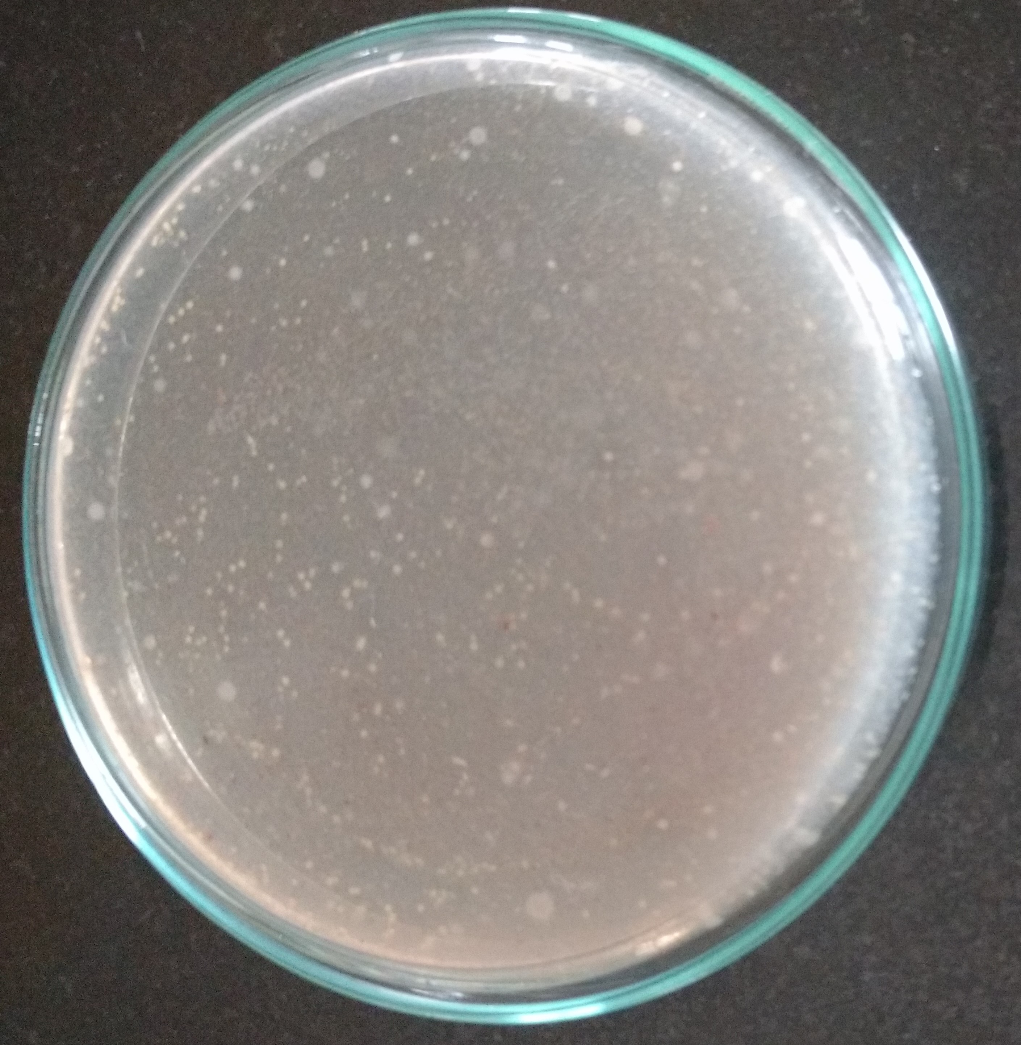
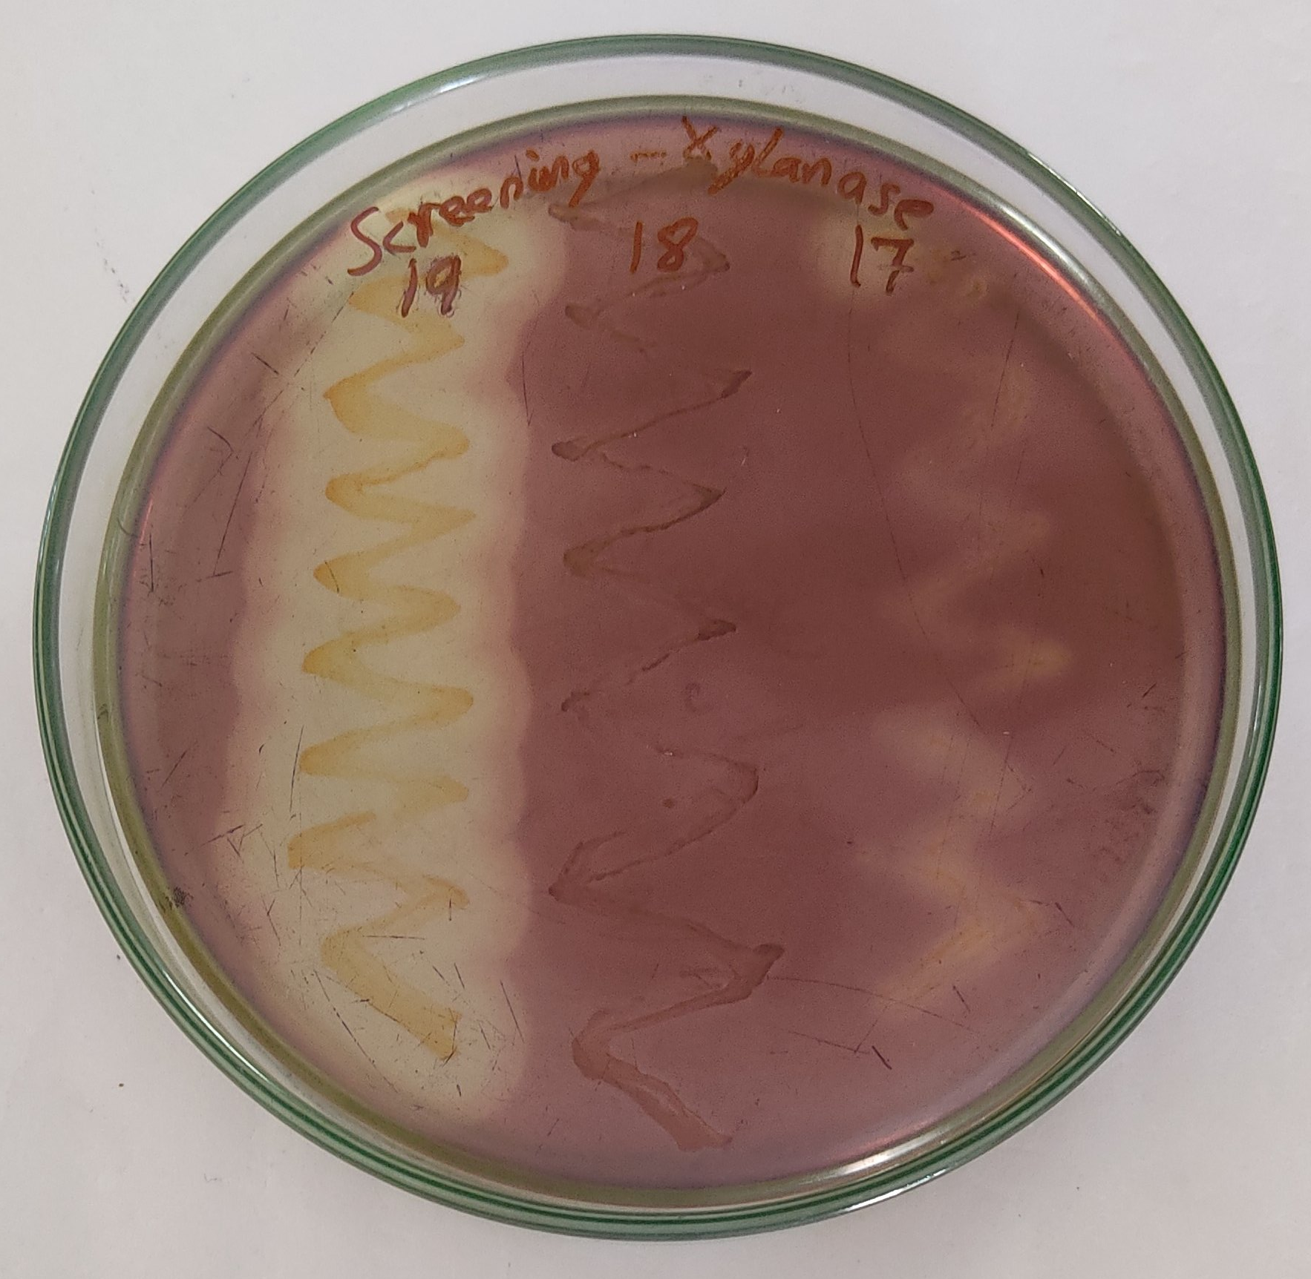

Fig. 1. Isolation of organisms
Fig. 2. Screening the organisms
for xylanase production

  - Identification of Organism

The organism showing more action confirmed through biological activity was identified by using 16S rRNA sequencing. The universal primers (27F´ and 1492R´) used for the amplification of 16S rRNA were able to amplify the region giving ~1.4 kb size fragment in isolated strain. Amplicons visualized on 1% agarose gel with 1X Tris-acetate EDTA buffer at constant voltage (80 V). The absorbance ratios (A 260/280) of the preparations were in range of 1.80-1.85 by spectrophotometer. Based on 16S rRNA sequenced data, BLAST search showed that Bacillus sp. is highly resembled Bacillus cereus up to 99 % with Bacillus cereus strain as reported in Fig.3. Differentiation is considered based on biochemical test in species level and 16S rRNA sequencing is one of the best advanced processes for identification of bacteria. New Bacillus species similar to Bacillus arseniciselenatis DSM 15340 was isolated from soil sample collected at coastal areas of Mandovi, Goa, India [37]. Bacillus arseniciselenatis DSM 15340 and Bacillus arsenicus were isolated and reported from a bore well located in the chakdah region of West Bengal, India [38]. A novel moderately thermophilic, gram positive, endospore forming, rod shaped, motile and alkaline active xylanase producing bacterial strain D1021T was isolated from Kaynarca hot spring in the province of Izmir, Turkey. The isolated bacterial strain was identified as Anoxybacillus kaynarcensis on the basis of phenotypic characteristics, rpoB analysis and 16S rRNA gene amplification [39]. The isolation of a cellulase-free xylanase producing bacterial strain was examined and identified as Cellulosimicrobium sp. on the basis of morphological, physiological, biochemical characteristics as well as 16S rRNA sequencing by Microbial Type Culture Collection (MTCC) and gene bank. The bacterial strain was deposited as Cellulosimicrobium sp. MTCC 10645. Xylanase activity of 4,962 U/gds was obtained after optimization of xylanase production in SSF [8]. Four xylanolytic bacterial strains were isolated from Soda Lake (pH 8.2, salt concentration 9.9%) on media encompassing xylan, categorized these on the basis of morphological, physiological, biochemical characters and the stain recognized belonging to Bacillus genus [40].
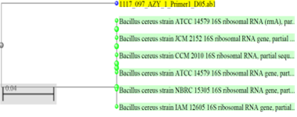

Fig. 3. Phylogenetic tree of 16S rRNA sequences of Bacillus sp.

Bacillus sp was isolated from soil sample from Rajshahi university campus. The isolated bacterium was an aerobic, gram-positive, spore forming, rod-shaped organism and was recognised as Bacillus cereus on the basis of 16S rRNA gene amplification, morphological properties and taxonomic characteristics [41]. The production of xylanase from Bacillus pumilus strain B20 was extensively explored using DeMeo’s fractional factorial design, which allowed for a systematic investigation of various factors influencing enzyme yield. Remarkably, the production of xylanase improved significantly, achieving an increase of up to 3.4-fold when an optimized culture medium was utilized. This medium comprised specific components, including K₂HPO, sodium chloride (NaCl), peptone, yeast extract, and wheat bran. Among the different variables assessed during the optimization process, it was found that wheat bran had a notably positive impact on xylanase production in the initial optimization phase. In contrast, the addition of magnesium sulfate heptahydrate (MgSO₄·7H₂O) and calcium chloride dihydrate (CaCl₂·2H₂O) exhibited a detrimental effect on enzyme yield [42].

Furthermore, solid-state fermentation (SSF) conditions were rigorously optimized to achieve maximum xylanase production from B. pumilus [43]. This was accomplished by employing paddy husk that was moistened with a liquid fermentation medium containing specific concentrations of substrates: xylan at 20.0 g/L, peptone at 2.0 g/L, yeast extract at 2.5 g/L, K₂HPO at 1.0 g/L, sodium chloride at 0.1 g/L, ammonium sulfate ((NH₄)₂SO₄) at 2.0 g/L, calcium chloride at 0.005 g/L, magnesium chloride hexahydrate (MgCl₂·6H₂O) at 0.005 g/L, and iron chloride (FeCl₃) at 0.005 g/L, all adjusted to a pH of 9.0. Under these optimized conditions, the highest xylanase activity was recorded following an incubation period of six days at a temperature of 30 °C. The optimal ratio of paddy husk to the liquid fermentation medium was determined to be 2:9. Additionally, it was observed that certain carbohydrates influenced xylanase production [44]. The presence of sucrose, fructose, and arabinose significantly enhanced xylanase yield, while glucose, galactose, and lactose tended to reduce the enzyme production. Separately, another species, Streptomyces sp. QG-11-3, was also investigated for its capacity to produce thermostable and cellulase-free xylanase through SSF, utilizing wheat bran and eucalyptus kraft pulp as solid substrates [45]. The solid substrates were thoroughly mixed with a mineral salts solution containing the following concentrations (g/l): potassium dihydrogen phosphate (KH₂PO₄) at 1 g, sodium chloride (NaCl) at 2.5 g, magnesium sulfate heptahydrate (MgSO₄·7H₂O) at 0.1 g, ammonium sulfate ((NH₄)₂SO₄) at 1 g, calcium chloride (CaCl₂) at 0.1 g, and 2 mL (v/v) of soil extract, with the pH adjusted to 8.0. The maximum xylanase yields obtained from these two types of substrates were unusually high, achieving 2360 U/g for wheat bran and 1200 U/g for eucalyptus kraft pulp at substrate to moisture ratios of 1:3 and 1:2.5, respectively [46].

  - Xylanase Production in Solid State Fermentation (SSF)

Agricultural waste materials, such as vegetable remnants, dairy byproducts, and crop residues, are abundant sources of polysaccharides, including hemicellulose, pectin, lignin, and xylan. The degradation of these complex compounds poses significant challenges. However, certain microorganisms possess the remarkable capability to break these down by producing hydrolytic enzymes, one of the most notable being xylanase. Numerous studies have highlighted the effectiveness of various agricultural residues for the production of xylanase through solid-state fermentation (SSF). Specifically, materials such as sugarcane bagasse, sawdust, paddy husk, wheat bran, and orange peel powder have been identified as promising substrates for this purpose. Commercially available wheat bran is particularly rich in polysaccharides, comprising approximately 30% cellulose, 27% hemicellulose, 21% lignin, and 8% ash content [47,48]. In experiments comparing the enzyme production capabilities of different substrates, sugarcane bagasse demonstrated superior enzyme activity compared to sawdust, paddy husk, wheat straw, and orange peel powder, as illustrated in Fig. 4. In a more focused study, xylanase production was optimized using the bacterium Arthrobacter sp. MTCC 5214 in SSF, with wheat bran serving as the primary carbon source. The bacterial cultures utilized were isolated from xylan-rich sediment samples collected from the Mandovi estuary along the West Coast of India. Among the various bacterial isolates, Arthrobacter sp. MTCC 5214 emerged as the most efficient xylanase producer. This strain exhibited peak enzyme activity at a temperature of 30 °C, utilizing wheat bran as the substrate with a moisture ratio of 1:3, and achieving maximum production after a 7-day incubation period [49].
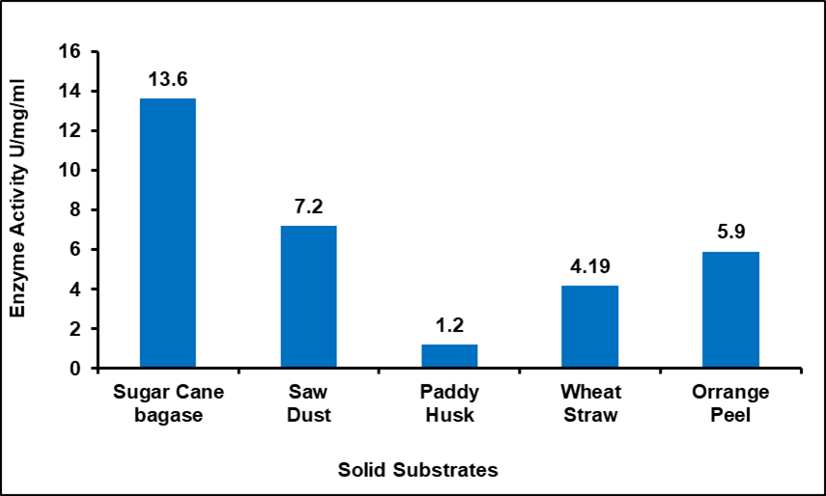

Fig. 4. Enzyme activity of different solid substrate

  - Effect of Physical Parameters for the Growth of Organism

The physical parameters of an environment are crucial for the growth of organisms, as they significantly influence metabolic processes and overall development. The rate of organism multiplication varies over time, which in turn leads to the production of specific metabolites that are essential at different stages of growth. Enzymes, which are vital for biochemical reactions, exhibit peak activity under optimal conditions; any deviation from these ideal conditions can result in a noticeable decline in their effectiveness [50]. For instance, as illustrated in Fig. 5, the production of xylanase reaches its maximum level after 72 hrs, highlighting the importance of timing and conditions for enzyme activity and metabolite production.
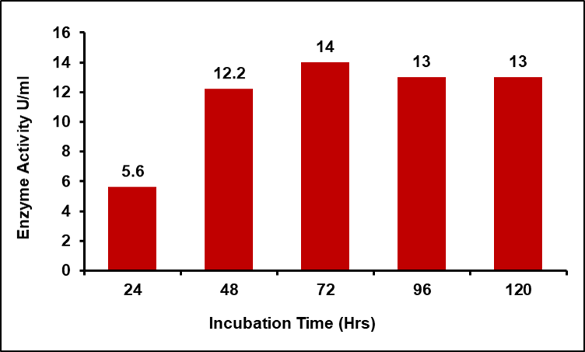

Fig. 5. Effect of incubation time on xylanase activity

The pH level emerged as the most significant factor influencing enzyme activity. Xylanase derived from Bacillus sp. exhibited a remarkable level of enzymatic activity at a pH of 8.0, despite its optimal performance being recorded at pH 5.5, as illustrated in Fig. 6. Even at elevated pH levels, the enzyme maintained an impressive 95 % activity. In terms of stability, xylanase demonstrated consistent act, retaining 100 % activity across all pH values tested over 1 hr duration. Additionally, two distinct xylanases, identified as xylanase N and xylanase A, were successfully purified from Bacillus sp. No. C-125. Among these, xylanase N displayed full activity within a pH range of 6.0 to 7.0, while xylanase A was notably vigorous, exhibiting robust enzymatic activity across a broader pH range from 6.0 to 10.0 and even maintaining some activity at an alkaline pH of 12.0 [51].
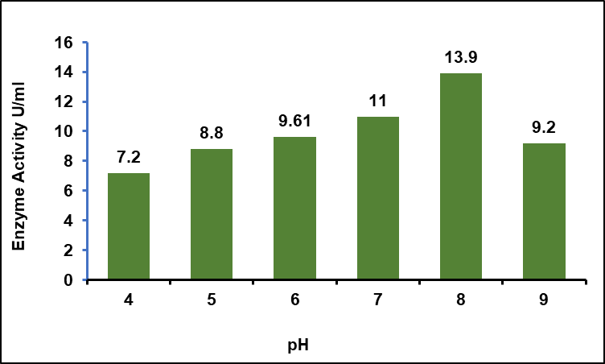

Fig. 6. Effect of pH on xylanase activity

Temperature plays a crucial role in regulating the physiological processes within living cells, serving as a key environmental factor that governs growth, microbial activity, and the normal function of enzymes [31].
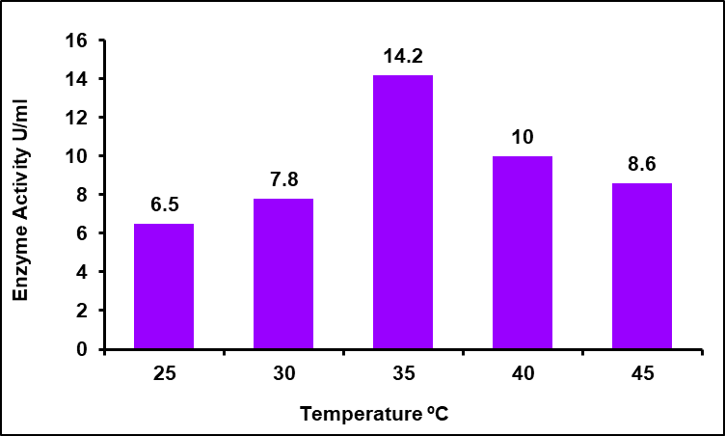

Fig. 7. Effect of temperature on xylanase activity

Research into the thermodynamic stability of enzymes has demonstrated that they remain stable at temperatures up to 40 °C. This temperature appears to represent the peak for enzyme production; both higher and lower temperatures result in diminished enzyme activity and output. As illustrated in Fig. 7, deviations from this optimal temperature range lead to a notable decrease in enzyme production, emphasizing the delicate balance required for optimal enzymatic function.

Several forms of xylanases were successfully purified from the bacterium Aeromonas sp., and the properties of three distinct xylanases were thoroughly characterized in detail [52]. It was noted that these particular xylanases exhibited their peak enzymatic activity at temperatures ranging from 50 °C to 60 °C, showcasing their suitability for industrial applications that require elevated temperatures [53]. Among these, two xylanases stood out due to their exceptional activity and relative stability when subjected to a temperature of 50 °C, leading to significant interest in their potential applications [54]. Moreover, xylanase production was significantly enhanced from the strain B. pumilus SV-85S through solid-state fermentation (SSF) utilizing wheat bran as a substrate. This optimization phase resulted in a remarkable increase in enzyme production levels, soaring from an initial measurement of 5,300 IU/g to a staggering 73,000 IU/g [55]. The conditions for maximum enzyme yield were identified as an incubation period of 48 hrs at a stable temperature of 30 °C, utilizing a 1:3 ratio of substrate to moistening agent, and incorporating an inoculum level of 15%. Wheat bran served as the primary carbon source for this fermentation process [56]. In a further investigation, xylanase production was optimized from an alkalophilic strain of B. subtilis using cost-effective agricultural residues. Among the various agro-residues tested, wheat bran emerged as the most superior substrate, yielding the highest enzyme activity of 8,964 U/g after a 72-hrs incubation period at 37 °C. The optimal substrate-to-moisture ratio was determined to be 1:2 (w/v), coupled with a 15% inoculum level, which led to maximum xylanase production. Additionally, the introduction of nutrients such as yeast extract, peptone, and beef extract was found to further stimulate enzyme production. Conversely, the addition of simple sugars like glucose and xylose was observed to repress xylanase production, indicating a delicate balance in nutrient management for optimal enzyme yield [57].

  - Effect of Metal Ions for the Production of Xylanase
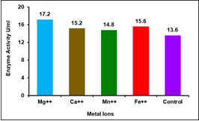

Fig. 8. Effect of metal ions for the production of xylanase

Metal ions serve as essential cofactors in various enzymes that facilitate metabolic processes. Their presence significantly boosts the growth of organisms and promotes the production of enzymes. Studies have demonstrated that the incorporation of magnesium ions (Mg++) can lead to a remarkable increase in enzyme production, with enhancements reaching up to 22% when compared to control conditions, as illustrated in Fig. 8. In this context, the bacterial strain B. circulans AB 16 was uniquely isolated from a garbage dump located in Delhi, India. This strain has shown impressive capabilities, producing an extracellular thermophilic xylanase at a concentration of 19.28 µ/ml when cultivated in a specialized basal medium. This growth medium comprised 0.1% KH₂PO₄, 0.1% K₂HPO₄, 0.05% MgSO₄, 0.1% NaCl, and 0.3% oat spelt xylan, providing an optimal environment for enzyme production. The enzyme itself performs best at a pH range of 6.0 to 7.0, but intriguing stability is exhibited across a broader pH spectrum of 5.0 to 9.0. Furthermore, the enzyme thrives at elevated temperatures, showcasing its optimum activity at a striking 80 °C, making it a valuable asset for various industrial applications [58,59].

  - Purification of the Enzyme

Following the production phase, the cell-free media underwent a 70% ammonium sulfate precipitation process. This treatment resulted in a notable increase in specific activity, reaching up to 36%, with a corresponding fold purification factor of 12, as detailed in Table 1. Comparable findings were noted in a study where xylanase was purified from Bacillus sp, achieving a 3.06-fold increase in purity and a specific activity of 299.25 U/mg [60]. Additionally, xylanase produced by Bacillus pumilus exhibited a specific activity of 298 U/mg [57].

Table 1. Purification of Xylanase Enzyme
Steps | Total Volume (ml) | Total Activity (U) | Total Protein (mg) | Specific Activity (U/mg) | Fold Purification
Crude Enzyme | 200 | 216 | 60 | 3.6 | 100
Ammonium Sulphate Precipitation | 25 | 176 | 12 | 14.6 | 40
Ion Exchange | 10 | 132 | 8 | 16.5 | 17
Gel Filtration | 10 | 86 | 2 | 38 | 12

  - Molecular Weight Determination by SDS Page

A distinct band of monomeric protein was observed upon electrophoresis of the sample on a 13% SDS-PAGE gel. The molecular weight of the denatured xylanase, determined by analyzing the relative mobility of proteins on the gel, was estimated to be approximately 62 kDa, as illustrated in Fig. 9. These findings are consistent with previous research in the field. For instance, xylanase produced by Bacillus sp. strain BP-23 was reported to have a molecular weight of 32 kDa, indicating significant variability among xylanases derived from different strains [60].
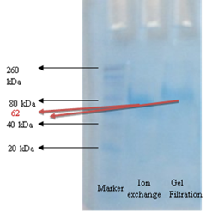

Fig. 9. SDS-PAGE analysis
of purified xylanases from Bacillus sp.

Similarly, xylanase extracted from Bacillus firmus exhibited a higher molecular weight of 45 kDa [61]. Additionally, previous studies identified an enzyme derived from the fungus Plectosphaerella cucumerina, which had a notably smaller molecular weight of just 19 kDa [62]. These variations highlight the diversity of xylanase proteins across different species and strains.

- CONCLUSION

Xylanases play a crucial role in the degradation of biomass, requiring both high catalytic efficiency and remarkable thermostability to be effective. Soil samples have been identified as a promising reservoir for xylanolytic microorganisms, providing a valuable resource for the isolation and study of these enzymes. Among various sources, Bacillus species have emerged as exceptional producers of xylanase enzymes, particularly when cultivated on affordable agro-waste substrates such as sugar cane bagasse. Additionally, metal ions, particularly magnesium ions (Mg++), have been found to significantly enhance xylanase production. The purified xylanase exhibits a robust capability to degrade xylan, a key component of plant cell walls. Following comprehensive characterization of these enzymes, they can be effectively utilized across a wide array of applications in industries such as paper and pulp, textiles, food processing, and animal feed production. Given the extensive range of applications, the isolation of novel xylanase-producing microorganisms is of considerable importance for both academic researchers and industrial stakeholders. This approach not only meets current demands but also paves the way for large-scale production processes that can effectively harness these valuable biocatalysts.

DISCLAIMER (ARTIFICIAL INTELLIGENCE)

Author(s) hereby declare that NO generative AI technologies such as Large Language Models (ChatGPT, COPILOT, etc) and text-to-image generators have been used during writing or editing of manuscripts.

REFERENCES

[1] | Reilly PJ. Xylanases: Structure and function. In: Hollaender A, Rabson R, Rogers P, Pietro AS, Valentine R, Wolfe R. (eds) Trends in the Biology of Fermentations for Fuels and Chemicals. Basic Life Sciences. Springer, Boston, MA. 1981;18: 111-129. doi:10.1007/978-1-4684-3980-9_8
[2] | Mohanty SM, Behera S, Swain MR, Ray RC. Bioethanol production from mahula (Madhuca latifolia L.) flowers by solid-state fermentation. Appl. Energy. 2009;86:640.
[3] | Barlaz MA. Carbon storage during biodegradation of municipal solid waste components in laboratory‐scale landfills. Global Biogeochem. Cycles. 1998;12(2):373-380. doi.10.1029/98GB00350
[4] | Gírio FM, Fonseca C, Carvalheiro F, Duarte LC, et al. Hemicelluloses for fuel ethanol: a review. Bioresour. Technol. 2010;101(13):4775-800.
[5] | Balat M, Balat H. Recent trends in global production and utilization of bio-ethanol fuel. Appl. Energy. 2009;86(11):2273-2282.
[6] | Singh A, Yadav RD, Kaur A, Mahajan R. An ecofriendly cost effective enzymatic methodology for deinking of school waste paper. Bioresour. Technol. 2012;120:322-327. doi.10.1016/j.biortech.2012.06.050
[7] | Singh A, Kaur A, Dua A, Mahajan R. An efficient and improved methodology for the screening of industrially valuable xylano-pectino-cellulolytic microbes. Enzyme Res. 2015;Article ID:725281. doi.10.1155/2015/725281
[8] | Ho HL, Ku XN. Kinetic study of cell growth and production of amylase, cellulase and xylanase by Bacillus subtilis using barley husk as the prime carbon source. J. Adv. Biol. Biotechnol. 2017;14(2):1-18. doi:10.9734/JABB/2017/33698
[9] | Kareem RAWA, Khushk I, Bhutto MA, Sattar QA, et al. Xylanase production using fruit waste as cost effective carbon source from thermo-tolerant Bacillus megaterium. Afr. J. Microbiol. Res. 2014;8(38):3463-3470. doi.10.5897/AJMR2013.6563
[10] | Ping L, Wang M, Yuan X, Cui F, Huang D, et al. Production and characterization of a novel acidophilic and thermostable xylanase from Thermoascus aurantiacu. Int. J. Biol. Macromol. 2018;109:1270-1279. doi.10.1016/j.ijbiomac.2017.11.130
[11] | Kamble RD, Jadhav AR. Isolation, purification, and characterization of xylanase produced by a new species of Bacillus in solid state fermentation. Int. J. Microbiol. 2012; Article ID: 683193. doi:10.1155/2012/683193
[12] | Mokni-Tlili S, Ben Abdelmalek I, Jedidi N, Belghith H, et al. Exploitation of biological wastes for the production of value-added hydrolases by Streptomyces sp. MSWC1 isolated from municipal solid waste compost. Waste Manag. Res. 2010; 28(9): 828-837. doi.10.1177/0734242X09357078
[13] | Levasseur A, Asther M, Record E. Overproduction and characterization of xylanase B from Aspergillus niger. Can. J. Microbiol. 2005;51(2):177-183. doi.10.1139/w04-116
[14] | Maki ML, Broere M, Leung KT, Qin W. Characterization of some efficient cellulase producing bacteria isolated from paper mill sludges and organic fertilizers. Int. J. Biochem. Mol. Biol. 2011;2: 146-154.
[15] | Polizeli MLTM, Rizzatti ACS, Monti R, Terenzi HF, et al. Xylanases from fungi: properties and industrial applications. Appl. Microbiol. Biotechnol. 2005;67(5): 577-591. doi.10.1007/s00253-005-1904-7
[16] | Bindu B, Jitender S, Saurabh SD, Ramesh CK. Enhanced production of cellulose-free thermostable xylanase by Bacillus pumilus ASH and its potential application in paper industry. Enzyme Microb. Technol. 2007;41(6-7):733-739. doi.10.1016/j.enzmictec.2007.06.006
[17] | Aysegul EY, Sahin A, Sahin FI, Mehmet M. Isolation of endophytic and xylanolytic Bacillus pumilus strains from Zea mays. Tarim Bilimleri Dergisi J. Agric. Sci. 2008;14(4):374-380. doi:10.1501/tarimbil_0000001054
[18] | Rifaat HM, Nagieb ZA, Ahmed YM. Production of xylanases by Streptomyces species and their bleaching effect on rice straw pulp. Appl. Ecol. Environ. Res. 2005;4(1):151-160. doi:10.15666/aeer/0401_151160
[19] | Khandeparker RDS, Bhosle NB. Isolation, purification and characterization of the xylanase produced by Arthrobacter sp. MTCC 5214 when grown in solid-state fermentation. Enzyme Microb. Technol. 2006;39(4):732-742. doi.10.1016/j.enzmictec.2005.12.008
[20] | Sonia KG, Chadha BS, Saini HS. Sorghum straw for xylanase hyper-production by Thermomyces lanuginosus (D₂W₃) under solid-state fermentation. Bioresour. Technol. 2005;96(14):1561-1569. doi.10.1016/j.biortech.2004.12.037
[21] | Beg QK, Kapoor M, Mahajan L, Hoondal GS. Microbial xylanases and their industrial applications: a review. Appl. Microbiol. Biotechnol. 2001;56(3-4):326-338. doi.10.1007/s002530100704
[22] | Wakarchuk WW, Sung WL, Campbell RL, Cunningham A, et al. Thermo stabilization of the Bacillus circulans xylanase by introduction of disulfide bonds. Protein Eng. 1994;7(11):1379-1386. doi:10.1093/protein/7.11.1379
[23] | Panbangred W, Shinmyo A, Kinoshita S, Okada H. Purification and properties of endoxylanase produced by Bacillus pumilus. Agric. Biol. Chem. 1983;47(5): 957-963. doi.10.1271/bbb1961.47.957
[24] | Prade RA. Xylanases: From biology to biotechnology. Biotechnol. Genet. Eng. Rev. 1996;13(1):101-132. doi.10.1080/02648725.1996.10647925
[25] | Avcioglu B, Eyupoglu B, Bakir U. Production and characterization of xylanases of Bacillus strain isolated from soil. World J. Microbiol. Biotechnol. 2005;21:65-68. doi.10.1007/s11274-004-1934-9
[26] | Kinegam S, Tanasupawat S, Akaracharanya A. Screening and identification of xylanase-producing bacteria from Thai soils. J. Gen. Appl. Microbiol 2007; 53(1):57-65. doi.10.2323/jgam.53.57
[27] | Sanchez MM, Fritze D, Blanco A, Sproer C, et al. Paenibacillus barcinonensis sp. nov., A xylanase-producing bacterium isolated from a rice field in the Ebro river delta. Int. J. Syst. Evol. Microbiol. 2005;55(2):935-939. doi.10.1099/ijs.0.63383-0
[28] | Xu ZH, Bai YL, Xu X, Shi JS, et al. Production of alkali-tolerant cellulase-free xylanase by Pseudomonas sp. WLUNO24 with wheat bran as the main substrate. World J. Microbiol. Biotechnol. 2005;21: 575-581. doi.10.1007/s11274-004-3491-7
[29] | Rawashdeh R, Saadoun I, Mahasneh A. Effect of cultural conditions on xylanase production by Streptomyces sp. (strain Ib 24D) and its potential to utilize tomato pomace. Afr. J. Biotechnol. 2005;4(3):251-255. doi.10.5897/AJB2005.000-3048
[30] | Suto M, Takebayashi M, Saito K, Tanaka M, et al. Endophytes as producers of xylanase. J. Biosci. Bioeng. 2002;93(1):88-90. doi.10.1016/S1389-1723(02) 80059-7
[31] | Sneath PHA. Endospore-forming gram-positive rods and cocci. In Bergey's Manual of Systematic Bacteriology. Vol 2. Ed., Williams and Wilkins, Baltimore, MD. 9th edition. 1994;1104-1139.
[32] | Norman DL. Bergey’s Manual of Determinative Bacteriology. 8th Edition, Buchanan RE, Gibbons NE. (eds.). 1974. Williams & Wilkins Co, Baltimore. J. Protozool. 1975;21(1):1-7. doi.10.1111/j.1550-7408.1975. tb00935.x
[33] | Bailey MJ, Biely P, Poutanen K. Interlaboratory testing of methods for assay of xylanase activity. J. Biotechnol. 1992;23(3):257-270. doi.10.1016/0168-1656 (92)90074-J
[34] | Miller GL. Using of dinitrosalicylic acid reagent for determination of reducing sugar. Anal. Chem. 1959;31(3):426-428.
[35] | Mahesh M, Somashekhar R, Bagchi P, Puttaiah ET. Optimization for the production of extracellular alkaline phosphatase from Proteus mirabilis. J. Bioprocess Biotech. 2015;5(3):1000213. doi.10.4172/2155-9821.1000213
[36] | Laemmli UK. Cleavage of structural proteins during the assembly of the head of bacteriophage T4. Nature. 1970;227(57):680-685.
[37] | Rajashri DK, Anandrao RJ. Isolation, purification and characterization of xylanase produced by a new species of Bacillus in solid state fermentation. International J. Microbiol. 2012;Article ID: 683193. doi.10.1155/2012/683193
[38] | Shivaji S, Suresh K, Chaturvedi P, Dube S, Sengupta S. Bacillus arsenicus sp. nov., an arsenic-resistant bacterium isolated from a siderite concretion in West Bengal, India. Int. J. Syst. Evol. Microbiol. 2005;55(3):1123-1127. doi.10.1099/ijs.0.63476-0
[39] | Inan K, Canakci S, Beldüz AO. Isolation and characterization of xylanolytic new strains of Anoxybacillus from some hot springs in Turkey. Turk. J. Biol. 2011; 35(5):529-542. doi:10.3906/biy-1003-75
[40] | Azeri C, Tamer AU, Oskay M. Thermoactive cellulase-free xylanase production from alkaliphilic Bacillus strains using various agro-residues and their potential in biobleaching of kraft pulp. Afr. J. Biotechnol. 2010;9(1):63-72. doi.10.5897/AJB09.1356
[41] | Roy N, Rowshanul HM. Isolation and characterization of xylanase producing strain of Bacillus cereus from soil. Iranian J. Microbiol. 2009;1(2):49-53.
[42] | Geetha K, Gunasekaran P. Optimization of nutrient medium containing agricultural waste for xylanase production by Bacillus pumilus B₂₀. Biotechnol. Bioprocess Eng. 2010;15(5):882-889. doi.10.1007/s12257-009-3094-0
[43] | Kapilan R, Arasaratnam V. Paddy husk as support for solid state fermentation to produce xylanase from Bacillus pumilus. Rice Sci. 2011;18(1):36-45. doi.10.1016/S1672-6308(11)60006-1
[44] | Chen WP, Matsuo M, Yasui T. Purification and some properties of β-1,3-xylanase from Aspergillus terreus A-07. Agric. Biol. Chem. 1986;50(5):1183-1194. doi.10.1080/00021369.1986.10867543
[45] | Beg QK, Bhushan B, Kapoor M, Hoondal GS. Enhanced production of a thermostable xylanase from Streptomyces sp. QG-11-3 and its application in biobleaching of eucalyptus kraft pulp. Enzyme Microb. Technol. 2000;27(7): 459-466. doi.10.1016/S0141-0229(00)00231-3
[46] | Coral G, Arikan B, Unaldi MN, Guvenmez HK. Some properties of thermostable xylanase from an Aspergillus niger strain. Ann.Microbiol. 2002; 52(3):299-306.
[47] | Malarvizhi K, Murugesan K, Kalaichelvan PT. Xylanase production by Ganoderma lucidum on liquid and solid state fermentation. Indian J. Exp. Biol. 2003;41(6):620-626.
[48] | Heck JX, Soares LHDB, Hertz PF, Ayub MAZ. Purification and properties of a xylanase produced by Bacillus circulans BL53 on solid-state cultivation. Biochem. Eng. J. 2006;32(3):179-184. doi.10.1016/j.bej.2006.09.020
[49] | Gawande PV, Kamat MY. Production of Aspergillus xylanase by lignocellulosic waste fermentation and its application. J. Appl. Microbiol. 1999;87(4):511-519. doi.10.1046/j.1365-2672.1999.00843.x
[50] | Khandeparker R, Bhosle NB. Application of thermoalkalophilic xylanase from Arthrobacter sp. MTCC 5214 in biobleaching of kraft pulp. Bioresour. Technol. 2007;98(4):897-903. doi.10.1016/j.biortech.2006.02.037
[51] | Bisswanger H. Enzyme assays. Perspect. Sci. 2014;1(1-6):41-55. doi.10.1016/j.pisc.2014.02.005
[52] | Honda H, Kudo T, Ikura Y, Horikoshi K. Two types of xylanases of alkalophilic Bacillus sp. No. C-125. Can. J. Microbiol. 1985;31(6):538-542. doi.10.1139/m85-100
[53] | Bernier R, Desrochers MJr, Jurasek L, Paice MG. Isolation and characterization of a xylanase from Bacillus subtilis. Appl. Environ. Microbiol. 1983;46(2):511-514. doi.10.1128/aem.46.2.511-514.1983
[54] | Ohkoshi A, Kudo T, Mase T, Horikoshi K. Purification of three types of xylanases from an alkaliphilic Aeromonas sp. Agric. Biol. Chem. 1985;49(10): 3037-3038. doi.10.1080/00021369.1985.10867211
[55] | Kang MK, Maeng PJ, Rhee YH. Purification and characterization of two xylanases from alkaliphilic Cephalosporium sp. strain RYM-202. Appl.Environ. Microbiol. 1996;62(9):3480-3482. doi.10.1128/aem.62.9.3480-3482.1996
[56] | Nagar S, Mittal A, Kumar D, Kumar L, Gupta VK. Hyper production of alkali stable xylanase in lesser duration by Bacillus pumilus SV-85S using wheat bran under solid state fermentation. New Biotechnol. 2011;28(6):581-587. doi.10.1016/j.nbt.2010.12.004
[57] | Nagar S, Jain RK, Thakur VV, Gupta VK. Biobleaching application of cellulase poor and alkali stable xylanase from Bacillus pumilus SV-85S. 3 Biotech. 2013;3:277-285. doi.10.1007/s13205-012-0096-y
[58] | Sanghi A, Garg N, Sharma J, Kuhar K, et al. Optimization of xylanase production using inexpensive agro-residues by alkalophilic Bacillus subtilis ASH in solid-state fermentation. World J. Microbiol. Biotechnol. 2008; 24(5):633-640. doi.10.1007/s11274-007-9521-5
[59] | Dhillon A, Khanna S. Production of a thermostable alkali-tolerant xylanase from Bacillus circulans AB16 grown on wheat straw. World J. Microbiol. Biotechnol. 2000;16(4):325-327. doi.10.1023/A:1008911026606
[60] | Blanco A, Vidal T, Colom JF, Pastor FIJ. Purification and properties of xylanase A from alkali-tolerant Bacillus sp. strain BP-23. Appl. Environ. Microbiol. 1995;61(12):4468-4470. doi.10.1128/aem.61.12.4468-4470.1995
[61] | Tseng MJ, Yap MN, Ratanakhanokchai K, Kyu KL, Chen ST. Purification and characterization of two cellulase free xylanases from an alkaliphilic Bacillus firmus. Enzyme Microb. Technol. 2002;30(5):590-595. doi.10.1016/S0141-0229(02)00018-2
[62] | Zhang GM, Huang J, Huang GR, Ma LX, Zhang XE. Molecular cloning and heterologous expression of a new xylanase gene from Plectosphaerella cucumerina. Appl. Microbiol. Biotechnol. 2007;74(2):339-346. doi.10.1007/s00253-006-0648-3

