***Nutritional properties of Moringa Oleifera***

**Abstract**

*Moringa oleifera*, a tree that belongs to the *Moringaceae* family, is native to theHimalayas and iscurrently cultivated in all tropical, subtropical and semi-arid regions of the world. It can grow in water shortage conditions, but its intensive cultivation with irrigation and fertilization increases biomass yields to over 100 tons per hectare. It is known by different names depending on the area of cultivation, such as: marango, moringa, resedá, radish tree, drumstick tree, Angela, asparagus tree, pearl tree, ben tree, tree of life and miracle tree.

Numerous beneficial properties are attributed to health and the environment, as well as a nutritional approach. The various parts of the plant have multiple applications, from the leaves to the seeds and roots, through various products made of them. Due to the above, today, studies focused on*Moringa oleifera*are increasing. In the south of the State of Yucatan, Mexico, a small company dedicated to the planting of the moringa tree and the production of products based on the leaves and seeds of the planthas been established. For this reason, the need to carry out scientific studies about the properties attributed to the Moringa plant arises.

# **Introduction and Generalities**

*Moringa oleifera* known as the miracle tree, or the tree of life, it is an evergreen tree native to the southern Himalayas, from NE Pakistan to N West Bengal, India (Ramachandran, 1980). It has been introduced and naturalized in other parts of India, Bangladesh, Afghanistan, Pakistan, Sri Lanka, SE Asia, western Asia, the Arabian Peninsula, E and W Africa, Madagascar, southern Florida, the Caribbean Islands and South America from Mexico to Peru, Paraguay and Brazil (Ramachandran, 1980).

In Central America it was introduced as an ornamental plant and live fences. The Romans, Greeks and Egyptians extracted edible oil from the seeds and used it for perfume and lotions. In the 19th century, from Moringa plantations in the Caribbean they exported the oil extracted from the seed to Europe for perfumes and machinery lubricants.

*Moringa oleifera* can grow in water shortage conditions, but its intensive cultivation with irrigation and fertilization increases biomass yields to over 100 tons per hectare (Makkar and Becker, 2001). It is known by different names, such as: marango, moringa, resedá, radish tree, drumstick tree, Angela, asparagus tree, pearl tree, ben tree, tree of life and miracle tree (Fuglie, 2001).

It reaches 7-12 m in height and 20-40 cm in diameter, with an open umbrella-like crown and straight stem. The leaves are compound and arranged in groups of leaflets with 5 pairs of these arranged on the main petiole and one leaflet at the terminal part. The leaves are alternate tripinate with a length of 30-70 cm (Foidlet al, 2001).

It is a perennial tree, very fast growing, but not long-lived, at most it can live 20 years.It provides a high amount of nutrients to the soil, in addition to protecting it from external factors such as erosion, desiccation and high temperatures.

Currently it is distributed throughout the world, in the tropics and subtropics.*Moringa oleifera* is morphologically associated with*Moringa concanensis*and *Moringa peregrina* and are called "slender trees" due to their tall and stylized shape(Fuglie, 2001).

It is cultivated in tropical regions around the world, from Africa to Asia and Latin America (Cavallini, 2001).*Moringa oleifera* can grow up to 1,200 meters above sea level, on hills or slopes, although itis most common to find it in meadows and riverbanks. It can reachsix or seven meters in height in a year, with an average annual water consumption of 400 mm.



**Fig.1**Areas where *Moringa oleifera* currently grows

Source: Hernández (1997)

# **Botanical description**

Moringa oleiferaIt is an evergreen or deciduous tree (it loses its leaves in winter or seasonally) of small size and accelerated growth that usually reaches 10 to 12 m in height. It has an open and spreading crown of inclined and fragile branches, a feathery foliage of three-pinnate leaves, and a thick, whitish and corky bark. It is valued mainly for its fruits, leaves, flowers, roots, all edible, and for the oil (also edible) obtained from the seeds. This crop can be propagated by seeds or by asexual reproduction (cuttings), even in poor soils; it resists long periods of drought and grows well in arid and semi-arid conditions. The taxonomic classification of the *Moringa oleifera* is presented(Caceres, 2005).

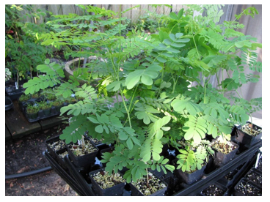

**Fig. 2.** Moringa oleíferaplant

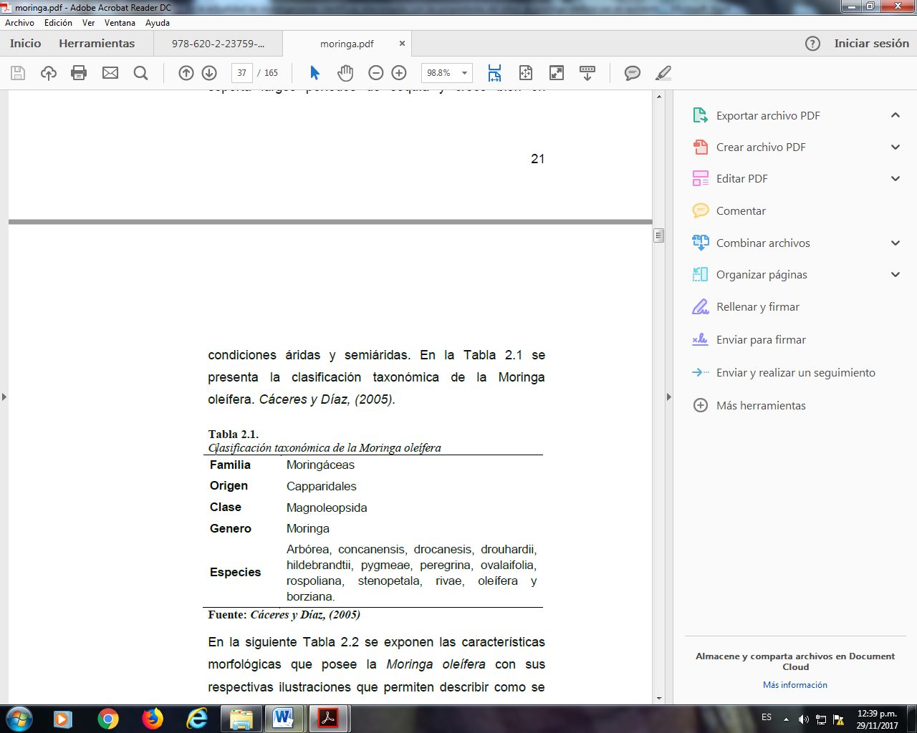

**Table 1.** Taxonomyof*Moringa oleífera*

# **Practical applications of *Moringa oleifera***

The *Moringa oleifera tree*provides a countless number of valuable products that have extremely interesting uses and that communities have taken advantage of for hundreds or perhaps thousands of years. Since ancient times in Greece and Rome, the 28 cosmetic properties of the oil of this plant were known and, during the 19th century, it was exported from the intensive plantations of India to Europe, as a lubricant for precision machinery. *Moringa oleifera*seed oil can be used in cooking, to produce soaps, cosmetics and fuel for lamps (Sánchez-Martín, 2004).

Residues from seed oil extraction can be used as a soil conditioner or fertilizer and have potential to be used as a feed supplement for poultry and livestock (Folkard and Sutherland, 1996). The green pods, leaves, flowers and roasted seeds are very nutritious and are consumed in many parts of the world. It can be grown as living fences or windbreaks and is suitable for areas where the combination of strong winds and long periods of drought cause serious soil erosion. It adapts well and is a good source of firewood (Folkard and Sutherland, 1996).

*Moringa oleifera*can be used as a raw material for biogas production, as a householdcleaning agent, a dye, a natural rubber producer, a water clarifier and as a honey producer. It also has medicinal and ornamental uses, and it works as a natural coagulant for water clarification, among others.

# **Studies on *Moringa oleifera***

Currently, scientific research related to the properties of the *Moringa oleifera*tree are increasing, due to the great demand that this tree has in herbal or nature medicine, there are many favorable testimonies from people who have used the leaves and seeds of the moringa tree to treat diseases such as diabetes, hypercholesterolemia, hyperlipidemia, hypertension, among others.

In Yucatan, Mexico, in a municipality in the southern region, Tekax de Álvaro Obregón, there is a small company called “Flor de Miel Maya” dedicated to the commercialization of processed moringa leaves and the oil extracted from the seeds, the company is also involved in the plantation of this tree. It is common to find moringa trees in the yards of houses in the southern region of Yucatan, because the warm climate favors its easy development, without nutritional demands for cultivation.

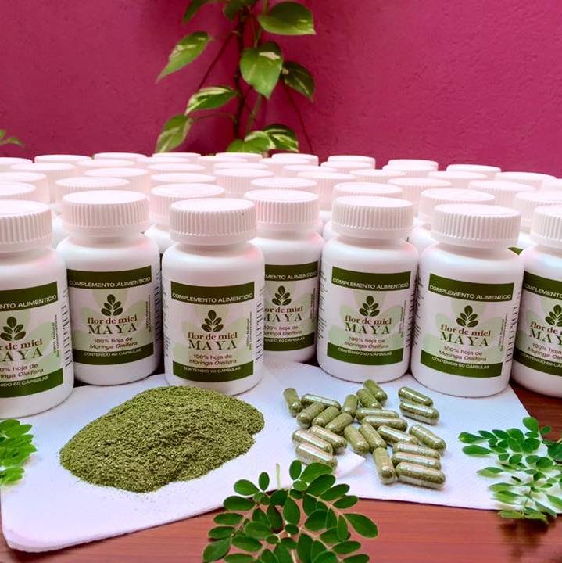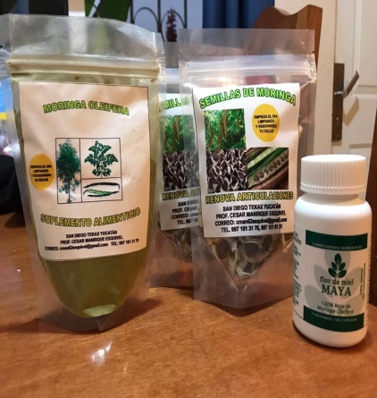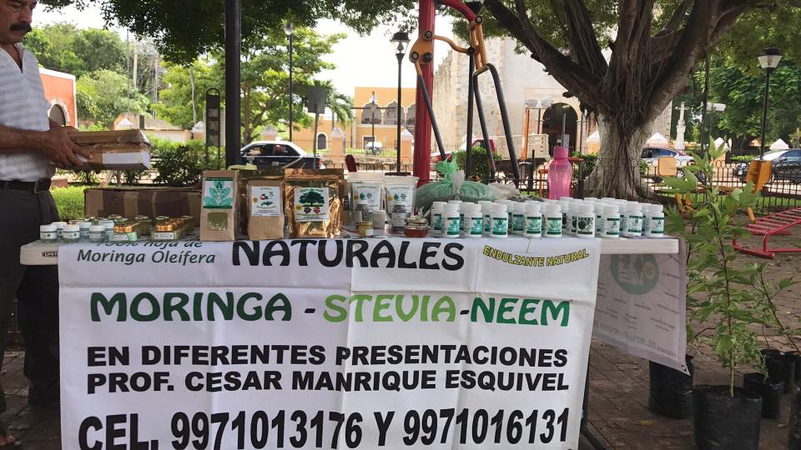

**Fig. 3.**Moringa-based products (Flor de mielmaya company)

The company “Flor de miel maya” is also dedicated to producing its raw material by planting

moringa trees. It currently has approximately one hectare of plantation. The trees are grown using a method called mulching, where the soil is covered withextensions of a nylon material with the purpose of retaining soil moisture and thus promoting the growth of moringa plants.

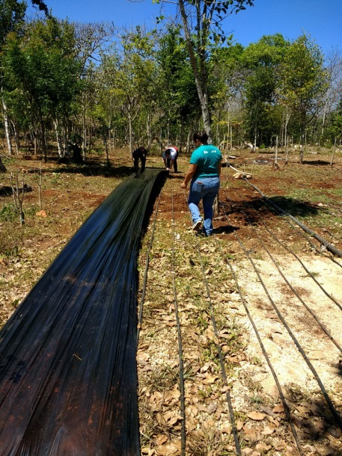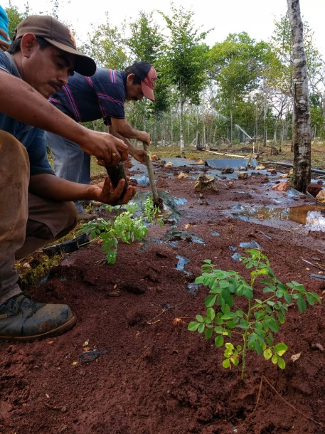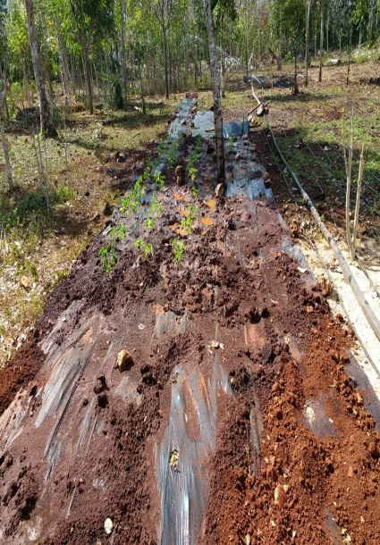

**Fig. 4.***Moringa oleífera*planting using the mulching method.

One of the region's educational institutions, the Instituto Tecnológico Superior del Sur del Estado de Yucatán, has been partnering with the region's company “Flor de miel maya” for two years now to carry out scientific research on the properties of the moringa tree.

Among the studies that have been carried out include the properties and quality of the seed oil, the antimicrobial and nutritional properties of the leaves and the design of an innovative product fromseed waste.

# **Nutritional content of *Moringa oleifera* leaves**

Another of the works carried out on*Moringa oleifera*in the Biochemistry laboratory of the Instituto Tecnológico Superior del Sur del Estado de Yucatán, is the nutritional content of a powderproduct made from moringa leaves(Figure 19).

|  |  |
| --- | --- |
| moringa |  |
|  |  |

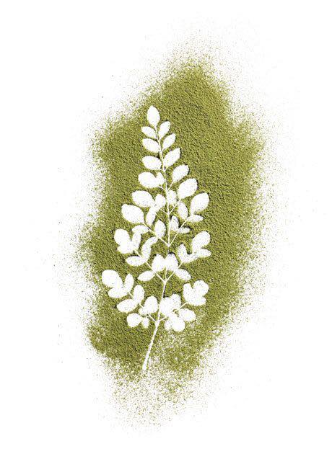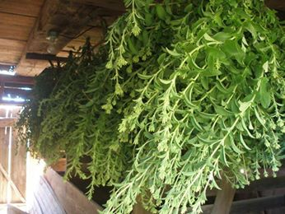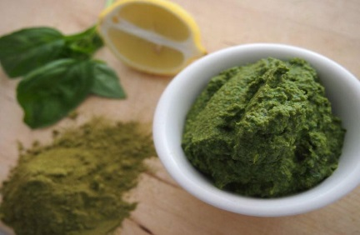

**Fig. 5.**Moringa powder for making supplements.

# **Determination of proteins by the Kjeldahl method (NMX-F-068-S -1980)**

The amount of protein contained in a powder product based on moringa leaves was determined. First, moisture was removed from the sample for 4 hours at a constant temperature of 60 ° C, the sample was placed in a desiccator for 30 minutes, then it was weighed. In a Kjeldahl flask 1 g of dry sample, 1 g of copper sulfate, 5 g of anhydrous sulfate and 12.5 mL of sulfuric acid were added slowly, glass beads were added, the flask was placed in the digester and carefully heated at low temperature until the sample was carbonized, noticing a change from the original color to green, as the temperature gradually increased, digestion was continued for 30 minutes at the same temperature until the heat was stopped and it was allowed to cool.

For distillation, 225 mL of H2O was added to the flask to completely dissolve the sample, 4 zinc granules and 25 mL of sodium hydroxide were added, the flask was immediately connected to a distillation system to collect the sample in a 500 cm3 Erlenmeyer flaskcontaining 25 mL of boric acid and a few drops of methyl red indicator. The sample was titrated with 0.1 N hydrochloric acid to quantify the amount of protein as nitrogen contained in the distilled ammonia.

The nitrogen content in different proteins is approximately 16%, so multiplying the percentage of nitrogen obtained by the factor 6.25 gives the amount of proteins present in the food. The protein content found in the product was 6.7%, a value that coincides with what was reported by various authors for moringa leaves.

# **Determination of fats by the Soxhlet method (NMX-F-089-S-1978)**

The quantity of fat contained in the samples was determined. 100 mL roundbottom flasks were used, from which the moisture was previously removed in a drying oven at 100°C. 2 g of sample was weighed and placed in a cartridge or thimble, covering it with a piece of cotton. The cartridge was placed inside a Soxhlet chamber and a condenser was fitted. Ethyl ether was added to the upper end of the condenser and recirculated. It was heated in a Soxhlet extractor for 8 hours with a frequency of 2 drops per second. Finally, the heating was suspended to continue with the distillation, recovering the solvent completely. The flask was weighed with its extracted fat content and the concentration was determined by weight difference.

Fat content is one of the most important values in food, because nowadays people are looking to consume nutritious foods with a low-fat content. Moringa can be considered as a food with a low-fat content, which was 1.79% for the leaves, and with a high protein content according to previous tests.

# **Determination of total carbohydrates**

Moringa leaves can be considered as a food supplement with high energy value since the total carbohydrate content was 13.4%, a value determined by the component difference method.

# **Determination of calcium by titration**

The calcium content of the moringa leaves based product was determined by a volumetric method. 2 g of sample was calcined for 3 h, allowed to cool, and then the ashes were digested with approximately 20 mL of 1:1 HCl. The ashes were transferred to a 100 mL volumetric flask and filled to the mark with water. A 50 mL aliquot was taken and placed in a 500 mL beaker, and 10 mL of 4.2% ammonium oxalate plus 0.5 mL of methyl orange indicator were added. Subsequently, ammonium hydroxide 1:1 was then added until the color changed to yellow. The sample was heated to boiling and allowed to cool, filtered through Whatman No. 5 filter paper, and the precipitate was washed with 1:1 ammonium hydroxide. The filter paper was placed in a beaker and 200 mL of water was added and heated to boiling. It was removed from the heat and 5 mL of 8% sulfuric acid was added, plus a few drops of methyl orange indicator. It was titrated until obtaining a slightly pink viro with 0.05 N potassium permanganate. The calcium concentration found in the product samples was 0.44%.

# **Determination of phosphorus by spectrophotometry**

A phosphorus standard curve was constructed as a reference. 2 g of sample was calcined for 3 h, allowed to cool and the ashes were transferred to a 100 mL beaker, 20 mL of 1:1 HCl was added and heated until the ashes were completely dissolved and filtered, and filled to 100 mL with distilled water. A 50 mL aliquot was filled to 250 mL again. 5 mL were taken and transferred to a 100 mL flask, 10 mL of sodium acetate buffer solution, 1 mL of 1% ascorbic acid solution in oxalic acid solution and 10 mL of 1% ammonium molybdate solution in sulfuric acid were added. The phosphorus concentration recorded for the moringa leaves product was 0.07%.

# **Determination of vitamin C**

The vitamin content was determined by the iodine titration method in samples of the product made from moringa leaves, and a value of 0.022% was found, a value that is within the range reported for fruits but lower than that found in some fruits such as oranges and guavas.

**Conclusion/summary**

Write a brief summary or conclusion

# **References**

Cáceres Montes, C., Díaz Ayala, J. (2005). Propuesta de Tratamiento de Aguas de Desecho de una Industria Química de Adhesivos utilizando Extracto Acuoso de la Semilla de *Moringa oleífera* (Teberinto), Trabajo de Grado, Universidad de El Salvador, Facultad de Química y Farmacia, San Salvador, El Salvador.

Cavallini, R. (2001). La *Moringa oleífera*, iLMateriali di ACRA coperiamo lo sviluppo, Lombardia, Italia.

Chang R. (2002). Química. 7ª Edición. Editorial Mac Graw-Hill.

Fahey, J. (2005). *Moringa oleífera* a review of the medical evidence for it nutritional, therapeutic and prophylactic properties. Part 1. Trees for life journal.

Flora, S., Pachauri, V. (2011). Moringa (*Moringa oleífera*) seed extract and the prevention of oxidative stress. Elsevier Inc. Amsterdam, The Netherlands. p. 776.

Foidl, N., Makkar, H. y Becker, K. (2001). The potential of *Moringa oleifera* for agricultural and industrial uses. CTA Publication. Wageningen, The Netherlands. p. 45.

Folkard, G., Sutherland, J. (1996). *Moringa oleífera*, un árbol con enormes potencialidades. Agroforestry today. Vol. 8:3. p. 5-8.

Fuglie, L. (2001). The Miracle Tree. The Multiple Attributes of Moringa. Technical Centre for Agricultural and Rural Cooperation.

Ramachandran, C., Peter, K. y Gopalakrishnan P. (1980). Drumstick (*Moringa oleifera*): a multipurposeIndian vegetable. Econ Bot. Vol. 34. p. 276–283.

Sánchez Martín, J. (2004). Aplicación de Floculantes Naturales a la Potabilización de Aguas, Trabajo de Grado, Departamento de Ingeniería Química y Energética, Universidad de Extremadura, España.

Verma, A., Vijayakumar, M., Mathela, C. y Rao, C. (2009). In vitro and in vivo antioxidant properties of different fractions of *Moringa oleifera* leaves. Food chem. Toxicol. Vol. 47. p. 2196

Walter, A., Samuel, W. Peter, A. y Joseph, O. (2011). Antibacterial activity of Moringa oleifera and Moringa stenopetala methanol and n-hexane seed extracts on bacteria implicated in water borne diseases. African J. Microbiol. Res. p. 153