Study of Wind Motions During the Presence of High-altitude Cloud–Cirrus Using MST Radar and Lidar

PREFACE

Varieties of clouds are seen at different altitudes in the Earth’s atmosphere. The role of clouds in climate is in its capability of modulating the Earth’s basic radiation balance and in producing precipitation. The global energy balance equation is affected both sides by the clouds by reflecting incoming sunlight and hinder the heat radiation from the surface. Most of the clouds are formed in the lower atmosphere i.e. troposphere. Clouds in the troposphere are classified based on their altitude of formation as high, middle and low clouds. Low clouds (stratus, stratocumulus and nimbostratus) and middle clouds (altocumulus, altocumulus castellanus, altostratus and nimbostratus) mostly reflect the solar radiation and cool the Earth’s surface while the high clouds (cirrus, cirrostratus and cirrocumulus) transmit the short wave radiation and cause heating of the atmosphere. So, the study of high altitude clouds finds its importance rather than the low or middle altitude clouds.
Cirrus clouds are the most common form of high altitude clouds, composed almost of ice crystals and cause significant warming to the Earth’s climate. Most of the cirrus clouds in the atmosphere are formed due to two mechanisms;
1) Strong convective activity due to vertical transport of water vapor and
2) Spreading of cumulus anvils due to strong horizontal winds.
In the Indian sub-tropical region, deep cumulus clouds are frequently observed during April to December due to deep convective activity. The fibrous anvils of the cumulus clouds are laden with ice particles and are blown off by the strong winds in those altitudes and cause the appearance of a layer of ice cloud. Cirrus clouds act as a thermal blanket to the Earth’s atmosphere by reflecting the incoming solar radiation (Albedo effect) and at the same time, trap the outgoing long wave radiation (Greenhouse effect). Thus, the net impact of cirrus on climate depends on the balance between the above two effects.
The accurate impact of cirrus on the Earth’s radiation budget necessitates accurate parameterization of cirrus. Lidar remote sensing is proven to be one of the best techniques for studying the characteristics of cirrus clouds. The polarization lidars are especially capable in distinguishing the cloud phase (liquid or ice) by means of Linear Depolarization Ratio (LDR). High values of LDR represent highly non spherical ice particles and low values correspond to spherical particles.
Cirrus clouds usually occur in fair weather conditions and point in the direction of winds at their elevation. The strong winds in the upper troposphere and lower stratosphere may transport the cirrus clouds. Cirrus properties vary in association with the background wind fields. Simultaneous observations of cirrus clouds with mm-wave radar and the MU radar showed that the development of cirrus clouds with large particles depends largely on the background wind field. The boundaries of cirrus are associated with enhanced horizontal wind, reduced vertical wind and vertical shear of horizontal wind. Absence of large-scale updrafts is considered to be a candidate to explain the observed cloud descent over mid latitudes. Thus, there exists an association between the winds and the cirrus clouds. However, very few studies have been focused on the association between wind motions and different types of cirrus manifestations (like subvisual, thin and dense) observed at different altitudes.
Further, frequent passages of multi layered cirrus over tropics using active and passive remote sensing techniques were reported by many researchers. Space based lidars can also detect the passage of multiple cirrus layers during their passage over different geographical locations over the globe. However, satellite passage over a particular location is only for few seconds during which the clouds identified are either single cirrus or multiple cirrus. But, the clouds which are identified by the satellite may change their texture and geometrical structure (such as transition between multiple thin layers and single geometrically thick cirrus) or there may be temporal variations in optical and geometrical properties due to the dynamical environment either before the arrival or after the departure of the satellite. Sometimes the cirrus layers undergo a type of overlapping with the lower lying water clouds or with the other cirrus layers. The net positive radiative forcing at the top of the atmosphere and warming the climate as estimated by ISCCP cloud data (that is obtained from satellites) did not consider the effect of overlapping of cirrus layers. However, the frequency of cirrus transition over tropics is not negligible and the variation in cirrus microphysical and optical properties causes large uncertainties in the accurate radiative forcing calculations. In the present research work, an attempt is made to study the variations in wind velocities during the presence of different manifestations of cirrus clouds such as optically subvisible, thin and thick/dense cirrus that are observed at different altitudes. Also, the frequency of cirrus transition between multiple and single thick cirrus (which cannot be identified using passive remote sensing techniques) and the corresponding variations in cirrus optical and depolarization properties over a low latitude station Gadanki (13.5°N, 79.2°E), India. Finally, the modulation in the wind structures during the transition of cirrus from multiple thin layers to single geometrically thick cirrus is also studied.
Further, Homogeneity of cirrus clouds in terms of their particle sphericity can be understood through the variation of LDR. Mid-latitude cirrus clouds are highly inhomogeneous due to dynamically and chemically perturbed atmosphere when compared with calm polar cirrus. But, the homogeneity of cirrus over tropical region is not yet reported. In the present research work, an attempt is also made to study the in-cloud variability of LDR of cirrus observed over Gadanki and the results are presented.
Objectives of the present research is to study the
a) Wind motions around the tropical cirrus clouds by using simultaneous
observations of MST radar and collocated polarization lidar over Gadanki region
b) Relationship between the peak LDR and horizontal winds within, above and below
the cirrus clouds
c) Effect of winds in modulating the cloud vertical structure
d) Variation in cloud parameters like Back Scatter Ratio (BSR), Cloud Optical Depth
(COD) and Linear Depolarization Ratio (LDR) during the transition between
Multiple and Single geometrically thick cirrus which can contribute strong radiative forcing
e) Potential capability of geometrically thick cirrus clouds in modulating the wind
motions.
f) In-cloud variability of LDR of cirrus observed at different altitudes over
Gadanki during four contrasting seasons.

The Present Thesis entitled “Study of wind motions during the presence of high-altitude cloud–cirrus using MST radar and lidar” consists of six chapters and the chapter wise description of the present work is summarized as follows.
Chapter1 gives necessary background information on structure and composition of the Earth’s atmosphere. A portion of this chapter is dedicated to basic physics that is required for understanding the clouds in the atmosphere and their impact on climate, Cirrus clouds, Effect of Cirrus on climate, dynamical processes around the cirrus clouds and remote sensing of winds around the cirrus using radar and lidar. The content provided in this chapter is fundamental for understanding the connection between wind motions and the cirrus properties.
Chapter 2 describes briefly the technical details and measurement techniques of ground-based remote sensors such as MST radar, Mie lidar, GPS radiosonde
collocated at Gadanki (13.5ºN, 79.2ºE) and Space-Borne (passive satellite) remote sensor such as CALIPSO along with ERA Interim reanalysis which are the data sources considered in the present thesis for observing wind motions around the tropical cirrus clouds. Various methods of data analysis and techniques associated with these instrumental measurements for extracting the information of winds and different parameters of the cirrus clouds are also described briefly.
Chapter 3 provides the wind motions around the tropical cirrus using simultaneous radar and lidar observations over Gadanki (13.45˚N, 79.18˚E). Three different cases, one during a North-East monsoon day and other two during South-West monsoon days of passage of cirrus at different altitudes are discussed. Variations in cirrus depolarization properties with the variations in winds above, below and within the cirrus altitudes; effect of synoptic scale features on the passage of cirrus clouds and the effect of vertical winds on the cirrus ascent/descent are discussed.
Chapter 4 contains Mie lidar observations of cirrus cloud variability showing transition between multiple and single thick cirrus over Gadanki. In this connection, 72 nights of lidar observations during January 2007 to August 2007 are taken into consideration. Out of 72 nights of lidar observations, only 46 nights (64%) are associated with cirrus passage over Gadanki, out of which during 6 specific nights (13%), there is transition between multiple and single thick cirrus. Significant variation in peak LDR (Linear Depolarization Ratio), Back Scatter Ratio (BSR) and COD (Cloud Optical Depth) along with strong correlation between them during the transition is noticed which contribute strong radiative forcing. The CALIPSO satellite passage over Gadanki longitude is also shown, which is only for few seconds during which, the observed cirrus is multiple in some cases and single layered in other cases. But, the transition of cirrus is noticed only by using ground based lidar just before/after the passage of CALIPSO over Gadanki longitude showing the importance of long term ground based data products in calculating accurate radiative forcing and is illustrated in detail. Effect of transition from multiple to single thick cirrus on the horizontal wind fields using simultaneous observation of MST radar and polarization lidar over Gadanki region is described. In one of the case studies, simultaneous measurement of background wind fields using MST radar showed weakening of horizontal winds during the transition from multiple to single geometrically thick cirrus indicating potential capability of thick cirrus in modulating the background wind fields and the results are discussed in this chapter.
Chapter 5 describes the in-cloud variability of LDR of cirrus observed over Gadanki at different altitudes using ground based polarization lidar at NARL during four contrasting seasons of the years 2006-2007. A parameter known as depolarization variability indicator is measured for each cirrus cloud noticed at different altitudes and at different temperatures. The results are discussed in this chapter.
Chapter 6 summarizes important findings from the present study. The scope of extension of this work is also included.

Contents____________________________________________________________
CONTENTS

Page No

Acknowledgements i
Preface iii
Contents viii
List of Figures xi
List of Tables xiv
List of Abbreviations xv
List of Symbols xvii

Chapter-1: Introduction
1.1 Background
1.1.1 The vertical structure of the atmosphere 1
1.1.2 Composition of the atmosphere 4
1.1.3 Clouds in the atmosphere and their impact on climate 5
1.1.4 Cirrus clouds 7
1.1.5 Effect of Cirrus on climate 8
1.1.6 Lidar monitoring of cirrus 11
1.1.7 Characteristic Features of cirrus over Gadanki 12
1.1.8 Remote sensing of winds around the Cirrus 15
1.1.9 MST radar measurement of winds in the UTLS region 16
1.1.10 Background winds over Gadanki region 17
1.1.11 Dynamical processes around the cirrus 18
1.1.12 Theory of Scattering 18
1.2 Science goals and objectives of the thesis 21
Chapter-2: Observational Techniques
2.1 Introduction 24
2.2 Techniques and Measurements 26
2.2.1 Indian MST Radar, Gadanki (13.5oN, 79.2oE) 26
2.2.1.1 The MST Radar Technique 26
2.2.1.2 Description of the Indian MST radar system 27
2.2.1.3. Antenna Array and Feeder Network 30
2.2.1.4 Transmitter System 32
2.2.1.5 Receiver 32
2.2.1.6 Exciter and Radar Controller 33
2.2.1.7 Signal Processing System 33
2.2.1.8 Data Processing 34 2.2.1.9 Computation of Absolute Wind Velocity Vectors 35
2.2.2 Mie Lidar 36
2.2.2.1 Lidar principle 36
2.2.2.2 Lidar System Description 36
2.2.2.3 Data Analysis 39
2.2.2.4 Determination of Scattering Ratio, Depolarization ratio
and Extinction Coefficient 44
2.2.3 Radiosonde 50
2.2.4 Reanalysis data sets 55
2.2.5 The CALIPSO mission 57
2.2.5.1 Global cloud coverage by lidar measurements from space 57
2.2.5.2 Scientific challenges and limits of CALIPSO 58
2.2.5.3 The CALIOP payload 59
Chapter 3: Wind motions around the tropical cirrus using simultaneous radar and lidar observations over Gadanki (13.45 0 N, 79.18 0 E)
, India
3.1 Introduction 62
3.2 Experiment Details and Description of the data 64
3.2.1 MST Radar 65
3.2.2 Mie Lidar 65
3.2.3 Objective Reanalysis 67
3.3 Variations in wind velocities during the presence of different cirrus
manifestations-case studies 67
3.4 Summary 80
Chapter 4: Mie lidar observation of variations in cirrus properties during
the transition between multiple and single cirrus over Gadanki
(13.450 N, 79.180 E)
4.1 Introduction 82
4.2 Experiment Details and data Description 84
4.2.1 Mie lidar 84
4.2.2 MST radar 85
4.2.3 CALIPSO Signatures 85
4.3 Results and Discussion
4.3.1Lidar observation of variations in cirrus properties during transition between multiple and single geometrically thick cirrus over Gadanki 86
4.3.2. MST radar observation of variation of the background wind field during transition from multiple to single
geometrically thick cirrus-a case study 88
4.4 Summary 98
Chapter-5: In-cloud variability of Linear Depolarization Ratio (LDR) of
cirrus observed over Gadanki (13.5°N, 79.2°E)
5.1 Introduction 100
5.2 Data and Methodology 101
5.3 Background information of tropical cirrus and its variability 103
5.4 In-cloud variability of LDR of cirrus observed over Gadanki during
four contrasting seasons of the years 2006-2007 103
5.5 Summary 113
Chapter-6: Conclusions and future directions
5.1 Summary and conclusions 114
5.2 Future works 116

References 119
Papers/Posters presented in conferences 137
List of publications 138

_____________________________________________________Chapter 1
Introduction
1.1 Background
1.1.1 The vertical structure of the atmosphere
Earth is surrounded by a blanket of air composed of gases like Nitrogen and Oxygen, various trace gases like CO₂, H₂O, and O₃ etc. The atmosphere which is extending hundreds of kilometers vertically protects Earth's surface by modulating solar radiation and plays a key role in maintaining the equilibrium climate. The atmosphere is continuously exposed to wide range of wavelengths extending from infrared to x-rays. A considerable amount of solar radiation (in the infrared and visible wavelengths) directly reaches Earth’s surface and causes heating effect. Further heat transfer between different regions of the atmosphere or loss of heat to space can be caused by the atmospheric gases, clouds and the Earth’s surface by reemitting and absorbing the reemitted infrared radiation. The absorption, scattering and reemission of solar radiation by gasses in different regions of the atmosphere results in several atmospheric layers characterized by variations in temperature, pressure and other parameters. Temperature of the atmosphere varies temporally over any given geographical location both vertically and horizontally. Horizontal variations in temperature are not so similar everywhere over the globe compared to vertical structure of temperature which has similar structure everywhere at any time. The vertical profile of temperature over a tropical station Gandanki (13.450 N, 79.180 E) and the atmospheric layers are shown in Figure 1.1. The lowest layer of the atmosphere (also referred to as the lower atmosphere) is called the troposphere. Troposphere extends vertically to different altitudes (~16-18 km over tropics, 10-12 at mid latitudes and ~6-8 km at polar region) based on location and season. The greater solar radiation over tropics causes the greater thickness of the troposphere. The solar radiation warms the Earth’s surface and the air just above it is warmed due to sensible and latent heat fluxes. The heated surface air having low density rises aloft to higher altitudes and ultimately causes an increase in thickness of the troposphere over the tropics. The troposphere over tropics holds almost ~90% of the mass of the atmosphere. The importance of troposphere is that, it holds nearly all of the water vapor in the Earth’s atmosphere and regulates the temperature and thereby produces the local weather. This water vapor which when rises to higher altitudes undergoes condensation and then precipitation which releases latent heat that drives the atmospheric phenomena. The density and pressure of air decreases exponentially with altitude. Within the troposphere, the temperature steadily decreases with increasing altitude with a lapse rate of ~6.5K/km.
Different gases in the troposphere are almost transparent to incoming solar radiation and heat the Earth’s surface. This heated surface will re-radiate long wave radiation which is absorbed and re-emitted by the tropospheric gases. The gases in the troposphere are well mixed and highly unstable because of the differential heating on account of large scale dissimilarities in land and sea breezes which causes monsoonal circulations and tropical
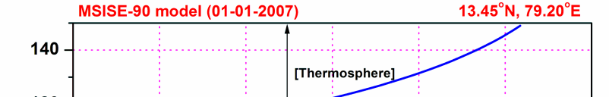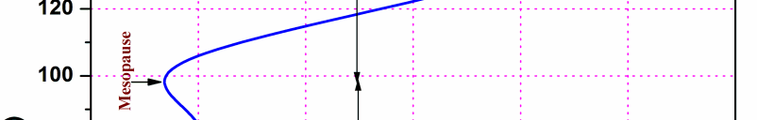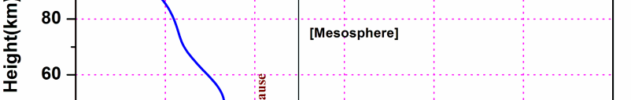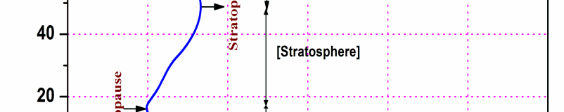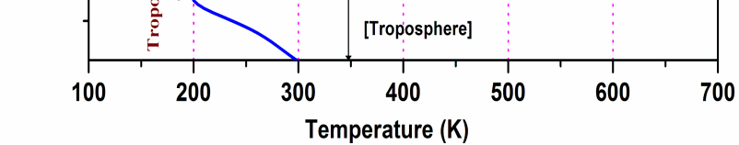
Figure 1.1 Altitude profile of temperature taken from the Mass Spectrometer Incoherent Scatter Extended-1990 (MSISE-90) model over Gadanki.
weather system. However, the midlatitude weather system is due to latitudinal differential heating. The latent heat that is released during the formation of clouds and precipitation causes the lower troposphere in acquiring convective equilibrium. Different types of clouds (low, middle as well as high) in general, are formed within the troposphere and less frequently the high clouds (cirrus) may intrude into the lower stratosphere. Hence, the study of tropospheric region finds its importance especially in the field of clouds research. The layer above the troposphere where the lapse rate decreases to 20C/km or less provided the average lapse rate between this particular layer and all higher layers within 2 km does not exceed 2°C/km is known as the tropopause. In the tropopause layer, the temperature remains almost constant (but not always) with altitude. The tropopause acts as a lid for the troposphere and resists the exchange of air between upper troposphere and lower stratosphere. But, most of the upward transport of air takes place during strong convection through tropopause region over tropics.
The second major atmospheric layer just above the troposphere extending in altitude up to ~50 km is the stratosphere. No weather occurs in the stratosphere and the temperature of the stratosphere increases rather slowly with altitude due to the absorption of sun light by the ozone layer present in this location. High stability and very long vertical mixing time scale are the characteristics of the stratosphere. The ozone (which is present in low densities) in the stratosphere absorbs UV radiation and transfers the kinetic energy to small number of molecules which ultimately causes an increase of temperature from the tropical tropopause to an altitude of ~50 km. The temperature of the stratosphere may sometimes reach its local maximum at an altitude of ~50 km and this negative lapse rate in the stratosphere does not allow rapid mixing of stable layers. The region that separates the stratosphere with the mesosphere is the stratopause which in general, is observed at the altitudes of ~45-55km, the region at which the increase in temperature ceases with altitude. Over winter pole to summer pole, the temperature of the stratopause in general varies in the range of 240K - 290 K.
Above the stratopause and below the thermosphere, a region where the temperature decreases gradually with altitude due to negligible concentrations of Ozone and water vapor and extending from 50 km to 85 km is called as the mesosphere. The temperature of the mesosphere decreases rapidly from the top of the stratopause to an altitude of ~80-90 Km. Due to the negligible concentrations of water vapor and Ozone in the mesosphere, the temperature reaches to very low values. The chemical composition of the mesosphere is uniform and coldest temperatures of ~ - 900C are also reported. The region that separates the mesosphere and the next upper layer, thermosphere is known as the mesopause. It is the coldest region of the Earth’s atmosphere where the temperature reaches ~ -180 K in the altitudes of ~80-100 Km. Particularly very low mesopause temperatures are observed during Northern hemispheric summer. Above the mesopause, the atmosphere becomes ionized and hence the region is called as ionosphere. In the ionosphere, radio waves are strongly reflected and this property is having great practical importance. Thermosphere, the region of very high temperatures includes the ionosphere and extends vertically to several hundreds of kilometers. Within the thermosphere, the short wavelength UV radiation is absorbed by the Oxygen molecules which cause heating of this region. The UV radiation dissociates the molecules (including O₂) that results in a scarcity in polyatomic molecules which ultimately causes low loss of Infra-red energy. This increased IR radiation in the thermosphere causes an abnormal increase in temperature which ranges from ~500 K-2000 K. The chemical composition of the thermosphere is non-uniform and is a part of the heterosphere. The level at which the increase in temperature ceases is the thermopause. Based on the solar activity, the height of thermopause is located between 250-500 Km. Exosphere, the top most layer of the atmosphere whose upper boundary extends to ~1000 Km and is a transition zone between Earth’s atmosphere and the interplanetary space.
1.1.2 Composition of the atmosphere
Earth’s atmosphere consists of a mixture of several different gases in different quantities. Some of the gases whose percentages do not change day by day are permanent gases such as Nitrogen (78%), Oxygen (21%) and Argon (0.9%). Some gases like CO₂, NO, CH₄, and O₃ that account for about a tenth of one percent of the atmosphere are trace gases. The most important component in predicting the local weather is the content of water vapor which varies widely (less than 1% of the atmosphere in the cold regions and almost 4% in humid and tropical regions). The Earth’s atmosphere comprised of some Greenhouse gases whose concentration changes daily, seasonally and yearly. These gases interact directly with the solar radiation and affect the energy balance of the globe. Scientists are monitoring these greenhouse gases in a continuous basis over different geographical locations using active and passive remote sensors carefully because of their negative impact on equilibrium climate system. Recent studies showed an increase in the concentration of greenhouse gases such as Methane, (CH₄), CFC’s, CO_{2,} water vapor etc., in the atmosphere which ultimately causes positive Radiative forcing effect.
1.1.3 Clouds in the atmosphere and their impact on climate
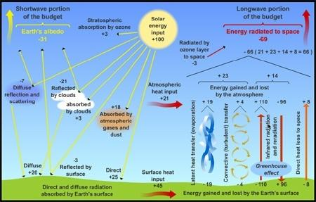
Varieties of clouds are seen at different altitudes in the Earth’s atmosphere. These clouds are the signs of the weather to come. But, at the same time, they obscure our vision in forecasting the climate. The role of clouds in climate is in its capability of modulating the Earth’s basic radiation balance and in producing precipitation. The global energy balance equation is affected both sides by the clouds by reflecting incoming sunlight and hinder the heat radiation from the surface. Radiative balance of the Earth’s climate through the interaction between various components of the atmosphere with the solar radiation is shown in Figure 1.2.

Fig.1.2. Radiative balance of the earth’s climate through the interaction between various components of the atmosphere with the solar radiation.

Clouds are produced by the atmospheric motions like winds and waves which in turn are produced by the radiative and latent heating that are influenced again by the clouds. This loop is known as a feedback loop. It is a complex issue in climate research that how these clouds will respond to changes in the climate and to predict exactly the net impact of clouds on the energy and water balances.
Most of the clouds are formed in the lower atmosphere (troposphere) and the depths of troposphere are different at different places around the Earth. Near the equator, the troposphere is higher in altitude due to warmer air (The Sun heats the Earth typically near the equator causing the warm air to rise and hence the deeper troposphere) than at the poles (where the air is cooler and sinks and hence the thinner troposphere). The clouds in the troposphere are classified based on the height of the cloud’s base above the Earth surface. Because of the latitudinal variations in height of the troposphere, altitude of the cloud’s base is also different for different clouds over different latitudes. Clouds over the tropics have a higher base and a higher top than clouds in the mid-latitudes or Polar Regions.
In general, the clouds in the troposphere are classified based on their altitude of formation as high, middle and low clouds.
High level clouds include cirrus, cirrostratus and cirrocumulus, are composed mostly of ice crystals and are wispy. These clouds interact directly with the solar radiation and cause positive/negative radiative forcing at the top of the atmosphere depending on the nature of the ice particles within the clouds. These clouds are formed in the altitude range of 16,500 to 45,000 ft.
Middle level clouds include altocumulus and altostratus that are often called as water clouds; these clouds sometimes may contain ice crystals, when it is cold enough at that altitude in the atmosphere. These clouds are observed in the altitude range of ~6,500 to 23,000 ft above the Earth’s surface.
Low level clouds include cumulus, stratus, cumulonimbus and nimbostratus which are in general made of water droplets. Cumulus and cumulonimbus clouds are towering clouds, with their tops as high as high clouds, but their bases are as low as the other low clouds. These clouds are observed in the altitudes < 6,500 ft from the Earth’s surface.
Low level clouds (such as stratus, stratocumulus and nimbostratus) and middle level clouds (altocumulus, altocumulus castellanus, altostratus) mostly reflect radiation from the Sun and cools the Earth’s surface. On the other hand, high and thin clouds mostly transmit the incoming radiation and at the same time trap a portion of the outgoing infrared radiation that was re-emitted by the Earth’s surface and re-radiate it back downward, thereby warming the surface of the Earth. So, the study of high (cirri form) clouds find its importance rather than the low or middle clouds.
1.1.4 Cirrus clouds
Cirrus clouds are the most common form of high clouds predominantly composed of ice crystals (Lynch et al., 2002). These clouds form in very cold air at high altitudes. They have a feathery or wispy appearance due to the presence of ice crystals. Strong winds often blow streamers or “tails” off cirrus clouds. These features show the direction of the wind in the upper troposphere and lower stratosphere. Usually, cirrus clouds are seen in fair weather and a sign for an approaching storm. The other clouds of course, mainly made of water droplets even though they may contain ice crystals as well. Cirrus clouds are found to be situated more frequently in the upper troposphere and rarely in the lower stratosphere at very low temperatures < 250 K. Cirrus clouds are defined as the clouds whose optical thickness lies in between 0.03 and 3.6 (Sassen and Cho., 1992) and geometrical thickness from few hundreds of meters to three kilometers. Cirrus is in general, more homogeneous and sometimes may extend up to thousands of Kilometers in the horizontal direction over tropical region (Devara et al., 1995). At any given time, 20 to 30 % of the Earth’s surface is covered with cirrus. Especially over tropical region, the occurrence frequency of cirrus is high. The study of cirrus is so important due to its variable microphysical, optical and physical properties. Liou (1986) and Stephens et al (1990) reported the cirrus as one of the most uncertain components in the atmosphere.
Lynch (2002) based on the physical appearance classified the high clouds as
Cirrus: Cirrus clouds are detached clouds in the form of white, delicate filaments or white or mostly white patches or narrow bands. These clouds have a fibrous (hair-like) appearance, or a silky sheen, or both.
Cirrocumulus: Cirrocumulus clouds are thin, white patch, sheet or layer of cloud without shading, composed of very small elements in the form of grains, ripples, etc., merged or separate, and more or less regularly arranged; most of the elements have an apparent width of less than one degree.
Cirrostratus: Transparent, whitish cloud veil of fibrous (hair-like) or smooth appearance, totally or partly covering the sky, and generally producing halo phenomena.
World Meteorology Organization (WMO) has defined only these three types of cirrus even though there are different types of cirrus exist in the UTLS region. Further, Sassen and Cho (1992) classified the cirrus (based on their cloud optical thickness) as sub visual, thin and thick cirrus. The high level clouds with optical thickness τ ≤ 0.03 are subvisible, those with optical thickness 0.03 ≥ τ ≤ 0.3 as thin and those with τ > 0.3 as thick cirrus. Subvisible cirrus clouds are frequently observed near the tropical tropopause region with geometrical thickness of the order of few hundreds of meters to less than a kilometer, while, the other two, thin and thick cirrus have geometrical thickness more than a kilometer. Over tropics, the convective transport of water vapor from the planetary boundary layer to the upper part of the troposphere is the prime mechanism involved in the formation of cirrus, while some times, the out flow of cumulonimbus clouds results in the formation of cirrus.
1.1.5 Effect of Cirrus on climate
The high altitude cirrus clouds are perhaps the smallest of the water vapor reservoirs of the atmosphere. However, the ice crystals when distributed as part of large-scale cirrus clouds extending to some thousands of kilometers exert a disproportionate influence on the energy and water budgets of the Earth. Cirrus clouds in the Upper Troposphere and Lower Stratosphere (UTLS) region play a significant role in modulating the radiation balance of the Earth-atmosphere system and so, must be recognized as an essential component in solving the climate change puzzle. Because of their high altitudes, these cold, ice clouds act as a thermal blanket to the Earth’s atmosphere, by trapping the outgoing terrestrial infrared radiation, but, at the same time, they are effective in reflecting the incoming solar radiation back out to space. The balance between these two contradictory radiative processes namely the greenhouse effect and albedo effect will determine the net impact of cirrus on the climate system. The process which dominates in determining the radiative impact of cirrus on climate depends on the cloud microphysical and macro physical properties (Stephens et al. 1990). The detailed description of these two effects is described below.
The thin and high altitude cirrus is highly transparent to short wave radiation and transmits to the Earth surface, while, they are good absorbers of outgoing long wave radiation. Cirrus absorb the earth’s radiation and then emit long wave infrared radiation both out to space and back to the Earth surface. The quantity of energy radiated to outer space by the high, cold cirrus is lower than it would be without the cirrus. Thus a portion of the radiation is trapped and sent back to the Earth’s surface which is added to the short wave energy from the sun and the long wave energy already reaching the surface. This additional energy due to the cirrus reflectance causes a warming to the atmosphere. The net impact of cirrus is thus, to enhance the atmospheric green house warming.
The role of tropical cirrus clouds on the Earth’s climate system is however, highly complex when compared with the cirrus of other regions (polar or mid-latitude cirrus). The complexity is mainly due to their high altitude of formation (near to tropical tropopause) at very low temperatures. Other reason for its complexity includes the dependency of Cloud Radiative Forcing (CRF) on the cloud vertical structure, thickness, ice crystal size, shape and distribution that are highly variable parameters over tropics compared to other regions.
Tropical cirrus clouds however, contains very small ice crystals because of their high altitude of formation. Zhang et al (1999) reported that the cirrus containing small ice crystals with single model size distribution caused a net positive CRF and hence results in a warming effect, while large ice crystals contributes to negative CRF resulting in a net cooling effect. The above results were reported by assuming the cloud to be homogeneous. Even though, the cirrus clouds are homogeneous, there will always be spatio-temporal variations in their properties. These variations in the properties of cirrus are due to the surrounding dynamically and chemically perturbed environment. When compared with mid latitude cirrus, polar cirrus clouds are more homogeneous due to the calm atmosphere (Del Guasta and Edgar Vallar 2003), while the homogeneity of tropical cirrus clouds is not yet reported. The study of tropical cirrus especially needs special attention due to their complex role in the Earth’s climate system. The effect of increasing global warming due to building up of carbon dioxide and other greenhouse gases, increasing jet aircraft traffic causes an increase in the cloud cover and hence increase in temperature of the lower atmosphere. This will cause the increase of water vapor which is a crucial green house gas (Chahine 1992) which again provides feedback on climate forcing (Lindzen 1990, Inamdar and Ramanathan 1994). This increased positive radiative forcing would ultimately favor the cirrus formation and thereby causes an additional increase in temperature of the earth’s atmosphere. Prediction of these feedback effects requires complete understanding of the cirrus life cycle.
Recent measurements showed an increased horizontal and vertical variability of Cloud Condensation Nuclei (CCN) due to industrial activity and biomass burning in the UTLS region. The altering of cirrus cloud properties is also due to the particulate and gaseous emissions from jet aircraft or volcanic eruptions. These alterations in cirrus properties ultimately modifies the cloud radiative forcing and thereby to the climate change.
The cirrus near tropopause will have higher impact on climate than the cirrus well below the tropopause due to the difference in sizes of ice particles. Over tropics, the occurrence of cirrus is more near the cold point tropopause. Jensen et al., (1996) reported that the cirrus near the tropical tropopause consists of ice crystals smaller than 10 µm which results in an increased solar albedo and a decreased infrared emittance compared to clouds of larger particles. Winker and Trepte (1998) using space borne lidar measurements recognized large spatial extent of thin to subvisual tropopause cirrus. Parameswaran et al (2003) also studied high altitude cirrus clouds near the tropopause over a tropical region Gadanki and reported that the formation and persistence of the trpopause cirrus is found to be closely associated with the strength of tropospheric turbulence. This tropopause cirrus plays a significant role in dehydrating the air entering into the lower stratosphere and causes a significant radiative impact on the earth atmosphere system. Cirrus plays a significant role in atmospheric chemistry, troposphere–stratosphere exchanges and mainly affects the earth’s climate through cloud – radiation interaction processes (Ramaswamy, V. and Ramanathan, V. 1989). The study of tropical tropopause cirrus is thus attracting the scientists and researchers towards the accurate modeling of the radiative impact of cirrus on the Earth’s climate.
In the present research work, an attempt is made to study the variations in cirrus depolarization properties with variations in horizontal winds within the cirrus altitudes; The frequency of transition between multiple and single thick cirrus; corresponding variations in depolarization and optical properties before, during and after the transition along with modulations in horizontal winds due to the transition of multiple and single geometrically thick cirrus, which are useful in climate modeling and weather forecasting models.
1.1.6 Lidar monitoring of cirrus
LIDAR is an acronym for LIght Detection And Ranging. LIDAR remote sensing is almost similar to RADAR, but uses optical wavelengths and hence is also called as Optical radar. Lidars are preferably suited to investigate cirrus compared with other instruments because of their great sensitivity of light scattering to the presence of aerosols and hydrometeors (Platt 1979, Grund and Eloranta 1990, Sassen 1991, Platt et al. 1994). The basic advantages of LIDAR is the relatively low cost involved in obtaining extended observations, the inherent capability to obtain accurate range-resolved data, and the application of powerful technique of depolarization that can be applied to derive important cloud parameters. Fiocco and Grams (1964) reported the first lidar derived stratospheric aerosol profiles which signify the extensive use of elastic backscatter lidars in investigating clouds and aerosol layers. During the past few decades, significant progress has been made towards the cirrus research solely based on the lidars.
The LIDAR at National Atmospheric Research Laboratory (NARL) has been in operation since 1999. The lidar system essentially comprises a transmitter, receiver and a lidar controller. The transmitter is a laser source, the receiver is an optical telescope and the Lidar controller is a circuit which provides accurate timing and controls the pulses for the operation of different channels and simultaneously provides synchronization with the transmitted laser pulse. The laser source emits short light pulses (duration of less than100 ns and with specific spectral properties) into the atmosphere. Many lidar systems employs a beam expander (in the transmitter unit) to reduce the divergence of the light beam before it is sent into the atmosphere. A fraction of the transmitted pulse is scattered back by the molecules and particles (like aerosols, clouds etc) which act as distributed scatterers in the atmosphere. The backscattered light is received by the telescope at the receiver end and then selection of specific wavelengths or polarization states out of the collected light can be done. The output of which is then focused on to the cathode of a photo multiplier tube, an optical detector. The electrical signal from Photo multiplier tube is then amplified, digitized, stored and then analyzed depending on the application. The intensity of the signal and time elapsed after the transmission of the laser source is determined by electronic means and then finally stored in a computer. The detailed description of the NARL lidar system can be found elsewhere (Bhavani Kumar et al. 1999). The morphology and structure of cirrus cloud/aerosol layers at different altitudes in the atmosphere with high temporal and spatial resolutions for a long period can be achieved by using ground based lidars. The lidar systems are however most widely used in the mid and high latitudes compared to tropics (Osborn et al 1995). However, extended studies showed that the cirrus over tropical region is causing warming effect on the equilibrium climate. Hence, more research has to be carried out in the field of cirrus using lidar and more lidar stations must be installed in the tropical region.
1.1.7 Characteristic features of tropical cirrus
Study of cirrus at different locations over the globe showed distinctly different features (Wang et al. 1996, Winker and Trepte, 1998, Mergenthaler et al., 1999, and Massie et al., 2000). Using Extensive measurements of SAGE II and High Resolution Infrared Spectrometer (HIRS), Wang et al., (1996) and Wylie and Menzel (1999) showed that the cirrus formation is mostly favored over the Indian subcontinent. Different forms of cirrus manifestations (like subvisual, thin and dense) prevailing over Gadanki region, a tropical station in the southern part of India is reported by so many researchers (Parameswaran et al 2003, Sunil kumar et al 2008 and Kumar et al 2001). Sunil kumar et al (2008) using 281 night time lidar observations over Gadanki during 1998-2002 reported the cirrus occurrence frequency as ~77.2%. In 63% of the cases, the observed cirrus is of sub-visual type, in 30 % of the cases the cirrus is thin while in the remaining cases, the cirrus is of dense type. Occasionally, another type of cirrus called Ultra Thin Cirrus (UTC) is observed most often, very close to the cold point tropopause. Over Gadanki region, the most favored altitude of cirrus formation is found to be around 14–16 km. Optically thin cirrus clouds are formed due to either an outflow from deep convection or due to in situ mechanism (Pfister et al., 2001). The in-situ formation of cirrus is recognized when these clouds are observed far from deep convection. But, in this case also, the source of humidity is supposed to be a deep convective outflow that is transported by the winds in the upper troposphere (Boehm and Verlinde, 2000). Cirrus clouds over tropics can persist for few hours to few days before dissipation mainly due to the sedimentation of ice crystals from the cloud layer or evaporation due to warming of the cloud layer. Using cirrus simulations, Boehm et al (1999) suggested that the large scale upward motion (like waves, circulations, convection) is required to maintain the cirrus cloud by adiabatic cooling of the cirrus layers to decrease the ice crystal loss due to radiative heating. Over tropics, cirrus appears mostly below the cold point tropopause with cloud tops coinciding with the tropopause. But, less frequently tropopause cirrus undergoes descent and extends downwards (Sunilkumar and Parameswaran, 2005). Occasionally, the occurrence of cirrus in the lower stratospheric region persisting for about few days is reported by Sandhya et al (2015). The formation of cirrus at these altitudes over tropics is expected due to the homogeneous nucleation of Sulphuric acid and its 5 days persistence is due to its cold anomaly associated with the presence of a 4 day wave.
Cirrus over Gadanki showed significant short term variations in their physical and optical properties. Using simultaneous measurements of lidar and MST radar observations at Gadanki along with data from Geo-stationary satellite (KALPANA-1), Sunil Kumar et al (2010) showed that the multi-layered and highly structured Semi Transparent Cirrus (STC) during the monsoon period originate mostly from the deep convections while the sub-visual / ultrathin STCs during winter could mostly be of in situ origin. Of the 217 nights of cirrus occurrence, passage of single layered (thin or mostly highly structured thick) cirrus is observed only on 160 nights and continues to persist in the same category throughout the observation period in ~47% of the cases with a small amount of temporal variation in optical properties while on the remaining nights the variation in cloud optical properties is so large that the cloud type changes even from one class to another in short time scales in the remaining 53% of the cases. The cirrus parameters showed significant short term oscillations along with a long period variation extending over the entire night.
An interdependence of cirrus optical and depolarization properties along with the asymmetry parameter is reported by Sunil Kumar et al 2008. They reported that the cirrus becomes more asymmetric in its scattering property with an increase in cloud optical depth (τ_{c}) and showed significant variations in the physical properties with different time scales during the period of observation. There exists an opposite phase relation between short term variations in τ_{c} with the asymmetry factor (ξ) and volume depolarization ratio (δ) while the long term variations in τ_{c} are found to be in phase with the δ and opposite phase with the asymmetry factor (ξ). The short term variations in volume depolarization ratio (δ) and optical depth (τ_{c}) are due to the possible changes in the ice crystal orientation, while the long period variations are attributed to the cloud evolution process. The value of depolarization ratio (δ) shows a pronounced variation along the vertical, with low values near the cloud top and cloud base and high values in the middle. These variations in δ within the cloud can be attributed to the prevailing dynamical processes around the cirrus.
Heymsfield and MacFarquhar (2002) based on the observations, reported that the in-situ generated cirrus clouds can be represented by three distinct layers in the vertical, namely the nucleation layer, the growth layer and the sublimation layer. The upper most part of the cloud called the “nucleation layer”, where the relative humidity is more than that required for ice initialization, leading to the formation of small ice crystals. In the middle part of the cloud, called the “growth layer”, the ice super saturation sustains crystal growth and hence is composed of pristine ice crystals. In the “sublimation layer” near the base of the clous, the ice sub saturation causes crystals to sublimate and disappear. This layer is relatively thin and composed of relatively small rounded crystals of a nondescript shape. From the above, it can be seen that ice crystals in the nucleation and sublimation layers are either smaller in size or having a lesser non-sphericity compared to those in the growth layer having larger and highly non-spherical crystals with sharp edges. The depolarization caused by the smaller crystals which are in spherical shape having rounded edges will be smaller than that caused by the larger crystals having sharp edges. This particular feature of vertical variation of depolarization ratio is observed in almost all the cirrus formed over Gadanki (Bhavani Kumar et al 2001, Sunil Kumar et al 2008). In general, these short period variations in cirrus parameters are associated with the dynamical processes and play a crucial role in determining the cloud vertical structure, which includes cells, turbulence, winds, eddies and waves (Gultepe and Starr, 1995; Gultepe et al., 1995).
Recently, Pandit et al. (2015) reported the tropical cirrus cloud climatology using 16 years of night time ground based Mie lidar observations (1998-2013) against 7.5 years (June 2006–December 2013) of space based CALIOP day and night time observations. Based on their straight forward analysis of cirrus climatology, discrepancies in statistical comparisons of cirrus altitude, frequency of occurrence, geometrical thickness, temperature and optical thickness between the two data sets can be understood. An increasing mid-cloud height and decreasing optical thickness of sub-visual cirrus clouds over long term that results in a warming effect of the climate is also reported. Their observations provided a huge data set to the scientific community to understand the long term trends in sub-visual cirrus clouds over Gadanki region.
1.1.8 Remote sensing of winds around the Cirrus
Remote sensing is a technique for observing, measuring and monitoring a remote physical process or a physical object under consideration. Two types of remote sensing techniques are there to probe the atmosphere namely active remote sensing and passive remote sensing. In active remote sensing techniques, electromagnetic waves are transmitted into the atmosphere and the back scattered signals are analyzed to retrieve the properties of the remote objects. In passive remote sensing techniques, radiation from sun, thermal emissions from earth surface, atmosphere and the radiation scattered by the clouds, aerosols or dust particles etc are analyzed to study the properties of the meteorological objects. Active remote sensing technique in general is used to monitor long term variations in the meteorological objects or processes over a particular location where as passive remote sensing find its significance for studying the global meteorology rather a particular location.
Remote sensing of winds around the cirrus clouds can be better studied using a combination of atmospheric radars and cloud profiling radars (Yamamoto et al., 2008). However, cloud profiling radars due to the lack of sensitivity, fails to detect the cloud top altitudes. Platt et al., 1987) reported that, the lidar measurements are proven to be more precise than the other instrumental techniques for determining the cloud structure and altitude of occurrence. Thus, simultaneous lidar and MST radar observations yield valuable information on the structure and dynamics of the cirrus.
In the present research work, however, ground-based active remote sensing instruments such as MST radar and lidar, passive satellite (CALIPSO) imagery along with ERA-Interim reanalysis data sets are used to study the wind motions during the presence of high altitude cloud–cirrus.
1.1.9 MST radar measurement of winds in the UTLS region
The Radar used to examine motions of the middle atmosphere on temporal and spatial scales and also to investigate the interactions among the three important altitude regions namely Mesosphere, Stratosphere, and the Troposphere is known as MST radar. MST radars are ‘Coherent Pulse Doppler Radars’ generally provides atmospheric winds with high temporal and spatial resolutions on a continuous basis which is very important in the study of various dynamical processes occurring in the atmosphere. MST radar receives the echoes from the meteorological objects over the height range of 1-100 km which is used to study the winds, waves, turbulence and the atmospheric stability. MST radar uses the scattering and reflection from the irregularities in radio refractive index due to the variability of humidity, temperature and electron density induced by turbulence in the lower and middle atmosphere. The size scales of refractive index variations determine the frequency of operation such as VHF, UHF and L band etc. The Indian MST radar however, is operating in the VHF band (53MHz) of frequency. Echoes below 50 km arise mainly due to the neutral turbulence, above 50 km is due to the irregularities in the electron density and echoes from 30 to 60 km is due to density of atmosphere as well as electron density and are highly stable resulting in very weak echoes.
Two different techniques are employed in MST radar operation
- Doppler Beam swinging technique
- Spaced antenna drift technique
In Doppler beam swinging technique, a narrow beam pointed in at least three directions is used to measure the Doppler shift of echoes from irregularities in the atmosphere. A beam in the zenith and at least two off zenith beams in two perpendicular directions are used to measure the radial velocity in each beam direction. The resultant radar returns are further used to estimate the vertical and horizontal components of the wind vectors.
In spaced antenna drift technique, three or more spaced antennas are used and the echoes are cross correlated to determine the horizontal velocity components.
Indian MST radar uses Doppler beam swinging technique to study the dynamics of middle atmosphere. The details of the data analysis are described in the second chapter. In the present study, winds in the UTLS are derived by using MST radar, where simultaneously the lidar detected the passage of cirrus over Gadanki region.
1.1.10 Background winds over Gadanki region
The MST radar at NARL has been in operation to study the background wind filed of the atmosphere and the weather conditions over Gadanki. This region is mainly an area of monsoons. In summer, warm equatorial maritime air prevail over the major part of the country, while in winter, air mass recedes south and replaced by tropical cool air. Over the subcontinent, the quasi sub systems exist and slowly move with the change of season. Because of convective activity and land and sea breezes at some areas, the mesoscale phenomena dominates and therefore causes difficulties in discriminating the seasons over the whole country from north to south. However, seasons are classified based on the meteorological conditions over these sites as winter monsoon (December, January, and February), pre monsoon (March, April, and May), monsoon (June, July, and August) and post monsoon (September, October, and November). The background wind velocities during different seasons of the year will be different and the peak wind velocities observed are reported (Jagannadha Rao et al., 2003). The zonal winds in general will be westerly with maximum velocity of about 10 m/s during winter season, ~13 m/s during pre monsoon and ~5m/s during post monsoon season. During monsoon season, the upper level winds are easterlies and lower level winds are westerly. The tropical easterly jets are ubiquitous over this region during monsoon season with maximum velocity sometimes reaching about ~45 m/s. Meridional winds are southward with a maximum velocity of ~5 m/s up to an altitude of 8 km and then change to northward in all the seasons. The nature of horizontal winds throughout the southern part of India will be more or less the same.

1.1.11 Dynamical processes around the cirrus
It might seem incredible that cirrus clouds, consisting of fragile ice particles, can endure while being carried along in high-level winds that often blow at speeds more than 100 mph. Cirrus, similar to all other clouds, move with the wind, and that affords a serene ride. Wind speed is not considered as a factor in the dissipation of cirrus clouds. Cirrus clouds disappear when the ice particles of which they are composed evaporate, but the particles will persist as long as they remain in a high-humidity environment. However, dynamical processes around the cirrus clouds play a significant role in modulating the microphysical processes of clouds (Starr and Cox, 1985). Recent studies on the wind motions around the cirrus showed that the generation and growth of cirrus depends on the background wind fields of the atmosphere (Parameswaran et al 2003). Kumar et al (2001) reported that the boundaries of cirrus are associated with an enhanced horizontal wind, significant vertical shear in the horizontal winds and reduced vertical velocity. From the observations of the VHF band MU radar and mm wave radar over mid latitudes, Wada et al (2004) found that the cirrus appeared coincident with the layers of the strong vertical shear of the horizontal winds, and they developed and became thicker under the condition of the strong vertical shear of the horizontal wind. Parameswaran et al (2003) studied the characteristics of tropical cirrus and their association with tropospheric turbulence using MST radar and lidar. They observed that the region below the tropopause is highly turbulent and divergence followed by convergence has also been noticed which is the prime reason for the formation of cirrus. Yamamoto et al (2009) studied the winds around the cirrus over mid latitudes and reported that the absence of synoptic scale upward winds caused a significant descent of cirrus. Thus, in order to determine the accurate cirrus effect on Earth-atmosphere system, more attention must be paid on the dynamical processes around the cirrus clouds.
1.1.12 Theory of Scattering
The scattering of light may be thought of as the redirection of light that takes place when an electromagnetic (EM) wave (i.e. an incident light ray) encounters an obstacle or non-homogeneity, in our case, the scattering particle. As the EM wave interacts with the discrete particle, the electron orbits within the particle’s constituent molecules are perturbed periodically with the same frequency (ν_{o}) as the electric field of the incident wave. The oscillation or perturbation of the electron cloud results in a periodic separation of charge within the molecule, which is called an induced dipole moment. The oscillating induced dipole moment is manifest as a source of EM radiation, thereby resulting in scattered light. The majority of light scattered by the particle is emitted at the identical frequency (ν_{o}) of the incident light, a process referred to as elastic scattering. In summary, the above comments describe the process of light scattering as a complex interaction between the incident EM wave and the molecular/atomic structure of the scattering object; hence light scattering is not simply a matter of incident photons or EM waves “bouncing” off the surface of an encountered object.
Formal light scattering theory may be categorized in terms of two theoretical frameworks. One is the theory of Rayleigh scattering (after Lord Rayleigh) that is, strictly speaking as originally formulated, applicable to small, dielectric (non-absorbing), spherical particles. The second is the theory of Mie scattering (after Gustav Mie) that encompasses the general spherical scattering solution (absorbing or non-absorbing) without a particular bound on particle size. Accordingly, Mie scattering theory has no size limitations and converges to the limit of geometric optics for large particles. Mie theory, therefore, may be used for describing most spherical particle scattering systems, including Rayleigh scattering. However, Rayleigh scattering theory is generally preferred if applicable, due to the complexity of the Mie scattering formulation.
The criteria for Rayleigh scattering is that size parameter α << 1 and |m| α << 1, where α =2πa/λ, a is the radius of the spherical particle and λ is the scattering wavelength which is given by λ= λ₀/m₀. λ₀ and m₀ are the wavelength of the incident light with respect to vacuum and refractive index of the surrounding medium.
The refractive index of the scattering particle ‘m’ is represented by the complex notation
m = n-ik
In the above notation, n represents the refraction of light while the complex term is related to absorption of light.
The magnitude of the refractive index |m| is given by
|m| = (n2+k2)1/2
The condition of Rayleigh criteria demands that the scattering particle should be sufficiently small and encounter uniform electric field at any moment. This assumption again requires short time periods for penetration of electric field than the time period of oscillation of the incident EM waves.
In the Rayleigh regime, the differential scattering cross sections are directly proportional to the 6th power of particle size and inversely proportional to the 4th power of wavelength. The air molecules in the atmosphere (like N₂, O₂) are within the Rayleigh regime and are highly efficient in redirecting the short wavelength blue light from the sun and gives rise to the blue color of sky.
The scattering and absorption of light by particles whose size parameters are out of Rayleigh regime are dealt with the Lorentz-Mie theory often called as Mie theory. In this theory, the particles are assumed to be spherical and homogeneous (with a single value of refractive index at a given wavelength). Mie theory requires the relative refractive index to be equal to refractive index of the particle of the medium. Mie theory calculates the EM field at all points within the single particle as well as at all points of the homogeneous medium within which the particle is embedded. Applying the Mie theory for single spherical particle, extinction, absorption and scattering cross sections, scattering and absorption efficiencies, the scattering amplitudes and the scattering phase matrix are derived.
In computing optics of an ensemble of spherical particles (such as aerosols) one needs to compute the effective optical properties, while, in case of clouds consisting of single species-water, the calculation of absorption and scattering cross sections requires size of droplets and the refractive index of water droplets with respect to wavelength. However, the high clouds (cirrus, cirrostratus and cirrocumulus) consists of an ensemble of ice crystals and the optics of ice crystals differs from that of water droplets due to particle shapes and differences in refractive indices of water and ice. In order to study the optics of ice crystals of different size parameters, different approaches are employed. They are a) ray tracing approach based on geometrical optics for size parameters of 15-20 or larger, b) Finite Differences Time Domain (FDTD) approach for size parameters smaller than about 20, and c) laboratory measurements of optical properties for ice crystals of known shapes and sizes.
The lidar which works on the Rayleigh scattering theory is the Rayleigh lidar and the one which works on the principle of Mie scattering is the Mie lidar. In the present study, Mie lidar is used to study the polarization and optical properties of cirrus clouds over Gadanki region.
1.2 Science goals and objectives of this thesis
Science goals
With the advancement of satellite remote sensing of cirrus clouds, the spatial and temporal variations of cirrus properties over the globe can be widely studied. By the use of sophisticated active remote sensors at different locations over the globe, long term studies of cirrus are also reported. However, cirrus clouds have proved to be the most uncertain components in the atmosphere because of the dynamic nature of the atmosphere and the complex nature of cirrus, at any time. The vertical structure of cirrus (cloud base, top and mid cloud height) plays a major role in determining the impact of cirrus on CRF. Over mid latitudes, cirrus is formed more frequently just below the tropopause and less frequently above the tropopause. The tropopause height over mid latitudes is low (~8 -10 km) and the turbulence near the tropopause is high. However, over tropical region, the cirrus formation is more favorable in the altitude region of 14-16 km (which is high enough compared to mid latitudes) where the temperature is so low that the cirrus mostly consists of ice particles. The properties of cirrus, their growth and development depend on the dynamical processes that are taking place around the cirrus. Thus, there is a significant gap in understanding the relationship between the background winds and the properties of cirrus. To achieve this goal, simultaneous measurements of winds and cirrus using radar and lidar are essential. The ground based Radars (VHF radars) measures the wind fields and the lidar monitors the passage of cirrus with high temporal and spatial resolutions. The Indian MST radar and the co-located polarization lidar at National Atmospheric Research Laboratory (NARL), Gadanki (13.50N, 79.20E) provided an excellent opportunity to undertake the systematic studies on the modulation of wind motions during the presence of cirrus clouds.
Further, frequent passages of single layered as well as multi layered cirrus clouds (with a clear sky between multiple layers) over tropics have been reported using both, active remote sensors as well as passive satellites. Occasionally, cirrus undergoes either ascent or descent and may cause the overlapping of cirrus layers with the lower lying clouds. Cirrus overlapping with lower lying water clouds is reported by surface and aircraft observations (Hahn et al. 1982, 1984; Warren et al. 1985; Tian and Curry 1989). The retrieval of optical and microphysical properties of overlapped cirrus posed a great challenge to the researchers. Even, the net positive radiative forcing at the top of the atmosphere (Chen et al., 2000; Hartmann et al., 1992) and warming the climate are estimated by ISCCP cloud data (that is obtained from satellites) do not considered the effect of overlapping of cirrus layers. Especially over tropics, the frequency of cirrus overlapping is not negligible and the variation in cirrus microphysical and optical properties causes large uncertainties in calculating the accurate radiative forcing (Stephens et al., 2004).
In order to overcome the above mentioned difficulties, Chang and Li (2005) developed a novel retrieval method to identify the overlapped cirrus and low water clouds and to determine their individual cloud optical depths, top heights and the emissivities by taking full advantage of the MODIS satellite data. But, this method is also useful only when there is an overlapped cloud during the passage of satellite over that particular location. All these studies relied on the data from satellites whose passage over a particular location is only for few seconds. The clouds which were seen by the satellite over a particular location, may change their texture and geometrical structure (like transition from multiple to single layer cirrus or vice versa, overlapping of two cirrus layers to a single layer etc) or there may be temporal variation in optical and geometrical properties due to dynamical environment before or after the passage of satellite. These variations in cirrus properties take place in short periods of time which cannot be identified by satellite data. Also, the wind motions are affected due to the transition of cirrus from multiple, thin to single geometrically thick cirrus indicating the capability of thick cirrus in modulating the horizontal wind fields. Hence, there is a need to study the frequency of occurrence of transition between multiple and single thick cirrus, the variations in cirrus properties and the associated wind variations during the transition over a particular site.
Homogeneity (in terms of in-cloud variability) of mid latitude and polar cirrus clouds are compared and reported that the midlatitude cirrus are more inhomogeneous compared to polar cirrus. However, the in-cloud variability of tropical cirrus is not yet reported. In the present research work, an attempt is made to study the in-cloud variability of LDR of cirrus observed over Gadanki and the results are presented.
Objectives
Objectives of the present research work is to study the
a) Wind motions around the tropical cirrus clouds by using simultaneous observations of
MST radar and co located polarization lidar over Gadanki region.
b) Correlation between the peak LDR and horizontal winds within, above and below the
cirrus cloud.
c) Effect of winds in modulating the cloud vertical structure
d) Variation in cloud parameters like Back Scatter Ratio (BSR), Cloud Optical Depth
(COD) and Linear Depolarization Ratio (LDR) during the transition of cirrus between
multiple and single cirrus which can contribute strong radiative forcing
e) Potential capability of geometrically thick cirrus clouds in modulating the wind
motions.
f) In-cloud variability of LDR of cirrus observed at different altitudes over
Gadanki, during four contrasting seasons.

__________________________________________________Chapter 2
OBSERVATIONAL TECHNIQUES
2.1 Introduction
Study of wind motions during the presence of different manifestations of cirrus clouds (like sub-visual, thin and dense) at different altitudes in the upper troposphere is an important topic of cirrus research, as the growth and properties of cirrus depends mainly on the background wind fields. This can be achieved by means of active as well as passive remote sensing techniques. Both, the active and passive remote sensing techniques have their own advantages as well as disadvantages. For example, Passive satellites can provide information on global cirrus characteristics, sources of their formation, transport and longitudinal/latitudinal variations in their properties. Further, the region of upper troposphere is more influenced by large scale circulation patterns and in order to look into the prevailed large scale wind pattern for any significant cirrus event, reanalysis data sets are highly useful. These reanalysis data sets such as ERA-Interim, NCEP/NCAR etc will provide wind velocities on a continuous basis for long periods. The disadvantage of using passive satellite data and Reanalysis data sets is in their low spatial and temporal resolutions compared with active remote sensors. Also, variations in cirrus properties and the corresponding variations in wind motions takes place in short periods of time, which cannot be identified by passive satellites as their passage over a particular location is only for few seconds. Hence, passive remote sensing techniques along with re analysis data sets alone are not useful to study the small scale/short period variations in wind motions during the presence of cirrus clouds.
The use of active remote sensing measurements on the other hand, is highly useful to study the wind motions around the cirrus clouds due to their high spatial and temporal resolutions. They can monitor the cirrus over a particular location on a continuous basis and the variations in properties of the cirrus and the wind motions can be better studied. But, the disadvantage of active remote sensing technique is that, they are limited to a particular location and cannot be useful to study the global cirrus characteristics. Hence, a combination of both active and passive remote sensors along with reanalysis data products will yield more reliable information to study the wind motions during the presence of cirrus clouds. During the past few decades, MST radars have been widely in use in studying the wind motions on a continuous basis while, lidars to monitor the cirrus clouds. Thus, simultaneous measurements of ground based MST radar, polarization lidar (with high spatial and temporal resolutions) passive satellite data along with reanalysis data sets provides an excellent opportunity to study the modulations in wind motions during the presence of different types of cirrus clouds at different altitudes.
However, in the present research work on study of wind motions during the presence of cirrus clouds, importance of long term ground based remote sensors is highlighted rather than passive measurements. This is due to continuous monitoring of cirrus, large variations in cirrus properties observed along with the modulations in wind motions during transition from multiple to single thick cirrus which cannot be identified by passive remote sensors and the details are described in the following paragraph.
Frequent passages of multiple cirrus layers over different geographical locations are reported by so many researchers (Baum et al 1994, Bhavani Kumar et al 2001 Sunil Kumar et al 2010, Heidinger and Pavolonis 2005). The problem with passive remote sensing of multi layered cirrus is the underestimation of the lower layer cirrus. Advancements in satellite measurements (such as MODIS) uses modified algorithms consisting of several models can estimate the lower lying cirrus layers more accurately. But, the passage of satellites over a particular location is for few seconds and hence variations in the texture, geometrical structure and properties of cirrus before or after the passage of satellite over that particular location cannot be estimated precisely. Hence, the spatial and temporal variations in cirrus properties along with the background wind fields especially wind modulations during transition from multiple to single thick cirrus can be studied only by the use of long term ground based active remote sensing techniques rather than passive data products. Hence, in the present study, a combination of MST radar and polarization lidar is used to monitor the wind variations during the presence of cirrus clouds.
The details of ground based active remote sensors that are discussed in this chapter include the Indian MST radar, Mie lidar, and radiosonde collocated at Gadanki (13.5oN, 79.2oE) and the passive satellite (CALIPSO) and the ERA-Interim Reanalysis data sets.
2.2 Techniques and Measurements
The details of Indian MST radar, Mie lidar, radiosonde, Reanalysis data sets and passive satellite CALIPSO are discussed in the following sub sections.
2.2.1 Indian MST Radar, Gadanki (13.5oN, 79.2oE)
2.2.1.1 The MST Radar Technique
The MST radar which is used to study the dynamics of middle atmosphere was evolved from the work of Woodman and Guillen (1974). The MST radar works in the VHF band of frequencies (30-300MHz). The back scatter echoes arise mainly due to the variations in regular refractive index and temperature changes in the neural atmosphere and lower ionosphere. The scale size of fluctuations in the refractive index (for the Bragg backscattering process to occur) must be of the order of half of the transmitted wavelength. Analysis of these backscattered signals will yield the atmospheric winds, waves, turbulence etc. The signals observed by the MST radar are due to diverse echoing mechanisms in the atmosphere. Gage and Balseley (1980), Roettger (1980) demonstrated the scattering / reflection mechanisms are responsible for the radar returns. Some of the other mechanisms include Bragg scattering, Fresnel reflection/scattering, Rayleigh scattering and Thomson scattering etc.
The radio refractive index (n) in a non ionized medium can be expressed as (Balseley and Gage, 1980)
N = (n-1) x106 = + ----------(2.1)
Where p is the atmospheric pressure in hPa, e is the partial pressure of water vapor in hPa and T is the absolute temperature in K.
The term (e/T2) is relatively negligible in the upper atmosphere but dominate in the lower troposphere. The dry term (second term) is quite significant above mid troposphere. Refraction or reflection of transmitted radar signal is due to the macroscopic spatial changes and scattering is due to microscopic spatial changes in radio refractive index (n). Especially in the troposphere and stratosphere regions, atmospheric turbulence causes fluctuations in water vapor content, temperature and pressure, which ultimately cause fluctuations in the refractive index (∆n). The atmospheric wind motions can be determined by using MST radar technique that requires the frequency coherence (meaning that the transmitted and received signals must be correlated both in amplitude and phase) of the radar system. Obtaining echo power spectrum of the radar returns requires typical analysis procedures (like Fourier analysis) to derive the Doppler spectra. The radar Doppler spectrum is then subjected to standard moment analysis to get the zero moment (echo power), first moment (mean Doppler shift) and second moment (the spectral width) respectively. These three parameters describe the intensity of fluctuation, radial velocity of the scattering medium and the random velocities distribution within the scattering volume (Woodman and Guillen, 1974).
2.2.1.2 Description of the Indian MST radar system
The Indian MST radar at Gadanki (13.50N, 79.20E) is a high power, coherent, highly sensitive and phased-array Doppler radar. The radar is operating at a frequency of 53 MHz (VHF) with an average power aperture product of 7x108 Wm2. The radar consists of 1024 crossed Yagi-Uda antenna elements consisting of 1024 crossed pairs of half-wave dipoles. These elements are arranged in a 32x32 matrix dimension about an area of 130m x 130m. The array is illuminated in either of the linear polarizations (East-West), (North-South) making use of 32 transmitters of different power levels and each feeding a linear sub array of 32 antennas. In order to suppress the side lobes to a desired low level, the power distribution across the array is approximated to modified Taylor series weighting in both the principal planes. The advantage of large antenna array is to radiate narrow beams but having large directional gain. For example, the Indian MST radar generates a radiation pattern consisting of a main beam with a width of 2.80 (full width at half maximum), a gain of 36 dB and a side lobe level of -20 dB. The main beam is positioned at any look angle within ±20o in the East-West and North-South planes. However, in order to allow the beam scanning up to 24o from the Zenith, an inter antenna spacing of 0.71 λ is used in both the planes. MST radar can able to transmit both coded and uncoded pulses with a Pulse Repetition Frequency (PRF) ranging from 62.5 Hz to 8 KHz by keeping the duty cycles below the maximum limit of 2.5 %. The uncoded pulses possess pulse widths ranging from 1 to 32 μs in multiples of 2 where as the coded pulses are either 16 or 32 baud bi-phase complementary pair (with a 1μs baud length and 150 m range resolution). The lowest probing height is limited to ~1.5 km by adjusting the size of the antenna array and the timing of the T/R switch. Detailed description of the Indian MST radar system is given by Rao et al (1995). The functional block diagram of the Indian MST radar system is shown in Figure 2.1 and an extensive view of radar antenna array is shown in Figure 2.2.

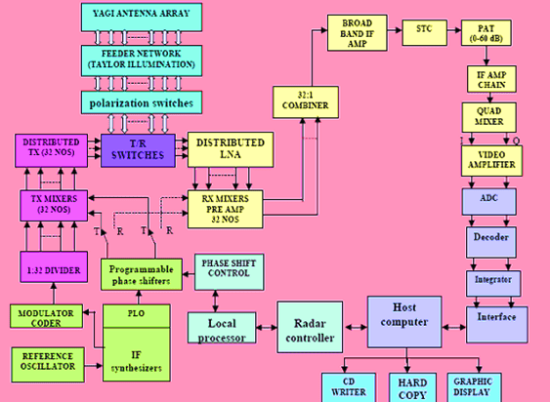
Figure 2.1 Functional Block Diagram of Indian MST Radar

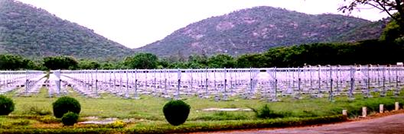
Figure 2.2 An extensive view of Indian MST Radar

The following table gives the major specifications of the Indian MST radar system
________________________________________________________________________
Table 2.1 Major specifications of the Indian MST radar system
________________________________________________________________________
Frequency : 53 MHz
Peak Power Aperture Product : 3 × 1010 W m2
Peak Power : 2.5 MW
Maximum duty ratio : 2.5%
Number of Yagi antennas : 1024
Beam Width : 30
Mode of operation : Doppler Beam Swinging
Number of beams for automatic scan : 18
Pulse width : 1 to 32 μs uncoded (in binary steps)
and 16 & 32μs coded
Pulse repetition frequency : 62.5 Hz to 8 KHz (in binary steps)

Signal processor : HP Kayak XU with ADSP
21060 SHARC based Card
Maximum number of range bins : 512
Number of coherent integrations : 4 to 512
Maximum number of FFT points : 1024
Data type : Raw Data / Spectral Data
Radar Controller : HP Kayak XU
________________________________________________________________________
A brief description of the operation of different subsystems of the radar system is presented in the following sections.
2.2.1.3. Antenna Array and Feeder Network
The phased antenna array of the Indian MST radar system consists of two orthogonal sets (one for each polarization) of 1024 three element Yagi - Uda antennas arranged in a matrix of dimension 32x32 over an area of 130 m x 130m. The two orthogonal sets are collocated with pairs of crossed Yagis which are mounted on the same set of poles. The antenna array configuration is shown in Figure 2.3.

Figure 2.3 Configuration of antenna array for (a) tilting antenna beam in north and south off-zenith angles and (b) tilting antenna beam in east and west off-zenith angles.
In order to enable the radar beam to be converse to the Earth’s magnetic field, the antenna array is oriented along the geomagnetic axis. The inter element spacing is taken as 0.71 λ in both the principal directions to allow the free beam scanning up to an angle more than 24º from the zenith. Using 32 transmitters (each feeding a sub-array of 32 antennas again), the array is illuminated.
The feeder network however, consists of 32 parallel runs of center-fed series structures with the two orthogonal sets (one for each polarization). A 3-dB in-phase power divider is fed by the RF power from a transmitter and then by using proper couplers of the feeder line, the transmitter power is distributed along the sub-array. The feeder line loss from the Duplexer to the end antenna of a sub array is about 3.5 dB. The power is distributed across the array following a modified Taylor weighting in both the principal directions. The weighting function for the first side lobe of the radiation pattern was arrived at to realize a –20 dB level. The power distribution across the array is accomplished in one principal direction by different powers of the transmitters while in the other directions, use of appropriate coupling coefficients of the series feed network is made. The three dimensional antenna array pattern computed for the E plane is shown in Figure 2.4. The array pattern for the main and first few side lobes is almost same as the radiation pattern (since the antenna pattern is rather broad with 3 dB beam width of about 66º in the E plane). It is shown from the array pattern that the aperture distribution is adopted with a gain of about 37 dB with a half power beam width of 2.62º and a first side lobe level of -20dB. The radar beam is programmed in such a way that the beam can be sequenced automatically in any combination of 82 look angles; Zenith in X and Y polarizations, up to 20º off – zenith with 1º step towards the E, W, N and S directions.
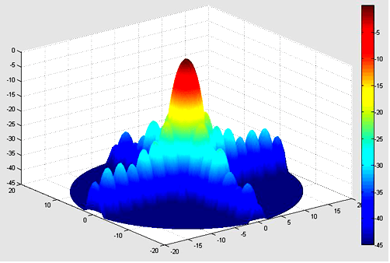
Figure 2.4 Antenna pattern
2.2.1.4 Transmitter System
The transmitter system consisting of 32 transmitters having different powers ranging from 15kW to 120 kW with each transmitter further feeding a sub array of 32 Yagis provides a total transmitter power of 2.5 MW (peak). Each transmitter consists of four stage amplifier chain with associated power monitoring; controlling as well as safety interlock circuits. The amplifier chain essentially consists of a solid state amplifier, Pre-Driver, Driver along with a High Power Amplifier. A 1mW low level pulse modulated (either coded or uncoded) signal at 53 MHz frequency is the input to the transmitter. The 53 MHz frequency is generated by a mixer which receives a 5 MHz pulse modulated signal and a suitable phase shifted 48 MHz local oscillator signal. The remotely generated signals by the radar Exciter systems are brought to the four transmit (Tx) rooms. These signals are further divided and then distributed with the required phase shifts introduced in the Local Oscillator channels. A duty cycle of transmitters can be achieved up to ~ 2.5% by limiting the total average power to ~60 kW. By using proper transmit-receive (T/R) duplexers and polarization selection switches, the output of the transmitters are connected to antenna sub-arrays. In order to switch the antenna array between the transmitters and receiver channels, Duplexers are used.
2.2.1.5 Receiver
The receiver consists of a blanking switch, a low-noise amplifier (LNA), a mixer pre-amplifier for each of the 32 channels and all of these electronic equipments are located in the four transmitter huts, eight in each of them. The output of LNA is mixed with the phase shifted 48 MHz LO signal and is amplified in a mixer pre-amplifier (with an effective gain of 7 dB) to obtain IF signal at 5MHz. The combined IF signal is then amplified with a gain of about 15 dB. Later, the signal is sent to a sensitivity time control (STC) attenuator circuit which provides a fixed attenuation of ~20 dB up to a selectable range over which the signal tends to be saturated. The signal (with a gain of 73 dB and band width of 1.7 MHz) finally goes through an IF amplifier chain and now it is split into two components and are applied to a pair of quadrature mixers (which mixes them with 5 MHz LO signals having quadratute phases of 00 and 900 which are called In-phase (I) and Quadrature-phase (Q) channels respectively). The Q signals are then fed to two identical channels of Low Pass Filter (LPF) and Video Amplifier (VA) to obtain the two bipolar video signal components, A Cos ϕ and A Sin ϕ at the output. The overall gain of the receiver is about 120 dB and the dynamic range is 70 dB.
2.2.1.6 Exciter and Radar Controller
The RF, timing and control signals for various subsystems of the radar are generated by the Exciter unit. The Exciter unit consists of a master reference oscillator (MO), a frequency synthesizer, a timing signal generator, a phase locked oscillator etc. The Master Oscillator (MO) is an oven-controlled crystal oscillator generating a 5 MHz frequency with short term stability better than 1 part in 1010. Two 5 MHz channels (with digitally programmable relative amplitude and phase) are provided by the two channel synthesizer which is phase locked to the MO. The Phase Locked Oscillator (PLO) acts as Locked Oscillator for up conversion during transmission and down conversion while receiving. A programmable multichannel pulse generator (Timing Signal Generator, TSG) supplies control signals for synchronizing operations of various sub systems of the radar. The radar system operates as per the instructions from the Radar Controller (RC) which executes an experiment consistent with the data that is given in the form of an experiment specification file. The set up, control and synchronization of operations of various subsystems of the radar during its normal operation are performed by the Radar Controller (RC).
2.2.1.7 Signal Processing System
The importance of signal processing of the MST radar is to improve the Signal to Noise Ratio (SNR) or equivalently to extract the useful signal by separating the interferences such as cosmic noise, clutter, instrumental leakages or biases, system related ambiguities etc. The extraction of the signal is carried out partly online (through hardware or real time data processing) and partly off-line (through additional data processing). The processing in each of the In-phase (I) and Quadrature (Q) channels for maximizing the SNR comprises of a) analog filters in I and Q video channels b) analog to digital converters c) digital decoder to integrate the signal d) digital integrator and e) a 16
bit parallel interface. Figure 2.1 shows the block diagram of flow controls.

2.2.1.8 Data Processing
The complex time series of the samples (decoded and integrated) are subjected to Fast Fourier Transform (FFT) for each range bin of the selected range window for on-line computation of the Doppler power spectra. For off-line processing, the Doppler spectra are recorded on a magnetic tape or data storage devices. Various steps involved in the off-line data processing for parameterization of Doppler spectrum are (1) removal of dc, (2) estimation of average noise level (3) removal of interference (if any) (4) incoherent integration and (5) computation of the three moments (0th, 1st and 2nd).
In the present analysis, average noise level is estimated using an objective method developed by Hildebrand and Sekhon (1974) and is subsequently subtracted from the received power for each Doppler bin. Any interference band (that might run through the entire window) is subtracted out by estimating it in a range bin in which it dominated the real signal. For each range bin, the signal is taken as the highest peak in the spectrum and the continuous points that are above zero level determines its window. Using the expressions given by Woodman (1985), the first three moments are then computed through Numerical Integration. The three moments represents the strength of the signal, the weighted mean Doppler shift and half width parameter of the spectrum respectively.
The computation of the three lower order moments is described below.
The zeroth moment represents the total signal power or total power in the Doppler spectrum and is given by
M₀ = ----------(2.2)

The first moment represents the weighted mean Doppler shift and is given by
M₁ = ----------(2.3)
The second moment represents the variance, a measure of dispersion from the mean frequency and is given by
= ----------(2.4)
where a and b are the lower and upper limits of the Doppler spectral window representing the signal. P_{i} and f_{i} represent the power and frequency corresponding to the ith Doppler bin within the spectral window.
Signal to Noise ratio (SNR) in dB can be estimated from the formula given by
SNR = 10 log ( ----------(2.5)
where N and L are the total number of Doppler bins and average noise level respectively and N x L, therefore, gives the total noise power over the whole Doppler spectral bandwidth, that is, coherent integration band width.
2.2.1.9 Computation of Absolute Wind Velocity Vectors
The three orthogonal components of wind velocities are obtained from the radial velocities in 3 non-coplanar directions. The computation will yield a best result in the least square method, if there exists more than three non coplanar beams.
The line-of sight component (V_{d}) of the velocity vector V = (V_{x} V_{y} V_{z}) at a given altitude is given by

V_{d} = V. i = V_{x}cos θ_{x} + V_{y}cos θ_{y}+ V_{z}cos θ_{z} ----------(2.6)

where ‘i’ is the unit vector along the radar beam, the three directions X, Y, and Z are aligned to east-west, north-south and zenith directions respectively and θ_{x},θ_{y} and θ_{z} represents the angles that the radar beam makes with the X,Y and Z axis.
Applying least square method (Sato, 1989)

ε2 = (V_{x}cos θ_{x} + V_{y} cos θ_{y} + V_{z}cos θ_{z} - V_{dm})2 ----------(2.7)

where V_{dm} = f_{dm} (λ/2), λ represents the wavelength of the radar (=5.66m for Indian MST radar) and m is the beam number. The condition for minimum residual is

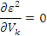
----------(2.8)
where k corresponds to X, Y and Z directions.

=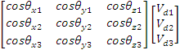 ----------(2.9)
By solving the above equation, the zonal, meridional and vertical components (V_{x}, V_{y} and V_{z}) of wind velocities are derived.
2.2.2 Mie Lidar
2.2.2.1 Lidar Principle
Light Detection And Ranging (LIDAR) is one of the most powerful remote sensing techniques to explore the Earth’s atmosphere similar to radar technique. In Lidar technique, short laser pulses are sent into the atmosphere which interacts with the constituents of the atmosphere and thereby causing modifications in the properties such as intensity, polarization, wavelength etc of the backscattered light. Parameterization of the received backscattered signal yields information of the properties of the atmosphere and its constituents. Using lidars, vertical profiles of the atmospheric parameters can be obtained. The time delay of the return signal can be used to deduce the accurate range of the scattering medium. Based on the physical phenomena that takes place between the laser pulse and the scattering particles (like absorption, fluorescence, scattering, resonance etc), lidars can be used to monitor the ice crystals in the cirrus clouds, solid particulates such as aerosols, low concentration species such as ozone, water vapor and metallic layers in the atmosphere with high vertical and temporal resolutions for long term series.
2.2.2.2 Lidar System Description
A state - of - art lidar system has been installed at National Atmospheric Research Laboratory (NARL), Gadanki (13.45 0 N, 79.18 0 E) in the southern part of India
. The aerosols and high altitude clouds (cirrus) are continuously monitored by the elastic backscatter lidar, since April 1998. Figure 2.5 (a-e) shows different parts of the lidar system at NARL used for the present investigation. The major specifications of the lidar system are given in Table 2.2 and the technical block diagram is shown in Figure 2.6. The lidar transmitter employs a Nd:YAG laser that emits laser radiation at a wavelength of 532 nm (frequency doubled) with an energy of 550 mJ per pulse. The pulse-width is 7 nsec with a pulse repetition rate of 20 Hz. In order to make the beam divergence < 0.1 mrad, the laser beam is expanded using a 10×beam expander. The receiver section of the lidar system consists of Schmidt–Cassegrain-type telescope (350 mm diameter with a FOV of 1 mrad). The receiver is used to retrieve the vertical structure of atmospheric aerosols and high altitude clouds such as cirrus by receiving the Mie scattered signals. In order to reduce noise from the sky background radiation, a narrow band interference filter with a central wavelength of 532 nm (band width of 1.13 nm) is used
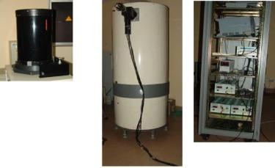
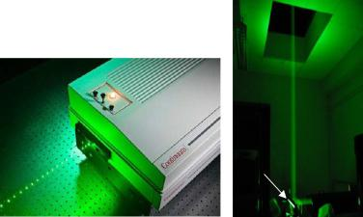

(a) (b) (c) (d) (e)
Figure 2.5 (a) Nd: YAG laser source (b) beam reflecting from the steering mirror c) Schmidt–Cassegrain type telescope (Mie receiver) d) Newtonian type telescope (Rayleigh receiver) and e) electronics rack containing different electronic systems
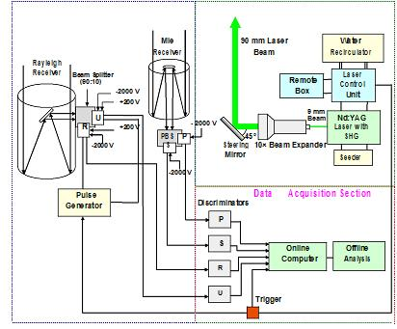

Figure 2.6 Block diagram of Mie-Rayleigh lidar system at NARL, Gadanki.
________________________________________________________________________
Table 2.2 Major specifications of the Indo-Japanese lidar system
________________________________________________________________________
Transmitter
Laser Source : Nd:YAG, Continum, USA make
Operating Wavelength : 532 nm
Average energy per pulse : 550 mJ
Pulse width : 7 nsec (Typical)
Pulse repetition rate : 20 Hz
Beam Divergence : < 0.1 mRad (Including
beam expander)
Receiver
Telescope type : Schmidt-Cassegranin
Diameter : 350 mm
Field of View : 1 mRad
I F Filter (BW) : 1.13 nm
Signal and data processing : 4 channel PC based photon
counting system operating
under EG & G MCS real-
time software
Bin width (Range Resolution) : 2 µsec (300 m)
Integration time : 250 sec (corresponding to
5000 laser shots)
________________________________________________________________________
The polarized beam splitter in the receiver section splits the collected laser backscattered returns into parallel (referred to as Co-) and perpendicular (referred to as Cross-) polarized signal components. Data acquisition and signal processing of the lidar signals with a range resolution of 300 m (corresponding to a dwell time of 2μs) can be done through a PC-based photon counting system. The photon counting signals are then sent to an MCS-Plus (Multi Channel Scalar) channel for signal analysis. The present MCS-plus PC based photon counting system is working with four data acquisition channels (two from Rayleigh receiver and the other two from Mie receiver) for the simultaneous photon counting with 5000 laser shot averaged photon count profile as one frame. The lidar system is optically aligned to heights greater than 8 km in order to remove the interference with the observation (caused by the low level clouds and aerosols). The detailed description of the lidar system is given by Bhavani Kumar et al (1999).
2.2.2.3 Data Analysis
The standard data analysis of the basic lidar signal starts with the measurement of backscattered light returned at 1800 to the incident light pulse. Backscattering of the transmitted signal arises primarily due to molecular (Rayleigh) and aerosol (Mie) scattering. Non-spherical particles (such as ice crystals and volcanic ash) also contribute to the backscattering of the laser pulses. To obtain the vertical profiles of the atmosphere, three factors should be considered that are affecting the backscattered light received by the lidar telescope. They are
a) Two way light extinction
b) Molecular backscatter and
c) Instrumental constant
The lidar signal (backscattered) in its general form can be represented by
P(Z) =KG(Z)β(Z)T2(Z) ----------(2.10)
where, p(Z) represents the power received from an altitude Z and is made up of four factors.
The first factor K represents the performance of the lidar system, the second term G(Z) represents the range dependent measurement geometry. These two factors are completely determined and also controlled by the lidar experimentalist. The third term β(Z) represents the backscatter coefficient at an altitude Z that depends on the ability of the atmosphere to scatter light in the backward direction from which it comes. The last term T(Z) represents the atmospheric transmittance at outgoing wavelength λ_{L} and return wavelength λ, describes the quantity of light that gets lost during its propagation from the lidar to an altitude Z and back. The last two terms (β(Z) and T2(Z)) are the topic of investigation.
The system factor K is given as
K = P₀ ----------(2.11)
where, P₀ represents the average power of single laser pulse, τ is energy of the pulse and cτ represents the length of the volume that is illuminated by the pulse at a fixed time. ½ is introduced for the apparent folding of the laser pulse through the process of backscattering. A is area of cross section of the receiver optics and η is the hardware optical efficiency of the lidar system e.g., mirrors, lens, filters, detectors, etc
The geometrical factor which mainly concerns the overlap of the area of laser irradiation with the FOV of the receiver optics is given by
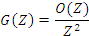
----------(2.12)
The term O(Z) represents the receiver field of view overlap function and Z2 represents the quadratic decrease of signal intensity with distance. The term O(Z)/Z2 represents the probability that the scattered photon is collected by the receiving telescope representing solid angle subtended by the receiver aperture to the scatterer (also known as perception angle).
The backscatter coefficient β_{t}(Z,λ) is the primary atmospheric parameter that determines the strength of the lidar backscattered signal and is given by

β(λ,λ_{L},Z) = n_{i}(Z) p_{i}(λ) ----------(2.13)
where represents the differential backscatter cross-section of the single particle, n_{i}(z) is the number density of scatter species ‘i’ and p_{i}(λ) is the probability of the scattered photons falling into the wavelength λ, then, the product n_{i}(Z)p_{i}(λ)=N_{i}(Z) represents the concentration of scattering particle of kind ‘i’ in the volume that is illuminated by the laser pulse.
The total backscatter coefficient β_{t}(Z,λ) consists of two parts, one corresponding to molecular back scatter and the other corresponding to particulate matter and is expressed as
β_{t}(Z,λ) = β_{mole}(Z,λ) + β_{aerosol}(Z,λ) ----------(2.14)
Molecular backscattering Β_{mole} arises primarily due to Nitrogen and Oxygen in the atmosphere. In general, the air density decreases gradually with altitude and so the value of β_{mole}(Z,λ) also decreases gradually. The magnitude of β_{aerosol}(Z,λ) is highly variable in the atmosphere both spatially and temporally. A great variety of scattering particles that contributes to β_{aerosol} includes tiny liquid and solid air pollutants such as soot, organic compounds, mineral dust, sea salt particles, biogenic materials as well as large hydrometeors like cloud and rain droplets and ice particles etc.
Further, a fraction of transmitted laser light gets attenuated during its propagation from the lidar source to distance Z and from distance Z to receiver. It is represented by the atmospheric transmittance term T2(Z) and is given by
T2(Z, λ) = exp [-2 ] ----------(2.15)
This term is an outcome of Lambert-Beer-Bouguer law for lidar. The integration is from the lidar source to distance Z. The factor 2 accounts for the two way transmission path of the lidar signal. The summation of all types of transmission losses is known as light extinction and the parameter representing the total extinction is the extinction coefficient α(Z,λ). It is defined as the product of number concentration and extinction cross section σ(Z,λ) for each type of scatterer ‘i’ i.e.
α (Z, λ) = ----------(2.16)
In general, extinction occurs due to scattering as well as absorption of light by molecules and particles in the atmosphere. Hence, the extinction coefficient can be written as
α(Z,λ)= α_{mole, scat}(Z,λ)+ α_{mole, abs} (Z,λ)+ α_{aero, scat} (Z,λ)+ α_{aero, abs} (Z,λ) ------(2.17)

where the indices scat and abs represents scattering and absorption respectively. The unit of extinction coefficient is m-1. Both the coefficients α and β are functions of wavelength of the laser light.
Summing all the individual terms, we get
P(Z, λ) = P₀ β(λ,Z) exp[-2] + P_{b} -----(2.18)
where, P_{b} is the background signal which arises due to the direct scattered sunlight during day time while the moon and stars as well as other artificial light sources contributes during night time. Sometimes, undesired signals also arise due to the detector noise. The background signal can be estimated by taking a number of data points from the far end of the signal and are used to calculate the mean background signal. The mean background signal is then subtracted subsequently from each lidar signal before starting the calculations.
In general, any backscatter lidar can detect the backscatter without distinguishing the molecular and particle contributions. Inversion methods are adopted in order to separate the particulates from the molecules. Klett inversion method (Klett, 1985) has been extensively used for lidar retrieval of cirrus and aerosol parameterization and the same method is used in the present investigation. Cirrus optical properties such as extinction coefficient and scattering ratio are retrieved based on the 532 nm co-polarized lidar signal. In Klett inversion method, the ratio of backscatter to extinction coefficient is assumed to be a constant and then total backscattering ratio is calculated. The backscattered photon count signal is first corrected for background noise as mentioned earlier and then range corrected. The noise removed and range corrected photon counts are then normalized with the model atmosphere air density profile (U.S. Standard atmosphere, 1996) corresponding to 150N in the height range of 35 km where the contribution of aerosols to the backscattered photons is negligible. The top to bottom integration is performed from the reference altitude (Z_{m}=35 km) where the contribution to backscattering is mainly due to air molecules. The total backscattering coefficient is given by (Klett, 1985)
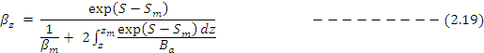
where, S and S_{m} are logarithm of the range corrected photon counts at any altitude Z and the reference altitude Z_{m}. β_{m} represents the molecular (Rayleigh) backscattering coefficient at altitude Z_{m} and is typically calculated from the pressure/temperature profiles obtained from radiosonde observations. In the present investigation, the molecular backscattering coefficients for different months (different seasons) are estimated from the profiles of pressure and Temperature that is provided by the U.S Standard atmosphere at 150N for 532 nm which can be applicable for this region (Sasi, 1994). The following flow chart shows the procedure of calculating molecular backscatter coefficient. In the flow chart, represents the backscattering cross section for the given wavelength of 532 nm. B_{a} represents the ratio of aerosol backscattering to extinction coefficient. The above solution is similar to that obtained by Fernald (Fernald, 1984) provided the value of B_{a} must be taken as a constant and independent of altitude. Jagar and Hofmann (1991) obtained the values of B_{a} for 532 nm wavelength during 1980-1987 using simultaneous lidar and ballonborne optical particle counter data over the longitude of 47.50N. Ramachandran and Jayaraman (2003) obtained the values of B_{a} (using the same but excluded the volcanic period data) for the background conditions and are found to lie in the range of 0.017-0.022 with a mean value of 0.019. In the present study, the total backscattering coefficient (β_{tot}) is calculated using this mean value of B_{a}.
Flow chart
Standard Atmosphere Model Altitude (Z), Pressure P(Z), Temperature T(Z) Density (Z)

(Z) =

x

β_{m}(Z) = n_{i}(Z)

Figure 2.7 Flow chart showing the steps involved in calculating the Rayleigh backscattering coefficient using standard atmospheric model.
Using the above mean value of B_{a} (=0.019), Ramachandran and Jayaraman (2003) estimated the uncertainties in the derived extinction as 20-25% in the altitude region of 15-30 km, and less than 20% in the altitude region below. In the above flow chart, P(Z) represents the Atmospheric Pressure in Nm-2, T(Z) the Temperature in K, N_{A} the Avogadro Number in mole-1, R_{a} the Gas Constant in J mole-1K-1, N_{i}(Z) the Number Density in m-3, the backscattering cross section in m2sr-1 and β_{m}(Z) the backscattering coefficient in m-1sr-1 respectively.
2.2.2.4 Determination of Scattering Ratio, Depolarization ratio and
Extinction Coefficient
Scattering ratio (SR) is a fundamental parameter for studying the aerosols and cloud properties and can be derived from the analysis of lidar measurements. It is defined as the ratio of total (aerosol plus molecular) backscattering coefficient (β_{tot}) to the molecular backscattering coefficient (β_{mole}).
The Scattering Ratio (SR) can be expressed as
SR = β_{tot}(z) / β_{mole}(z) = [β_{aero}(z)+ β_{mole}(z)] / β_{mole}(z) ----------(2.20)
where, β_{mole}(z) and β_{aero}(z) are the molecular (Rayleigh) and aerosol backscatter coefficients at altitude z respectively. The ratio of aerosol extinction to aerosol backscatter (also equal to 1/B_{a}) known as Lidar ratio is taken as a constant (LR = 52.6) and is used in deriving the vertical profiles of aerosol extinction coefficient given by
α_{ext}(z) = 1/B_{a} = Lidar Ratio x β_{aero}(z) ----------(2.21)
The range and time resolutions of the lidar profiles are 300 m and 250 sec respectively. The Nd:YAG lidar at National Atmospheric Research Laboratory, Gadanki is well calibrated and also validated in many studies (Bhavani Kumar et al 2001, Parameswaran et al 2003, Sunil Kumar et al 2008 etc). For an aerosol/cloud free atmosphere (also known as Rayleigh atmosphere), the scattering ratio is unity and increases with an increase in the aerosol concentration or cloud amount. Jayaraman et al., (1995) reported typical values of scattering ratio in the 1.0-1.5 range during volcanically quiescent period. Typical vertical profiles of SR and extinction coefficient corresponding to cirrus night (06 April 2007) are shown in Figure 2.8 (a-b). An enhancement in the SR value (with a peak value of ~10.8) is observed in the altitude of 11-13.5 km region indicating the presence of cirrus cloud as shown in Figure 2.8a. The corresponding extinction coefficient is shown in Figure 2.8b and is found to be ~10-2 in the cirrus altitudes and decreased value in the upper troposphere to about ~10-5 km-1 and reached a minimum value of ~10-6 in the lower stratosphere region.
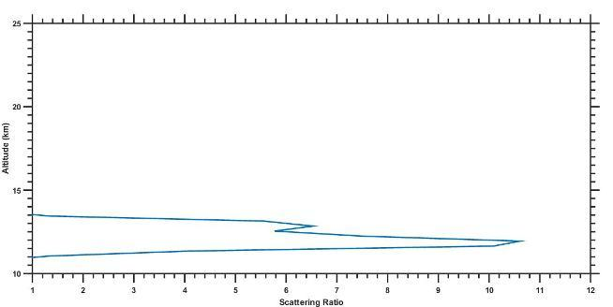
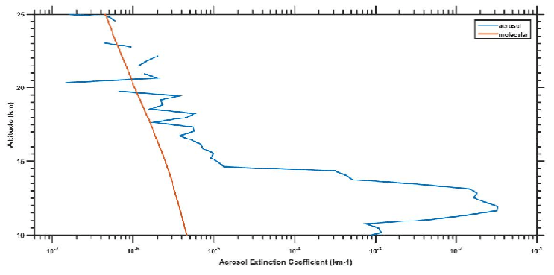
Figure 2.8 (a-b) Vertical profiles of scattering ratio and aerosol extinction coefficient measured over Gadanki on 06 April 2007.
On the other hand, lidar measurements of depolarization ratio can be used to discriminate liquid and ice phase of water in the atmosphere. In lidar studies of atmospheric polarization, a linearly polarized laser beam is sent in to the atmosphere and the backscattered signals are detected for their polarization at the receiver by a pair of PMTs, one for each polarization component. The degree of depolarization is described using a parameter known as Linear Depolarization Ratio (LDR) represented by ‘δ’ and is given by
δ = SR┴(z) / SR║(z) ----------(2.22)
where, the subscripts represent the perpendicular and parallel polarized signal components. The backscattered signal of linearly polarized transmitted signal is totally linearly polarized (δ=0), if the scattering particles are spherical as in the case of wet haze, cloud droplets, fog and raindrops. Because of the anisotropic nature of air, the depolarization of the pure molecular atmosphere is nonzero and cause a 0.37 – 0.4 % of depolarization for the Cabannes line. The depolarization of the molecular return (containing Carbannes as well as rotational Raman line) is found to be 1.5%. However, if the scattering particles are non spherical such as ice crystals, snowflakes or dust particles, the backscattered signal then contains enhanced cross polarized component ( 0< δ<1). But, Cloud layers containing highly oriented ice crystals sometimes cause a specular reflection which contributes to a small depolarization of the transmitted beam. This leads to misinterpretation of ice cloud as a water cloud. This can be overwhelmed by using the off-vertical pointing beam as in the case of HSRL.
The cloud optical depth (τ), a crucial parameter in radiative forcing calculations is determined using the equation
----------(2.23)
where, α(z) is the extinction coefficient, z_{b} and z_{t} are the cloud base and top altitudes respectively.
Further, determination of cloud base and top altitudes are very important in cloud studies. The reason is being the fact that the clouds are essentially complex themselves and due to their interaction with the surrounding dynamic environment. Some of the complexities include brokenness, high non-homogeneity etc. The determination of cloud base altitude is highly problematic because the clouds often precipitate and sometimes composed of mixed phase and especially the high altitude clouds such as cirrus are highly inhomogeneous due to shear in the horizontal winds and are convective in nature. Hence, the cloud base altitude varies rapidly both spatially and temporally in one cloud system.
Experimental Cloud Lidar Pilot Study (ECLIPS) is an initiation taken by Platt et al (1994) to obtain statistics on cloud vertical structure, cloud optical depth, extinction and surface fluxes. Several methods of cloud base and top altitude retrievals have been used successfully during the analysis of ECLIPS data. The ECLIPS data sets are being archived at NASA Langley Research Center and are available to the international scientific community. The ECLIPS data is a valuable resource for cloud parameterizations in model studies. One of the main aims of ECLIPS is to illustrate the possibility of obtaining long term climatology of cloud vertical structure and optical properties using ground based lidar and to make a plan of long term measurement.
For the determination of cloud base and top altitudes, three basic methods were developed during ECLIPS. They are: 1) Differential Zero Crossing method (Pal et al 1992) 2) Threshold method (Platt et al 1994), and 3) a quantitative approach based on the clear air assumption (Sassen and Cho 1992). The choice of selecting any of the methods for the determination of cloud vertical structure depends on the magnitude of the peak cloud backscatter coefficient compared to molecular and aerosol backscatter coefficient at the cloud base. In case of low and middle clouds, the returns are strong and the aerosol and molecular contributions are negligible. In contrast to low and middle clouds, the high altitude cirrus clouds with low density the peak backscatter returns are about three or four times greater than that of the molecular returns. The details of the three methods are described below.
a. The Differential Zero Crossing method
Differential Zero Crossing method proposed by Pal et al (1992) is used to determine the cloud vertical structure and is illustrated in Figure 2.9. The first diagram of Figure 2.9 shows the full overlap of the lidar and receiver beams at an altitude of Z₀ and a deviation in signal at Z_{b} indicating an increase in backscatter from a cloud. Figure 2.9b shows the first derivative (dP/dZ) of the lidar backscatter power. The derivative (dP/dZ) changes its sign from negative to positive at an altitude of z_{b} representing the cloud base altitude. A further change in sign occurs at the cloud peak back scatter altitude Z_{t}. The determination of cloud top altitude is somehow complex than cloud base determination. If the cloud is rather thin or semitransparent and backscatter signals are from above the cloud top are received, then the above technique can be used for the determination of cloud vertical structure. If no signals are received (the case in which transmitted signal is completely attenuated within the cloud) from above the cloud top altitude, then the signal level will decrease into the background noise. In this situation, an apparent height z_{a} is to be defined as the height at which the signal decreases below that at Z_{b}. This method was originally proposed by Pal et al (1992), but, various refinements were further reported. Figure 2.8 shows the schematic representation of DZC method. The passage of cirrus is noticed in the altitudes of ~13-15.8 km on 02 November 2006. The cloud base and top altitudes are z_{b} = 13 km and z_{top} = ~15 km. The mid cloud height can then be taken as the average of the base and top altitudes.
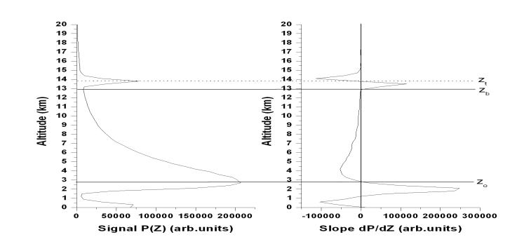
Fig.2.9 (a-b) Schematic representation of the Differential Zero Crossing Technique for automatic retrieval of cloud base and top heights (11 November 2006).

b. Threshold method
The “threshold method” proposed by Platt et al (1994). The level at which the signal power first increases above the clear background level whose magnitude equals to ‘n’ times the standard deviation of background fluctuations is taken as the cloud base altitude. Further, the signal must increase continuously for at least ‘m’ successive height intervals to ensure the presence of cloud (to avoid misinterpretation of sudden noise ‘spikes’ as clouds). In this method, standard deviation of the signal power around the mean value in the height range ∆z at an altitude z is calculated first and then, instigates the cloud base altitude by incrementing z at altitude well below the expected cloud base. Typical values of n and m are ~2 and ~5 respectively depending on the amplitude of the cloud compared to the background noise level. Cloud top altitude can be determined by estimating the standard deviation of noise above the cloud top altitude and moving downward from maximum range.
The two methods namely the DZC method and threshold method are closely related to each other as they both distinguish a change of slope from the decreasing total backscatter (aerosol plus molecular) just below the cloud base altitude to sharp increase in backscatter above the cloud base altitude. In the threshold method, small enhancements in backscatter due to aerosol pre condensation growth and in the DZC method, effects of noise fluctuations are ignored. These two methods are however, applicable to those cases where there is an enhancement in signal above the cloud base and fine tuning is required to avoid triggering of cloud base by short term spikes caused by electrical interferences. c. A quantitative approach based on clear air assumption
The method of quantitative approach based on the clear air assumption was proposed by Sassen and Cho (1992) for the determination of cloud base and top altitudes of low density clouds such as cirrus as shown in Figure 2.10. In this method, the cloud base and top altitudes are more precisely determined by fitting vertical profile of the lidar signal to a calculated vertical profile of molecular backscatter that is calculated from either collocated or nearby radiosonde data. The two profiles coincide exactly in the cloud free regions and an enhancement in the cloud backscatter coefficient can be seen in the cloud altitudes. Cloud top and base altitudes are then automatically retrieved when the cloud backscatter increases above the molecular level. One such retrieval of cloud vertical structure is illustrated in Figure 2.10 where Z_{b} and Z_{t} represent the cloud base and cloud top altitudes and are found to be ~11.6 and ~16 km respectively. This method (method-3) can be used for any type of cirrus clouds (either low or high optical depth) where there is a measurable Rayleigh backscatter return from above the cloud top altitude. This method gives more accurate retrieval of cloud vertical structure compared to the other two methods.
In the present study of wind motions during the presence of different types of high altitude cirrus (subvisual, thin and dense) clouds, determination of cloud top, base and mid cloud heights are crucial and hence the third method is adopted for the accurate retrieval of cloud vertical structure.
Figure 2.10 Schematic representation of the method of quantitative approach based on clear air assumption (at ~22:00 IST on 17 January 2007).
2.2.3 Radiosonde
Radiosonde is a balloon-borne instrument used for the measurement of atmospheric parameters like temperature, pressure, humidity, wind speed and wind direction at different heights from the ground to about 35 km. The vertical resolution of radiosonde is very high compared to satellite and re-analysis products. The earliest radio sounding was initiated in the late 1920’s and 1930’s by Vaisala. But, the archived data is available only after 1958. At most of the operational cites, radiosonde systems are generally used for upper wind information. In addition, some radiosondes are launched to probe the atmospheric constituents like ozone concentration in the stratosphere, radioactive elements etc. In general, the radiosondes are designed to probe the atmosphere up to an altitude of ~35 km. However, due to high cost of the balloons and the fuel required for lifting the balloon to higher altitudes (low pressure regions), most of the radiosondes are limited to an altitude of ~25 km only. The radiosonde frequencies are different for different locations and are specified by the International Telecommunication Union (ITU). The frequency selection depends on so many factors. The 400 MHz frequencies are generally used over regions where the elevation of balloon is very low due to the strong upper winds. If the upper winds are not so strong enough, the selection of frequency will be determined by the method of upper wind measurements used. A radiosonde system comprises of three main subsystems. They are 1) Sensor package (radiosonde) 2) ground receiving system and 3) data acquisition system
The meteorological balloons (made up of high quality neoprene rubber) filled with Hydrogen gas is used for the ascent of the radiosonde. In general, the radisonde comprises the necessary sensors that are kept in a package required for the measurement of vertical profiles of atmospheric parameters and is carried aloft by using balloon.
A radio transmitter transmits the sensor information back to the ground receiving station. A thermistor covered with a white ceramic material is used as a temperature sensor whose resistance changes in accordance with changes in temperature. In order to minimize the heating by direct sunlight, thermistor is painted white. Most of the modern radiosonde systems measures temperature of the lower atmosphere with a standard error of 0.1-0.5 K. Unfortunately, standard errors of about 1K are also found over tropics. At very low pressures (high altitudes), a relatively small error in the radiosonde pressure measurement will cause large errors in height which will cause large errors in the measured radiosonde temperature. A radiosonde should be capable of transmitting a signal to the receiver on the ground over a slant range of about 200 km. Another factor determining the performance of a radiosonde is its speed of response to changes of temperature. The modern radiosonde systems have very high speeds of response to changes in temperatures and achieve this by means of sensor time constants.
The aneroid capsules are generally used as the radiosonde pressure sensors. These sensors must sustain high accuracy over a wide range of pressures from 3 to 1000 hPa with a resolution of 0.01 hPa for pressures less than 100 hPa and a resolution of 0.1 hPa above 100 hPa. The pressure changes are identified by changes in the electrical or mechanical signals. Pressure sensors are in general, mounted within the radiosonde body to reduce the temperature changes that occur. The pressure sensor and its transducer are designed in such a way to increase the sensitivity with decreasing pressure.
The successful operation of relative humidity sensor of the radiosonde depends on the capability of exchange of water vapor between the sensor and the atmosphere. In modern radiosondes, hygristor is used as the humidity sensor, which is in general a thin film capacitor with a polymer dielectric. The capacitance of the sensor depends on the absorption of water on the dielectric material. With changes in atmospheric humidity, the electrical resistance of the dielectric material also changes. The design and arrangement of humidity sensor is such that the outside air can easily pass through the hygristor. The relative humidity measurements are reliable if it resolves 1 percent of saturated water vapor pressure from 46 hPa (at 303 K) down to at least 0.06 hPa (at 223 K). In general, operation of relative humidity sensors is very difficult at low temperatures and pressures. At low temperatures, exchange of water molecules between the sensor and the atmosphere is hampered during the ascent of the radiosonde which causes contamination of the sensor from high concentrations of water vapor earlier in the ascent and will cause significant system bias in sensor measurements. Most of the relative humidity sensors need protection from contamination by precipitation earlier in the ascent.
Two types of radisondes namely Vaisala and Meisei radiosondes have been launched from Gadanki regularly (Figure 2.11). In Vaisala radiosonde, vertical profiles of pressure are obtained using capacitance based aneroid barometer, while in Meisei radiosonde, pressure levels are computed using the hydrostatic equation without using any pressure sensors. The major specifications of the two types of sensors and accuracies of radiosondes are given in Table 2.3. The winds in the UTLS region are determined by measuring the time rate change of radiosonde positions with respect to Earth’s surface using GPS. Vertical profiles of horizontal wind speed and direction are then retrieved by converting the information concerning the azimuth and elevations of the balloon. The electronic subsystem reads each sensor data at regular intervals and then transmits the data to the receiver section. The data acquisition system of the receiver section collects the data, reduces the data in real time and stores in PC-type hard disks.
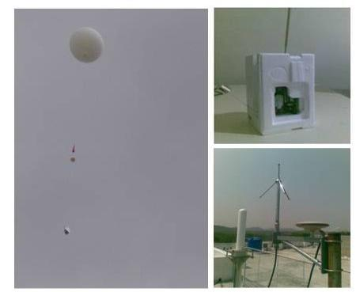
Figure 2.11 Image of GPS balloon, radiosonde and antenna system (In clockwise)

Table 2.3 Types of the sensors and accuracies of Radiosondes
Vaisala (RS 92)
Parameter | Sensor | Range | Accuracy | Resolution
Temperature | Thermo cap | -90° C to 60° C | 0.2° C to 0.3° C | 0.1° C
Relative Humidity | Thin Film | 0-100% | 2% | 1%
Pressure | Aneroid | 3-1080 hPa | 1 hPa | 0.1 hPa
Wind Speed and Direction | MW 15 |  | 0.15 m/s, 2° | 0.1 m/s
Meisei (RS01GII)
Temperature - | Thermistor | 90° C to 40° C | 0.2° C to 0.5° C | 0.1° C
Relative humidity | Carbon | 0-100% | 2% | 1%
Pressure | Calculated from hydrostatic equation using height determined from GPS
Wind speed and  Direction | RD-06G |  | 0.2 m/s | 0.2 m/s
Potential Temperature
Water is an incompressible liquid whose density is a function of temperature i.e. ρ = ρ (T). The temperature of a water parcel is conserved in adiabatic conditions and hence can be used as tracer. But air, which is a compressible fluid and its density is a function of both the temperature as well as pressure. i.e. ρ = ρ (P,T). In fact, the atmospheric air obeys the ideal gas equation ρ = P/RT, where R is the universal gas constant (287 JK-1Kg-1). The air parcel in the atmosphere rises aloft in the vertical, say for example due to convection, then, it reaches ultimately to a region of low pressure. This air parcel has to adjust itself to this low pressure by means of expansion, which does a work on the surroundings and gets cooled. So, in the atmosphere, the temperature of the air parcel is not conserved during its vertical displacement and hence the temperature of the air parcel must not be used as a tracer.
The non-conservative nature of temperature (T) under adiabatic displacement makes it less ideal for measurements of atmospheric thermodynamics. However, a parameter known as potential temperature (θ), which is a conserved quantity during adiabatic vertical displacement, can be used. Potential temperature can be defined as the temperature of the air parcel that would have, if it were compressed adiabatically (from its existing pressure and temperature) to a standard pressure level P_{o} and is defined as
θ = k ----------(2.24)
Where, k = R/C_{p} = 9/7 and P_{o} = 1000 mb.
But, the vertical distribution of pressure can be expressed as
P=Po e (-z/H) ----------(2.25) where P_{o} is the standard reference pressure at 1000 hPa and ‘H’ is the mean scale height (=RT_{s}/g_{o}, where T_{s} is the constant reference temperature and g_{o} is the global average of gravity at mean sea level).
Now, using equation (2.25), equation (2.24) can be re-written as
θ = T e (zk/H) ----------(2.26)
The above equation implies that θ is a function of height and the atmospheric lapse rate Г(=dT/dZ) which is different from the adiabatic lapse rate Г_{d} that can be obtained by taking the logarithm of equation (2.24). Using the hydrostatic relation =) and the ideal gas equation P=ρRT to simplify the result, it gives,

= 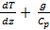 ----------(2.27)
The lapse rate for the atmosphere with constant potential temperature with height is given by
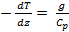 = Гd ----------(2.28)
Now eq. (2.27) can be written as
----------(2.29)
If Г < Г_{d}, the potential temperature increases with altitude meaning that the air parcel undergoes adiabatic displacement from its equilibrium level and is said to be positively buoyant during its downward displacement and vice versa. In this situation, when the air parcel tends to return to its equilibrium condition, it is said to be stably stratified.
In general, potential temperature represents a line of thermodynamic equilibrium for dry air where there is no exchange of energy with the surrounding environment (either due to turbulent mixing or due to radiative absorption or emission). If an air parcel rise or sink or move horizontally without any exchange of energy with the environment, the potential temperature remains constant. In general, air motions tend to follow surfaces of constant potential temperature, which is used in air quality modeling to see where air is going or coming from.
In the present research work, vertical profiles of potential temperature were drawn to find the air mass mixing in the vicinity of cirrus clouds that are present near the tropical tropopause.
2.2.4 Reanalysis data sets
Reanalysis uses a modern data assimilation system to reprocess past observations. Reanalysis produces in-detail explanation of the atmospheric evolution over an extensive period of time. It consists of gridded fields of observed meteorological parameters (like temperature, winds, surface pressure, humidity and ozone etc), along with many additional parameters generated by a forecast model (such as cloud parameters, rainfall, boundary layer height, etc.). The data assimilation ensures that the reanalyzed fields are controlled by the available observations in a manner consistent with the laws of physics as reported by the forecast model.
Reanalysis is a young field with origins in the utilization of meteorological data sets collected for the First GARP (Global Atmospheric Research Programme) Global Experiment (FGGE) in 1979. These data sets were reanalyzed a number of times to make better use of observations in numerical weather forecasting. The reanalyzed data sets however, can be of great value in atmospheric research. Reanalysis can be performed with single data assimilation system and ensures that the reanalyzed data products are not at all affected by any of the modifications to the data processing algorithms that are sporadically introduced in operational forecasting systems. In reanalysis data, the depiction of long-time scale variability is more homogeneous than that which can be obtained from operational analyses. Also, the use of latest version of the data assimilation system means that the quality of reanalyzed fields for earlier dates tends to be higher than that of the original operational analysis. Because of these reasons, reanalysis data is becoming extremely admired for different types of applications. Reanalysis data sets thus provide convenient admittance to the observational record, in terms of a comprehensive set of large-scale geophysical parameters.
The latest global atmospheric reanalysis project at European Centre for Medium-Range Weather Forecasts (ECMWF) is the ERA-Interim that covers the period from 1 January 1989 to till date and continues to be restructured in near real time. ERA-Interim was envisaged partially to prepare more ambitious reanalysis project for future at ECMWF, which will span the entire 20th century. The primary objective for ERA-Interim is to address certain complex data assimilation problems encountered during the production of ERA-40 that are related to the illustration of the hydrological cycle, the stratospheric circulation quality and the reliability in time of re-analyzed geophysical fields. The second objective for ERA-Interim is to improve on various technical aspects of reanalysis like bias correction, data selection, performance monitoring and quality control.
A large subset of the products is available on 1.50 ×1.50 regular latitude/longitude grids for research purposes. These gridded data products comprise a large variety of 3-hourly surface parameters (to describe the weather, condition of ocean-wave and land–surface) and 6-hourly upper air parameters covering the troposphere and the stratosphere. Along with these parameters, the ERA-Interim products contains the vertical integrals of atmospheric fluxes, daily, monthly averages for many of the atmospheric parameters and other derived fields. The details of the ERA-Interim product archive are provided by Berrisford et al. (2009). The total information about current status, availability of online data, and the near-real-time updates of several climate indicators that are derived from ERA-Interim data products is available at http://www.ecmwf.int/research/era. The description of model, method of data assimilation, production of ERA-Interim data sets from observations and few basic measures of performance is given by Dee DP et al. (2011). The entire ERA-Interim data sets are available to ECMWF’s Member State users via MARS. The reanalysis data products can be downloaded from the web site, http://data.ecmwf.int.
In the present research work, ERA-Interim reanalysis data sets were used to depict the effect of synoptic scale features on the passage of different cirrus manifestations over the observational site.
2.2.5 The CALIPSO mission
2.2.5.1 Global cloud coverage by lidar measurements from space
The NASA’s Cloud-Aerosol Lidar and Infrared Pathfinder Satellite Observation (CALIPSO) is a two wavelength polarization sensitive lidar used for extensive high resolution cloud distribution analysis. In association with the A-train constellation of satellites on a 16 day repeat cycle, CALIPSO was launched on 28 April 2006 to monitor the aerosol and cloud properties, their variety of interactions and impact on climate system (Winker et al., 2010). In general, Passive satellite sensors are incapable of retrieving vertical profiles of aerosols and clouds and also their optical properties. CALIPSO on the other hand, is capable in distinguishing optically thin boundary layer clouds from dense clouds (such as stratus clouds) and also from aerosols. CALIPSO clearly distinguishes the cloudy and cloud free atmospheric columns because of its direct observation of the cloud top altitude and extent. Lot of investigations on clouds, aerosol distribution (e.g Winker et al., 2010a, Wu et al., 2011) and their interactions have been published.
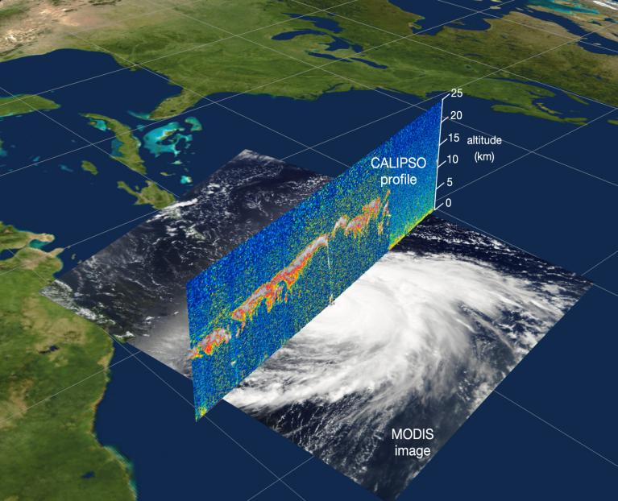

Firure. 2.12 Image of CALIPSO profile
The CALIPSO data has been used for validating passive and active sensor data (Berthier et al., 2008, Karlsson and Johansson, 2013) and to examine specific cloud types (Leahy et al., 2012, Veglio and Maestri, 2011). One such CALIPSO profile is shown in Figure 2.12.
2.2.5.2 Scientific challenges and limits of CALIPSO
Even though, CALIPSO have been proved to be one of the best passive satellite missions in its performance for the detection of clouds with a high resolution of 333 m, some types of cloud retrievals are still remain challenging. Especially, low optical depth cirrus clouds (subvisual cirrus (SVC) or Polar Stratospheric Clouds (PSC)) require extensive averaging of many successive lidar measurements. Horizontally oriented ice crystals in the cirrus clouds can be detected by the nadir viewing lidar beam. By an increment of 30 in the lidar beam from the nadir pointing direction, optical and physical properties of cirrus clouds are determined more accurately (Hunt et al., 2009). CALIPSO uses 110 mJ laser pulses and larger telescope and is specifically designed to retrieve and penetrate multiple cloud layers in the atmosphere. Chan and Comiso, 2011 reported the failure of CALIPSO in detecting a cloud at all, which can be found by comparing MODIS data with CloudSat. Most of the geometrically thin, subvisual, even sometimes the low level clouds whose layer thickness not exceeding 1 km that remaining below 2.5 km altitude are still treated as undetected clouds. However, CALIPSO has been proved to be the only passive satellite that provides observations with high vertical and horizontal resolutions (30m, 333 m) on a global scale.
2.2.5.3 The CALIOP payload
The CALIPSO satellite basically comprises of an Infrared Imaging Radiometer (IIR), a Wide Field Camera (WFC) and the Cloud Aerosol LIdar with Orthogonal Polarization (CALIOP) as shown in Figure 2.13. The IIR and WFC are supportive passive instruments while the laser transmitter subsystem of CALIOP consists of two identical laser transmitters. Both the Nd:YAG lasers generates laser pulses of energy 220 mJ with a repetition rate of 20.16 Hz with a pulse width of 20 ns at 532 nm and 1024 nm.
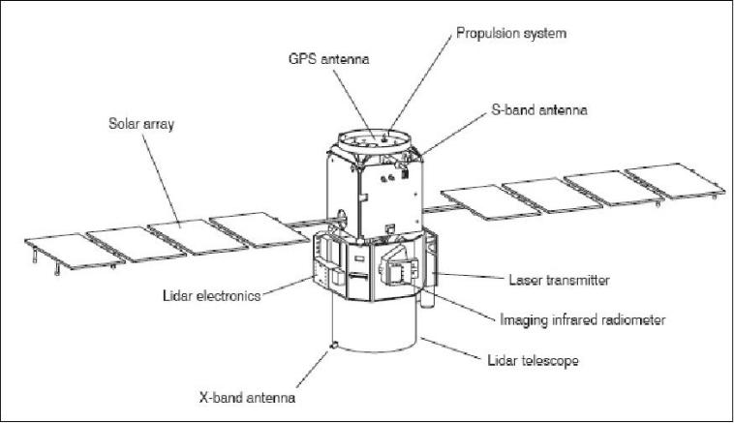
Figure 2.13 Different parts of the CALIPSO satellite

A highly polarized output beam (due to the out-coupling of polarization) is provided and then, the angular divergence of the transmitted laser beam is reduced with the help of beam expanders. This will produce a foot print of ~ 70 m at the surface of Earth. The receiver subsystem which consists of 1-m telescope receives and measures the light that is backscattered by the molecules, aerosols and clouds in the atmosphere. The on-board detectors must have excellent sensitivity in detecting even tiniest backscattering events. By using suitable high quality interference filters located upstream of the detectors, it is possible to reduce the solar background illumination. A polarization beam splitter is placed upstream of the 532 nm detector to separate the parallel and perpendicular components of the 532 nm return signal (Hunt et al., 2009, Winker et al., 2006). The parallel and perpendicular channels along with the beam splitter measure the depolarization of the backscattered signal and thereby able to discriminate the cloud phase and sphericity of the particles (such as aerosols, ice crystals of cirrus etc). CALIOP uses an on-board averaging algorithm in order to hoard the on-board storage and limit the quantity of data that is to be transmitted to the ground. The atmosphere becomes spatially uniform with altitude and hence the signals (returns) from the higher altitudes become weaker. In order to overcome this difficulty, CALIOP uses different averaging schemes for different altitudes (Winker et al., 2006). For the lower troposphere (altitudes < ~8.2 km), where the spatial variability of particles is high, CALIOP uses its fundamental vertical resolution of 30 m. For higher altitudes (from 8.2 to 20.2 km), CALIOP uses 60 m vertical resolution and for signals from 20.2 km to 30.1 km, it uses 180 m resolution to achieve the required SNR and also to reduce the data. Level 1 algorithm gives the attenuated backscatter coefficient profiles including their respective uncertainties and level 2 algorithms gives information of the future detection of aerosols and clouds within the measured atmospheric column. Improvements in these algorithms by version 3.01 and reduction of previous overestimation of cloud fractions are reported (Liu et al 2010).
In the present study, version 3.01 of level-1 products were used to show (or validate) the passage of cirrus clouds as detected by the ground based lidar at NARL, Gadanki. The images of temporal and spatial (latitudinal/longitudinal) variations in depolarization ratio are downloaded directly from the CALIPSO lidar browse images (http://www-calipso.larc.nasa.gov/tools/data_avail/). The passage of single layered as well as multi layered cirrus can also be clearly detected using the CALIPSO data products. As an example, passage of single geometrically thick cirrus in the altitudes of ~11.0-15 km over Gadanki region (13.450 N, 79.180 E) along with lat/lon variations in depolarization ratio is shown in Figure 2.14a and passage of multi layered cirrus in the altitudes of ~9-12 km (lower cirrus layer) and ~13-15 km (upper layer) respectively and is shown in Figure 2.14b.
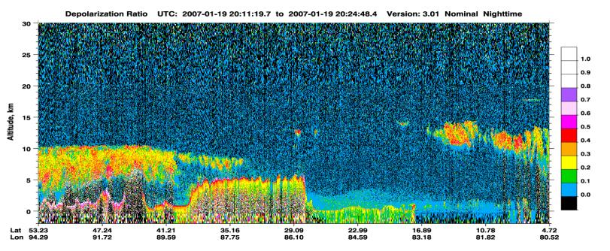
Figure 2.14a Image of variations of Depolarization Ratio (lat/lon variations) derived from CALIPSO showing the passage of single layered cirrus near Gadanki (13.450 N, 79.180E) on 19 January 2007.
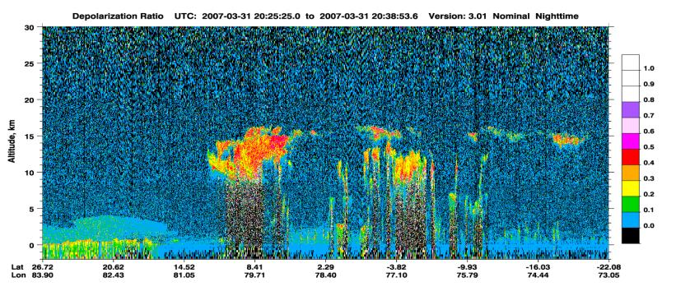
Figure 2.14b Image of variations of Depolarization Ratio (lat/lon variations) derived from CALIPSO showing the passage of multi layered cirrus near Gadanki (13.450 N, 79.180E) on 31 March 2007.
_____________________________________________________Chapter 3
Wind motions around the tropical cirrus using simultaneous radar and lidar observations over Gadanki (13.45 0 N, 79.18 0 E)
, India

3.1 Introduction
Cirrus clouds have long fascinated the scientists because of their variable microphysical and optical properties. They are thin wispy clouds blown in high winds and intermittently associated with strong turbulence in the region of upper troposphere and lower stratosphere (Parameswaran et al., 2003). These clouds will significantly affect the Earth’s climate through infrared absorption and solar albedo effect (Zerefos et al., 2003). Their contribution to the radiation budget strongly depends on their optical and geometrical properties. Space borne lidars, in situ measurements and ground based experiments showed that nearly, 20-30% of Earth’s atmosphere is covered with cirrus clouds. Their frequency of occurrence is so high over tropics causing a significant warming to the equilibrium climate through the interaction processes between cloud and radiation (Ramaswamy and Ramanathan, 1989).
Cirrus clouds form at different altitudes at different geographical locations, ranging from 8 to 20 km (Devara et al., 1995). For example, at mid-latitudes, thin cirrus will occur between 8.5 and 11.5 km altitude region (Sassen and Cho, 1992), Ansmann et al 1992, Heymsfield and McFarquahar, 1996, Goldfarb et al., 2001 and Yamamoto et al. 2009) with a persistence of few hours only which is because of rapid crystal growth and dissipation by precipitation due to high tropopause temperatures (Jensen et al., 1996) and over tropics they usually occur in the altitude region of 8-17 km with the maximum occurrence of cirrus in the 13-14 km altitude region (Sivakumar et al., 2003). The mean altitude of cirrus cloud will increase with the decrease in cold point temperature near the tropopause (Parameswaran et al., 2003, Sivakumar et al., 2003). They also reported that sharp discontinuity in vertical gradient of eddy diffusion coefficient due to divergence followed by convergence above, in the strong and persistent region of cirrus is responsible for the formation of cirrus. In fact, these clouds are confined to occur very near to the tropopause region (Prabhakara et al., 1988, Dowling et al., 1990, Winker and Trepte 1998 and Boehm et al., 1999). The horizontal extent of cirrus can be more than ~1000 km and they can persist for few hours to few days in the tropical region (Immler and Schrems 2002, Sivakumar et al., 2003). The reason for the long time persistence of cirrus clouds near the tropical region is due to the utilization of absorbed infrared radiation for lifting the cloud layer under weak vertical wind instead of raising the temperature of local air parcel with the absorbed radiation (Jensen et al., 1996). Especially, in tropics these clouds will often appear below the tropopause and those clouds that appear near tropopause will act as tropopause tracers (Beyerle et al 1998).
Cirrus clouds are composed of complex structures and are spatially inhomogeneous due to shear in the horizontal wind, therefore alter the radiative properties (Houze 1993). In general, atmospheric circulation will be affected by vertical gradient of radiative forcing due to cirrus clouds especially in the Upper Troposphere and Lower Stratosphere (UTLS) region (Webster and Stephens, 1984). Since, cirrus clouds will influence the dehydrated air entering into the UTLS region there by affecting the climate change. Cirrus clouds will also play an important role on the atmospheric chemistry by reducing the ozone concentration and may also take active part in the chlorine chemistry during their presence especially near tropical and midlatitude regions (Reichardt 1999).
The accurate determination of the microphysical properties and vertical structure of cirrus clouds necessitates knowledge on dynamical processes (Starr and Cox 1985). The reason is being the fact that the formation of cirrus, their development and persistence are associated with the background wind fields. Das et al (2011) studied the redistribution and transport of Upper Tropospheric Humidity (UTH) along with the formation mechanism of the tropical cirrus clouds coupled with the Tropical Easterly Jet using the passive remote sensors and reanalysis data sets. They reported a low value (< 220 watts m-2) of Outgoing Long-wave Radiation (OLR) during South Asian Summer Monsoon period over the North Bay of Bengal with maximum amount of UTH over the Indian peninsular region. The occurrence of cirrus is high where the UTH is higher. The formation of tropical cirrus is attributed to the redistribution of UTH from a highly convective zone to the Indian peninsular region. The role of TEJ on the formation of tropical cirrus is well documented by Das et al (2011), but did not focused on the short term/long term variations in cirrus microphysical and optical properties during the propagation of TEJ. Further, Hubert Luce et al (2009) using simultaneous measurements of VHF radar and Rayleigh – Mie - Raman (RMR) lidar over midlatitudes, reported a downward penetrating ice crystal structures at the cirrus cloud base in association with a clear air turbulent layers developing downward from the cirrus base in the environment of the protuberances. Downward clear air motions were associated with the descending protuberances and updrafts noticed between them. These results suggest that the observed protuberances at the base of the cloud might be due to the downward push of the cloudy air by the downdrafts of convective instability and upward push by the updrafts. Fortuin et al., 2007 studied the origin of cirrus clouds and the dynamical processes and reported that the occurrence of cirrus often corresponds with a northerly meridional wind flow even when the ITCZ lies to the south in the January- May period. The transport of cirrus is attributed to the inertial instability flow in the form of vertically stacked meridional circulation cells in the UT region. A thermal wind in the form of Westerly Jet / Easterly Jet associated with northward / southward transport of moist air caused by a Radiative cooling of a moist layer that is transported in the upper troposphere is also reported. Finally, Fortuin et al., 2007 concluded that the cirrus originates mostly from either ITCZ or from deep convective centers that are formed to the south during the early summer monsoon. Few studies on wind motions around tropical cirrus clouds (Kumar, Y.B. et al., 2001, Parameswaran and Sunil Kumar et al 2003) are also available. However, all these studies have been focused on the origin, formation, transport and ascent/descent of cirrus but did not consider the modulations in the wind motions during the presence of cirrus clouds.
In the present research work, an attempt is made to study the modulations in wind motions within the cirrus clouds observed at different altitudes, different manifestations (such as subvisual, single layered thin and multiple cirrus layers) using three different cases, one during post-monsoon and the other two during Indian summer monsoon seasons. Cirrus clouds are monitored with the help of ground based polarization lidar and simultaneous wind information around the cirrus clouds is obtained from MST radar at National Atmospheric Research Laboratory (NARL), Gadanki.

3.2 Experiment Details and Description of the data
3.2.1 MST Radar
The present observations were made using VHF radar located at Gadanki. The radar system details are discussed in chapter 2. The data collected by the VHF radar operated in Doppler Beam Swinging mode with six beams (viz. East, West, Zenith-X, Zenith-Y, North and South) during which the passage of cirrus over Gadanki is detected by the co-located lidar for the three Cases, i.e., on 2nd November 2006, 25th July 2007 and on 08 June 2006 with a height resolution of 150 m and a temporal resolution of 4 min has been used to study the continuous wind motions around the tropical cirrus clouds.
3.2.2 Mie Lidar
A monostatic, dual polarization lidar operated at 532 nm installed at National Atmospheric Research Laboratory (NARL), Gadanki has been used for observing the spatial and temporal variations of cirrus clouds during 02 November 2006, 25 July 2007 and 08 June 2006. The detailed description of the lidar system is presented in Chapter 2. The altitude profiles of signal intensity received by linear and orthogonal polarization channels were obtained with a bin width of 2 μs (corresponding to an altitude resolution of 300 m) and summed over 250 seconds constitutes the basic lidar signal. The lidar data is processed by employing Fernald method (Fernald, 1984) to estimate the altitude profile of total backscatter coefficient (β_{total}) from 7–30 km altitude range by taking the reference altitude as 30 km where the value of aerosol backscatter coefficient (β_{aero}) is assumed to be insignificant. For lidar signal inversion, altitude profile of molecular backscatter coefficient (β_{mol}) is essential and is estimated using altitude profiles of pressure and temperature from Radiosonde launched every day at 17:30 IST since August 2006 over Gadanki. The location map of Gadanki region is shown in Figure 3.1
Further, we have used the particulate backscatter coefficient to determine the cloud vertical structure (cloud base and top altitudes), cloud backscatter coefficient (β_{c}) and the lidar derived Linear Depolarization Ratio (LDR). For the determination of cloud base and top altitudes, three basic methods were developed during Experimental cloud Lidar Pilot Study - ECLIPS and are described earlier in chapter-2. In the present study, however, we used the method of quantitative approach based on clear air assumption (method-3) for the accurate determination of the cloud base and cloud top altitudes.
The method of quantitative approach based on clear air assumption
In this method, the altitude profiles of cloud backscatter coefficient β_{cloud}(z) has been calculated for the determination of cloud borders. First of all, we have computed the backscatter ratio S(z) of the lidar signal and then, the altitude profiles of the molecular backscatter coefficient β_{mol}(z) has been obtained using the altitude profiles of the number density of molecules N_{mol}(z) by averaging pressure and temperature profiles obtained by radiosonde. Now, the cloud backscatter coefficient β_{cloud}(z) can be computed (Yamamoto, et al. 2009) by using the formula β_{cloud}(z) = (SR(z)-1)* β_{mol}(z). In order to determine the cloud borders, we have to find the threshold value of β_{c}(z), (i) which should be small enough to observe small variations in β_{cloud}(z) due to the presence of cloud particles, and (ii) the threshold should be large enough to determine the uncertainties in the received signal at the cloud borders due to fluctuations in β_{cloud}(z). The threshold value can be changed arbitrarily to satisfy (i) and (ii). This low value of β_{cloud}(z) threshold will capture all the layers of enhanced scattering above the level of molecular and ambient aerosol backscatter, includes sub visual cirrus as defined by Sassen and Cho (1992). Now, the altitude profile of total backscatter β_{total}(z) = (β_{cloud}(z) + β_{mol}(z)) will be obtained by using the cloud backscatter coefficient β_{total}(z) using lidar. Finally, by plotting the β_{total}(z) and β_{mol}(z) together, one can automatically retrieve the cloud base and top altitudes more accurately , since, there will be proper coincidence between profiles of β_{total}(z) and β_{mol}(z) except in the cloud region. The reason for using method-3 in determining the cloud base and top altitudes is that, this method can give more precise values of cloud base and cloud top altitudes. Whereas, the methods 1 and 2 are more closely related (distinguishes a change of slope from the decreasing total backscatter just below the cloud base to the sharp rise in backscatter above cloud base) requires fine tuning in order to avoid triggering of cloud base by random noise, short range spikes and also tuned to ignore small enhancements in backscatter below the cloud base caused by aerosol pre condensation growth. In order to overcome some of the above mentioned problems, Sassen and Cho (1992) have developed the method-3, which can be used for low-density clouds also. Hence we have used the method-3 for finding the vertical structure of the broad cirri form clouds.

3.2.3 Objective reanalysis
In addition to MST radar winds and radiosonde temperature data, we have used pressure to height converted 6 hourly zonal wind and temperature data sets available at 37 standard pressure levels (1000 hPa to1 hPa) from ERA-Interim Reanalysis (Simmons et al 2007) downloaded from http://data-portal.ecmwf.int/ for the present study to depict effect of synoptic scale features on the passage of cirrus clouds over the observational site.
3.3 Variations in wind velocities during the presence of different cirrus Manifestations-case studies
Wind variations around the cirrus clouds were monitored by using MST radar and Mie-lidar co-located over Gadanki (13.50 N, 79.18o E) using three different cases, one during post-monsoon season and the other two during Indian summer monsoon.

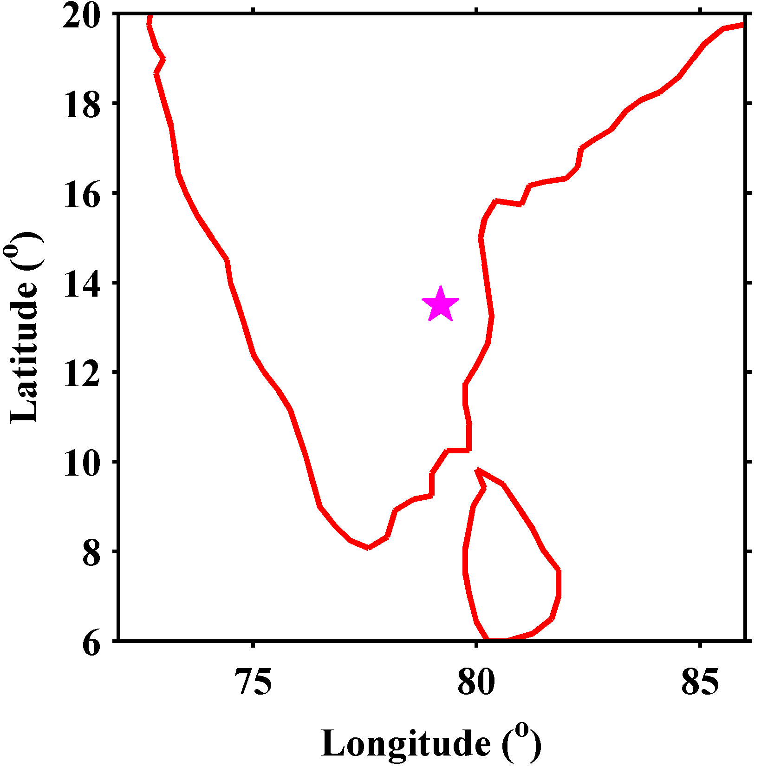
Figure 3.1 Location map of region of study (* indicates Gadanki location).
Case-(a): Figure 3.2a shows the height-time section of cloud backscatter coefficient deduced from lidar showing the presence of cloud between the altitude regions of 13-14.8 km on 02 November 2006 between 01:15-01:55 LT. On this day the simultaneous wind information is available between 01:00-04:30 LT in Upper Troposphere and Lower Stratospheric region (Figure 3.4a).
Case-(b): On 25 July 2007 both lidar and MST radar observations were made simultaneously from 20:50 to 24:00 LT (Figure 3.2b). The presence of cirrus is noticed between ~12.6-16.5 km and the corresponding wind information can be noticed from the winds determined using MST radar (Figure 3.4b).
Case-(c): The presence of multiple clouds is noticed at ~12.4 km-14.5 km and ~16.2-17.1km altitude regions from β_{c} between 03:00-05:00 LT on 08 June 2006 (Figure 3.2c) and its corresponding wind variation available between 02:00-05:30 LT can be noticed from the Figure 3.4c.
Figure 3.2(a-c) describes the altitude-time plot of the cloud backscatter coefficient β_{cloud} calculated using lidar. During Case-(a) cirrus cloud is found to be present in the ~13-14.8 km altitude region with cloud top altitude located at around ~14.8 km. During Case-(b), we have noticed the presence of cirrus at two different altitudes, one corresponding to cloud top of ~16.5 km and another with a cloud top of ~13.7 km which might be due to the detachment of cirrus from the original cloud which can be noticed from β_{cloud} especially, between 23:00 to 24:00 LT (as in Figure 3.2b) . In Case-(c), there is two layers of cirrus with cloud tops of ~14.5 km and ~17.2 km is found between 03:00 LT to 05:00 LT on 08 June 2006 respectively. Except in Cases (a) and (c), we have noticed a slight descent in the cloud top altitude in Case-(b) (as seen in Figure 3.2b) between 23:00 LT to 24:00 LT.
In order to discriminate the cloud phase and also to observe the effect of wind during the presence of cirrus, we have calculated the values of Linear Depolarization Ratio (LDR) for all the three Cases. Figure 3.2(d-f) shows the height–time zenith lidar display of the LDR which is a trace of cirrus cloud. The peak LDR values are found to be 0.182, 0.089 and 0.23 for the Cases (a) to (c) respectively. Sivakumar et al (2003) has classified the cirrus with LDR <0.15 are composed of liquid layer and those with LDR between 0.16-0.25 are composed of super cooled layer (like ice). Hence, the cirrus clouds observed during Cases (a) and (c) are composed of super cooled layer and in Case-(b) the cirrus cloud is composed of liquid layer. As reported by Thomas et al (1990), cirrus cloud with low values of LDR corresponds to regular quasi-spherical or horizontally oriented and flat ice crystals. While, high values of LDR indicates randomly oriented and highly non-spherical ice particles. We have also noticed that the clouds occurring at higher altitudes (lower temperatures) during Case-(c) show high LDR than the clouds observed at lower altitudes (higher temperatures), during Cases (a) and (b) indicating strong dependence of LDR on the ambient temperature conditions of surroundings (Platt et al 1998). It is observed that low to moderate values of LDR indicating low ice water content, which is consistent with the earlier investigations (Heymsfield and McFarquahar, 1996, Takahashi and Kuhara 1993, Sivakumar et al., 2003 and Kumar et al., 2001).

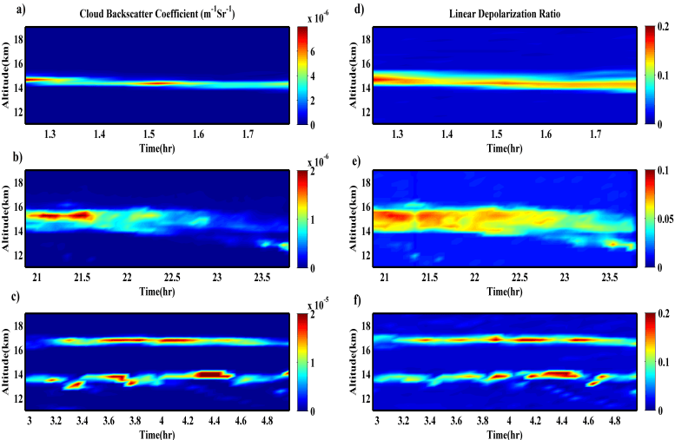

Figure 3.2 Time-altitude plots of (a-c) cloud backscatter coefficient (β_{c}(z), m-1Sr-1) and (d-f) linear depolarization ratio (LDR) for 02 November 2006 between 01:15-01:55 LT (top panel), 25 July 2007 between 20:50-24:00 LT (middle panel) and 08 June 2006 between 03:00-05:00LT (bottom panel), respectively.
While classifying cirrus clouds as visible and sub visual, Sassen, K. and Cho, B.S. (1992) has projected a threshold value for cloud optical depth (COD) as 0.03 for the sub visual cirrus cloud for the first time at an optical wavelength of 694 nm. The values of COD are found to be 0.08 (visible) for the Case-(a), 0.04 (visible) for the Case-(b) and 0.06 for the lower cloud layer (visible) and 0.001 for the upper cloud layer (sub-visual) for the Case-(c), respectively. It is clear from the values of COD from the present study that the COD shows a direct correlation with ambient temperature, since we have noticed cirrus at different altitudes during the cases of present study, which is in agreement with the previous results (Bhavani Kumar et al., 2001, Chen et al., 2002 and Sivakumar et al., 2003).

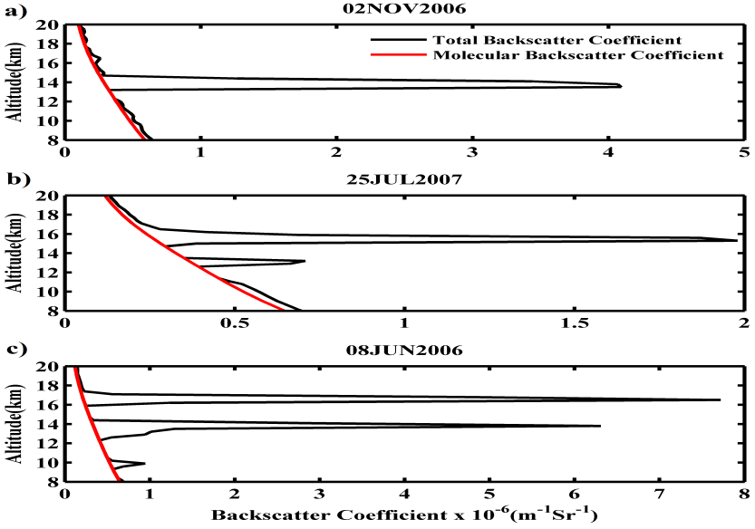

Figure 3.3(a-c) Altitude profile of β_{cloud}(z) + β_{mol}(z) observed by lidar (black line) and β_{mol}(z) calculated from radiosondes (red line) for a) 02 November 2006, b) 25 July 2007 and c) 08 June 2006.
Further, we have determined the cloud base and top altitudes by using the method-3 as in Sassen and Cho (1992) and are shown in Figure 3.3(a-c).
It is clear from this figure that, except in the cloud regions, the total backscatter coefficient β_{total} and the background molecular backscatter coefficient β_{mol} were almost the same. Thus the regions, where the cloud backscatter coefficient β_{c} > 1.21 ×10−7 km−1 sr−1 in Case-(a), βc > 6.17×10−8 km−1 sr−1 in Case-(b) and βc > 3.46 ×10−7 km−1 sr−1 in Case-(c) respectively were identified as clouds. Values of cloud base and top altitudes are found to be ~13.0 km and ~14.8 km for the Case-(a). From Figure 3.3b one can notice that there are two peaks one corresponding to regular cirrus which is noticed with cloud base and top altitudes at ~14.6 km and ~16.5 km and the other corresponding to the detached cloud with cloud base and top altitudes at ~12.6 km and ~13.7 km noticed between 23:00-24:00 LT for the Case-(b). During Case-(c) there are two cirrus layers one with cloud base and top altitudes at ~12.3 km and ~14.5 km and the other at ~16.1 km and ~17.2 km, respectively.
Figure 3.4(a-c) shows the MST radar winds (u, v and w) during the passage of cirrus cloud over Gadanki for the three Cases.

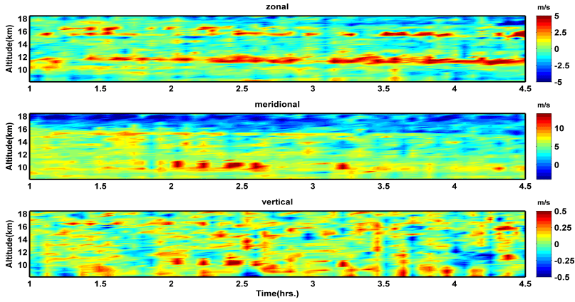
Figure 3.4a Time-altitude plot of zonal (top panel), meridional (middle panel) and vertical (bottom panel) winds from 01:00-04:30 LT 02 November 2006.

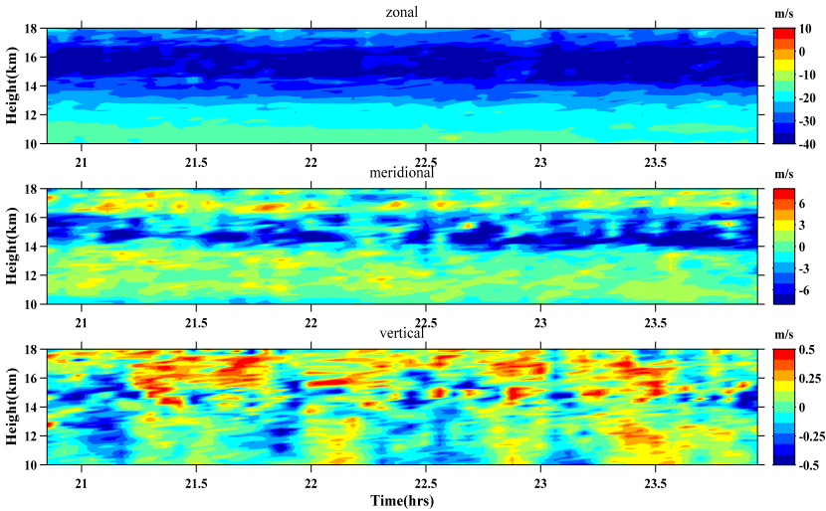
Figure 3.4b Same as Figure 3a for 25 July 2007 between 20:50-24:00 LT.

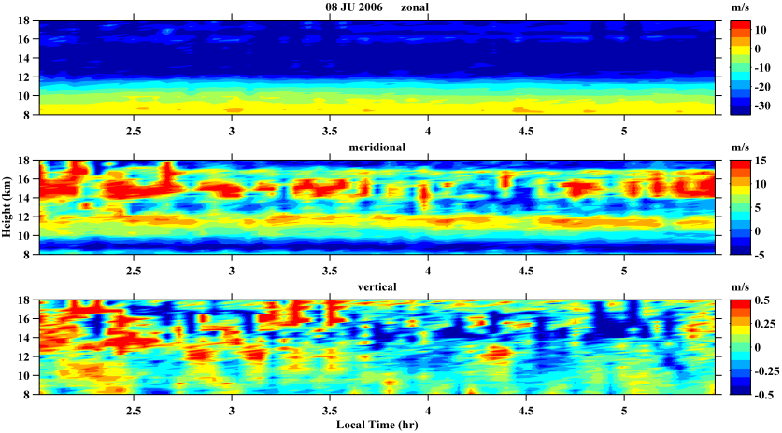
Figure 3.4c Same as Figure 3.3a and 3.3b for 08 June 2006 between 02:00-05:30 LT.
In order to find the relation between the background wind fields within, above and below the cirrus altitudes, temporal map of winds Within Cloud Height (WCH), Below Cloud Height (BCH) and Above Cloud Height (ACH) were plotted in Figure 3.5.
In Case-(a), we observed a westerly wind (Figure 3.4a) with a maximum of ~5 m/s just below the cirrus cloud altitude from 01:00 LT to 04:30 LT . Zonal wind below the cloud height (BCH, 12.0-13-0 km) is found to show similar variation as that of LDR within in the cloud (Fig.3.5a).
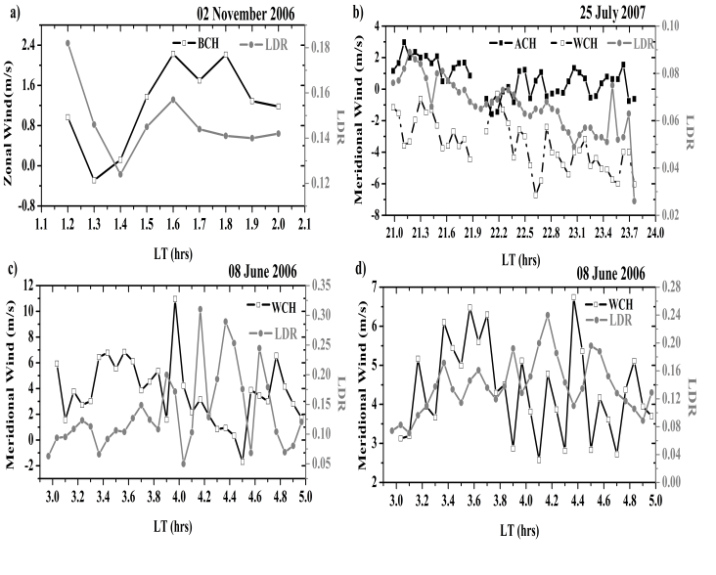
Figure 3.5 Time variation of mean (a) Zonal wind below the cloud height (BCH) on 02 November 2006, (b) Meridional wind above and within the cloud height (ACH and WCH) on 25 July 2007 and (c and d) Meridional wind within the cloud height (WCH) for dual cloud noticed on 08 June 2006 with peak linear depolarization ratio (LDR).

Above the cloud height we have noticed weakening of westerly wind when the LDR is strong. Later again westerly wind BCH is found to show significant increase in magnitude with time. Even though, it is difficult to depict variation of winds during this type of small-scale / short-time phenomena of cirrus cloud passage using Re-analysis data sets, a significant increase in the zonal wind with time (as in Figure 3.4a) can be explained by the existence of a sub-tropical westerly jet (as shown in Figure. 3.6a) whose outer core existed to the North of Gadanki (13.45 N). No significant feature is observed in the meridional wind relating to the passage of cirrus, but it is becoming weaker in magnitude with time. Even though there is no significant feature noticed in vertical wind during the passage of cirrus during Case-(a), but it is found to be increasing in magnitude similar to that of zonal wind. In Cases (b) and (c), we have noticed tropical easterly jet (Figure 3.4b and 3.4c) which is often noticed in the months of (monsoon) June, July and August whose speed is found to be more than 30 ms-1 in the present observation. As this jet is continuous for the months of time, so it is difficult to interpret the effect of this wind on the microphysical properties of cirrus clouds present in these heights. But, there may be a chance of these clouds to move in the direction of wind. In Case-(b), the meridional wind is found to be slightly fluctuating from northerly to southerly above the cloud height (ABH, 16.5-17.5 km) (Figure 3.4b). Within the cloud height (WCH, 13.5-15.5 km) it shows similar trend as that of LDR but the meridional wind (southerly) is increasing in magnitude with decrease in LDR (Figure 3.4b). The vertical wind is also found to show strong fluctuations within the cloud height and above the cloud the vertical wind is found to be mostly upward (Figure 3.4b). In Case-(c), for the lower cloud layer, the meridional wind within the cloud height (WCH,12.5-14.5 km) is found to show almost opposite variation as that LDR (Figure 3.5c), ie., meridional wind is decreasing with increase in LDR. Above the lower cloud layer (14.5-15.5 km) northerly wind is dominant with an amplitude of ~15 m/s except between ~ 3.5- 4.5 hrs (Figure 3.4c). For the upper cloud layer, again the meridional wind is found to show opposite variation as that of LDR (Figure 3.5d) as in Figure 3.5c. Even though the vertical wind is slightly fluctuating, it is upward dominant up to ~3:15 hrs; it is dominantly downward in the later hours.
Figure 3.6a shows, latitude–altitude plot of zonal wind and potential temperature (black contour lines) over the Gadanki longitude (79.18E) at 2330 LT (top panel) 1st November 2006 and 0530 LT (bottom panel) 2nd November 2006 for the Case-(a). It shows a sub tropical westerly jet around 10 to 12 km. The westerly wind is found to be maximum (larger than 40 ms-1) around 240-260N latitude. Gadanki (13.5°N) is southward of the core of the subtropical westerly jet.

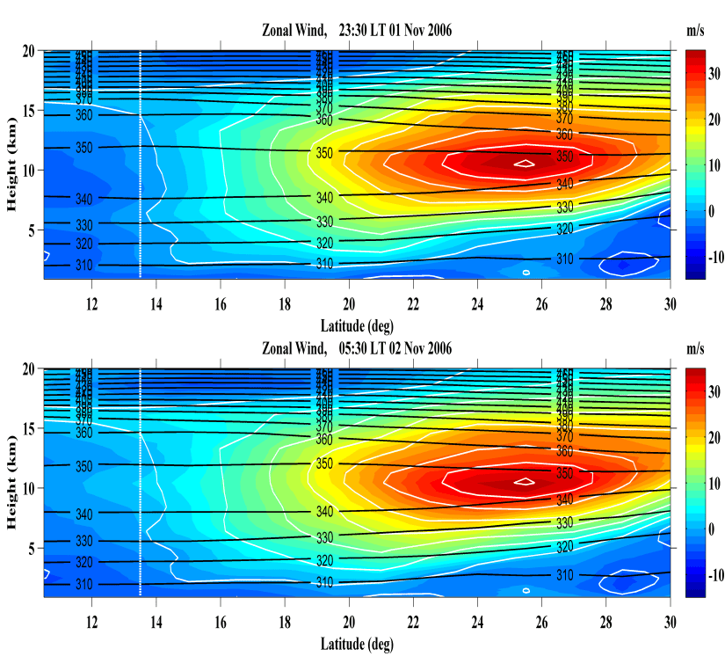

Figure 3.6a Latitude-height plots of zonal wind (white contour with colored) and Θ (black contour) along 79.5°E (top panel) at 23:30 LT 01 November 2006 and (bottom panel) at 05:30 LT 02 November 2006.

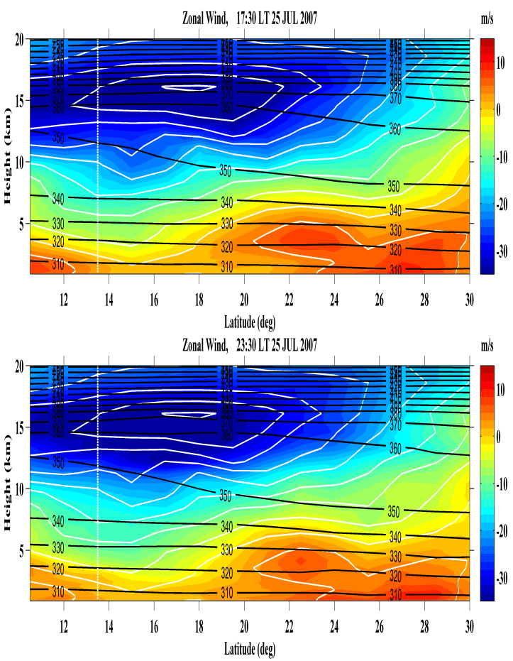

Figure 3.6b. Same as Figure 3.5a, (top panel) at 17:30 LT and (bottom panel) at 23:30 LT 25 July 2007.

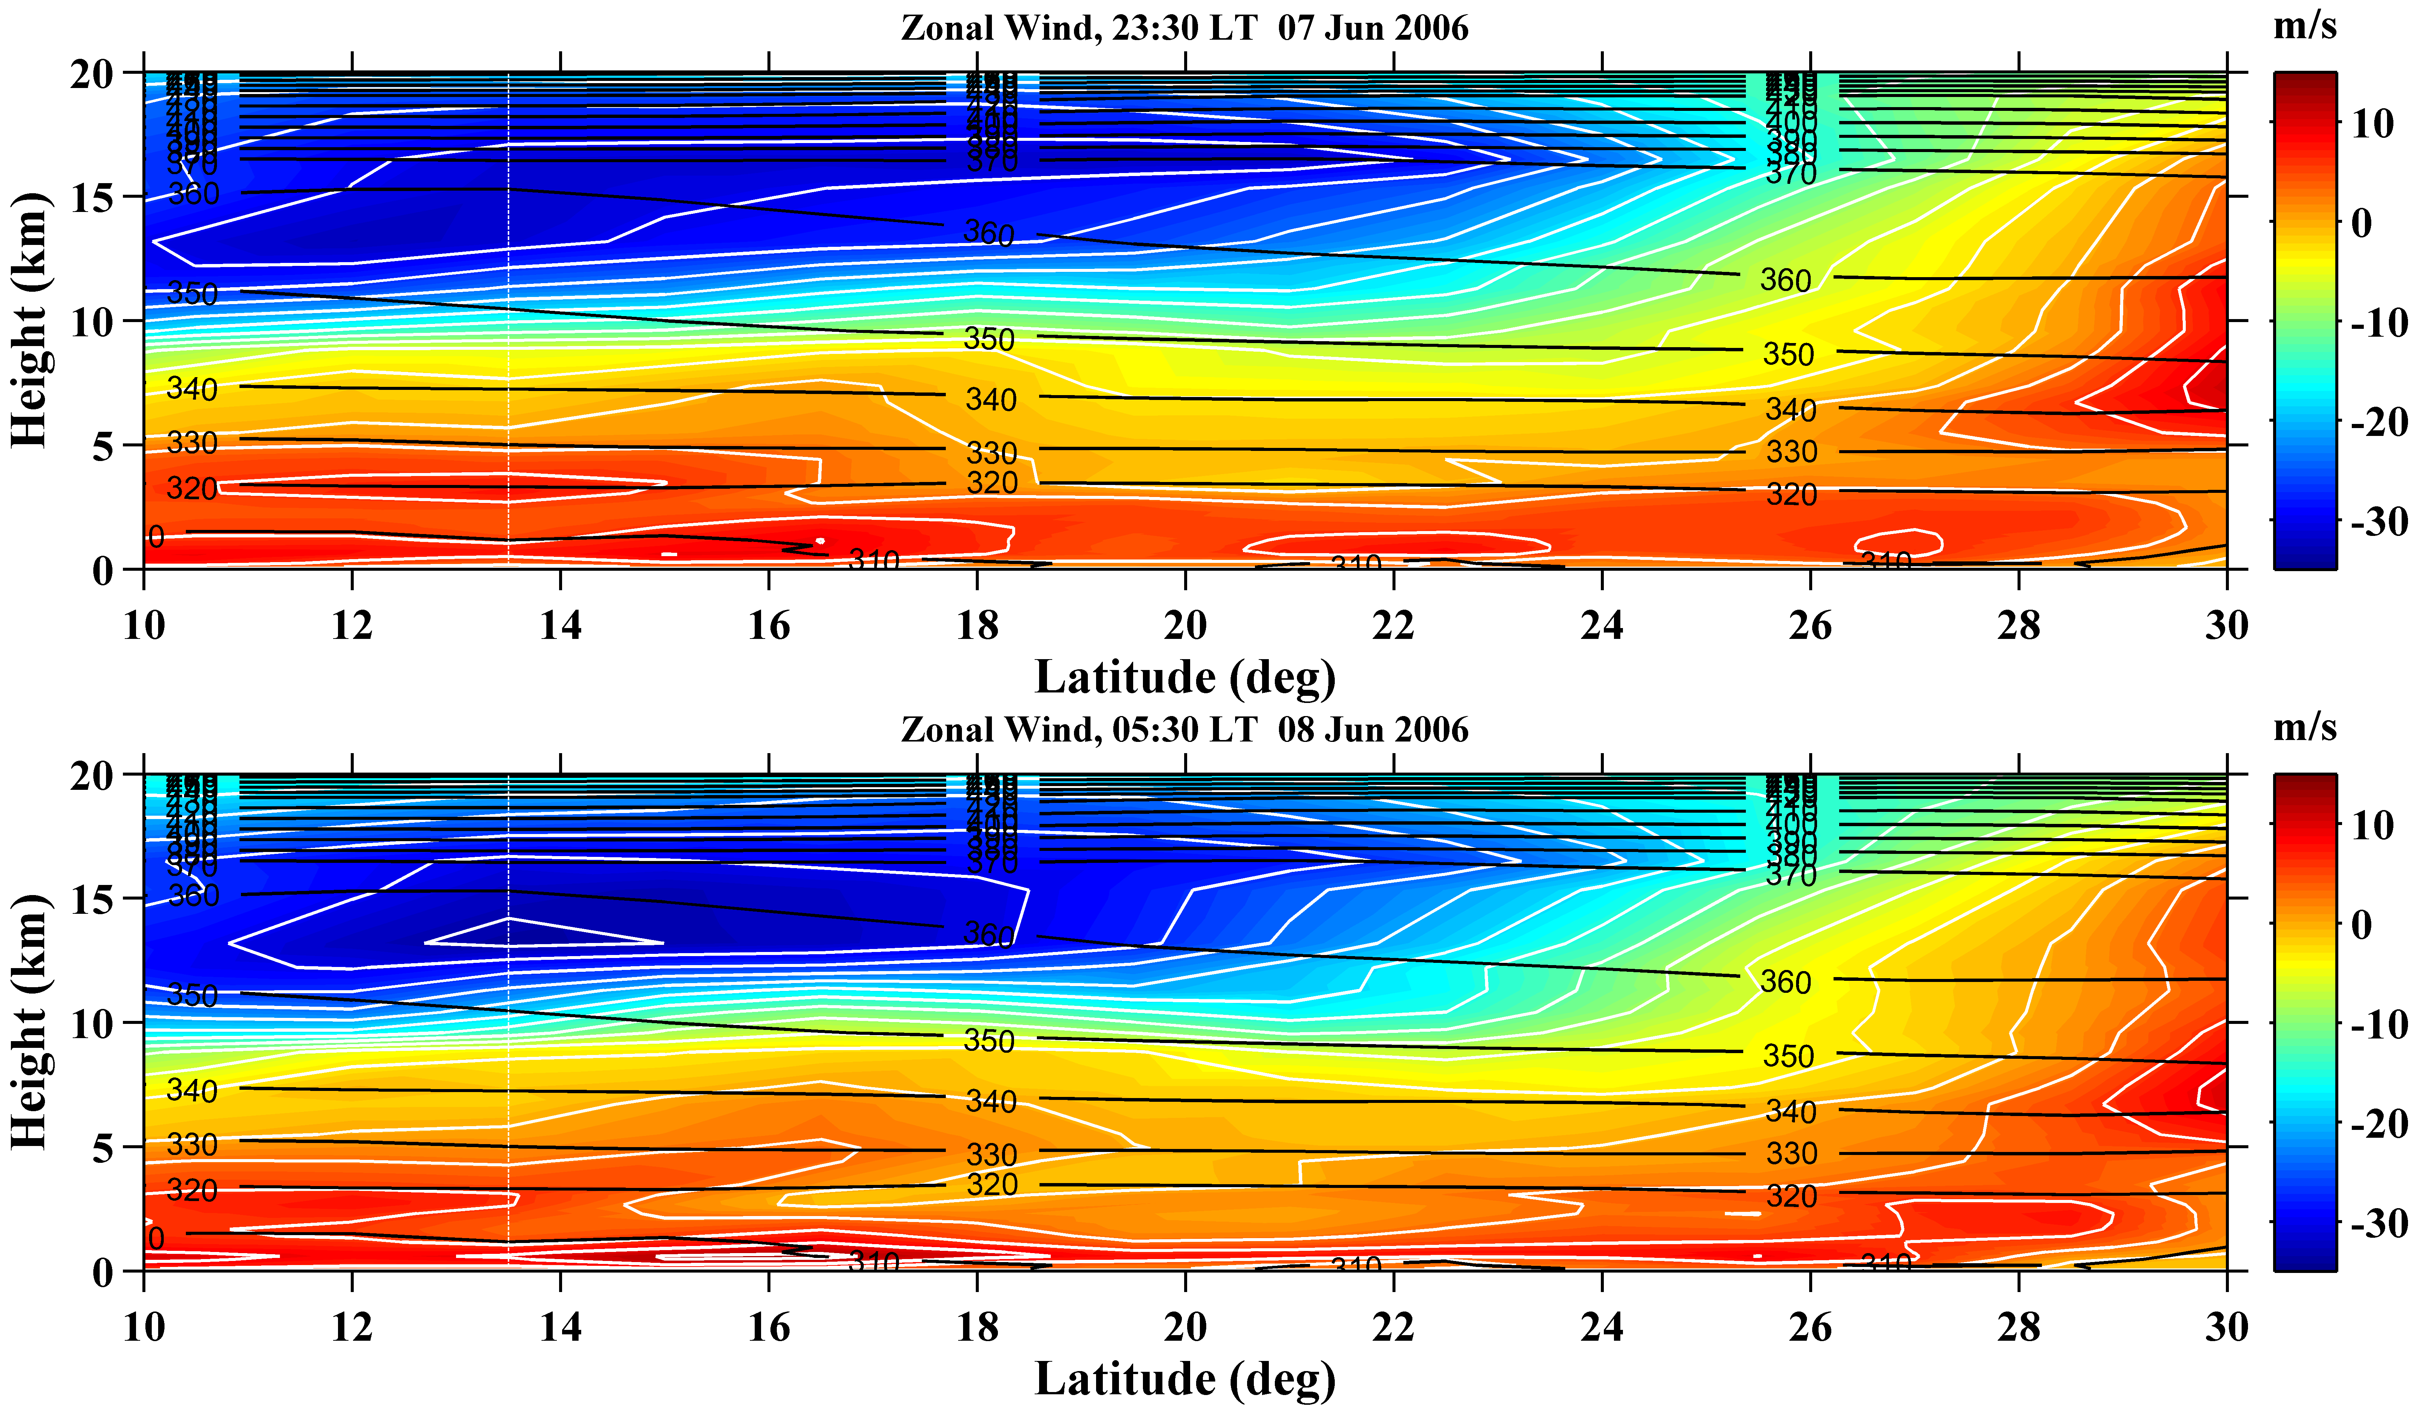

Figure 3.6c Same as Figure 3.5a and 3.5b, (top panel) at 23:30 LT 07 June 2006 and (bottom panel) at 05:30 LT 08 June 2006.
The westerly wind over Gadanki region showed a little increase in velocity (above ~10 km) with altitude and is ~5 ms-1 near tropopause region (~15.5 km). The wind is found to show increase in speed with time as seen both from MST radar (Figure 4a) as well as from ERA-Interim data (Figure. 3.6a). Same as Figure 3.6a, Figure 3.6b shows the latitude – altitude plot of the zonal wind (colored contour) and potential temperature (black lines) over the Gadanki longitude (79.18E) at 17:30 LT (top panel) and 23:30 LT (bottom panel) 25th July 2007 for the Case-(b). It shows that, the tropical easterly jet whose core is existed at 160 to 190 N, which is very nearer to the observational site Gadanki (13.450 N) with a maximum wind of ~35 ms-1 and is in agreement with the radar observed wind. Similar to Figure 3.5b we have plotted Figure 3.5c at 2330 LT and 0530 LT 07 and 08 June 2006 for the Case-(c), in which TEJ core existed between 11-14N, i.e. exactly over Gadanki region with a maximum wind speed of ~35 ms-1. Also, double tropopause structure (Figure 3.7a, left panel) with cold point tropopauses at 17.55 km (87.96 hPa) and 18.5 km (74.85 hPa) for the Case-(a), 16.2 km (112.11 hPa) and 16.8 km (100.90 hPa) for Case-(b), and 16.95 km (96.08 hPa) and 17.55 km (86.36 hPa) for Case-(c) are identified, indicating that there is mass transport between troposphere and stratosphere, leading to tropopause folding (double tropopause).
Further, potential temperature, a parameter that represents the temperature a parcel would have, if it were brought adiabatically from a pressure (P), Temperature (T) to a standard pressure (P₀), which is typically set to 1000 mb and is given by the expression θ = T()R/Cp. The potential temperature (θ) is an important concept in atmospheric sciences as it represent a line of thermodynamic equilibrium for dry air where there is no net exchange of energy with the environment through any of the processes such as radiative absorption or emission, or through turbulent mixing, such that the change in enthalpy (dh_{d}) = 0. An air parcel may rise or sink, or even move around horizontally, but if there is no exchange of energy, the potential temperature (θ) is constant. In fact, all air parcels lying along a constant theta surface are always in local thermodynamic equilibrium. In the present study, vertical profiles of temperature and potential temperature were drawn for the three cases of observation to examine the regions of maximum air mass mixing in the troposphere. An interesting feature noticed from the potential temperature profiles (Figure 3.7, right panel) for the three cases is that the potential temperature gradient within the cloud heights is found to be maximum, i.e. ~13.5 K/km for the Case-(c) between 16-17.5 km, is ~3.6 K/km for the Case-(b) between 14.5-16.5 km, is ~2.8 K/km for the Case-(a) between 13-14.9 km, and is ~2.13 K/km for the Case-(c) between 12-14.2 km. The significance of maximum or minimum value of potential temperature gradient is to depict the region of maximum or minimum air mass mixing that takes place in the atmosphere. From the above values of potential temperature gradient one can state that the maximum air mass mixing will takes place when the cirrus exists in the region of tropopause folding.

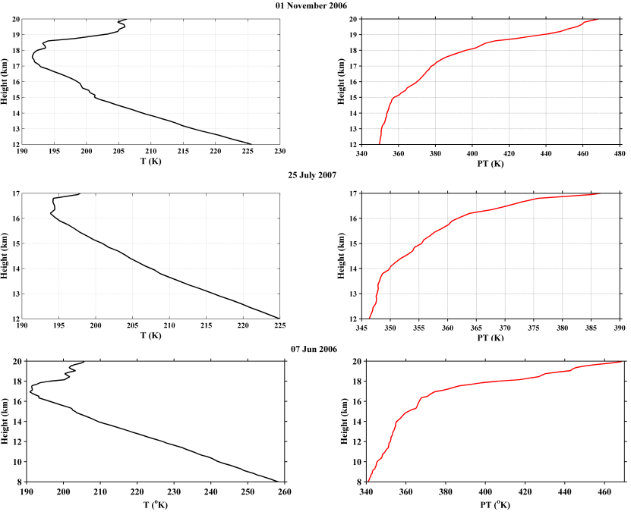
Figure 3.7 Altitude profiles of temperature and Θ observed by radiosondes launched at 17:30 LT on (top panel) 01 November 2006, (middle panel) 25 July 2007 and (bottom panel) 07 June 2006.
Though the coarser vertical and time resolutions of Era-Interim reanalysis (Figure 3.6a and 3.6b), there is discrepancy from observations, it hasn’t shown similar tropopause variation as the observed one. From 23:30 LT 1st November 2006 and 05:30 LT 2nd November 2006, the eastward-moving trough extended the subtropical tropopause region northward and produced a higher tropopause pressure at 13.5◦N, 79.2◦E. At 17:30 LT and 23:30 LT 25 July 2007 tropopause pressure at 13.5◦N, 79.2◦E is similar to Case-(a) as the tropical tropopause region extended southward. On 07 June 2006 the tropical tropopause region has extended its core more towards south as seen from the Figure 3.6c.
3.4 Summary
Using Mie lidar observations of cirrus clouds over Gadanki, we have determined the cloud vertical structure (i.e. the cloud base and top altitudes) for three different Cases one during winter and other two during summer monsoon season by using a quantitative approach based on the clear air assumption as proposed by Sassen, K. and Cho, B.S. (1992). Further, we have examined the variation (ascent/descent) of cloud base and top altitudes with the help of cloud backscatter coefficient β_{cloud}, for all the three Cases and found that there is a significant descent during Case-(b) between 23:00-24:00 LT. From values of peak linear depolarization ratio (0.182, 0.089 and 0.23) it is found that the cirrus cloud is associated with randomly oriented, highly non-spherical ice particles in all the three cases as in Thomas et al., (1990). It is clear from the values of COD for the cirrus observed at different altitudes in Cases (a), (b) and (c) that the cirrus clouds are found to be visible in all cases except for the cirrus noticed near the tropoapuse region during Case-(c), which is sub-visual Sassen, K. and Cho, B.S. (1992).
We have examined the effect of background winds on cirrus clouds with the help of MST radar collocated near to the lidar over Gadanki. A significant result noticed with the help of MST radar in present study is that zonal wind below the cloud height has shown similar variation as that of LDR during Case-(a) and above the cloud height zonal wind is weak when LDR is strong, later the zonal wind BCH has started increasing. The increase in zonal wind over Gadanki is further justified by the existence of outlier of sub-tropical westerly jet core from ECMWF Reanalysis dataset. By observing zonal wind for Case-(b) and Case-(c) that, it is difficult to interpret the effect of TEJ on the microphysical properties of cirrus clouds present in these heights. Further justification has to be made by a number of simultaneous lidar and radar measurements during the passage of cirrus clouds in the monsoon period. But, within the cloud heights the meridional wind is found to show almost opposite variation as that of LDR, for Cases (b) and (c) i.e. the LDR is increasing when the meridional wind is decreasing in magnitude, vice versa.
The vertical wind is found to be increasing similar to that of zonal wind in magnitude during Case-(a). In Case-(b) the vertical wind has shown strong fluctuations within the cloud height and it is found to be mostly upward above the cloud altitude and during Case-(c) it is found to be upward dominant up to ~3:15 hrs and is mostly downward in the later hours. Bhavani Kumar et al (2001) using MST radar has shown that there were enhanced horizontal winds, significant wind shear and significant decrease in vertical velocity at boundaries of cirrus. It indicates that strong circulation at the cloud boundaries will lead to entrainment in the vicinity of cirrus clouds.
Finally, an interesting feature from the Radiosonde data is the noticed double tropopause structures in all the three Cases of observation. The gradient of potential temperature is found to be maximum for Case (b) and (c) (Yamamoto et al 2009) when the cirrus cloud is present near the tropopause and is minimum when the cirrus cloud is well below the tropopause folding. The significance of maximum or minimum value of potential temperature gradient is to depict the region of maximum or minimum air mass mixing that takes place in the atmosphere.

_____________________________________________________Chapter 4
Mie lidar observation of variations in cirrus properties during the transition between multiple and single cirrus over Gadanki (13.450 N, 79.180 E)
4.1 Introduction
The impact of cirrus clouds on the Earth-climate system needs a better understanding of their coverage, occurrence frequency, optical, dynamical and microphysical properties. Long term observational programs (Sassen. and Campbell 2001) and several field campaigns (Starr 1987) have reported coverage of cirrus about 20-30% of the globe. Frequent occurrence of thin cirrus near the cold point tropopause in the altitude of 15 to 18 km over the tropical region is reported by using ground based (Mather et al 1998) airborne (Winker. and Trepte., 1998) and satellite (Wang et al 1996) observations. The net impact of cirrus on the climate depends on the cloud microphysical, optical and thermal properties. Kinne and Liou (1989), Mishchenko et al. (1996) reported that the effect of crystal non-sphericity on the albedo of cirrus and solar Radiative transfer are very significant. Cloud Radiative Forcing (CRF) is estimated to evaluate the radiation budget corresponding to changes in the cloud physical properties. CRF is calculated as the difference between the perturbed value and that in a cloud free atmosphere. In general, CRF is defined as the changes in net radiative flux due to clouds at the top of the atmosphere (Stenchikov et al., 1997). The variation in radiation budget in the upper atmosphere would cause variations in temperature at the surface or in the atmosphere. Hence, the CRF signify the variations in climate due to clouds. Macke (1993) and Macke et al., (1996) reported that the reflectance of ice clouds strongly depends on ice particle shape. Several cases of particle size distributions within the cirrus clouds are reported by several field projects such as FIRE-The First ISCCP Regional Experiment, EUCREX - European Cloud and Radiation Experiment etc. The particle size distribution in general may vary horizontally as well as vertically. Heymsfield and Platt, (1984) reported the vertical variations in ice crystal size distributions with larger crystal sizes at lower part of cloud layers.
Further, Cloud Optical Depth (COD) an important parameter that describes the transparency of the cloud to the incoming solar radiation. COD retrievals from POLDER / PARASOL and MODIS / AQUA satellite data showed that there exists a strong dependency of accurate COD retrieval on cloud type, environmental factors such as coverage, thermodynamic phase and cloud particle information (Zeng et al 2012). They also reported that the phase function selected is crucial for ice cloud optical depth retrieval. Zhang et al (2009) reported the difference in retrieved COD of ice clouds is principally related to the choice of microphysical model used in the algorithm. Zhang et al (1999) calculated the net cloud radiative forcing with single-modal and bi-modal size distribution and shapes of ice crystals considering that the cirrus is homogeneous (considering a constant optical depth value for a given type of ice particles). They reported a net cooling effect due to large ice particles and a net warming effect due to small ice particles.
More frequently, cirrus clouds containing particles with different sizes, shapes and distributions were observed and hence, variable ice particle distributions must be considered in accurate modeling of cirrus. Moderate Resolution Infrared Sounder (MODIS) is such an operation in which, several models built from observations of ice clouds are used, considering variable ice particle distributions with their sizes determined by its Near Infrared Channel. Even, some space based lidars can detect the presence of multiple cirrus layers during their passage over different geographical locations. But, the clouds which are identified by the satellite may change their texture and geometrical structure (like transition from multiple to single layer cirrus or vice versa) or significant temporal variations in optical and geometrical properties due to the dynamical environment. Also, the net positive radiative forcing at the top of the atmosphere (Chen et al., 2000a; Hartmann et al., 1992) and warming the climate are estimated by ISCCP cloud data (that is obtained from satellites) but the effect of overlapping of cirrus layers is not considered. But, especially over tropics, the frequency of overlapping cirrus is not negligible (Nazaryan et al., 2008) and the variation in cirrus microphysical and optical properties causes large uncertainties in calculating the accurate radiative forcing (Stephens et al., 2004). So, there is a need of studying the frequency of occurrence of cirrus transition and thereby the variations in cloud properties over a particular site for a long period. In this regard very few observations are available over Gadanki region, a tropical station located in the southern part of India.
Sunil Kumar et al., (2008) using lidar observations over 281 nights during 1998-2002, reported ~63% of the cirrus over Gadanki as sub-visual, 30% of cirrus as optically thin and in rest of the cases as dense cirrus. They also reported the variations in COD and LDR as well as their correlation during the presence of single layered cirrus as well as during the transition of cirrus from one type to another (SVC/TC/DC). Long term variations in COD are found to be in-phase with that of LDR and in opposite phase with that of the asymmetry factor. However, their study focuses on the observation of transition of cirrus from one type to another and there by the variations in LDR and COD but did not considered the transition between multiple and single cirrus. More research is needed in understanding the microphysical and dynamical processes associated with the transition of cirrus between multiple and single thick cirrus.
4.2 Experiment Details and Data Description
4.2.1 Mie lidar
Polarization lidars have been proved to be one of the best means to study and characterize the cirrus clouds (Sassen, 1994). The lidar at National Atmospheric Research Laboratory (NARL), Gadanki is being widely used during the past few decades and monitored the cirrus with good spatial and temporal resolutions. The lidar system employs a transmitter consisting of a pulsed Nd:YAG laser at its second harmonic wavelength of 532 nm (pulse repetition rate of 20 Hz). The technical details of the lidar system at NARL are described earlier in chapter 2. A photon count profile corresponding to 5000 laser shot integration (time resolution is 250 s) constitutes the basic lidar signal. The noise and range corrected lidar signals are then analyzed to obtain the altitude profiles of backscatter coefficient employing Klett algorithm (Klett., 1981). The reference altitude is taken as 35 km where the contribution of aerosols is assumed to be negligible. The altitude profile of molecular backscatter is obtained from radiosonde temperature and pressure data and is used in the lidar signal inversion.
The lidar back Scatter Ratio (SR) which describes the lidar signal strength is calculated using the formula
SR (z) = {β_{mol} (z) + β_{cloud} (z)} / β_{mol} (z)
where, β_{mol} (z) and β_{cloud} (z) are the molecular and cloud backscatter coefficients at an altitude z.
The lidar derived Linear Depolarization Ratio (LDR) is computed using the backscatter ratios of Cross- and Co- polarized signal components of the received signal and is given by
LDR (z) = SR┴(z) / SR║(z)
The cloud optical depth, a crucial parameter in radiative forcing calculations is determined using the equation
where, α(z) is the extinction coefficient, z_{b} and z_{t} are the cloud base and top altitudes respectively. From the value of COD, cirrus is classified according to Sassen, K. and Cho, B.S (1992) as sub visual (τ_{c} <0.03), thin (0.03< τ_{c} <0.3) and thick (τ_{c} >0.3).
4.2.2 MST radar
The MST radar at National Atmospheric Research Laboratory (NARL), Gadanki is operating at a frequency of 53 MHz. An experiment was conducted with five beams (one zenith beam and four 100 off-zenith beams in the N, E, S and W directions) continuously during 18:00 to 24:00 IST on 17 January 2007 which is used in the present study to measure the background wind fields. A detailed description of the radar system is given by Rao et al (1995). The range and time resolutions of the radar are 150 m and 2.5 min respectively. The back scattered signals are subjected to Fourier analysis to derive the Doppler spectra. The radar Doppler spectrum is then subjected to standard moment analysis to get the zero moment (which gives radar reflectivity), first moment (which gives the atmospheric wind field) and second moment (which gives the energy associated to the radar backscatter) respectively. Details of the data analysis and the computation of wind velocity vectors were provided earlier in chapter 2. For the present study, the Doppler shift of the signal is used to obtain the atmospheric wind fields up to an altitude of 18 km.
4.2.3 CALIPSO Signatures
CALIPSO lidar version 3.01 of level-1 products were used to validate the passage of cirrus clouds as detected by the ground based lidar at NARL, Gadanki. The images of latitudinal/longitudinal variations in depolarization ratio were downloaded directly from the CALIPSO lidar browse images (http://www-calipso.larc.nasa.gov/tools/data_avail/).
4.3 Results and Discussion
4.3.1 Lidar observation of variations in cirrus properties during transition between
multiple and single geometrically thick cirrus over Gadanki
In order to study the variations in microphysical and optical properties during transition between multiple and single cirrus, 72 nights of lidar observations during January 2007 to August 2007 are taken into consideration. Out of 72 nights of lidar observations, only 46 nights (64%) were associated with cirrus passage over Gadanki, out of which during 6 specific nights (13%), there is transition between multiple and single thick cirrus. Optical and microphysical properties of large-scale cirrus layers containing double and single thick layers has been studied with the help of polarization lidar during their passage over low latitude station Gadanki. Present work is carried out with the help of six case studies one corresponding to winter season i.e. 17 Jan 2007, two cases corresponding to pre monsoon season i.e., 14 and 15 May 2007, and three cases corresponding to summer monsoon season i.e., 12 Jun, 14 and 24 July 2007. Detailed description of each case is given below:
Case 1: 17 January 2007
Height vs. time contour map of back scatter coefficient in Figure 4.1a (top panel) shows the passage of large scale cirrus containing two geometrically thin and double layered cirrus (lower layer in the altitudes of ~11.34-13.4 km and upper layer in the altitude of ~14-15.8 km) between 20:30 IST and 21:20 IST and the transition of these two layers into single geometrically thick cirrus is noticed during 21:20 IST to 23:40 IST in the altitude region of ~11.6-15.54 km. In order to discriminate these two different cirrus layers, vertical profiles of LDR and BSR before and during the transition of cirrus have been plotted in Figure 4.1(b-c) (middle panel). The value of scattering ratio greater than 1.25 is taken as a threshold (Ramachandran and Jayaraman, 2003a, Kulkarni et al 2008) for identifying cirrus clouds over tropics. It is clear from the BSR profile that, there exist cirrus free region (with BSR< 1.25) between the two layers before the transition while after transition there is no gap between the layers indicating single geometrically thick cirrus. Low value (~3.2) of peak BSR is noticed in the upper layer cirrus before transition and high value (~6.8) during the transition. The vertical profile of LDR also resembles the similar features as that of scattering ratio. An increase in LDR indicates an increase in non sphericity of the ice crystals. In the bottom panel the legends LL, TC, UL represents Lower Layer, Transition Cloud, and Upper Layer, respectively. Figure 4.1(d) (bottom panel) shows the temporal variation of peak LDR and COD during the observation period. An interesting feature noticed is the transition of cirrus from sub-visual (before transition) to optically thin cirrus. Another feature noticed is that both peak LDR and COD are linearly varying with each other before the transition of cirrus into single thick layer (~21:20 IST), at the time of transition (i.e., ~21:30 IST) there is a significant increase in LDR and COD is noticed and later both COD and LDR are found to show similar variation after the transition (from 21:30 to 23:34 IST).
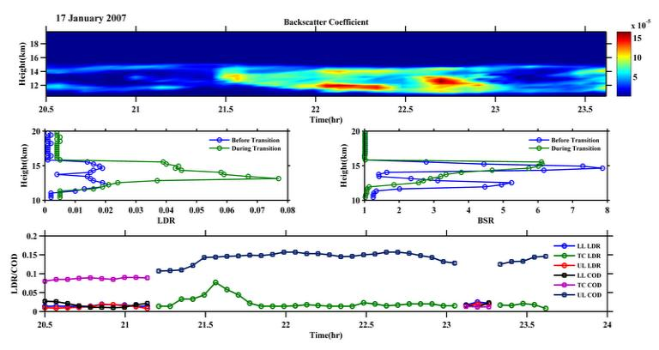Fig. 1(a) Time - altitude plot of total backscatter coefficient (top panel) (b) Vertical profile of Linear Depolarization Ratio (LDR) before and during the transition to single geometrically thick cirrus (left side of the middle panel) (c) Vertical profile of Back Scatter Ratio before and during the transition to single geometrically thick cirrus (Right side of the middle panel) (d) Temporal variation of peak LDR and Cloud Optical depth (COD) during the whole observational period (bottom panel) on 17 January 2007.
Figure 4.1e shows the CALIPSO image of Depolarization Ratio at ~01:53 IST to 02:07 IST on 18 January 2007 during its passage nearest to Gadanki latitude. It is clear from the figure that the cirrus is single geometrically thick for the present case.
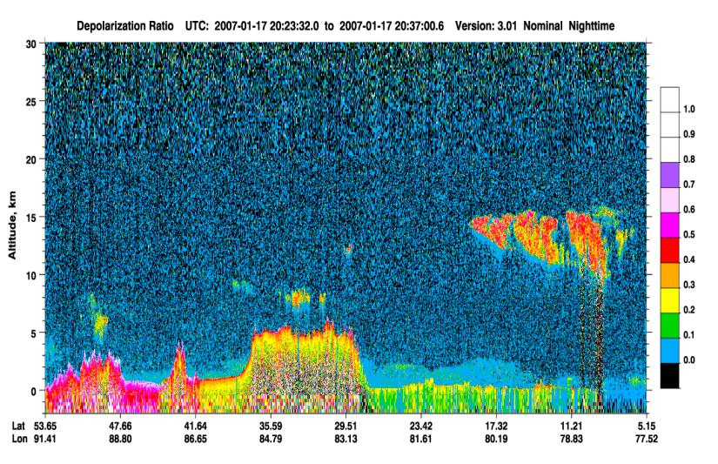
Figure 4.1(e) Image of Depolarization Ratio derived from CALIPSO passage on 17 January 2007.

4.3.2 MST radar observation of variation of the background wind field during transition from multiple to single geometrically thick cirrus-a case study
Simultaneous measurement of background winds from MST radar is used to examine variation of wind pattern before and after cirrus transition. Contour maps of zonal (u), meridional (v) and vertical wind (w) measured by MST radar between 18:00 and 24:00 IST on 17 January 2007 are plotted in Figure 4.2 (a-c). The measurement of radar winds is taken well before the detection of cirrus by lidar to visualize significant weakening of horizontal winds due to transition of cirrus. From Figure 4.2(a-b), it is clear that the zonal and meridional wind velocities in the gap between cirrus layers as seen in the altitudes of ~12.5–14.0 km from 20:30 to 21:30 IST is ~15 m/s and is
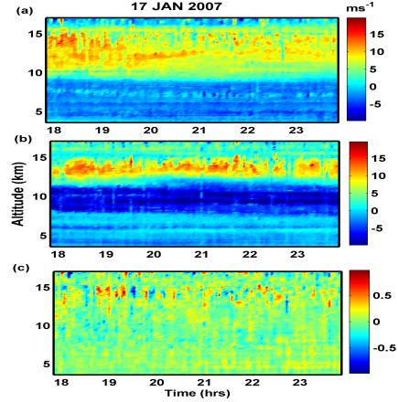

Figure 4. 2(a-c) Time-altitude plot of zonal (top panel), meridional (middle panel) and vertical (bottom panel) winds from 18:00 - 24:00 LT 17 January 2007.

decreased to ~8 m/s when single thick layer of cirrus (from 21:30 to 23:40 IST in Figure 4.1a) is detected. Figure 4.2c shows the vertical wind velocity which is varying with time and consisting of both upward and downward motions throughout the observational period. But there is a significant change in vertical velocity between 20:25 IST and 21:15 IST where there is no downdraft motion rather than updrafts alone. The presence of dominant upward wind might contribute to the significant ascent of cloud-base when two thin layers of cirrus are found to become single thick layer. Yamamoto, M.K et al (2009) reported that the absence of upward wind contributed to the significant descent of cloud-top noticed over Shigaraki (34.51ºN, 136.06ºE). But it has been shown that, vertical wind alone cannot be the possible reason for the observed ascent / descent of cloud top / base altitudes (Rao et al 2014). Hence, the variation of cloud-base altitude of lower lying cirrus noticed between 20:25 IST and 21:15 IST (as in Figure 4.1a), which might be one of the possible reasons for two thin cirrus layers to form a single geometrically thick cirrus.
Case 2: 14 May 2007
In this case a transition of single cirrus layer in the altitude region of ~15.7 to 17.2 km between 22:07 IST on 14 May 2007 and 01:05 IST on 15 May 2007 into two distinct layers in the altitudes of ~15.7-16.2 km (lower layer) and 16.5-17.2 km (upper layer) between 01:05 IST and 04:20 IST on 15 May 2007 is noticed during the passage of cirrus
over Gadanki (Figure 4.3a, top panel). The cirrus layer is found to be optically thin before transition and two distinct sub- visual cirrus layers after transition. Both LDR and BSR profiles are clearly distinguishing the transition of cirrus for the present case (Figure 4.3b, middle panel). The temporal variation of peak LDR and COD is indicating that they are linearly varying with each other (Figure 4.3c, bottom panel). But, the LDR is fluctuating before transition which is not found from COD as in bottom panel of Figure 4.3d.

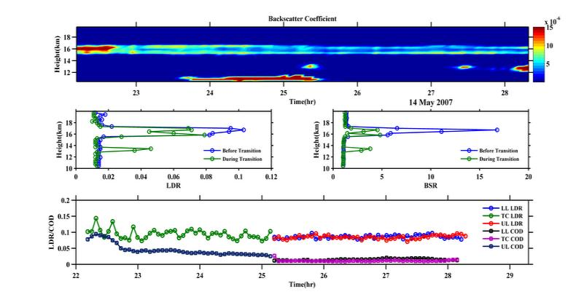
Fig 4.3(a-d) Same as Fig. 4.1(a-d) but for 14-15 May 2007.
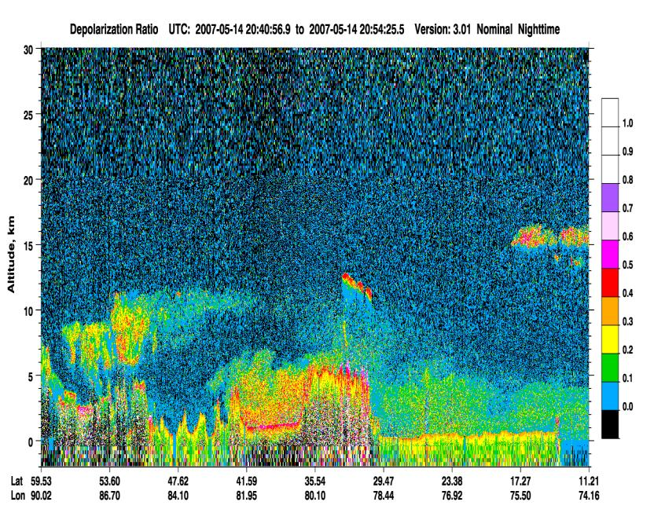
Figure 4.3(e) Image of Depolarization Ratio derived from CALIPSO passage on 14 May 2007
Case 3: 15 May 2007
Figure 4.4a shows the passage of single geometrically thick and optically thin cirrus from 19:29-22:49 IST on 15 May 2007 in the altitude range of ~15.8 to 17.2 km, sub-visual cirrus from 22:49 IST to 23:40 IST containing two layers separated by few hundred meters and finally passage of single geometrically thick and optically thin cirrus during 23:40 to 01:43 IST on 16 May 2007 is noticed. Vertical profiles of LDR and BSR in the cloud altitudes from Figure 4.4b-c (Middle Panel) shows similar variation with each other and the BSR is found to be less when there are two layers. Variation of LDR and COD in the cloud altitudes from Figure 4.4d (Bottom Panel) shows that they are linearly varying with each other and the BSR is found to be less when there is two layers.
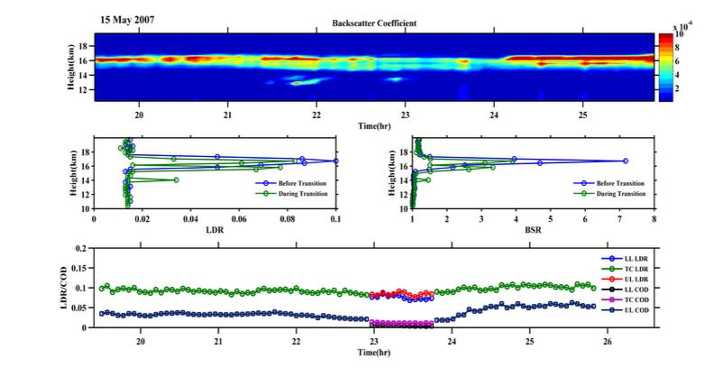
Figure 4.4(a-d) Same as Fig. 4.1(a-d) but for 15 May 2007.
Case 4: 12 June 2007
Figure 4.5(a) shows the passage of multiple cirrus layers in the altitudes of ~11.9-14.6 km (lower layer which is optically thin), ~14.8-15.6 km (middle layer which is sub visual) and ~15.8-17.3 km (upper most layer) from 21:58 to 22:30 IST on 12 June 2007. Later, the passage of single geometrically thick cirrus in the altitude of ~11.8-15.6 km during 22:32 – 01:20 IST on 13 June 2007 and then passage of multiple cirrus layers during 01:20 – 02:05 IST on 13 June 2007 are noticed. High values of peak LDR and peak BSR (Figure 4.5(b-c), middle panel) during the passage of single thick cirrus and low values during the passage of multiple cirrus layers are noticed. Figure 4.5(d) (bottom panel) shows that both peak LDR and COD are varying linearly with each other before transition, there is a significant increase in peak LDR and COD at the time of transition and later they are varying linearly with each other. The Lat/Lon variation of DR from CALIPSO satellite passage over Gadanki region is shown in Figure 4.5e. Passage of multi layered cirrus over Gadanki longitude in the altitudes of ~16- 17 km (lower layer) and ~17-18 km (upper layer) is noticed during 01:42 -01:55 IST on 13 June 2007 confirms the passage of two cirrus layers over Gadanki location.

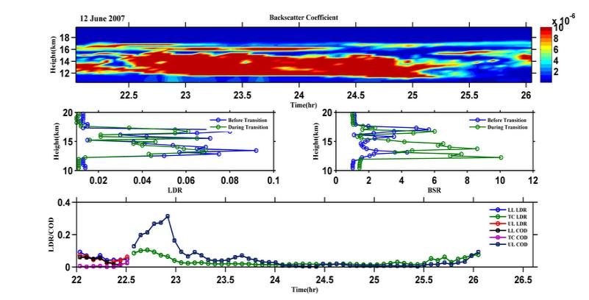

Figure 4.5(a-d) Same as Fig. 4.1(a-d) but for 12 June 2007
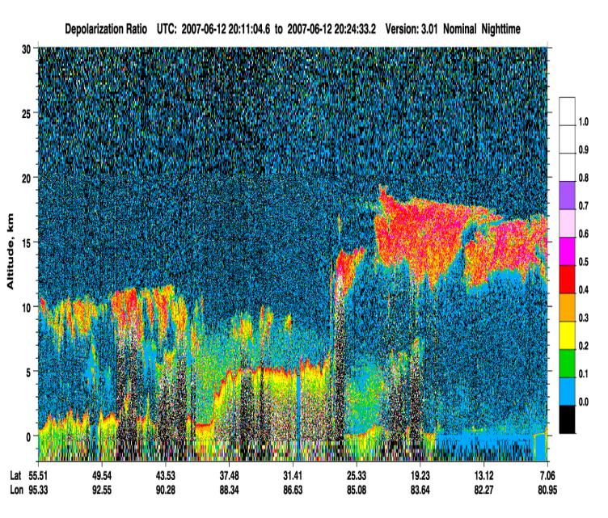
Figure 4.5(e) Image of Depolarization Ratio derived from CALIPSO passage on 12 June 2007
Case 5: 14 July 2007
Passage of two cirrus layers in the altitudes of ~12.4-13.1 km (lower layer) and ~14-16.9 km (upper layer) during 21:09-21:50 IST and single geometrically thick cirrus during 21:50 to 23:09 IST 14 July 2007 and further transition to two cirrus layers is noticed between 23:09-00:37 IST on 15 July 2007 is notice from the Figure 4.6(a). The cirrus layers corresponding to the present case are anvil type cirrus corresponding to convection bearing cumulonimbus (Cb) cloud. Vertical profiles of the peak values of LDR and BSR in Figure 4.6(b-c) (middle panel) shows that both LDR and BSR values are very high as the cloud is of cumulonimbus anvil. Temporal variation of peak LDR and COD (Figure 4.6(d), bottom panel) shows strong enhancement in both the values during the passage of single geometrically thick cirrus indicating saturation of ice crystals within the cloud. COD is found to be maximum (~0.997) during the passage of single geometrically thick cirrus (optically thin) noticed from 22:13-22:38 IST on 14 July 2007. Later, both COD and peak LDR values are found to be decreased and varying linearly with each other. Lat/Lon variation of DR derived from CALIPSO from the Figure 4.6(e) also confirms the presence of two cirrus layers with lower layer in the altitude of ~15.0- 16.0 km and upper layer in the altitude of 16.5-17.5 km near to Gadanki location. The lower layer corresponds to Cb cloud anvil and the upper layer might be detached from it.

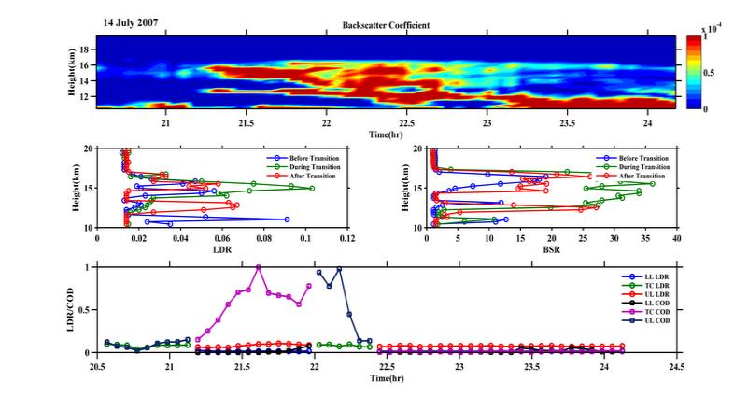
Figure 4.6(a-d) Same as Fig. 4.1(a-d) but for 14 July 2007.

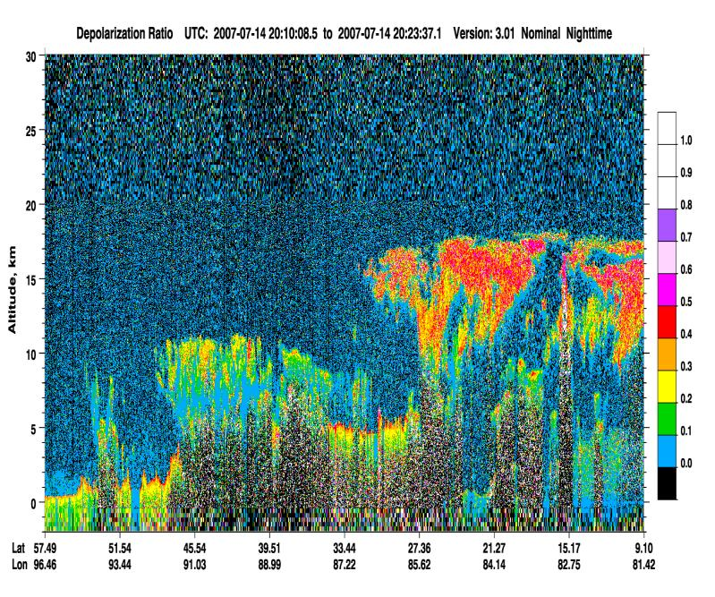
Figure 4.6(e) Image of Depolarization Ratio derived from CALIPSO passage on 14 July 2007.
Case 6: 24 July 2007
Figure 4.7(a) (top panel) shows the passage of two sub-visual cirrus layers from 19:46 IST to 20:03 IST and single geometrically thick (optically thin) cirrus from 20:03 to 22:05 IST and then again into sub-visual cirrus layers from 22:06 to 23:10 IST and finally passage of single geometrically thick (optically thin) cirrus is noticed during 23:11 to 00:05 IST on 24 July 2007. Vertical profiles of LDR and BSR shows maximum (~0.096 and ~14.5) after the transition into single geometrically thick cirrus when compared with the values (~0.056 and ~2.5) before transition (Figure 4.7(b-c), middle panel). Both peak LDR and COD from Figure 4.7(d) (bottom panel) shows significant peaks during the transition period and are linearly varying with each other with time before and after the transition is noticed. The cirrus layer noticed during this period also corresponds to anvil type cirrus corresponding to the top of Cb cloud. Lat/Lon variation of LDR derived from CALIPSO (the period of CALIPSO passage is just after the Gadanki lidar observation period) is shown in Figure 4.7(e). Passage of patch of rain baring Cb clouds associated with anvil cirrus layers near to Gadanki location is noticed in the altitude region of ~15-18 km with a minimum DR of 0.3-0.4 and maximum of 0.5-0.6.
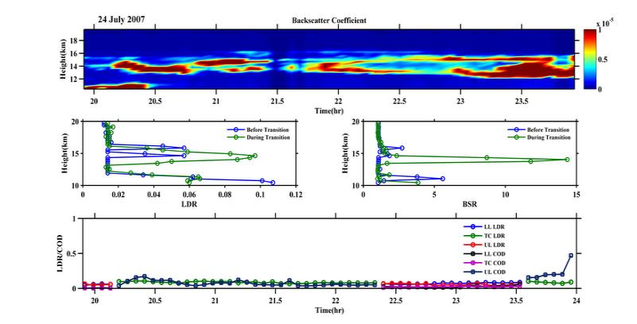
Figure 4.7(a-d) Same as Fig. 4.1(a-d) but for 24 July 2007.
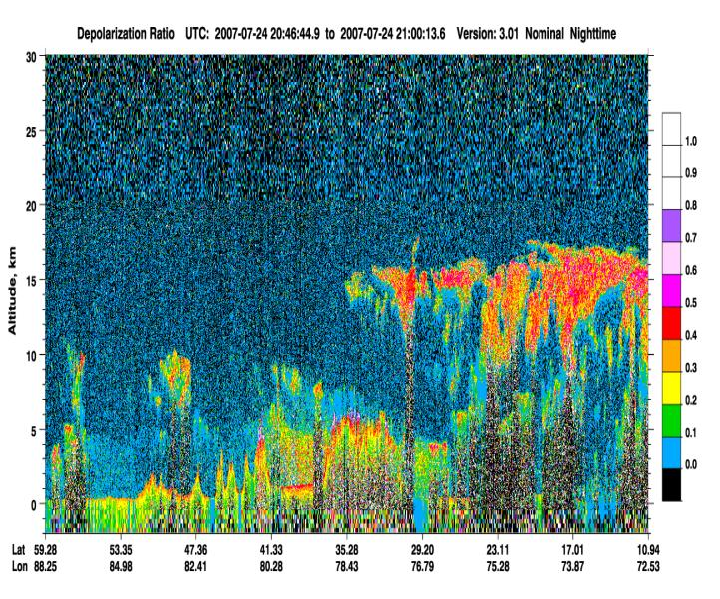
Figure 4.7(e) Image of Depolarization Ratio derived from CALIPSO passage on 24 July 2007.
4.4 Summary
Present study illustrates the observation of transition of cirrus from multiple thin layers into single thick layer and vice versa has been studied for the first time with the help six case studies during different months of the year 2007.
Important findings of the present study are as follows:
1. There is a significant increase/decrease in BSR, LDR and COD during the transition of cirrus from multiple thin layers into single thick layer/single thick layer into multiple thin layers.
2. Both BSR and LDR are found to show similar kind of peaks before and during (after) transition with a maximum during transition to single thick cirrus.
3. Peak LDR and COD corresponding to LL and UL are linearly varying with each other except during TC, showing strong peaks of COD during transition due to the formation of geometrically thick cirrus.
4. There is a significant reduction of zonal and meridional winds after transition into single thick layer along with considerable ascent of cloud-base due to the existence of strong updrafts with downdrafts becoming weaker (showing near zero values) during 17 January 2007, which might be a possible reason for the observed transition to single thick cirrus.
The variations in the optical and microphysical properties of cirrus clouds will contribute to significant Radiative forcing. It is difficult to identify these kind of transitions with the help of satellite based observations, since they occur in very short period of time which cannot be recognized by the satellites (if the transition takes place well before the arrival or after the departure of the satellite) over the experimental site and ultimately causes uncertainties in the derived radiative forcing calculations. Therefore, the accurate radiative forcing calculations over a particular region requires long term ground based data products to include the variations in cirrus optical and dynamical properties during the transition of cirrus. The variation of background wind field during the transition of cirrus has to study further with long term observations.

_____________________________________________________Chapter 5

In-cloud variability of Linear Depolarization Ratio (LDR) of cirrus observed over Gadanki (13.5°N, 79.2°E)
5.1 Introduction
Cirrus clouds, the most uncertain component in the lower atmosphere continues to receive special attention from the scientific community due to its variable nature. The positive radiative forcing of cirrus on the Earth’s climate system is reported using both active and passive remote sensing measurements assumes the homogeneity of cirrus. Even by the inclusion of longitudinal/latitudinal variations in cirrus properties (obtained from passive satellites), the results are true only to first approximation. The reason is being the fact that, cirrus over any region sometimes may not be uniform throughout their persistence and may dissipate, evaporate or they may undergo transition from one type to another type (Sunil Kumar et al., 2008: Srinivasan et al., 2016). These variations in cirrus properties over a particular location can be monitored only by the ground based measurements (Srinivasan et al., 2016) showing the importance of ground based observations over passive measurements. Hence, more ground based observations are needed over different parts of the world to include the temporal/spatial variations in cirrus properties and to obtain more accurate impact of cirrus on climate. In this context, very few studies have focused on in-cloud variability of cirrus properties.
Del Guasta and Edgar Vallar (2008) compared the homogeneity of cirrus over mid latitudes and Polar Regions and reported that the midlatitude cirrus is more inhomogeneous than the calm polar cirrus due to chemically and dynamically perturbed atmosphere. In global cirrus climatology, tropical cirrus especially, finds its importance due to its warming effect and the large spatio temporal variations compared to other regions. The interdependence of cirrus properties and their variability is reported by Pandit et al (2015), Sunil Kumar et al (2008) and Sassen and Bensen (2001) etc., however significant research is to be focused on the homogeneity of tropical cirrus at different altitudes during different seasons.
Polarization lidars have proven to be the best means to study the spatial and temporal variations in cirrus properties (Sassen, 1991). The parameter Linear Depolarization Ratio (LDR) is an indicator for anisotropy of the particles/ice crystals which are lidar targets. Magnitude of LDR is related to the dominance of parallel or perpendicular component of the lidar returns. In the present chapter, the homogeneity of tropical cirrus observed at different altitudes (the cases where the cirrus is uniform by visual appearance) during four contrasting seasons during the years 2006-2007 are discussed.
5.2 Data and Methodology
The polarization lidar at National Atmospheric Research Laboratory (NARL) at Gadanki is being operational since 1999. The lidar data is used to study the in-cloud variability of LDR of cirrus over a low latitude station Gadanki. The lidar is a zenith pointing system that employs a transmitter consisting of ND: YAG laser at its second harmonic wavelength of 532 nm with a pulse repetition rate of 20 Hz with a maximum energy of 550mJ per pulse. The Mie receiver comprises of a Cassegrain telescope (with an aperture of 350 mm). To reduce the background noise in the return signal, an interference filter with a band width of 1.13 nm is used. The collected backscatter signal is further divided into Co- and Cross polarized components by a polarized beam splitter. Two low noise Photo Multiplier Tubes (PMT’s) are used to detect the linear and orthogonal polarized backscattered signals. For data acquisition and signal processing, a PC-based photon counting system is employed. The range resolution of the lidar system is 300 m. The technical details of the lidar system are discussed in chapter 2.
The basic lidar signal is a photon count profile (corresponding to 5000 laser shot integrations) with a time resolution of 250 seconds. The background noise is calculated for each measurement and is subtracted from the return signal. This noise removed signal is then range normalized and subjected to inversion (Klett., 1984) to obtain the total volume backscatter coefficient β_{total}. The component of molecular backscatter is then removed point by point from β_{total} to obtain the volume aerosol backscatter component β_{aero}. As cirrus depolarization is almost unaffected by extinction, no extinction corrections were made (Sun et al,. 1989). In order to validate the passage of cirrus over the experimental site, the parameter Scattering Ratio (that represents the lidar signal strength) is measured using the formula
SR = {β_{m} (Z) + β_{c} (Z)} / β_{m} (Z) (5.1)
where β_{m}(Z) and β_{a}(Z) are the molecular and cloud backscatter coefficients at altitude Z. Scattering ratio greater than the threshold value of 1.25 (Ramachandran and Jayaraman et al ) indicates the presence of cirrus.
For each cirrus data set, the two types of depolarization values namely total LDR (δl) and mean aerosol LDR (δ) values were computed and are given by
The total Linear Depolarization Ratio (δl) = (β_{s}l/β_{p}l) (5.2)
where the suffixes ‘p ’and ‘s’ represents the Co- and Cross- polarization of the backscattered light. The parameter δ is computed point by point for the comparison of results with the data in literature. Further, the aerosol depolarization δ is computed as
The mean aerosol depolarization ratio δ = ‹β_{s}/β_{p}› (5.3)
The in-cloud variability of LDR is studied using 8 cases. The duration of each cirrus event is variable and ranges between 30 minutes to few hours.
To study the homogeneity of cirrus over Gadanki, a parameter known as depolarization variability indicator ‘ε’ is calculated for each cirrus event. The use of depolarization variability indicator ε is virtually insensitive to miscalibration of the two polarized reception channels and also to the measurement duration. The procedure of calculating the parameter (ε) is as follows. First, the aerosol backscatter coefficients of p and s channels were calculated and scatter plot of the difference (β_{p} -β_{s}) is drawn. The linear fit of the scatter plot (β_{p} -β_{s}) gives the slope which is taken as δ. In doing this calculation, noisy points that are distributed randomly around the axis origin were removed (by applying a circular filter of constant radius centered at the origin) from the (β_{p} -β_{s}) plot. Finally, the parameter ‘ε’ is calculated using the standard deviation σ_{δ} (Edwards,1984) of the slope, the number of data points (n) for each cirrus event and aerosol mean depolarization ratio (δ) and is given by
ε =√n . σ_{δ} / δ (5.4)
The quantity ε is √n times the relative standard error of the mean slope δ. The spreading of the difference (β_{p} -β_{s}) around the line of linear fit is completely independent of the number of data points and also of uncertainties of Co- and Cross channel inter calibration (due to normalization of δ). The depolarization values in general, vary with temperature and altitude. Cirrus at higher altitudes has relatively higher LDR values than those at lower altitudes. Also, the peak LDR values increases with an increase in the mid cloud altitude due to saturation of cloud. Hence, in order to observe the temperature dependency of cirrus depolarization, radiosonde data is also used. The mid cloud altitude (the average of the cloud base and top altitudes) is computed using the method of quantitative approach based on clear air assumption (Sassen et al 1992) and the details of this method are given earlier in chapter 2. The temperature at this mid cloud height is then taken as the mid cloud temperature.
5.3 Background information of tropical cirrus and its variability
Using 16 years of lidar observations (1998-2013) over Gadanki, Pandit et al., (2015) reported, more night time cirrus occurrence than day times except during post monsoon season; about 50-55 % of the observed cirrus have geometrical thickness less than 2 km; Cirrus clouds with mid cloud temperatures of ~-50 -70 0C have mean geometrical thickness greater than 2 km; Most of the subvisible and thin cirrus are observed at mid cloud temperatures below -600C; and an increase in the altitude of subvisible cirrus occurrence. Sunil Kumar et al., 2008 reported that the short time variations in cirrus depolarization ratio are attributed to possible changes in the ice crystal orientations, while, long period variations to cloud evolution processes. Heymsfield and Mac Farquhar (2002) reported a decrease in mm sized ice crystals observed at > - 400C to particle sizes <100 μm at temperatures below – 600C. As the temperature decreases, the particles become more irregular in its shape with sharper edges and hence cause an increase in LDR. Several studies on LDR of cirrus over Gadanki region reported mean value of LDR between 0.03 and 0.9 (Rao C.D et at 2014, Sunil Kumar et al., 2008, Bhavani Kumar et al., 2001).
5.4 In-cloud variability of LDR of cirrus observed over Gadanki during four
contrasting seasons of the years 2006-2007
In the present research work, an attempt is made to study the homogeneity of tropical cirrus using 8 cases of cirrus passages (uniform visually) during four different seasons of the years 2006-2007. Each of the cirrus events is further characterized by a value of ε. High values of ε represents large in-cloud variability of LDR (non-homogeneous) and a low value corresponds to homogeneity of cirrus. The homogeneity of tropical cirrus (through in-cloud variability of LDR) is studied using 8 cases during four contrasting seasons of the years 2006-2007 and are discussed below.
Post Monsoon Season (01 November 2006 and 06 September 2006)
Temporal map of LDR (Figure 5.1a & 5.2a) shows the passage of thin cirrus clouds over Gadanki region on 01 November 2006 and 06 September 2006. The temporal variations in peak LDR of the cirrus are shown in Figure 5.1b & 5.2b.
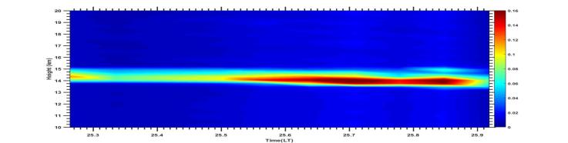
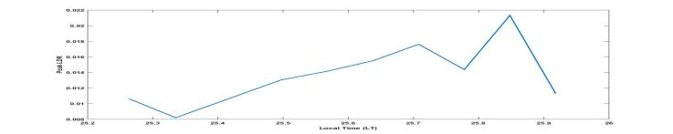
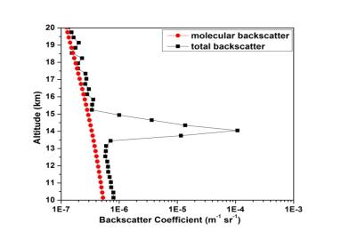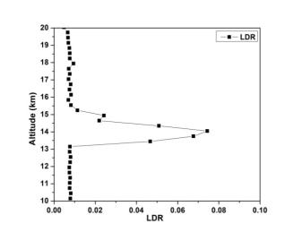
Figure 5.1 a) Temporal map of LDR b) Temporal variation of peak LDR c) Vertical profile of Backscatter coefficient and d) Vertical profile of LDR e) Vertical profile of temperature and f) Vertical profile of Relative Humidity on 01 November 2006.
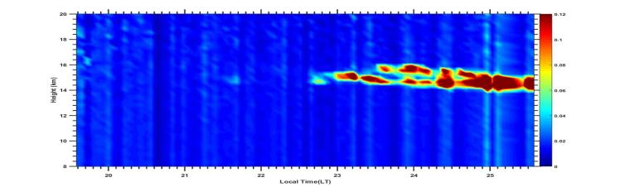
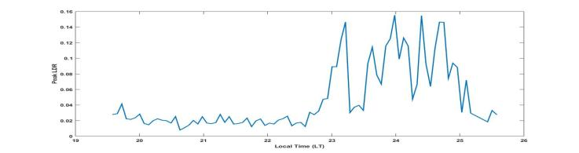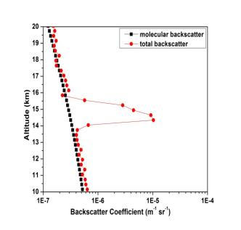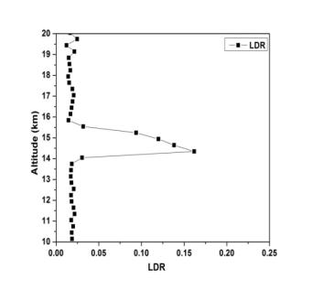
Figure 5.2(a-f). Same as Figure 5.1(a-f) but for 06 September 2006.
Vertical profiles of total backscatter coefficient and molecular backscatter coefficients are plotted (Figures 5.1c & 5.2c) together to find the cloud base and top altitudes respectively using the method of quantitative approach based on clear air assumption (Sassen and Cho., 1992). The mid cloud altitude is then taken as the average of cloud top and base altitudes and are found to be 14.35 km and 14.5 km respectively for the two cases. Figure 5.1d & 5.2d shows the vertical profile of LDR to measure the peak value of LDR during the passage of cirrus and are found to be 0.08 for 01 November 2006 and 0.17 for 06 September 2006 respectively. High value of LDR indicates the presence of highly non spherical particles with sharp edges. Generally the temporal variations in LDR are associated with the variations in temperature, relative humidity in the cloud altitudes, but, these parameters are not available on a continuous basis throughout the cirrus observational period and hence, only vertical profiles of temperature (Figure 5.1e & 5.2e) and relative humidity (Figure 5.1f & 5.2f) that are obtained from radiosonde observations at ~17:30 IST over Gadanki are presented. The mid cloud temperature is found to be - 670C and the max relative humidity in the cloud altitude is ~32% on 01 November 2006 and – 670C and ~ 46% on 06 September 2006. The depolarization variability indicator ‘ε’ is calculated for the two cases and are found to be 0.49 on 01 November 2006 and 0.64 on 06 September 2006.
Winter Season (12 January 2007 and 25 February 2007)
Figure 5.3a & 5.4a shows the temporal map of LDR from which the passage of geometrically thick cirrus during 12 January 2007 and thin cirrus on 25 February 2007 over Gadanki region is noticed. The temporal variations in peak LDR of the cirrus are shown in Figures 5.3b & 5.4b for the two cases. The mid cloud altitudes are found to be 13.05 and 16.25 km (Figures 5.3c & 5.4c) and the peak LDR values are found to be ~0.20 and ~0.06 (Figures 5.3d & 5.4d) for the two cases respectively. From the vertical profiles of temperature (Figure 5.3e & Figure 5.4e), the mid cloud temperature is found to be ~ - 610C on 12 January 2007 and ~ -770C on 25 February 2007. The value of relative humidity in the cloud altitude is found to be ~45% on 12 January 2007, but the relative humidity data is not good on 25 February 2007 and hence the profile is not shown. The depolarization variability indicator ‘ε’ is calculated and are found to be 0.47 and 0.09 respectively for the two cases, indicating the high homogeneity of cirrus observed at high altitudes near to cold point tropopause.

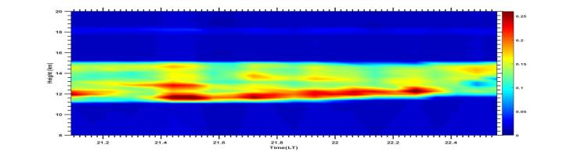
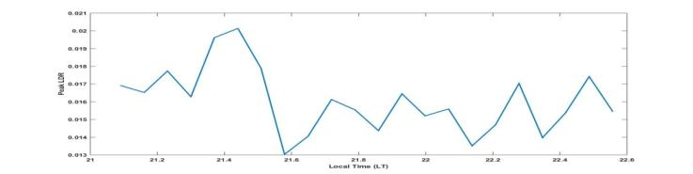
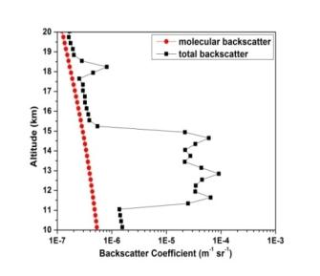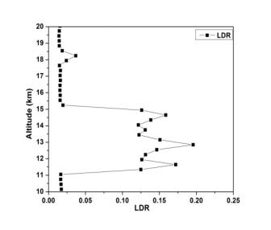
Figure 5.3(a-f). Same as Figure 5.1(a-f) but for 12 January 2007.
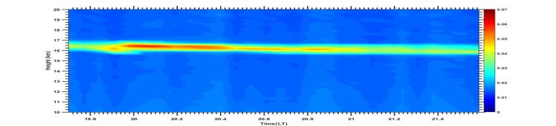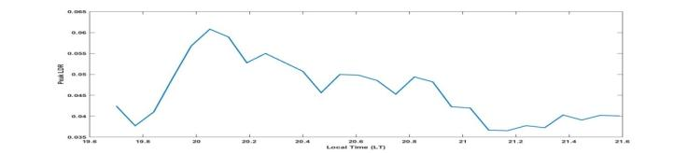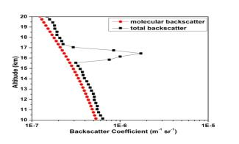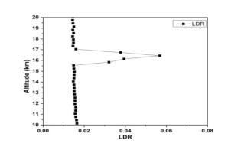
Figure 5.4(a-e). Same as Figure 5.1(a-e) but for 25 February 2007.
Pre Monsoon season (10 March 2007 and 16 May 2007)
Figure 5.5a & 5.6a shows the temporal map of LDR on 10 March 2007 and 16 May 2007. Passage of single geometrically thin cirrus on 10 March 2007 and geometrically thick cirrus on 16 May 2007 over Gadanki is noticed. The temporal variations in peak LDR for the two cases are shown in Figures 5.5b & 5.6b. The mid cloud altitudes are found to be 15.95 km and 15.90 km (Figures 5.5c & 5.6c) and the peak LDR values are found to be ~ 0.13 and ~0.095 (Figures 5.5d & 5.6d) for the two cases respectively. Radiosonde temperature and relative humidity data over Gadanki are not available and hence the vertical profiles are not shown for these two cases. The depolarization variability indicator ‘ε’ is found to be 0.33 and 0.35 respectively for the two cases.
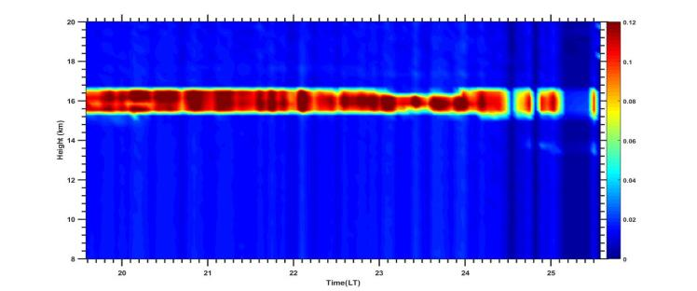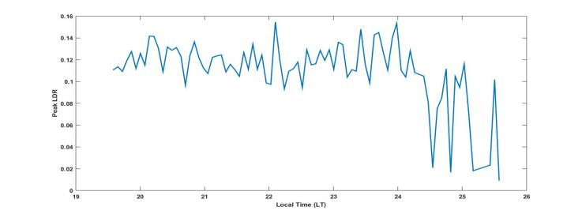
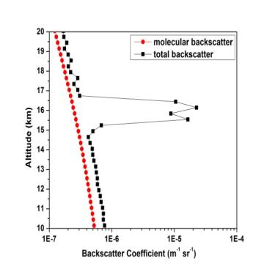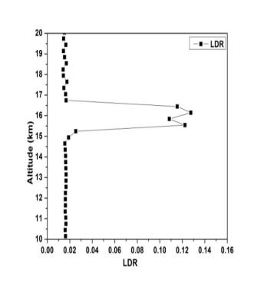
Figure 5.5(a-d). Same as Figure 5.1(a-d) but for 10 March 2007.
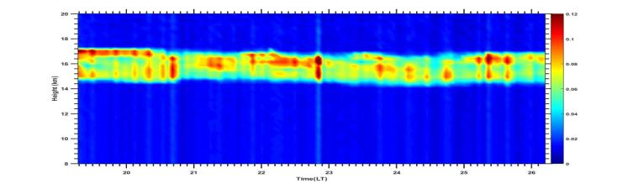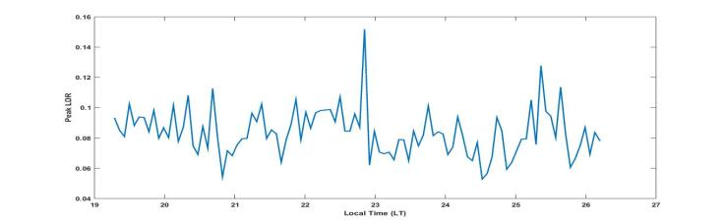
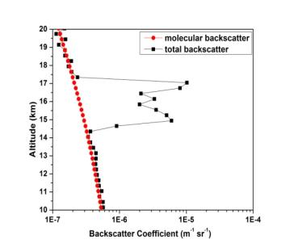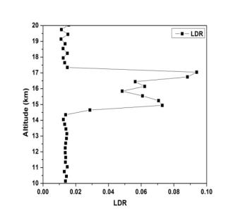
Figure 5.6(a-d). Same as Figure 5.1(a-d) but for 16 May 2007.
Monsoon Season (01 June 2007 and 10 July 2007)
The temporal maps of LDR for the two cases (01 June 2007 and 10 July 2007) are shown in Figures 5.7a and 5.8a. Passage of single geometrically thin cirrus on 01 June 2007 and geometrically thick cirrus on 10 July 2007 are noticed. The temporal variations in peak LDR of the cirrus are shown in Figures 5.7b & 5.8b. The mid cloud altitudes are found to be 16.55 km and 13.95 km respectively for the two cases (Figures 5.7c & 5.8c) and the peak LDR values are found to be ~0.078 and ~0.058 (Figures 5.7d & 5.8d) for the two cases respectively. From the vertical profiles of temperature (Figure 5.7e & Figure 5.8e), the mid cloud temperature is found to be ~ -780C on 01 June 2007 and ~ - 630C on 10 July 2007. The relative humidity data is not good on 01 June 2007 and hence, the profile is not shown, but for 10 July 2007 the maximum value of relative humidity is found to be ~ 62% in the cloud altitudes. The value of ‘ε’ is found to be 0.19 & 0.99 respectively for the two cases showing lowest in-cloud variability of LDR for the cirrus at high altitudes (near cold point tropopause) and high in-cloud variability of LDR at low altitudes.
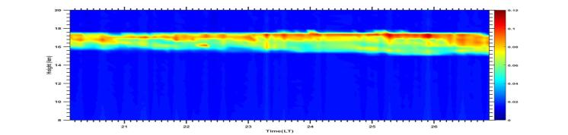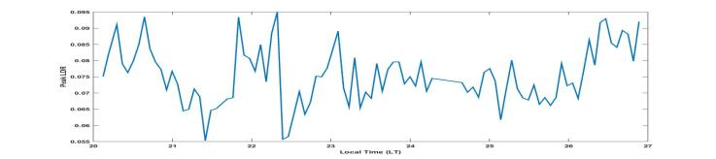
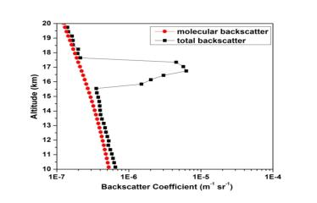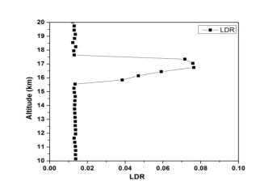
Figures 5.7(a-e). Same as Figure 5.1(a-e) but for 01 June 2007.
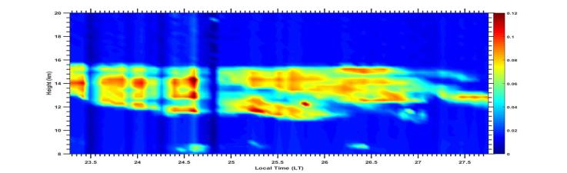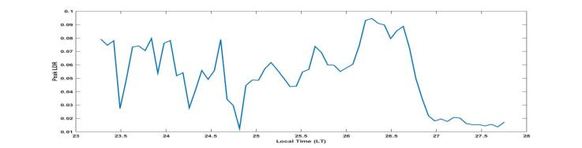
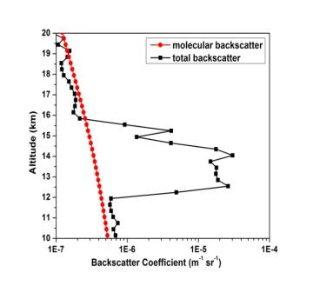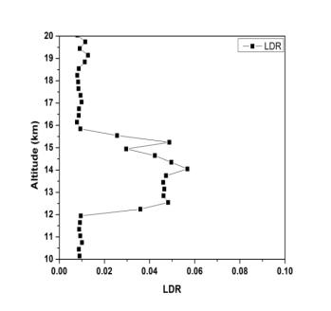
Figures 5.8(a-f). Same as Figure 5.1(a-f) but for 10 July 2007.
5.5 Summary
In the present chapter, an attempt is made to examine the in-cloud variability of Linear Depolarization Ratio (LDR) of cirrus using ground based polarization lidar at Gadanki located in the southern part of India. In this context, 8 cases of uniform cirrus (visually) are considered during four contrasting seasons of the years 2006-2007. The in-cloud variability of LDR of cirrus is measured using a parameter known as depolarization variability indicator (ε) which is practically insensitive to miscalibration of the two reception channels and also to the duration of the measurement. Lowest in-cloud variability of LDR of cirrus (and hence high homogeneity) is noticed during the passage of cirrus near the cold point tropopause, and high values when the cirrus is present at low altitudes. The highest in-cloud variability of LDR (compared to other seasons of the year) is noticed in one of the case studies (in the monsoon season) which might be due to strong convection that is common during monsoon period over Gadanki region. Dynamical processes around the cirrus are most important for a better understanding of in-cloud variability of LDR which will be addressed.

_____________________________________________________Chapter 6
CONCLUSIONS AND FUTURE DIRECTIONS

6.1 Summary and Conclusion
This chapter summarizes the results obtained from the study of wind motions during the presence of high altitude clouds–cirrus observed over a low latitude station Gadanki (13.7˚N and 79.2˚E) using simultaneous measurements of MST radar and polarization lidar. Major part of this research work is devoted to understand the modulations in wind velocities during its propagation within and around the cirrus cloud with respect to peak Linear Depolarization Ratio (LDR) of the cirrus. An attempt is also made to study the effect of vertical wind on the ascent/descent of cirrus. Further, the frequency of transition between multiple and single geometrically thick cirrus over Gadanki and the corresponding changes in the cirrus optical and depolarization properties along with modulations in the background wind velocities are examined. CALIPSO satellite imagery is used to validate the passage of cirrus clouds over the experimental region and at the same time, the inability of the passive satellites in identifying these transitions. Lidar measurements were used to study vertical distribution of cirrus clouds; transition between multiple and single cirrus and the variations in cirrus microphysical and optical properties while, MST radar is used to study the modulations in the background wind fields during the presence of cirrus clouds.
The variation of winds with peak LDR in the cloud altitude is discussed using three different cases (one case during North-East monsoon day and the other two cases during South-West monsoon days) where the passage of cirrus is noticed at different altitudes. The zonal wind below the cloud height has shown similar variation with LDR during 02 November 2006 and the meridional wind within the cloud height during 25 July 2007 and 08 June 2006 has shown opposite variation with peak LDR. Even though there is a significant increase in zonal wind due to the existence of Tropical Easterly Jet (TEJ) above cloud height during 25 July 2007 and 08 June 2006, also, the vertical wind is found to be continuously varying during 25 July 2007 and it is upward dominant in the initial stage and is mostly downward in the later stage of observation on 08 June 2006, there is a slight descent in cloud altitude only during 25 July 2007. Thus, the wind above the cloud height alone may not affect the ascent/descent of the cloud top altitude. The potential temperature gradient is high within the cloud heights when the cirrus present near the cold point tropopause indicates the maximum air-mass mixing near the tropopause.
The present study describes Mie lidar observations of cirrus cloud variability showing transition between multiple and single thick cirrus over Gadanki. In this connection, 72 nights of lidar observations during January 2007 to August 2007 are taken into consideration. Out of 72 night time lidar observations, only 46 nights (64%) were associated with cirrus passage over Gadanki, out of which during 6 specific nights (13%), there is transition between multiple and single thick cirrus. Significant variation in back scatter ratio (BSR), Linear Depolarization Ratio (LDR) and Cloud Optical Depth (COD) along with strong correlation between them during the transition is noticed and these enhancements in cirrus properties may contribute strong radiative forcing. This type of transitions can takes place during very short periods of time and can be observed only by the use of long term ground based remote sensors such as lidars. Passive satellites such as CALIPSO can also detect the passage of different types of cirrus (either single or multiple including subvisual) but, the clouds which are seen by the satellite may change its texture and geometrical structure due to its dynamic environment either before arrival or after departure of the satellite over a particular site. Hence, in order to study the characteristics of cirrus and for the determination of accurate radiative forcing effect of cirrus on climate over any particular location, long term ground-based data products are more useful than the passive satellite data.
The effect of transition of double layered cirrus to single geometrically thick cirrus on the background wind fields is also described using one of the case studies (17 January 2007). Transition of cirrus from double layered to single layered cirrus is detected by the lidar and simultaneously, the background winds are monitored by MST radar. A significant weakening of zonal and meridional winds during the transition period is observed which might be due to the transition from multiple to single thick cirrus indicating potential capability of thick cirrus in modulating the wind fields. There exists strong upward wind dominance that might contribute to significant ascent in cloud-base altitude thereby causing transition of multiple thin layers into single thick cirrus.
In-cloud variability of LDR of cirrus at different altitudes over Gadanki is studied using lidar observations during four contrasting seasons of the years 2006-2007. A parameter known as depolarization variability indicator ‘ε’ (which is practically insensitive to miscalibration of the two reception channels and also to the duration of the measurement) is used to measure the in-cloud variability of LDR. Large in-cloud variability of LDR is noticed in the cirrus at low altitudes (high temperatures) and low values (and hence more homogeneity) for high altitude cirrus clouds near the cold point tropopause.
6.2 Future works
The present research work advanced our knowledge on the wind motions during the presence of tropical cirrus clouds observed using simultaneous measurements of MST radar and Mie lidar at NARL, Gadanki. In particular, the modulations in background wind motions with peak LDR of cirrus; the variations in cirrus optical and microphysical properties before, during and after the transition between multiple and single geometrically thick cirrus; and the capability of geometrically thick cirrus clouds in weakening the horizontal winds were discussed. Finally, the in-cloud variability of LDR of cirrus at different altitudes during different seasons is also reported. However, this work can be extended in several ways.
Sine few decades, a challenging task in climate modeling is the representation of cirrus clouds and its accurate impact on climate. This complexity is partially due to the lack of basic information of cloud microphysical processes and partially due to incapability in resolving small scale processes in the General Circulation Model (GCM) grid box (Boucher et al., 2013). For example, the cloud feedback from optically thin cirrus amount is still unknown which causes a substantial ambiguity in the climate model predictions. In order to overcome the above said difficulty, there is a dead need of stable, precise, long-term ground based and space based lidar data sets to represent the cirrus, its processes and validate the models.
Upper troposphere is more influenced by large scale circulation patterns. Hence, more research is needed to look into the prevailed large scale wind pattern for any significant effect on cirrus to occur. Propagation of Tropical Easterly Jets (TEJ) is more common in the monsoon months over Gadanki. The effect of TEJ on tropical cirrus is not yet reported due to their high velocities. In general, there exist a strong dependency of cirrus microphysical properties and the surrounding dynamic environment. Hence, more research is to be carried out on the effect of TEJ in modulating the cirrus properties.
Further, descending nature of cirrus over midlatitudes has been reported by so many researchers (e.g. Yamamoto et al., 2009). The effect of ascending/descending cirrus on climate is very important, but the reasons for the observed ascent/descent as well as its impact on climate are least understood. Yamamoto et al., 2009 reported that the absence of updrafts is considered to be one of the prime factors for the observed ascent/descent of cirrus. But, the winds alone cannot be the reason for the observed ascent/descent of cirrus (Rao et al 2014). Hence more research is to be focussed on the wind motions around the ascending /descending cirrus clouds.
In the present research work, transition between multiple and single cirrus events are studied during different seasons of the year. However, more research is needed in the following areas.
The variations in cirrus microphysical and thermo dynamical and radiative properties during transition between multiple and single cirrus is to be studied in detail. This particular study necessitates more number of temperature and relative humidity data sets during each cirrus event. Even though the occurrence frequency of cirrus transition is low (only 13%), the variations in the cirrus properties are not insignificant. Radiative forcing calculations (based on satellite measurements) are true to first approximation only and hence inclusion of ground based data products in the GCM is required to explore more accurate results. Further, the reasons and conditions that are favorable for the formation of multiple cirrus and the transition of cirrus between multiple and single thick cirrus are to be studied.
There is an association between temporal variations in cirrus microphysical properties with the background winds (especially vertically propagating winds), waves and turbulence etc. Very few studies have been focused on the effect of cirrus on winds, waves etc and vice-versa. Hence, more simultaneous observations of radar and lidar along with radiosonde are needed.
. The dynamical processes that are taking place around the cirrus are very important in understanding the physics of cirrus. Hence, more research is to be carried out in studying the dynamics of the lower atmosphere. Moreover, homogeneity of midlatitude and polar cirrus are compared and concluded that the midlatitude cirrus are more inhomogeneous than the polar cirrus due to chemically and dynamically perturbed atmosphere. No such comparisons are available with the tropical cirrus. Hence, there is a need to study the homogeneity of tropical cirrus using statistical methods and comparison with the mid latitude and polar cirrus.

References

Ansmann, A., Wandinger, U., Riebesell, M., Weitkamp, C., and Michaels, W. (1992); Independent measurement of extinction and backscatter profiles in cirrus clouds by using a combined Raman elastic backscatter lidar, Appl. Opt., 31, 7113–7131.

Balsley B. B., and K. S. Gage (1980); The MST Radar Technique: Potential for Middle Atmospheric Studies, Pageoph, 118, 452-493.

Baum B.A., T.Uttal, M.Poellot, T.P Ackerman, J.M Alvarez, J.Intrieri, D.O.C.Starr,
J.Titlo, V.Tovinkere, and E.Clothiaux (1994); Satellite remote sensing of multiple cloud layers, Journal of the atmospheric sciences, Vol.53, No.23, 4210-4230.

Berthier, S., P. Chazette, J. Pelon, and B. Baum (2008); Comparison of cloud statistics from spaceborne lidar systems, Atmos. Chem. Phys., 8, 6965–6977.

Berrisford P, Dee DP, Fielding K, Fuentes M, Kallberg P, Kobayashi S, ˚ Uppala SM. (2009); The ERA-Interim Archive. ERA Report Series, No. 1. ECMWF: Reading, UK.

Beyerle J, Schäfer HJ, Neuber R, Schrems O, Macdemid IS (1998); Dual wavelength lidar observation of tropical high-altitude cirrus clouds during the ALBATROSS 1996 campaign. Geophys Res Lett, 25:919-922.

Bhavani Kumar, Y., Raghunath, K., Siva Kumar, V., Rao, P. B., Jain, A. R., Mizutani, K., Aoki, T., Yasui, M., and Itabe, T., (1999); NMRFCRL Lidar system
description and data processing, Proc. IRSI ‘99, Bangalore, India, 560–570, .
Boehm, M. T., J. Verlinde, and T. P. Ackerman, (1999); On the maintenance of high tropical cirrus. J. Geophys. Res., 104, 24,423-24,433.
Boehm, M. T. and Verlinde, J (2000); Stratospheric influence on upper tropospheric
Tropical cirrus, Geophys. Res. Lett., 27, 19, doi:10.1029/2000GL011678.

Boucher, O., D. Randall, P. Artaxo, C. Bretherton, G. Feingold, P. Forster, V.-M.
Kerminen, Y. Kondo, H. Liao, U. Lohmann, P. Rasch, S.K. Satheesh, S. Sherwood, B. Stevens and X.Y. Zhang, (2013); Clouds and Aerosols. In: Climate Change 2013: The Physical Science Basis. pp. 578–595, Cambridge Univ. Press, Cambridge, U. K.

Chan M.A and J. C. Comiso (2011). Cloud features detected by modis but not by
cloudsat and caliop. Geophysical Research Letters, 38(24):n/a–n/a, ISSN
1944-8007. doi:10.1029/2011GL050063.
URL http://dx.doi.org/10.1029/2011GL050063.

Chahine, M. T. (1992): The hydrological cycle and its influence on climate. Nature, 359, 373–379.

Chang, F-L, and Z Li. (2005); A new method for detection of cirrus overlapping water clouds and determination of their optical properties. J. Atmos. Sci., 62, 3993– 4009
Chen, T., Rossow, W. B., and Zhang, Y (2000); Radiative effects of cloud-type
variations, J. Climate, 13, 264–286, doi: 10.1175/1520-0442(2000)013<0264: REOCTV>2.0.CO;2.

Chen W N, C W Chiang, and J B Nee (2002); Lidar ratio and depolarization ratio for cirrus clouds. Appl Opt, 41, 6470-6476.

Das, S. K., C.W. Chiang, and J.B. Nee (2011); Influence of tropical easterly jet on upper tropical cirrus: An observational study from CALIPSO, Aura‐MLS, and NCEP/NCAR data, J. Geophys. Res., 116, D12204, doi:10.1029/2011JD015923.

Dee DP, Uppala SM, Simmons AJ, Berrisford P, Poli P, Kobayashi S, Andrae U, Balmaseda MA, Balsamo G, Bauer P, Bechtold P, Beljaars ACM, van de Berg L, Bidlot J, Bormann N, Delsol C, Dragani R, Fuentes M, Geer AJ, Haimberger L, Healy SB, Hersbach H, Holm EV, Isaksen L, K ´ allberg P, K ˚ ohler M, ¨Matricardi M, McNally AP, Monge-Sanz BM,
Morcrette J-J, Park B-K, Peubey C, de Rosnay P, Tavolato C, Thepaut J-N, Vitart F. (2011); The ERA-Interim reanalysis: configuration
and performance of the data assimilation system. Q. J. R. Meteorol. Soc.
137: 553–597. DOI:10.1002/qj.828

Del Guasta and Edgar Vallar (2003); In-cloud variability of LIDAR depolarization of polar and midlatitude cirrus, Geographycal Research Letters, VOL. 30,
NO.11, 1578, doi:10.1029/2003GL017163.

Devara, P.C.S., Raj, P.E., Sharma, S. and Pandithurai, G. (1995); Real-Time Monitoring of Atmospheric Aerosols Using a Computer Controlled Lidar. Atmospheric Environment, 29, 2205-2215.
http://dx.doi.org/10.1016/1352-2310(94)00355-O

Dowling D R, and L F Radke (1990); A summary of the physical properties of cirrus
clouds. J Appl Meteorol, 29, 970– 978.

Edwards, A.L., (1984); An introduction to linear regression and correlation,
W.H.Freeman and Company, Newyork, p.206.

Fernald, F.G. (1984); Analysis of Atmospheric Lidar Observations: Some Comments. Applied Optics, 23, 652-653. http://dx.doi.org/10.1364/AO.23.000652

Fiocco, G.; and Grams, G. (1964); Observations of the Aerosol Layer at 20 km by
Optical Radar. J.A.S. 1, 323

Fortuin J P F, C R Becker, M Fujiwara, F Immler, H M Kelder, M P Scheele, O
Schrems, and G H L Verver (2007); Origin and transport of tropical cirrus clouds observed over Paramaribo, Suriname (5.8N, 55.2W). J Geophys Res, 112, D09107, doi:10.1029/2005JD006420

Gage, K. S., and B. B. Balsley (1980); On the scattering and reflection mechanisms contributing to clear air radar echoes from the troposphere, stratosphere and mesosphere, Radio Sci., 15, 243-257.

Ghosh, A. K., Jain, A. R., and Siva Kumar, V. (2000); Characteristics of atmospheric
winds, associated shear and turbulence: Indian MST Radar measurement
during summer monsoon season, Indian. J. Radio and Space Phys., 29, 222–230.
Ghosh, A. K., Siva Kumar, V., Kishore Kumar, K., and Jain, A. R. (2001); VHF radar observation of atmospheric winds, associated shears and Cn² at a tropical location : Interdependence and seasonal pattern, Ann. Geophysicae, 19, 8, 965–973.

Goldfarb L, Keckhut P, Chanin M L, and Hauchecorne A (2001); Cirrus climatological results from lidar measurements at OHP. Geophys Res Lett, 28, 1687-1690.

Grund, C. J. and Eloranta, E. W. (1990); The 27–28 October 1986 FIRE IFO cirrus case
study: cloud optical properties determined by high spectral resolution lidar,
Mon.Weather Rev., 118, 2344–2355, doi:10.1175/1520- 0493(1990)1182.0.CO;2.
Gultepe I, Starr DO’C. (1995); Dynamical structure and turbulence in cirrus clouds: aircraft observations during FIRE. Journal of the Atmospheric Sciences 52: 4159–4182.

Gultepe.I, D.O’C.Starr, A.J.Heymsfield, T.Uttal, T.P.Ackerman and D.L Westphal
(1995); Dynamical characteristics of cirrus clouds from aircraft and radar observations in micro and meso-g scales. J. Atmos. Sci., 52, 4060–4078.

Hahn C. J, Warren S.G, London.J, Chervin.R.M and Jenne.R (1982); Atlas of
simultaneous occurrence of different cloud types over the ocean. NCAR Tech. Note TN241 STR, 209 pp. [Available from National Center for Atmospheric Research, Boulder, CO 80307.]

Hahn, C. J, Warren S.G, London.J, Chervin.R.M and Jenne.R (1984); Atlas of
simultaneous occurrence of different cloud types over land. NCAR Tech. Note TN-241 STR, 216 pp. [Available from National Center for Atmospheric Research, Boulder, CO 80307.]

Hartmann, D. L., Ockert-Bell, M. E., and Michelsen, M. L (1992); The effect of cloud
type on Earth’s energy balance: global analysis, J. Climate, 5, 1281–1304, doi:10.1175/1520-0442(1992)005<1281:TEOCTO>2.0.CO;2.

Heidinger A.K, Pavolonis. M. J (2005); Global Daytime Distribution of Overlapping Cirrus Cloud from NOAA’s Advanced Very High Resolution Radiometer, Journal of Climate, 18, 4772-4784.

Heymsfield, A.J., Platt, C.M.R (1984); A parameterization of the particle spectrum of ice
clouds in terms of the ambient temperature and the ice water content, J.
Atmos. Sci.,41, 846-855.

Heymsfield, A.J. and McFarquahar, G.M. (1996); High Albedoes of Cirrus in the
Tropical Pacific Warm Pool: Microphysical Interpretation CEPEX and from Kwajalein, Marshall Islands. Journal of the Atmospheric Sciences, 53, 2424-2541.
http://dx.doi.org/10.1175/1520-0469(1996)053<2424:HAOCIT>2.0.CO;2

Heymsfield, A. J. and McFarquhar, G. M (2002); Mid-latitude and tropical cirrus-
Microphysical properties, in: Cirrus, edited by: Lynch, D., Sassen, K., Starr, D. O., and Stephens, G., Oxford University Press, 78–101.

Hildebrand, P. H., and R. S. Sekhon (1974); Objective determination of the noise level in Doppler spectra, J. Appl. Meteorol., 13, 808–811.

Houze R A, Jr. (1993); Cloud dynamics, International geophysics series, 53, Academic press.

Hubert Luce, Takuji Nakamura, Masayuki K. Yamamoto, Mamoru Yamamoto and
Shoichiro Fukao (2009); MU Radar and Lidar observations of clear air
turbulence underneath cirrus, Monthly weather review.,138, 438-452

Hunt. W. H.,Winker, D. M., Vaughan, M. A., Powell, K. A., Lucker, P. L., and Weimer, C (2009); CALIPSO 432 lidar description and performance assessment, J. AtmosphericOcean.Technol.,26,1214–1228,433
doi:10.1175/2009JTECHA1223.1.
Inamdar, A. K. and V. Ramanathan (1994); Physics of greenhouse effect and convection in warm oceans. J. Climate 5, 715–31.

Immler F, Schrems O (2002); Determination of tropical cirrus properties by simultaneous
LIDAR and radiosonde measurements. Geophysical Research Letters 29(23): 2090, DOI:10.1029/2002GL015076.

Jagannadha Rao, V. V. M., Narayana Rao, D., Ratnam, M. V., Mohan, K., and Vijaya Bhaskara Rao, S. (2003); Mean vertical velocities measured by Indian MST
Radar and comparison with indirectly computed values, J. Appl. Meteorol.,
42, 541–552.

Jayaraman, A., Ramachandran, S., Acharya, Y. B., and Subbaraya, B. H. (1995);
Pinatubo volcanic aerosol layer decay observed at Ahmedabad (23 N)
India using Nd:YAG backscatter lidar, J. Geophys. Res., 100, 23 209–23
214.

Jäger, H., and D. Hofmann (1991); Midlatitude lidar backscatter to mass, area, and
extinction conversion model based on in situ aerosol measurements from
1980 to 1987, Appl. Opt., 30, 127–138.

Jensen, E.J., Toon, O.B., Selkirk, H.B., Spinhirne, J.D. and Schoeberl, M.R. (1996); On the Formation and Persistence of Subvisible Cirrus Clouds near the Tropical Tropopause. Journal of Geophysical Research, 101, 21361-21375.

Karlsson, K. -G., & Johansson, E. (2013); On the optimal method for evaluating cloud products from passive satellite imagery using CALIPSO–CALIOP data: example investigating the CM SAF CLARA-A1 dataset. Atmospheric Measurement Techniques, 6, 1271–1286,
http://dx.doi.org/10.5194/amt-6-1271-2013.

Kinne, S and Liou, K-N., (1989); The effects of the nonsphericity and size distribution of
ice crystals on the radiative properties of cirrus clouds. Atmos. Res. 24, 273–284

Klett, J. D. (1981); Stable analytical inversion solution for processing lidar returns,
Appl. Opt., 20, 211–220.

Kulkarni, P., Ramachandran, S., Bhavani Kumar, Y., NarayanaRao, D., and Krishnaiah, M. (2008); Features of upper troposphere and lower stratosphere aerosols
observed by lidar over Gadanki, a tropical Indian station, J. Geophys. Res.-Atmos., 113, D17207, doi:10.1029/2007JD009411.

Kumar, Y.B., Kumar, V.S., Jain, A.R. and Rao, P.B. (2001); MST Radar and Polarization Lidar Observations of Tropical Cirrus. Annales Geophysicae, 19, 873-883. http://dx.doi.org/10.5194/angeo-19-873-2001.

Leahy L, Wood R, Charlson R, Hostetler C, Rogers R, Vaughan M, D W. (2012). On the nature and extent of optically thin marine low clouds. J. Geophys. Res. 117: (D22 201) doi:10.1029/2012JD017 929.

Liu. Z, R. Kuehn, M. Vaughan, D. Winker, A. Omar, K. Powell, C. Trepte, Y. Hu, and C. A. Hostetler (2010); The calipso cloud and aerosol discrimination: version 3 algorithm and test results. In Proceedings of the 25th International Laser Radar Conference, St.-Petersburg, 5-9 July 2010.

Lindzen, R. S. (1990); Some coolness concerning global warming. Bull. Amer. Meteor. Soc. 71, 288–99.

Liou,K.-N, (1986); Influence of cirrus cloud on weather and climate processes: A global perspective. Mon. Weather Rev., 114, 1167-1199.

Lynch, D.K., Sassen, K., Starr, D.O’C. and Stephens, G. (2002); Cirrus. Oxford University Press, New York, 18.

Macke, A. (1993); Scattering of light by polyhedral ice crystals. Appl. Opt. 32, 2780– 2788.

Macke, A., Mueller, J., Raschke, E., (1996); Single scattering properties of atmospheric ice crystals. J. Atmos. Sci. 53, 2813–2825.

Massie Steven, Paul Lowe, XueXi Tie, Mark Hervig, Gary Thomas and James
Russell., (2000); The effect of E1 Nino on the distribution of upper
tropospheric cirrus, Journal of Geophysical Research, Vol. 105, No. D18, Pages 22,725-22,741
Mather, J. H., Ackerman, T. P., Jensen, M. P., and Clements, W. E. (1998);
Characterisation of the atmospheric state and the surface radiation budget at
the tropical western Pacific ARM site”, Geophys.Res. Lett., 25, 4513–4516,.

Mergenthaler, J. L , A. E. Roche, J. B. Kumer, and G. A. Ely., (1999); Cryogenic Limb
Array EtaIon Spectrometer observations of tropical cirrus., J. Geophys. Res., 104, No. D18, Pages 22,183-22,194, September 27, 1999.

Mishchenko, M.I., L.D. Travis, and D.W. Mackowski, (1996); T-matrix computations of light scattering by nonspherical particles: A review. J. Quant. Spectrosc. Radiat. Transfer, 55, 535-575, doi:10.1016/0022-4073(96)00002-7.

Mishchenko, M.I., Rossow, W.B., Macke, A., Lacis, A.A., (1996); Sensitivity of cirrus cloud albedo, bidirectional reflectance and optical thickness retrieval accuracy to ice particle shape. J. Geophys. Res. 101, 16973–16985.

Nazaryan, H., McCormick, M. P., and Menzel, W. P. (2008); Global characterization of
cirrus clouds using CALIPSO data, J. Geophys. Res.-Atmos., 113, D16211, doi:10.1029/2007JD009481.

Osborn, M. T., D. M. Winker, D. C. Woods, R. J. DeCoursey, and C. R. Trepte (1995); Evolution of the Pinatubo volcanic cloud over Hampton, Virginia, Geophys. Res. Lett., 22, 1101–1104, doi: 10.1029/95GL00815.

Osborn, M.T., R.J. De Coursey, C.R. Trepte, D.M. Winker, and D.C. Woods (1995);
Evolution of the Pinatubo volcanic cloud over Hampton, Virginia, Geophys.
Res. Lett. , 22, 1 1 01-1104.

Pal, S.R., W. Steinbrecht, and A.I. Carswell, (1992); Automated method for lidar determination of cloud base height and vertical extent. Appl. Opt., 31, 1488- 1494.

Pandit A. K. , Gadhavi H. S. , M. Venkat Ratnam , K. Raghunath , S. V. B. Rao,
and A. Jayaraman., (2015); Long-term trend analysis and climatology of
tropical cirrus clouds using 16 years of lidar data set over Southern India,
Atmos. Chem. Phys., 15, 13833–13848, 2015;
doi:10.5194/acp-15-13833-2015.

Parameswaran, K., Sunilkumar, S.V., Krishna Murthy, B.V., Satheesan, K., Bhavanikumar, Y., Krishnaiah, M. and Nair, P.R. (2003); Lidar Observations of Cirrus Cloud Near the Tropical Tropopause: Temporal Variations and Association with Tropospheric Turbulence. Atmospheric Research, 69, 29- 49. http://dx.doi.org/10.1016/j.atmosres.2003.08.002

Pfister Leonhard, Henry B. Selkirk, Eric J. Jensen, Mark R. Schoeberl, Owen B. Toon,

Edward V. rowell, William B. Grant, Bruce Gary, Michael J. Mahoney,

Thaopaul V. Bui, Eric Hintsa., (2001); Aircraft observations of thin cirrus clouds near the tropical tropopause, J. Geophys. Res., 106(D9), 9765–9786.

Platt, C. M. R., (1979); Remote sounding of high clouds. I: Calculation of visible and infrared optical properties from lidar and radiometer measurements. J. Appl. Meteor., 18, 1130–1143.

Platt, C. M. R., Scott, J. C., and Dilley, A. C. (1987); Remote sounding of High Clouds
VI: Optical properties of mid latitude and tropical cirrus, J. Atmos. Sci., 44,
729–747, 1987.

Platt, C.M.R., Young, S.A., Carswell, A.I., Pal, S.R., McCormick, M.P., Winker, D.M., et al. (1994); The Experimental Cloud Lidar Pilot Study (ECLIPS) for Cloud- Radiation Research. Bulletin of the American Meteorological Society, 75, 1635-1645.
http://dx.doi.org/10.1175/1520-0477(1994)075<1635:TECLPS>2.0.CO;2
Platt, C. M. R., Young, S. A., Manson, P. J., Patterson, G. R., Marsden, S. C., Austin, R. T., and Churnside, J. H. (1998); The optical properties of equatorial cirrus
from observations in the ARM pilot radiation observation experiment, J. Atmos. Sci.,55, 1977–1996.

Prabhakara C, R S Fraser, G Dalu, C W Man-Li, and R J Curran (1988); Thin cirrus
clouds: Seasonal distribution over oceans deduced from Nimbus-4 IRIS. J Appl Meteorol, 27, 379– 399.

Ramachandran, S., and A. Jayaraman, (2003a); Spectral aerosol optical depths over Bay
of Bengal and Chennai: I—Measurements, Atmos. Environ., 37, 1941–1949.
Ramaswamy, V. and Ramanathan, V. (1989); Solar Absorption by Cirrus Clouds and Maintenance of the Tropical Upper Troposphere Thermal Structure. Journal of the Atmospheric Sciences, 46, 2293-2310.
http://dx.doi.org/10.1175/1520-0469(1989)046<2293:SABCCA>2.0.CO;2

Rao C D, Arunachalam Srinivasan M, Krishnaiah M, Kumar Y B and Rao S V B, (2014);
Wind motions around the tropical cirrus using simultaneous radar and lidar observations over Gadanki (13.45°N, 79.18°E), India, International Journal of Geosciences (China), 5, 1241, doi: 10.4236/ijg.2014.511103.

Rao, P.B., Jain, A.R., Kishore, P., Balamuralidhar, P., Damle, S.H. and Viswanathan, G.,
(1995); Indian MST Radar Part-I: System Description and Sample Wind
Vector Measurements in ST Mode,.Radio Science, 30, 1125-1138. http://dx.doi.org/10.1029/95RS00787.

Reichardt J (1999); Optical and geometrical properties of northern midlatitude cirrus clouds observed with a UV Raman lidar. Phys. Chem. Earth, 24, 255– 260.

Röettger, J. (1980); Reflection and scattering of VHF radar signals from atmospheric refractivity structures. Radio Sci., 15, 259-276.

Sandhya, M., Sridharan, S., Indira Devi, M., Niranjan, K., and Jayaraman, A. (2015); A
case study of formation and maintenance of a lower stratospheric cirrus cloud
over the tropics, An. Geo Comm., 33, 599–608, doi:10.5194/angeocom-33-
599-2015.

S.Berthier, P. Chazette, J. Pelon, and B. Baum. (2008); Comparison of cloud statistics
From spaceborne lidar systems. Atmospheric Chemistry and Physics,
8(23):6965–6977,2008.doi:10.5194/acp-8-6965-2008.URL
http://www.atmos-chem-phys.net/8/6965/ 2008/.

Sasi M N, (1994); A reference atmosphere for the Indian equatorial zone, Ind. J. Rad.
Space Phys., (INDIA), 23, 299–312.

Sassen, K. (1991); The polarization lidar technique for cloud research: a review and
current assessment, Bull. Am. Meteorol. Soc., 72, 1848–1866.

Sassen, K. and Cho, B.S. (1992); Subvisual-Thin Cirrus Lidar Dataset for Satellite Verification and Climatological Research. Journal of Applied Meteorology, 31,1275-1285.
http://dx.doi.org/10.1175/1520-0450(1992)031<1275:STCLDF>2.0.CO;2
Sassen K, (1994); Advances in Polarization Lidar for Cloud Remote Sensing, Proc. IEEE,
(USA) 82, No.12, 1907–1914.

Sassen, K. and S. Bensen.(2001); A midlatitude cirrus cloud climatology from the facility for atmospheric remote sensing, Part II: Microphysical properties derived
from LIDAR depolarization”, J. Atmos. Sci., 58, 2103–2112.

Sassen, K. and Campbell, J. R. (2001); “A midlatitude cirrus cloud climatology from the
facility for atmospheric remote sensing, Part I: Macro physical and
synoptic properties”, J. Atmos. Sci., 58, 481–495.

Sato.t., (1989); Radar Principles, n Hand book or MAP, edited by S.Fukao, Vol.30,
pp.19-53, SCOSTEP Sect., Urbana, Ill.

Simmons, A., Uppala, S., Dee, D. and Kobayashi, S. (2007); ERA-Interim: New
ECMWF Reanalysis Products from 1989 onwards. ECMWF Newsletter, 110,
29-35.

Sivakumar V, Y Bhavanikumar, P B Rao, K Mizutani, T Aoki, M Yasui, and T Itabe
(2003); Lidar observed characteristics of the tropical cirrus clouds, Radio
Sci., 38(6), 1094, doi:10.1029/2002RS002719.

Srinivasan M.A, C. Dhananjaya Rao, M.Krishnaiah, (2016); Lidar observation of
transition of cirrus clouds over a tropical station Gadanki: Case studies, Proceedings of SPIE, vol. 9879, 98790H-1, doi:10.1117/12.2222745.

Starr, D. and Cox, S.K. (1985); Cirrus Clouds. Part II: Numerical Experiments on the Formation and Maintenance of Cirrus. Journal of the Atmospheric Sciences, 42, 2682-2694.
http://dx.doi.org/10.1175/1520- 0469(1985)042<2682:CCPINE>2.0.CO;2

Starr, D. O’C. (1987); A cirrus cloud experiment: Intensive field observations planned
for FIRE, B, Am. Meteorol. Soc., 68, 199–124.

Stenchikov, G.L., Kirchner, I., Robock, A., Graf, H.-F., Antuna, J.C., Grainger, R., Lambert, A., Thomason, L., (1997); Radiative Forcing from the 1991 Mount Pinatubo Volcanic Eruption. Max-Planck-Institut fuer Meteorologie, Rep. No. 231, 40 pp.

Stephens, G.L., S.-C. Tsay, P.W. Stackhouse and P.J.Flatau (1990); The relevance of the microphysical and Radiative properties of cirrus clouds to climate and climate feedback, J. Atmos. Sci., 47, 1742-1753.

Stephens, G. L., Wood, N. B., and Gabriel, P. M. (2004); An assessment of the parameterization of subgrid-scale cloud effects on radiative transfer. Part I: Vertical overlap, J. Atmos. Sci., 61, 715–732, doi:10.1175/1520-0469,
0612.0.CO;2
Sun,Y., Z.Li, and J.Bosenberg, (1989); Depolarization of polarized light caused by high altitude clouds. I: Depolarization of LIDAR induced by cirrus, Appl. Opt., 28(17), 3625-3632.
Sunilkumar, S. V. and Parameswaran, K. (2005); Temperature dependence of tropical
Cirrus properties and radiative effects, J. Geophys. Res., 110, D13205, doi:10.1029/2004JD005426.

Sunil Kumar, K. Parameswaran, and Bijoy V. Thampi., (2008); Interdependence of
tropical cirrus properties and their variability, Ann. Geophys., 26, 413–429,www.ann-geophys.net/26/413/2008.

Sunilkumar S.V., K. Parmeshwaran, K. Rajeev, B.V. Krishna Murthy, S.Meenu, Sanjay Kumar Mehta, Asha Babu.,(2010); Semitransparent cirrus clouds in the
tropical tropopause layer during two contrasting seasons, JASTP, 2010, 72,
745-762

Takahashi, T. and Kuhara, K., (1993); Precipitation Mechanism of cumulonimbus clouds
at Pohnpei, Micronesia, J. Meteor. Soc. Japan, 71, 21–31.

Thomas, L., Cartwright, J. C., and Wareing, D. P. (1990); Lidar observations of the
horizontal orientations of ice crystals in cirrus clouds, Tellus, 42B, 211–216.

Tian, L., and J. A. Curry, (1989); Cloud overlap statistics. J. Geophys. Res., 94, 9925–
9935

Veglio. P and Maestri. T (2011); Statistics of vertical backscatter profiles of cirrus clouds. Atmospheric Chemistry and Physics, 11(24):12925–12943, 2011. doi: 10.5194/ acp-11-12925-2011. URL http://www.atmos-chem- phys.net/11/12925/2011/.

Wada, Hiroyuki Hashiguchi, Masayuki K. Yamamoto, Michihiro Teshiba, and Shoichiro Fukao (2004); Simultaneous Observations of Cirrus Clouds with a Millimeter-Wave Radar and the MU Radar, Journal of Applied Meteorology, Vol 44, pp. 313-323.

Wang, P.-H., Minnis, P., McCormick, M. P., Kent, G. S., and Skeens, K. M. ,(1996); A 6
Year climatology of cloud occurrence frequency from stratospheric aerosol and Gas Experiment II observations (1985–1990), J. Geophys. Res., 101, 29 407–29429.

Warren S.G; C. J. Hahn, and J. London, (1985); Simultaneous occurrence of different cloud types. J. Climate Appl. Meteor., 24, 658–667.

Webster P.J and Stephens G.L (1984); Tropical upper-tropospheric extended clouds:
inferences from winter MONEX. Journal of Atmospheric Science, 37, pp. 1521–1541.

Winker, D. M. and Trepte, C. R (1998); Laminar cirrus observed near the tropical
tropopause by LITE, Geophys. Res. Lett., 25, 3351–3354.

Winker D. M., Y. Hu, M. C. Pitts, M. Avery, B. J. Getzewich, J. Tackett, C. Kittaka, Z. Liu, and M. A. Vaughan (2010a); The calipso mission: results and progress.
Proc. SPIE,7832,.doi:10.1117/12.864901.
URL http://dx.doi.org/10.1117/12. 864901.

Winker, D. M., Hostetler, C. A., Vaughan, M. A., and Omar, A. H. (2006); CALIOP
Algorithm Theoretical Basis Document, Part 1: CALIOP Instrument, and
Algorithms Overview, Release, 2, 29.

Winker D.M, C. A. Hostetler, M. A. Vaughan, and A. Omar (2006); Part 1: Caliop
instrument, and algortihms overview release 2.0. In D. M. Winker, C. A. Hostetler, M.A.Vaughan, and A. Omar, editors, CALIOP Algorithm Theoretical Basis Document. URL
http://www-calipso.larc.nasa.gov/resources/pdfs/PC-SCI-202.
Part1_v2-Overview.pdf

Winker, D.M, J. Pelon, J. A. Coakley Jr., S. A. Ackerman, R. J. Charlson, P. R. Colarco,
P. Flamant, Q. Fu, R. M. Hoff, C. Kittaka,* T. L. Kubar, H. Le Treut, M. P. Mccormick, G. Mégie,* L. Poole, K. Powell, C. Trepte, M. A. Vaughan, and B. A. Wielicki (2010); The Calipso mission: A global 3D view of aerosols and clouds, Bull. Am. Meteorol. Soc., doi:10.1175/ 2009JTECHA1281.1

Winker D. M, Y. Hu, M. C. Pitts, M. Avery, B. J. Getzewich, J. Tackett, C. Kittaka, Z. Liu, and M. A. Vaughan (2010a). The calipso mission: results and
progress. Proc. SPIE, 7832, 2010a. doi: 10.1117/12.864901.
URL http://dx.doi.org/10.1117/12. 864901.

Woodman, R. F., and Guillen (1974), Radar observations of winds and turbulence in the stratosphere and mesosphere, J. Atmos. Sci., 31, 493-505.

Woodman, R. F., (1985); Spectral moment estimation in MST radars, Radio Sci., 20,
1185±1195.

Wu D, Y. Hu, McCormick, M. P., and F. Yan (2011); Global cloud-layer distribution
statistics from 1 year calipso lidar observations. Int. J. Remote Sens.,
32(5):1269–1288.
Wylie, D. P. and W. P. Menzel (1999); Eight years of global high cloud statistics using
HIRS. J.Climate ,12 , 170-184.

Yamamoto Masayuki K, Yuichi Ohno, Hiroaki Horie, Noriyuki Nishi, Hajime

Okamoto, Kaori Sato, Hiroshi Kumagai, Mamoru Yamamoto, Hiroyuki Hashiguchi, Shuichi Mori, Noriko O. Hashiguchi, Hajime Nagata, Shoichiro Fukao, (2008); Observation of particle fall velocity in cirriform cloud by VHF and millimeter-wave Doppler radars. J. Geophys. Res., 113, D12210, doi:10.1029/ 2007JD009125.

Yamamoto Masayuki K. Toyohisa Kishi, Takuji Nakamura, Noriyuki Nishi,
Mamoru Yamamoto, Hiroyuki Hashiguchi and Shoichiro Fukao (2009);
Wind Observation around the Tops of the Midlatitude Cirrus by the MU
Radar and Raman/Mie Lidar. Earth Planets Space, 61, e33-e36.

Zeng.S, Cornet.C, Parol.F, Riedi.J, and Thieuleux.F. (2012); A better understanding of
cloud Optical thickness derived from the passive sensors MODIS/AQUA and POLDER/PARASOL in the A-Train constellation”,Atmos. Chem. Phys., 12, 11245–11259, doi:10.5194/acp-12-11245-2012.

Zerefos, C.S., Eleftheratos, K., Balis, D.S., Zanis, P., Tselioudis, G. and Meleti, C.
(2003); Evidence of Impact of Aviation on Cirrus Cloud Formation.
Atmospheric Chemistry and Physics, 3, 1633-1644.
http://dx.doi.org/10.5194/acp-3-1633-2003

Zhang, Andreas Macke, Frank Albers., (1999); Effect of crystal size spectrum and crystal shape on stratiform cirrus radiative forcing”, Atmospheric Research, 52, pp.
59–75.

Zhang, Z., Yang, P., Kattawar, G., Riedi, J., C.-Labonnote, C.,Baum, B. A., Platnick, S., and Huang, H.-L. (2009); Influence of ice particlemodel on satellite ice cloud retrieval: lessons learned from MODIS and POLDER cloud product comparison, Atmos. Chem.Phys., 9, 7115–7129, doi:10.5194/acp-9-7115.

List of Figures Page
No
  - Altitude profile of temperature taken from the Mass Spectrometer
Incoherent Scatter Extended-1990 (MSISE-90) model over Gadanki 2
1.2 Radiative balance of the earth’s climate through the interaction between
various components of the atmosphere with the solar radiation 5
2.1 Functional Block Diagram of Indian MST Radar 28
2.2 An extensive view of Indian MST Radar 29
2.3 Configuration of antenna array for (a) tilting antenna beam in north and
south off-zenith angles and (b) tilting antenna beam in east and west off-zenith
angles 30
2.4 Antenna pattern 31
2.5 (a) Nd: YAG laser source (b) beam reflecting from the steering mirror
c) Schmidt–Cassegrain type telescope (Mie receiver) d) Newtonian type
telescope (Rayleigh receiver) and e) electronics rack containing different
electronic systems 37
2.6 Block diagram of Mie-Rayleigh lidar system at NARL, Gadanki 37
2.7 Flow chart showing the various steps involved in the calculation of Rayleigh
backscatter coefficient using standard atmospheric model 43
2.8 Vertical profiles of scattering ratio and aerosol extinction coefficient
measured over Gadanki on 06 April 2007 45
2.9 (a-b) Schematic representation of the Differential Zero Crossing Technique for
automatic retrieval of cloud base and top heights (11 November 2006). 48
2.10 Schematic representation of the method of quantitative approach based
on clear air assumption (at ~21:00 IST on 17 January 2007) 50
2.11 Image of GPS balloon, radiosonde and antenna system (In clockwise) 53
2.12 Image of CALIPSO profile 58
2.13 Different parts of the CALIPSO satellite 59
2.14 a) Image of variations of Depolarization Ratio (lat/lon variations) derived
From CALIPSO showing the passage of single layered cirrus
near Gadanki (13.450 N, 79.180E) on 19 January 2007 61
2.14 b) Image of variations of Depolarization Ratio (lat/lon variations) derived
from CALIPSO showing the passage of multi layered cirrus near Gadanki
(13.450 N, 79.180E) on 31 March 2007 61
3.1 Location map of region of study (* indicates Gadanki location) 67
3.2 Time-altitude plots of (a-c) cloud backscatter coefficient (β_{c}(z), m-1Sr-1) and
(d-f) linear depolarization ratio (LDR) for 02 November 2006 between
01:15-01:55 LT (top panel), 25 July 2007 between 20:50-24:00 LT
(middle panel) and 08 June 2006 between 03:00-05:00LT (bottom panel),
respectively 69
3.3 Altitude profile of β_{cloud}(z) + β_{mol}(z) observed by lidar (black line) and β_{mol}(z)
calculated from radiosondes (red line) for a) 02 November 2006,
b) 25 July 2007 and c) 08 June 2006 70
3.4 a) Time-altitude plot of zonal (top panel), meridional (middle panel) and vertical
(bottom panel) winds from 01:00-04:30 LT 02 November 2006 71
b) Same as Figure 3.4 a, but for 25 July 2007 between 20:50-24:00 LT 72
c) Same as Figure 3.3a and 3.3b for 08 June 2006 between 02:00-05:30 LT 72
3.5 Time variation of mean (a) Zonal wind below the cloud height
(BCH) on 02 November 2006, (b) Meridional wind above and within
the cloud height (ACH and WCH) on 25 July 2007 and (c and d)
Meridional wind within the cloud height (WCH) for dual cloud noticed
on 08 June 2006 with peak linear depolarization ratio (LDR) 73
3.6 a) Latitude-height plots of zonal wind (white contour with colored) and Θ (black
contour) along 79.5°E (top panel) at 23:30 LT 01 November 2006 and (bottom
panel) at 05:30 LT 02 November 2006 75
b) Same as Figure 3.6a, (top panel) at 17:30 LT and (bottom panel) at
23:30 LT 25 July 2007 76
c) Same as Figure 3.6a and 3.6b, (top panel) at 23:30 LT 07 June 2006 and
(bottom panel) at 05:30 LT 08 June 2006 77
3.7 Altitude profiles of temperature and Θ observed by radiosondes launched
at 17:30 LT on (top panel) 01 November 2006, (middle panel)
25 July 2007 and (bottom panel) 07 June 2006 79
4.1 a) Time - altitude plot of total backscatter coefficient (top panel) (b) Vertical
profile of Linear Depolarization Ratio (LDR) before and during the transition
to single geometrically thick cirrus (left side of the middle panel)
(c) Vertical profile of Back Scatter Ratio before and during the transition
to single geometrically thick cirrus (Right side of the middle panel)
(d) Temporal variation of peak LDR and CloudOptical depth (COD)
during the whole observational period (bottom panel) on 17 January 2007 87
4.1 e) Image of Depolarization Ratio derived from CALIPSO passage on 17 January
2007 88
4.2 (a-c): Time-altitude plot of zonal (top panel), meridional (middle panel) and
vertical (bottom panel) winds from 18:00 - 24:00 LT 17 January 2007 89
4.3 (a-d): Same as Fig. 4.1(a-d) but for 14-15 May 2007 90
(e) Image of Depolarization Ratio derived from CALIPSO passage on 14 May
2007 91
4.4 (a-d): Same as Fig. 4.1(a-d) but for 15 May 2007 92
4.5 (a-d): Same as Fig. 4.1(a-d) but for 12 June 2007 93
(e) Image of Depolarization Ratio derived from CALIPSO passage
on 12 June 2007 94
4.6 (a-d) Same as Fig. 4.1(a-d) but for 14 July 2007 95
(e) Image of Depolarization Ratio derived from CALIPSO passage
on 14 July 2007 96
4.7 (a-d) Same as Fig. 4.1(a-d) but for 24 July 2007 97
(e) Image of Depolarization Ratio derived from CALIPSO passage on
24 July 2007 98
5.1 a) Temporal map of LDR b) Temporal variation of peak LDR c) Vertical
profile of Backscatter coefficient and d) Vertical profile of LDR
e) Vertical profile of temperature and f) Vertical profile of relative
humidity on 01 November 2006 104
5.2 (a-f) Same as Figure 5.1(a-f) but for 06 September 2006 105
5.3 (a-f) Same as Figure 5.1 (a-f) but for 12 January 2007 107
5.4 (a-e) Same as Figure 5.1(a-e) but for 25 February 2007 108
5.5 (a-d) Same as Figure 5.1(a-d) but for 10 March 2007 109
5.6 (a-d) Same as Figure 5.1(a-d) but for 16 May 2007 110
5.7 (a-e) Same as Figure 5.1(a-e) but for 01 June 2007 111
5.8 (a-f). Same as Figure 5.1(a-f) but for 10 July 2007 112
List of Tables
2.1 Major specifications of the Indian MST radar 29
2.2 Major specifications of the Indo – Japanese lidar system 38
2.3 Types of the sensors and accuracies of Radiosondes 53

List of Abbreviations

BSR Back Scattering Ratio
CALIOP Cloud Aerosol Lidar with Orthogonal Polarization
CALIPSO Cloud-Aerosol Lidar and Infrared Pathfinder Satellite Observation
COD Cloud Optical Depth
CRF Cloud Radiative Forcing
DC Dense Cirrus
ECLIPS Experimental Cloud LIdar Pilot Study
ECMWF European Centre for Medium-Range Weather Forecasts
ERA ECMWF Re-Analysis
EUCREX EUropean Cloud and Radiation Experiment
FIRE First ISCCP Regional Experiment
FOV Field Of View
GCM General Circulation Models
GPS Global Positioning System
IIR Infrared Imaging Radiometer
ISCCP International Satellite Cloud Climatology Program
IST Indian Standard Time
ITCZ Inter Tropical Convergence Zone
ITU International Telecommunication Union
LIDAR Light Detection And Ranging
LDR Linear Depolarization Ratio
LR Lidar Ratio
LS Lower Stratosphere
LT Local Time
MCS Multi Channel Scalar
MODIS MODerate resolution Imaging Spectoradiometer
MST Mesosphere-Stratosphere-Troposphere
NARL National Atmospheric Research Laboratory
NdYAG Neodymium Yittrium Aluminium Garnet
OLR Outgoing Long-wave Radiation
PARASOL Polarization& Anisotropy of Reflectances for Atmospheric Sciences coupled with Observations from a Lidar
PMT Photo Multiplier Tube
POLDER POLarization and Directionality of Earth's Reflectance
PRF Pulse Repetition Frequency
PSC Polar Stratospheric Clouds
RADAR RAdio Detection And Ranging
RMR Rayleigh – Mie – Raman
SNR Signal to Noise Ratio
SVC Sub Visual Cirrus
TC Thin Cirrus
TEJ Tropical Easterly Jet
TL Transition Cloud
UT Upper Troposphere
UTH Upper Tropospheric Humidity
UTLS Upper Troposphere and Lower Stratosphere
VHF Very High Frequency
WFC Wide Field Camera
WMO World Meteorology Organization

List of Symbols
ρ Density
e Partial Pressure of water vapor
τ_{c} Cloud Optical Depth
P Pressure
P₀ Reference Pressure (1000 hPa)
T Temperature
Г Lapse rate of temperature (= - )
Г_{d} Dry adiabatic lapse rate
R Universal gas constant
Θ Potential Temperature
n Refractive index
N Avogadro number
β Backscatter coefficient
α Extinction coefficient
g acceleration due to gravity
g_{o} Global average of gravity at mean sea level
f_{i} Frequency
ω Angular frequency
M₀ Total signal power
M₁ Weighted mean Doppler shift
M₂ Variance (measure of dispersion from central frequency)
u x-component of velocity
v y-component of velocity
w z-component of velocity
K lidar system constant
P₀ Average power of single laser pulse
τ Energy of the pulse
δ Linear Depolarization Ratio
η System efficiency
C_{p} Specific heat of dry air at constant pressure
H Mean scale height (=RT_{s}/g_{o})
T_{s} Constant reference temperature

