**Original Research Article**

CADAVERIC STUDY OF BRANCHES OF ARCH OF AORTA

# ABSTRACT

**Introduction:** The aim of the study was to note the variations in the branching pattern of the Arch of Aorta. The neck and thoracic cavity was opened and structures in the superior mediastinum were dissected. The branches of the arch of aorta were traced. The embryological basis and clinical implications of variations in the branches of the Arch of aorta are discussed in detail.

**Materials and Methods:** Study was carried out in 50 donated embalmed cadavers were studied in department of Anatomy at K.J. Somaiya Medical College, Sion, Mumbai. The studies were carried out in the period from December 2016 to March 2017.

**Observation and Discussion:** In 47 of the specimens it was observed that the arch of aorta had three branches arising from its superior surface. In 3 specimens it was noted that the arch of aorta had four branches arising from its superior surface and various other branching pattern was discussed in detail. (please mention the percentage and be elaborate)

**Conclusion:** In approximately 6% of the population the left vertebral artery was seen arising from the arch of aorta, usually between left common carotid and left subclavian artery. A knowledge of a morphological variation in the branches of the Arch of aorta is considerably important for all diagnostic and surgical procedures in the head and neck region. The present study should be of significance for clinicians with regard to vascular variations in the neck and thoracic region.

**KEY WORDS:** Variations, Aortic Arch, Diagnostic and Surgical Procedures.

# INTRODUCTION

The arch of aorta gives three branches, Brachio- cephalic (Innominate) artery, Left common carotid artery & Left subclavian artery (please write the name of branches in small letters). These branches supply blood to the head, face, neck and upper limb and are significant in clinical angiography. The proximal segment of these branches and the arch of aorta are frequent sites

for atherosclerosis as a result of which the blood supply to brain can be compromised. Anoma- lies of origin and supply of these branches can alter the haemodynamics of the brain. Vertebral artery(VA) is a major branch of subclavian artery, both in origin and distribution [1].

The vertebral arteries commence at the root of

theneck as the first branch from the supero-pos- terior aspect of the subclavian arteries (mention which part of subclavian artery). They lie medial to the scalenus anterior muscle. The two vertebral arteries are frequently unequal in size; the left being larger than the right. The verte- bral arteries take a vertical posterior course to enter the foramina transversaria of the sixth cervical vertebrae on both sides, they then con- tinue through the transverse foramina of the upper six cervical vertebrae [2].

**Aim:** To study the branches of the Arch of Aorta in order to document the frequency of anatomi- cal variations in its branching pattern.

# MATERIALS AND METHODS

50 donated embalmed cadavers (45 male & 5 female) all ranging between age groups of 65 to 75 years were studied in department of Anatomy at K.J. Somaiya Medical College, Sion, Mumbai. The studies were carried out in the period from December 2016 to March 2017. The neck and thoracic cavity was opened and structures in the superior mediastinum were dissected. The branches of the arch of aorta were traced.

# OBSERVATIONS

In 47 of the specimens it was observed that the arch of aorta had three branches arising from its superior surface. First branch on the right side was the brachiocephalic trunk giving out its two branches – right common carotid artery and right subclavian artery. The second branch found was the left common carotid artery, the third branch was the left subclavian artery. No other congenital anomaly was found. In all the above 47 specimens, the vertebral artery origi- nated from the posterosuperior aspect of the first part of the subclavian artery. It crossed medially in front of scalenus anterior and lon- gus colli and behind the common carotid artery before entering the foramen transversarium of C6 vertebra.

In 3 specimens it was noted that the arch of aorta had four branches arising from its superior surface. First branch on the right side was the brachiocephalic trunk giving out its two branches – right common carotid artery and right subclavian artery. The second branch found was the left common carotid artery, the third branch

was the left vertebral artery and the fourth branch was the left subclavian artery. No other congenital anomaly was found. The left verte- bral artery was seen ascending behind the left common carotid artery with stellate ganglion and ventral rami of cervical spinal nerves posterior to it and thoracic duct arching anterior to it before it entered the foramen transversarium of C6 vertebra. Thereafter its course was normal. The Right VA originated from the posterosupe- rior aspect first part of the Right subclavian artery. It traversed medially behind the common carotid artery to enter the foramen transversarium of C6 vertebra.

**In Specimen -1:** The distance between the origins of left vertebral artery and the left common carotid artery was 3.56 mm and left vertebral artery and left subclavian artery was

4.5 mm.

**In Specimen -2:** The distance between the origins of left vertebral artery and the left common carotid artery was 3.88 mm and left vertebral artery and left subclavian artery was

4.75 mm.

**In Specimen -3** The distance between the origins of left vertebral artery and the left common carotid artery was 3.92 mm and left vertebral artery and left subclavian artery was

4.46 mm.

All photographs of the structures in the superior mediastinum were taken for proper documentation.

**Fig. 1:** Showing the origin of Left Vertebral Artery from Arch of Aorta between Left Common Carotid and Left Subclavian Artery in first specimen.

**Fig. 2:** Showing the origin of Left Vertebral Artery from Arch of Aorta between Left Common Carotid and Left Sub- clavian Artery in second specimen.

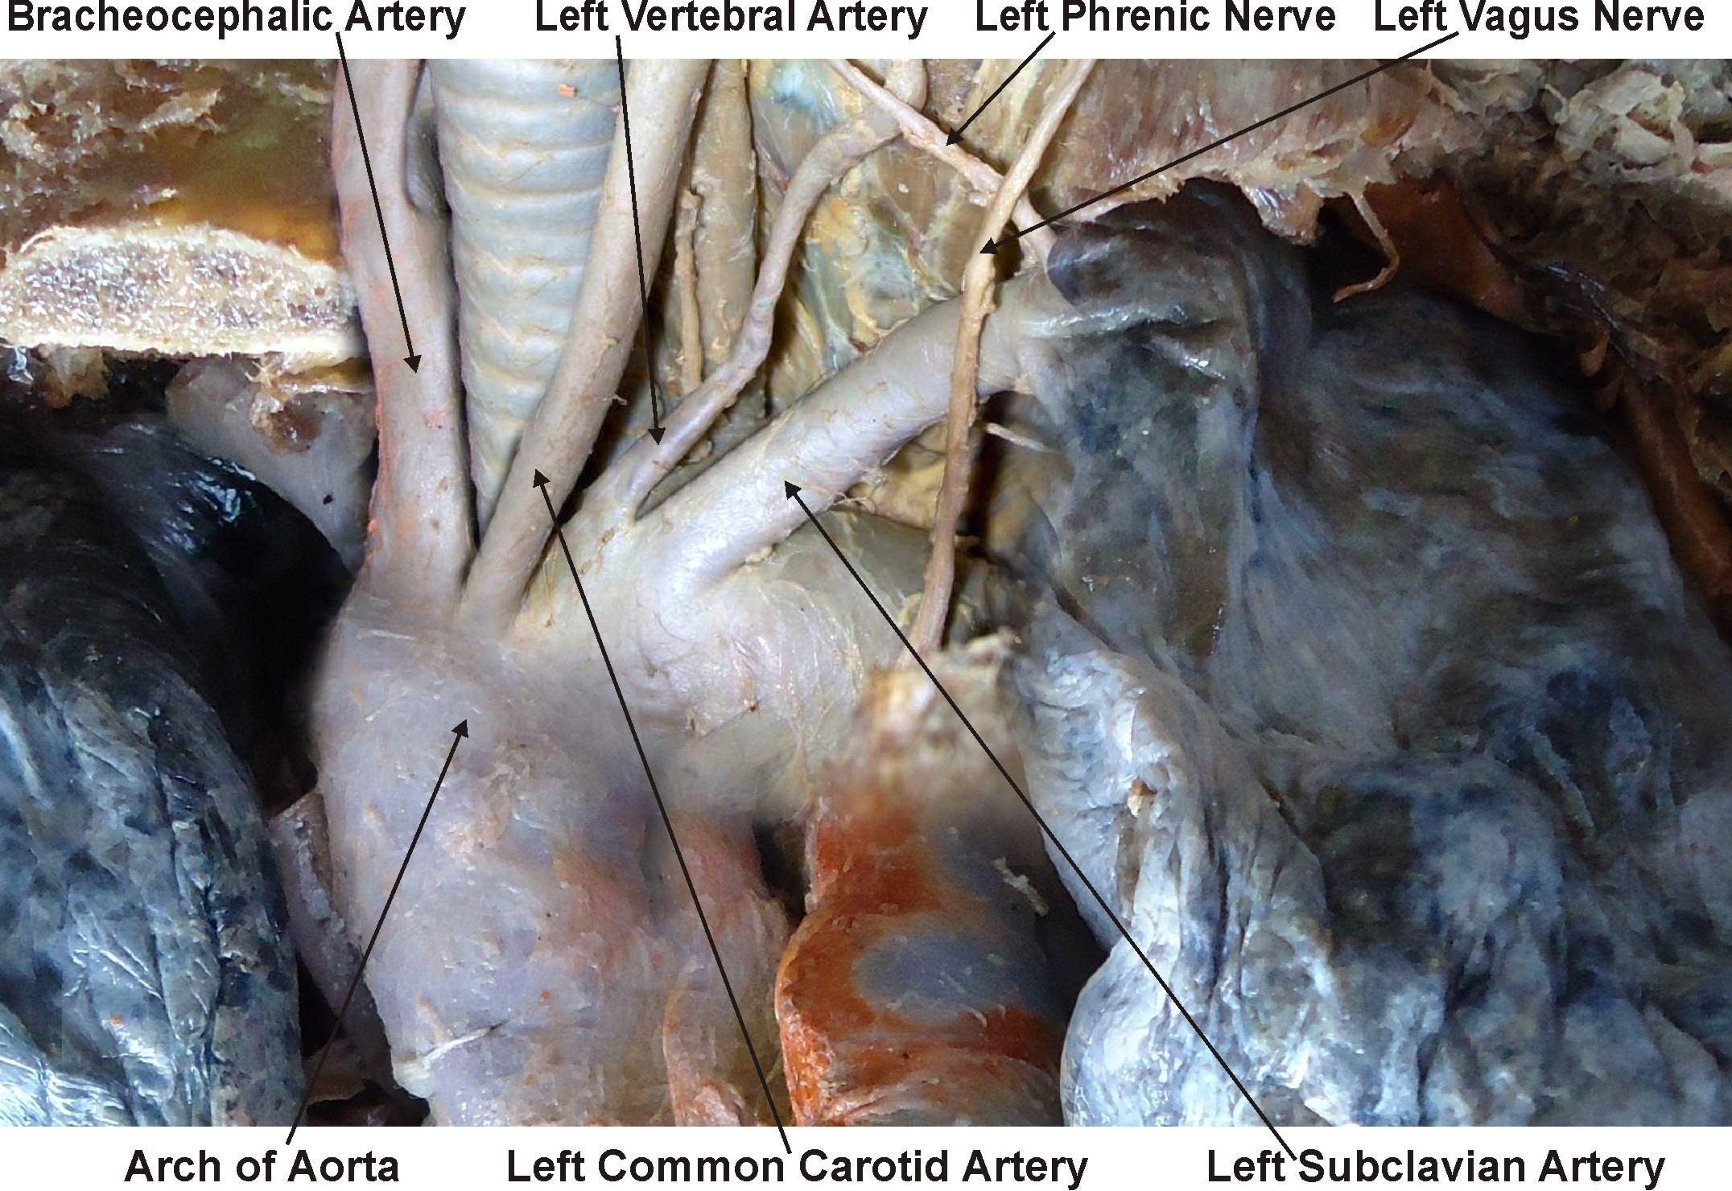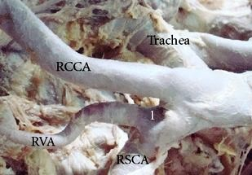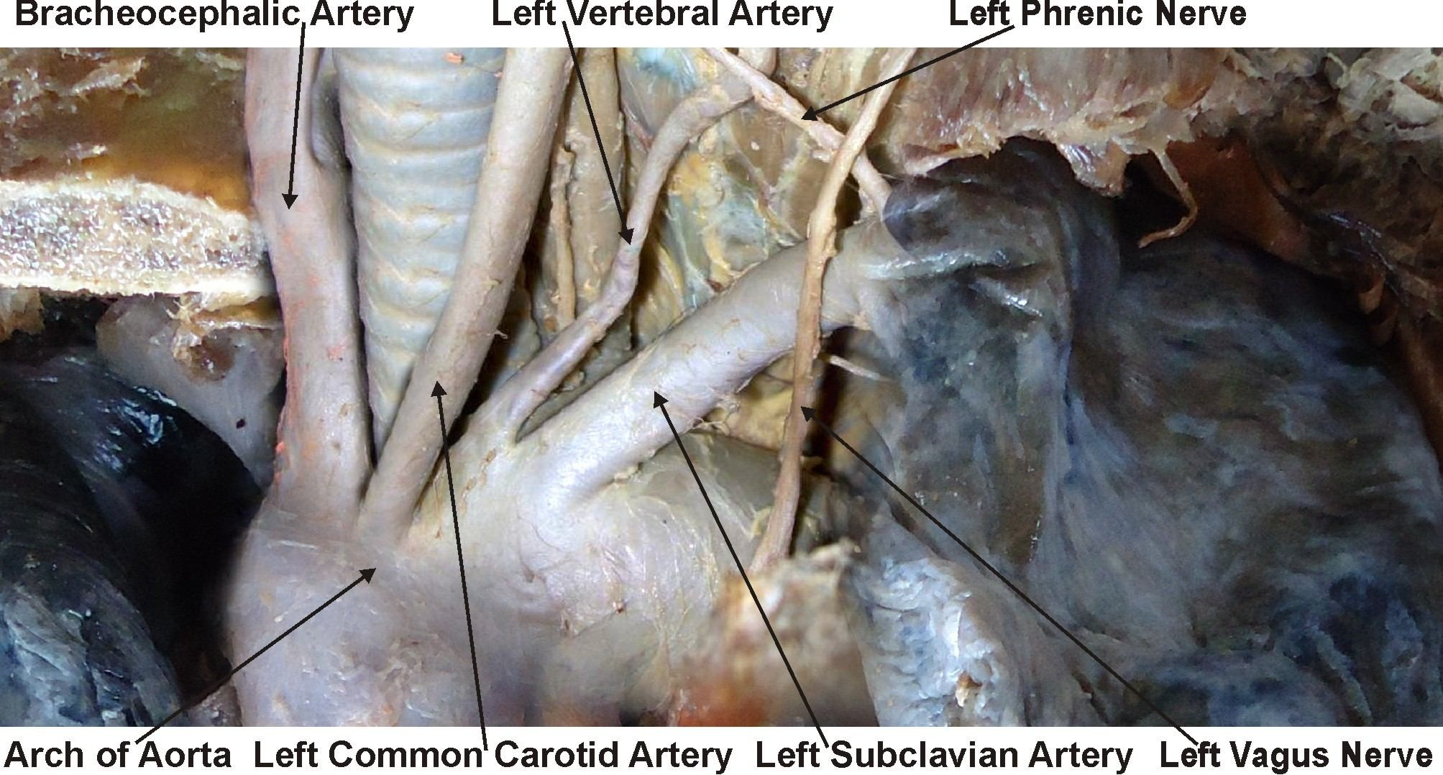

**Fig. 3:** showing the origin of Left Vertebral Artery from Arch of Aorta between Left Common Carotid and Left Sub- clavian Artery in third specimen.

**Fig. 4:** Showing the normal origin of Right Vertebral artery from Right Subclavian Artery.

# DISCUSSION

In approximately 6% of the population the left vertebral artery arises from the arch of aorta, usually between left common carotid and left

subclavian artery [3]. The left vertebral artery usually enters the sixth cervical foramina transversaria (88%), only in 5–7% cases the left vertebral artery will enter seventh or fifth cervical vertebra [4]. Nanthan & Seidal, 1993 had reported a left vertebral artery of aortic origin associated with retroesophageal right subclavian artery and thoracic duct terminating on right side, yet with normal origin of right ver- tebral artery [5]. Komiyana et al, (2001) reported the incidence of arterial dissection of the verte- bral artery of aortic origin and vertebral artery of subclavian origin [6]. According to their studies left vertebral artery of aortic origin was associated with a significantly higher incidence of vertebral artery dissection than left or right vertebral artery of subclavian origin. Earlier studies by Pasturet, 1958 had reported that left vertebral artery of <3.5 mm diameter may be considered hypoplastic [7].

A vertebral artery of aortic arch origin has been earlier described by different authors in the range of 3.1-8.3 % (Table I). Nevertheless, most authors have stated that it is about 2.5-3 %.

**Table 1:** Incidence of left vertebral artery of aortic arch origin [8].

|  |  |  |
| --- | --- | --- |
| **No.** | **Author (Year)** | **Incidence (%)** |
| 1 | Bean (1905) | 5.20% |
| 2 | Adachi (1928) | 5.40% |
| 3 | Aso (1932) | 3.20% |
| 4 | Mori (1941) | 6.90% |
| 5 | Stein et al. (1962) | 6% |
| 6 | Argenson et al. (1980) | 5.80% |
| 7 | Lippert Pab (1985) | 3.00% |
| 8 | Nizanowski et al. (1982) | 3.10% |
| 10 | Cavdar and Arisan (1989) | 8.30% |
| 11 | Takafuji and Sato (1991) | 6.90% |
| 12 | Vorster (1998) | 3.00% |
| 13 | Komiyama (2001) | 2.40% |
| 14 | Panicker et al. (2002) | 5% |
| 15 | Yamaki (2006) | 5.80% |

Origin point of the VA has also been reported from the thyrocervical trunk, from the brachio- cephalic trunk, from the common carotid artery, from the external carotid artery, from a trunk formed by LSA and LVA [11–15].

Gluncic reported the length of the prevertebral segment of the left vertebral artery originating from aortic arch as 87.3 mm and its diameter at

the origin as 3.3 mm [9]. Panicker reported the diameter of left vertebral artery at origin was

3.1 mm as compared to that of the right, which had a diameter of 6.5 mm at origin. The length of prevertebral segments of right vertebral artery was 38 mm and that of left vertebral artery was 92 mm [10]. Entry point of the LVA originating from the aortic arch, into the Fora- men transversarium was also reported variable. Most common entry points were reported as C5 and C6, respectively Overall, the most common entrance for vertebral arteries was at C6 [11].

Lippert Pab’s classified the LVA according to the origin from the aortic arch [8] as:

|  |  |  |
| --- | --- | --- |
| **Type** | **Incidence** | **Site of Origin** |
| Type A | 3% | between the LCCA and LSA |
| Type B | <1% | between a common trunk formed by BT and LCCA and LSA |
| Type C | <1% | after the LSA |
| Type D | <0,1% | after the LSA as the third branch |
| Type E | <0,1% | after a common trunk as the second branch |
| Type F | <0,1% | RSA appears from descending aorta |
| Type G | <1% | one of two roots as a penultimate branch |
| Type H | <0,1% | both VA branch from the aortic arch |

In the present study we got the origin of the vertebral artery from the arch of aorta in 6% of the specimens. This incidence was similar to the incidence found by Stein et al.in1962. It was more than incidence found by Bean, Adachi, Aso, Argenson et al, Lippert Pab, Nizanowski et al, Vorster et al, Komiyama, Panicker et al and Yamaki and less than found by Mori, Cavdar and Arisan and Takafuji and Sato.

**Embryological Basis:** Thirty or more branches of the dorsal aorta form the dorsal intersegmen- tal arteries. They originate from the branchial aortic system. In the neck, the cervical interseg- mental arteries unite to form a longitudinal artery on each side which develops into the vertebral artery. Most of the original links of the intersegmental arteries to the dorsal aorta disappear. Mostly the first part of vertebral artery develops from proximal part of dorsal branch of seventh cervical intersegmental artery proximal to postcostal anastomosis. The second part is derived from longitudinal communications of the postcostal anastomosis. Third part is from spinal branch of the first cervical intersegmental artery and fourth part is a continuation of third part [12].

In the present case, the left sixth dorsal inter- segmental artery may have persisted as the first part of vertebral artery hence left vertebral artery began from arch of aorta.

The left fourth aortic arch forms part of the arch of aorta. The proximal part of the arch develops from the aortic sac & the distal part from the left dorsal aorta. The left subclavian artery is not derived from aortic arch but from the left seventh intersegmental artery. As development proceeds, differential growth shifts the origin of the left subclavian artery cranially, subse- quently it comes to be positioned in close proximity to the origin of the left common carotid artery [13].

According to Vorster et al, 1998, there are two factors that control the development of the branches of subclavian artery [14]. First, ability of the blood to follow the longitudinal channels offering the least resistance and second, the tension on the vessels; resulting from the cau- dal shifting of the heart and aorta. The proximal parts of the segmental arteries are exposed to longitudinal tension and bending due to caudal shifting of the aorta resulting in retarded blood flow and abnormal connections between longi- tudinal channels (vertebral artery) and subcla- vian artery or aorta. Panicker et al. [10], conceded the views of Vorster et al. [20], and opined that a left vertebral artery of aortic arch origin may be because of persistence of dorsal division of left 6th intersegmental artery becom- ing the first part of vertebral artery instead of that of left 7th dorsal intersegmental artery.

Arey is of the view that the anomalous blood vessels may be due to (i) the choice of unusual paths in the primitive vascular plexus, (ii) the persistence of vessels normally obliterated, (iii) the disappearance of vessels normally retained,

(iv) incomplete development, and (v) fusions and absorption of the parts usually distinct [15].

**Clinical Significance:** A knowledge of a morpho- logical variation of the left vertebral artery is considerably important for all diagnostic and surgical procedures such as vascular angiogra- phies and arterial dissection as well as all non-invasive procedures in the head and neck region [16]. Anomalous Vertebral Artery origin also represents a potential pitfall in diagnostic cerebrovascular injury [17].

An incomplete knowledge can result in compli- cations. The extracranial portion of Vertebral Artery is frequently affected from atherosclero- sis [18] and according to Fischer et al the most common site of the resultant stenosis is at its origin from subclavian artery [19]. According to Bernardi and Detori, the unusual origin of the Vertebral Artery ‘‘may favor cerebral disorders because of alterations in the cerebral haemodynamics’’[20]. According to the litera- ture, most patients with morphological variation of the left vertebral artery are clinically asymp- tomatic. Though the overall occurrence of anomalous origin of prevertebral segment of vertebral artery is low, it is of clinical importance to identify the origin and course of the prevertebral segment of the vertebral artery in detail so as to prevent complications [10]. Preceding any medical procedures it is vital to gauge vascularisation of the region. The most significant benefit of detecting potential left vertebral artery origin variants is diagnostic im- provements before vascular surgeries of supra aortic arteries. The knowledge is essential for planning aortic arch surgery or endovascular interventions [21]. It is also of great conse- quence for assessing vertebro-basilar insuffi- ciency thought to be due to atherosclerosis, and during cannulation of vertebral artery for endovascular procedures. Vitte et al. stressed to keep the variant origin of vertebral artery in mind during its manual compression which is used routinely for positional haemodynamic vertebro-basilar insufficiency [22].

# CONCLUSION

In approximately 6% of the population the left vertebral artery arises from the arch of aorta, usually between left common carotid and left subclavian artery. The left vertebral artery usually enters the sixth cervical foramina transversaria (88%), It occurs due to persistence of the left sixth dorsal intersegmental artery as the first part of vertebral artery, hence the aortic origin. A variant origin of vertebral artery of this kind may favor cerebral disorders because of alterations in cerebral haemodyna- mics. It is important to be aware of this rare variation in the origin and course of left verte- bral artery as it might have serious implication in surgical and angiographic procedures. The

knowledge is necessary and beneficial for planning aortic arch surgery or endovascular interventions.

# REFERENCES

[1]. Moore KL, Dalley AF. Clinically Oriented Anatomy. 4th Ed., Philadelphia-Baltimore-New York- LondonBuenos Aires-Hong Kong-Sydney-Tokyo: Lippincott Williams & Wilkins. 1999;893–894.

[2]. Hollinshead WH. Arteries: The Neck. In: Anatomy for Surgeons. Vol. I, The Head & Neck. New York, Paul B Hoeber, Inc, Medical Book Department of Harpers & Brothers. 1954;467–474.

[3]. Koenigsberg RA, Pereira L, Nair B, McCormick D, Schwartzman R. Unusual vertebral artery origins: examples and related pathology. Catheter Cardiovasc Interv. 2003;59:244–250.

[4]. Kubikova E, Osvaldova M, Mizerakova P, El Falougy H, Benuska J. A variable origin of the vertebral ar- tery. Bratisl Lek Listy. 2008;109:28–30.

[5]. Nathan H, Seidel MR. The association of a retroesophageal right subclavian artery, a right- sided terminating thoracic duct, and a left verte- bral artery of aortic origin: anatomical and clini- cal considerations. Acta Anat (Basel). 1983;117:362–373.

[6]. Komiyana, M., Morikawa, T., Nakajiman, H., Nishikawa, M. and Yasui, T. High incidence of arte- rial dissection associated with left vertebral artery of aortic origin. Neurology Medical Chir (To- kyo)2001;41(1):8-11.

[7]. Pasturet, G. Traite’d anatomic humaine: appareil circutoire (tome II, fasciula 1). Paris: Massm, 1958;387-394.

[8]. Lippert H, Pabst R. Arterial Variations in Man. Clas- sification and Frequency. JF Bergmann Verlag, Munchen. 1985;30–38.

[9]. Gluncic V, Ivkic G, Marin D, Percac S. Anomalous origin of both vertebral arteries. Clin Anat. 1999;12:281–284.

[10]. Panicker HK, Tarnekar A, Dhawane V, Ghosh SK. Anomalous origin of left vertebral artery – embryo- logical basis and applied aspects – A case report. J Anat. Soc. India. 2002;51:234–235.

[11]. Nayak SR, Pai MM, Prabhu LV, D’Costa S, Shetty P. Anatomical organization of aortic arch variations in the India: embryological basis and review. J Vasc Bras. 2006;5:95–100.

[12]. Keibel FN, Mall FP. Development of the vascular sys- tem. In: Manual of Human Embryology. Vol II, Phila- delphia and London, J. B. Lippincott Company. 1912;659–667.

[13]. Congdon ED. Transformation of the aortic arch sys- tem during during the development of human em- bryo. Contrib Embryol Carnegie Inst. 1922;68:47– 110.

[14]. Vorster W, Du Plooy PT, Meiring JH. Abnormal origin of internal thoracic and vertebral arteries. Clin Anat. 1998;11:33–37.

[15]. Arey LB. Development of arteries. The vascular sys- tem. In: Developmental Anatomy. A Textbook and Laboratory Manual of Embryology. 6th Ed., Phila- delphia and London, WB Saunders Company. 1957;367–373.

[16]. Stein BM, McCormick WF, Rodriguez JN, Taveras JM. Postmortom angiography of cerebral vascular sys- tem. Arch Neurol. 1962;7:545–559.

[17]. Goray VB, Joshi AR, Garg A, Merchant S, Yadav B, Maheshwari P. Aortic arch variation: a unique case with anomalous origin of both vertebral arteries as additional branches of the aortic arch distal to left subclavian artery. AJNR Am J Neuroradiol. 2005;26: 93–95.

[18]. Vicko, G., Goran, I., Damjan, M. and Sanja, P. Anoma- lous origin of both vertebral arteries. Clinical Anatomy 1999;12:281-284.

[19]. Fisher CM, Gore I, Obake N, White PD. Atherosclero- sis of the carotid and arteries – extracranial and intracranial. J Neuropathol Exp Neurol 1965; 24: 244-245.

[20]. Bernardi L, Dettori P. Angiographic study of a rare anomalous origin of the vertebral artery. Neuroradiology. 1975;9:43–47.

[21]. Vitte E, Feron JM, Guerin-Surville H, Koskas F. Ana- tomical study of digital compression of the verte- bral artery at its origin at the suboccipital triangle. Anat Clin. 1985;7:77–82.

[22]. Yazar F, Yalcin B, Ozan H. Variation of the aortic arch branches: Two main trunks originating from the aortic arch. Gazi Medical Journal, 2003;14:181–184.