**State of knowledge of the entomofauna of some resinous species of the Traras Mountains (North West Algeria)**

**Abstract**

As part of the biocenotic study of insects related to coniferous species in the Western Traras region (Tlemcen), as complete a knowledge as possible of the entomofauna frequenting in particular the Aleppo pine (Pinus halepensis Mill), the Barbary Thuja (Tetraclinis articulata (Vahl) Master) and the Green Cypress (Cupressus sempervirens L) is essential. The different methods of capturing insects used have allowed us to collect a significant number of species, and a large number remain unknown. These species are divided into 10 systematic orders, the most important of which are Coleoptera, Hymenoptera and Lepidoptera. Through this list of insects and according to their feeding habits, we have discerned 6 diets to which these species belong. The most representative are defoliators, auxiliaries and xylophages. This inventory allowed us to draw up a list of insects harmful to the coniferous species studied in the region. They total 30 species including 9 defoliators, 8 xylophagous, 7 conobiantes, 5 opophagous and one gall-eating species. The auxiliaries are represented by 26 species.

**Keywords**: resinous species, Aleppo pine, Barbary thuja, green cypress, inventory, entomofauna, Western Traras (Tlemcen).

1. **INTRODUCTION**

The forest represents an integral and main element of the life of the planet, of the environment, a valuable genetic reservoir and a source of appreciable income. In this context, it must be managed and developed with the aim of ensuring the sustainability of social and economic well-being, (Anonymous, 2009).

Ecological balance, environmental protection, desertification and sustainable development have become vital issues, when we know that the forest has been considered by many as an inequitable source of wood. This environment has been thoughtlessly cleared by man, which has led to harmful consequences on the loss of biodiversity and the destruction of the balance of existing trophic chains.

In addition to this irrational exploitation, there are numerous problems posed to the forest economy worldwide by the very high level of harmfulness of insect pests. This is why the fight against forest pests requires knowledge of forest entomology, a science that many researchers are currently interested in (Abgrall and Soutrenon, 1991; Dumerle, 1991).

The coniferous forests that are the subject of our study, *Pinus halepensis* Mill, T*etraclinis articulata* (Vahl) Master and *Cupressus sempervirens* L have been experiencing significant phytosanitary problems for several years. It is obvious that the causal factor is the lack of appropriate silviculture and non-compliance with reforestation methods. In this type of forest, insect pests are the main sources of forest disturbance (Khous and Gachi, 1996).

However, inventories have evolved and detection, monitoring and control work now focuses on insects whose economic or social impact is recognized.

Carrying out a good inventory is fundamental not only to understand the diversity and state of health of a forest, but also to be able to understand the functioning and complexity of the interactions between organisms in the forest ecosystem.

Some insect species can have abundant infestations and cause significant damage. It was essential to carry out, in a minimum period of time, a study as precise as possible, to highlight the potentially harmful species in this region (Khous, 1992).

For this reason, this present work carried out for the first time in this region has a double aim: on the one hand, to draw up a first list concerning the entomofauna of conifers and on the other hand, to have an idea of ​​the main pests of these precious species.

1. **MATERIALS AND METHODS**

**2. 1. Choice of stations**

Our choice is to take three experimental stations (Fig.1). This choice was made after a broader prospection of the forest massif of the study area taking into account the following points: the accessibility of the stations, the intensity of the attack, the exposure, the altitude, the topography and all the possibilities of climatic variations that influence the development of the insect will be considered.

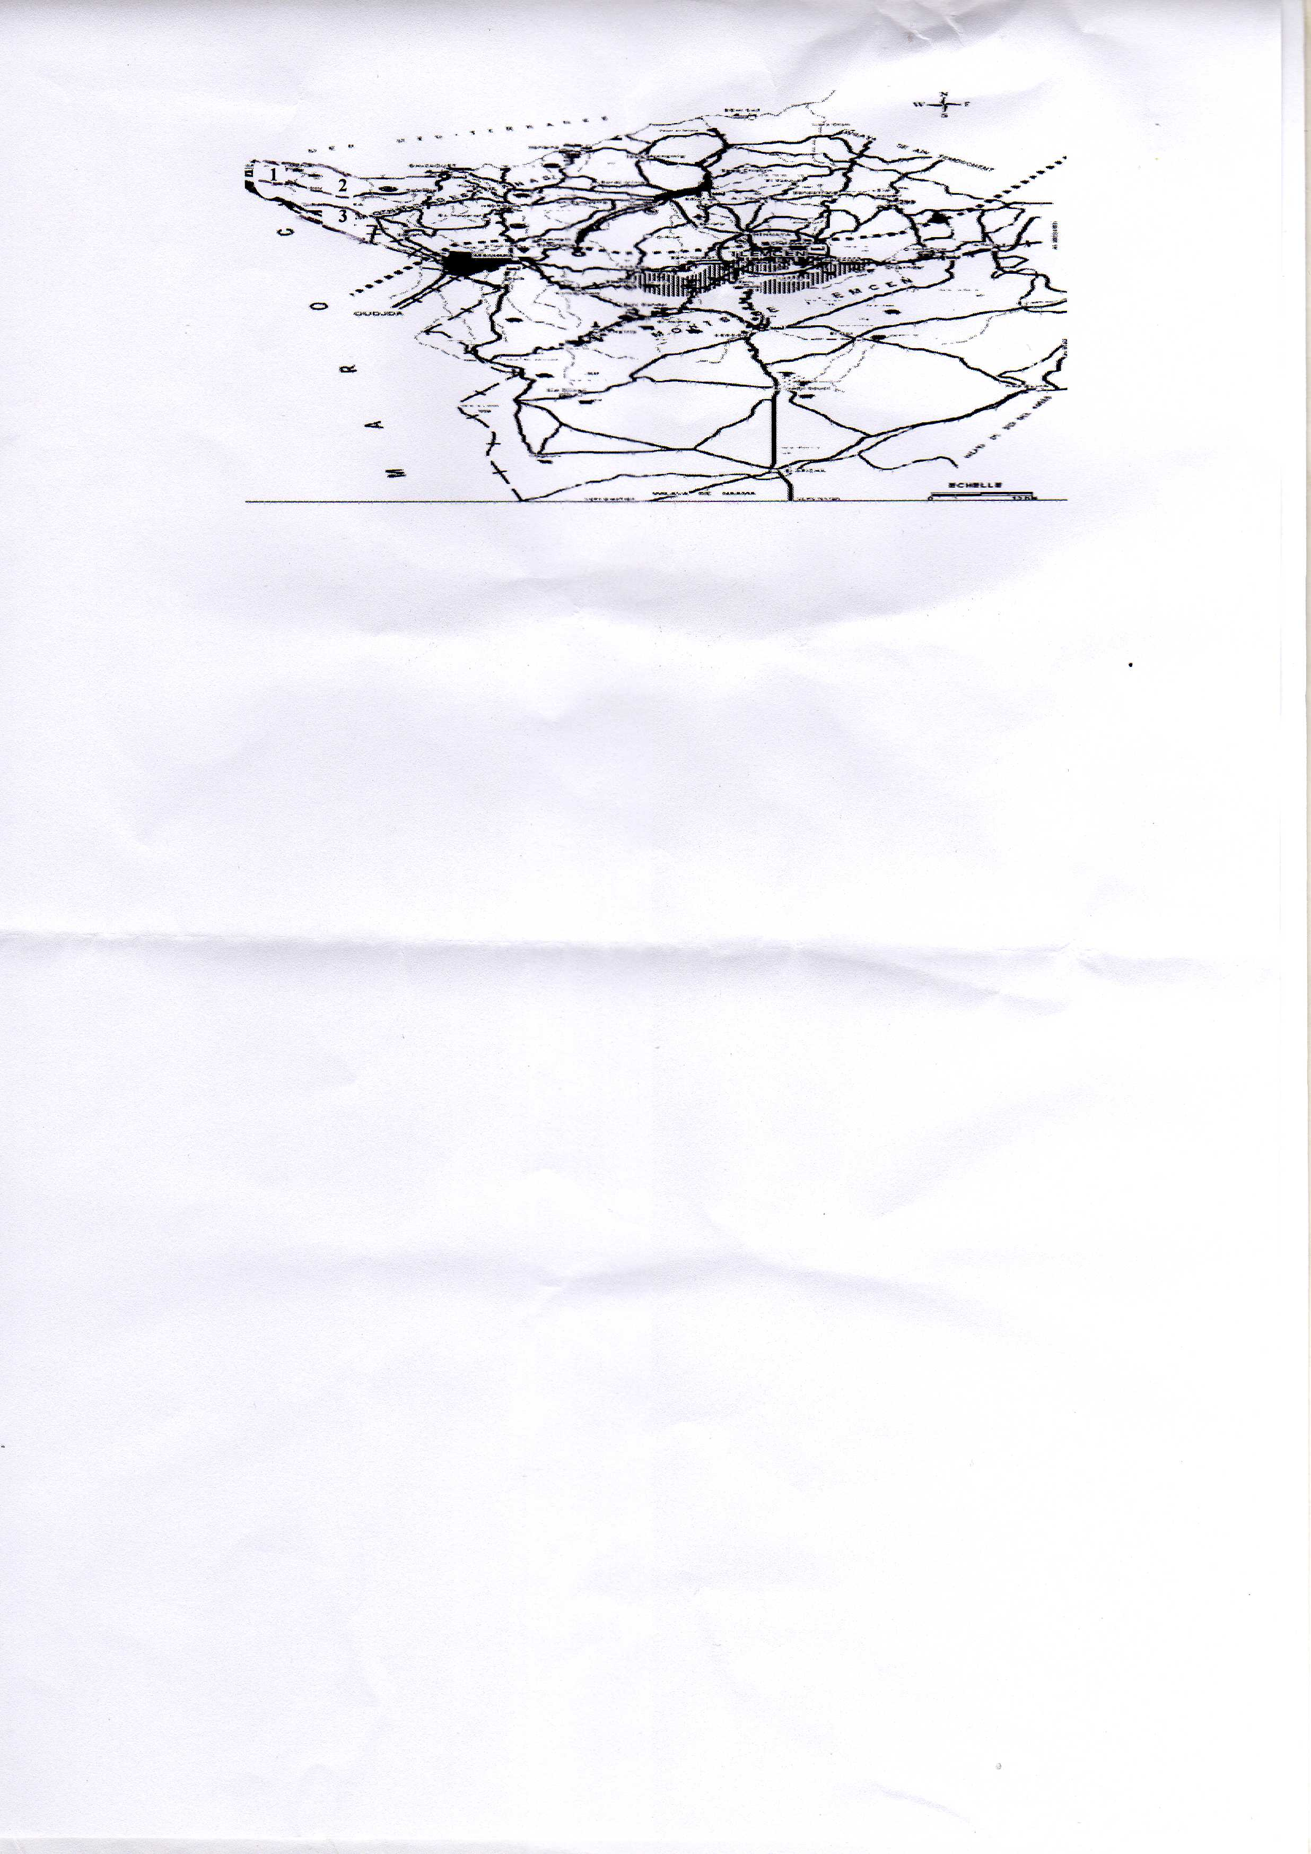

**Figure 1:** *Location of the three study stations (1, 2, 3) in the wilaya of Tlemcen*,

(Anonymous, 2006).

***Station 01***

The place called "Tamarchalet", a massif which is part of the commune of Marsa Ben M'hidi. It is located to the north-east of the capital of the commune. The forest massif has an area of ​​around332 ha. The station is located on a hilly terrain with a slope of 25% exposed to the north slope with an altitude of 100m. The forest is characterized by a Mediterranean type climate, semi-arid cool. Annual precipitation does not exceed 350 mm/year, Extreme temperatures vary from10°Chas32°C, the prevailing winds are generally from the northeast to northwest and from the west to southwest, (Anonymous, 2006).

The station is characterized by a soil composed mainly of marls and clays which promote runoff and consequently cause water erosion (sheet erosion) and wind erosion on the summits, (Anonymous, 2003). It is characterized by the monospecificity of the plantation which is composed of Aleppo pine (100%), hence the intensity of the attack is around 65%. There are also some species of the herbaceous layer such as *Calycotome intermedia*, *Chamoerops humilis*, *Juneperus phoenicia*, *Erica multiflora*, *Lavandula dentata*, *Ampelodesma mauritanica* etc.

***Station 02***

The place called "Tarasmouth" is part of the commune of Souk Tleta. The station is located northwest of the main town of the commune. The area of ​​the forest is estimated at503 ha, it is located on very uneven terrain with a slope greater than 25%. The characteristic climate of the massif is Mediterranean, quite cold and rainy in winter, dry and hot in summer. It is favored by the maritime influence which allows the practice of certain particular agricultural speculations, (Anonymous, 2006). The average minimum temperature is 10°c in winter, in summer the average maximum temperature varies between20°CAnd30°C. The average annual precipitation recorded varies between 300 and 400mm. Frosts are very rare. The prevailing winds are generally from the northwest, (Anonymous, 2006). The soils are generally represented by the Solonetz types (clay-marl), their texture formed at the expense of the salt marls is very heavy. It swells when humid and gives large cracks when drying. The latter allow water to circulate deeply and cause risks of water erosion and landslides, (Bouchenafa, 1995). The characteristic vegetation of the station is mixed with two main forest species; Aleppo pine (50%) and Thuja (50%) from which the intensity of the attack is of the order of 45 to 50%. We also find *Chamaerops humilis*, *Lavendula dentata*, *Ampelodesma mauritanica* etc.

***Station 03***

The station is located in the commune of M'sirda Fouaga. The population is generated by a Mediterranean climate, semi-arid characterized by a mild winter and a moderately hot summer. The temperatures recorded at the station are between 12°C for the cold months (December-January) and30°Cfor the hot months (July – August). Precipitation is around 300 to 350 mm/year. The prevailing winds are winds coming from the north, which cause damage; the degradation of plantations. The station is based on a clayey limestone soil, with a slope of more than 25%, which causes a remarkable risk of erosion, (Anonymous, 2006). It is characterized by a mixture of species; Aleppo pine and Cypress. This is a stand resulting from reforestation which allows the soil to be fixed as a windbreak. The station is also characterized by other genera of the herbaceous layer such as the genera *Chamaerops*, *Juneperus* etc with an attack rate of 50 to 60%.

The second stage involves carrying out an entomological inventory, using various insect harvesting techniques (collecting leafy branches, collecting cones, sight hunting, sweep net, Japanese umbrella, bark stripping, aerial trap, Barber trap, yellow bin).

All insects collected during these operations were brought back to the Forest Zoology laboratory (Agro-Forestry Department) for identification, others using certain documentation (Paul, 1953), (Balachowsky, 1962), (Moucha, 1972), (Reichholf-Riehm, 1984), (Chinery, 1983), (Pihan, 1986), (Mathys, 1988).

**3. RESULTS AND DISCUSSION**

Using different capture methods allowed us to collect 78 species of insects grouped in the table below (Table 1).

**Table 1:** *List of species recorded in the study area*

|  |  |  |  |  |  |
| --- | --- | --- | --- | --- | --- |
| **Order** | **Family** | **Species** | **Diet** | **Host plant** | **Abundance** |
| Orthoptera | Gryllidae | *Grylus campestris* | Defoliator | *P halepensis* | ++ |
| Blattoidea | Blattidae | *Blattella sp* | Predator | *P halepensis* | ++ |
| *Laboptera sp* | Defoliator | *C sempervirens* | ++ |
| Mantodea | Mantidae | *Mantis religiosa* | Predator | *P halepensis* | ++ |
| Dermaptera | Forficulidae | *Forficula auricularia* | Predator | *P halepensis* | +++ |
| *Forficula*sp 2 | Predator | *T articulata* | +++ |
| *Forficula*sp 3 | Predator | *C sempervirens* | +++ |
| Hemiptera | Lygaeidae | *Nysius cynoides* | Opophagus | *C sempervirens* | N++ |
| *Orsillus maculatus* | Conobiante | *C sempervirens* | N++ |
| Anthacoridae | *Elatophilus*sp | Defoliator | *P halepensis* | N++ |
| Aphididae | *Elatobium*sp | Opophagus | *P halepensis* | N++ |
| *Cinara cupressi* | Opophagus | *C sempervirens* | N++ |
| *Cedrobium laportei* | Opophagus | *C sempervirens* | N++ |
| Diaspididae | *Carulaspis minima* | Conobiante | *C sempervirens* | N++ |
| Cicadea | *Cicada*sp | Opophagus | *P halepensis* | N++ |
| Neuroptera | Chrysopidae | *Chrysopa vulgaris* | Predator | *P halepensis* | ++ |
| Coleoptera | Curculionidae | *Rhyncolus*sp | Xylophagous | *P halepensis* | + |
| *Tomicus piniperda* | Xylophagous | *P halepensis* | N++ + |
| *Pityogenes*sp | Xylophagous | *P halepensis* | N + |
| *Tomicus destruens* | Xylophagous | *P halepensis* | N +++ |
| *Pityogenes bidentatus* | Xylophagous | *P halepensis* | N + |
| *Orthotomicus erosus* | Xylophagous | *P halepensis* | N +++ |
| *Hylurgus*sp | Xylophagous | *P halepensis* | + |
| *Hylastes*sp | Xylophagous | *P halepensis* | + |
| *Curculio*sp | Conobiante | *P halepensis* | N++ |
| *Hylobius*sp | Xylophagous | *P halepensis* | + |
| Nanophyidae | *Nanodiscus transversus* | Conobiante | *C sempervirens* | N++ |
| Buprestidae | *Scintillatrix rutilans* | Xylophagous | *T articulata* | N +++ |
| *Anthaxia*sp | Xylophagous | *C sempervirens* | N +++ |
| *Habroloma*sp | Defoliator | *T articulata* | ++ |
| *Chalcophora mariana* | Xylophagous | *P halepensis* | N++ |
| Anabidae | *Ernobium*sp | Defoliator | *P halepensis* | N++ |
| Coccinellidae | *Harmonia lyncea* | Predator | *P halepensis* | + |
| *Cocinella algerica* | Predator | *P halepensis* | ++ |
| *Scymnus*sp | Predator | *T articulata* | ++ |
| *Ladybug*sp | Predator | *T articulata* | + |
| Carabidae | *Carabus violaceus* | Predator | *P halepensis* | + |
| *Carabus*sp | Predator | *P halepensis* | +++ |
| Scarabaeidae | *Scarabaeus*sp | Xylophagous | *T articulata* | ++ |
| Cerambycidae | *Icosium*sp | Xylophagous | *T articulata* | ++ |
| Tenebrionidae | *Scaraurus*sp | Xylophagous | *T articulata* | + |
| *Corticeus*sp | Predator | *T articulata* | ++ |
| *Tenebrio obscurus* | Xylophagous | *T articulata* | + |
| *Tenebrio*sp | Xylophagous | *T articulata* | ++ |
| *Akis*sp | Predator | *P halepensis* | + |
| *Pimelia servillei* | Predator | *T articulata* | ++ |
| Hymenoptera | Vespidae | *Vespa germanica* | Parasite | *P halepensis* | ++ |
| Ichneumonidae | *Scambus*sp | Parasite | *P halepensis* | + |
| *Ichneumon*sp | Parasite | *P halepensis* | ++ |
| Torymidae | *Megastigmus wachtli* | Conobiante | *C sempervirens* | N++ |
| Apidae | *Apis*sp | Defoliator | *P halepensis* | ++ |
| *Apis milifera* | Defoliator | *T articulata* | ++ |
| Diprionidae | *Pini sawfly* | Defoliator | *P halepensis* | N++ |
| Formicidae | *Formica*sp 2 | Predator | *T articulata* | +++ |
| *Crematogaster scutellaris* | Defoliator | *P halepensis* | +++ |
| *Formica*sp 3 | Predator | *C sempervirens* | +++ |
| *Aphaenogater senilisant* | Predator | *P halepensis* | + |
| *Cataglyphis bicolor* | Defoliator | *P halepensis* | ++ |
| *Formica*sp 1 | Predator | *P halepensis* | +++ |
| Lepidoptera | Thaumetopoidae | *Thaumetpoea pityocampa* | Defoliator | *P halepensis* | N +++ |
| Pyralidae | *Dioryctria mendacella* | Conobiante | *P halepensis* | N + |
| *Dioryctria*sp | Defoliator | *C sempervirens* | N++ |
| Tortricidae | *Rhyacionia buoliana* | Defoliator | *P halepensis* | N +++ |
| *Pseudococcyx tessulatana* | Conobiante | *C sempervirens* | N++ |
| *Blasthostera*sp | Defoliator | *P halepensis* | N + |
| Papilionidae | *Iphiclides podalirius* | Defoliator | *P halepensis* | + |
| *Papilio manchaon* | Defoliator | *C sempervirens* | +++ |
| Sphingidae | *Hyles livornica* | Defoliator | *P halepensis* | ++ |
| *Sphinx maurorum* | Defoliator | *P halepensis* | N++ |
| Noctuidae | *Euclia adulatrix* | Defoliator | *P halepensis* | + |
| Ponomeutidae | *Argyresthia*sp | Defoliator | *T articulata* | N +++ |
| Diptera | Tachinidae | *Phryx*sp | Parasite | *P halepensis* | ++ |
| *Compsilura*sp | Parasite | *P halepensis* | + |
| *Actia nudibasis* | Parasite | *P halepensis* | + |
| Cecidomyidae | *Cecidomyia*sp | Gallicole | *P halepensis* | N++ |
| Agromyzidae | *Agromyza*sp | Defoliator | *T articulata* | +++ |
| *Napomyza gymnostona* | Defoliator | *P halepensis* | ++ |
| Syrphidae | *Xanthandrus*sp | Predator | *P halepensis* | + |

+++: Very abundant species; ++: Abundant species; +: Not very abundant species.; N: Harmful species.

The measured abundance is the relative abundance (Ar) of the species which is expressed as a percentage; is the number of individuals of a species compared to the total number of individuals. To differentiate this we took a calculation scale for our study as follows:

A species is very abundant if Ar > 5%

A species is abundant if 2 < Ar < 5%

A species is low in abundance if Ar < 2%

Harmfulness is estimated by the volume of damage to the host plant (defoliation, insect penetration holes in bark, etc.)

Table 1 shows that the insects inventoried number 78 species divided into 10 orders, the most representative of which are Coleoptera, Hymenoptera and Lepidoptera (Fig. 2)

**Figure 2:** *Distribution of entomofauna according to systematic position*

According to diet, species are divided into 6 categories (Fig. 3).

Figure 3. Distribution of entomofauna according to diet

**Figure 3:** *Distribution of entomofauna according to diet*

Auxiliaries are the most dominant with 26 species including 20 predators and 6 parasites, i.e. a rate of 33%.

Defoliating insects come second with 22 species, or a rate of 29%.

Wood consumers rank third with 17 species, a rate of 22%.

The conobiantes that attack the cones of the host plant are represented by 7 species, i.e. a rate of 9%.

Opophages are important because by sucking the sap, they burn the leaves causing the tree to wilt. They are present with 5 species, or a rate of 6%.

Gall-eating insects that cause the formation of galls on leaves or branches are present with a single species of the Cecidomyidae family (Cecidomyia sp) associated with the Aleppo pine.

According to their economic importance, the insects recorded are classified into three categories: harmful or ravaging insects (30 sp), auxiliaries (26 sp) and indifferent (22 sp) (Fig. 4).

**Figure 4: Distribution of entomofauna according to economic importance**

Concerning the harmful entomofauna of the coniferous species of our region (Fig. 5).

**Figure 5:** *Distribution of harmful entomofauna according to diet*

There are 9 defoliating species, the most important of which are Thaumetpoea pityocampa Denis and Schiff, Rhyacionia buoliana Schiff, Diprion pini L and an unidentified species of the genus Argyresthia. Xylophages include 8 species, such as Tomicus piniperda L, Scintillatrix rutilans Fabricius and 3 unidentified species of the genera Anthaxia, Icossium and Tenebrio. The cones are attacked by 7 insects belonging to the orders Hemiptera, Lepidoptera, Hymenoptera and Coleoptera. Sap-sucking insects are highlighted in our inventory by 5 species represented by the families Lygaeidae, Aphididae and Cicadae. Finally, insects that cause the formation of galls with a single species (Cecidomyia sp). Auxiliaries are present with 26 species.

Taking the overall list of insects inventoried in the region, we see that the most important order remains that of Coleoptera. The genera Tomicus and Pityogenes are present with two species including T. piniperda L and T. destruens Wolaston, P. bidentatus Herbst and Pityogenes sp. These species have already been highlighted on the Aleppo pine in Djelfa as being real pests.

Regarding Buprestidae, we captured 2 xylophagous species Scintillatrix rutilans Fabricius (on thuja) and Anthaxia sp (on cypress). According to the forest services of the region, these two species are highlighted for the first time in our study area.

Hymenoptera occupy the second rank in the inventory. Formicidae with 6 species and Ichneumonidae with 2 species are the best represented in our inventory. Apidae with 2 species generally grouping defoliators harmful to the host plant.

Lepidoptera occupy the third rank. Thaumetopoea pityocampa Denis and Schiff (Aleppo pine), Argyresthia sp (on Thuja) and, Orsillus maculatus Fieber and Nysius cynoides Spinola (on Cypress) remain first-rate pests at the regional level.

The other orders are poorly represented in our inventory. This is due either to capture methods not well adapted to this group of insects, or to the low specific diversity in the ecosystem.

On the Aleppo pine, we have identified 48 species divided into 9 orders, 17 of which are Coleoptera, 9 Hymenoptera and 8 Lepidoptera. In comparison with other inventories carried out in Algeria or elsewhere and in other ecosystems, Roques (1983) established a significant list concerning insect pests of cones and seeds in France; Kerris (1987) estimated the damage caused by Rhyacionia buoliana Schiff in Algeria. Zemmouri (1991) inventoried a significant entomofauna of the Aleppo pine in the Bainem forest (Algiers) divided between Coleoptera and Lepidoptera; Maatoug (1992) estimated the damage caused by the pine processionary moth in the Nador forest (Tiaret). Two species of the genus Thaumetopoea have been treated in Lebanon, namely Thaumetopoea libanotica Kiriakiff and Talhouk and Thuametopoea wilkinsoni S. These are serious pests of the Cedar of Lebanon, Cedrus libani, (Tohme, 1982; Tohme and Hossari, 1993). Nichane (1996) listed in a bibliographic study 160 species divided between 47 Coleoptera, 45 Hymenoptera and 37 Lepidoptera. Bouragba (2002) studied two species causing the decline of the Aleppo pine in the Senalba Chergui forest (Djelfa), namely Orthotomicus erosus Wollaston and Tomicus piniperda L. Chakali (2005) highlighted a formidable pest of pines in a semi-arid zone (Algeria), namely Tomicus destruens Wollaston.

These works mentioned above clearly show that on the Aleppo pine, the Coleoptera and the Lepidoptera remain the most important orders.

On the Thuja, 3 species cause considerable damage in Tunisia, (Belahbib, 2004; Benjamaa, 2004; Benjamaa, 2005) even in Morocco, (Arahou, 1982; el Hassani Et Messoudi, 1987) including one species absent in our inventory (Phloeosinus aubei L), the other 2 are Scintillatrix rutilans Fabricius and Icosium tomentosum Lucas, hence the Scintillante is considered as a new species at the level of the study area.

On the Cypress, Bouaziz (1993) and Bouaziz and Chakali (1998) highlighted 5 species on the cones of the Cypress in Algeria (Nanodiscus transversus Aubé, Brachyacma oxycedrella Millière, Orsillus maculatus Fieber, Orsillus depressus Dallas, Carulaspis minima Targioni and Tozzetti), one species was established by Roques (1998) in the south-east of Europe and which is absent in our inventory (Orsillus depressus Dallas), 3 species considered new to the study area (Pseudococcys tessulatana Staudinger, Nysius cynoides Spinola and Megastigmus wachtli Seitner), 3 species evolve on the Cypress in Tunisia (BENJAMAA and ROQUES, 1999) namely N.transversus Aubé, O.maculatus Fieber and O.depressus Dallas. EL HASSANI (1984) and EL ALAOUI (1999) identified 6 species growing on the cones of the Cypress in Morocco, 2 of which are absent from our inventory (Megastigmus atlanticus Roques et Slk and Orsillus depressus Dallas).

Regarding the spatial distribution of entomofauna, the most common statistical method AFC is used.

The AFC is performed on a raw data matrix (species/stations) representing species by their presence, absence and dominance. These variables were introduced in the form of codes using STATISTICA software (Fig. 6).

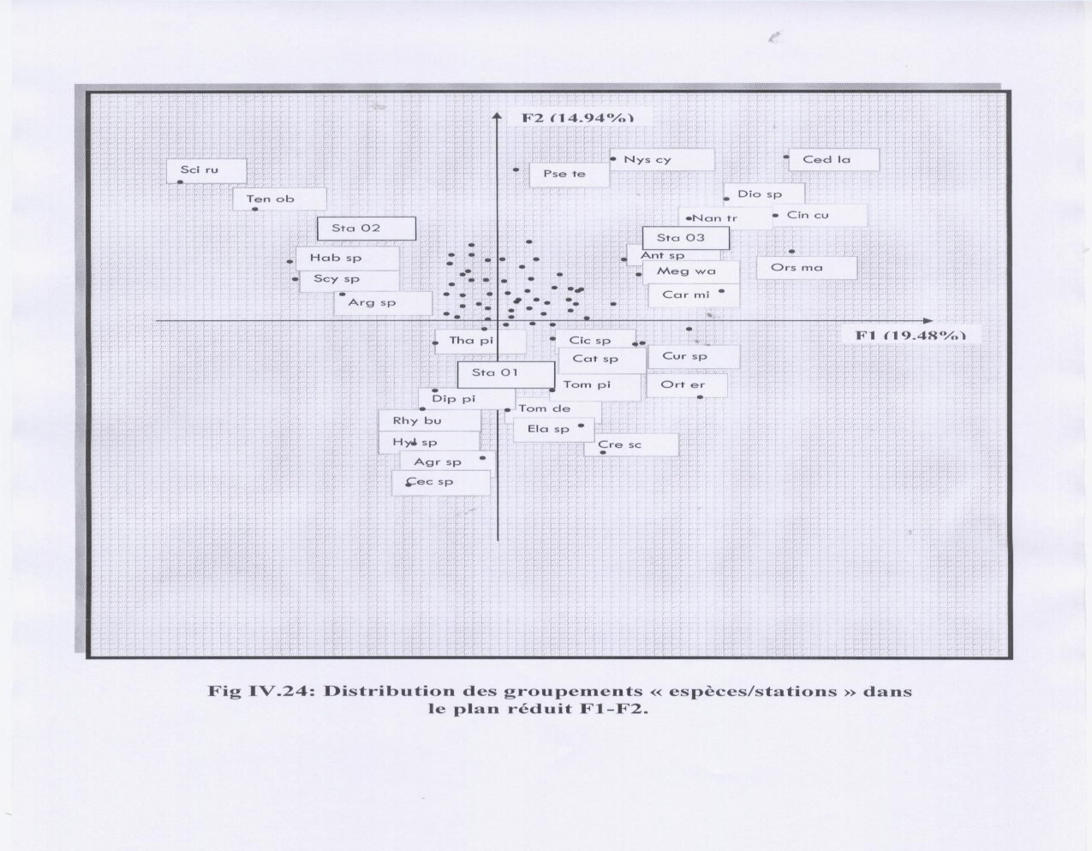

**Figure 6:** *Distribution of “species/station” groupings in the F1-F2 plan*

**Table 2:** *Eigenvalues ​​and inertia rates for the first 4 factorial axes*

|  |  |  |  |
| --- | --- | --- | --- |
| **Axis** | **Eigenvalue** | **Inertia rate (%)** | **Cumulative inertia (%)** |
| 1 | 0.85 | 19.48 | 19.48 |
| 2 | 0.79 | 14.94 | 34.42 |
| 3 | 0.66 | 10.92 | 45.34 |
| 4 | 0.66 | 10.92 | 56.26 |

The four factorial axes total a fairly high percentage of inertia (56.26%) expressing more than half of the total information on the species-station distribution (Table 2, Fig.6). Only the first two descriptors (axes) are retained, totaling 34.42% of the information collected. The eigenvalues ​​of these two axes (F1, F2) are high, particularly that of the first axis. This implies a good diagonalization of the data on each axis and indicates a fairly good overlap between the station and the species.

A large proportion of species are concentrated on the central axis and form a core. Only species that are located on either side, i.e. at the extremities of the factor spaces are considered in this analysis.

At this level, it is possible to distinguish 3 groups:

* The first on the left, consisting of Scintillatrix rutilans Fabricius, Tenebrio obscursus Fabricius, Habroloma sp, Scymnus sp, and Argyresthia sp which are all dependent on Thuja. The belonging of these species to this group only confirms the results of Arahou (1982) on Moroccan tetraclinias.
* The second on the right consists of Carulaspis minima Targioni and Tozzetti, Megastigmus wachtli Seitner, Anthaxia sp, Orsillus maculatus Fieber, Nanodiscus transversus Aubé, Cinara cupressi Buckton, Dioryctria sp, Cedrobium laportei Remaudière, Nysius cynoides Spinola and Pseudococcyx tessulatana Staudinger which are mostly characteristic of the cones and seeds of Cypress. These results are consistent with those of El Alaoui (1999) (Morocco), Benjamaa and Roques (1999) (Tunisia) and Bouaziz and Chakali (1998) in Algeria.
* And the rest constitutes the third group. That is to say the insects which attack the Aleppo pine. These results are consistent with those of Roques (1983) in France and Zemmouri (1991) in Algeria in the forest from Bainem.

The application of factorial correspondence analysis in forest entomology is practical and fruitful. Several coenotic and biocoenotic gradients are revealed on the stationary level (climate, altitude, topographic exposure, etc.) or on the specific level (trophic gradient; xylophagous, defoliating, sap-sucking, conobiant, auxiliary species, etc.), (Delannoy and Lecompte, 1975; Lecompte, 1986).

**4. CONCLUSION**

These initial investigations, using different methods of capturing insects, have made it possible to identify 78 species and it should be noted that certain species are in the process of being determined, such as certain micro lepidoptera.

It should be noted that apart from these species there are many other species in Algeria which are recognised as harmful to forests.

Among the 78 species, 30 were found to be notorious or potential pests of conifers, including 9 defoliators, 8 xylophages, 7 conobiantes, 5 opophages and one gallicole.

The methodology adopted in the field allowed us to capture certain insects highlighted for the first time in the study region, unlike in Morocco and Tunisia.

In light of these results and following the remarks that we recorded during our various surveys, we can consider that our study, like any other research, can only be participatory and absolutely requires complementarity with other studies. Additional survey work is therefore necessary to identify new species.

These observations will form the basis of specific study programs on this or that species, aimed at deepening our knowledge of the biology, behavior, harmfulness and population dynamics of the selected species, as part of the development of a strategy for monitoring and protecting forest heritage.

**5. REFERENCES**

Abgrall JF and Soutrenon A., 1991- The forest and its enemies. Ed. CEMAGREF. Grenoble Diosa. France, 400p.

Anonymous, 2003- Study on the protection and development of the coastline of the wilaya of Tlemcen. ANAT, 90p.

Anonymous, 2006- PDAU. Marsa Ben M’hidi. URBOR, Oran, 60p+cards.

Anonymous, 2009- What to do to save the Algerian forest, 2p.

Arahou M., 1982- Contribution to the ecological study of the frondicole arthropods of the Thuja (Tetraclinis articulata) in the central Moroccan plateau. Thesis. Doc. Spec. Univ. AIX-Marseille III, 109p.

Balachowsky A., 1962 - Entomology applied to agriculture. Volume I. Beetles. Masson et Cie, 146-229.

Belahbib R., 2004- Contribution to the study of the bio-ecology of the bark beetle Phloeosinus sp (Cole, Scol). DEA –FST, Tunisia, 55 p.

Benjamaa ML and Roques A., 1999- Survey of insect impact on seeds and cones of two species of Cupressacea, Cupressus sempervirens L and Tetraclinis articulata Mast in Tunisia. Arab J.P1.Port.Vol17, n°2, pp 107-112.

Benjamin ML, 2004- Decline of forest trees (Cypress, Eucalyptus, Pines) in the Gulf of Carthage. Tour report, Tunisia, 3p.

Benjamin ML, 2005- Dying of Cypress plants in the forest nursery of Sidi Thabet (Ariana). Tour report, 2p.

Bouaziz K., 1993- Contribution to the study of cone insects in the Meurdja arboretum and in the Chréa cedar forest. INA. El Harrach, Algiers, pp 20-65.

Bouaziz K. and Chakali G., 1998- Diversity and impact of cone and seed insects in Algeria, Italy, pp 193-208.

Bouchenafa L., 2004- Problems of development of a coastal zone by a cartographic approach. Case of the municipalities of Ghazaouet, Souahlia and Souk Tleta. Mém. Ing. Ecology. Univ. Tlemcen, 156p.

Bouragba N., 2002- Biology of Orthotomicus erosus W and Tomicus piniperda L (Coleoptera, Scolytidae) and their associated fungi in the forest of Sénalba Chergui (Djelfa). Thesis. Ing. Inst. Agr .Past Univ. Djelfa, pp 1-23.

Chakali G., 2005- Pine beetle, Tomicus destruens (Coleoptera, Scolytidae) in semi-arid zone (Algeria).Silva Lusitana, Lisboa Portugal, pp 113-124.

Chinery M.,- 1993. Insects of Europe. Ed. Bordas. Paris, 380p.

Delannoy H. andLecompte M., 1975 - Methods for studying thermal regimes in relation to meteorological situations in the Middle Atlas (Morocco). Example of the "thermal belt". Bull.Assoc.Geogr.Fr, n° 422-423: 83-94.

Dumerle P., 1991- Studying insect pests of forest trees: Why? How?... Some results. Forests, 23-27.

El Alaoui El Fels A., 1999- Arthropods associated with native conifers of the Moroccan Atlas: biology, distribution of the main pests of cones and seeds and impact on natural regeneration. Thesis. State doctorate. Es-sciences-entomology. Univ. Cadi Ayyad, Fac.Sci.Semlalia-Marrakech, 127 p.

El Hassani A., 1984- Contribution to the knowledge of the fauna of the cones of the main species of conifers in certain forests in Morocco. Third cycle thesis, IAV Hassan II, Rabat, 1-72.

El Hassani A. and Messaoudi J., 1987- Conifer cone and seed pests and their distribution in Morocco. INRA Versailles. France, 5-14.

Kerris T., 1987- The pine shoot moth (Rhyacionia buoliana Schiff., distribution, damage and control in Algeria, international seminar on techniques for combating desertification - ALESCO - Bou-Sâada, 1-25.

Khous MG, 1992- Contribution to the inventory of lepidopterists of the forests (oak and cedar groves) of Algeria. Ann. Rech. Fore. INRF. Algeria, 44-84.

Khous MG, and Gachi M., 1996- The entomological problems of our forests. Information review “the Algerian forest”, n° 01. INRF, 11-13.

Lecompte M., 1986- Biogeography of the Moroccan mountains. The central Middle Atlas. Thesis. Doc. Géo. CNRS, 202p.

Maatoug M., 1992- Bioecology of the pine processionary moth: Thaumetopoea pityocampa (Lep-Thaum) and damage assessment in the Nador forest (Tiaret). Thesis. Ing. For. Univ. Tlemcen, 122p.

Mathys G., 1988 - Main crop enemies of the Sahel. World Meteorological Organization. Niger, 110-113.

Moucha J., 1972- Butterflies of the day. Ed. Gérard et Cie, 15-186.

Nichane M., 1996- Contribution to the study of the bio ecology of pine entomofauna. Application to Aleppo pine (Pinus halepensis Mill).Mem.Ing.For. Univ. Tlemcen, 105p.

Paul L., 1953- Biological encyclopedia. Ed. Paris, 70p.

Pihan JC,- 1986. Insects. Green collection. Masson, 154p.

Reichholf Riehm H., 1984- Insects. Ed. Solar. Paris, 288p.

Roques A., 1983- Insect pests of conifer cones and seeds in France. INRA. Paris, 134p.

Roques A., 1998- Impact of insects damaging seed cones of Cypress, Cupressus sempervirens in natural stands and plantations of South eastern Europe. Zool. Forest. INRA. France, 167-177.

Tohme H., 1982- Action of some species of Ants on the processionary caterpillar Thaumetopoea wilkinski in Lebanon and their behavior in the presence of this caterpillar. Bull. Soc. Ebnt. France. T. 87, 321-325.

Tohme H. and Hossari A., 1993- Contribution to the study of Thaumetopoea libanotica Kiriakiff and Talhouk, pest of the Cedar of Lebanon. Rich. Lebanese Science Bulletin, vol, 7, n°1.

Zemmouri F., 1991- Contribution to the study of the inventory of the entomofauna of Pinus halepensis Mill, Pinus pinaster L, Pinus radiata D in the Bainem forest (Algiers). Mem. Eng. INA. Algiers, 54p.