Pre TRIPS, Post TRIPS Patent Regime and the Indian Pharmaceutical Industry: An Empirical Study

**Abstract**

The legal protection to intellectual property is available in India since British rule. The British law regarding protection of intellectual property was wide and encompassing. The British law provided highest degree of protection to the pharmaceutical industry; however this also led to very high prices of medicines in India. To provide cheap medicine and to promote Indian pharmaceutical Industry, Indian Patent Act (1970) was implemented in India it allowed process patent for pharmaceutical Industry. The law was later amended to fulfill the mandatory requirements of WTO and TRIPS. The changes in law caused paradigm shift in the business of Indian pharmaceutical industry. The present paper is an attempt to find how the change in law has impacted the Indian pharmaceutical industry. The present paper is based on Secondary data taken from annual reports of pharmaceutical Industries Aurbindo, Cipla, Lupin, Ranbaxy, Dabur. The technique of GAP analysis has been used to compare the financial position of Indian pharmaceutical companies in PRE TRIPS period and POST TRIPS period. SPSS package has also been used to analyze the data. The results of the study indicate that there is overall improvement in financial position of Indian pharmaceutical companies in POST TRIPS period. The improvement is due to more spending in R&D activities and strengthening of their core competencies. The study provides an insight to the position of Indian pharmaceutical industry in the present legal scenario.

**Keywords:** Average Cash and Bank Balance, Average Investments, GAP Analysis, Net Block, PRE TRIPS, POST TRIPS

# Introduction

A population with low standard of health leads to lower productivity. Medicines are the easiest and cost-effective way of getting rid of ailments. Therefore, all Nations of the world covet existence of self-reliant pharmaceutical industry which can fulfill the needs of people. In the quest for achieving self-sufficiency in the pharmaceutical industry Process Patent law (the Indian Patent Act 1970) was enforced in India. One of the key feature of the act allowed process patent of medicines. Under the process patenting provision a drug molecule was not patentable rather the method of making that molecule could be patented. This provision not only ensured access of cheap medicines to Indians but presented a plethora of opportunities for Indian pharmaceutical companies.

After the enactment of the Indian Patent Act of 1970,

it was legally allowed in India to manufacture any blockbuster medicine patented in any part of the world by slightly modifying the manufacturing process. It revolutionized the Indian pharmaceutical Industry; India became a hot spot of reverse engineering in the field of medicine. In India, the price of medicines became lowest in the world. Indian Pharmaceutical Company Cipla became the largest AIDS generic drug supplier in the world. Indian Pharmaceutical companies achieved excellence in manufacturing all kinds of generics.

The present study attempts to look in the changed business model of pharmaceutical companies. What are the steps that are being taken to counter the new patent scenario, what is the new business model and the changed R&D profile of the pharmaceutical, impact on the financial position of pharmaceutical companies are some the areas of the present study.

In1 stated that; the India had shaped its own Intellectual Property path 41 years back to meet the needs of its poor population and to encourage the growth of the domestic Pharmaceutical Industry. Recently India has changed Intellectual Property Laws to meet the requirement of the International IP regime. Indian pharmaceutical Industry is in state of transition and the effects of stronger patent laws are on all functional areas of the Industry.

In2 discussed the patent amendments after the implementation of TRIPS Agreemen tin India. This article focuses on the flexibilities, granted to TRIPS member countries like exceptions from grant of patents, exceptions to exclusive rights, early working, parallel imports, limiting data protection and compulsory licensing. The author elaborates out how various flexibilities in TRIPS agreement can be used by domestic Indian pharmaceutical companies to their advantage and also by the Indian Government for the benefit of common masses.

In3 analysed the effect of agreements of WTO and the system of WTO on growing nations, with an orientation to India.

In4 analysed the shortfalls of the Indian Patent Act (1970) especially the TRIPS Agreement and the changes essential for compliance with the TRIPS provisions.

exclusive monopoly protection on biological products and processes that originate in developing countries (or that are based on traditional knowledge) continues to be controversial.

In8 concluded that there is a positive correlation between CSR and the performance of the Indian pharmaceutical companies during the period 2009-2104.

In9 stated that; India has over the last few years acquired the status of a global hub for generic drug manufacturing. This status has come about largely due to the fact that the country was not a signatory to the World Trade Organisation (WTO)’s Trade Related Aspects of Intellectual Property Rights (TRIPS) agreement. Due to this fact, India has enjoyed the “Bolar Provision” (BP) which allows the development, testing, and experimental work required for the registration of a generic medicine during the patent period of the original product. The purpose of BP is to allow the immediate entry into the market of generic drugs following the expiration of their patents. This, it is argued, would improve accessibility to these drugs and encourage competition among manufacturers.

# Objective of the Study

In5 suggested that the unpleasant consequences on the

growth of the pharmaceutical industry can be minimized if the pharmaceutical industry, the medical professionals and the policy-makers give a new direction to the drug industry for research and drug production.

In6 discussed the likely impact of the new WTO agreements on growing Nations. The author has also highlighted the repercussion of WTO on pharmaceutical prices and the Indian pharmaceutical industry.

In7 stated that; the TRIPS agreement obligates all WTO member countries to adopt and enforce minimum standards of intellectual property. The TRIPS Agreement

* To analyse the effect of product patent law on pharmaceutical industries in India.
* To analyse the new strategies adopted by the Indian Pharmaceutical companies to counter TRIPS.
* To analyse the role of Indian Government in supporting the pharmaceutical companies to cope with the impact of TRIPS agreement.
* To suggest further avenues of growth of Indian Pharmaceutical Industry.

# Research Significance

requires member countries to make patents available

for inventions, whether products or processes, in all fields of technology without discrimination, subject to the standard patent criteria (novelty, inventiveness, and industrial applicability). However, during the negotiations on the TRIPS Agreement, consensus was not reached on the controversial area of biotechnological inventions. The United States and some other developed countries pushed for no exclusions to patentability, while some developing country members preferred to exclude all biological diversity-related inventions from IP laws. For many developing countries, the patenting of life forms and

The change in Patent Law in India dramatically changed the way medicines can be manufactured in India. The paper is an attempt to find the impact of changed patent laws on various financial parameters of leading pharmaceutical companies.

# Research Methodology

This research is based on Secondary data taken from annual reports of pharmaceutical companies Aurbindo,

Cipla, Lupin, Ranbaxy, Dabur and other resources like Pharmaceutical websites and magazines. After classification and tabulation of data, we used the statistical tools like Excel and SPSS for data analysis. This study focused on the performance of pharmaceutical industry after the Agreement on TRIPS became fully operational in India, i.e.,2005. To know and compare the financial

Net block of all companies except Cipla has increased in the post TRIPS period.

It is evident from the analysis that; net block of all companies except Cipla has increased in post TRIPS period. The increase is highest in Lupin followed by the Dabur.

**Table 2.** Average investments (in million Rupees)

position of Pharmaceutical Industries of India during pre and post TRIPS period, the data of 11 years of relevant items of balance sheet have been taken. The technique of GAP analysis is used in the study. First of all average value of items are calculated in pre TRIPS period and post TRIPS period respectively. In the second step these average values are compared. The average value of pre

|  |  |  |  |
| --- | --- | --- | --- |
| **Companies** | **TRIPS** | **TRIPS** | **Analysis** |
| Aurbindo | 997 | 2785 | 1788 |
| Cipla | 1684 | 164 | -1520 |
| Lupin | 99 | 28769 | 28670 |
| Ranbaxy | 4241 | 30496 | 26255 |
| Dabur | 10689 | 32377 | 21688 |

**Pharmaceutical**

**Pre**

**Post**

**Gap**

TRIPS period is then deducted from the average value of post TRIPS period. This method gives a precise account of changes which has occurred in the post TRIPS period.

# Results and Findings

## Analysis of Assets of Pharmaceutical Companies

**Table 1.** Average net block (in million Rupees)

|  |  |  |  |
| --- | --- | --- | --- |
| **Pharmaceutical** | **Pre** | **Post** | **Gap** |
| **Companies** | **TRIPS** | **TRIPS** | **Analysis** |
| Aurbindo | 2755 | 8662 | 5907 |
| Cipla | 3500 | 1674 | -1826 |
| Lupin | 4599 | 93731 | 89132 |
| Ranbaxy | 7115 | 15340 | 8225 |
| Dabur | 24860 | 31892 | 7032 |

**Source:** Annual reports of the pharmaceutical companies. Pre TRIPS data 2001-2004 Post TRIPS data 2005-2011.

**Source:** Annual reports of the pharmaceutical companies. Pre TRIPS data 2001-2004 Post TRIPS data 2005-2011

Average investments of all companies except Cipla has increased in the post TRIPS period.

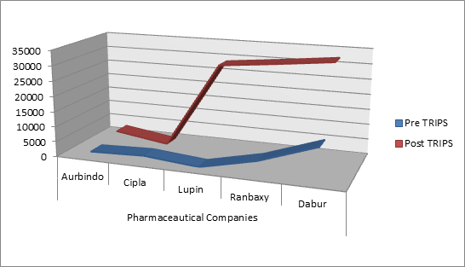

**Figure 2.** Average investments (in million Rupees).

It is evident from the analysis that; investments of all companies except Cipla, has increased in post TRIPS period. The increase is highest in Dabur followed by the Ranbaxy.

**Table 3.** Average cash and bank balance (in million Rupees)

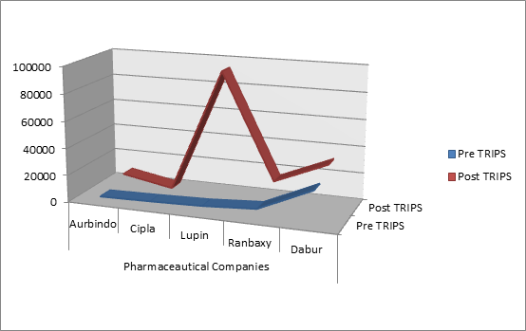**Pharmaceutical**

**Pre**

**Post**

**Gap**

**Companies TRIPS TRIPS Analysis**

|  |  |  |  |
| --- | --- | --- | --- |
| Aurbindo | 216 | 1584 | 1368 |
| Cipla | 102 | 67 | -35 |
| Lupin | 162 | 16121 | 15959 |
| Ranbaxy | 741 | 11011 | 10270 |
| Dabur | 2693 | 9532 | 6839 |

**Figure 1.** Average net block (in million Rupees).

**Source:** Annual reports of the pharmaceutical companies. Pre TRIPS data 2001-2004 Post TRIPS data 2005-2011

Average Cash and Bank balance of all companies except Cipla has increased in the post TRIPS period.

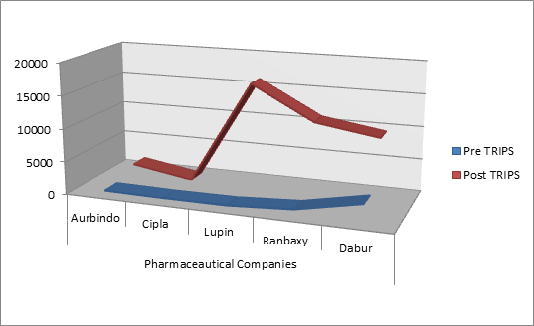

**Figure 3.** Average cash and bank balance (in million Rupees).

It is evident from the analysis that; Cash and Bank Balance of all companies except Cipla, has increased in post TRIPS period. The increase is highest in Lupin followed by the Ranbaxy.

**Table 4.** Average loans and advances (in million Rupees)

Average loans and advances of all companies except Cipla have increased in the post TRIPS period.

It is evident from the analysis that; loans and advances of all companies except Cipla, has increased in post TRIPS period. The increase is highest in Lupin followed by the Dabur.

## Analysis of Liabilities of the Pharmaceutical Companies

**Table 5.** Average share capital of pharmaceutical

|  |  |  |  |
| --- | --- | --- | --- |
| companies (in million Rupees) | | | |
| **Pharmaceutical** | **Pre** | **Post** | **Gap** |
| **Companies TRIPS TRIPS Analysis** | | | |
| Aurbindo | 223 | 273 | 50 |
| Cipla | 600 | 134 | -466 |
| Lupin | 449 | 6487 | 6038 |
| Ranbaxy | 1682 | 2016 | 334 |

Dabur 2857 9754 6897

**Source:** Annual reports of the pharmaceutical companies. Pre TRIPS data 2001-2004 Post TRIPS data 2005-2011.

Average Share Capital of all companies except Cipla

**Pharmaceutical**

**Pre**

**Post**

**Gap**

has increased in the post TRIPS period.

**Companies TRIPS TRIPS Analysis**

|  |  |  |  |
| --- | --- | --- | --- |
| Aurbindo | 990 | 4940 | 3950 |
| Cipla | 2958 | 872 | -2086 |
| Lupin | 2462 | 35256 | 32794 |
| Ranbaxy | 4978 | 8073 | 3095 |

Dabur 10367 21021 10654

**Source:** Annual reports of the pharmaceutical companies. Pre TRIPS data 2001-2004 Post TRIPS data 2005-2011.

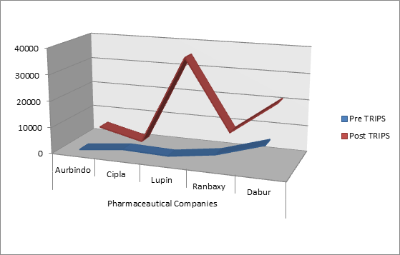

**Figure 4.** Average loans and advances (in million Rupees).

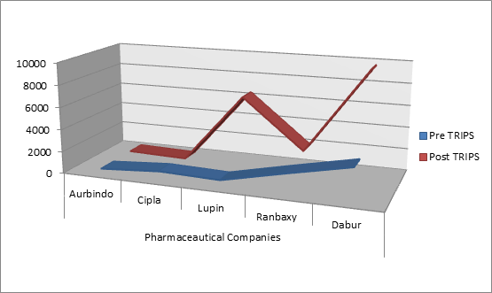

**Figure 5.** Average share capital of pharmaceutical companies (in million Rupees).

It is evident from the analysis that; Share Capital of all companies except Cipla, has increased in post TRIPS period. The increase is highest in Dabur followed by the Lupin. The share capital of a company may be increased by issuing new shares (new issue) or by the company’s own funds being transferred from unrestricted equity to share capital (bonus issue). A new issue means that the company is supplied with new capital or reduces its

debt. A bonus issue involves, however, only an accounting reposting from unrestricted equity into share capital, and will not supply fresh capital to the company or reduce its debt.

**Table 6.** Average reserve and surplus of pharmaceutical companies (in million Rupees)

|  |  |  |  |
| --- | --- | --- | --- |
| **Pharmaceutical** | **Pre** | **Post** | **Gap** |
| **Companies** | **TRIPS** | **TRIPS** | **Analysis** |
| Aurbindo | 4596 | 11285 | 6689 |
| Cipla | 9273 | 4235 | -5038 |
| Lupin | 11081 | 169348 | 158267 |
| Ranbaxy | 19068 | 29923 | 10855 |
| Dabur | 33774 | 42100 | 8326 |

**Source:** Annual reports of the pharmaceutical companies. Pre TRIPS data 2001-2004 Post TRIPS data 2005-2011.

Average Reserve and Surplus of all companies except Cipla has increased in the post TRIPS period**.**

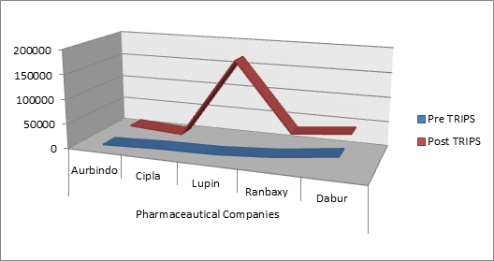

**Figure 6.** Average reserve and surplus of pharmaceutical companies (inmillion Rupees).

It is evident from the analysis that; Reserve and Surplus of all companies except Cipla, has increased in post TRIPS period. The increase is highest in Lupin followed by the Dabur.

**Table 7.** Average secure loan of pharmaceutical companies (in million Rupees)

|  |  |  |  |
| --- | --- | --- | --- |
| **Pharmaceutical** | **Pre** | **Post** | **Gap** |
| **Companies TRIPS TRIPS Analysis** | | | |
| Aurbindo | 3100 | 7271 | 4171 |
| Cipla | 268 | 18 | -250 |
| Lupin | 4464 | 52395 | 47931 |
| Ranbaxy | 539 | 2437 | 1898 |
| Dabur 5761 1725 -4036 | | | |

**Source:** Annual reports of the pharmaceutical companies. Pre TRIPS data 2001-2004 Post TRIPS data 2005-2011.

Average Secure loan of all companies except Cipla has increased in the post TRIPS period.

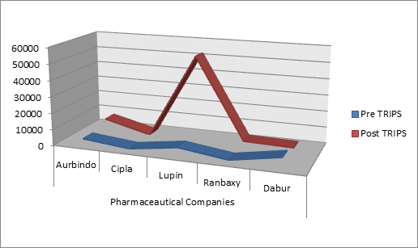

**Figure 7.** Average secure loan of pharmaceutical companies (in million Rupees).

It is evident from the analysis that; secure loan of Cipla, has decreased in post TRIPS period. The secure loan of all other companies has increased in post TRIPS period. It may also an indicator of good performance of the company. As only if public have confidence in the company; they will subscribe to the Debenture/Bonds of the company. Bank will also provide loan to the company if company is doing good.

**Table 8.** Average unsecured loan of pharmaceutical companies (in million Rupees)

|  |  |  |  |
| --- | --- | --- | --- |
| **Pharmaceutical** | **Pre** | **Post** | **Gap** |
| **Companies** | **TRIPS** | **TRIPS** | **Analysis** |
| Aurbindo | 1164 | 10077 | 8913 |
| Cipla | 642 | 375 | -267 |
| Lupin | 589 | 33581 | 32992 |
| Ranbaxy | 218 | 30962 | 30744 |
| Dabur | 12950 | 7032 | -5918 |

**Source:** Annual reports of the pharmaceutical companies. Pre TRIPS data 2001-2004 Post TRIPS data 2005-2011.

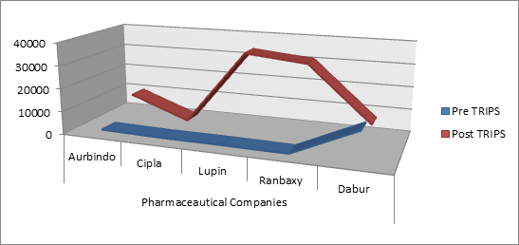

**Figure 8.** Average unsecured loan of pharmaceutical companies (in million Rupees).

Average unsecured loan of all companies except Cipla has increased in the post TRIPS period.

It is evident from the analysis that; unsecure loan of Cipla, has decreased in post TRIPS period. The unsecure loan of all other companies has increased in post TRIPS period. It may also an indicator of good performance of the company. As only if public have confidence in the company; they will invest in the company. Bank and other financial institutions will also provide loan to the company if company is doing good.

# Recommendations

Indian Pharmaceutical Industry needs to spend more in developing new molecules companies should invest in R&D process; the benefits of R&D can be reaped for many years to come.

Indian Pharmaceutical Industry should also adopt Good Manufacturing practices and invest more in this area. Products manufactured in GMP certified facility are globally accepted and will greatly add to the revenue of the company.

Although human beings have conquered many infectious diseases; many new life style diseases have come up, this makes Pharmaceutical Industry a sunshine industry which always has new frontiers of growth. The unending human quest for easy treatment of ailments will always present new opportunities for the pharmaceutical industry.

# Conclusions

In this study the key objectives of research was to find out the effect of the changed patent laws on the Indian pharmaceutical industry. The study of available literature reveals that; initially the Indian Government utilized a variety of policy measures to develop the native pharmaceutical industry and to guard it from huge multinational companies. The establishment of Govt. controlled pharmaceutical companies for production of drugs was the first type of government involvement in this sector. Later since 1970, a lenient patent regime was implemented which promoted native pharmaceutical industry on a new scientific course having capability to develop new cost-effective processes and new drug delivery

systems. The export potential of Indian pharmaceutical companies was propelled by the recognition of its strong process patents in different countries, which made them penetrate a number of countries. However later on India had to change its Intellectual Property Laws to meet the requirement of International IP regime. Although due to the provision of transitional period of 10 years, in TRIPS agreement there was only a minimal effect of changed patent laws on Indian pharmaceutical industry till 2005.

Despite initial Govt. assistance it was a long tough bumpy journey for the Indian pharmaceutical industry, at first an import reliant and later developing into a self-reliant producer. Pharmaceutical industry of India has developed from almost zero to world leader in the production of quality, low-cost generic drugs. The Indian pharmaceutical industry produces roughly 20 percent of the world’s total production. Indian pharmaceutical companies currently produce almost all domestic drug needs and control over 80 percent of the Indian market. Another promising area for Indian pharmaceutical industry is acute disease therapeutics which is attributable to growing younger population.

The process of economic liberalization and TRIPS agreement had a positive effect on the Indian Pharmaceutical industries. The TRIPS agreement presented a mammoth problem for pharmaceutical firms in some growing nations. But for Indian pharmaceutical companies it acted as a catalyst and accelerated their movement towards the innovative R&D. The synchronization of patent laws in the world and expiry of patent period of successful drugs has opened a window of opportunity for Indian pharmaceutical manufacturers known for their skills at producing generic version of off patent drugs at low-cost drugs. The Indian firms are presently developing the capability in innovative R&D by acquiring new components of the knowledge and reconfiguring the architectural linkages between these components in a new way. The growth of Indian Pharmaceutical industry is also assisted by the human resource it is the biggest strength as India has vast pool of highly qualified personnel who work at very low wage. It has resulted in lower cost of drug discovery and R&D in India. Indian companies have also been benefitted from TRIPS provision which provides for non-retrospective patenting of drugs in India that are already in the market or covered by existing patent applications elsewhere.

# References:

1. Alam T, Rastogi R, Malki S. The Indian pharmaceutical in- dustry: The empirical study. VSRD International Journal of Business and Management Research. 2011; 1(7):408–15.
2. Chaudhuri S. TRIPS and changes in pharmaceutical patent regime in India. Available from: [http:llwww.who.int/hiv/](http://llwww.who.int/hiv/) amds/IDA_India-Patent-amendments-Sudip.pdf
3. Dubey M. An unequal treaty: World trading after GATT. New Delhi: New Age International Publishers; 1996.
4. Ahuja SD. GATT and TRIPS: The impact on the Indian pharmaceutical industry. Patent World; 1994. p. 28–34.
5. Pillai AM. Impact of GATT agreement on drug prices. Journal of the Indian Medical Association. 1995; 93(3):1–3.
6. Sen B. The uruguay round: Implications for world trade. New Delhi: Jawahar Publisher; 1996.
7. Koosha A, Ahmadi M, Nazifi A, Mousazadeh R. Intellec- tual property rights of nano-biotechnology in trade related aspects of intellectual property agreement (TRIPS). Indian Journal of Science and Technology. 2012 Mar; 5(S3).
8. Mehta M, Chandani A. Where Indian pharma corporates stand – Study with reference to corporate governance prac- tices and CSR. Indian Journal of Science and Technology. 2015 Feb; 8(S4). DOI: 10.17485/ijst/2015/v8iS4/60359.
9. Bollampally K, Dzever S. The impact of RFID on pharma- ceutical supply chains: India, China and Europe compared. Indian Journal of Science and Technology. 2015 Feb; 8(S4). DOI: 10.17485/ijst/2015/v8iS4/71218.
10. Annual Reports, Aurbindo Pharmaceuticals; 2001-2011. p. 34, 40, 60, 54, 62, 52, 54, 62, 56, 54, 56.
11. Annual Reports, Cipla Pharmaceuticals; 2001-2011. p. 18,

16, 19, 16, 16, 32, 32, 34, 34, 32, 32.

1. Annual Reports, Dabur Pharmaceuticals; 2001-2011. p. 32,

38, 81, C2, 68, 18, 64, 68, 128, 94, 86.

1. Annual Reports, Lupin Pharmaceuticals; 2001-2011. p. 55,

73, 53, 60, 35, 82, 94, 86, 104, 86, 82.

1. Annual Reports, Ranbaxy Pharmaceuticals; 2001-2011. p. 76, 76, 76, 104, 54, 46, 50, 56, 56, 66, 80.