# Microplastic Pollution in the Marine Ecosystem: A Study of Seawater and Fish Samples from Bhaucha Dhakka and Versova Beach, Mumbai Coast

## ABSTRACT

|  |
| --- |
| The prevalence of microplastics in our environment is well recognized, but the deep extent of its impact on ecosystems is unknown. This study investigates the prevalence of microplastics in seawater and three species (Bombay duck, Silver Pomfret, and Indian prawn) of commercially available marine fish from the Mumbai suburbs. The investigation found microplastics in both water and fish samples, with an average concentration of 20 ± 14.8 MPs/L and 42 ± 14.8 MPs/L in two water samples from Versova Beach and Bhaucha Dhakka selected for the study. And 70 ± 10, 36 ± 08, and 23 ± 09 MPs/L respectively in three fish species. The highest concentrations were found in water samples from Bhaucha Dhakka and Bombay duck (*Harpadon nehereus*) from Bhaucha dhakka. The discovery of microplastics in fish tissues raises concerns about their potentially harmful impact on fish health and the implications for human consumption.  **Graphical Abstract** |

*Keywords: Microplastics, marine pollution, Bombay duck, silver pomfret, Indian prawn.*

## 1. INTRODUCTION

Plastics gained prominence in enhancing human lives due to their long durability, good mechanical qualities, weather resistance, and extended service life [1]. Decades ago, when plastic was first produced as paint, few could have anticipated its detrimental effects on the ecosystem. What seemed like a simple discovery has since taken over the world, leaving us now struggling to find ways to eradicate it from our planet. The plastics business started in the 1920s and has expanded quickly since the 1940s. In 2014, the worldwide plastic output was twenty times of that in 1964. The decomposition and fragmentation of marine plastic trash result in dangerous secondary microplastics in the water [2]. In 2020, scientists discovered that plastics have entered our planet's water cycle, traveling through clouds and rain. According to research, the carbon cycle also contains a lot of plastic [3].

Microplastics come in a wide range of sizes, shapes, colours, and densities, and are considered a complicated set of contaminants due to their variable composition [4]. Microplastic is classified into two categories: primary microplastic (microplastic manufactured in micro-sized particles such as microbeads) and secondary microplastic (microplastic resulting from the breakdown of bigger plastic components) [2].

Microplastics, synthetic organic polymers smaller than 5 mm, have emerged as a major environmental concern, particularly in aquatic habitats. Microplastics can obstruct the gastrointestinal tract of tiny marine species, causing hunger [5]. Microplastics found their importance in the cosmetic and beauty industry before becoming an integral part of all walks of life. Microplastics (MPs), which are barely visible plastic pieces, pose a significant concern due to their abundance in aquatic and terrestrial habitats. Because of their small size, microplastics are accessible to species throughout the food chain [6].

Due to their small size, these particles are impossible to be seen with the naked eye, making them difficult to be detected in most life forms. They can also pass through filters undetected, raising significant concerns about the safety of our purification processes. There have been numerous ways used to identify microplastics so far. Optical microscopy has been widely used to assess microplastic abundance because it is inexpensive and efficient. However, optical microscopy cannot guarantee the chemical composition of identified particles, and plastic classification based solely on colour and morphology has been observed to have error rates of up to 70%.Vibrational Spectroscopy, such as transmission or Attenuated Total Reflectance (ATR), Fourier Transform Infrared (FTIR) Spectroscopy, and Raman Spectroscopy, are analytical procedures that can validate both the abundance and chemical composition of microplastic [5]. The pervasive presence of MPs in the environment and common products makes human exposure to MPs unavoidable. These microplastics enter the human body mostly by ingestion, inhalation, and skin exposure [7].

Awareness about exposure to these contaminants has been increasing in recent years. Several studies have been conducted to detect the presence of these particles in our ecosystem [8]. Additionally, the presence of microplastics in the edible parts of fish is a significant concern for human health. To reduce microplastic pollution, it is necessary to understand the source of microplastic and its transit, degradation, and potential solutions. The intricate transportation and dispersion processes of microplastic include ocean dynamics (i.e. surface drifting, vertical mixing, beaching, settling, and entrainment) and physical qualities (i.e. size, shape, and density) [2,9,10,11].

## 2. MATERIALS AND METHODS

**2.1 Sample Collection**

Water samples were collected from Versova Beach (19°07'35"N 072°48'55"E) and Bhaucha Dhakka (18°57'28"N 072°51'01"E) as indicated in Fig. 1, major ports connecting Mumbai to Alibaug and Uran. These locations also serve as significant fish landing centers, supplying fish to most markets and restaurants in the suburban area. Additionally, three types of fish—Bombay duck (*Harpadon nehereus*), silver pomfret (*Pampus argenteus*), and Indian prawn (*Penaeus indicus*)—were also collected from Bhaucha Dhakka and Versova beach respectively. This major fish landing center supplies fish to markets and restaurants across Mumbai and its suburbs.

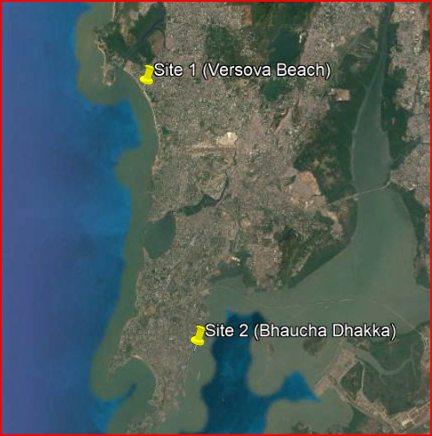

**Fig. 1. Geolocation of sampling site 1 Versova Beach and Site 2 Bhaucha Dhakka**

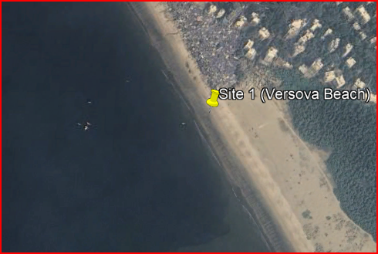

**Fig. 1A. Versova Beach Fig. 1B. Bhaucha Dhakka**

**2.2 Sample Preparation**

Water samples were first treated with acid 10% KOH (Potassium Hydroxide) to remove any organic matter before analysis. Fish samples were dissected to remove gills, tissues, gut, and fins. Then, the organs were incubated in 10% KOH for 48 hours which covered the period of 36-48 hours digestion time in selected fish species. After 48 hours, samples were filtered with Whatmann filter paper no. 1 of pore size 11μm and 0.45μm respectively.

**2.3 Sample Analysis**

The microplastics remaining on the filter paper were subsequently analyzed using both a stereo zoom and a research microscope to visualize the particles. Microplastics observed under the stereo zoom microscope were carefully transferred onto a slide and further examined using a fluorescence microscope. This procedure ensures that the filter paper is free from contamination by non-plastic materials, as only plastic polymers will fluoresce due to staining with Nile Red dye.

## 3. RESULTS AND DISCUSSION

The particle count in water samples from Bhaucha Dhakka was 42 ± 10, but in samples from Versova Beach, it was 20 ± 10. As indicated in Table 1 Bhaucha Dhakka showed a higher concentration of microplastics than Versova Beach, most likely due to significant boat traffic day and night (Fig. 1B). Fig. 2 shows various microplastics observed in water samples under an Optical microscope in 10X magnification. Fig. 2. B and Fig. 2. C are obtained from *Harpadon nehereus* and Fig. 2. D polymer particles were obtained in *Pampus argenteus.* Fig. 2 shows microplastics under Fluorescence microscope images observed in fish samples under 10x magnification. Table 2 and Fig. 3 show that the Bombay duck (*Harpadon nehereus*) sampled from both locations contained the greatest microplastics of any fish sample (as mentioned by Hossain et al*.* [12], Hasan et al. [13], followed by the pomfret (*Pampus argenteus*) and the prawn (*Penaeus indicus*) [14]. This high amount can be linked to the Bombay duck's voracious, cannibalistic feeding habits. The polymer particles were a mixture of threads, filaments, granules, and pellets. Curren et al*.* [15] detected significant MP contamination, which is not consistent with our findings. However, in comparison to our investigation, the findings of [16] demonstrate a low presence of MP.

MPs can collect in the hepatopancreas of prawns, affecting their immune system. Shrimp, unlike humans and other fish species, rely solely on their immune systems. This increases their susceptibility to external diseases and stressors. The tension caused by the accumulation of these plastic particles may kill the organism [17]. The gastrointestinal tract of *H. nehereus* included a high proportion of tiny fish and prawns. According to various literature, some small fish and prawns in India have been contaminated with MPs. MPs can be transferred from tiny fish and prawns to *H. nehereus* via trophic transmission in the food chain [18], [19-22].

**Table 1. Number of Microplastics in Water samples**

|  |  |  |
| --- | --- | --- |
| **S. No.** | **Samples** | **No. of Microplastics/L** |
|  | Versova Beach | 20 + 14.8 |
|  | Bhaucha Dhakka | 42 + 14.8 |

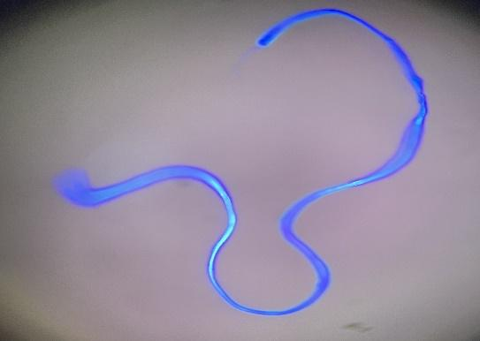 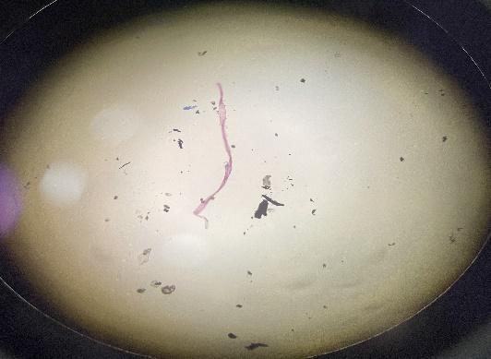

A)))

B)

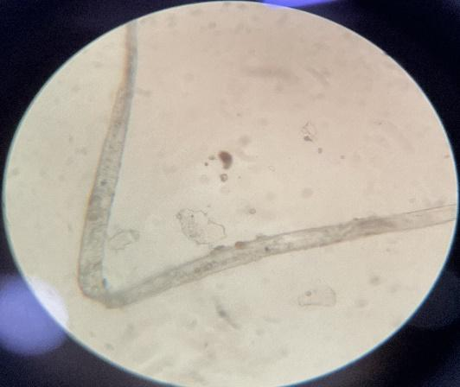 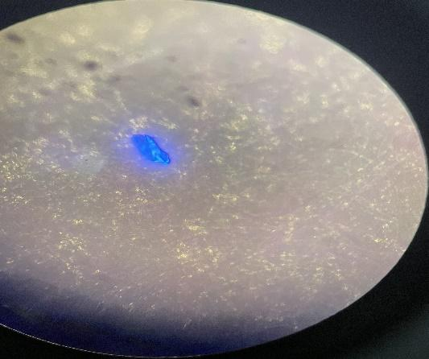

C)

D)

**Fig. 2. Microscopic images of different microplastics (A, B, and C) are filaments and D is a fragment (10x magnification)**

|  |  |
| --- | --- |
|  |  |
|  |  |
| **Fig. 3. Microplastics of fish samples under Fluorescence microscope (10x magnification)** | |

**Table 2. Number of MPs in each fish sample**

|  |  |  |  |  |
| --- | --- | --- | --- | --- |
| **S. No.** | **Fish Sample** | | **No. of Microplastic/g from Versova Beach** | **No. of Microplastic/g from Bhaucha Dhakka** |
| 1. | *Harpadon nehereus* | Fish body | 63 + 07 | 70 + 07 |
| Edible part (Tissue) | 36 + 8.4 | 24 + 8.4 |
| Non-edible parts (Gills, fins, gut) | 27 + 13.4 | 46 + 13.4 |
| 2. | *Pampus argenteus* | Fish body | 43 + 4.9 | 36 + 4.9 |
| Edible part (Tissue) | 16 + 1.4 | 18 + 1.4 |
| Non-edible parts (Gills, fins, gut) | 27 + 3.5 | 22 + 3.5 |
| 3. | *Penaeus indicus* | Fish body | 17 + 4.9 | 24 + 4.9 |
| Edible part (Tissue) | 07 + 0.7 | 08 + 0.7 |
| Non-edible parts (Gills, fins, gut) | 11 + 2.8 | 15 + 2.8 |

**Fig. 4. Comparative microplastic analysis of all three fishes**

## 4. CONCLUSION

Microplastic contamination is widespread across all ecosystems. The highest concentrations were found in water samples from Bhaucha Dhakka and Bombay duck (*Harpadon nehereus*) from Bhaucha dhakka. The current study findings are relevant given that hundreds of thousands of people ingest fish every day. The presence of microplastics in all test samples of fish and prawn tissues heightens the risk of contamination for higher trophic-level mammals, including human. There is a noticeable percentage of increase in microplastic concentration from water to fish, indicating an augmentation through trophic levels, especially in Bombay Duck. The presence of microplastics makes gills more prone to obstruction leading to asphyxia causing death. A literature review of the past decade suggests the presence of microplastics in human blood, infant milk, and various body parts. Although we lack sufficient studies to directly link specific contaminants to specific diseases, the presence of plastic particles in our food should raise significant health concerns.

The causes of contamination and toxicity effects are still under investigation but wear and tear from fishing nets and tools contribute significantly to contamination in coastal ports. Additionally, ongoing construction and redevelopment projects in and around the Mumbai region are major sources of pollution in nearby water bodies, which may also be linked to microplastic contamination. More research and animal model studies will be critical in filling the knowledge gap on the impacts of microplastics on human health.

**DISCLAIMER (ARTIFICIAL INTELLIGENCE)**

Author(s) hereby declare that NO generative AI technologies such as Large Language Models (ChatGPT, COPILOT, etc) and text-to-image generators have been used during writing or editing of this manuscript.

## REFERENCES

1. Ahmed MB, Rahman MS, Alom J, Hasan MS, Johir M, Mondal MIH, et al. Microplastic particles in the aquatic environment: A systematic review. Sci Total Environ. 2021;775:145793.

DOI:10.1016/j.scitotenv.2021.145793.

1. Amelia TSM, Khalik WMaWM, Ong MC, Shao YT, Pan H, Bhubalan K, et al. Marine microplastics as vectors of major ocean pollutants and its hazards to the marine ecosystem and humans. Prog Earth Planet Sci. 2021;8(1).

DOI:10.1186/s40645-020-00405-4.

1. Herring M. Microplastics are the Not-So-Secret ingredient in marine snow. Eos. 2023;104.

DOI:10.1029/2023eo230496.

1. Microplastic in the environment: Pattern and process. In: Environmental contamination remediation and management; 2022.

DOI:10.1007/978-3-030-78627-4.

1. Willans M, Szczecinski E, Roocke C, Williams S, Timalsina S, Vongsvivut J, et al. Development of a rapid detection protocol for microplastics using reflectance-FTIR spectroscopic imaging and multivariate classification. Environ Sci Adv. 2023;2(4):663–74.

DOI:10.1039/d2va00313a.

1. Xu J, Thomas KV, Luo Z, Gowen AA. FTIR and Raman imaging for microplastics analysis: State of the art, challenges and prospects. TrAC Trends Anal Chem. 2019;119:115629.

DOI:10.1016/j.trac.2019.115629.

1. Mariano S, Tacconi S, Fidaleo M, Rossi M, Dini L. Micro and Nanoplastics identification: classic methods and innovative detection techniques. Front Toxicol. 2021;3.

DOI:10.3389/ftox.2021.636640.

1. Baztan J, Jorgensen B, Pahl S, Thompson RC, Vanderlinden J. MICRO 2016: Fate and Impact of Microplastics in Marine Ecosystems: From the Coastline to the Open Sea. 1st ed. Elsevier; 2016 Dec 15.
2. Karthik R, Robin R, Purvaja R, Ganguly D, Anandavelu I, Raghuraman R, Microplastics along the beaches of southeast coast of India. Sci Total Environ. 2018;645:1388–99.

DOI:10.1016/j.scitotenv.2018.07.242.

1. Mashirin R, Chitra KC. Assessment of microplastic pollution across the Malabar Coast, India. Environ Qual Manag. 2024;34(1).

DOI:10.1002/tqem.22273.

1. Nikki R, Jaleel KA, Ragesh S, Shini S, Saha M, Kumar PD. Abundance and characteristics of microplastics in commercially important bottom dwelling finfishes and shellfish of the Vembanad Lake, India. Mar Pollut Bull. 2021; 172:112803.

DOI:10.1016/j.marpolbul.2021.112803

1. Hossain MS, Rahman MS, Uddin MN, Sharifuzzaman S, Chowdhury SR, Sarker S, et al. Microplastic contamination in Penaeid shrimp from the Northern Bay of Bengal. Chemosphere. 2020;238:124688.

DOI:10.1016/j.chemosphere.2019.124688.

1. Hasan J, Islam SM, Alam MS, Johnson D, Belton B, Hossain MaR, et al. Presence of microplastics in two common dried marine fish species from Bangladesh. Mar Pollut Bull. 2022;176:113430.

DOI:10.1016/j.marpolbul.2022.113430.

1. Daniel DB, Ashraf PM, Thomas SN. Abundance, characteristics and seasonal variation of microplastics in Indian white shrimps (Fenneropenaeus indicus) from coastal waters off Cochin, Kerala, India. Sci Total Environ. 2020;737:139839.

DOI:10.1016/j.scitotenv.2020.139839.

1. Curren E, Leaw CP, Lim PT, Leong SCY. Evidence of marine microplastics in commercially harvested seafood. Front Bioeng Biotechnol. 2020;8.

DOI:10.3389/fbioe.2020.562760.

1. Hossain MS, Sobhan F, Uddin MN, Sharifuzzaman S, Chowdhury SR, Sarker S, et al. Microplastics in fishes from the Northern Bay of Bengal. Sci Total Environ. 2019;690:821–30.

DOI:10.1016/j.scitotenv.2019.07.065.

1. Timilsina A, Adhikari K, Yadav AK, Joshi P, Ramena G, Bohara K. Effects of microplastics and nanoplastics in shrimp: Mechanisms of plastic particle and contaminant distribution and subsequent effects after uptake. Sci Total Environ. 2023;894:164999.

DOI:10.1016/j.scitotenv.2023.164999.

1. Prusty K, Rabari V, Patel K, Ali D, Alarifi S, Yadav VK, et al. An Assessment of Microplastic Contamination in a Commercially Important Marine Fish, Harpadon nehereus (Hamilton, 1822). Fishes. 2023;8(9):432.

DOI:10.3390/fishes8090432.

1. Prata JC, Da Costa JP, Duarte AC, Rocha-Santos T. Methods for sampling and detection of microplastics in water and sediment: A critical review. TrAC Trends Anal Chem. 2019;110:150–9.

DOI:10.1016/j.trac.2018.10.029.

1. Rahmawati S, Nuzula F, Sulistyo E, Hakim L. Identification of microplastics in fish from the local fish market of Yogyakarta Province, Indonesia. IOP Conf Ser Earth Environ Sci. 2023;1263(1): 012043.

DOI:10.1088/1755-1315/1263/1/012043.

1. Rocha-Santos TAP, Duarte AC. Characterization and Analysis of Microplastics. 1st ed. Comprehensive Analytical Chemistry. 2017 Apr 6;75. Elsevier.
2. Singh J, Yadav BK, Schneidewind U, Krause S. Microplastics pollution in inland aquatic ecosystems of India with a global perspective on sources, composition, and spatial distribution. J Hydrol Reg Stud. 2024;53:101798.

DOI:10.1016/j.ejrh.2024.101798