Do the contour feathers of Cisticolae exhibit adaptations to annual rainfall in their habitats?

# Abstract

Birds of the genus *Cisticola* occur over most of Southern Africa in varying habitats ranging from low to high altitudes and wet to dry areas causing species to have unique distributions. In order to determine if Cisticolas have evolved species‐specific water repellency and resistance to water penetration compatible with their habitats, we have measured the barb diameter and spacing of abdominal, breast and throat feathers of six Cisticola species and related the results to mean annual rainfall and altitudes in five different locations. Water repellency was not significantly associated with altitude or maximum mean summer temperatures. However, water repellency increased markedly with annual rainfall in the 550 to 600 mm/year range for abdominal and breast feathers, but not for throat feathers. This increase was evident both among species occurring at multiple sites and among different species occurring at single sites. However, the two species occurring at the wettest sites showed low water repellency, but increased resistance to water penetration. These findings suggest that water repellency and resistance to water penetration are part of the evolutionary forces that shape the microstructure of *Cisticola* contour feathers.

**Résumé** Les oiseaux du genre *Cisticola* vivent presque partout en Afrique australe, dans des habi- tats qui vont de basse à haute altitude, des zones humides à arides, ce qui fait que des espèces ont des distributions uniques. Pour déterminer si les cisticoles ont développé une imperméabilité à l'eau spécifique pour chaque espèce et une résistance à la pénétra- tion de l'eau compatible avec leurs habitats, nous avons mesuré le diamètre des barbes et l'espacement entre les plumes du ventre, de la poitrine et du cou de six espèces et relié les résultats aux chutes de pluie annuelles moyennes et à l'altitude de cinq lieux dif- férents. L'imperméabilité à l'eau n’était pas significativement associée à l'altitude ou à la température maximum moyenne en été. Mais elle augmentait significativement là où les chutes de pluie annuelles étaient comprises entre 550 et 600 mm/an pour les plumes du ventre et de la poitrine, mais pas celles du cou. Cette augmentation était évidente aussi bien chez les espèces qui vivent en de nombreux endroits que chez différentes espèces qui ne vivent que sur un seul site. Cependant, les deux espèces qui vivent dans les sites les plus humides présentaient une faible imperméabilité mais une résistance plus grande à la pénétration de l'eau. Ces résultats suggèrent que l'imperméabilité à l'eau et la résis- tance à la pénétration de l'eau font partie de forces évolutives qui façonnent la micro- structure des tectrices de *Cisticola*.

**KEY W ORD S**

adaptation, annual rainfall, *Cisticola*, feathers, resistance to water penetration, water repellency

# | INTRODUCTION

Birds of the genus *Cisticola* are infamous for their similar appearance. They are enigmatic in their plumage coloration and most species are identifiable only with certainty by their songs (Peacock, 2012). These small birds (9–18 cm) mostly occur alone or in pairs, but in large flocks on occasion, in open or light woodlands with a grassy under layer. Of the 52 species described, all but four are endemic to sub‐ Saharan Africa; these four are found in Madagascar, southern Eur- ope, Asia and northern Australia (Peacock, 2012).

All Cisticola species are either resident or migrate over a short distance to gain or lose altitude. They are insectivorous, but may also feed on other invertebrates. Seeds and other plant material sel- dom form part of their diet. The majority of Cisticolas are territorial, and the male and female are monogamous. Breeding takes place in summer and is dependent on rainfall. Breeding will occur about 2 months earlier in areas with winter rainfall (Peacock, 2012).

* 1. | **Habitat**

The habitats of Cisticolas vary considerably with some preferring moist areas and others drier places (Figure 1). For the purpose of this study, the habitats and distributions of the following Cisticola species were considered (Peacock, 2012).

1. The Zitting Cisticola (*C. juncidis*) is home in moist grasslands with tufts less than one meter tall. Sometimes, it may occur alongside Desert Cisticola (*C. aridulus*) in drier areas, but mostly it prefers grasslands that are taller and denser.
2. Desert Cisticola typically occurs in dry savannah areas with both short and tall grasses. It is often seen on agricultural lands and airstrips.
3. Cloud Cisticola (*C. textrix*) is common in very short to medium grassland that has bare patches of ground between tufts of grass. It occurs on gentle slopes and plains that are well-drained.
4. Rattling Cisticola (*C. chiniana*) can be described as a Savannah Cisti- cola because it prefers areas with scattered small to medium trees. It may even occur in grasslands that are subject to bush encroachment.
5. Neddicky Cisticola (*C. fulvicapilla*) is usually found in the under- story of broadleaf woodland and Acacia.
6. The Red-faced Cisticola (*C. erythrops*), a plain-backed species, prefers moist areas close to water where it can be found on the edges of reed beds and in the leafy understory of riverine wood- lands. It also occurs in tall lush grass (Peacock, 2012).

Zitting, Desert, Cloud and Neddicky are the smallest of the genus and most difficult to identify based on appearance alone. It is by their aerial displays and songs that they can be distinguished.

# | Feather Structure and Water Repellency

It is well established that contour feathers serve a variety of func- tions that range from intraspecific signalling to such physical qualities as thermal insulation, water repellency, and resistance to impact. It is no surprise, therefore, that they are composed of an array of elements that confer these qualities to the optimal benefit of the avian bearer.

The structural details of contour feathers have been well described in the ornithological literature (Landsborough-Thomson, 1964; Stettenheim, 1976). The downy (plumulaceous) feathers along- side the proximal two‐third of the rachis are thought to function as a means to regulate body temperature by entrapping air (King & Far- ner, 1961; Lei, Qu, Gan, Gebauer, & Kaiser, 2002; Lucas & Stetten- heim, 1972; Stettenheim, 2000). The distal one‐third has a patterned structure similar to pennaceous feathers with rami extending from the rachis, each sprouting barbules of which the distal ones have hooks that catch upon the curled, proximal barbules of the ramus next more distal. They are arranged in an overlapping fashion like shingles on a roof, having their dorsal side exposed to air or water. This continuous‐locking, hook‐and‐flange arrangement provides the distal one‐third with the rigidity so critical for its mechanical proper- ties. It also confers water repellency and resistance to water pene- tration to the body plumage.

The water repellency of feathers and other biological porous structures, such as the stomatal apparatus of leaves and the spiracles of insects, is governed by the fundamental principles of surface phy- sics that apply to *all* porous surfaces whether natural or manmade. It is determined by the relative areas of solid–water and air–water interface and their respective interfacial energies regardless of the actual architecture of the repellent structure itself (Cassie & Baxter, 1944). If the surface of the solid is coated with another material, such as paint or preening oil, it will assume the properties of the coating material. For feathers coated with uropygial gland oil, the feather–water interface is, in fact, an interface between gland oil and water.

When a drop of water is placed on a smooth feather surface such as the rachis, it will pearl up and roll off easily (Cassie & Baxter, 1944; Moilliet, 1963). The surface is then said to be water repellent,

the actual extent of which is determined by the contact angle θ,

defined as the angle between the tangent to the curved water sur- face at the point of contact with the solid surface and the plane of the surface on which the drop is resting, measured through the water. When the drop is placed on the porous vane of the feather, it will entrap air in the hollows and interstices, forming additional air–water interfaces, which will cause considerable increase in the contact angle, according to

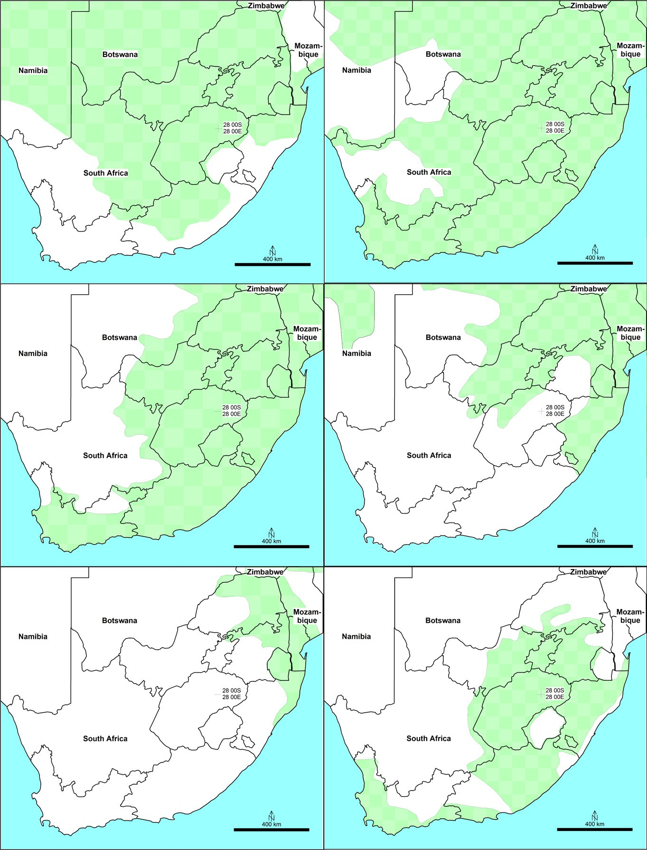Desert Cisticola Zitting Cisticola

Neddicky Rattling Cisticola

Red-faced Cisticola Cloud Cisticola

**FI GU RE 1** Distribution maps of the six species considered. Maps were redrawn from Peacock, 2012

cos θ*a* = *f*1 cos θ — *f*2 (1)

where *f*1 is the area of solid‐water interface and *f*2 is the area of the air–water interface per unit of apparent surface area. For water drops on barbs, *f*1 and *f*2 can be expressed as

*f*1 = (π — θ)*r/*(*r* + *d*) (2a)

and

*f*2 = 1 — *r* sin θ*/*(*r* + *d*) (2b)

where 2*r* represents the diameter of the rami measured in the plane of the long axes of the rami separated by distance 2*d* (Cassie & Bax- ter, 1944; Moilliet, 1963).

Note that the increase in apparent contact angle is ascertained only by the parameter (*r* + *d*)/*r* and not by the separate values of *r* and *d*. Thus, θa for values of this parameter ranging between 2.4

(penguins, *Spheniscidae*) and 10 (land birds) would vary between

about 126° and 154°, roughly correct by experimental verification (Rijke & Jesser, 2011). These values are significantly higher than those attained for the most repellent of smooth surfaces which equal about 114° (Moilliet, 1963).

Equation 1 has been derived solely from basic physicochemical principles without reference to parameters pertaining to any specific dimensions of the porous surface. In addition, the values of *f*1 and *f*2 are determined only by the areas of solid–liquid and air–liquid inter- face per unit of macroscopic surface areas without dictating the shape, curvature or configuration of these interfaces. Therefore, the relationship between the dimensions of a porous surface provided in terms of *f*1 and *f*2 and its ensuing contact angle, as represented by Equation 1, is a rigorous one, not an empirical one, and is of general validity. Such relationships do not require repeated measurements to establish their validity. Nonetheless, Equation 1 has been tested experimentally and was found to be correct by Cassie and Baxter (1944) and Rijke (1965) using paraffinated stainless steel wire cages and grids. For these particular models, calculations for the values of *f*1 and *f*2 could be made according to Equation 2a,b. Many other studies including recent ones have reported contact angle measure- ments on porous substrates including feathers and consistently con- firmed the correctness of the above premises (Bormashenko, Bormashenko, Stein, Whyman, & Bormashenko, 2007; Ma & Hill, 2006; Moilliet, 1963; Rijke, 1965).

In order to measure contact angles on smooth or porous surfaces correctly, certain experimental conditions have to be met, such as the drop has to be small enough so as not to be perturbed by gravi- tational forces, but large enough to cover a representative area of the porous surface. The drop should be prevented from evaporation which would turn the advancing contact angle into a receding one. Feather specimens should be covered with fresh preening oil, not rinsed with an ethanol wash (Bormashenko et al., 2007). When these conditions are met, the correct contact angle is usually found to be within one degree error as observed by multiple authors (Adam & Elliot, 1962; Cassie & Baxter, 1944; Rijke, 1965; Rijke, Jesser, & Mahoney, 1989; Shafrin & Zisman, 1952, 1957).

These results have shown conclusively that contact angles can be calculated from and represented by the dimensions of the porous surface alone without the need for empirical measurements.

An expression for the pressure (*P*), required to force water between the rami and barbules, can be derived from similar premises and reads

*P* = γ*/r*{cos θ + ,[(*r* + *d*)*/r*] — sin θ} (3)

2 2

Here, γ represents the surface tension of the water. This equa-

tion shows *P* to be inversely proportional to *r* and (*r* + *d*)/*r*. As a result, the requirement of relatively large values for (*r* + *d*)/*r* to provide sufficient water repellency is opposed by the need for small values for this parameter to attain good resistance to water pene- tration. Thus, the structural characteristics compatible with optimal water repellency are, at least in part, in conflict with the require- ments of resistance to water penetration. This conflict has important implications for water birds, which must realize a balance between these two opposing functions to cope with their respective habitats and behavioural patterns as indeed they do (Rijke & Jesser, 2011).

Experimental data on water repellency and resistance to water penetration for Double‐crested cormorants (*Phalacrocorax auritus*) and Anhingas (*Anhingidae*) have shown that results can be satisfacto- rily interpreted in terms of ramus diameter and spacing only without recourse to barbules. Their (*r* + *d*)/*r* values for barbules are in the approximate range of 4.5 to 5.5 as found for almost all bird families regardless of their feeding habits or interaction with open water (Rijke & Jesser, 2011). However, exceptions do exist in Sandgrouse (*Pteroclidae*) (Rijke, 1972) and in birds with iridescent feathers, which show flattened barbules often twisted towards the feather plane along the barbule axis (Doucet, Shawkey, Hill, & Montgomerie, 2006; Eliason & Shawkey, 2011). Presumably, these unusual barbules reduce the area of air–water interface between rami leading to smal- ler values for (*r* + *d*)/*r* and resulting in lower water repellency as con- firmed by experiment. But most families, including the genus *Cisticola*, have rounded barbules that primarily provide a mechanical function by interlocking the rami, preventing them from separating under water pressure while increasing their own separation in the process (Rijke et al., 1989).

Small birds such as cisticolas have ramus diameters in the range of 6 to 11 μm, which, according to Equation 2a,b, increases their water repellency relative to that of water birds, which have diame- ters in the range of 25 to 75 μm. However, the concomitant decrease in water resistance as a result of their large value for

(*r* + *d*)/*r* is partly offset by the small value for *r* in the denominator of Equation 3, which raises the value of *P*. Therefore, cisticola‐sized birds are at a relative advantage because they can attain a greater extent of water repellency at less expense of their water resistance than larger size birds can.

The contact angle θ of water drops on smooth feather surfaces,

such as the rachis or on a microscopic slide covered with preening oil, measures about 90° as established by various authors (Cassie & Baxter, 1944; Moilliet, 1963; Rijke et al., 1989). The same value was found for water drops on polyethylene foil (Adam & Elliot, 1962)

and this is no coincidence: polyethylene almost exclusively consists of methylene groups (‐CH2‐) which are the predominant chemical

component of preening oil (Elder, 1954; Odham & Stenhagen, 1971). Note that when θ is 90°, cosθ equals zero and sin θ equals one, which reduces Equation 1 to cosθa =−*f*2 and Equation 2b to *f*2 =

1−*r/(r + d).* These fortuitous circumstances allow the investigator to

determine the apparent contact angle from the value of (*r* + *d*)/*r*

alone. For instance, Cassie and Baxter (1944) found *(r + d)/r* for their

**TABL E 1** GPS coordinates, altitude, mean annual rainfall and mean minimum and maximum monthly temperatures of the five sampling sites

duck feathers to be 5.9, which corresponds to a θa of 147° in good agreement with their experimental value of 150°. These results, cor-

**Site**

**Mean minimum and maximum**

**Altitude Rainfall monthly**

**GPS coordinates (m) (mm/year) temperatures°C**

roborated by other workers (Rijke, 1970), have shown that for feath- ers coated with fresh preening oil, both the water repellency in terms of the apparent contact angle θa and the balance between

water repellency and resistance expressed by the value of (*r + d*)*/r*,

can be correctly predicted from the micro‐structure of the feather alone. In this study, we have used the value of (*r + d*)*/r* to indicate the level of water repellency/resistance of the Cisticola contour feathers.

Because of their physical similarity and distribution over wide

Tzaneen 23°49′15.4″ S 30°13′21.1″ E

Bloemhof 27°47′48.1″ S

Soekmekaar 23°27′13.7″ S

29°53′04.0″ E

1,158

499

14–24

25°40′43.4″ E

|  |  |  |  |  |
| --- | --- | --- | --- | --- |
| Roodekraal | 26°45′11.1″ S  27°18′33.4″ E | 1,441 | 607 | 10–23 |
| Vaal | 26°43′42.2″ S  27°52′35.7″ E | 1,480 | 547 | 10–23 |

719 881 16–24

1,236 350 10–24

ranges of wet and dry habitats, cisticolas lend themselves eminently for studying the contour feathers of each species and how it relates to its respective environment. Both repellency and resistance and, in particular, the balance between them are apparent and well described in water birds, but not in terrestrial birds which are pre- sumably concerned with water repellency only (Kennedy, 1970; Rijke & Jesser, 2011). Even so, an earlier study conducted on Blue Swal- lows (*Hirundo atricaerulea*) (Rijke, Jesser, Evans, & Bouwman, 2000) and studies on Dippers (*Cinclidae*) have indicated that these passeri- nes have evolved small but significant differences in water repel- lency and resistance in relation to their specific feeding habits (Rijke & Jesser, 2010). However, such adaptations were previously consid- ered sporadic and absent in land birds that have no access to open water. It is the purpose of this study to show that cisticolas have evolved the structural characteristics in their contour feathers to cope with the specific requirements of their wide‐ranging habitats.

# | MATERIALS AND METHODS

Using standard bird ringing equipment, birds were caught by experi- enced bird ringers with appropriate permits, in the austral summer months of 2014‐15. The proper use of mist nets and the handling of birds were followed as described by De Beer et al. (2001). When sampling the contour feathers, care was taken not to inflict any pain or damage to the birds. Only three feathers per body area—ab- domen, breast and throat—were taken for our study.

Five sampling sites were chosen based on the distribution of the six species (Figure 1), altitude, maximum mean summer temperatures, and mean annual rainfall. Their details are listed in Table 1.

Feathers were measured and their (*r + d*)*/r* values determined using a Nikon AZ100 Multi‐Purpose Zoom microscope with the accompanying NIS‐Elements computer software. No cover glass was placed on the feathers so as not to distort their micro‐structure. To

obtain the value of the ramus diameter, two lines were drawn each on the edge of a ramus and its width recorded. The separation between two rami was measured by recording the distance between two adjoining rami (Figure 2). Care was taken to avoid damaged samples. Only data from rami that were perfectly aligned and parallel to each other and secured by interlocking barbules were recorded. For each feather, anything between three and five measurements were taken and (*r + d*)*/r* values calculated. Statistics were calculated using GraphPad Prism Ver 7.02 [(www.graphpad.com).](http://www.graphpad.com/) As there were some sites that did not have normally distributed data, the Kruskal– Wallis test was used to compare (*r + d*)*/r* between sites. We used linear regressions to relate transformed (*r + d*)*/r* data per site to rain- fall and altitude, and altitude was regressed against the maximum mean summer temperatures for all sites, and against annual rainfall.

# | RESULTS

The values for the measured ramus diameter and those calculated for (*r + d)/r* are listed in Table 2. Ramus widths for Zitting (9 g), Ned- dicky (9 g), Desert (8.5 g) and Cloud (10 g), the smallest of the six species, are slightly smaller than for Rattling (18 g) and Red‐faced Cisticolas (15 g). This is in line with previous observations, which show that ramus diameter increases with body mass. Impact forces are directly proportional to mass and, as a result, the thicker rami of big birds can withstand mechanical forces and avoid damage better than the thinner rami of small birds (Rijke & Jesser, 2016).

Furthermore, the ramus widths of the breast feathers of the six species appear, on the whole, to be slightly larger than those of abdominal and throat feathers (Table 2). This too may be explained by mechanical considerations: breast feathers being more exposed to impact forces than abdominal and throat feathers. Small although these differences may be their effect on (*r* + *d*)/*r* is pronounced. Values for this parameter and therefore the water repellency of

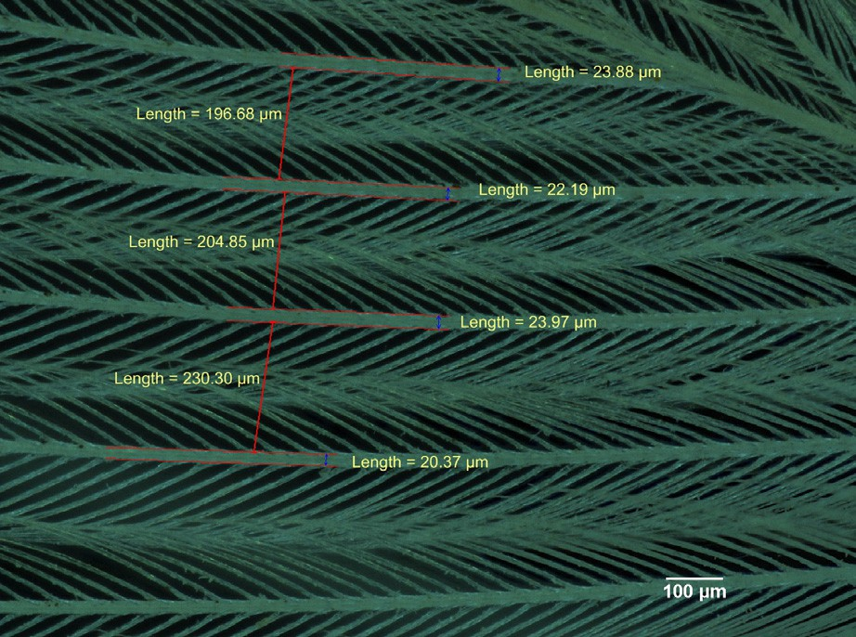

**FI GU RE 2** Photomicrograph of a breast feather of Red‐faced Cisticola, showing rami and barbules and part of the rachis (right upper corner), illustrating the parallel‐line measuring technique. The abdominal, breast, and throat images of this and other Cisticola species all look alike to the unaided eye, but reveal their dimensional differences by microscopic measurement

abdominal and throat feathers are consistently larger than for breast feathers and, conversely, the water resistance of breast feathers tops that of the other feathers.

Annual rainfall and maximum mean summer temperatures were negatively but not significantly associated with altitude (linear regression *p* = 0.1353 and *p* = 0.2429, respectively; data not shown). The Kruskal–Wallis test showed highly significant differences (p < 0.0001) for each feather type between sites. There were no sig- nificant (*p* > 0.2) linear regressions between (*r* + *d*)/*r* and altitude for all three feather types. Because annual rainfall was independent of altitude and maximum mean summer temperatures at the sites cho- sen, we assume that the differences we see were solely or largely due to rainfall and not altitude or summer temperatures.

The left‐hand sides of (Figure 3a,b) show the dependence of water repellency of abdominal and breast feathers, expressed as (*r* + *d*)/*r,* on annual rainfall. For areas of low rainfall, this dependence is small and very similar for both feather types, but increases mark- edly for areas with a rainfall of about 550 mm/year. This is observed for different species that occur at single sites, Rattling at Soek- mekaar and Cloud at Vaal as well as for the same species occurring at different sites, Zitting at Soekmekaar and Vaal, and Desert at Bloemhof and Vaal. No such dependence is obvious for the throat feathers of any of the six species (Figure 3c).

The right‐hand sides of Figure 3a,b show the dependence of the water resistance on annual rainfall over 580 mm/year. Only two Cis- ticola species, Neddicky and Red‐faced, occur at locations in this high rainfall range. Their data points, below those of Cloud and more or less on a level with other cisticolas, suggest that resistance to

water penetration rather than water repellency is here the driving force in coping with their environment.

Figure 3 illustrates the opposing water repelling and resisting functions of feathers quite well. Both work to prevent water from reaching the skin and the feathers from becoming waterlogged. In areas of low rainfall repellency is the most important function, but at sites with more than 580 mm/year resistance becomes the dominant characteristic, increasingly so at higher rainfalls. Note that the two sides of Figure 3 represent two separate relationships given by Equations 1 and 3, each differently related to (*r* + *d*)/*r.* As a result, there is no connectivity or continuity between these two functions and there is no specific transition point on the rainfall axis at which repellency ceases and resistance comes into play or vice versa. Both functions are operative over the entire rainfall range, only their rela- tive dominance changes with level of rainfall.

Unfortunately, this study is restricted by number of species and sites with a sufficiently wide spread in annual rainfall. Only four spe- cies occurring at three dry locations and two species at two wet loca- tions were available for our purpose. This has made it impossible to fit meaningful curves using multiple regression analysis to our data sets.

# | DISCUSSION

This study has shown for the first time that the contour feathers of land birds exhibit in their micro‐structure, specifically in the diameter and spacing of their rami, a correlation with the annual rainfall of their respective habitats. Water birds and bird families with access

**TABL E 2** Mean ramus diameter and mean values and standard deviations (*SD*) for (*r* + *d*)/*r* of contour feathers of abdomen (AB), breast (BR) and throat (TH) for six species of cisticola occurring at five different sites

|  |  |  |  |  |  |  |  |
| --- | --- | --- | --- | --- | --- | --- | --- |
| **Species** | **ID** | **Site** | **Region** | **Ramus diameter (μm)** | ***SD*** | **(*r* + *d*)/*r*** | ***SD*** |
| Zitting | SG002 | Soekmekaar | AB | 7.83 | 0.85 | 17.84 | 0.16 |
|  |  |  | BR | 11.12 | 0.29 | 14.28 | 0.03 |
|  |  |  | TH | 6.72 | 0.46 | 26.88 | 0.16 |
|  | SG003 | Soekmekaar | AB | 9.28 | 0.01 | 16.25 | 1.50 |
|  |  |  | BR | 10.78 | 0.10 | 10.80 | 0.18 |
|  |  |  | TH | 6.93 | 0.38 | 17.25 | 0.29 |
|  | L34361 | Vaal | AB | 7.22 | 0.05 | 22.60 | 0.22 |
|  |  |  | BR | 8.36 | 0.12 | 19.64 | 0.36 |
|  |  |  | TH | 6.40 | 0.20 | 19.20 | 0.09 |
|  | L34362 | Vaal | AB | 9.31 | 0.57 | 21.90 | 0.48 |
|  |  |  | BR | 10.31 | 0.49 | 14.22 | 0.02 |
|  |  |  | TH | 7.03 | 1.09 | 18.30 | 0.14 |
| Desert | BG001 | Bloemhof | AB | 9.11 | 0.13 | 18.47 | 0.29 |
|  |  |  | BR | 9.66 | 0.16 | 11.68 | 0.15 |
|  |  |  | TH | 7.23 | 0.01 | 14.32 | 0.04 |
|  | BG002 | Bloemhof | AB | 9.32 | 0.40 | 14.67 | 0.29 |
|  |  |  | BR | 9.02 | 0.16 | 14.66 | 0.16 |
|  |  |  | TH | 8.80 | 0.13 | 21.55 | 0.37 |
|  | L34358 | Vaal | AB | 8.18 | 0.16 | 23.14 | 0.04 |
|  |  |  | BR | 10.20 | 0.02 | 13.15 | 0.05 |
|  |  |  | TH | 8.86 | 0.10 | 15.57 | 0.18 |
|  | L34694 | Vaal | AB | 7.84 | 0.18 | 16.59 | 0.23 |
|  |  |  | BR | 8.87 | 0.14 | 16.26 | 0.04 |
|  |  |  | TH | 8.55 | 0.10 | 14.61 | 0.01 |
| Cloud | L34356 | Vaal | AB | 7.62 | 0.27 | 29.78 | 0.24 |
|  |  |  | BR | 7.95 | 0.35 | 30.65 | 0.33 |
|  |  |  | TH | 6.73 | 0.14 | 15.26 | 0.16 |
|  | L34357 | Vaal | AB | 8.28 | 0.13 | 26.46 | 0.23 |
|  |  |  | BR | 9.76 | 0.16 | 19.05 | 0.01 |
|  |  |  | TH | 7.77 | 0.43 | 12.91 | 0.02 |
| Rattling | SG001 | Soekmekaar | AB | 10.77 | 0.25 | 14.53 | 0.22 |
|  |  |  | BR | 10.53 | 0.17 | 13.24 | 0.01 |
|  |  |  | TH | 10.39 | 0.26 | 12.76 | 0.04 |
|  | SG004 | Soekmekaar | AB | 6.65 | 0.00 | 20.54 | 0.00 |
|  |  |  | BR | 11.97 | 0.36 | 13.24 | 0.07 |
|  |  |  | TH | 6.33 | 0.11 | 19.16 | 0.10 |
| Red‐faced | LG001 | Tzaneen | AB | 12.63 | 0.15 | 15.74 | 0.18 |
|  |  |  | BR | 11.36 | 0.49 | 12.48 | 0.04 |
|  |  |  | TH | 10.83 | 0.00 | 9.50 | 0.00 |
|  | LG002 | Tzaneen | AB | 9.59 | 0.09 | 15.64 | 0.16 |
|  |  |  | BR | 11.10 | 0.28 | 11.01 | 0.17 |
|  |  |  | TH | 11.86 | 0.15 | 11.19 | 0.20 |
| Neddicky | PG001 | Roodekraal | AB | 9.07 | 0.71 | 20.56 | 1.38 |
|  |  |  | BR | 9.29 | 0.43 | 15.49 | 0.77 |
|  |  |  | TH | 7.94 | 0.3 | 21.02 | 0.98 |

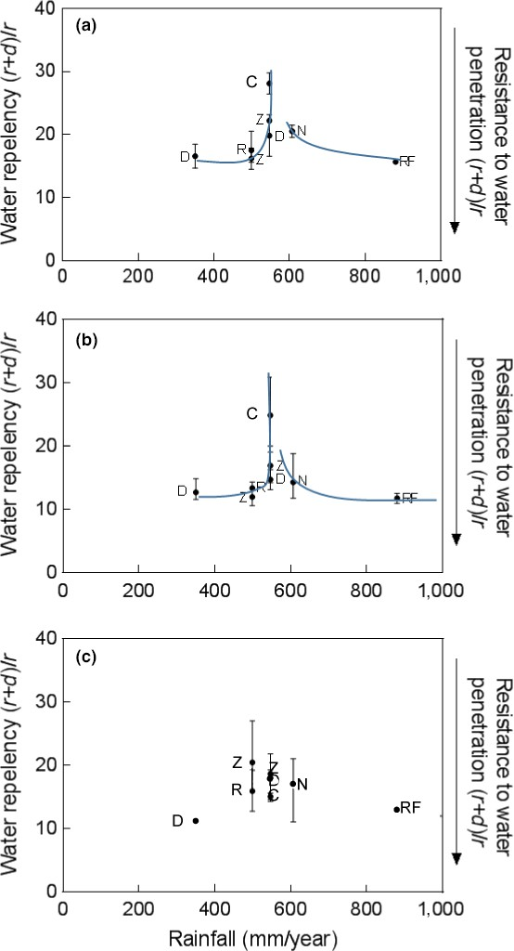

**FI GU RE 3** Plots of water repellency and resistance versus mean annual rainfall for the abdominal, breast and throat feathers of six Cisticola species, Z for Zitting, D for Desert, R for Rattling, C for Cloud, N for Neddicky and RF for Red‐faced, occurring at five different sites. (a)—abdominal feathers; (b)—breast feathers; (c)— throat feathers. 95% confidence intervals are indicated. The hand‐ drawn line through the data points on the left side of the graph highlights the increase in water repellency with rainfall in the 500 to about 580 mm/year range. The right side shows the increase in resistance to water penetration at higher rainfalls

to open water are well‐known to have adapted to a large degree to the requirements of repelling and resisting the penetration of water, depending on their specific feeding habits, but for terrestrial birds no such correlation with annual rainfall had been previously observed. There are several reasons for this. First, for the study of any relation between feather structure and rainfall, one needs to select closely related species, preferably on the genus level, that share the same feeding habits and occur in areas of different rainfall. Phylogenetic

analyses of the genus *Cisticola* confirmed the close relatedness of the species within this genus with an African origin (Nguembock, Fjeldså, Tillier, & Pasquet, 2007; Olsson, Irestadt, Sangster, Ericson, & Alström, 2013). Second, the species has to be nonmigratory so each species is only exposed to the annual rainfall in one habitat. If the same species occurs in more than one habitat with one being wetter or dryer than the other, then there should be no migratory movement between habitats or interbreeding for the specific water repellent qualities to evolve. Populations of such species need to be geographically isolated as subspecies are. Third, a minimum number of species within the genus occurring in multiple distinct habitats with a wide spread in annual rainfall is required to observe trends and substantiate conclusions. It was based on these considerations that we chose the southern African cisticolas for testing our hypoth- esis of adaptations in contour feather micro‐structure.

As shown in Figure 3, dependence of (*r + d)/r* on annual rainfall is minimal or nonexisting in the range of 350 mm to 500 mm rainfall, but rather sharply increases for areas with a rainfall of 550 mm/year. Cloud cisticolas, occurring only at Vaal, show (*r + d)/r* values between

26.5 and 29.8, which, incidentally, are larger than those of co‐habitants Zitting and Desert that are also found in dryer locations. Such high val- ues are near the upper limits for water repellency to be effective and balance with resistance to water penetration. It is therefore no sur- prise that for habitats with an annual rainfall of well over 580 mm/ year, conditions for resistance to water penetration are predominant. The Neddicky and Red‐faced cisticolas, occurring exclusively in such habitats, demonstrate this point. Figure 3 shows the means and 95% confidence intervals. These are, on the whole, larger for species occur- ring at multiple sites suggesting that their adaptation to rainfall at dif- ferent sites may be only partially complete, adapted to a wider range of conditions, or individual movement.

Note that only small changes in ramus width and spacing can alter a mostly water repellent structure into one that is water resis- tant and vice versa. This feature represents a highly adaptive trait in the evolution of contour feathers for it enabled birds to colonize specific habitats and adopt specialized feeding habits.

Feather production during moult requires energy, usually expressed in kJ/g feather (Lindström, Visser, & Daan, 1993). A tighter weave in the same feather surface would mean more keratin to be produced and therefore require more energy. A heavier or denser feather will also require more energy for the bird to fly. Moult costs increases with a decrease in body mass. For the Long‐eared Owl (*Asio otus*) and the European Kestrel (*Falco tinnunculus*), both weighing about 200–330 g, cost of feather production is about 100 kJ/g feather, while it is about 400 kJ/g feather for the Chaffinch weighing about 20–30 g (Lindström et al., 1993). Smaller birds would therefore need to spend a higher percentage of energy beyond their basal metabolic rate (BMR) during moulting than larger birds, due to lower energy efficiency for feather synthesis. For instance, 1.2 g of feather synthesized over 45 days of moult would require 47% in excess of BMR for the Blue‐throat (*Lus- cinia svecica*) (Lindström et al., 1993). For smaller birds in particular, it is likely therefore that energy consuming feather traits could be under local environmental selection pressure as these would affect fitness.

It is tempting to speculate on how future climate change involv- ing changes in annual rainfall may influence the local populations of cisticolas. It is conceivable that a drier habitat would result in a feather structure with lower water repellent properties, perhaps with a *(r + d)/r* value of about 15. This, in particular, would affect the Zit- ting and Cloud cisticolas presently occurring at Vaal. In wetter habi- tats, with a higher than 580 mm/year rainfall, a shift to even lower *(r + d)/r* values may be anticipated to acquire the needed resistance to water penetration. Food sources too will change with higher or lower rainfall. If climate change involves access to open water, fur- ther changes in feather structure may be expected such as presently seen in Dippers and shorebirds (Rijke & Jesser, 2011).

We know of no obvious explanation for the finding that throat feathers are so different from abdominal and breast feathers (Fig- ure 3). Perhaps throat feathers, as a result of their anatomic location, are less exposed to rainfall and therefore less likely to have evolved under the pressure of rainfall.

Our results present testable predictions. Species inhabiting large ranges cover multiple habitat types and rainfall regimes. The Zitting and Desert cisticolas, or other widespread, largely sedentary birds, such as some Sparrows (*Passeridae*), Prinias (*Cisticolidae*), Robins (*Muscicapidae*) and Weavers (*Ploceidae*), could present gradient adaptations to local rainfall patterns. Discontinuously ranged species, such as the Pale‐ crowned Cisticola (*C. cinnamomeus)* and Wailing Cisticola (*C. lais)*, which inhabit similar discontinuous ranges, may also have observable differ- ences and similarities in feather structure. Restricted‐range species, on the other hand, such as some larks (*Alaudidae*) may exhibit differences and coincidences of feather structure aligned with the presumably nar- row range of rainfall regimes peculiar to their distributions.

The above results are consistent with the notion that birds of the genus *Cisticola* have evolved a species‐specific feather micro‐ structure with respect to water repellency and resistance to water penetration compatible with the annual rainfall in their habitats. This study has shown for the first time a correlation between the feather micro‐structure of land birds and the annual rainfall of their habitats that is shaped by the evolutionary forces of water repellency and resistance to water penetration.

## REF E RE NCE S

Adam, N. K., & Elliot, G. E. P. (1962). Contact angles of water against sat- urated hydrocarbons. *Journal of the Chemical Society (Resumed)*, *424*, 2206–2209. <https://doi.org/10.1039/jr9620002206>

Bormashenko, E., Bormashenko, Y., Stein, T., Whyman, G., & Bor- mashenko, E. (2007). Why do pigeon feathers repel water? Hydrophobicity of pennae, Cassie‐Baxter wetting hypothesis and Cassie‐Wenzel capillarity‐induced wetting transition. *Journal of Colloid and Interface Science*, *311*(1), 212–216. [https://doi.org/10.1016/j.jcis.](https://doi.org/10.1016/j.jcis.2007.02.049)

[2007.02.049](https://doi.org/10.1016/j.jcis.2007.02.049)

Cassie, A. B. D., & Baxter, S. (1944). Wettability of porous surfaces. *Transactions of the Faraday Society*, *40*, 546–551. [https://doi.org/10.](https://doi.org/10.1039/tf9444000546) [1039/tf9444000546](https://doi.org/10.1039/tf9444000546)

S. J. De Beer, G. M. Lockwood, J. H. F. A. Raijmakers, J. M. H. Raijmak- ers, W. A. Scott, & H. D. Oschadleus (eds) (2001) *SAFRING Bird ring- ing manual. ADU Guide 5*. Cape Town, South Africa: Avian Demography Unit, University of Cape Town.

Doucet, S. M., Shawkey, M. D., Hill, G. E., & Montgomerie, R. (2006). Iridescent plumage in satin bower birds: Structure, mechanisms and nanostructural predictors of individual variation in colour. *Journal of Experimental Biology*, *209*, 380–390. [https://doi.org/10.1242/jeb.](https://doi.org/10.1242/jeb.01988)

[01988](https://doi.org/10.1242/jeb.01988)

Elder, W. H. (1954). The oil gland of birds. *The Wilson Bulletin*, *66*, 6–31. Eliason, C. M., & Shawkey, M. D. (2011). Decreased hydrophobicity of iri-

descent feathers: A potential cost of shiny plumage. *Journal of Experi- mental Biology*, *214*, 2157–2163. <https://doi.org/10.1242/jeb.055822> Kennedy, R. J. (1970). Directional water‐shedding properties of feathers.

*Nature*, *227*, 736–737. <https://doi.org/10.1038/227736a0>

King, J. R., & Farner, D. S. (1961). Energy metabolism, thermoregulation and body temperature. In A. J. Marshall (Ed.), *Biology and Comparative Physiology of Birds*, Vol. *2* (pp. 215–288). New York and London: Aca- demic Press. <https://doi.org/10.1016/B978-1-4832-3143-3.50014-9>

Landsborough Thomson, A. (Ed.) (1964). *A new dictionary of birds*. Lon- don: Nelson.

Lei, F. M., Qu, Y. H., Gan, Y. L., Gebauer, A., & Kaiser, M. (2002). The feather microstructure of passerine sparrows in China. *Journal of Ornithology*, *143*, 205–213. <https://doi.org/10.1007/BF02465449>

Lindström, Å., Visser, G. H., & Daan, S. (1993). The energetic cost of feather synthesis is proportional to basal metabolic rate. *Physiological Zoology*, *66*, 490–510. [https://doi.org/10.1086/physzool.66.4.](https://doi.org/10.1086/physzool.66.4.30163805)

[30163805](https://doi.org/10.1086/physzool.66.4.30163805)

Lucas, A. M., & Stettenheim, P. R. (1972). *Avian Anatomy-Integument. Agriculture Handbook,* part I and II, Vol 362. Washington, DC: Depart- ment of Agriculture.

Ma, M., & Hill, R. M. (2006) Superhydrophobic surfaces. *Current Opinion in Colloid and Interface Science*, *11*, 193–202. [https://doi.org/10.](https://doi.org/10.1016/j.cocis.2006.06.002) [1016/j.cocis.2006.06.002](https://doi.org/10.1016/j.cocis.2006.06.002)

Moilliet, J. L. (Ed.) (1963). *Water proofing and water repellency*. New York: Elsevier.

Nguembock, B., Fjeldså, J., Tillier, A., & Pasquet, E. (2007). A phylogeny for the Cisticolidae (Aves: Passeriformes) based on nuclear and mito- chondrial DNA sequence data, and a re‐interpretation of a unique nest‐building specialization. *Molecular Phylogenetics and Evolution*, *42*, 272–286. <https://doi.org/10.1016/j.ympev.2006.07.008>

Odham, G., & Stenhagen, E. (1971). On the chemistry of preen gland waxes of water fowl. *Accounts of Chemical Research*, *4*, 21–128.

Olsson, U., Irestadt, M., Sangster, G., Ericson, P. G. P., & Alström, P. (2013). Systematic revision of the avian family Cisticolidae based on a multi‐locus phylogeny of all genera. *Molecular Phylogenetics and Evolution*, *66*, 790–799. <https://doi.org/10.1016/j.ympev.2012.11.004>

Peacock, F. (2012). *Chamberlain's LBJ: The definitive guide to southern Afri- ca's little brown jobs*. Cape Town: Mirafra Publishing.

Rijke, A. M. (1965). The liquid repellency of a number of fluoro‐chemical finished cotton fabrics. *Journal of Colloid Science*, *20*, 205–216. <https://doi.org/10.1016/0095-8522(65)90011-5>

Rijke, A. M. (1970). Wettability and phylogenetic development of feather structure in water birds. *Journal of Experimental Biology*, *52*, 469–479. Rijke, A. M. (1972). The water‐holding mechanism of sandgrouse feath-

ers. *Journal of Experimental Biology*, *56*, 195–200.

Rijke, A. M., & Jesser, W. A. (2010). The feather structure of dippers: Water repellency and resistance to water penetration. *The Wilson Journal of Ornithology*, *122*, 563–568. <https://doi.org/10.1676/09-172.1>

Rijke, A. M., & Jesser, W. A. (2011). The water penetration and repel- lency of feathers revisited. *The Condor*, *113*, 245–254. [https://doi.](https://doi.org/10.1525/cond.2011.100113) [org/10.1525/cond.2011.100113](https://doi.org/10.1525/cond.2011.100113)

Rijke, A. M., & Jesser, W. A. (2016) Contour feathers of water birds. How do they resist the impact forces of diving, plunging and alighting? Pos- ter presented at 14 PAOC, 16-21 October, 2016, Dakar, Senegal.

Rijke, A. M., Jesser, W. A., Evans, S. W., & Bouwman, H. (2000). Water repellency and feather structure of the blue swallow *Hirundo atri- caerulea*. *Ostrich*, *71*, 143–145. [https://doi.org/10.1080/00306525.](https://doi.org/10.1080/00306525.2000.9639893)

[2000.9639893](https://doi.org/10.1080/00306525.2000.9639893)

Rijke, A. M., Jesser, W. A., & Mahoney, S. A. (1989). Plumage wettability of the african darter, *Anhinga melanogaster* compared with the

double‐crested cormorant *Phalacrocorax auritus*. *Ostrich*, *60*, 128–132. <https://doi.org/10.1080/00306525.1989.9633739>

Shafrin, E. G., & Zisman, W. A. (1952). The spreading of liquids on low‐ energy surfaces IV: Monolayer coatings on platinum. *Journal of Colloid Science*, *7*, 166–177. <https://doi.org/10.1016/0095-8522(52)90059-7> Shafrin, E. G., & Zisman, W. A. (1957). The adsorption on platinum and wettability of monolayers of terminally fluorinated octadecyl deriva- tives. *The Journal of Physical Chemistry*, *61*, 1046–1053. [https://doi.](https://doi.org/10.1021/j150554a004)

[org/10.1021/j150554a004](https://doi.org/10.1021/j150554a004)

Stettenheim, P. R. (1976). Structural adaptations in feathers. *Proceedings of the International Ornithological Congress*, *16*, 385–401.

Stettenheim, P. R. (2000). The integumentary morphology of modern birds – an overview. *American Zoologist*, *40*, 461–477.