Wide Awake local anesthesia no tourniquet (WALANT) versus Bier’s block, in internal fixation of unstable metacarpal and phalangeal fractures of the hand: A comparative study

Abstract
Hand fractures are a common injury in emergency department, and the majority of these are stable injuries that can be treated conservatively with excellent functional results. When respective injuries are characterized as unstable, surgical reduction and stabilization is necessary. Generally, these operations are conducted under regional or general anesthesia to avoid pain and tourniquet for bloodless surgical fields. Wide Awake local anesthesia no tourniquet (WALANT) procedure is described as a local injection of anesthetic agent and epinephrine without tourniquet application, with scope to allow local anesthesia without other sedation and at the same time hemostasis. The purpose of the study is to compare the functional assessment of the hand function during a period of three months after surgical intervention for unstable metacarpal and phalangeal fractures under WALANT versus Biers block.
Material &Methods: Between May 2021 to October 2022, 43 patients with unstable metacarpal and phalangeal fractures underwent open reduction and internal fixation, 21 cases with Biers block(BB) anesthesia and rest with WALANT technique. Metacarpal fractures appeared in 29 cases and phalangeal fractures in 14 patients. Patients were operated within the first week from the injury. According to implants they employed locking plates, screws and Kirschner wires in two groups.
Results: At three months postoperatively, Quick Dash Score is better in WALANT group while patients’ satisfaction does not differ between two groups. In WALANT group immediate postoperative median VA Score appeared 2/10, while in the Biers block group appeared 6/10. Patients which underwent WALANT technique were discharged on the same day after operation, while the patients with regional anesthesia the next postoperative day. Mean duration of analgesic use was shorter in WALANT group (2,3 days) than in BB group(5,7 days).
Conclusion: Οbjective of surgical treatment of unstable hand fractures (metacarpal-phalangeal) is early mobilization and enhance hand functionality to avoid stiffness and tendon adhesions. Wide Awake Local Anesthesia No Tourniquet technique is an alternative sedative procedure which immediately offers postoperative numerous advantages (low-cost technique, no complication from tourniquet, decrease sensation of intra or postoperative pain) compared with Bier’s block anesthesia. Based on our results we believe that WALANT technique offers many benefits in surgical treatment of hand fractures and is suggested as first choice anesthesiologist procedure.
Keywords: Metacarpal fracture, phalangeal fractures, internal fixation, WALANT, Biers Block

Introduction
Hand fractures (metacarpal-phalanx) are some of the most often fractures encountered at the emergency department. They have an incidence of 10% - 19% of all human body fractures, while metacarpal fractures constitute about one-third of all hand fractures.^{1,2} They are found more often in the active working population, between the second and third decades of life and they have a large economic concern in terms of treatment costs and impairment of hand functional incapacity.⁴ Anakwe et al(2011) in an epidemiology study of hand fractures refer to an incidence of 3.7 per 1000 per year for men and 1.3 per 1000 per year for women.³ The main mechanism of injury is related to gender. In men, these are related to direct trauma, or a punching mechanism and the most common fracture is the little finger metacarpal, while in women the mechanism is fall or work-related injuries.^{3,5}
The majority of metacarpal and phalangeal fractures are stable injuries, and the conservative treatment is the proper therapy. Unstable hand fracture is defined the fracture which cannot be reduced by closed reduction or cannot maintain the reduction, the multiple hand fractures, and the open fractures.⁶ Day et al(2010) reported that three main factors (shortening, dorsal angulation, rotation deformity) determine the stability of displaced metacarpal fractures.¹ To restore the proper anatomy of metacarpal or phalangeal bones, open or closed surgical reduction and stabilization with an implant has been proposed with scope to allow early mobilization and to reinstate hand functionality.^{7,8}
To achieve hand surgery procedure two main factors are essential: Anesthesia to avoid pain and suffering from the tourniquet application and a bloodless surgical field. In general, for surgical fixation of hand fractures various methods have been proposed like general anesthesia, regional block, Bier block.⁹ Sellbrandt et al (2017) presented a study to identify which anesthetic procedure affects postoperative pain for open surgical repair of wrist fracture. He concluded that short term regional anaesthesia presents more benefits compared with other techniques.¹⁰ In situations where surgery may have prolonged duration of time, the general anesthesia is compulsory as tourniquet becomes intolerable after a mean of twenty minutes (varied from 19.4 to 24,1min), while prolonged duration of application of tourniquet use is associated with nerve, muscle injury and toxic metabolic release into the systemic circulation after its release .^{11,12}
The term Wide awake anesthesia is described as local injection of anesthetic agent(lidocaine) and epinephrine without other sedation and without tourniquet.¹³ During the pandemic period, the WALANT procedure started to become more popular among hand surgeons because it is performed without anesthetic support and is accessed to general surgical theatre.¹⁴ Main advantage of the procedure is that the combination of lidocaine and adrenaline allows to ensure local anesthesia and at the same time hemostasis is achieved with patient being comfortable since there is no need of tourniquet. In addition, intraoperative examination of patient to ascertain stability of the fracture osteosynthesis and whether soft-tissue impingement interrupted active range of motion of involved finger.¹⁵
The aim of this study is to compare the effectiveness of WALANT technique versus Bier’s block in surgical fixation of unstable metacarpal and phalangeal fractures, during a period of three months postoperatively in a case series from our hand reconstruction unit according patient’s satisfaction, complications, and functional outcomes.

Material & Methods
This study was performed at the Orthopaedic Department of General Hospital of Heraklion-“Venizeleio-Pananeio” from May 2021 to October 2022. The Institutional Ethical Committee approved the study. Inclusion criteria were: I age > 18 years, II open fractures without soft tissue loss, III closed unstable metacarpal or phalangeal unstable fracture, IV isolated or maximum two unstable metacarpal or phalangeal fractures, adequate understanding of language, V follow-up interval of at least three months. Exclusion criteria were: I age<18 years old, II diseases such as scleroderma, Raynaud, Vasculitis, III corrective osteotomies, IV finger amputation injuries, V open fractures with soft tissue loss that required second operation, VI polytrauma patients, VII hand vascular injuries. Indications for operative treatment were: open fracture, comminuted fractures, fractures with rotational malalignment of digit, shaft angulation >20°-40° (depending on the metacarpal: 2nd-3rd >20°, 4th >30°, 5th >40°) and shaft shortening >2mm, intraarticular displacement, angulation >10°(phalangeal fracture).
Forty-three patients (32 men and 11 female) with a mean age of 35.5 years underwent surgical treatment in our department for unstable metacarpal or phalangeal fractures. (Table I) Patients were receiving WALANT or Biers block (BB) randomly. All patients were operated on by the author, within the first week of the injury. Twenty-two patients receive the WALANT (first group) technique and 21 cases BB (second group). From the first group were 15 cases with metacarpal fractures (two cases with two metacarpal fractures: (4th and 5th) and 7 cases with phalangeal fractures, while in the second group 17 patients with metacarpal fractures (one case with double fracture: 3rd and 4th) and 4 phalangeal fractures. Open reduction was performed in 35 cases and closed reduction in 8 cases. Open fractures were in 5 cases (one metacarpal grade I, one in proximal phalanx grade I, and the rest in middle phalanxes grade II). According to surgical stabilization implants in 31 cases were applied low profile locking plates, in 7 cases only cortical screws and in 5 cases Kirschner wires. (Table II) Before surgery, all patients received one dose of cefazoline 2g.

Anesthesia

WALANT procedure
We prepared an analgesic-hemostasis mixture of 10cc of premixed 1% lidocaine with 1:100.000 adrenaline and 1ml of bicarbonate sodium 8.4% according to the Lalonde technique.¹³ To decrease injection pain 27-gauge needles were used, and the rhythm of injection was slow according to Hamelin et al instructions.¹⁶ A total of 20 ml of the mixture was injected for the metacarpal fractures while for the phalangeal fracture 12 ml. First 10 ml was injected at subcutaneous fat on the proximal edge at the dorsal surface of the involved metacarpal. (Fig 1(a),1(b), 1(c)) Next, we injected 8 ml at the middle side of the metacarpal and at the metacarpophalangeal joint 2ml. For phalangeal fractures we injected 4 ml at the dorsal side of the metacarpophalangeal joint, and 4 ml in subcutaneous fat of the volar side of the metacarpal head, followed by 2 ml at the dorsal side of the proximal and middle involved phalanges.(Fig 2(a), 2(b), 2(c)) In cases with two metacarpal fractures initial injection(15ml of the mixture) is performed in the space between the proximal ends of the involved metacarpal, followed by injection at the middle area of both sides of the involved bone with a mixture of 8 ml. Finally at the metacarpophalangeal joint we injected 2ml in every involved bone.^{13,15,17}

Biers block procedure
They were performed in the operative room with the anesthesiology group. A mixture of solution volume of 40ml was injected intravenously. Specific mixtures were contained: Lidocaine 2% in dosage 2.5 mg/Kg, Ropivacaine 0.75% % in volume 5 ml, Pethidine 1mg/Kg, Dexamethasone 8mg, Ondansetron 8 mg, Magnesium 25% in dosage 20mg/Kg and N/S 0.9% %. Pneumatic tourniquet was inflated to a mean 250 mmHg (range from 220-270 mmHg varied from the blood pressure of patient). Sensory and motor blockade was obtained after 10 minutes from the injection.

Surgical procedure
The patients were placed in supine position under fluoroscopic control. In the WALANT group the operation was started 20 minutes after the injections while in the BB group a mean of 10 minutes. The approach was dorsal, between the space of the involved metacarpal and the adjacent. In cases with 1st metacarpal fracture, a Wagner approach was performed, while in cases with 5th metacarpal fracture, the approach was dorsoulnar. In patients with phalangeal fractures, the approach was dorsal over the midline of the involved phalanx.
After dissection of subcutaneous tissue, the extensor tendons were relocated radially or ulnarly and the juncturae tendenium was sectioned for better visualization of the fracture line. In majority of cases the periosteum was released from bone and the fracture was reduced by traction of the involved digit. The reduction was secured by reduction clamp and imagining intensifier control was performed. The plates were applied in the dorsal surface of the bone, except for 5th metacarpal fractures in which they were applied on the ulnar surface of the 5th metacarpal bone. In cases which performed closed reduction the fractures (middle phalanx) were stabilized with one or two Kirchner wires.
In WALANT group, patients were asked to perform active range of motion of the involved digit, with scope to control the stability of osteosynthesis, tendon friction on the plate or malreduction. In the BB group, the range of motion was performed passively by the surgeon.(see Video, Supplemental Digital Content)
Finally, in both groups, examination with C-arm intensifier was performed to check the final osteosynthesis and screw sizes. Sufficient soft tissue closure over the plate was secured to decrease the extensor tendon irritation and repair the junction tendenium in cases in which it was sectioned.
In both groups postoperatively a volar cast was applied to control swelling, and pain and enhance soft tissue healing. The stitches were removed in two weeks, while the cast remained, depending on the comminution of the fracture and the quality of the osteosynthesis, for a varying period of two to four weeks. In cases with Kirschner wire, they were removed at four weeks postoperatively.
A standard rehabilitation protocol program from the first postoperative day was applied in all patients starting from adjacent joints. Active-assisted exercises were performed in free finger joints while supervised physiotherapy treatment was initiated, after the immobilization phase and after the cast removal. Continuous passive movement and active assisted exercises in wrist and finger joints were performed initially to restore the range of motion. Patients were trained to follow a personalized home-based daily exercise program to increase the range of movement and enhance muscle strength and grip strength in a later phase.

Statistical analysis
The mean VAS score was measured on the first postoperative day and one-week post operation for each group. The mean duration needed for postoperative analgesia was estimated as well. The mean quick DASH score and a Likert type of scale regarding satisfaction, three months after the operation were measured.
The means of the VAS score, the mean duration of postoperative analgesia and the mean quick DASH score between the two groups were compared using the unpaired one-tailed t-test. The Mann-Whitney U test for nonparametric variables was used to compare the three months post-operation satisfaction between the walant and the RA group. The SPSS 25.0 program was used for the statistical analysis.

Results
The minimum follow-up was three months. None of the patients missed out on the last re-examination. Patients were assessed on the first postoperative day, in one, in two weeks and in 1,3 months post surgically. Results were evaluated according to fracture union (determined by follow-up x-rays), complications, Visual Analogue pain Scale, Quick Dash Score, duration of postoperative analgesia and satisfaction of the patients (Patient satisfaction rating scale).¹⁸ According to complications, we distinguished them into two categories: first the category of complication regarding the type of anaesthesia (change of method of anaesthesia) and second the category concerned consolidation of the fracture.
All patients with the WALANT procedure were discharged on the same day from the clinic while the cases from the second group were discharged on the 1st postoperative day except two cases which were discharged on the second day because of numbness distribution median nerve. The mean VAS score on the first postoperative day for the WALANT anaesthesia group was 2.1 (range: 0-4, SD: 2) and 5.7 (2-7, SD: 1.25 ) for the Biers block group respectively and this difference was statistically significant ( p-value <0,00001). The mean VAS score one-week post operation for the WALANT group was 1,1 (0-3, SD: 0,75) and for the BB group was 2,3(0-4, SD: 2). This difference was also statistically significant (p value = 0,006). The same result was found for the mean duration of postoperative analgesia, as this variable reflects the mean VAS score.
Regarding complications in the WALANT group, no patients required additional another anesthetic method to control pain during surgery, while in the BB group respectively in two cases in ΒΒ group converted to general anesthesia. Consolidation of the fracture was obtained by radiography examination (anteroposterior lateral and oblique views) post-surgically in 1,3 months. The union of fracture in the majority of cases was obtained with an average period of 5,8 weeks (range from 4,2 to 8,5 weeks) in both groups. Three cases appear with delay union (two from the WALANT group and another from the BB) for more than 10 weeks. The mean quick DASH score three months post-operation was 4,5(0 -6,8, SD: 1,7) and 6,8(0-9,1, SD: 2,275) for the WALANT and BB groups respectively. This difference was statistically significant ( p-value = 0,0003). We believe that the intraoperative collaboration of the patients enhances two major factors: first, it enables the control of the stability of osteosynthesis and eventual soft tissue impingement (extensor tendons) and second, it gains patients’ confidence to initiate active early range of motion.
Finally, all patients’ responses to major questions reported to the satisfaction rating scale with five elements (very satisfied, satisfied, neutral, unsatisfied, very unsatisfied). Out of the WALANT procedure, the majority of patients were very satisfied or satisfied (86,3%) while in the BB group the results approximately were the same with a per cent of 85,7% being very or satisfied. (Table III). No difference was found regarding the satisfaction three months postoperatively between the two groups (p-value = 0,92).

Discussion
Unstable metacarpal or phalangeal fractures are common injuries with the main treatment to be open or close reduction and internal fixations with locking plates or Kirshner wires. G The goal of surgical treatment is early mobility of the affected digit, decreased stiffness and restoration of functional ability of patients. To achieve these, two interrelated factors must be present: sedation to control surgical pain and tourniquet discomfort and a bloodless surgical field. Traditional hand surgery is performed under general anaesthesia (GA) or wrist blocks. Brachial plexus anaesthesia requires a specialized operator, patients must be monitored to avoid complications (pneumothorax) and this is not successful in all cases.²⁵ Bier’s block (with or without supplemental sedation or analgesia) with arm or forearm tourniquet is the most common type of local anaesthesia in hand surgery but presents all complications of tourniquet’s application and system lidocaine toxicity.^{24,26} Many studies have described the complications(post-tourniquet thrombosis, bleeding, postoperative pain, blisters, skin burn, ischemia and reperfusion, neuromuscular damage) of tourniquet when application is more than twenty minutes, which additionally aggravates rehabilitation of the initial injury.^{26,29,32}
Hustedt et al(2017) compared postoperative complications for hand surgery treated with local or regional anaesthesia with or without sedation and general anaesthesia and suggested that GA must be avoided especially in ages over 65 years because of the increased incidence of complications.²⁷ Two studies present the superiority of regional anaesthesia for hand surgery: Chan et al(2001)compared intravenous regional anaesthesia, brachial plexus block and general anaesthesia for outpatient hand surgery patients and concluded that regional anaesthesia presented more favourable patient recovery, decreased postoperative hospitalization care time and less postoperative nausea and vomiting percentage.²⁸ Galos et al(2016) presented the same point of view in a randomized control study, comparing GA versus brachial plexus block in distal radius fracture surgery treatment and concluded that postoperative pain was decreased in the group with regional anaesthesia but brachial plexus block is associated with rebound pain if not treated appropriately.²⁹
Term Wide awake anaesthesia is described as the local injection of anaesthetic agent(lidocaine) and epinephrine without other sedation and without a tourniquet introduced by Lalonde(2009).¹⁵ Additionally, author suggests information about areas of injection, volume and constituents of mixture anaesthetic for flexor tendon repair, also introduces active participation (intra-operative) of the patients as a part of the surgical technique.^{15,17} In the following years until the pandemic period of COVID -19, many researchers presented their positive results applying the WALANT technique to their studies or compared it with other anaesthetic procedures in hand surgery, but the method did not have much appeal in the hand surgeons’ community.^{19,20} The COVID-19 pandemic period enforced an alteration according to the functionality of the staff (anesthesiologist) and health facilities for the treatment of the affected patients with the virus. This new situation inducted a hand surgeon to find alternative methods of anaesthesia with similar results to the existing ones. During the pandemic period, the WALANT procedure started to be more popular among hand surgeons because it is performed without anaesthetic support and is accessed to the general surgical theatre or emergency department area, for minor hand surgeries (carpal tunnel syndrome, trigger finger) or flexor tendon injuries of the hand ^{19,20,21,22} Wide Awake Local Anaesthesia No Tourniquet procedure used in the following years by other hand surgeons increased the indications of this anaesthetic procedure and Brown et al(2021) described the indication of the WALANT procedure which except primary indication included all complex injuries of the hand or wrist.^{15,30}
In the literature, there are researchers who present the benefits of the WALANT method compared with GA or locoregional anaesthetic procedures. Ki Lee et al(2020) showed that in minor hand surgery(carpal tunnel, trigger finger release, De Quervain) the duration of effective anaesthesia was double in WALANT in contrast with regional anaesthesia and the necessity of the administration of analgesics, in the first two days was lower in WALANT.³¹ Abitbol et al(2021) compared WALANT and RA in surgical plated treatment of unstable distal radius fractures showing better functional outcomes, resumption to previous work at three months and earlier stoppage of analgesia with the WALANT technique.³³ Xing et al(2014) in 7 patients with metacarpal fracture and 21 cases of hardware removal with the WALANT anaesthetic approach suggested that this method eliminated the risk of the GA or RA and tourniquet application, while the intraoperative participation of the patients achieves revision of the osteosynthesis if necessary, medical cost is lower, and patients’ satisfaction is greater.³⁴ Feldman et al(2020) in 10 patients with an unstable metacarpal fracture with WALANT suggested the method because the surgeon has the advantage to reduce malunion or revision of the osteosynthesis, especially in internal fixation with headless screws.²⁴ Moscato et al(2021) compared WALANT versus local anesthesia with peripheral nerve block for trapeziometacarpal arthroplasty and reported better functional outcomes in the WALANT group.³⁶
In our study, in three cases with phalangeal fractures (two proximal one case middle) in active range of motion, we distinguished rotational deviation, and we revised the osteosynthesis (two cases with plate and in other with screws). This possibility cannot be provided by the other anaesthetics procedures. According to functional outcomes (Quick Dash Score), postoperative pain (VAS) or use of analgesics, and hospitalization care time we had the same satisfied results with Abitbol and Lin in WALANT procedure.^{33,38}
Finally, according to the cost of hand surgery, WALANT reduces the cost because preoperative tests are not necessary, an anaesthesiologic team, medication or monitoring are not needed, and hospitalization care time is decreased.³⁷ Lin et al(2021) estimated that the cost of treatment for internal fixation of metacarpal fracture is lower than 287 USD per case in WALANT instead of GA.³⁸ Maliha et al(2019) presented that the cost in trigger finger with WALANT is decreased to a third compared with convectional anaesthesia, while Bismil et al(2012) demonstrated $ 3.2 million in saving with WALANT anaesthetic procedure on the first 1000 cases with minor hand surgery with respective technique^{.39, 40}
The strength of this study is that statistically significant differences were found regarding the short-term postoperative pain and the mean quick DASH score three months post-operative between the WALANT and the RA group, favouring the WALANT technique. This result is most likely explained by the fact that the WALANT type of anaesthesia allows a quicker rehabilitation and mobilization compared to the BB technique. The limitations of this study are, that this is a retrospective study based on the results of a single institution, this is a non-blinded retrospective cohort study with a small sample size of each group. The grouping of the patients was randomized without patient preferences. A small number from WALANT group were anxious about the ability of the procedure after the explanation of the method, the follow-up time of patients is short and maybe a longer time may present different results.

Conclusion

The main purpose of surgical treatment of unstable hand fractures (metacarpal-phalangeal) is early mobilization to enhance hand functionality and to avoid stiffness functional incompetence. Wide Awake Local Anaesthesia No Tourniquet technique is an alternative procedure which offers numerous advantages (low-cost technique, decreased complication from tourniquet, less of intra or postoperative pain) compared with Bier’s block anaesthesia. According to functional outcomes, the WALANT procedure seems to be better than the Biers block, and this relies on the method ability of intraoperative participation of the patient in the procedure. . Based on our results, we believe that the WALANT technique offers many benefits in the surgical treatment of hand fractures and can be suggested as a first choice of anaesthesiology procedure.

References
- Day CS, Stern PJ. Fractures of metacarpals and phalanges. In: Wolfe SW, Pederson WC, Hotchkiss RN, Kozin SH, Cohen MS, eds. Green’s Operative Hand Surgery. 6th ed. Philadelphia, PA: Elsevier Churchill Living stone; 2010:239–290.
- Van Onselen EBH, Karim RB, Hage JJ, Ritt MJPF. Prevalence and distribution of hand fractures. J Hand Surg Br 2003;28(5):491–5,doi:10.1016/s0266-7681(03)00103-7.
- Anakwe RE, Aitken SA, Cowie JG, Middleton SD, Court – Brown CM. The epidemiology of the fractures of the hand and the influence of social deprivation. J Hand Surg Eur Vol. 2011;36(1):62-65, doi:10.1177/1753193410381823.
- Nakashian MN, Pointer I, Owens BD, Wolf Jm. Incidence of metacarpal fracture in the US population. Hand 2012;7(4):426-430.doi:10.1007/s11552-012-9442-0.
- Debski T, Noszczyk BH. Epidemiology of complex hand injuries treated in the plastic surgery department of a tertiary referral hospital in Warsaw. Eur J Trauma Emerg Surg. 2012;47(5):1607-12, doi:10.1007/s00068-020-01312-5.
- Margic K. External fixation of closed metacarpal and phalangeal fractures of digits. A prospective study of one hundred consecutive patients. J Hand Surg 2006;31(1):30-40, doi:10.1016/j.jhsb.2005.09.013.
- Meals C, Meals R. Hand fractures: a review of current treatment strategies. J Hand Surg Am 2013;38(5):1021–31, doi:10.1016/j.jhsa.2013.02.017.
- Kastanis G, Magarakis G, Kapsetakis P, Pantouvaki A. Fixation of unstable diaphyseal metacarpal fractures with low profile locking plates: Case series – Current concepts. J of Med Science and Clinic Research. 2021;9(10):1-12, doi:10.18535/jmscr/v9i10.01.
- Haghighi M, Mardani-Kivi M, Mirbolook A, Tehran SG, Saheli NA, Hashemi- Motlagh K, Sahbe – Ekhtiari K. A comparison between single and double tourniquet technique in distal upper limb orthopedic surgeries with intravenous regional anesthesia. Arch Bone Jt Surg 2018;6:63–70.
- Sellbrandt I, Brattwall M, Warre´n Stomberg M, Jildensta˚ P, Jakobsson JG. Anaesthesia for open wrist fracture surgery in adults/elderly. F1000Res 2017;13(6):1996, doi:10.12688/f1000research.13004.1.
- Tanpowpong T, Kitidumrongsook P, Patradul A. The deleterious effects of exsanguination with a tight bandage on tourniquet tolerance in the upper arm. J Hand Surg Eur Vol 2012;37(9):839-42, doi:10.1177/1753193412442288.
- Oragui E, Parsons A, White T, Longo UG, Khan WS. Tourniquet use in upper limb surgery. Hand (N Y) 2011;6(2):165–73, doi:10.1007/s11552-010-9312-6.
- Lalonde D, Martin A. Tumescent local anesthesia for hand surgery: improved results, cost effectiveness, and wide-awake patient satisfaction. Arch Plast Surg 2014; 41(4): 312-6, doi:10.5999/aps.2014.41.4.312
- Hobday D, Welman T, O’Neill N, Pahal GS. A protocol for wide awake local anesthetic no tourniquet(WALANT) hand surgery in the context of coronavirus disease 2019(COVID-19) pandemic. Surgeon 2020, 18(6):e67-71,doi:10.1016/j.surge.2020-06.015.
- Lalonde DH. What is wide awake hand surgery? In: Lalonde D, editor. Wide awake hand surgery. CRC Press Taylor & Francis Group;2016.,p 17-23.
- Hamelin ND, St-Amand H, Lalonde DH, Harris PG, Brutus JP. Decreased the pain of finger block injection: level II evidence. Hand (N Y) 2013;8(1):67–70, doi:10.1007/s11552-012-9478-1.
- Lalonde D. How to inject local anesthetic with minimal pain. In Lalonde D, editor. Wide awake hand surgery. New York Stuttgart: Thieme;2015.p.37-48.
- McKinley RK. Manku-Scott T, Hastings AM, French DP, Baker R. Reliability, and validity of a mew measure of patient’s satisfaction with out of hours primary medical care in the United Kingdom: Development of a patient’s questionnaire. BMJ,1997;314(7075):193-198,doi:10.1136/bmj.314.7075.193.
- Higgins A, Lalonde D, Bell M, McKee D, Lalonde JH. Avoiding flexor tendon repair rupture with intraoperative total active movement examination. Plast Reconstr Surg 2010; 126(3): 941-945. doi:10.1097/PRS. 0b013e 3181e60489.
- Gunasagaran J, Sean E, Shivdas S, Amir S, Ahmad T. Perceived comfort during minor hand surgeries with wide awake local anaesthesia no tourniquet (WALANT) versus local anaesthesia (LA)/tourniquet. Journal Orthopaedic Surgery (Hong Kong) 2017; 2593:1-4 30949. doi: 10.1177/2309499017739499.
- Ruxasagulwong S, Kraisarin J, Sananpanich K. Wide awake technique versus local anesthesia with tourniquet application for minor orthopedic hand surgery: a prospective clinical trial. J Med Assoc Thai. 2015,98(1);106-10.
- Kastanis G, Kapsetakis P, Trachanatzi E, Chaniotakis C, Siligardou MK, Andriopoulos C, Pantouvaki A. Wide -Awake local anesthesia no tourniquet(WALANT) procedure for primary repair of traumatic rupture of flexor tendon of the hand: A single center experience. Int J of Innovative Research in Med Science, 2022;7(12):771-776, doi.org/10.23958/ijirms/vol7-i12/1591.
- Huang YC, Chen CY, Lin KC, Yang SW, Tarng YW, Chang WN. Comparison of wide-awake local anesthesia no tourniquet with general anesthesia with tourniquet for volar plating of distal radius fracture. Orthopedics 2019;42(1):e93–8, doi:10.3928/01477447-20181206-01.
- Feldman G, Orbach H, Rinat B, Rozen N, Rubin G. Internal fixation of metacarpal fractures using wide awake local anesthesia and no tourniquet. Hand Surg Rehabil 2020;39(3):214–7, doi:10.1016/j.hansur.2020.01.003.
- Vaid VN, Shukla A. Inter Scalene Block: Revisiting old technique. Anesth Essays Res 2018;12(2):344–8, doi:10.4103/aer.AER_231_17.
- Vaughn N, Rajan N, Darowish M. Intravenous regional anesthesia using a forearm tourniquet: A safe and effective technique for outpatient hand procedures. Hand (N Y) 2018;15(3):353-359, doi10.1177/1558944718812190.
- Hustedt JW, Chung A, Bohl DD, Olmschied N, Edwards SG. Comparison of postoperative complication associated with anesthetic choice for surgery of the hand. J Hand Surg Am 2017;42(1):1-8, doi:10.1016/j.jhsa.2016.10.007.
- Chan VWS, Peng PWH, Kaszas Z, et al. - Anesth Analg. 2001;93(5):1181-1184. Doi:10.1097/00000539-200111000-00025.
- Galos DK, Taormina DP, Crespo A, et al. Does brachial plexus blockade result in improved pain scores after distal radius fracture fixation? A randomized trial. Clin Orthop. 2016;474(5):1247e1254, doi:10.1007/s11999-016-4735-1.
- Brown M, Bainbridge C, Wong J, Phillips A. Wide Awake Surgery Handbook. British: British Society for Surgery of the Hand. Accessed July 20, 2021, at: https:// www. Bssh .ac. uk/_ userfiles/pages/files/COVID/Wide%20Awake%20Hand%20Surgery%20 Hand book%20v2.pdf7
- Ki Lee S, Gul Kim S, Sik Choy W. A randomized controlled trial of minor hand surgeries comparing wide awake local anesthesia no tourniquet and local anesthesia with tourniquet. Orthop Traumatol Surg Res 2020;106(8):1645–51, doi:10.1016/ j.otsr.2020. 03.013.
- Edwards SA, Harper GD, Giddins GEB. Efficacy of forearm versus upper arm tourniquet for local anaesthetic surgery of the hand. J Hand Surg Br 2000;25(6):573–4, doi:10.1054/ jhsb.2000.0420.
- Abitbol A, Merlini L, Masmejean EH, Gregory T. Applying the WALANT technique to surgical treatment of distal radius fractures. Hand Surg Rehabil 2021;40(3):277–82, doi:10.1016/j.hansur.2021.02.001.
- Xing SG, Tang JB. Surgical treatment, hardware removal, and the wide-awake approach for metacarpal fractures. Clin Plast Surg 2014;41(3):463–80, doi: 10. 1016/ j.cps. 2014. 03.005.
- Ruterana P, Abitol A, Castel L-C, Gregory T. WALANT technique versus locoregional anesthesia in the surgical management of metacarpal and phalangeal fractures: Lessons from the Covid-19 crisis. Hand Surg Rehabil 2022;41(2):220–25, doi:10.1016/ j.hansur. 2021.12.002.
- Moscato L, Laborde A, Kouyoumdjian P, Coulomb R, Mares O. Trapeziometacarpal (TMC) arthroplasty under Wide Awake Local Anesthesia with No Tourniquet (WALANT) versus Local Anesthesia with peripheral nerve blocks (LAPNV): perioperative pain and early functional results in 30 patients. Hand Surg Rehabil 2021;40(4):453–7, doi:10.1016/j.hansur.2021.03.006.
- Yen CY, Ma CH, Wu CH, Yang SC, Jou IM, Tu YK. A cost and efficacy analysis of performing arthroscopic excision of wrist ganglions under wide-awake anaesthesia versus general anaesthesia. BMC Musculoskelet Disord. 2020;21(1):459, doi:10.1186/s12891-020-03482-0.
- Lin YC, Chen WC, Chen CY, Kuo SM. Plate osteosynthesis of single metacarpal fracture: WALANT technique is a cost-effective approach to reduce postoperative pain and discomfort in contrast to general anesthesia and wrist block. BMC Surg.2021;21(1):358. doi:10.1186/s12893-021-021-01362-5.
- Bismil M, Bismil Q, Harding D, et al. Transition to total one-stop wide-awake hand surgery service-audit: a retrospective review. JRSM Short Rep. 2012;3(4):23, doi:10.1258/ shorts.2012.012019.
- Maliha SG, Cohen O, Jacoby A, Sharma S. A cost and efficiency analysis of the WALANT technique for the management of trigger finger in a procedure room of a major city hospital. Plast Reconstr Surg Global Open 2019;7(11):e2509, doi: 10.1097/GOX. 0000000000002509.

Table I. Demographic details- Surgery Characteristics
Groups
WALANT (n=22%) BB (n=21/%)
Gender M/F | 17/5( 77.2 %/ 22.8 %) | 15/6 ( 71.4 %/ 28.6 %)
Mean Age | 33yr (22-46) | 38yr o (20-52)
Hand Involved (Right/Left) | 17/5(77.2 %/ 22.8%) | 18/3( 85.7%/ 14.3%)
Dominant Hand (Right/Left) | 14/4( 63.7 %/18.1%) | 15/3( 71.4%/ 14.2%)
Work-related Injuries | 14(%) | 15( 71.4%)
Manual Workers | 16(%) | 17( 80.9%)
Mean Surgery Duration (min) | 44.2 | 45.8
Complementary anaesthesia | 0(0%) | 2( 9.5%)
WALANT: Wide Awake local anesthesia no tourniquet, BB: Bier’s block, n: Number

Table II. Fracture – Method of Treatment
Groups
WALANT (n=22/%) BB (n=21/%)
Bone (Metacarpal Phalanx) | 15/7(68,1%/31,9%) | 16/5(76,2%/23,8%)
Open Fractures | 2(9,1%) | 3(14,2%)
Open reduction/ Closed reduction | 18/4(81,9%/18,1%) | 17/4(80,9%/19,1%)
K- Wire  Fixation Procedure Screws  Plate | 2(9,1,%)  4(18,2%)  16(72,7%) | 3(14,3%)  3(14,3%)  15(71,4%)
WALANT: Wide Awake local anesthesia no tourniquet, BB: Bier’s block, n: Number

Table III. Functional Outcomes
Groups
WALANT (n=22) BB (n=21) P- value
Mean VAS score | 1st Postoperative Day |  | 2,1 (0-4), SD: 2 | 5,7(2-7), SD: 1,25 | p < 0,00001
Mean VAS score | 1 week postoperative |  | 1,1 (0-3), SD: 0,75 | 2,3(0-4), SD: 2 | p = 0,006
Mean Quick DASH score( 3 months) |  |  | 4,5(0 -6,8), SD: 1,7 | 6,8(0-9,1), SD: 2,275 | p = 0,0003
Mean Duration of postoperative analgetic |  |  | 2,3 days  (0-5), SD: 1,25 | 5,7 days  ( 1-7), SD: 1,5 | p < 0,00001
Satisfaction |  | Very Satisfied | 14 | 15 | p = 0,92
 |  | Satisfied | 5 | 3 | p = 0,92
 |  | Neutral | 3 | 1 | p = 0,92
 |  | Unsatisfied | 0 | 2 | p = 0,92
 |  | Very Unsatisfied | 0 | 0 | p = 0,92

Figures
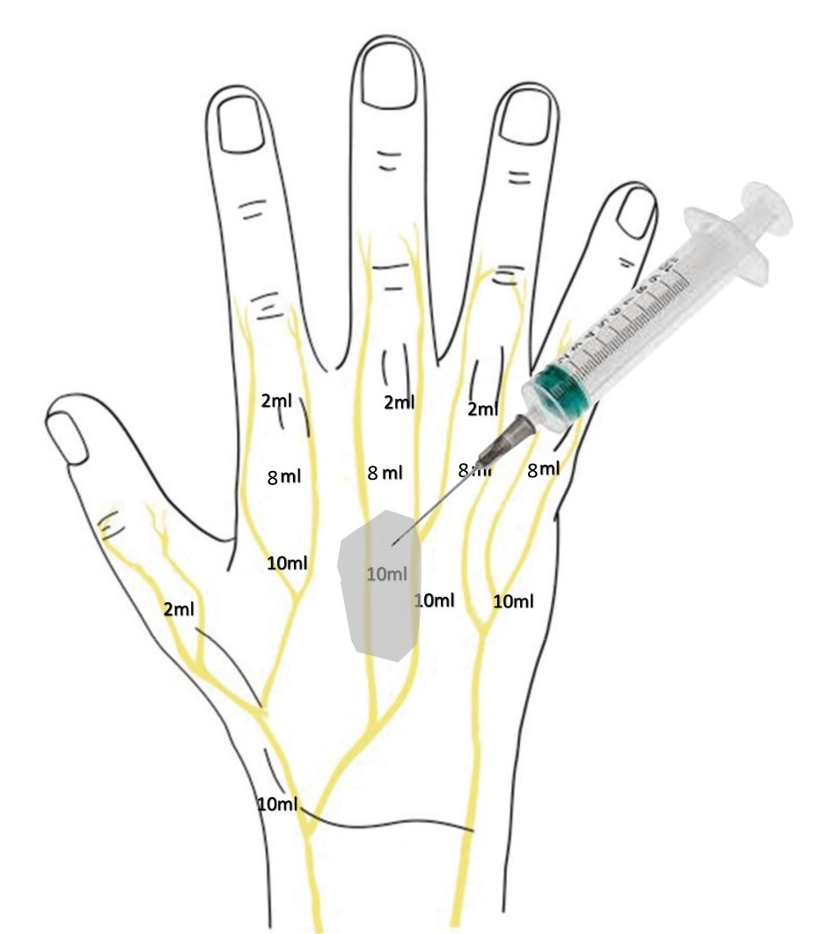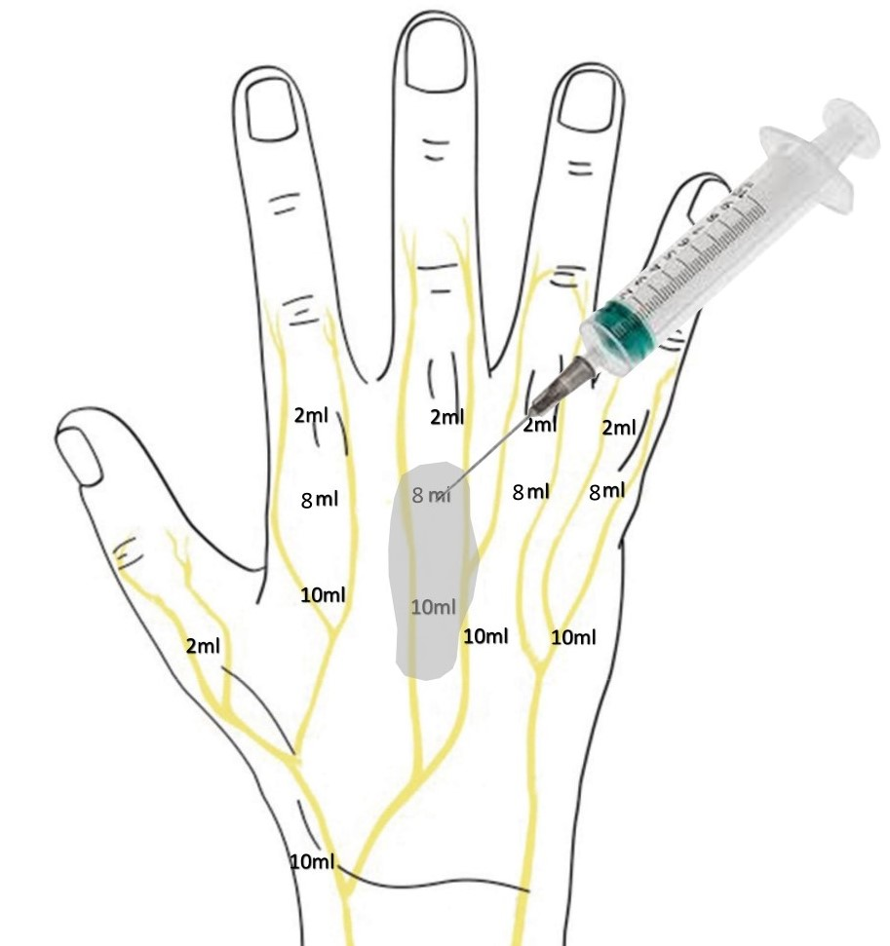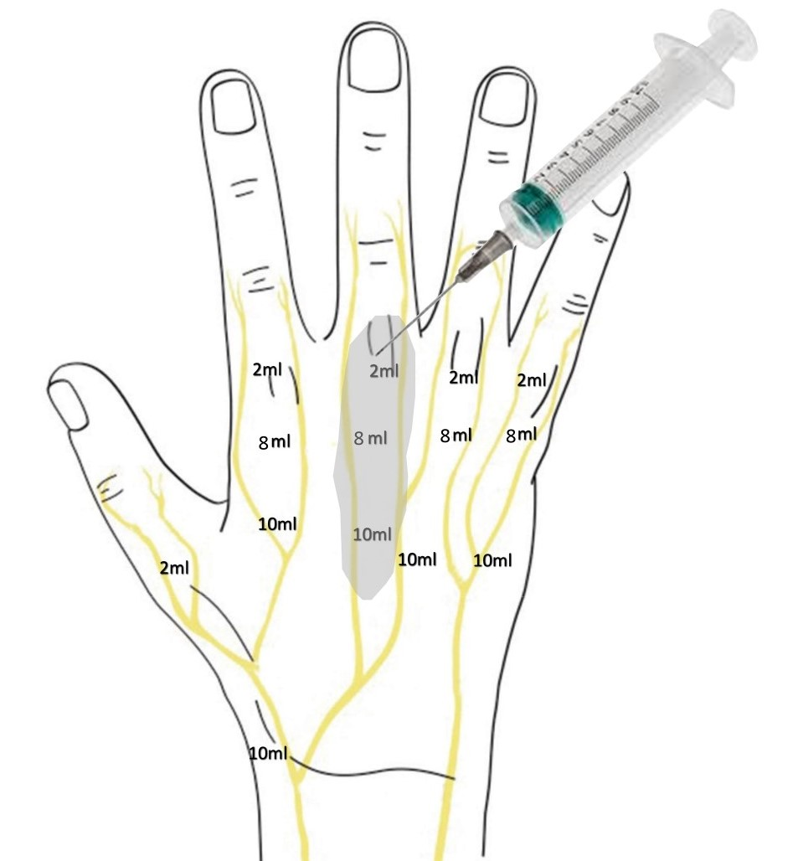
- (b) (c)

Figure 1: A total of 20 ml of the mixture was injected for the metacarpal fractures. First 10 ml were injected at subcutaneous fat on proximal edge at dorsal surface of involved metacarpal.(Fig 1(a) After 15 minutes, 8 ml were injected at the middle side of the metacarpal(b) and finally at metacarpophalangeal joint 2ml(c).
Artist’s rendition of schematic presentation of injections area at the palmar surface of the hand.(Compliments of Kastani Evangelia).

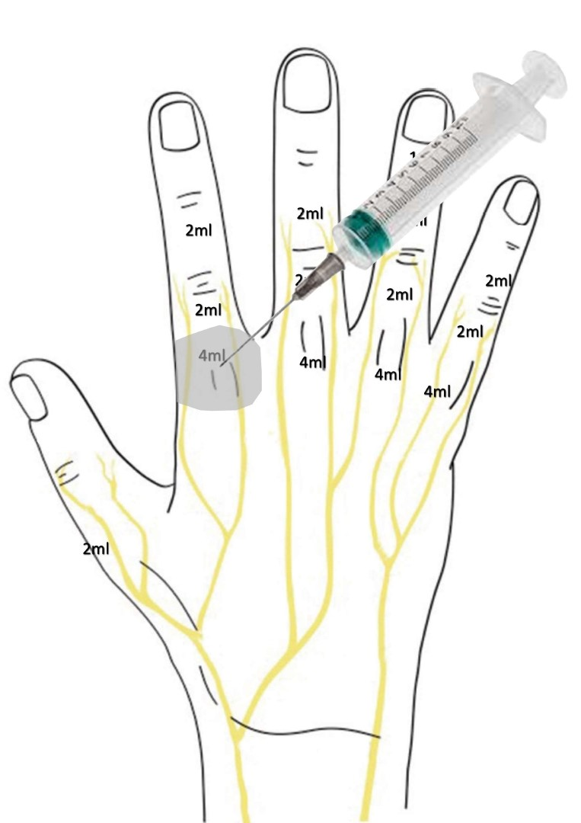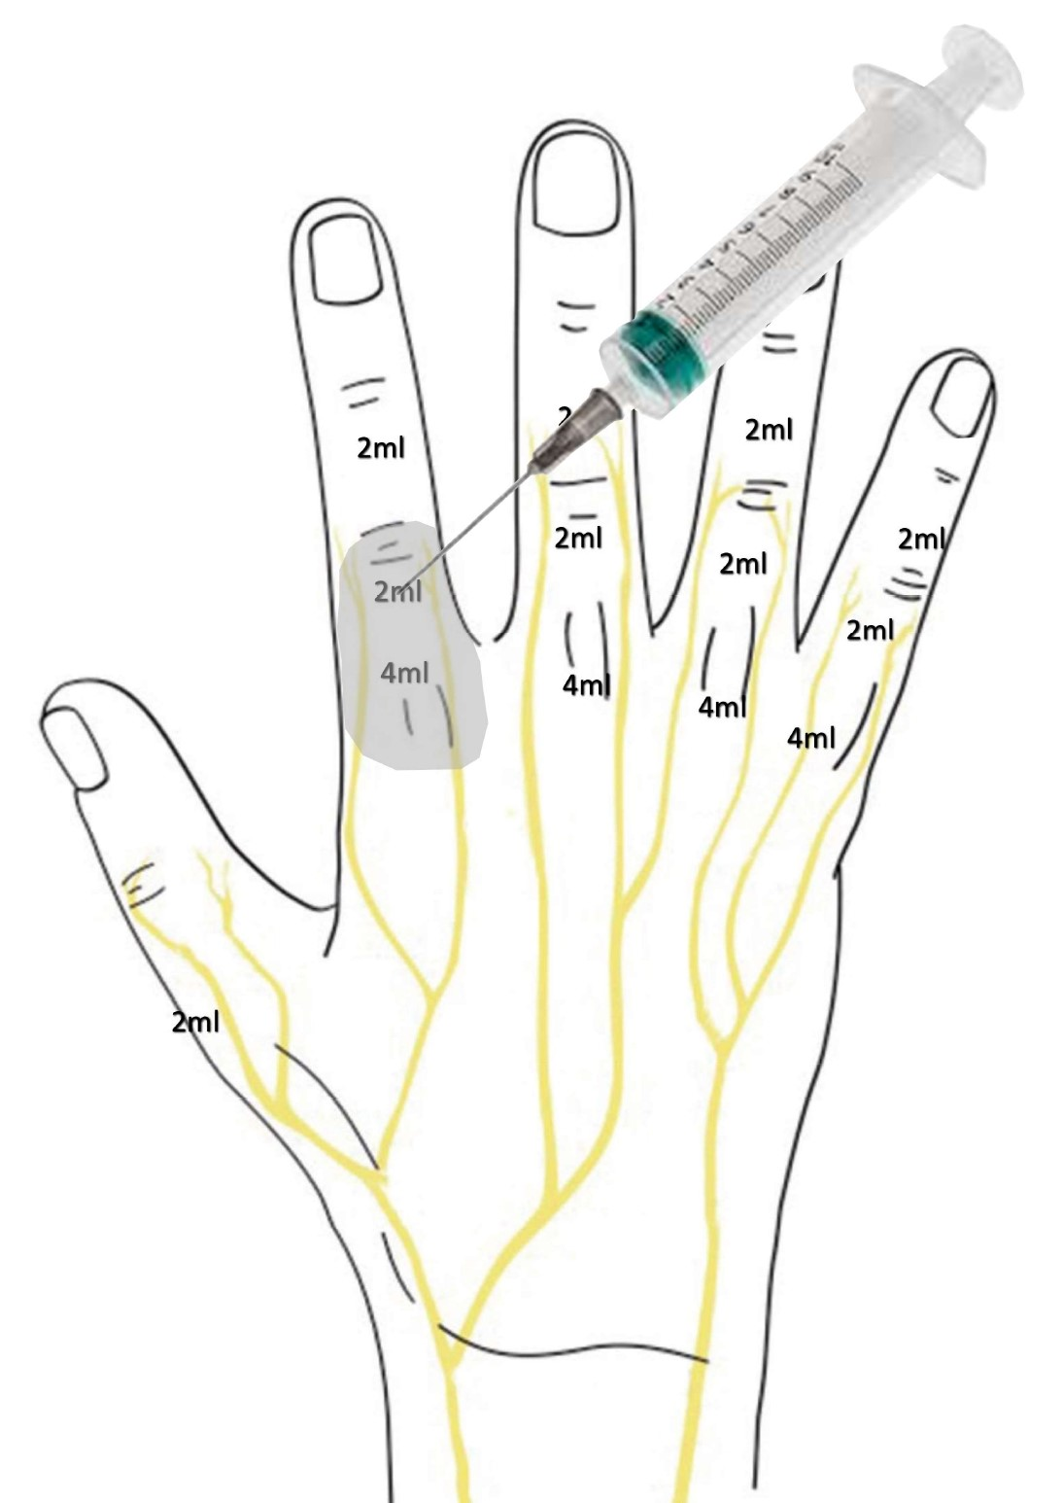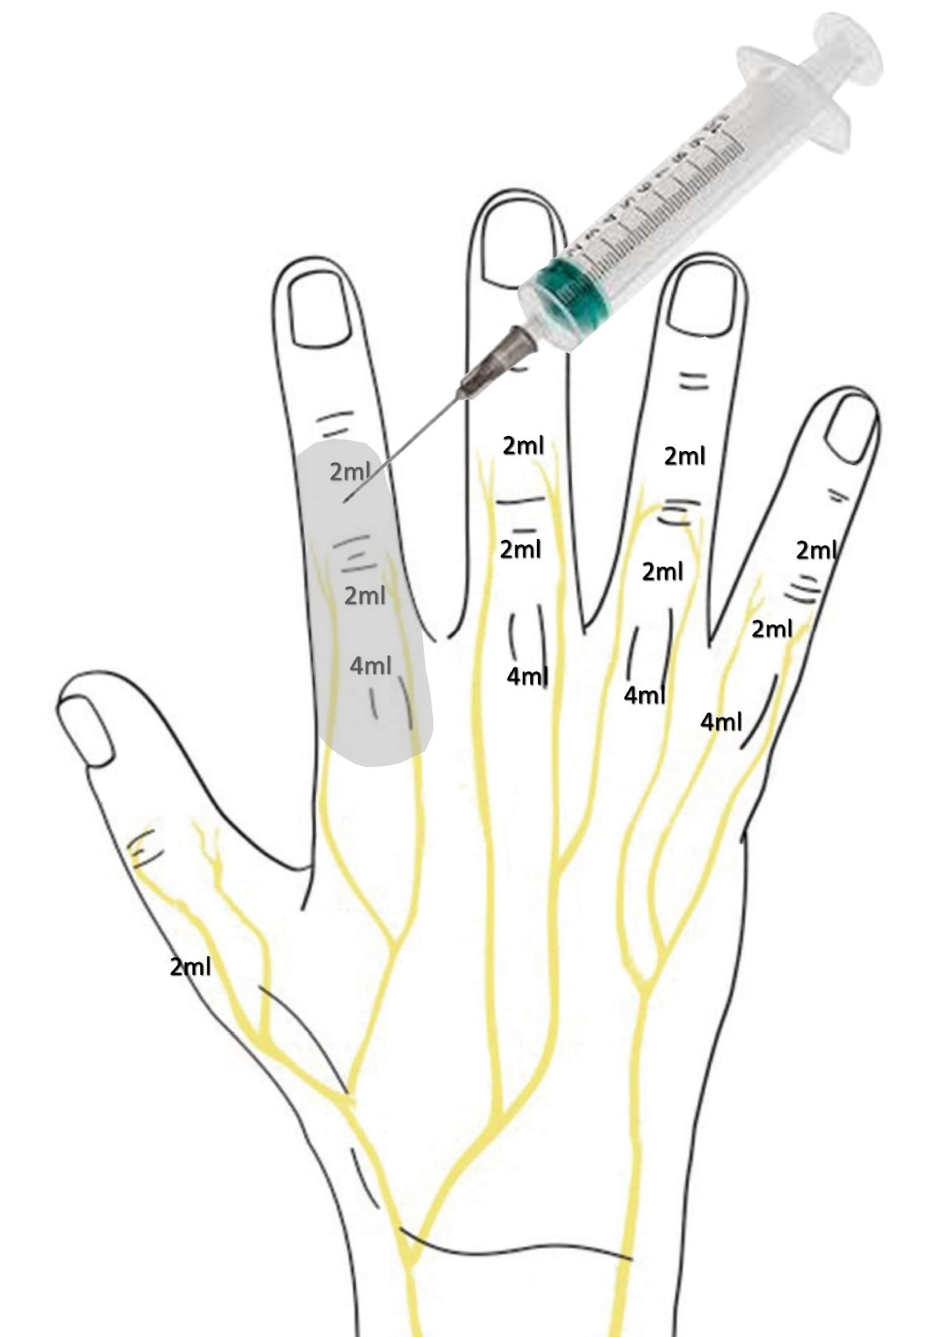
- (b) (c)

Figure 2: The technique for phalangeal fractures performed is the following: starting from the dorsal side of metacarpophalangeal joint first we injected (a) 4 ml of the mixture (12ml of premixed 1% lidocaine (10ml) with 1:100.000 adrenaline and 1ml of bicarbonate sodium 8,4%) and in 4ml in subcutaneous fat of volar side at the metacarpal head. 15 minutes after the first injection, we continued with a second injection with 2cc at the dorsal side of proximal phalanx (b). Third injection is over dorsal side of the middle phalanx(c).
Artist’s rendition of schematic presentation of injections area at the palmar surface of the hand. (Compliments of Kastani Evangelia).

