**A resilient point-of-care fluorescent SCDs-MPs probe for insight recognition of a dopamine neurotransmitter in human fluid samples and its cytotoxicity investigation**

**ABSTRACT**

This research presents a novel sensing platform for detecting dopamine, a crucial neurotransmitter, in biological fluids. The platform combines a signal-transducing element with a selective recognition component to achieve highly sensitive and specific dopamine detection. The sensing mechanism relies on the interaction between the target analyte and the platform, resulting in a detectable change in signal. The developed sensor demonstrates a low detection limit and excellent recovery in complex biological matrices. Furthermore, biocompatibility assessments confirm the platform's suitability for potential biological applications. This approach offers a promising tool for diagnosing neurological disorders and advancing our understanding of dopamine-related processes.

*Keywords:* Neurochemical, Recovery, Specificity, Biocompatibility, Dopamine

1. **Introduction**

Dopamine, a catecholamine neurotransmitter, plays vital roles in neurological, renal, and cardiovascular systems, acting as a chemical messenger between nerve cells [1,2]. Its concentration in the human body is tightly regulated, and imbalances are linked to serious conditions like Parkinson's, Huntington's, Schizophrenia, memory loss, and epilepsy [3]. While various dopamine sensing methods exist (e.g., photo-electrochemistry, Raman spectroscopy), they often suffer from limitations like complex procedures and high cost. Fluorometric sensing offers a promising alternative due to its high sensitivity, selectivity, and cost-effectiveness. However, developing a highly sensitive and selective fluorometric method for dopamine detection in complex biological media remains a significant challenge [4,5].

Carbon dots (CDs), carbon nanomaterials under 10 nm, have become prominent in fluorometric sensing due to their exceptional optical properties [6]. These quasi-spherical nanoparticles, with sp2 hybridized carbon structures, offer advantages over other fluorescent probes like quantum dots and organic dyes, including superior photostability, bright photoluminescence, tunable surface functionalities, and low toxicity [7-9]. While CDs can be synthesized via top-down or bottom-up approaches (e.g., solvothermal/hydrothermal treatment, microwave irradiation), a key challenge for CD-based sensors is limited selectivity and a lack of active sites [10]. To address this, molecular imprinting has emerged as a promising technique to enhance target specificity and improve the accuracy of CD-based sensors.

Molecular imprinting, initially conceived in the 1970s, has evolved from a reversible covalent to a more widely used non-covalent approach, gaining traction in biomedical and analytical applications [11]. Inspired by antibody-antigen recognition, this technique creates polymeric receptors for specific molecules. Extensively studied using optical techniques, molecularly imprinted polymers (MIPs) find application in diverse fields like sensing, drug delivery, catalysis, and extraction. MIPs enhance selective absorption, and incorporating carbon dots (CDs) allows the transduction of chemical interactions into detectable fluorescent signals [12,13]. Combining the sensitivity of CDs with the selectivity of MIPs, these adaptable, stable, cost-effective, and easily prepared fluorescent sensors are crucial in molecular recognition [14].

This work reports the development of a fluorescent probe, SCDs-MPs (silane-functionalized carbon dots with molecularly imprinted polymer), for dopamine (DA) detection. Silane-functionalized carbon dots (SCDs), synthesized hydrothermally from citric acid and TEOS, serve as the foundation for the imprinting process. SCDs-MPs were then fabricated via a reverse microemulsion method using the SCDs, DA as the template, 3-aminopropyltriethoxysilane as the functional monomer, and tetraethoxysilane as the crosslinker, with ammonia as a catalyst. The resulting fluorescent probe, possessing specific recognition sites, was thoroughly evaluated for its sensitivity and selectivity towards DA, and the underlying sensing mechanism was investigated.

1. **Experimental section**
   1. **Synthesis of SCDs-MPs and SCDs-NPs nanocomposites**

Based on previously described techniques, the silane-functionalized CDs were produced with minor alterations. 15,16 By using a modified reverse microemulsion technique, silane-functionalized carbon dots with molecularly imprinted polymer (SCDs-MPs) were synthesized. 17 18 mL of cyclohexane, 3.8 mL of n-hexanol, and 4 mL of Triton X-100 were added successively into the RB flask and stirred for 25 min to form a microemulsion. Followed by the addition of 5 mL of SCDs, and then 280 μL of TEOS and 100 μL of NH3H2O were added, and stirred for 2 h. 1.2 mL of n-hexanol was combined with 20.6 mg DA and 260 μL APTES before being progressively added dropwise to the solution. For 24 hours in the dark, the solution was mechanically agitated. After that 20 mL of acetone was added, and particles were obtained by centrifuging the mixture at 5000 rpm. To remove DA and contaminants, the precipitate was cleaned with ethanol and acetonitrile combined at a 9:1 ratio. SCDs-NPs underwent the same preparation procedure as SCDs-MPs (Scheme 1) but without the addition of the template.

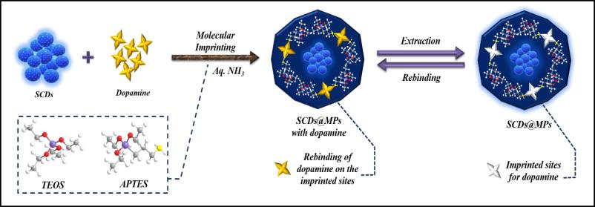

**SCHEME 1.** Synthesis of silane-functionalized carbon dots with molecularly imprinted polymer (SCDs-MPs).

1. **Results and discussion**
   1. **Physiochemical characterizations of SCDs-MPs and SCDs-NPs**

HRTEM was used to examine the morphology and size of the synthesized SCDs-MPs. The results show a cocci-like shape with an average particle size of 12.9 nm (Fig. 1a), where the particles appear aggregated and the SCDs are coated by a thin polymer matrix. SAED patterns (Fig. 1b) confirm the amorphous nature of the SCDs-MPs. Lattice fringes with a spacing of 0.49 nm are observed (Fig. 1c). EDS analysis (Fig. 1d) reveals the elemental composition of C (22.14%), N (10.09%), O (41.98%), and Si (25.78%) in the SCDs-MPs.

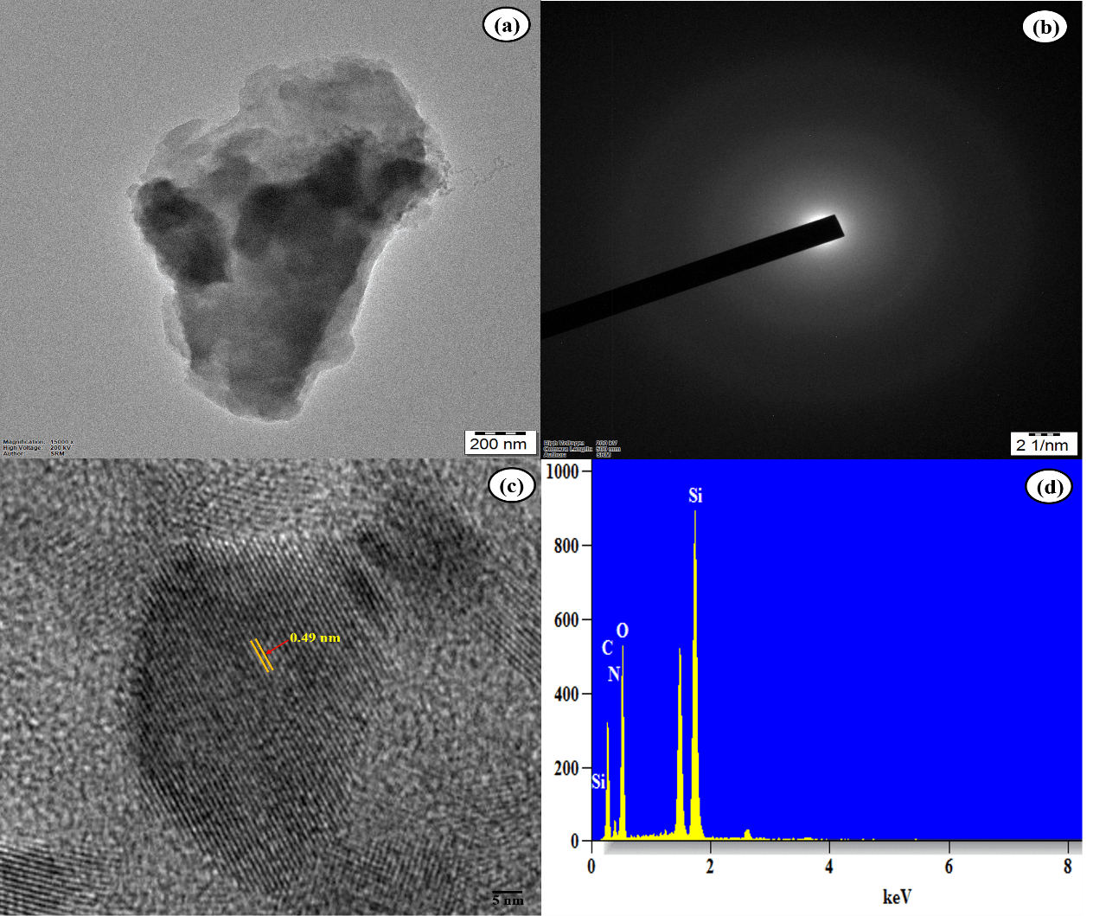

**Fig. 1. (**a) TEM images, (b) SAED pattern, (c) lattice fringes, and (d) EDS analysis of SCDs-MPs.

Fig. 2a, b displays the SEM image of as-prepared SCDs-MPs and SCDs-NPs. The SCDs-MPs are mostly spherical in structure with rough surface but there is some aggregation. Figures 2c–f presented the elemental mapping outcomes of SCDs-MPs. The corresponding findings revealed that the elements C, N, O, and Si were uniformly distributed, indicating the homogeneous nature of the SCDs-MPs.

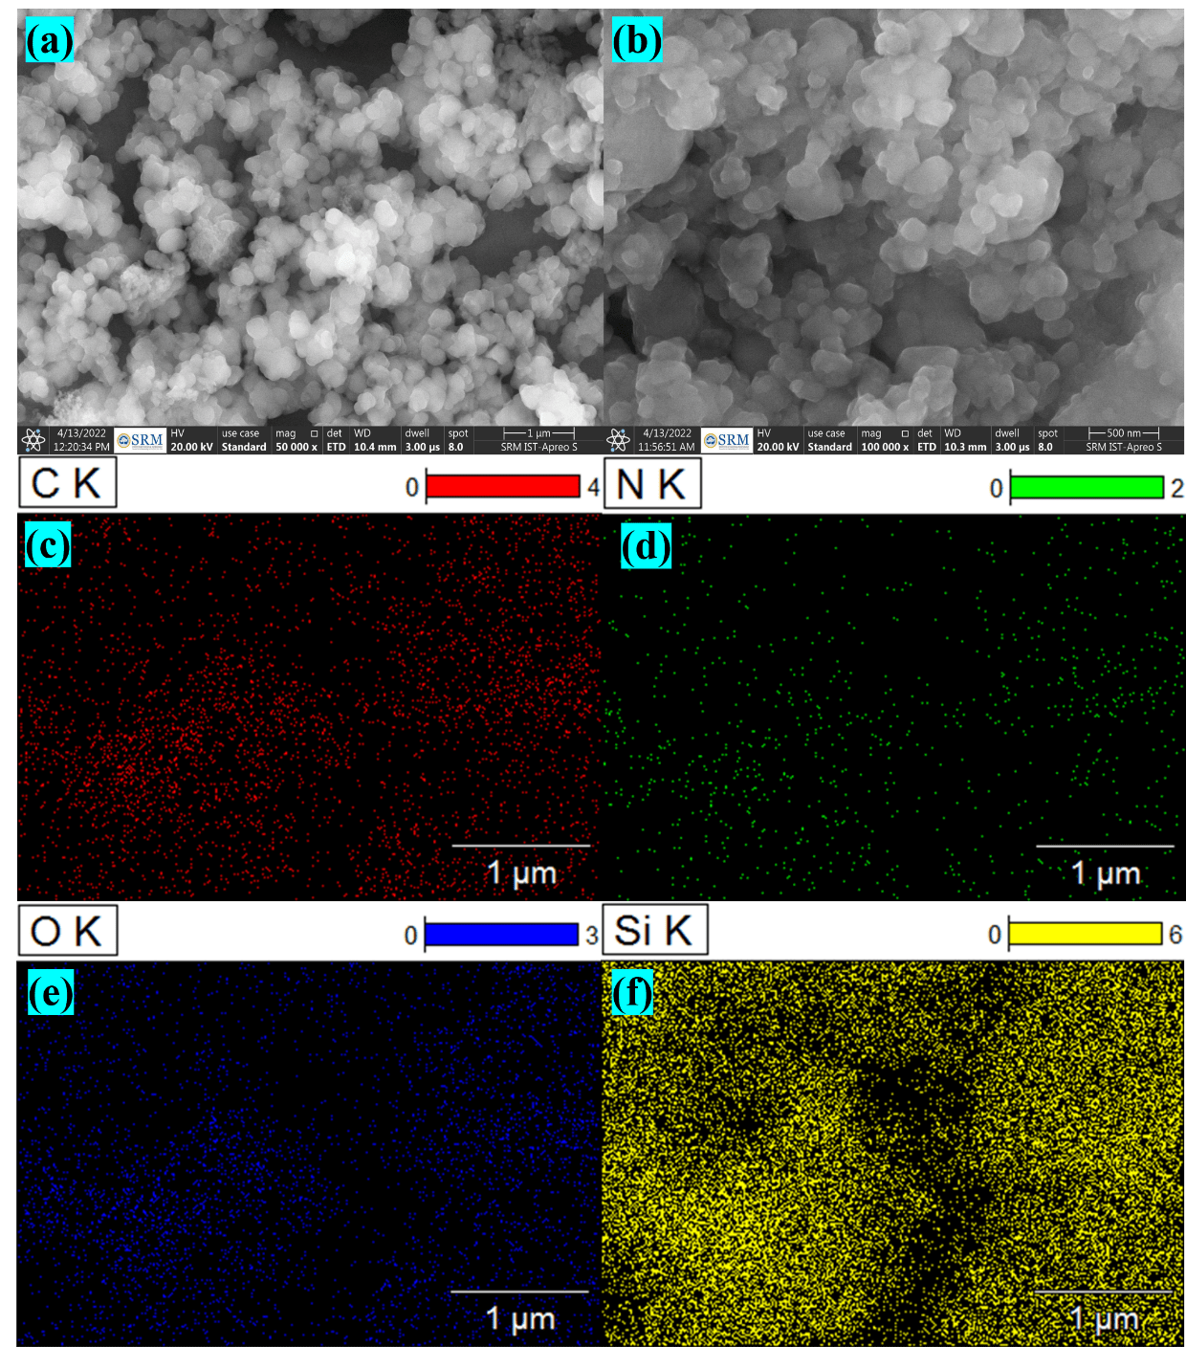

**Fig. 2.** SEM images of (a) SCDs-MPs, (b) SCDs-NPs. (c – f) Elemental mapping of SCDs-MPs.

X-ray diffraction (XRD) analysis was performed to investigate the structural properties of the synthesized materials. The XRD patterns of SCDs-MPs, SCDs-MPs with dopamine (DA), and SCDs-NPs (non-imprinted) are shown in Fig. 3. A broad peak at 22.6° indicates the presence of the polymer matrix and the disordered arrangement of carbon atoms in the SCDs. A peak at 26.5° in the SCDs-MPs+DA spectrum corresponds to the DA template. The disappearance of this peak in the SCDs-MPs spectrum confirms the removal of DA from the imprinted polymer. The SCDs-NPs spectrum lacks the characteristic peaks observed in SCDs-MPs and SCDs-MPs+DA, indicating fewer selective binding sites. These results confirm the amorphous nature of the synthesized probe.



**Fig. 3.** XRD spectrum of SCDs-MPs+DA, SCDs-MPs, and SCDs-NPs.

FT-IR spectroscopy was used to identify surface functional groups in SCDs-MPs, SCDs-MPs+DA, and SCDs-NPs. A Si-O-CH stretching vibration was observed at 1036 cm−1. Peaks at 2940 and 1565 cm−1 indicated the presence of -CH2- and C=O groups, respectively (Fig. 4). -CH stretching vibrations appeared around 2940-2864 cm-1. Si-O vibrations were observed at 785 cm−1, Si-O-C vibrations at 696 cm−1, and Si-O-Si asymmetric stretching vibrations at 1051 cm−1. Characteristic dopamine peaks (SCDs-MPs+DA) appeared at 3256 cm-1, 1619 cm-1, and 1529 cm-1, corresponding to phenol -OH stretching, amine N-H bending, and aromatic C=C stretching vibrations. These peaks were absent in SCDs-MPs, indicating DA removal. SCDs-MPs and SCDs-NPs showed similar peak positions and intensities.



**Fig. 4.** FT-IR spectra of SCDs-MPs+DA, SCDs-MPs, and SCDs-NPs.

**3.2 Electrochemical properties of SCDs-MPs and SCDs-NPs**

As a follow-up to the characterization of functional groups, we determined the electrochemical properties of SCDs-MPs and SCDs-NPs to assess the effect of silane functionalized carbon dots incorporated molecularly imprinted polymer on electrochemical behavior. A cyclic voltammetry technique was utilized to determine the highest occupied molecular orbital (HOMO) and the lowest unoccupied molecular orbital (LUMO) of SCDs-MPs and SCDs-NPs. Fig. 5a shows the cyclic voltammetric data of the SCDs-MPs recorded at a scan rate of 50 mVs-1 in a solution containing ferrocyanide-ferricyanide (Fe (CN)6 3-/4-) as an electrolyte. Based on the CV data, the oxidation onset potential (*Eox*) is determined to be 0.046 eV. By analyzing the absorbance spectrum, the band gap (*Egap*) is found to be 3.34 eV. The half-wave potential (*E1/2*) of ferrocene was found to be 0.16 eV. These data can be used to calculate the HOMO and LUMO energy levels. Using the empirical relation,

*EHOMO* = - [(*Eox - E1/2*) + 4.8 eV]

the calculations for the HOMO energy level of SCDs-MPs were done [21,22]. The *EHOMO* was foundto be -4.68 eV and the band gap value of 3.34 eV led to the determination of the *ELUMO* energy level at -1.34 eV.

The cyclic voltammogram of SCDs-NPs was depicted in the Fig. 5b measured with a scan rate of 50 mVs-1. The *Eox* was found to be 0.06 eV and from the absorbance spectrum, the *Egap* was measured to be 3.45 eV. The *E1/2* was taken to be 0.16 eV. Using the empirical relation mentioned above the HOMO energy level of SCDs-NPs was calculated to be -4.72 eV. The *ELUMO* was found to be -1.27 eV corresponding to the *EHOMO* and *Egap* value of the SCDs-NPs. In SCDs-MPs, the presence of recognition cavities and electron donating groups on the polymer matrix increases the energy of the HOMO level and leads to a narrower band gap compared to SCDs-NPs. Therefore, the CV results confirm the SCDs-MPs possess, the energy shift in the band gap, and the change in the electrochemical behavior. These factors may impact the interaction of SCDs-NPs with other biological molecules.

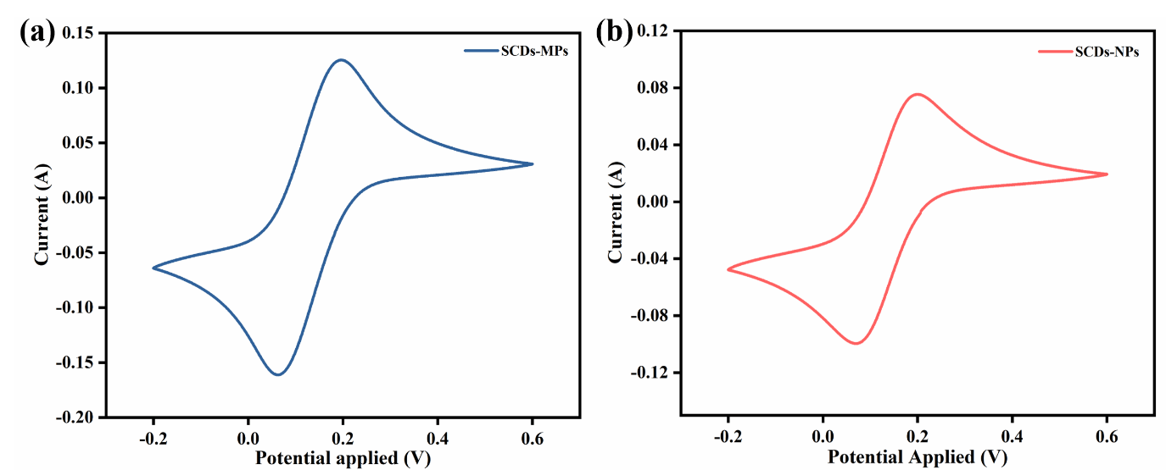

**Fig. 5.** Cyclic voltammogram of (a) SCDs-MPs, and (b) SCDs-NPs.

* 1. **Optical properties of SCDs, SCDs-MPs, and SCDs-NPs**

The eco-friendly fluorescent response of SCDs-MPs and SCDs-NPs is shown in Fig. 6. The SCDs-MPs were excited at various wavelengths ranging from 300 nm to 340 nm, the greatest emission intensity was achieved at 435 nm when excited at 316 nm. (Fig. 6b, c). As shown in Fig. 7a after template extraction, the fluorescence intensity of SCDs-MPs (B) nearly reached that of SCDs-NPs (A). In addition, the fluorescence intensity of SCDs-MPs quenched a lot when interacting with DA molecules (D), and a charge transfer between CDs and DA molecules was suggested to be responsible for the fluorescence quenching of the SCDs-MPs. In this recognition system, the SCDs and DA molecules acted as electron donors and electron acceptors, respectively. Furthermore, the zeta potential of SCDs-MPs before and after DA addition was determined. The initial zeta potential value for SCDs-MPs before the addition is -32.5 mV, and after addition, the value changes significantly to -23.9 mV (Fig. 6d). The apparent change in value indicates that with the addition of the template molecule DA, the interaction sites between the MPs layer and the SCDs increase, causing more SCDs to be attracted and more charges to be neutralized. This finding also demonstrates the presence of electrostatic interaction between SCDs-MPs and DA. Therefore, the photoluminescence of SCDs-MPs might be effectively quenched in case of interacting with DA molecules. Hence, considering both enhancing the sensitivity and improving the interaction between CDs and MIP, the SiO2 nanomaterials were selected for the synthesis of SCDs-MPs.

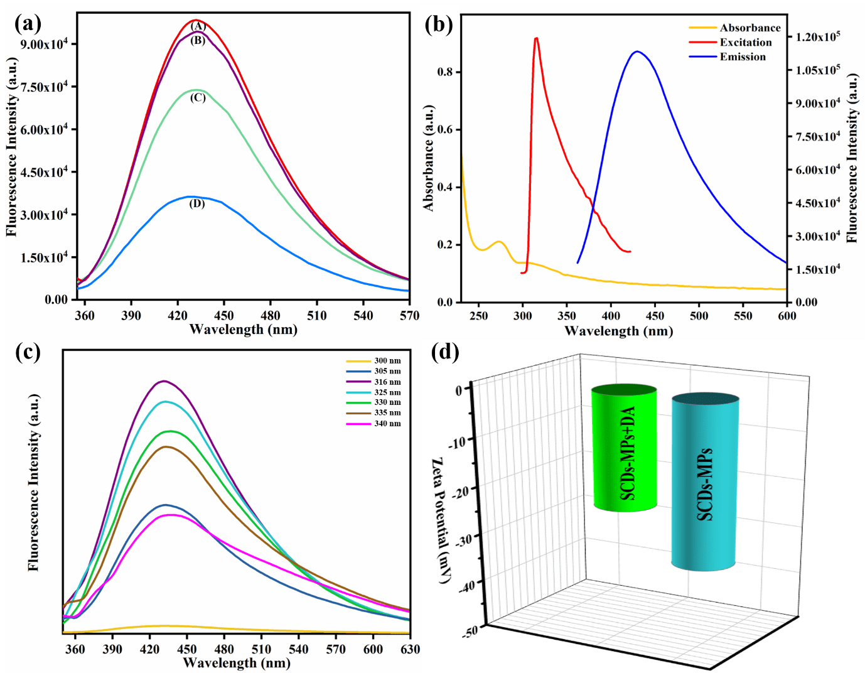

**Fig. 6.** (a) Fluorescence spectra of SCDs-NPs (A), SCDs-MPs (B), SCDs-NPs+DA (C), and SCDs-MPs+DA (D). (b) SCDs-MPs absorbance, excitation, and emission spectra. (c) Fluorescence intensity of SCDs-MPs at different excitation wavelengths. (d) Zeta potential plot.

* 1. **Fluorescence sensing mechanism of the proposed sensor**

Using the synthesized SCDs-MPs, a unique and reliable identification method for dopamine (DA) was developed. The molecular imprinting process was used for this purpose, with DA molecules serving as templates. The self-assembly co-polymerization of APTES and TEOS precursors, which served as primary monomers and cross-linkers, respectively, was used in the whole process. Silane-functionalized carbon dots were introduced as appropriate supports during the polymerization stage, resulting in their entrapment in the polymeric matrix and leading to the formation of fluorescent SCDs-MPs nanocomposite. Following that, an effective washing stage was performed to remove the non-covalently bounded template (DA) molecules. The coupling of DA template molecules at MIP sites was most likely caused by hydrogen bonds between nitrogen or oxygen moieties of DA and the amino groups of APTES monomers. This coupling can be eliminated and the template molecules can be detached from the polymer matrix by applying a moderately acidic environment (1% acetonitrile and 9% ethanol solution). The process of removing the DA molecule from the polymer matrix by the washing method has been confirmed by the UV-Vis spectroscopy technique. The washing was carried out five times to obtain less absorbance compared to the initial value. This indicates that practically the analyte molecules have been liberated. This has also been confirmed by the FTIR spectrum as can be seen in the Fig. 4 (SCDs-MPs) the characteristic peaks for the existence of dopamine 3256 cm-1, 1619 cm-1,and 1529 cm-1 were absent. Later the SCDs-MPs nanocomposite was dispersed using distilled water to remove the remaining mixture of acetic solution.

The resulting SCDs-MPs have specific imprinted sites corresponding to dopamine molecule functional groups and configurations. Subsequently, the molecularly imprinted polymer layer possesses greater affinity to the dopamine molecule without any interfering effect from the analog compounds. In this process, SCDs were used as optical antennas for distinguishing DA molecules associated with a molecularly imprinted polymer matrix. The fluorescence emission intensity of SCDs-MPs was quenched by the addition of dopamine molecules resulting in a less fluorescence intensity. Due to the abundance of oxygen-containing functional groups such as hydroxyl and carboxyl groups on the surface, the SCDs-MPs behave as negatively charged species, and with –NH3+ the dopamine molecule behaves as positively charged species. Thus, the charged SCDs-MPs enable a non-covalent interaction with the diols and amine functional group in the dopamine molecule (positively charged) through electrostatic interactions, π–π stacking, and hydrogen bonding under neutral conditions. The dopamine molecule is oxidized to dopamine-quinone that accepts the electron from the SCDs-MPs which results in the fluorescence quenching process [25]. This fluorescence quenching effect is due to the interruption of the electron-hole pair of SCDs by the dopamine molecule in the imprinted sites at the molecularly imprinted polymer matrix resulting in a lower fluorescence emission intensity. The fluorescence lifetime experiment was carried out for SCDs-MPs, SCDs-MPs+DA, and SCDs-NPs (Fig. 7a). The average lifetime of SCDs-NPs, and SCDs-MPs is 6.88 ns and 6.38 ns respectively. After the addition of the DA molecule to the SCDs-MPs the lifetime was changed to 6.17 ns the insignificant change between 6.38 ns and 6.17 ns demonstrates that the quenching may be a static quenching process. The fluorescence resonance energy transfer (FRET) method may also be excluded because it is clear from Fig. 7b that the emission spectra of the SCDs-MPs and the absorption spectrum of the DA do not overlap. This phenomenon suggests that the DA may effectively shield the excitation light for SCDs-MPs, which is an impressive feature of the static quenching effect. The sensitivity of the designed fluorescent probe SCD-MPs can be improved by the applied high fluorescent SCDs [26].

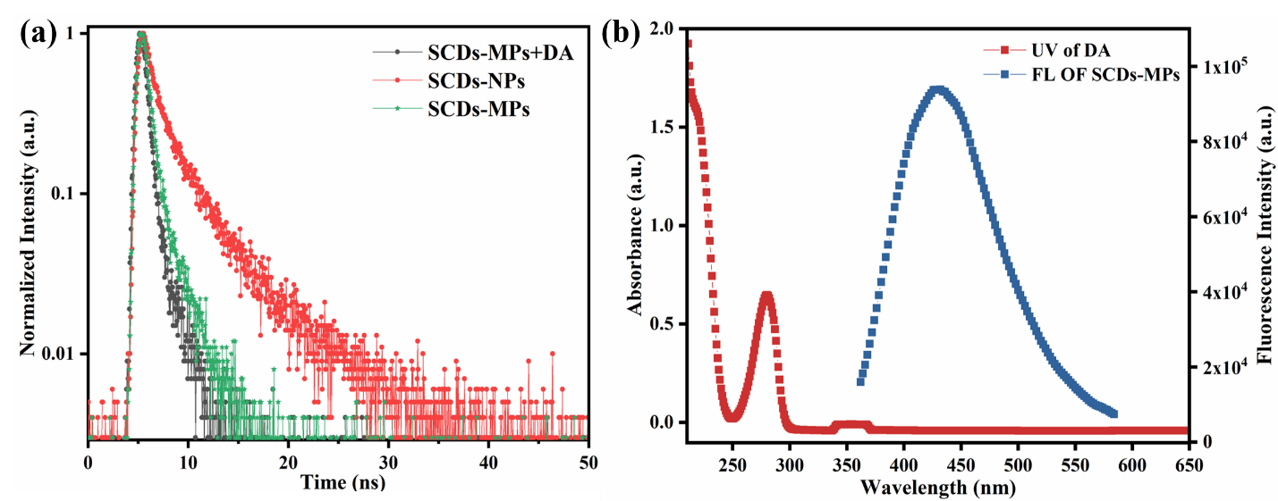

**Fig. 7.** (a) Fluorescence lifetime of SCDs-MPs, SCDs-MPs+DA, and SCDs-NPs. (b) UV-Vis spectrum of DA and Fluorescence emission spectrum of SCDs-MPs.

* 1. **Implementation of dopamine fluorescence detection technique**

The fluorescence sensing system SCDs-MPs relies on the different concentrations of DA and the response for each addition was recorded. The fluorescence quenching effect of SCDs-MPs with different DA concentrations is shown in Fig. 8a. Initially, the fluorescence intensity at 435 nm of SCDs-MPs was high, and we could observe that the fluorescence intensity gradually decreased after the addition of DA (template molecule). This clearly shows the quenching process of SCDs-MPs in the presence of DA. The Stern-Volmer equation was used to correlate the relationship between fluorescence intensity and DA concentration.

$$\frac{F_{0}}{F}=1+ K_{sv}[DA]$$

Where *F0* indicates the fluorescence intensity of SCDs-MPs without DA and *F* indicates the fluorescence intensity of SCDs-MPs with varied addition of DA. Fig. 8b and 8c depict the significant linearity between the fluorescence intensity and various concentrations of DA resembling a well-fitted equation *F0/F* =1.00129 + 0.00619[CDA] (R2 = 0.9986) over a linear concentration range 0 – 1000 nM. To assess the sensitivity of the proposed analytical method the Limit of Detection (LOD) is a vital parameter corresponding to the low analyte concentration and minimum level of signal detected [27,28]. The limit of detection for SCDs-MPs is 0.64 nM and the limit of quantification (LOQ) is 6.40 nM. This verifies that the fabricated fluorescence sensor can be a promising method for the trace quantification of DA.

The fluorescence responses of the SCDs-NPs were conducted as a control experiment. The SCDs-NPs fluorescence intensity shows a minor quenching effect in the addition of different concentrations of DA (Fig. 8d). The linear equation of SCDs-NPs was found to be *F0/F* =1.00649 +0.00322 [CDA] (R2 = 0.9888) with a LOD of 1.77 nM (Fig. 8e and 8f) the limit of quantification (LOQ) as 17.73 nM. These inferences show that the quenching effect of SCDs-MPs is higher than that of SCDs-NPs with a lower LOD value. This indicates SCDs-MPs are more sensitive towards DA than SCDs-NPs. From the Stern Volmer formula, the KSV (quenching constant) can be calculated. The slope of the calibration curve represents the KSV value which estimates the sensitivity of the fluorescent assay. The KSV value of SCDs-MPs and SCDs-NPs was found to be 0.00619 and 0.00322, respectively.

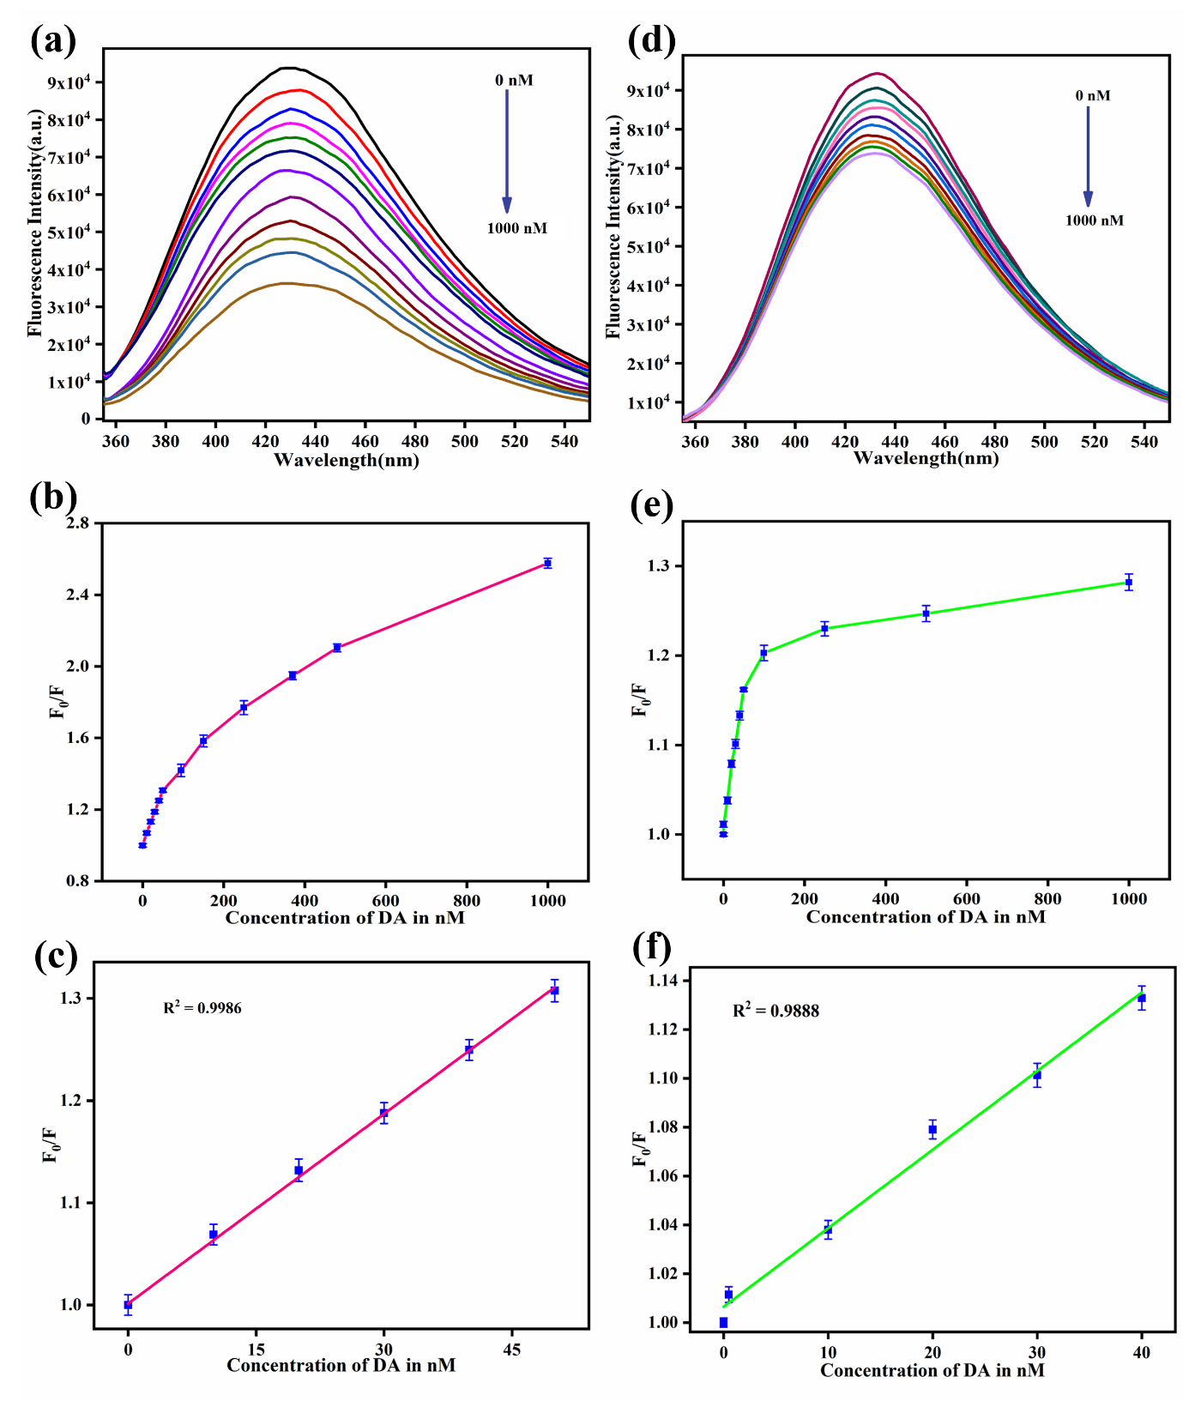

**Fig. 8.** Fluorescence response of (a) SCDs-MPs and (d) SCDs-NPs to varying DA concentrations. Integrated emission intensity of (b) SCDs-MPs and (e) SCDs-NPs vs. DA concentration. Calibration curves (F0/F vs. DA concentration) for (c) SCDs-MPs and (f) SCDs-NPs. Error bars represent standard deviation (n=3).

* 1. **Selective specificity**

The selectivity of the fluorescent probe for DA was evaluated against potential interferents (glucose, fructose, ascorbic acid, epinephrine, norepinephrine, citric acid, and uric acid; Fig. 9a). DA exhibited significantly higher quenching efficiency with SCDs-MPs compared to other analytes (Fig. 9b), demonstrating high selectivity due to the DA-imprinted cavities. SCDs-NPs, lacking imprinted sites, showed no such selectivity. These results confirm the excellent DA selectivity of the SCDs-MPs fluorescent assay for accurate identification in human samples.

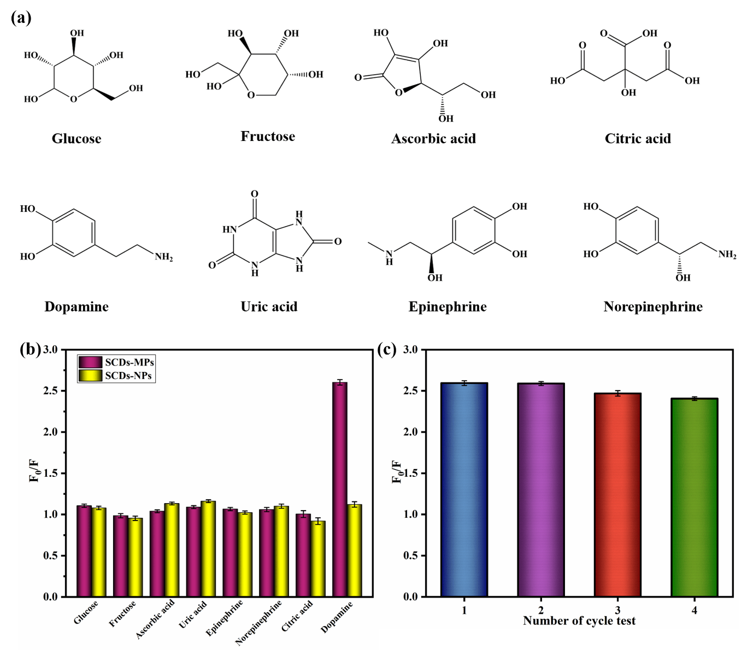

**Fig. 10.** (a) Structural representations of DA (Dopamine) and its analogues, (b) Fluorescence response of SCDs-MPs and SCDs-NPs in the presence of DA and its analogues, (c) Reproducibility of SCDs-MPs.

A removal-rebinding cycle test (Fig. 9c) assessed the reproducibility of SCDs-MPs. Four repeated experiments showed consistent detection performance (RSD < 3.69%), demonstrating exceptional reproducibility.

* 1. **Detection of DA in human fluid samples**

The SCDs-MP biosensor was tested for DA detection in human blood serum and urine samples using a standard addition method. Diluted samples (500-fold blood serum, 50-fold urine) were spiked with DA and analyzed under optimized conditions. Recoveries ranged from 98-102% (Table 1), demonstrating the reliability and accuracy of the SCDs-MPs biosensor for DA detection in these biological fluids.

**Table 1.** DA detection in human fluid samples using SCDs-MPs fluorescent probe

|  |  |  |  |  |
| --- | --- | --- | --- | --- |
| **Sample** | **Spiked (nM)** | **Detected ±SD** | **Recovery (%)** | **RSD (%)** |
| **DA** | **DA** |  |
| Human serum | 5 | 4.96x ± 0.04y | 99.6 | 0.80 |
|  | 10 | 10.1x ± 0.16y | 102.4 | 1.58 |
|  | 15 | 14.8x ± 0.26y | 98.08 | 1.76 |
| Human urine | 10 | 9.85x ± 0.36y | 97.9 | 3.65 |
|  | 20 | 19.86x ± 0.89y | 99.1 | 4.48 |
|  | 30 | 30.1x ± 0.34y | 100.7 | 2.6 |

* 1. **Cytotoxicity studies**

An MTT assay was performed to assess the cytotoxicity of SCDs-MPs against HeLa cells. Cells were incubated with varying SCDs-MPs concentrations (0.0 – 200.0 µg/ml). Lower concentrations of SCDs-MPs showed minimal impact on HeLa cell viability. However, higher concentrations at 48 hours exhibited increased cytotoxicity (Fig. 10), with an IC50 of 104.16 µg/ml. The results indicate that SCDs-MPs exhibit low toxicity towards HeLa cells.

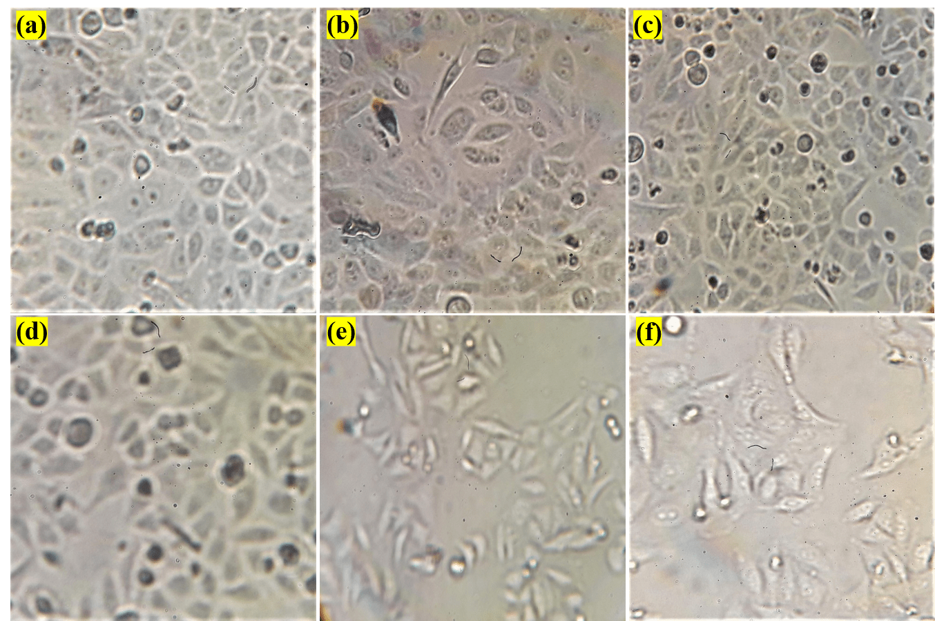

**Fig. 10.** Cytotoxicity effect of SCDs-MPs against HeLa Cell lines: (a) Control, (b) Concentration 12.5 µg/mL, (c) Concentration 25 µg/mL, (d) Concentration 50 µg/mL, (e) Concentration 100 µg/mL and (f) Concentration 200 µg/mL.

1. **Conclusion**

This study successfully developed a sensitive, selective, and robust fluorescent platform (SCDs-MPs) for dopamine (DA) sensing. Combining fluorescent silane-functionalized carbon dots (SCDs) with molecularly imprinted polymer (MIP) offers several advantages: 1) The MIP enhances DA interaction with the imprinted cavities due to its high affinity and specificity. 2) SCDs act as both a fluorescent signal and a carrier, facilitating DA binding. 3) The synergistic effect of the MIP and the unique luminescence of SCDs amplifies target interaction and fluorescence quenching, leading to high DA sensitivity. The SCDs-MPs probe achieved successful DA detection in human fluid samples with excellent recoveries (98-102%). Furthermore, biocompatibility assessments confirm the non-toxic nature of the nanocomposite, suggesting its potential for *in-vivo* applications.

**Conflicts of interest**

All authors acknowledged no conflicts of interest

**Data availability**

The data generated or analyzed to support the finding of this study are included within the article.

**REFERENCES**

1. Feng, P.; Chen, Y.; Zhang, L.; Qian, C.-G.; Xiao, X.; Han, X.; Shen, Q.-D. Near-Infrared Fluorescent Nanoprobes for Revealing the Role of Dopamine in Drug Addiction. ACS Appl. Mater. Interfaces 2018, 10 (5), 4359–4368. <https://doi.org/10.1021/acsami.7b12005>.
2. Zaidi, S. A. Development of Molecular Imprinted Polymers Based Strategies for the Determination of Dopamine. Sensors Actuators B Chem. 2018, 265, 488–497. <https://doi.org/https://doi.org/10.1016/j.snb.2018.03.076>.
3. González-Sálamo, J.; Socas-Rodríguez, B.; Hernández-Borges, J.; Rodríguez-Delgado, M. Á. Core-Shell Poly(Dopamine) Magnetic Nanoparticles for the Extraction of Estrogenic Mycotoxins from Milk and Yogurt Prior to LC–MS Analysis. Food Chem. 2017, 215, 362–368. <https://doi.org/https://doi.org/10.1016/j.foodchem.2016.07.154>.
4. Daniel, M.; Mathew, G.; Anpo, M.; Neppolian, B. MOF Based Electrochemical Sensors for the Detection of Physiologically Relevant Biomolecules: An Overview. Coord. Chem. Rev. 2022, 468, 214627. <https://doi.org/https://doi.org/10.1016/j.ccr.2022.214627>.
5. Shen, M.; Kan, X. Aptamer and Molecularly Imprinted Polymer: Synergistic Recognition and Sensing of Dopamine. Electrochim. Acta 2021, 367, 137433. <https://doi.org/https://doi.org/10.1016/j.electacta.2020.137433>.
6. Lim, S. Y.; Shen, W.; Gao, Z. Carbon Quantum Dots and Their Applications. Chem. Soc. Rev. 2015, 44 (1), 362–381. <https://doi.org/10.1039/c4cs00269e>.
7. Pavithra, S.; Jothi, V. K.; Rajaram, A.; Ingavale, S.; Natarajan, A. A Facile Synthesis of a Fusiform-Shaped Three-Dimensional Co/Mn@CNDs-MOF Nanocomposite as an Efficient Electrocatalyst for Oxygen Evolution Reaction in Alkaline Medium. Energy & Fuels 2022, 36 (12), 6409–6419. <https://doi.org/10.1021/acs.energyfuels.2c00780>.
8. Louleb, M.; Latrous, L.; Ríos, Á.; Zougagh, M.; Rodríguez-Castellón, E.; Algarra, M.; Soto, J. Detection of Dopamine in Human Fluids Using N-Doped Carbon Dots. ACS Appl. Nano Mater. 2020, 3 (8), 8004–8011. <https://doi.org/10.1021/acsanm.0c01461>.
9. Vinoth Kumar, J.; Arul, V.; Arulmozhi, R.; Abirami, N. Boron Doped Fluorescent Carbon Nano Dots for the Reduction of Ionic Dyes and as Encryption/Decryption QR Security Code Labels. New J. Chem. 2022, No. Ml, 7464–7476. <https://doi.org/10.1039/d2nj00786j>.
10. Zhou, X.; Ma, P.; Wang, A.; Yu, C.; Qian, T.; Wu, S.; Shen, J. Dopamine Fluorescent Sensors Based on Polypyrrole/Graphene Quantum Dots Core/Shell Hybrids. Biosens. Bioelectron. 2015, 64, 404–410. <https://doi.org/https://doi.org/10.1016/j.bios.2014.09.038>.
11. Molaei, M. J. A Review on Nanostructured Carbon Quantum Dots and Their Applications in Biotechnology, Sensors, and Chemiluminescence. Talanta 2019, 196, 456–478. <https://doi.org/https://doi.org/10.1016/j.talanta.2018.12.042>.
12. Chen, L.; Xu, S.; Li, J. Recent Advances in Molecular Imprinting Technology: Current Status{,} Challenges and Highlighted Applications. Chem. Soc. Rev. 2011, 40 (5), 2922–2942. <https://doi.org/10.1039/C0CS00084A>.
13. Komal, M.; Vinoth Kumar, J.; Arulmozhi, R.; Sherlin Nivetha, M.; Pavithra, S.; Abirami, N. Selective and Sensitive On-Site Colorimetric Detection of 4{,}4′-Isopropylidenediphenol Using Non-Enzymatic Molecularly Imprinted Graphitic Carbon Nitride Hybrids in Milk and Water Samples. New J. Chem. 2023, 47 (19), 9087–9100. <https://doi.org/10.1039/D3NJ01241G>.
14. Shariati, R.; Rezaei, B.; Jamei, H. R.; Ensafi, A. A. Application of Coated Green Source Carbon Dots with Silica Molecularly Imprinted Polymers as a Fluorescence Probe for Selective and Sensitive Determination of Phenobarbital. Talanta 2019, 194, 143–149. <https://doi.org/https://doi.org/10.1016/j.talanta.2018.09.069>.
15. Wang, Q., Wu, Y., Bao, X., Yang, M., Liu, J., Sun, K., Li, Z., Deng, G., 2022. Novel fluorescence sensor for the selective recognition of tetracycline based on molecularly imprinted polymer-capped N-doped carbon dots. RSC Adv. 12, 24778–24785. https://doi.org/10.1039/d2ra03923k
16. Anirudhan, T.S., Alexander, S., Lilly, A., 2014. Surface modified multiwalled carbon nanotube based molecularly imprinted polymer for the sensing of dopamine in real samples using potentiometric method. Polymer (Guildf). 55, 4820–4831. https://doi.org/https://doi.org/10.1016/j.polymer.2014.07.057
17. Pourhashem, S., Ghasemy, E., Rashidi, A., Vaezi, M.R., 2018. Corrosion protection properties of novel epoxy nanocomposite coatings containing silane functionalized graphene quantum dots, Journal of Alloys and Compounds. Elsevier B.V. https://doi.org/10.1016/j.jallcom.2017.10.150
18. Hu, X., Zhao, Y., Dong, J., Liu, C., Qi, Y., Fang, G., Wang, S., 2021. A strong blue fluorescent nanoprobe based on Mg/N co-doped carbon dots coupled with molecularly imprinted polymer for ultrasensitive and highly selective detection of tetracycline in animal-derived foods. Sensors Actuators, B Chem. 338, 129809. https://doi.org/10.1016/j.snb.2021.129809
19. Thakur, A., Ranote, S., Kumar, D., Bhardwaj, K.K., Gupta, R., Chauhan, G.S., 2018. Synthesis of a PEGylated Dopamine Ester with Enhanced Antibacterial and Antifungal Activity. ACS Omega 3, 7925–7933. https://doi.org/10.1021/acsomega.8b01099
20. Chen, Yu, et al. A potentiometric chiral sensor for l-Phenylalanine based on crosslinked polymethylacrylic acid–polycarbazole hybrid molecularly imprinted polymer. Analytica chimica acta 754 (2012): 83-90)
21. Benabid, W., Ouari, K., Bendia, S., Bourzami, R., Ait Ali, M., 2020. Crystal structure, spectroscopic studies, DFT calculations, cyclic voltammetry and biological activity of a copper (II) Schiff base complex. J. Mol. Struct. 1203, 127313. https://doi.org/https://doi.org/10.1016/j.molstruc.2019.127313
22. Tiwari, A., Walia, S., Sharma, S., Chauhan, S., Kumar, M., Gadly, T., Randhawa, J.K., 2023. High quantum yield carbon dots and nitrogen-doped carbon dots as fluorescent probes for spectroscopic dopamine detection in human serum. J. Mater. Chem. B 11, 1029–1043. <https://doi.org/10.1039/D2TB02188A>
23. Jana, J., Chung, J.S., Hur, S.H., 2019. ZnO-Associated Carbon Dot-Based Fluorescent Assay for Sensitive and Selective Dopamine Detection. ACS Omega 4, 17031–17038. <https://doi.org/10.1021/acsomega.9b02637>
24. Du, Q., Wu, P., Hu, F., Li, G., Shi, J., He, H., 2019. Novel molecularly imprinted polymers on metal–organic frameworks as sensors for the highly selective detection of zearalenone in wheat. New J. Chem. 43, 7044–7050. <https://doi.org/10.1039/C9NJ00589G>
25. Zhao, J., Zhao, L., Lan, C., Zhao, S., 2016. Graphene quantum dots as effective probes for label-free fluorescence detection of dopamine. Sensors Actuators B Chem. 223, 246–251. https://doi.org/https://doi.org/10.1016/j.snb.2015.09.105
26. Wen, Y., Li, J., Zhao, S., Fan, H., Li, H., Wang, J., Sun, B., 2023. A highly efficient molecularly imprinted fluorescence sensor for assessing whole wheat grains by the rapid and sensitive detection of alkylresorcinols. Biosens. Bioelectron. 223, 115032. https://doi.org/https://doi.org/10.1016/j.bios.2022.115032
27. Murugan, K., Jothi, V.K., Rajaram, A., Natarajan, A., 2022. Novel Metal-Free Fluorescent Sensor Based on Molecularly Imprinted Polymer N-CDs@MIP for Highly Selective Detection of TNP. ACS Omega 7, 1368–1379. https://doi.org/10.1021/acsomega.1c05985
28. Naik, V., Zantye, P., Gunjal, D., Gore, A., Anbhule, P., Kowshik, M., Bhosale, S. V., Kolekar, G., 2019. Nitrogen-Doped Carbon Dots via Hydrothermal Synthesis: Naked Eye Fluorescent Sensor for Dopamine and Used for Multicolor Cell Imaging. ACS Appl. Bio Mater. 2, 2069–2077. https://doi.org/10.1021/acsabm.9b00101