Ultrasound in Food Science

ABSTRACT
Ultrasound treatment involves transmitting energy at frequencies above 18 MHz. Currently, ultrasound is utilized in food processing for various applications beyond preservation, including degassing, foam control, mixing, emulsification, and meat tenderization. At high intensities, ultrasound exhibits antimicrobial properties, making it a potential method for food preservation. However, one of its limitations is that the intensity required for microbial inactivation can also cause physical changes in food. Ultrasound induces cavitation, and localized heating may lead to the formation of free radicals. Nevertheless, low-intensity ultrasound shows promise when integrated into combination preservation strategies. Additionally, high-intensity ultrasound, when combined with other preservation technologies, is effective in inactivating heat-resistant microbial spores. Despite its potential, ultrasound has not yet been widely adopted for monitoring food processing operations.
Introduction
Ultrasound technology has emerged as a versatile and transformative tool across a wide range of scientific and industrial fields. Rooted in the principles of sound wave propagation, ultrasound operates at frequencies above the audible range of the human ear, typically exceeding 20 kHz (Duck and Leighton, 2018) (Fig 1). The bats use low frequency to detect prey whereas dolphins use low intensity to catch the marine fishes and other aquatic animals. This technology has found applications in areas as diverse as medical diagnostics, food processing, material science, and environmental monitoring, showcasing its adaptability and efficacy.
In recent years, the use of ultrasound has gained significant attention due to its non-invasive, energy-efficient, and precise nature. In medical diagnostics, ultrasound imaging has revolutionized patient care, offering real-time insights into internal structures without the risks associated with ionizing radiation. In food processing, ultrasound serves as a green technology, enabling enhanced extraction, preservation, and quality control of products. Similarly, in material science, it facilitates improved bonding, cleaning, and testing of materials at the micro and macro scales.
In, the food industry to analyse the composition and to some extent for quality control of food we use low intensity ultrasound which is less than 1 W/cm². High intensity ultrasound from 10-100 W/cm² is used to inactivate microorganisms and as well as enzymes. 2.5 MHz ultrasound is used to create emulsion, to clean equipment’s, and to increase the chemical reaction rate. The devices operate at frequencies from 20 kHz to several GHz. American National Standards Institute define ultrasound as sound at a frequency greater than 20 kHz. This ultrasound has been classified into two categories: a) low energy, high-frequency diagnostic ultrasonication uses MHz range & b) high energy low-frequency power ultrasonication uses in kHz range.
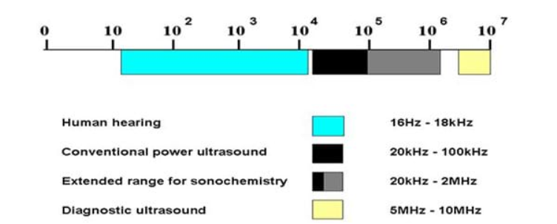
Figure 1: Ultrasound wavelength frequency
The application of ultrasound in monitoring food processing operations depends on understanding and measuring the ultrasonic properties of the material being analyzed. The three key ultrasonic properties include the propagation velocity of ultrasonic waves through the material, the degree of wave attenuation, and the acoustic impedance, which influences the reflection of ultrasound at the interface between different materials. These properties are crucial for assessing food composition, detecting structural changes, and ensuring process efficiency. Advances in ultrasonic technology have enhanced its potential for non-destructive testing, enabling real-time quality control and safety assessments in food processing.
Quality control of milk can be controlled for example (Bermúdez‐Aguirre et al., 2009) reported that ultrasonicated milk had a shelf life of 16 days at 4℃. Ultrasound has been used to ferment the milk from the reconstituted dry milk, which showed better probiotics compared to conventional reconstitution. Recently ultrasound has been used for homogenization, cream separation, pasteurization, renneting, emulsification and curdling (Carrillo-Lopez et al., 2021). Further, it is used to assess the degree of homogenization that can be controlled by controlling the ultrasound attenuation. Additionally, ultrasound can estimate the extent of emulsification by using its velocity and attenuation. Cohort workers reported that the edible fat and oil analysis can be achieved by measuring the attenuation and velocity of ultrasound and melting of the disperse emulsify particles (Singh et al., 2004).
Ultrasound technology relies on the interaction between high-frequency sound waves and materials to analyze their composition, structure, and dimensions as the waves propagate through them. The power levels used in ultrasonic testing are minimal, ensuring that the material's properties remain unchanged, making it a reliable non-destructive evaluation technique. This capability allows for real-time monitoring and quality assessment in food processing without compromising product integrity.
The underlying mechanism of ultrasound involves the generation of sound waves through mechanical vibrations, which propagate through a medium, causing localized pressure changes. These pressure changes give rise to physical phenomena such as cavitation, acoustic streaming, and thermal effects, which are harnessed for various applications. The versatility of ultrasound stems from its ability to operate under controlled frequencies, intensities, and durations, allowing for tailored solutions across disciplines.
Theory
A force is generated when ultrasound strikes the food surface, if the force is perpendicular to the surface compression wave is produced and if the force is parallel to the surface then a shear wave is produced. These two waves attenuated when they cross the food surface. These waves produce cavitation, and thinning of cell membranes by creating pressure and temperature due to compression and shear waves.
Ultrasound is a nondestructive analytical technique used in process control and quality safety. Sonicator and probe (Santos and Capelo, 2007) are the two approaches for applying low-frequency and high-intensity ultrasonication. A sonicator bath is a tank filled with fluid that contains a transducer that transfers the sound wave to the food sample / particle. A probe type sonicator is a probe that is directly inserted into the sample. Among them, probe type sonicator is the best one as it intensifies 100 times more than the sonicator bath (Sandhya et al., 2021).
Ultrasound as a preservation technology
The use of power ultrasound for microbial inactivation has been a subject of interest since the 1920s, following the pioneering work of Harvey and Loomis (1929). Their research investigated the effects of sonication, which they referred to as "raying," on a seawater suspension of *Bacillus fisheri* at 375 kHz under controlled temperature conditions. They observed that while heat alone could injure bacterial colonies, ultrasound had a more significant impact on microbial reduction. Maintaining the temperature at 19°C during sonication prevented bacterial regrowth, with microscopic analysis confirming complete inactivation. Their findings also indicated that under optimal conditions, high-frequency sound waves (around 400 kHz) could disrupt and eliminate luminous bacteria, effectively sterilizing the solution. However, they concluded that this method lacked practical or commercial viability due to its high operational costs.
Ultrasonic technology has become increasingly widespread in recent years, with reduced costs making its applications more economically feasible. The cavitation effects generated by ultrasound, as illustrated in Fig. 3, play a crucial role in food preservation. One of its well-established uses is surface cleaning, where the intense jet produced upon cavitation collapse effectively removes dirt and bacteria, even from hard-to-reach crevices that conventional cleaning methods may miss. Once dislodged into the surrounding liquid, harmful microorganisms are further subjected to ultrasonically assisted disinfection.
In liquid systems, ultrasound proves highly beneficial for sterilization and disinfection, particularly when combined with traditional sterilization methods such as heat treatment or the use of biocides. Research efforts have explored various experimental approaches and biological systems to understand the microbial inactivation potential of ultrasound. Several theories have been proposed to explain how ultrasound eliminates microorganisms, both independently and in combination with heat and/or pressure, contributing to the advancement of food safety technologies.
Principle of microbial inactivation
Ultrasonication forms cavitation in the microorganisms through chemical and physical changes in the cells present in liquid foods by creating cavitation. The cycle of compression and expansion caused by high intensity ultrasound creates a bubble to absorb the energy from the waves. Due to this cavitation explodes by absorbing energy from the sound waves (Fig 2). The bubble formation is depicted in Figure 2 Two types of cavitation occur namely internal (transient) cavitation in which bubbles form quickly and collapse at a faster rate. whereas in non-thermal cavitation bubbles do not collapse (stable). Cavitation mainly depends upon the temperature, pulse, power, frequency etc. In aqueous systems, when exposed to ultrasonic frequencies of around 20 kHz, each cavitation bubble's collapse creates a localized "hotspot" with temperatures reaching approximately 5,000 K and pressures of about 2,000 atmospheres. These extreme conditions contribute to the mechanical and thermal effects that can break down microbial cells, facilitating the sterilization and disinfection process in food and other materials.
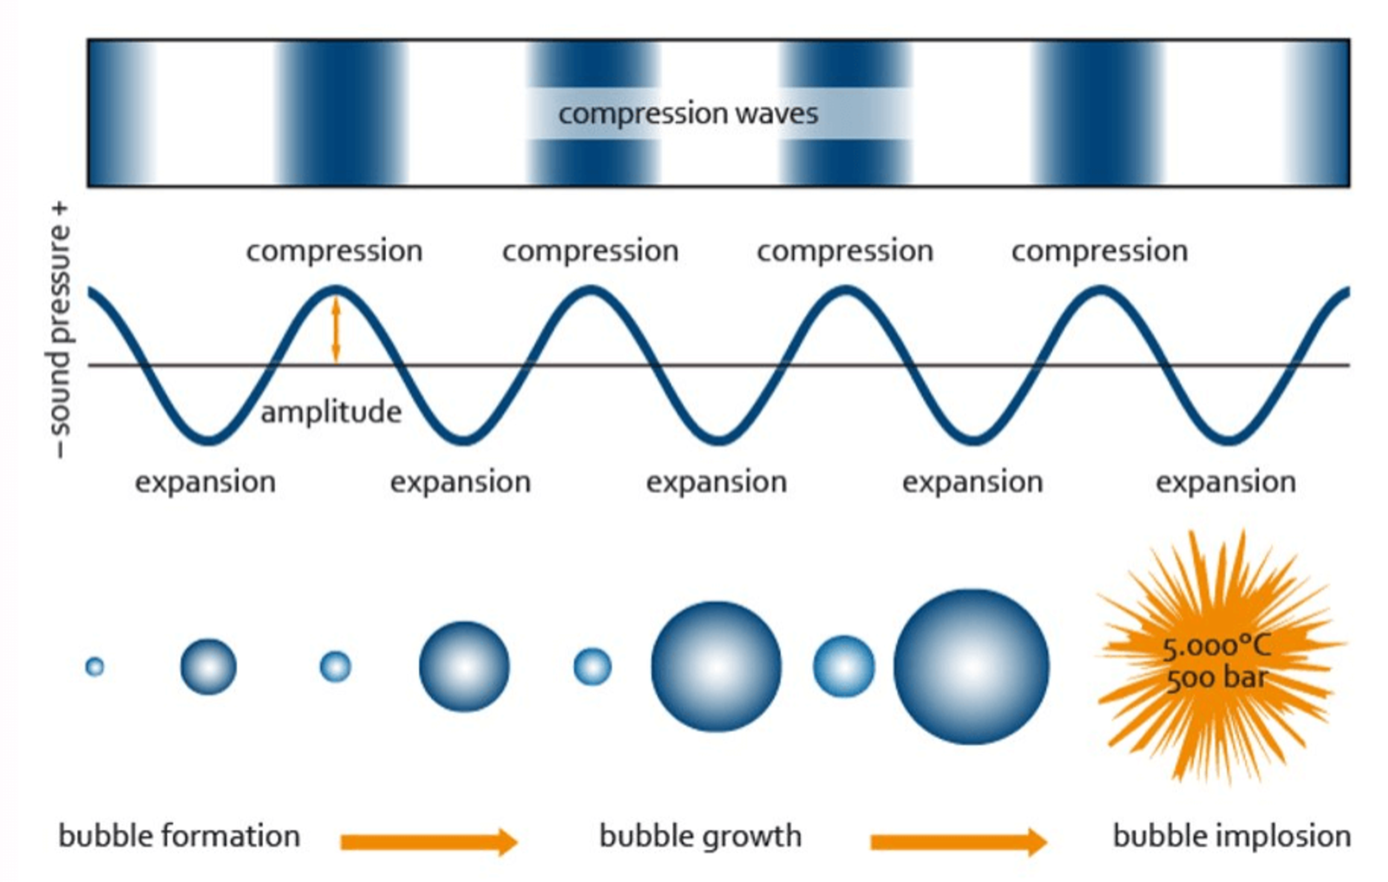
Figure 2: Formation of bubbles and implosion in the ultrasound

Ultrasound induced cell damage
It is difficult to draw a universal conclusion about the effect of ultrasound on living cells, despite the extensive research presented in this chapter. However, there is evidence that ultrasound can be lethal to a wide range of microorganisms, some enzymes, and even certain bacterial spores. Microorganisms exhibit varying degrees of resistance to ultrasound; larger cells tend to be more sensitive, coccal forms are more resistant than rod-shaped bacteria, and aerobic species show greater resistance compared to anaerobic species.
The mechanical effects of power ultrasound on chemical systems in liquid media are primarily attributed to cavitation, which has a profound impact on biological systems. Acoustic cavitation can be classified into two types: transient and stable. Transient cavitation occurs when bubbles filled with gas or vapor oscillate irregularly and eventually implode. This implosion generates extremely high local temperatures and pressures, capable of destroying biological cells and denaturing enzymes. The collapsing bubbles also generate shear forces and liquid jets, which can physically damage cell walls or membranes. This type of cavitation has been used on a small scale to disinfect water contaminated with microbial spores, such as Cryptosporidium, although it requires significant acoustic energy.
Stable cavitation, in contrast, involves bubbles that oscillate regularly for several acoustic cycles. These oscillations create microstreaming in the surrounding liquid, exerting stress on any microorganisms present. The microstreaming effect provides substantial mechanical force without the bubbles having to collapse, making it potentially significant for various applications in biotechnology (Reynolds and Willis, 1974). Ultrasound-induced inactivation has also been linked to intracellular cavitation, where mechanical shocks disrupt cellular structure and function, potentially leading to cell lysis (Butz and Tauscher, 2002).
A proposed mechanism for ultrasound-induced cell damage is depicted in Figure 2. Scherba et al. (1991) exposed specific bacteria, fungi, and viruses in aqueous suspensions to ultrasound at 26 kHz. They found that the percentage of bacterial death increased with longer exposure times and higher ultrasonic intensity. They proposed that the inner cytoplasmic membrane might be the primary site of ultrasonic damage, as there was no significant difference in kill rates between Gram-positive and Gram-negative bacteria.
Spores are generally more resistant than vegetative forms, and enzymes are often inactivated by ultrasound through a depolymerization effect, though the effectiveness of this process can vary. Cavitation—the formation, growth, and sometimes implosion of micro-bubbles in a liquid due to propagating ultrasound waves—results in the release of energy at "hot spots" (Mancuso et al., 2020). This phenomenon can cause enzyme inactivation through thermal effects due to the extreme temperatures generated during cavitation, free radicals formed by water sonolysis, and mechanical forces such as shear forces and shock waves. Possible mechanisms for spore inactivation include thermal effects, free radical generation, and mechanical forces induced by microstreaming and shock waves.
Ultrasonic equipment
The equipment is of probe type (Sonotrode) and sonication bath type. Ultrasonication equipment has been used in the cleaning and decontamination of equipment successfully but probe type are of laboratory scale range. The findings from successful small-scale experiments can be scaled up for large-scale applications, provided there is sufficient information on power input and the volume of material being treated. However, most of the small-scale studies conducted have not been optimized, meaning that the power requirements calculated for scaling up based on these studies are likely to be inaccurately high. In large-scale operations, there are generally two types of systems: batch and flow types (Mason and Lorimer, 2002). In some cases, the flow system may be incorporated into batch processing as a loop connected to the main vat, allowing for more continuous processing within a primarily batch-based setup.
Batch systems
Batch systems primarily utilize ultrasonic cleaning baths, functioning as comprehensive reactors for cleaning and sanitation purposes. These systems can accommodate capacities of several thousand liters and are often custom-designed as integral components of automated cleaning lines. Alternatively, the use of submersible transducers allows for the transformation of any tank into an ultrasonic reactor, providing increased versatility compared to dedicated ultrasonic baths.
The submersible unit consists of a sealed enclosure housing transducers affixed to one interior face. Upon activation, this face vibrates, creating a substantial surface area to generate ultrasound. The ultrasound bath system effectively converts low-frequency alternating current to high-frequency waves via piezoelectric transducers. This process results in the formation of millions of microscopic bubbles through the application of compression and shear forces. The rapid collapse of these cavities generates significant pressure and temperature, which play a crucial role in the efficient removal of contaminants.
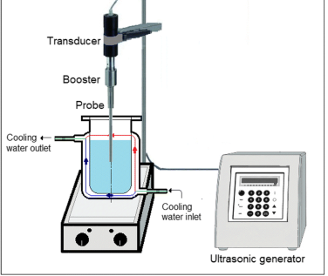 | 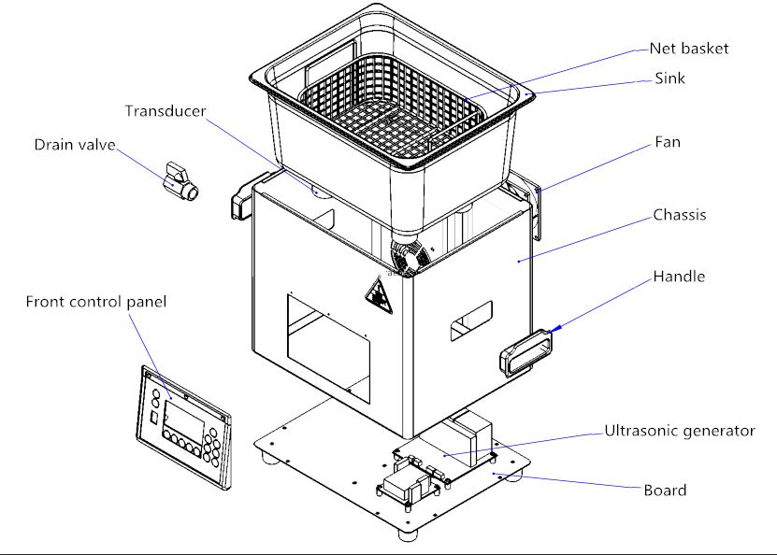
Figure 3: Ultra sonicator (a) Probe type (b) Ultrasonic bath
Flow systems
One of the earliest devices that utilized cavitation for mechanical action was the liquid whistle. Such devices are particularly valuable in applications where efficient homogenization and mixing are crucial. In these systems, process material is pumped under pressure through an orifice into a mixing chamber. Cavitational mixing occurs in two primary ways at this point. First, the venturi effect causes the liquid to rapidly expand into a larger volume as it exits the orifice. Second, the jet of liquid impacts a thin steel blade in the mixing chamber, causing it to vibrate and further mix the process material flowing over it. Since the system has no moving parts other than the pump, it is rugged and durable.
Typical applications of such whistles include the preparation of emulsion bases for soups, sauces, or gravies, which consist of a premix of water, milk powder, edible oil, fat, and flour or starch as a thickening agent. After passing through the homogenizer, a fine-particle-size emulsion is produced with a smooth texture.
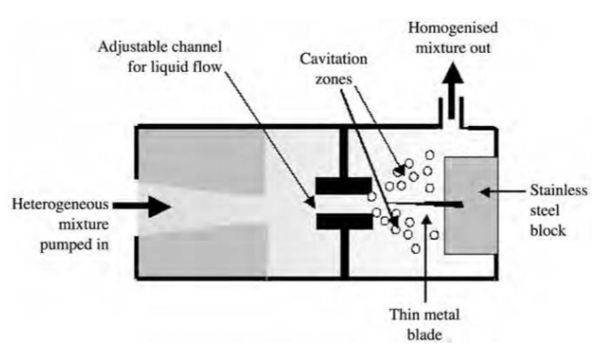
For large-scale operations requiring higher-intensity ultrasound, the source of power ultrasound is best integrated into a flow loop outside the main reactor. This setup allows the processing of larger volumes and offers significant advantages over a batch configuration, especially when using a probe system. High-intensity sonication is provided for continuously flowing liquid reactions, with power levels controlled either by adjusting the input power to the transducer or by modifying the flow rate through the cell. Temperature control is achieved by circulating the reaction mixture or through a pulse option, ensuring optimal conditions for the process.

Figure 4: Schematic number of flow system
For large-scale operations where higher-intensity ultrasound is required the source of power ultrasound is best used as part of a flow loop outside the main reactor. This permits the processing of large volumes and provides major advantages over the batch configuration for the probe system. High-intensity sonication is provided for a continuously flowing liquid reaction at controllable power by the adjustment of either input power to the transducer or the flow rate through the cell. Temperature control is provided through the circulating reaction mixture or a pulse option

Application of ultrasound in endospore inactivation
In the dairy industry, many thermophilic spore-formers exist in milk. If we do not eradicate these spores in milk causes the spoilage of milk and its products. For example, Geobacillus stearothermophilus causes flat sour spoilage in canned milk, Bacillus licheniformis produces the extra cellular substance which may spoil pasteurized milk products (Gilmour and Rowe, 1990). Nowadays microorganisms develop resistance to many processes, and because of that combination of processes called hurdle technology has been used.
Microorganism spores are very much resistant to extreme conditions like osmotic pressures & high temperatures, low & high pHs & mechanical shocks. Raso et al., (1998) stated that combining the effect of static pressure and 20 kHz of an ultrasonic probe inserted into samples resulted in an increased level of spores inactivation with an increase in static pressure. Manosonication treatments done at a pressure of 500 kPa for 12 minutes and inactivates nearly 99% of the spore. when we increase the amplitude of ultrasound vibrations of the transducer, that is the acoustic power let into the system, increases the level of inactivation, for example, 75% of the spores are inactivated by a 20 kHz probe at 90 % amplitude and a pressure of 300 kPa for 12 minutes.99.5% spore inactivation is achieved by increasing the amplitude to 150%. Instead of using thermal treatment alone, ultrasound and increasing thermal treatment result in greater rates of spore inactivation. The very high pressure & temperature of bubbles leads to the dissociation of water vapour into hydroxyl atoms & hydrogen atoms. These free radicals act in the inactivation of bacterial spores by oxidative damage as that of hydroperoxides.
Application of ultrasound in food industry
Depending on the frequency and intensity, ultrasound applications in food can be classified into high-intensity (low-frequency) and low-intensity (high-frequency) ultrasound. Below are the key applications of ultrasound in the food industry.
- Extraction of Bioactive Compounds
Ultrasound-assisted extraction (UAE) is a sustainable and efficient technique for recovering bioactive compounds such as polyphenols, flavonoids, carotenoids, and essential oils from plant materials. The acoustic cavitation disrupts cell walls, enhancing mass transfer and improving extraction yields. UAE is widely used in juice processing, herbal extracts, and functional food production.
- Emulsification and Homogenization
Ultrasound effectively stabilizes emulsions by reducing droplet size and improving dispersion. It is commonly used in the production of nanoemulsions for encapsulating bioactive compounds, such as vitamins and omega-3 fatty acids, enhancing their stability and bioavailability. In dairy and beverage industries, ultrasound-assisted homogenization improves texture, consistency, and shelf stability.
- Meat Processing and Tenderization
In meat processing, ultrasound enhances the tenderness and juiciness of meat by breaking down muscle fibers and connective tissues. It also improves brine penetration during marination, resulting in better flavor distribution. Additionally, ultrasound assists in the extraction of proteins for processed meat applications.
- Dairy and Bakery Applications
Ultrasound helps in homogenizing milk, improving the fermentation process in yoghurt production, and accelerating cheese ripening by modifying protein and fat structures. Ultrasound improves dough rheology by enhancing gluten network formation, leading to better aeration, increased volume, and improved texture in baked goods.
- Crystallization and Freezing
Ultrasound plays a crucial role in controlling crystallization processes in food products such as chocolate, margarine, and frozen foods. It promotes uniform ice crystal formation in frozen products, reducing texture degradation and improving sensory quality.
- Waste Treatment and By-Product Utilization
Ultrasound facilitates the breakdown of organic food waste, improving biofuel production and wastewater treatment. It is also used for extracting valuable compounds from food by-products, enhancing sustainability in food processing.
- Enhancement of Mass Transfer in Drying and Osmotic Dehydration
Ultrasound enhances mass transfer in drying and osmotic dehydration processes, reducing processing time and improving product quality. It is widely used in drying fruits, vegetables, and meat products while retaining bioactive compounds and structural integrity.
Conclusions
Ultrasound is a novel technology for food processing and also in terms of quality control. Lot to work in this area to come up with a standard procedures and also for regulating bodies to make certain guidelines. United States Food and Drug Authority says using alone ultrasound is ineffective in processional and quality control. We have to use hurdle technology that is along with ultrasound we should use thermal techniques, pressure technology or low temperature or irradiation for effective food safety. But ultrasound overcomes the other technology limitations. The continued development of ultrasound in the food industry depends on the availability of appropriate ultrasonic instrumentation, and workers using a systematic approach to the measurement and interpretation of ultrasonic data
References
BERMÚDEZ‐AGUIRRE, D, Mawson, R., Versteeg, K., & BARBOSA‐CÁNOVAS, G. V. (2009). Composition properties, physicochemical characteristics and shelf life of whole milk after thermal and thermo‐sonication treatments. Journal of Food Quality 32(3), 283-302.
Burgos, J., Ordon˜ez, J.A. and Sala, F.J. (1972) Effect of ultrasonic waves on the heat resistance of Bacillus cereus and Bacillus licheni formis spores. Applied Microbiology 24, 497–498.
BUTZ P and TAUSCHER B (2002), `Emerging technologies: chemical aspects', Food Research International 35, 279-284.
Carrillo-Lopez, L. M., Garcia-Galicia, I. A., Tirado-Gallegos, J. M., Sanchez-Vega, R., Huerta-Jimenez, M., Ashokkumar, M., & Alarcon-Rojo, A. D. (2021). Recent advances in the application of ultrasound in dairy products: Effect on functional, physical, chemical, microbiological and sensory properties. Ultrasonics Sonochemistry 73, 105467.
Duck, F., & Leighton, T. (2018). Frequency bands for ultrasound, suitable for the consideration of its health effects. The Journal of the Acoustical Society of America, 144(4), 2490-2500.
Gilmour, A., & Rowe, M. T. (1990). Microorganisms associated with milk. Dairy microbiology, 1, 37-75.
Mancuso, G., Langone, M., & Andreottola, G. (2020). A critical review of the current technologies in wastewater treatment plants by using hydrodynamic cavitation process: principles and applications. Journal of Environmental Health Science and Engineering, 18, 311-333.
Mason, T. J., & Lorimer, J. P. (2002). Applied sonochemistry. Weinheim, Wiley VCH.
Reynolds, C., & Wills, E. D. (1974). The effect of irradiation on lysosomal activation in HeLa cells. International Journal of Radiation Biology and Related Studies in Physics, Chemistry and Medicine, 25(2), 113-120.
Sandhya, M., Ramasamy, D., Sudhakar, K., Kadirgama, K., & Harun, W. S. W. (2021). Ultrasonication an intensifying tool for preparation of stable nanofluids and study the time influence on distinct properties of graphene nanofluids–A systematic overview. Ultrasonics sonochemistry, 73, 105479.
Santos, H. and J. Capelo. 2007. Trends in ultrasonic-based equipment for analytical sample treatment. Talanta 73(5):795-802.
SCHERBA G, WEIGEL R M and O'BRIEN J R (1991), `Quantitative assessment of the germicidal efficacy of ultrasonic energy', Applied and Environmental Microbiology, 57, 2079-2084.
Singh, A. P., McClements, D. J., & Marangoni, A. G. (2004). Solid fat content determination by ultrasonic velocimetry. Food Research International, 37(6), 545-555.
Suslick, K.S. (1988) Homogeneous sonochemistry. In Ultrasound: its Chemical, Physical, and Biological Effects ed. Suslick, K.S. pp. 123–163.

