Inflammation and Tissue Repair in Musculoskeletal Rehabilitation: Biological Mechanisms and Clinical Implications

ABSTRACT

Inflammation is a fundamental biological response in musculoskeletal injuries, serving as a critical mechanism for initiating tissue repair and restoring homeostasis. This chapter explores the cellular and molecular mechanisms that regulate inflammation and tissue repair, emphasizing their clinical implications in musculoskeletal rehabilitation. The inflammatory response follows a structured sequence of initiation, amplification, and resolution, orchestrated by immune cells, cytokines, and vascular changes. While acute inflammation is essential for clearing necrotic tissue and preparing the injury site for healing, dysregulated or prolonged inflammation can contribute to fibrosis, chronic pain, and impaired function. Tissue repair occurs through a continuum of inflammation, proliferation, and remodeling phases, with outcomes varying between regeneration and fibrosis depending on tissue type, injury severity, and patient-specific factors. Rehabilitation strategies must align with the biological dynamics of inflammation and repair to optimize patient outcomes. A comprehensive understanding of these mechanisms enables clinicians to design evidence-based treatment protocols that balance inflammatory control with tissue regeneration, minimizing complications and improving functional recovery. This chapter underscores the importance of integrating biological insights into musculoskeletal rehabilitation to enhance clinical decision-making and therapeutic efficacy.

Keywords: Inflammation; repair; rehabilitation; physical therapy

Introduction
Inflammatory process in musculoskeletal injuries
Inflammation is a fundamental biological response to tissue injury, playing a crucial role in initiating repair and restoring homeostasis. In musculoskeletal injuries, the inflammatory process is highly regulated and involves complex cellular and molecular mechanisms designed to eliminate damaged tissue, prevent infection, and create a suitable environment for healing [6,9].

Mechanisms of inflammation
The inflammatory response consists of three main phases: initiation, amplification and resolution [7]. These phases are orchestrated by a network of cells, signaling molecules, and vascular changes:
1) Initiation
This phase begins immediately after tissue injury and lasts from hours to a few days. Key events include:
- Vascular Response: Vasodilation and increased permeability of blood vessels occur due to the release of histamine, prostaglandins, and bradykinin, leading to increased blood flow and plasma exudation.
- Cellular Response: Neutrophils, the first responders, migrate to the site of injury via chemotaxis, guided by gradients of cytokines such as interleukin-1 (IL-1) and tumor necrosis factor-alpha (TNF-α). These cells perform phagocytosis, clearing necrotic debris and pathogens.
2) Amplification
Within 24 to 72 hours, monocytes differentiate into macrophages, sustaining the inflammatory response by releasing additional cytokines and growth factors. This phase facilitates:
- Secretion of Pro-Inflammatory Mediators: Macrophages and mast cells release interleukins (IL-6, IL-8) and prostaglandins, prolonging the inflammatory cascade and enhancing cellular recruitment.
- Formation of Edema: The accumulation of interstitial fluid, due to increased vascular permeability, results in localized swelling.
- Pain Sensitization: Prostaglandins and bradykinin activate nociceptors, leading to pain and functional impairment.
3) Resolution
Inflammation is actively resolved to prevent excessive tissue damage and fibrosis. This occurs through:
- Shift to Anti-Inflammatory mediators: Macrophages transition to an anti-inflammatory phenotype, releasing interleukin-10 (IL-10) and transforming growth factor-beta (TGF-β), which suppress further inflammation and initiate tissue repair.
- Apoptosis of neutrophils: Clearance of apoptotic neutrophils by macrophages prevents prolonged inflammation and contributes to resolution.
- Extracellular matrix remodeling: Fibroblasts and myofibroblasts begin depositing collagen, replacing lost tissue and restoring structural integrity.

Clinical signs and symptoms of musculoskeletal inflammation
The classical clinical manifestations of inflammation, known as Redness, Heat, Swelling, Pain, and Loss of Function, are particularly evident in musculoskeletal injuries [8,11,12]:
- Redness: Increased blood flow due to vasodilation.
- Heat: Elevated local temperature from hyperemia.
- Swelling: Edema formation due to increased vascular permeability.
- Pain: Sensitization of nociceptors by prostaglandins and cytokines.
- Loss of Function: Impaired mobility and strength due to pain and swelling.
The duration and intensity of inflammation in musculoskeletal injuries depend on the severity of the tissue damage, the affected tissue type, and individual patient factors such as age, comorbidities, and immune response. While acute inflammation is necessary for initiating tissue repair, excessive or prolonged inflammation can contribute to fibrosis, chronic pain, and impaired function. Understanding the mechanisms underlying inflammation in musculoskeletal disorders is crucial for optimizing therapeutic strategies, ensuring timely intervention, and facilitating effective rehabilitation. By balancing pro-inflammatory and anti-inflammatory pathways, clinicians can enhance tissue healing and minimize long-term complications.

Tissue repair in musculoskeletal injuries
Tissue repair is a highly regulated biological process aimed at restoring structural and functional integrity following musculoskeletal injuries. This process can occur via regeneration, in which damaged tissue is replaced by new cells of the same type, or through scarring (fibrosis), where connective tissue replaces the injured area, often leading to functional impairment. The repair outcome depends on the extent of the injury, the affected tissue type, and the inflammatory response [8,10].

Phases of tissue repair
The process of musculoskeletal tissue repair follows three primary overlapping phases:
1) Inflammation (0-7 days)
- Initiated immediately after injury, this phase aims to clear necrotic tissue and set the stage for healing.
- Neutrophils and macrophages release cytokines (IL-1, IL-6, TNF-α) and growth factors (TGF-β, VEGF) to modulate cellular responses.
- The inflammatory phase is necessary for proper healing but must be well-regulated to prevent chronic inflammation and excessive fibrosis.
2) Proliferation (4-21 days)
- Fibroblasts and myoblasts proliferate, producing extracellular matrix (ECM) components such as collagen and glycoproteins.
- Angiogenesis, driven by VEGF (vascular endothelial growth factor), restores blood supply to the injured area.
- Myogenic precursor cells (satellite cells) contribute to muscle regeneration by differentiating into new myofibers.
- In tendons and ligaments, fibroblasts produce type III collagen, which is later remodeled.
3) Remodeling (21 days - 12 months)
- Type III collagen is gradually replaced by the stronger type I collagen in tendons and ligaments.
- Myofibers mature in muscle tissue, leading to partial or full functional recovery.
- In cases of excessive injury, the repair process results in fibrosis, with increased deposition of disorganized collagen and impaired mechanical properties.
Regeneration OR Scarring
- Skeletal muscle has a moderate regenerative capacity due to satellite cells, but large injuries often result in fibrosis.
- Tendons and ligaments have poor regenerative ability due to limited vascularization, leading to predominant scar formation.
- Bone can regenerate efficiently via endochondral ossification, typically achieving complete repair in 6-12 weeks for uncomplicated fractures.
- Cartilage has minimal regenerative capacity due to avascular nature, leading to chronic degeneration in many cases.

Tissue-specific repair timelines
- Muscle: 6-8 weeks for minor injuries or months for severe damage.
- Tendon/Ligament: 6 weeks to 12 months, with long-term mechanical deficits.
- Bone: 6 weeks to 12 months, depending on fracture complexity.
- Cartilage: Limited repair, often leading to chronic degeneration.

The balance between regeneration and fibrosis determines the functional outcome of musculoskeletal healing [13,14]. Understanding the mechanisms and timelines of tissue repair is crucial for optimizing rehabilitation strategies and improving patient outcomes.

Rehabilitation and clinical implications
Clinical practice and graduate-level professional development courses in musculoskeletal rehabilitation have traditionally emphasized therapeutic modalities such as electrotherapy, phototherapy, manual therapy, biomechanics and kinesiotherapy. Techniques are very important; however, knowledge of the biological response of the tissues to injuries has often been taken for granted, left aside or not considered. This gap in knowledge can contribute to incomplete rehabilitation process and the development of chronic conditions.
In addition to the focus on techniques, clinical practice and studies often seek the development and testing of clinical rehabilitation protocols. While protocols offer numerous advantages, strictly adhering to them in a rigid and inflexible manner—akin to following a “cookbook recipe”—without considering the underlying biological mechanisms can result in treatment failures. A comprehensive understanding of inflammation and tissue repair is therefore fundamental to optimizing musculoskeletal disorder management.
The inflammatory process serves as a critical protective mechanism, preparing injured tissues for subsequent repair. Inflammation comprises both vascular and cellular events. The vascular events include vasodilation and increase hydrostatic pressure, culminating in the formation of edema. Meanwhile, cellular events involve the migration and diapedesis of inflammatory cells to the site of injury. The subsequent repair phase is characterized by two potential outcomes: regeneration or scarring. Regeneration entails the replacement of damaged tissue with new cells of the same type, whereas scarring results in the deposition of fibrous tissue. The primary determinants of whether regeneration or scaring occurs are the extent of the injury and the type of tissue that has been affected.
Inflammation and repair occur simultaneously, but in different time frames (Figure 1). Under normal physiological conditions, inflammation manifests with high initial intensity but resolves more rapidly than the repair process. Misinterpretation of the timeline and intensity of these processes is common among both patients and clinicians. The cessation of inflammation does not necessarily indicate that the patient is ready for discharge or to resume intensive therapeutic or recreational activities. Since the repair phase remains ongoing, the injured tissue may not yet possess the requisite biomechanical properties to withstand excessive loading. Consequently, a gradual and progressive increase in exercise intensity is essential to prevent re-injury and to facilitate a safe return to normal functional activities.
Although general timelines for tissue repair have been established, numerous factors—including age, genetic predisposition, injury severity, anatomical location, and tissue type—affect the duration of the healing process. Thus, a thorough understanding of tissue-specific repair timelines, combined with clinical parameters such as pain, erythema, edema, and heat, as well as functional indicators like strength, range of motion, and sensory-motor rebalancing, is essential for guiding rehabilitation professionals in designing effective treatment strategies. By integrating biological insights with evidence-based rehabilitation protocols, clinicians can enhance patient outcomes and minimize the risk of chronic dysfunction.

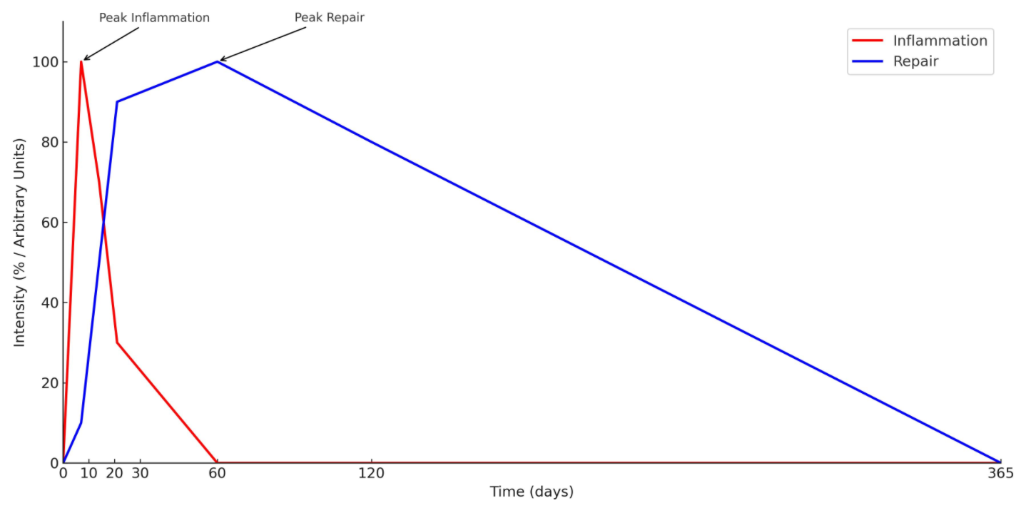

Fig 1. Temporal dynamics of inflammation and repair in musculoskeletal healing. Illustrative scheme depicting the relationship between the intensity and duration of inflammatory and reparative biological processes over time. While a general pattern of response can be identified, multiple factors—including age, genetic predisposition, injury severity, anatomical location, and tissue type—modulate the intensity and duration of these processes.

Competing interests

The author have declared that no competing interests exist.

References

- HALL, John E. (Ed.). Guyton & Hall. Tratado de fisiología médica. Elsevier Health Sciences, 2021.
- ROBBINS, Stanley; COTRAN, Ramzi S. Patologia - Bases Patológicas das Doenças. Guanabara Koogan, 2023.
- Quemelo PRV. The Biological Aspects in the Process of Musculoskeletal Rehabilitation. World J Phys Rehabil Med. 2017; 1(1): 1001.
- Alfredson H. Clinical commentary of the evolution of the treatment for chronic painful mid-portion Achilles tendinopathy. Braz J Phys Ther. 2015 Sept-Oct; 19(5):429-432.
- Choi B, Lee C, Yu JW. Distinctive role of inflammation in tissue repair and regeneration. Arch Pharm Res. 2023 Feb;46(2):78-89.
- Medzhitov, R. (2021). The spectrum of inflammatory responses. Science, 374(6571), 1070-1075.
- García, L. F. (2020). Immune response, inflammation, and the clinical spectrum of COVID-19. Frontiers in immunology, 11, 1441.
- Fioranelli, M., Roccia, M. G., Flavin, D., & Cota, L. (2021). Regulation of inflammatory reaction in health and disease. International journal of molecular sciences, 22(10), 5277.
- Mease, P. J. (2011). Inflammatory musculoskeletal disease: identification and assessment. The Journal of Rheumatology, 38(3), 557-561.
- Goodman, S. B., & Qin, L. (2017). Inflammation and the musculoskeletal system. Journal of orthopaedic translation, 10, A1.
- Woo, S. L. Y., & Buckwalter, J. A. (1988). Injury and repair of the musculoskeletal soft tissues. Savannah, Georgia, June 18–20, 1987. Journal of Orthopaedic Research, 6(6), 907-931.
- Li, Z., Xiang, S., Li, E. N., Fritch, M. R., Alexander, P. G., Lin, H., & Tuan, R. S. (2021). Tissue engineering for musculoskeletal regeneration and disease modeling. Organotypic Models in Drug Development, 235-268.
- R. Hadi, N. ., M. Muhammad-Baqir, B., & H. Ahmed, M. . (2021). Inflammatory Response Post PCI Technique. Inflammatory Response to Percutaneous Coronary Intervention, 35–59. https://doi.org/10.9734/bpi/mono/978-93-5547-374-5/CH3
- Frangogiannis, N. G., Smith, C. W., & Entman, M. L. (2002). The inflammatory response in myocardial infarction. Cardiovascular research, 53(1), 31-47.

___________________________________________________________________________________

