THE IMMUNODERMAL ASSAY ATLAS

PREFACE

An idea was going on within my mind that was oriented towards preparing an atlas for immune skin testing in human,rabbits,rats,mice and chicks.The presumed atlase bears the name "The immunodermal atlas.To investigate the originality of the idea, a dig through recent and rather old literature related to this topic,four atlases as in the followings;

1-Brockow K , Mortaz CG 2019.Global Atlas of Skin Allergy,EAACI.knowledge Hub.

2-Fiskin E et al.2023.Multimodal Skin Atlas identified a multicellular immuno-stromal community associated with altered conformation and specific T cell expasion in atopic dermatitis.bioRxiv.2023.Cold Spring Haber Laboratory.

3- 2023.Light camara and action;Vertebrate skin tests,the stage for immune cell interactions with arthropod-vectored pathogen.Front.Immunol.4;doi.10.fimmu.2013.00286.

4-O'Neal K.2022.Mapping The body's Defense Systems:The Immune Cell Atlas.Technology Network.Com.Immunology Article36725.

The abovementioned atlases were found spaning around the idea but not really within the considered theme.The present atlas is being an excerpt of rather a decade of work in our laboratories at Babylon University 1998 till 2014, when I have been working as professor inthe Biology Department,College of Science.The atlas was intended to present curated informations in an atlas form through the use of ease simplelucid way and suggested for biggener students and reaserchers of immunology.

Ibrahim M S.Shnawa Adnan AK ALSalamy

Feb 2025

ABSTRACT

The text was organized in two parts,two sections, and seven chapters.The first three chapters covered the theoretical fundametals.Part two composed of four chapters spans through the immune skin testings of human,rabbits,rats, and chickens.The text chaspters writing style starts with skin structure,skin functions,animal assignment ,Skin sensitins, immune response nature,the onsetting skin preparations , gross immune reaction,cellular immunobiologic reactions, interventions , gross immune reactions,cellular immunobiologic reactions and scoring parameters as well as the experimental excerpts the photos. ~~The text contour contained an array of tables and photos and figures~~ (The most significant data is summarized in tables, figures, and photos). ~~The text forming photos express tuberulin testing in humans,tuberculin -types skin DTH for bacterial and~~ ~~sperm- delayed allegens, toxin immune skin testings and immune potency testings in chikens and rats.As well as mitogenicity and blastogenicity in chicken models.~~ (The photographs attached to the text illustrate tuberculosis tests in humans, semen contact allergy, bacteriological skin tests, Shiga skin tests for dysentery toxins and immune tests in chickens and rats, as well as mitogenicity and blastogenicity tests in chicken models).

CONTENTS

I -Preface.

II – Abstract.

III – Contents (Illustrations) or (tables, figures, and photos).

PART ONE : BASIC PLATFORM

Section One :Theoretical Fundamentals

Chapter One :The Contribution of Animals to immunology

Chapter Two: Skin Structure And Functions.

Chapter Three:Skin Testing

PART TWO: THE ATLAS CORE CONCEPT

Section Two:Vertebrate Immune Skin Testings

Chapter Four :Human Immune Skin Tests

Chapter Five :Rabbit Immune Skin tests

Chapter Six : Rat Immune skin Tests

Chapter Seven :Birds immune skin Tests.

PART ONE : BASIC PLATFORM

Section One :Theoretical Fundamentals

Chapter One:Contribution of Animals to Immunology

Chapter Two : Skin Structure And Functions

Chapter Three:Skin Testings

CHAPTER ONE :ANIMAL CONTRIBUTION TO IMMUNOLOGY*

Abstract

There are several contributions of animals to human beings and to humanity. Among these contributions are those concerning the science of immunology. Traditionally ,mice are outstanding model both for research and for teaching trends in immunology. Animal biologists and immune-biologists all over the world put-forward several trails to trace and develop other animal models of use as contributors to immunology. The objective of the present opinion was to map thecontributions of both invertebrate and vertebrate to the science of immunology .A group wise immune features were summarized,and nine major contributions were briefed as; in-vitro investigation ,in-vivo investigation ,development ,models ,discovery ,evolution ,therapeutics, protection and phenomena. A detailed expression of immune system compartments comprising the evolutionary trends was made .Piscan ,anuran ,avian , and lapin immune models were suggested based on our research efforts and those of others as a choice for teaching and /or research purposes and a waiver other than mice model.

I- Introduction

Under the umbrella of the living world, there are five kingdoms. One of which is the Kingdom of animalia[1].Practically, animalia subdivided into invertebrates and vertebrates. Both of these subdivisions are, in turn, subdivided into higher and lower forms[2],[3] .Each of the four forms, in turn are divided into a number of specific animal groups[1],[4]. These groups possess a wide range of functions to human beings, among which their contribution to the field of immunology[5],[6],[7],[8],[9].The objective of the present opinion was to shed a light on the contribution of representatives of `these animal groups to the science of immunology. Beside put-forwarding immune models of choice as a waiver from mice[10].

Animals play an important role in human life and development. One of their contributions relates to the field of immunology, where they serve as valuable models for scientific research. Mice are traditionally used as a model in immunological research, but other invertebrates and vertebrates are also used. Biologists around the world are working to create animal models that can be used in immunological research. The purpose of this article is to review the contribution of invertebrates and vertebrates to immunology. The characteristics of group immunity are summarized and nine main contributions are described: in vitro and in vivo research, model development, discoveries, evolutionary aspects, therapy, protection, phenomena and components of the immune system reflecting evolutionary trends. Based on our own research and that of other authors, we have proposed immune models of fish, amphibians, birds, and rabbits that can be used for educational and/or research purposes, in addition to the mouse model. There are five (6-7 according to some reports) kingdoms under the aegis of the living world, one of which is the Animal Kingdom. Animals of the chordate type are divided into several subtypes: lower - Cephalochordata, Tunicata and higher- vertebrata. Each of these groups, in turn, can be subdivided into specific groups of animals that perform a wide range of functions for humans, including contributions to the field of immunology. The purpose of this article is to highlight the contribution of these animal groups to immunology and to propose alternative models for research in this field other than the mouse.

II- Theme

The lower and higher forms from both of the invertebrate and the vertebrates owns general and specific immune features[4],[8],[9]. These features are either specific structures and /or specific mechanisms unique to specific animal group. Or discovered in a specific group and then found to[ be ]applicable or operable in other groups. Nine broad contributions were traced throughout animalia so far concerning the use for the science immunology. Each contribution covers a synopsis on the immune feature, unique immune character in addition to a clue onto a suggested specific immune models as a substituent to the outstanding model the mice [10].[Thus in this issue , three hypotheses were proposed as;

i-Animals are of value for teaching , research and clinical application immunology (anti-snake serum, allergen-specific immunotherapy)

ii-Specific animal groups are valid as an immune models

iii-Animal cells and body fluids serves as a supporting materials for immunological invest

III- Contributions

Animals holds an indispensible and being a source for both teaching and research in the field of the science immunology. Enormous contributions are assumed to be found in both invertebrate and vertebrates.

*This chapter is originally one of my a papers published in Hunan University Journal 2022.

Traditionally mice are the model of choice for immunologic affairs.Spectacular screen to the now a day literature have shown that workers all over the world were trying to put-forward other animal models like farm animals ,rabbit ,fish and amphibia for instance[11],[12],[14],[15],[16],[17]. that are proved to be of help as contributors to the attitudes of immunology science and applications, Table- 1.

Table-1 :Animal Contributions To Immunology*.(add: humanized mice- modeling of the human immune system, the development of oncovaccines, Immunodeficient mice, transplantology (The *host-versus-graft reaction*))

|  |  |  |  |
| --- | --- | --- | --- |
| Contribution | Study nature | Entities | Use |
| Investigation | In-vitro | -BSA (bovine serum albumin)  - bovine serum albumin  -sheep red cells | -antigen  -cellular immune test  - E rosett formation  -antigen carrier |
| Investigation | In vivo | Test immune system | -hypersensitivity  -autoimmunity  -mitogenicity |
| Development | In vivo | Test immune system | -vaccines  -therapeutic sera |
| Models | In vivo | Test immune system | Immunity to infection |
| Discovery | In vivo | -Thymus  -Bursa of fabrecious | Structural immunology |
| Evolution | In vivo | Representative of each animal group | Evolutionary and developmental immunology |
| Therapeutics | In vivo | -antitoxins  -antiveinins  -standard globulin | Immunotherapy |
| Protection | In vivo | Microbial toxinosis | Mouse Protection test |
| Phenomena | In vivo | -Arthus reaction  -Jhon Moote reaction  -Anaphylaxis  -Anergy | -Building up models  -Detection of molecular mechanisms |
| Simulations | In vivo | Animal-Human | Immune simulations |

*Based onto: [5], [6],[7]

The lower and higher vertebrates of animals have common and specific immune properties[4],[8],[9]. These properties are either specific structures and/or specific mechanisms unique to a particular group of animals. Or found in a certain group, and then recognized as applicable or effective in other groups. To date, animalia has discovered nine major contributions related to its use in scientific immunology. Each article contains a brief overview of the immune function, the unique immune character, as well as information about the proposed specific immune models as a replacement for the mouse model [10].[Thus, in this issue, three hypotheses have been put forward as;

Animals are an indispensable source of information for teaching, as well as for research and clinical practice in the field of scientific immunology. It is assumed that both invertebrates and vertebrates can make a huge contribution..

* This chapter was originally one of my articles published in the Hunan University Journal for 2022.

Traditionally, mice are the preferred model for immunological research. An impressive review of modern literature has shown that scientists around the world have tried to use other animal models such as farm animals, rabbits, fish, and amphibians.[11],[12],[14],[15],[16],[17]. They help the development of science, in particular immunology (Table 1).

IV- Specific Immune Features

Both of the Invertebrate and vertebrates own general and specific immune features belonging to the forming specific animal groups. The general features mean that they are expressed in all or most of groups like phagocytosis, self-none-self recognition and graft rejection ,while the specific it concerns minor group or individual within the group like melano-macrophage centers in fish [9],[18]. These features were pinpointed in the Tables 2 & 3.

Table -2:Immune Features of invertebrates*

|  |
| --- |
| -Phagocytosis |
| -Self- non-self recognition |
| -Specific memory |
| -Haemagglutinins resembling antibodies |
| -Higher forms shown cell mediated immune reactions |
| -Higher forms shown the emergence of circulatory system |
| -IL-1,TNF in coelomate and echinoderms |
| -Tunicates, emergence of MHC, lymphoid like cells, stem cells |
| -Arthropods, complement |
| -D. melanogaster ,Toll like receptor |

Based onto[4],[8],[9].

Table-3:Immune features of Vertebrates*.

|  |
| --- |
| -Self-non-self recognition. |
| Phagocytosis |
| -graft versus host reaction |
| -MHC |
| -lymphoid system |
| -antibodies |
| -cytokines |
| -thymus in fish |
| -first lymph node and GALT appearance in amphibian **BALT** ? |
| -IgT cells in reptile and birds |
| -Will developed mucosal immune system in mammals. Trained immunity |

*Based onto [4],[8],[9].

V- A group wise contributions

In the following points a brief for the group wise contributions:

* Insects ,D melanogaster first in which Toll-like receptor discovered.
* Tunicates, first appearance of Single structured MHC.
* Jawless fish, first immunoglobulin to appear in this group.
* Cartilagenous fish ,rise of B and T lymphocyte compartments.
* Bony fish ,melanomacrophage centers first to appear a still is characteristic to this group ,Zebrafish as an analogous model to mice. Immunotoxicity models.
* Amphibia, typical lymph node, thymus ,GALT and bone marrow.
* Birds, chickens were first to be used in bacterin preparation of Pasteurellas.
* Birds, Bursa of Fabrecious first to be discovered in birds, separate T and B cells in the immune system ,multi-lobed thymus in the neck region.
* Mammals, lapin used as a model as an immune model for microbial and nonmicrobial (tumors) diseases
* Mammals, ovine ;B cells activated in their lymph node
* Mammals, bovine ;from the udder of the cow to human vaccines. Bovine thymus extract of use as immune-therapeutics for autoimmune diseases.
* Mammals ,equines; preparation of therapeutic antitoxins for toxin induced human diseases

VI-Evolution of The Immune System Compartments [4,8,19]).

VI_1:MHC ;

MHC class I genes are found in all of the major jawed vertebrates High levels of polymorphism and genetic diversity are characteristic of most classical MHC genes .Single structured MHC had been traced in Tunicates. Bony fish possess polymorphic MHC. Amphibians described to have clear cut MHC. Mammals however have evidently diverse MHC.

VI-2:Complement:

A specific glycoprotein molecules mediate self-non-self recognition had been found in corals and sponges. Molluece have a sort of alternative complement pathway. Cartilagenous fish have classical complement pathway. Birds have an evident complement system but differs from that of mammals. Mammals owns a three well developed and rather complicated pathways of complement system.

VI-3:Immunoglobulin;

Immunoglobulin structure starts first to appear as four chain unite in jawless fish .Cartilagenous fish have IgM,IgW IgNAR immunoglobulin. Bony fish have also IgM and IgD-like. Amphibians possess IgD,IgY, and IgK .Reptile have IgM&IgY . Birds have , IgM ,IgY and IgA. Mammals express diverse isotype structures as IgM,IgG,IgA,IgD &,IgE.

VI-4:Cytokines:

Coelontrate and echinoderms have the cytokines IL1 and TNF. Bony fish have IL2 and IFNs. Mammals have an array of cytokine types.

VI-5:Lymphoid Cells:

Lymphoid like cells were noted in Tunicates. Lymphoid cell were traced in jawless fish. In cartilagenous fish both B and T cells were matched. Developed lymphoid cells in functional sense were found in birds and mammals.

VI-6:Mononuclear cell system:

D. melanogaster cells bears TLR surface cell marker. Bony fish in their innate immune cell system have melano-macrophage formation.

VI-7:Phagocytosis:

Animals belonging to the very beginning creatures of the invertebrates have shown to perform phagocytic activity such that of Protozoa. Phagocytosis as a process, immunology literature considered it as crude way for differentiation of self-non-self .Though ,the discovery of Toll-like receptors on the surface of leukocytes, it became evident that it is semi-specific way to differentiate the self .All of the known animal groups starting from protozoa up to higher groups of mammals, the man perform phagocytosis.

VI-8:Lymphoid System;

The lymph nodes forming the majority of the lymphoid system compartments, starts as lymphoid cell foci in jawless fish. Thymus first appeared in cartilagenous fish. Lymph node structure, gut associate lymphoid tissue first appeared in amphibians with characteristic open system as compared to the closed system found in mammals. **BALT** in lung ? Lymph nodes containing germinal centers ,bursa of fabrecious containing B cells and separated B and T cell compartments were first seen in birds. Mammals have well developed systemic and mucosal lymphoid systems ,Table -4.

Table-4: Evolution of lymphoid organs of vertebrates*

|  |  |  |  |  |  |
| --- | --- | --- | --- | --- | --- |
| Cartilagenous fish | Bony fish | Amphibia | Raptile | Birds | Mammals |
| -GALT  -Epigonal  -Thymus  -spleen  **BALT?**  **Lung**  apud system? | -GALT  -Head Kidney  -Thymus  -spleen | -GALT  -Thymus  -Spleen  -Bone marrow | -GALT  -thymus  -spleen  -Bone marrow  -lymph node | -GALT,BF**  -Thymus  -spleen  -Bone marrow  -lymph node  -Germinal centers | -GALT  -Thymus  -spleen  -Bone marrow  -Lymph node -germinal centers |

*Based onto [9]. BALT?

BF**=Bursa of Fabrecious

VII-Models

VII-1:Fish;

Barbus cyprinus were proved to be valid piscan model for infection and immune modulation [13],[14].Zabrafish has been evaluated and proved to be valid as immunotoxicity mode[19] ,, some workers have been put-forward Zebrafish as an immune model analogous to that of mice[20].

VII-2:Amphibia;

It has been suggested that the anuran frog Rana sp. were suitable as teaching immune model and as probe for the mono-nuclear cell system[15],[16],[17].The anuran a glial cells were found as nervous system resident having a stage dependent morpho-type change[21].

VII-3:Avis:

Post hatch chicken was used as test model for T cell mitogenicity and found to be valid in mapping T cell mitogenicity [22].Therapeutic sera and Vaccines were found to be of T cell mitogenic potentials in post-hatch chicken skin test model[23].

VII-3:Lapin:

Rabbit were evaluated and proved to be as a valid immune models for both microbial and non-microbial disease conditions[23].As well as an immune modulation model[24]. Tumors?

VII-4: Vertebrate Carbohydrate Binding Lectin:

Representatives of the in common living vertebrates has been elected and lectins were assayed for the presence of the carbohydrate binding lectins as a probe for mapping vertebrate immunophily [25].Comparative view to the models validity for immunologic works,Table-5.

Table -5: Immune animal modeling comparative view.

|  |  |  |  |  |  |
| --- | --- | --- | --- | --- | --- |
| Features | Mice | Rabbit* | Chicken | Frog | Fish |
| A | Closed | Closed | Closed | Open | Open |
| Bone marrow ,thymus ,spleen, lymph nodes | + without BF | + without BF | + with BF** | + without BF | Without bone marrow and BF |
| B,cell T cell, Macrophage | + | + | + | + | + |
| MHC,GVHR | + | + | + | + | + |
| Humoral & cellular immune responses | + | + | + | + | + |
| Immunoglobulin | Five isotypes | Four isotypes | Three isotypes | Three isotypes | Two toThree isotypes |
| Immune model | General | General | Fairly common in vet studies | -Phagocytosis  -Macrophage labeling in tissue  -lymphography  -of use at once ,need special environment | -Immunization  -Immuno-toxicity  -Immune modulation  -limited by eligibility of aquatic need |

*Farm animal use as laboratory immune models limited by large size and economy.

**BF bursa of fabrecious

VIII-Model election Basis:

From the academic point of view all animal groups are of contributing value to immunology. Though vertebrate have the major share. Taking into account the researcher wish ,orientation ,purpose, economy and the availability of resources. The biology and medical oriented researchers focused onto rabbit as a substituent to mice. Veterinary interested researchers mainly focused onto farm animals ,avian and piscan models instead of mice. The purpose at the spot may shift the researchers to other than these choices. Frog model helpful for teaching basic investigations on innate immune system[26],[27]..

IX-[Limitations To The Proposed Models;

In the practical sense there are some limitations that should be born in mind on planning to use these proposed models as;

Fish needs special aquaculture request that not all laboratories teach or conduct research in immunology could fulfill .Likewise the aquaculture need of the aquatic part of amphibian life and their open nature of the lymphoid system .Large vertebrate animals have their part of limitation of use as; economy, reproductive nature, handling and management.]

X-[Applied Values;

The applied values of animal immune models can be summarized as fallows

i-Waiver models

ii-Suitability of certain animal model for demonstration of hypersensitivity as in white rat

iii-Specific immune phenomena needs specific immune model as that of melano-macrophage centers and well developed innate immune system in fish

iv-Academic research purposes]

XI: Conclusion:

The immune features of both vertebrate and invertebrates were pinpointed .Nine major contributions were reduced on the bases of the mapped groups. Evolution of the various components of the immune system entities was matched. Representative of some vertebrate groups were developed and evaluate, as a waiver immune model from the traditional murine model [10].

References

[1] Kenneth.A.Mason,Jonathan.B.Losos, Susann.R.Singer. [Biology] 14th.ed USA .MacGraw-Hill. 2014,455-471].

[2] Julie Ghosh,Cheng M.Lun,Audrey I,Majeske et al.Invertebrate immune diversity.[Develo.Comp.immunol.2011.35:959-974.]

[3] Thomas Boehm ,Norimasa. Iwanami , Isabell Hess .Evolution of the immune response in lower vertebrate. [Annual Rev. Genomic and Human Genetics]2012.13:127-149.

[4]Giovanni Di. Gurado,Micheal F,Criscitello,Eva Sierra, Sandro Mazzariol .Editorial.Comparative Immunology of marine mammals .[Front. Immunol .]2019. 10.2300.doi.3389/fr.immu.2019.93200] .

5- Edwin L.Cooper Advances In Comparative Immunology ,Switzerland ,Springer 2018 :3-22,pp .]

6-Christine D Stevens. Clinical Immunology and Serology :ALaboratory Perspective.3rd ed, Philadelphia. F.A.DavisCompany.2010:107-161].

7- Julie Jameson. Immunology Laboratory .Biology 477.Laboratory Manual.2016.1-22.]

8-Stephen Abolin, Elizabeth King ,Luke Lazarou et.al.The comparative immunology of wild and laboratory mice Mus musculus domesticus Nature Communications.May 2017 doi.10.1088/ncmmuns.14811:1-13].

9-Mason F. Flajnik ,Lous Du.Pasquar. .Evolution of The Immune System. In William ed. Fundamental of Immunology,7th ed..Philadelphia .Lippincott Williams And Wilkins.2012:67-128]

10 L.Tao , T A Reese .Making mouse model that reflect human immune responses.2017 .Trend, Immunol.38(3) :181-193.

11- Efrain Guzman , Moria Montoya . Contribution of farm animals to immunology.Frot.Veter.Sci.2018.5;8-12.Article No.307.

12-IbrahimShnawa ,Samah A Kadum . Vitamin D 2 as humoral immunomosuppressent in rabbit. Med.J. Baby.2004.2(2):177-181.

13-IbrahimShnawa ,Bashar AHEALSadi ,Khalida A ,ALNiaem, Piscan Ulcerative Aeromonas infection Int.J Boil .Biomol . Agri. Engen.2015a.9(4):385-391.

14-Ibrahim Shnawa ,Bashar AHE ALSadi Khalida A,ALNiaem ,Gelatin,Chitin ,and Carboxymethylcellulose versus Aeromonas live bacterin. As immunomodulant in common carp Cyprinus carpio .Exp.Rev. Immunol.Vaccine Infor 2015b,2(1):62-66.

15-Ibrahim Shnawa .Regional anuran lymphography.Baby.Uni.J.Pure.Appl.20038(3):486-472.

16-IbrahimShnawa .Anuran nonspecific cellular immune function .Baby. J.Pure.Appl.2002.7(3):745-749.

17-Ibrahim Shnawa The anuran gut associated lymphoid aggregates .J.Alqadisiya.2001.6910;130-134.

18-Ibrahim Shnawa .A Concise Piscan Immunology[Arabic].Germany.ALNoor Publishing. Omniscriptum .GmbH&Co.KG.2017,

19-F.Li , H.Wang ,T.Liu ,J.Lin , A.Zeng , , W.Ai , W,Wang , X.Wang , .Immunotoxicology of Dikelone antibiotic mixture to Zebrafish.(Dano rerio) .Plose One.2016. 11(4):e0152530.

20-Nikolaus.S.Terde ,David M. Langenau .The use of Zebrafish to understand immunity..Immunity2004.20;1-20.

21- Ibrahim Shnawa .The identification of the unuran gial cells .J.Biol .Vet.Agr.Food .Eng.2014.8(8):778-780.

22-Ibrahim. Shnawa ,Lubna AAALByatee .An invivo phytolectin induced skin test and T cell mitogenenicity .ALQadisiyah J Vet.Sci.2009.8(1):1-7.

23-Ibrahim Shnawa .Tuberculin ,Tetanus immunoglobulin, DPT vaccine. .Int .Sci. Ind.2013.7(7):57-61.

24-Ibrahim Shnawa ,Samah .A.Kadum .The herbicide 2-4-D as a human eco-immuno-toxicant.. Kufa.Med.2004 .J.8(1):177-181.

25-Ibrahim Shnawa ,Ferial J. Abd .. Role of carbohydrate binding complement, the lectin pathway in the immunophylitic tree of vertebrate. ALQadisiyah .J.Vet Sci.2005.4:1-5.

26-D.Malagoli . The evolution of the immune system: Conservation and Diversification.London.Academic Press.Elsevers..2010.

27-Veronika Mestanova ,Ivan .Varga .Morphological view on the evolution of the immunity and lymphoid organs of Vertebrate, focused on thymu.Biologia.2016.71(10):1080-1097.

28-Shnawa I M S.2021.Animal contribution to immunology.J.Hunan Uni.(Natural Science):48(7):330-335.

CHAPTER TWO: SKIN STRUCTURE AND FUNCTIONS

1-Overview:

The vertebrate skin is forming biological barrier between the internal and external environment of the individuals.

2-Structure ;

All vertebrates have multilayered skin include three layers,the epidermis,endodermis and hypodermis with verastile nature of cornified structures.,Table-6.

Table – 6 : Skin and Skin modifications of Vertebrates.

|  |  |  |  |  |
| --- | --- | --- | --- | --- |
| Human Skin | Rabbit Skin | Rat Skin | Mice Skin | Chicken skin |
| Epidermis | Epidermis | Epidermis | epidermis | Epidermis |
| Endodermis | Endodermis | Endodermis | endodermis | endodermis |
| Hypodermis | Hypodermis | Hypodermis | hypodermis | Hypodrmis |
| Skin modefied structures | Hair | Fur | Fur | feathers |
| Skin cornified foot palm | Foot pad | Foot pad | Foot pad | Legs cornified skin |

3-Functions:

Skin participates in an array of functions depending on the vertebrate species.The skin is the organ that holds the body together,covers and protects it,and furnish communication with its environment.It also forms the first line of defense against invading pathogens through its integrity.

4-Evolutionary Outlook:

Integument cornification began in amphibians,improved in raptilians and markedly developed in avian and mammals including human.The feathers the most ostentatious and functional structure of avian skin.Throughout the evolution of vertebrate classes birds continued to diversify followed by the enlargment,expansion and diversification of mammals,which brings human to the most complicated skin organisation of mamnals with various types of glands,cells,physiological and immunological pathways and the evolution of hair.During evolution radical changes so that some featurs were present among different vertebrate classes such as basic dermal structure,pigment cells,genetic encoded colors and sensory features.Skin microbiome,skin natural immune cells and skin adaptive immune cells are the basic elements of skin associated lymphoid tissue compartment.

Refernces

1. Akat E,Yenmis M , Pombal MA et al.Comparison of vertebrate skin struture at a class level.Anat.Rec.305:3543-3608.

CHAPTER THREE: IMMUNE SKIN TESTINGS

1-Overview:

Immune skin testings holds the bottolneck position in immunodignosis of microbial infections and allergic diseases in man and experimental laboratory animal models.The present chapter expresses the theoritical basics of immune skin testing in man and laboratory experimental animal models.

2-Principles of Immune Skin Testings;

The immunologic principles of immune skin testings spans around;in-vivo neutralisation as in shick's test,immediate hypersensitivity e.i. arthus reaction and semi-delayed hypersensitivity ,immune complex mediated hypersensitivity and delayed cell mediated hypersensitivity,Table – 7, as well as permeability factors of bacterial exotoxins.The election criteria for valid for immune skin test sites are 1-Have rather large suraface area ,2-devoided from cornified structures and 3-Their color should not be of dark colorations.Examples of these sites are; neck skin,tail flap, and sheep tail flap.The outstanding applications of immune skin testings are;1-Diagnosis of toxin mediated microbial infections,2-Diagnosis of an allergen mediated microbial infection and 3-Diagnosis of human parasitic diseases.The immune skin test scoring parameters were;appearance of erythema then fad up in the invivoneutralisation tests.Erythema,induration,necrosis swelling and edema in case of delayed skin hypersensitivity tests.

Table – 7 : Skin DTH testing types in accodance with the disease nature.

|  |  |
| --- | --- |
| Test | Disease |
| Tuberculin | Tuberculosis |
| Jhonen | Paratuberculosis |
| Brucillin | Brucillosis |
| Mallin | Amyliodosis |
| Nocardin | Nocardiosis |
| Hisoplasmin | Histoplasmosis |

3-Types of of Immune Skin Testings

3-1;Arthus Reaction;

In spite of being the local arthus reactions is not a typical example for immediate type of hypersensitvity.Though, ag-ab complexes did not affect the delayed pathologic chamges.But it is characterised by formation of vessels and clots in the site of antigen injection.It is belived that the reaction mechanism is as a results of precipitation of ag-ab complexes in the vascular tissues,provides that the antibody in the reaction mellue be a in a reasonable quantities sufficient for precipitation.The reaction can be performed as; 0.1ml. of an egg albumin solution injected intradermally to say 11 to 12 doses in a three days apart fashion at different skin sites and watching the appearance of the skin reactions.

3-2; Passive Cutaneous Anaphylaxis;

There are some skin localities that can be of marked passive sensitivity when an appropriate antibody introduced to the animal body.The introduced antibodies after lasting some time after introduction became fixed up within these tissues.Vital dyes labelled antigen injected via viens to these treated animals.The net results of the reaction of tissue fixed antibodies with dye labelled antigen lead to aggregation of the dye in subdermal localities around the sensitised skin areas leading to vein and capillary vasodilitation with derangment and change in permeability where dye aggregated in an adjacent tissue.In the laboratory settings this test can be done in gunia pigs where 0.1 ml. of anti-bovine serum albumin in rather separated skin areas.Six hrs later bovine serum albumin in 0.2 ml. amounts of 5% bovine serum albumin incorporated with 1% evans blue dye was intracardially injected,then watch the results dye aggregations and vasodilitations in veins and capillaries around the injection areas.

3-3;Skin Delayed Type Hypersensitivity

Skin DTH is a type of cell mediated hypersensitivity.In which neive TH cells activated to become TH1 cells these TH1 cells produce an array of pro and anti-inflammatory cytokine.These cytokines induced B cell activation T c lymphocyte activation,chemotaxis of T cells and macrophages to the site of injection.Such effects leads to cytotoxicity and inflammation.This can be performed as gunia pigs injected by 0.1 ml. of freund complete adjuvant and left for three weeks.Then fur clipped and 0.1 ml tuberculin injected.reaction noted after 48 to 72 hours as ;erythema,induration,necrosis ,swelling and edema.

3-4 ;Allergic Dermatitis

Allergic dermatitis is an inflammatory reaction evident in various dermal areas of both man and animals during and after exposure to an outdoor /indoor allergens and/o as a sequellae to an ongoing internal locallised allergen (s).It can be of immediate or delayed duration of reactions.To demonstrate this case,gunia pig was elcted as an experimental animal in a settings that skin hais were clippid in th flank areas in about 2 seq inches for 6 GPs.Then the clippid GP left for an overnight peroid then divided into two groups as;control group and test group each of three;1-Control Group hair clipped GP,the skin wa rubbed with an absolute alcohole in 0.2-0.3 ml ethanol ,2-The test group were rubbed ith DNCB 2% in absolute ethanol. The test and control animal groups left for three weeks then clippid the hair of the treated GPs,then leave them for a while, and rubb them with DNCB 1% on 1 seq. Inch area .Wach for the development of dermal inflammation gross signs.

3-5: Permeability Alteration Factor PAF of Bacterial Exotoxins;

Shiga exotoxin with in the epidermal tissue cell cuase alteration in membrane permeability ,vasodilitation,fluid accumilation and activation of fibroblast late in the course of reaction to form fibrin induration in the inoculation sites at 48 hrs postinjection.The crude exotoxin preparation was done by bulk growth in fluid media.Growth harvested,distrupted by sonication.The supernate of the sonicate ultrafiltrated[O'Brien and and Legveek 1982 a ,b].Then 0.2 ml amounts of the crude exotoxin injected in the clipped skin fur of the test rabbits.The injected rabbits were watched up to 24 hrs. For the presence of induration.the scoring parameter for positive PAF was the development of 8 mm or more induration zone diamtere[Duhamel et al.1970].

3-6; Chicken Wing Web Test and Immune Potency

Phytolectin chicken skin test was originally developed to check immune potency of bird and mammals and as an ecologic parameter for resistant to outdoor insults.A white Leghorn Galus domesticus of two days old 50gm chickswere the test system for the test lectins.For eah of the test lectin,the dose was determined by phytoletin skin test through bird wing web skin using graded doses.The score of the test was the formation of erythema, induration. Cholchicin was used for stopping mitosis of bone marrow cells in bone marrow stained films.Films showed mitotic figures,anaphase and lymphobast formation[Shnawa and AlBayatte 2009].

References

1-Triwatcharikorn J , Pholmoo N , Ratanasutiranon N et al. 2023.Skin testing might have a diagnostic role in immune complex mediated hypersensitivity.Clin.Exp.Dermatol.48(1):27-30.

2-Van Gramberg JL , de Veer MJ , 0'Hehir RE et al.2013.Use of animal models to investigate major allergen associated with food allergy.J.Allergy. 2013(1):63595.doi. 10.1155/2013/ 63595.

3-Ahmed AR , Blose DA 1983.Delayed type hypersensitivity skin testing.Areview.Arch. dermatol. 119(11):934-945.

4-Bates SE , Suen JY , tranum BL 1979.Immunological skin testing and interpretation;a plea for uniformity Cancer.43(6):2306-2314.

5- Burlick JF , WellsJr SA ,Herberman RB 1975.Immunologic evalution of patients with cancer by delayed type hypersensitivity reactions.Surg.Gynecol.Obstet.141(5):779-794.

6-Allergy testing 2024.DermaVet referrals.Co.UK.

7-Dermatologically verified application tests,2024.Deramatest.GmbH.

8-Alpha allergy and Asthma 2024.Seven types of allergy tests or procedures from allergists,2415,Musgrove Road #107,Siliver Spring,MD,20904.

PART TWO: THE ATLAS CORE CONCEPT

Section Two :Vertebrate Immune Skin Test

Chapter Four : human I mmune Skin Tests

Chapter five : Rabbit Skin immune Tests

Chapter Six : Rat Skin immune Tests

Chapter Seven : Bird Immune Skin Tests

CHAPTER FOUR : HUMAN IMMUNE SKIN TESTS

I-Skin Structure :Epidermis,endodermis ,hypodermis as well as other skin modifications and cornifications

Skin Functions : Physical protection , local Immune System,thermoregulation and excretions.

Skin Sensitins : Tuberculin

Immune Response :Humoral,Cellular ,both humoral and Cellular

Onsetting Skin Preparations :

Interventions : Tuberculion[PPD] , in strength of; 1 ,2 ,5 and 10 IU usable as 0.1 ml. intradermal injections to BCG vaccinee .Reaction read within 6 to72 hrs.

Scoring Parameters : Measuring The induration to the nearist mm.

Gross Immune Reactions :Erythema , induration ,necrosis ,and latter on scaring or fad up

Cellular Immunobiological Reactions :

Tuberculin activate macrophages,activated macrophages in turn activate naieve Th to be converted to TH1,TH1 produce an array of pro and anti-inflammatory cytokines ,these cytokins indces chemotaxis of lymphocytes and macrophage and activate B and cytotoxic T cells.The overall of the reaction ended with inflammation and cytotoxicity.

Experimental Excerpt : In a group of BCG vaccinee,tuberculin test was done.The figures -1 and 2. Were showing the gross reactions nature.

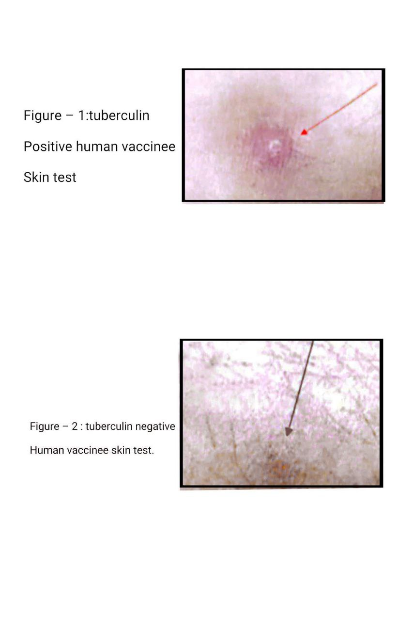

II-HUMAN SKIN BCG SCARING FATE

Skin Structure :Epidermis,endodeemis,hypodermis skin modified and cornified structures.

Skin Function :physical barrier,excretion,thermoregulation,local immune compartment.

Sensitins:Long term sequelae of tuberculin BCG vaccine in vaccinee.

Immune Responses Nature: Post vaccination Cellular and humoral immune responses.

Onsetting Skin Preparation:Cliping hair in the area of vaccine inroduction.

Interventions : BCG vaccine Shot

Gross Skin Immune Reaction;vaccine Scar formation is the final event in the local cellular immune reactions to BCG vaccine introduction.Scar become fad up on aging of the vaccinee.though lossing scar does not mean lossing tuberculosis immunity.Since part of the nonscar bearing vaccinee were with potent cellular immune reactions and part of scar bearing vaccinee were with lower cellular immunity[Karim and Shnawa , 2022,Karim eat al.2022]

Scar Sizing : Scars were measured in at least three diameters and the mean is considered to the nearist mm.

Experimrntal Excerpt :

A group of 90 differe age childs were screened for the presence of BCG scaring.Some were with nill scars others were with reducing scar sizes.Figure - .

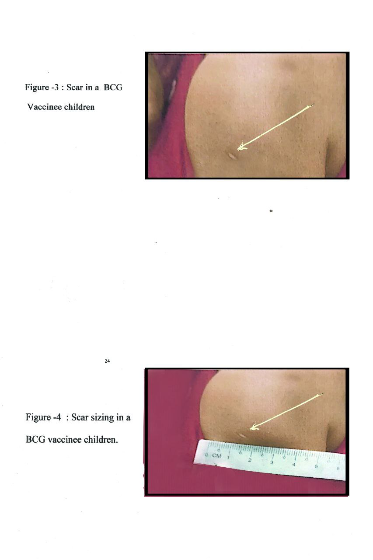

Acknowledgment

Thanks for Prof.Dr. AlSaa'di.MAK who graceously permit to use of these A and B photos.Thank goes to Ms AL-Waeely,T .K for here permission to use Figure C.

References

1-I:

1-Bass JB 2001.The tubercuin test,In Field MJ eds,Tuberculosis At Work Place.The National Academies Press.

2-AL-Saa'di MAK 2004.An Evaluation Stud of Cellular immunological Functions In Anergic Tuberculus Patients.Ph.D Thesis,Department of Biology College of Science,University of Babylon/IRAQ.

1-II:

3-Kareem TA 2022.The spectrum of macrophage migration inhibitory factor cytokines responses in padiatric BCG vaccinee.J Pharm Negative Results13:804-807.

4-Kareem TA 2022.Padiatric BCG vaccinee and IgE responses.AMJ62(6):2367-2372.

CHAPTER FIVE : RABBITS IMMUNE SKIN TESTS

I-Sperm Sonicate Protein DTH Skin Tests

Skin Structures :Epidermis ,endodermis , hypodermis,fur ,cornified layers

Skin Functions : Physical Protection,excretion,thermoregulation,local immune system compartment.

Animal Assignment:Rabbits assigned following standard methods.

Sensitins : Sperm Sonicate Proteins

Immunisation Protocols : Standard Animal assignmnt followed by multisite multi-injection protocols in male inculding intratesticular injections while in females including intra-uterin inocultions.

Immune Response Nature : Humoral,cellular,both humoral and cellular systemic and mucosal immune responses

Onsetting Skin preparation : Clipping of fur.

Interventions : Sensitin intradermal injection,watchiny fo results from 6 up to 72 hrs post ID injections

Gross Immune Reactions; erythema ,induration,necrosis

Scoring Gross Immune Reactions: Measuring erythema and induration

Cellular Immunobiology : T lymphocyte cytotoxicity,inflammation with marked lymphocyte and macrophage infiltration and cytokine production.

Experimental Excerpts; Subfertile and infertile semen samples were ;liquified,centrifuged, pellet washed and sonicated in 16-22 amplitude waves for 15 minutes.Sonicated samples were centrifuged at 5000 rpm fo 15 minutes in cooling centrifuge.Pellet discarded and supernates kept as sperm sonicate protein[checked by biurt reaction positivity] antigens and used for rabbits immunisation protocols and as sensitins[Hong-Yin et al.2000].post to ID sensitisation female have shown more induration than males,Table-8.

Table – 8 : Rabbits skin DTH reaction in sperm sonicate protein sensitisation in sonicate primed male and femal rabbits

|  |  |  |  |
| --- | --- | --- | --- |
| Treatment | 34 days post ID sensitisation | 37 days post ID sensitisation | 40 days post ID sensitisations |
| Male  Erythema  Induration  Necrosis | +++  16 mm  necrosis | ++  12  Necrosis | +  11  necrosis |
| Female  Erythema  Induration  Necrosis | +++  16  necrosis | ++  16  Necrosis | ++  17  necrosis |

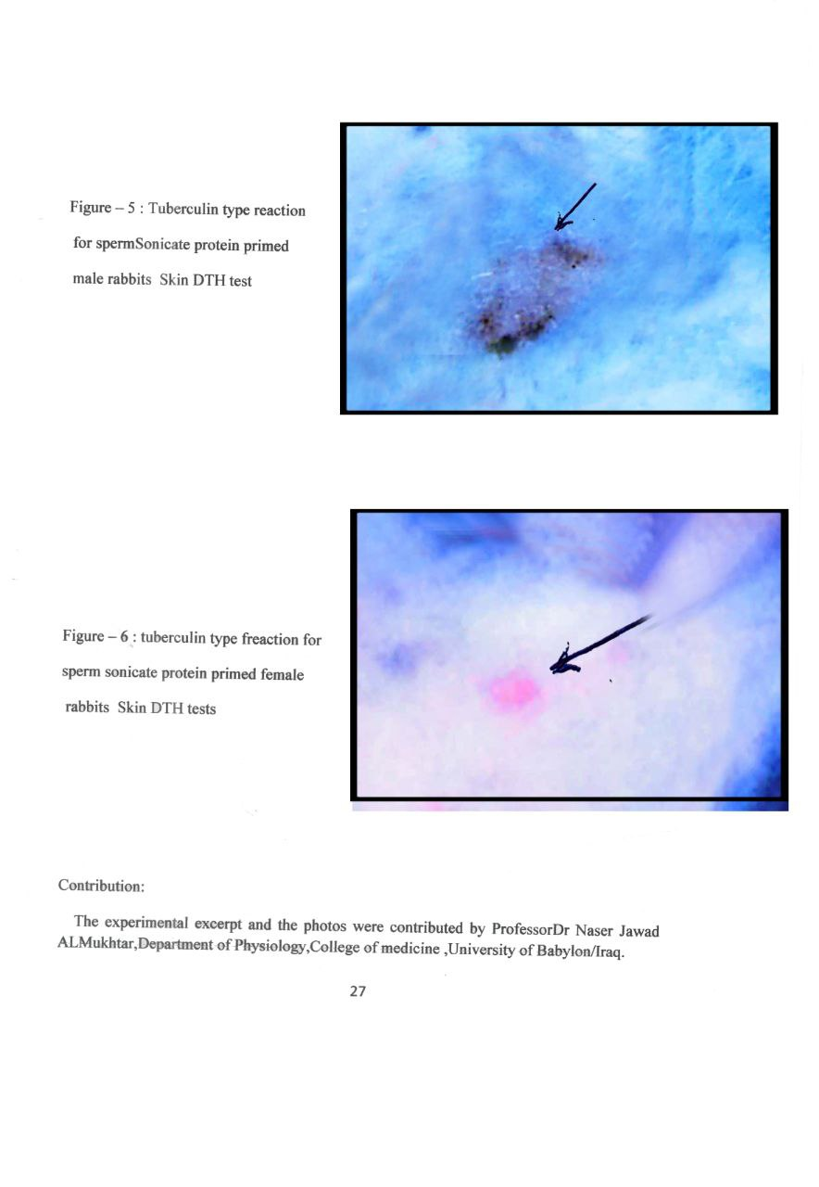Contribution:

The experimental excerpt and the photos were contributed by Professor Dr Naser Jawad ALMukhtar,Department of Physiology,College of medicine ,University of Babylon/Iraq.

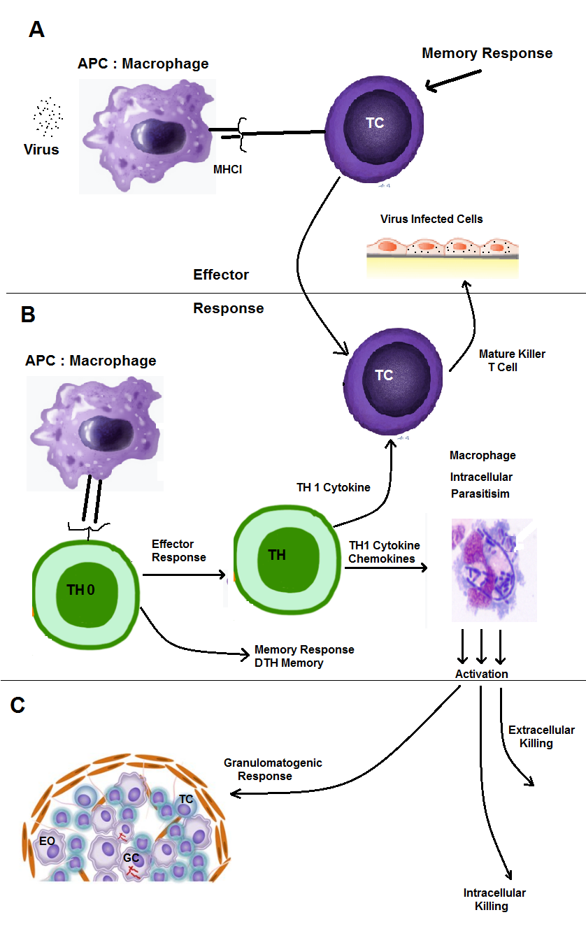Figue 7 : Delayed type hypersensitivity responses.

A-virus infection cytotoxic T cell responses,B-Delayed hypersensitivity DTH responses,C- granlomatogenic responses.GC;gaint cell,EO;e[pitheloid cell,TC killer T cell

II- Skin DTH allergenicity and Shared Allergenicity In Rabbits Models.

Skin Structure :Epidermis,endodermis hypodermis,fur and other cornified structures.

Skin Functions:physical Barrier,excretion,thermaregulation ,local immune compartment.

Animal Assignment: rabbits Assigned following standard Methods.

Sensitins : Gram negative protoplasmic sonicate proteins PSP.

Immunisation Protocols :Multisite injection protocol with use of complete freund adjuvants.

Nature of The Immune Responses:Humoral,cellular and /or humoral and cellular both at mucosal and systemic compartments.

Onsetting skin preprations : clipping fur

Interventions : Sensitin intradermal injection follow up fro 6 up to 72 hrs for watching DTH reacions

Cellular Immunobbiology: It ia a cellular immune reactions to delayed type allegen characterised by cellular toxicity and inflammation,sensitin activate macrophages ,macrophages active naieve Th to be TH1 ,Th1 cell produce pro and ntiinlammatory cytokines.As a result,lymphocytes and macrophasges accumilate <B and icity T cell activated gaving the whole mark of skin DTH reactions.

Gross Immune reactions : erythema , induration.

Scoring DTH reactions ; Measuring : erythema and indurations.Homologu reaction with homologue proteihn primed rabbits.Heterlogu sensitin with hetrologu proein primed. Rabbits

Expeimental Excerpt:

A-Skin DTH test for Bacterial Protoplasmic sonicate proteins:PSP:PSP from P aeruginosa and K .oxytoca were orepared,partially purified and quantified as an intracellur bacterial protein as in[10].the concentration of PA PSP was 2.71. mg/ml. and hat of KOPSP was 1.81 mg/ml..The immune primed rabbits were showing induration of 10 and 18 mm for homologu PA primed rabbits and 6 and 12 for heterlogueKOSP IN PAPSP primed rabbits[Shnawa et al. 2024].

B-Shigella Toxin DTH skin Test:

Shiga exotoxin paragraph 3-5, and LPS both induced skin DTH in shigella protein primed rabbits of tuberculin types.

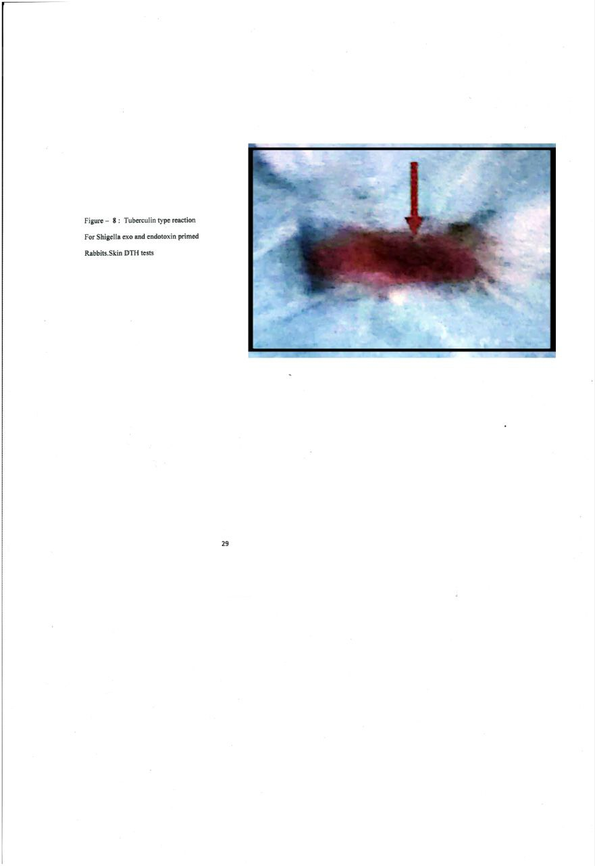

III –PERMEABILITY ALTERING FACTOR SKIN TESTS IN RABBITS

Skin Structure:Epidermis,endodermis,hypodermis fur and other cornified structures

Skin Functions: Physical Protection,excretion,local immune system and thermoregulation.

Animal Assignment :Rabbits assigned following standard methods

Sensitins; Shigella exotoxin permeability altering factor( paragraph )

Onsetting Skin Preparation: Fur clipping and rubbing with 70% alcohol.

Interventions: Intradermal injection of 0.2 ml.shiga exotoxin.

Skin Gross reactions :Marked erythema,induration

Cellular reactions: Skin resident marophage upregulate cytokin expression upon encounter with shiga exotoxin and regulate inflammation as well as innate immunity in rather complex mechanism[ ].

Scoring Parameters: Measuring induration to the nearist mm.

Experimental Excerpt: A group of five rabbits were intravenously injected with 0.2ml. of shiga crud exotoxin followed by watching gross skin changes as erythema and induration

Table -9 : PAF rabbits skin induration reactions.

|  |  |
| --- | --- |
| Animal Replicates | PAF induration in mm |
| R1 | 8.9 |
| R2 | 9.0 |
| R3 | 9.0 |
| R4 | 9.0 |
| R5 | 10 |

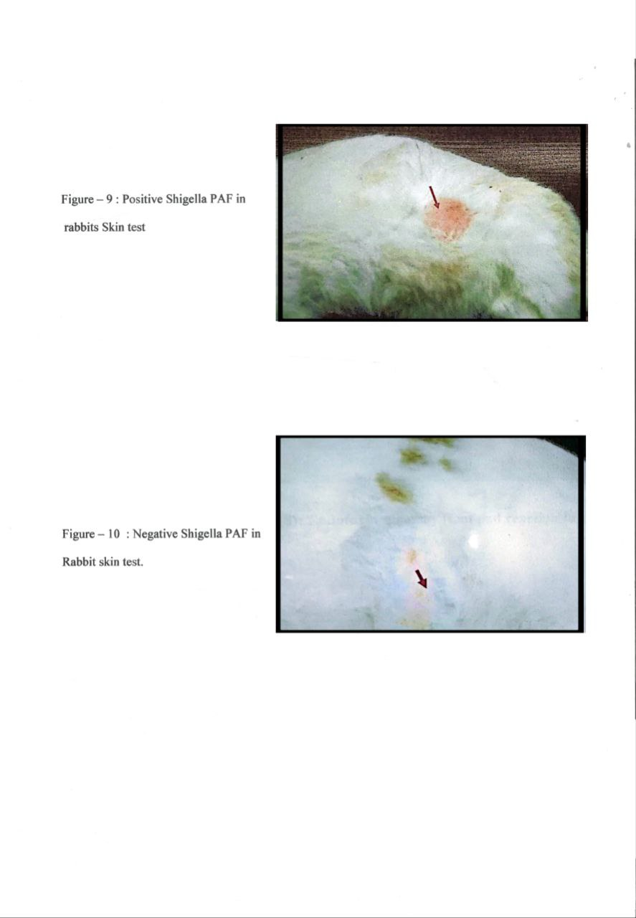

References

5-I:

1-Van Gramberg JL,de Veer MJ,O'hehir RE et al.2013.the use of animal models to investigate allergen associated with food allergy.J.Allergy.2013(1):635695.

2-Triwatcharikorn J ,Prolmoo N ,Ratanasatiranornt N et al.2023.Skin testing might have a diagnostic role in immune complex delyed type hypersensitivity reactions.Clin.Dermatol.48(1):27-30.

3-Ahmad AR ,BloseDA 1983.Dlayed type hypersensitivity skin testing: A review.Arch.dermatol.119(11):934-405.

4-Pates SE,BL.1979.Suen JY ,Tranum BL.1979.Immunological skin testing and interpretation: A plea for uniformity.Cancer 43(6):2306-2314.

5-Burdick JF,Wells Jr SA ,Herberman RA1975.Immunological evaluation of patients with cancer by delayed type hypersensitivity reactions.Surg.Gynecol.Obstet.141(5):779-794.

6-Shnawa I M S,Algebori ,Thewaini Q NO.2024.Shared allergenicity of delayed type hypersensitivity in rabbbit model A J I.

5-II;

7-AL_Salamy AKA 2005.A Comparative Study on the Specific Mucosal and Systemic I mmune Responses in Rabbits.Ph.D.Thesis,department of Biology,College of Science,University of Babylon?IRAQ.

8- Lee M-S,Tesh VL.2019.Role of shiga toxins in immunopathology.Toxins.11(4):212.

9-Yustudo T,Hondu T ,Miwatani T , Takeda Y.1986.Characterisation of purified shiga toxin from Shigella dysentrae i Microbial.Immunol.30(11):115-1127.

10-Jung G ,Carrera C ,Brucker H ,Bessler W G.1983.Mitogenic principle of E.coli.lipoprotein synthesis,spectroscopic characterisationand mitogenicity of N-palmitoyl-S-[(2Ry)-3-3-diplamitoyoxypropyl]-(R)-cystein methyl ester.Liebigs.Annalen.Chemie V.1983(9):1606-1622.

11-Peavy DL ,Shands JW ,AdlerWH ,Smith RT 1962.Mitogenicity of bacterial endotoxins;Characterisation of the mitogenic principle J.Immunol.111(2):352-357.

CHAPTER SIX : RAT IMMUNE SKIN TESTINGS

I-Skin Structures: Epidermis,endodermis ,hypodermis,fur and other cornifid modifictions

Skin Functions :Physical protection ,excretion,thermoregulation and local immune compartment.

Animal Assignment: Rats assigned following standard methods

Sensitins: lectins a polyfunctional glycoprotein of plant,animal and microbial origin

Immunization Protocol : No previous immunisation

Onsetting Skin Preparation cleaning the foot pad.

Interventions ; lectin introduced through foot pad of the rats

Gross Immune Reactions;Redness,induration

Cellular Immunbiology: T cell activation,mitogenicity and blatogenicity.

Scoring Parameters : Measuring indurations to the nearist mm. And noting the foot pad swellings.

Experimental Excerpts:

Plant lectin solutions were prepared from rice,musk melon and dukhen.The preparation was as; separation,partial characterisation and determination of concentration.0.05 ml of each of the lectins were injected in foot pat of normal nontreated group A and chromiume treated rats group B,Table 10 . chromium inhibited foot pad reaction.Rats exposed to chromium showed inhibited B and T cell functions in splencyte of exposed rats[Villnuen et al.2000,AlMosawy 2004].

Table -10 : Foot pad reactions in chromium and non-chromium treated rats.

|  |  |  |  |
| --- | --- | --- | --- |
| Lectin Type | Pad orientation | Induration in mm.in  Non- chromium exposed A | Induration in mm in  Chromium exposed  group B |
| Rice | Left  Right | 1.742  1.610 | 1.022*  0.640 |
| Nusk melon | Left  Right | 0.86  0.695 | 0.55  0.535 |
| Dukhen | Left  Right | 0.892  0.835 | 0.860  0.620 |

* Means of five replicates

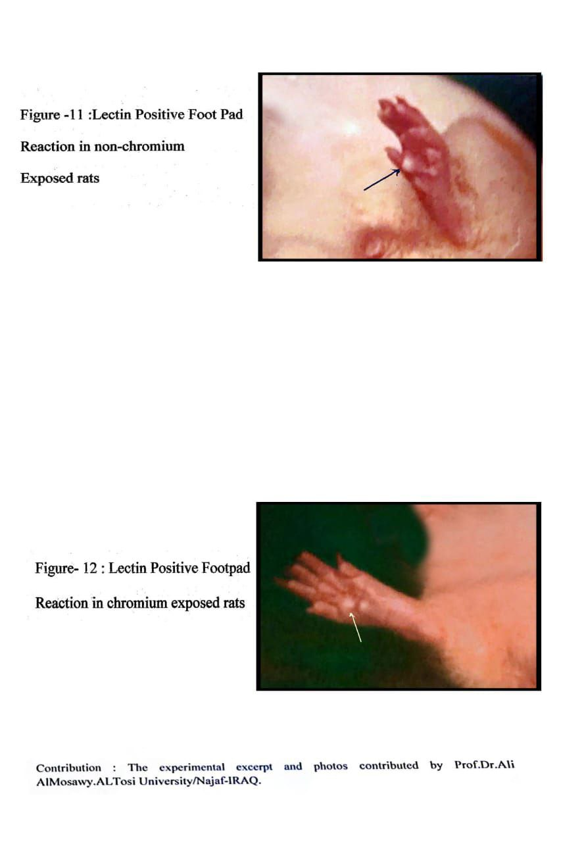

II-RAT FOOT PAD REACTIONS TO SHIGELLA LIPOPOLYSACCHARIDE ENDOTOXIN

Skin Structure : the food pad skin composed of epidermis,endodermis and hypodermis and devoided from fur.

Skin Functions : Feet pad function on motion and on rest,physical protection,and local immune system compartment

Animal Assignment ; Rats assigned following standard methods.

Sensitins : Shigella LPS purifid and characterised,0.3 ml. in foot pad.

Immune response : Early cellular events of immune responses.

Gross Skin Reaction : Erythema and induration

Cellular Reactions :Pad skin resident macrophages up regulate cytokines express upon encounter with LPS and regulate innate immunity and inflammation,latter on adaptive cellular rewaction mediated by LPS.

Scoring Parameters :Measuring foot pad induration

Experimental Excerpt ; A group of five rats were injected with 0.3ml. LPS solution in the foot pad.Then the treated rat foot pad watched for reacton to appear as mentioned in the Table- 11

Table -11 : Rat food pad reaction to Shigella LPS.

|  |  |  |  |  |
| --- | --- | --- | --- | --- |
| Replicates | Temperature | Erythema | Induration i mm | edema |
| R1 | 38C | + | 3.7 | + |
| R2 | 38C | + | 3.9 | + |
| R3 | 39C | + | 4 | + |
| R4 | 39C | + | 4 | + |
| R5 | 39C | + | 4.5 | + |

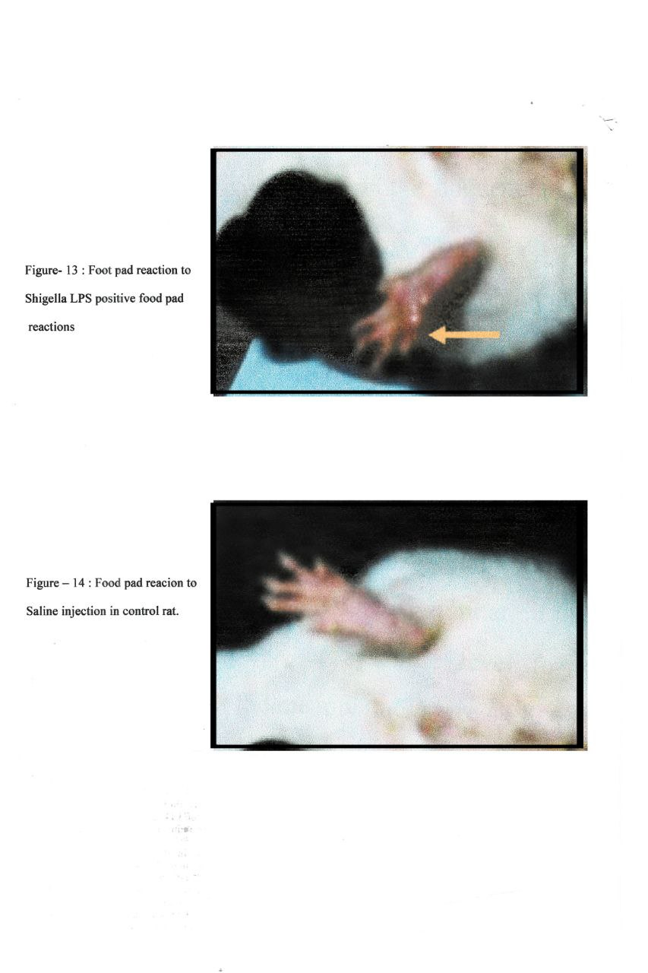

References

6-I:

1-AL.Mosawy A K N 2004.Toxic Effects of Alminium and Chromium on Sparg-Dawely Rat.Ph.D thesis,Department of Biology,College of Science,University of Babylon/Iraq.

2-Demas GE Zysling DA ,Beecher BR 2011.Beyond phytohemagglutination,assessing vertebrate immune function across ecological contex.J.Anim.Ecol.9(4):710-730.

3-Campbell DJ,Heaton RR ,Pritchard DI et al.2006.Assessment of ex-vivo responses to T cell mitogens and oxidative stress in lymphocytes from healthy adults and senur cats.J.Nut.136(7):20854-20865.

6-II:

4- Al-Salamy AKA 2005.A Comparative Study On The Specific Mucosal and Systemic Immune responses to Two Sigella Species In Rabbits.Ph.D Thesis,Department of Biology ,College of Science,University of Babylon/IRAQ>

5-Ghavami A ,froushani SMA,Tehrani A.2024.Immunomodulatory potential of Piperrini in rats.Tirk J,Immunol.12(1):1-8.

6-Flax MH, Waksman BH 1962.Delayed Cutaneous reactions in the rat.J.Immunol.89(4):496-504.

CHAPTER SEVEN : BIRD IMMUNE SKIN TESTS

I – Bird Immune Competence:

Skin Structure : Epidermis ,endodermis,hypodermis ,feathers andother cornified structure.

Skin Functions : Physical protection,aid in aviation, loccal immune compartment.

Animal assignment: Chicken assigned following standard methods

Sensitins : Lectin polyfunctional glycoprotein from plant,animal and microbial origins.

Immunisation Protocol ; no previous immunosation

Onsetting Skin Preparation :Cliping the feathers befor setting

Interventions : Intradermal injection in the wing web patigum.

Cellular Immunobiology; early events of lymphocyte activation ,mitogenicity and blatogenesis

Gross Immune Reactions:Redness and induration.

Scoring Parameters: Measuring induration to nearist mm. After an overnight watchings.

Experimental Excerpt :The lectins were separated,partially chacterised anddose determined.Each lectin tested with five replicates.The skin immune induration reactions were found increasing as conc. Increase inmg/ml. for CS.While the induration was increasing as the concentration of PHA,LPS decreased,Table - 12 .

Table -12 : Skin immune potency test as an induration reactions.

|  |  |  |
| --- | --- | --- |
| Lectin Conc.in mg/ml. | Skin induration in mm | Correlations |
| CS  4.648  1  0.1 | 1.8 +_0.373  0.7 +- 0.199  0.6+-0.224 | _  Y =82.51 +46.99X  R=0.54 |
| PHA  1.0  0.5  0.2 | 1.0+-0.11  1.2+-0.122  2.0+-0.55 | _  Y =1.45 +(-0.6)X  R=0.99 |
| LPS  1.0  0.5  0.25 | 1.1+-0.244  1.7 +- 0.199  1.9+-0.186 | _  Y =2.0+(-0.91)X  R=0.99 |

II-Bird immune Skin Test: A Check for DPT Vaccine Effects .

Skin Structure:Epidermis,endodermis,hypodermis,feathers and other cornified and modified structures

Skin Functions:Physical Barrier,thermoregulation,,excretion and local immune comapartment.

Animal Assignment: Chickens assigned following standard methods.

Sensitins :Whole and 1 in thenth dilution of DPT vaccine.

Immune Response Nature:No previouse specific immune priming.

Onsetting Skin Preparations :feather cliping near the skin web of the wing

Interventions : 0.1 ml amount of the whole and diluted DPT vaccine were injected in skin Web of the wing.

Gross Immune Reactions : Redness and Induration.

Cellular Immune Reactons : lymphocyte activation events including lymphoblast formation in bone marrow stained film

Scoring Immune Reactions :Measuring the the induration to the nearist mmm and clculation of blastgenesis.

Experimental Excerpt : sanofi DPT vaccine was diluted one to 10 and be the test two doses.These doses were injected in 0.1 ml amounts in the patagium area of web skin.The indurations were measured 18 hrs postinjection.To stope cell cycle events 100 mg/ml. cholchicine in a rate of 0.25ml per each 50 gm bird were injected intramuscularly.One hour later,femur bone was tremed from both sides and 5 mls.sterile saline injected in for bone marrow collection.Blastogenicity was measured as number formed blasts to the total numbers of lymphocytes as in the following formula;

Number of lymphobalsts

Blastogenicity % = -------------------------------------------- X 100

Total Numbers of lymphocytes

The blastgenicity % were found to be vaccine concentration dependent,Table – 13

.

Table -13 : DPT Vaccine Induced Blatogenicity in bird model.

|  |  |  |
| --- | --- | --- |
| Test bird replicates | Lymphoblast %, whole DPT vaccine | Lymphoblast %,1:10 DPTVaccine |
| C1 | 0.3 | 0.005 |
| C2 | 0.25 | 0.1 |
| C3 | 0.35 | 0.15 |
| C4 | 0.2 | 0.1 |
| C5 | 0.28 | 0.12 |

III- BIRD IMMUNE SKIN TEST: LECTINE INDUCED LYMPHOCYTE ACTIVATIONS

Skin Structure: Epidermis , endodermis,hypodermis,feathers and othercornified and modified structures.

Skin Functions : Physical Barrier,excretion,thermoregulation,local immune compartment.

Animal Assignment: Chicken assigned following standard method.

Senstins : Lectin,Phytohemagglutinin,LPS.

Laboratory animal model: Chickens

Immunisation Protocols:No Previous Specific Immune Primings.

Onsetting Skin Preparation : Clipping Feather around injection area.

Interventions : ID in the patagium area of the Wing Skin Web

Gross Immune Reactions : Redness and Indurations

Cellular Immunobiology : Lymphocyte activation event including mitogenicity and blastogenicity

Scoring Parameters : Gross Immune reactions were scored as redness and induration to the nearist mms.Lymphocyte actication events measured as mitotic index for mitogenicity and lymphoblasts percentages in stained bone marrow smears.

Expeimental Excerpt :Three test checken groups each of five, one for Phytolectin,one for phytohemagglutinin and the other for LPS.0.1ml. ml. for each bird fro the test materials injected in webskin of the wing.18 hrs later .check for gross and cellular immune reactions.Bone marrow stained films after ceasing mitotic cycle by cholchicine.The mitogenicity and blastogenicitywere decreasing as the concent decrease in CS lectin.The mitogenicity of PHA was decreasing as the conc.decease.While the blastogenicity was was zero in high PHA conc. And was decresing as the conc.of PHA decreased.The correlation seemed to bo of linear type.The studied lectins were mitogenic and blastogenic.,

Table -14 : Bird Skin Immune Test for mitogenicity and Blastogenicity of Lectins.

|  |  |  |  |
| --- | --- | --- | --- |
| Lectin Conc. Mg/ml. | Mitogenicity | Blastogenicity | Correlations |
| CS  3.648  1.0  0.1 | 0.4+-0.373  0.078+-0.144  0.038+-0.428 | 0.096+-0.31  0.02 +-0.001  0 | Mit.  _  Y= 102.88 +72.76  R=0.76  Blast.  _  Y=62+(-71665)X  R=-0.64 |
| PHA  1.0  0.5  0.25 | 0.1425 +- 0.00002  0.278+-0.0002  0.151+-0.0093 | 0  0.1125+-0.0023  0.03+-0.00026 | Mito.  _  Y=1.114+1.606  R=0.92  Blast.  _  Y=0.1394+ (-18.8)X  R=- 0.93 |
| LPS  1.0  0.5  0.25 | 0.431+-0.014  0.46 +-0.044  0.51 +-0.0086 | 0.025 +-0.0022  0.032+-0.015  0.05 +-0.0020 | Mito.  _  Y=4.78 +(-9.001)X  R=0.94  _  Y=1.53+(-26.8)X  R=0.905 |

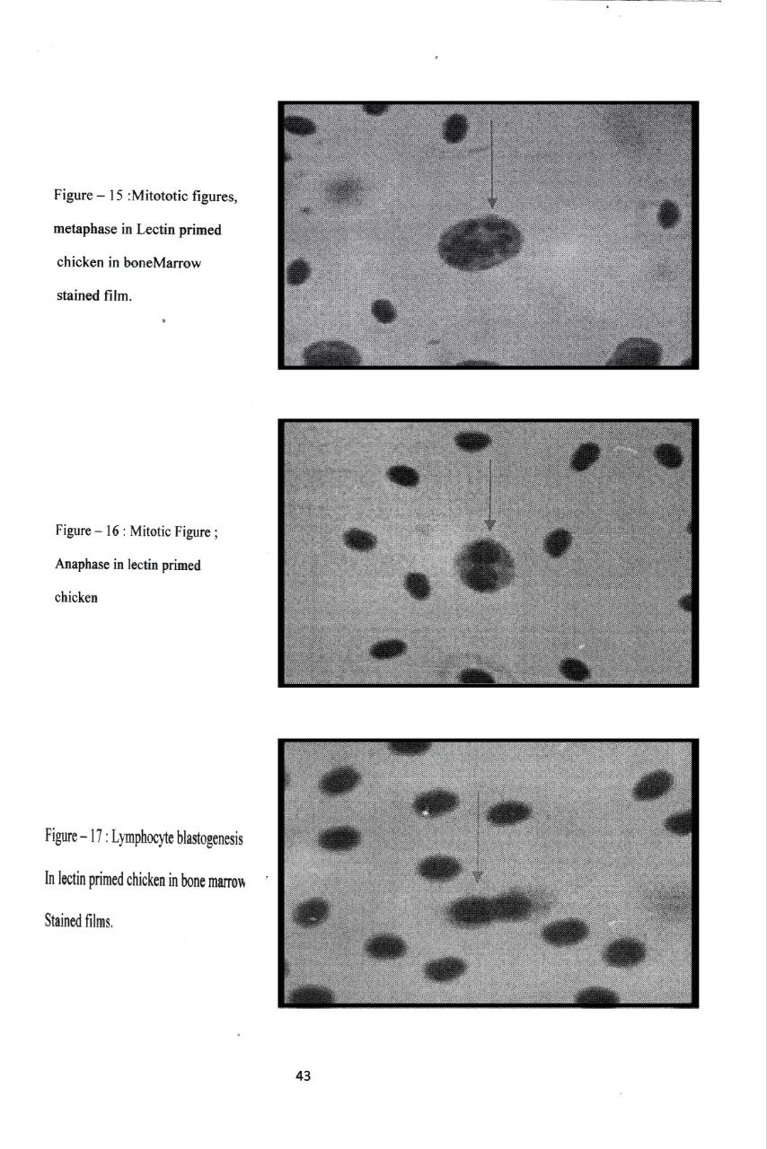

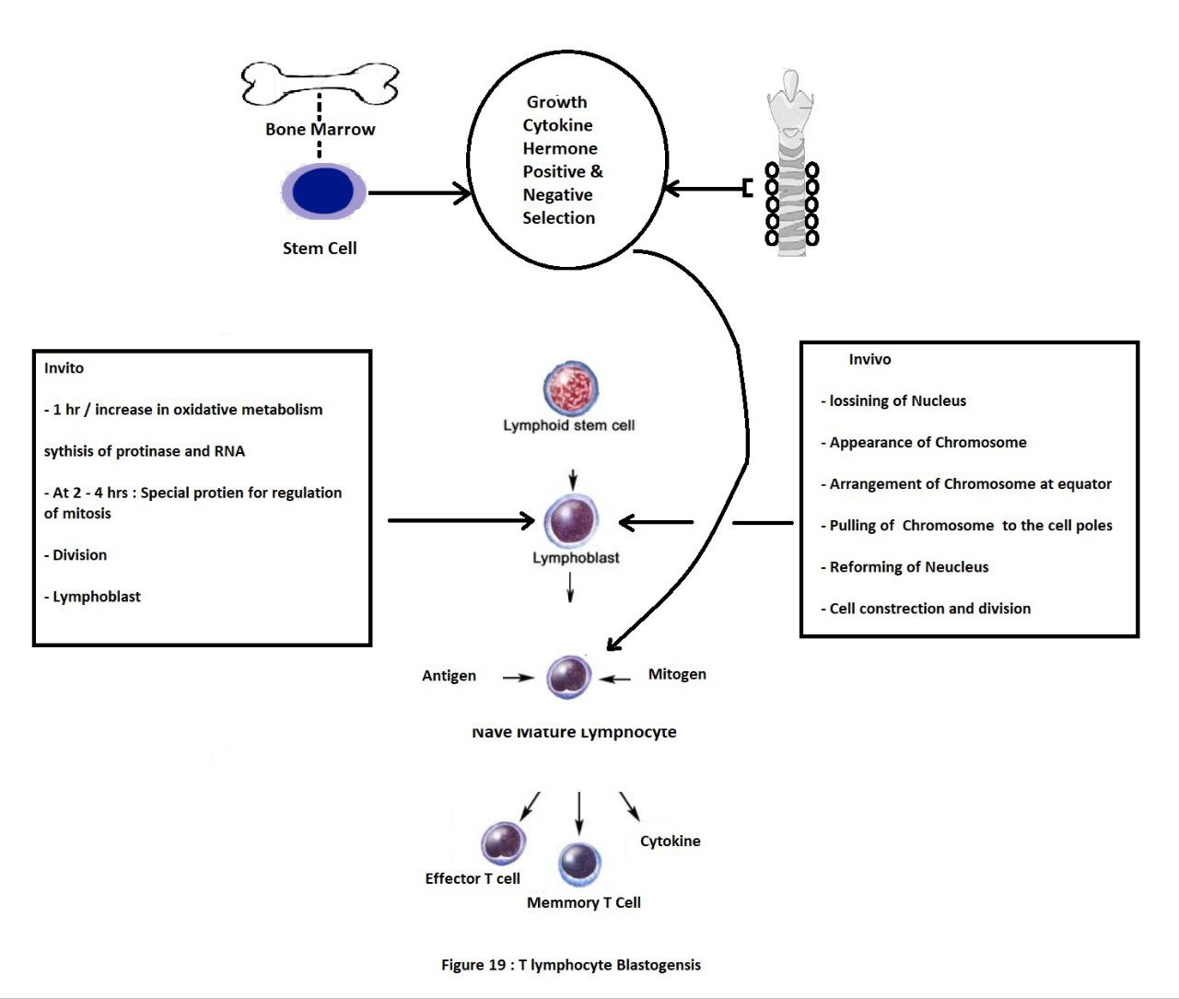

Figure 18 : The T lymphocyte Blastogenesis

VIGNETTE

Dermal edema in an animal skin or foot pad is a gross sign that can be underlined by more than one mechanism as; physiologic, immunobiologic and immunopahologic mechanisms. likewise, induration is a terminal event late into a series of biochemical, inflammatory and /or immunobiologic mechanisms.Vaccine tissue scar is a final event in the immunocellular tissue reactions within the dermal inoculastion area. Protein, protein toxins, lipoprotein, and lipopolysaccharide of microbial origin when injected intradermal or subcutaneous routes intiate erythema and induration in the skin of human, rabbits and chicken or in foot pad of the rat. This immunodrmal atlas lucidly uncover point by point the skin or pad reaction and matchs the test criteria , precautions and procedures in man, rabbit, rat and chicken models.

References

7-I: and III

1-Shnawa I M S.ALBayatte 2009.An invivo phytolectin induced skin tes and T cell mitogenicity.ALQadisiya .J.Vet.Med.Sci.8(1):1-7.

7-II:

2-Shnawa IMS 2013.Tuberculin,tetanous immunoglobulin and DPT vaccine as an avian T lymphocyte mitogenWASET 76:219-220

7-:I-III

3-Vinkler M,Schnitzer J ,Munclinger P Albrechet T 2012.Phytohemagglutinin skin swelling test in scarlet roseffinch males:low quailty birds respond more strongly.Anim.Behaviour 83(1):17-23.

4-Grasman KA2010.In vivo functional tests for assessing immunotoxicity in birds .MethodMol.Biol.598:387-398.

5- Tella JL .Lemus JA ,Carrete M ,Blanco G 2008.The PHA reflects aquired T cell mediated immunocompetence in birds.Pols One.3(9):e3295 .doi.10.1371/journal.pone.0003295.

Thanks for Prof.Dr.Lubna AA Albayatte,DNA Centre of Research who liberously permit to use photo and some quotes.