**Original Research Article**

Evaluation of outcome in laparoscopic and open ventral hernia repair: a prospective study

**ABSTRACT**

**Background:** Ventral hernias are categorized as epigastric, umbilical, spigelian, parastomal, and incisional hernias. Hernias occurring in epigastrium and umbilical region are considered as primary ventral hernias. There are various ways of hernia repair, in which the tension free repair remains the most important one. For doing a repair by laparoscopy, first of all the contents of the hernia are reposited back in the abdomen, followed by placement of mesh transabdominally which should be of optimum size and type

**Methods:** The present study is a prospective observational study that emphasizes to analyse and evaluate outcome in open and laparoscopic mesh repair of ventral hernia that presented to the Himalayan hospital over a period of 1 year. **Results:** Study shows that more than 50% of the cases were recorded in the age group between 26-50 years (mean 47 years) with majority being females. Umbilical hernia (45.1%) was the most common followed by incisional hernia (28.2%), paraumbilical hernia (22.5%) and epigastric hernia (4.2%). Diabetes mellitus was the most common comorbidity (88.7%) followed by hypertension (64.8%). VAS score was statistically significant between individuals who got surgery by laparoscopy when compared with open approach. A significant difference was also observed between period of mobilization and surgical procedure.

**Conclusions:** Surgery of ventral hernia by laparoscopy has less post-surgical pain, less problems, lesser stay in hospital and had lesser impact on economy as the individuals returned to their normal routine in lesser time.

**Keywords:** Ventral hernia, Open hernia, Laparoscopic hernia repair, IPOM

# INTRODUCTION

Ventral hernias are categorized as epigastric, umbilical, spigelian, parastomal, and incisional hernias. Hernias occurring in epigastrium and umbilical region are considered as primary ventral hernias.1 There are various ways of hernia repair, in which the tension free repair remains the most important one. As the techniques evolved, mesh placement came into action and need for overlapping it around the defect was also studied which showed a good result with a 3-5 cm overlap. In today’s era repair of the abdominal wall hernia has been standardized by the laparoscopic approach.2 For doing a repair by laparoscopy, first of all the contents of the hernia are reposited back in the abdomen, followed by

there is placement of mesh transabdominally which should be of optimum size and type. The prosthesis then should open in the intra peritoneal region. This mesh is then fixed over posterior aspect of the anterior wall of abdomen in a double crowning method. These are common step wise approach in repair by laparoscopy.3 The present study is planned to compare the outcome between open and laparoscopic repair of the ventral hernias.

# METHODS

The study was conducted in the department of general surgery at the Himalayan institute of medical sciences, Swami Ram Nagar, Dehradun over a period of 12

months. Patients were recruited as per the inclusion criteria after obtaining informed consents from the study subjects. Ethical clearance for the study was obtained from the institutional ethics committee.

### Study design

*Type of study*

Observational follow up study used as a study design.

*Sample size*

Total 71 patients were involved in the study.

*Sampling method*

Patients presenting to the surgery OPD as a case of ventral hernia were used as a sampling method.

*Inclusion criteria*

Patients with the age 18-70 years presenting with uncomplicated ventral hernias were included in the study.

*Exclusion criteria*

Pregnant women, patients with complicated ventral hernia (Obstructed, incarcerated, strangulated, recurrent), patients with immunocompromised states and patients with cirrhosis of liver and/or ascites were excluded from the study.

### Study tools

Study tools used were data collection form, laparoscopic set-Stryker 1180 HD and type of mesh used: Open repair- polypropylene mesh and laparoscopic repair-composite mesh.

### Study protocol

Thorough clinical history and examination of the patients was performed. Allocation of the patients in one of the two groups viz. Open or Laparoscopic surgical approach was done as per the patient’s choice. Investigations were done which included radiological investigations like USG and CT (if done). Postoperatively, both the groups were given VAS score card to express the intensity of pain on POD 2 and was recorded. Post-operative day of mobilisation and post-operative day of discharge was noted. The patients were “followed up in the post- operative period after discharge for a period of one month to look for the outcomes of the treatment done. Patients were assessed again at 2 weeks using the VAS score card for pain intensity and SF-8 score card for QOL. Quality of Life index was assessed using a score card SF-8 again on follow up at 1 month, day of return to work and complications (if any) were also recorded.

### Data management and statistical analysis

Interpretation and analysis of obtained results will be carried out using software SPSS version 22 and MS excel by application of descriptive methods (significance).

Data thus collected will be analysed (p value, Chi square test/ Fischer test, unpaired t test) and presented in the form of tables/ charts.

# RESULT

This study was done to evaluate the outcome between the laparoscopic and open ventral hernia repair based on the following parameters.

Figure 1 shows that more than 50% of the cases were recorded in the age group between 26-50 years followed by the age group >50 years (42.3%) and the age group

<25 years (2.8%). Moreover, number of female cases was slightly higher than male cases (Figure 2).

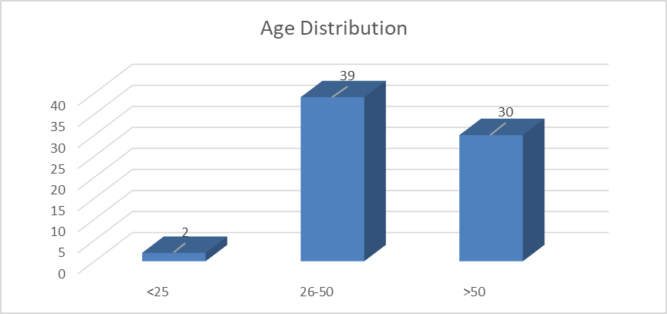

## Figure 1: Age distribution.

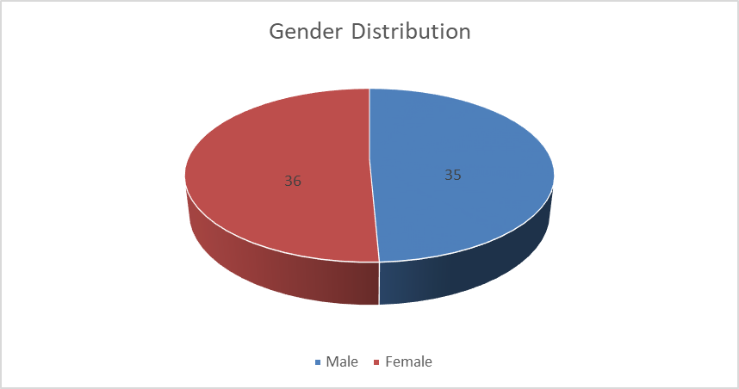

**Figure 2: Gender distribution.**

The mean age of the cases was 47 years, mean height of the cases was 1.61, mean weight of the cases was 61 kgs and mean BMI of the cases was 23.57.

As shown in Figure 3, of the total study subjects, 44 cases underwent open surgery while there were 27 of the cases who underwent laparoscopic surgery.

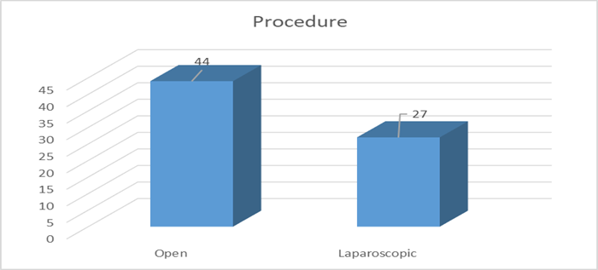

## Figure 3: Procedure. Table 1: Type of hernia.

|  |  |  |
| --- | --- | --- |
| **Type of hernia** | **Frequency** | **Percent (%)** |
| **UH** | 32 | 45.1 |
| **PUH** | 16 | 22.5 |
| **IH** | 20 | 28.2 |
| **Epigastric** | 3 | 4.2 |
| **Total** | 71 | 100.0 |

Umbilical hernia was the most common presentation among the patients of ventral hernia accounting for 45.1% of the cases followed by incisional hernia (28.2%), paraumbilical hernia (22.5%) and epigastric hernia (4.2%) (Table 1). Diabetes mellitus was the most common comorbidity recorded in majority of the cases (88.7%) followed by hypertension (64.8%).

## Table 2: Comparison between quality of life and procedure.

|  |  |  |
| --- | --- | --- |
| **Procedure** | **Mean±SD** | **P value** |
| **14 days** | | |
| Open | 28.52±0.369 | 0.0001 |
| Laparoscopic | 20.74±3.347 |  |
| **28 days** | | |
| Open | 19.57±3.890 | 0.0001 |
| Laparoscopic | 11.81±2.403 |

As shown in Table 2, a significant difference was observed between quality of life and surgical procedure.

## Table 3: VAS score.

|  |  |  |
| --- | --- | --- |
| **Procedure** | **Mean±SD** | **P value** |
| **2 days** | | |
| Open | 6.14±1.19 | 0.0001 |
| Laparoscopic | 3.81±1.54 |  |
| **14 days** | | |
| Open | 3.77±0.985 | 0.0001 |
| Laparoscopic | 1.52±0.975 |

As shown in Table 3, shows a statistically significant difference between the VAS score between the two. It was found to less in individuals who got surgery by a laparoscopy when compared with open approach.

## Table 4: POD mobilization.

|  |  |  |
| --- | --- | --- |
| **Procedure** | **Mean±SD** | **P value** |
| **Open** | 2.61±0.895 | 0.0001 |
| **Laparoscopic** | 1.30±0.542 |

As shown in Table 4, a significant difference was observed between period of mobilization and surgical procedure. It was lower in patients who underwent laparoscopic procedure as compared to the patients who underwent open surgery procedure. A significant difference was observed between day of return to work and surgical procedure. It was lower in patients who underwent laparoscopic procedure as compared to the patients who underwent open surgery procedure

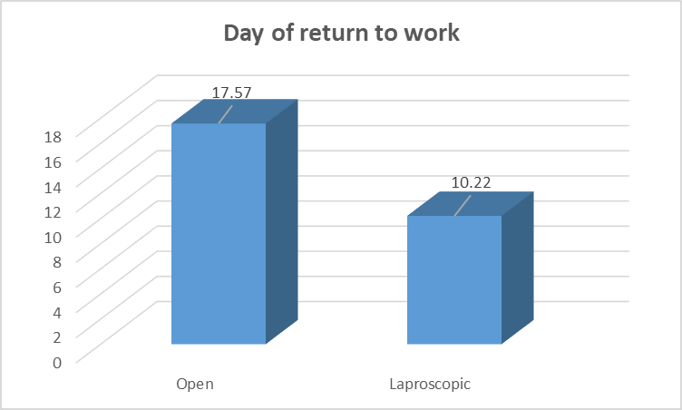

## Figure 4: Day of return to work.

**Table 5: Post-operative complications among the cases.**

|  |  |  |  |  |
| --- | --- | --- | --- | --- |
| **Complications** | **Procedure** | | | |
| **Laparoscopic surgery,**  **(N=27)** | | **Open surgery,**  **(N=44)** | |
| **N** | **%** | **N** | **%** |
| **Hematoma** | 1 | 4.2 | 0 | 0 |
| **Surgical site infections** | 0 | 0 | 3 | 6.81 |
| **Abdominal**  **distension, serous discharge** | 0 | 0 | 1 | 2.27 |
| **Acute kidney injury** | 0 | 0 | 1 | 2.27 |
| **Total** | 1 | 4.2 | 5 | 11.35 |

Of the total cases, it was observed that 6 cases had post- operative complications. Of the cases who underwent open surgery, there were 3 cases who developed surgical site infections followed by other complications like acute kidney injury (AKI) and abdominal distension and serous discharge whereas there was only one patient with complication who underwent laparoscopic surgery.

# DISCUSSION

In United Kingdom, approximately 25,000 ventral hernias are operated per year.4 Only few of them are symptomatic, but all the patients in common are advised to undergo surgery because of the risks involved in not operating. There are many approaches to undergo surgery for ventral hernia, which started from primary repair followed by mesh prosthesis implantation. Later on, laparoscopic repair came, which has now become a gold standard technique and is being preferred, but it is still under scrutiny.5

The present study recruited a total of 71 cases, consisting of 50.7% female cases and 49.3% male cases. Of these total cases, 44 cases underwent open surgery while 27 cases underwent laparoscopic surgery. According to the age wise distribution of the cases, it was reported that more than 50% of the cases in our study were observed between the age group 26-50 years. The youngest patient in our study was 18 years old while the eldest patient was

70 years old. Similar to our study, Patil recorded the majority of the cases between the age group 30-50 years, accounting for more than 50% of total cases.6 Youngest patient in his study was 20 years old and eldest patient 70-year-old. Another study conducted by CA Courtney et al 120 individuals had surgery for ventral hernia.7 Average age of individuals was 54.6 years, (ranging from 23-87) out of which 55% male while 45% were female.

Umbilical hernia was the most common presentation in the patients recruited in our study followed by incisional hernia, paraumbilical hernia while 3 cases in our study had epigastric hernia. In contrast to our findings, Patil in his study reported that paraumbilical hernia was the most common presentation in the patients, others being incisional hernia, epigastric hernia, umbilical hernia. On the other hand, in a study carried out by CA Courtney et al incisional hernia was the most common presentation among the recruited cases.

Distribution of the study subjects in our study according to the presence of co morbidities revealed that majority of the cases had diabetes mellitus followed by (64.8%) hypertension. However, a randomized trial conducted by Kamal et al showed that most of the patients had diabetes.8 Also, some of the cases were recorded with co morbidities like chronic constipation and loss of body weight. Another study conducted by Tessier and his partners who studied 97 individuals who underwent repair of ventral hernia by laparoscopy, in which 76% of the individuals were more than 60 years of age.9 Although the older patient’s group (greater than or equal to 60 years) had more co-morbidities, this group demonstrated comparable postoperative length of hospital stay and complication rates when compared with the younger group (younger than 60 years).

Our study reported that the mean VAS score among the patients who underwent laparoscopic surgery was lesser

than the patients who underwent open surgery. Moreover, a significant difference was found between VAS and the procedure of surgery. Ilani et al also showed that pain measured using visual analogue score on 3rd post- operative day showed decreased pain score in laparoscopic group (mean 2.23) compared to open group (mean 6.23).8

The present findings also reported that the quality of life among the patients who underwent laparoscopic surgery was better as compared to open surgery. Variables like period of mobilization, days of returning to work was lower in the patients who underwent laparoscopic surgery as compared to the patients who underwent open surgery. Moreover, mean post-operative days of movement among the cases who underwent laparoscopic surgery in our study was 1.30±0.542 days while in the other group in which the cases underwent open surgery was 2.61±0.895 days. Similar results were depicted by the findings of Patil et al that reported mean post-operative day of movement in laparoscopic group was 1.9 days and in open repair group was 2.9 days.

Post-operatively patients of laparoscopic group returned back to the work early as compared to the patients who underwent open surgery. The mean days of returning to work after the laparoscopic surgery was 10.22 days whereas the mean days of returning to work after the open surgery was 17.57 days. Relevant to our findings, Patil et al in his study reported that Post surgery the individuals who underwent repair by laparoscopy had return to their normal work in shorter time (average 12.8 days) when compared with open approach (average 18.5 days). Raftopoulos et al in his evaluation found that the average return to normal routine was 25.95 vs 47.8 days, which was found to be more as compared to the study done by Itani et al who reported the average of 23 vs 28.5 days.8,10

Post-operatively, there were 6 cases who had complications. Of this case, there were 5 cases reported with post-operative complications who underwent open surgery. These complications included surgical site infections (6.81%), acute kidney injury (2.27%), abdominal distension and serous discharge (2.27). On the other hands, one of the total cases who underwent laparoscopic surgery was recorded with hematoma. Patil et al in their findings also reported that the main complication encountered post-operatively included seroma, surgical site infection and chronic pain. Goodney et al and Park et al also showed the complications relevant to our findings.10,11

# CONCLUSION

The present study was proposed to analyse and evaluate outcome in open and laparoscopic mesh repair of ventral hernia. The age of the cases ranged from 18-70 years. However, majority of the cases were observed between the age group 26-50% accounting for more than 50% of

the cases. The incidence of ventral hernia was recorded majorly in females (50.7%) followed by male cases (49.3%). Of the total cases (n=71), 62% of the cases underwent open surgery while 38% of the cases underwent laparoscopic surgery. The most common hernia in the present study was umbilical hernia. Diabetes was the most common co morbidity recorded in majority of the cases. The quality of life of the recruited cases was assessed on the 14th and 28th day after the surgery for both the methods. Majority of the patients undergoing laparoscopic surgery reported that their health status was excellent during the past 4 weeks after the operation. However, none of the patients undergoing open surgery had excellent health status. The patients were asked whether physical health problems limited their usual physical activities (such as walking or stairs). It was recorded that most of the patients undergoing laparoscopic surgery had no health problem. The quality of life among the patients undergoing laparoscopic surgery was better as compared to the patients undergoing an open surgery. Our study encountered several post operative complications in both the groups. These complications included surgical site infections, acute kidney injury, abdominal distension and serous discharge and hematoma. However, majority of the cases in the open surgery group had complications. Quality of life, VAS score, period of mobilization, days of returning to work were significantly associated with the procedure. Surgery of ventral hernia by laparoscopy has less post- surgical pain, less problems, lesser stay in hospital and had lesser impact on economy as the individuals returned to their normal routine in lesser time.

*Ethical approval: The study was approved by the Institutional Ethics Committee*

# REFERENCES

1. Muysoms FE, Miserez M, Berrevoet F. Classification of primary and incisional abdominal wall hernias. Hernia. 2009;13:407.
2. Lanzafame RJ, Stadler I, Brondon P, Soltz BA, Devore DP. Preliminary assessment of postoperative adhesion formation after laser assisted mesh fixation to the peritoneal surface. J Laparoendoscopic Adv Surg Tech A. 2005;15(2):105-11.
3. Kayaoğlu HA, Özkan N, Hazinedaroğlu SM, Ersoy ÖF, Erkek AB, Köseoğlu RD. Comparison of adhesive properties of five different prosthetic materials used in hernioplasty. J Invest Surg. 2005;18(2):89-95.
4. Office of Population Censuses and Surveys Hospital Episode Statistics 1998-99. London: HMSO. 2000.
5. Thoman DS, Phillips EH. Current status of laparoscopic ventral hernia repair Surg Endosc. 2002;16;939-42.
6. Sandeep Patil. Comparison of Openvs Laparoscopic Repair of Uncomplicated Ventral Hernia. New Indian J Surg. 2017;8(1).
7. Courtney CA. Ventral hernia repair: a study of current practice. Hernia. 2003;7:44-6.
8. Itani KM, Hur K, Kim LT, Antony T, Berger DH, Reda D et al. ComparisionOf Laparoscopic and Open Repair with Mesh For Treatment Of Ventral Incisional Hernia. Arch Surg. 2010;145(4):322-8.
9. Tessier DJ, Swain JM, Harold KL. Safety of laparoscopic ventral hernia repair in older patients. Hernia. 2006;10:53-7.
10. Raftopoulos I, Vanuno D. Comparison of Open and Laparoscopic Prosthetic Repair of Large Ventral Hernias. JSLS. 2003;7:227-32.
11. Goodney PP, Birkmeyer CM. Short-term outcomes of laparoscopic and open ventral hernia repair: a meta-analysis. Arch Surg. 2002;137(10):1161-5.