Ultrastructural Studies of Embryo Abortion in

Buckwheat (Fagopyrum esculentum) as a Heat-stress

Summary Embryo abortion of Fagopyrum esculentum under high temperature stress was studied, firstly, at 1–3 d after pollination (DAP) with light and transmission electron microscope (TEM). The first sign of degeneration appeared at the subcellar level in the embryo sac within 2 DAP. Embryo development is significantly slowed. Almost all abortion is at the proembryonic, 8 to 24 cell stage. Embryo abortion is characterized by the appearance of large vacuoles in the embryo proper. The cy- toplasm either is low in density or shows gradual condensation. And various changes occur in the ab- normal cytoplasm: the cell walls expand, the ER becomes vesiculate, and osmiophilic deposits accu- mulate along the cell wall. The central cell degenerates to a greater degree. In particular, endosperm is absent or degenerates with either electron-dense condensed cytoplasm or dispersed cytoplasm in the early free-nuclear stage. The membrane system of organelles collapses. Dictyosomes and ER also become highly vesiculated and almost all organelles disperse within the central cell, while ribo- some number is sharply decreased. In the aborted embryo sac, nucellar cells show a high degree of degeneration with condensed cytoplasm and vacuolation. As both of the nucellus and endosperm are heavily damaged by heat-stress of high temperature, this damage leads to the loss of normal en- dosperm function. Nutrients are not stored or transported to the developing embryo and, thus, em- bryo abortion is triggered before the embryo becomes autophytic.

Key words Buckwheat, Embryo abortion, Endosperm, Fagopyrum esculentum, Organelle, Ultra- structural changes.

The history of the cultivation of buckwheat (Fagopyrum esculentum Moench) goes back to ancient times. In particular, in Asia this crop has been cultivated since the eighth century. Recently,
F. esculentum has become popular cereal as a health-food grain and is now widely cultivated in many countries of Asia and Europe because of its high content of vitamins and valuable proteins. However, there has been a problem of low and unstable seed set existed has persisted for a long time, which is an impediment to commercial production of F. esculentum. Although the overall trends in e mbryogenesis are remarkably similar among dicotyledonous plants, there is a considerable variation in the mode, ultrastructure, initiation, and physiology of embryos and endosperm among different plant taxa. F. esculentum is a special dicotyledonous cereal that belongs to the Polygonaceae. It has one locule and a single orthotropous ovule in the superior ovary. Using light microscopy, first exam- ination of the embryogenesis was done by Stevens (1912), and the early stages of embryo develop- ment were studied by Adachi et al. (1983). Recently, the whole embryo sac has been examined using a clear staining method and Nomarski differential interference contrast microscopy (DIC) (Guan and Adachi 1992). And the ultrastructure of the mature embryo sac has also been studied in

F. esculentum (Guan and Adachi 1994). In addition, the ultrastructural changes that occurred during embryogenesis have been clarified (Guan and Adachi 1997). They provided information on embryogenesis at ultrastructural level concerning with the interdependent patterns of embryo, endosperm, and two-celled embryo to the torpedo-shaped embryo in detail in the fertilized ovules. On the other word, the standard model of embryogenesis process has been shown, which is useful to understand mechanisms of abortive sterility in F. esculentum and other plants.
For the abortion of embryos in F. esculentum, Nakayama (1975) reported failure of embryo and endosperm development leading to the formation of numerous empty seeds under hot summer condition (32°C). And pre- and post- zygotic barriers appeared and finally seed set could not be completed (Adachi et al. 1983; Guan and Adachi 1992, 1994). About 70% of embryo sacs develop abnormally within 3 days after pollination (DAP) in “Miyazakizairai”, and about 30% of them hav- ing aborted embryos (Guan and Adachi 1992). The high rates of embryo abortion affect not only buckwheat breeding program but also the low and unstable production. To clarify the mechanism of embryo abortion caused by environmental stress, i.e. heat-stress has important meaning for resolv- ing the problem of embryo abortion in F. esculentum. In this study, we focus on the clarifying of embryo abortion of F. esculentum under hot summer conditions in cytological and ultrastructural levels using embedding in Spurr’s resin with light and transmission electron microscopy (TEM).

Materials and methods
Fagopyrum esculentum Moench var. “Miyazakizairai”, a traditional local variety of Miyazaki, Japan, was used as experimental material, and grown in a phytotron at 32°C/23°C, day and night, (day length 12 h) as the heat-stress condition. As a control, “Miyazakizairai”, the same variety was grown in a phytotron under the condition of 25°C/20°C, day and night (day length 12 h). The florets were hand-pollinated at anthesis. The ovaries were excised from flowers that were at 1, 2 and 3 DAP from each plant for observation of light and transmission electron microscopy (TEM), respectively.
The ovules excised from ovaries at 1–3 DAP were fixed in 4% glutaraldehyde and 1.5% paraformaaldehyde in 0.1 M cacodylate buffer, at pH 7.2 for 5 h at room temperature, and then post- fixed with 1% osmium tetroxide in the same buffer at 4°C for 5 h. The fixed samples were dehydrat- ed by a graded ethanol series and embedded in Spurr’s resin. For light microscopy, sections approxi- mately 15 m m in thickness were cut with glass knife on a microtome and stained with toluidine blue. Ultrathin sections were prepared with an ultramicrotome using a glass knife and double stained with uranyl acetate and lead citrate. The sections were examined with a Hitachi H-800 MV TEM at 75 kV.
The rates of embryo sac with different abnormal types were counted in ultrastructural revel re- ferred to Guan and Adachi (1995). The classification of the types above is described briefly as fol- lowings: A type is the common type of the abnormal embryo sac, that is neither egg cell nor fusion nucleus divide, due to lack of fertilization; B type, that either the egg cell or the fusion nucleus did not divide; C type, that the development of the embryo is remarkably delayed; D type, that begin- ning of embryo collapse (abortive sterility); E type, that defectiveness of embryo sac development in some normal florets; F type, that in this class other complex types of ovule degeneration are in- cluded.

Results
Lack of endosperm
Some embryo sacs contained a normal-looking embryo exhibiting to rod-shaped (Fig. 1a), but lacking endosperm. Instead, a large, fused polar nucleus was observed near the proembryo (Fig. 1a). The embryo with unclearly outlined cells at 3 DAP also observed in the lacking endosperm of

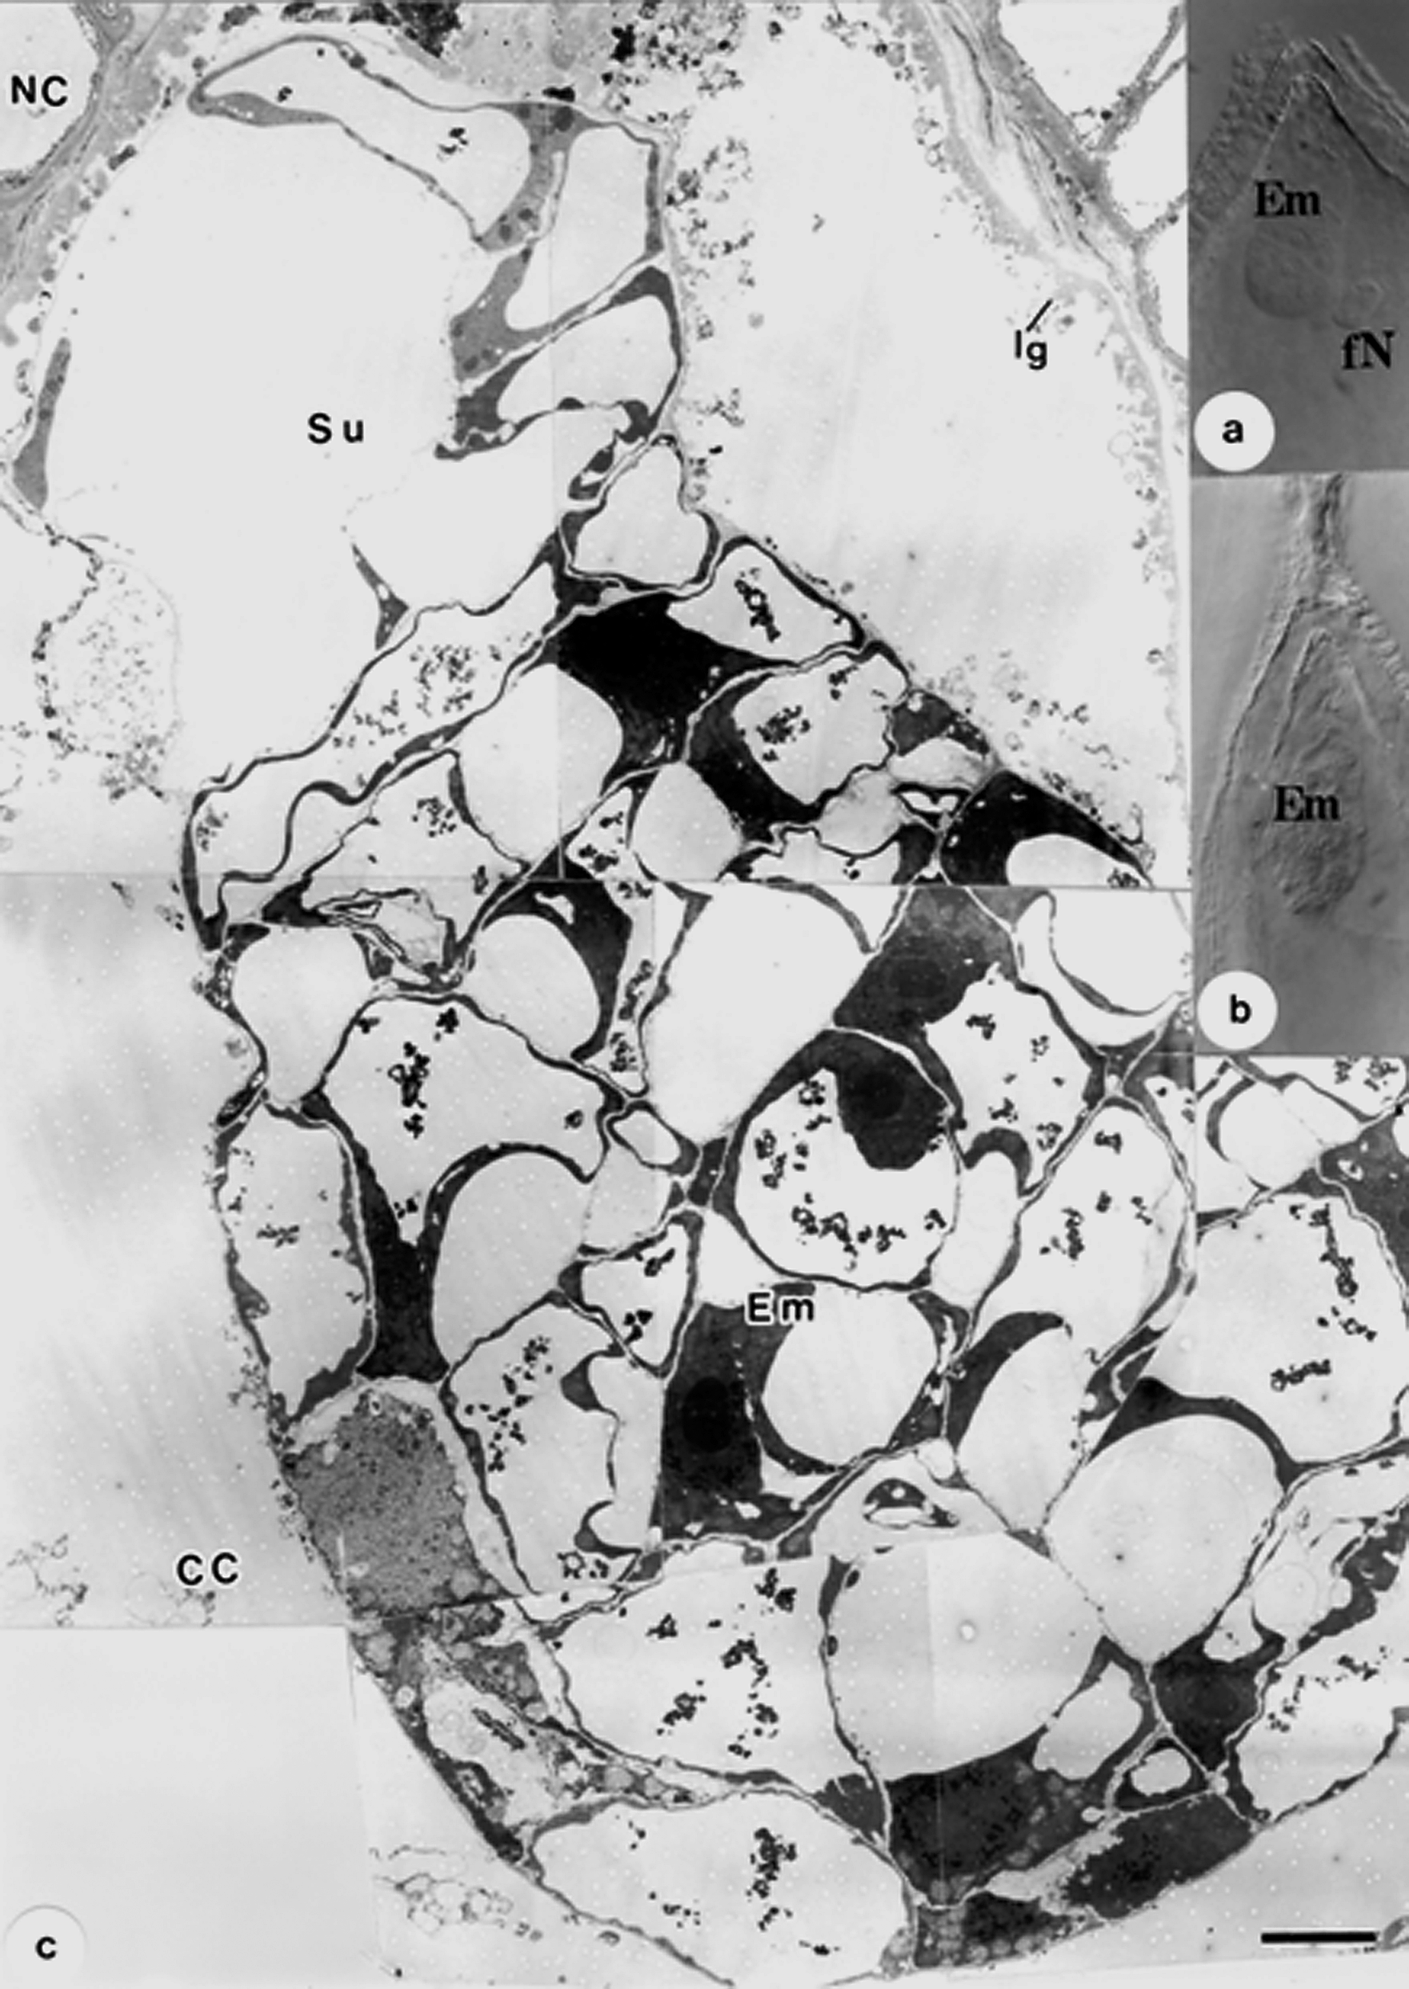

Fig. 1. a, Unfertilized polar nucleus (fN) of central cell attached to embryo (Em) at 1 DAP. b, Degenerated ovule tissue covering embryo (Em) with unclearly outlined cells at 3 DAP. c, Aborted embryo (Em) without endosperm at 3 DAP; Bar=5 m m. CC=central cell; Lg=ingrowth of cell wall; NC=nucel- lus; Su=suspensor.

embryo sac (Fig. 1b). Embryo sacs were further investigated in ultrathin section of the ovule by TEM (Fig. 1c). The withered embryo was at the early globular shape, and was highly vacuolated. Cytoplasm in the embryo cells was condensed and electron dense. Plasma membrane and plasmod-

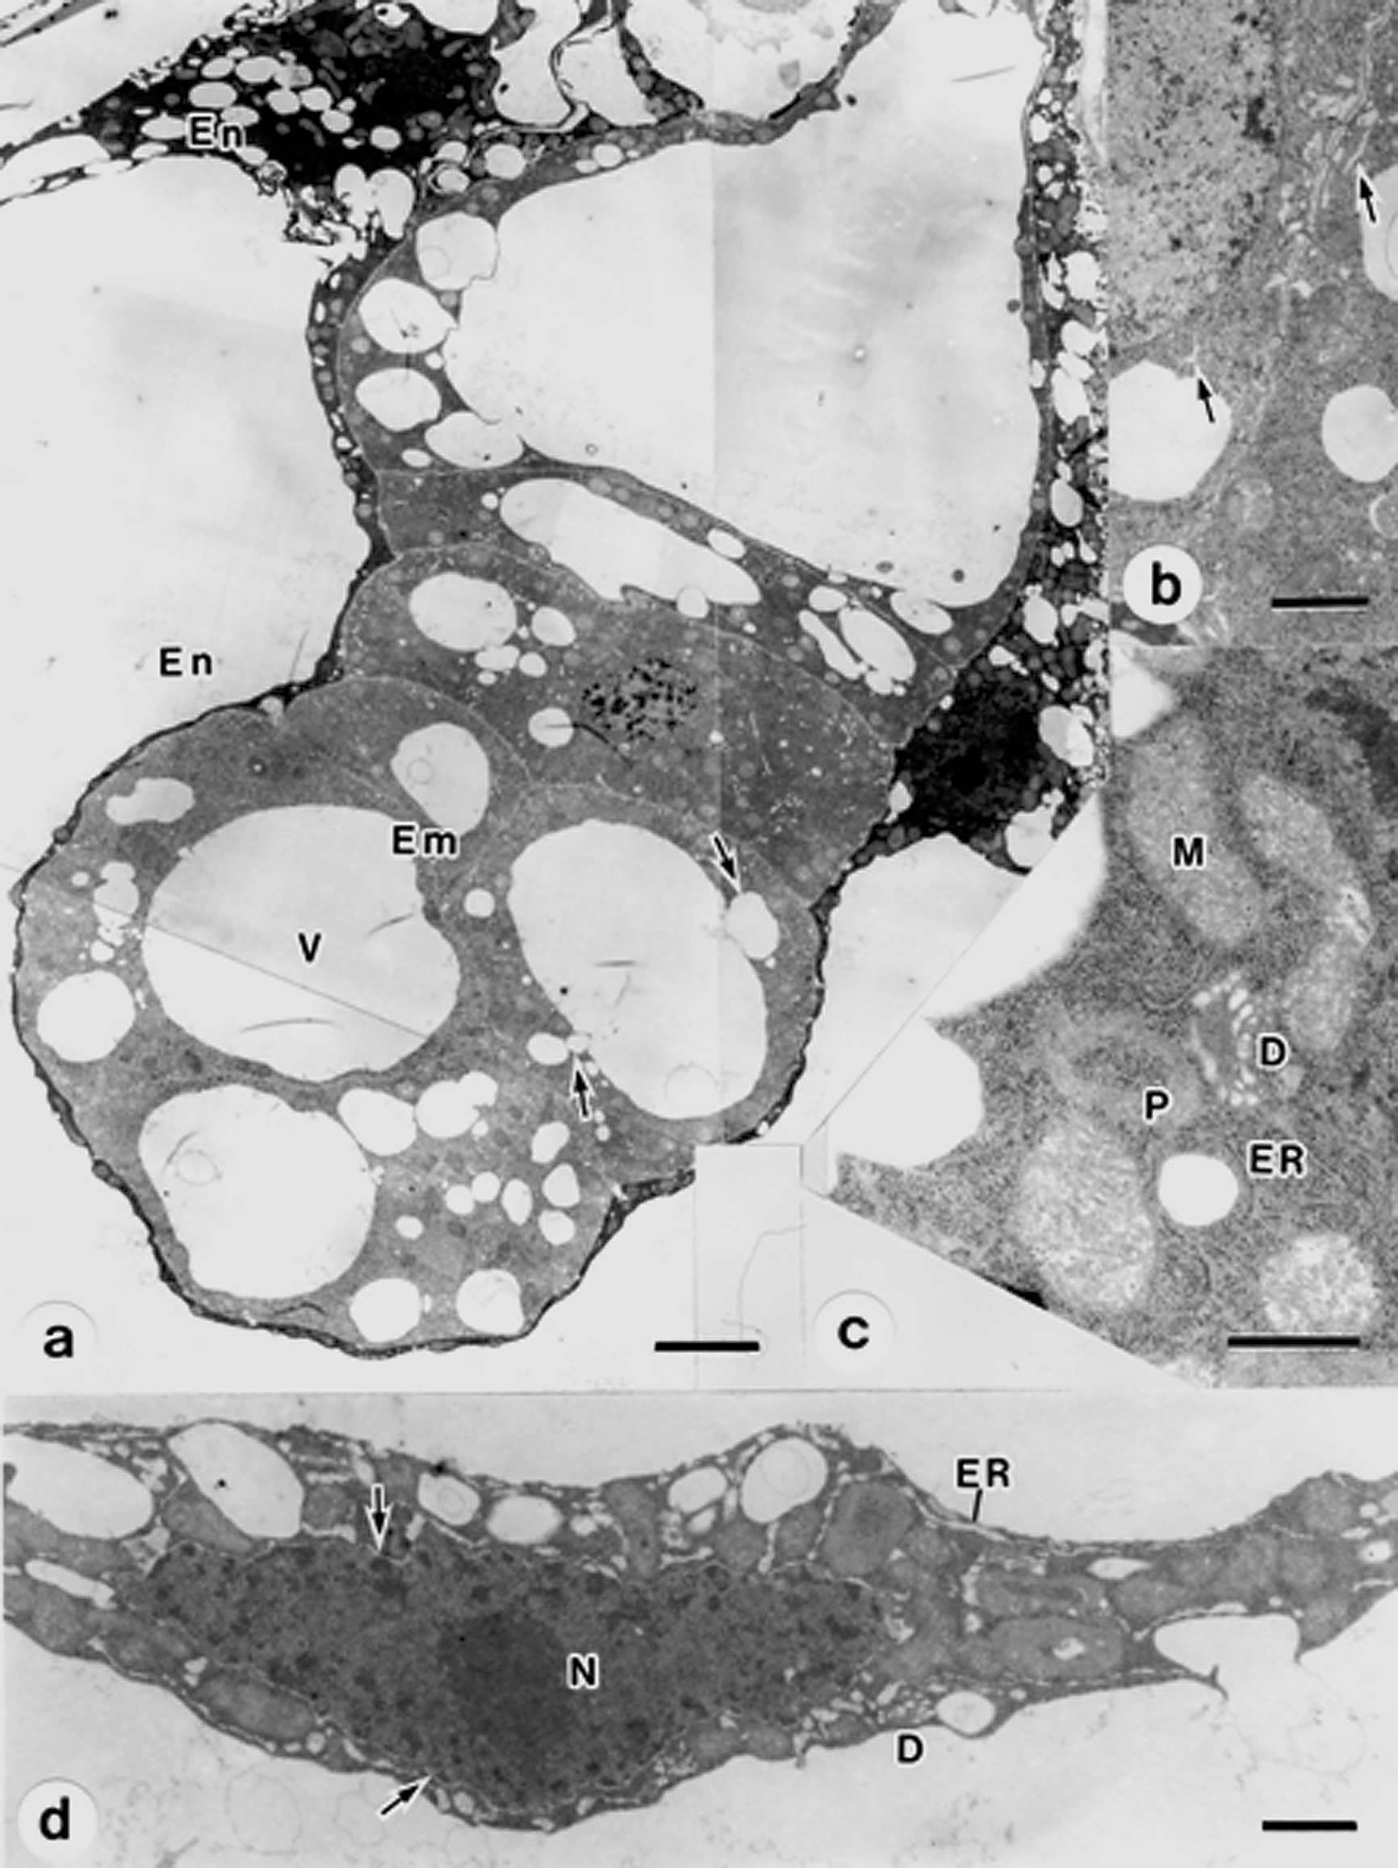

Fig. 2. Embryo at 2 DAP. a, Vacuolated embryo (Em) covered by condensed endosperm (En). Small vac- uoles (arrow) fuse with large vacuoles (V); Bar=4 m m. b, Vesiculated cisternae of ER (arrows) ap- pearing in embryo cell; Bar=1 m m. c, membrane system of organelles and nuclear envelop have dis- appeared; Bar=0.5 m m. d, Dilated nuclear envelop (arrows), ER and dictyosomes (D) in condensed endosperm cytoplasm at central part of embryo sac; Bar=1 m m. M=mitochondria; N=nucleus; P=plastid.

esmata had completely disappeared in internal walls, and the cell outline was only visible because of remnant opaque materials of the collapsed wall. Cytoplasm of the central cell had also disap- peared and the wall ingrowth pattern was visible as opaque materials in the micropylar end (Fig. 1c). Nucellar cells were highly vacuolated (Fig. 1c).

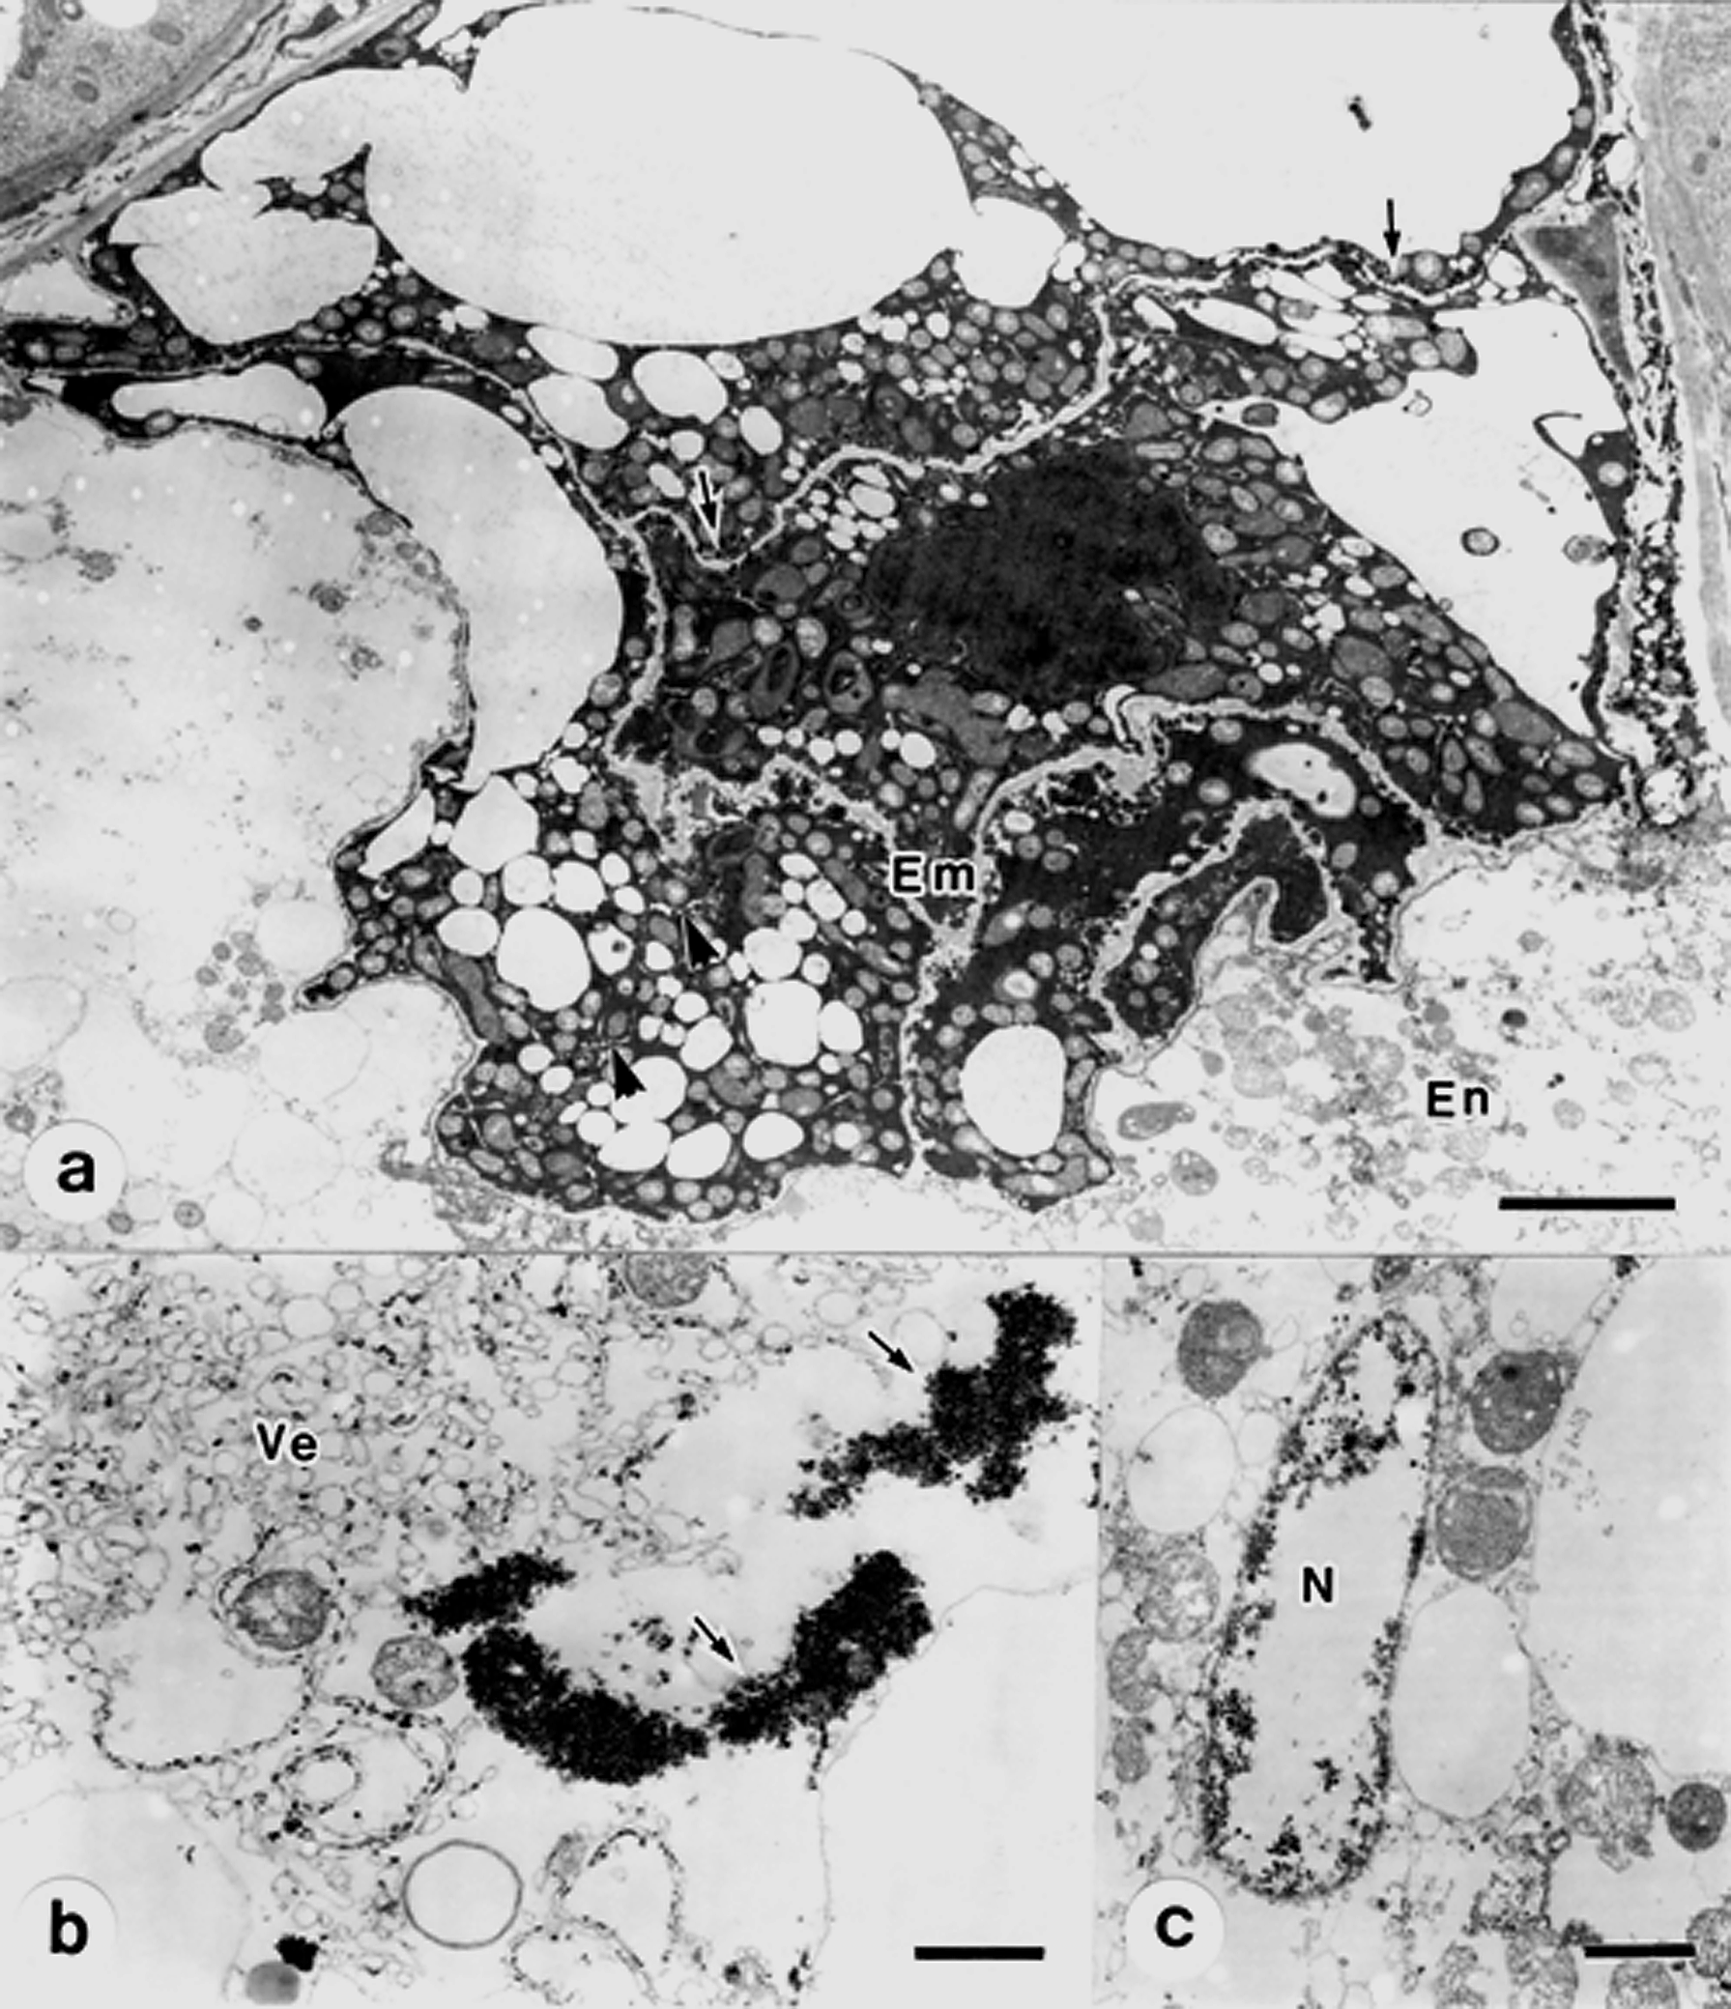

Fig. 3. Aborted embryo sacs at 1 DAP. a, A deformed embryo (Em) contains electron dense cytoplasm with organelles. Osmiophilic deposits are dotted along enlarged walls (arrows), and expanded cisternae of ER enclose bits of cytoplasm (arrowheads); Bar=4 m m. b, RER dilates into vesicles (Ve) and ri- bosomes are gathered to form electron dense clumps (arrows) in endosperm; Bar=1 m m. c, Re- mains nucleus (N) of endosperm; Bar=1 m m. En=endosperm; V=vacuole.

Endosperm condensation
In an embryo sac at 2 DAP, the embryo consists of approximately 12 cells, mostly rod-shaped, and the endosperm is formed. The cells of the embryo proper contain one large and many small vacuoles. Small vacuoles and vesicles were often found near the large vacuole and seemed to fuse with the large vacuole (Fig. 2a). By comparison with normally developing embryos (Guan and Adachi 1997), cytoplasm of the suspensor and embryo proper displayed almost identical degrees of density, and became gradually dense. Most of the mitochondria and plastids were spherical-, or oval-shaped (Figs. 2a, b), and rough endoplasmic reticulum (RER) in single expanded cisternae ap-

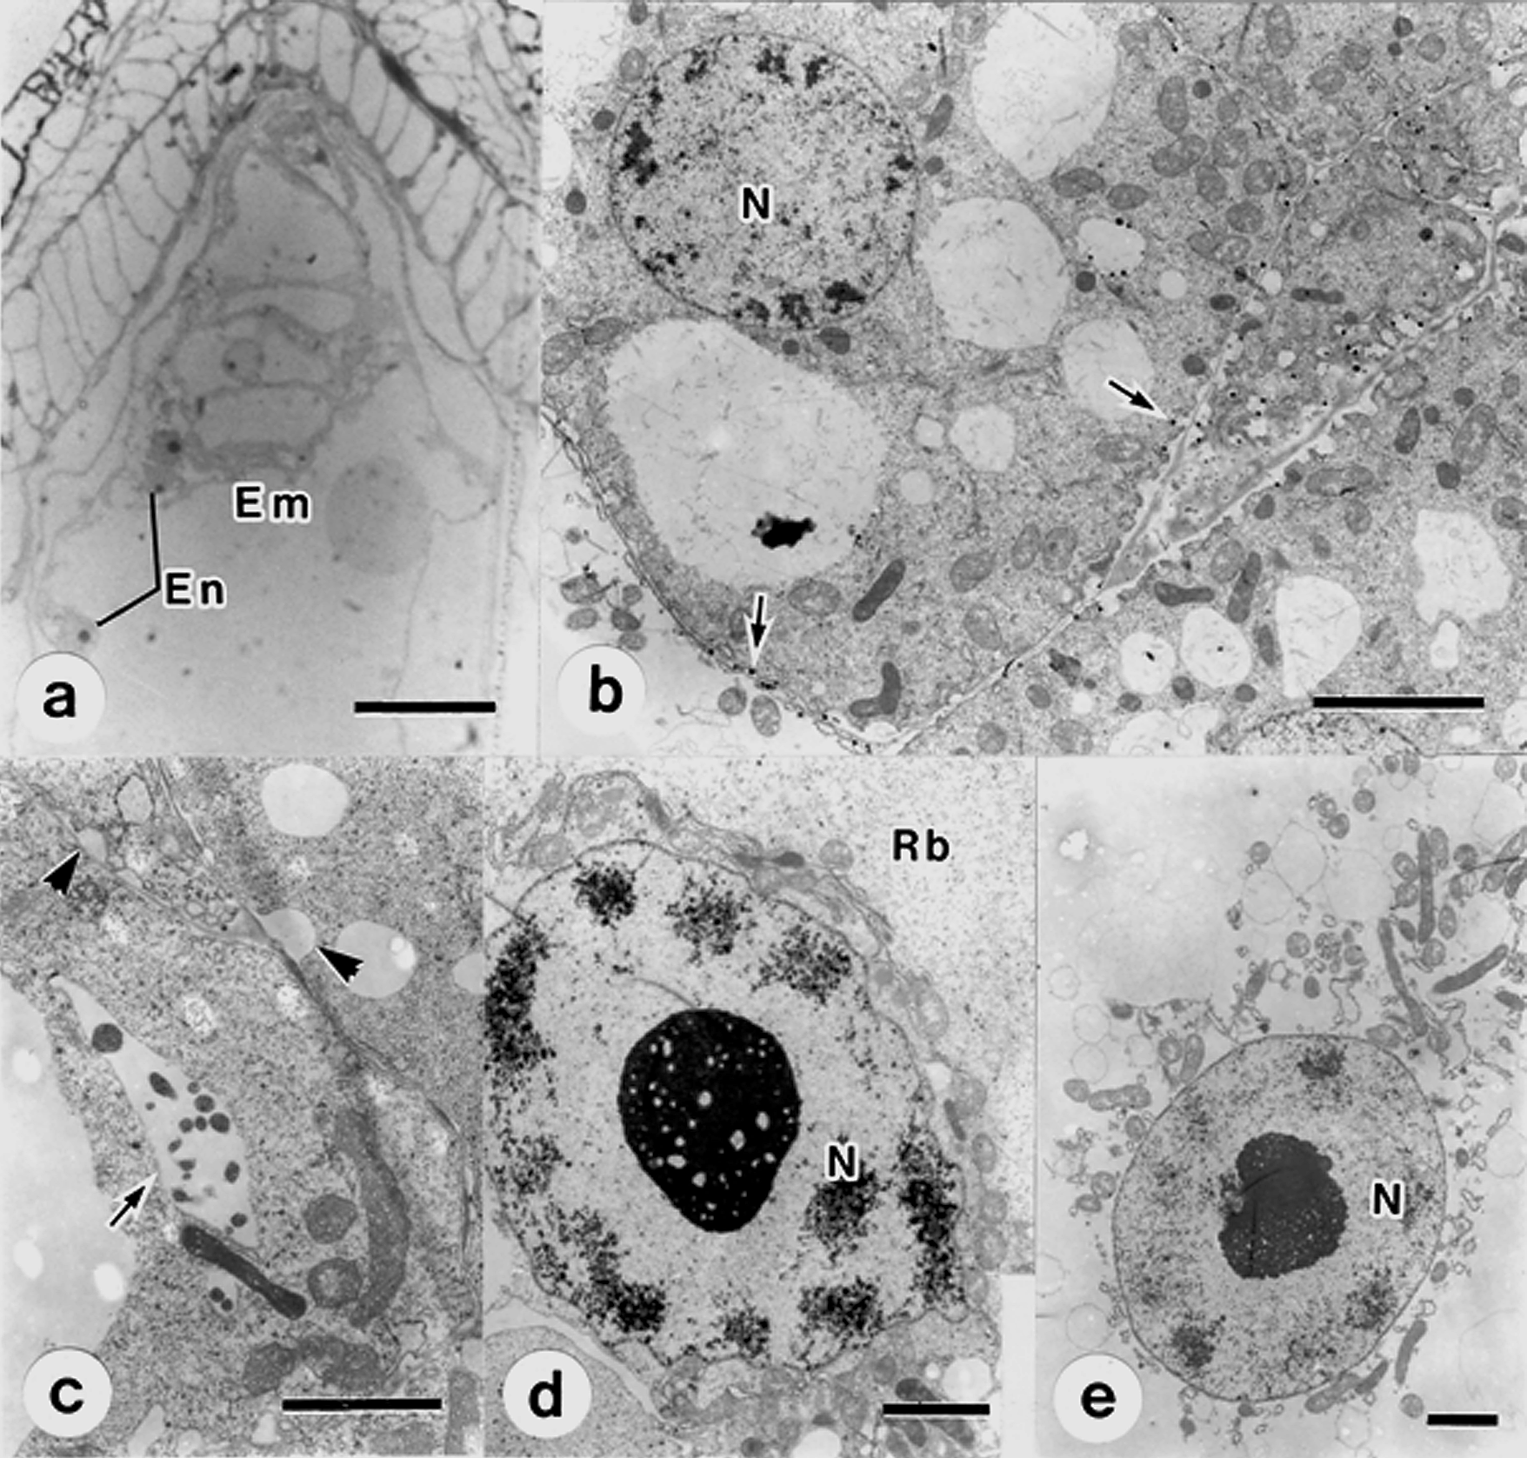

Fig. 4. Vacuolated aborting embryo. a, Vacuolated embryo (Em) surrounded by degenerated endosperm (En) and vacuolated tissue. Bar=30 m m. b, Osmiophilic deposits (arrows) appear in plasma mem- branes of embryo. Some of the cytoplasm contains low density ribosomes. Bar=3 m m. c, Expanded cisternae of ER (arrows) surrounds cytoplasmic regions and dilated cell wall (arrowheads) presents in vacuolated embryo; Bar=2 m m. d, Low density ribosomes (Rb) are uniformly distributed, but or- ganelles are clustered near endosperm nucleus (N) in micropylar region. Bar=2 m m. e, Free or- ganelles near endosperm nucleus (N). Bar=2 m m. NC=nucellus.

peared in the cytoplasm (Fig. 2b). The endosperm cytoplasm showed a higher degree of condensa- tion than that of the embryo, forming a thin layer of high electron density that surrounded the em- bryo. Mitochondria remained spherical or elongated in shape and plastids contained low-density stroma (Fig. 2c). The membrane system of organelles disappeared (Figs. 2c, d), and some nuclear envelops, ER cisternae and dictyosomes were expanded. It was difficult to distinguish between mi- tochondria and plastids because their internal structures had vanished and their contents collapsed (Fig. 2d).

Endosperm dispersion
In addition to condensed endosperm, dispersed endosperm was identified as a second pattern of collapse. At 1 DAP, irregularly shaped embryos had about 8 cells with condensed cytoplasm con- taining vacuoles and spherical mitochondria of various sizes, polymorphic plastids, and expanded dictyosomes and ER. Osmiophilic materials were found along the expanded cell walls. Plasmodes-

Table 1. Relative distribution (%) of abnormal embryo sac types in ovules of “Miyazakizairai”

Days after Day/night Abnormal embryo sac types Total % of Examined
abnormal number
pollination | temeperatures | A | B | C | D | E | F | embryo sac | of ovules
1 | 25°C/15°C | 10.9 | 0 | 0 | 0 | 0 | 1.1 | 12 | 92
 | 33°C/23°C | 33.7 | 7.8 | 0 | 2.6 | 3.9 | 24 | 72.7 | 100
3 | 25°C/15°C | 4.8 | 0 | 0 | 0 | 2.4 | 2.4 | 9.6 | 84
 | 33°C/23°C | 4.3 | 0 | 11.6 | 10.1 | 7.3 | 43.5 | 76.8 | 69

Notes: the abnormal embryo sac types refers to “M and M”.

mata are missing (Fig. 3a). Surrounding the embryo, there was dispersed endosperm (Fig. 3a). Few ribosomes were attached to the RER, instead most of them were accumulated in dense clumps (Fig. 3b). RER was highly vesiculated (Fig. 3b). Endosperm nuclei contained little nucleoplasm and were electron transparent (Fig. 3c). At 2 DAP, the embryo contained about eight highly vacuolated cells, surrounded by dispersed endosperm. Vacuolated integument and nucellar cells were observed by light microscopy (Fig. 4a). The embryo is characterized by lower-density, uniformly distributed ri- bosomes (Fig. 4b). Cell membrane and tonoplast were dotted with osmiophilic deposits, and the cell walls were relatively thin and dilated in places. Mitochondria and plastids remained distributed in the cytoplasm, and most of the ER was vesiculated (Figs. 4b, c). Vesicles were somewhat en- larged and seemed to form vacuoles and may have enclosed areas of cytoplasm (Fig. 4c). The en- dosperm adjacent to the embryo had a reduced density of uniformly distributed ribosomes and or- ganelles concentrated towards the nucleus (Fig. 4d). Free organelles accumulated at the chalazal end of the embryo sac where ribosomes were few (Fig. 4e).

Distribution of different abnormal embryo sac types
Among the 5 kinds of abnormal types at 1 DAP, A (10.9%) and F (1.1%) types occurred in total 12%, in the normal condition, respectively, and however, the 4 types accept C type did in total 72.7%, in the heat-stress (Table 1). At 3 DAP, the total abnormal rates are 9.6% with 3 types and 76.8% with 4 types, in the normal and heat-stress, respectively. And on the other hand, A type rep- resented near half (33.7/72.7) of the total rates at 1 DAP, and F type over half (43.5/76.8) at 3 DAP, respectively.

Discussion
The micropylar chamber is an important area of absorption of nutrients by the proembryo. Nu- trient transport occurs across the wall ingrowths of the central cell and suspensor cells. Nutrients traverse the endosperm from nucellus to the embryo in normally developing embryo sacs (Guan and Adachi 1997). Our investigation, however, confirmed the presence of a post-zygotic barrier to embryo development under high temperature conditions. When grown at higher temperature, em- bryo growth was slower than under normal conditions. This result is consistent with our previous report (Guan and Adachi 1992). Most of the aborted embryos were highly vacuolated and had de- veloped to the rod-shaped 8–24 cell stage.
To find out why the ovary fails to develop and why embryos abort, we analyzed aborting em- bryo sacs. Numerous features of embryo sac abortion were at first observed in the central cell. At rod-shaped embryo stage, endosperm sometimes failed to form. Failure of endosperm formation is a common cause of sterility in some plants. Tomer and Gazit (1979) found a few Persea americana fruitlets possessing an embryo but lacking endosperm (Tomer and Gazit 1979). In Crinum latifoli-

um, the polar nucleus fails to divide due to lack of fertilization, resulting in a so-called “naked em- bryo” (Inoh 1977). In F. esculentum, cv. “Miyazakizairai”, 7.8% of ovules contained “naked em- bryos” when grown in hot summer conditions by 1 DAP (Guan and Adachi 1992). This abnormal type results when the fused polar nucleus is not fertilized, due to high temperature stress. Lack of endosperm probably means that the transport of sufficient nutrients from the maternal tissue is in- hibited and translocation of necessary metabolites to the embryo is thus prevented and ovaries can- not develop into seeds.
When the polar nucleus was fertilized, the endosperm often degenerated by either condensa- tion or dispersion. This usually occurred during the early free-nuclear endosperm stage. In plants of Persea americana (Tomer and Gazit 1979) and Trifolium repens (Pasumarty et al. 1993), shriveled ovules showed endosperm collapse leading to the formation of empty seeds. There is evidence that interspecific crosses within Trifolium (Williams and White 1976), Lens (Abbo and Ladizinsky 1991) and Lycopersicon (Chen and Adachi 1992, 1995) result in ovule abortion due to endosperm failure. When heat stressed, 23% of embryo sacs of F. esculentum were of this type by 3 DAP (Guan and Adachi 1992). During late embryo stages, the endosperm is a storehouse for many macromole- cules like carbohydrates, various types of proteins, lipids and growth regulating substances (New- comb 1973, Jones and Rost 1989, Guan and Adachi 1997). During early developmental stages, al- though it can not store nutrients for the proembryo, the endosperm functions in nutrient absorption and transports from surrounding integument and nucellar tissue to the embryo. Also as an envelop- ing medium, it may protect the proembryo (Brink and Cooper 1947). In this study, it was commonly found that in the aborted embryo sac the free-nuclear endosperm had a higher degree of collapse than did the aborted embryo. This result is further evidence that the endosperm is an indispensable factor during early embryo development in F. esculentum.
A cause of embryo abortion was abnormal development in the nucellus. In the normal ovary, the nucellus, a so-called “nutrient jacket”, has high density cytoplasm containing abundant or- ganelles, and transfers and provides the bulk of nutrients for the developing embryo (Stevens 1912, Carapetian and Rupert 1989, Guan and Adachi 1997). In this study, an initial sign abnormality was that some nucellar cells were vacuolated while others still contained uniform cytoplasm with many organelles. In completely aborted embryo sacs, almost all nucellar cells displayed condensed cyto- plasm and were highly supply of vacuolated. Following initial embryo division and enlargement, nutrients stored in the nucellus are consumed completely. However, the nutrients are not newly syn- thesized or nutrient supply does not meet embryo demand. Therefore, nutritional deficiencies re- sulting from nucellar degeneration may cause embryo deterioration.
Although adversely affected by high temperature conditions, embryo development took place to some degree in some embryo sacs. For example, some ovary developed was normally in regards to embryo sac formation, and then, the egg cell was viable and competent to be fertilized. By con- sidering the stages that embryos aborted as heat-stress it can be concluded that embryo abortion is caused by complex factors: (1) activities of embryo cells are degraded by high temperature stress,
(2) embryo abortion is promoted by problems in endosperm development, and (3) embryo abortion can be resulted from obstacles in nutrient partition and transport within the ovule. Therefore, al- though the zygote has undergone some cell divisions at early free-nuclear endosperm stage, its de- velopment and differentiation is prevented as above complex factors. That is why only 23.2% of the ovules contained globular-shaped embryo after 3 DAP was observed in summer conditions (Guan and Adachi 1992).
This study describes ultrastructural changes in the aborted embryo sac and indicates that em- bryo abortion is probably the result of nutrient deficiencies. There remain many questions about abortive sterility but these data provide new information that furthers the study of sterility and breeding of environmental tolerance in F. esculentum.

References
Abbo, S. and Ladizinsky, G. 1991. Anatomical aspects of hybrid embryo abortion in the genus Lens L. Bot. Gaz. 152: 316–320.
Adachi, T., Kawabata, K., Matsuzaki, N., Yabuya, T. and Nagatomo, T. 1983. Observation of pollen tube elongation, fertil- ization and ovule development in autogamous autotetraploid buckwheat. Buckwheat Research (Proc. 2nd. Int. Symp. Buckwheat, Miyazaki, Japan) pp. 103–113.
Brink, R. A. and Cooper, D. C. 1947. The endosperm in seed development. Bot. Re. 13: 423–451.
Chen, L. Z. and Adachi, T. 1992. Embryo abortion and efficient rescue in inter-specific hybrids Lycopersicon esculentum
and the “peruvianum-complex”. Jpn. J. Breed. 42: 65–77.
- and — 1995. Mechanism of abortion of postfertilization hybrid embryo in interspecific backcross, Lycopersicon esculen- tum X (L. esculentum×L. peruvianum). Cytologia 60: 123–131.
Franz, R. E., Jolliff, G. D. and Seddigh, M. 1991. Embryo abortion in three meadow foam genotypes. Crop Science 31: 1651–1654.
Guan, L. M. and Adachi, T. 1992. Reproductive deterioration in buckwheat (Fagopyrum esculentum) under summer condi- tions. Plant Breed. 109: 304–312.
- and — 1994. Ultrastructural changes of the mature embryo sac in buckwheat (Fagopyrum esculentum) as a result of high temperature exposure. Cytologia 59: 237–248.
- and — 1997. Ultrastructural studies of embryogenesis in Fagopyrum esculentum. Int. J. Plant Sci. 158: 110–120.
Herr, J. W. 1982. An analysis of methods for permanently mounting ovules cleared in four-and-a-half type clearing fluids.
Stain Technology 57: 161–169.
Inoh, S. 1977. Plant histology (in Japanese). Uchida Rokakuhoshinsha Press, Japan 551 pp.
Jones, T. J. and Rost, T. L. 1989. Histochemistry and ultrastructure of rice (Oryza sativa) zygotic embryogenesis. Am. J. Bot. 76: 504–520.
Mogensen, H. L. 1975. Fine structure of the unfertilized, abortive egg apparatus in Quercus gambelii. Phytomorphology 25: 19–30.
Nakayama, K. 1975. Gynecology on buckwheat and perspectives of breeding (in Japanese). Nougyo oyobi Engei (Agric. and Hort.) 50: 497–502.
Newcomb, W. 1973. The development of the embryo sac of sunflower (Helianthus annuus) after fertilization. Can. J. Bot.
51: 879–890.
Tomer, E. and Gazit, S. 1979. Early stages of avocado (Persea americana Mill) fruit development: anatomical aspects. Bot.
Gaz. 140: 304–309.
Williams, E. G. and White, D. W. R. 1976. Early seed development after crossing of Trifolium ambiguum and T. repens. NZ.
J. Bot. 14: 307–314.

