Evaluation of Bio Dynamic Compost and Bio Dynamic Compost Wash on

Growth and Yield of Rice

# ABSTRACT

The present investigation, was conducted in the *Kharif* of 2021–2022 at the Student's Instructional Farm at the A.N.D. University of Agriculture & Technology, Kumarganj, Ayodhya (U.P.). The experiment was laid out in Randomized Block Design, replicated thrice, having 8 treatments i.e. T1 (Absolute Control), T2 (Bio dynamic compost 1q/ha + 50 % RDF), T3 (Bio dynamic compost 2 q/ha

+ 50 % RDF), T4 (T2 + Root dipping with Bio dynamic compost wash 10 ml/ lit of water), T5 (T3 + Root dipping with Bio dynamic wash 10 ml/lit of water), T6 (T2 + foliar application of Bio dynamic compost wash of 10 ml/10 lit of water), T7 (T3 +foliar application of Bio dynamic compost wash of

10 ml/ lit of water), T8 (100 % RDF. Result revealed that the highest growth attributes viz., Plant height (cm), maximum dry matter accumulation, highest number of tiller (m-2), Panicle length (cm), number of grain per panicle and test weight (gm), maximum grain yield (q ha-1), highest straw yield, maximum biological yield (q ha-1) and maximum harvest index (q ha-1) was recorded significantly over rest of the treatments in T7 (T3 +foliar application of Bio dynamic compost wash of 10 ml/ lit of water) while it recorded lowest in in T1 (absolute control) during the investigation.

*Keywords: Bio dynamic compost; bio dynamic wash; growth attribute; yield attribute.*

# INTRODUCTION

Rice (*Oryza sativa* L.) is one in all the most important food crops, grown in south Asia. Rice is the most popular staple meal consumed by more than half of the world's population, especially in Asia and Africa. As a result, it is a key source of food for around 35% of the world's population and one of the principal crops in developing nations.[]

After maize and sugarcane, it is the agricultural product with the third-highest global production (https://[www.fao.org/faostat/en/#data/QCL).](http://www.fao.org/faostat/en/%23data/QCL)) The rice plant is capable of growing to a height of 1-

1.8 m (3-6 feet), depending on the soil's kind and fertility. Its long, narrow leaves are 2-2.5 cm (3-4 in) broad and range in length from 50 to 100 cm (20 to 40 in). The small wind-pollinated blossoms are carried by a branching, arching, to pendulous inflorescence that is 30–50 cm (12–20 in) in length. The most extensively produced grain in the world, paddy is a staple meal for more than 60% of humanity. Over the last 15 years, the global paddy output has expanded gradually but slowly, from 400 million tonnes to 477 million tonnes. The world's first crop to be intentionally grown is said to have been paddy. Asia, which leads the sector, produces over 90% of the world's paddy crop. It is the second most widely grown cereal in the world after maize. India is the world's second-largest producer of rice. According to the Directorate of Economics and Statistics (2021) the production of rice in 2020-21 was 122.27 million tons with productivity of 2713 kg ha-1 under 43.82 mha area in India. In Uttar Pradesh, production was 15.66 million tons and productivity was 2759 kg ha-1 under 19.93 mha area in 2020-21.[]

According to Ponnamperuma et al. [1] rice straw is most suited for this use because it typically contains 0.9% N, 0.2% P, 0.2% S, 2.5% K, 0.6% Ca, 7.0% Si, and 40% C. There are many different production techniques utilised to create organo-mineral fertilizers from organic and mineral wastes. Numerous studies have

shown that chemical, thermochemical, and biological methods can all be used to produce products with adequate fertilizing capabilities. The nature of the employed feedstock and the intended market have a major role in the selection of an appropriate procedure. This section thoroughly examines the most significant chemical and biological techniques used in the OMF generation process by valorising organic/mineral waste and low-grade phosphate. Biodynamic farming is a method of production that actively cooperates with the elements of nature that support wellness. It served as the catalyst for the nonchemical farming movement. In a nutshell, "biodynamic" agriculture is a group of "biological dynamic" farming practices. Numerous well-known organic agriculture practices that improve soil health are referred to as "biologically" in this sentence.

"Dynamic" farming methods try to change the biological and metaphysical qualities of the farm (like increasing vital life energy) or to make the farm more in sync with the seasons (like sowing seeds at certain moon phases). The initial biodynamic formulations were identified by numbers (500–508). The fermentation process for the BD 500 preparation, sometimes referred to as horn manure, takes place in a cow horn that has been buried in dirt for six months in the autumn and winter. The quartz powder-based BD 501 preparation (horn-silica) is packaged in a cow horn and submerged in soil for six months in the spring and summer. The fact that biodynamic preparations 502–507 are used to create the compost makes it special. In many nations, biodynamic farming is carried out on a commercial scale, and it is becoming more well-known for its contributions to community supported agriculture, organic farming, food quality, and qualitative tests for soils and composts. From a real-world perspective, biodynamic farming has been shown to be effective and produce wholesome, high-quality foods [2]. Therefore**,** present investigation was emphasized to know the

effect of biodynamic compost and bio dynamic wash on growth and yield parameters of rice.

# MATERIALS AND METHODS

## Experimental Site and Climatic Conditions

The experiments were conducted at the Student's Instructional Farm of the Acharya Narendra Deva University of Agriculture and Technology in Kumarganj, Ayodhya, which is located in the subtropical Indo Gangetic Plains climate zone at 26.470 N latitude, 82.120 E longitude, and an elevation of 113 metres above mean sea level.

## Cultural Operations

* + 1. **Preparation of field**

The experimental area was ploughed with tractor just after harvest of winter crop and ploughed again in the 3rd week of July. The experiment was then set up according to the experimental design after the field had been flattened and puddled with cage wheels.

* + 1. **Application of fertilizers**

The test crop was 894 ertilized according to treatment using the N: P2O5: K2O (150:60:40 kg ha-1) recommended fertilizer dose (RDF) for the Ayodhya region. Before transplanting, potassium, phosphorus, and nitrogen were all administered topically at the recommended doses. At the active tillering and panicle initiation stages, the remaining two thirds of nitrogen were applied in two equal portions.

## Growth Parameter

For the record of growth and yield parameter following methodology were used:

* + 1. **Plant height (cm)**

The height of the plants was measured from the base of the plant to the tip of the uppermost fully opened leaf at harvest and at 30, 60, and 90 days following transplantation from five randomly chosen/tagged hills. Height was measured from the point when the panicle first emerged to its tip.

* + 1. **Number of tillers (m-2)**

At 30, 60, 90, and at harvest from each plot, tillers were counted from 5 tagged hills to

determine the average number of tillers hill. Attributes and yields of the crop. During experiments, the following observations on yield and yield studies were made.

* + 1. **Effective tillers (m-2)**

At 30, 60, and 90 DAT, as well as at harvest, crop plants from each plot were cut with a sickle at ground level in three different places along the sample lines. The plants were then allowed to dry in an oven at 700 C until a steady weight was attained. The weight of the dry substance was then determined using an electronic scale and given as dry weight in gram hills-1.

* + 1. **Length of panicle (cm)**

Ten randomly selected panicles from tagged plants were measured from the neck node to the tip of the topmost spikelet, and the average length was recorded.

* + 1. **Numbers of grain panicle-1**

After the crop had reached full maturity, it was measured by randomly planting 0.25 m2 quadrate at two different positions within each net plot. The quantity of panicles that entered the quadrate was counted, and the average number of panicles m-2 was recorded.

* + 1. **Flag leaf area (cm2)**

Grid paper: Place the flag leaf on a sheet of graph paper or any paper with a grid pattern. Trace the outline of the leaf on the paper and count the number of grid squares that the leaf covers. Multiply this count by the known area represented by each grid square to calculate the total leaf area.

* + 1. **Test weight (g)**

Grain samples were taken from the threshed and cleaned produce of each net plot and 1000grains were counted and weighed.

* + 1. **Grain yield (q ha-1)**

The net plot's harvested produce was sun-dried and threshed to determine the grain yield in kg plot-1.Straw yield (q ha-1).

The straw yield was worked out by subtracting the grain yield from total biologicalyield and finally it was computed to q ha-1.

* + 1. **Harvest index (%)**

Harvest index of each experimental plot is calculated with the help of following formulae:

Harvest index= (Grain yield / Biological yield)

# RESULTS AND DISCUSSION

## Effect of Bio Dynamic Compost and Bio Dynamic Compost wash on Plant height (cm)

The maximum plant height 36.25 cm, 80.20 cm,

109.5 cm and 112 cm respectively, at 30 DAS, 60 DAT, 90 DAT and at harvesting stage were recorded with the application of T7 (T3 + foliar application of Bio Dynamic compost wash of 10 ml 10 lit-1 of water) and statistically at par with T5:-(T3 + Root dipping with Bio dynamic compost wash 10 ml lit-1 of water) while, minimum plant height was observed under the non-treatment plot (Control) T1. It was observed that plant height of rice can be increased sustainably with the application of Bio dynamic compost, root dipping with Bio dynamic compost wash and foliar application of Bio dynamic wash at different growth stages of crop. In contrast, 100 % RDF also gave significantly higher growth compared to control plot. Similar observations also reported by Mahmud [3].

## Dry matter Accumulation

The maximum dry matter accumulation m-2 227.5, 460.25, 797.5 and 1401.70 m-2

respectively, at 30 DAS, 60 DAT, 90 DAT and at harvesting stage were recorded with the application of T7 (T3 + foliar application of Bio

dynamic compost wash wash of 10 ml lit-1 of water) and statistically at par with T5 (T3 + Root dipping with Biodynamic compost wash 10 ml lit-1 of water) while minimum dry matter accumulation m-2 was observed under the non-treatment plot (Control) T1.The reason for the increase in total dry matter production could be that HA has promotive effect on photosynthesis by increasing soluble protein content (Khristeva and Luk‟ Yanenka, 1962). Similar results was obtained by Ravindra Prasad et al. [4], Tiwana et al. [5] studying on rice-wheat sequence with or without green manure to rice have also reported favourable effect of green manuring on dry matter accumulation by rice at all stages of crop growth. Khan et al. [6] reported application of lime with FYM before planting showed beneficial effect during initial growth stages and dry matter production through stimulated mineralization of nitrogen from FYM and soil.

## Effect on Yield and Yield Attributes

Data pertaining to grain yield (q ha-1), straw yield (q ha-1), biological yield (q ha-1) and harvesting index (%) as influenced by various treatments Table 4 & Fig. 3. Among the various treatments application of T7 (T3 +foliar application of Bio dynamic compost wash of 10 ml lit-1 of water) significantly influenced the maximum grain yield (57.92 q ha-1),straw yield (82.25 q ha-1),biological yield (140.17 q ha-1) and harvest index (41.31%), and these were statistically at par with T5:-(T3 + Root dipping with Bio dynamic compost wash 10 ml lit-1 of water) while minimum grain yield, straw yield, biological yield and harvesting index was observed under the non-treatment plot (Control) T1.

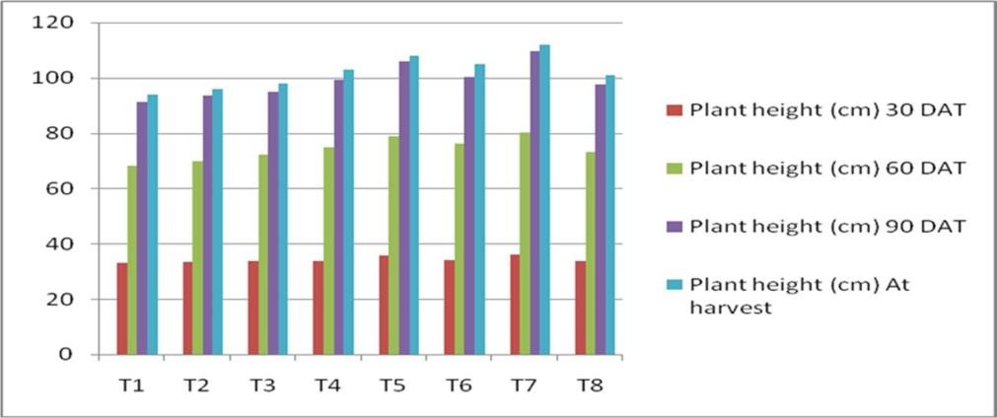

**Fig. 1. Effect of bio dynamic compost and bio dynamic compost wash on plant heightat different days after sowing**

**Table 1. Details of treatment used in experiment**

|  |  |
| --- | --- |
| **Treatment No.** | **Treatment details** |
| T1 | Absolute Control |
| T2 | Bio Dynamic Compost 1q/ha+50%RDF |
| T3 | Bio Dynamic compost 1.5 q/ha+50%RDF |
| T4 | T2+Root dipping with Bio Dynamic compost wash 10 ml/ lit of water |
| T5 | T3 + Root dipping with Bio Dynamic compost wash 10 ml/lit of water |
| T6 | T2+foliar application of Bio Dynamic compost wash of 10 ml/ lit of water |
| T7 | T3 +foliar application of Bio Dynamic compost wash of 10 ml/ lit of water |
| T8 | 100%RDF |

**Table 2. Effect of bio dynamic compost and bio dynamic compostwash on plant height (cm)**

|  |  |  |  |  |  |
| --- | --- | --- | --- | --- | --- |
|  |  | **Plant height(cm)** | | | |
| **S.No.** | **Treatment combination** | **30**  **DAT** | **60**  **DAT** | **90**  **DAT** | **At harvest** |
| T1 | Control | 33.20 | 68.20 | 91.20 | 94.00 |
| T2 | Bio dynamic compost1q ha-1 +50 % RDF | 33.50 | 69.80 | 93.50 | 96.00 |
| T3 | Bio dynamic compost1.5 q ha-1 + 50 % RDF | 33.70 | 72.10 | 95.00 | 98.00 |
| T4 | T2 + Root dipping withBio dynamic compost wash 10 ml lit-1 of water | 33.90 | 75.00 | 99.40 | 103.00 |
| T5 | T3 + Root dipping withBiodynamic wash 10 ml lit-1 of water | 35.80 | 79.00 | 106.10 | 108.00 |
| T6 | T2 + foliar application of Bio dynamic compost wash of 10 mllit-1 of water | 34.10 | 76.20 | 100.40 | 105.00 |
| T7 | T3 + foliar application of Bio dynamic compost wash of 10 mllit-1 of water | 36.20 | 80.20 | 109.50 | 112.00 |
| T8 | 100 % RDF | 33.80 | 73.1 | 97.50 | 101.10 |
| SEm± |  | 0.473 | 1.01 | 1.353 | 1.399 |
| C.D. |  | 1.447 | 3.12 | 4.144 | 4.284 |

**Table 3. Effect of bio dynamic compost and bio dynamic compost on dry matter accumulation m-2 of rice crop**

|  |  |  |  |  |  |
| --- | --- | --- | --- | --- | --- |
| **S. No.** | **Treatment combination** | **Dry matter accumulation m-2** | | | |
|  |  | **30**  **DAT** | **60**  **DAT** | **90**  **DAT** | **At harvest** |
| T1 | Control | 188.10 | 424.11 | 715.30 | 908.30 |
| T2 | Bio dynamic compost1q ha-1 +50 % RDF | 194.10 | 412.70 | 726.30 | 1144.20 |
| T3 | Bio dynamic compost2 q ha-1 +50 % RDF | 198.10 | 431.10 | 734.10 | 1184.70 |
| T4 | T2 + Root dipping with Bio dynamic compost wash 10 mllit-1 of water | 205.40 | 435.10 | 752.20 | 1293.80 |
| T5 | T3 + Root dippingwith Biodynamicwash 10 ml lit-1 of water | 218.10 | 455.20 | 780.10 | 1379.70 |
| T6 | T2 + foliar applicationof Biodynamic compost wash of 10ml lit-1 ofwater | 211.10 | 470.50 | 761.20 | 1340.70 |
| T7 | T3 + foliar applicationof Bio dynamic compost wash of 10ml lit-1 of water | 227.50 | 460.20 | 797.50 | 1401.70 |
| T8 | 100 % RDF | 201.20 | 480.50 | 742.10 | 1233.10 |
| SEm± |  | 2.80 | 6.17 | 10.34 | 17.06 |
| C.D. |  | 8.59 | 18.91 | 31.68 | 52.24 |

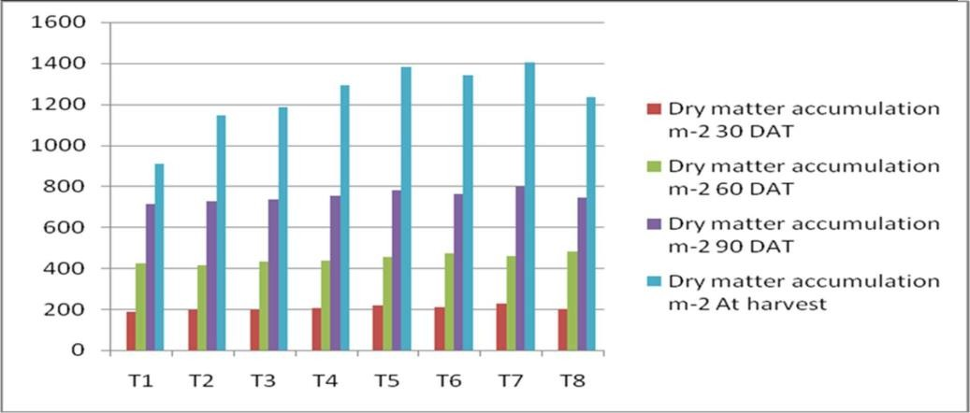

**Fig. 2. Effect of bio dynamic compost and bio dynamic compost dry wash on matter accumulation at different days after sowing**

The above finding showed that the optimum dose of nitrogen, phosphorus, potassium and Bio dynamic compost and their interaction increased the vegetative growth significantly, which helped to increase the grain and straw yield, biological yield and ultimately harvest index of rice. The higher yields with T7:-(T3+foliar application of Bio dynamic compost wash of 10 ml lit-1 of water) were mainly owing to adequate supply of major nutrients to plants, which in turn contributes to better growth and yield attributes, thus leading to higher yields. Our findings are in close conformity with Kumar et al. [7] who had also reported similar to present results.

## Effect of Different Treatments on Number of Grains Panicle-1

It is obvious from Table 4 that the number of grains panicle-1 in rice was firmly affected by various treatment combinations. The maximum number of grains panicle-1 (150.5) was recorded with treatment T7:-(T3 + foliar application of Bio dynamic compost wash of 10 ml lit- 1 of water) which was significantly superior over the treatment T1(control), and T5:- (T3 + Root dipping with Bio dynamic wash 10 ml lit-1 of water) which was statistically at par to each other in their performance. However, minimum number of grains panicle-1 (114.25) was recorded in T1 (control) treatment. Similar to present finding Muhammad Usman et al. [8] also reported that increased number of grains per panicle in rice might be due to better utilization phosphorus in organic manures, phosphorus as a part of DNA played a crucial role in the building of genetic parts of plants.

## Effect of Different Treatments on Panicle Length (cm)

The data presented in Table 5 & Fig. 4 revealed that the panicle length vigorously affected by various treatment combinations. The maximum panicle length (25.20 cm) was recorded with treatment T7:-(T3 + foliar application of Bio dynamic compost wash of 10 ml lit-1 of water) which was significantly superior over the treatment T1 (control), and statistically at par with T5:- (T3 + Root dipping with Bio dynamic wash 10 ml lit-1 of water). The minimum panicle length (20.78 cm) was recorded in T1 (control) treatment. HA improved soil nutrient status by increasing organic matter (9%), total N (30%), available P (166%) and available K (52%). Similar observation was also recorded by Reddy et al. [9] as well as Dixit and Gupta [10]. Murali and Setty [11] observed that the increased yield and yield attributing character are mainly due to better source and sink relationship such as increased dry matter production and its translocation from source to sink.

## Effect of Different Treatments on Test Weight (g)

Test weight of rice generally varied from 22.00 to

26.00 g. There is no significant difference found between treatments. However, highest test weight was observed in T7:-(T3 + foliar application of Bio dynamic compost wash of 10 ml lit-1 of water) (26.09 g) and lowest is observed in control T1 (22.24 g).

The results are in close conformity with the findings of Mondal et al. [12].

**Table 4. Effect of bio dynamic compost and bio dynamic compost wash on grain yield (qha-1). straw yield (q ha-1), biological yield (q ha-1), harvest index (%) of rice crop**

|  |  |  |  |  |  |
| --- | --- | --- | --- | --- | --- |
| **S. No.** | **Treatment combinations** | **Grain yield (qha-**  **1)** | **Straw**  **Yield (q ha-1)** | **Biological yield(q ha-1)** | **Harvest Index(%)** |
| T1 | Control | 36.30 | 54.50 | 90.80 | 39.90 |
| T2 | Bio dynamic compost1q ha-1 + 50 % RDF | 47.10 | 67.30 | 114.40 | 41.10 |
| T3 | Bio dynamic compost 2q ha-1 + 50 % RDF | 48.60 | 69.80 | 118.40 | 41.00 |
| T4 | T2 + Root dipping withBio dynamic compostwash 10 ml lit-1 of  water | 53.20 | 76.10 | 129.30 | 41.10 |
| T5 | T3 + Root dipping withBio dynamic wash 10  ml lit-1 of water | 56.20 | 81.70 | 137.90 | 40.70 |
| T6 | T2 + foliar application of Bio dynamic compost wash of 10 ml  lit-1 of water |  | 79.10 | 134.00 | 40.90 |
|  | 54.80 |  |  |  |
| T7 | T3 + foliar application of Bio dynamic compost wash of 10 ml lit-1 of water | 57.90 | 82.20 | 140.10 | 41.30 |
| T8 | 100 % RDF | 51.11 | 72.20 | 123.30 | 41.40 |
| SEm± |  | 0.70 | 1.00 | 1.70 | 0.57 |
| C.D at 5 % | | 2.14 | 3.07 | 5.22 | N/S |

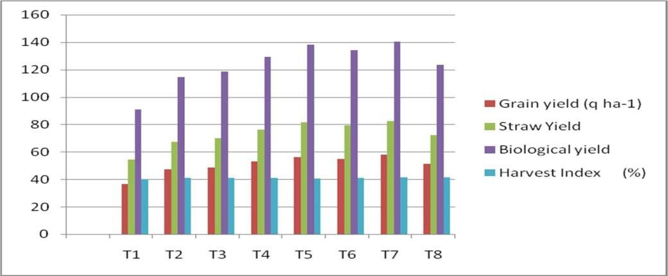

**Fig. 3. Effect of bio dynamic compost and bio dynamic compost washon grain yield (qha-1) straw yield (q ha-1), biological yield (q ha-1), harvest index (%) of rice crop**

## Number of Tillers (m-2)

The number of tillers increased at different stage of crop growth different methods of applying Bio dynamic compost and Bio dynamic compost wash. The maximum number of tillers m-2 at harvesting stage were recorded with the application of T7:- (T3 + foliar application of Bio dynamic compost wash of 10 ml lit-1 of water)

which is statistically at par with T5:- (T3 + Root dipping with Bio dynamic wash 10 ml lit-1 of water) while minimum number of tillers m-2 was observed under the non-treatment plot (Control)T1.Tillering is an important trait for grain production and is thereby an important aspect in rice yield. The results are in conformity with the findings of Singh and Jain [13], and Godhwale et al*.* [14].

**Table 5. Effect of bio dynamic compost and bio dynamic compost wash on panicle length (cm), number of grains panicle-1, Test weight (g) and number of tillers (m-2)**

|  |  |  |  |  |  |
| --- | --- | --- | --- | --- | --- |
|  |  |  | **Yield attribute** | | **No of tiller(m-2)** |
| **S. No.** | **Treatment combination** | **Panicle length(cm)** | **No. of grain panicle-1** | **Test weight(gram)** | **At Harvest** |
| T1 | Control | 20.70 | 114.20 | 22.20 | 308.90 |
| T2 | Bio dynamic compost1q ha-1 + 50 % RDF | 21.90 | 114.60 | 22.60 | 317.90 |
| T3 | Bio dynamic compost1.5 q ha-1  + 50 %RDF | 22.80 | 138.50 | 22.80 | 329.00 |
| T4 | T2 + Root dippingwithBio dynamic compost wash 10 ml lit- 1 ofwater | 24.00 | 143.10 | 23.50 | 348.00 |
| T5 | T3 + Root dipping with Bio dynamic wash 10 ml lit-1 of water | 25.00 |  | 25.10 | 365.00 |
|  |  | 145.50 |  |  |
| T6 | T2 + foliar application ofBio dynamic compostwash of 10 ml lit-1of water | 24.10 | 143.50 | 23.70 | 352.00 |
| T7 | T3 + foliar application ofBio dynamic compostwash of 10 ml lit-1of water | 25.20 | 150.00 | 26.00 | 366.90 |
| T8 | 100 % RDF | 23.40 | 141.20 | 23.28 | 336.90 |
| SEm± |  | 0.32 | 1.89 | 0.32 | 4.71 |
| C.D.at 5% | | 0.99 | 5.80 | 0.99 | 14.42 |

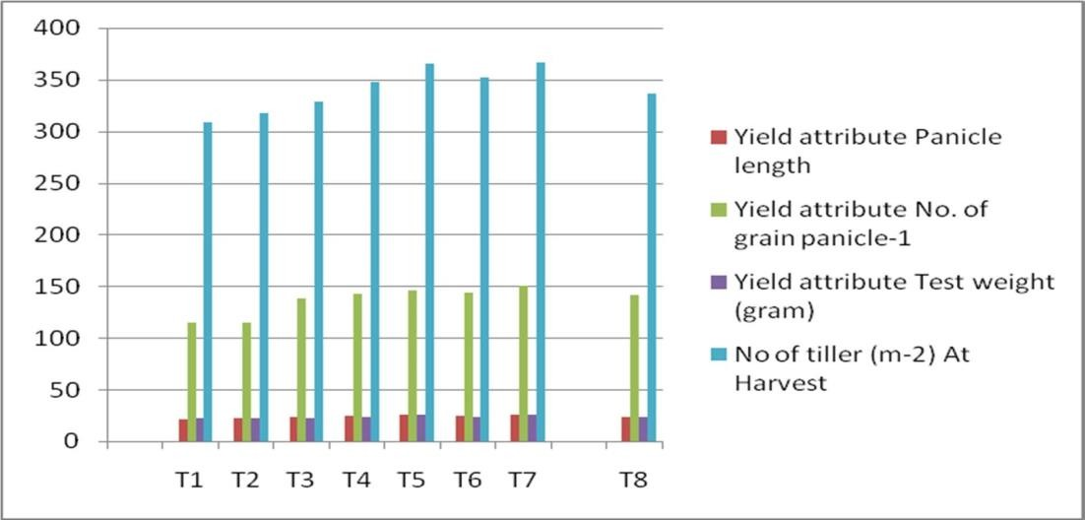

**Fig. 4. Effect of bio dynamic compost and bio dynamic compost wash on paniclelength(cm), number of grains panicle-1, test weight (g), and number of tillers (m-2)**

## Effect of Bio Dynamic Compost and Bio Dynamic Compost wash on plant population

It is obvious Table 6 that the plant population in rice was firmly affected by various treatment combinations. The maximum plant population at initial stage (52) and at final stage(50) was recorded with treatment T7 (T3 + foliar

application of Bio dynamic compost wash of 10ml lit- 1 of water) which was significantly superior over the treatment T1(control) and statistically at par with T5:-(T3 + Root dipping with Bio dynamic wash 10 ml lit-1 of water).The minimum plant population at initial stage (45) and at final stage(42) was recorded in T1 (control) treatment due to the biotic and abiotic stress final plant population decrease.

## Effect of bio Dynamic Compost and Bio Dynamic Compost Wash on Flag Leaf Area(cm2)

The data on progressive Flag leaf area at the successive stages of crop growth as greatly influenced by various Bio dynamic compost application practices. The presented in Table 7 depicted that, at 30 Panicle initiation, at 50% flowering, 100% flowering and at harvesting stage clearly indicates that bio-decomposed treatment influenced significantly over all treatment.The maximum Flag leaf area (38.50 cm2), (43.98cm2) and (44.52cm2) respectively, at 30 Panicle initiation, at 50% flowering, 100% flowering stage

were recorded with the application of T7( T3 + foliar application of Bio dynamic compost wash of

10 ml lit-1 of water) This treatment was statistically comparable to T5 (T3 + Root dipping with Bio dynamic wash 10 ml lit-1 of water) while minimum Flag leaf area was observed under the non-treatment plot (Control) T1. The primary factor of photosynthetic rate is leaf area. Higher dry matter production results from larger leaf area expansion because it improves light absorption [15]. The stimulation of chloroplast growth, particularly in terms of size, by HA therapy may have contributed to the increase in leaf area and, number of grana mm'2 as reported by Forton et al. [16].

**Table 6. Effect of bio dynamic compost and bio dynamic compost wash onplant population in rice**

|  |  |  |  |
| --- | --- | --- | --- |
| **S.No.** | **Treatment combination** | **Initial plant population (m-2)** | **Final plant population** |
| T1 | Control | 46 | 42 |
| T2 | Bio dynamic compost 1q ha-1 +50 % RDF | 48 | 44 |
| T3 | Bio dynamic compost 1.5 q ha-1 + 50 % RDF | 47 | 45 |
| T4 | T2 + Root dipping with Biodynamic compost wash 10 ml lit-1 of water | 48 | 46 |
| T5 | T3 + Root dipping with Biodynamic wash 10 ml lit-1 of water | 51 | 48 |
| T6 | T2 + foliar application of Biodynamic compost wash of 10 ml lit-1 of water | 49 | 46 |
| T7 | T3 + foliar application of Biodynamic compost wash of 10 ml lit-1 ofwater | 52 | 50 |
| T8 | 100 % RDF | 47 | 46 |
| SEm± |  | 0.66 | 0.63 |
| C.D. |  | 2.04 | 1.939 |

**Table 7. Effect of bio dynamic compost and bio dynamic compost wash on flag leafarea (cm2)**

|  |  |  |  |  |
| --- | --- | --- | --- | --- |
|  |  | **Flag leaf area(cm2)** | | |
| **S.No.** | **Treatment combination** | **Panicle initiation** | **At 50%**  **Flowering** | **At 100%**  **Flowering** |
| T1 | Control | 33.48 | 40.85 | 40.25 |
| T2 | Bio dynamic compost 1q ha-1 + 50 % RDF | 35.37 | 40.90 | 42.10 |
| T3 | Bio dynamic compost 1.5 q ha-1 + 50 %RDF | 35.55 | 41.20 | 41.90 |
| T4 | T2 + Root dipping with Bio dynamiccompost wash 10 ml lit-1 of water | 36.40 | 42.15 | 42.60 |
| T5 | T3 + Root dipping with Bio dynamic wash10 ml lit-1 of water | 38.10 | 43.10 | 43.25 |
| T6 | T2 + foliar application of Bio dynamiccompost wash of 10 ml lit-1 of water | 35.78 | 42.10 | 42.11 |
| T7 | T3 + foliar application of Bio dynamic washof 10 ml lit-1 of water | 38.50 | 43.98 | 44.52 |
| T8 | 100 % RDF | 35.79 | 41.8 | 42.65 |
| SEm± |  | 0.50 | 0.581 | 0.589 |
| C.D. |  | 1.532 | 1.78 | 1.803 |

# CONCLUSION

On the basis of the current experiment , it can be concluded that the application of Bio dynamic compost 1.5q ha-1 + 50% RDF + foliar application of Bio dynamic compost wash of 10 ml lit-1 of water may be advised to acquire the high values of growth and yield characteristics in rice crop.

# REFERENCES

1. Ponnamperuma FN. Straw as a source of nutrients for wetland rice. Organic Matter and Rice. 1984;117:136.
2. Steve Diver. Biodynamic farming and compost preparation; 1999.

Available:[www.attra.ncat.org.](http://www.attra.ncat.org/)

1. Mahmud AJ, Shamsuddoha ATM, Haque MN. Effect of organic and inorganic fertilizer on the growth and yield of rice (*Oryza sativa* L*.*). Nature Science. 2016;14(2):45-54.
2. Ravindraprasad G, Balasubramanian P, Govindasamy R, Chandrasekaran S. Effect of graded levels of humic acids on the growth and phenolic contents of paddy IR-20 in atropoaqualf soil. Proc. National Seminar on Humus Acids in Agriculture. Annamalai University, Tamil Nadu. 1989;209-218.
3. Tiwana US, Narang RS, Gosal KS. Nutrient management for yield maximization of rice *(Oryza sativa)*, wheat *(Triticum aestivum)* cropping system. Indian Journal of Agronomy. 1999;44(1):1-

7.https://eands.dacnet.nic.

1. Khan SK, Mohanty SK, Chalam AB. Integrated management organic manures and fertilizer nitrogen for rice. J. Indian Soc. Soil Sci. 1986;14:505-509.
2. Kumar Y, Naresh RK, Dhaliwal SS, Sharma V, Kumar R, Mandal A. Impact of NPK Enriched Bio-compost on rice yield and sustainability ofnutrients in sandy loam soils of India. Commun. Soil Sci. Plant Anal. 2022;53(22):2996- 3007.
3. Muhammed Usman, Ehsan Ullah, Ejaz Ahamad Warriach, Muhammad Farooq, Amir Liaqat. Effect of organic and inorganic manures on growth and yield of rice variety “Basmati–2000”. International Journal of Agriculture & Biology. 2003;5(4):481- 483.
4. Reddy MBG, Pattar PS, Kuchanur PH. Response of rice topoultry manure and graded levels of NPK under irrigated conditions. *Oryza* 200542(2):109- 111.
5. Dixit KG, Gupta BR. Effect of FYM, chemical and bio-fertilizers on yield and quality of rice and soil properties.

J. Indian Soc. Soil Sci. 2000;48(4):773- 780.

1. Murali MK, Setty RA. Grain yield and nutrient uptake of scented rice variety, Pusa Basmati 1, at different levels of NPK, vermicompost and triacontanol. *Oryza*. 2001;38(1/2),84-85.
2. Mondal S, Mallikarjun M, Ghosh DC, imsina J. Influence of integrated nutrients management (INM) on nutrient use efficiency, soil fertility and productivity of hybrid rice. Arch. Agron. Soil Sci. 2016;62(11): 1521-1529.
3. Singh S, Jain MC. Growth and yield response of traditional tall and improvedsemi- tall rice cultivars to moderate and high nitrogen, phosphorus and potassium levels*.* Indian J. Plant Physiol. 1999;5(1):38-46.
4. Godhawale GV, Dapiphale VV, shad GN. Effect of organic nutrition on yield potential and economic feasibility of rice (*Orgza sativa*) under upland eco-system. National Symposium on Conservation Agriculture and Environment. BHU, Varanasi. 2006; 191:26-28,
5. Shibles RM, Weber CR. Interception of solar radiation and dry matter production by various soybean planting patterns. Crop Sci., 19666;55-59.
6. Forton, S.Rapsch, Ascaso C. Action of humic acid preparations of leaf development, mineral element

contents and chloroplast ultrastructure of ryegrass plants. Photosynthetica. 1985;19:294-299.