**CLIMATE-SMART AGRICULTURE: ADAPTIVE STRATEGIES FOR ENHANCING RESILIENCE TO CLIMATE VARIABILITY**

**ABSTRACT**

This review aims to comprehensively analyze the variability of climate in agriculture and the adaptive behaviour of farmers in response to climate change, synthesizing existing knowledge and examining measures for mitigating climate fluctuations. To achieve this, a systematic literature review (SLR) was conducted using the Scopus database, covering the past eleven years. A total of 177 articles were identified through a methodological application of the Preferred Reporting Items for Systematic Reviews and Meta-analyses (PRISMA) framework. While these studies encompass a broad geographical scope, the selection was deliberately constrained by small sample size to exclude regions lacking conflicting evidence, ensuring relevance and high-quality information, a standard practice in systematic reviews within this field. This study hypothesizes that adaptive strategies, such as climate smart agriculture and early warning systems, significantly reduce farmers’ vulnerability to climate change. Key findings indicate that practices like conservation tillage, agroforestry and other climate-resilient approaches enhance agricultural sustainability and resilience. The results highlight the urgent need for further investigation and policy incentives to encourage adaptive behaviour and provide food security in the presence of climaticvariability. Thus, the conclusion of these findings encourages the widespread uptake of climate-smart practices coupled with early warning mechanisms to reduce climatic risks effectively.

*Keywords: Agricultural adaptation; agriculture resilience; climate change; climate variability; mitigation;sustainability, food security*

**1. INTRODUCTION**

Climate variability significantly impacts agriculture by disrupting traditional practices such as cropping, livestock rearing and fish farming. In addition to these documented effects, this study seeks to understand farmers’ underlying adaptive behaviours and synthesise this understanding to help reduce climate-induced vulnerabilities (Patel, Zala, & Patel, 2023). Subsistence farmers in impoverished regions, who heavily rely on natural resources, are of particular concern as they are especially vulnerable to intensified climate extremes, including droughts, floods and heatwaves (Kumar, Lim, Sivarajah, & Kaur, 2023; Usmail, Maja, & Lakew, 2023). these challenges are exacerbated by the fact that farmers in arid climates experience up to a 30% reduction in revenue, while those in wetter conditions see a 20% decline (Gerling et al., 2022). Furthermore, the unpredictability of future climate patterns, marked by significant uncertainties in climatological projections, makes planning for climate extremes exceedingly difficult(Habib-ur-Rahman et al., 2022).

Technological advancement offers promising solutions to enhance resilience, such as sustainable protein production through insect rearing on bio-waste and the techno-economic assessment of processing cellulose casings waste. These strategies demonstrate how environmental sustainability can be integrated with economic feasibility (Lai et al., 2021; Mobeen, Kabir, Schneider, Ahmed, & Scheffran, 2023). This research employs a mixed-method approach, combining SLR and PRISMA framework to synthesize knowledge. The study integrates climate modelling, remote sensing technologies and economic analyses, highlighting the need importance of collaborative efforts spanning technical, ecological and socio-economic domains. Balancing profitability with urgency is crucial to ensure longer-term sustainability in adaptation strategies. For instance, increasing methane yield from rye straw offers an economically viable method to mitigate environmental impacts while addressing immediate climatic threats (Feng, Zhao, Fu, Ding, & Wang, 2017; Mustafa, Alotaibi, & Nayak, 2023). However, economic realities, such as the prohibitively high production cost of biochar, underscore the necessity of innovative financing and resource optimization to enable large-scale adoption(Alvi & Khayyam, 2020; Lane, Murdock, Genskow, Rumery Betz, & Chatrchyan, 2019). In regions such as hilly terrains and alluvial plains, farmers generally show greater adaptability by adopting practices like cultivating short-gestating crops, using drought-resistant varieties and planting trees. Nevertheless, most smallholder farmers remain reactive, responding only to evident changes in rainfall and temperature patterns, rather than proactively developing adaptive measures to cope with the gradual shifts brought about by climate change (Menike & Arachchi, 2016). This study aims to contribute to the field by addressing three key objectives: first, evaluating thematic research maps; second, analysing country–author collaboration networks; and finally, identifying the most influential and productive contributors in the domain of climate variability and adaptive behaviour.

**2. material and methods**

To analyse the impact of climate variability and change, the SLR method, which is a structured approach to reviewing and synthesising existing literature was used (Pham, Reardon-Smith, Mushtaq, & Cockfield, 2019). This systematic review specially examined the climate change adaption strategies of Asian farmers to identify research trends and gaps in this area (Shaffril, Krauss, & Samsuddin, 2018). Additionally, bibliometric analysis was conducted to provide quantitative insights into the effects of climate variability on agriculture(Wu, Meng, Liu, Gao, & Liang, 2023).

The SLR technique facilitated the creation of detailed and comprehensive literature summaries by systematically organizing descriptions and bibliographies. The review process adhered to the PRISMA methodology, ensuring transparency and reproducibility(Malaisamy, 2021b). The literature search, was conducted using the Scopus database and other sources, utilizing keyword combinations such as "climate variability," "agriculture," and "adaptation behaviour." (Table 1), which enabled a focused and targeted search strategy.

Table 1: Combination of keywords used and the total number of publications from databases

|  |  |  |
| --- | --- | --- |
| **Databases** | **Search terms** | **Numbers of articles** |
| scopes | “Climate variability” AND “adaptation behaviour” | 520 |
| Scopes | “Climate variability” AND “agriculture” AND “adaptation behaviour” | 411 |

Vosviewer software was used to visualise and analyse the bibliometric data. The software allowed for the development of bibliographic connexions, thematic maps, cross-references and co-occurrence analyses, which were instrumental in identifying key trends and relationships within the literature. (Van Eck & Waltman, 2010). The search process, illustrated in (Fig. 1), initially identified a pool of 931 articles. As summarized in (Table 2), a 30% exclusion rate was applied based on initial relevance, narrowing the selection to 40 articles for detailed review. Using predefined inclusion and exclusion criteria, such as language restrictions, accessibility limitations and review-only articles, 545 articles were automatically filtered out. Of the remaining 386 articles, 199 were excluded, resulting in a final selection of 177 articles for quantitative analysis. These articles were chosen for their relevance, clarity and focus on stress and coping variables. This study strengthens the evaluation of climate variability and adaptation strategies in agriculture by combining bibliometric analysis with systematic literature review methods, offering valuable insights for researchers and policymakers(Malaisamy, 2021a).

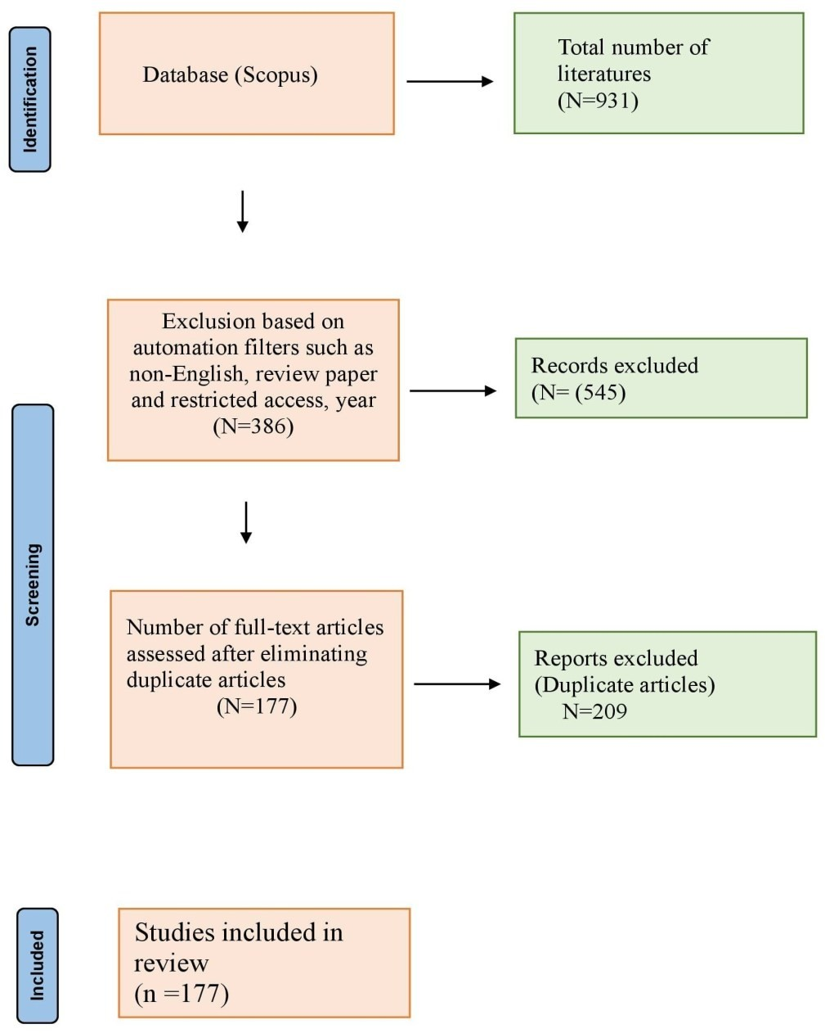

**Fig. 1**. PRISMA flowchart depicting the number of studies inclusion and exclusion for identifying the determinants

Table 2: Inclusion and exclusion criteria

|  |  |  |
| --- | --- | --- |
| Criteria | inclusion | exclusion |
| Period | 2014-2024 | <2014 |
| Subject area | Social science,  Agricultural & Biological Science,  Multidisciplinary,  Environmental science | Earth and planetary science, Engineering, Economics, Econometrics and Finance  Biochemistry, Genetics and Molecular Biology,  Energy,  Medicine, Arts and Humanities, Computer Science, Business, Management and Accounting, Decision Sciences, Immunology and Microbiology, Chemical Engineering, Veterinary, Mathematics, Chemistry, Psychology, Physics and Astronomy, Materials Science, Neuroscience, Pharmacology, Toxicology and Pharmaceutics, Health Professions, Nursing |
| Document Type | Article | Conference papers, Book chapters |
| Languages | English | Non-English |
| Source type | Journal | Trade journal |
| Publication stage | Final | Press |
| Open access | Open access | Restricted access |
| **Screening** |  |  |
| Title and abstract | Existence of predefined  keywords in the title,  abstract, or keywords part of  the paper. Considered the climate variability and adaptation behaviour as an outcome. |  |
| Full text | Included at least two determinants from climate variability, agriculture, and adaptation behaviour. |  |

**2. RESULTS AND DISCUSSIONS:**

Main information about the data (Table 3).

|  |  |
| --- | --- |
| **Description** | **Results** |
| **MAIN INFORMATION ABOUT DATA** |  |
| Timespan | 2014:2024 |
| Sources (Journals, Books, etc) | 103 |
| Documents | 177 |
| sAnnual Growth Rate % | 15.82 |
| Document Average Age | 2.87 |
| Average citations per doc | 15.98 |
| References | 13307 |
| **DOCUMENT CONTENTS** |  |
| Keywords Plus (ID) | 844 |
| Author's Keywords (DE) | 600 |
| AUTHORS |  |
| Authors | 842 |
| Authors of single-authored docs | 14 |
| **AUTHORS COLLABORATION** |  |
| Single-authored docs | 14 |
| Co-Authors per Doc | 5.27 |
| International co-authorships % | 41.81 |
| DOCUMENT TYPES |  |
| article | 177 |

**2.2. THEMATIC MAP**

Thematic maps of climate variability and adaptation behaviour (Fig. 2).

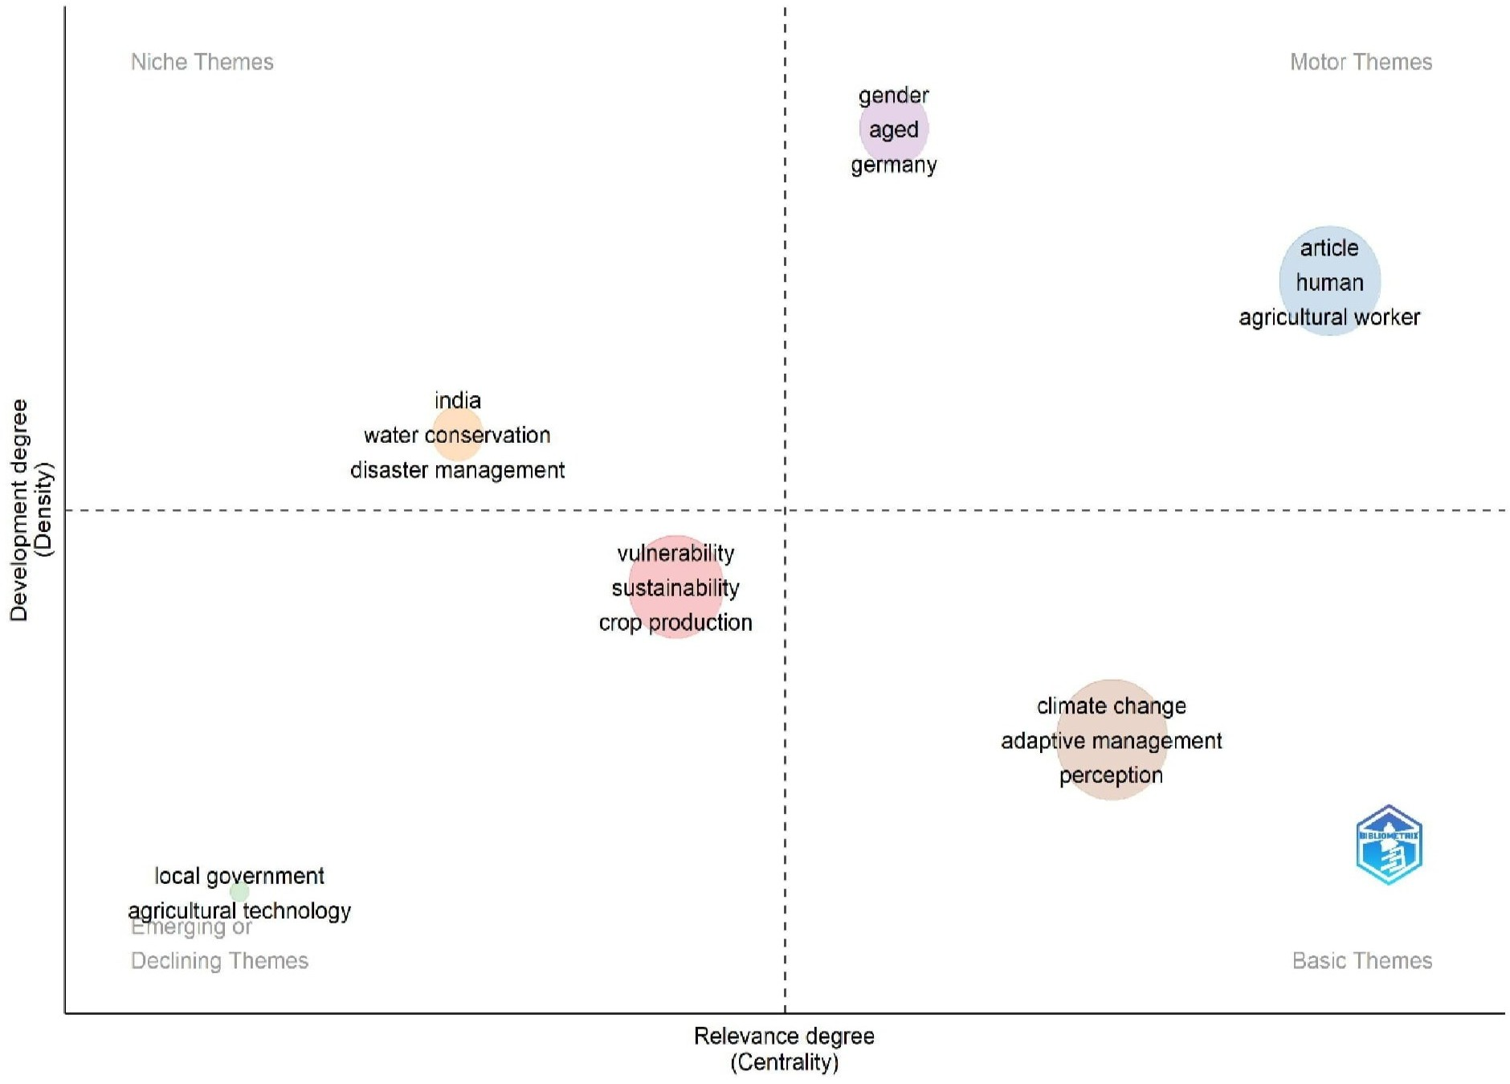

**Fig. 2**. Thematic maps of climate variability and adaptation behavior (Source: R studio)

This thematic map displays information on a range of vulnerability-related factors, including concepts such as "sustainability," "crop production," and "food security." These factors are grouped under the overarching theme of "vulnerability," reflecting their thematic cohesion. Betweenness centrality scores highlight the importance of specific terms in connecting various components within the cluster, with "vulnerability" emerging as a highly central term. PageRank centrality measures the overall influence of terms, while closeness centrality values indicate the proximity of each term to others within the cluster.

In terms of centrality metrics, terms such as "developing world" and "environmental policy" play a pivotal role in discussions surrounding vulnerability. The findings emphasize the interconnection of numerous factors contributing to susceptibility, underscoring the need for comprehensive and integrated strategies to address complex socio-environmental challenges.

**2.3. CO-AUTHORSHIP AUTHOR NETWORK**

The minimum threshold for publications and citations were set as 1 and 60, respectively. As a result, 52 authors contributing to publications in the journal were identified. (Fig. 3) illustrates the co-authorship network of these authors, revealing the presence of 13 distinct clusters.

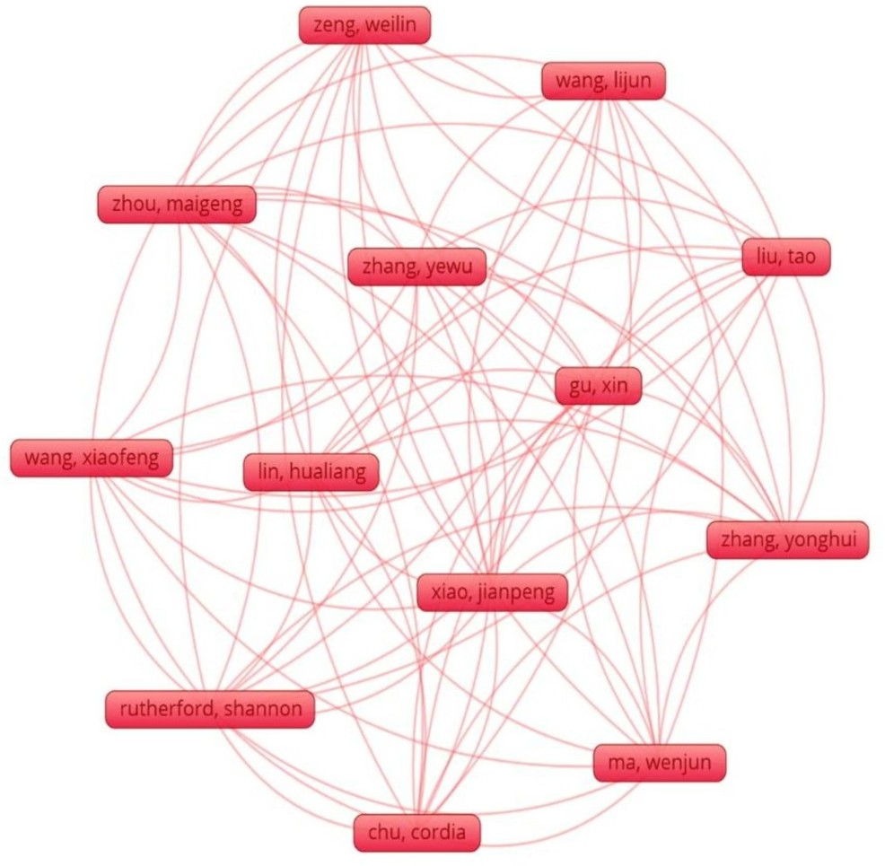

Fig. 3. Shows the article and collaboration network (Source: Vos viewer)

**2.4. MOST FREQUENT OR RELEVANT WORDS**

This graph in Figure 4 illustrates the frequency of specific phrases within a given context. The term “climate change” appears most frequently, highlighting its central importance to the discourse. Following this, “adaptive management” occurs significantly less often, indicating a notable but secondary emphasis. Terms such as “agriculture,” “perception,” and “risk perception” gradually bring attention to various aspects of environmental and cultural dynamics. Interestingly, the term “China” appears in conjunction with words like “agriculture” and “adaptation,” suggesting the relevance of these topics in a specific geographical context. The relatively infrequent occurrence of terms like “human” and “article” may reflect their broader, less specialized usage. Overall, the table provides valuable insights into the key concepts and themes within the field under review, highlighting recurring topics and focal points in the discussion.

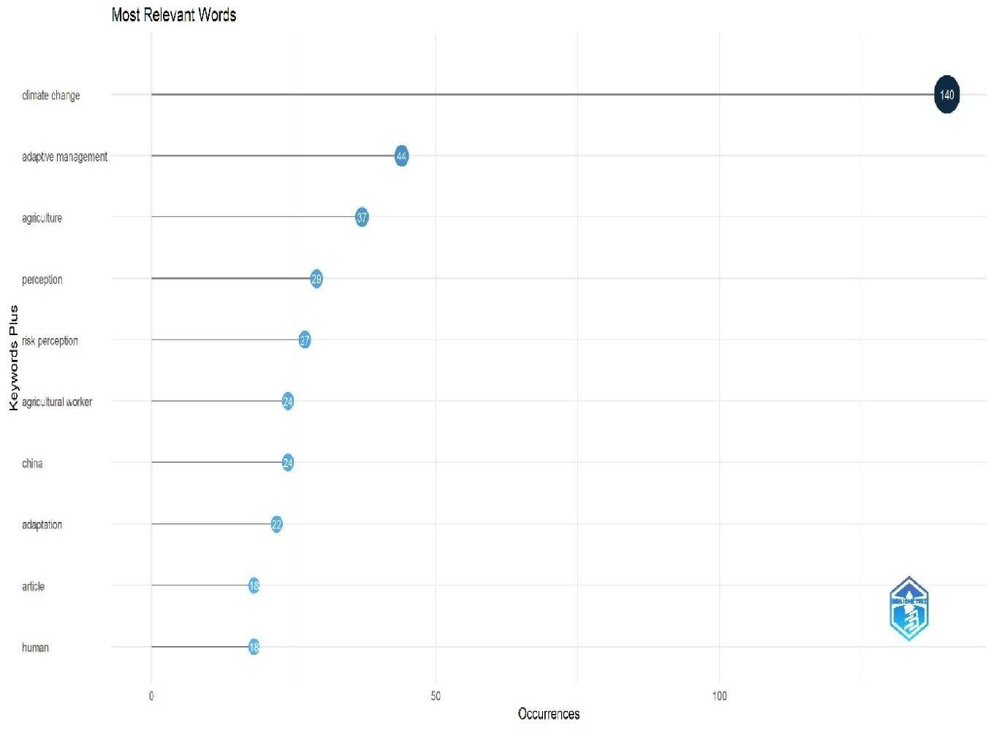

Fig. 4. Most frequent or relevant words used (Source: R studio)

**2.5. MOST GLOBALLY CITED ARTICLE**

The graph in Figure 5 presents a list of several papers along with their corresponding DOIs, Total Citations, annual Total Citations (TC annually) and Normalized TC values. The paper "BERRANG-FORD L, 2021, NAT CLIM CHANGE" demonstrates significant scholarly impact, with the highest Total Citations of 212. Additionally, its impressive TC per year significance is indicated by the fact that has the greatest Total Citations of 212. Additionally, its impressive TC per Year of 53.00 underscores its continued relevance and influence within the field. In contrast, the word "COMOŽ H, 2015, MITIGATION ADAPT STRATEG GLOBAL CHANGE" has the lowest Total Citations and TC per Year, indicating a comparatively lower level of impact and recognition.

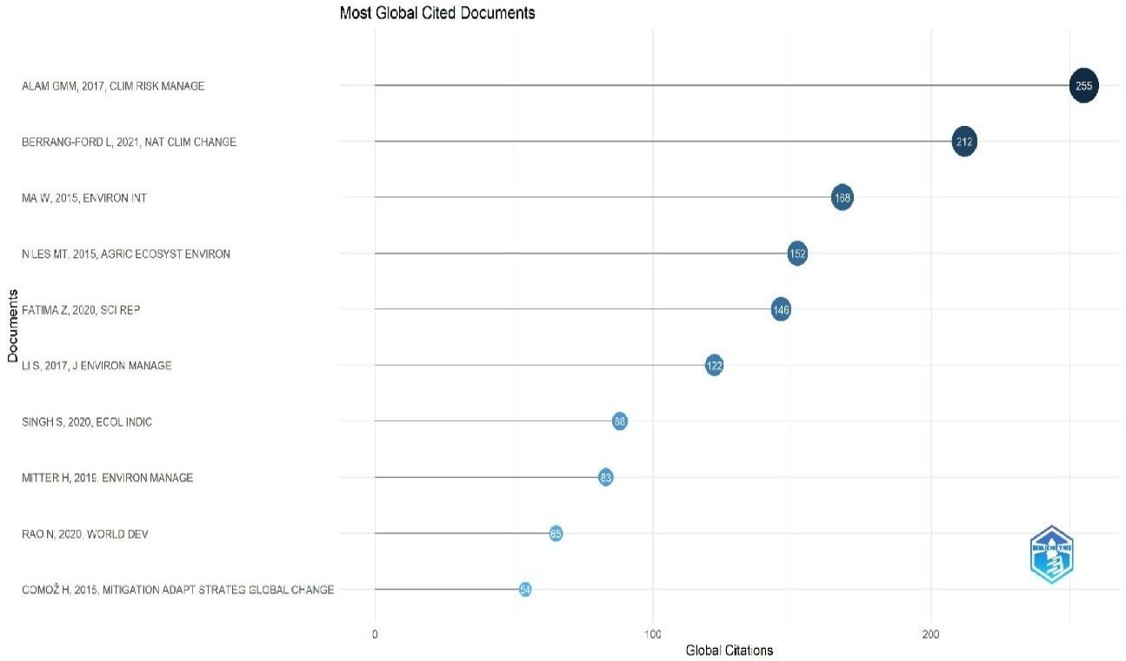

**Fig. 5**. Most globally cited articles (Source: R studio)

The Normalized TC values further enhance the analysis by illustrating the relative influence of each work for every year since its publication. Overall, the graph offers insightful data regarding these works' citation metrics and influence, assisting in the evaluation of their academic significance within the scholarly community.

**2.6. MOST RELEVANT AUTHORS**

The graph in Figure 6 presents the authors' varying article counts alongside the fractionalized representation of their contributions. Authors with higher fractionalized counts-such as Fischer AP and Wang J-have authored fewer articles overall but have made substantial contributions to each publication-possibly as main authors or through significant involvement in collaborative works. In contrast, authors such as Zhang Y exhibit lower fractionalized counts despite having authored three papers, suggesting shared authorship or a comparatively smaller contribution per publication.

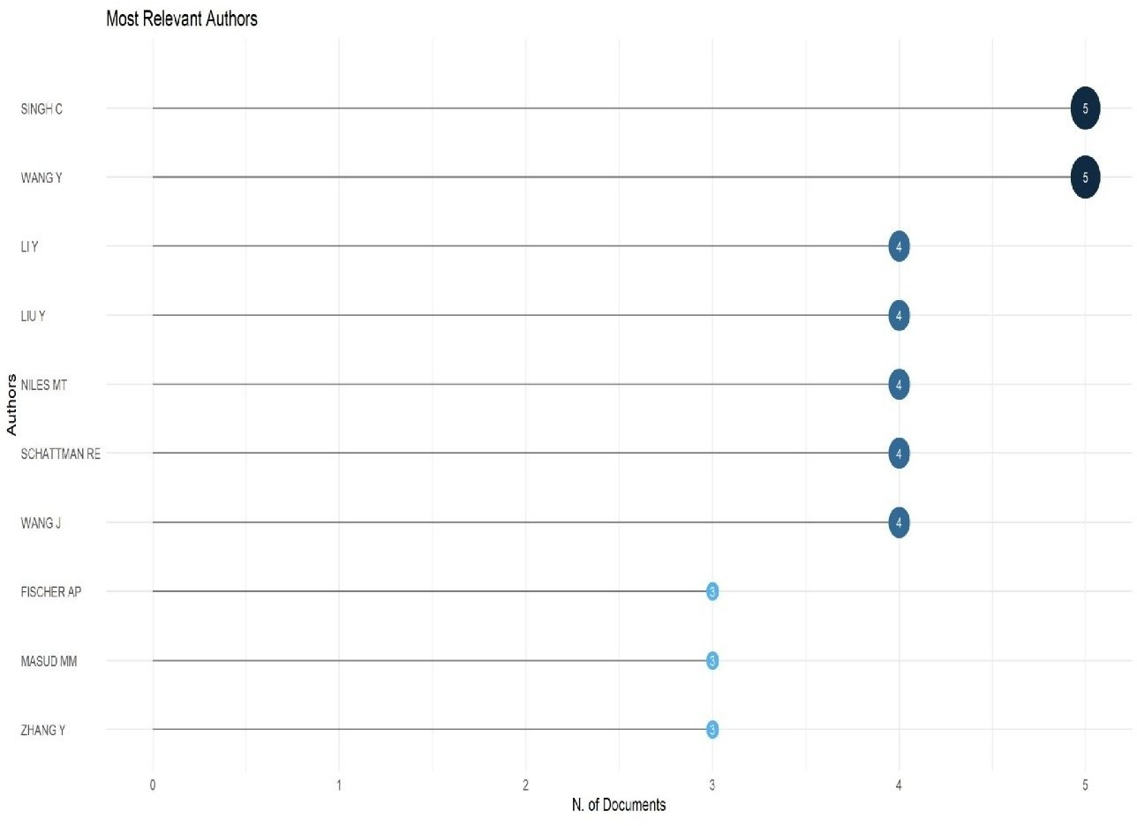

**Fig. 6**. Most relevant authors (Source: R studio)

This data underscores the diverse roles that authors play in academic publishing, ranging from individual contributions to collaborative efforts. Understanding these dynamics is essential for evaluating research impact, authorship credit and the nature of intellectual collaboration within academic communities(K. Praveena, Malaisamy, Prabakaran, Rani, & Balaji, 2024).

**2.7. FACTORIAL ANALYSIS**

The graph in Figure 7 displays words along with their assigned clusters and corresponding dimensional values. These dimensions likely represent abstract features derived through dimensionality reduction techniques such as t-SNE or PCA. Words within the same cluster are presumed to share similarities in meaning or context. For instance, terms like "agriculture," "climate change," and "adaptive management" are grouped in Cluster 1, indicating thematic coherence related to environmental or agricultural topics. Similarly, terms such as "perception" and "risk perception" are grouped, reflecting their conceptual alignment within the same domain.

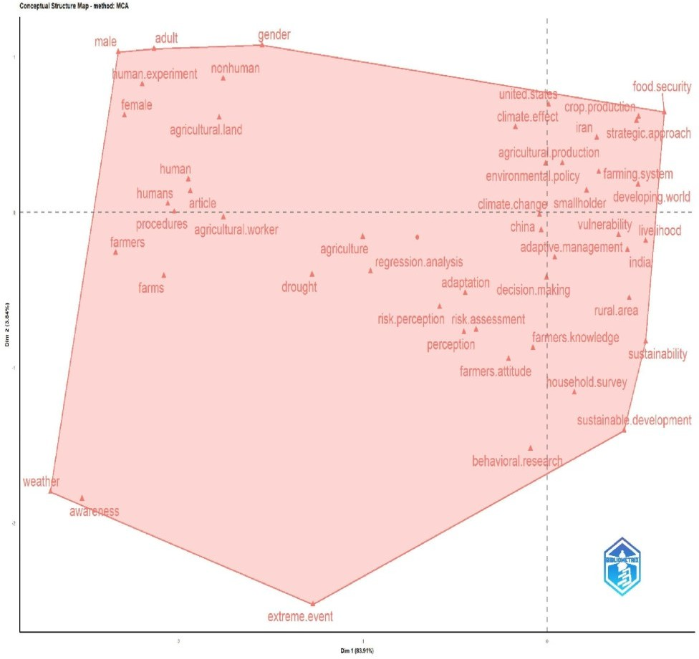

**Fig. 7.** Factorial analysis (Source: R studio)

This clustering reveals potential patterns or relationships among the terms, providing valuable insights into the dataset's underlying structure. By highlighting semantic relationships and thematic patterns, these analyses enhance the understanding and interpretation of the content.

**2.8. TECHNOLOGICAL ADVANCEMENTS**

The use of technology and resource optimization in recent agricultural adaptation strategies in developed countries is highlighted.(Malaisamy, 2021c). One notable trend is the enhancement of biodiesel production efficacy from Jatropha curcas L through the use of underwater high-voltage discharges.(K Praveena & Malaisamy, 2024). This technique, which involves the disruption of cell walls using pressure shockwaves, significantly improves oil extraction, achieving yields of up to 94%.(Randeepanee, Basnayake, Wijayasenaratne, Gunawardhana, & Ariyawansha, 2023; Rithika, Malaisamy, & Raswanthkrishna, 2025) Additionally, it enhances the usability of the residual materials for biogas production. This approach represents a sustainable model that combines energy efficiency with effective agricultural waste management(Rithika, Malaisamy, Raswanthkrishna, et al., 2025).

**2.9. LIMITATIONS**

The findings from this study are subject to several limitations, which may affect the generalizability of the results. First, the reliance on a single research database (Scopus) may have excluded relevant studies from other databases, potentially reducing the comprehensiveness of the review. Second, the exclusion of patent databases overlooks insights from innovators related to adaptation technologies in agriculture. Third, the emphasis on English-language studies may have introduced linguistic bias, potentially excluding important research from non-English-speaking regions. Furthermore, the stringent inclusion criteria, while ensuring relevance and quality, may have resulted in the omission of valuable perspectives. Addressing these limitations in future studies would enhance the robustness of the findings.

**3. Conclusion**

This study concludes that traditional knowledge and social networks significantly influence farmers' decisions regarding the adoption or rejection of specific adaptation strategies. Climate-smart agriculture and early warning systems are employed to mitigate the challenges associated with climate variability, while access to extension services on climate-smart practices enhances farmers’ adaptive capacity. Conservation tillage, agroforestry and improved livestock management help reduce greenhouse gas emissions from farming practices. Crop insurance schemes play a crucial role in assisting farmers to overcome financial crises resulting from climate-related vulnerabilities. Additionally, crop rotation enhances resilience to climate variability. Further investigation into the extension services related to early warning systems, climate modelling and remote sensing is needed to improve awareness of climatic variability.

**DISCLAIMER (ARTIFICIAL INTELLIGENCE)**

Author(s) hereby declare that NO generative AI technologies such as Large Language Models (ChatGPT, COPILOT, etc.) and text-to-image generators have been used during the writing or editing of this manuscript.

**References**

1. Alvi, S., & Khayyam, U. (2020). Mitigating and adapting to climate change: attitudinal and behavioural challenges in South Asia. *International Journal of Climate Change Strategies and Management, 12*(4), 477-493.
2. https://doi.org/10.1108/ [IJCCSM-08-2019-0054](https://doi.org/10.1108/IJCCSM-08-2019-0054)
3. Feng, Q., Zhao, W., Fu, B., Ding, J., & Wang, S. (2017). Ecosystem service trade-offs and their influencing factors: A case study in the Loess Plateau of China. *Science of the total environment, 607*, 1250-1263. . [https://](https://doi.org/10.1016/j.scitotenv.2017.07.079) [doi.org/10.1016/j.scitotenv.2017.07.079](https://doi.org/10.1016/j.scitotenv.2017.07.079)
4. Gerling, C., Drechsler, M., Keuler, K., Leins, J. A., Radtke, K., Schulz, B., . . . Wätzold, F. (2022). Climate–ecological–economic modelling for the cost-effective spatiotemporal allocation of conservation measures in cultural landscapes facing climate change. *Q Open, 2*(1), qoac004.
5. Habib-ur-Rahman, M., Ahmad, A., Raza, A., Hasnain, M. U., Alharby, H. F., Alzahrani, Y. M., . . . Nasim, W. (2022). Impact of climate change on agricultural production; Issues, challenges, and opportunities in Asia. *Frontiers in Plant Science, 13*, 925548.
6. https://doi.org/10.3389/fpls.2022.925548
7. Kumar, S., Lim, W. M., Sivarajah, U., & Kaur, J. (2023). Artificial intelligence and blockchain integration in business: trends from a bibliometric-content analysis. *Information Systems Frontiers, 25*(2), 871-896. <https://doi.org/10.1007/s10796-022-10279-0>
8. Lai, C.-H., Liao, P.-C., Chen, S.-H., Wang, Y.-C., Cheng, C., & Wu, C.-F. (2021). Risk perception and adaptation of climate change: An assessment of community resilience in rural Taiwan. *Sustainability, 13*(7), 3651. https:// [doi.org/10.3390/su13073651](https://doi.org/10.3390/su13073651)
9. Mobeen M, Kabir KH, Schneider UA, Ahmed T, Scheffran J. Sustainable livelihood https://doi.org/10.1016/ [j.heliyon.2023.e20818](https://doi.org/10.1016/j.heliyon.2023.e20818)
10. Lane, D., Murdock, E., Genskow, K., Rumery Betz, C., & Chatrchyan, A. (2019). Climate change and dairy in New York and Wisconsin: Risk perceptions, vulnerability, and adaptation among farmers and advisors. *Sustainability, 11*(13), 3599. https://doi.org/10.3390/ [su11133599](https://doi.org/10.3390/su11133599)
11. Malaisamy, A. (2021a). Econometric analysis of optimization of water among different sectors. *International Journal of Farm Sciences, 11*(3), 90-95. http://dx.doi.org/10.5958/2250-0499.2021.00043.4
12. Malaisamy, A. (2021b). Economic analysis of ground water exploitation and productivity of water. *International Journal of Farm Sciences, 11*(4), 38-45. [http://dx.doi.org/10.5958/2250 0499.2021.00053.7](http://dx.doi.org/10.5958/2250%200499.2021.00053.7%20)
13. Malaisamy, A. (2021c). Measuring the effect of irrigation on the rate of technological change in crop production. *International Journal of Farm Sciences, 11*(1-2), 37-50. [http://dx.doi.org/10.5958/2250 0499.2021.00008.2](http://dx.doi.org/10.5958/2250%200499.2021.00008.2%20)
14. Menike, L., & Arachchi, K. K. (2016). Adaptation to climate change by smallholder farmers in rural communities: Evidence from Sri Lanka. *Procedia food science, 6*, 288-292. [https://doi.org/10.1016/](https://doi.org/10.1016/j.profoo.2016.02.057) [j.profoo.2016.02.057](https://doi.org/10.1016/j.profoo.2016.02.057)
15. Mobeen, M., Kabir, K. H., Schneider, U. A., Ahmed, T., & Scheffran, J. (2023). Sustainable livelihood capital and climate change adaptation in Pakistan's agriculture: Structural equation modeling analysis in the VIABLE framework. *Heliyon, 9*(11). https://doi.org/10.1016/ [j.heliyon.2023.e20818](https://doi.org/10.1016/j.heliyon.2023.e20818)
16. Mustafa, G., Alotaibi, B. A., & Nayak, R. K. (2023). Linking climate change awareness, climate change perceptions and subsequent adaptation options among farmers. *Agronomy, 13*(3), 758. [http://](http://dx.doi.org/10.3390/agronomy13030758) [dx.doi.org/10.3390/agronomy13030758](http://dx.doi.org/10.3390/agronomy13030758)
17. Patel, R. S., Zala, P. H., & Patel, A. A. (2023). Weather Forecasting, Climate Variability and Change. *Agronomy*, 69.
18. Pham, Y., Reardon-Smith, K., Mushtaq, S., & Cockfield, G. (2019). The impact of climate change and variability on coffee production: a systematic review. *Climatic Change, 156*, 609-630. [https://](https://link.springer.com/article/10.1007/s10584-019-02538-y) [link.springer.com/article/10.1007/s10584-019-02538-y](https://link.springer.com/article/10.1007/s10584-019-02538-y)
19. Praveena, K., & Malaisamy, A. (2024). Climatic Shifts and Agricultural Strategies: A thorough Review on Impact of Climate Change on Food Security and Crop Productivity. *International Journal of Environment and Climate Change, 14*(1), 817-831. <https://doi.org/10.9734/ijecc%2F2024%2Fv14i13900>
20. Praveena, K., Malaisamy, A., Prabakaran, K., Rani, P. S., & Balaji, R. (2024). Impact of climate change on cropping and land use pattern in Ramanathapuram district: A Markov chain analysis. *Plant Science Today, 11*(sp4).doi:10.14719/pst.5330 [https://doi.org/10.14719/pst.5330](%20https:/doi.org/10.14719/pst.5330)
21. Randeepanee, M., Basnayake, P., Wijayasenaratne, K., Gunawardhana, M., & Ariyawansha, R. (2023). Determination of the Climate Change Adaptability of Paddy-growing Farmers in Ampara District, Sri Lanka: A Case Study.
22. Rithika, S., Malaisamy, A., & Raswanthkrishna, M. (2025). Unveiling key adaptation strategies: A systematic review of climate variability’s impact on agriculture. *Plant Science Today*.https:// doi.org/10.14719/pst.6107
23. Rithika, S., Malaisamy, A., Raswanthkrishna, M., Parimalarangan, R., Balaji, R., & Prabakaran, K. (2025). Review of assessing the impact of climate change on tank irrigation: vulnerabilities and adaptation strategies. *Plant Science Today*. doi:10.14719/pst.6100 <https://doi.org/10.14719/pst.6100>
24. Shaffril, H. A. M., Krauss, S. E., & Samsuddin, S. F. (2018). A systematic review on Asian's farmers' adaptation practices towards climate change. *Science of the total environment, 644*, 683-695. . [https://](https://doi.org/10.1016/j.scitotenv.2018.06.349) [doi.org/10.1016/j.scitotenv.2018.06.349](https://doi.org/10.1016/j.scitotenv.2018.06.349)
25. Usmail, A. J., Maja, M. M., & Lakew, A. A. (2023). Farmers’ perceptions of climate variability and adaptation strategies in the rural areas of Dire Dawa administration, eastern Ethiopia. *Heliyon, 9*(5). [https://](https://doi.org/10.1016/j.heliyon.2023.e15868) [doi.org/10.1016/j.heliyon.2023.e15868](https://doi.org/10.1016/j.heliyon.2023.e15868)
26. Van Eck, N., & Waltman, L. (2010). Software survey: VOSviewer, a computer program for bibliometric mapping. *scientometrics, 84*(2), 523-538. <https://doi.org/10.1007/s11192-009-0146-3>
27. Wu, Y., Meng, S., Liu, C., Gao, W., & Liang, X.-Z. (2023). A bibliometric analysis of research for climate impact on agriculture. *Frontiers in Sustainable Food Systems, 7*, 1191305. <https://doi.org/10.3389/fsufs.2023.1191305>