# Impact of Luminal α-Glucosidase Inhibition on Lipogenic and Glycaemic Enzymes in Obese Diabetic Rats: Consequences for the Treatment of Type 2 Diabetes

**Abstract**

This study aims to determine the effect of delayed carbohydrate (sucrose) digestion in type 2 diabetes mellites on the activity of glycemic and lipogenic enzyme parameters. Groups of young adult male obese T2DM (diabetic) SHR/Ntul//-cp rats were fed a nutritionally complete USDA-formulated diet containing 54% sucrose (CONTROL) or the same diet with 150 mg of the luminal α-glucosidase inhibitor miglitol (MIG) for up to 8 weeks. All animals demonstrated profound (4+) glycosuria by 8 weeks of age to confirm T2 DM. Body Weight Gain (BWG), relative adiposity and glycosuria were elevated in control animals, but decreased significantly following miglitol. Measures of oral Glucose Tolerance (OGT, 250 mg glucose/kg BW, via gavage), AUC for glucose and insulin response to OGT and glycated hemoglobin (HbA1c) were elevated in controls and decreased by 20% after miglitol treatment. Hepatic Glucokinase (GK), malic enzyme (ME) and glucose-6-phophate dehydrogenase (G6PD) were elevated in the Controls and decreased toward normalization following miglitol treatment. In conclusion, these observations indicate that an 8-week course of miglitol is an effective agent in improving the magnitude of the elevated glycemic and lipogenic enzymes and their impact on developing adiposity in the SHR/Ntul//-cp genetic rat strain of obesity+T2DM and may be an effective adjunct in clinical management of obesity, hyperlipidemia and T2DM.

**Keywords:** Miglitol; Obesity; Diabetes; T2DM; Hemoglobin A1c; Glucokinase; G6PD; Malic enzyme

## Introduction

Obesity and overweight conditions and their pathophysiologic impacts continue to occur throughout much of the world, despite many advances in understanding the multiple etiologies and management of the disorder. The progression of adult onset, type 2 diabetes (T2DM) is among the most common sequelae of the disorder and is also the most prevalent form of diabetes worldwide [1-3]. The incidence of T2DM affects over 90% of the known diabetic populations worldwide and currently affects approximately one sixth of the populations of some Westernized nations. Unfortunately, many individuals that may exhibit symptoms consistent with a predisposition for T2DM often remain undiagnosed especially during the earlier, formative and somewhat asymptomatic stages of the illness in addition to inadequate recognition in marginalized populations [3]. The longstanding hallmark of treatment includes attention to disordered factors of diet and lifestyle, deemed to be among the

primary contributors to the disorder [4,5]. Once an individual is diagnosed, however, ameliorative dietary, pharmacologic and lifestyle treatment approaches are typically continued throughout the remainder of the patient’s lifetime, but often fall short of complete success in achieving a full stop return to a prediabetes status [4,5]. The long-term nature of the disorder thereby enables the progression of the pathophyiologic comorbidities of obesity and T2DM to continue to develop. Both early diagnosis and later therapeutic regimens are usually focused on an assessment of initial and ongoing glycemic status, via measures of fasting blood glucose, glycated hemoglobin, glycosuria, assessment of body fatness, vital signs and lifestyle contributors in an attempt to mark the magnitude of progression of the disorder and to determine the intensity and magnitude of treatment regimens to apply. While day-to-day efforts to control the symptoms of T2DM focus primarily on monitoring measures of glycemic status, longer term goals often include assessments of blood lipids, as

1

pathophysiological contributors to various cardiovascular disorders that are also common comorbidities of T2DM. A common hallmark of T2DM is chronic hyperinsulinemia, which also functions as a metabolic contributor to hyperlipidemia via metabolic actions of insulin on lipid biosynthesis and storage in liver and adipose tissues respectively [6,7]. The activities of certain insulin-linked glycemic and lipogenic enzymes including glucokinase, malic enzyme, and glucose-6-phosphate dehydrogenase typically become elevated in states of obesity+T2DM, as consistent contributors to the elevations in plasma lipid profiles and relative adiposity that are also typically observed in such individuals. In addition, obesity and overweight conditions are also marked with systemic, chronic low-grade inflammation, thereby adding an additional often unresolved burden to the clinical management and progression of both neurologic and metabolic complications of T2DM [8,9].

Adipose tissue represents an active endocrine tissue, capable not only of energy deposition and storage primarily in the form of triglycerides, but also a source of multiple hormonally active peptides including leptin and others that impact factors of satiety, lipid deposition and preadipocyte generation and expansion [10,11]. In contrast to brown adipocytes, white adipocytes can continue to proliferate well into adulthood in most visceral and subcutaneous fat depots [10]. In addition, white adipose tissue hosts a broad variety of immune cells, including macrophages, capable of responding to the state of energy balance, especially in visceral adipose depots [12]. During periods of excess energy balance, insulin triggers both de novo fatty acid biosynthesis in liver and adipose tissues and facilitates lipid energy deposition and storage in adipocytes, in addition to enhancing additional preadipocyte expansion. Once differentiated, white adipocytes can remain active and preadipocytes appear to be able to continue to regenerate and differentiate throughout much of the remaining lifespan of an animal or human in most fat depots [8,10,11]. It is widely accepted that inflammatory responses originating in visceral adipose tissue play a contributory role in the development of the systemic insulin resistance commonly associated with the obese state [8,9,12-15]. In addition, the metabolic state of positive energy balance is associated with the activation of a population of M1 proinflammatory macrophages which may develop into inflammatory M1 macrophages. The M1 macrophages can then bring about the generation of unhealthy, inflammatory reactive oxygen species (iROS). The iROS can then further contribute to the generation and activation of inflammatory responses in the form of inflammatory cytokines including C-reactive protein and others that may also contribute to atherogenic processes [14,15]. The formation of inflammatory cytokines occurs in general proportion to the magnitude and duration of over nutrition and central adiposity, and to the progression of inflammation of both the vascular endothelium and neurologic tissues unless quenched

by nutritional and/or metabolic antioxidant actions. The end-result of the iROS may also impact on the activity of the cell cycle, thereby contributing to genomic actions and membrane viability and thereby impacting the potential for continued tissue regeneration. In neural tissues including the CNS, the iROS can contribute to apoptosis of neural cells, an acceleration of the shortening of telomeres, impaired neuronal regeneration, and thus contribute to neuronal senescence. In the worst-case scenario, a spontaneous voluminous release of inflammatory cytokines can result in grave responses sometimes referred to as a ‘cytokine storm’ that may result in severe respiratory collapse and the rapid demise of the individual [14,15]. In contrast to the above dysregulations in energy balance, a controlled state of energy balance brings about the maturation and proliferation of alternative, healthy M2-macrophages in adipose tissue depots [12]. The physiological effects of the M2 macrophages counter the negative effects of the M1 macrophages via enhancing healthy immunogenic responses. Thus, in healthy adipose tissue, the expression of M2 macrophages tends to dominate and is associated with decreases in the rate of telomere shortening, enhanced cellular lipid handling and essential mitochondrial functions, production of healthful, anti-inflammatory cytokines, improved insulin sensitivity, and further inhibition of iROS formation and thereby damping their inflammatory and pathophysiological actions. Therefore, implementation of a healthy diet and lifestyle and pharmacological agents as needed form important key elements in the treatment and long-term management of obesity, overweight conditions, and T2DM [8,10,14,15].

Hepatic tissues also form an important element in the enzymatic contributions to energy balance and to an ordered, healthful metabolism [13,16-19]. Glucokinase generally responds to rising plasma glucose concentrations, where it provides a signal for pancreatic β-cells to release insulin, thereby facilitating the efficiency of glucose uptake and oxidation in peripheral tissues. In T2DM, this can also bring about an increase in hepatic glycogen synthesis and storage, in addition to providing 2 and 3- carbon substrates to contribute to *de novo* fatty acid and triglyceride biosynthesis and eventual storage in adipose tissues mostly in the form of fatty acids, triglycerides or triacylglycerols. In addition, malic enzyme and glucose 6 phosphate dehydrogenase actions generate NADPH, an essential co- substrate for the *de novo* fatty acid biosynthesis in liver and adipose tissue. Glucose readily enters glycolysis in peripheral tissues, usually in concert with insulin-linked GLUT4 glucose transporters located along the plasma membranes of those tissues [13,17,18-21]. Glycolysis from glucose moieties results in providing substrates for glycogen deposition in addition to providing reducing equivalents for mitochondrial high energy phosphate generation. In contrast, fructose, derived from luminal

digestion of sucrose into glucose and fructose, or from dietary sources of fructose such as high fructose corn syrup (HFCS) sweeteners [18,19,21]. Once fructose is absorbed by liver or intestinal tissues via GLUT5 and independently of insulin-linked GLUT4 activity, it is readily converted to fructose-1-phosphate and ADP, followed by splitting the ketohexose into two trioses, namely dihydroxyacetone phosphate (DHAP) and glyceraldehyde (GA). Both trioses can provide preferential substrate including NADPH for *de novo* insulin-stimulated lipogenesis [13,17]. In addition, the ADP may undergoe further spontaneous degradation to AMP and IMP, and may eventually become further degraded into uric acid, a contributor to metabolic disorders including gout due to its decreased solubility in plasma and its potential to form crystals and induce inflammatory responses in other physiologic tissues.17 Thus, as improvements in plasma insulin concentration occur following dietary or pharmacologic intervention, the activity and tissue levels of insulinogenic and lipogenic enzymes are likely to undergo a favorable, more healthful improvement with concurrent shifts in intermediary metabolism.

The compound [1,5 dideoxy-1,5-[(2-hydroxyethyl) imino]-D glucitol; generic = miglitol; marketed as Glyset®) is an established water soluble competitive inhibitor of luminal starch digestion in the α-glucosidase and sucrase inhibitor family, and acts within the brush border sucrase and α-glucosidase receptor domains of the small intestine [22-24]. Unlike other members of the glucosidase inhibitor family, miglitol actions are confined to the uppermost regions of the small intestine, where the agent undergoes virtually complete luminal absorption within 2 hours of ingestion and luminal exposure, thereby limiting the duration and magnitude of its direct pharmacologic effects. In addition, due to its relatively short duration of action, miglitol limits potential gastrointestinal side effects secondary to undigested carbohydrate moieties entering the domain of the colonic microbiota, since typically, both carbohydrate digestion and miglitol absorption are usually complete within two hours or less in a healthy, unobstructed small intestine. The agent reportedly bypasses hepatic metabolism and conjugation and undergoes complete renal excretion without further chemical modification. The luminal physiological effects of exposure to miglitol is a modest, dose-related delay in luminal sucrose digestion in the upper regions of the small intestine, and in an attenuated and delayed response in the glycemic excursions that normally follow a carbohydrate meal [22,23]. Accordingly, the immediate and longer term insulinogenic responses would also be predicted to become proportionately attenuated over time, including the genomic expression of hepatic insulin-linked enzymatic responses with continued glucosidase inhibition, and likely generally proportional to the AUCglucose concentrations [24-27]. Also, since the hemoglobin glycation reaction occurs via a non- enzymatic, non-reversible, mass action kinetics process that

corresponds to the mean 24-hour plasma glucose concentrations the erythrocyte is exposed to during its lifespan, one would predict that this glycemic marker would also become decreased within up to 12 weeks of treatment as the hemoglobin-glycated erythrocytes undergo replacement during the miglitol treatment [13,28,29]. Accordingly, the percent of circulating glycated hemoglobin would also be predicted to decrease in proportion to the lower mean plasma glucose concentrations in the weeks and months that follow introduction of the glucosidase inhibitor agent. In mammalian species, the duration of the lifespan of an erythrocyte once released into the general circulation is typically 3 to 4 months in healthy adult humans and animals [13,28,29]. As the proportion of glycated hemoglobin improves, issue oxygen delivery would also be predicted to improve, as the processes of oxygen dissociation and the transitions between taut and relaxed forms of adult hemoglobin become inhibited in the presence of glycation [29]. Thus, the purpose of the present study was to determine the effects of delayed sucrase and glucosidase activity on the expression of key enzymatic markers of glycemic status and of insulin-linked enzymes of carbohydrate oxidation and lipid biosynthesis in liver homogenates of obese, T2DM animals after an 8 week trial of luminal α-glucosidase inhibition via miglitol. Studies were conducted in the SHR/Ntul//-cp rat, a congenic genetic rodent model of early onset obesity and T2DM, and where the T2DM develops soon after weaning and independently of extraordinary dietary interventions [30]. Historically, dietary and lifestyle changes remain the hallmark of conventional therapeutic approaches to treat and manage the diabetes element of the obesity syndrome in a strategy designed to improve glycemic markers, while luminal modulation represents a new approach with regard to improvement in atherogenic parameters and enzymatic indicators as contributors to lipid metabolism.

## Materials and Methods

## Animals

Groups of obese SHR/Ntul//-cp rats were selected from the breeding colony at ~5 weeks of age (n=8 rats/treatment group) and maintained on stock Purina rodent chow and house water, ad libitum, until 7 weeks of age, reared under conventional environmental conditions (20-22°C, 50% RH and housed in plexiglass cages lined with ~1 inch of fresh pine shavings).

**Diets**

Animals were then switched to a USDA-formulated control diet containing 54% carbohydrate as sucrose, 20% protein as equal parts lactalbumin and casein, 16 % fats as equal parts corn oil, beef tallow, lard and coconut oil, 5.9 % cellulose, 3.1 % AIN vitamin and mineral salt mix, and 1% Teklad vitamin mix, for the remainder of the study [31]. In addition a second group of littermates were fed the same diet with the addition of miglitol ([1, 5 dideoxy-1, 5-[(2-hydroxyethyl) imino]-D glucitol; generic = miglitol; currently marketed as Glyset®) at a dosage of 150 mg/kg (0.015%) of diet as an admixture, calculated to provide ~

2.5 mg of miglitol per animal per day based on typical daily consumption of the control diet.

**Determination of Body weight and Urine collection**

Body weights were obtained weekly as an indicator of animal wellness. Urines were collected in a metabolic cage beginning at 8 weeks of age for measures of glycosuria to confirm the onset and progression of diabetic status.

**Oral Glucose Tolerance Test**

After 6 weeks of the miglitol diet, rats were subjected to an oral glucose tolerance (250 mg/kg BW via gavage administered slowly within a one minute duration) and blood obtained periodically via tail bleeding over a 2 hour duration for measures of glucose (glucose oxidase method) and plasma insulin concentration via immunochemistry [32]. The area under the glucose and insulin curves was determined via the method of Sagakuchi et al. [33]. Measures of Hemoglobin A1c were determined via spectrophotometry after microcolumn separation [34].

**Method of Euthanasia and Tissue Collection**

At the end of the study, rats were humanely sacrificed with a small animal guillotine and principal fat pads including the dorsal, retroperitoneal, and epididymal fat pads were dissected in their entirety, weighed to the nearest 0.1 mg., and the sum of the 3 depots expressed as a percent of body weight as a measure of relative adiposity. The liver tissue was also dissected free in its entirety, weighed, and aliquots homogenized in a sucrose-EDTA phosphate buffer for measures of glucokinase, malic enzyme, and glucose-6-phosphate dehydrogenase activity and expressed as units/mg protein/liver [19,35,36]. Tissue protein was determined with the classic method of Lowry et al [36].

**Statistical Analysis**

Data were analyzed via standard statistical procedures including student t test, ANOVA, and Pages L test for trend analysis [37,38]. The study was approved by the Institutional Animal Care and Use Committee.

## Results

The results of urine volume and quantitative glucose excretion at 8, 10 and 12 weeks of age are presented in (Figures1A and 1B) respectively and indicate that the onset of glycosuria occurred by 8 weeks of age in both groups. Both urine daily volume and 24- hour glucose excretion was similar in both groups at the onset of the miglitol diet. By 10 and 12 weeks of age however, urine volume in miglitol fed animals decreased by nearly 50%, while daily glucose excretion in control fed rats increased dramatically, but became decreased significantly after 2 to 4 weeks of the miglitol regimen to excretion levels that were similar to those observed at 8 weeks of age, on day one of the miglitol diet. The effects of miglitol on weight gain are depicted in (Figure 2) and indicate that the effects of miglitol on weight gain resulted in an average 20% decrease in net weight gain after 8 weeks of the miglitol diet. Mean daily energy intake was also similarly decreased by approximately 15% in the miglitol-treated animals, (Control 20.83 g/d *vs* Miglitol 17.55 g/d). The effects of miglitol on oral glucose tolerance when animals were 12 weeks of age after 5 weeks on diet are depicted in (Figure 3A), and indicate

that miglitol decreased the magnitude of the glycemic response to an oral glucose tolerance by an average of 20% or more and resulted in a significant decrease in the glucose area under the curve and in the percent of glycated hemoglobin (HbA1c). The insulin response to an oral glucose tolerance is depicted in (Figure 3B,3C) and indicates that miglitol also decreased the AUCinsulin by approximately 18%, consistent with a reduction in the insulin concentrations following the glucose challenge.

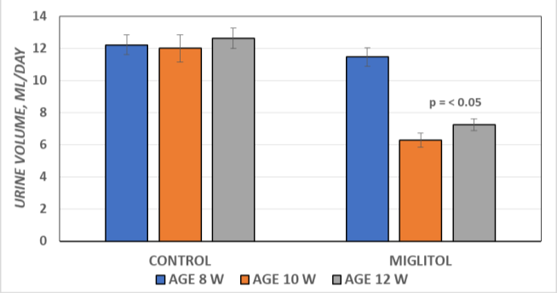

***Figure 1A****: The effects of miglitol on urine volume in control and miglitol treated animals and indicates that daily urine volume decreased at 10 and 12 weeks of age in animals receiving the miglitol diet. (p = < 0.05).*

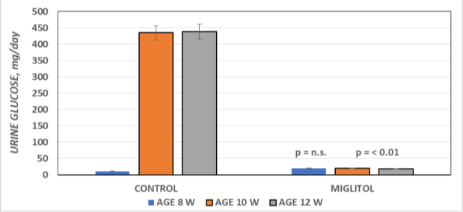

***Figure 1B****: The effects of miglitol on urine glucose excretion at 8, 10 and 12 weeks of age, and indicate that daily urine glucose excretion became markedly increased at 10 and 12 weeks of age, and remained at prediabetic levels following dietary miglitol treatment (p = < 0.05).*

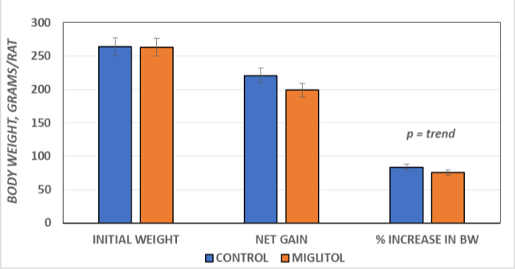

***Figure 2:*** *Effects of miglitol on body weight and weight gain in obese, T2DM rats. Gain = grams BW gained/8 weeks; Adiposity based on sum of 3 Fat depots / final body weight x 100. Data are mean ± 1 SEM, nrats/group. Significance by Students T Test; trend (far right column) determined by Pages L Test for trend analysis.*

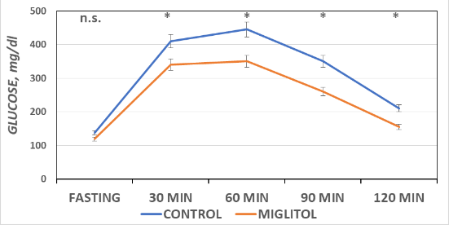 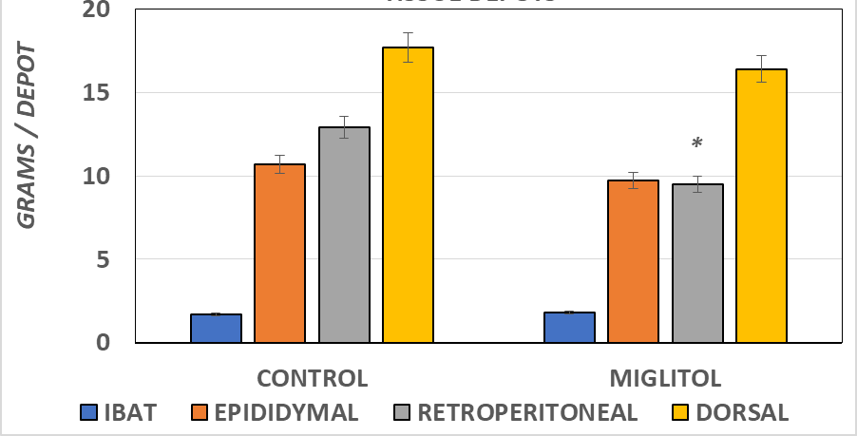

***Figure 3A****. Oral glucose tolerance in Miglitol treated rats.*

*Effect of miglitol on OGT in T2DM rats. Data are mean ± 1 SEM, n = 8 rats/group. P = < 0.05 via ANOVA. The mean AUCglc Control = 1034 vs miglitol = 812 (21% decrease).*

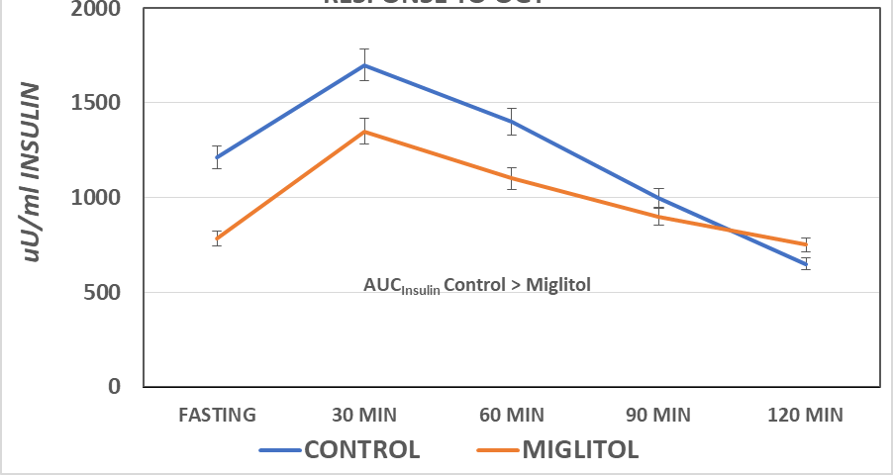

***Figure 3B****: Effect of miglitol on Insulin response to an oral glucose tolerance in T2DM rats. Effect of miglitol on insulin response in OGT in T2DM rats. Data are mean ± 1 SEM, expressed as a percentage of control; n = 8 rats/group. P = < 0.05; ^Trend = < 0.05 via Pages L test for trend analysis at 90 min only. Mean AUCins Control = 1903 vs. miglitol = 1572. (17.4% decrease, proportionately similar to that observed in the glycemic response.).*

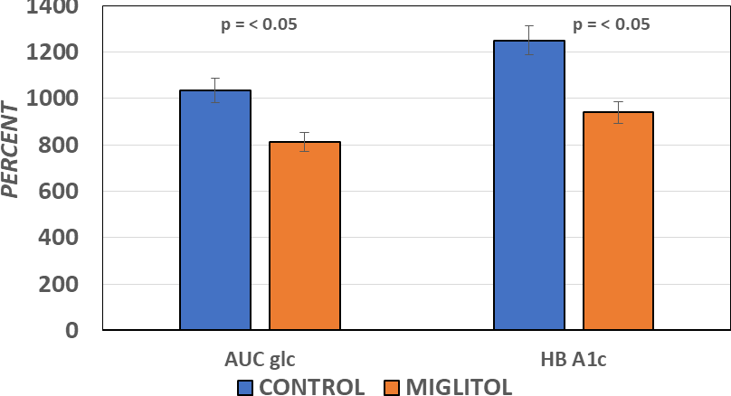

***Figure 3C****: Effect of miglitol on AUC glucose and Glycated hemoglobin A1C. Data are mean ± 1 SEM, n= 6 rats/group. P =*

*< 0.05 (Students T Test) of a significant trend (Pages L test for trend analysis).*

***Figure 4A****: Effect miglitol on fat pad mass in obese, T2DM rats. Data are mean ± 1 SEM, expressed as a percentage of control; n*

*= 6-8 rats/group.* = p = < 0.05; V= significant trend via Pages L test for trend analysis.*

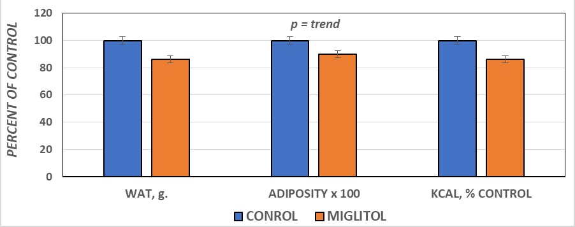

***Figure 4B****: Effect of miglitol on combined adipose tissue depot mass. Data are the sum ± 1 SEM of the epididymal, retroperitoneal and dorsal depots, expressed, grams of white adipose tissue as percent of control (WAT, left panel) and as a proportion of body weight (Right panel). Kcal consumed as a percent of control in far right panel.N = 6-8 rats/group.*

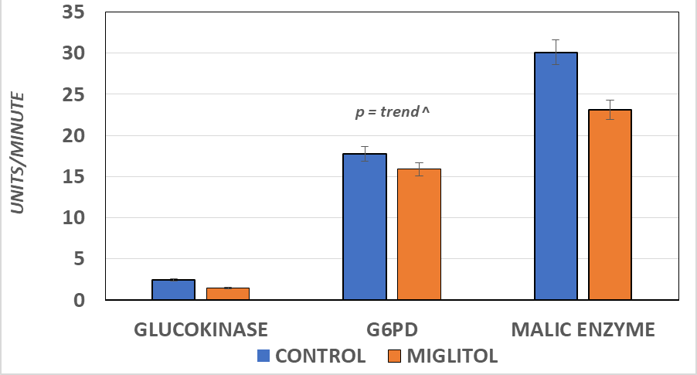

***Figure 5****: Effect of miglitol on hepatic metabolic enzymes. Data are mean ± 1 SEM, n=6 rats/group. P = < 0.05; ^ = trend via Pages L test for trend analysis.*

The effects of miglitol on indicators of adiposity without and following miglitol are depicted in (Figures 4A, 4B), respectively. The mass of the interscapular brown adipose tissue, and the epididymal retroperitoneal and dorsal depots are depicted in Figure 4A and indicate that miglitol was associates with

decreased mass in the retroperitoneal depot, and a trend toward a net decrease in total fat pad mass in the dorsal depot.In contrast, the mass of the intescapular brown adipose tissue and the epidymal fat pads were similar in both treatment groups, likely because those depots attain their maximum mass prior to adolescence in the rat. The combined mass of the fat pads as an indator of adiposity are depicted in Figure 4B, and indicate that miglitol resulted in a modest decrease in adiposity both as a percent of weight gain (Figure 2) and as a proportion of final body weight (center column Fig 4B). The effects of miglitol on total energy intake as a percent of control are depicted in the far right panel of Figure 4B, and indicate that net energy intake over the 8 weeks of study was decreased by an average of 14%, qualitatively similar to the reduction in WAT mass. The effects of miglitol on hepatic glycemic and lipogenic enzymes after 8 weeks of study are depicted in (Figure 5). The effects of miglitol on glucokinase are shown in the left panel and indicate that miglitol resulted in a significant decrease in glucokinase enzyme activity, consistent with the significant improvements in AUCglucose, AUCinsulin and HbA1c.The effects of miglitol on the lipogenic enzymes Malic Enzyme and Glucose-6-phosphate Dehydrogenase are depicted in the central and right panels, respectively, and indicate that the capacity for generation of NADPH, essential for de novo fatty acid biosynthesis, was also decreased following 8 weeks of miglitol treatment.

## Discussion

The results from this investigation indicate that a nominal dosage of miglitol as a dietary admixture resulted in significant decreases in both glycemic and lipogenic enzyme parameters in the SHR/Ntul//-cp rat, a genetic rodent model of early onset obesity, insulin resistance, and T2DM.38 The animals were fed a nutritionally complete USDA-formulated moderate carbohydrate, sucrose-enriched diet, while a subgroup received the same diet regimen but containing an admixture of 0.015% generic miglitol, with both diets ad libitum. The macronutrient distribution of the semisynthetic diet fed is similar to that which a large segment of the population consumes in much of industrialized society. Miglitol was associated with a modest decrease in daily and cumulative energy intake, and which decreases may have contributed to the improvements in glycemic and lipogenic enzyme activity noted. The effects of the miglitol dietary admixture were of similar magnitude to those reportd in other studies of α-glucosidase inhibition on dietary intakes reported elsewhere [22,39,40]. The onset of glycosuria, indicative of T2DM typically occurs by 6 to 8 weeks of age in the obese phenotype of this strain, regardless of the dietary composition consumed, and progresses to severe levels of glycosuria by 10 weeks of age. Once glycosuria is observed, it typically remains present thereafter throughout the remainder of their lifespan

unless therapeutic intervention is initiated. Typical lifespan among obese T2DM in this strain is decreased by 30% or more compared to congenic lean littermates or to non-diabetic LA/Ntul//-cp rats that carry the same trait for obesity but in a genetically non-diabetic background [20,41]. The biologic basis for the decreased adiposity following miglitol treatment in the present study is proposed to be secondary to cumulative decreases in plasma insulin responses and improved insulin sensitivity, in addition to decreases in net energy intake when consuming the miglitol supplemented, sucrose-enriched diet. The luminal uptake and post ingestion plasma glucose concentrations following an orally administered glucose challenge in fasted animals would not be expected to occur differently in animals previously fed the glucosidase inhibitor or not in the absence of improved insulin sensitivity since the luminal glucose uptake would not be expected to become compromised by a glucosidase inhibitor. However, the cumulative effect of the glucosidase inhibitor over time would be expected to decrease insulin demand due to the miglitol induced delay in enzymatic digestion of sucrose to its monosaccharide moieties glucose and fructose and their subsequent luminal absorption as glucose and fructose. The decreased rate of sugar moieties for absorption would be predicted to decrease insulin requirements and gradually improve peripheral glucose uptake and insulinogenic responses secondary to decreasing the magnitude of insulin resistance while improving insulin sensitivity in peripheral tissues including the liver and adipose tissue depots. Whether the improved insulin sensitivity occurred via improvement in insulin-mediated GLUT4- glucose transporter activity or some other insulin-linked physiologic factors could not be determined, but regardless of the biophysiologic mechanism, the genomic expression and activity of key regulatory hepatic enzymes of glycemic and lipogenic mechanisms as demonstrated.20 The significant, down-regulated improvement in those enzymes likely contributed at least in part to the modest trend toward a decrease in the progression of glycogenesis, adiposity and systemic clearance of a glucose challenge via decreases in a primary enzyme of glycogen deposition in addition to impacting two key enzymes linked to de novo lipogenesis. Malic enzyme and G6PD provide NADPH+, an essential cofactor for de novo lipid biosynthesis in especially in liver and adipose tissue, while hepatic glucokinase serves as a signal for the release of insulin from β-cells, and with secondary effects on glycogen formation and deposition [19,36,42].

In previous studies, it was noted that miglitol and other inhibitors of luminal starch digestion were associated with modest decreases in dietary energy intake of a magnitude that was similar to the present study and likely also contributed to the induced secondary satiety factors linked to delayed intestinal digestive actions [39,40]. Since miglitol-linked brush border actions would require additional time for the ingested meal to undergo duodenal

digestion followed by intestinal distention and further luminal transit of the remaining digestive contents, the combined impact would be predicted to reduce the overall quantity of caloric intake, in a manner analogous to voluntary or programmed reductions in meal size, appetite and energy density of the diet. Regardless of the physiological mechanism or mechanisms impacted, the effects of the miglitol resulted in an attenuation in voluntary daily energy intake resulted in modestly improved glycemic and lipogenic enzyme activity. The effects of the glucosidase inhibitor on glycosuria, however, were much more profound, thereby preserving the majority of the ingested carbohydrate for metabolic processes. Despite the significant loss of carbohydrate calories in the control animals, they still demonstrated a greater propensity for regional fat accretion, despite of an equivalent of a daily loss of over 1.7 kcals/day in excreted glucose assuming the caloric metabolic equivalent of 4 kcals/gram for glucose, and which represents a total conservation of approximately 100 kcals and over 10 grams of accumulated lipid during the course of the miglitol treatment in the present study. In addition, improvement in insulin actions responded differentially in an adipose tissue depot-specific manner, consistent with the observations reported elsewhere [40,41]. Although not specifically identified in the current study, the miglitol-induced decreases in daily energy intake in association with reported alterations in regional fat deposition would be consistent with a decreased magnitude of systemic inflammation over time, including a potential decrease in M1-macrophage iROS generation, a shift toward antiinflammatory M2- macrophages, and in a progressive transition toward a more healthful plasma lipid profile in obesity,T2DM and hyperinsulinemic states and their typical pathophysiologic sequela. Effective therapeutic options for the management of the above disorders impacts a lifelong attention. However, when doable pharmacologic measures such as those that may occur following miglitol administration are effectively incorporated into the potentially additive factors of diet and lifestyle, the clinical outcomes can become the real winners in an otherwise compromising metabolic state, should the progression of comorbidities remain unchecked [2,14,15,43,44]. Thus, in future studies, it would be productive to continue the luminal therapeutic options beyond the post-adolescent lifestage of the present investigation to more fully determine the long term potential of the physiological benefits of luminal α-glucosidase inhibition health and longevity in an animal model predisposed to early onset obesity, insulin resistance and T2DM.

## Conclusions

The effects of a modest dosage of miglitol resulted in favorable responses in the activity of key glycemic and lipogenic enzymes, in association with modest decreases in energy intake and body

fat accretion in some but not all adipose tissue depots. In other studies, miglitol was found to decrease daily food and energy intake, which may also have been a contributing factor to the favorable responses in the insulin-linked enzymes in the instant study.

## Use of Artificial Intelligence (AI)

No applications of AI were utilized in the preparation of this manuscript.

## References

1. [Kelly T, Yang W, Chen CS, Reynolds K, He J. Global burden of](https://www.nature.com/articles/ijo2008102) [obesity in 2005 and projections to 2030. Int J Obes (Lond). 2008;](https://www.nature.com/articles/ijo2008102) [32: 1431-1437.](https://www.nature.com/articles/ijo2008102)
2. [Aggarwal R, Ostromnski JW, Vaduganathan M. Prevalence of](https://jamanetwork.com/journals/jama/fullarticle/2818457) [Cardiovascular-Kidney-Metabolic Syndrome Stages in US Adults,](https://jamanetwork.com/journals/jama/fullarticle/2818457) [2011-2020. JAMA. 2024; 331: 1858-1860.](https://jamanetwork.com/journals/jama/fullarticle/2818457)
3. Njoloma I, Lewis N, Sainvil F, Einstein GP, Sciranka A, Tulp OL, et al. A primer on hypertension and the racial / ethnic disparities in diagnosis and management. A comprehensive overview. Int J Family Clin Med. 2021; 5: 229-239.
4. [Pantalone KM, Hobbs TM, Wells BJ, Kong SX, Kattan MW,](https://drc.bmj.com/content/3/1/e000093) [Bouchard J, et al. Incidence of T2DM • Clinical characteristics,](https://drc.bmj.com/content/3/1/e000093) [complications, comorbidities and treatment patterns among patients](https://drc.bmj.com/content/3/1/e000093) [with type 2 diabetes mellitus in a large integrated health system.](https://drc.bmj.com/content/3/1/e000093) [BMJ Open Diabetes Res Care. 2015; 3.](https://drc.bmj.com/content/3/1/e000093)
5. [Halder F, Imam SM, Tulp OL, Rizvi SAA. Incretin mimetics for the](https://accscience.com/journal/IMO/articles/online_first/2974) [management of diabetes and associated comorbidities: An overview.](https://accscience.com/journal/IMO/articles/online_first/2974) [Innovative Medicines and Omics. 2024.](https://accscience.com/journal/IMO/articles/online_first/2974)
6. [Joseph Loscalzo (editor), Harrison TR. Harrison's Principles of](https://pesquisa.bvsalud.org/portal/resource/pt/dan-2224) [Internal Medicine, 21](https://pesquisa.bvsalud.org/portal/resource/pt/dan-2224)[st](https://pesquisa.bvsalud.org/portal/resource/pt/dan-2224) [edn. 2022.](https://pesquisa.bvsalud.org/portal/resource/pt/dan-2224)
7. [Knowler LM, Barrett-Connor E, Fowler SE, Hamman RF, Lachin](https://www.nejm.org/doi/full/10.1056/NEJMoa012512) [JM, Walker EA, et al. Reduction in the Incidence of Type 2](https://www.nejm.org/doi/full/10.1056/NEJMoa012512) [Diabetes with Lifestyle Intervention or Metformin. Diabetes](https://www.nejm.org/doi/full/10.1056/NEJMoa012512) [Prevention Program Research Group. N Engl J Med. 2002; 346:](https://www.nejm.org/doi/full/10.1056/NEJMoa012512) [393-403.](https://www.nejm.org/doi/full/10.1056/NEJMoa012512)
8. [Sotak M, Clark M, Suur BE. Borgeson E. Inflammation and](https://www.nature.com/articles/s41574-024-01047-y) [resolution in obesity. Nat Rev Endocrinol. 2024.](https://www.nature.com/articles/s41574-024-01047-y)
9. [Wiley, CD, Campisi J. The metabolic roots of senescence:](https://www.nature.com/articles/s42255-021-00483-8) [mechanisms and opportunities for intervention. Nat Metab. 2021; 3:](https://www.nature.com/articles/s42255-021-00483-8) [1290-1301.](https://www.nature.com/articles/s42255-021-00483-8)
10. Rahman MS, Einstein GP, Tulp OL. Autonomic, Immunological and Endocrine influences on adipose tissue as an organ. Adv Obes Weight Manag Control. 2021; 11: 48-58.
11. Tulp OL, Einstein GP. Can biophotonic therapy ameliorate the metabolic sequelae of NIDDM? Int J Complement Alt Med. 2024; 17: 97-101.
12. [Surmi BK, Hasty AH. Macrophage infiltration into adipose tissue.](https://pmc.ncbi.nlm.nih.gov/articles/PMC2575346/) [Future Lipidol. 2008; 3: 545-556.](https://pmc.ncbi.nlm.nih.gov/articles/PMC2575346/)
13. Devlin, T.M. (Editor) Textbook of Biochemistry with Clinical Correlations: 6th Edition. Publisher: John Wiley & Sons; 2005.
14. [Schattenberg JM, Martini C, Herrera R, Rauly M, Yates M, Younes](https://journals.lww.com/ajg/fulltext/2024/10001/s1815_causes_of_death%2C_mortality_rates%2C_and_the.1816.aspx) [R, et al. Causes of Death, Mortality Rates, and the Role of Socio-](https://journals.lww.com/ajg/fulltext/2024/10001/s1815_causes_of_death%2C_mortality_rates%2C_and_the.1816.aspx) [demographic Risk Factors and Biomarkers in Metabolic](https://journals.lww.com/ajg/fulltext/2024/10001/s1815_causes_of_death%2C_mortality_rates%2C_and_the.1816.aspx) [Dysfunction-associated Steatohepatitis Mortality in More than](https://journals.lww.com/ajg/fulltext/2024/10001/s1815_causes_of_death%2C_mortality_rates%2C_and_the.1816.aspx) [18,000 Real World Patients from the United States. Presented at the](https://journals.lww.com/ajg/fulltext/2024/10001/s1815_causes_of_death%2C_mortality_rates%2C_and_the.1816.aspx) [22nd Annual World Congress Insulin Resistance Diabetes &](https://journals.lww.com/ajg/fulltext/2024/10001/s1815_causes_of_death%2C_mortality_rates%2C_and_the.1816.aspx) [Cardiovascular Disease (WCIRDC). Los Angeles, California. 2024.](https://journals.lww.com/ajg/fulltext/2024/10001/s1815_causes_of_death%2C_mortality_rates%2C_and_the.1816.aspx)
15. Tulp OL, Einstein GP. Review: Obesity and its associated inflammatory cytokines pose significant risk factors for COVID-19 outcomes. Advances in Obesity, Weight Management and Control. 2022; 12: 14-20.
16. Nelson DL, Cox MM. Lehninger: Principles of Biochemistry. 6th Ed. WH Freeman NY. ISBN 978-1-4242-3414-6. 2012.
17. [Leto D, Saltiel A. Regulation of glucose transport by insulin: traffic](https://www.nature.com/articles/nrm3351) [control of GLUT4. Nat Rev Mol Cell Biol. 2012; 13: 383-396.](https://www.nature.com/articles/nrm3351)
18. [Anderson ME, Tulp OL. The Effects of High Dietary Fructose](http://www.escientificlibrary.com/public-health/Article/ESJPH-V4-1019.pdf) [Consumption on the Development of Gout. MOJPH, 2023: 4: 1019.](http://www.escientificlibrary.com/public-health/Article/ESJPH-V4-1019.pdf)
19. [Chang GG, Tong L. Structure and function of malic enzymes, a new](https://pubs.acs.org/doi/abs/10.1021/bi035251%2B) [class of oxidative decarboxylases. Biochemistry. 2003; 42: 12721–](https://pubs.acs.org/doi/abs/10.1021/bi035251%2B)

[12733.](https://pubs.acs.org/doi/abs/10.1021/bi035251%2B)

1. [Freeland RA. Effect of starvation on rat liver enzymes. J Nutr.1967;](https://www.sciencedirect.com/science/article/abs/pii/S0022316623150231) [91: 489-495.](https://www.sciencedirect.com/science/article/abs/pii/S0022316623150231)
2. [Tulp OL. Glucocorticoid ablation restores glycemic and](https://www.intechopen.com/chapters/1154678) [thermogenic responses in obesity in Cortisol – between physiology](https://www.intechopen.com/chapters/1154678) [and pathology. Intech open pubs. 2024; 73-90.](https://www.intechopen.com/chapters/1154678)
3. [Bray GA. Energy and Fructose from Beverages Sweetened with](https://www.sciencedirect.com/science/article/pii/S2161831322011061) [Sugar or High-Fructose Corn Syrup Pose a Health Risk for Some](https://www.sciencedirect.com/science/article/pii/S2161831322011061) [People. Adv Nutr. 2013; 4: 220-225.](https://www.sciencedirect.com/science/article/pii/S2161831322011061)
4. [Assefa ST, Yang EY, Chae SY, Song M, Lee J, Cho MC, et al.](https://www.mdpi.com/2223-7747/9/1/2) [Alpha Glucosidase Inhibitory Activities of Plants with Focus on](https://www.mdpi.com/2223-7747/9/1/2) [Common Vegetables. Plants (Basel). 2020; 9: 2-19.](https://www.mdpi.com/2223-7747/9/1/2)
5. [Leonhardt W, Hanefeld M, Fischer S, Schulze J. Efficacy of alpha-](https://onlinelibrary.wiley.com/doi/abs/10.1111/j.1365-2362.1994.tb02256.x) [glucosidase inhibitors on lipids in NIDDM subjects with moderate](https://onlinelibrary.wiley.com/doi/abs/10.1111/j.1365-2362.1994.tb02256.x) [hyperlipidemia. Eur J Clin Invest. 1994; 3: 45-49.](https://onlinelibrary.wiley.com/doi/abs/10.1111/j.1365-2362.1994.tb02256.x)
6. [Sugimoto S, Nakajima H, Kosaka K, Hosoi H. Review: Miglitol has](https://link.springer.com/article/10.1186/s12986-015-0048-8) [potential as a therapeutic drug against obesity. Nutr Metab (Lond).](https://link.springer.com/article/10.1186/s12986-015-0048-8) [2015; 12: 51.](https://link.springer.com/article/10.1186/s12986-015-0048-8)
7. [Scott LJ, Spencer CM. Miglitol: a review of its therapeutic potential](https://link.springer.com/article/10.2165/00003495-200059030-00012) [in type 2 diabetes mellitus. Drugs. 2000; 59: 521-549.](https://link.springer.com/article/10.2165/00003495-200059030-00012)
8. [Segal P, Feig PU, Schernthaner G, Ratzmann KP, Rybka J, Petzinna](https://diabetesjournals.org/care/article/20/5/687/21316/The-Efficacy-and-Safety-of-Miglitol-Therapy) [D, et al. The efficacy and safety of miglitol therapy compared with](https://diabetesjournals.org/care/article/20/5/687/21316/The-Efficacy-and-Safety-of-Miglitol-Therapy) [glibenclamide in patients with NIDDM inadequately controlled by](https://diabetesjournals.org/care/article/20/5/687/21316/The-Efficacy-and-Safety-of-Miglitol-Therapy) [diet alone. Diabetes Care. 1997; 20: 687-691.](https://diabetesjournals.org/care/article/20/5/687/21316/The-Efficacy-and-Safety-of-Miglitol-Therapy)
9. [Coniff RF, Shapiro JA, Robbins D, Kleinfield R, Seaton TB,](https://diabetesjournals.org/care/article/18/6/817/19912/Reduction-of-Glycosylated-Hemoglobin-and) [Beisswenger P, et al. Reduction of glycosylated hemoglobin and](https://diabetesjournals.org/care/article/18/6/817/19912/Reduction-of-Glycosylated-Hemoglobin-and) [postprandial hyperglycemia by acarbose in patients with NIDDM. A](https://diabetesjournals.org/care/article/18/6/817/19912/Reduction-of-Glycosylated-Hemoglobin-and) [placebo-controlled dose-comparison study. Diabetes Care. 1995; 18:](https://diabetesjournals.org/care/article/18/6/817/19912/Reduction-of-Glycosylated-Hemoglobin-and) [817-824.](https://diabetesjournals.org/care/article/18/6/817/19912/Reduction-of-Glycosylated-Hemoglobin-and)
10. Tulp OL, Rizvi SAA, Einstein GP. Effects of biophotonic treatment on hemoglobin A1c and blood oxygen saturation. ES J Clin Trials. 2024; 12.
11. [Michaelis OE IV, Ellwood KC, Tulp OL. Effect of feeding sucrose](https://www.sciencedirect.com/science/article/abs/pii/S0271531786802032) [or starch diets on parameters of glucose tolerance. Nutrition Res.](https://www.sciencedirect.com/science/article/abs/pii/S0271531786802032) [1986; 6: 95-99.](https://www.sciencedirect.com/science/article/abs/pii/S0271531786802032)
12. [Raabo E, Terkilden TC. On the enzymatic determination of blood](https://www.tandfonline.com/doi/pdf/10.3109/00365516009065404) [glucose. Scand J Clin and Lab Invest. 1960; 402-407.](https://www.tandfonline.com/doi/pdf/10.3109/00365516009065404)
13. [Hales CN, Randle PJ. Immunoassay of insulin and insulin antibody](https://pmc.ncbi.nlm.nih.gov/articles/PMC1203862/) [precipitate. Biochem J. 1963; 88: 137-146.](https://pmc.ncbi.nlm.nih.gov/articles/PMC1203862/)
14. [Sakaguchi K, Takeda K, Maeda M, Ogawa W, Sato T, Ohnishi Y, et](https://link.springer.com/article/10.1007/s13340-015-0212-4) [al. Glucose area under the curve during oral glucose tolerance test as](https://link.springer.com/article/10.1007/s13340-015-0212-4) [an index of glucose intolerance. Diabetol Int. 2015; 7: 53-58.](https://link.springer.com/article/10.1007/s13340-015-0212-4)
15. [Jiang Z, Wang J, Zhao P, Zhang L. Guo Y. HbA1c: High in acute](https://www.sciencedirect.com/science/article/abs/pii/S1877117319300195) [cerebral infarction and low in brain trauma. Progress in Molecular](https://www.sciencedirect.com/science/article/abs/pii/S1877117319300195) [Biology and Translational Science. 2019; 162: 293-306.](https://www.sciencedirect.com/science/article/abs/pii/S1877117319300195)
16. Lowry OH, Rosebrogh NJM, Farr AL, Randall RJ. Measurement of proteins in tissues. J Biol Chem. 1951; 193: 265-275.
17. [Matschinsky FM, Wilson DF. The Central Role of Glucokinase in](https://www.frontiersin.org/journals/physiology/articles/10.3389/fphys.2019.00148/full) [Glucose Homeostasis: A Perspective 50 Years after Demonstrating](https://www.frontiersin.org/journals/physiology/articles/10.3389/fphys.2019.00148/full) [the Presence of the Enzyme in Islets of Langerhans. Front Physiol.](https://www.frontiersin.org/journals/physiology/articles/10.3389/fphys.2019.00148/full) [2019; 10.](https://www.frontiersin.org/journals/physiology/articles/10.3389/fphys.2019.00148/full)
18. Nie N, Hull CH, Jenkins K, Sternbrunner K, Bent D. Statistical Package for the Social Sciences, 2nd Edn, NY: McGraw Hill Pubs
19. [Page EB. Ordered Hypothesis for Multiple Treatments: A](https://www.tandfonline.com/doi/abs/10.1080/01621459.1963.10500843) [significance Test for Linear Ranks. K Ameri Stat Assn. 1963; 58:](https://www.tandfonline.com/doi/abs/10.1080/01621459.1963.10500843) [216-230.](https://www.tandfonline.com/doi/abs/10.1080/01621459.1963.10500843)
20. Tulp OL. Effects of Miglitol on Caloric Efficiency and Lipid Profiles in Obese Male SHR/Ntul//-cp Rats. British J Healthcare Med Res. 2024; 11:49-58.
21. [Vedula U, Schnitzer-Polokoff R, Tulp O. The effect of acarbose on](https://www.sciencedirect.com/science/article/abs/pii/0300962991905035) [the food intake, weight gain, and adiposity in LA/Ntul//-cp rats.](https://www.sciencedirect.com/science/article/abs/pii/0300962991905035) [Comp Biochem Physiol A. 1991; 100: 477-482.](https://www.sciencedirect.com/science/article/abs/pii/0300962991905035)
22. [Tulp OL. Characteristics of thermogenesis, obesity, and longevity in](https://academic.oup.com/ilarjournal/article/32/3/32/682480) [the LA/Ntul// –cp rat. ILAR J. 1990; 32: 32-39.](https://academic.oup.com/ilarjournal/article/32/3/32/682480)
23. [Chang GG, Tong L. Structure and function of malic enzymes, a new](https://pubs.acs.org/doi/abs/10.1021/bi035251%2B) [class of oxidative decarboxylases. Biochemistry. 2003; 42: 12721-](https://pubs.acs.org/doi/abs/10.1021/bi035251%2B)

[12733.](https://pubs.acs.org/doi/abs/10.1021/bi035251%2B)

1. [Nordmann TM, Dror E, Schulze F. The Role of Inflammation in β-](https://www.nature.com/articles/s41598-017-06731-w) [cell Dedifferentiation. Sci Rep 2017; 7: 6285.](https://www.nature.com/articles/s41598-017-06731-w)
2. [King GL. The Role of Inflammatory Cytokines in Diabetes and Its](https://aap.onlinelibrary.wiley.com/doi/abs/10.1902/jop.2008.080246) [Complications. J Periodontology. 2008; 79: 1527-1534.](https://aap.onlinelibrary.wiley.com/doi/abs/10.1902/jop.2008.080246)