Role of Risk Management and Standardization for supporting Innovation in New Normal based on Lessons Learned during Pandemic COVID-19

**Abstract.** COVID-19, which hit all countries in the world at the end of 2019, has disrupted various aspects of life, social, economic, and work model in organizations such as government organizations, private organizations, and businesses. In terms of a supply chain, the various activities disrupted by the Pandemic COVID-19 are production, processing, distribution, and consumption. Many efforts have done to overcome this situation, not only to combat the pandemic its selves but also to the resulting impact in the short- term, middle-term, and long-term, national-wide or locally. In the course of time, there are still a lot of risks that must be well managed and mitigated properly. On the other hand, there are also opportunities to open innovation based on the lesson learned from the COVID-19 pandemic. This paper describes the role of risk management and standardization in supporting innovation in the new normal based on lessons learned during the COVID-19 pandemic. Key factors affecting risk management and standardization on the innovation are identified and analyzed. Some recommendations for improvement based on risk management and standardization are also summarized. The method used in this review is descriptive-analytic based on literature studies from several scientific journals, and publications released by international organizations, associations, and government policies.

*Keywords:* Innovation; Lesson learned; New normal; Risk management; Standardization

# Introduction

The multidimensional crisis caused by the Coronavirus disease (COVID-19) has caused vulnerabilities in various aspects of political, health, social, economic, industrial, educational, and other life. The dynamics of declining business performance, decreasing income at the community level, business people, increasing unemployment, and the potential risk of poverty for most of the population. Although in many countries, the impact of the pandemic and its magnitude is still not known with certainty. However, there has been definite progress in several countries, including Indonesia, from September 2021 until now.

The development of the health crisis that impacts the social and economy at this time has forced several countries to change the strategic plans that have been previously set by adjusting emergency response policies that mobilize all resources in overcoming the Covid- 19 pandemic. After several months of the emergency response period, the Indonesian government began to try to implement the new normal (new normal life). The risks the public sector faces in the new normal era are increasingly diverse. Protocols to prevent the spread of the virus are still enforced and continue to be encouraged in every public service procedure so that they can be implemented during normal situations. Because no country in the world has experience in dealing with pandemics, organizations in the form of companies or in the form of state/government institutions require referrals.

Simultaneously, economic conditions, especially businesses including Small and Medium- sized Enterprises (SMEs), must be ensured to be recovered. To achieve this goal, implementing risk management and several standards to support innovation in the new normal will be significant. There are many publications reported on the identification of risks affected by the dynamic of the pandemic, including post-pandemic (Reis *et al*., 2021, ). However, risk identification and assessment followed by continuous improvement in systematic recovery from pandemics based on comparable platforms such as international standards are still lacking.

Siegel (2021) reported on a dynamic risk-based approach to managing a pandemic and suggested a need to revisit risk assessments and business impact analyses, the assumptions and time frames on which they are based, and the plans that they have generated (In this review will report the role of risk management and standardization based international standard for supporting innovation in new normal based on lesson learned during pandemic COVID-19. The method uses description analysis based on secondary data from a series of publications from scientific journals, government policy, and business actor publications.

# Literature Review

According to ICTV (the International Committee on Taxonomy of Viruses), the COVID-19 is categorized as severe acute respiratory syndrome coronavirus 2 (SARS-CoV-2). Scientific and clinical evidence is evolving on the sub-acute and long-term effects of COVID-19, which can affect multiple organ systems (Carfie, Bernabei, and Landi, 2020; Dong, Du, and Gardner, 2020). The speed of the spread of the COVID-19 so fast indicates that the characteristics and dynamics of the Corona Virus are different from previous viruses. The potential of mutation depends on many factors, such as physical conditions (humidity, temperature, climate) and biological ecosystem.

Indonesia belongs to a humid tropical country that can be a good habitat for various microorganisms, including viruses and their variants. The combination of geographical conditions, humidity, and air temperature can create opportunities for variations in micro- climate. The existence of periodization and relatively high intensity of the sunlight can cause virus mutations, so the opportunity for the emergence of various mutants or new variants is very large (Wang, Horby, and Hayden, 2020). In the history of pandemics caused by the virus, the fact shows that mutation of the virus leads to different health impacts (Nalbandian *et al*., 2021; Tang *et al*., 2020).

Each viral pandemic event has different characteristics, such as the 1918 flu pandemic and the 2003 SARS bird flu pandemic. The control is generally classified into several actions, each with a different level of risk. At the first level, the action taken is the use of Personal Protective Equipment (PPE). At this level, the use of masks, washing hands, and maintaining distance are important keys, and this is the initial stage of prevention. The next level is controlled with administrative control. At the stage in Indonesia, for example,

the implementation of restrictions on movement and activities of people such as LSSR (Large-Scale Social Restrictions), setting office hours, Work from Home (WFH), and Work from an Office (WFO). Third, at the engineering controls level, control is carried out by providing infrastructure such as facilities for the isolation of infected people and provision of treatment facilities. At the fourth level, substitution is carried out; namely, the act of removing dangerous pathogens (hazard), and the fifth level is the elimination action which aims to eliminate the pathogen (AVMA, 2020).

In evolving prevention action, the utilization of vaccines plays an important role. A considerable number of SARS-CoV-2 preventive vaccine projects were initiated shortly after the reporting of this virus. These projects include technologies that generate inactivated virus vaccine, viral protein subunits vaccine, messenger RNA (mRNA) vaccine, DNA plasmid vaccine, and recombinant human adenovirus type 5 (rAd5) or simian adenovirus type 26 (rAd26) expressing SARS-COV-2 spike protein, a non-viral replicating vector expressing SARS-CoV-2 protein vaccine, and also replicating viral vector expressing SARS-CoV-2 protein vaccine.

So far, there have been at least 30 announced vaccine projects globally, and vaccines derived from mRNA, expression using recombinant adenoviral vectors, and inactivated viruses have already gained regulatory approvals in certain countries (Folegatti *et al*., 2020; Jackson *et al*., 2020). Wang, Horby, and Hayden (2020) gave a systematic review of therapeutic development and application, including the following areas: epidemiology, virology, and pathogenesis, diagnosis, and use of artificial intelligence in assisting diagnosis, treatment, and vaccine development. A critical review of globalization and the outbreak of COVID-19 was reported by Farzanegan, Feizi, and Gholipour (2021). The transition from the pandemic to the endemic phase was analyzed by Biancolella *et al*. (2022).

In terms of the supply chain, especially the food system, which can be an indicator of people's behavior during the pandemic, there has been special attention to food standards, application of established principles of environmental sanitation, personal hygiene, and food hygiene practices that help reduce the possibility of harmful microorganisms that threaten the safe food supply, regardless of whether the food is sourced from intensive agriculture, is a small stakeholder (WHO, 2015).

To date, all food industry organizations must strictly follow the Food Safety Management System (FSMS) protocol provided by the authorities based on the principles of Hazard Analysis Critical Control Points (HACCP) and must be continuously updated in response to new evidence of the virus when necessary (WHO, 2020). Moreover, the outbreak has pushed consumers out of their normal routines by adopting habits and behaviors many anticipate will continue in the long term. One trend is increasing awareness of smart and responsible consumption. Consumers are trying to limit food waste, shop more consciously, and buy more sustainable choices with minimal environmental impact [*Minister of Law and Human Rights of Republic Indonesia* (MLHR], 2020; Kemenkeu, 2020).

To combat toward COVID-19 pandemic and to recover the economy, the Indonesia government delivered policies such as enabling the environment, improving productivity and enacting the job creation law. The first activity focused on improving the business climate, increasing competitiveness, and economic resilience through food, energy, and infrastructure improvements. To increase productivity, it is focused on improving business sectors that have the potential to support the performance of the national economy, including the revitalization of manufacturing, and tourism development, as well as empowerment and formalization of micro, small and medium enterprises.

As an effort to improve the regulation, the implementation and enforcement of job creation laws become one of the vehicles for harmonizing various laws and existing regulations. Standardization and conformity assessment play an important role in this harmonization. One of the most important aspects of the harmonization of regulations is the clustering of types of

businesses providing goods and services based on the level of risk. The greater the risk, the more stringent regulations are carried out, for example, inspection, certification by third parties, distribution permits, etc., while for low-risk products, only self-declaration and registration are required (Kemenkeu, 2021; BSN, 2021).

Even though uncertainties still vary in every country in the world, some plans must be prepared, including the incentives policies for investment and strengthening of trade both for the domestic and global markets. Policies for combating and preparing for a new normal in the post-pandemic era to support innovation based on lessons learned during pandemic synergies between government and stakeholders will endorse the possibility of creating opportunities for innovation, including incentive policy for supporting the digital platform (Zaremba, Kizys, and Aharone, 2021; Sheth, 2020).

In line with this effort, risk management will play an important role. One important risk management practice used in several enterprises, organizations, and government institutions is ISO 31000: 2018 (ISO, 2021). Implementing risk management principles can help minimize the impacts of the COVID-19 pandemic and navigate the risks (and opportunities) associated with socio-enviro-economical change during the pandemic. According to UNIDO (2020), the role of standardization is very important in dealing with the COVID-19 pandemic. Standardization, including part of the quality infrastructure, helps reduce the negative impact of the pandemic crisis and ensures the provision of essential services. Quality infrastructure, where standardization and conformity assessments function to ensure the need for relevant standards, accurate measurements (metrology), guarantees reliable test results through accreditation. Risk management and standardization play an important role in innovating the new normal based on lessons learned during the pandemic (ISO, 2021; Muhyiddin and Nugroho, 2021; UNIDO, 2020).

# Methods

WHO introduced a guideline for doing a review to respond to a dynamic situation like the COVID-19 pandemic, which has become a pragmatic alternative to comprehensive systematic reviews (Tricco *et al.*, 2017). In this review, some critical points must be considered, such as a need for a clear research protocol derived from a needs assessment and defining the scope. The approaches used for the study are screening and selection, data extraction, researcher experience, and available resources. In term of rapid reviews usually use a descriptive synthesis method rather than quantitative meta-analysis (King *et al*., 2022; Plüddemann *et al*., 2018).

According to Tricco *et al.* (2020), there are eight steps: (1). question and scope, (2). literature search, (3). citation screening, (4). data abstraction, (5). methodological assessment, (6). synthesis, (7). dissemination, (8). updating and back to Step 1. The method used in this review is descriptive-analytic based on literature studies from several scientific journals, and publications released by international organizations, associations, and government policy. The collected empirical evidence and statistics have been compiled, validated, analyzed, assessed, and used for descriptive-narrative formulation and recommendation (Table 1).

**Table 1** Research Stages and Methods

|  |  |  |
| --- | --- | --- |
| No | Stage (*Compare* to Tricco method Tricco *et al.* (2020)) | Methods |
| 1 | Scoping (1) | Literature Review, Summary of various FDG (Focus Group Discussion), Press release of  official government |
| 2 | Data Collection (Steps 2 and 3) | Journal, proceeding, official data release, website of the organization, an official report  of the organization and official government |
| 3 | Validation (Step 4) | Cross-reference and expert consultation |
| 4 | Assessment (Step 5) | Analysis of extracted data |
|  | Synthesis and recommendation formulation (Steps  6,7, and 8) | Narrative description |

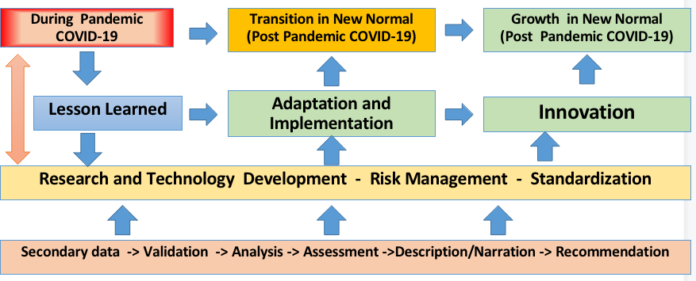

**Figure 1** Research Design and Dissemination of Recommendation

The formal legal method was used to analyze international instruments governing relations in the food supply and security field published by international organizations such as FAO, UNCTAD, ISO, and WHO. The government's strategies and policies in dealing with the pandemic, including economic recovery policies, are discussed. The dissemination of recommendations is illustrated as shown in Figure 1.

# 4. Results and Discussion

* 1. *Socio-economical Dynamic and the Opportunity for the Innovation*

During the pandemic, there have been changes in the business process in education, transaction, trade, meeting, the supply chain model, and people's behavior. Some significant changes in Figure 2 are, among others: public awareness of health, concern for the environment, creative ideas of society, innovative packaging, healthy lifestyle, consumption of functional food, nutraceuticals, using E-commerce applications, online shopping, distant learning, teleconference-webinar, crisis governance, emerging non-thermal technology, biosecurity arrangements, traceability of food and products, concern on standardization and traceability.

Based on this change and the lesson learned during the pandemic, it is open to the opportunity to make innovation in the new normal. Reflecting activities in the new normal will have a lot to do with the subject of optimizing the supply chain, mitigation of environmental impact, valorization of bio-resources, improving the consumer's health, reducing waste and foods loos, more protecting the consumer, more intensive digitalization

through utilization internet of things, communication technology, machine services, automation/robotics and other matters related to industry 4.0 and society 5.0 (Agus *et al*., 2021; Asvial, Mayangsari, and Yudistriansyah 2021; Candra, Ayudina, and Arashi, 2021;Galanakis *et al*., 2021; Prasetya 2021; Yatmo *et al*., 2021 ).

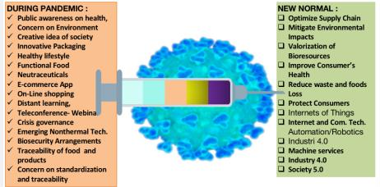

**Figure 2** Potential socio-dynamic change for innovation in the new normal time According to Contractor (2022), there are still many unpredictable socio-economic

conditions and trends in the new era. Therefore, identification of Volatility, Uncertainty, Complexity, and Ambiguity (VUCA)??. In this situation, it is necessary to use more appropriate and advanced information to strengthen the interconnecting between the producer-processing-distribution-retailer- the consumer. At the same time, utilization and implementation of a safety-healthy protocol, clear regulation and public policies, and other requirements to build trust between society, consumers, industries, and regulators.

The pandemic prompted extraordinary interest in innovation, including calls to inspire, initiate and coordinate innovations beyond those already designed and implemented. Some of these initiatives were global or national in scope. The innovation is mostly very clear in developing a new product, service, process, and business model. Available digital and information technology infrastructure affects the acceleration of change in a business model and service.

The business model in several sectors, like education, trading, logistics, etc., developed rapidly. While innovation in the product consumes more time because the safety aspect and technical performance need a serial test to be completed with a standard or another requirement. In Indonesia, innovation during the pandemic focuses, in general, on the field of medical care. In order to support efforts to prevent, spread, transmit, and/or overcome the increasing outbreak of COVID-19 in Indonesia, the government, through the Ministry of Research and Technology/National Research and Innovation Agency, plays an active role in integrating, aligning, coordinating, and synergizing research and innovation programs to deal with the COVID-19 pandemic quickly. One of the efforts is to conduct research, development, assessment, and application activities relatively quickly. There are five technological innovation programs/groups from the COVID-19 Research and Innovation Consortium Team for the prevention of COVID-19, namely Prevention, Screening and Diagnostics, Medical Devices and Supporters, Drugs and Therapy, and Multi-centre clinical trials (BRIN, 2020).

In terms of the global supply chain, about 30 percent of Indonesia's non-oil and gas imports come from China, which is the largest import. The dependence on industrial raw materials, which is unavailable during the pandemic, has hit various important industries. Based on this fact, using the local component or raw material to support national industry with a certain economic and technical feasibility adjustment is very reasonable. This will endorse the research and technology development to support the utilization of local potential. It is also recognized that the users, especially the manufacturing industry, still need time to adjust to their existing manufacturing processes and technical and economic feasibility.

Another benefit of the effort to be self-sufficient in raw materials is the creation of new supply chains, business fields, and employment opportunities, and in the end, it can strengthen the national industrial structure. This condition will also invite global partnerships in research and innovation. These activities will also significantly drive all research centers and university and private sectors to contribute to research, development, and technical-economical assessment in various aspects of production, such as processes, manufacturing, testing, and new product development. To support this effort, it is necessary to analyze data related to industrial needs and data on the development of imports of raw materials. Based on the very valuable experience during the pandemic that the capability of domestic research and innovation can make remarkable innovations in health care in other sectors will also got a positive impact on accelerating economic recovery and strengthening national competitiveness and resiliency.

The lessons learned from preceding pandemics can become the basis for new normal habits. In line with this, the omnibus Law, Law No. 11, the year 2020, Job Creation Law (Job Creation Law, UUCP) (MLHR, 2020)which have derivative regulations for implementing the Job Creation Law are 194 Ministerial/Agency Regulations, and 22 Ministerial/Institutional Regulations are directly related to the Online Single Submission (OSS) System. One of the important aspects of this system is risk-based assessment for providing business permit licensing. The innovation for this system is the change from permission-based to risk-based. This means that business licenses are grouped based on the level of business risk, and this level of risk determines the type of business license. The lower the business risk, the easier and faster the process. In this case, the role of standardization and conformity assessment play an important role (KAN, 2020).

The Job Creation Law pays special attention to low-risk for Small & Medium-sized Enterprises (SMEs), which are more than 60 million SMEs. A single license in the form of a Business Identification Number (NIB) already includes the national standard (SNI) and also Halal Product Assurance Certification (SJPH) in terms of food-based products and or services. The business actors will be facilitated and fostered by government institutions, the National Standardization Agency (BSN) related to SNI, the Halal Product Guarantee Agency (BPJPH) related to SJPH, and sectoral public service Institutions. SMEs are very diverse and generally use the potential of local resources, which are relatively available in district areas. The assistance of fostering SMEs includes access to information sources, market information, regulations, places for consultation and assistance, capital incentives, capacity building in online use, use of digital-based technology for marketing, and communication with partners (Prasetya 2020; Utama *et al*., 2021; Zutshi *et al*., 2021).

* 1. *The Role of Risk Management in Response to the COVID-19 Pandemic and the New Normal*

During the COVID-19 pandemic, a lot of enterprises, industries, companies, organizations, government institutions and universities used the basic principles of risk management to better make identification of risks and minimize the lasting negative impacts. One important thing is to predict unpredictable matters. To navigate the risks (and

opportunities) associated with the pandemic, it is critical to first identify the risks. The exceptional circumstances surrounding COVID-19 pandemic may have brought to light risks that have not yet been considered. In order to accomplish this most effective identification of all kinds of risks such as operational, strategic, and financial. Factual and comprehensive information from many influentialvariables and from a large cross-section of stakeholders will be necessary to assess risk. This requires a supply chain analysis and assessment of the risks faced by vendors, manufacturers, suppliers, distributors, purchasers, and all organizations and stakeholders you interact with and rely upon. It is also highly significant to involve organizational risks associated with people or employees' conditions, such as health and safety, financial, legal, operational, etc.

Risk management relies upon a holistic approach to identifying, analyzing, evaluating, and treating risk. Commitment and full endorsement from the top management are involved in gaining an optimal goal. Risk management also aims to achieve business continuation and ensure the business can survive a critical incident. It consists of a series of plans implemented over phases to shorten recovery time and mitigate the impact. The International Organization for Standardization (ISO) has issued versions or editions of ISO 31000, the initial version in 2009 and the second in 2018. ISO 31000: 2018 Standard defines the risk management process as coordinated activities to direct and control an organization concerning risk. It also defines a risk management framework as a set of components that provide the foundations and organizational arrangements for integrating, designing, implementing, evaluating, and improving risk management throughout the organization (ISO, 2020).

ISO 31000 Standard gained broad acceptance in many countries and large corporations as it is practical and business-oriented, which can be used for the private sector or government institutions. This standard belongs to high-level structural (HLS), which in the implementation, can be integrated with other standards depending on the need of the organizations. During the pandemic and the new normal, this standard can be integrated with relevant standards such as ISO 90001, ISO 14001, ISO 37001, and ISO 22001 (UNIDO, 2020). ISO 31000 also attempts to harmonize risk management practices and tries to achieve the position as a global benchmark for risk management even though there are still some challenges to address (Almeida *et al*., 2019).

ISO 31000 framework sets out the principles, a framework, and a process for the management of enterprise risk that applies to different types of organizations. It consists of three components: principles of managing risks, a framework for managing risks, and the process of managing risks. The relationship between the principles, framework, and process is independent. The principles are fundamental to effectively managing any risks and, therefore, need to be reflected in the other two elements. While the management framework provides the arrangements for risk management that will embed it throughout the organization at all levels. The risk management process should be a part of the business process and corporate culture and tailored to its needs and context. Furthermore, its universal characteristics make them applicable to any type of organization, public or private, large-size or small-size corporations (Choo and Goh, 2015; ISO, 2021). Figure 3 illustrates the interdependence between principles, framework, and process of ISO 31001.

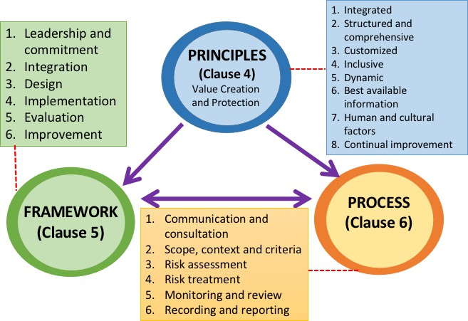

**Figure 3** Principles, framework, and process according to ISO 31001 Risk management system

Pagach and Wieczorek-Kosmala (2020) reviewed the challenges and opportunities for enterprise risk management post-COVID-19, including identifying future research. In the emerging research, it also becomes an important aspect to fill the gap in the role of risk management response to COVID-19 pandemic impacts, as Anton and Nucu (2020) identified recently. Moreover, understanding and managing tail events is an effective and mature risk management process (Dardis, Lau, and Weis, 2020). In order to gain optimum results from the implementation of ISO 31001, the organization can adopt a three-phased response to the current crisis, involving first a rapid response to urgent pandemic needs, then shifting resources to ensure stabilization, and then finally implementing changes to ensure long-term success. The initial response requires ensuring that employees and others are safe and that the organization can communicate critical policies and information to stakeholders.

In the second phase, there is an evaluation of risks, assurance of compliance with emerging safety and legal protocols, and an examination of risk recurrence. In the final phase of response, an organization should examine and implement changes to ensure the sustainability and continued success of the organization. Study on the implementation of ISO 31001 during the pandemic COVID 19 in government institutions reported by Fahma, Sutopo, and Prakoso (2021) and in State-Owned Enterprise (SOE) by Alijoyo and Norimarna (2021). In general, implementing ISO 31000 in the organization can identify the risk and how to make preventive actions. Study implementation in SOE-based risk management maturity assessment is carried out by observations, a qualitative approach through document reviews, questionnaires, focused group discussions, and interviews. The results indicate that this standard can be used as a tool to analyze the substantial resiliency and sustainability of the SOE.

* 1. *The Role of Standardization to Respond Pandemic COVID-19 and the New Normal*

Standardization in dealing with pandemics plays an important role, especially in ensuring safety, quality, and traceability. Product standards, especially medical equipment, include respiratory protection devices, body protective equipment such as medical gloves, face masks, and personal eye protection. Because the existing standard is not fully available for supporting activities during pandemics, it is still necessary to develop new standards obtained by adopting or modifying international standards processes adapted to

Indonesian conditions. In developing standards, several things that should be considered are the recognition and acceptance systems of standards between countries. Accepting equality of standards among trading partners (Business to Business) is important to mobilize the demand for medical equipment, which needs a relatively short time.

Generally, standards are formulated based on needs assessment and carried out based on consensus to agree with draft standards among stakeholders and refer to scientific evidence. In order to obtain broad acceptance among stakeholders, the process of the formulation of national standards in accordance with the WTO code of good practice must meet several basic principles; ensure transparency, openness, impartiality and consensus, effectiveness and relevance, coherence, and to address the concerns of development opportunities (WTO, 2021). To apply these norms, the development of the national standard of Indonesia (SNI) is carried out through the following formulation stages: 1). Planning of a national program for standard development based on needs analysis and prioritizing 2). Drafting the SNI Draft Standard 3). Depth analysis and assessment through Technical Meetings, 4). Consensus Meetings for the public poll, 5). Public pool and Discussion of the results of the opinion poll, 6). Final Determination and Publication of SNI. The total time required for this process is divided into 4 types: 1). normal track (13 months), 2) fast track (9-12 months), 3). urgent needs (4 months) and 4) for amendment

(5 months) (BSN, 2020).

The increasing need for standards as a result of increasing activities in dealing with the COVID-19 pandemic and the existence of a health protocol system during the pandemic has encouraged accelerating services. In terms of standard development, the process of accelerating standard formulation has been carried out, teleconferencing in the formulation of standards (virtual) and developing a program for formulating standards on an urgent track which needs much shorter from around 4 months. There are various factors affecting the acceleration of formulation standards, such as availability of needs assessment, scientific-based assessment, compliance with regulation, coherence with innovation and development, appropriate track-way of formulation of standard, compliance with WTO principles, and taking into high consideration with safety, security, health, and environmental concerns. It is also recommended to look for the availability of the accreditation and certification scheme and the certification body's readiness.

One of the important pillars of the national quality assurance system is accreditation. Accreditation activities are very important in supporting the application of standards so that the conformity of products, services, processes, and management can run in accordance with the requirements and standards applied. The National Accreditation Committee (KAN) provides formal acknowledgment/approval of the integrity and competence of the Conformity Assessment Body (CAB) to carry out conformity assessment activities. The CABs are referred to include test laboratories, certification bodies, inspections, and calibrations. Currently, most of the accreditation processes are carried out for test and calibration laboratories. It is intended that the results of laboratory testing are valid and reliable and meet the required standards. Laboratory accreditation also ensures that human resources working in laboratories are competent. Likewise, the professional and competent management of the laboratory is able to provide various testing services. During this pandemic, many innovations have been produced from within the country. Because they are generally new products, accreditation of product certification bodies and test laboratories is very necessary to ensure product safety and also increase public confidence in domestic innovation products.

To ensure CAB works properly and complies with international standards, accreditation by a national accreditation body (KAN) which has been recognized worldwide

by international accreditation organizations, is very important. Compatibility of the use of globally recognized certificates will facilitate the cross-border mobilization of products. KAN recognition by the international accreditation organization ILAC (International Laboratory Accreditation Cooperation), following the MLA (mutual recognition arrangement) scheme, and by the International Accreditation Forum (IAF) through the MRA (Multilateral Recognition Arrangement) scheme (UNIDO, 2020).

In response to the COVID-19 pandemic, the accreditation process is carried faster and has already been done successfully in more than a year and a half of this pandemic through remote assessment / virtual assessment, applying for digital accreditation, remote assessment, and remote auditing. Following assessment by the technical committee, meetings are done virtually. In general, virtual assessment methodologies can also be improved. To maximize accreditation services, a digital service system utilizing Artificial Intelligence (AI) is used to make it easier for the public to get the best service.The remote audit is also the best choice during the pandemic for most conformity assessment bodies that release certificates the quality management systems, management systems for education organizations, anti-bribery management systems, information security management systems, and product certification. The remote audit is carried out without visiting the location, either in whole or in part, by utilizing information and digital technology. This certification Remote Audit mechanism is conducted through communication media such as document sharing according to audit needs through document links and online meeting applications that are mutually agreed upon with customers.

All conformity assessment activities aligned with the recommendation of ISO's Committee on Conformity Assessment (CASCO). This recommendation is based on a global survey conducted among ISO/CASCO Strategic Alliance and Regulatory Group (CASCO/STAR) members to collect their experience of coping with the COVID-19 pandemic. The key findings from the survey are focused on maintaining business continuity and replacing on-site activities with remote activities. Remote activities are understood as activities within the process of conformity assessment or accreditation, which do not require the physical presence of the assessing personnel at the site of the object of assessment. Remote activities are mainly used as determination activities but can contribute to all functions of conformity assessment, such as virtual meetings (with internal staff or with external clients and stakeholders), web-based document review, remote auditing, assessing and evaluating by ICT, review and decision making by electronic communication (e.g., by circular emails, web-based voting), and e-learning (Smith *et al*., 2020).

In fulfilling the suitability of the characteristics of a product, a series of physical, mechanical, biological, and chemical properties tests are required according to the desired standard. Metrology assures reliable measurements as the basis for scientific research, technical development, and production. The national metrology (National Standard for Units of Measure) mandated by Law No. 20 of 2014 must be the highest reference for measurement in Indonesia. The task of this standard is to provide, develop, maintain, and disseminate units standard. National Metrology is needed to support product testing laboratories to ensure that goods, services, and processes meet product quality, environmental, health, and safety requirements and meet consumer needs and expectations. The level of conformity with the requirements is largely determined by the level of accuracy of the test equipment that must be traced to the international system of units of measure (BIPM) to increase international recognition and acceptance. Thus, users can take advantage of it to expand access to global markets.

To enhance the metrological service to the stakeholder, a digital best service was also developed to do efficient service for laboratories. Likewise, for calibration services, remote calibration and analysis support are also carried out on calibration records from service users. The digital service system improves the calibration and proficiency testing services and implements bureaucratic reform that emphasizes efficient and transparent services; the users can more easily access services and interact with service officers. The information on types of services and prices will be more accessible, and customers' registration process and process monitoring will also be easier to provide customers certainty and satisfaction. In these systems, information on measurement and calibration services covers 6 areas of measurement, namely mass and related quantities, length, acoustics & vibration, temperature, electricity and time, radiometry & photometry. Meanwhile, the proficiency test service covers the quantities found in the field of chemical metrology measurements (ITC, 2020).

* 1. *Sustainable Innovation to Support the New normal (Post-pandemic)*

According to OECD (2021), the science and technology innovation system must be enabled technology governance which opens broader opportunities in certain countries in the post-pandemic era to innovate more and to innovate well. To fulfill this mission, the most important aspect is to mitigate the potential negative effects of technology while gaining maximum benefits. Many efforts have been made to mitigate negative impacts; one of these efforts is the utilization of internationally adopted standards that can lower risk by reducing information asymmetries, providing transparency, comparability, interoperability, providing scale advantages and accountability (Contractor, 2022).

The novelty in innovation contains better, cheaper, and faster than existing products or processes in an ecosystem which enables risk mitigation, gain opportunity, and industrial- costumer acceptance (Reding and Eaton, 2020). The technical risk of technology can also be by increasing technology readiness level. Figure 4 describes the research and development stage from idea, proof concept, lab-scale research, prototype, testing, patents, scaling up, trial production, trial market, and commercialization. Every stage needs reproducibility, interoperability, and traceability, which can be set up by certain standards.

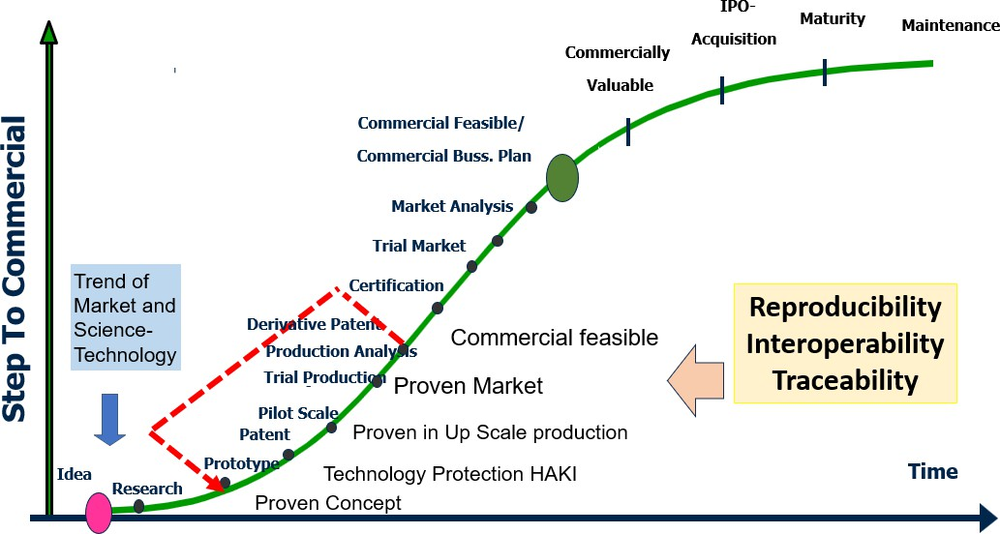

**Figure 4** Stage from idea to commercial stage of research and development technology

In terms of good governance of innovation, there are driving factors. First, government business-targeted funding – can be for specific research areas, technology development,

and small business. Second, need for a standard setting in which the government is involved in setting various standards for measurement, performance, safety, testing, and interoperability. Third, procurement policies which, as a large purchaser of goods and services, the government can influence business activity.

Almost all the results of an innovation are new products, so the implementation must fulfill the security requirements. For this, role of standards in supporting product innovation is very important. In addition, the availability of testing laboratories must be available, including calibration laboratories, to ensure the traceability of measurement equipment. If the standard is unavailable, then a new standard is developed, either formulated by yourself or by adopting international standards from ISO, IEC, and other standards organizations. The trend of technology development will evolve due to the high demand for certain products and mostly the end-user involved in the setting of technical specifications. Increased end-user involvement, especially in medical devices and supporting policies, are needed for the acceleration of the development of technology and innovation. However, these potential developments need to be discussed alongside ethical considerations around social exclusion, collection of and access to data, and privacy, as well as issues related to intellectual property (Dutta *et al*., 2021; ISO, 2014).

* 1. *The Role of SMEs on the National Economic*

The Impact of COVID-19 hit SMEs significantly and become very vulnerable due to being infected by business disruptions. SMEs' lack of resilience and flexibility in dealing with this pandemic is due to several things, such as levels of digitization is still low, difficulties in accessing technology, and lack of understanding of survival strategies in business. The recovery of SMEs has also become an important priority because SMEs have a strategic value for creating family income and employment. There are around 64 million SMEs, and they are mostly located in Java. SMEs in Indonesia employ more than 110 million workers.

One of the important aspects of fostering SMEs is advocacy on the implementation of need standards. During the advocation activity, the role model of SMEs in implementing standards will be set up in several locations across all provinces in Indonesia. There are around 707 SMEs as role mode has been advocated, including 452 SMEs in the food sector and 255 non-food SMEs spread across 28 provinces. Part of the advocation is the facilitation of 98 SMEs to obtain SNI certification, including certification maintenance (BSN, 2020).

The systematic approach in coaching and assistance of SMEs, starting from awareness, approval, and commitment of business actors, understanding of standard management systems and technical product standards, gap analysis, system development, and implementation to continuous improvement, has had a positive impact on the business performance of SMEs. The business activities become much improved in the organized production system, efficient use of resources, decrease rejects/errors, and build a better and disciplined work culture. Several role model testimonials state that the benefits of implementing standards include maintaining sustainable quality, increasing efficiency, reducing revenue (reducing rejects), facilitating market access, reducing regular inspections cost in the production process, and encouraging innovation.

SMEs are very diverse and generally use the potential of local resources, which are relatively available in district areas. The assistance of fostering SMEs in these are included access to information sources, market information, regulations, places for consultation and assistance, capital incentives, capacity building in online use, use of digital- based technology for marketing, and communication with partners. Zutshi *et al*. (2021) give a systematic review and recommendations concerning enhancing SMEs' resilience in the context of COVID-19. To strengthen SMEs, researchers can identify and assess the opportunities, interlinkages, and complexities associated with the use of

digital technologies for SMEs. Moreover, to support the survival ability of SMEs and their value-adding potential, the decision-makers can adopt the recommendations, while researchers and scholars may find it useful to test the viability of applying the proposed framework of recommendations to SME settings. Digital marketing has proven helpful to SMEs in maintaining their sales performance during the COVID-19 pandemic while maintaining customer and sale performance sustainably, improving customer satisfaction, and building long-term customer relationships (Ramful and Kieck, 2020).

The application of SNI is also able to expand their market access at the national level, in supermarkets, national retailers, e-catalogs, and marketplace of the SMEs that are fostered can meet export market requirements (France, United States of America, Australia, Saudi Arabia, Middle East, South Korea, Singapore, Timor Leste). To broaden the market, the role standard, metrology, and accreditation to support Enterprises, including SMEs, need the interlink with the global system, as described in Figure 7. Agreement forums like Technical Barrier to Trade (TBT) in WTO are used for support to access the global market. TBT agreement worked based on standard and conformity assessment procedures.

In line with the government's program to encourage innovation, the development of standards must also be able to support the development of innovation. Creation of new products and processes resulting from domestic research. Innovation must be supported in an integrated manner with standards and suitability assessment systems to improve the selling position of innovative products. Community needs, developments in science and technology, and the global market generally drive innovations that occur in the country. However, some innovations occur due to changes in community or market behavior. During the pandemic, many observations indicated that people's behavior had occurred due to this pandemic. Therefore, innovation and standard development support need to pay attention to this to improve the downstream process.

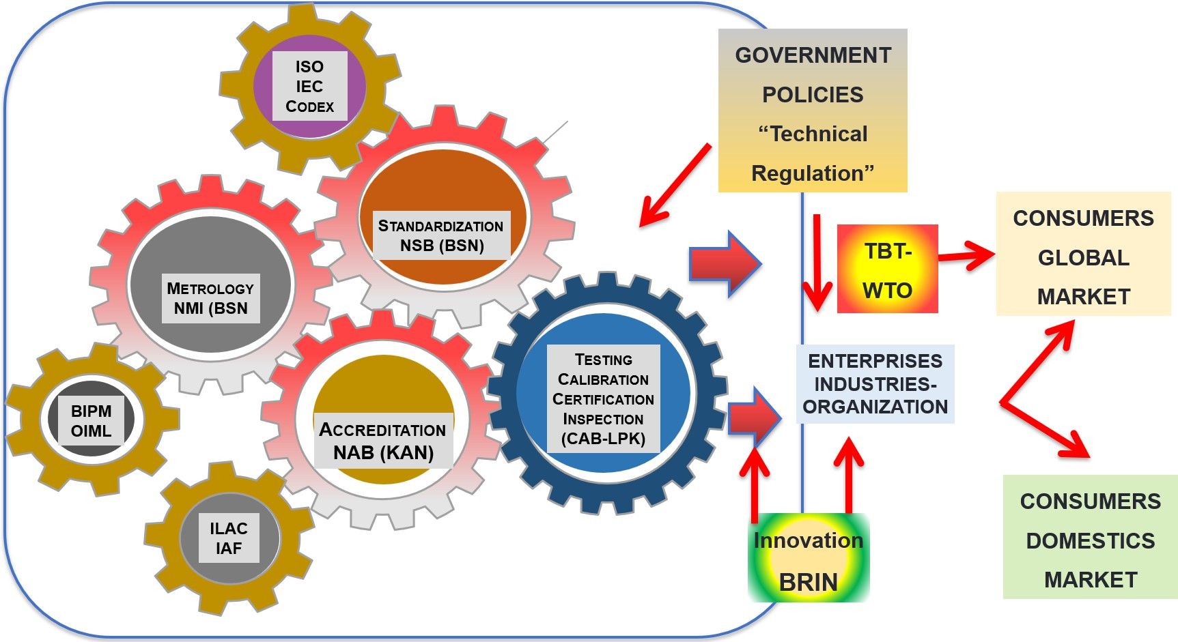

**Figure 5** The role of standardization in supporting the global market

# 5. Conclusions

The COVID-19 pandemic has changed various aspects of life regarding health and economic, social, and environmental aspects. Various government policies have been

carried out, both directly related to health or related to handling the impact of the pandemic. In line with ongoing and planned government policies, implementing risk management and standardization for supporting innovation in the new normal play an important role. The lesson learned obtained from experience during combating toward COVID-19 pandemic can be used as a platform from innovation in the new normal. For recovery and continuing development post-pandemic, either in the middle or long-term period will be more effective implementation a standard management system. The principles of a standard management system based on ISO 3100 can help mitigate risk and gain opportunity in the new normal. Significant support of standardization for government policies and programs can increase the effectiveness in strengthening the supply chain and fostering the SME. Moreover, the standard implementation leads to recovery of the pandemic impact and for sustainable improvement.

# References

Agus, A.A., Yudoko, G.G, Mulyono, N., Imaniya, T., 2021. E-Commerce Performance, Digital Marketing Capability and Supply Chain Capability Within E-Commerce Platform: Longitudinal Study Before and After Covid-19. *International Journal of Technology*, Volume 12(2), pp. 360–370

Alijoyo, F.A., Norimarna, S., 2021. Risk Management Maturity Assessment Based on ISO 31000 - A Pathway Toward The Organization's Resilience and Sustainability Post COVID-19: The Case Study of SOE Company in Indonesia. In: *3rd International Conference on Management, Economic and Finance*, Volume 3, pp. 125–142

Almeida, R., Teixeira, J.M., Mira da Silva, M., Faroleiro, P., 2019. A Conceptual Model for Enterprise Risk Management. *Journal of Enterprise Information Management*, Volume 32(5), pp. 843–868

Anton, S.G., Nucu. A.E.A., 2020. Enterprise Risk Management: A Literature Review and Agenda for Future Research. *Journal of Risk and Financial Management*, Volume 13(11),

p. 281

Asvial, M., Mayangsari, J., Yudistriansyah, A., 2021. Behavioral Intention of E-Learning: A Case Study of Distance Learning at A Junior High School in Indonesia Due to The COVID- 19 Pandemic. *International Journal of Technology*, Volume 12(1), pp. 54–64

*American Veterinary Medical Association* (AVMA), 2020. Guidelines for PPE Use as Veterinary Facilities Resume Providing Normal Services. Available online at: https:[//www.avma.org/resources-tools/animal-health-and-welfare/COVID-19/guide](http://www.avma.org/resources-tools/animal-health-and-welfare/COVID-19/guide) lines-ppe-COVID-19-pandemic-demand-exceeds, Accessed on August 15, 2021

*Badan Riset dan Inovasi Indonesia* (BRIN), 2020. Covid-19 Research and Innovation Consortium. Available online at: https:[//www.brin.go.id/wp-](http://www.brin.go.id/wp-) content/uploads/2020/08/Katalog-Produk-Konsorsium-COVID-19-26082020.pdf, Accessed on August 22, 2021

*Badan Standardisasi Nasional* (BSN), 2020. Strategic Plan 2020-2024. Available online at: https://bsn.go.id/uploads/download/renstra_bsn_2020-2024.pdf, Accessed on August 22, 2021

*Badan Standardisasi Nasional* (BSN), 2021. Contrubution Badan Standardisasi Nasional (BSN) in Acceleration of Handling of Covid-19 Pandemic. Available online at:

https://bsn.go.id/main/berita/detail/12279/kontribusi-bsn-tangani-percepatan-pen anganan-pandemi-covid-19, Accessed on August 22, 2021

Biancolella, M., Colona, V.L., Mehrian-Shai, R. Watt, J.L., Luzzatto, L., Novelli, G., Reichardt, J.K.V., 2022. COVID-19 2022 Update: Transition of The Pandemic to The Endemic Phase. *Human Genomics*, Volume 16(1), p. 19

Candra, S., Ayudina, M., Arashi, M.A., 2021.The Impact of Online Food Applications during The Covid-19 Pandemic. *International Journal of Technology,* Volume 12(3), pp. 472– 484

Carfi, A., Bernabei, R., Landi, F., 2020. Persistent Symptoms in Patients After Acute COVID-

19. *Journal of the American Medical Association,* Volume 324, pp. 603–605

Choo, B.S.Y., Goh, J.C.L., 2015. Pragmatic Adaptation of The ISO 31000:2009 Enterprise Risk Management Framework in a High-tech Organization Using Six Sigma. *International Journal of Accounting and Information Management*, Volume 23(4), pp. 364–382

Contractor, F.J., 2022. The World Economy Will Need Even More Globalization in The Post- Pandemic 2021 Decade. *Journal of International Business Studies*, Volume 53(1), pp. 156–171

Dardis, T., Lau, C., Weis, A., 2020. Covid-19 and Enterprise Risk Management. Available online at: https:[//www.milliman.com/en/insight/covid-19-and-enterprise-](http://www.milliman.com/en/insight/covid-19-and-enterprise-) riskmanagement, Accessed on August 22, 2021

Dong, E., Du, H., Gardner, L., 2020. An Interactive Web-based Dashboard to Track Covid-19 in Real-time. *The Lancet Infectious Diseases,* Volume 20(5), pp. 533–534

Dutta, S., Lanvin, B., Leon, L.R., Wunch-Vincent, S., 2021. Global Innovation Index 2021. Tracking Innovation Through the Covid-19 Crisis. Available online at: https:[//www.wipo.int/edocs/pubdocs/en/wipo_pub_gii_2021.pdf,](http://www.wipo.int/edocs/pubdocs/en/wipo_pub_gii_2021.pdf) Accessed on September 2, 2021

Fahma, F., Sutopo, W., Prakoso, F.D., 2021. Risk Management in the Service of Population and Civil Registration Departement of Surakarta City Goverment in the New Normal Era. *Jurnal Standardisasi*, Volume 23(2), pp. 121–132

Farzanegan, M.R., Feizi, M., Gholipour, H.F., 2021. Globalization and the Outbreak of Covid- 19: An Empirical Analysis. *Risk Financial Management*, Volume 14(105), pp. 1–10 Folegatti, P.M., Ewer, K.J., Aley, P.K., Angus, B., Becker, S., Belij-Rammerstorfer, S., 2020.

Safety and Immunogenicity of The ChAdOx1 nCoV-19 Vaccine Against SARS-CoV-2: a Preliminary Report of a Phase 1/2, Single-blind, Randomized Controlled Trial. *The Lancet,* Volume 396(10249), pp. 467–478

Galanakis, C.M., Rizou, M., Aldawoud, T.M.S., Ucak, I., Rowan, N.J., 2021. Innovations and Technology Disruptions in The Food Sector Within the Covid-19 Pandemic and Post- Lockdown Era. *Trends in Food Science and Technology*, Volume 110, pp. 193–200

*International Organization for Standardization* (ISO), 2014. Standardization and Innovation. *In:* ISO-CERN Conference Proceedings, pp. 13-14

*International Organization for Standardization* (ISO), 2020. Committee for Conformity Assessment (CASCO)/STAR Covid-19 Survey May 2020. Available online at: https:[//www.iso.org/files/live/sites/isoorg/files/standards/conformity_assessment](http://www.iso.org/files/live/sites/isoorg/files/standards/conformity_assessment)

/casco/CASCO%20STAR%20COVID-19%20survey%202020.pdf, Accessed on August 22, 2021

*International Organization for Standardization* (ISO), 2021. International Organization for Standardization (ISO) Standards are Internationally Agreed by Experts. Available online at: https:[//www.iso.org/standards.html,](http://www.iso.org/standards.html) Accessed on August 22, 2021

*International Trade Center* (ITC), 2020. Covid-19: The Great Lockdown and it is Impact on Small Business. Available online at: https://intracen.org/file/itcsmeco2020 exsummaryenwebpdf, Accessed on August 22, 2021

Jackson, L.A., Anderson, E.J., Rouphael, N.G., Roberts, P.C., Makhene, M., Coler, R.N., 2020. An mRNA Vaccine Against SARS-CoV-2—Preliminary Report. *New England journal of medicine*, Volume 383(20), pp. 1920–1931

*Kementerian Keuangan Republik Indonesia* (Kemenkeu), 2020. Macroeconomic Framework (KEM) and Principles of Fiscal Policy (PPKF) in 2021. Available online at: https:[//www.kemenkeu.go.id/publikasi/berita/kem-ppkf-tahun-2021-skenario-apb](http://www.kemenkeu.go.id/publikasi/berita/kem-ppkf-tahun-2021-skenario-apb) n-menghadapi-tantangan-tahun-depan, Accessed on September 5, 2021

*Kementerian Keuangan Republik Indonesia* (Kemenkeu), 2021. Ministry of Finance responds to the covid-19 pandemic: the latest information. Available online at https:[//www.kemenkeu.go.id/covid19.](http://www.kemenkeu.go.id/covid19) Accessed on September 2, 2021

King, V.J., Stevens, A., Nussbaumer-Streit, B., Kamel, C., Garritty, C., 2022. Paper 2: Performing Rapid Reviews. *Systematic Reviews*, Volume 11(1), p. 151

Komite Akreditasi Nasional (KAN), 2021. Direktori Lembaga Penilaian Kesesuaian *(Directory of Conformity Assessment Institution)*. Available online at: [http://www.kan.or.id/index.php/documents/terakreditasi,](http://www.kan.or.id/index.php/documents/terakreditasi) Accessed date on August 22, 2021

*Minister of Law and Human Rights of Republic Indonesia (MLHR)*, 2020. Law Number 11 about Job Creation. Indonesia

Muhyiddin, M., Nugroho, H., 2021. A Year of Covid-19: A Long Road to Recovery and Acceleration of Indonesia's Development. *The Indonesian Journal of Development Planning*, Volume 5(1), pp. 1–19

Nalbandian, A., Sehgal, K,, Grupta, A., Madhavan, M.V., McGroder, C., Stevens, J.S., Cook, J.R., Norvig, A., Shalev, D., Sehrawat, T.S., Ahluwalia, N., Bikdeli, B., Dietz, D., Der- Nigoghossian, C., Liyanage-Don, N., Rosner, G.F., Bernstein, E.J., Mohan, S., Beckley, A.A., Seres, D.S., Choueiri, T.K., Uriel, N., Ausiello, J.C., Accili, D., Wan, E.Y., 2021. Post-acute Covid-19 Syndrome. *Nature Medicine*, Volume 27(24), pp. 601–615.

The Organization for Economic Cooperation and Development (OECD), 2021. Technology Governance. Available online at: https://[www.oecd.org/sti/science-technology-](http://www.oecd.org/sti/science-technology-) innovation-outlook/technology-governance/, Accessed date on 22/08/2021

Pagach, D., Wieczorek-Kosmala, M., 2020. The Challenges and Opportunities for Erm Post- Covid-19: Agendas for Future Research. *Journal of Risk and Financial Management*, Volume 13(12), p. 323

Plüddemann, A., Aronson, J.K., Onakpoya, I., Heneghan, C., Mahtani, K.R., 2018. Redefining Rapid Reviews: A Flexible Framework for Restricted Systematic Reviews. *BMJ Evidence Based Medicine*, Volume 3, pp. 201–203

Prasetya, B., 2020. The Role of Standardization and Conformity Assessment for The Supporting of Acceleration to Recovery of Pandemic Covid-19. *In:* Conference PPISM 2020, pp. 1–9

Ramful, K., Kieck, E., 2020. Blog: Standards: Life Support for Small Businesses During Covid-

19. Available online at: https:[//www.intracen.org/covid19/Blog/Standards-Life-](http://www.intracen.org/covid19/Blog/Standards-Life-) support-for-small-businesses-during-COVID-19, Accessed on August 28, 2021

Reding, D.F., Eaton, J., 2020. Science and Technology Trends 2020-2024. Available online at: https:[//www.nato.int/nato_static_fl2014/assets/pdf/2020/4/pdf/190422-ST_](http://www.nato.int/nato_static_fl2014/assets/pdf/2020/4/pdf/190422-ST_) Tech_ Trends_Report_2020-2040.pdf, Accessed on August 28, 2021

Reis, J., Özturk, S., Tülek, Z., Spencer, P., 2021. The Covid-19 Pandemic, A Risk Management Approach. *Turkish Journal of Neurology*, Volume 27, pp. 1–5

Sheth, J., 2020. Impact of COVID-19 on Consumer Behavior: Will the Old Habits Return or Die?. *Journal of Business Research*, Volume 117, pp. 280–283

Siegel, M., 2021. A Dynamic Risk-Based Approach to Managing a Pandemic. *Journal of Business Continuity and Emergency Planning*, Volume 15(1), pp. 53–64

Smith, L., Pifer, A., Fennel, A., 2020. Enterprise Risk Management. Available online at: https:[//www.huronconsultinggroup.com/insights/enterprise-risk-management,](http://www.huronconsultinggroup.com/insights/enterprise-risk-management) Accessed on September 05, 2021

Tang, N., Li, D., Wang, X., Sun, Z., 2020. Abnormal Coagulation Parameters are Associated With Poor Prognosis in Patients With Novel Coronavirus Pneumonia. *Journal of Thromb. Haemost*, Volume 18, pp. 844–847

Tricco, A.C., Garritty, C.M., Boulos, L., Lockwood, C., Wilson, M., McGowank, J., McCaull, M., Hutton, B., Clement, F., Mittmann, N., Devane, D., 2020. Rapid Review Methods More Challenging During Covid-19: Commentary with A Focus on 8 Knowledge Synthesis Steps. *Journal of Clinical Epidemiology*, Volume 126, pp. 177–183

Tricco, A.C., Langlois, E.V., Straus, S.E., World Health Organization, 2017. *Rapid Reviews To Strengthen Health Policy and Systems: A Practical Guide*. World Health Organization

United Nations Industrial Development Organization (UNIDO), 2020. Quality and Standards and Their Role in Responding to Covid-19. Available online at: https:// [www.unido.org/sites/default/files/files/2020-04/Quality%20and%20Standards%2](http://www.unido.org/sites/default/files/files/2020-04/Quality%20and%20Standards%252) 0and%20their%20Role%20in%20Responding%20to%20COVID-19.pdf, Accessed date August 28, 2021

Utama, M.N., Ariska, I., Pratiwi, S.R., Kaujan, K., 2021. Strategies for Maintaining SMEs Performance During Covid-19 Pandemic. *International Journal of Social Science and Business,* Volume *5*, pp. 34–43

Wang, C., Horby, P.W., Hayden, F.G., Gao, G.F., 2020. A Novel Coronavirus. Outbreak of Global Health Concern. *The Lancet*, Volume 395, pp. 470–473

World Health Organization (WHO), 2015. World Health Organization (WHO) Estimates of The Global Burden of Foodborne Diseases: Foodborne Diseases Burden Epidemiology Reference Group 2007-2015. *World Health Organization (WHO)*

World Health Organization (WHO), 2020. Coronavirus Diseases (COVID-19) Outbreak: Rights, Roles, and Responsibilities of Health Worker, Including Key Consideration for Occupational Safety and Health. *World Health Organization (WHO)*

World Trade Organization (WTO), 2020. The TBT Committee's Six Principles for The Development of International Standards: Are They Still Relevant? Available online at: https:[//www.wto.org/english/tratop_e/tbt_e/tbt_six_principles_e.htm,](http://www.wto.org/english/tratop_e/tbt_e/tbt_six_principles_e.htm) Accessed on August 28, 2021

Yatmo, Y.A., Harahap, M.M.Y., Atmodiwirjo, P., 2021. Modular Isolation Units for Patients with Mild-to-Moderate Conditions in Response to Hospital Surges Resulting from the COVID-19 Pandemic. *International Journal of Technology*, Volume 12(1), pp. 43–53

Zaremba, A., Kizys, R., Aharone, D.Y., 2021. Volatility in International Sovereign Bond Markets: The Role of Government Policy Responses to The Covid-19 Pandemic. *Finance Research Letters*, Volume 43, p. 102011

Zutshi, A., Mendy, J., Sharma, G.S., Thomas, A., Sarker, T.,2021. From Challenges to Creativity: Enhancing SMEs’ Resilience in The Context of Covid-19. *Sustainability*, Volume 13, p. 6542