**ICP-MS - a tool for determination of strontium and lead isotopic ratios in environmental matrices**

**ABSTRACT**

Determining the 87Sr/86Sr isotopic ratio in environmental samples by inductively coupled plasma quadrupole mass spectrometry (ICP-Q-MS) can be performed to explore this ratio as a tracer of the pollution source. The isotopic ratios of Sr in environmental samples have strong regional variations usually controlled by the underlying geology. This fact allows the creation of methodologies by which these elements can be used as traceability indices to determine the origin of metals. Lead isotopic ratios are often monitored to identify the isotopic fingerprint and as tracers to differentiate natural and anthropogenic lead.

This work presents the 87Sr/86Sr and 206Pb/207Pb isotope compositions of 40 samples of river waters and sediments from regions of Romania using the ICP-MS technique.

*Keywords: lead, strontium, isotopes, ICP-MS, environmental, water, sediment*

1. **INTRODUCTION**

Normally, the isotopic abundance of elements is constant. However, some elements have variable isotopic composition, including strontium and lead [1]. Measurements of isotopic ratios of elements with variable isotopic abundance can be useful for characterizing different homogeneous matrices, such as wines, ceramics, etc.; this variation can be explored to determine the radiogenic origin of some isotopes, which correlate with the geological history of the site of origin. Isotope ratios are used for different applications; they can be seen as a fingerprint and used to identify origin and transformation [2]. For example, in food analysis, isotope ratios can indicate the sites of the food's origin, and in environmental tasks, they are used as a powerful analytical tool [3].

Strontium is one of the most common lithophile metals; it is a group II element, an alkaline earth metal that has four natural isotopes with relative natural abundances of 82.29-82.75% for 88Sr, 6.94-7.14% for 87Sr, 9.75-9.99% for 86Sr, 0.55-0.58% for 84Sr, according to IUPAC [4, 5]. Its ionic radius is similar to that of calcium, so it can be a substitute for calcium in a wide range of natural minerals, so it plays an outsized role in geochemistry [6, 7]. Of the four isotopes, 87Sr is radiogenic, and its abundance increases over time in minerals due to the radioactive decay of 87Rb, which has a half-life of almost 50 billion years [8]. The primordial value of the 87Sr/86Sr isotopic ratio derived from meteorites is constantly increasing, its magnitude being a function of the geological age of the rocks and their original rubidium content. Consequently, the abundance of the 87Sr/86Sr isotopic ratio provides an isotopic fingerprint for different rock types. The strontium isotopic fingerprint can thus be helpful in authenticity determinations; the analysis of the 87Sr/86Sr isotopic ratio can provide an additional level of geographical resolution to the extent that there are different lithologies related to the region in question. The study of Sr isotope ratios (87Sr/86Sr) has already demonstrated its added value for fingerprinting environmental matrices [9, 10, 11] such as forensic sciences [12], medical application [13, 14], archaeology, archaeometry [15, 16, 17], and food provenance [18 - 20].

Stable isotope ratios of Sr in environmental samples have substantial regional variations usually controlled by the underlying geology, meaning that these elements can be used as tracers to determine their origin. The stable isotope ratio of certain elements in rocks and minerals has strong regional characteristics reflected in atmospheric components, water, and living organisms that form the Earth's surface environment, as well as in agricultural and fishery products. The use of stable isotopes as markers in diverse, dynamic ecosystems has been demonstrated over time by various studies, focusing on Sr isotopes but also on those of Li and Pb, hence the subsequent evaluation of their potential for a wide range of environmental research related to the geographical origin of food products or archaeological materials. It has been shown that variations in these ratios can be correlated with climatic and geochemical changes. Significant changes in the amounts of the radiogenic 87Sr isotope are caused by (i) significant inputs through modification of ancient continental geological formations during glacial periods, (ii) increased discharge of river and groundwater, and (iii) increased mid-ocean ridge activity.

As biological processes involved in plant and/or animal metabolism do not significantly fractionate strontium isotopes, the 87Sr/86Sr isotopic ratio can be used as a tracer of the origin of foods and beverages, strontium being almost always present at trace levels and having a high natural variability of the isotopic ratio. To characterize a soil-vegetation system, it is necessary to consider all possible sources of natural and anthropogenic strontium. The 87Sr/86Sr isotopic ratio is a characteristic of strontium with a particular geological history and, therefore, characterizes a specific geographical location. The problem that arises is to know the value of this ratio in the soil; this value can be correlated with the value of the isotopic ratio for wine samples, and in this way, the origin of the wine can be confirmed (established) [21-23]. Measuring the isotopic ratios of elements with variable abundance can help protect prestigious wines; this variation can be explored to determine the origin of the wine.

In the Earth’s crust, lead exists in four stable isotopes in decreasing order of abundance: 208Pb (52%), 206Pb (24%), 207Pb (22%), and 204Pb (2%) [24]. The radioactive decay of 238U, 235U, and 232Th generates 206Pb, 207Pb, and 208Pb, respectively. 204Pb is the isotope whose concentration is non-radiogenic and has not changed over geological eras. The lead isotope ratios vary between different sources, allowing for identifying pollutant sources and tracing their migration processes, so the respective proportion of these isotopes of lead varies with geological age and consequently with geographical locations [25]. The analysis of isotopic ratios provides a reliable analytical means of using lead isotopes as environmental indicators and tracers. It can provide information on the geographical origin of lead in a given sample [26-29]. The isotopic ratios 206Pb/207Pb and 208Pb/206Pb are most often monitored to identify the isotopic fingerprint as tracers to differentiate natural and anthropogenic lead, reflecting the anthropogenic or parental geogenic source of metals at trace levels.

Water is a renewable natural resource, and its acceptable quality is essential for human health [30]. Sustainably managing the water cycle is the key to protecting natural resources and human health. The water problem is increasingly acute in the country and the world; resource exploitation and pollution have continuously increased, so the quantitative and qualitative provision of water for human communities, despite special efforts at national and international levels, is far from being "solved".

Polluted water has become a real environmental and human health problem recently. Lead is considered one of the most significant pollutants due to its expressed toxicity, leading position among ecotoxicological pollutants, and anthropogenic activities from previous decades, which condition the current load of lead in environmental factors. Simultaneously with the accumulation of lead in environmental objects and the eventual possibility of its incorporation into the human body, disorders of the population's health are induced, especially in children and people who come into contact with the pollutant. Lead is a persistent environmental element and continues to pose a danger to the population's health, so determining lead isotopic ratios in environmental matrices (water, sediments) can be a valuable tool to detect possible sources of lead contamination. Also, the Pb isotopic ratio analysis provides useful information in describing local and global lead pollution [31, 32].

Studies on environmental matrices (river water and sediments) were performed to illustrate the method's "potential" for determining isotopic ratios using inductively coupled plasma mass spectrometry. Forty environmental samples (water and sediments) taken from rivers in Transylvania-Romania were characterized.

Inductively coupled plasma mass spectrometry (ICP-MS) is a multi-element technique suitable for the analysis of liquid samples, providing high selectivity, superior sensitivity, and much lower detection limits than other multi-element techniques [33, 34]. These characteristics make ICP-MS an excellent tool for the detailed characterization of the elemental composition of numerous samples and for the measurement of isotopic ratios [35]. It measures elements at specific mass-to-charge ratios and is considered the gold standard methodology [36]. The principle of the method consists of the solution containing the sample being pumped into an injection system, where it is atomized, thus forming a fine aerosol of the sample. The aerosol is transported inside an argon plasma at a high temperature, which atomizes and ionizes the sample, producing a cloud of positively charged ions. The ions from the sample are extracted from the plasma in a vacuum system containing a quadrupole analyzer or a mass filter. The analyzer can quickly scan the mass range to perform multi-element analysis on the same sample. The ions are focused in the analyzer and separated based on their mass-to-charge ratio (m/z). An electron multiplier detector measures the ion concentration for a given mass-to-charge ratio.

1. **EXPERIMENTAL PROCEDURE**
   1. **Standards and chemicals**

Ultrapure deionized water (18 MΩ cm−1) from a Milli-Q analytical reagent-grade water purification system (Millipore), nitric acid 60% and hydrofluoric acid (48%) (Merck KGaA, Supelco, Sigma-Aldrich, Darmstadt, Germany, 60%) were used. All plastic containers, pipettes, and reagents were new or cleaned by soaking them for 24 h in nitric acid HNO3, w = 10%, p.a grade, Merck KGaA, Sigma-Aldrich, Supelco, Darmstadt, Germany, and washing them with ultrapure water. A solution with Mg, Cu, Rh, Cd, In, Ba, Ce, Pb, and U (10 μg/L) from Perkin-Elmer (Pure Plus, Billerica, Massachusetts, USA), for optimization procedures and two isotopic standard reference materials (SRM 987-strontium carbonate; SRM 981 -common Lead Isotopic Standard) were used.

* 1. **Sample preparation**

The 87Sr/86Sr isotopic ratio in environmental samples can be determined after a previous step of sample preparation by microwave mineralization in an acidic medium, eliminating the samples' organic component. The digestion method ensures the reduction of interferences due to the matrix by destroying the organic components that, in the ICP-MS analysis, interfere in the argon plasma and can form colloidal suspensions and particles that influence the sample nebulization process, block the sample introduction system, and block the cones.

Microwave digestion of samples in hermetically sealed Teflon vessels is an efficient technique because the samples are subjected to high temperatures and pressures. Microwave-assisted digestion is a fast method and does not allow the loss of analytes due to evaporation. Also, by using relatively small volumes of mineralization reagents, interferences due to contaminants in the reagents are low.

Before elemental analysis, the sediment samples were oven-dried at 600C for 12 h until a constant weight was obtained. Then, the dried samples were ground in a stainless-steel mill until fine particles that could pass through a 0.45 mm mesh were obtained. The internal laboratory method for the digestion of samples was optimized to be 0.1 g of sample and 3 mL of 60% nitric acid HNO3, 2 mL of 48% hydrofluoric acid HF. A microwave oven model Speedwave (Berghof Products and Instruments Ltd., Eningen, Germany) was used to digest environmental samples. The digestion was performed with the controlled program (pressure and temperature) for 12 min at 2000C. After complete digestion and cooling, the samples were filtered, transferred to 50 mL graduated polypropylene tubes, and diluted to volume with deionized water.

* 1. **Apparatus**

The determinations were performed with a Perkin-Elmer Elan DRC(e) inductively coupled plasma mass spectrometer equipped with a Meinhart nebulizer. The isotope ratio method is a specialized technique that measures the exact ratio of two isotopes of an element in a sample. When using the isotope ratio technique, the isotope of interest is compared with a reference isotope of the same component, or alternatively, more than one isotope or all remaining isotopes of an element can be reported with the desired reference isotope. The report is presented in the following format: report = isotope of interest/reference isotope.

The precision for the determination of isotope ratios of this instrument is approximately 0.08 % - determined on silver isotopes. The experimental parameters were: gas flow in the nebulizer: 0.92 L/min; auxiliary gas flow: 1.20 L/min; plasma gas flow: 14.50 L/min; lens voltage: 8.00 V; radiofrequency power: 1100 W; CeO/Ce ratio=0.029, and Ba++/Ba ratio=0.029.

* 1. **Method performance**

The results of the analysis of the isotopic ratios of Sr (87Sr/86Sr) and Pb (206Pb/207Pb), for the certified reference material (NIST SRM 987, NIST SRM 981), as well as the relative standard deviation values, RSD%, are presented in Table 1.

**Table 1.** Sr and Pb isotopic composition of the measured NIST SRM 987, NIST SRM 981 standards

|  |  |  |  |
| --- | --- | --- | --- |
|  | **Measured\*** | **Reference** | **RSD%\*\*** |
| **Measured 87Sr/86Sr** | 0.7097±0.0015 | 0.7103±0.0002 | 0.6 |
| **Measured 207Pb/206Pb** | 0.9145±0.0004 | 0.9146±0.0003 | 0.04 |

*mean of a 10 measurements; **mean of a 5 measurements

**3. RESULTS AND DISCUSSION**

Table 2 presents the isotopic ratio data obtained.

**Table 2.** Results for isotopic ratios 87Sr/86Sr and 206Pb/207Pb in the studied environmental samples

|  |  |  |  |  |
| --- | --- | --- | --- | --- |
| **Samples** | **Isotopic ratio 87Sr/86Sr ± SD** | | **Isotopic ratio 206Pb/207 Pb ± SD** | |
| River  water | River  sediment | River  water | River  sediment |
| 1 | 0.716±0.003 | 0.788±0.018 | 1.125±0.059 | 1.134±0.021 |
| 2 | 0.714±0.005 | 0.801±0.015 | 1.144±0.027 | 1.130±0.007 |
| 3 | 0.712±0.008 | 0.761±0.026 | 1.134±0.006 | 1.159±0.014 |
| 4 | 0.712±0.002 | 0.762±0.012 | 1.141±0.032 | 1.129±0.017 |
| 5 | 0.719±0.005 | 0.777±0.030 | 1.139±0.025 | 1.136±0.018 |
| 6 | 0.722±0.002 | 0.724±0.007 | 1.135±0.042 | 1.129±0.017 |
| 7 | 0.715±0.003 | 0.786±0.011 | 1.142±0.024 | 1.142±0.010 |
| 8 | 0.725±0.001 | 0.720±0.004 | 1.154±0.010 | 1.154±0.007 |
| 9 | 0.714±0.006 | 0.740±0.026 | 1.140±0.036 | 1.151±0.010 |
| 10 | 0.714±0.006 | 0.768±0.017 | 1.126±0.035 | 1.153±0.002 |
| 11 | 0.712±0.003 | 0.779±0.033 | 1.136±0.004 | 1.151±0.010 |
| 12 | 0.715±0.004 | 0.792±0.014 | 1.125±0.028 | 1.128±0.009 |
| 13 | 0.713±0.003 | 0.782±0.017 | 1.131±0.032 | 1.143±0.001 |
| 14 | 0.726±0.002 | 0.738±0.020 | 1.133±0.038 | 1.122±0.007 |
| 15 | 0.714±0.006 | 0.782±0.023 | 1.129±0.053 | 1.136±0.003 |
| 16 | 0.716±0.006 | 0.741±0.020 | 1.111±0.043 | 1.139±0.008 |
| 17 | 0.719±0.004 | 0.754±0.033 | 1.125±0.010 | 1.147±0.005 |
| 18 | 0.717±0.003 | 0.740±0.006 | 1.127±0.034 | 1.127±0.009 |
| 19 | 0.713±0.002 | 0.731±0.020 | 1.117±0.034 | 1.124±0.007 |
| 20 | 0.715±0.005 | 0.732±0.005 | 1.107±0.044 | 1.132±0.006 |

The absolute concentration of 87Sr varies with geological age and geographical location [37]. Acidic rocks (silica-rich granites) have high 87Sr/86Sr ratios (0.710 - 0.750) due to the high original Rb/Sr ratio, while bare rocks (e.g., carbonate and basaltic rocks) have relatively low 87Sr/86Sr ratios (0.702 - 0.706). Limestones have intermediate 87Sr/86Sr isotopic ratios (0.706 - 0.709) and high strontium contents (600-1000 μg/g) [38].

In the last four decades, the whole world has been confronted with acid rain, pollution and climate change which may explain the significant oscillation range of the 87Sr/86Sr ratio in both water (0.712 - 0.726) and sediments (0.720 - 0.801) in the Romanian area (Fig. 1, Fig. 2).

The strontium ratios of precipitation resulting from the chemical erosion of bedrocks, mainly basaltic ones which have an extremely high Sr isotopic ratio, do not exceed the limit of 0.715. Ratio values higher than 1.0 have been observed in calcium-silicate soils and between 0.70 and 0.75 in dolomite and limestone rocks.

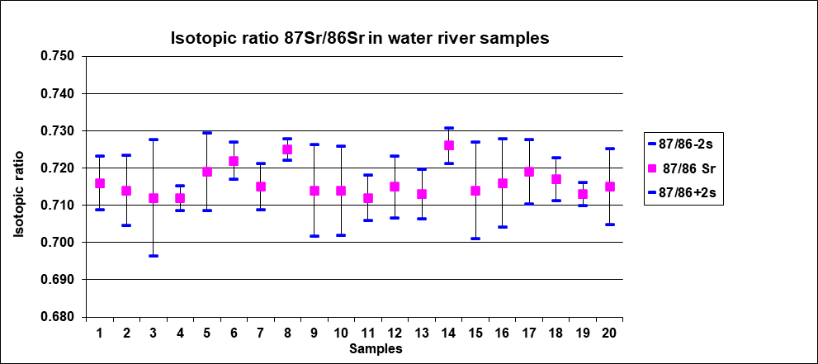

**Fig.1** Graphic representation of the 87Sr/ 86Sr isotopic ratio for the studied water samples

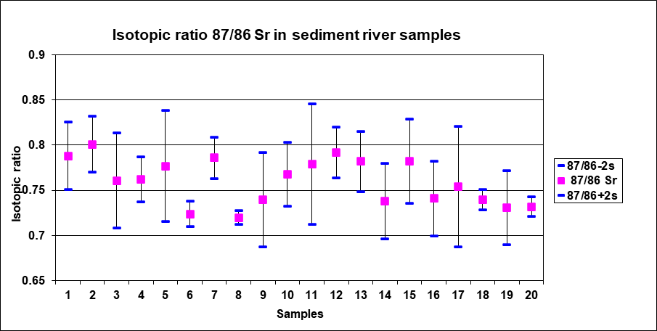

**Fig.2** Graphic representation of the 87Sr/ 86Sr isotopic ratio for the studied sediment samples

Fig. 3 and Fig. 4 graphically represent the 206Pb/207Pb isotopic ratios for the investigated water and sediment samples.

In Central Europe, the isotopic signature of pollution sources varies from relatively high values of 206Pb/207Pb ratios (natural Pb, ash carried by atmospheric currents; 206Pb/207Pb =1.17-1.22) to low 206Pb/207Pb values (gasoline, oil combustion; 206Pb/207Pb =1.06-1.14) [39]. Taking into account these data from the literature, it can be said that the lead content of all studied environmental samples comes from anthropogenic sources.

The low 206Pb/207Pb ratio indicates anthropogenic sources compared to naturally occurring after values higher than 1.20. Thus, the 206Pb/207Pb isotopic ratios for the studied waters and sediments were in the range of 1.107-1.154 (waters) and 1.122-1.159 (sediments). Pollutants, such as acids from industrial wastewater, accelerate the process by which Pb and other ions dissolve in groundwater. The waters in the region were gradually enriched by the leaching of groundwater contaminated by surface deposits resulting from industrial processes. The isotopic signature of fluvial Pb loads generally reflects a spatially complex influence of mining activity, mineralization, and hydrological processes, controlling contaminants' release, dispersion, and storage. Furthermore, the remarkably heterogeneous Pb isotope ratios observed along the depth profile could be explained by different relative inputs of anthropogenic and geogenic sediment supply or by successive deposition of contaminants and sustained infiltration by rainfall water.

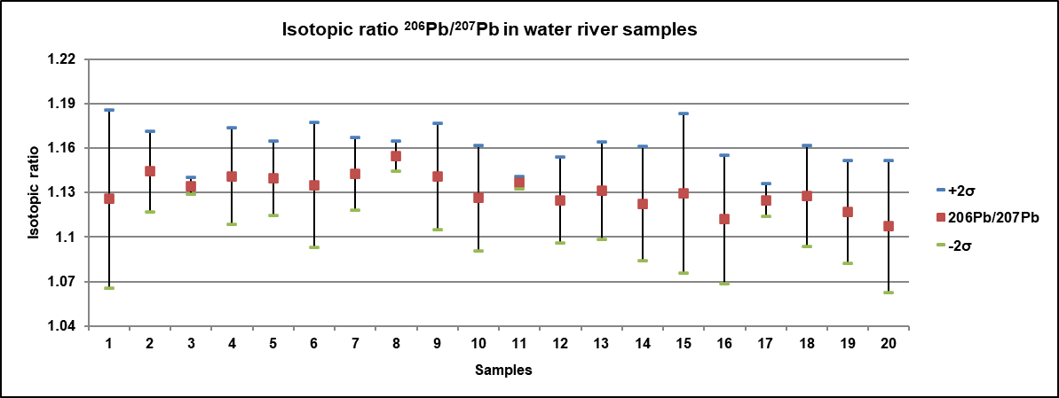

**Fig. 3** Graphic representation of the 206Pb/ 207Pb isotopic ratio for the studied water samples

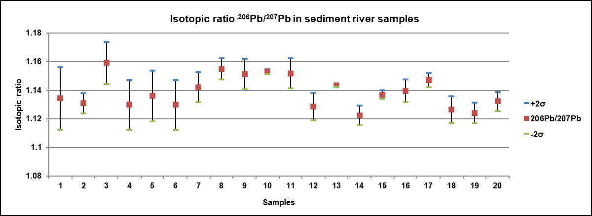

**Fig. 4** Graphic representation of the 206Pb/ 207Pb isotopic ratio for the studied sediment samples

1. **CONCLUSIONS**

In this study, an analytical procedure based on the determination of the isotopic ratios 87Sr/86Sr and 206Pb/207Pb was developed and applied to 40 environmental samples (water and sediment). Inductively coupled plasma mass spectrometry (ICP-MS) is a convenient and suitable technique for determining these isotopic ratios.

The isotopic ratio 87Sr/86Sr is a characteristic of strontium with a particular geological history and, therefore, characterizes a specific geographical location, and the ratio 206Pb/207Pb can be determined quite accurately to differentiate the source of anthropogenic/lithogenic lead contamination.

Data related to strontium isotopes of surface waters and groundwater can contribute to understanding hydrological processes. There is a close interrelationship between the chemical composition of groundwater and surface water, especially in areas where surface and subsurface flow systems interact. Strontium isotopes are, therefore, convenient and suitable tracers to delineate and characterize potential sources of Sr that contribute, through rock/soil mixing and leaching, to the mass budget and composition of surface and groundwater bodies. Since there is no measurable fractionation of strontium (Sr) isotopes during mineral precipitation and chemical weathering, Sr isotopes can be used to study water-rock interactions and monitor groundwater pollution through the ecosystem water cycle. In the last four decades, the world has been faced with acid rain, pollution, and climate change, which may explain the significant oscillation range of the 87Sr/86Sr ratio in both water (0.712 - 0.726) and sediments (0.720 - 0.801) in our study area.

Geogenic and anthropogenic sources of Pb have different isotopic ratios, so Pb isotopes can be used as “fingerprints” to track the sources of contamination in soil, groundwater, and other environmental matrices. The 206Pb/207Pb isotopic ratios for the studied environmental samples (1.107 - 1.154 - water; 1.122 - 1.159 - sediments) suggest that the lead content comes from anthropogenic sources. Due to the complexity of the Pb source in the surface environment, lead and strontium isotopes can be combined to be used as multiple geochemical tracers and to differentiate Pb pollution in groundwater, respectively.

Inductively coupled plasma mass spectrometry (ICP-MS) is a multi-element technique suitable for analyzing liquid samples. It provides high selectivity, superior sensitivity, and much lower detection limits than other multi-element techniques. These characteristics make ICP-MS an excellent tool for the detailed characterization of the elemental composition of numerous samples and for measuring isotopic ratios.

**REFERENCES**

1. Greenwood NN, Earnshaw A, editors. Origin of the Elements. Isotopes and Atomic Weights. Chemistry of the Elements (Second Edition), Butterworth-Heinemann, 1997. Pages 1-19, ISBN 9780750633659.

2. Stoll-Werian A, Flierl L, Rienitz O, Noordmann J, Kessel R, Pramann A. Absolute isotope ratios – Analytical solution for the determination of calibration factors for any number of isotopes and isotopologues. Spectrochimica Acta Part B: Atomic Spectroscopy. 2019; 157: 76–83.

3. Drivelos SA, Georgiou CA. Multi-element and multi-isotope-ratio analysis to determine the geographical origin of foods in the European Union Trends Anal. Chem. 2012; 40: 38–51.

4. Izzo F, Di Renzo V, Langella A, D'Antonio M, Tranfa P, Widory D, Salzano L, et al. Investigating strontium isotope linkage between biominerals (uroliths), drinking water, and environmental matrices. Environmental Pollution. 2024; 344; 123316.

5. Rosman KJR and Taylor PDP. Isotopic compositions of the elements (Technical Report). Pure and Applied Chemistry. 1998; 70(1): 217–235.

6. Rodríguez-Maese R, Cerdà V, O. Leal L. An overview of automated flow systems for total and isotopic analysis of strontium and yttrium in samples of environmental interest. Talanta. 2024; 270; 125643.

7. Peucker-Ehrenbrink B, Fiske GJ. A continental perspective of the seawater 87Sr/86Sr record: A review, Chemical Geology. 2019; 510: 140–165.

8. Rotenberg E, Davis DW, Amelin Y, Gosh S, Bergquist BA. Determination of the decay-constant of 87Rb by laboratory accumulation of 87Sr. Geochim. Cosmochim. Acta. 2012; 85: 41–57.

9. Coelho I, Castanheira I, Bordado JM, Donard O, Silva J.A.L. Recent developments and trends in the application of strontium and its isotopes in biological related fields. TrAC - Trends Anal. Chem. 2017; 90: 45–61.

10. Holt E, Evans JA, Madgwick R. Strontium (87Sr/86Sr) mapping: a critical review of methods and approaches. Earth Sci. Rev. 2021; 216; 103593.

11. Frei R, Frei KM, Munch Kristiansen S, Jessen S, Schullehner J, Hansen B. The link between surface and groundwater-based drinking water – strontium isotope spatial distribution patterns and their relationships to Danish sediments. Applied Geochemistry. 2020; 121; 104698.

12. D’Antonio M, Di Renzo V, Arienzo I, Widory D. Isotopic Analysis Techniques Applied to Forensics: New Frontiers of Isotope Geochemistry. In: Mercurio, M., Langella, A., Di Maggio, R.M., Cappelletti, P. (eds) Mineralogical Analysis Applied to Forensics. Soil Forensics. Springer, Cham. 2023.

13. Font L, van der Peijl G, van Wetten I, Vroon P, van der Wagt B, Davies G. Strontium and lead isotope ratios in human hair: investigating a potential tool for determining recent human geographical movements. J. Anal. At. Spectrom. 2012; 27: 719–732.

14. Coelho I, Castanheira I, Moura Bordado J, Donard O, Silva JAL. Recent developments and trends in the application of strontium and its isotopes in biological related fields. TrAC Trends in Analytical Chemistry. 2017; 90: 45–61.

15.Rossi M, Iacumin P, Venturelli G. 87Sr/86Sr Isotope Ratio as a Tool in Archaeological Investigation: Limits and Risks. Quaternary. 2024; 7; 6.

16. Al-Shorman A, Perry M, Coleman D. Ancient mobility in northern Jordan during the Roman and Byzantine periods using stable strontium isotope analysis of human dental enamel. Journal of Archaeological Science: Reports. 2015; 61; 104879.

17. Nafplioti A. Moving forward: Strontium isotope mobility research in the Aegean. Medit. Archaeol. Archeom. 2021; 21: 165–179.

18. Cardin M, Mounier J, Coton E, Cardazzo B, Perini M, Bertoldi D, Pianezze S et al. Discriminative power of DNA-based, volatilome, near infrared spectroscopy, elements and stable isotopes methods for the origin authentication of typical Italian mountain cheese using sPLS-DA modeling. Food Research International. 2024; 178; 113975.

19. Reyrolle M, Bareille G, Epova EN, Barre J, Bérail S, Pigot T, Desauziers V et al. Authenticating teas using multielement signatures, strontium isotope ratios, and volatile compound profiling. Food Chemistry. 2023; 423; 136271.

20. Aoyama K, Nakano T, Shin K-C, Izawa A, Morita S. Variation of strontium stable isotope ratios and origins of strontium in Japanese vegetables and comparison with Chinese vegetables. Food Chemistry. 2017; 237: 1186–1195.

21. Lancellotti L, Sighinolfi S, Ulrici A, Maletti L, Durante C, Marchetti A, Tassi L. Tracing geographical origin of Lambrusco PDO wines using isotope ratios of oxygen, boron, strontium, lead and their elemental concentration. Curr. Res. Food Sci. 2021; 4: 807–814.

22.Marchionni S, Braschi E, Tommasini S, Bollati A, Cifelli F, Mulinacci N, Mattei M, Conticelli S. High-precision 87Sr/86Sr analyses in wines and their use as a geological fingerprint for tracing geographic provenance. J. Agric. Food Chem. 2013; 61: 6822–6831.

23. Epova EN, B´erail S, S´eby F, Vacchina V, Bareille G, M´edina B et al. Strontium elemental and isotopic signatures of Bordeaux wines for authenticity and geographical origin assessment. Food Chemistry. 2019; 294: 35–45.

24 Wang Z, Dwyer GS, Coleman DS, Vengosh A. Lead isotopes as a new tracer for detecting coal fly ash in the environment. Environ. Sci. Technol. Lett. 2019; 6: 714–719.

25. Yuan C-S, You J-W, Tseng Y-L, Cheng W-H, Kao Y-Y, Lo C-L, Lee C-W. Utilizing lead isotopes in airborne particulates and soils to trace lead sources: A case study from southern Taiwan, Atmospheric Pollution Research. 2025; 16(2); 102390.

26. Bi X-Y, Li Z-G, Wang S-X, Zhang L, Xu R, Liu J-L, Yang H-M, Guo M-Z. Lead isotopic compositions of selected coals, Pb/Zn ores and fuels in China and the application for source tracing Environ. Sci. Technol. 2017; 51: 13502–13508.

27. Kolawole TO, Olajide-Kayode JO, Afolabi OO, Azeez LA, Anifowose AJ, Aladejana JA. Lead and lead isotopes as tracers of soil contamination in southwestern Nigeria. J. Trace Elem. Miner. 2023; 5; 100086.

28. Wu P-C, Huang K-F. Tracing local sources and long-range transport of PM10 in central Taiwan by using chemical characteristics and Pb isotope ratios. Sci. Rep. 2021; 11: 1–15.

29. Li J, Hao G, Wang X, Ruan L, Zhou J. Anthropogenic Pb contribution in soils of Southeast China estimated by Pb isotopic ratios. Sci. Rep. 2020; 10; 22232.

30. Alhagri IA, Al-Hakimi AN, Al-Hazmy SM, Albadri AEAE. Determination of trace and heavy metals in bottled drinking water in Yemen by ICP-MS. Results in Chemistry. 2024; 8; 101558.

31. Bińczycki T, Weber J, Mielnik L, Asensio C. Lead isotope ratios in Podzol profiles as a tracer of pollution source in the subalpine zone of the Karkonosze National Park, Sudety Mts (south-western Poland). Catena. 2020; 189; 104476.

32. Hansmann W, Köppel V. Lead-isotopes as tracers of pollutants in soils. Chemical Geology. 2000; 171(1-2): 123–144.

33. Chevallier E, Chekri R, Zinck J, Guérin T, Noël L. Simultaneous determination of 31 elements in foodstuffs by ICP-MS after closed-vessel microwave digestion: Method validation based on the accuracy profile. Journal of Food Composition and Analysis. 2015; 41: 35–41.

34. Wilschefski SC, Baxter MR. Inductively Coupled Plasma Mass Spectrometry: Introduction to Analytical Aspects Clin. Biochem. Rev. 2019; 40: 115–133.

35 Ammann AA. Inductively coupled plasma mass spectrometry (ICP-MS): a versatile tool. Journal of Mass spectrometry. 2007; 42: 419–427.

36. Bajaj AO, Parker R, Farnsworth C, Law C, Johnson-Davis KL. Method validation of multi-element panel in whole blood by inductively coupled plasma mass spectrometry (ICP-MS). Journal of Mass Spectrometry and Advances in the Clinical Lab. 2023; 27: 33–39.

37. Zieliński M, Dopieralska J, Królikowska-Ciągło S, Walczak A, Belka Z. Mapping of spatial variations in Sr isotope signatures (87Sr/86Sr) in Poland — Implications of anthropogenic Sr contamination for archaeological provenance and migration research, Science of The Total Environment. 2021; 775; 145792.

38. Faure G, Powell LL. Strontium Isotope Geology. Springer-Verlag, Berlin. 1972.

39. Mihaljevic M, Ettler V, Sebek O, Strnad L. Chrastny, V. Lead isotopic signatures of wine and vineyard soils—Tracers of lead origin. J. Geochem. Explor. 2006; 88: 130–133.