|  |  |
| --- | --- |
| Book Name: | **Morden control theory** |
| Manuscript Number: | **Ms_BP_8574A.7** |
| Title of the Manuscript: | **Optimal Control** |
| Type of the Article | **Book chapter** |

|  |  |  |
| --- | --- | --- |
| **PART 1: Review Comments** | | |
|  | **Reviewer’s comment** | **Author’s comment** *(If agreed with the reviewer, correct the manuscript and highlight that part in the manuscript. Authors must write his/her*  *feedback here)* |
| Is the manuscript important for the scientific community?  Please write a few sentences explaining your answer | Yes. Challenges in study and application of different systems for researchers are objects of new researches. The study of optimal control has provided an attractive field for researchers of mathematical sciences, which plays a prominent role in a range of  application areas, including economics, financial mathematics and engineering sciences. |  |
| Is the title of the article suitable?  Do you have any alternative Title in your mind? | Yes |  |
| Is the abstract of the article comprehensive?  If your answer is No, please provide suggestions | Yes. |  |

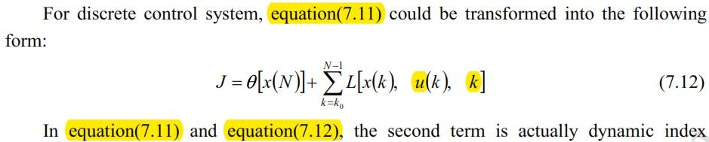

|  |  |  |
| --- | --- | --- |
| Do you think the English quality of the article is suitable for  scholarly communications?  If your answer is No, please provide suggestions | I recommend that the text be literary edited. Also, I suggest to correct the following typing errors:  It appears that you don't have improperly spaced some punctuation. Also, consider removing a space in some parts.  All formulas need a comma or period at the end. Please edit this item in the entire text.    … to correctly **~~apply~~** **applying** optimal control … Furthermore**,** maximum principle … (Add a comma)  … for readers. In this chapter … (Add a space)  … control of **the** control system. Recognize **the** Bellman equation. In **~~chapter6~~** **chapter 6**, as …  … , if **the** system is completely …  … pole assignment **~~is~~** **are** mainly determined …  … poles of **the** closed-loop control system …  … system; however**,** in **a** practical …  … optimal in **the** control system.  … design method **in** which **the** core problem …  … to select **a** control signal to …  … system indexes **~~be~~** optimal in …  … to find **~~a~~** **the** best scheme to …  … to acquire **the** optimal effect …  … includes optimal **~~problem~~** **problems**.  … are 2000 **~~merchandises~~** **merchandise** in warehouse …  … and 1000 **~~merchandises~~** **merchandise**.  How is **~~these merchandises~~** **this merchandise** carried to …  … transportation cost **~~become~~** cheapest? A to **~~workshop~~** **workshops** I,  … of variable x , such optimal …  … , such **an** optimal problem is called **a** linear optimization problem… A to **~~workshop~~** **workshops** I, II and III **~~is~~** **to be** cheaper than …  … we should **~~firstly~~** **first** select **~~merchandises~~** **merchandise** from warehouse …  **~~Then~~** **The** above example … problem with **an** equality constraint. |  |

|  |  |  |
| --- | --- | --- |
|  | etc.  It is recommended to The formula number starts in each section of one. For example (7.1) convert to (7.1.1) etc. |  |
| Please provide your comments regarding the appropriateness  of different sections of the manuscript. | Considering that equations (7.48) and (7.49) are the general form of the calculus of variation problems, it is suggested to consider a section to introduce this category of problems and their solution.  A fundamental review should be done in setting the derivative symbol. Newton's notation of first derivatives of (𝑡) with respect to 𝑡 is 𝑥̇(𝑡) and Lagrange's notation of 𝑥(𝑡), with respect to 𝑡 is 𝑥′(𝑡). Please use this symbol appropriately throughout the text. For example    Considering that the (𝑡) is used to display the control variable, it is suggested to use the 𝑦(𝑡) variable instead of 𝑢(𝑡) in section 7.4.1 and example 7.5.    In equation (7.332) "u" > "u*" |  |
| Do you think that the references in the manuscript are proper, recent and sufficient?  If you have any suggestions, please write here. | The references are relatively old and it is necessary to use newer works. |  |

|  |  |  |  |  |
| --- | --- | --- | --- | --- |
| **PART 2:** | | | | |
|  | | | **Reviewer’s comment** | **Author’s comment** *(if agreed with reviewer, correct the manuscript and highlight that part in the manuscript. It is mandatory that authors should write his/her feedback here)* |
| **Are there ethical issues in this manuscript?** | | | *(If yes, Kindly please write down the ethical issues here in details)* |  |
| **Reviewer Details:** | | | | |
| Name: | **Behzad Kafash** | | | |
| Department, University & Country | **Ardakan University, Iran** | | | |